The Effect of Metacognitive Strategy (MCS) in Reading Arabic Text

ABSTRACT

This study focused on the use of Arabic metacognitive strategy (MCS) which are used by form 4 students at SMK Agama in Seremban. Apart from that, this article aimed to investigate the effects on MCS use of Arabic text in comprehension and Arabic vocabulary. Based on stratified sampling, 60 respondents were taken from SMKA in Seremban to undergo this study. This group divided into two groups that consisting 30 of the experimental group and 30 control group. This study follows quantitative research which is a numerical-based research method ANCOVA test. Eventually, after quasi-experimental studies were done, the finding showed that there is a significant difference in the Arabic comprehension and Arabic vocabulary post-test between the experimental group and control group. The experimental group indicated higher than the control group. This study contributes to the field of Arabic education from the perspective of the effectiveness of MCS in reading Arabic text.

Keywords: Metacognitive Strategy (MCS); Arabic; reading text; pre-test and post-test

INTRODUCTION

The Metacognitive Strategy (MCS) in reading according to Yahya Othman (2013) is the action of reading which involving the process of thinking in comprehending text using metacognitive strategy. Metacognition plays a critical role in successful learning, it is important to study metacognitive activity and development to determine how students can learn a better ways to apply their cognitive resources through metacognitive control.
Metacognitive reading strategies are interesting not only for what they indicate about the ways readers arrange their interaction with the text, but also for how the use of strategies is related to effective reading comprehension. The most important factors that need to be emphasized in readings are metacognitive reading strategy awareness which facilitate reading comprehension and would foster language learning. In another hand, these strategies help students to focus on their assigned texts and assist in organizing what knowledge they already possess. Thus, students can determine what to look for in the texts (Mokharti & Reichard, 2002).

LITERATURE REVIEW

In this age of knowledge society, everybody knows how to read but for academic work and for effective learning, we need critical reading strategy. This structure has been established with work carried out by; Chayada Danuwong (2006), Adil Bentahar (2012), Yahya Othman, Dayang Raini Pakar (2013, Mohsen Mahdavi and Majid Mehrabi (2014), Nur Aisyah Mohamad & Zamri Mahamod (2014)) and Yen-Hui Wang (2015).
At this point, a similarity from the MCS perspective chosen by Chayada (2006) determined the training of two groups; Agricultural Science 34 respondents and Communication Arts 44 respondents. She investigated four metacognitive strategies e.g. planning strategies, monitoring strategies, evaluating strategies and solving problem strategies.
Based on Adil Bentahar’s thesis (2012); “Can ESL teachers teach reading metacognitive strategies?” He used Metacognitive Awareness of Reading Strategy Inventory (MARSI) which developed by Mokhtari & Reichard, (2002) as pre-test and post- test. There were 8 respondents. Adil (2012) aimed to evaluate three metacognitive strategies i.e. planning, monitoring, and evaluating after teaching them.
After several years, Mohsen Mahdavi and Majid Mehrabi (2014) came out with the frequency of the use and types of reading strategies employed by Iranian EFL university students in an input-poor environment. This study involving 144 university students are consisted 80 males and 64 females. Results from their study on the reading learning strategies used by EFL learners in an “input-poor” environment which suggested that the students indicated that awareness of almost all of the reading strategies included in the Survey of Reading Strategies (SORS) developed by Mokhtari and Sheorey (2002).
Meanwhile, study that done by Nur Aisyah Mohamad & Zamri Mahamod (2014) “Tahap Kemahiran Metakognitif Murid Tingkatan Empat Dalam Pembelajaran Bahasa Melayu”. Nur Aisyah and Zamri investigated monitoring, evaluating and regulation in the context of learning Malay language that involving two groups; science and art.
Yen-Hui Wang (2015) came out with the study about “Metacognition in reading: EFL learners’ metacognitive awareness of reading strategy use”. The participants were 12 Taiwanese college students who were required to read aloud and think aloud the eight designated texts. This study is about pre-and post-test questionnaires and an interview on metacognition in EFL reading, this study also including think aloud protocols.
Chayada (2006), Adil Bentahar (2012), Nur Aisyah & Zamri (2014) and Yen-Hui Wang (2015) agreed that MCS can increase the ability of students in learning the language. Based on the studies above, there were studies had been done for other languages but not including the Arabic language.

PROBLEMS STATEMENTS AND RESEARCH QUESTIONS

Students are wrongdoing by choosing the unsuitable strategy in reading Arabic text are unable to build sentences and answer the question incorrectly after reading the text (Rosni Samah, et al, 2009). Since the strategy is the crucial link to effective reading, text comprehension should be emphasized using the strategy before, during and after reading. Without adequate strategy before, during and after reading, many adolescent students can become more and more behind grade level in their reading level (Caitlin Dakin, 2013). According to Chayada Danuwong (2006) emphasizes if readers are not facing metacognitive experiences involving awareness of their own cognitive and affective processes they are having hard time to comprehend accurately.
As for Harison Mohd Sidek (2008), the training or experience that is decoded when monitoring students’ own mental processes while reading is recommended. From the observation that had been done, students’ failure was really noticeable that cognitive resources on comprehension process continuing corrupt while they attempted to comprehend the text.
In addition, for students who fail to understand the content of the subject perhaps, they are facing lack of knowledge in reading strategy. This study conducted by Sahlan Surat (2012) Shafee Abdul Hamid (2012) and Saemah (2004) also found that students who fail to understand the content of the subject are because frequently they had problems of strategy in learning language especially in reading text.
If students facing problems that relate to strategy in reading especially in comprehension; this leads to them the limited ability to generalize ideas. Subsequently, not only students will face the low level of achievement in their studies. But, not even interested in learning anymore, give up easily and will quit from the current learning that occurs in class (Zamri, 2012). Therefore, based on problem statements the research questions of this study such as the following:

- To identify the effects of metacognitive strategies use on Arabic text comprehension among students of SMKA in Seremban, Negeri Sembilan
- To identify the effects of metacognitive strategies use on Arabic text vocabulary among students of SMKA in Seremban, Negeri Sembilan

THEORETICAL FRAMEWORK

Brown (1987) introduced the concept of “autopilot state”, arguing that expert learners (e.g. readers) monitor their comprehension and retention and evaluate their own progress in the light of the purposes for which they are learning to the extent that these activities become automatic and learners proceed as if in “automatic pilot”. This concept tries to explain why metacognitive learners (i.e. those who apply metacognitive knowledge and skills in learning situations) sometimes are not conscious of their strategies and cannot describe their metacognitive knowledge. This model emphasizes the executive processes, stressing the importance of the control that people bring or fail to bring to cognitive endeavours. Moreover, Brown points to important characteristics of regulation of cognition, that has to be taken into account for those interested in the applications of these concepts into instructional research.
There was an issue of a study about children failure to resolve the issue even they had been trained to master the procedures of necessary solution. Yet, they still fail to answer the question. Regarding the failure of these children; Flavel (1976) suggested that children can be trained to respond the questions when facing the problems.
This is because the process of storage and retrieval of information from the mind. He suggested that children should learn a lot about the 'how', 'where' and 'when' to store information and 'how', 'where' and 'when' to reproduce the information of knowledge. Flavell (1979), highlighting metacognitive model which emphasizes cognitive monitoring of process conditions called 'Model of Cognitive Monitoring'.
Tobias and Everson (1999) had performed a series of empirical studies to investigate this aspect of metacognition and its relationship to learning from instruction in different domains, focusing on issues such as domain specificity of knowledge monitoring, measurement concerns, and the relationship of knowledge monitoring to academic ability. They define knowledge monitoring as the ability of knowing what you know and knowing what you don’t know.

CONCEPTUAL FRAMEWORK

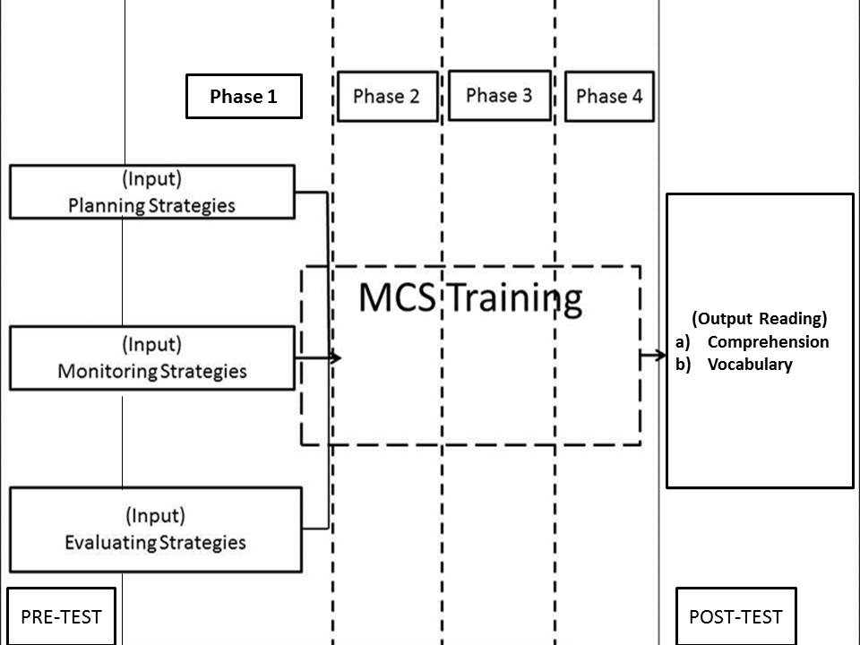

FIGURE 1: Conceptual Framework,
Adapted from Chamot, A. U., Barnhardt, S., El-Dinary, P. B.& Robbins, J. (1999).
Cited in Anna Uhl Chamot, Ph.D. Jill Robbins, Ph.D & Aileen Watts. (2005)

This study based on the conceptual framework which was adapted based on a model constructed by (Chamot, A. U., Barnhardt, S., El-Dinary, P. B. & Robbins, J, 1999). Learning outcomes factors also affect the frequency and types of language learning strategies that were selected by the students. If the students intend to be successful in understanding the Arabic text they will use their ability of the mind to think and reach the top of thinking process which is called higher thinking process, and that skill that they used to generate their mind is the highest mechanism namely is MCS in reading Arabic text. Students need to sit before phase 1 pre-test and after phase 4 post-test. Students also need to undergo four phases of MCS Training. Based on conceptual framework above, the students also must face several training in reading Arabic text which is called MCS training. This conceptual framework indicates that there is an interactive relationship between the level of success and metacognitive language learning strategy in reading that being used by students. Based on (FIGURE 1) researchers intend to know the output of the MCS such as Comprehension and Vocabulary.

RESEARCH METHODOLOGY

This study follows quantitative research which is a numerical-based research method (Chua, 2014). Researchers suggested ANCOVA test; because this kind of test is used when a study needs repeated measures, or within subjects. In this kind of study design one group is exposed to both treatments, whereas the researchers prefer to identify that the information on whether or not there is a significant relationship between the dependent variable (post score) Arabic Comprehension and Vocabulary test with covariate variable (pre score) Arabic Comprehension and Vocabulary test by controlling independent variables (groups). In order to make a better finding, this study contains a test to evaluate respondents’ strategy in MCS. The advantages of this test; to monitor student progression and learning throughout a course or training; it can be helpful in refocusing the information to be presented while providing a point of comparison from beginning to end (Ary, Jacobs, Razavieh, & Sorensen, 2006).

METHOD

This study considered pre-test and post-test studies which focused on experimental group and control group. Before running the test, the test was validated by 4 experts who are also known as validity experts. The content of the items was carried out from the pilot studies before being distributed to the respondents in the actual study. Between pre-test and post-test, there was MCS training being set for the experimental group, while for the control group there was conventional training. Therefore, after both groups done their training session, they need to sit for post-test.

THE SAMPLE SIZE

The sample consists of 60 respondents which are taken from Form Four students of SMKA Sheikh Haji Mohd Said. Since this study is about experimental study Chua (2014) suggested the number of samples is less for easy control of control variables. "If the sample number is more than 30 then the normality is ignored" (Pallant 2001: Chua 2006). Pre and post tests are used to test significant of MCS tests. The test which used is (ANCOVA) to control the covariance that exists. Pre-test and post-test tests were taken and adapted from the test which belongs to (Leslie & Caldwell, 2004). The pre-test and post-test are divided into two parts Part A: Comprehension and Part B: Vocabulary.

PILOT STUDY, DATA ANALYSIS AND RESULT

Before this study distributes to the actual respondents, it was distributed as a pilot study which the item of Cronbach’s Alpha indicates the reliability of comprehension 0.95 and vocabulary 0.96. The content reliability of the two items is high. Thus, the contents of this item can be distributed to the respondents. After running the two ANCOVA’s test results, show that experimental groups and control groups differ significantly in two test scores which is for two scores comprehension and vocabulary test towards the use of metacognitive strategies. The two results of comprehension and vocabulary are the following matters:

SIGNIFICANT DIFFERENCE IN PRE-TEST AND POST-TEST FOR CONTROLLED GROUP AND EXPERIMENTAL GROUP IN THE ARABIC COMPREHENSION TEST
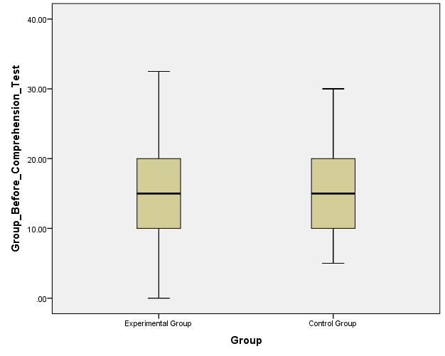

FIGURE 2: Comparison between Experimental Group and Control Group
During Pre-Test of Comprehension Test Session

Based on (FIGURE 2), that experimental group and control group possess the same strategy during pre-test. This is the comparison between experimental group and control group during pre-test of comprehension test session. This indicates that the both groups have the same ability when answering Arabic Comprehension Test.
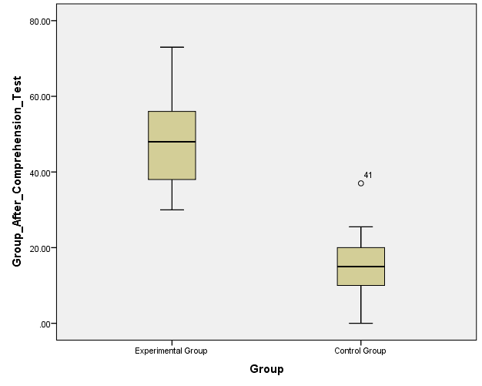

FIGURE 3: Comparison between Experimental Group and Control Group
During Post-Test of Comprehension Test Session

Based on (FIGURE 3) indicates the difference of both of the groups. Even at the first place (FIGURE 2) indicates that these two groups possess the same strategy and the same ability in answering Arabic Comprehension Test. In the box-plot of experimental group appears up higher than control group due to the exposure of metacognitive strategy. In the meantime, the small circle which is indicates 41 is the outlier.

TABLE 1: Levene's Test of Equality of Error Variances for Comprehension Test
F | df1 | df2 | Sig.
2.855 | 1 | 58 | .096
Tests the null hypothesis that the error variance of the dependent variable is equal across groups.

TABLE 2: ANCOVA Test of Experimental Group and Controlled Group for Comprehension Test
GROUP | MEAN | STD. DEVIATION | N
1 Experimental Group | 48.5000 | 11.19960 | 30
2 Controlled Group | 13.8000 | 8.38266 | 30
Total | 31.1500 | 20.05782 | 60

After Post-Test of Comprehension Test had been done, using ANCOVA Test based on (Table 1) and (Table 2), a descriptive statistical result indicates significant difference that the mean value of the metacognitive strategy for group 1 Experimental Group, is 48.5 which is 30 respondents overcome the group 2 Controlled Group, 13.8. Levine's Test of Equality of Errors Variances [F (1, 58) = 2.855, p > .05] is insignificant. The data of this study complies with the ANCOVA test requirements as suggested by (Chua Yan Piaw, 2014).
Refer to the table in "Test of between Subjects Effects" in the first column of "source", see the "group" independent variable line, note that the "Sig" column in line with the “group”, researchers can see the value of .000 (p <.001) which is obtained less than .05, this means there is a significant difference. This analysis shows that there is a significant difference in the Arabic Comprehension post-test score between the experimental group and the control group after the covariate (pre-test score) of the Arabic Comprehension test.

TABLE 3: Test of Between- Subjects Effects
Dependent Variable: Post-test
Source | Type III Sum of Squares | Df | Mean Square | F | Sig. | Partial Eta Squared
Corrected Model | 18246.841 | 2 | 9123.421 | 94.727 | .000 | .769
Intercept | 9001.785 | 1 | 9001.785 | 93.464 | .000 | .621
Pre-test Comprehension | 185.491 | 1 | 185.491 | 1.926 | .171 | .033
Group | 18224.011 | 1 | 18224.011 | 189.218 | .000 | .768
Error | 5489.809 | 57 | 96.312
Total | 81956.000 | 60
Corrected Total | 23736.650 | 59
a. R Squared = .769 (Adjusted R Squared = .761)

Based on (TABLE 3), after controlling the test scores statistical analysis indicates that there are significant differences in the Arabic-language comprehension post-test score between experimental groups and control groups, F (1, 57) = 189.21, p = .001, eta squared = .76. The analysis shows that (r = .03) there is a very weak correlation and it is not significant between the pre-test score of Arabic comprehension before the intervention with post-test Arabic comprehension score after the intervention.
However, if we see the (TABLE 3), labelled as; "Test of between Subjects Effects". This method allows the researchers more detail about the significant differences between the independent variables i.e. the experimental group and the control group.
Refer to the table in "Test of between Subjects Effects" in the first column of "source", see the "group" independent variable line, note that the "Sig" column in line with the “group”, researchers can see the value of .000 (p <.001) which is obtained less than .05, this means there is a significant difference.
This analysis shows that there is a significant difference in the Arabic Comprehension post-test score between the experimental group and the control group after the covariate (pre-test score) of the Arabic Comprehension test.

SIGNIFICANT DIFFERENCE IN PRE-TEST AND POST-TEST FOR CONTROLLED GROUP AND
EXPERIMENTAL GROUP IN THE ARABIC VOCABULARY TEST
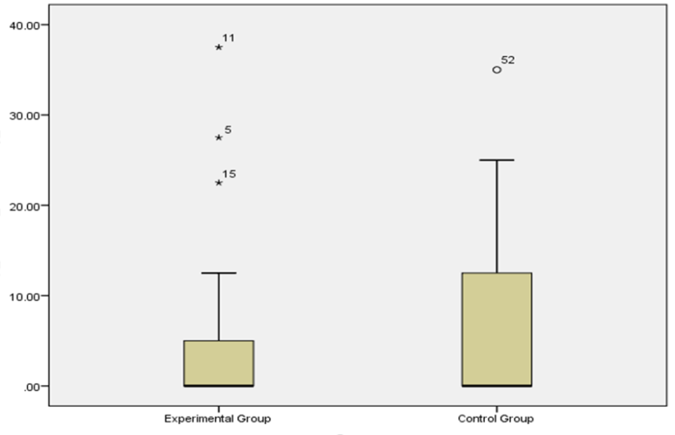

FIGURE 4: Comparison between Experimental Group and Control Group
During Pre-Test of Vocabulary Test Session

Based on (FIGURE 4), the box-plot shows that the distribution of the data set and the comparison between experimental group and control group. However, the experimental group appears lower than the control group. In the meantime, there are outliers for both of experimental group 11, 5 and 15 and control group 52.

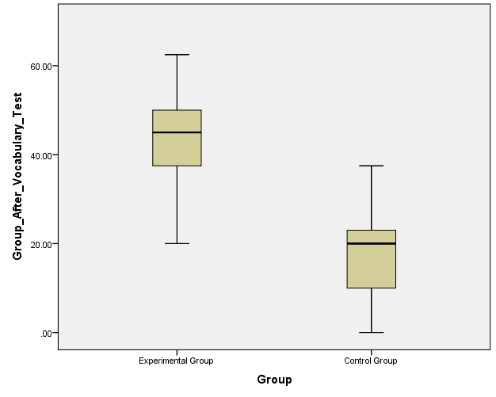

FIGURE 5: Comparison between Experimental Group and Control Group
During Post-Test of Vocabulary Test Session

There are comparison occurs between experimental group and control group during post-test of vocabulary test session based on (FIGURE 5). The result changes whereas the experimental group appears up higher than control group. This occurs because of the strategy of metacognitive in reading that had been used by the respondents. This post-test result of experimental group (FIGURE 5) contrast with the experimental group in the pre- test (FIGURE 4), where the comparison is obviously appears when experimental group during post- test boosts higher than the pre- test.
TABLE 4: Levene's Test of Equality of Error Variances for Vocabulary Test

F | df1 | df2 | Sig.
.076 | 1 | 58 | .784
Tests the null hypothesis that the error variance of the dependent variable is equal across groups.

TABLE 5: ANCOVA Test of Experimental Group and Controlled Group
GROUP | MEAN | STD. DEVIATION | N
1 Experimental Group | 44.4000 | 10.28591 | 30
2 Controlled Group | 17.4833 | 9.09479 | 30
Total | 30.9417 | 16.63901 | 60

Based on (TABLE 4) and (TABLE 5) using ANCOVA Test to computed Vocabulary Test, a descriptive statistical result indicates significant difference that the mean value of the metacognitive strategy for group 1 Experimental Group, is 44.4 which is n=30 overcome the group 2 Controlled Group n=30, 17.4. Levine's Test of Equality of Errors Variances [F (1, 58) = .076, p > .05] is insignificant. The data of this study complies with the ANCOVA test requirements.

TABLE 6: Test of Between- Subjects Effects for Arabic Vocabulary Test
Dependent Variable: Post-test
Source | Type III Sum of Squares | Df | Mean Square | F | Sig. | Partial Eta Squared
Corrected Model | 11165.712ª | 2 | 5582.856 | 61.566 | .000 | .684
Intercept | 44029.809 | 1 | 44029.809 | 485.545 | .000 | .895
Pre-test Vocabulary | 298.108 | 1 | 298.108 | 3.287 | .075 | .055
Group | 10374.806 | 1 | 10374.806 | 114.410 | .000 | .667
Error | 5168.834 | 57 | 90.681
Total | 73777.750 | 60
Corrected Total | 16334.546 | 59
a. R Squared = .684 (Adjusted R Squared = .672)

Based on (TABLE 6) a one-way ANCOVA analysis is conducted to compare the effectiveness of Metacognitive Strategy in text reading that focuses on Arabic vocabulary between experimental groups and control groups. An independent variable is a group of experiment and control group. Pre-test scores are covarized and measured before all groups receive intervention or on-going training. The ANCOVA test assumptions have been carried out first to ensure that it does not violate the assumption of normality, linearity, homogeneity of variances and reliable measurement of the covariate. Therefore, after controlling the test scores, statistical analysis showed that there were significant differences in the Arabic-language vocabulary post-test score between experimental group and control group, F (1, 57) = 114.41, p = .001, eta squared = .76. The analysis showed the correlation was consider weak (r = .05) while the correlation indicates insignificant between the pre-test score of Arabic vocabulary before the intervention with post-test Arabic comprehension and the score after the intervention.
For Arabic comprehension test and vocabulary test, the both are quasi- experimental studies need to compute using ANCOVA test. Through this analysis, the effect of covariate (pre and external variables) on statistical treatment can be controlled during this analysis conducted. Therefore, bias (biased) on the results or test results can be reduced.
In Arabic comprehension test, based on (TABLE 3) the data obtained which is the mean score for the experimental group is 48.61 higher than the control group mean which 13.68. The mean score is difference significantly which is very high at 34.93. Based on the "eta squared” (.033) is only by 3.3 per cent (.033 x 100) variance of the dependent variable (score post) Arabic Comprehension Test, which can be explained by the variable covariate (pre score) of Arabic Comprehension Test. This finding answered research question 1.
Meanwhile, based on (TABLE 6) for Arabic vocabulary test, the mean score for the experimental group is 44.16 higher than the control group mean which 17.71. The mean score is difference significantly which is very high at 26.45. In view of the " eta squared” (.667) is just by 66.7 per cent (.667 x 100) change of the needy variable (score post) Arabic vocabulary test, which can be clarified by the variable covariate (pre score) in Arabic vocabulary test. This finding answered research question 2.
These two analysis are equivalent to study than done by Chayada (2006), Adil Bentahar (2012), Nur Aisyah & Zamri (2014) and Yen-Hui Wang (2015) which proven that MCS can boost students’ ability after reading, training and learning language.

DISCUSSION, FUTURE RESEARCH AND CONCLUSION

The purpose of this study is to determine the status of students in using MCS at SMK Agama in Seremban in the context of reading Arabic text. This study also investigates to what extent they use the planning strategy, monitoring strategy and evaluation strategy. This study is also based on certain variables, such as independent variables comprising intervention groups and control groups, dependent variables i.e. understanding test scores and vocabulary test scores and covariant variables i.e. pre-comprehension test scores and pre-test vocabulary scores.
Given the present and previous research, at least two avenues of future research are pertinent. First, for the sake of the future research, hopefully, researchers need to explore the use of MCS to the students regarding how they read Arabic text. This study focused on the district of Seremban, Negeri Sembilan. This leaves several important questions unanswered. For example, do students of SMK Agama in Negeri Sembilan use MCS in reading Arabic text? To what extent do they use this strategy? These questions still remained unanswered because the study needs to be expanded to the level of the state which is Negeri Sembilan. Finally, this study was addressed the complete benefits of MCS in reading Arabic text such as; comprehension and vocabulary. In other hand, this study needs to proceed to other MCS in reading Arabic text due to rectify for the sake of human kind to gain strategy in reading Arabic text.

REFERENCES

Adil Bentahar. (2012). Can ESL teachers teach reading metacognitive strategies? Master of Arts in Education, Curriculum and Instruction. Boise State University. Retrieved from:
Ary, D., Jacobs, L. C., Razavieh, A., & Sorensen, C. (2006). Introduction to research in education (7th ed.). Belmont, CA: Thomson Wadsworth.
Anna Uhl Chamot, Ph.D. Jill Robbins, Ph.D & Aileen Watts. (2005). CALLA REVISTED: More Strategies for ELL Student Success Workshop for Region 10. New York City Board of Education New York, NY
Brown, A. (1987). Metacognition, executive control, self-regulation, and other more mysterious mechanisms. In F. E. Weinert & R. H. Kluwe, (Eds.) Metacognition, motivation, and understanding (pp. 65-116). Hillsdale, NJ: Lawrence Erlbaum.
Chamot, A.U., Barnhardt, S., El-Dinary, P.B., & Robbins, J. (1999).
The learning strategies handbook. White Plains, NY: Addison Wesley Longman.
Chamot, A.U., Keatley, C., Barnhardt, S., El-Dinary, P.B., Nagano, K., & Newman, C.
(1996). Learning strategies in elementary language immersion programs.
Final report submitted to Center for International Education, U.S.
Department of Education. Available from ERIC Clearinghouse on Languages and Linguistics.
Chayada Danuwong. (2006). The role of metacognitive strategies in promoting learning English as a foreign language independently. Phd Thesis. Edith Cowan University.
Chua Lee Chuan. (2006). Jurnal Penyelidikan IPBL, Jilid 7, 2006. Retrieved from:
https://www.academia.edu/8303970/SAMPLE_SIZE_ESTIMATION_USING_KREJCIE_AND_
MORGAN_AND_COHEN_STATISTICAL_POWER_ANALYSIS_A_COMPARISON
Chua Yan Piaw. (2014). Kaedah dan statistic penyelidikan: Ujian univariat dan multivariat.
McGraw-Hill Education. Malaysia
Dakin, Caitlin. (2013). "The effects of comprehension through close reading". Education
http://scholarworks.boisestate.edu/cgi/viewcontent.cgi?article=1259&context=td
Masters. Paper 237.
Flavell, J. H. (1976). Metacognitive aspects of problem solving In Resnick, L. B.,The Nature
of Intelligence, 12, 231-235. Lawrence Erlbaum Associates.
Flavell, J.H., Miller, P.H., & Miller, S.A. (1993). Cognitive development. Englewood Cliffs,
NJ: Prentice Hall.
Harison Mohd Sidek. (2008). Second Language Reading: Problem, Diagnosis & Instruction. Universiti Sains Islam Malaysia. Malaysia
Leslie, L. & Caldwell, J. (2004). Qualitative reading inventory-4. Boston: Pearson Education
Company
Leslie, L. & Caldwell, J. (2006). Qualitative reading inventory-4. Boston: Pearson Education
Company
Mat Nawi Mat Jusoh, Mohd Ridwan Hj Abd Rashid, Mod Zaini Sijo. (2013). Al-Lughah al-arabiah lissanah ar-rabiah. Bahasa Arab Tingkatan 4. Percetakan Suria Sendirian Berhad. Bukit Katil. Melaka. Malaysia
Mohsen Mahdavi and Majid Mehrabi (2014). Metacognitive Awareness of Reading Strategies among Iranian EFL Learners in an “Input-poor” Environment. International Journal of Innovation and Applied Studies ISSN 2028-9324 Vol. 5 No. 4 Apr. 2014. (pp. 360-366)
Mokhtari, K., & Reichard, C. (2002). Assessing students’ metacognitive awareness of reading
strategies. Journal of Educational Psychology, 94(2) (pp.249-259).
Nur Aisyah Mohamad & Zamri Mahamod. (2014). Tahap kemahiran metakognitif murid
Pelajar Tingkatan 4. Phd Thesis. Universiti Kebangsaan Malaysia, Bangi.
Pallant, J. (2001). s p s s s u r v i v a l m a n u a l a step by step guide to data analysis
using spss for windows (version 10)
Rosni Samah. (2009). Isu Pembelajaran Bahasa Arab Di Malaysia. Persidangan Kebangsaan Pengajaran Dan Pembelajaran Bahasa Arab 2012 (PKEBAR’12).Universiti Sains Islam Malaysia.
Saemah Rahman. (2001). Hubungan Antara Metakognisi, Motivasi Dan Pencapaian Akademik
Pelajar Universiti. Phd Thesis. Universiti Malaya. Malaysia
Sahlan Surat. 2012. Keberkesanan Strategi 4-Meta dalam Aktiviti Penulisan Bahasa Melayu
strategies. Journal of Educational Psychology, 94(2) (pp.249-259).
tingkatan empat dalam pembelajaran Bahasa Melayu. Jurnal Pendidikan Bahasa Melayu – JPBM (Malay Language Education Journal – MyLEJ). ISSN: 2180-4842. Vol. 4, Bil. 1 (Mei 2014). (pp. 41-47).
Shafee Abdul Hamid. (2012). Amalan metakognitif dalam kalangan murid ketika belajar
komponen sastera. Project Paper. M.Ed Universiti Kebangsaan Malaysia, Bangi.
Tobias, S. and Everson, H. T. (1996). Assessing Metacognitive Knowledge Monitoring. College Board Report No.96-01. New York: The College Board. Retrieved from: http://professionals.collegeboard.com/profdownload/pdf/RR%2096-1.PDF
Tobias, S. and Everson, H. T. (2002). Knowing What You Know and What You Don’t: Further Research on Metacognitive Knowledge Monitoring (Research Report No.2002-3). New York: The College Board.
Yahya Othman,Dayang Raini Pakar, (2013) Keberkesanan strategi metakognisi dalam pengajaran bacaan dan kefahaman menggunakan teks ekspositori. GEMA: Online Journal of Language Studies, 13 (3). pp. 133-149. ISSN 1675-8021http://ro.ecu.edu.au/cgi/viewcontent.cgi?article=1059&context=theses
Yen-Hui Wang. (2015). Metacognition in reading: EFL Learners’ metacognitive awareness of reading strategy use. International Journal of English Language and Literature Studies

Corresponding authors:
PROF MADYA DR. MAIMUN AQSHA LUBIS
Universiti Kebangsaan Malaysia, Bangi, Malaysia
mal@ukm.edu.my

HJ. MOHD SHAM KAMIS
Kementerian Pendidikan Malaysia
mohdsham856@gmail.com

