EXAMINE VARIABLES=Beliefs
/PLOT BOXPLOT STEMLEAF HISTOGRAM NPPLOT
/COMPARE GROUPS
/STATISTICS DESCRIPTIVES EXTREME
/CINTERVAL 95
/MISSING LISTWISE
/NOTOTAL.

Explore

Notes
Output Created |  | 09-FEB-2018 16:13:01
Comments
Input | Active Dataset | DataSet0
Input | Filter | <none>
Input | Weight | <none>
Input | Split File | <none>
Input | N of Rows in Working Data File | 76
Missing Value Handling | Definition of Missing | User-defined missing values for dependent variables are treated as missing.
Missing Value Handling | Cases Used | Statistics are based on cases with no missing values for any dependent variable or factor used.
Syntax |  | EXAMINE VARIABLES=Beliefs  /PLOT BOXPLOT STEMLEAF HISTOGRAM NPPLOT  /COMPARE GROUPS  /STATISTICS DESCRIPTIVES EXTREME  /CINTERVAL 95  /MISSING LISTWISE  /NOTOTAL.
Resources | Processor Time | 00:00:03,15
Resources | Elapsed Time | 00:00:03,17

Case Processing Summary
 | Cases
 | Valid |  | Missing |  | Total
 | N | Percent | N | Percent | N | Percent
Beliefs | 76 | 100,0% | 0 | 0,0% | 76 | 100,0%

Descriptives
 |  |  | Statistic | Std. Error
Beliefs | Mean |  | 71,3421 | ,49685
Beliefs | 95% Confidence Interval for Mean | Lower Bound | 70,3523
Beliefs | 95% Confidence Interval for Mean | Upper Bound | 72,3319
Beliefs | 5% Trimmed Mean |  | 71,4649
Beliefs | Median |  | 71,5000
Beliefs | Variance |  | 18,761
Beliefs | Std. Deviation |  | 4,33144
Beliefs | Minimum |  | 60,00
Beliefs | Maximum |  | 80,00
Beliefs | Range |  | 20,00
Beliefs | Interquartile Range |  | 6,75
Beliefs | Skewness |  | -,373 | ,276
Beliefs | Kurtosis |  | -,073 | ,545

Extreme Values
 |  |  | Case Number | Value
Beliefs | Highest | 1 | 17 | 80,00
Beliefs | Highest | 2 | 39 | 80,00
Beliefs | Highest | 3 | 9 | 78,00
Beliefs | Highest | 4 | 26 | 78,00
Beliefs | Highest | 5 | 30 | 78,00
Beliefs | Lowest | 1 | 6 | 60,00
Beliefs | Lowest | 2 | 21 | 61,00
Beliefs | Lowest | 3 | 12 | 62,00
Beliefs | Lowest | 4 | 54 | 63,00
Beliefs | Lowest | 5 | 23 | 64,00

Tests of Normality
 | Kolmogorov-Smirnovª |  |  | Shapiro-Wilk
 | Statistic | df | Sig. | Statistic | df | Sig.
Beliefs | ,096 | 76 | ,077 | ,981 | 76 | ,316

a. Lilliefors Significance Correction

Beliefs

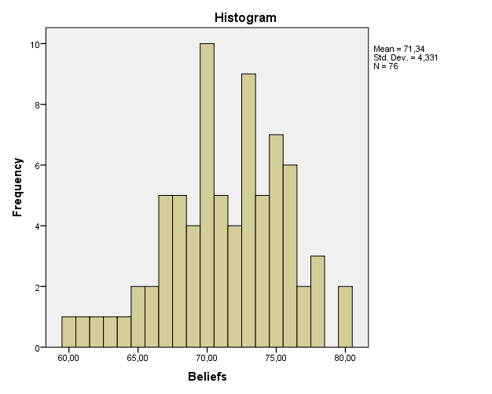

Beliefs Stem-and-Leaf Plot

Frequency Stem & Leaf

5,00 6 . 01234
18,00 6 . 556677777888889999
33,00 7 . 000000000011111222233333333344444
18,00 7 . 555555566666677888
2,00 8 . 00

Stem width: 10,00
Each leaf: 1 case(s)

