APPENDICES

Appendix A

Social Media Memes


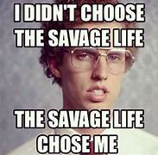
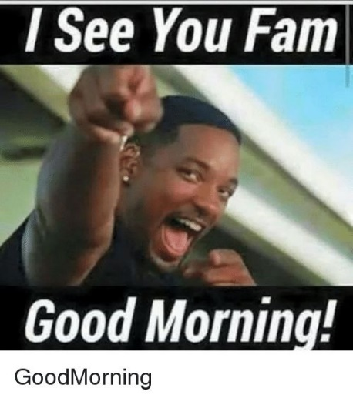
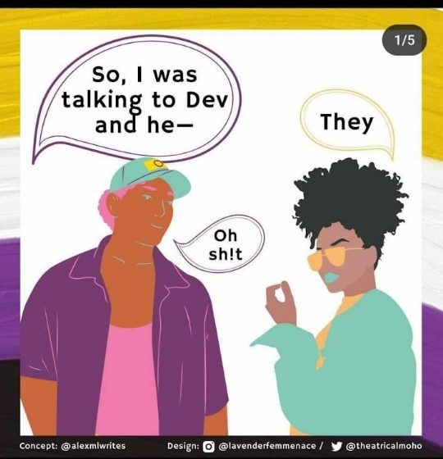
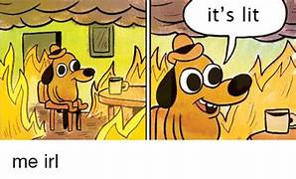
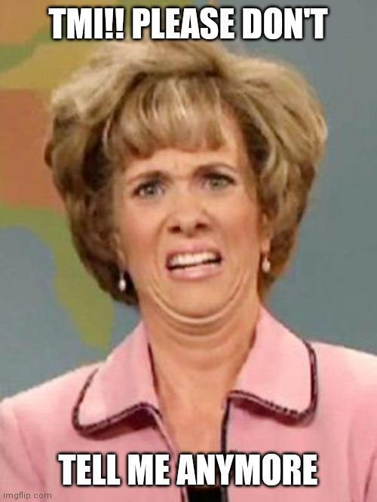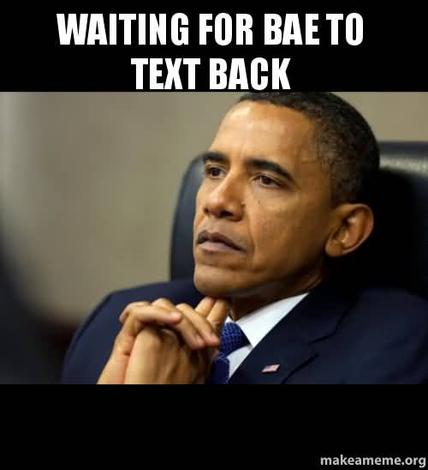

Appendix B
Interview Questions

Introductory Questions:
Researcher asks general questions at the start of the interview.
- Describe your experience with social media and exposure to memes that use Gen Z slang?
Sub guide questions:
- Are there any particular social media platforms where you encounter these memes more often?
- What kind of content do you typically come across on your social media feeds?
- Are there any specific memes that have made a strong impression on you? If so, what was it about those memes that stood out?
- How familiar are you with Gen Z slang, and can you provide some examples?
- When you encounter Gen Z slang in memes, do you generally understand the meanings, or are there some that you find confusing?

To Address Research Question 1:
What are the participants' perceptions on social media memes featuring Gen Z slang?
Interview Guide Questions:
Researchers present slides that show different kinds of memes.
Show each meme to the participant and they are given time to look at it. For each meme presented, ask the following questions:
- Have you seen these memes online?
- Describe what you see in the image.
- Look at the text or message in the meme, what do you think it means, especially with regards to Gen Z slang?
- Are there any specific words or phrases in the meme that you find interesting or noteworthy?
- What are your immediate thoughts and feelings when you see this meme? How does it make you feel, and why?
- Do you think this meme is humorous, relatable, confusing, or something else? Can you explain?
- Does this meme remind you of any personal experiences or stories related to its content
- or the use of Gen Z slang in memes?
- Have you used or shared this meme before? If not, are you willing to use it? Can you explain your answer?
These sets of questions will be repeated for each meme.

To Address Research Question 2:
What variations exist on how teachers and students interpret Gen Z slang in memes?

Questions for Teachers:
- Have you ever encountered situations where you don’t understand the slang in memes used by the students? Provide some examples or situations.
Sub Questions:
- How did you interpret the memes at first?
- Do you notice any differences in how you and your students understand Gen Z slang in memes?
- How do you adapt your teaching style or communication when you encounter this kind of slang in educational settings?
- In your opinion, how does your understanding of Gen Z slang influence your approach to teaching and communicating with students?
Sub questions:
- Are you willing to use memes as a teaching strategy tool?
- Are you willing to use Gen Z slang as a way of communicating with students?
- If yes, what are the challenges or benefits in adapting your teaching approach to match students’ use of Gen Z slang?
- Do you think that a better understanding of Gen Z slang helps you connect with students both academically and socially?
- Do memes with Gen Z slang help bring different generations closer together or make the gap between them wider, especially when it comes to education?
- To fully utilize Gen Z slang in memes, what advice can you give to improve communication among generations particularly in educational settings?

Questions for Students:
- How often do you use Gen Z slang in memes in your conversations? Can you provide examples?
- Have you encountered situations of misinterpretation using Gen Z slang in a teacher-student conversation?
- What are some examples of situations where you and your friends have used Gen Z slang at school or with teachers?
- Do memes with Gen Z slang help bring different generations closer together or make the gap between them wider, especially when it comes to education?
- To fully utilize Gen Z slang in memes, what advice can you give to improve communication among generations particularly in educational settings?

Appendix C
Validity Test

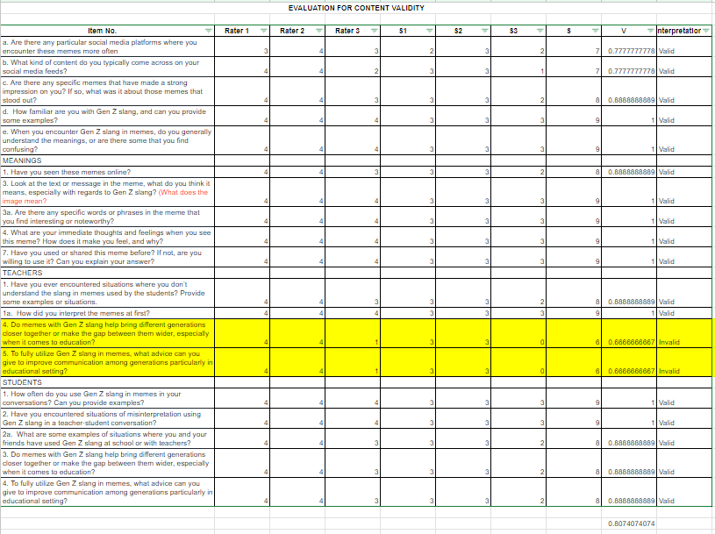

Appendix D
Recordings and Transcriptions

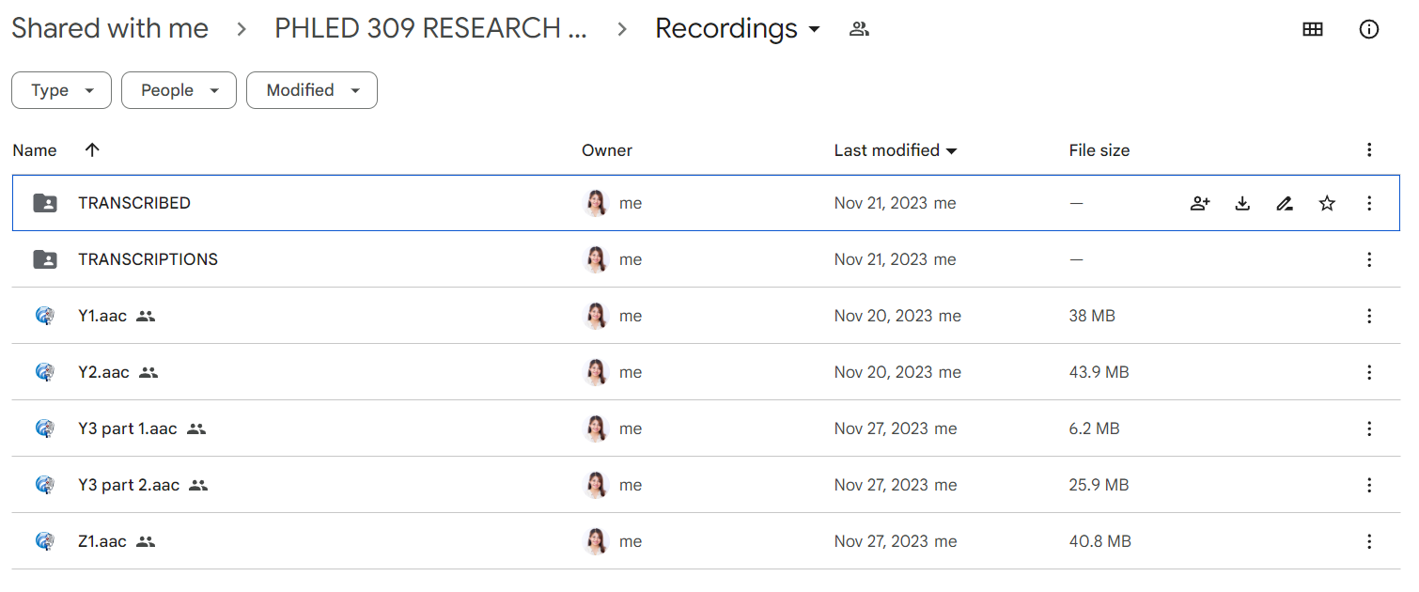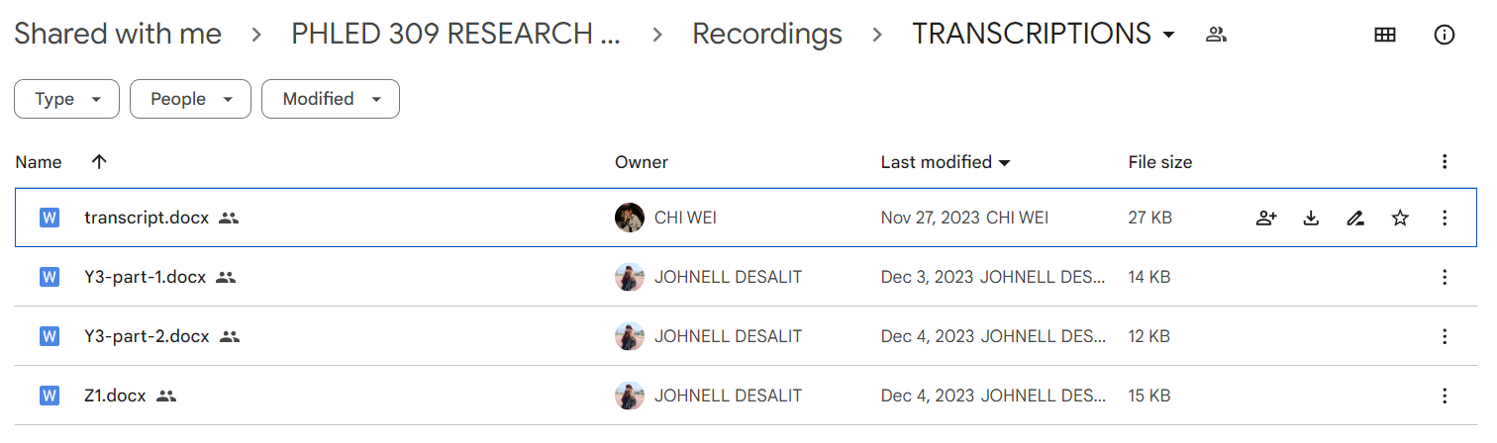

Appendix E
Google Forms and Transcriptions
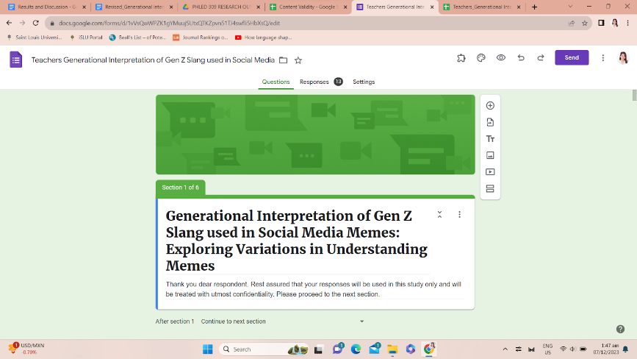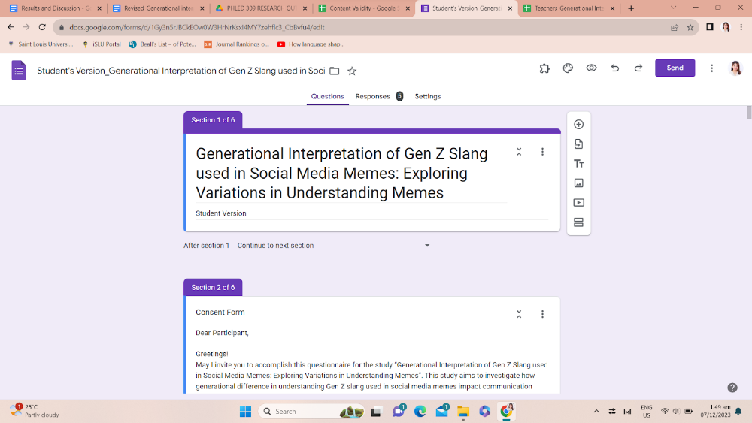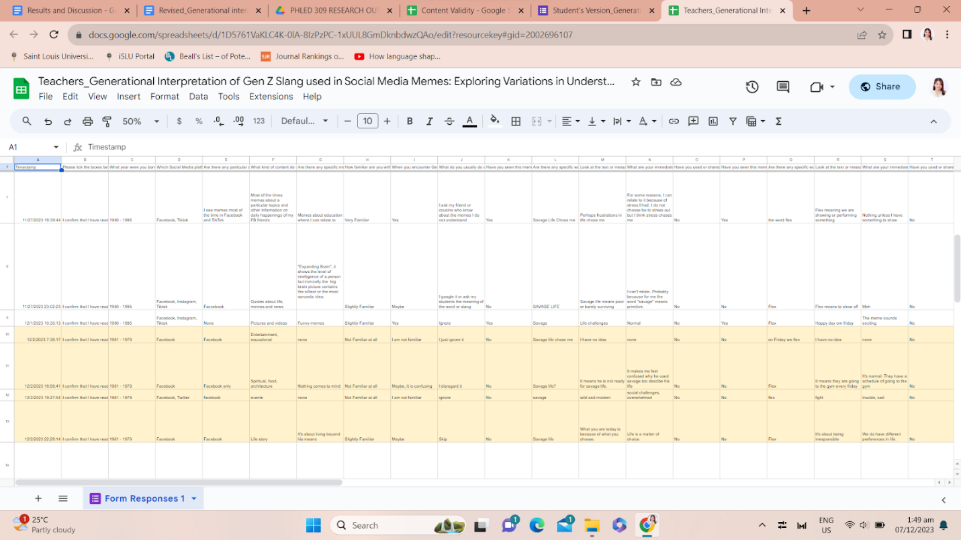

Appendix F
Consent Forms
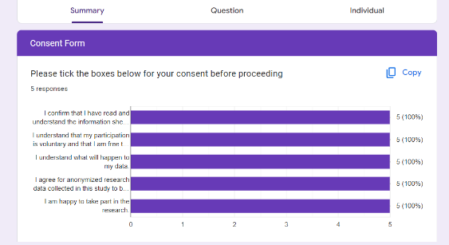
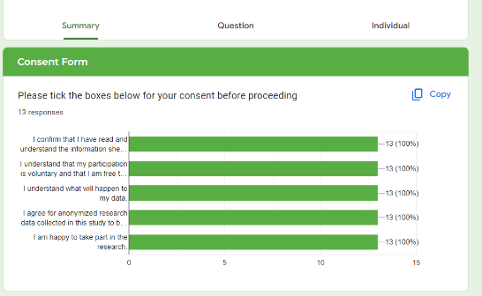
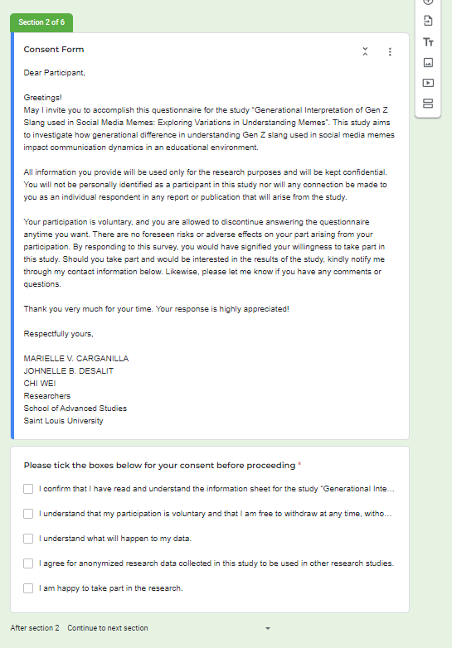

Appendix G
Sample Content Validator Letter 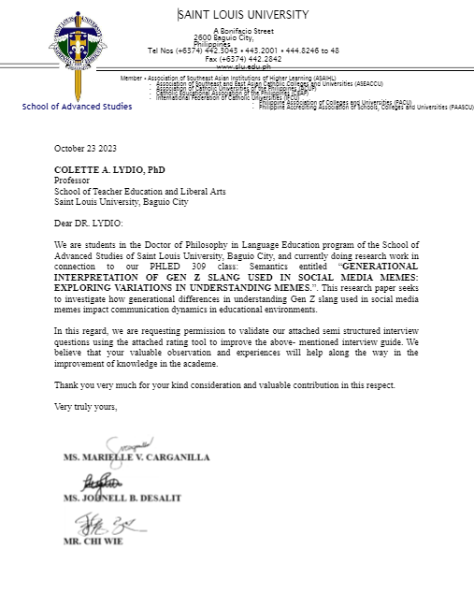

2

