APPENDIX A
Table outlining lexical choices challenging hegemonic constructs in The King's Speech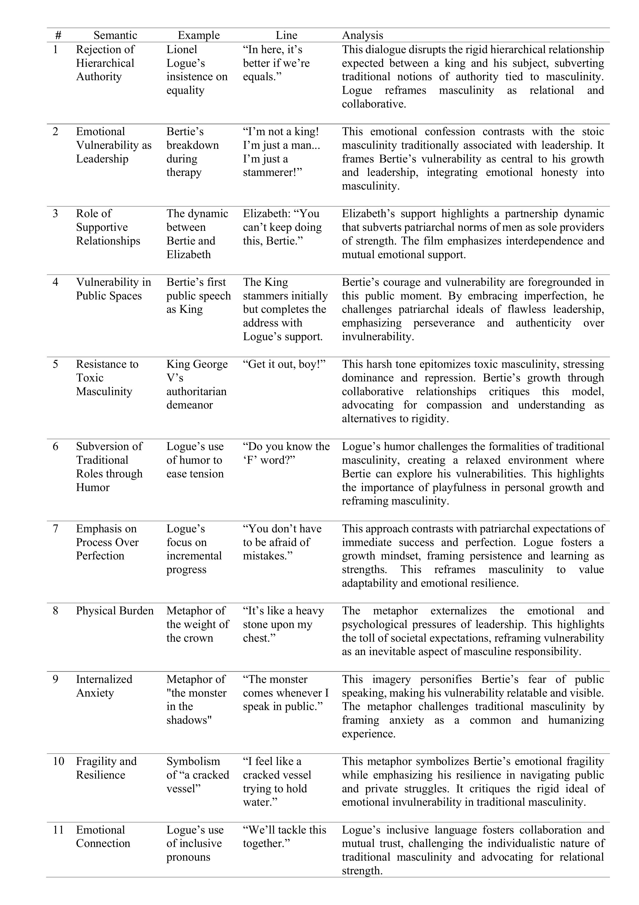

APPENDIX B
Table outlining metaphors constructing emotional and psychological representations of masculinity in The King's Speech
