Visualising the themes of Business Intelligence & Analytics in Accounting studies over 20 years

Abstract
The purpose of this paper is to provide an overview of the developments in Business Intelligence and Analytics (BI&A) research trends, in the area of accounting studies. The review includes an assessment of the thematic evolution of BI&A over 20 years. Published articles that combine the keywords BI&A, Accounting, and Audit were searched from the Web of Science (WoS) database. Biblioshiny from the Bibliometrix R Package was utilized to analyse 320 articles published between years 2002 and 2022. The review indicates that articles with BI&A themes have grown gradually within those 20 years. Nevertheless, there is sharp increase in numbers of articles published in 2021, with linear trend line predicting growth at the end of year 2023. Publications for these articles were mostly from the USA, covering almost half of the publications for the past two decades. Notably, the BI&A article that received highest citations is an article written in year 2020 with a focus on managerial accounting. Only the WoS database was used to investigate BI&A from multiple angles in accounting studies. Future investigation could investigate relevant publications available in other reputable databases. This paper adds to the knowledge as this is one of the first attempts to decipher the research streams that, through time, have prepared the way for the junction of Big Data analytics and management domains.

Keywords: Bibliometric analysis; Business intelligence and analytics; Business analytics; Data analytics; Accounting

INTRODUCTION
Recent development in accounting field has seen tremendous innovation, especially with the support of advanced business intelligence and analytics (BI&A). New strategic business opportunities can be found by analysing vast amounts of structured, semi-structured and unstructured data with the help of business intelligence and analytics (BI&A) technology (Chen & Lin 2021). BI&A implements core operational factors such as pricing and process improvement as well as fraud detection and differential analysis and production placement, blending external data with internal data in order to get the most out of business intelligence (Eggert & Alberts 2020).
A timely informed decision is crucial for firms to sustain in today’s current impulsive business environment. Should managers able to reap the full benefit of BI&A technology, the deployment of algorithms to evaluate large datasets, would elevate managers’ ability to draw out insights from the accounting data that is may not be previously obvious to them. The BI&A technologies have been connected with the emergence of industry revolution 4.0 (IR4.0) along with Internet of Things (IoT), Mobile and Augmented reality, additive manufacturing and 3D printing, cloud computing and cybersecurity (Santos et al. 2017). BI&A has been routinely regarded as one of the most important agenda topics by senior executives (Paradza & Daramola 2021). Nevertheless, Bentley (2017) claims that more than 35% of the top 5,000 global companies regularly fail to make insightful decisions about significant changes in their business and markets due to a lack of information, processes, and tools.

It was obvious that the documentation of research on how BI&A techniques impacted the practice is lagging behind. Many researchers have focused on enhancing and augmenting BI&A procedures and algorithms, yet, how these techniques and algorithms can impact accounting practices has not been systematically studied (Appelbaum, Kogan, Vasarhelyi, et al. 2017; Peters et al. 2016; Rikhardsson & Yigitbasioglu 2018; Schneider et al. 2015). While it is acknowledged that BI&A activity is important to enterprises in order to obtain a long-term sustainable competitive advantage, it would be meaningless without further elaboration on the subject from an accommodating perspective (Chen et al. 2012; Chen & Lin 2021; Schneider et al. 2015). Several organisations are currently employing BI&A-related solutions to optimise their business process, while the academic research related to accounting fields has thrived (Youssef & Mahama 2021). The study of BI&A in accounting is evolving without a solid theoretical foundation. With the development in practice, it is highly timely that scholars improve their understanding of how BI&A techniques are assimilated within business processes, and this goal may be better guided if the facets of the research on the technicality behind BI&A are connected.

In an attempt to pave the way for the intersection between data analytics and accounting fields, this study will examine the literature connecting BI&A and accounting domains. The primary aim is to provide a systematic overview of the development of BI & A research trends, specifically in the area of accounting studies. Accordingly, the current research will conduct a bibliometric analysis and review of articles in order to answer mainly, “How has the theme of BI&A evolved within the accounting literature over the past two decades?” Specifically, the search seeks to examine the trends and growth of the BI & A literature within the accounting domain, the major contributors in the area, namely the authors and their networks, and the country where the articles originate, using bibliometric tools.

This research lays the groundwork for uncovering new areas of study by recognizing the researchers who have published on themes that are now trending. Over a thousand published studies have been reviewed in this paper from multiple categories to provide research clusters, such as those based on citation analyses. Using these clusters as a starting point, we were able to categorize the published models and investigate how these clusters evolved. As a result of these findings, new information about current research priorities and potential future avenues in research is revealed.

The remainder of this paper is organized as follows. Section 2 reviews relevant literature to discover established and emerging themes. Next, the literature search strategy of the bibliometric analysis was described under the methodology section. Section 4 reports the results of the bibliometric analysis, which are the descriptive analysis and network analysis. Section 5 discusses the insights from the analysis and provides the underlying research streams identified using R Studio. Section 6 concludes the findings, identifies the limitations, and suggests areas for future studies.

LITERATURE REVIEW
The literature is lacking on the consensus over specific definition of analytics and how it varies from similar topics. The most frequently cited definition comes from Davenport and Harris (2007, p.7) where data analytics is seen as “the extensive use of data, statistical and quantitative analysis, explanatory and predictive models, and-fact based management to drive decisions and actions. The analytics may input human decisions or may drive fully automated decisions. Analytics are a sub-set of business intelligence.”. The perspective that analytics is a subset of business intelligence (BI) is supported by some studies (see for example, Bartlett 2013) that argue that Business Intelligence equals Business Analytics plus Information Technology. In sum, many studies regard business intelligence and data analytics to be a composite and refer to it with the name "BI&A" (Chen et al. 2012; Chen et al. 2012; Lim et al. 2013). The implication that can be drawn from their work is that the first part of the acronym relates to the technologies that process and alter data, and that the second part refers to its analysis. From a more cynical point of view, the distinction between the two is fundamentally irrelevant, and the debate of "analytics" is essentially an attempt to revitalise interest in the already established discipline of business intelligence (BI) (Mortenson et al. 2015).

This paper regard BI&A as a composite in which both work simultaneously and complementarily process structured, semi-structured and unstructured data to meet business needs. Accordingly, BI&A is an "umbrella term" because it encapsulates a broad range of tools and methodologies that enable organisations to collect data from internal and external sources, prepare it for analysis, develop and run queries against the data, and create reports, dashboards, and visualisations for end users. Accordingly, this study adopts the definition by Chen et al. (2012), recognizing, emerging fields in analytics such as mobile and sensor-based content analytics and, more generally, big data (Chen et al., 2012).

It is contended that the influence of the industry revolution 4.0 (IR 4.0) had on businesses has resulted in an increasing interest on BI&A (Santos et al. 2017). The key technological advancements that have been applied to manufacturing processes in the areas of automation, control, and information technologies are a part of what is known as IR4.0 era (Hermann et al. 2015). The fundamental concept of IR4.0 is based on the idea that businesses are able to build intelligent grids all along the value chain by connecting their machines, technologies, and assets together. These smart grids can then control the production processes on their own. Within the scope of IR4.0, businesses will have the ability and autonomy to schedule maintenance, foresee breakdowns, and adapt themselves to new demands and unplanned changes in the manufacturing processes (Jazdi 2014). BI&A are essential components of IR4.0 because they are used to manage the data that is produced by a variety of sources, including machine controls, sensors, manufacturing systems, daily customer activities, etc. It deals with a massive amount of data that is entering at a rapid pace and in a variety of formats. The analysis of large amounts of data in order to discover valuable insights, patterns, or models is the essential component of an IR4.0 corporate’s capacity for sustained innovation (Lee et al. 2014). Several prior studies compared the IR4.0 with IR3.0, and it was argued that IR3.0 depends on less amount of data, and allows more human intervention (Lau et al. 2019; Torn & Vaneker 2019). The comparison is summarised in the following table:

Features | IR3.0 | IR4.0
Concept | Operational decision and automation | Self-flexible, self-adaptable, and self-learning, smart intelligence and decentralised analytics
Production | Mass production | Mass customisation and personalisation
Production planning | Demand forecasting | On-demand production
Quality control | Statistical process control | Self-aware and self-predict
Base for revenue model | Selling products | Servitisation (integrating services into manufacturing)
Alignment | Interconnection of production process | Interconnection of the whole value chain
Table 1: Comparison between IR3.0 and IR4.0

BI&A has been operated by accounting professionals to lead the data-driven decision analysis processes (Appelbaum, Kogan, Vasarhelyi, et al. 2017; Rikhardsson & Yigitbasioglu 2018). It has been found that BI&A improves performance measurement and harnesses management control by integrating diagnostic and interactive dimensions; this augments knowledge competency and enhances the pursuit of competitive advantage (Peters et al 2020). The financial performance drivers can be pinpointed by utilising the structured and unstructured data through the BI&A solutions. The roles of BI&A not only stop with management accounting practices such as budgeting, forecasting, deferential analysis, performance and measurement but includes risk management, forensic accounting, audit and financial analysis. For example, bias and anomalies in financial accounting can be efficiently predicted, and financial performance can be evaluated and forecasted, fraud can be detected, using BI&A (Schneider et al. 2015).

Several studies found that data analytics assist to identify overpayment of taxes for multinational corporations, used in auditing to detect fraud to ensure regulatory compliance or determine effectiveness of controls and discover anomalous transactions or irregular transaction volumes that indicate money laundering (Smith et al. 2019; Schneider et al. 2015; Siegel 2013). Extant literature indicate focuses on different aspects of BI&A in accounting, for example, the role of BI&A to boost management control, performance measurement, and costing strategies (Elbashir et al. 2008, 2021; Peters et al. 2016; Uyar & Kuzey 2016; Youssef & Moustafa 2014), the new skillset that is required from managerial accountants who deals with big data and analytics modelling (Schneider et al. 2015; Spraakman et al. 2020), the role of BI&A in fraud detection, audit, and risk management strategies (Appelbaum et al. 2021; Haq et al. 2020; Holt & Lang 2021; Tang & Karim 2018), insurance claim prediction problems (Manski et al. 2021), role of BI&A in SMEs and business in organisations (Llave 2017; Paradza & Daramola 2021).

Each study has shed light on various aspects of the area; however, subsequent analysis of this literature using rigorous bibliometric approaches has the potential to shed light on aspects that have not been fully comprehended or evaluated up until this point. The emergent research literature has been combed through, and these reviews have uncovered a variety of timely concerns. Although bibliometric analysis of BI&A has been found in the literature, those contributions were conducted in different contexts than accounting research, for instance, decision-making effectiveness in the public sector, big data analytic in business mainly in retail operations, BI&A in manufacturing decision-making, (Vaio et al., 2022;Nobanee et al.,2021; Sahoo 2021; Aboelmaged & Mouakket 2020) the determinants of big data analytics; the last bibliometric study found is (Liang & Liu 2018) which focuses on two core disciplines of Computer Science and management information systems. Accordingly, the current paper review academic literature associated with “Business intelligence and analytics” and “accounting” to explore the development and research trends.

4.0 RESEARCH METHODOLOGY

Biblioshiny, under the Bibliometrix R package, was used for the analysis. Biblioshiny application provides additional data statistics including author, affiliation and keyword statistics. It has the potential to introduce a systematic, translucent and reproducible review process (Derviş 2019). Network analysis was also performed by conducting the citation analysis and topical content-based classification of the existing literature of BI&A in accounting research.

The search strategy and the criteria used to determine inclusions and exclusions of the reviewed literature is presented in Figure 1. First, a search was conducted in the WoS database using a combination of keywords related to Business Intelligence and Analytics (BI&A) and accounting, specifically "Business Intelligence and Analytics" or "business analytics" or "data analytics" or "Business Intelligence" AND "accounting" AND "audit". The search was limited to the "topic" option, which includes article titles, abstracts, and keywords. The WoS database was selected for this search due to its vast collection of over 71 million entries from various publications, including journals, books, and conference proceedings. After filtering the results by language, document type, and research areas, a total of 1906 articles were initially obtained.

Second, two authors reviewed the titles, abstracts, and keywords of the 1906 articles, identifying 320 articles as relevant to BI&A and accounting. Articles from the "Business Finance" category were included in their entirety, while articles from the "management," "economics," and "business" categories were scrutinized, and only the relevant ones were selected with confirmation from two other authors. Duplicates were removed, and missing dates for 12 publications were manually added by comparing with the output of WoS. Finally, the 320 selected articles were used, and their full records were obtained in the "bib" extension format, which includes the article's title, author name(s) and affiliation, journal name, number, volume, pages, date of publication, abstract, and cited references.

Article in Journal from WoS database Web of Science
Title “Business Intelligence and analytics” OR “business analytics” OR “data analytics” OR “Business intelligence” OR “BI&A”AND “accounting” AND “audit”
Keywords & Search String
n = 1906
Record Identified & Screened
Business intelligence and analytics in accounting research
Screening
Included
Topic, Scope & Eligibility
Topic
Scope & Coverage
Record Included for Bibliometric Analysis
n = 1586
Record Removed
n = 320
1st Jan 2023
Date Extracted
Figure 1. Flow of the search strategy

ANALYSIS AND RESULTS
The following sections reports the findings based on bibliometric analysis.

4.1 Descriptive analysis

4.1.1 Background information
The earliest paper discussing business intelligence and analytics in accounting appeared in the WOS database in year 2002. As shown in Table 2 The dataset contains a total of 320 articles that present a time span of 20 years starting from 2002 to 2022. During this duration, articles with the BI&A themes has shown a growth rate of 24.34 percent. The dataset also revealed that 86% of the articles are not single authored, with almost 3 authors per document. The following sections elaborates the background information of the articles examined.

Description | Results
Timespan | 2002:2022
Sources (Journals, Books, etc) | 126
Documents | 320
Annual Growth Rate % | 24.34
Document Average Age | 3.79
Average citations per doc | 10.55
References | 1
DOCUMENT CONTENTS
Keywords Plus (ID) | 583
Author's Keywords (DE) | 1074
AUTHORS
Authors | 673
Authors of single-authored docs | 37
AUTHORS COLLABORATION
Single-authored docs | 44
Co-Authors per Doc | 2.62
International co-authorships % | 25
DOCUMENT TYPES
Article | 275
Article; book chapter | 13
Article early access | 29
Article proceedings paper | 3
Table 2: Background information

4.1.2 Annual publication trends
Visual inspection of the annual publication trends (see Figure 2) indicate that the first published paper related to the research theme was in 2002. In fact, less than 15 academic outputs of the research were published until 2014. The publication in the field of BI&A in accounting research increased gradually to reach its peak in 2022 with total of 93 publications. This growing trend of published BI&A in accounting research probably indicate a growing interest by researchers. Figure 2 also shows the linear trend line that predicts the growth of the publication at the end of 2023.

The annual publication trend was further examined to provide insights into the possibilities of increasing interest in the area. Accordingly, Table 3 displays the number of articles published per year and their corresponding citations. The table also shows the total citation per article and the total citation per year.

Figure 2: Annual publication trend

Year | N | TC/D | TC/Y | Citable Years
2002 | 1 | 3.00 | 0.14 | 21
2003 | 0 | 0.00 | 0.00 | 0
2004 | 0 | 0.00 | 0.00 | 0
2005 | 2 | 33.50 | 1.86 | 18
2006 | 0 | 0.00 | 0.00 | 0
2007 | 0 | 0.00 | 0.00 | 0
2008 | 1 | 20.00 | 1.33 | 15
2009 | 1 | 8.00 | 0.57 | 14
2010 | 1 | 0.00 | 0.00 | 13
2011 | 5 | 34.00 | 2.83 | 12
2012 | 2 | 58.00 | 5.27 | 11
2013 | 6 | 15.67 | 1.57 | 10
2014 | 5 | 28.00 | 3.11 | 9
2015 | 14 | 31.43 | 3.93 | 8
2016 | 12 | 12.08 | 1.73 | 7
2017 | 18 | 24.11 | 4.02 | 6
2018 | 25 | 14.40 | 2.88 | 5
2019 | 30 | 10.20 | 2.55 | 4
2020 | 36 | 23.97 | 7.99 | 3
2021 | 68 | 2.01 | 1.01 | 2
2022 | 93 | 0.78 | 0.78 | 1
Total | 320 | - | - | -
Table 3: Annual publication trend
The number of citations may indicate importance and relevance of the BI&A in the accounting studies. It probably shows an emerging area that deserve further investigation. Compared to other established area in accounting, the number of articles published on the intersection between the BI&A area with accounting domain are considered low. It should be noted however, that this small publication number could be due to the overlapping in the applications of BI&A which are conducted in different management and business disciples such as human resources, marketing, operations, logistics and supply chain; where the articles published in those areas have been excluded from the analysis. Furthermore, BI&A has been covered from a technical orientation perspective, thus, due to specific search keywords for this study, those papers too, have also been excluded.

4.1.2 Most productive authors
Row Labels | TP | TC | TC/Y
SUTTON SG | 11 | 235 | 28.656
ARNOLD V | 7 | 53 | 11.167
VASARHELYI MA | 7 | 150 | 23.666
APPELBAUM D | 4 | 215 | 31.953
KOGAN A | 4 | 245 | 35.536
ELBASHIR MZ | 4 | 180 | 16.237
GEPP A | 4 | 96 | 17
KOREFF J | 4 | 4 | 2
KOZLOWSKI S | 4 | 21 | 3.262
O'LEARY DE | 4 | 57 | 7.371
Table 4: top authors contributed to the literature on BI&A in accounting
Note: TP: Total publications, TC: Total Citations, TC/Y: Total Citation Per Year
Most productive authors were gathered through the Biblioshiny application, where the frequency of occurrence of the authors' names in different domains of the bibliographic data were revealed. The author field was extracted from the data file and the frequency of appearance of all authors was recorded.
Table 4 depicts top ten contributing authors, their respective number of publications, total citations and total citations per year. The data indicate Sutton S.G. as the most productive author, followed by Arnold V. Both authors affiliate to “The University of Central Florida” in the USA, and with an accounting background. Browsing through their publications, their contributions in the field of accounting have most pertained to accounting information system and emerging technologies in the auditing and accounting domains. Interestingly for authors Appelbaum D and Kogan A who ranked fourth and fifth with regard to number of publications have shown high number of total citations. Browsing through the google scholar H Index of Kogan is 39 while Appelbaum is 13. Compared to Sutton, the google scholar H Index is 44 while Arnold is 35. It was unclear as to what influenced an author’s citation at this moment, but further examination of which journal the author published their article would probably reveal some insights.

4.1.4 Most cited articles
Top cited article determines popularity and acclaim of the article (Guo et al. 2021). The initial citation analysis in R package revealed that the top 10 papers based on the number of global citations. The article with the highest citation is written by authors Di Wu, Yong Choi, and Ji Li (2020) that focuses on conducting linear programming under managerial accounting tools and techniques using data analytics. The authors provided a concise summary of the primary advantages of using data analytics in this management accounting practice, as a data-driven business analytics can perform the highly sophisticated computational challenges of SLP.

Most productive countries
Country | TP | CSP | % | SCP | MCP
USA | 134 | 434 | 42% | 122 | 12
Italy | 18 | 46 | 6% | 16 | 2
Australia | 16 | 48 | 5% | 12 | 4
United Kingdom | 16 | 50 | 5% | 9 | 7
China | 13 | 55 | 4% | 9 | 4
Canada | 9 | 26 | 3% | 6 | 3
Germany | 9 | 22 | 3% | 8 | 1
Norway | 7 | 17 | 2% | 1 | 6
India | 6 | 15 | 2% | 4 | 2
Jordan | 6 | 15 | 2% | 0 | 6

Table 5: the country's scientific production and countries total citation of BI&A in accounting
CSP: Country’s scientific production, SCP: single country publications, MCP: multiple country publications
Table 5 presents the data on countries with high publications for articles of BI&A in accounting area. These countries are led by the USA, followed by Australia and Italy, the UK, China, Canada, Germany and Norway. The USA is the most productive country, where total publication encompasses almost half of the publications in the area for the 20 years’ duration. The data indicates that this country is by far, has the most globally cited articles. Table 5 also displays the two key indices that can be used to analyse international collaboration. Single country publications (SCP) and multiple country publications (MCP) shows intra-country and inter-country collaboration, respectively. Again, the US dominate the list in both MCP or international collaboration, and the SCP.

4.1.7 Most frequent journals

The initial statistics show that 126 journals have contributed to the publication of 320 articles. Notably, almost half or 159 of the identified publications were published by only 15 journals. The Journal of Emerging Technologies in Accounting (JETA) has the highest number of publications followed by Issues in accounting education and international journal of accounting information systems. The highest h-index is connected to JETA with a value of eight, followed by International journal of accounting information systems and Accounting horizons with H-Index of 7.

4.1.8 Most frequent keywords
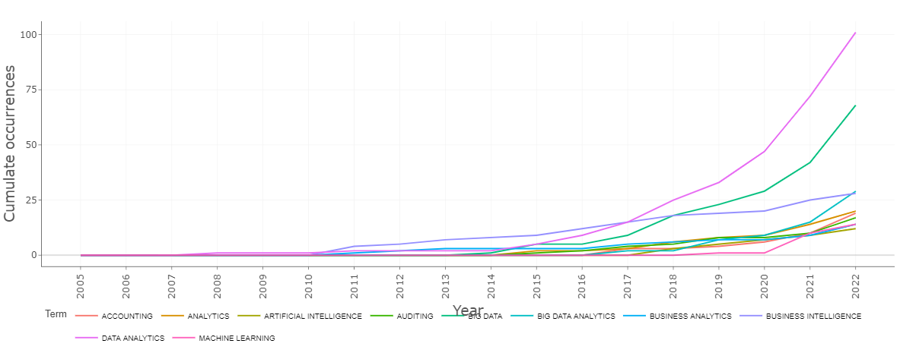

Figure 3: the keywords dynamics (Authors’ keywords)

The most frequent keywords used in the authors’ keywords of publications are illustrated in Figure 3, where it explains that “data analytics” and “big data” are the top two keywords with a high frequency of occurrence which is far large than other used keywords in the authors’ categorised keywords. Increasingly, “data analytics” keyword is at the top of the publication’s titles and authors’ keywords. The other keywords include business intelligence, big data, business analytics, accounting, auditing. Based on the frequency of the keywords used, it is evident that there is overlapping and interchangeability of using the BI&A as “data analytics” and “business analytics” and connecting it to big data. Apparently, the main functional role of BI&A emerged when the data grow to a massively huge volume and rapidly changing.

Table 6 shows the search for keywords in both authors’ keywords and the title for the articles published in the accounting area. It appears that the word ‘data analytics’ was most commonly used this area of research studies.

Author Words | Occurrences | Title Words | Occurrences
data analytics | 101 | data analytics | 98
big data | 68 | business intelligence | 22
big data analytics | 29 | audit data | 12
business intelligence | 28 | machine learning | 12
analytics | 20 | business analytics | 9
accounting | 19 | internal audit | 7
auditing | 17 | management accounting | 7
business analytics | 14 | risk management | 7
machine learning | 14 | accounting information | 6
artificial intelligence | 12 | artificial intelligence | 6
data | 12 | audit quality | 6
management accounting | 11 | accounting curriculum | 5
blockchain | 10 | continuous auditing | 5
business | 10 | data analytic | 5
audit data analytics | 9 | emerging technologies | 5
audit | 8 | management accountants | 5
internal audit | 8 | management control | 5
social media | 8 | performance measurement | 5
audit quality | 7 | auditors’ reliance | 4
financial | 7 | external auditing | 4
fraud | 7 | financial statement | 4
fraud detection | 7 | accounting directions | 3

Table 6: Most frequent keywords in authors’ keywords and titles.

The visualised cloud of keywords in the 320 publications in BI&A in accounting is depicted in figure 6. Keywords clouds, also known as tag clouds or word clouds, are a popular tool used in bibliometric analysis for data analytics and business intelligence. These clouds provide a visual representation of the most commonly used keywords or phrases in a given literature dataset. In the accounting literature, keywords clouds can be created using different clusters to identify trends and patterns in research over time. In the accounting literature, the cluster of management accounting is presented in the green keyword clouds, the significant keywords are denoted by a huge spot. A keyword cloud for this cluster might include terms such as "performance management," "management controls system". Another cluster shown is data analytics in accounting and auditing, which could include terms such as "accounting," "auditing," "data analytics," "big data," "machine learning," and "block chain.”. Increasingly, this cluster includes different tools such as text mining, data visualisation such as Tableau platform, data analysis for the social media. By examining keyword clouds for different clusters, the most prevalent themes in the literature is identified.

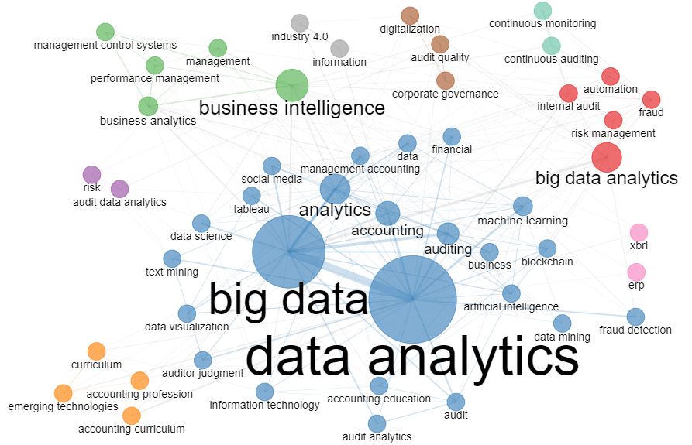
Figure 5: keywords clouds

4.2 Network analysis
Figure 6 presents an analysis of critical collaborations among countries. The figure effectively demonstrates that the advancement and cultivation of research in this field is primarily driven by the United States, Australia, Norway, and China. These pioneering nations exhibit robust collaborative efforts among themselves and with other countries as well.
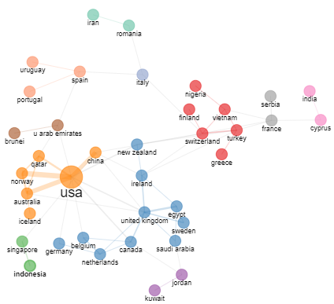
Figure 6: Countries Collaboration Network
The collaboration cloud figure shows some contributions of the middle eastern countries such as Qatar, Egypt, Saudi Arabia, United Arab Emirates, and Jordan, while China is strongly presenting Asia. According to authors collaboration, Figure 7 shows the authors collaboration network. As shown in the figure, there are three different groups of collaboration where Sutton SG and Arnold V are showing high level of collaboration in the green group, while Appelbaum D and Vasarhelyi MA show high level of collaboration in the blue group (Arnold et al. 2004; Elbashir et al. 2013; Elbashir, Sutton, Arnold, et al. 2021; Elbashir, Sutton, Mahama, et al. 2021; Koreff et al. 2021).

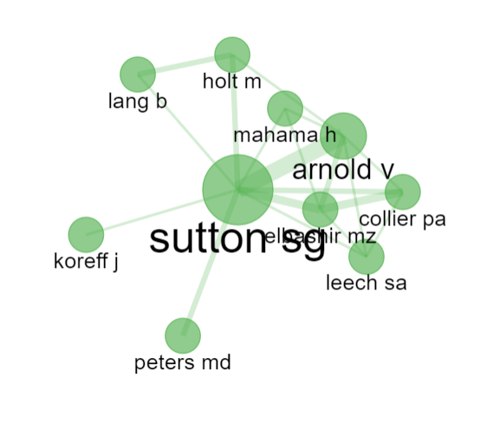 | 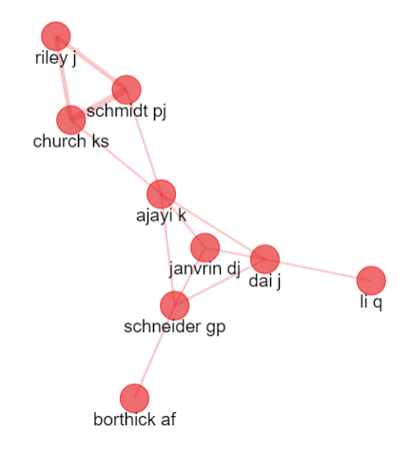
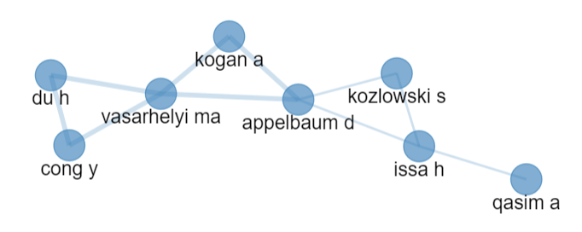
Figure 7: Authors Collaboration network

4.4.4 Thematic Evolution
This section shows the thematic evolution based on the authors’ keywords for two intervals namely from years 2002-2014 and from years 2015 - 2022. The main reason behind choosing year 2014 as a cut-off point is to show the difference before and after the emergence of the industry revolution 4.0 and compare it with the industry revolution 3.0. Thematic evolution reveals information and assumptions about the topics or themes of interest before and after the cutting year. Key terms have been represented across four quadrants, according to their relative development degree or density, centrality, or frequency of use.

Figure 8 and Figure 9 show the thematic evolution for the two intervals. Relevance degree is a metric that measures the frequency of a term within a given set of documents. This metric can be used to identify the most relevant topics in a particular set of articles. For example, by analysing the relevance degree of terms in a set of articles on financial reporting, researchers can identify the most commonly discussed topics within that field. Development degree, on the other hand, measures the growth or decline of a term over time. This metric can be used to identify the motor themes driving the evolution of the accounting literature. For example, by analysing the development degree of terms related to sustainability reporting, researchers can identify how this topic has grown in importance over time. By analysing the relevance and development degree of different terms, researchers can identify the motor themes driving the evolution of the accounting literature. For example, they might find that terms related to data analytics and business intelligence have a high relevance degree and a high development degree, indicating that this is a rapidly evolving field that is driving the thematic evolution of the accounting literature.
The upper right quadrant displays the motor themes. High centrality and density are used to classify them, as this is the most well-developed theme in the literature and the primary focus of BI&A studies in the field of accounting. The motor quadrant in the first interval shares limited themes “business intelligence” and “data analytics” with the basic theme quadrant. On contrary, in the second interval demonstrates themes of “management control systems”, “accounting curriculum”, “accounting profession”, “outlier detection”, and “audit innovation”. This explains that the well-developed theme has evolved to incorporate many practices under the accounting literature. It also shows, how these sections have received the “business intelligence” and “business analytics” themes from lower density area before 2015 to higher density area of focus after 2015. Niche themes or high-density themes, which have a big impact but aren't widely used, are displayed in the upper left quadrant. The first interval shows only two topics which are “corporate performance management” and “management control systems”. While in the second interval, themes such as “value creation”, “intellectual capital”, “audit data analytics” have risen, which might indicate that those new themes have replaced the formers in terms of researchers’ interest.
The emerging or declining themes quadrant is filled in the second interval with themes of “digital transformation”, “corporate governance”, “ERP”, “XBRL technology” in financial reporting, and financial technology. Those themes are either on the rise or on the decline and found in the bottom left quadrant. Those themes do not seem to occur in the accounting research before 2015, which might indicate that those themes are emerging themes. For example, the theme of extensible Business Reporting Language XBRL has been used in many solutions to collect, store, process, and disseminate accounting information experience emerging in the accounting research although this technology has started in the early 2000s (Guo et al. 2021). In the contrary, the digital transformation is an emerging theme in association to the main keywords in this research, most probably due to the pandemic impact on business. The lower right section displays the overarching and foundational ideas presented throughout the research area. Topics in the second interval range from “data analytics”, “big data”, “internal audit”, “dynamic pricing”, “Tableau” visualisation, “management accounting” and “machine learning”. These topics have been determined to be more central, although receiving less attention. These issues must be taken into consideration in future accounting studies, and increasingly, studies can expand to cover the various sub-categories of these issues, particularly within the IR 4.0 framework.

In sum, this section presents the results of bibliometric analysis on the thematic evolution of the accounting literature, based on authors' keywords between two time-intervals. The study used relevance and development degree metrics to identify the motor themes driving the evolution of the literature. The upper right quadrant represents the most well-developed and central motor themes in the literature, while the upper left quadrant displays niche themes with a big impact but not widely used. The emerging or declining themes are shown in the bottom left quadrant, which contains themes that were not present in the accounting research before 2015, such as digital transformation, corporate governance, and financial technology. The lower right section highlights foundational ideas that should be considered in future accounting studies, particularly within the IR 4.0 framework.

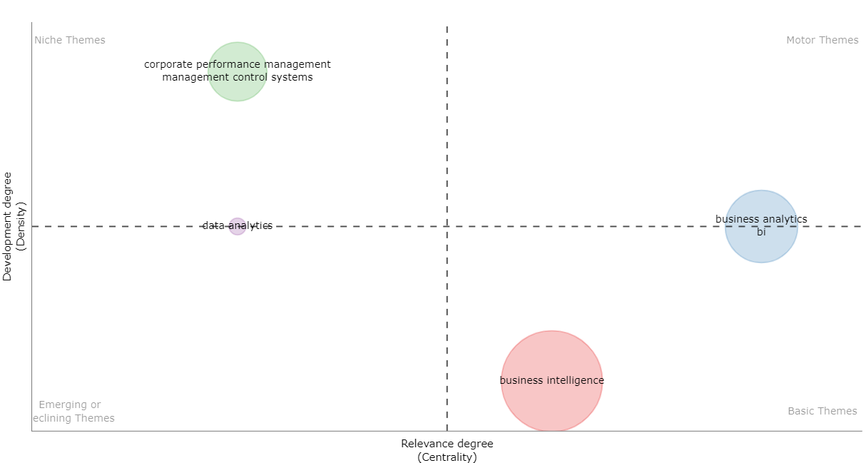
Figure 8: Thematic map (2002 – 2014)

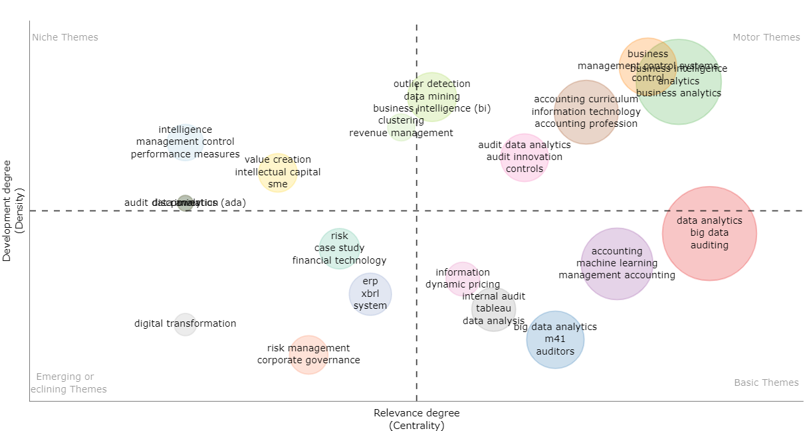

Figure 9: Thematic map (2015 – 2022)

DISCUSSION
The last two decades have witnessed the emergence of the discussion of BI&A in various accounting domains including the financial accounting, management accounting, and auditing. Despite the increasing importance of BI&A in accounting studies, as of the year 2020, it has been determined that future scholars will be more critical of the issue under discussion, particularly in terms of the research clusters that are appropriate to cover to fill the significant current gap. According to our findings, just a small number of academics are responsible for a disproportionately large share of the most prominent bodies of work. However, as time goes on and the industry continues to develop, an increasing number of authors have joined the sub-discipline of accounting, which has resulted in an expansion of the work in a number of different fields. It seems that many of the studies that have had the most impact have been published only in the past five years. This outcome should not come as a surprise given that it occurred about this time when the level of scrutiny applied to the research began to increase. The recently published works, within the last two to three years, have not had the opportunity to gain as much traction as they could have because citations have not yet accumulated. This is due to the fact that management and business research typically requires a longer period of time to build up citations.

Accounting researchers may proceed with analysing the various BI&A activities from different stakeholder’s perspectives (accountants, investors, management, and government). The increasing interest in studying BI&A and its related technologies may have started due to the pandemic that started early of 2020. This possible reason can be linked to the jump in the number of publications from 2020. The successful integration of BI&A methodologies into managerial accounting practices provides many benefits for management accounting. Given that management accounting is a decision-supporting activity, there is a natural connection between BI&A and management accounting. However, contributions and efforts in this area resides on the low-density area in the thematic map, which signifies that further research still required in this area.

The geographical distribution of the works demonstrated that the United States, which is home to numerous extremely influential publications, appeared to be in possession of the highest number of works, with Europe following close behind. Alongside the countries of the Middle East, there are indications that the effort is beginning to spread into Asia as well. Visualization of the keywords indicated that data analytics has been widely engaged in the publications, showing that authors are using the business intelligence, business analytics and data analytics interchangeably (H. Chen et al. 2012; Lim et al. 2013). However, this would neglect the main technical difference between each technology, as well as the skillset required to apply and employ the technology (IBM 2021).

The implemented research in the era of industry 4.0 has shown the emergence of themes that emphasize on technological innovations that integrate more automation, controlling and information technologies. For example, big data analytics which deal with massive volume, variety and velocity of data that increased due to with the increase of digital transformation or business and individuals. Machine learning, for example, robotics, can link computers with machine learning algorithms, allowing different systems to learn from data and improve in response time, accuracy, and flexibility. Increasingly, the visualization, represented in Tableau as an emerging-customizable technology, has been found in the current research. Comparing this with the research conducted in the IR3.0, we can find some contributions in the intelligence systems, and negligible contributions in the data analytics and business analytics. This implies that at this time those themes in the accounting domains were not thought-provoking. In addition, this indicates that appropriate BI&A and big data technologies were not adopted and integrated in the IR3.0 to meet the requirements for data gathering, storage, processing, and analysis. The emerging themes in the IR4.0 have been engendered from the dominant journals in the research scheme which are JETA, Issues in Accounting Education, International Journal of Accounting Information Systems. This may signify that those sources would lead future research of BI&A-related topics in different accounting domains, especially for the themes such as achieve automation in accounting, conduct time series analysis to exploit accounting information, continuous auditing, emerging accountants' skillsets, cognitive computing to conduct accounting tasks, visualization using dashboards and storyboards, blockchain, and risk management of digital assets. It is probable that those themes are influenced by the influence and contribution of affiliations. For example, it has been found that the top three affiliations of Rutgers State University (US), University Central Florida (US), and NHH Norwegian School of Economy (Norway) are most frequent entities to exercise and practice the themes.

The study's findings are beneficial not only to academicians and researchers, but also to professional accounting bodies such as the Chartered Institute of Management Accountants (CIMA), American Institute of Certified Public Accountants (AICPA), institute of management accountants (IMA), and institute of internal auditors (IIA). Those institutions can renovate their knowledge and competency framework in which they assess their members and affiliates with the most contemporary topics for accounting and finance professionals.

CONCLUSION
The current research paper has visualised the current state of the applying BI&A technologies in the accounting domain research via bibliometric analysis using R package software. The research has articulated comprehensively necessary data about the publications analysed in this study, stressing essential information such as publication years, article type, sources, and document content. In addition, the analysis provides key information on annual publication trends, the most productive authors, the most cited papers, the most productive countries, the most productive institutions or affiliations, the most productive source titles, the top keyword collaboration analysis, and the thematic map of the theme study in the BI&A in accompanying research.

To the knowledge of the authors, this paper has presented among the first studies to concentrate on bibliometric research in accounting information systems fields. In reality, this paper has highlighted key areas where future research should concentrate. BI&A and other associated technical advances have a significant impact on all industry stakeholders. This bibliometric analysis enriches our knowledge of the crucial feature of BI&A research in the accounting field.
In interpreting the findings, certain limitations of this study should be acknowledge. The use of keywords to search for publications related to BI&A in accounting is one of the fundamental constraints that need to be addressed in this study. Because the search is using a combination of keywords and the keywords plus strategy (which are terms that appear frequently in citation titles but not necessary in the article's title or Author Keywords.) was not guaranteed that all of the published articles related to the subject area has been included. Nevertheless, it is believed that this study has covered an adequate quantity of previous work in the field of accounting and BI&A. The online database that was used for this research is the second limitation that should be highlighted in this study. The WoS online database is utilised extensively throughout this research as the primary source for bibliometric analysis. In this particular instance, the search can be constrained due to the selection of this database.
Future may explicitly investigate the subject of BI&A and its different applications in areas under management accounting such as marginal analysis, risk management, pricing, cost management methodologies, value chain analysis, financial statements. Specifically, prospective academics might investigate the problem of the data quality and different methodologies to improve the data quality in the accounting context in greater depth in the future. It is possible for the inquiry to be carried out by a variety of organisations, including those in the private and public sectors as well as professional accounting bodies. Additionally, the researchers might also investigate the primary distinction between business intelligence, business analytics and data analytics and its relations to the accountants’ skillset and roles.

Notably, several studies centre their attention on process management and supply chain, thus, measuring internal management such as budgeting and cost accounting receives very little consideration. After conducting this investigation, it can be concluded that potential research lines are associated with the utilisation of management accounting techniques for the purpose of locating and evaluating, from among a variety of BI&A applications, the most appropriate technology to be implemented in businesses. This is consistent with what Rikhardsson & Yigitbasioglu (2018) have suggested that BI&A and digitalisation are quickly becoming an important developing research area to investigate in the field. The 'core' articles that have been identified may serve as a suitable beginning point for those who are interested in conducting research in the subject area as well as for educational purposes.

REFERENCES
Abbasi, A., Albrecht, C., Vance, A. & Hansen, J. 2012. Metafraud: a meta-learning framework for detecting financial fraud. Mis Quarterly 1293–1327.
Aboelmaged, M. & Mouakket, S. 2020. Influencing models and determinants in big data analytics research: A bibliometric analysis. Information Processing & Management 57(4): 102234.
Appelbaum, D., Kogan, A. & Vasarhelyi, M. A. 2017. Big data and analytics in the modern audit engagement: Research needs. Auditing: A Journal of Practice & Theory 36(4): 1–27.
Appelbaum, D., Kogan, A., Vasarhelyi, M. & Yan, Z. 2017. Impact of business analytics and enterprise systems on managerial accounting. International Journal of Accounting Information Systems 25: 29–44.
Appelbaum, D., Showalter, D. S., Sun, T. & Vasarhelyi, M. A. 2021. A framework for auditor data literacy: a normative position. Accounting Horizons 35(2): 5–25.
Aria, M. & Cuccurullo, C. 2017. bibliometrix: An R-tool for comprehensive science mapping analysis. Journal of informetrics 11(4): 959–975.
Arnold, V., Collier, P. A., Leech, S. A. & Sutton, S. G. 2004. Impact of intelligent decision aids on expert and novice decision‐makers’ judgments. Accounting & Finance 44(1): 1–26.
Bartlett, R. 2013. A PRACTITIONER’S GUIDE TO BUSINESS ANALYTICS: Using Data Analysis Tools to Improve Your Organization’s Decision Making and Strategy. McGraw Hill Professional.
Bhimani, A. & Willcocks, L. 2014. Digitisation,‘Big Data’and the transformation of accounting information. Accounting and Business Research 44(4): 469–490.
Brown-Liburd, H., Issa, H. & Lombardi, D. 2015. Behavioral implications of Big Data’s impact on audit judgment and decision making and future research directions. Accounting horizons 29(2): 451–468.
Chen, H., Chiang, R. H. L. & Storey, V. C. 2012. Business intelligence and analytics: From big data to big impact. MIS Quarterly: Management Information Systems 36(4): 1165–1188. doi:10.2307/41703503
Chen, Hsinchun, Chiang, R. H. L. & Storey, V. C. 2012. Business intelligence and analytics: From big data to big impact. MIS quarterly 1165–1188.
Chen, Y. & Lin, Z. 2021. Business intelligence capabilities and firm performance: A study in China. International Journal of Information Management 57: 102232.
Derviş, H. 2019. Bibliometric analysis using Bibliometrix an R Package. Journal of Scientometric Research 8(3): 156–160.
Di Vaio, A., Hassan, R. & Alavoine, C. 2022. Data intelligence and analytics: A bibliometric analysis of human–Artificial intelligence in public sector decision-making effectiveness. Technological Forecasting and Social Change 174: 121201.
Earley, C. E. 2015. Data analytics in auditing: Opportunities and challenges. Business Horizons 58(5): 493–500.
Eggert, M. & Alberts, J. 2020. Frontiers of business intelligence and analytics 3.0: a taxonomy-based literature review and research agenda. Business Research 13(2): 685–739. doi:10.1007/s40685-020-00108-y
Elbashir, M. Z., Collier, P. A. & Davern, M. J. 2008. Measuring the effects of business intelligence systems: The relationship between business process and organizational performance. International journal of accounting information systems 9(3): 135–153.
Elbashir, M. Z., Collier, P. A. & Sutton, S. G. 2011. The role of organizational absorptive capacity in strategic use of business intelligence to support integrated management control systems. The Accounting Review 86(1): 155–184.
Elbashir, M. Z., Collier, P. A., Sutton, S. G., Davern, M. J. & Leech, S. A. 2013. Enhancing the business value of business intelligence: The role of shared knowledge and assimilation. Journal of information systems 27(2): 87–105.
Elbashir, M. Z., Sutton, S. G., Arnold, V. & Collier, P. A. 2021. Leveraging business intelligence systems to enhance management control and business process performance in the public sector. Meditari Accountancy Research.
Elbashir, M. Z., Sutton, S. G., Mahama, H. & Arnold, V. 2021. Unravelling the integrated information systems and management control paradox: enhancing dynamic capability through business intelligence. Accounting & Finance 61: 1775–1814.
Gepp, A., Linnenluecke, M. K., O’Neill, T. J. & Smith, T. 2018. Big data techniques in auditing research and practice: Current trends and future opportunities. Journal of Accounting Literature.
Guo, F., Luo, X., Wheeler, P. R., Yang, L., Zhao, X. & Zhang, Y. 2021. Enterprise Resource Planning Systems and XBRL Reporting Quality. Journal of Information Systems 35(3): 77–106.
Guo, Y.-M., Huang, Z.-L., Guo, J., Guo, X.-R., Li, H., Liu, M.-Y., Ezzeddine, S., et al. 2021. A bibliometric analysis and visualization of blockchain. Future Generation Computer Systems 116: 316–332.
Haq, I., Abatemarco, M. & Hoops, J. 2020. The Development of Machine Learning and its Implications for Public Accounting. The CPA Journal 90(6): 6–9.
Hermann, M., Pentek, T. & Otto, B. 2015. Design principles for Industrie 4.0 scenarios: a literature review. Technische Universität Dortmund, Dortmund 45.
Holt, M. & Lang, B. 2021. GADGET: An Accounting Data Generator. Journal of Emerging Technologies in Accounting 18(1): 113–129.
IBM. 2021. Business analytics. https://www.ibm.com/analytics/business-analytics [5 March 2021].
Jazdi, N. 2014. Cyber physical systems in the context of Industry 4.0. Proceedings of 2014 IEEE International Conference on Automation, Quality and Testing, Robotics, AQTR 2014, hlm. 1–4. IEEE. doi:10.1109/AQTR.2014.6857843
Koreff, J., Weisner, M. & Sutton, S. G. 2021. Data analytics (ab) use in healthcare fraud audits. International Journal of Accounting Information Systems 42: 100523.
Lau, S. E. N., Zakaria, R., Aminudin, E., Saar, C. C., Abidin, N. I. A., Roslan, A. F., Abd Hamid, Z., et al. 2019. Identification of roadmap of fourth construction industrial revolution. IOP Conference Series: Materials Science and Engineering, hlm. Vol. 615, 12029. IOP Publishing.
Lee, J., Kao, H.-A. & Yang, S. 2014. Service innovation and smart analytics for industry 4.0 and big data environment. Procedia cirp 16: 3–8.
Liang, T.-P. & Liu, Y.-H. 2018. Research landscape of business intelligence and big data analytics: A bibliometrics study. Expert Systems with Applications 111: 2–10.
Lim, E.-P., Chen, H. & Chen, G. 2013. Business intelligence and analytics: Research directions. ACM Transactions on Management Information Systems 3(4). doi:10.1145/2407740.2407741
Ljasinnenluecke, M. K., Marrone, M. & Singh, A. K. 2020. Conducting systematic literature reviews and bibliometric analyses. Australian Journal of Management 45(2): 175–194.
Llave, M. R. 2017. Business intelligence and analytics in small and medium-sized enterprises: A systematic literature review. Procedia Computer Science 121: 194–205.
Manski, S., Yang, K., Lee, G. Y. & Maiti, T. 2021. Extracting information from textual descriptions for actuarial applications. Annals of Actuarial Science 15(3): 605–622.
Mortenson, M. J., Doherty, N. F. & Robinson, S. 2015. Operational research from Taylorism to Terabytes: A research agenda for the analytics age. European Journal of Operational Research 241(3): 583–595.
Nobanee, H., Dilshad, M. N., Al Dhanhani, M., Al Neyadi, M., Al Qubaisi, S. & Al Shamsi, S. 2021. Big Data Applications the Banking Sector: A Bibliometric Analysis Approach. SAGE Open 11(4): 21582440211067230.
Paradza, D. & Daramola, O. 2021. Business Intelligence and Business Value in Organisations: A Systematic Literature Review. Sustainability 13(20): 11382.
Peters, M. D., Wieder, B., Sutton, S. G. & Wakefield, J. 2016. Business intelligence systems use in performance measurement capabilities: Implications for enhanced competitive advantage. International Journal of Accounting Information Systems 21: 1–17.
Rikhardsson, P. & Yigitbasioglu, O. 2018. Business intelligence & analytics in management accounting research: Status and future focus. International Journal of Accounting Information Systems 29: 37–58.
Sahoo, S. 2021. Big data analytics in manufacturing: a bibliometric analysis of research in the field of business management. International Journal of Production Research 1–29.
Santos, M. Y., e Sá, J. O., Andrade, C., Lima, F. V., Costa, E., Costa, C., Martinho, B., et al. 2017. A big data system supporting bosch braga industry 4.0 strategy. International Journal of Information Management 37(6): 750–760.
Saunders, M., Lewis, P. & Thornhill, A. 2009. Research methods for business students. Pearson education.
Schneider, G. P., Dai, J., Janvrin, D. J., Ajayi, K. & Raschke, R. L. 2015. Infer, predict, and assure: Accounting opportunities in data analytics. Accounting Horizons 29(3): 719–742.
Siegel, E. 2013. Predictive analytics: The power to predict who will click, buy, lie, or die. John Wiley & Sons.
Smith, T., Stiller, B., Guszcza, J. & Davenport, T. 2019. Analytics and AI-driven enterprises thrive in the Age of With. Deloitte Insights.
Spraakman, G., Sanchez-Rodriguez, C. & Tuck-Riggs, C. A. 2020. Data analytics by management accountants. Qualitative Research in Accounting & Management.
Tang, J. & Karim, K. E. 2018. Financial fraud detection and big data analytics–implications on auditors’ use of fraud brainstorming session. Managerial Auditing Journal.
Torn, I. A. R. & Vaneker, T. H. J. 2019. Mass Personalization with Industry 4.0 by SMEs: A concept for collaborative networks. Procedia manufacturing 28: 135–141.
Uyar, A. & Kuzey, C. 2016. Does management accounting mediate the relationship between cost system design and performance? Advances in accounting 35: 170–176.
Wu, D., Choi, Y. & Li, J. 2020. Application of stochastic linear programming in managerial accounting: Scenario analysis approach. International Journal of Accounting & Information Management.
Youssef, M. A. E.-A. & Moustafa, E. E. 2014. Influence of control system characteristics on the choice of management accounting techniques in an emerging economy: the case of the United Arab Emirates. International Journal of Accounting and Finance 4 4(4): 378–397.
Youssef, M. & Mahama, H. 2021. Does business intelligence mediate the relationship between ERP and management accounting practices? Journal of Accounting and Organizational Change 17(5): 686–703. doi:10.1108/JAOC-02-2020-0026
Zakaria, R., Ahmi, A., Ahmad, A. H. & Othman, Z. 2021. Worldwide melatonin research: a bibliometric analysis of the published literature between 2015 and 2019. Chronobiology International 38(1): 27–37.
Zhong, X. & Enke, D. 2019. Predicting the daily return direction of the stock market using hybrid machine learning algorithms. Financial Innovation 5(1): 1–20.

