DISASTERPREP: GAMIFIED MOBILE EDUTAINMENT FOR FUTURE DISASTER PREPAREDNESS AND RESILIENCE

(Corresponding author:)

Abstract

In 2021, Malaysia experienced a significant flood, known as 'the worst flood of the century'. In 2019, a severe haze led to the closure of over 2000 schools. Despite these incidents, over half of the surveyed individuals rated their disaster preparedness knowledge as poor or fair. While the government has taken steps to manage disasters, there is still a lack of preparedness at the community level. This research aims to assess the target users' current disaster preparedness knowledge and behaviours. To address this, we develop a user-centred mobile application that combines education and entertainment elements to enhance disaster preparedness and resilience. Our application, DisasterPrep, introduces a three-dimensional (3D) virtual environment using a metaverse concept, incorporating gamification and user engagement to simulate calamities in Malaysia. The game includes four primary menus: training, flood, earthquake, and disaster outbreak. These offer scenarios of varying difficulties and levels where users can prepare for, respond to, or recover from disasters. Additional information is provided when items are tapped, and a list of actions is available during simulations for better preparation and response. The application supports voiceover in English and Malay, and upon completing each level, users are awarded an e-certificate. Usability testing of the application has shown improvement in disaster preparedness knowledge, positive behaviour change, increased resilience, and community impact. Moreover, this innovation offers sustainability benefits through reduced paper usage, energy efficiency, cost savings, and wide accessibility for training at a low cost. The Disaster Preparedness mobile application aims to enhance student engagement by providing interactive, personalised, accessible, collaborative, engaging, and practical digital learning experiences as a futuristic teaching method.

Keywords: Disaster, Edutainment, Gamification, Preparedness, Resilience

Abstrak

Pada 2021, Malaysia mengalami banjir besar, dikenali sebagai 'banjir terburuk abad ini'. Pada 2019, jerebu teruk menyebabkan lebih 2000 sekolah ditutup. Di sebalik kejadian ini, lebih separuh daripada individu yang dikaji menilai pengetahuan kesiapsiagaan bencana mereka sebagai lemah atau neutral. Walaupun kerajaan telah mengambil langkah untuk menguruskan bencana, masih terdapat kekurangan kesiapsiagaan di peringkat masyarakat. Penyelidikan ini bertujuan untuk menilai pengetahuan dan tingkah laku semasa kesiapsiagaan bencana pengguna sasaran. Untuk menanganinya, kami membangunkan aplikasi mudah alih berpusatkan pengguna yang menggabungkan elemen pendidikan dan hiburan untuk meningkatkan kesiapsiagaan dan daya tahan bencana. Aplikasi kami, DisasterPrep, memperkenalkan persekitaran maya tiga dimensi (3D) menggunakan konsep metaverse, menggabungkan gamifikasi dan penglibatan pengguna untuk mensimulasikan malapetaka di Malaysia. Permainan ini termasuk empat menu utama: latihan, banjir, gempa bumi, dan wabak bencana. Ini menawarkan senario pelbagai kesukaran dan tahap yang membolehkan pengguna bersedia untuk, bertindak balas atau pulih daripada bencana. Maklumat tambahan disediakan apabila item diketuk, dan senarai tindakan tersedia semasa simulasi untuk penyediaan dan tindak balas yang lebih baik. Aplikasi ini menyokong alih suara dalam bahasa Inggeris dan Melayu, dan apabila melengkapkan setiap peringkat, pengguna dianugerahkan e-sijil. Ujian kebolehgunaan aplikasi telah menunjukkan peningkatan dalam pengetahuan kesiapsiagaan bencana, perubahan tingkah laku positif, peningkatan daya tahan dan impak komuniti. Selain itu, inovasi ini menawarkan faedah kemampanan melalui pengurangan penggunaan kertas, kecekapan tenaga, penjimatan kos dan kebolehcapaian luas untuk latihan pada kos yang rendah. Aplikasi mudah alih Kesiapsiagaan Bencana bertujuan untuk meningkatkan penglibatan pelajar dengan menyediakan pengalaman pembelajaran digital yang interaktif, diperibadikan, boleh diakses, kolaboratif, menarik dan praktikal sebagai kaedah pengajaran futuristik.

Kata kunci: Bencana, Didik Hibur, Gamifikasi, Kesediaan, Ketahanan

1.0 INTRODUCTION

Malaysia has encountered multiple disasters, with floods being the most prevalent. In March 2023, heavy rainfall led to flooding in six states, affecting over 40,000 people and resulting in six reported deaths (Utusan Malaysia, 2023). The flood losses were valued at RM 6.1 billion in 2021 and RM 622.4 million in 2022 (Department of Statistics Malaysia, 2023). The significant loss in 2021 was due to the worst flood Malaysia had experienced since 2014. In addition to floods, the country experiences annual haze, with the most recent major haze disaster occurring in 2019, caused by forest fires and transboundary haze (New Straits Times, 2019; Utusan Borneo, 2019). Consequently, 2,459 schools in eight states were closed as the Air Pollutant Index (API) exceeded 200 (The Star, 2019). Given these statistics, it is crucial to prepare for such disasters to ensure better responses when they occur.

The urgency of disaster preparedness and resilience through mobile edutainment has been identified in three recent problem statements. First, there is a general lack of awareness and comprehension of catastrophe risk and preparedness in many areas. During disasters, this knowledge gap may make people more vulnerable. Residents of the Klang Valley were caught off guard by the sudden and catastrophic nature of the 2021 flash flood, which no one had anticipated. High tides and over double the annual rainfall, which was the source of the flood, were the contributing factors, according to (Harian Metro, 2021). However, this does not adequately account for the enormous loss that the flood victims endured. Berita Harian discovered that many people ignored METMalaysia's flood prediction because of the rain since early November, as reported by (Wan Izatul, 2021). Therefore, they were uninformed of the disaster and unprepared for it. A review of 222 publications on behavioural training and individual readiness in the context of natural hazards was conducted (Fazeli et al.,2024). They discovered that the majority of communities globally lack sufficient knowledge about preparedness. Second, information about disaster preparedness is impractical. These days, radio, television, and social media campaigns are used to inform people about disaster preparedness (Sobian, 2016). Nevertheless, there is no assurance that people who see infographics online and on social media platforms will understand and act upon the information. Malaysia's communities do not adequately prepare their communities for disasters (Sobian, 2016). Only cities vulnerable to disasters are more prepared because they have started taking precautions and grown accustomed to the circumstances. That is not how things work in other communities.

The low interest in and participation in disaster preparedness education constitutes the third issue. Another problem is that many people believe they do not need to learn how to prepare for disasters or do not want to. This research indicates that most people believe Malaysia is safe from disasters and will not be impacted even if one occurs (Sobian, 2016). On the other hand, more disasters are happening there. Furthermore, the existing approaches to disaster preparedness teaching leave students bored and uninterested. As a result, many lost interest in learning more about disaster preparedness. This led to a carefree, uninformed populace and ill-prepared municipalities to deal with disasters. To enhance disaster preparedness and resilience, this study seeks to ascertain the target users' present knowledge and behaviours related to disaster preparedness. Furthermore, it designs a user-centred mobile application that blends educational and entertaining components.

This paper aims to investigate target users' current disaster preparedness knowledge and behaviours and design a user-centred mobile application that combines education and entertainment elements to enhance disaster preparedness and resilience. Thus, DisasterPrep mobile edutainment is proposed as a virtual futuristic teaching with metaverse technologies involving virtual gamification and user engagement that simulate calamities in Malaysia. It aims to educate society, especially young adults, on disaster preparedness. This mobile application will have gamification elements to engage and interest the target users in the learning process.

DisasterPrep aims to fulfil three main objectives, which are (i) to investigate current disaster preparedness knowledge and behaviours among target users, (ii) to design a user-centred mobile application that combines education and entertainment elements as the new learning path to enhance disaster preparedness and resilience of citizens and (iii) to meet social needs by educating the community early to increase awareness of disaster preparedness.

2.0 RESEARCH METHODS

This research used quantitative research, which analyses and collects data in advance to identify patterns in understanding disaster preparedness for mobile applications. As illustrated in Figure 1, this study used the Agile methodology in four stages. Agile is renowned for its incremental and iterative methods, which are flexible and adaptable to change, making it a good fit for mobile development. Following the completion of the preliminary design, a user-centred approach will guide the design and development process. The purpose of the testing phase is to evaluate the suggested application's functionality. Due to Agile's flexibility, these phases can overlap and are iterative.

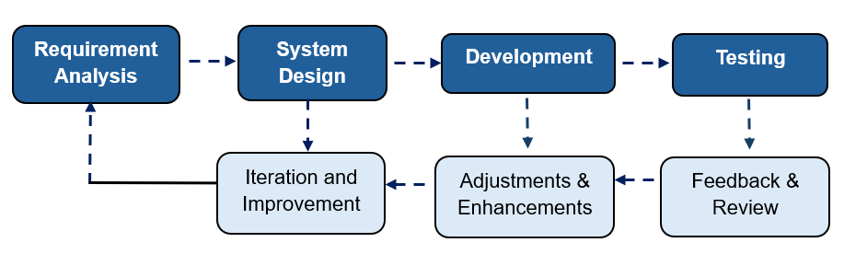

Figure 1: Agile’s phases for DisasterPrep mobile application

2.1 Requirement Analysis

This requirement analysis aims to identify gaps and areas for improvement by examining target users' current disaster preparedness knowledge and behaviours. As a result, in 2023, an online preliminary survey was conducted to ascertain the degree of preparedness knowledge as a guide before design and development. The respondents' demographics are the main focus of the first three questions. The age distribution of the respondents is shown in

Table 1. In this initial survey, users 41 years old and older cast the most votes. Urban areas rank highest among the participants' residing locations, followed by suburban and rural areas, as seen in Table 2.

Table 1: Age demographic of the respondents
Age | Percentage (%)
18 - 25 | 25
26 - 40 | 29
41 and above | 46

Table 2: Distribution of respondents' living areas
Living area | Percentage (%)
Urban | 56
Suburban | 39
Rural | 6

The respondents were mainly adults aged 41 and above (46%) and were employed (63%), as shown in Table 3. This preliminary survey focuses on the status of employed people because properties such as houses and cars or motorbikes are exposed to disasters.

Table 3: The distribution of respondent's employment status
Living area | Percentage (%)
College/University student | 24
Employed | 63
Retired | 11
School student | 1
Unemployed | 1

The following survey shows the findings in Table 4 for the types of disasters faced by the respondents. The top three chosen were flood/tsunami, haze, and disease outbreak (excluding COVID-19), with 32%, 26%, and 15%. Even though the earthquake is not the most voted on, most participants come from a country that does not face it. However, the impact could be more potent than that of haze. Therefore, the three disasters chosen for the subsequent development game simulation are floods, disease outbreaks and earthquakes to enhance disaster preparedness and resilience.

Table 4: The number of responders who have experienced various disaster
Type of disaster | Percentage (%)
Building collapse | 0
Drought and/or Extreme heat | 13
Disease outbreak | 15
Earthquake | 2
Explosion and/or Fire | 3
Flood and/or tsunami | 32
Haze | 26
Landslide | 0
Major transportation accidents | 4
None | 6

Table 5 discovers the user expectations for mobile edutainment from various ages, with 34% and 32% of the respondents expecting simulations and educational notes, respectively. 20% of the respondents also expect an emergency contacts or directory. However, the emergency contact is less practical to be included in the game application. Therefore, gamification elements, educational notes and disaster simulation are proposed.

Table 5: Respondents' expectations from a mobile game for disaster preparedness
User expectation | Percentage (%)
Directory/Emergency contacts | 20
Educational notes | 32
Gamification elements | 12
Other | 1
Simulations | 34

Table 6 summarises that most users would like to learn more about the top three things: preparing emergency kits, communication, and evacuation plans. Thus, a game simulation trains the user to pick up the necessary items during a disaster, and training mode is considered via practical virtual digital training. Medical assistance, communication and evacuation plans are not chosen as this proposed application focuses on preparedness via game-based learning. Based on Table 7, simulation receives the highest vote by the user on the game type for a mobile application. This was followed by word games, role-playing games and match 3.

Table 6: Respondents' expectations from a mobile game for disaster preparedness
User interest | Percentage (%)
Communication plans | 23
Evacuation plans | 22
Hazard mitigation | 13
Medical assistance | 18
Preparing emergency kits | 24
Other | 0

Table 7: Respondents' type of game chosen for the mobile application
Type of game | Percentage (%)
Card games (e.g: Uno) | 6
Hidden object (e.g: Magical Mystery) | 11
Match 3 (e.g: Candy Crush) | 13
Other | 1
Role-playing game (RPG) | 13
Running games (e.g: Subway Surfers) | 7
Simulation | 23
Tic Tac Toe/Connect 4 | 4
The Game of Life/Monopoly | 9
Word games (e.g.: Word search) | 14

2.2 System Design

During this stage, the system architecture is outlined, the requirements are refined, and the intended user interface (UI) and prototypes are designed. Early visual representations and prototypes of the user-centred mobile application with entertainment and educational components are made to validate design concepts. The use case diagram for the suggested application is shown in Figure 2. The user can choose any of the four main menus, and each of them will have sub-functions. In this system design, all flow and questions for each disaster have been scrutinised to tailor the time given during game simulation. Before the final caption is added to the application, the translation for the Malay setting is reviewed.

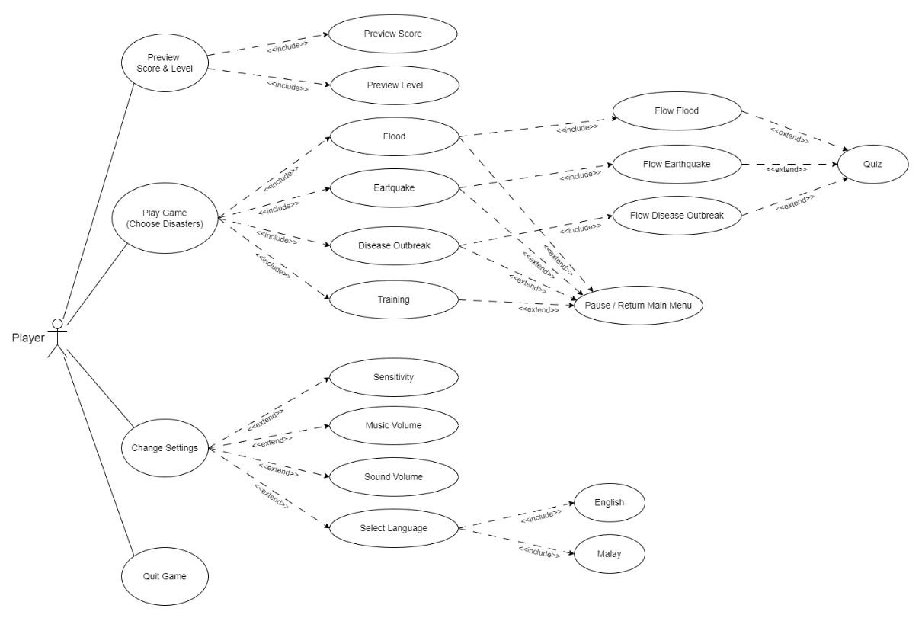

Figure 2: Use case diagram for the suggested disaster simulation game.

2.3 Development

This design phase aims to develop functional features in a short cycle to ensure high-quality code through frequent testing and continuous integration. Each application interface verified during system design is developed in the Unity platform. The menu is divided into four menus on the interface page: (i) Play Game (Choose scenario), (ii) Change settings, (iii) Preview Score & Level, and (iv) Quit Game. Code is integrated frequently, and manual tests are run to detect issues early during development. Agile methodology embraces change, allowing the development phase to quickly adapt to new requirements or changes.

2.4 Testing

Early flaw detection and correction during the unit integration process is the goal of the testing phase. Test cases and plans are created, the test scenario environment is simulated, and the cases are assessed for manual and functional testing. Exploratory and usability testing are done manually to find problems that automated tests could overlook. End users test the application during functional testing to make sure it satisfies functionality criteria and is the most user-friendly mobile educational tool for promoting disaster preparedness. Therefore, if necessary, the application can be improved. Agile methodology benefits mobile development projects because of its focus on teamwork, iterative progress, and ongoing feedback.

Table 6 displays a sample of test cases that have been carried out. In this phase, seven test cases are developed (main menu, game scope, setting, flood, earthquake, disaster outbreak, training gameplay page). If any status failure is found, the function will be inspected and redesigned for improvement.

Table 6: Test cases of the game scope page for DisasterPrep application
No. | Description of Test Data | Expected Result | Actual Result | Status
1. | Only allow the player to play a game once after finishing training. | The warning popup warns the player to go through training first whenever the first-timer player chooses another scope. | The warning popup warns the player to go through training first whenever the first-timer player chooses another scope. | Pass
2. | Start simulation of the flood when the flood button is clicked. | The flood simulation 3D environment appeared for the player to start playing. | The flood simulation 3D environment appeared for the player to start playing. | Pass
3. | Start simulation of the earthquake when the earthquake button is clicked. | The earthquake simulation 3D environment appeared for the player to start playing. | The earthquake simulation 3D environment appeared for the player to start playing. | Pass
4. | Start simulation of disease outbreak when the disease outbreak button is clicked. | The disease outbreak simulation 3D environment appeared for the player to start playing. | The disease outbreak simulation 3D environment appeared for the player to start playing. | Pass

3.0 Results and Discussion

DisasterPrep offers informal interactive learning for disaster preparedness via game simulation with four primary menus: (i) training, (ii) flood, (iii) earthquake, and (iv) disaster outbreak. It also provides three levels (beginner, intermediate, hard) of quiz-based games on disaster preparedness knowledge in a 3D environment via game simulation concepts. Voiceover during simulation games is also provided in English and Malay, depending on the language setting.

Gamification includes scenarios with different difficulties, zones, and levels where users must prepare, respond, or recover from the disaster. Users can also download the e-certificate of completion for each level of the disaster chosen. The following Figures 3-6 describe the interfaces in the DisasterPrep application for the English setting.

3.1 Simulation - Flood

In the flood game simulation, players begin by turning on a virtual television to receive real-time updates on the flood situation in their area, as shown in Figure 3. The next phase is for them to locate and collect necessary items from within their home to prepare for flooding. After they are equipped, players venture outside their virtual home to personally evaluate the water situation. Players must accomplish these tasks as soon as possible and locate a haven before the waves rise and threaten to swallow them. A popup window with more information will also appear if the player touches or picks up the object. It will ask the player to prepare for flooding before the disaster in that game occurs.

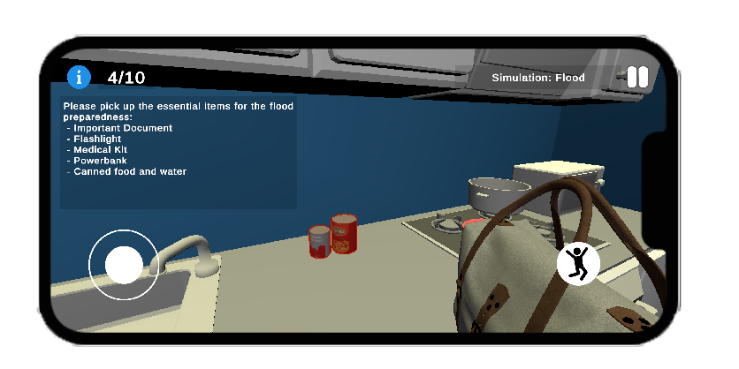

Figure 3: Interface of flood page game simulation in DisasterPrep

3.2 Simulation - Disaster Outbreak
The game flow simulation for disease outbreaks is explained in this section. Players start the game by grabbing a mobile phone to check the status of the disease outbreak. Players are told to visit the mall and purchase everything they need to survive. Reminder popups to maintain space will be displayed.

Once the player has gathered all the groceries, they must go to the counter and pay for those products, as shown in Figure 4. The players have to answer a call on their cell phones when they get home. After disinfecting every floor in the house with a mop, participants answer a quiz to confirm their understanding and level of readiness, so concluding the simulation.
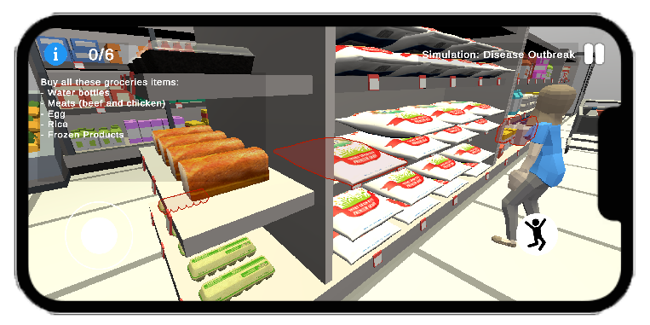
Figure 4: Interface of disaster outbreak page game simulation in DisasterPrep

3.3 Simulation - Earthquake
Players start the earthquake game simulation by turning on a cell phone or virtual television to get the most recent information on the local earthquake scenario. A list of necessary goods to bring and guidance on where to find a safe spot to shelter from earthquakes will be provided through pop-up information. Figure 5 uses the suggested DisasterPrep application to show the safe place to stay during the earthquake.
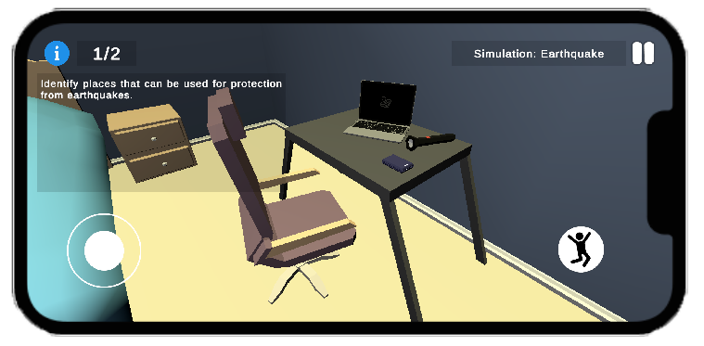
Figure 5: Interface of earthquake page game simulation in DisasterPrep

The score interface page is displayed in Figure 6 once the player answers the quiz about the chosen disaster. The player can get a digital certificate of achievement after finishing every level. Considering DisasterPrep has features such as interactive learning, real-time information, resource accessibility, community participation, hands-on training, and assessment, it can significantly improve the teaching and learning of geography, environmental science, and public health.

For example, professionals and students could collaborate in common areas for remote learning and work. In the metaverse concept, bringing disparate experiences together under one roof could lead to more engaged user experiences. Teachers could lead field trips without going to the location in person. Additionally, through this 3D virtual environment, the metaverse events can offer more experiential digital learning opportunities.

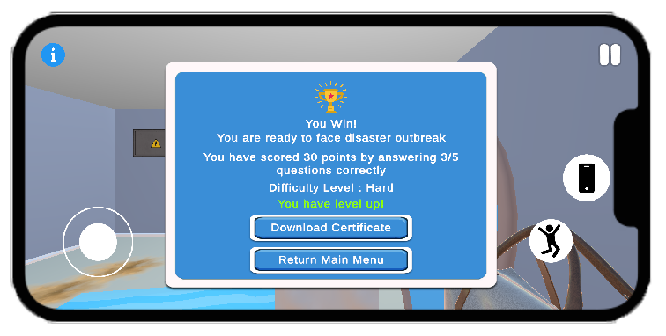
Figure 6: Interface sample of score achievement for disaster outbreak quiz

DisasterPrep can significantly enhance the teaching and learning of geography, environmental science, and public health by providing the following values: interactive learning, real-time information, resource accessibility, community engagement, practical training, and assessment. Professionals and students, for instance, could join common areas for studying and working remotely. There is potential for more engaged user experiences in the metaverse concept when the dispersed experiences are combined under one setting. Instructors could conduct field trips without physically visiting the destination. Furthermore, the metaverse events may present more significant opportunities for experiential digital learning via this 3D virtual environment.

By incorporating these features, a mobile disaster recovery application can enhance teaching and learning, making them more dynamic, effective, and responsive to real-world needs.
- Interactive Learning: The application provides interactive simulations and scenarios to teach users about disaster preparedness, response, and recovery, making learning more engaging and practical.
- Resource Accessibility: The application can be a repository of educational resources, guidelines, and best practices, accessible anytime and anywhere, ensuring continuous learning.
- Community Engagement: It facilitates user communication and collaboration, enabling knowledge sharing and collective problem-solving during and after disasters.
- Digital Practical Training: The application can offer step-by-step guides and checklists for disaster response, providing hands-on training and reinforcing theoretical knowledge with practical application via game simulation.
- Assessment and Feedback: It includes quizzes (three difficulty levels) and assessments to test users’ knowledge and provide feedback by displaying pop-up notifications, helping learners identify improvement areas and track their progress. The user can also earn an e-certificate of completion once each level is accomplished.

3.4 Impact

Three primary domains can be used to classify the possible effects of this application: society, education, and the country. In the education domain, it can improve curricula, serve as a digital learning tool for practice, offer teacher materials and resources, and support community projects. DisasterPrep has the potential to improve society by increasing public awareness of the value of disaster preparedness, fostering a culture of readiness, building community resilience through the provision of tools and resources, and guaranteeing that vulnerable groups, such as the elderly and disabled, have access to vital information and resources that are catered to their needs. Impacts on the nation include improved public health through edutainment on preventing and addressing disaster health risks, decreased economic impact from damage and recovery costs through improved preparedness and early response, and increased national preparedness.

4.0 CONCLUSION

In conclusion, DisasterPrep is an example of metaverse technology in action. This technology improves education about disaster preparedness and resilience by utilising immersive simulations, tailored and interactive learning experiences, real-time interaction, increased engagement, accessibility, and the development of valuable skills. Students learn in a setting that is more interesting, productive, and meaningful as a result.

DisasterPrep recommends that mobile edutainment can have a lasting impact on individuals' preparedness and resilience mindset. It is also aligned with the National Disaster Management Agency (NADMA), which drives the establishment of strategic planning for disaster management and highlights that community-based education and awareness of disaster risk management could also lead to reducing the impact of disaster (Zainal Azman, 2017). It can aid in cultivating a long-term behavioural impact in a society where users who continue to use the mobile application over an extended period will showcase sustained disaster preparedness behaviours.

5.0 ACKNOWLEDGEMENTS

The authors would like to express their appreciation for the support of the sponsors of Universiti Sains Islam Malaysia (USIM), specifically the Centre of Excellence for Teaching and Learning (CETL) and under the USIM Grant Scheme (PPPI/PENTADBIR/FST/USIM/19723).

6.0 REFERENCES

Berita Harian (2021). Wan Izatul Asma Wan Talaat. December 20. Amaran banjir di KL, Selangor tidak boleh dipandang remeh. https://www.bharian.com.my/kolumnis/2021/12/901418/amaran-banjir-di-kl-selangor-tidak-boleh-dipandang-remeh

Department of Statistics Malaysia. (2023). Special Report on Impact of Flood in Malaysia 2022

Harian Metro (2021, Dis 18). Hujan luar biasa, air pasang punca banjir di Selangor - MB. https://www.hmetro.com.my/mutakhir/2021/12/790139/hujan-luar-biasa-air-pasang-punca-banjir-di-selangor-mb

Fazeli S., Haghani M., Mojtahedi M. & Rashidi T. (2024). The role of individual preparedness and behavioural training in natural hazards: A scoping review. International Journal of Disaster Risk Reduction. 105(3). https://doi.org.10.1016/j.ijdrr.2024.104379

New Straits Times. (2019, Feb 26). 40ha of Pahang forest, peat land on fire [NSTTV].

https://www.nst.com.my/news/nation/2019/02/463995/40ha-pahang-forest-peat-land-fire-nsttv

Sobian, A. (2016). An Overview of the Participation of Community and Faith-Based

Organisations (FBO) in Disaster Preparedness in Malaysia. TAFHIM: IKIM

Journal of Islam and the Contemporary World, 9(1). 87-111.

https://doi:10.56389/tafhim.vol9no1.4

The Star. (2019, September 18). Haze: Over 2,000 schools closed, affecting close to 2 million

students. https://www.thestar.com.my/news/nation/2019/09/18/haze-over-2000-schools-closed-affecting-close-to-2-million-students

Utusan Malaysia. (2023, March 8). Jumlah mangsa banjir di Johor bertambah, 41,543 orang.

https://www.utusan.com.my/berita/2023/03/jumlah-mangsa-banjir-di-johor-bertambah-41543-orang/

Utusan Borneo. (2019, September 22). Kronologi jerebu di Malaysia.

https://www.utusanborneo.com.my/2019/09/22/kronologi-jerebu-di-malaysia

Zainal Azman, A.S. (2017). Disaster Management in Malaysia, National Disaster Management

Agency.

