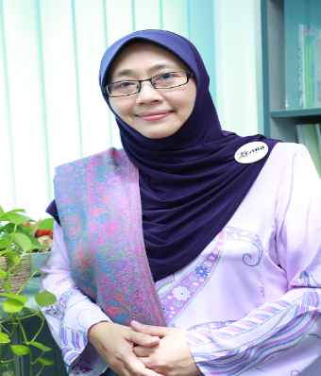

Halizah Omar is a senior language instructor who is currently the Deputy Director (Communication) at Pusat Citra Universiti, Universiti Kebangsaan Malaysia. She has been teaching English for academic and occupational purposes courses for more than 20 years. She is also involved in staff training at UKM and other institutions such as ILIM, YADIM and Department of Fisheries, Malaysia. She attained her doctoral degree in TESL from UKM. Her research interests include communication strategies, oral and computer-mediated interactions as well as online teaching and learning.

