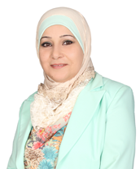

Ahlam Jamal Esruq Labin (Dr.) is currently an Assistant Professor at Department of Architecture, Hijjawi Faculty for Engineering Technology, Yarmouk University, Jordan. She attained her PhD from The National University of Malaysia- UKM, in the discipline of Architecture. Her research interests focus on performance measurement for sustainable housing.

