AUTHOR’S BIOGHRAPHY



Assoc. Professor Dr. Mek Wok Mahmud
Department Fiqh and Usul Fiqh,
Kulliyyah Of Islamic Revealed Knowledge and Human Science,
International Islamic University Malaysia,
Jalan Gombak, 53100, Kuala Lumpur
Email: mekwok@iium.edu.my
Contact: +60196490584

Assoc. Professor Dr. Mek Wok Mahmud is currently an Assoc. Professor at the Department of Fiqh and Usul al-Fiqh, at the Kulliyyah of Islamic Revealed Knowledge and Human Sciences, International Islamic University Malaysia (IIUM). She has been a senior lecturer and conducting research at IIUM since 1989. She holds a B.A in LLB (Hons) and M.A in Islamic Revealed Knowledge from IIUM, and a PhD in Islamic Law from International University of Africa, Khartoum, Sudan. She has authored several books and papers and she has been invited to deliver lectures in various events and occasions.

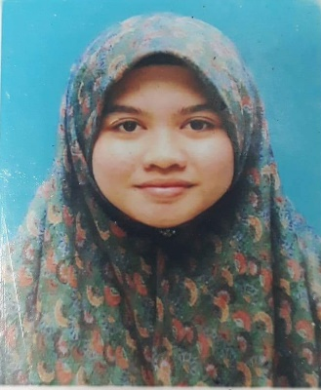

Naimah Mohamad Nasir
Department Fiqh and Usul Fiqh,
Kulliyyah Of Islamic Revealed Knowledge and Human Science,
International Islamic University Malaysia,
Jalan Gombak, 53100, Kuala Lumpur
Email: naimah011@gmail.com
Contact: +60133926653

Naimah Mohamad Nasir graduated from Mu’tah University of Jordan with Bachelor of Fiqh and Usul al Fiqh in 2013-2017. Currently, she pursues her Master of Fiqh and Usul al Fiqh in International Islamic University Malaysia (IIUM). She has been an author for several article and conference paper since 2018. Her area of interest included family laws and contemporary fiqh issues.



Asst. Prof. Dr. Saidatolakma Mohamad Yunus
Department Fiqh and Usul Fiqh,
Kulliyyah Of Islamic Revealed Knowledge and Human Science,
International Islamic University Malaysia,
Jalan Gombak, 53100, Kuala Lumpur
Email: akmayunus@iium.edu.my
Contact: +60125510233

Asst Prof Dr Saidatolakma Mohd Yunus graduated with Bachelor of Fiqh and Usul al Fiqh, Master of Fiqh and Usul al Fiqh, and Doctor of Philosophy in Islamic banking and Finance (Ph.D) from International Islamic University Malaysia. Currently, she joined the Kulliyyah of Islamic Revealed Knowledge as a lecturer in the Department of Fiqh and Usul al-Fiqh.
She has written several articles published in both local and international journal and has also presented papers at conferences in the area of Islamic banking and Islamic transaction and contract amongst them: Joint Ventures in Construction 2 (Contract, Governance, Performance and Risk) (London: ICE Publishing, 2012), Application of BOT Contract as a Means of Financing the Development of Waqf Land: Malaysia Experience ( Arab Law Quarterly, 2014), Build, Operate and Transfer Contract and its Models from Shariah Perspectives (Arab Law Quarterly, 2014), Towards Banking Jurisprudence: Understanding Islamic Banking Products in Malaysia (International Journal of Academic research in Business and Social Sciences (IJARBSS), 2017), Purification of non-halal income in Islamic Banks in Malaysia (Al-Shajarah 2018).
Her areas of interest include Islamic Banking and finance, Islamic banking products, purification of non-halal income, social finance, Islamic financial transactions and contracts as well as Fiqh muamalat.

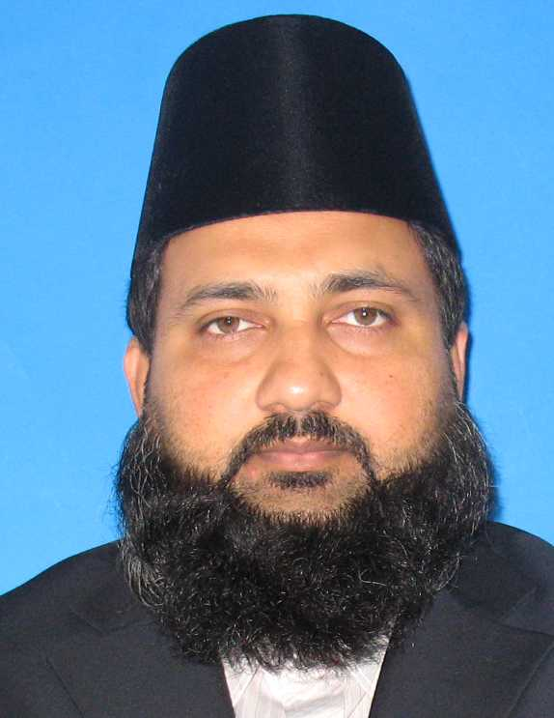
Asst. Prof. Dr. Mohammed Farid Ali
Department Fiqh and Usul Fiqh,
Kulliyyah Of Islamic Revealed Knowledge and Human Science,
International Islamic University Malaysia,
Jalan Gombak, 53100, Kuala Lumpur
Email: abumariyah@iium.edu.my
Contact: +60172447913

Mohammed Farid Ali al-Fijawi is an Assistant Professor at Department of Fiqh and Usul al-Fiqh, KIRKHS, International Islamic University Malaysia. He formally served Fiji Islands as a Mufti and religious adviser. He obtained his Doctor of Philosophy (Muslim World Issues) in 2011 and Masters in Islamic Civilization in 2006 from International Institute of Islamic Thought and Civilization (ISTAC), IIUM. His doctoral dissertation was “Principles of Issuing Fatwa (Usul al-ifta) in the Hanafi Legal School: An Annotated Translation, Analysis and Edition of Sharh 'Uqud Rasm al-Mufti of Ibn 'Abidin al-Shami.” He is the author of the book: The Position of Custom (‘Urf/’Adat) in Issuing Fatwa. Currently he is teaching "Introduction to Fiqh," "Qadaya Fiqhiyyah Mu'asirah (Contemporary Fiqh Issues)", and "Islamization of Human Knowledge" at IIUM.

