Nurul Aimi Razali
Centre for General Studies and Co-curricular,
Universiti Tun Hussein Onn Malaysia,
86400 Parit Raja,
Batu Pahat, Johor.
Associate Professor Dr. Azima Abdul Manaf,
Editor-in-Chief Journal of Southeast Asia Social Science and Humanities (AKADEMIKA),
Faculty of Social Sciences and Humanities,
Universiti Kebangsaan Malaysia,
43600 UKM Bangi,
Selangor Darul Ehsan, Malaysia 26 May 2021

Dear Editor-in-Chief,
COVER LETTER: SUBMISSION OF A RESEARCH ARTICLE FOR EVALUATION
I am enclosing herewith a research article entitled "A Hybrid Analysis of CDA and SFL to Unmask Ideological Stance inside the President Joko Widodo's Political Speech Text" for publication in your honored journal for possible evaluation. With this manuscript's submission, I would like to undertake that the manuscript mentioned above has not been published, accepted for publication or under editorial review for publication elsewhere. All co-authors listed below have agreed to have seen and approved the manuscript for submission.
2. Details of authors and co-authors:
Suswanto Ismadi Megah S
E-mail: megah76@yahoo.co.id
Affiliation Address: Centre for Language Studies, Universiti Tun Hussein Onn Malaysia (UTHM) 86400 Parit Raja, Batu Pahat, Johor.

Siti Noor Fazelah Mohd. Noor
E-mail: fazelah@uthm.edu.my
Affiliation Address: Centre for Language Studies, Universiti Tun Hussein Onn Malaysia (UTHM) 86400 Parit Raja, Batu Pahat, Johor.

Azmi Abdul Latif
E-mail: asmial@uthm.edu.my
Affiliation Address: Centre for Language Studies, Universiti Tun Hussein Onn Malaysia (UTHM) 86400 Parit Raja, Batu Pahat, Johor.

Corresponding Author: Nurul Aimi Razali*
E-mail: aimirazali@yahoo.com
Affiliation Address: Centre for General Studies and Co-Curricular, Universiti Tun Hussein Onn Malaysia (UTHM) 86400 Parit Raja, Batu Pahat, Johor.

3. Your further action is very much appreciated, and I am looking forward to hearing from you soon. Thank you.

Regards,
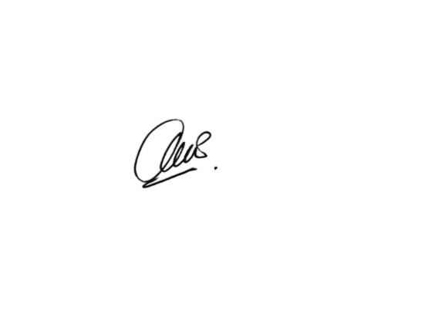

Nurul Aimi Razali
PhD Candidate (GL180011),
Centre for General Studies and Co-curricular,
Universiti Tun Hussein Onn Malaysia.

