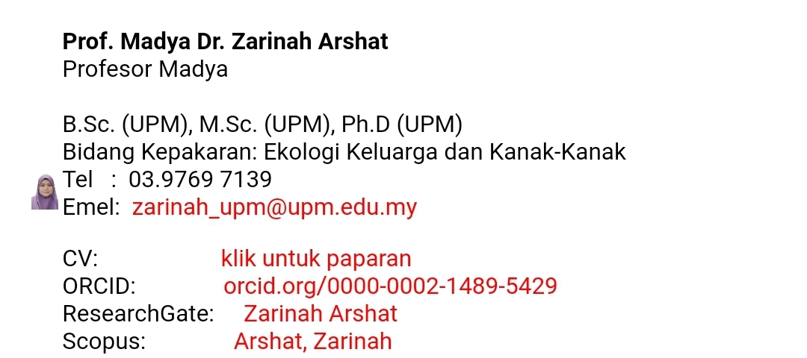

Dr. Masarah Mohamad Yusof
Social Work Program
School of Social Sciences,
Universiti Sains Malaysia.

Email: masarahmy@usm.my

