RESUME

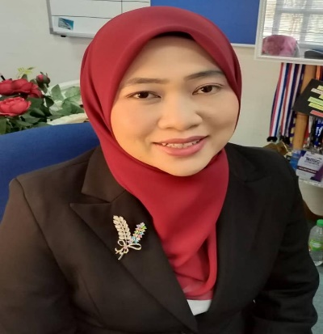

Zalinawati Abdullah
Head of Graduate Studies Centre
Graduate Studies Centre
Universiti Teknologi MARA Terengganu Dungun Branch
23000 Dungun Terengganu,
MALAYSIA.

Email: zalin5026@uitm.edu.my

Biopic:
Zalinawati Abdullah is a senior lecturer at the Faculty of Business & Management and currently the Head of Graduate Studies Centre at the Graduate Studies Centre, Universiti Teknologi MARA Terengganu Branch. She has been in this academic profession since 2003. Prior to her appointment at UiTM, she served various educational and corporate institutions in different capacities, such as marketing executive and lecturer. She earned a Diploma in Marketing from Politeknik Kota Bharu, a Bachelor of Business Administration in Marketing (BBA Hons Marketing) from Universiti Teknologi MARA, UiTM, and a Master of Business Administration (MBA) degree from Universiti Utara Malaysia. In 2021, she successfully obtained a PhD in marketing focused on consumer behaviour from Universiti Malaysia Terengganu. Now, she teaches marketing and management courses such as Consumer Behaviour, Fundamentals of Marketing, Customer Service Management, Fundamentals of Management, and Marketing Research and Management. Her research interests lie primarily in the consumer behavioural aspect of CSR, consumer buying decisions, sustainability marketing, socially responsible consumption, online shopping, and oycotts. She recently won two best papers awards at the Terengganu International Business and Economics Conference (TiBEC VII), which were combined with the other two conferences at the Terengganu Multidisciplinary International Conference 2021. She has also been involved in several research projects, including this PhD research on the effect of values and attitudes on socially responsible consumption behaviour. She has presented papers at both national and international conferences.

