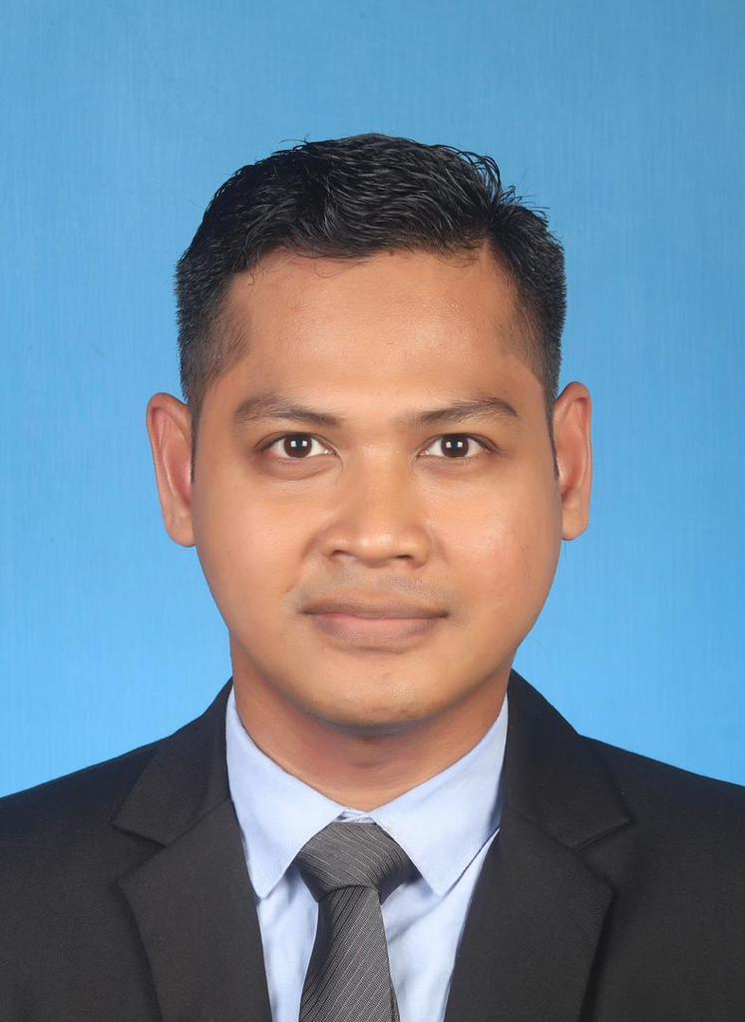

Mohd Khairi Bin Ismail
Coordinator (Coursework)
Graduate Studies Centre
Universiti Teknologi MARA Terengganu Dungun Branch
23000 Dungun Terengganu,
MALAYSIA.

Email: khairiismail@uitm.edu.my

Biopic:

Mohd Khairi Ismail is a Senior Lecturer in Economics at the Faculty of Business & Management and is currently the Coordinator (Coursework) at the Graduate Studies Center, UiTM Cawangan Terengganu. He holds a First-Class degree in Bachelor of Economics from Universiti Utara Malaysia and a Distinction in his Master of Economics study from Universiti Kebangsaan Malaysia (UKM). He then completed his PhD studies (Environment and Development) in 2019. His areas of specialization are Development, Education and Financial Economics. He has contributed more than 50 articles in the form of journal articles, chapters in book and proceedings papers. In addition, he was also appointed as an editorial board and article referee for SAGE Open, Estudios de Economia Aplicada, MDPI Journals and many more.

