Amirul Fahmie bin Abdul Razak
PhD Student
Department of Educational Management, Planning & Policy
Faculty of Education University of Malaya
amirulfahmie89@gmail.com
0174186040
Amirul Fahmie Abdul Razak is a dedicated researcher at the University of Malaya, under a Malaysian Ministry of Education scholarship. With nine years of experience in the governmental sector, Amirul has excelled in roles such as Student Affairs Officer, Auditor, Program Accreditation Officer, and English Teacher. He holds a Master's in Education Administration from Universiti Putra Malaysia and a Bachelor's in Education (TEFL) from Queensland University of Technology. Amirul is known for his leadership, problem-solving skills, and proficiency in English and Bahasa Malaysia. He has written a number of articles in the education leadership field.

Muhammad Faizal bin A. Ghani (PhD)
Associate Profesor
Department of Educational Management, Planning & Policy
Faculty of Education University of Malaya
mdfaizal@um.edu.my
01112377418
Muhammad Faizal A. Ghani  is an Associate Professor in the Department of Educational Management, Administration and Policy, Faculty of Education, University of Malaya, Kuala Lumpur. His expertise is Educational Leadership focusing on Educational Management and Administration, and School Finance. His expertise is for the benefit of society by sharing some academic knowledge, skills, and value in the forms of reading material such as publishing nine academic books and two hunderd articles. His latest academic book entitled “Professional Learning Communities: Theories and Practices”. In terms of delivering an academic speech, he has been selected to be keynote speakers and invited speakers for some international and national conferences, seminars, and workshops. In the research area, besides being an evaluator for research proposals of his university’s academic staff, he has been awarded more than USD80,000 research grants for his interest in Effective School, Educational Leadership, School Finance, and Principalship. Therefore, all experiences of him are put in the shape of a journal namely Journal of Educational Leadership by appointing him as an editor besides being an editorial board for some international journals like Bannu University Research Journal in Education, Journal of Economics and Finance, European Journal of Educational and Social Sciences and International Journal of Education Teaching and Learning.

Norfariza binti Mohd Radzi (PhD)
Senior Lecturer
Department of Educational Management, Planning & Policy
Faculty of Education University of Malaya
norfariza@um.edu.my
0192501519
Dr. Norfariza Mohd Radzi is a distinguished academic at the University of Malaya. She holds the position of Senior Lecturer in the Department of Educational Management, Planning, and Policy. Dr. Norfariza's research interests span across various domains, including educational management, leadership, and policy, with a particular focus on cross-cultural adaptation and intrinsic motivation in educational settings. Her academic journey includes extensive research and publications on topics such as financial literacy among undergraduate students, the design of effective school enterprise programs, and leadership within religious-based schools in Malaysia. Dr. Norfariza has contributed significantly to the field through her numerous scholarly articles published in reputable journals. In addition to her research contributions, Dr. Norfariza plays an active role in academic peer review and editorial responsibilities. She has served as a reviewer for several journals, including the Malaysian Online Journal of Educational Management and the Jurnal Pendidikan Malaysia, and holds editorial positions in key educational management journals. Dr. Norfariza's work is instrumental in shaping educational policies and practices in Malaysia, making her a respected figure in the academic community. Her dedication to improving educational management and leadership continues to inspire and influence educators and researchers both locally and internationally​.

Developing Leadership For Pre-Service Teachers: Previous Concepts and Models

Pembangunan Kepimpinan Untuk Guru Pra-Perkhidmatan: Konsep dan Model Terdahulu

AMIRUL FAHMIE ABDUL RAZAK, MUHAMAD FAIZAL A. GHANI, NORFARIZA MOHD RADZI

ABSTRACT
In the realm of education, cultivating leadership skills among pre-service teachers is essential for the advancement and sustainability of the educational landscape. The primary goal of this concept paper is to examine the critical role of pre-service teacher leadership in shaping future educational environments. Drawing upon theoretical frameworks and empirical research from scholars such as Bond (2011), Grossman & Richert (1996), Phelps (2008), and Wang, Ko & Qian (2022), this paper highlights the significance and dimensions of pre-service teacher leadership. Six common aspects crucial for developing leadership qualities in pre-service teachers are identified: (i) striving for futuristic leadership, (ii) setting direction, (iii) enriching data practices, (iv) valuing diversity, (v) respecting stakeholder consensus, and (vi) practicing collaborative and collective culture. The research design involves a comprehensive literature review and critical analysis of existing studies on pre-service teacher leadership. The main outcomes include practical recommendations for integrating leadership initiatives within teacher education programs, emphasizing experiential learning, mentorship, and professional development. These recommendations aim to empower future educators, enhancing the quality and effectiveness of education. The paper concludes that a systemic and sustained effort in developing leadership skills among pre-service teachers can lead to significant positive impacts on both teachers and students. Implications for further research involve exploring the long-term effects of leadership development on pre-service teachers' career trajectories and their impact on educational outcomes. Additionally, the paper suggests potential applications for practice, particularly in designing teacher education curricula that prioritize leadership development.
Keywords: pre-service teachers, educational leadership development, teacher education programs, leadership skills

ABSTRAK
Dalam bidang pendidikan, memupuk kemahiran kepimpinan dalam kalangan guru praperkhidmatan adalah penting untuk kemajuan dan kelestarian landskap pendidikan. Matlamat utama kertas konsep ini adalah untuk mengkaji peranan kritikal kepimpinan guru praperkhidmatan dalam membentuk persekitaran pendidikan masa hadapan. Berdasarkan kerangka teori dan kajian empirikal daripada sarjana seperti Bond (2011), Grossman & Richert (1996), Phelps (2008), dan Wang, Ko & Qian (2022), kajian konseptual ini menyerlahkan kepentingan dan dimensi kepimpinan guru pra-perkhidmatan. Enam aspek umum yang penting untuk membangunkan kualiti kepimpinan dalam guru praperkhidmatan dikenal pasti: (i) berusaha untuk kepimpinan futuristik, (ii) menetapkan hala tuju, (iii) memperkayakan amalan data, (iv) menghargai kepelbagaian, (v) menghormati konsensus pihak berkepentingan, dan (vi) mengamalkan budaya kolaboratif dan kolektif. Reka bentuk penyelidikan melibatkan tinjauan literatur yang komprehensif dan analisis kritis terhadap kajian sedia ada mengenai kepimpinan guru pra perkhidmatan. Hasil utama termasuk cadangan praktikal untuk menyepadukan inisiatif kepimpinan dalam program pendidikan guru, menekankan pembelajaran pengalaman, bimbingan dan pembangunan profesional. Cadangan ini bertujuan untuk memperkasakan pendidik masa depan, meningkatkan kualiti dan keberkesanan pendidikan. Kajian ini merumuskan bahawa usaha yang sistematik dan berterusan dalam membangunkan kemahiran kepimpinan dalam kalangan guru praperkhidmatan boleh membawa kepada impak positif yang ketara kepada kedua-dua guru dan pelajar. Implikasi untuk penyelidikan lanjut melibatkan penerokaan kesan jangka panjang pembangunan kepimpinan terhadap trajektori kerjaya guru praperkhidmatan dan kesannya terhadap hasil pendidikan. Selain itu, kajian ini mencadangkan aplikasi yang berpotensi untuk amalan, terutamanya dalam mereka bentuk kurikulum pendidikan guru yang mengutamakan pembangunan kepimpinan.
Kata kunci: guru praperkhidmatan, pembangunan kepimpinan pendidikan, program pendidikan guru, kemahiran kepimpinan

INTRODUCTION
In the ever-evolving landscape of education, the role of teachers extends far beyond the confines of the classroom. Study by Siddiqui and Ahamed (2020) shows that the teachers to play their roles on a broader scale facilitated by a cooperative working environment, crystal clear organizations' policies, stimulating carrier paths, and professional recognition. The idea of pre-service teacher leadership, as articulated by Goff-Kfouri (2013), is a concept that highlights the growing recognition of the significance of empowering future educators with the capacity to lead within educational contexts. This concept emphasizes the pivotal role that pre-service teachers play in effecting positive change, not only within their own classrooms but also in the wider educational landscape. On top of that, pre-service teacher leadership involves equipping aspiring educators with the necessary skills, knowledge, and mindset to become proactive agents of change (Véliz, 2018). Rather than viewing pre-service teachers solely as recipients of instruction, this perspective positions them as potential catalysts for innovation and advocates for equity within the educational system. The idea is supported by Ghamrawi and Al-Thani (2023) who claim that by nurturing pre-service teacher leadership, educational institutions acknowledge the untapped potential that these individuals possess. These future educators are seen as not just individuals preparing to enter the profession but according to Van Katwijk et al. (2023), they are viewed as vital contributors to shaping the future of education. This perspective encourages pre-service teachers to embrace their role not only as facilitators of learning but also as advocates for transformative practices that promote inclusivity, diversity, and excellence in education.
At its core, pre-service teacher leadership encapsulates the idea that leadership is not a trait reserved for a select few but rather a skill set that can be cultivated and nurtured in all educators from the onset of their careers (Aliu & Kaçaniku, 2023). By embedding leadership development within pre-service teacher education programs, institutions have the opportunity to mold a new generation of educators who are not only proficient in pedagogy but also adept at inspiring and influencing change at multiple levels. This approach recognizes that effective teaching goes beyond the dissemination of knowledge as King and Logan (2022) mention leadership is an inclusion that entails fostering critical thinking, collaboration, and a commitment to continuous improvement.
Moreover, pre-service teacher leadership holds promise for addressing some of the persistent challenges facing the field of education. From inequitable access to resources to systemic barriers that hinder student success, these issues demand proactive and innovative solutions. By instilling a sense of agency and advocacy in pre-service teachers, educational institutions can cultivate a cadre of change agents who are equipped to confront these challenges head-on (Wiessner & Sullivan, 2007). Whether through curriculum design, community engagement initiatives, or policy advocacy, pre-service teacher leaders have the potential to effect meaningful and lasting improvements in educational outcomes for all students.
This concept paper explores the foundations, principles, and implications of pre-service teacher leadership. Drawing upon research literature, theoretical frameworks, and practical examples, which aim to elucidate the significance of integrating leadership development into pre-service teacher education programs. By examining the intersection of teacher preparation and leadership theory, this concept paper provides insights into how educators, policymakers, and stakeholders can collaborate to cultivate a culture of leadership among pre-service teachers, thereby fostering positive change within the educational landscape.

LITERATURE REVIEW
The notion of pre-service teacher leadership has garnered noteworthy interest in the evolving field of teacher education during the past several years. Understanding the adaptable nature of pre-service teacher leadership and its consequences for teacher education is becoming more and more important as a result of the shifting needs and challenges of this profession. This literature review aims to provide insight into the diverse dimensions of this concept by synthesizing key findings from relevant studies. An underlying theme in the exploration of pre-service teacher leadership is the complex relationship between external responsibilities and the autonomy of academic leaders. Hulme, Meanwell, and Bryan (2023) researched the impact of audit-based responsibilities on academic leaders in teacher education programs. Their study highlights the challenges academic leaders face in reconciling policy directives with reflexive leadership practices and critical policy activism, emphasizing the need to strike a delicate balance between compliance and innovation.
Focusing on the experiences and potential of pre-service teachers, several studies describe their motivations, their views on leadership, and the challenges they face. Harms and Knobloch ( 2005) studied the motivation and leadership behavior of pre-service teachers in relation to their career choices. Their findings emphasize the importance of understanding the motivations and leadership potential of pre-service teachers to effectively prepare them for the teaching profession. Aitken (2008) investigates competing conceptions of teacher leadership and examines pre-service teachers' representations of teacher leadership. This study reveals various views on what constitutes teacher leadership, raising important questions about the possibilities and challenges that pre-service teachers face in leadership roles.
Additionally, Sharp et al. (2018) talked about how crucial it is to train incoming teachers to lead literacy initiatives in classrooms and schools. In order to highlight the necessity of teacher education programmes incorporating leadership qualities within the framework of literacy education, this study explores the ways in which literacy teacher educators cultivate literacy leadership among pre-service teachers. Furthermore, Wang et al. (2023) underscored the significance of fostering pre-service teachers as prospective teacher leaders from the outset of their education. According to their research, pre-service teachers can acquire the abilities and qualities needed to flourish as future educators by giving them the chance to take on leadership responsibilities. The inclusion of leadership development in teacher education programmes is emphasised by this study.
This synthesis also looks at the connection between transformational leadership and future educators' moral and socioemotional competencies. The significance of transformational leadership as a driving force behind creativity and constructive change in education is elucidated by Álamo and Falla (2023). Their study revealed a number of moral and socioemotional skills that are directly linked to transformational leadership, including self-control, social awareness, and responsible decision-making. This highlights how crucial it is to help pre-service teachers build these characteristics in order to help them become leaders.
The challenges faced by pre-service teachers as they strive to be agents of change are important aspects discussed in this synthesis. Huang et al. (2023) describe the challenges pre-service teachers face when implementing anti-racist pedagogy. Their study highlighted concerns related to teacher identity, parental misunderstandings, and support for educational leadership. This underscores the need for comprehensive support structures and training to empower pre-service teachers as effective agents of change in promoting social justice in the educational context.
Further, research by Meirink et al. (2020) and Acquaro (2019) emphasize the potential involvement of new teachers in leadership roles and the importance of strengthening curriculum related to leadership in teacher education programs. In addition, studies by Chaaban and Sawalhi (2020) and Mohamad Izzuan Mohd Ishar and Mohd Khata Jabor (2016) describe the development of teacher leadership during the practicum experience, suggesting opportunities for increased understanding and development of teacher leadership among pre-service teachers. Finally, research by Khalip Musa et al. (2016) emphasized the effectiveness of teacher leadership in providing essential knowledge to pre-service teachers before they enter the job market.
Overall, the exploration of pre-service teacher leadership has illuminated several critical aspects in the realm of teacher education and development. In the ever-changing landscape of teacher education, the collective findings from these studies emphasize the versatile nature of pre-service teacher leadership and its long-term implications. In addition, these studies collectively contribute to a deeper understanding of how pre-service teacher leadership can be fostered, utilized, and integrated.

OBJECTIVES OF STUDY
This paper seeks to evaluate and critique a number of concepts, models, and frameworks employed in the assessment of pre-service teachers' leadership. Additionally, it aims to provide a summary of the common elements found within these models and frameworks as identified in empirical research.
Therefore, the research questions are as below:
- What are the various concepts, models and frameworks used to measure pre-service teacher leadership?
- What are the common aspects in the analysed pre-service teacher leadership framework and models defined within the empirical research?

RESEARCH METHODOLOGY
There were two stages to the research in order to address the research questions. The systematic literature review, which comprised article, abstract, and literature review reviews, was the initial step. Using Walker and Avant (2005) methodology, the second stage concentrated on the idea analysis of "pre-service teacher leadership."
Stage 1. Conducting the literature review
The current research's conceptual and pragmatical challenges served as inspiration for the inclusion and exclusion criteria. Xu and Patmor (2012) state that a number of practical factors, such as the elements of pre-service teacher leadership, should be the basis for the literature selection criteria for pre-service teacher leadership idea construction. The criteria encompassed many literature selection principles since they were grounded in the working definition of pre-service teacher leadership (Table 1).
The defining terms "pre-service teacher leadership" were used to search the Scopus and WoS databases for pertinent scholarly literature. Only English-language articles released between 1995 and 2024 were included in the search. The search was not restricted by publisher names, publishing journals, or geographic region. 382 articles from Web of Science and 351 items from Scopus were found using the primary search.
TABLE 1. The Inclusion And Exclusion Criteria For Literature Review

Inclusive criteria | Exclusive criteria
- Empirically based findings; literature must report the findings of empirical studies | - Exclude purely descriptive pieces
- Participants are college-level teacher or preservice teachers. | - Exclude studies about public, private school teachers. Exclude studies about principals’ or school administration’s leadership.
- Pre-service teachers at teacher preparation stage who have not been employed at schools | - Exclude studies in which participants are in service teachers who are employed at schools
- Pre-service teacher leadership is a subject of the study | - Exclude studies with intentionly included teacher leadership.
- Articles published in the peer-reviewed journals. Open access journals, full-text articles. | - Exclude studies without peer review

The abstract review using the inclusion/exclusion criteria listed in Table 1 was the next stage. Consequently, 710 additional papers were disqualified from the literature evaluation due to their failure to satisfy any of our established standards. Thus, the sample of 23 works of literature on the subject of pre-service teacher leadership were included for comprehensive review based on the abstracts that were read.
Stage 2. Concept analysis
There are a few different approaches to concept analysis: the most popular approach, which is appropriate for discussing ideas related to pre-service teacher leadership, is concept analysis as it is used in business studies and nursing science (Walker & Avant, 2005). Concept analysis is also included in terminological analysis.
Walker and Avant (2005) emphasised six steps in the concept analysis process: Select a concept, establish the analysis's goals, identify each of the idea's component pieces, choose a model, draw boundaries, and define the case. The idea should appeal to the researcher, which implies it should be connected to what they do. Concept analysis often aims to identify a concept's idiosyncrasies, clarify the significance of a placed idea, enhance an existing theory, and provide a primary definition (Walker & Avant, 2005). The application of concept analysis as a method allowed for the exploration of pre-service teacher leadership conceptions and the definition of term usage idiosyncrasies.

DEFINITION AND CONCEPT OF PRE-SERVICE TEACHER LEADERSHIP
Developing strong leadership skills during the training period is crucial for aspiring educators, as these skills lay the foundation for future success in the classroom and beyond. The concept of pre-service teacher leadership is different in terms of locality. Western researchers such as Meirink et al. (2020) and York-Barr and Duke (2004) define pre-service teacher leadership by using the term student teacher candidate leadership. Their views are only focused on the classroom environment by influencing students to improve their learning. For them, pre-service teacher leadership involves the ability to inspire and motivate others, communicate effectively, work collaboratively, solve problems creatively, and act with integrity and responsibility. On the other hand, Lasekan and Mendez-Alarcon (2022) see the leadership of pre-service teachers as informal leadership without conventional leadership positions that focus on the potential to influence others and the ability to build school community relationships that support school improvement.
Pre-service teacher leadership is defined as the development of a professional mindset in teacher education programs, aimed at preparing future educators to critically assess their own teaching methods, as emphasized by Bronkhorst et al. (2014) in the context of the Netherlands. Pre-service teacher leadership refers to the ability of individuals training to become educators to lead and influence students and the broader school community. Cranston and Kusanovich (2015) argue that this leadership should be fostered from the beginning of teacher preparation programs. Bond (2011) highlights the importance of developing a willingness to grow as a leader and opportunities to enhance leadership skills. Consequently, King (2017) suggests that teacher training programs must equip pre-service teachers with the skills necessary to effect change both in the classroom and the larger school environment.
In the context of Malaysia, Mohamad Izzuan Mohd Ishar and Mohd Khata Jabor (2016) define the concept of pre-service teacher leadership as a process of influencing students and other stakeholders by strengthening teaching skills, communication skills and being open with views. It is beyond mere character, but also taking into account the way of thinking, teaching skills, communication and others. In other words, the concept of student teacher leadership is important to produce quality teacher candidates who are able to educate students to be useful people and who can serve the country in line with the country's wishes and development. The concept of leadership of student teacher candidates held by them revolves around a process that involves more than one other party to determine the value of the quality of a teacher that will be produced at the higher education level.
In conclusion, the concept of pre-service teacher leadership provides an overview of the expectations of a quality teacher from various interpretations. The leadership of pre-service teachers can be seen from the aspects of classroom teaching and learning, knowledge and leadership skills, communication and also the way of thinking inside and outside the classroom. These aspects should continue to be improved in prospective students from time to time according to the situation and achieve the teacher standards desired by the country.

LEADERSHIP PREPARATION FOR PRE-SERVICE TEACHER
A crucial stage in the development of pre-service teachers' pedagogy and educational philosophy is currently underway. According to Buchanan et al. (2020), pre-service teachers begin their careers as researchers who want to understand the nature of learning and reflect on their own methods as aspiring instructors battling with the structures and systems in place. Furthermore, student teachers frequently view teacher education as a task, expecting instructors to provide them with precise instructions so they may implement what they learn in the classroom. According to Buchanan (2017), in order to determine the proper course of action, pre-service teachers frequently engage in teacher education.
In relation to the issue, higher education providers should provide a solid learning foundation based on research-based theory and practice to better prepare student teacher candidates. Strong theories and foundations related to leadership skills should be widely disseminated by teacher education to pre-service teachers as early as possible for the purpose of developing leadership skills and fostering change (Bond, 2011). In reality, prospective teacher students have latent leadership talent when unearthed in the right way. This is supported by Rogers and Scales (2013) who concluded that pre-service teachers have the potential to be teacher leaders but they are not always given the opportunity to show their leadership. Although pre-service teacher at teacher training institutions are still ranked as youth who still lack experience and responsibility in the real world of education, Pucella (2014) agrees that age and years of experience should not be a weakening factor in identifying teacher leaders. He also claimed that prospective pre-service teacher in teacher education institutions have a lot of energy, insight, and enthusiasm to offer and may be used as a more positive opportunity in applying leadership values.

FUTURE TRENDS IN TEACHER LEADERSHIP
With time, the function of the teacher is evolving. Since many people outside the field make decisions that impact both the teaching profession and students, accountability and reform are changing the face of education (Kraft et al., 2020). Many people are urging educators to take the initiative and lead the way in changing the educational landscape by developing curricula, assessing students, creating policies, advocating for change, and taking on other leadership roles (Hargreaves & Fullan, 2015). The field of teacher education must advance if the role of teachers is to expand. According to Holland et al. (2014), the term teacher leader will be obsolete by 2030, and pre-service teachers will have developed the abilities, know-how, attitudes, and mentalities that great instructors share in both virtual and in-person settings.
Although there are many obstacles faced during the period of developing teacher leadership skills in pre-service teachers, there are also many trends that can be expected (Barth, 2001). Among them, according to Kahlenberg and Potter (2014) there are many school leaders in the future who will realize that giving the right to speak in a discussion can empower teachers and foster a deeper commitment to the school's vision and mission. This point is also supported by Wilks et al. (2019) who argue that when all teachers have a high level of thought as leaders, then ethical violations or prohibitions will not occur. Therefore, teachers in the future should have strong independence in voicing their views as well as being authoritative to collaborate with school members.
Persuing the idea, Khusnul Khotimah et al. (2023) outlined autonomy as an expected trend of teacher leadership in the future. For example, the granting of autonomy in School-Based Assessment (PBS) by the Ministry of Education and Culture where learning expectations have been determined by standards, but the steps to handle those standards have been left to the autonomy of schools and individuals. This new development has to some extent given the opportunity for teachers to be actively involved in decision making instead of just following the curriculum and teaching practices that have been mandated. In relation to that, future teachers should practice relevant professional skills in order to be able to exercise the autonomy granted by their superiors.
The next trend that is perhaps most predictable is that when a new leadership perspective has developed, teachers will be allowed to be active participants in school-wide decision-making including addressing issues of instructional coordination, curriculum development, staff development, assessment, general school affairs, personnel, regulations, discipline, administration and policy formulation (Brezicha et al., 2020). Based on that, it can be concluded that schools in the future will be more inclined and rely heavily on input from teachers to empower more teachers to speak and share their knowledge and wisdom. Therefore, the preparation of pre-service teacher candidates especially from the leadership aspect, should be given more attention so that future teachers who will be born can meet the needs of the stakeholders in the future.

PRE-SERVICE TEACHER LEADERSHIP CONCEPTS AND MODEL
This paper will discuss four concepts of teacher leadership identified in previous literature, which are (i) the Pre-service Teacher Preparation Model to Become Leaders by Bond (2011), (ii) the Pre-service Teacher Leadership Capacity and Commitment Model by Grossman & Richert (1996), (iii) Teacher Leadership Model by Phelps (2008), and (iv) New Teacher Leader Development Model by (Wang, Ko and Qian (2023).

Preservice Teacher Preparation Model to Become Leader by Bond (2011). The Model of Preparing Pre-service Teachers to Become Leaders by Bond (2011) is used as one of the models for this study. This model was chosen because it is one of several models specifically formulated to develop teacher leadership in preservice teachers using a developmental approach that integrates essential knowledge, skills, and dispositions throughout all courses in a teacher preparation program (Bond, 2011). This developmental approach supports pre-service teachers as they deepen their understanding through the constructivist process. Figure 1 shows the Model of Preparing Pre-Service Teachers to Become Leaders by Bond (2011).

FIGURE 1. Preservice Teacher Preparation Model to Become Leader

Source: Bond (2011)

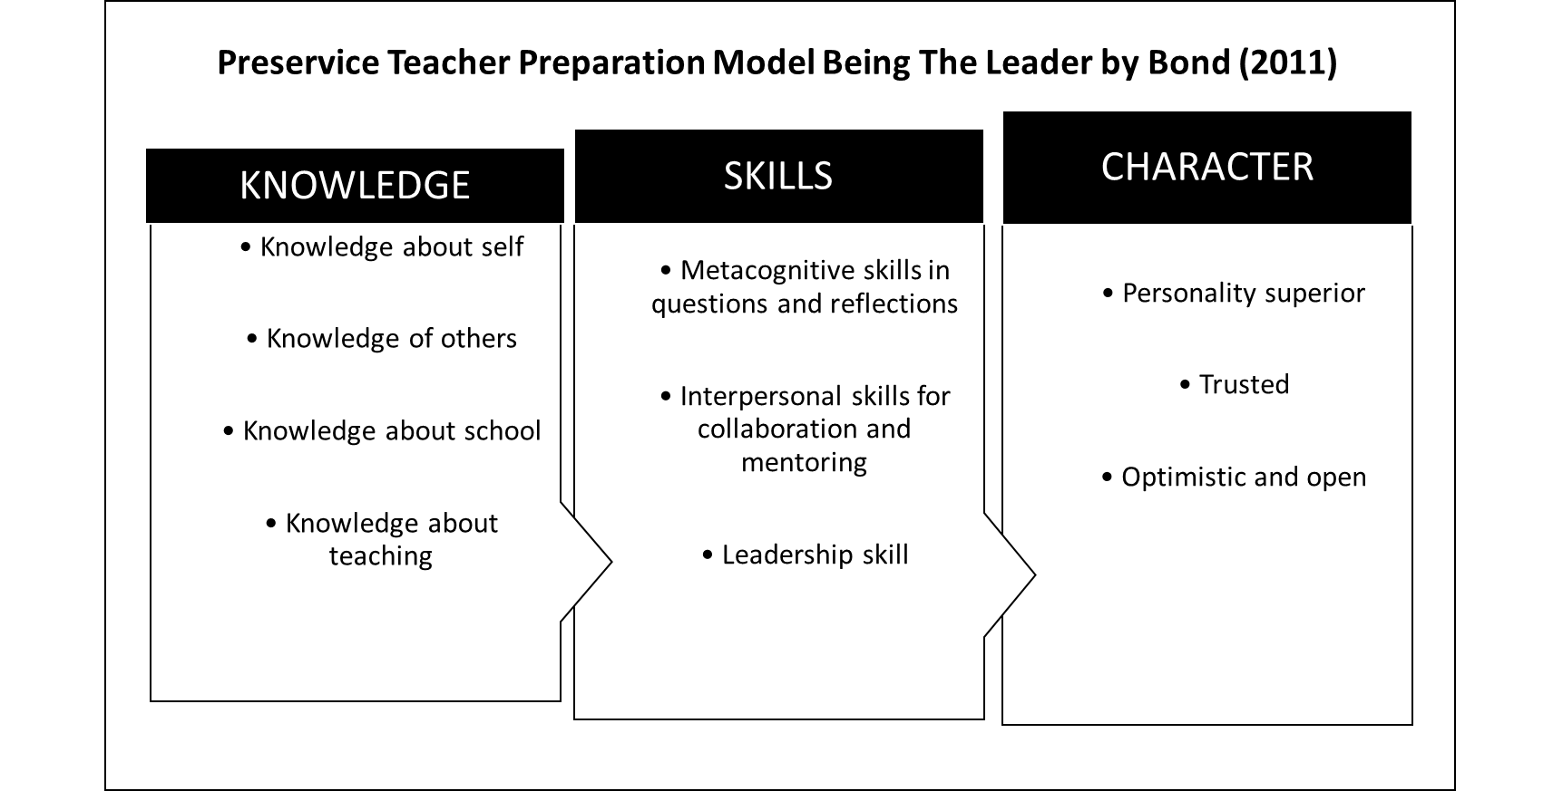

Bond's model (2011) consists of three main cores which are (1) knowledge as a teacher leader; (2) skills as teacher leaders; and (3) character as a teacher leader. This model is used as a guide to integrate leadership training throughout the undergraduate study period in teacher training institutions as well as to be implemented in specific courses designed for leadership (King, 2017). Bond (2011) also supports the idea that the time to start leadership training is during the pre-service undergraduate course. Beginning the application of leadership earlier in the career will cause future teachers to be more prepared to develop into greater and take on a greater teacher leadership role (Bond, 2011).
Pre-service Teacher Leadership Capacity and Commitment Model by Grossman & Richert (1996). The model developed by Pamela L. Grossman and Anna E. Richert is also used as the main support in this study. In this model, Grossman and Richert argue that pre-service teacher education must help novice teachers develop the commitment, skills, and knowledge necessary for teacher leadership. This model resulted when the task of preparing teachers for leadership roles was found to be difficult during professional development. This model is specific to the need to build capacity and commitment during pre-service education. Grossman and Richert (1996) believe that the development and refinement of further skills can be implemented in the work environment as a teacher later. Therefore, a model of pre-service teacher leadership capacity and commitment has been produced by highlighting three main elements in the pre-service curriculum, namely (i) commitment, (ii) knowledge and (iii) skills required for teacher leadership. Figure 2 shows the Leadership Capacity and Commitment Model of Pre-service Teachers by Grossman & Richert (1996).

FIGURE 2. Pre-service Teacher Leadership Capacity and Commitment Model

Source: Grossman & Richert (1996).

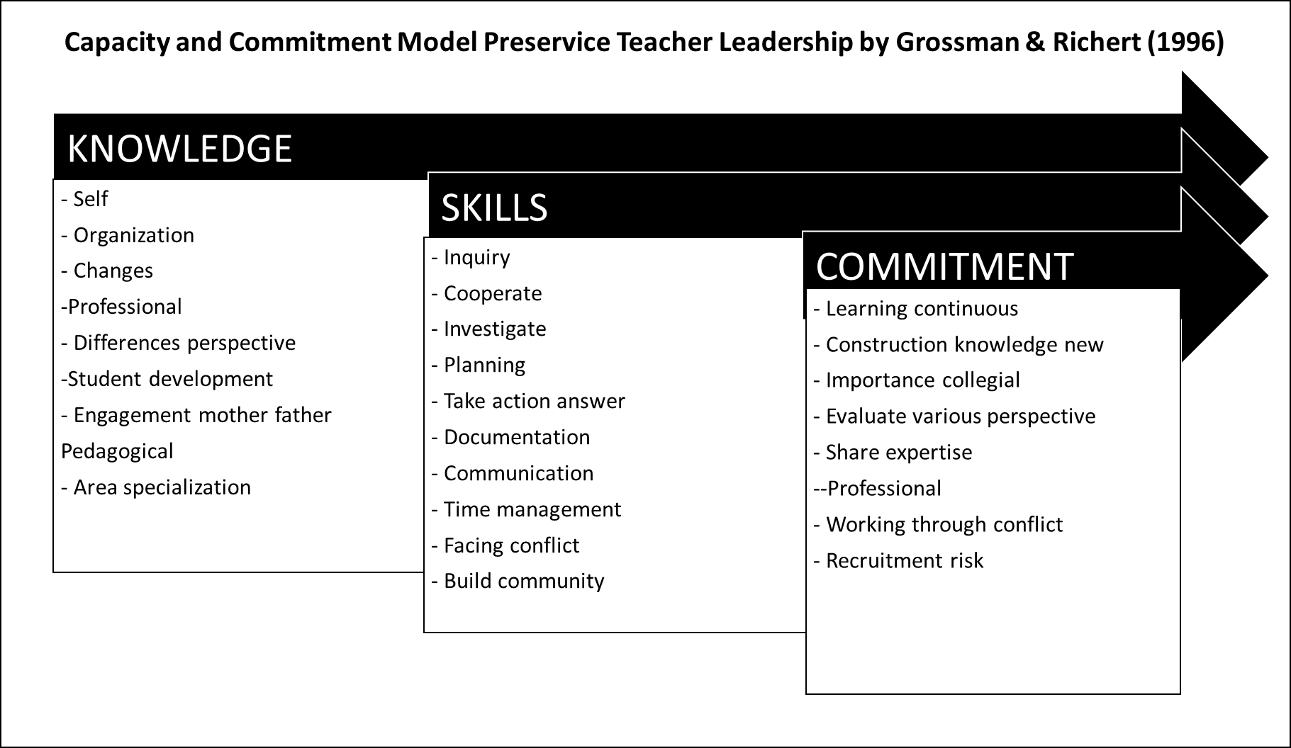

The commitments outlined in this model include a commitment to continuous learning, the importance of collegiality, the value of multiple perspectives, and the importance of taking risks. These commitments must be accompanied by the necessary skills to be realized in teacher preparation. Rather than being taught in isolation, these skills should be integrated into the curriculum as an inherent process in the work of teaching, and in turn, learning to teach.
The skills emphasized in this model are communication skills and also skills to work together in the community. Neither requires a separate course or addition to the current curriculum. Rather, the content of teacher education should be taught in a way that fosters the need for these skills so that aspiring teachers are able to work effectively with colleagues with whom they will share leadership in their schools.
Finally, this model believes that future leadership potential depends on self-knowledge, as well as knowledge of the larger organization that frames the work of teaching. To exercise leadership, novice teachers also need to know more about the history of school reform in general, about current reform proposals, and about leadership itself. As such, pre-service education can play a role in introducing key ideas about educational reform and school politics. Thus, pre-service teachers can begin the process of self-understanding during teacher education, followed by a commitment to reflective practice.

Teacher Leadership Model of Essential Knowledge, Skills, and Character by Phelps (2008). According to Patricia H. Phelps (2008), more teachers need to take on leadership roles in order to improve schools. To support the growth of more teachers as leaders, it is necessary to have an understanding of the numerous facets of teacher leadership. When faced with challenges in the classroom, teacher leaders are able to take on a variety of tasks. As such, Phelps (2008) addresses the challenge of supporting teachers in leadership roles by presenting a model and recommending ways for administrators and teacher educators to develop teacher leaders. He also describes teacher leaders as having certain knowledge, skills, and attitudes that can be developed at the pre-service and in-service levels.
FIGURE 3. Teacher Leadership Model of Essential Knowledge, Skills, and Character

Source: Phelps (2008)

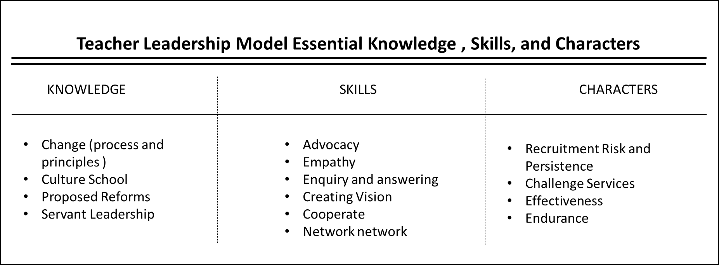

The traits depicted in Figure 3 are part of the teacher leadership paradigm. Knowledge is the first characteristic. The concepts of educational reform and school culture make up the majority of the knowledge base for teacher leadership. Teachers may not have much opportunity to learn about the change process and debate its consequences for their everyday job, despite the fact that they are continuously dealing with students and experiencing change within the existing school culture (ie values, beliefs, attitudes and rituals). Among those who are directly involved in education, changing the current school culture is frequently frowned upon. The perception of school culture as stagnant is the cause of this way of thinking. Analysing aspects of school culture critically might yield insightful information. Being a teacher leader also entails knowing about proposed reforms and comprehending the idea of servant leadership.
The second attribute is a set of abilities related to networking, advocacy, empathy, questioning, vision-creation, and collaboration. By having the chance to craft vision statements, act out scenarios (i.e., practice empathy), or pose meaningful questions, educators can hone their talents. They hone those abilities by asking insightful questions of educators. Then, their inquiries can serve as coordinating tools for departmental gatherings and professional growth exercises. Working in teams also teaches teachers how to collaborate with others. Teachers need to reward and acknowledge those who are leaders in order to develop more teachers into leaders. For instance, when a teacher demonstrates advocacy, others ought to recognise and applaud this action, not just the administrator. Being proactive is another essential trait for educators to possess. Teachers who demonstrate initiative should be commended and given support, both in-service and pre-service. Administrators might also create teacher-led study groups on specific themes to promote an inquiry-based culture. Teachers develop as leaders and schools create better environments when they feel free to raise questions, seek answers, and share ideas.
The latter trait is a propensity that encompasses efficacy, resilience, service challenges, risk-taking, and persistence. Important attributes that need to be reinforced after they are proven require further development. For instance, teacher leadership is fundamentally characterised by a risk-taking nature. Risk-taking educators ought to be commended and other educators ought to be inspired to follow suit. Creating relationships where instructors may share their experiences is one method to encourage them to take more risks. Teachers will be more likely to take chances in the classroom when they feel that it is okay to experiment and make mistakes in their relationship. Another important quality associated with teacher leadership is resilience; schools will become more resilient when their teachers become teacher leaders. Improvements will increase as more educators make the commitment to building a resilient school culture. To sum up, this model can be used by planners of pre-service professional education and in-service professional development to set up workshops, meetings, and activities.

New Teacher Leader Development Model by Wang, Ko and Qian (2022). Pre-service teachers in the Chinese context were the subject of a recent study conducted in 2022 by Ye Wang, James Ko, and Haiyan Qian. The study also revealed possible teacher leadership traits that arose among pre-service teachers who demonstrated a deeper depth of contemplation. In order to support the professional development of teacher leadership, this study suggests a new model of pre-service teacher development that places a strong emphasis on the value of ongoing reflection. Understanding the traits of teacher leadership potential that surface among pre-service teachers in the Chinese setting is affected by this approach. In order to help pre-service teachers develop into outstanding future educators, this model also emphasises the significance of encouraging teacher leadership skills in them during the teacher training phase. Figure 4 shows the New Teacher Leader Development Model by Wang, Ko and Qian (2022).

FIGURE 4. New Teacher Leader Development Model

Source: Wang, Ko and Qian (2022)
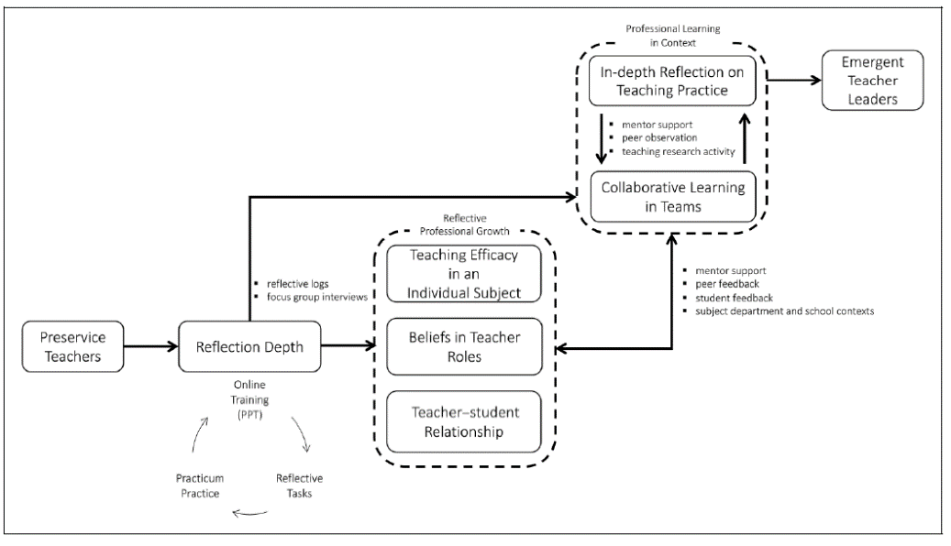

According to this model, the process of recursive and dynamic professional learning development in a context through reflection determines or manifests the new teacher leaders' depth of reflection, which in turn determines professional growth for pre-service teachers. According to the model's findings, pre-service teachers should consistently deepen their reflection in order to achieve successful instruction and foster innovative teaching practices. According to Wang, Ko, and Qian (2022), pre-service teachers who exhibit deeper contemplation are more likely to have an impact on others and to uphold strong interpersonal relationships.
As possible markers of a leader's capacity to foster the professional development of pre-service teachers, three factors have come to light. The first component is how well pre-service instructors teach a variety of subjects. Teachers' efforts and perseverance in accomplishing the required learning objectives are indicators of their self-efficacy. According to this concept, pre-service teachers who demonstrate a greater sense of teaching effectiveness in a particular subject have a greater chance of succeeding in effective teaching if they can help students grasp the material more fully.
The pre-service teacher's perception of the teaching role makes up the second component. Teachers' actions are influenced by their ideas and perceptions, according to Wang, Ko, and Qian (2022). According to this paradigm, teachers who see themselves as leaders in the classroom are more inclined to take on tasks and responsibilities outside of it, which would eventually hinder their development as teacher leaders.
The favourable rapport between the instructor and the pupil makes up the third component. The necessity of preserving a good rapport between educators and students has been highlighted by this model as one of the distinctive traits of more adaptable, thoughtful, and creative educators. This approach so demonstrates that fostering a pleasant teacher-student relationship, a greater sense of teaching efficacy in the subject, and a better belief in the teacher's position are all ways to enhance pre-service teacher leadership. To this end, pre-service teachers benefit even from in-depth thought.
Furthermore, it was determined that team-based collaborative learning might be a component in pre-service teachers' leadership development. On the one hand, pre-service teachers' views and ideas about teaching can be changed by collaborative learning activities like peer recognition, student feedback, mentor support, and involvement in learning communities in practicum schools. Conversely, collaborative learning can encourage pre-service teachers to provide insightful reflection and enhance the quality of their instruction. Examples of this include peer observation and mentorship for teacher leaders during professional development programmes in schools. Additionally, according to this approach, critical reflection can help pre-service teachers develop the professional knowledge and abilities necessary to become teacher leadersThus, this model contends that pre-service teachers' capacity to critically reflect on their learning outcomes and pedagogical effectiveness can foster leadership and influence their early professional development.

FINDINGS
Based on the review of the four pre-service teacher leadership concepts and models, this paper has identified 6 aspects in pre-service teacher leadership. The aspects are (i) Leadership practice strives for futuristic leadership, (ii) Leadership practice sets the direction, (iii) Leadership practices enrich data, (iv) Leadership practices value diversity, (v) The practice of leadership that respects the consensus of stakeholders and (vi) Leadership practice practicing collaborative & collective culture.
To summarise, the four pre-service teacher leadership frameworks and models have emphasised on common aspects, as shown in the table below:

TABLE 2. Summary Of Common Aspects Identified In Four Pre-Service Teacher Leadership Concepts And Models

Aspects | Pre-service Teacher Preparation Model to Become Leaders by Bond (2011) | Pre-service Teacher Leadership Capacity and Commitment Model by Grossman & Richert (1996) | Teacher Leadership Model by Phelps (2008) | New Teacher Leader Development Model by Wang, Ko and Qian (2022)
(i) Leadership practice strives for professional leadership | √ | √ | √ | √
(ii) Leadership practice sets the direction | √ | √ | √ | √
(iii) Leadership practices enrich data |  |  |  | √
(iv) Leadership practices value diversity |  | √ | √
(v) The practice of leadership that respects the consensus of stakeholders | √ | √ | √ | √
(vi) Leadership practice practicing collaborative & collective culture | √ | √ | √ | √

DISCUSSION
Based on the review of four pre-service teacher leadership concepts and models, six common aspects of pre-service teacher leadership have been identified as crucial for developing leadership qualities in future educators. These aspects are essential for shaping pre-service teachers into effective leaders who can navigate the complexities of contemporary educational environments.
Firstly, the practice of striving for futuristic leadership is fundamental. Pre-service teacher leadership involves preparing educators who are visionary and forward-thinking. This aspect emphasizes the importance of equipping pre-service teachers with the ability to anticipate future educational trends and challenges. As noted by Bond (2011), fostering a futuristic outlook enables pre-service teachers to be proactive leaders who can implement innovative practices and adapt to changes in the educational landscape. This idea is reinforced by Holland et al. (2014) who assert that futuristic leadership can significantly impact teacher preparation by prompting a reconceptualization of the program's structure to better incorporate successful practices. By developing a mindset geared towards continuous improvement and long-term planning, teacher preparation programs cultivate leaders who are prepared for future demands.
Secondly, effective leadership requires the ability to set a clear direction. Pre-service teachers must learn to establish goals, set priorities, and create a shared vision for their classrooms and schools. Grossman and Richert (1996) highlight the importance of direction-setting in their model, suggesting that pre-service teachers need to be trained to articulate and pursue a coherent vision for education. This aligns with the findings of Daoud and Parsons (2021), who observed that teachers with leadership insights can effectively overcome classroom obstacles and make informed decisions based on input and data. This skill enables them to guide their students effectively and contribute to the strategic objectives of their schools.
Thirdly, enriching leadership practices with data is crucial for informed decision-making. Phelps (2008) underscores the need for pre-service teachers to be adept at collecting, analyzing, and interpreting data to improve teaching and learning outcomes. By integrating data into their leadership practices, pre-service teachers can make evidence-based decisions, identify areas for improvement, and measure the impact of their interventions. Prestigiacomo et al. (2020) confirm that a deeper understanding of teachers' perspectives on data as evidence, is required to improve student educational outcomes. This data-driven approach ensures that future educators are reflective practitioners and effective leaders.
Fourthly, valuing diversity is an essential component of inclusive leadership. Pre-service teachers must be trained to recognize and embrace the diverse backgrounds, cultures, and perspectives of their students. This aspect, emphasized in the models by both Grossman and Richert (1996) and Phelps (2008), advocates for the development of culturally responsive teaching practices. The findings of Sunthonkanokpong and Murphy (2020) indicate that pre-service teachers experience the highest anxiety when teaching students who are diverse in terms of resources, mental, physical, and learning disabilities, highlighting the role of higher education in preparing teachers for various contexts. By valuing diversity, pre-service teachers can create inclusive learning environments that respect and celebrate differences, thereby fostering equity and social justice in education. Alsen and Buss (2022) concluded that when pre-service teachers develop critical awareness, they become more capable of acting as teachers who are responsive to diversity and can cultivate a culturally responsive pedagogical mindset in collaboration with stakeholders.
The fifth aspect involves the practice of leadership that respects the consensus of stakeholders. Effective leadership in education necessitates collaboration and consensus-building among various stakeholders, including students, parents, colleagues, and the community. Bond (2011) and Wang, Ko, and Qian (2022) stress the importance of pre-service teachers developing skills in participatory decision-making and stakeholder engagement. Study by Caldwell (2016) found that there is a need for stronger policy and practice alignment among stakeholders in teacher education and that it should be shaped by stakeholders regarding what constitutes quality in schooling and quality in teaching. By respecting the consensus of stakeholders, pre-service teachers ensure that their leadership practices are democratic, transparent, and reflective of the collective needs and aspirations of the school community.
Lastly, practicing a collaborative and collective culture is a cornerstone of successful educational leadership. Pre-service teachers must be equipped to work collaboratively with others, fostering a culture of teamwork within their schools. All four models reviewed; Bond (2011), Grossman and Richert (1996), Phelps (2008), and Wang, Ko, and Qian (2022) emphasize the importance of shared leadership and collective responsibility. By practicing collaborative leadership, pre-service teachers can build strong professional relationships, leverage diverse expertise, and create a supportive network that enhances student learning and well-being. Widyastuti's (2022) study supports this by highlighting the critical role of leadership in collaborative governance. Leaders act as organizers, persuading stakeholders to participate and making unbiased decisions based on their experience and reputation. These findings underscore the need for targeted interventions and professional development initiatives aimed at increasing collaborative leadership capacity among prospective educators. Strengthening the ability of trainee teachers to work collaboratively, communicate effectively, and leverage collective expertise and resources is essential for promoting a culture of collaboration and shared responsibility in the educational environment.

IMPLICATIONS FOR FURTHER RESEARCH AND PRACTICE
The implications of these findings for further research and practice are significant. First, teacher education programs should incorporate the six identified aspects of pre-service teacher leadership into their curricula. By doing so, they can better prepare pre-service teachers for leadership roles, ensuring they are capable of driving positive educational outcomes and fostering sustainable change within schools. Second, professional development initiatives should be designed to enhance pre-service teachers' leadership capacities, focusing on areas such as futuristic leadership, data-driven decision-making, and collaborative culture. These initiatives will help bridge the gap between theoretical knowledge and practical application.
Further empirical research is needed to validate the identified aspects of pre-service teacher leadership across diverse educational contexts. This research will help refine existing models and frameworks, ensuring their applicability and effectiveness in various settings. Longitudinal studies should be conducted to examine the long-term impact of leadership training on pre-service teachers' professional development and their effectiveness as leaders in educational settings. Such studies will provide valuable insights into the sustainability and scalability of leadership initiatives. Additionally, future research should explore how contextual factors, such as cultural, socio-economic, and institutional variables, influence the development and practice of pre-service teacher leadership. Understanding these factors will help tailor leadership training programs to meet the specific needs of different educational environments.
This study contributes to the field of educational leadership by providing a comprehensive analysis of pre-service teacher leadership concepts and models. By identifying common aspects of leadership and highlighting their significance, the study offers a clear framework for developing leadership capacities in pre-service teachers. The findings serve as a foundation for designing and implementing effective leadership training programs within teacher education, thereby enhancing the overall quality of education and promoting positive student outcomes. By emphasizing the importance of empirical validation and contextual considerations, the study encourages ongoing research and innovation in the field, ensuring that leadership training remains relevant and impactful in an ever-evolving educational landscape.

CONCLUSION
This concept paper has thoroughly explored pre-service teacher leadership, drawing insights from existing concepts and models in the field. Through a review of four prominent frameworks, six fundamental aspects of pre-service teacher leadership were identified. These aspects serve as foundational pillars for empowering future educators with the skills, competencies, and dispositions needed to thrive in leadership roles. By focusing on futuristic leadership, direction-setting, data enrichment, valuing diversity, stakeholder consensus, and collaborative culture, teacher education programs can effectively prepare pre-service teachers for leadership. This paper sets the groundwork for designing and implementing such programs and calls for further research to refine and operationalize the proposed concept of pre-service teacher leadership. Future research should also explore how leadership development impacts educational outcomes and how to best integrate leadership training into teacher education curricula.

REFERENCES
Acquaro, D. (2019). Preparing the Next Generation of Educational Leaders: Initiating a Leadership Discourse in Initial Teacher Education. International Studies in Educational Administration, 47(2), 107–121.
Aitken, A. (2008). The Novice With Expertise: Is There a Leadership Role for Preservice Teachers in Times of Educational Change? Learning Landscapes. https://doi.org/10.36510/learnland.v1i2.259
Álamo, M., & Falla, D. (2023). Transformational Leadership And Its Relationship With Socio-Emotional And Moral Competencies In Pre-Service Teachers. Psychology, Society and Education, 15(1), 48–56. https://doi.org/10.21071/pse.v15i1.15552
Aliu, J., & Kaçaniku, F. (2023). An Exploration of Teacher Leadership: Are Future Teachers Ready to Lead? Center for Educational Policy Studies Journal, 13(4), 37–62. https://doi.org/10.26529/cepsj.1634
Alsen, E., & Buss, R. R. (2022). Developing Pre-Service Teachers: A Social Justice Approach for Educating Culturally and Linguistically Diverse Students. Impacting Education: Journal on Transforming Professional Practice, 7(2), 61–73. https://doi.org/10.5195/ie.2022.213
Barth, R. S. (2001). Teacher Leader. Phi Delta Kappan, 82(6), 443–449. https://doi.org/10.1177/003172170108200607
Bond, N. (2011). Preparing Preservice Teachers to Become Teacher Leaders. Educational Forum, 75(4), 280–297. https://doi.org/10.1080/00131725.2011.602578
Brezicha, K. F., Ikoma, S., Park, H., & LeTendre, G. K. (2020). The ownership perception gap: exploring teacher job satisfaction and its relationship to teachers’ and principals’ perception of decision-making opportunities. International Journal of Leadership in Education, 23(4), 428–456. https://doi.org/10.1080/13603124.2018.1562098
Bronkhorst, L. H., Koster, B., Meijer, P. C., Woldman, N., & Vermunt, J. D. (2014). Exploring student teachers’ resistance to teacher education pedagogies. Teaching and Teacher Education, 40, 73–82. https://doi.org/10.1016/j.tate.2014.02.001
Buchanan, R. (2017). It’s Not About That Anymore: An Ecological Examination of the Theory-Practice Devide in Contemporary Teacher Education.
Buchanan, R., Mills, T., & Mooney, E. (2020). Working across time and space: developing a framework for teacher leadership throughout a teaching career. Professional Development in Education, 580–592. https://doi.org/10.1080/19415257.2020.1787204
Caldwell, B. J. (2016). The Need for Stakeholder Alignment on the Future of Teacher Education Australia. In Quality and Change in Teacher Education: Western and Chinese Perspectives. In Cham: Springer International Publishing.
Chaaban, Y., & Sawalhi, R. (2020). Student Teachers’ Development as Teacher Leaders During the Practicum Experience. Journal of Applied Research in Higher Education, 12(5), 927–942. https://doi.org/10.1108/JARHE-04-2019-0093
Cranston, J., & Kusanovich, K. (2015). Learning to Lead against the Grain Dramatizing the Emotional Toll of Teacher Leadership. Issues in Teacher Education, 24(2), 63–78.
Daoud, N., & Parsons, S. A. (2021). Visioning and hope: A longitudinal study of two teachers from preservice to inservice. Peabody Journal of Education, 96(4), 393–405.
Ghamrawi, N., & Al-Thani, H. (2023). Wellbeing leadership: Perceptions of pre-service school leaders. HELIYON, 9(11). https://doi.org/10.1016/j.heliyon.2023.e21706
Goff-Kfouri, C. A. (2013). Pre-service Teachers and Teacher Education. Procedia - Social and Behavioral Sciences, 93, 1786–1790. https://doi.org/10.1016/j.sbspro.2013.10.117
Grossman, P. L., & Richert, A. E. (1996). Building Capacity and Commitment for Leadership in Preservice Teacher Education. Journal of School Leadership, 6(2), 202–210. https://doi.org/10.1177/105268469600600206
Hargreaves, A., & Fullan, M. (2015). Professional Capital: Transforming teaching in every school. Teachers COllege Press.
Harms, B. M., & Knobloch, N. A. (2005). Preservice Teachers’ Motivation and Leadership Behaviors Related to Career Choice. Career and Technical Education Research. https://doi.org/10.5328/cter30.2.101
Holland, J. M., Eckert, J., & Allen, M. M. (2014). From Preservice to Teacher Leadership: Meeting the Future in Educator Preparation. Action in Teacher Education, 36(5–6), 433–445. https://doi.org/10.1080/01626620.2014.977738
Huang, T., Zhou, J., Chen, S., & Barnett, E. (2023). “I’m concerned about actually doing it”: The Struggles of Pre-service Teachers Becoming Change Agents. Middle School Journal, 54(4), 37–50. https://doi.org/10.1080/00940771.2023.2232263
Hulme, M., Meanwell, K., & Bryan, H. (2023). Between A Rock And A Hard Place: Leading University Teacher Education In England. Journal of Further and Higher Education. https://doi.org/10.1080/0309877X.2023.2248025
Kahlenberg, R. D., & Potter, H. (2014). Why Teacher Voice Matters.
Khalip Musa, Masturah Zainal Abidin, & Norlia Mat Norwani. (2016). Teacher Leadership Knowledge to Pre-Service Teachers. International Journal of Academic Research in Business and Social Sciences, 6(11), 351–360. https://doi.org/10.6007/ijarbss/v6-i11/2404
Khusnul Khotimah, Yazid Basthomi, & Evi Eliyanah. (2023). EFL Pre-service Teacher Development for Autonomy: Rethinking Future Autonomy Supportive Teacher (Vol. 2). Atlantis Press SARL. https://doi.org/10.2991/978-2-38476-054-1_27
King, F. (2017). Evolving Perspective(s) of Teacher Leadership: An Exploration of Teacher Leadership for Inclusion at Preservice Level in the Republic of Ireland. International Studies in Educational Administration (Commonwealth Council for Educational Administration & Management (CCEAM)), 45(3), 5–21. http://login.ezproxy.lib.umn.edu/login?url=http://search.ebscohost.com/login.aspx?direct=true&AuthType=ip,uid&db=aph&AN=128198209&site=ehost-live
King, F., & Logan, A. (2022). Leadership For Inclusion And Special Education: Novice Teachers Walking The Walk. Research in Educational Administration & Leadership, 7(1), 132–160.
Kraft, M. A., Brunner, E. J., Dougherty, S. M., & Schwegman, D. J. (2020). Teacher accountability reforms and the supply and quality of new teachers. Journal of Public Economics, 188, 104212. https://doi.org/10.1016/j.jpubeco.2020.104212
Lasekan, O., & Mendez-Alarcon, C. (2022). The Depiction of Servant Teacher Leadership Attributes in Mass Media: A Characterization Analysis of the Protagonist in Rita TV Series. Journal of Curriculum and Teaching, 11(8), 122–133. https://doi.org/10.5430/jct.v11n8p122
Meirink, J., Van Der Want, A., Louws, M., Meijer, P., Oolbekkink-Marchand, H., & Schaap, H. (2020). Beginning Teachers’ Opportunities for Enacting Informal Teacher Leadership: Perceptions of Teachers and School Management Staff Members. European Journal of Teacher Education, 43(2), 243–257. https://doi.org/10.1080/02619768.2019.1672654
Mohamad Izzuan Mohd Ishar, & Mohd Khata Jabor. (2016). Pembentukan Kemahiran Kepimpinan Guru Pelatih Melalui Latihan Mengajar. In Malaysian Journal of Social Sciences and Humanities (MJSSH) (Vol. 1, Issue 1). www.msocialsciences.com
Phelps, P. H. (2008). Helping Teachers Become Leaders. The Clearing House: A Journal of Educational Strategies, Issues and Ideas, 81(3), 119–122. https://doi.org/10.3200/tchs.81.3.119-122
Prestigiacomo, R., Hunter, J., Knight, S., Martinez-Maldonado, R., & Lockyer, L. (2020). Data in practice: A participatory approach to understanding pre-service teachers’ perspectives. Australasian Journal of Educational Technology, 36(6), 107–119.
Pucella, T. J. (2014). Not Too Young to Lead. The Clearing House: A Journal of Educational Strategies, Issues and Ideas, 87(1), 15–20. https://doi.org/10.1080/00098655.2013.818524
Rogers, C., & Scales, R. Q. (2013). Preservice Teachers&apos; Perceptions of Teacher Leadership: Is It about Compliance or Understanding? Issues in Teacher Education, 22(2), 17–22.
Sharp, L. A., Piper, R., & Raymond, R. D. (2018). Are We Preparing Teachers for Literacy Leadership? Reading Teacher, 72(2), 223–232. https://doi.org/10.1002/trtr.1704
Siddiqui, S., & Ahamed, M. M. (2020). Teachers’ Roles Beyond and Within the Context: An Ever-Changing Concept. ARAB WORLD ENGLISH JOURNAL, 11(1), 282–296. https://doi.org/10.24093/awej/vol11no1.21 WE - Emerging Sources Citation Index (ESCI)
Sunthonkanokpong, W., & Murphy, E. (2020). Pre-service teachers’ concerns about diversity. Journal of Applied Research in Higher Education, 13(4), 1097–1109. https://doi.org/10.1108/JARHE-06-2020-0193
Van Katwijk, L., Jansen, E., & Van Veen, K. (2023). Pre-service teacher research: a way to future-proof teachers? European Journal of Teacher Education, 46(3), 435–455. https://doi.org/10.1080/02619768.2021.1928070
Véliz, H. P. (2018). Educational Research: Perception of In Service Teachers, Pre-service Teachers and Educational Agents. Perspectiva Educacional, 57(2), 123–142. https://doi.org/10.4151/07189729-Vol.57-Iss.2-Art.649 WE - Emerging Sources Citation Index (ESCI)
Walker, L. O., & Avant, K. C. (2005). Strategies for Theory Construction in Nursing (Vol. 4). Pearson/Prentice Hall. https://doi.org/10.12968/ijpn.2018.24.8.399
Wang, Y., Ko, J., & Qian, H. (2023). How Would Preservice Teachers With Deeper Reflection Emerge as Teacher Leaders? ECNU Review of Education, 6(2), 237–260. https://doi.org/10.1177/20965311221142892
Widyastuti, Y. (2022). Analisis Peran Dan Strategi Kepemimpinan Kolaboratif. Majalah Ilmiah Dinamika Administrasi, 19(1), 1–6. https://doi.org/10.56681/da.v19i1.51
Wiessner, C. A., & Sullivan, L. G. (2007). New learning: Constructing knowledge in leadership training programs. Community College Review, 35(2), 88–112. https://doi.org/10.1177/0091552107306414
Wilks, J. L., Snow, M., Lasczik, L., & Bowling, A. (2019). Working towards “Doing it Better”: Seeking the student voice in teacher education. Australian Journal of Teacher Education, 44(1), 76–92. https://doi.org/10.14221/ajte.2018v44n1.5
Xu, Y., & Patmor, G. (2012). Fostering Leadership Skills in Pre-Service Teachers. International Journal of Teaching and Learning in Higher Education, 24(2), 252–256.
York-Barr, J., & Duke, K. (2004). What do we know about teacher leadership? Findings from two decades of scholarship. Review of Educational Research, 74(3), 255–316. https://doi.org/10.3102/00346543074003255

Amirul Fahmie bin Abdul Razak
PhD Student
Department of Educational Management, Planning & Policy
Faculty of Education University of Malaya
amirulfahmie89@gmail.com

Muhammad Faizal bin A. Ghani (PhD)
Associate Profesor
Department of Educational Management, Planning & Policy
Faculty of Education University of Malaya
mdfaizal@um.edu.my

Norfariza binti Mohd Radzi (PhD)
Senior Lecturer
Department of Educational Management, Planning & Policy
Faculty of Education University of Malaya
norfariza@um.edu.my

