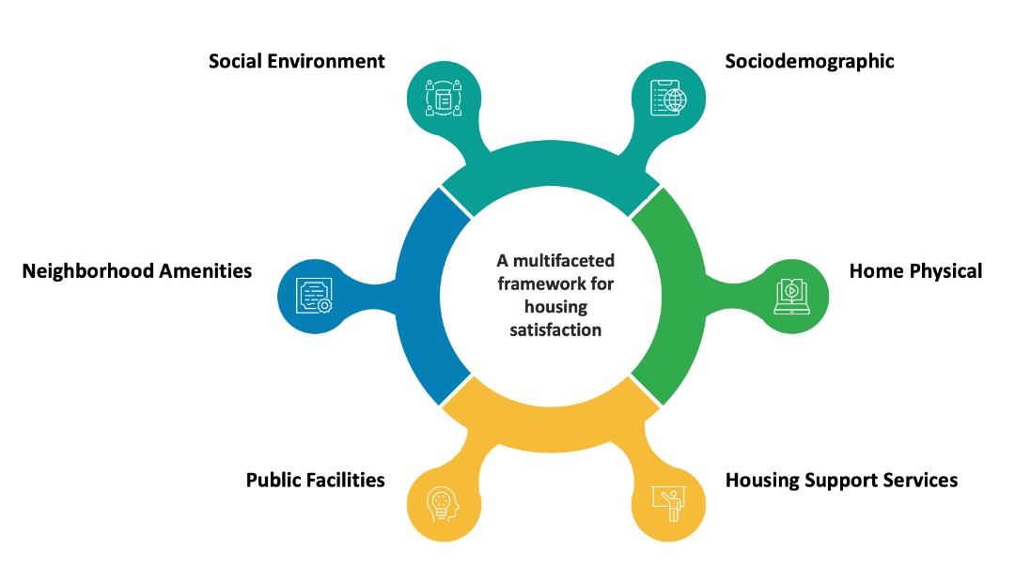

Figure 1: Framework for Various Aspects of Housing Satisfaction

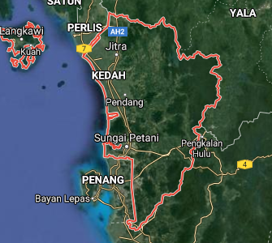
Figure 2: Map of Kedah State
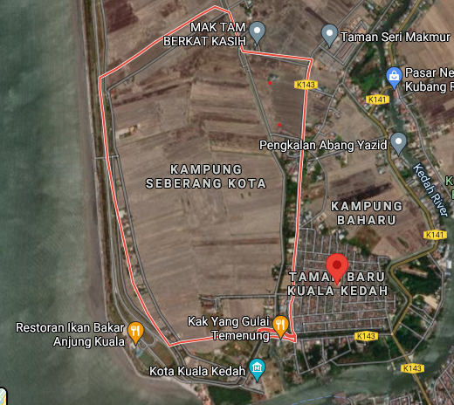
Figure 3: Map of Kampung Seberang Kota

Home Structure

Formal Housing Model
Formal Housing Satisfaction
Housing Environment

Community and Neighbourhood

Facilities and Infrastructure

Security and Safety

Figure 4: Framework
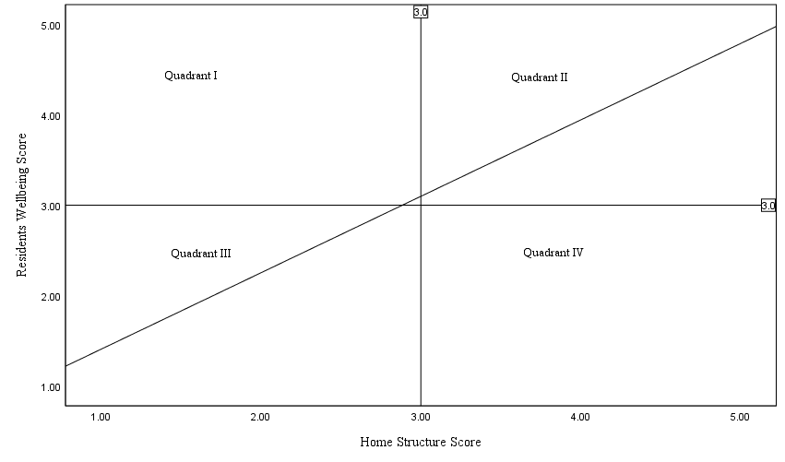
Figure 5: Schematic of Relationship between Home Structure and Residents Wellbeing

Figure 6: Satisfaction Formal Housing by respondents.

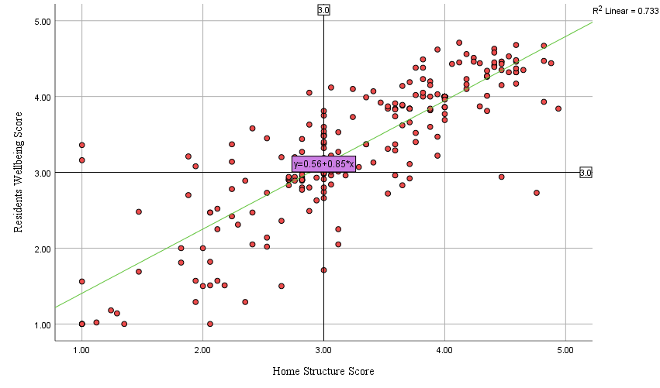
Quadrant IV
Quadrant III
Quadrant II
Quadrant I
Figure 7: Relationship between Formal Housing Satisfaction Score and Determinant of Formal Housing

Figure 8: Home Structure Satisfaction Index

Figure 9: Home Environment Satisfaction Index

Figure 10: Community and neighborhood Satisfaction Index

Figure 11: Facilities and Infrastructure Satisfaction Index

Figure 12: Security and safety Satisfaction Index

