THE UNDERSTANDING OF PSYCHOLOGICAL CHALLENGES FACING SOUTH AFRICAN SCHOOL LEARNERS IN 21ST CENTURY: A VISUAL EXPLANATORY APPROACH.

Abstract: The 21st century has brought rapid social, technological, and economic changes that have reshaped the educational landscape worldwide. Within this context, South African school learners face a multifaceted psychological challenges that significantly impact their well-being and educational outcomes. These challenges are shaped by the unique sociocultural context of South African societies, which are marked by historical inequalities, cultural diversity, and socioeconomic disparities. In order to develop effective interventions and support systems, this qualitative research aims to explore the understanding of these challenges through its’ participants’ perspectives. The study employed the interpretive paradigm, research context and the participants were purposively and convenience selected from two Secondary schools in the Kwa-Zulu Natal province of South Africa. The study utilized the focus group discussion and drawing as a visual explanatory approach to generate data on the understanding of psychological challenges of South African learners and their lived experiences in the 21st Century.
Keywords: 21st Century, Psychological challenges, South African school, Learner, Visual Explanatory Approach.

BACKGOUND OF THE STUDY
Various research studies in post 1994 has shown strides and motives taken by the government to address inequalities and injustices that are inherited from the previous education system in South Africa (Adonis & Silinda, 2021; Walton & Engelbrecht, 2022). However, the legacy of apartheid continues to manifest in various aspects of society, including the education system (Kanyopa & Hlalele, 2021; Pillay & Prinsloo, 2021). This shows that there are some disparities that excessively affect learners, especially those who are from historically underprivileged communities, perpetuating the cycle of poverty and inequality. Despite the advancements made to increase access to education Feng, Hu, Afshan, Irfan, Hu and Abbas (2023); Kanyopa (2023) mentioned that disparities in resources, quality, and opportunities still exist. On the other hand, literatures also pointed out some of the key challenges that facing South African school learners in 21st C such as the high levels of academic pressure and stress (Wills & Hormeyr, 2019; Mofokeng, 2023). It was mentioned that academic pressure seems to be as a push gear towards psychological challenges such as depression, stress, anxiety, and substance abuse which are ultimately hindering South African learners' achievements and personal growth (Kanyopa; 2022; 2023).
In addition, socioeconomic factors such as poverty and unemployment were mentioned to play a significant role in influencing the psychological challenges faced by South African learners (Pillay & Prinsloo, 2021). Adonis and Silinda (2021); Ajani (2023) argue that the unfair distribution of resources according to race leads to a widening achievement gap between advantaged and disadvantaged learners in South African schools. Despite of having social economic factors, scholars like Walton and Engelbrecht (2022); Feng et al. (2023) state that exposure to violence creates feelings of fear and anxiety which also play significant roles in affecting learners psychologically. These scholars further pointed that crime and violence in South African schools contributes to a hostile and unsafe learning environment for teaching and learning which negatively impact learner’s psychological well-being and academic success. Ajimudin and Mukuna (2023); Mofokeng (2023) supported that high level of violence and crime happening in South African school communities lead to the extensive psychological challenges to the learners which resulted to the detrimental impacts on their mental health, well-being, and academic achievement.

LITERATURE REVIEW
Defining psychological challenges
The term “Psychological challenges” refer to mental health problems that may negatively affect a persons’ emotion, mental, and physical functioning (Zwane & Mukuna, 2023). Psychological challenges normally trigger the mental issues such as anxiety and depression which were mentioned as prevalent among the South African school learners. Bechtel and Wright (2019) explained the psychological challenges as the specific difficulties, issues, and problems encountered by South African school learners within their sociocultural and educational environment. These challenges are influenced by factors such as the country's historical background, cultural diversity, socioeconomic disparities, educational policies, and community dynamics (Ajimudin & Mukuna, 2023; Wills & Hormeyr, 2019). Thus, in order to understand these challenges requires an in-depth exploration of how various contextual factors intersect and shape the psychological well-being and educational experiences of South African school learners, in order to develop effective interventions and support strategies tailored to their specific needs.
Relationship between 21st C Technological advancement and psychological challenges in teaching and learning
The impacts of psychological challenges in teaching and learning are seen obstacles to the mental well-being of both teachers and learners at schools (Khahro & Javed, 2022). In South African education context, it was mentioned that the advancement of technology in 21st C brought both pros and cons in the teaching and learning process. Studies revealed that the advancement of technology in 21st Century did not immune the far-reaching consequences of psychological challenges in teaching and learning process (Van Niekerk & van Gent, 2021). This also was supported by (Sarbrini, 2023; Zammit, 2023) that the advancement of technology in the 21st C goes hand in hand with critical psychological challenges such as lack of concentration in the classrooms, peer pressure and feeling of inadequate. (Sarbrini, 2023) goes further and mention that when the learners are engaged too much with technology such as online games, gambling etc. their ability to engage with learning material, and their academic performance may be compromised. This implies that their overall academic achievements of the learners can be adversely affected if they are too occupied by the technology.
It was also affirmed that technology advancement prompts the dropout rate and disengagement of the learners in the classrooms (Marino, Israel, Vasquez III, Fisher & Gallegos, 2018). Dropout rates were mentioned to go higher as a large number of learners decided to engage themselves with online marketing and businesses that was mentioned to provide them with progressive income. (Van Niekerk & van Gent, 2021; Zammit, 2023) they supported this by saying that factors such as poverty, societal pressures and family issues can contribute to a sense of hopelessness that making learners more susceptible to disengagement in the classrooms and ultimately, abandoning their educational journey. In addition, technology advancement seemed to create a negative atmosphere within the classroom. (Marino et al., 2018; Pillay & Prinsloo, 2021) revealed that technology brought a number of conflicts among the learners with an online bullying and mocking, that influencing lack of empathy among learners and turned them to be unpleasant when they are dealing with their emotional struggles. Thus, the negative learning atmosphere was declared to bring a negative impact towards the overall classroom dynamics and making the process of teaching and learning more challenging.
Indeed, the relationship between the 21st C technological advancements and psychological challenges in teaching and learning are multifaceted. Therefore, recognizing the trigger factors within a specific context and addressing the psychological challenges that learners are facing is crucial for creating an educational environment that supports their mental well-being (Ajimudin & Mukuna, 2023; Van Niekerk & van Gent, 2021), and fostering a positive and effective learning experiences to the learners. Hence, the current study employed a visual participatory approach to explore the understanding of psychological challenges facing South African school learners in 21st century.
METHODOLOGY
Leavy (2022) define research methodology as a systematic way of inquiry that examines and comprehend the complexity of research problem. It comprises components such as research design, paradigm, research approach and methods for data generation. The research methodology is an aspect of the research that seeks to dive thoroughly into its’ subjective elements to explain the research phenomenon to acquire a thoroughly knowledge of its’ social, cultural, and environmental impacts to the researched contexts and participants (Prosek & Gibson, 2021).

Research approach
According to Flick (2019); Tracy (2019) the research approach is a logical plan and procedure for the research that consists of certain steps toward data collection and analysis. The current study is grounded in a qualitative research approach to explore the understanding of psychological challenges that facing South African learners in the 21st Century. Leavy (2022) defines the qualitative approach as an approach that is used to gather non-numerical data. Qualitative research approach is characterized by its three main characteristics which are description, explanation and interpretation (Tracy, 2019). Thus, the approach provided the current study with in-depth understanding of the psychological challenges facing South African school learners in 21st Century. The qualitative approach also enabled the researchers to comprehensively explore the psychological challenges in 21st century to the learners by mainly focusing on their socio-cultural contexts, and learning experiences. Also this approach offered insightful that informed causes of psychological challenges to South African school learners, interventions, and support mechanisms for the successful teaching and learning process.

Research design
This is a visual explanatory research design that was influenced by active participation of research participants in the research process. In this design, the researchers incorporated visual elements such as photographs, drawings and other visual data contributed by the participants to explain the research problem. Vaughn and Jacquez (2020) affirmed that visual explanatory design involves active involvement of participants in various stages of the research process. It also allowing them to co-create knowledge, express their perspectives, and have a voice in shaping the research outcomes (Johannesson, Ohlson & Zhai, 2023). It was mentioned that visual explanatory research design is particularly valuable in studies where traditional verbal or written communication may not fully capture the complexity and richness of participants' experiences (Flick, 2019; Prosek & Gibson, 2021).

Research context and participants
Research took place in two selected secondary schools in KwaZulu-Natal province of South Africa, over the period of two months. The schools selected were both township schools with limited teaching and learning resourced. The schools also have high rate of violence that sometimes are caused by the communities around the schools. Staff in both schools are experiencing the feeling of insecurity and fear time to time due to lack of security companies to secure the schools. The majority of learners in both schools are black learner population who are come from disadvantaged communities. To ensure the confidentiality these schools were pseudonym named as school X and School Z. Each school was presented by 2 teachers and 3 learners.
A total of 10 (5 females, 5 males) participants were selected by using purposive and convenience sampling method. The sample comprises 4 teachers and 6 learners from grade ten and eleven. The written informed consents were given to the teacher participants while the learners since they are minors, the informed consent letter were sent to their parents to give the permission for their participation in the research process. All participants were blacks and selected voluntarily. The ethical clearance also was given by the ethics committee of the University where both authors are working. The table below presents the profiles of the participants of the study.

Table 1. Participants’ profiles
Participant pseudonym | School | Grade | Gender | Age between
Teacher 1 | X | 11 | M | 30-35 years
Teacher 2 | X | 11 | F | 20-25 years
Teacher 3 | Z | 12 | M | 40-45 years
Teacher 4 | Z | 12 | F | 45-50 years
Learner 1 | X | 11 | M | 15-17 years
Learner 2 | X | 11 | F | 15-17 years
Learner 3 | X | 11 | M | 15-17 years
Learner 4 | Z | 12 | M | 15-17 years
Learner 5 | Z | 12 | F | 15-17 years
Learner 6 | Z | 12 | F | - ears

Data generation methods
Data generation is the activity of obtaining and compiling information from different sources (Leavy, 2022; Walton & Engelbrecht, 2022). Data generation methods are crucial in research process because “how the information was collected and explained determine the methodology applied in the research process” (Leavy, 2022, p.44). This study employed the focus group discussion and drawing to generate data to answer the following research questions.
- What are the understanding of psychological challenges facing South African school learners in the 21st century?
- What are the impacts of psychological challenges to South African school learners in the 21st century?
- Why is it important to have a visual understanding of the psychological challenges facing South African school learners in the 21st century?

- Focus group discussion
A focus group discussion is a data generation method that includes a small group of participants, sitting together and discus in details the research problem topic in a structured and interactive manner (Flick, 2019; Vaughn and Jacquez (2020). A focus group discussion was selected because it is most suitable method for the researchers and participants as it saved time, and enabled us to get in-depth insights into participants' opinions and experiences related to psychological challenges facing South African school learners in 21st Century. The four teacher participants were involved in focus group discussion to seek the clarity of the research questions mentioned above. Thus, in this study the focus group discussion took place in two days (23rd and 24th) of November, 2023. And each session was lasted for one hour, whereby, teacher participants were actively engaged in the discussion regarding their understanding of psychological challenges facing South African school learners in 21st century.

- Drawing
Kanyopa and Hlalele (2021) mentioned the significance of conducting research using drawings to generate data. Hripcsak, Schuemie, Madigan, Ryan and Suchard (2021, p.280) alluded that “drawing is a method that creates opportunities for its participants to generate data that is not reliant on language skills and can also provide access to unconscious views and beliefs”. Research also affirmed that the use of drawing in a research involves participants to picture their thoughts, and explaining in details the meaning embedded in their drawing (Kanyopa & Hlalele, 2021; Kanyopa, 2022). Six learners are the only participants that were involved to this generation method This is because drawing method seems to be more relevant to their age group, and also it gave them an opportunity to express their nonverbal experiences in a picture form.

Therefore, the drawing data generation process in this study took places in three main sessions, that lasted for two hours. In the first session, researchers begun by explaining to the participants on how to do the drawing method by using metaphors to explain their understanding and their experiences of psychological challenges facing South African school learners in 21st century. The second session was the making of drawing, whereby the participants were asked to use pencils and paper to draw their drawings. The participants were encouraged to think deeper to provide a drawing that is relevant and corresponds to their understanding and experiences of psychological challenges facing South African school learners in 21st century. The third session was interpretation of the drawing, whereby each participant was given an opportunity to speak freely about their drawings as to gain deeper understanding of the researched phenomenon.

Data Analysis
According to Braun, Clarke and Hayfield (2023); Morgan (2022) thematic is a data analysis method in qualitative research that includes detecting and analysing patterns within a generated data to acquire a greater knowledge of the study issue. Researchers employed this strategy to carefully study and code the data from the focus group discussions and drawings’ transcripts, field notes, or other textual data, in order to find repeating patterns of meaning, ideas, or experiences. Thematic analysis allowed us to identify the recurring patterns from the data generated by starting with transcribing the verbal, textual and visual information from the participants.

Trustworthiness of the study
The current study undertakes several measures to ensure its’ trustworthiness. To ensure the credibility, researchers employed member checking on the instruments that provided the feedback and suggestions from the colleagues on the formation of questions and objectives of the study. In addition, triangulation of data sources and diverse methods were employed to strengthen the robustness of the findings. Dependability was ensured by providing a clear description of data generation procedures, coding, and analytical decisions that could be followed and verified by the future research. The transferability is ensured by rich information regarding the research participants and contextual descriptions of the research context to allow readers to assess the applicability of the findings to other similar contexts. While, Confirmability was ensured by embracing reflexivity throughout the research process, acknowledging, and documenting the researchers' biases and preconceptions to maintain transparency and minimize undue influence on the interpretation of data. Also, transcripts were sent back to the participants to review and validate the interpretations of the findings to ensure no omission or addition of what they contributed.

FINDINGS
This section discusses the findings of the study under the emerging themes. Data analysis process revealed three main themes which are; Diverse understanding of psychological challenges facing South African school learners in 21st century; Impacts of psychological challenges facing South African school learners in the 21st century; The importance of understanding psychological challenges facing South African school learners in the 21st century. Participants elaborated study’s findings through these themes as follows;

Theme one: Diverse understanding of psychological challenges facing South African school learners in 21st century.
When engaging in the focus group discussion to answer the first research question, the participants’ response revealed that psychological challenge is anything that affects the wellness of an individual mental health.

Teacher 1 explained;
“A psychological challenge refers to a difficult or stressful situations that an individual may experience, which can negatively impact their mental and emotional well-being.”

Teacher 2 also added;
“psychological challenges involve cognitive and behavioural factors that contribute to suffering and maladaptive functioning.”
Teacher 3 mentioned that;
“Psychological challenge is anything that may cause an emotional draining to a person, which may be caused by the disappointment in life and sadness linger for long time”

When engaging in drawing sessions, learners also explained this theme by providing their drawings that elaborate their understanding of psychological challenges as follows;

Learner 6 explained her understanding of psychological challenge by related it with the state of a person being overwhelmed with work or study related issues and life circumstances in general. The drawing below elucidates her understanding of the research phenomenon.


During the drawing interpretation session, learners 6 states “learners in 21st century we are overwhelmed, this is because, there is a point where we feel like we are being buried by studies’ stress, life challenges and the weight of responsibilities”

Furthermore, Learner 3 also explained his understanding of psychological challenges by relate it with the situation whereby the person does not have a clear mental attitude. The drawing below elucidates his understanding of psychological challenges. that is lost and not knowing what to do.
During the drawing interpretation, learner 3 elaborated that “psychological challenges is the situation where us as learners we are finding ourselves in the situation that we need to make choices that rise the conflicts between our morals and our temptations”

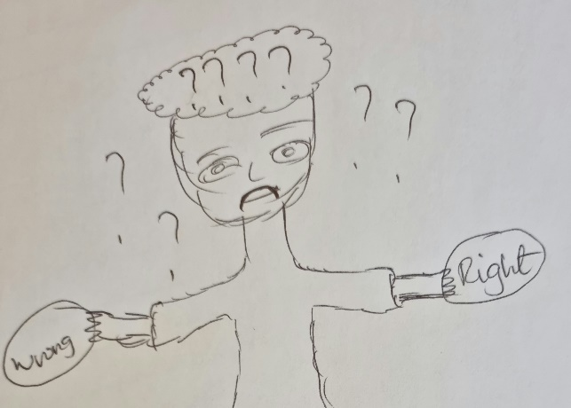

However, some of the learner participants tried to answer and explain the first theme from the positive psychology point of view, and relate the issue of psychological challenges with encouragements that an individual gets after experiencing unrest mental state towards certain task and force himself or herself towards the achievements, personal growth and self-improvement. Learner 4 provided a drawing that express positivity of understanding psychological challenges.
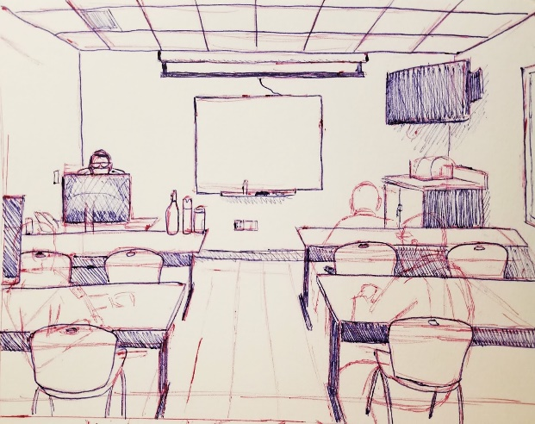
During drawing interpretation session, learner 4 mentioned that
“I view psychological challenges as a reminder to myself about my goals and try to keep focusing on them everyday”

This also was supported by Learner 2 who alluded that;
“… a psychological challenge can be seen as an opportunity for … growth and development.”

Learner 3 also commented;
“… South African learners are encouraged to embrace challenges as opportunities for personal growth and self-improvement”

Bechtel and Wright (2019); Mofokeng (2023) stipulated the perspective on the understanding of psychological challenge as a golden opportunity for an individual to learn and grow from that experience. They both argued that people should consider difficult situations as temporary and focus more on improving themselves and not situations, this will help them to avoid stresses.

Theme two: Impacts of psychological challenges facing South African school learners in the 21st century.
It was mentioned in Ajimudin and Mukuna (2023) that high rates of poverty, unemployment, and unfair access to basic services are the core reasons for psychological challenges to South African school learners. Participants’ responses on the second theme revealed that learners from low economic class are experiencing financial stress, lack of resources, and limited opportunities which result to feelings of low self-esteem. During the focus group discussion teacher participants revealed that learners are negatively affected by the psychological challenges and contribute to the poor discipline issues in their schools.
Teacher 1 contributed;
“…currently we are experiencing a high range of poor discipline in our school… which always come with harmful behaviors and thoughts… such as suicide thoughts”
Teacher 2 also added;
“… Mmmh, true…I still remember a tragic death of one our grade 10 learner in 2021… he ended his life and left us with lots of unanswered questions till now”

The responses of teacher participants from school Z revealed that psychological challenges contribute to learners’ maladaptive functioning and poor performance in their school works.

Teacher 3 commented;
“I saw some of our best learners turned to be lazy, lost focus and becoming less optimistic in everyday basis… which hindering their academic performance”

Teacher 4 also agreed;
“…True…psychological challenges affect our learners’ energy level, mental ability and their concentration in the classrooms”

Moreover, during the drawing sessions, learners also explained this theme by providing their drawings that elaborate the impacts of the psychological challenges as follows;

Learner 1 explained the impacts of the psychological challenges facing South African school learners in 21st century by associate it with high suicidal rates in schools. He drew the following drawing to explain such impact.
During the drawing interpretation session, Learner 1 mentioned that “psychological challenges are linked to many chronic emotional, mental and behavior problems that contribute to the feeling of loss control, confusion and exhaustion to many learners”

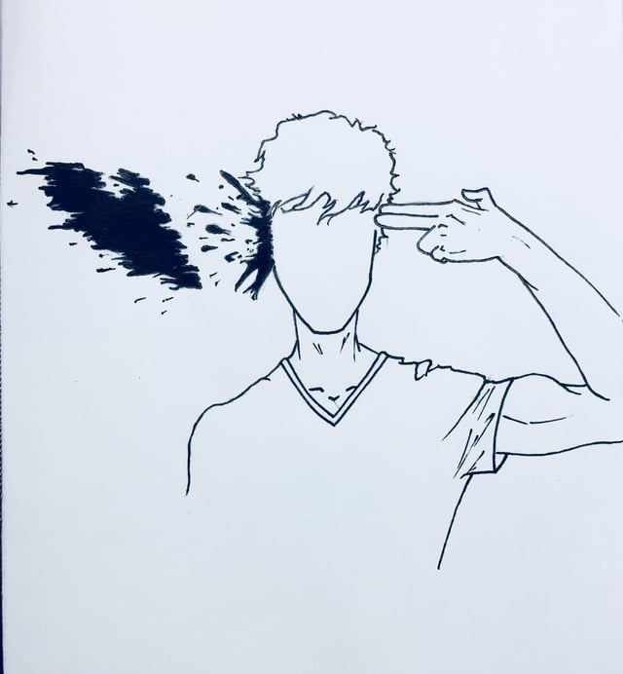

In addition, Learner 4 explained the impacts of psychological challenges by associating it with his personal experiences, and mentioned that learners’ actions and behaviors always reflect to what is in their minds. He explained this by pulling out the issue of bullying in schools and say that most of the time bullies’ actions is expression of their resentment that covered their mentality. He drew the following drawing to elucidate this.
During the drawing interpretation session, Learner 4 said “bullies are trapped in a world where no one seems to understand the pain they are going through…they often feel like they have nobody to turn to, which only deepens the sense of loneliness. As a result, they are deciding to express it in a bitter way”.
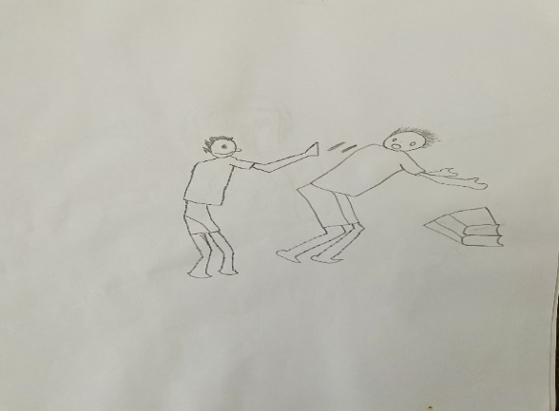

Moreover, Learner 5 shared the profound impact of psychological challenges and describing it as a constant source of fear, anxiety, and isolation. She drew the following drawing to comprehend this.

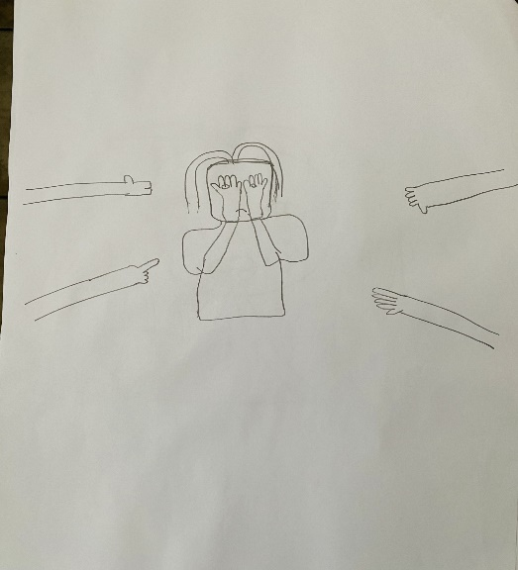
During the drawing interpretation session, Learner 5 mentioned “this picture shows that learners are facing a lot, and at the same point…their emotions are covered, silenced and their thoughts are remaining unspoken…which turn them to choose isolation”.

The above responses from the participants show that the psychological challenges have negative impacts to South African school learners as most tend to contribute to the loss of focus and becoming unhappy to themselves and everyone of everything around. As evidenced in Magabane (2021); Van Niekerk and van Gent (2021) that psychological challenges lean towards the mental complications that decrease enjoyment of life and increase time to time conflicts to an individual.

Theme three: The importance of having an understanding of psychological challenges facing South African school learners in the 21st century

Participants of the study further shared their perspectives of the importance of having a concrete understanding of psychological challenges facing South African school learners in the 21st century. Harrison, Loxton and Somhlabe (2021) mentioned that it is crucial for parents, teachers and caregivers to have a full understanding of psychological challenges facing South African school learners in 21st century, this will decrease hopelessness and suicides to many learners. Zwane and Mukuna (2023) affirm that the understanding of psychological challenges will save life by save millions of learners from developing serious mental illnesses. Participants of the study commented as follows:

Teacher 3 commented that;

“Understanding of psychological challenges enables learners to become more self-aware, also it pushes schools’ authorities to provided access to trained counsellors and therapists who will help learners to address and cope with their psychological challenges.”

Teacher 1 also mentioned;

“Having a critical understanding of psychological challenges that facing our learners in 21st century allows us as teachers to work cooperatively with parents to provide individual support tailored to the learner's needs”

Teacher 2 added;

“The understanding of psychological challenges helps us to develop effective coping strategies to our learners… as school, it is our responsibility to created safe and supportive environment that deals with diverse challenges of our learners”

Teacher 4 also commented;
Having an understanding of psychological challenges would significantly impact our learners’ academic achievements as they will improve with coping mechanisms and skills provided by their schools”

When engaging in drawing sessions, learner participants also shared their drawings that represent their perspectives on this theme. To start, was Learner 1 who mentioned that:

“Comprehending these challenges allow schools to provide us with appropriate interventions and support systems”
During the drawing interpretation session, Learner 1 interpreted his picture by saying that “the understanding helps the counselor and learner with psychological challenges to speak one language and understand each other”

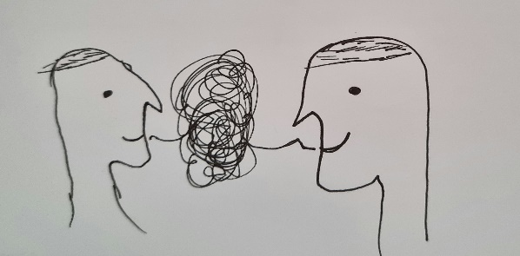

Learner 5 also commented:
“understanding these challenges contribute to breaking of the violence, isolation and stigmas”

Learner 2 further supported that:
“Breaking of those cycles offering the learners some opportunities for personal growth, healing, and empowerment”
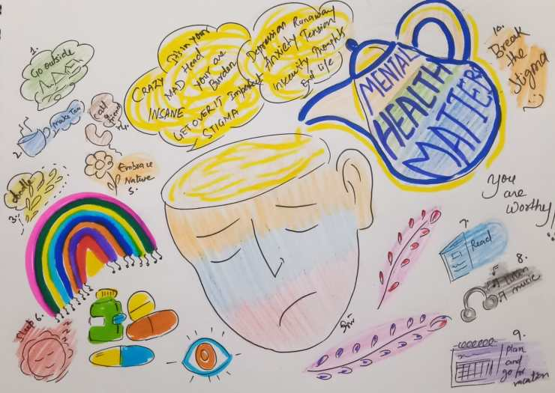
During drawing interpretation session, Learner 2 mentioned that “the understanding of psychological challenges helps to break the cycle of discrimination, exclusion and stigmatization which are dangerous in our communities”

Learner 4 also explained:
“Understanding creates awareness…which help learners to deal with their challenging situations without losing themselves”
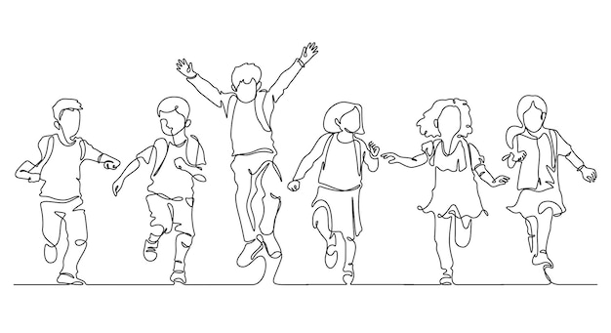
During drawing interpretation session, Learner 4 mentioned “the understanding of these challenges help learners to cope effectively with stresses, which I view it as a self-care and stress reduction”

The participants’ comments above show that it is crucial to have a critical understanding of psychological challenges facing South African school learners in 21st century because having a full understanding of these challenges help learners to seek and appropriate support and interventions, that will enable them to thrive academically Feng et al., 2023; Khahro & Javed, 2022). In addition, by recognizing these challenges both teachers and policymakers can develop targeted interventions that promote psychological well-being and assist them in creating a supportive learning environments (Adonis & Silinda, 2021; Zammit, 2023).

DISCUSSION
This demonstrated that psychological challenges affected the well-being of learners and their academic performance. The effects including poor concentration in the classroom, anxiety, low self-esteem, stress and frustrations that leads to the low mental functioning. These findings concurred with research which revealed some of considering factors that impact learners’ overall well-being and academic success (Ajimudin & Mukuna, 2023). Therefore, it is important for South African teachers to be well equipped with knowledge and skill to understand the psychological challenges facing their learners specifically in the 21st century whereby the technology brought both pros and cons to young generations. This is also supported by the studies that indicated that technology advancement in 21st century plays a crucial role in education, but its impact is not uniform across all socio-economic groups (Marino et al., 2018; Sarbrini, 2023). This implies that, learners from affluent backgrounds may have access to the latest technological resources, while those from disadvantaged communities may lack basic access to the internet and electronic devices Thus, the digital divide creates a psychological challenge, as learners without adequate access to technology may feel left behind, fostering a sense of inadequacy and limiting their educational opportunities (Wills & Hormeyr, 2019; Zammit, 2023).

The results of the study indicated that psychological challenges are influenced by socio-economic disparities such as poverty, inequalities and poor parenting which are predominant in the country. It is consistent with the literature which alluded that historical legacy of apartheid has left a lasting impact on access to resources, with a significant portion of learners facing economic hardship (Ajani, 2023; Zochi, 2017). In addition, Hripcsak et al. (2021); Kanyopa and Hlalele (2021) affirmed that learners from disadvantaged backgrounds often experience heightened stress, anxiety, and a sense of inadequacy, as they contend with the pressure to succeed in an environment where resources are rare. Body of South African literature affirm that lack of adequate nutrition, housing, and other basic needs contributes to a challenging psychological landscape for South African school learners (Wills & Hormeyr, 2019; Zwane & Mukuna, 2023). This study has found that peer pressure is another source of psychological challenges as most of the time teachers are confronted with unpleasant behavior and poor discipline from the learners. Ajimudin and Mukuna (2023) pointed out that some of unpleasant behavior at schools are influenced by the learners who are not well mannered and show disrespect to the teachers.

In addition, the study has found that psychological challenges cause a negative learner-teacher relationship as both parts may have bad experience from each other. This is also supported by the studies that indicated negative relationship always influence negative experience (Ajimudin and Mukuna (2023). This was also supported by scholars like Kanyopa (2022); Zwane and Mukuna (2023) who had negative relationship with their teachers earlier in their schooling years. Thus it is advised that learners and teachers need to work collaboratively in a supportive environment to enhance learners’ academic performance (Harrison et al., 2021; Magabane, 2021). Findings has indicated the shortage of learning resources contributing on psychological challenges to South African school learners. However, teacher participants of the study revealed that the problem is not that schools do not have the resources at all, but problem is the learners who do not look after the resources.
The study has found that external distractions also contribute to psychological challenges to school learners in 21st century. Poor living conditions, situations at homes as well as too much responsibilities that learners facing at their homes are mentioned to have specific effects on learners’ well-being and academic performance at school (Adonis & Silinda, 2021; Wills & Hormeyr, 2019). Psychological challenges seem to affect many areas of learners’ lives, reducing their productivity, and academic achievement. These challenges also are mentioned to negatively impact relationships with their friends, teachers and family members. This study notes that these challenges can have long-term consequences for learners’ future careers and their overall well-being, thus the next section stipulates the recommendations of this research.

RECOMMENDATIONS
Drawing from the psychological challenges and its effects to the learners, this study recommended that teachers should adopt various classroom management strategies to monitor and assess their learners’ behavior at school. Harrison et al. (2021); Pillay and Prinsloo (2021) recommended that classroom control strategies like peer evaluation, class charter and encouraging of initiatives are important for eliminating factors that contributing to the psychological challenges to the learners.

Also, this study views teachers as facilitators at school as they determine the teaching and learning atmosphere, create and maintaining their classes, and therefore, the study recommends that teachers’ training is vital in supporting South African learners emotionally, socially, mentally and physically. Kanyopa (2022); Walton and Engelbrecht (2022) advised teachers to have self-evaluation and where they need to improve and where they can collaborate with parents and communities for better practices in navigating psychological challenges facing learners in schools.
For future research, this study recommends community engagement as professional way of learning South African learners’ communities, this will help to eliminate psychological challenges which are grounded within these communities. In addition, when involving teachers and learners in the studies, this study recommends that future researchers to facilitate cooperative research process because it gives the participants opportunity to share their lived experiences and enrich the study with diverse perspectives in its finding.
CONCLUSION
The psychological challenges facing South African school learners in 21st century are complex and interconnected, rooted in historical, social, economic, and educational factors. Addressing these challenges requires a holistic approach that considers the multifaceted nature of South African learners lived experiences. Efforts to bridge the social-economic gap, promotion of culture understanding, reduction of inequalities, and ensuring of equitable access to education are indispensable steps toward creating an educational environment that bring up positive psychological well-being for all South African learners. It is believed that addressing of psychological challenges facing South African school learner fosters motives towards building a more inclusive, integrative and supportive educational system that nurtures the potential of every South African learner regardless of their background.

CONFLICT OF INTEREST
Both authors declared that they have no conflict of interest.

DATA AVAILABILITY STATEMENT
The data that support the findings of the current study are available from the corresponding author upon reasonable request.

REFERENCES

Adonis, C. K., & Silinda, F. (2021). Institutional culture and transformation in higher education in post-1994 South Africa: a critical race theory analysis. Critical African Studies, 13(1), 73- 94. https://doi.org/10.1080/21681392.2021.1911448
Ajani, O. A. (2023). Challenges of school resources management for curriculum delivery in South African Rural High Schools: Principals' perceptions on the way forward. International Journal of Research in Business and Social Science (2147-4478), 12(6), 275-285. https://doi.org/10.20525/ijrbs.v12i6.2709
Ajimudin, F., & Mukuna, K. R. (2023). Psychological challenges facing grade 7 learners in mathematics classes at schools in the Frances Baard district, Northern Cape. International Journal of Studies in Psychology, 3(2), 53-62. https://doi.org/10.38140/ijspsy.v3i2.934
Bechtel, W., & Wright, C. D. (2019). What is psychological explanation?. In The Routledge companion to philosophy of psychology (pp. 113-130). Routledge.
Braun, V., Clarke, V., & Hayfield, N. (2023). Thematic analysis: A reflexive approach. SAGE Publications.
Feng, Y., Hu, J., Afshan, S., Irfan, M., Hu, M., & Abbas, S. (2023). Bridging resource disparities for sustainable development: A comparative analysis of resource-rich and resource-scarce countries. Resources Policy, 85, 103981. https://doi.org/10.1016/j.resourpol.2023.103981
Flick, U. (2019). The concepts of qualitative data: Challenges in neoliberal times for qualitative inquiry. Qualitative Inquiry, 25(8), 713-720. https://doi.org/10.1177/1077800418809132
Harrison, C., Loxton, H., & Somhlaba, N. Z. (2021). Stress and coping: considering the influence of psychological strengths on the mental health of at-risk South African adolescents. Child Care in Practice, 27(1), 72-86. https://doi.org/10.1080/13575279.2019.1604492
Hripcsak, G., Schuemie, M. J., Madigan, D., Ryan, P. B., & Suchard, M. A. (2021). Drawing reproducible conclusions from observational clinical data with OHDSI. Yearbook of medical informatics, 30(01), 283-289. https://doi.org/10.1055/s-0041-1726481
Johannesson, E., Ohlson, J. A., & Zhai, S. W. (2023). The explanatory power of explanatory variables. Review of Accounting Studies, 1-31. https://link.springer.com/article/10.1007/s11142-023-09781-w
Kanyopa, T. J. (2022). Understanding and enhancing learner integration in a selected ex-model c school (Doctoral dissertation).
Kanyopa, T. J. (2023). Exclusion, Diversity and Inclusion. Inclusion in Southern African Education: Understanding, Challenges and Enablement, 3-9. https://link.springer.com/chapter/10.1007/978-3-031-43752-6_1
Kanyopa, T. J., & Hlalele, D. J. (2021). The learning experiences of learners transitioning from rural and township schools to ex-Model C schools. The Independent Journal of Teaching and Learning, 16(1), 96-114. https://hdl.handle.net/10520/ejc-jitl1-v16-n1-a9
Khahro, S. H., & Javed, Y. (2022). Key challenges in 21st century learning: a way forward towards sustainable higher educational institutions. Sustainability, 14(23), 16080. https://doi.org/10.3390/su142316080
Leavy, P. (2022). Research design: Quantitative, qualitative, mixed methods, arts-based, and community-based participatory research approaches. Guilford Publications.
Magabane, D. C. (2021). An exploration of strategies used by schools to cope with indiscipline: a case of rural secondary schools in Limpopo Province, South Africa (Doctoral dissertation).
Marino, M. T., Israel, M., Vasquez III, E., Fisher, K. M., & Gallegos, B. (2018). Teaching and learning with technology. The Wiley International Handbook of Educational Foundations, 245. https://doi.org/10.1002/9781118931837
Mofokeng, P. S. (2023). Effects of COVID-19 on Learners’ Wellbeing in a Rural High School District. International Journal of Studies in Psychology, 3(2), 11-17. https://doi.org/10.38140/ijspsy.v3i2.921
Morgan, H. (2022). Understanding thematic analysis and the debates involving its use. The Qualitative Report, 27(10), 2079-2090. https://doi.org/10.46743/2160-3715/2022.5912
Pillay, K., & Prinsloo, T. (2021). Using the Diffusion of Innovation Theory to Explain Foundation Phase Teachers’ Perceptions of Online Zoom Classes During a Pandemic–A Case of a South African Private School. In Innovative Technologies and Learning: 4th International Conference, ICITL 2021, Virtual Event, November 29–December 1, 2021, Proceedings 4 (pp. 521-532). Springer International Publishing. https://link.springer.com/chapter/10.1007/978-3-030-91540-7_53
Prosek, E. A., & Gibson, D. M. (2021). Promoting rigorous research by examining lived experiences: A review of four qualitative traditions. Journal of Counseling & Development, 99(2), 167-177. https://doi.org/10.1002/jcad.12364
Sarbini, S. (2023). Challenging Ethics and Moral Education in The Age of Technology Among Student in Bandung. Edukasi Islami: Jurnal Pendidikan Islam, 12(03). http://dx.doi.org/10.30868/ei.v12i03.4215
Tracy, S. J. (2019). Qualitative research methods: Collecting evidence, crafting analysis, communicating impact. John Wiley & Sons.
Van Niekerk, R. L., & van Gent, M. M. (2021). Mental health and well-being of university staff during the coronavirus disease 2019 levels 4 and 5 lockdown in an Eastern Cape university, South Africa. South African Journal of Psychiatry, 27. http://www.sajp.org.za/index.php/sajp/pages/view/policies#part_4
Vaughn, L. M., & Jacquez, F. (2020). Participatory research methods–Choice points in the research process. Journal of Participatory Research Methods, 1(1). https://doi.org/10.35844/001c.13244
Walton, E., & Engelbrecht, P. (2022). Inclusive education in South Africa: path dependencies and emergences. International Journal of Inclusive Education, 1-19. https://doi.org/10.1080/13603116.2022.2061608
Wills, G., & Hofmeyr, H. (2019). Academic resilience in challenging contexts: Evidence from township and rural primary schools in South Africa. International Journal of Educational Research, 98, 192-205. https://doi.org/10.1016/j.ijer.2019.08.001
Zammit, L. (2023). Teaching Ethics in the Age of Technology: Promoting the Ethical Use of Technology in Maltese Secondary Schools (Doctoral dissertation, UCL (University College London). https://discovery.ucl.ac.uk/id/eprint/10167592
Zwane, N. P., & Mukuna, K. R. (2023). Psychosocial factors influencing the academic performance of students at a rural college in the Covid-19 era. International Journal of Studies in Psychology, 3(1), 6-12. https://doi.org/10.38140/ijspsy.v3i1.897

