Article

Hallyu Stars Mediated Fandom: Understanding Mediatisation of Non-K-Pop Consumption Among Malaysian Youth

Nurul Akqmie Badrul Hisham

Institute of Ethnic Studies (KITA), Universiti Kebangsaan Malaysia
43600 UKM Bangi, Selangor, Malaysia

*Corresponding author: akqmiehisham@ukm.edu.my

Abstract: Tapping into mediatisation as a critical lens to examine how cultural synergy, particularly Korean Wave’s influence, manifests and impacts of everyday cultural practice in Malaysia. Despite a delayed start compared to neighbours, the Korean Wave ignited by the drama “Winter Sonata” in 2002, maintains a remarkable popularity in Malaysia. This study delves deeper than the surface of the Korean Wave, or Hallyu, exploring the intricate interplay between Korean stars, social media, and the phenomenon’s power. This work aims to understand how these elements actively shape and maintain its influence. While there has been a proliferation of research on the Korean Wave, it focuses on K-Pop music and K-Drama. Thus, this research project is designated to highlight elements other than K-Pop and K-Drama in the Korean Wave phenomenon by focusing on non-K-Pop cultural products. By observing open social media accounts and content, as well as events related to South Korean products, this study will use qualitative methods, netnography and participant observation for data collection. The findings are discussed in four key themes: Exploring Platforms and Fan Communities and Their Impact on Everyday Practices; International Brands Using Korean Stars for Product Promotion in Malaysia; the Potential of Selected Qualitative Methods for Understanding Social Phenomena; and the Limitations of These Methods in Research. The study highlights the need to choose relevant theories and research methods to improve the quality and depth of findings, especially when exploring complex subjects such as fandom.

Keywords: Mediatisation; Korean Wave; Fan Culture; Youth; Media Studies

Introduction
Social media has had a significant impact on Malaysia, bringing about various changes. Due to the progress of media and technology, we currently exist in a time where individuals have the ability to retrieve information from the Internet utilising various devices, regardless of their location. Previously, Couldry and Hepp (2017) argue that society is currently experiencing the effects of mediatisation, in a time where advancements in media and communication technology have revolutionised our methods of communication. While Dueze, (2012) clearly stated that media is as essential to humans as water is to fish. Whether we like it or not, media has become an integral part of every aspect of our lives as it is no longer just a technological tool, but a fundamental element of our world. Research conducted by Abu Hasan and Sukimi (2023) illustrates how social media fosters a type of communication marked by direct two-way interaction between the ruling elite and the general populace, engaging in reciprocal exchanges. This highlights the profound impact of social media on interpersonal communication dynamics, emphasising the necessity for further scholarly inquiry in this field.
Mediatisation among youth refers to the increasing influence and role of media in shaping the perceptions, behaviours and lifestyles of young people. With the advent and widespread availability of digital media platforms, young people today are more connected to media than ever before. This constant exposure to various forms of media, such as television, social media, video games and online content, plays a significant role in shaping their identities, values and attitudes. While the process of mediatisation among young people can have both positive and negative impact. Thus, there is a need to understand the process of mediatisation among young people in various aspects of life. With a focus on enhancing general understanding, this study aims to explore the mediatisation process among Korean wave fans in Malaysia.
Known as a global phenomenon, the Korean wave has made its mark in Malaysia with some slight variations. Despite initial concerns about cultural differences, the Korea Wave has gained popularity in Southeast Asia, even among Muslim audiences (Shim, 2017). The Korean wave started in Malaysia and other Southeast Asian countries like Thailand, Vietnam and Indonesia in the late 1990s (Mohd Jenol & Ahmad Pazil, 2022). To be precise, while neighbouring countries in Southeast Asia embraced the Korean wave earlier, Malaysia’s embrace took a bit longer and can be traced back to 2002 with the broadcast of the drama Winter Sonata (Hamzah & Mustafa, 2008). Although the Korean wave entered Malaysia later and faced initial resistance, Malaysians quickly embraced it, especially in the 2010s. The Korean wave has influenced various sectors in Malaysia, including tourism, marketing, food and education, leading to changes in consumer behaviour (Gan, 2019).
According to the newspaper, Winter Sonata, which aired in Malaysia in 2002, drew more than 1.5 million viewers each time it was broadcast on the local television (Cho, 2010). Lee et al. (2020) state that one of most popular topics in Korean popular culture discourse on Malaysian social media is the passion for Korean food in Korean dramas. This is supported by the increasing popularity of Korean food restaurants in Malaysia, even among Malaysian Muslims (Buang et al., 2018). Another reason for this popularity is the famous Korean celebrity’s beauty. They are often recognized and attract the audience’s attention and encourage them and the celebrity fans to try the Korean-made cosmetics (Lim et al., 2020).
Coherently, Han et al. (2022) found that attachment to Korean wave’s stars along with psychological and experiential cultural proximity, are key factors influencing purchase intentions for Korean goods. A study conducted by Suvittawat (2022), also revealed that K-Pop celebrities have a significant impact on fans’ consumer expectations, loyalty, satisfaction, and brand loyalty, not only in terms of music but also in the products they endorse and recommend. Locally, Malaysian youths are accustomed to tracking their favourite celebrities on social media, so when Korean celebrities serve as brand ambassadors for Korean cosmetics, they introduce and motivate people to try the products (Chan, 2018). Thus, there is a need to further explore the extent of this influence and its impact on fans’ behaviour in Malaysia. Additionally, understanding the elements that contribute to the attachment to Korean wave’s stars and drive the acceptance of Korean goods or products is crucial for researchers in this field.
Therefore, this research aims to understand the mediatisation process among Korean wave fans, particularly through social media and how it influences beyond K-pop and K-Dramas on everyday cultural practices among Malaysian youth. This research is guided by two research questions:
- How does the mediatization process, specifically social media engagement among fandom, contribute to the consumption of non-K-pop products among Malaysian youth?
- What are the potential limitations and opportunities associated with using netnography and participant observation to study the impact of the Korean wave in Malaysian youth culture?

Literature Review
1 Korean Wave
The global phenomenon of accepting Korean cultural products is known as the Korean Wave. Korean Wave is often seen as a light entertainment that was initially liked by housewives which later enjoyed by teenagers. Just as soap opera from Latin America, Indonesia’s Sinetron, serial drama from Taiwan and Japan to pop music and lively group dances, the public sees this as a new trend in the entertainment world.
This study looks at the Korean Wave phenomenon as a phenomenon to be studied. In previous studies, Korean cultural products were also discussed by using other terms. Terms such as Korean Wave or KWave and Hallyu refers to the same meaning. According to previous research, Korean Wave refers to the increase of the visibility and acceptance of Korean culture at the international level, beginning in East Asia in the 1990s and continue recently in the United States, Latin America, Middle East and in several parts of Europe. However, a study by Nazri et al. (2022) highlighted concerns among the community when various incidents and negative sentiments involving Islamic culture and religion arose with the presence of this popular Korean wave in Malaysia.
The topic of the Korean Wave, which has been previously explored by academics, encompasses two media types - television series and pop music (K-pop), with Korean films and other genres of music playing a role in this phenomenon (Shim, 2017; Jang & Paik, 2012; Jalaluddin & Ahmad, 2011). The term "Korean Wave" (Hallyu), believed to have originated from Chinese journalists who coined it to describe the surge of Korean pop culture that spread through China in the 1990s, was first introduced in a 1999 issue of the Chinese magazine Qingnianbao (Kim, 2011). "Hallyu" is derived from the Chinese characters “han” and “lyu”, meaning “sudden cold wave”, aptly symbolising the sudden popularity of Korean mass culture on a global scale. This term served as a cautionary message to local audiences, warning them about the influence of Korean popular culture.
Kim (2015) elaborates on the concept by highlighting that Hallyu has emerged as a key driver of popular culture in East Asia. Additionally, he suggests an alternative interpretation of Hallyu as "the winter wind blowing fiercely over China’s mainland." Simultaneously, Kim introduces the term "Hanmi" to portray the fervent obsession with K-pop culture in China, drawing parallels between the English word 'mania' and the Chinese term “mi”. The Korean Wave encompasses a broad spectrum of cultural offerings from Korea, such as music, television dramas, movies, and video games, often centred around charismatic celebrities who garner not just popularity but also admiration akin to worship. Moreover, celebrities play a pivotal role as the main attraction for fans within the realm of the Korean Wave (Lee, 2015; Parc & Moon, 2013). Shim (2017) goes on to expand the scope of these terms by asserting that post-2010, Hallyu has encompassed all facets of Korean culture, extending beyond entertainment to include elements like Soju, cuisine, fashion, makeup, and more.
With the advancement of technology, enthusiasts and specific target groups of the Korean Wave are frequently linked to the online sphere, referred to by Kim (2015) as Hallyu 2.0. Research conducted by Lim (2013) reveals that members of this community often organise face-to-face meetings via virtual dialogues. This community has played a role in the growth of young people using social platforms to rally their peers sharing similar interests, encouraging them to participate in offline gatherings like flash mobs, street celebrations, and K-pop dance contests.
In delving into the intricacies of digital fandom, Capili's 2014 study highlighted the trend of celebrities and K-pop groups establishing exclusive fan clubs. In the current landscape of online social platforms, the growth of these digital communities is seen as a natural progression, with the internet serving as a central gathering place for like-minded enthusiasts to connect and create new collectives. Capili's research also noted how fans of the Korean Wave, especially dedicated K-pop followers, adeptly blend their online interactions with real-world experiences, showcasing a seamless integration of virtual and tangible engagement within fandom. This underscores the need for a thorough examination of present-day Korean Wave fandom in light of technological advancements, emphasising the importance of a deeper exploration to enhance our understanding of this cultural phenomenon. Examining this further, a study by Ismi and Ahmad Badayai (2023) delves into how the BTS fanbase utilises the internet as a platform to voice their opinions and engage with contemporary issues. Despite encountering obstacles stemming from prevailing netizen stereotypes, several research initiatives strive to elucidate the authentic essence and objectives of online fandom. The research outcomes delineate various Korean Wave activities, including concerts, fan gatherings, and local meet-ups, shedding light on the diverse dimensions of fan engagement in the digital realm.
Now, in Malaysia's perspective, it is acknowledged that the Korean wave is not embraced by everyone but rather by their fans. Therefore, instead of focusing on the level of acceptance, this work aims to explore what comes next for fandom. According to Loke and Omar (2020), the Korean wave has gained a strong following in Malaysia, especially among the younger generation. As a result, businesses have started using the Korean Wave to promote their products and services to Malaysian consumers. Moreover, collaborating with Korean celebrities, brands and entertainment companies for celebrity endorsement with Korean wave content has become a popular marketing strategy in Malaysia. This helps their brand image and appeal to the Malaysian market (Wan Mat et al., 2019).

2 Mediatisation and Culture
In exploring the societal effects of technological advancements, Krotz (2007) emphasised the necessity of grounding mediatisation theory in empirical investigations, specifically analysing unique mediatisation processes across diverse demographic groups. Similarly, a study by Döveling et al. (2018) illustrated how media and mediatisation processes play a crucial role in the worldwide spread and expansion of fan communities. It is noted that the theory provides a pertinent framework to guide this research endeavour.
Therefore, employing the theory of mediatisation offers a clear method of conducting research on what may initially seem insignificant (Hjarvard 2008). Hjarvard noted that this seemingly trivial culture is intertwined with the prevailing influence of local society and media, which serve as key institutions in delivering cultural content and shaping the beliefs of a society's audience. This holds particular importance in examining and comprehending various facets of societal existence and addressing questions that cannot be adequately answered solely through numerical data.

Methodology
An emphasis is placed on analysing the effects of specific research methods on the outcomes obtained, as well as their capacity to provide greater insight into the Korean wave phenomena in Malaysia. This study utilised a qualitative approach, employing netnography and participant observation. While participant observation is a well-known method, more work is required to strengthen the netnography approach.
Previous research carried out by Kozinets (2002, 2010, 2015) and further elaborated by Costello et al. (2017) enhances the comprehension that netnography functions as a data collection methodology focused on analysing interactions within online communities and social media platforms. Furthermore, Heinonen and Medberg (2018) emphasised that netnography is valuable for researchers seeking access to authentic online data and is a promising method for future research. Kozinets and Gretzel (2023) explain that netnography as a qualitative research approach, involves the researcher immersing themselves systematically in a digital environment to gain cultural insights through observation, digital traces and interactions.
On the other side, according to Neuman (2014) understanding the logic and assumptions behind specific research techniques (such as experiments and participant observation) is crucial. This method was developed by scholars to study one’s own society based on three principles: (1) studying people in their natural settings, (2) directly interacting with people over time and (3) developing broad theoretical insights based on a deep understanding of members’ perspectives on the social world. While Creswell and Creswell (2018) define qualitative observation as the process of taking field notes on behaviour and activities of individuals at a research site. Where observers may play different roles, ranging from nonparticipant to complete participant. Typically, these observations involve open-ended questions, allowing participants to freely express their views.
In this study, the researcher observed all relevant events and their corresponding online discussions, as well as the connections to celebrities and related products. Participant observation was used to verify whether the findings from netnography matched the actual behaviours of physical fans. To conduct netnography, online observation was carried out with the consent of KMania, a local online media portal that covers news and events related to the Korean Wave in Malaysia. The researcher observed the comments on KMania's official social media accounts, including Instagram, Facebook, Twitter, YouTube, and TikTok. The announcement and promotion of events began two months in advance to engage fans before the events took place. This also allowed the researcher to have access to the events for participant observation. For example, a meet and greet with Cha Eun Woo for the Skechers Exchange TRX Grand Opening was posted months in advance, with countdowns and reminders for fans. This generated excitement among fans and ensured that they were informed about the date, details, and regulations. By adopting such methodological rigour and aligning research strategies with specific subjects, the study aimed to produce more reliable and insightful results.
Netnography also carried out post-event analysis by performing an open search using hashtags as a means of access. For instance, on platforms such as Twitter, Instagram, and TikTok, it is crucial for researchers to know the appropriate hashtags in order to gain access to open discussions, non-private fan accounts, and even fan accounts that share their interactions with celebrities during and after events. Hashtags like #ChaEunWooinKL, #ChaEunWooinMY, and #SKECHERSxChaEunWoo are some of the popular and frequently used hashtags in social media discussions. Similarly, in the case of Song Ji Hyo's event, online discussions commenced with teasers hinting at her potential return to KL, followed by fans sharing her arrival at KLIA, her experiences attending events, and the extensive coverage of the events flooding social media and even becoming trending topics in online discussions. It was essential to follow these hashtags in order to stay up to date on the events, comprehend the discussions within the fandom, and even gain insights on sightings and tips for meeting the celebrity.
However, there is a notable distinction with MILOxParkSeoJoon. This particular event was overseen and regulated by the agency responsible for MILO. Consequently, the scope of our research was confined to the official MILO Facebook, Twitter, and YouTube channels. By scrutinizing the videos shared on these authorized platforms, examining the accompanying comments, and personally attending the event as an on-site observer, we were able to gain insights into the event's success. Furthermore, post-event interactions, such as fans sharing their experiences using the hashtags #ParkseoJooninMY and #MiloParkSeojoon, yielded significant findings. Despite certain limitations, these publicly accessible accounts offered a glimpse into the fans' interactions and engagements.

Findings and Discussion

1. Exploring Platforms, Fan Communities, and Their Influence on Everyday Practices.

Focusing on a deeper level of acceptance, this work aims to explore what comes next for fandom and relations to the celebrities of the Korean wave. This research seeks to understand the mediatisation process among Korean wave fans, particularly through social media and how it influences everyday cultural practices among Malaysian youth beyond K-pop and K-Dramas. The first research question is: how does the mediatisation process, specifically social media engagement among fandom, contribute to the consumption of non-K-pop products among Malaysian youth?
Previous studies have shown the significant role the internet plays in maintaining power of the Korean wave (Lim, 2013, Capili, 2014 & Kim, 2015). It has also been proven that the majority of fandoms comes from younger generation (Loke & Omar, 2020). This is reflected in both netnography and participant observations of how celebrities fully utilize their social media accounts to strengthen engagements with the fans. While official accounts of certain brands may curate professionals’ editorial content for branding engagements, but the one who gets more engagements is celebrities' own accounts, especially the everyday practices of the celebrities. The products they endorse may be showcased in their daily posts about their everyday lives, what they wear, or eat. This excites fans, leading them to leave comments and likes, expressing their desire to purchase these products or even sharing that they already own them. By observing the celebrities’ social media accounts, their post, stories, tweets and live sessions on platforms like Instagram or TikTok, it becomes evident that attachment to the stars can be viewed as a key factor influencing purchase intentions for Korean goods, as stated by Han et al. (2022). The power of connections to celebrities can also be observed in South Korea’s brand engagement with local companies to hold an event in Malaysia.

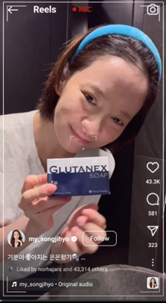
Picture1: Song JiHyo posting using Glutanex on her social media account.

In the case of Glutanex, a South Korean skincare brand, they collaborated with Watson Malaysia to host the Watson Kbeauty Fiesta in Kuala Lumpur for two days. While Glutanex was the main focus of the event, South Korean beauty brands were also included. The main goal was to generate sales of beauty products by providing attendees with a full experience of Kbeauty, and also by bringing the official brand ambassador, actress Song JiHyo. Having a popular Korean female celebrity endorse a skincare brand significantly increased brand visibility and attracted a large audience. The event not only drew Song Jihyo’s existing followers but also fans of South Korea's skincare. Importantly, social media played a crucial role in promoting the event. Almost all of Watson’s official social media accounts and Song JiHyo’s posts about the event generated substantial engagement, including likes, shares, and comments. Attendees at the event were exposed to various brands and their products, resulting in a notable increase in brand awareness, engagement, and product sales during and after the event. Additionally, Song JiHyo had already started promoting the products on her social media accounts months before the events, raising awareness among her followers about the brand, products and how she uses them in her daily routine. Closer to the event, she began sharing her whereabouts in Malaysia and leaving comments to further excite fans before and after attending the event. This further strengthens the argument of not only receiving information on celebrities on daily basis is a part of fans’ everyday practices hence, the attachment to celebrities is stronger and definitely a major factor in the power of the Korean wave.

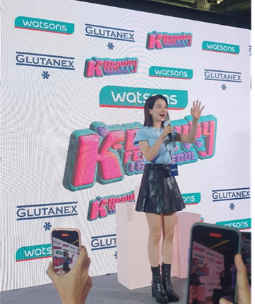

Picture 2: Song JiHyo at Watson Kbeauty Fiesta

Another well-known brand that has enlisted South Korean celebrity as official ambassador is MILO. The popular malt drink has chosen Park Seo Joon for their Jom Minum MILO campaign, labelling him as a friend of MILO in an energetic collaboration. They began by releasing short videos on social media accounts, featuring the tagline “Jom Minum MILO” by Park Seo Joon, which created a lot of excitement among fans. Having one of the famous Hallyu heartthrob endorsing something close to their life definitely create a lot of joys among the fans. When Milo announced that they would hold an event with Park Seo Joon at Sunway Pyramid Mall in Malaysia and issued tickets based on the purchase of certain MILO products (specifically, the 3 in 1 MILO packets), fans flocked to the malls to make purchases and only a select few were able to obtain tickets. However, this did not deter thousands more fans from coming to the event location on that day just to catch a glimpse of Park Seo Joon and witness him making and tasting MILO in front of thousands screaming fans.

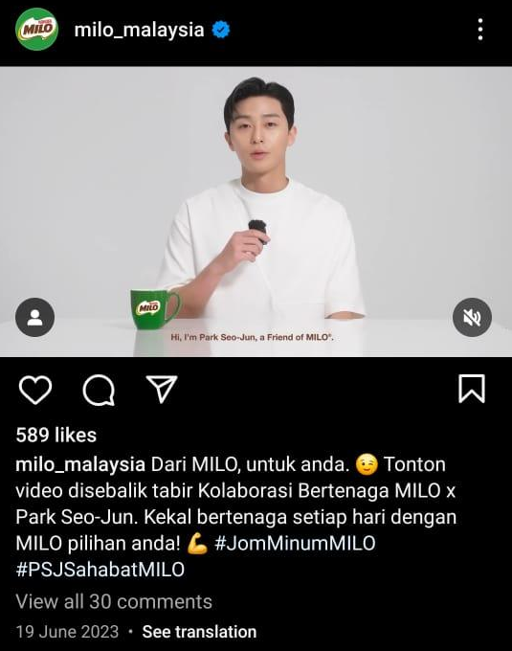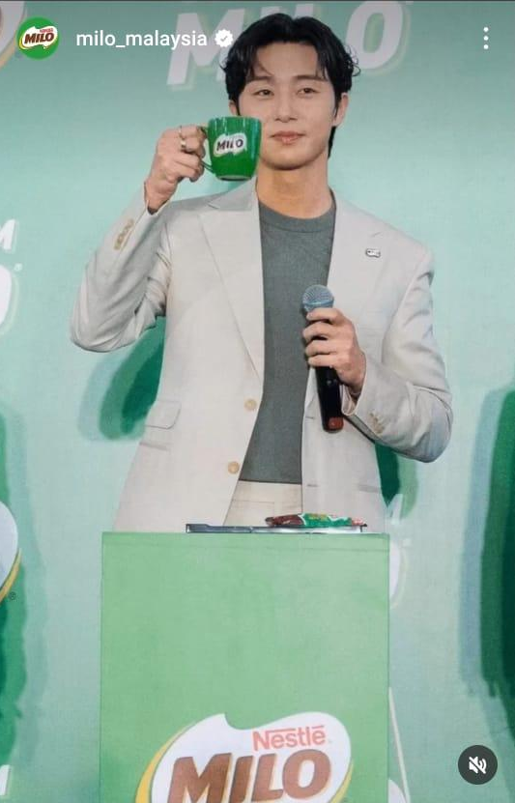

Picture 3 and 4: MILO official Instagram account postings.

2. International Brands Using Korean Stars to Promote Products in Malaysia.

The study finds it interesting that not only South Korean brands, but also international brands are increasingly hiring South Korean celebrities and inviting them to events in Malaysia. Two examples of this are the Skechers and Longchamp, who celebrated the grand opening of their new boutique in TRX, Malaysia with the presence of Cha Eun Woo and Kim Sejeong. As expected, fans flocked to these events in the hopes of catching a glimpse of these celebrities. Skechers distributed flyers and social media posters about the grand opening, as well as announcing that the top two spenders would get the chance to meet Cha Eun Woo in person on the 9th January 2024. The campaign previously took place from 1st December to 17th December 2023. Not only that, on the day of the event, they also offered discounts and a special edition of Cha Eun Woo products to buyers. Cha Eun Woo himself, further extended his endorsement by providing vouchers for fans who attended his concert in Malaysia. As for Longchamp, after the event, they continue to use Kim Sejeong as their global ambassador, conducting social media campaigns worldwide and shooting editorials in famous universities around the world with the tagline #LongChampUniversity.

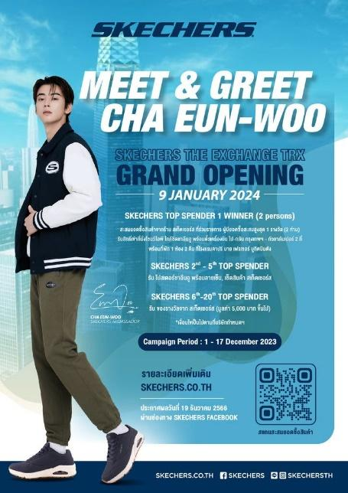

Picture 5 and 6: Promotional poster for the event and Cha Eun Woo on the day of the event.

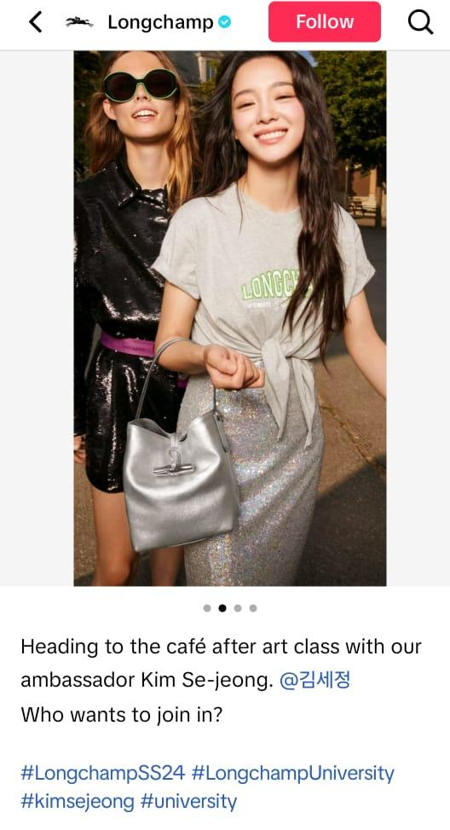

Picture 7 and 8: Kim Sejeong arriving at the Longchamp boutique in TRX, Malaysia and official Longchamp TikTok account.

3. Potential of the Selected Qualitative Methods in Investigating Social Phenomena.

On the other hand, this study aims to explore how certain methods can provide insight into social phenomena. Therefore, this part will address the second research question: What are the potential limitations and opportunities associated with using netnography and participant observation to study the impact of the Korean wave in Malaysian youth culture?
During the observing both physical and online fandom scenes for the Korean wave, the findings exceeded the researcher’ expectations. To stay informed about upcoming events, researchers need to be familiar with key figures in the Malaysia Korean wave scene. Following the right influencers, key individuals and official fandoms can yield more information compared to a general keyword search as access for netnography. By following the official Malaysia Korean wave media through platforms like Facebook, Instagram and X (previously known as Twitter) accounts such as KMania, Hallyu Pop, goKPOP, MYKpopHuntress, Malaysian Kpop fans, K-popped and popular local influencers like Hani Fadzil and Munaa Bella, who have established their careers through their involvement with the Korean wave scene in Malaysia, researchers can closely monitor these social media accounts for access to information about upcoming events. They may amalgamate and fully utilize all their social media accounts, giving information needed to know about events and celebrities’ sightings. These accounts serve as more than a typical source of entertainment or gossip; they share news and fact-check information related to the Korean wave in Malaysia, even issues concerning South Korean celebrities. They also provide teasers for upcoming events, offering clues and hints about the next celebrity visit to Malaysia several months in advance. Once confirmed. These social media accounts give updates and instructions to fans on how to participate. Other than that, announcements, gifts, and event passes are announced to the fans through these social media accounts.
Therefore, it is crucial to follow the right people for accurate information and updates about Korean Wave events and information in Malaysia. The issue of scammers selling fake tickets has been discussed on platforms like X and shared on Instagram, causing fans to be cautious when believing information. Being part of the right community also plays a significant role in fandom. Through observation, it is evident that there are numerous events related to South Korean brands, products and events managed by official bodies such as the Korea Tourism Organization and even the embassy itself. These events aim to introduce Korean culture and promote South Korea as a tourist destination, as well as showcase selected movies through screenings in local malls. These events are not open to the public; fans must access them through official social media accounts, participate in quizzes and games, and lucky winners will be announced. However, what is interesting from a consumer behaviour perspective is the openness of certain things to the public. This includes brands using South Korean celebrities to endorse their products, not only limited to Korean brands, but also collaborating with brands from other countries.

4. Limitations of Selected Qualitative Methods in Investigating Social Phenomena.

This research focuses on the use of netnography and observation to conduct more thorough research. It goes beyond simply understanding the Korean wave that has been reported. One significant limitation faced by the researcher is that fans are becoming more selective about who they share their information with, requiring a high level of trust to obtain in-depth findings on this matter. Additionally, researchers need to immerse themselves in the scene and observe for an extended period to be able to identify fake accounts and anti-fan pages that aim to spread negative narratives about celebrities. Researchers must also conduct their own fact-checking to be able to separate factual content from fan-fiction found across social media. To gain a better understanding of the Korean wave scene, it is crucial to know who is who and to obtain a clear idea of the sample, ensuring a comprehensive understanding of the social phenomenon. Therefore, the findings of this study align with the previous work of Heinonen and Medberg (2018), which suggests that netnography is suitable for this study. The researcher also seeks authentic data and follows the approach recommended by Kozinets and Gretzel (2023), systematically immersing into a digital environment to gain cultural insights through observations, digital traces and interactions among fans, celebrities and the Korean wave itself.

Conclusion
As a conclusion, the preference for marketing now leans towards social media accounts compared to traditional media. This is because that's where the fans and followers are. Gaining attention, shares, and likes has become part of everyday life for the new generation. They are the ones who determine what is popular and who is popular, and they also decide how to be accepted by the "in" crowd. Brands and celebrities are fully aware of this, as most fans and fandoms reside in the social media world. They see social media as the source of information and a means to transcend physical boundaries. This indicates that the mediatisation process among fans and celebrities of their choice is the main factor in strengthening the power of the Korean wave.
Thus, considering recommendations for future research can be divided into two main areas. Firstly, to enhance the understanding of fandom, researchers could focus exclusively on Korean wave fandom or broaden the understanding of fandom in the context of the contemporary digitally advanced era. It is suggested to incorporate additional sociological theories, such as the structural-consensus theory, to gain a more comprehensive perspective on fans. Researchers should specifically investigate the effects of the transition from the physical realm to the digital realm on individuals or communities within fandom, and evaluate how this transformation influences their norms and roles.
In addition to theoretical recommendations, the present study initially sought to investigate the possible insights that researchers could gain from specific chosen methods. Therefore, further investigation in this area would be of great interest. For instance, future research on similar topics could delve into the perspective of the receiver or explore the experiences of fans in relation to fandom, examining how engagements with celebrities can hold significant meaning for them. Additionally, an exploration of how these engagements may influence fans' purchasing habits in relation to products promoted by celebrities would be valuable. Conducting focus group discussions would be an effective means to delve into the experiences of fans and their contributions. In conclusion, it is crucial to employ suitable theories and research methods, as they have a significant impact on the comprehensiveness and quality of the findings, especially when seeking a deep understanding of subjects like fandom.

Acknowledgement: The author expresses gratitude to KMania for facilitating access to events, providing consent and support throughout the research process, and collaborating with the informants.

Informed Consent Statement: Informed consent was obtained from all subjects involved in the study.

Conflicts of Interest: The authors declare no conflict of interest.

References

Abu Hasan, S. S.N. L., & Sukimi, M.F. (2023). Wacana Raja dan Rakyat: Pola Komunikasi Di Media Sosial. e-Bangi Journal of Social Sciences & Humanities, 20 (1), 191-207. http://dx.doi.org/10.17576/ ebangi.2023.2001.16

Buang, N.N., Sulaiman, Z., Thoo, A. C., Muharam, F.M., Masod, A., Zakuan, N., Tan, L. C. (2018). Muslim consumers’ patronage intention towards Korean restaurant chains in Malaysia. AIP Conference Proceedings. https://doi.org/10.1063/1.5080063

Capili, P. L. (2014). Painting the Scenario of Filipino K-pop Fan Culture. Proceedings of Ateneo de Manila University, Philippine, 1(1), 35 – 47. https://doi: 10.13185/G2004

Chan, K. Y. (2018). The experiences of Malaysian youth with Korean cosmetic product. BERJAYA Journal of Services & Management, 9, 101–114. https://journal.berjaya.edu.my/wp-content/uploads/2019/10/Jan-2018_101-114.pdf

Chen, J. (2018). The Globalizing Effect of Korean Pop Culture. Mountaineer Undergraduate Research Review, 3(1), 102-129. https://researchrepository.wvu.edu/murr/vol3/iss1/7.

Biber, D., & Brandenburg, G. (2021). Understanding gratitude, curiosity and life satisfaction in college. Journal of Interdisciplinary Studies in Education, 10(2), 65-80. https://eric.ed.gov/?q=gratitude&ff1 =dtysince_2019&id=EJ1341720

Cho, C.H. (2010). Korean Wave in Malaysia and changes of the Korea-Malaysia relations. Jurnal Pengajian Media Malaysia, 12(1), 1–14. https://ejournal.um.edu.my/index.php/JPMM/article/view/32621

Costello, L., McDermott, M.-L., & Wallace, R. (2017). Netnography: Range of practices, misperceptions, and missed opportunities. International Journal of Qualitative Methods, 16(1). https://doi.org/10.1 177/1609406917700647

Creswell, J. W., & Creswell, J. D. (2018). Research design qualitative, quantitative, and mixed methods approaches (5th ed.). Sage.

Dianrama, L. D., Rauf, D. B., & Fany. (2021). What makes K-pop powerful. TFR.
https://tfr.news/articles/2021/12/9/what-makes-k-pop-powerful.

Hamzah, A., & Mustafa, S.E. (2008). Drama products and copyright issues in Malaysia. Proceedings on Korean Studies in Southeast Asia in the New Era of Cultural Interactions. 371 – 397. http://eprints.um.edu.my/id/eprint/11249

Ismi, F., & Ahmad Badayai, A.R. (2023). Peranan Sikap Peminat sebagai Pengantara dalam Hubungan antara Buli Siber, Penghargaan Kendiri dan Kesejahteraan Psikologi. e-Bangi Journal of Social Sciences & Humanities, 20 (1), 407-418. http://dx.doi.org/10.17576/bangi.2023.2001.34

Glynn, B., & Kim, J. (2013). Oppa”-tunity Knocks: Psy, Gangnam Style and the Critical Reception of K-Pop in Britain. Situations: Cultural Studies in the East Asian Context, 7(1), 1-20. http://situations.yonsei.ac.kr/product/data/item/1535538940/detail/eae967b8fb.pdf

Han, G., Park, J., & Lee, J. E. (2022). The Effects of Attachment to Korean Wave Stars and Cultural Proximity on Chinese Consumers’ Purchase Intention of Korean Products. Business Communication Research and Practice, 5(1), 4–13. https://doi.org/10.22682/bcrp.2022.5.1.4.

Hjarvard, S. (2008). Mediatization of Society. A theory of the media as agents of social and cultural change. Nordicom Review, 29(2), 102–131. https://www.semanticscholar.org/paper/The-Mediatization-of-Society-Hjarvard/953ae63016b903770406e4fc8a0b8b86fad7dccd

He, H., Li, X., Tavsel, M., & Zhou, R. (2022). A Literature Review on Fans’ Identity Construction. Advances in Social Science, Education and Humanities Research. Proceedings of the 2021 International Conference on Public Art and Human Development (ICPAHD 2021), 638, 419 – 423. https://www.semanticscholar.org/paper/A-Literature-Review-on-Fans%E2%80%99-Identity-Construction-He-Li/d1ce353eb96364f19823b69cbe5b0d7ce9700ff6

Heinonen, K. & Medberg, G. (2018). Netnography as a tool for understanding customers: implications for service research and practice. Journal of Services Marketing, 32(6), 657-679. https://doi.org/10.1108/JSM-08-2017-0294

Kang, Y., & Houlihan, B. (2021). Sport as a diplomatic resource: the case of South Korea, 1970-2017. International Journal of Sport Policy and Politics, 13(1), 45- 63. https://doi.org/10.1080/19406940.2021. 1877169.

Jalaluddin, N. H., & Ahmad, Z. (2011). Hallyu Di Malaysia: kajian sosio-budaya. Jurnal Komunikasi, Malaysian Journal of Communication, 27(2). http://ejournal.ukm.my/mjc/article/view/15089/ 4695

Jang, G., & Paik, W. K. (2012). Korean Wave as Tool for Korea’s New Cultural Diplomacy. Advances in Applied Sociology, 02(03), 196–202. https://doi.org/10.4236/aasoci.2012.23026

Jung, S., & Shim, D. (2014). Social distribution: K-pop fan practices in Indonesia and the “Gangnam Style” phenomenon. International Journal of Cultural Studies, 17(5), 485–501. https://doi.org/10.1177/136787 7913505173

Kim, M. (2011). The Role of the Government in Cultural Industry: Some Observations from Korea’s Experience. Keio Communication Review, (33). http://www.mediacom.keio.ac.jp/publication/pdf2011/ 10KIM.pdf

Kozinets, R. V. (2010). Netnography: Doing ethnographic research online. International Journal of Advertising, 29(2), 328-330. https://doi.org/10.2501/S026504871020118X

Kozinets, R. V. (2002). The field behind the screen: Using netnography for marketing research in online communities. Journal of Marketing Research, 39, 61–72. https://doi.org/10.1509/jmkr.39.1.61.18935

Kozinets, R. V. (2015). Netnography. In P. H. Ang & R. Mansell (Eds.), The international encyclopaedia of digital communication and society. John Wiley & Sons. https://doi.org/10.1002/9781118767771.wbiedcs067

Kozinet, R., & Gretzel, U. (2023). Netnography evolved: New context, scope, procedures and sensibilities. Annals of Tourism Research, 104, 1-13. https://doi.org/10.1016/j.annals.2023.103693

Lee, W.J. (2015). The effects of the Korean wave (hallyu) star and receiver characteristics on TVdrama satisfaction and intention to revisit. International Journal Science and Technology, 8(11), 347–356. https://doi.org/10.14257/ijunesst.2015.8.11.34

Lee, Y. L., Jung, M., Nathan, R. J., & Chung, J. E. (2020). Cross-national study on the perception of the Korean wave and cultural hybridity in Indonesia and Malaysia using discourse on social media. Sustainability, 12(15), 6072. https://doi.org/10.3390/su12156072.

Leung, S. (2012). Catching the K-Pop wave: Globality in the production, distribution, and consumption of South Korean popular music (Unpublish thesis). https://digitalwindow.vassa r.edu/cgi/viewcontent.c gi?article=1151&context=se nior_cap stone.

Lim, C. S., Loo, J. L., Wong, S. C., & Hong, K. T. (2020). Purchase Intention of Korean Beauty Products among Undergraduate Students. Journal of Management Research, 12(3), 19-40. https://doi.org/10.5296/ jmr.v12i3.17149

Lim, J., B., Y. (2013). Engaging participation: Youth culture and the Korean wave in Malaysia. In M. J. Ainslie & Joanne B.Y. Lim (Eds.). The Korean wave in Southeast Asia: Consumption and cultural production (pp. 155–174). Malaysia: SIRD.

Loke, M. S., & Omar, B. (2020). The Impact of Korean Wave on Malaysian Metrosexual Grooming Attitude and Behaviour: The Moderating Role of Visual Media Consumption. Media Watch, 11(2). DOI: 10.15655/mw/2020/v11i2/195647.

Nazri, N. A., Badrul Hisham, N. A., & Ahmad, A. L. (2022). Drama Adaptasi Korea: Suatu Analisis Terhadap Pemaparan Islam Dalam Drama Monalisa. e-Bangi Journal of Social Sciences & Humanities, 19 (1), 15-30.

Nueman, W. L. (2014). Social research methods: Qualitative and quantitative approaches (7th ed.). Pearson.

Mohd Jenol, N.A., & Ahmad Pazil, N.H. (2020). Escapism and motivation: Understanding K-pop fans well-being and identity. Geografia Journal of Society and Space, 16 (4), 336 -347. https://doi.org/10.17576/geo-2020-1604-25.

Parc, J., & Moon, H.-C. (2013). Korean Dramas and Films: Key Factors for Their International Competitiveness. Asian Journal of Social Science, 41, 126–149. https://doi.org/10.1163/15685314-12341295.

Parc, J. (2021, October 20). Measuring the Impact of Hallyu on Korea’s Economy: Setting Off on the Wrong Foot. Korea Economic Institute of America. https://keia.org/publication/measuring-the-impact-of-hallyu-on-koreaseconomy- setting-off-on-the-wrong-foot/.

Shim, D. (2017, May 24). Riding the Korean Wave in Southeast Asia. Fair Observer. https://www.fairobserver.com /region/asia_pacific/korean-wave-k-pop-culture-southeast-asia-news-45109/

Suvittawat, A. (2022). The influence of customer expectations, customer loyalty, customer satisfaction and customer brand loyalty on customer purchasing intentions: A case study of K-POP fans in Thailand. African Journal of Business Management, 16(1), 1–9. https://doi.org/10.5897/ajbm2021.9321

Song, S. (2020). The Evolution of the Korean Wave: How Is the Third Generation Different from Previous Ones? Korea Observer, 51(1), 125-150. https://www.proquest.com/openview/e95a805acdffeee9dfedc6aef 74218ce/ 1?pq- origsite=gscholar&cbl=46815.

Teng, H. Y., & Chen, C. Y. (2020). Enhancing celebrity fan-destination relationship in film-induced tourism: The effect of authenticity. Tourism Management Perspectives, 33. https://doi.org/10.1016/j.tmp.2019.100605

Wan Mat, W.R., Kim, H.J., Abdul Manaf, A.A., Ing, G.P., & Abdul Adis, A. (2019). Young Malaysian consumers’ attitude and intention to imitate Korean celebrity endorsements. Asian Journal of Business Research, 9(3), 1-23. https://doi.org/10.14707/ajbr.190065.

Yeung, J. (2023, January 18). South Korea brought K-pop and K-dramas to the world. The Korean language could be next. CNN. https://edition.cnn.com/2023/01/17/asia/korean-language-learning-risehallyu-intl-hnk-dst/index.html.

