SOCIAL IDENTITY ANALYSIS THE BUTTONSCARVES COMMUNITY
IN BUILDING BRAND LOYALTY

Nurul Mustaqimmah¹, Lintang Arum Bagasati² ,Welly Wirman ^{3,}

^{1,2,3}Ilmu Komunikasi, Universitas Riau, Pekanbaru, Indonesia

*Corresponding author: lintangarumb@gmail.com

Abstract: Social Identity is part of the self concept that comes from experience and knowledge of individuals when they are in a particular social group. The association of individuals in the community unknowingly makes community members loyal to certain brands, one of which is the buttonscarves community. This study wanted to see how social identity can build community members' loyalty to the buttonscarves brand. Through the theory of social identity proposed by Jackson & Smith about social identity that underlies Four dimensions where a person has perception in the context of intergroup, attraction in groups, interrelated beliefs and depersonalization that produce brand loyalty proposed by Alfares are positive behavior towards the brand, repeat purchases, satisfaction, liking, commitment, trust and transition costs. The results of this study show that the identity formed in the buttonscarves community can increase brand loyalty to the buttonscarves brand. Each individual in the community has the same goal so as to form a social identity so as to exclude negative issues from outsiders. The uniqueness, economic value and reputation that buttonscarves have is able to meet the symbolic needs of community members.

Keywords: Social identity, brand loyalty, buttonscarves, community engagement, share values

Introduction
The Buttonscarves community commonly called Buttonscarvers Lady is a community of lovers or users of the Buttonscarves brand . Buttonscarves is one of the well-known local brands to the international market, since 2016 with its main product hijab. In addition to hijab, Buttonscarves also offers other products such as brooches, shoes, bags, accessories, cosmetics, cases and clothing, then the target market of all products offered by Buttonscarves is women aged 24-50 years and the upper middle class (Oeren Lee, 2021). The Buttonscarvers Lady Riau community always makes events and associations, this makes many Muslim women interested in being part of the Buttonscarvers Lady Riau community. Because at this time fashion and lifestyle provide a new phenomenon for hijab women, besides the results of research (hidayanti et al.,) show that Indonesian people's interest in hijab fashion is increasing every day because hijab designers are increasingly interested in creating diverse and unique hijab motifs. There are several local hijab products in Indonesia.
Table 1: Information of hijab local product
Brands | Motif | Price start from
Ria Miranda | Unique, Farsel | 325.000
Kami Idea  Buttonscarves  Zittadelia  Louisaluna  Heaven Light  Kinaya | Print  Laser Cut  Color  Louisaluzna  Cantic  Cantic | 300.000  375.000  220.000  225.000  185.000  195.000
Source: (www.facetofeet.com)
The data above shows that buttonscarves are local hijab products with the highest sales prices compared to others. For hijab products, Buttonscarves has fantastic prices. Although the data above shows buttownscarves have the highest sales figures, buttonscarves is one and only brand that has succeeded in forming a community with high member interest as well. Consumption drives economic development, serving as a key element in human production and daily life. It transcends being merely an economic activity, representing a significant social and cultural phenomenon as well. (Simei, 2024). This can be seen by how community members rush to make purchases every time they launch a new product within minutes the product is sold out. The sense of belonging possessed by the Buttonscarves lady shows an interesting phenomenon in the Muslim fashion industry.
This is what brand loyalty is all about. Brand loyalty is that consumers exhibit positive behavior toward a brand, who have an interest in a particular brand, and make repeat purchases. Consumers consistently buy products issued by brands without considering the situation and marketing carried out by their brands. (Selly, 2022). The important thing in forming brand loyalty is satisfaction and trust. Without satisfaction and trust, consumers will not make repeat purchases. The behavior shown by the Buttonscarves lady community shows satisfaction and trust in this brand. In addition to repeat purchases, community members are willing to make time to get together to discuss these products.
The Buttonscarves community plays an important role in building brand loyalty. In this community, loyal members and customers of buttonscarves gather to share experiences, style inspiration and love for the brand's products. The exchange of information and support between community members creates a strong bond between them. Thus reinforcing a positive brand perception. Through repeated interactions within the community, members not only gain an immersive experience with buttonscarves products but also strengthen their identity as members of this community. They feel connected to the brand and the values it represents, which gives them a compelling reason to remain loyal. Active participation in various community activities is also carried out regularly such as online discussions, fashion shows, or in-person meetings. This certainly helps strengthen the relationship between customers and brands.
In addition to generating loyal customers to the brand, this community also forms a social identity within the group. Social identity is an individual's self-concept that develops into a collective self-concept acquired during interactions with members of his community (Tajfel in Wibisono &; Musdalifah, 2020). When individuals identify themselves in a group, the status and prestige of the group affects them. By using luxury products from buttonscarvers will increase the prestige of community members, this is what makes the connection between community, social identity and brand loyalty. Based on the above phenomenon, this article will clearly illustrate how the buttonscarves community through its social identity is able to grow brand loyalty.

Literature Review
- Identity Social
Social identity is defined as an individual who feels that he or she is part of a group that has similar values and emotions (Tajfel in Sarifah, 2016). Social identity is how a person defines himself, including comparing himself within a group so that positive and negative assessments of a group arise Merdawati (2021). The existence of the group will form an emotional bond between individuals and their groups.
Jackson and Smith (Merdawati, 2021) mentioned that identity social has 4 dimensions; perception in context between group; Power attract in-group; confidence each other related; and depersonalization .
- Perception in context between group, When individual identify himself part of the group, status and prestige of the group the will influence their self-perception.
- Power attract in-group, Individuals within the group have a feeling of belonging and common identity. They consider people outside of the group is different from their group, so there is a sense of bias that their group is better than other groups.
- Interrelated beliefs, In social identity, individuals have a self-concept that they possess the same emotional attachment and meaning as their social group. The attachment arises after recognizing their existence as a member of a group. If that group perceived positively, then the group identity will become stronger, and their self-esteem will also increase.
- Depersonalization An individual who feels become part of a group will tend to adopt the group's values as their own. This may also be caused by a fear of being disregarded or feeling alienated within the group for ignoring the group's values.
Bryne, as cited in Rengganis (2016), states that social identity encompasses who an individual is, including personal attributes and attributes shared with other group members. Individuals within the group associate themselves with the group, they will adopt the behaviors and practices of the group.
Social identity is part of an individual's self-concept that develops into collective self-esteem acquired during interactions with his social group. To achieve social identity, individuals within a group must have similar values and emotional ties (Tajfel in Wibisono &; Musdalifah, 2020)
- Buttonscarves Lady Riau Community
Herbert Blumer in Senis et al., (2024) defines community as a concept that refers to how individuals in a group interact with each other based on the symbolic meaning they understand. The actions performed by individuals are based on goals that they associate with things and events.
Buttonscarves Lady Riau Community is a community that has an interest in the Buttoncraves brand. Yasin (2022) said that Buttonscarves is a local brand that has been known internationally since 2016. Buttonscarves carries a luxurious lifestyle with its main product hijab. In addition, Buttonscarves also produces shoes, bags, accessories, cosmetics, cases, and clothing. The segmentation of the Buttonscraves brand is women aged 24-50 years and comes from the upper middle class.
The Buttonscarves Lady community often holds gatherings and events that attract women outside the community to be part of this community. Through their social media, they display interesting fashion and lifestyle, namely using branded products so that they are considered prestigious, fashionable, and elegant. Indirectly, these communities show their social identity based on the values and standards they have set. Social media allows individuals to swiftly form connections, gain insights, shape and express their identity, and showcase it to others(Amrullah, 2024).
The Buttonscarves brand has an international brand image, thus generating trust from consumers and making consumers buy it even at a high price. The brand image keeps people buying them, even consumers are scrambling to get their hands on the Buttonscarves collection. It is not uncommon for Buttonscarves products to sell out when launched, so Buttonscarves Lady Riau is also willing to pay a deposit fee to get the desired product. The role of consumers who are members of the Buttonscarves brand lovers community supports the sale of Buttenscarves products. They volunteer to introduce, narrate, and promote Buttonscarves products to others. They also declared themselves loyal customers of Buttonscarves.
- Brand Loyalty
John W Creswell in Shelly (2022) Mentioning that brand loyalty is consumers showing positive behavior to a brand, who have an interest in a particular brand, and make purchases repeatedly. Consumers consistently buy products issued by brands without considering the situation and marketing.
Alvarez & Rubiyanti (in Saputra &; Lusia, 2023) Mention that brand loyalty can be measured by the following dimensions:
- Behavior Measuremen, Consumer loyalty to brands is built through consumer actions. When consumers are used to certain behaviors, they tend to make repeat purchases without much consideration. Consumers consistently make purchases of products issued by the brand.
- Transition fees, The difference arises in the trade-off between what customers sacrifice, cost, effort, and the physical impact they bear when choosing alternatives. If the cost of the transition is large, consumers will consider switching to another brand because of the increased risk of disappointment, which often encourages them to maintain loyalty.
- Satisfaction, Consumers show loyalty to a brand if they feel satisfaction with the product or brand. When consumers use the product and the product exceeds the satisfaction criteria, they will interpret the experience. A positive experience keeps consumers satisfied and making consistent repurchases.
- Brand liking, Loyalty and commitment depend on the level of consumer loyalty. The level of loyalty can be measured by the development of interest in products and brands, thus achieving trust formed from product performance.
- Commitment, A strong product has many committed consumers. Loyalty arises when consumers have trust in a brand and foster communication and interaction between customers involved in product discussions.
Satisfaction and trust are two important factors to achieve brand loyalty. Consumers who are dissatisfied and do not trust the brand will not make a repeat purchase, unless there is no other option. Consumers have brand loyalty if these consumers repurchase products issued by a brand, causing high habits and attachments in the long run (Kartikaningsih, 2021). Loyal consumers will also recommend the brand to their relatives to buy products issued by the brand.
According to He in Ingemansson et al., (2015) Satisfaction and trust relate to brand identity and thus brand loyalty. Uniqueness, economic value, and reputation are factors in a luxury brand identity that can satisfy the symbolic needs of consumers and in the long run create trust in the brand. Luxury brand identities tend not to meet the functional needs of consumers, as consumers typically do not purchase luxury brands or products for functional needs.

Methodology
In order to reach the aims of this study, this research used the qualitative method. As we know qualitative is a research method that described and interpreted phenomena based on natural setting which verified by the resources and behaviour observation who related to the object (Moleong, 2007). This research using interview, observation and documentation to collecting data. Non Purposive is the technique chosen in this research because everyone who is a member of the Buttonscarves community can be interviewed and become data in the research.
Researchers met 5 informants in several different places. 5 informants provide similar information and reach saturation points so that additional informants are not needed. Furthermore, participant observation was carried out by following the meeting activities carried out by the buttonscarves lady. In these meetings, researchers observe with the five senses and then ultimately triangulate.
This research also uses literature reviewes as comparison for findings, concepts, and theories along with some documentaries related to buttonscarves as data support for analyzing process. at the end this research used sources triangulation to verify the data credibility that collected from different informants and methods conducted

The Findings and Discussion
- Perception in an intergroup context
Buttonscarves consumers see themselves as having the same meanings, impressions and values as other community members. Once a person identifies himself or herself with the group, he joins the individual interested in joining the group. After that, being in the community makes individuals adopt the status and prestige that has been formed in the group into their own status and prestige. This is evidenced by the statement of the informant stating that
“.. Yes, at first I thought it because it looked beautiful and elegant, well I found it on the Instagram of this BS Lady community. Because I saw them using the same product, it looked elegant, so I was interested in joining."

The same statement is stated by melissa
"At first I used it because it was just difficult... happened to be invited by a friend to join.. Because I saw that the style was suitable for me so I joined. Uh, even when I joined, I felt more pride, so when I showed disosmed again to gather with BS Lady Ni.."
"Initially, I saw that this community was rich in fun, in beautiful like a prestigious community, so I was interested in joining. Surely when I was already in I became consumptive with buttonscarves.. Moreover, the hijab often runs out quickly. So it's like grabbing."
The informant's statement above shows that the first dimension proposed by Jackson & Smith regarding perception in this intergroup context corresponds to individuals in the BS Lady community. It begins with interests and shared values that make the individual join the community. Not only joining the community, at regular meetings they are increasingly interested in new products released. The more interested they are, the higher their enthusiasm to buy products issued in limited quantities. This phenomenon encourages repeat purchases on products issued by buttonscarves. This is also in accordance with the dimension of measuring brand loyalty behavior where consumers will make repeat purchases without long consideration. As well as consistently making purchases of new products issued. Brand loyalty in this community is also illustrated by product sales that are immediately sold out in the first five minutes.

- In Group Attractiveness and commitment
This dimension of attraction in group is interpreted by an individual who is a member of a community has a feeling of bonding. This attachment between individuals and communities causes them to feel, their group is better and superior compared to others. Any negative issues raised by external parties will not be believed by the Buttonscarves Lady. It also shows that members of the bs lady community have a commitment and trust in buttoscraves. In accordance with the commitment dimension which is also a dimension of brand loyalty. Communication and interaction between community members involved in product discussions increases their trust so that they are not influenced by the opinions of others.
In accordance with the informant's statement stating that :
"Yes.. Even though people say the product is expensive, it's normal but we are not affected, it's still good if you use it."

"Even though the price is expensive, it's still worth it. At most, people just can't buy it... hahaha"

"Right when tu viral tuy on TikTok, he said that this button product is not good quality, rich in shoes, bags. but we still just buy it.. It's rich hatters just want to fall."

The informant's statement above shows that community members have high trust so that they are not affected by negative issues that occur outside their group. They still have a high commitment to continue to faithfully buy the latest products from buttonscarves.

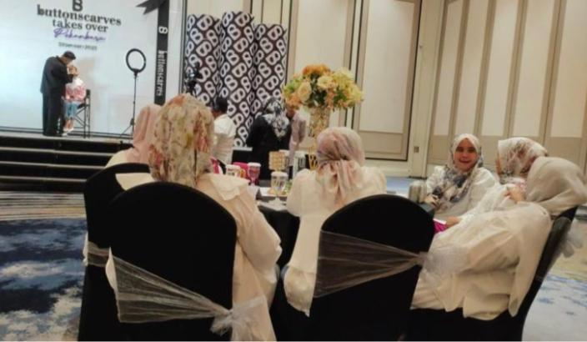
Figure 1 : Regular meeting Buttonscarves lady

- Mutual Attraction Confidence
This dimension of mutual attraction refers to individuals having the same self-concept and meaning as their social group. This belief arises after realizing his existence as a member of a group. If the group is judged positively, the stronger the group's identity, the stronger its self-esteem. The longer you interact with fellow community members, it creates a feeling that individuals in this community are representations of the buttonscarves brand. This feeling arises because the satisfaction given by buttonscarves exceeds the satisfaction criteria they have.
This is in accordance with the informant's statement stating that:
"Being in this community for a long time makes me feel like I'm really like Buttonscarves"

"If you hear people discussing buttonscarves, I feel like talking about it again, brother hehehe"

"I've been here for a long time, sis, so I really know you about buttonscarves products. So yes this product describes me bgt.."

"I was the one who tried with this brand, eh it turned out to be right for me. The product suits me."

In this dimension, it is explained that individuals in a group will feel themselves integrated with the brand, in this case buttonscarves. Consumer culture is generally perceived as the activities of consumption, particularly the actions of purchasing and using goods or services. Nonetheless, the role of consumer culture extends beyond just buying and using items. Within a social framework, consumer culture is linked to identity, social status, and an individual's role in society (Sukimi, 2024). This is in accordance with the informant's statement above. Not only was Salling's confidence attracted but there was also satisfaction that exceeded expectations after they interpreted the experience of using Buttonscarves. Brand loyalty can be obtained because members of this community feel satisfied after interpreting their experiences when interacting in the community. Not only that, they also participated in promoting the buttonscarves brand voluntarily to the closest relatives.

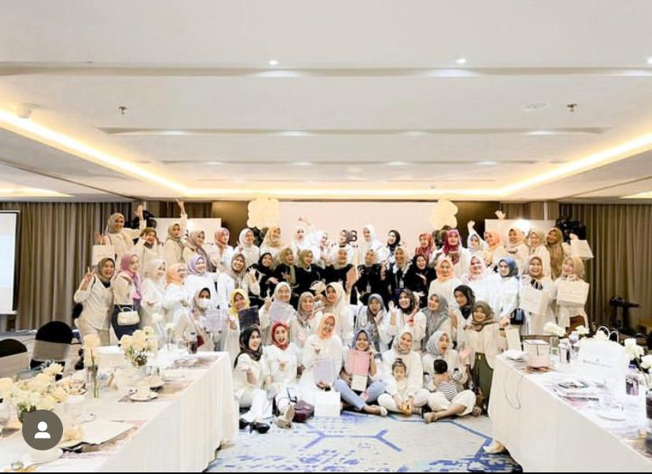
Figure 2 : Togetherness in buttonscarves

- Personalized
This personalized portrayal describes individuals feeling that they are using the values that exist in the community so that they do not have foreign feelings or feelings of fear of not being considered. These values can be obtained one of them by continuing to use the product and continuing to make repeat purchases consistently. This dimension also makes individuals in the community prioritize their social identity rather than their own identity. Unwittingly they continue to adopt group values to the point of ignoring personal situations.
This is in line with the informant's statement that:

"Every routine agenda gathering, yes, as much as possible, we certainly use the latest collection of buttonscarves. yaa karna appreciate ajaa.."

“.... yes, even though I think I have a lot of hijab, but it's not good if I don't use the latest release."

“aneeh aja dong kak kalo pas kumpul bulanan ngga pakai produk buttonscarves.”
The results of the interview above shown that in order not to be ostracized, community members always use products from buttonscarves from head to too. This figure shown bs lady community using buttonscarves brand products in daily appearance and when gathering routine community agendas.

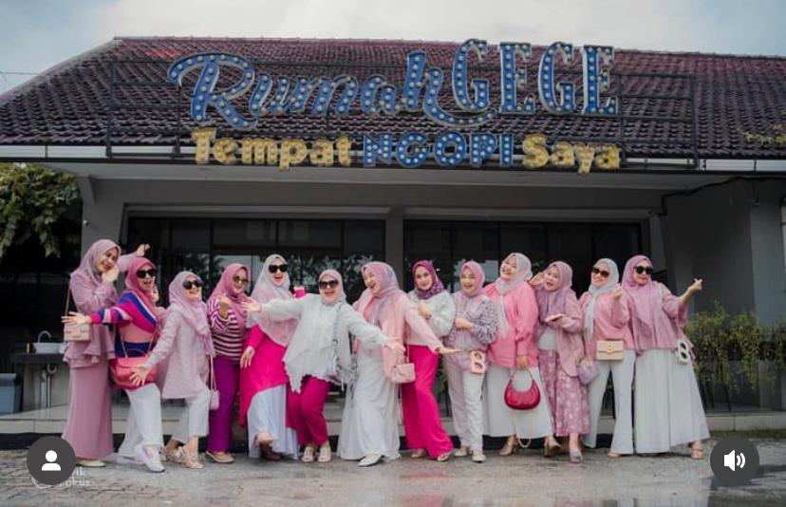
Figure 3 : Buttonscarves lady in head to too of buttonscarves product
Conclusion
The interaction carried out by members of the Buttonscarves Lady community has succeeded in shaping social identity thereby increasing brand loyalty on Buttonscarves. The 4 dimensions of social identity proposed by Jackson and Smith (Merdawati, 2021) It seems to have a role in increasing brand loyalty. Individuals who identify themselves as part of the group will strive to continue using the latest products issued by Buttonscarves. This process of self-identification gives rise to consistent buying tendencies. Community members do not care about outsiders' views on Buttonscarves products. They still feel satisfied with the products presented and continue to put trust in the brand. Satisfaction and trust are two important factors to achieve brand loyalty. In fact, community members' satisfaction and trust are found in all dimensions of social identity ranging from perception, attractiveness, belief and depersonalization.
Community members have a sense that they are representations of Buttonscarves. They interpret the experience of using buttonscarves in the community so that they continue to try to fulfill the values held by the community without considering personal situations. As is known that Buttonscarves is a luxury brand that is known to the international market. Uniqueness, economic value and reputation are factors of luxury brands that can satisfy the symbolic needs of consumers. Actually, the devotees of the needs of luxury products prioritize meeting the needs of their desires rather than the functional needs of it self products, even though the goods are expensive, they do not care because they can fulfill their symbolic needs as a representation of luxury hijab brands. The transition cost dimension of brand loyalty is not found in the Buttonscarves Lady community. Although Buttonscarves products sell at a higher price than their competitors, members of the Buttonscarves Lady community do not turn away from the brand.

References

Haekal Fajri Amrullah, & , Andi Pajolloi Bate, K. P. & M. M. (2024). Construction of Personal Identity for Outside Baduy Citizens on Instagram. E-Bangi: Journal of Social Sciences & Humanities, 1(1), 4–6. https://doi.org/10.17576/ebangi.2024.2101.02
Ingemansson, V., Nilsson, I., & Vllasalija, D. (2015). An Exploratory Research on the Relationship between Low Product Involvement and Brand Loyalty. Bachelor Thesis, 1–59.
Kartikaningsih, D. (2021). Brand Relationship Quality Strategy and Brand Loyalty of Abekani’s Product. Jurnal Sekretaris & Administrasi Bisnis (JSAB), 5(1), 51. http://jurnal.asmtb.ac.id/index.php/jsab/article/view/196
Merdawati. (2021). Hubungan Antara Identitas Sosial dengan Konformitas Pada Klub Motor Fort Supermoto Squad. Industry and Higher Education, 3(1), 1689–1699. http://journal.unilak.ac.id/index.php/JIEB/article/view/3845%0Ahttp://dspace.uc.ac.id/handle/123456789/1288
Mohamad Fauzi Sukimi, M. N. M. N. (2024). Identiti Maskuliniti: Konsumsi sebagai Manifestasi Mimpi Imej ‘Sado’ dalam kalangan Belia Melayu (Masculinity Identity: Consumption as a Dream Manifestation of the ‘Sado’ Image among Malay Youth). E-Bangi: Journal of Social Sciences & Humanities, 4(02), 7823–7830. https://doi.org/10.17576/ebangi.2024.2102.21
Rengganis, D. A. (2016). Kontribusi Identitas Sosial terhadap konfromitas Pada Penggemar K-Pop. Jurnal Ilmiah Psikologi, 9(2), 161–167.
Saputra, R. Y. B., & Lusia, A. (2023). Pengaruh Brand Loyalty, Brand Trust Dan Harga Terhadap Keputusan Pembelian Ulang Paket Data Tri Di Solo Raya. Indonesian Journal of Strategic Management, 6(2), 71–82. https://doi.org/10.25134/ijsm.v6i2.7900
Sarifah, R. (2016). IDENTITAS SOSIAL DENGAN PRASANGKA PADA PRAJURIT TNI AD TERHADAP ANGGOTA KEPOLISIAN. Jurnal Ilmiah Psikologi Terapan, 04(01), 75–88. https://ejournal.umm.ac.id/index.php/jipt/article/view/2879
Senis, Y., Ayorbaba, M., & Luas, A. (2024). Building a New Understanding of Changing Patterns of Community Interaction, Social Behavior, and Conflicts of Interest: A Theoretical Study. Journal of Urban Sociology, 1(1), 10. https://doi.org/10.30742/jus.v1i1.3456
Shelly. (2022). PENGARUH BRAND IMAGE, BRAND QUALITY, BRAND TRUST TERHADAP BRAND LOYALTY PADA PRODUK MEREK PHILIPS. 6(1), 1–17.
Wang, Simei, K. L. G. C. & A. A. (2024). A Critical Review of Women’s Consumption and Empowerment in China. E-Bangi: Journal of Social Sciences & Humanities, 1(April). https://doi.org/10.17576/ebangi.2024.2101.44
Wibisono, M. D., & Musdalifah. (2020). Pengembangan Skala Identitas Sosial : Validitas, Dan Analisis Faktor Konfirmatori. Proyeksi, 15(1), 58. https://doi.org/10.30659/jp.15.1.58-67

Website:
Yasin, Rindra. (2020). BSLady Community Exhibition: A Communication and Lifestyle Riau.pos.com
https://riaupos.jawapos.com/opini/amp/2253682253/eksistensi-komunitas-bslady-sebuah-komunikasi-dan-lifestyle

