Article

The Effect of Customer-Based Brand Equity (CBBE) BPJS Ketenagakerjaan After the Simultaneous Implementation of the Re-Call Strategy on Informal Worker (BPU) Purchase Intention

Bangkit Pradana¹ & Enjang Pera Irawan^{2,}*

Faculty of Communication Sciences, Mercu Buana University, Jakarta, Indonesia
²Faculty of Communication Sciences, Mercu Buana University, Jakarta, Indonesia

*Corresponding author: bangkitpradana@gmail.com, enjang.irawan@mercubuana.ac.id

Abstract: Indonesia's growing population demands social protection, such as health insurance and pension insurance. Although BPJS Ketenagakerjaan strives to improve services, challenges to social protection still exist, especially for informal workers. Further efforts are needed to increase their participation in social security programs. This study aims to investigate the effect of Customer-Based Brand Equity (CBBE) BPJS Ketenagakerjaan after the simultaneous implementation of the Re-Call strategy on Non-Wage Earner (BPU) Purchase Intention. The growth of the labour force in Indonesia raises the complexity of the economy and the high risk of workplace accidents. BPJS Ketenagakerjaan exists as an effort by the government to provide social protection to workers, including informal workers. The Re-Call strategy is carried out to increase the participation of informal workers in the BPU Program. This study proposes a hypothesis that CBBE BPJS Ketenagakerjaan through the Re-Call strategy has a positive effect on BPU's Purchase Intention. The Structural Equation Modelling (SEM) analysis method was used to analyse survey data collected from 400 active participants of BPJS Ketenagakerjaan BPU. The results showed that there was a positive and significant influence between CBBE BPJS Ketenagakerjaan and BPU Purchase Intention. These findings make an important contribution in understanding the dynamics of the relationship between CBBE elements and consumer purchase interest, as well as their implications for increasing informal workers' participation in social security programs.

Keywords: Customer-Based Brand Equity (CBBE); BPJS Ketenagakerjaan; Re-Call Strategy; Re-Call Strategy; Purchase Intention.

Introduction
The growth and spread of the population in Indonesia results in different types of jobs, reflecting the complexity of the economy and the resilience of the workforce. Social security is important for workers, including health insurance, pension insurance, and protection from work accidents. The program helps workers overcome economic risks and supports social stability and economic growth. However, good policies and transparent management are needed. BPJS Ketenagakerjaan, based on Law No. 24 of 2011, aims to improve the quality of services that are fair to all. This reflects the state's responsibility in providing social and economic protection in accordance with the values of Pancasila. With a non-discriminatory, participatory, and sustainable approach, BPJS Ketenagakerjaan increases worker productivity and supports economic growth. This is a concrete step towards inclusive and sustainable development.

The implementation of social protection has become increasingly important as the workforce has grown in the last 10 years. Data from BPS (2023) shows that the number of labour force in 2012 was 114,061 thousand. This figure fluctuates to 138,632 thousand workers in 2023. The recording carried out by the Central Statistics Agency also stated that the increase in unemployment rate remained stable from 2012 of 7,757 thousand people to 7,989 thousand people in 2023.

Figure 1. Number of Work Accident Victims to Indonesia (2005-2021)
Source: Ministry of Manpower (Kemnaker) Report (2023)
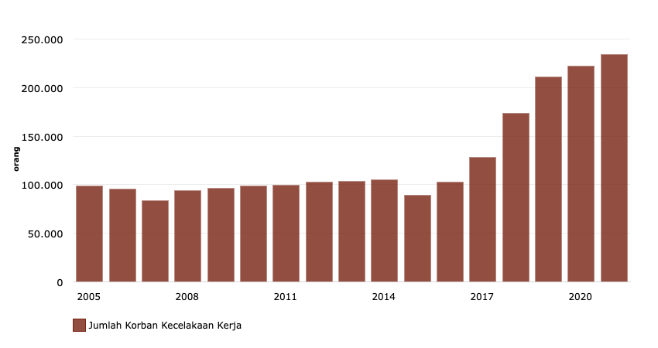

The growth of the labour force in the last 10 years increases the risk of occupational accidents in Indonesia. According to the Ministry of Manpower, victims of occupational accidents and occupational diseases (PAK) are increasing, reaching a record high of 234 thousand people in 2021. The majority of accidents occur in the workplace, especially in the industrial, trade, services, agriculture, and consumer goods sectors. For protection, the Government established BPJS Ketenagakerjaan and BPJS Kesehatan. Although BPJS Ketenagakerjaan aims to complement the employment security system that is not yet comprehensive, BPJS Kesehatan has received criticism for limiting services in several health facilities. Although BPJS Ketenagakerjaan carries out a re-branding strategy, challenges in providing equitable and quality social protection for the community remain.

This effort is made to avoid misperceptions, especially for informal workers who are not required to get social security such as formal workers. The number of informal workers reached 38,845 thousand in 2019, 46,830 thousand in 2020, and 45,333 thousand in 2021. However, membership data of non-active wage earners shows that BPJS Ketenagakerjaan is only able to get <10% active membership from informal workers each year. This reflects the still very high market potential for BPJS Ketenagakerjaan among informal workers.

The BPU program from BPJS Ketenagakerjaan is important for informal workers. To increase their participation, BPJS Ketenagakerjaan implements a re-call strategy through Consumer-Based Brand Equity (CBBE). A strong CBBE is expected to strengthen the image of BPJS Ketenagakerjaan as a trustworthy social protection provider, increase participant satisfaction, and achieve the goal of providing quality social protection for workers in the informal labour sector. This strategy includes increasing brand awareness by giving BPJAMSOSTEK a nickname, as well as an emphasis on trust, loyalty, and satisfaction of program participants. Thus, CBBE plays an important role in achieving the objectives of BPJS Ketenagakerjaan and increasing the interest and participation of informal workers in the BPU program.

Increasing Consumer-based Brand Equity (CBBE) through a re-call strategy can potentially increase the purchase intention of prospective BPU customers towards BPJS Ketenagakerjaan products and services. A positive perception of the brand and emotional connection with the brand can motivate potential consumers to choose BPJS Ketenagakerjaan in fulfilling social security needs. It is important to note that the success of this re-call strategy depends on effective and consistent execution, along with inconsistencies in findings from previous studies.

Factors affecting Purchase Intention, especially with respect to Brand Awareness, Brand Associations, Perceived Quality, and Brand Loyalty. Brand Awareness is a key element, where several studies (Aquinia &; Soliha, 2020; Muslim & Qur'anis, 2017; Supiyandi et al., 2022; Susilowati &; Novita Sari, 2020; Tuinesia et al., 2022) found that Brand Awareness has a positive effect on Purchase Intention. However, other research results (Azzari &; Pelissari, 2020; Enjelina &; Dewi, 2021; Gabriella &; Sonny, 2021; Nazara et al., 2023; Rungsrisawat &; Sirinapatpokin, 2019; Widjaja, 2019) shows that not all contexts have a positive correlation between Brand Awareness and Purchase Intention. Moreover, the interaction between sellers and buyers takes place quickly as soon as the product image is shared. Buyers can respond to the marketed product more quickly to the seller. (Mohd Ilham, N.M., & Mohamad Salleh, M. A., 2016)

Brand Associations are also a consideration, with several studies (Azzari &; Pelissari, 2020; Muslim & Qur'anis, 2017; Nazara et al., 2023; Rungsrisawat &; Sirinapatpokin, 2019; Susilowati &; Novita Sari, 2020) showed that Brand Associations have a positive effect on Purchase Intention, while other research results (Enjelina &; Dewi, 2021; Supiyandi et al., 2022; Widjaja, 2019) noted its insignificance in several different studies.

Perceived Quality also plays an important role, where several studies (Aquinia &; Soliha, 2020; Azzari &; Pelissari, 2020; Nazara et al., 2023; Supiyandi et al., 2022; Susilowati &; Novita Sari, 2020) found that Perceived Quality has a positive effect on Purchase Intention. However, other research results (Enjelina &; Dewi, 2021; Gabriella &; Sonny, 2021; Muslim & Qur'anis, 2017; Nazara et al., 2023; Rungsrisawat &; Sirinapatpokin, 2019; Tuinesia et al., 2022) showed different results, with some cases where Perceived Quality did not have a positive correlation with Purchase Intention.

Brand Loyalty is also a noteworthy factor, due to a number of studies (Azzari &; Pelissari, 2020; Enjelina &; Dewi, 2021; Gabriella &; Sonny, 2021; Muslim & Qur'anis, 2017; Rungsrisawat &; Sirinapatpokin, 2019; Supiyandi et al., 2022; Tuinesia et al., 2022; Widjaja, 2019) found that Brand Loyalty has a positive effect on Purchase Intention. However, other findings (Aquinia &; Soliha, 2020; Nazara et al., 2023; Susilowati &; Novita Sari, 2020) show that there is not always a positive correlation between Brand Loyalty and Purchase Intention.

From various studies that have been conducted, it can be concluded that Consumer-based Brand Equity (CBBE) has a positive impact on consumer purchase interest. Factors such as brand awareness, brand associations, perceived quality, and brand loyalty have been shown to increase purchase interest. Increasing CBBE through a re-call strategy can potentially increase the purchase intention of potential customers towards certain products and services, including in the context of the BPU BPJS Ketenagakerjaan Program. However, it is important to note that the success of this re-call strategy depends heavily on effective and consistent execution. Findings from various studies show inconsistencies in the relationship between CBBE factors and purchase interest, especially in the context of brand awareness, brand associations, perceived quality, and brand loyalty. Thus, further research and in-depth evaluation are needed to better understand the dynamics of the relationship between CBBE elements and consumer purchase interest.

In this context, research investigating the effect of Customer-Based Brand Equity BPJS Ketenagakerjaan and BPU Purchase Intention after the implementation of the re-call strategy is important, both in academic and practical contexts. Thus, this research is not only relevant for the development of theory and knowledge in the field of branding and social security, but also has a direct impact in improving the welfare of informal workers through increased participation in social security programs.

Based on this background, the formulation of the problem in this study is whether the Customer-Based Brand Equity of BPJS Ketenagakerjaan After the Implementation of the Re-Call Strategy simultaneously affects the Purchase Intention of Non-Wage Earners (BPU)?

Literature Review

- Consumer-based brand equity (CBBE)
Consumer-based brand equity (CBBE) is a highly effective tool that allows organizations to understand the value of their brand in customer perception. The basic idea behind CBBE is that a strong brand is built through a deep understanding of consumer attitudes and perceptions. Among researchers and marketing practitioners, CBBE is becoming the preferred view because it recognizes that a brand's success ultimately depends on its significance to consumers. If a brand has no meaning or value in the eyes of consumers, then the brand will be less relevant to the investors or retailers. (Smith & Aaker, 1992) (Keller, 2011) (Keller & Brexendorf, 2019)

The core view of CBBE lies in customer experience and perception over time. The value of a brand is determined by what customers learn, feel, see, and hear about the brand through their interactions and experiences with it. CBBE encompasses the additional value that a brand provides to a business by creating positive associations in the minds of consumers, leading to increased loyalty and retention. This additional value can manifest in a variety of ways, including increased customer satisfaction, repeat purchase behaviour, and positive word-of-mouth referrals. (Dev, 2016)

By developing a strong CBBE, organizations can create differentiation from competitors and create a brand identity that is attractive and highly memorable to their target audience. As a result, this can increase customer loyalty and support profitability. At its core, CBBE is a critical determinant of a brand's success, as it forms a strong emotional and psychological connection between the brand and the customer. By understanding and leveraging CBBE, organizations can foster lasting relationships with their customers and stimulate business growth over time (Ahmad et al., 2022) .

CBBE is based on five main variables – value, performance, trustworthiness, social image, and commitment. These variables play a vital role in building a strong brand that resonates with consumers and fosters long-term relationships. To create a strong CBBE, brands must start by establishing a connection with consumer needs and product offerings. This can be done by increasing awareness about the brand and creating perceptions of value and performance that match consumer expectations.

Figure 2. Customer-Based Brand Equity (CBBE) Model
Source: Aaker (1991)

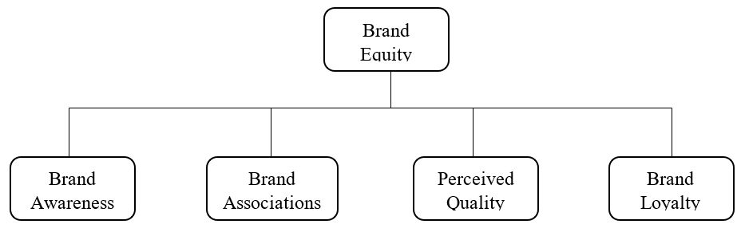

Models are well-known models in achieving high CBBE. This model emphasizes the importance of increasing brand awareness, brand association, perceived quality, and brand loyalty to achieve a high CBBE. This model recognizes that building a strong brand requires focusing on the functional and emotional attributes of the brand, as well as building a close relationship with consumers as the key to achieving a high CBBE. Overall, understanding the variables that contribute to CBBE and implementing strategies to build and improve those variables is critical in creating a strong and successful brand in the marketplace.(Aaker, 1991)

- Purchase Intention
Aprilisya et al. (2017) Stating a purchase intention as a desire to be able to own a product if the intention is driven by the influence of the quality and quality of a product and the existence of information that supports the existence of the product. Meanwhile, describing a consumer's purchase intent can be defined as a customer's willingness to purchase a particular product or service at a certain period of time. Purchase intent is a prologue to a purchase decision and is influenced by many factors. In this position, intent occurs before people make a purchase decision. The emerging stimuli and the comparison between the product and the company become one of the supporters of the purchase decision - the intention of society, which is a person's feeling of interest in something by combining knowledge and comparison of objects. (Sianturi et al., 2022)

According to Bangkara and Neem (2016) behavioural intention, it is still an interest, interest is defined as the desire to perform a behaviour. Meanwhile, behaviour (behaviour) is the actual action or activity carried out. So that behaviour will be done if someone has an interest in doing it. And behavioural interests will determine his behaviour. Interests are subject to change. The wider the time interval, the more likely it is to change in interest. states "People think about the implications of their actions before they decide whether or not to do certain behaviours". Durman and Musdholifah (2020) . Moreover, purchase intention combines various factors from sociology, psychology, and economics which seek understanding in the process of buying decision-making of a buyer. (Mariades, P.A., Abdullah, H., & Abdullah, N., 2016).

While according to in Namkung and Jang (2007) Purwianti & Tio (2017) behavioural intention is the behaviour of consumers who are loyal or loyal to the company so that they are willing to recommend to others because they have received good service from the company. According to Kotler (2014) behavioural intention is a condition where customers have intentions or attitudes loyal to brands, products and companies and willingly tell their superiority to other parties. Behavioural intention determines the likelihood that consumers will perform certain actions in the future. Defines Oktama (2018) behavioural intention as the possibility of customers to perform a certain behaviour such as positive word of mouth about a service provider to others, having a repurchase intention and loyalty to the service provider.

The emergence of consumer buying interest in a brand begins with the formation of preferences of all available preferred brands. Consumers who want a product based on confidence in addition to the ability to buy. According to (Kotler &; Keller, 2016)Kotler and Keller (2016) purchase intention is a form of behaviour from consumers who want to buy or choose a product based on experience, use and desire for a product. According to Kotler & Keller (2016) purchase intention is a form of behaviour from consumers who want to buy or choose a product based on experience, use and desire for a product. Marketing majors perceived that marketing would help increase consumers awareness as they would obtain more knowledge about marketing concepts and learn about current marketing practices. (Malenee & Chee, 2015)

In conclusion, purchase intention is the tendency or desire of customers to buy or use a particular product or service. It is influenced by a variety of factors, including experience, previous use, trustworthiness, desirability, and loyalty to the brand, product, or company. This purchase intent becomes the initial stage in the purchase decision process and can influence consumer actions in the future.

- Hypothesis
This increase in CBBE also has the potential to lead to an increase in the Purchase Intention of prospective BPU customers towards the products and services offered by BPJS Ketenagakerjaan. When potential consumers have a positive perception of the brand and feel an emotional or affective connection with the brand, they are more likely to choose BPJS Ketenagakerjaan as their choice when considering social security and protection needs. However, keep in mind that the success of the Re-Call strategy in influencing this Purchase Intention will largely depend on the effective and consistent execution of the strategy. Other factors that can influence are the quality of services provided by BPJS Ketenagakerjaan, brand image, and the level of trust and transparency established with potential customers. Therefore, BPJS Ketenagakerjaan needs to ensure that the Re-Call strategy is well implemented and balanced with satisfactory services in order to achieve a positive and significant influence on the Purchase Intention of prospective BPU customers. For this reason, the hypotheses in this study are as follows:
H1 Customer-Based Brand Equity (CBBE) BPJS Ketenagakerjaan After Strategy Implementation Re-Call positively and significantly affect Purchase Intention Non-Wage Earner (BPU)
H0 Customer-Based Brand Equity (CBBE) BPJS Ketenagakerjaan After Strategy Implementation Re-Call does not have a positive and significant effect on Purchase Intention Non-Wage Earner (BPU)

Methodology

- Types of Research
This research is a type of survey study, where researchers make observations in the process of collecting data. In this method, researchers carefully record data as it is, then analyse and interpret it. Survey research takes a sample from a population and uses questionnaires as the main instrument in data collection.

- Research Location
The location in this study is at the Head Office of BPJS Ketenagakerjaan, Jakarta.

- Population and Sample
Population is a generalized area consisting of: objects or subjects that have certain qualities and characteristics that are determined by researchers to be studied and then drawn conclusions. So, the population is not only people, but also other objects and objects of nature. Population is also not just the number that exists in the object or subject studied, but includes all the characteristics or properties possessed by that subject or object. For this reason, the population in this study is Non-Wage Earner Workers (BPU) as many as 4,189,212 people or 9.60% of the total BPU workers based on projections from the Ministry of Bappenas (BPJAMSOSTEK Annual Report, 2021).(Sugiyono, 2018) It is known that the population is 4,189,212 people and the level of precision is set at 5%. Based on the Slovin formula, the number of samples (n) is 400 respondents who are active participants of BPJAMSOSTEK Non-Wage Earners (BPU).

- Variable Operational Definition
- The Independent variable (X) is customer-based brand equity (CBBE), which includes: brand awareness, brand association, perceived quality, and brand loyalty.
- The Dependent variable (Y), is Purchase Intention, which includes: behavioural intention is still an interest, interest (intention)

- Data Analysis Methods
Structural Equation Modelling (SEM) is a method used to cover the weaknesses contained in the regression method. According to experts, Structural Equation Modelling (SEM) research methods are grouped into two approaches, namely the Covariance Based SEM (CBSEM) approach and Variance Based SEM or Partial Least Square (PLS). Partial Least Square is a powerful analysis method which in this method is not based on many assumptions. The PLS approach is distribution free (does not assume specific data, it can be nominal, categorical, ordinal, interval and ratio) PLS uses bootstrapping methods or random doubling which assumption of normality will not be a problem for PLS. In addition, PLS does not require a minimum number of samples to be used in research, studies that have small samples can still use PLS. Partial Least Square is classified as a non-parametric type, therefore in PLS modelling no data with normal distribution is needed.

The Findings
This study examines the effect of Consumer-Based Brand Equity BPJS Ketenagakerjaan through Re-Call Strategy on Brand Resonance and Customer Purchase Intention Not Wage Earners (BPU). The following are the results of a recapitulation of the results of direct and indirect influence testing (mediation) to answer the research hypothesis.

Figure 3. Bootstrapping Results
Source: Data processed with SmartPLS 4 (2024)

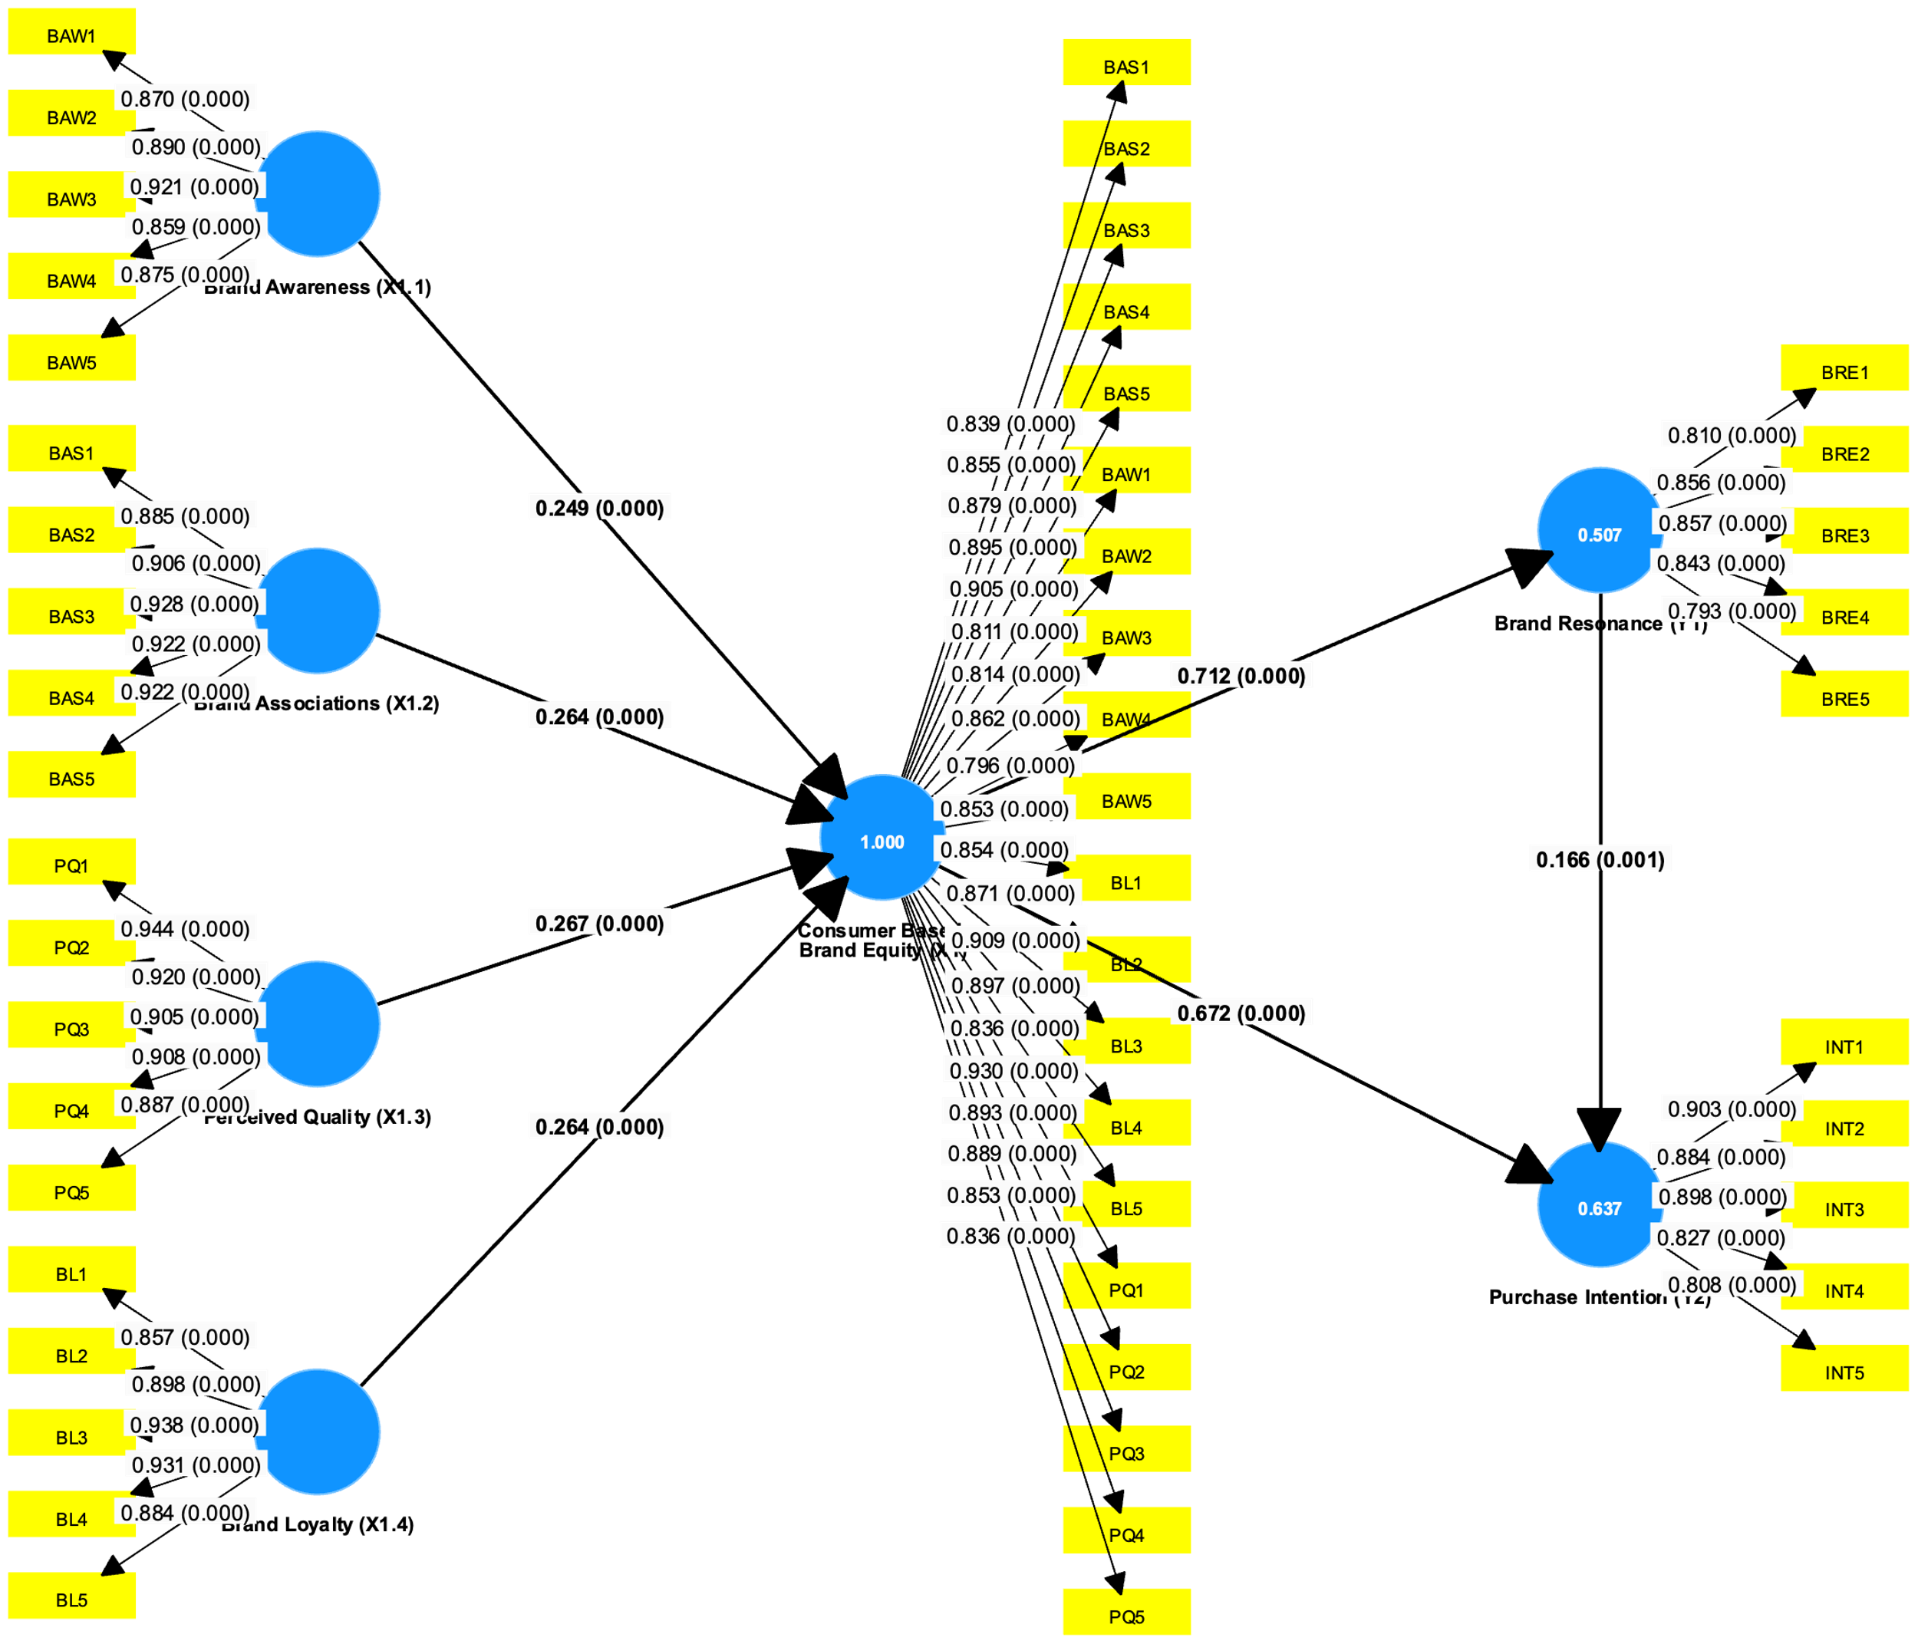

Table 1. Results of Hypothesis Test Value

Hypothesis | Direct Influence | Original sample (O) | T statistics (|O/STDEV|) | P values | Conclusion
H1 | Consumer Based Brand Equity (X1) -> Purchase Intention (Y2) | 0.672 | 15.206 | 0.000 | Accepted
H1a | Brand Awareness (X1.1) -> Consumer Based Brand Equity (X1) -> Purchase Intention (Y2) | 0.167 | 15.133 | 0.000 | Accepted
H1b | Brand Associations (X1.2) -> Consumer Based Brand Equity (X1) -> Purchase Intention (Y2) | 0.177 | 14.656 | 0.000 | Accepted
H1c | Perceived Quality (X1.3) -> Consumer Based Brand Equity (X1) -> Purchase Intention (Y2) | 0.179 | 14.755 | 0.000 | Accepted
H1d | Brand Loyalty (X1.4) -> Consumer Based Brand Equity (X1) -> Purchase Intention (Y2) | 0.177 | 15.215 | 0.000 | Accepted
H2 | Consumer Based Brand Equity (X1) -> Brand Resonance (Y1) | 0.712 | 23.170 | 0.000 | Accepted
H3 | Brand Resonance (Y1) -> Purchase Intention (Y2) | 0.166 | 3.337 | 0.001 | Accepted
H4 | Consumer Based Brand Equity (X1) -> Brand Resonance (Y1) -> Purchase Intention (Y2) | 0.118 | 3.362 | 0.001 | Accepted
Total Direct Effect (VAF) |  | Formula |  | VAF | Conclusion
Consumer Based Brand Equity (X1) -> Brand Resonance (Y1) -> Purchase Intention (Y2) |  | =(a*b)/(a*b)+c | =(0.712*0.166)/(0.712*0.166)+0.672 | 0.149 | Partial Mediation

This stage is carried out to find out whether the research hypothesis proposed in the research model is accepted or rejected. To test the hypothesis proposed, it can be seen from the value of path coefficients, T-Statistic values through bootstrapping procedures and p-values. According to Hair (2014), the value of the path coefficient is in the range of -1 to +1, where the value of the path coefficient close to +1 represents a strong positive relationship and a path coefficient value of -1 indicates a strong negative relationship. While T-Statistic (bootstrapping) is used to see which significance values between constructs. (Ramayah, 2017) suggests doing a bootstrapping procedure with a re-sample value of 5,000. The limit for rejecting and accepting the proposed hypothesis is ±1.96, where if the t-statistic value is in the range of -1.96 and 1.96 then the hypothesis is rejected or in other words accepts the null hypothesis (H0). Based on Figure 3 and Table 1, the following are the conclusions of the findings from the existing hypothesis tests:

Based on the results of hypothesis testing in Figure 3 and Table 1, it is known that the p-value is found to be 0.000 which is smaller than p <0.05. This means that H_{o} is rejected and H_{a} is accepted, it shows that there is a positive and significant influence between Customer-Based Brand Equity and Purchase Intention. In addition, the coefficient value was found to be 0.672 and the significance value of t-value was 15.206, which is greater than the t-table >1.96. That is, the variable Customer-Based Brand Equity has an influence of 67.2% on Purchase Intention. Thus, the H1 hypothesis in this study states that there is an influence between Customer-Based Brand Equity and Purchase Intention. From these results, it can be concluded that the more Customer-Based Brand Equity increases by one unit, the Purchase Intention also increases by 0.672 (67.2%)

Discussion
The results of this study show that the Customer-Based Brand Equity (CBBE) of BPJS Ketenagakerjaan, after the implementation of the Re-Call Strategy, has a significant influence on the Purchase Intention of Non-Wage Earners (BPU). These findings are consistent with previous research that has also highlighted the important role of CBBE elements in influencing consumer purchase interest.

CBBE elements, such as brand awareness, brand associations, perceived quality, and brand loyalty, have been a major focus in previous literature. Research by Aquinia &; Soliha (2020), Muslim & Qur'anis (2017), Supiyandi et al. (2022), Susilowati &; Novita Sari (2020), and Tuinesia et al. (2022) shows that brand awareness is a key factor in influencing consumer purchase interest. When consumers are more aware of the BPJS Ketenagakerjaan brand, they tend to be more interested in using the services offered.

In addition, research by Azzari & Pelissari (2020), Nazara et al. (2023), and Rungsrisawat &; Sirinapatpokin (2019) shows that brand associations play an important role in shaping consumer perceptions of brands. If consumers associate the BPJS Ketenagakerjaan brand with positive and relevant values, they are more likely to consider using the service.

Perceived quality is also a significant factor in influencing consumer purchase interest, as found in the research of Aquinia &; Soliha (2020), Azzari &; Pelissari (2020), Nazara et al. (2023), Supiyandi et al. (2022), and Susilowati &; Novita Sari (2020). If consumers believe that the services offered by BPJS Ketenagakerjaan are of high quality, they will tend to be more motivated to use these services.

Finally, brand loyalty is also a very important factor in maintaining consumer purchase interest, as revealed in the research of Enjelina &; Dewi (2021), Gabriella &; Sonny (2021), Muslim & Qur'anis (2017), Rungsrisawat &; Sirinapatpokin (2019), Supiyandi et al. (2022), Tuinesia et al. (2022), and Widjaja (2019). If consumers feel loyal to the BPJS Ketenagakerjaan brand, they are likely to choose to use the service rather than looking for other alternatives.

Thus, these findings not only strengthen the evidence on the relationship between CBBE and Purchase Intention, but also highlight the importance of understanding and effectively managing elements of CBBE to increase consumer purchase interest. This provides valuable insights for BPJS Ketenagakerjaan and other organizations in the development of more effective and consumer-oriented marketing strategies.

Analysis of findings on the influence of Customer-Based Brand Equity (CBBE) BPJS Ketenagakerjaan after the implementation of the re-call strategy on Purchase Intention showed significant results. With an influence value of 0.672 or 67.2%, this shows that the re-call strategy implemented by BPJS Ketenagakerjaan has a major impact on consumers' desire to make purchases or subscribe to their services. The re-call strategy, in this context, involves efforts to increase brand awareness and strengthen the values carried by BPJS Ketenagakerjaan, thereby increasing brand equity in the eyes of consumers.

CBBE factors include dimensions such as brand awareness, quality perception, brand association, and brand loyalty. The increase in CBBE through the re-call strategy shows that consumers are not only more aware of the BPJS Ketenagakerjaan brand, but also have a positive perception of the quality of the services they offer. This shows the importance of building strong and positive brand associations in the eyes of consumers to encourage their desire to make a purchase or subscription.

In the context of BPJS Ketenagakerjaan, an increase in Purchase Intention can have a direct impact on the number of participants or service users. This is important, considering that BPJS Ketenagakerjaan is a government program that aims to provide social security to workers. Therefore, the increase in Purchase Intention shows the success of BPJS Ketenagakerjaan in increasing public participation and trust in the social security programs they offer.

Furthermore, these findings also demonstrate the importance of implementing an effective communication strategy in building brand equity. A successful re-call strategy emphasizes the importance of communicating the value and benefits of BPJS Ketenagakerjaan services to consumers effectively. This not only increases brand awareness, but also strengthens positive associations and builds brand loyalty, which ultimately drives increased Purchase Intention.

Lastly, these findings provide valuable insights for BPJS Ketenagakerjaan and other organizations on the importance of maintaining and improving CBBE through effective communication strategies. In today's digital era, implementing innovative re-call strategies that are relevant to consumer needs and preferences is the key to increasing Purchase Intention. This shows that organizations need to continuously implement and adjust their strategies to maintain relevance and increase consumer trust and loyalty.

Conclusion
Customer-Based Brand Equity BPJS Ketenagakerjaan After the Implementation of the Re-Call Strategy simultaneously affects the Purchase Intention of Non-Wage Earners (BPU). With an influence value of 0.672 or 67.2%, this shows that the re-call strategy implemented by BPJS Ketenagakerjaan has a major impact on consumers' desire to make purchases or subscribe to their services. The re-call strategy, in this context, involves efforts to increase brand awareness and strengthen the values carried by BPJS Ketenagakerjaan, thereby increasing brand equity in the eyes of consumers. This shows that the higher the Customer-Based Brand Equity of BPJS Ketenagakerjaan After the Implementation of the Re-Call Strategy, the higher the Non-Wage Recipient (BPU) Purchase Intention.

Acknowledgement: The author wishes to express gratitude to Mercu Buana University for their support in publishing this article. Appreciation is also extended to MICOCS for selecting this article for publication through their conference. The collaboration and assistance given significantly advancing research in the field of communication

Informed Consent Statement: In this study, every participant was informed concerning the objectives, methods, possible hazards, and advantages of the research. The participants were told that their participation was voluntary, and they did not have to complete the study if they so wished. All respondents signed a consent form before being involved in the study, before they filled the questionnaire. All participants’ identities have been kept in disclosure consistent to the pertinent laws and rules and regulations set by the institutions involved in the study.

Acknowledegement

Conflicts of Interest: Both authors declare no conflict of interest.

References

Ahmad, B., Göç, K., & Yin, X. (2022). Employee-based brand equity. https://doi.org/10.4018/978-1-6684-3621-9.ch005
Aprilisya, N. P. E., Yasa, N. N. K., & Giantari, K. I. G. A. (2017). The role of attitude mediates the influence of green marketing on the purchase intention of environmentally friendly products. E-Journal of Management Unud, 6(4), 1701–1728.
Aquinia, A., & Soliha, E. (2020). The effect of brand equity dimensions on repurchase intention. Diponegoro International Journal of Business, 3(2). https://doi.org/10.14710/dijb.3.2.2020.97-103
Azzari, V., & Pelissari, A. (2020). Does brand awareness influence purchase intention? The mediation role of brand equity dimensions. Brazilian Business Review, 17(6), 669–685. https://doi.org/10.15728/BBR.2020.17.6.4
Bangkara, R. P., & Memba, N. P. S. H. (2016). The effect of perceived usefulness and perceived ease of use on interest in using internet banking with attitude toward using as an intervening variable. E-Journal of Accounting Udayana University, 16(3), 2408–2434.
Dev, C. S. (2016). Brand equity. In Hospitality Branding (pp. 82–92). Cornell University Press. https://doi.org/10.7591/cornell/9780801452031.003.0009
Durman, T. Y., & Musdholifah. (2020). Integration of technology acceptance model and theory of planned behavior on intention to use mobile payment (Study on Ovo users in Surabaya). Journal of Management Science, 8(2), 621–633.
Enjelina, E., & Dewi, C. K. (2021). The influence of brand awareness, brand association, perceived quality, and brand loyalty toward purchase intention of Emina cosmetic product in Bandung region. EProceedings.
Gabriella, G., & Sonny, S. (2021). The impact of brand equity to purchase intention (Case study from iPhone users in Makassar). Journal of Estuary Economics and Business, 5(1). https://doi.org/10.24912/jmieb.v5i1.8696
Hair, J. F., Sarstedt, M., Pieper, T. M., & Ringle, C. M. (2012). The use of partial least squares structural equation modeling in strategic management research: A review of past practices and recommendations for future applications. Long Range Planning, 45(5–6), 320–340. https://doi.org/10.1016/j.lrp.2012.09.008
Hair, J. F., Sarstedt, M., Ringle, C. M., & Gudergan, S. P. (2018). An overview of recent and emerging developments in PLS-SEM. Advanced Issues in Partial Least Squares SEM, June.
Keller, K. L., & Brexendorf, T. O. (2019). Measuring brand equity (pp. 1409–1439). https://doi.org/10.1007/978-3-658-13342-9_72
Keller, K. L., Prameswaran, A. M. G., & Jacob, I. (2015). Building, measuring, and managing brand equity (4th ed.). Pearson India Education Services.
Keller, K. L., & Swaminathan, V. (2020). Strategic brand management (global ed.). Pearson Education Limited.
Kotler, P. (2014). Marketing management (13th ed.). Prenhalindo.
Kotler, P., & Keller, K. L. (2016a). A framework for marketing management. PT Index.
Kotler, P., & Keller, K. L. (2016b). Marketing management (12th ed.). PT Index.
Malenee, A., & Chee, C. S. (2015). Students’ Perceptions Of The Relevancy Of Marketing Education. In e-Bangi (Vols. 10–10, Issue 1, pp. 208–222).
Mariadas, P. A., Abdullah, H., & Abdullah, N. (n.d.). Factors Affecting Purchasing Decision of Houses in The Urban Residential Property Market in Klang Valley, Malaysia. Vol. 16, No.4, 1–9.
Mohd Ilham, N. M., & Mohamad Salleh, M. A. (2016). Privasi dan Keselamatan Maklumat dalam Kalangan Pengguna Instagram Ketika Membeli Produk Secara dalam Talian. In Vol. 11, No. 1 (pp. 032–044).
Muslim, E., & Qur'anis, R. (2017). Strategy to increase customer's purchase intention on Garuda Indonesia's international flights based on brand equity factors. Journal of Technology Management, 16(2), 124–140.
Namkung, Y., & Jang, S. C. (2007). Does food quality really matter in restaurants? Its impact on customer satisfaction and behavioral intentions. Journal of Hospitality and Tourism Research, 31(3), 387–409. https://doi.org/10.1177/1096348007299924
Nazara, D. S., Satmoko, N. D., Surahman, B., & Nuryanto, U. W. (2023). Analysis of the influence of brand equity elements on consumers' purchase intention of packaged tea products.
Oktama, M. J. (2018). Analysis of the influence of customer perceived value variables on the behavioral intention of go-ride products in Malang City. In https://Medium.Com/. Brawijaya University.
Purwianti, L., & Tio, K. (2017). Factors affecting behavioral intention. Maranatha Journal of Management, 17(1), 15–32. https://doi.org/10.28932/jmm.v17i1.415
Ramayah, T., Cheah, J., Ting, F. C. H., & Memon, M. A. (2017). Partial least squares structural equation modeling (PLS-SEM) using SmartPLS 3.0: An updated and practical guide to statistical analysis. Practical Assessment, Research and Evaluation, 4(October), 291.
Ringle, C. M., Wende, S., & Becker, J.-M. (2022). SmartPLS 4. SmartPLS. https://www.smartpls.com/
Rungsrisawat, S., & Sirinapatpokin, S. (2019). Impact of brand equity on consumer purchase intent. Utopia y Praxis Latinoamericana, 24(Extra6).
Smith, D. C., & Aaker, D. A. (1992). Managing brand equity: Capitalizing on the value of a brand name. Journal of Marketing, 56(2), 125. https://doi.org/10.2307/1252048
Sugiyono. (2016). Quantitative, qualitative, and R&D research methods. Alfabeta Bandung.
Sugiyono. (2017). Qualitative research methods: For research that is exploratory, interpretive, interactive, and constructive. Alfabeta.
Supiyandi, A., Hastjarjo, S., & Slamet, Y. (2022). Influence of brand awareness, brand association, perceived quality, and brand loyalty of Shopee on consumers' purchasing decisions. CommIT Journal, 16(1). https://doi.org/10.21512/commit.v16i1.7583
Susilowati, E., & Novita Sari, A. (2020). The influence of brand awareness, brand association, and perceived quality toward consumers' purchase intention: A case of Richeese Factory, Jakarta. Independent Journal of Management & Production, 11(1). https://doi.org/10.14807/ijmp.v11i1.981
Tuinesia, R., Sutanto, J. E., & Sondak, M. R. (2022). The influence of brand awareness and perceived quality on repurchase intention: Brand loyalty as intervening variable (Case study at Kopi Soe branch of Panakkukang Makassar). International Journal of Economics, Business and Accounting Research (IJEBAR), 6(1). https://doi.org/10.29040/ijebar.v6i1.4861
Widjaja, Y. G. (2019). Effect of brand awareness, brand association, perceived quality, and brand loyalty on purchasing decision: Case study on ACE Hardware Indonesia consumers. International Journal of Advanced Engineering, Management and Science, 5(9), 542–548. https://doi.org/10.22161/ijaems.59.1

