PLEASE DO NOT MAKE ANY EDITING HERE. YOU NEED TO DOWNLOAD THE FILE.
THANK YOU

Type of the Paper (Article)

Canvas of Culture: Public Art’s Role in Reinvigorating Pekan Parit

Muhamad Ferdhaus ¹, Nur Ayunni², Hasnizam Ab’dul Hamid³ & Azal Fikri⁴

^{1.2,3&4} Program of Town and Regional Planning, Universiti Teknologi MARA,
Perak Campus, Seri Iskandar Branch,

*Corresponding author: ferdhaus@uitm.edu.my

Abstract: Accepting public art is vital for boosting tourism in Pekan Parit, Perak, as it enhances the area's cultural richness and appeal to visitors. This study focuses on how public art influences local perceptions and emotions, examining its potential to unite the community and attract tourists. The primary objective is to provide a comprehensive understanding of how public art can enrich the tourist experience and support sustainable tourism development. The research explores the impact of public art on tourist behaviour and its contribution to Pekan Parit’s cultural vibrancy by enhancing the town's infrastructure. A quantitative approach, primarily through surveys, was used to assess community attitudes toward public art. The findings reveal that while public art significantly improves the town's aesthetic and cultural appeal, its effectiveness in attracting tourists depends on active community engagement. Ensuring that public art resonates with both locals and tourists is essential for sustaining interest in the region's cultural offerings. Additionally, the study underscores the importance of preserving Pekan Parit's cultural identity while involving the local community in the planning and execution of public art projects. Public art can serve as a powerful tool for promoting sustainable tourism growth, enriching the visitor experience, and fostering deeper engagement with the area's cultural heritage. This research offers valuable insights for policymakers, urban planners, and cultural practitioners aiming to leverage public art as a means of revitalizing tourism in Pekan Parit, Perak.

Keywords: Public Art, Revitalization, Engagement, Identity, Tourism

Introduction
Public art has progressively emerged as a crucial instrument for rejuvenating tourism, especially in geographical areas aiming to augment their cultural attractiveness and economic viability. The incorporation of art into public areas enables cities and towns to provide visually captivating settings that appeal to both residents and visitors, therefore promoting a feeling of location and communal identity (Zebracki, 2017). Within the setting of Pekan Parit, Perak, a town rich in cultural legacy, public art presents a unique chance to stimulate tourism by augmenting the town's visual attractiveness and cultural liveliness. The endorsement of public art by the local community is essential, as it not only enhances the effectiveness of such projects but also guarantees that these creative pursuits have a strong impact on both inhabitants and tourists (Sharp, Pollock, & Paddison, 2005). Prior research has shown that public art can shape visitor behaviour by generating unforgettable experiences that promote return visits and good word-of-mouth (Hall & Smith, 2019). Furthermore, public art has the potential to act as a catalyst for community involvement, drawing individuals together and cultivating a collective feeling of identity and satisfaction in their immediate surroundings (Senie, 2002). Nevertheless, the effectiveness of public art in rejuvenating tourism relies heavily on the active participation of the community during both the design and execution stages (Goldstein, 2020). To maintain interest in the cultural offerings of the region, it is essential that the art accurately represents the local culture and values. The objective of this research is to investigate the effects of public art on tourism in Pekan Parit, specifically examining its effect on local views and tourist behaviour. Through an analysis of the community's reception of public art, this study aims to provide valuable understanding on how these projects might facilitate sustainable tourist development and enhance the cultural and economic progress of the town.

Literature Review
Urban development has long recognized public art as a vital component, widely acknowledging its role in enhancing the aesthetic and cultural dimensions of public spaces. Public art can serve as a visual narrative that reflects the history, culture, and identity of a place, contributing to a sense of belonging among residents and offering an authentic experience to visitors (Miles, 1997). The integration of public art into tourism strategies has gained traction, particularly in regions seeking to differentiate themselves in a competitive market. The broader concept of cultural tourism, which leverages a place's unique cultural assets to attract visitors, aligns with this approach (Richards, 2018). Research by Mathews (2014) highlights the transformative potential of public art in revitalizing declining urban areas. Public art installations can attract tourists, generate media attention, and stimulate economic activity by creating vibrant public spaces that encourage social interaction. This is particularly relevant in small towns like Pekan Parit, where tourism is a crucial driver of economic sustainability. The success of public art in such contexts, however, hinges on the degree of community involvement and acceptance. McCarthy (2006) noted that the community is more likely to embrace public art that resonates with local values and identity, thereby enhancing its appeal to tourists. Public art’s role in fostering community engagement is another critical aspect explored in the literature. According to Cartiere and Willis (2008), public art can act as a medium for social dialogue, bringing diverse groups together and fostering a sense of collective identity. This is particularly important in multicultural societies, where public art can bridge cultural divides and promote social cohesion. Such engagement can enhance the visitor experience in tourism by providing deeper insights into the local culture and fostering connections between tourists and the local community (Eshun & Madge, 2012). However, the literature also highlights the challenges associated with public art in tourism development. Perceiving public art as inauthentic or disconnected from the local context, especially when imposed without sufficient community input, is a significant issue (Evans, 2005). In such instances, people may perceive public art as a cultural imposition instead of a genuine expression of local identity. Additionally, the maintenance and sustainability of public art projects are critical factors that influence their long-term impact on tourism (Zebracki, 2012).

In summary, the literature underscores the importance of public art as a tool for tourism revitalization, particularly in culturally rich regions like Pekan Parit. However, effective public art requires thoughtful integration into the community, reflecting local values and fostering genuine engagement. This approach not only enhances the cultural appeal of a destination but also contributes to sustainable tourism development.

Study Area
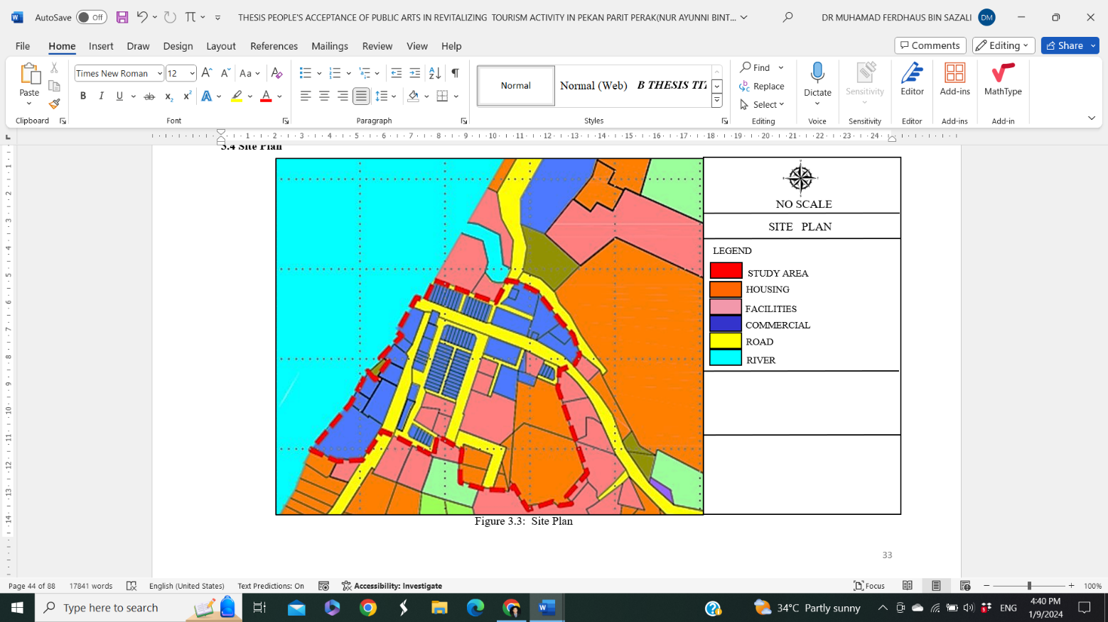
Parit, a small town in Perak, presents an intriguing opportunity to investigate the potential and reception of public art in the process of urban rehabilitation, particularly in relation to tourist developments, refer Figure 1. Mosaics and other forms of public art have the capacity to attract tourists and visitors, therefore providing a significant economic stimulus to the region. Through the analysis of the influence of public art on tourism in Parit, scholars may evaluate the potential of these projects to provide economic stimulation to the local community. Moreover, public art has the potential to significantly contribute to the development of a distinctive character for Parit, therefore enhancing the attractiveness of the town to tourists, refer Figure 2.
Figure 1: Site Plan

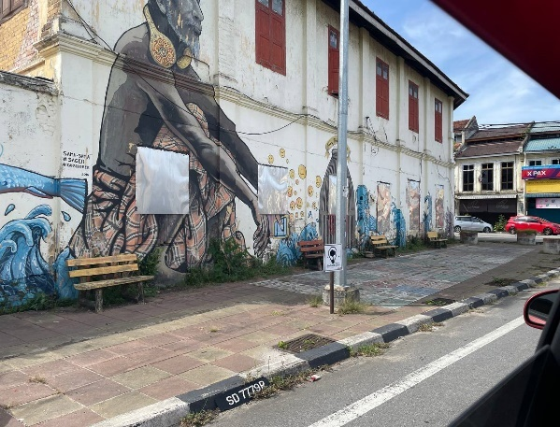
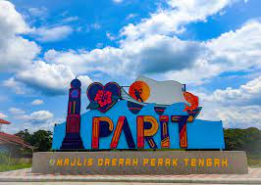
The goal of this study is to investigate the role of public art in shaping the town's character and enhancing its appeal as a tourist destination. Moreover, public art has the potential to greatly augment the visual allure of public areas, therefore converting Parit into a more captivating and welcoming destination. The project will investigate how these aesthetic enhancements may also augment the town's accessibility and navigation, therefore increasing its appeal to tourists. Parit, a tightly knit town, provides an ideal environment for involving residents in the process of rehabilitation through public art. This study aims to investigate the ways in which public art promotes community pride and involvement in tourist development initiatives. Indeed, Parit, Perak, is an excellent location for exploring the many advantages of public art in the process of urban rejuvenation. The municipality's capacity for tourism expansion, distinctive identity development, aesthetic enhancement, increased accessibility, and active community involvement make it a captivating and enlightening subject for analysis within the wider framework of public art and urban development.

Figure 2: Public Art & Mural at Memory Lane in Pekan Parit
Source: Field Study, 2024

Methodology
The present study adopts a hybrid research technique, including a mixed-methods approach, to develop a thorough comprehension of the research subject. Mixed-methods research is the systematic gathering, statistical analysis, and synthesis of both quantitative and qualitative data in one study, which allows for a more comprehensive and detailed investigation of the research issues (Creswell, 2014). The integration of these approaches enables a more thorough examination of the reception of public art in rejuvenating tourism in Pekan Parit, Perak, by including both statistical patterns and contextual understanding.

The research's quantitative aspect entails the deployment of a detailed questionnaire to collect primary data. The questionnaire was specifically developed to collect the viewpoints and impressions of local inhabitants about their acceptance of public art to enhance tourism in Pekan Parit. The questions are designed to specifically examine important considerations such as the perceived influence of public art on cultural identity, economic growth, and appeal to visitors of the community. To get a representative sample of the local community, a total of 103 respondents from the Pekan Parit area will be surveyed via site visits. A statistical analysis will be conducted on the quantitative data collected from the questionnaires to discover patterns, correlations, and trends that provide insight into the general approval of public art projects throughout the community. The qualitative component of the study involves using direct observation as a way of collecting secondary data. The present condition of public spaces in Pekan Parit, the positioning and reception of existing public art, and the interaction between inhabitants and tourists with these places will be evaluated via observations made during site visits. The available observational data will facilitate the identification of certain aspects that require attention to achieve the research goals. These aspects may include places that need aesthetic enhancement or possibilities for further community involvement.

Integrating both primary and secondary data sources will achieve a comprehensive perspective on the research topic. Primary data obtained from the questionnaire will give quantifiable insights into public opinion, while observational data will provide contextual knowledge, enabling a more informed appraisal of the successful contribution of public art to the regeneration of tourism in Pekan Parit. The inclusion of various data sources will provide a thorough evaluation of the research inquiries and offer practical suggestions for policymakers and stakeholders involved in the town's cultural and tourist development initiatives. By integrating quantitative and qualitative approaches, this research seeks to provide a comprehensive assessment of the capacity and reception of public art in the rejuvenation of tourism in Pekan Parit, guaranteeing that the results are both statistically significant and contextually pertinent.

The Findings
The researcher's respondent profile refer Table 1, reveals several significant demographic features, providing a valuable understanding of the wide range of viewpoints on public art in Pekan Parit. The gender distribution of the respondents is mostly female, comprising 75.7% (78 out of 103) of the entire sample, while males account for 24.3% (25 out of 103). The observed gender disparity implies that women have a higher propensity to participate in surveys, whether it is due to a greater inclination to divulge information or an increased fascination with public art and other subjects within the specific research domain. This pattern suggests that women may exhibit higher levels of involvement and receptiveness towards public art initiatives.

Furthermore, the respondents are classified according to their age, with five clearly defined age categories included. Adults aged 20-29 are the biggest category, accounting for 56.3% (58 responses) of the total. The subgroup of those aged 30-39 comprises 22.3% (23 respondents), while those aged 40 and above account for 21.4% (22 respondents). The prevalence of younger participants indicates that this age group is more open to novel concepts and modifications, which may significantly augment the appeal of Pekan Parit as a tourist spot. Furthermore, younger people may possess a heightened awareness of current trends in public art, thereby making their input essential for comprehending the possible influence of such endeavors. Among the interviewees, 91.3% (94 out of 103) identify as Malay, which accurately represents the demographic makeup of the research region. The remaining respondents, consisting of 8 Chinese and 1 Indian, demonstrate a very homogeneous population. The prevalence of Malay participants enabled effective communication throughout the survey procedure, since we customized the questionnaire to suit the language and cultural specificities of the area.

Based on their job situation, the respondents were classified into six distinct groups: government employees, private sector workers, freelancers, unemployed persons, housewives, and students. The private sector had the largest proportion, accounting for 26.2% (27 participants). In contrast, the categories of housewives and recent graduates were the least represented, accounting for 1.9% and 1%, respectively. The wider exposure of private sector workers to a variety of creative and cultural activities may have enhanced their responsiveness, leading to their increased involvement in the questionnaire.

Furthermore, the survey distinguished between locals and tourists, as 67.0% (69 participants) identified as local inhabitants and 34.0% (34 participants) identified as visitors. This analysis provides a comprehensive perspective on both residents and visitors' perceptions of the contribution of public art to rejuvenating Pekan Parit. It provides important insights into the acceptability and potential influence of public art on the town's tourism initiatives.

Table 1. Respondent’s Profile
Respondent’s Profile | Frequency(n=103) | Percentage %
Gender
Male | 25 | 24.3
Female | 78 | 75.7
Total | 103 | 100
Age
20 – 29 years | 58 | 56.3
30 – 39 years | 23 | 22.3
> 40 years | 22 | 21.4
Total | 103
Race
Malay | 94 | 91.3
Indian | 1 | 1.0
Chinese | 8 | 7.8
Total | 103 | 100
Employment
Government | 14 | 13.6
Private | 27 | 26.2
Self-employed | 18 | 17.5
Part-time worker | 3 | 2.9
Housewife | 2 | 1.9
Retired | 3 | 2.9
Student | 23 | 22.3
Fresh Graduate | 1 | 1.0
Unemployment | 12 | 11.7
Total | 103 | 100
Locality
Local people | 69 | 67.0
Tourist | 34 | 33.0
Total | 103 | 100
Source: Field Study, 2024
Using Likert scale data, analysing the public's knowledge and appreciation of public art in Pekan Parit, Perak, reveals interesting things about the community's view of public art's function in elevating the town's aesthetic and cultural worth. According to the research, most people are pleased to see public art projects, particularly when they reflect the local culture and improve the town's visual appeal.
- The effects on culture and consciousness
Most respondents (81.6%) are familiar with the term "public arts," according to the mean Likert scale score of 3.84. This points to a high level of public art knowledge, which is essential for encouraging local participation in tourist initiatives that make use of cultural resources. In addition, 85.4% of respondents agreed or strongly agreed that public art may enrich Pekan Parit's cultural environment, yielding a high mean score of 4.12. This is in line with research that shows how important public art is in fostering a culturally rich environment that draws in visitors and residents alike (Richards, 2018).
- Beauty and long-term cultural viability
With an average score of 4.12, the community views Pekan Parit's public art as greatly enhancing its visual value. This near-universal agreement (85.4% of people) emphasizes the importance of public art in enhancing the aesthetic value of public places. Residents see public art as a vital instrument for promoting and protecting the region's cultural identity, as it contributes to creating awareness about the sustainability of local culture and history. The highest mean value of 4.13 demonstrates the impact of public art on this matter.
- Obstacles: Upkeep and Pertinence
Although the survey found that public art in Pekan Parit was generally well-received, it did find several problems with its execution. The average score of 3.68 indicates that the lack of attention or care for public art is a significant issue. That public art is well-received but needs better upkeep to persist is a logical conclusion.
The community also believes that certain public art pieces do not represent the town's values, culture, or history or are inappropriate for their present sites, which is another important conclusion. A significant number of respondents (52.4% and 64.1%, respectively) were unhappy with these features, which resulted in mean ratings of 2.64 and 2.5, respectively. According to McCarty (2006), there seems to be a mismatch between the cultural expectations of the community and certain public art projects. This highlights the need to ensure that public art efforts are in line with the local identity and values. The findings suggest that while public art is generally well-received in Pekan Parit, its success in revitalizing tourism depends on maintaining its cultural relevance and ensuring proper upkeep. Public art that resonates with local values and enhances the town’s aesthetic appeal is seen as a powerful tool for promoting cultural sustainability and tourism growth. However, to maximize its impact, there is a need for greater community involvement in the planning and maintenance of public art projects.
Table 2. Public's Knowledge and Appreciation of Public Art In Pekan Parit, Perak
ASPECTS | LIKERT SCALE |  |  |  |  | Mean
ASPECTS | 1 | 2 | 3 | 4 | 5 | Mean
ASPECTS | F | F | F | F | F | Mean
Aware of the concept of public arts | 1 | 3 | 11 | 84 | 4 | 3.84
Aware of the concept of public arts | 1.0 | 2.9 | 10.7 | 81.6 | 3.9 | 3.84
Believe public arts can enhance the cultural ambiance of Pekan Parit | 1 | 0 | 0 | 88 | 14 | 4.12
 | 1.0 | 0 | 0 | 85.4 | 13.6 | 4.12
The presence of public arts in Pekan Parit adds aesthetic value to the town. | 0 | 1 | 0 | 88 | 14 | 4.12
 | 0 | 1.0 | 0 | 85.4 | 13.6 | 4.12
Public art in Pekan Parit contributes awareness to the sustainability of local culture and heritage. | 1 | 0 | 1 | 84 | 17 | 4.13
 | 1.0 | 0 | 1.0 | 81.6 | 16.5 | 4.13
Public art in Pekan Parit is neglected or poorly maintained | 4 | 8 | 6 | 84 | 1 | 3.68
Public art in Pekan Parit is neglected or poorly maintained | 3.9 | 7.8 | 5.8 | 81.6 | 1.0 | 3.68
Public art in Pekan Parit in the city does not suitable in this current place | 2 | 54 | 26 | 21 | 0 | 2.64
 | 1.9 | 52.4 | 25.2 | 20.4 | 0 | 2.64
Public art in Pekan Parit does not reflect the history, culture, or values of the city. | 3 | 66 | 16 | 16 | 2 | 2.5
 | 2.9 | 64.1 | 15.5 | 15.5 | 1.9 | 2.5
Source: Field Study, 2024

Discussion
The findings of this study underscore the complex interplay between public art and community engagement in Pekan Parit, Perak, highlighting both the positive impacts and areas for improvement. The high levels of awareness and acceptance of public art among the local community reflect a strong recognition of its potential to enhance the town's cultural and aesthetic appeal, which aligns with broader research on the role of public art in urban revitalization (Richards, 2018). However, to fully realize the benefits of public art, we must address the notable challenges revealed by the study.

Community Engagement and Cultural Impact
The mean scores indicating that public art enhances Pekan Parit’s cultural ambiance (4.12) and adds aesthetic value (4.12) suggest a strong community belief in the positive contributions of public art. This supports the view that public art can play a significant role in enriching cultural experiences and beautifying urban spaces (Mathews, 2014). Public art not only improves the town's attractiveness to visitors by creating visually appealing environments, but it also fosters a sense of pride among residents. This aligns with the findings of Richards (2018), who emphasizes that cultural assets, including public art, are crucial for enhancing the appeal of tourist destinations by offering authentic and engaging experiences.

Challenges in Public Art Implementation
Despite these positive aspects, the study identifies critical issues related to the maintenance and relevance of public art. The mean score of 3.68 for public art maintenance indicates concerns about art installations' neglect or poor upkeep. Effective maintenance is essential for sustaining the visual and cultural impact of public art, as neglected installations can detract from their intended benefits and diminish community engagement (McCarthy, 2006).
Furthermore, the lower mean scores for the relevance of public art (2.64) and its reflection of local history and values (2.5) highlight a disconnect between some public art projects and the community’s cultural expectations. This implies that the alignment of public art with local cultural narratives and historical context significantly influences its impact, despite its valued status. McCarthy (2006) argues that public art must resonate with the community’s identity to foster meaningful engagement and support.

Implications for Future Public Art Projects
The findings suggest several implications for future public art projects in Pekan Parit. First, ensuring that public art reflects the town’s cultural heritage and values is crucial for maximizing its impact. Engaging local stakeholders in the planning process can help align art installations with community expectations and enhance their relevance (Mathews, 2014). Additionally, improving maintenance practices is essential to preserving the aesthetic and cultural value of public art over time. Regular upkeep and community involvement in maintenance can help sustain the positive effects of public art and prevent it from becoming a source of dissatisfaction.

Overall, the study demonstrates that public art holds significant potential for revitalizing tourism and enhancing cultural identity in Pekan Parit. However, to fully leverage these benefits, it is vital to address issues related to maintenance and relevance. By aligning public art with local cultural values and ensuring its proper upkeep, Pekan Parit can enhance its appeal as a tourist destination and foster a stronger sense of community pride.

Conclusion
The current study has examined the role of public art in revitalizing tourism in Pekan Parit, Perak, thereby clarifying its significant impact on enhancing the district's cultural and aesthetic appeal. The findings indicate that the local community places considerable importance on public art due to its ability to refine the cultural ambiance and increase the visual appeal of the town. This finding aligns with the current corpus of empirical studies on the benefits of public art in metropolitan settings (Richards, 2018; Mathews, 2014). The significant levels of public art knowledge and endorsement highlight its potential as a very effective tool for encouraging community engagement and stimulating tourism development. However, the study also highlights crucial issues that require attention. The slightly lower average evaluations regarding the importance of public art and its maintenance suggest that certain pieces fail to meet community expectations or lack adequate care. This suggests that public art should align closely with local values and maintain a superior standard of excellence to enhance its effectiveness in attracting tourists and enhancing cultural identity (McCarthy, 2006).

Overall, public art has shown its substantial value in augmenting the cultural and visual attractiveness of Pekan Parit, thereby making a beneficial contribution to tourism and community pride. Nevertheless, it is crucial to tackle obstacles associated with cultural relevance and preservation to optimize its influence. Future studies should prioritize a more comprehensive knowledge of community attitudes, assess the long-term effects of tourism, establish efficient maintenance mechanisms, and investigate the wider urban development responsibilities for public art. Such endeavours will provide a more sophisticated understanding of the possibilities of public art and give direction for maximizing its advantages in comparable situations.
Paper Contribution to Related Field of Study
This paper makes a significant contribution to the field of public art and tourism by providing a detailed analysis of how public art impacts community engagement and tourism development in Pekan Parit, Perak. It enhances understanding of the role that public art plays in revitalizing small towns, particularly in terms of boosting cultural vibrancy and attractiveness to visitors. By employing a quantitative approach to gauge community attitudes and examining how public art influences tourist behaviour, the study offers valuable insights into the dynamics of integrating art into tourism strategies. Additionally, it highlights the importance of community involvement in the planning and execution of public art projects, underscoring how this involvement can enhance both local acceptance and the effectiveness of such initiatives in promoting sustainable tourism. The findings provide practical guidance for policymakers, urban planners, and cultural practitioners seeking to leverage public art for economic and cultural development, making a meaningful contribution to both academic research and practical applications in the field.

References
Cartiere, C., & Willis, S. (2008). The practice of public art. Routledge.
Eshun, G., & Madge, C. (2012). Cultural cohesion and the role of public art. Journal of Cultural Geography, 29(2), 93-110.
Eshun, G., & Madge, C. (2012). Cultural cohesion and the role of public art. Journal of Cultural Geography, 29(2), 93-110.
Goldstein, B. (2020). Public art and community engagement. Routledge.
Hall, T., & Smith, C. (2019). Tourism and public art: Creating memorable experiences. Tourism Management, 40(3), 54-61.
Mathews, S. (2014). Revitalizing urban spaces through public art. Urban Design International, 19(1), 11-23.
McCarthy, J. (2006). Regeneration of cultural quarters: Public art and social inclusion. Urban Studies, 43(10), 1925-1943.
Richards, G. (2018). Cultural tourism: A critical review of the literature. In D. D. Silva & R. Burns (Eds.), Tourism and cultural change. Palgrave Macmillan.
Senie, H. F. (2002). The role of public art in urban regeneration. Art Journal, 61(2), 34-42.
Sharp, J., Pollock, V., & Paddison, R. (2005). Just art for a just city: Public art and social inclusion in urban regeneration. Urban Studies, 42(5-6), 1001-1023.
Zebracki, M. (2017). Public art and cultural policy. Palgrave Macmillan.

