Table 1. Tabulation of demographic data of respondents.

Demographic Data | N | P (%)
Age
18-22 | 142 | 79.8
22-25 | 31 | 17.4
25-30 | 5 | 2.8
Gender
Female | 146 | 82.0
Male | 29 | 16.3
Prefer not to say | 3 | 1.7
Faculty
Faculty of Science | 44 | 24.7
Faculty of Business and Economics | 37 | 20.8
Faculty of Arts and Social Sciences | 23 | 12.9
Faculty of Engineering | 13 | 7.3
Faculty of language and Linguistics | 12 | 6.7
Faculty of Law | 11 | 6.2
Faculty of Computer Science and Information Technology | 10 | 5.6
Others  (Faculty of Education, Faculty of Creative Arts, Academy of Islamic Studies, Faculty of Medicine, Faculty of Pharmacy, Faculty of Built Environment, Faculty of Sport Science and Recreation, Faculty of Dentistry, Academy of Malay Studies, prefer not to say  Faculty) | 28 | 15.8

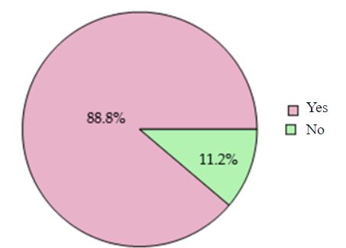

Figure 1. Question: Have you heard of menstrual cups before?

Table 2. Question: Where did you first learn about menstrual cups?

Method | N | P (%)
Friends or Family | 31 | 17.4
Internet or Social Media | 152 | 85.4
Educational Workshop or Classes | 40 | 22.5
Healthcare provider or Gynecologist | 10 | 5.6
Newspaper | 1 | 0.6
Forum | 1 | 0.6
I haven’t heard of menstrual cups | 3 | 1.8

Table 3. Question: What do you know about menstrual cups? (Multiple Choice)

Statement | N | P = N × 100%  178
They are reusable menstrual products. | 141 | 79.2
They are made of medical-grade silicone, rubber, or latex. | 114 | 64.0
They can be worn for up to 12 hours. | 57 | 32.0
They are eco-friendly and reduce waste. | 115 | 64.6
They are cost-effective | 95 | 53.4
They are uncomfortable to use. | 47 | 26.4
They are comfortable to use. | 1 | 0.6
I don’t know | 4 | 2.4

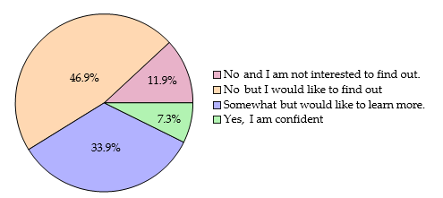
Figure 2. Question: Do you know how to properly insert a menstrual cup?

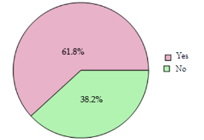
Figure 3. Question: Have you ever considered trying a menstrual cup?

Table 4. Reasons for Using Menstrual Cups

Reason | N | P (%)
Reduce leakage | 2 | 3.6
Cost-effective | 17 | 30.4
More comfortable | 12 | 21.4
Curiosity | 5 | 8.9
Environmental Factors | 18 | 32.1
Safer option | 2 | 3.6

Table 5. Reasons for Not Considering Menstrual Cups

Reason | N | P (%)
Comfortable With Sanitary Pads/Tampons | 11 | 17.2
Fear/Discomfort | 38 | 59.8
Lack of Knowledge | 6 | 9.4
Unsure of Safety | 4 | 6.3
Peer Influence | 1 | 1.6
Inconvenience | 1 | 1.6
Cost/supply concerns | 3 | 4.7

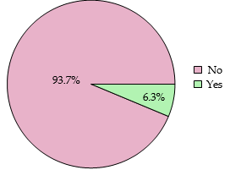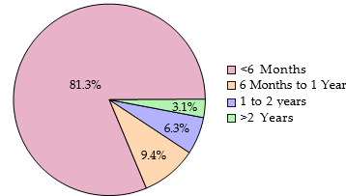

Figure 4a. Question: Are you still using menstrual cups? (79 responses)

Figure 4b. Question: Do you know how to properly insert a menstrual cup? (32 responses)

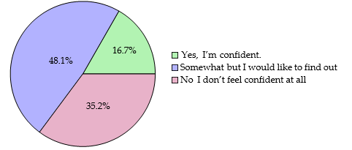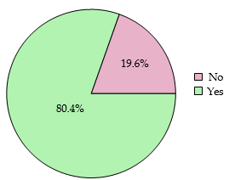

Figure 5a. Question: Do you feel confident in your knowledge of how to use a menstrual cup safely? (54 responses)

Figure 5b. Question: Do you think using menstrual cup is cost-effective for you? (56 responses)

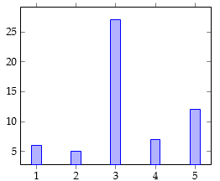

Figure 6. On a scale of 1 to 5, how much would you recommend someone else to try out menstrual cup? (57 responses)

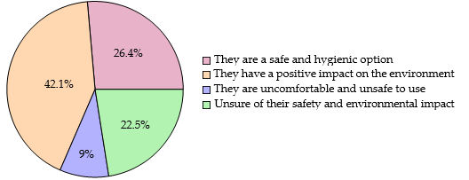
Figure 7. Question: What are your perceptions regarding the safety and environmental impact of menstrual cups?

Table 6. Question: Do you have any concerns about menstrual cups?

Concern | N | P (%)
None | 70 | 39.3
Hygiene/Safety Concerns | 23 | 12.9
Discomfort | 43 | 24.2
Lack of Knowledge | 38 | 21.3
Lack of Awareness | 3 | 1.7
Cost | 1 | 0.6
Total | 178 | 100.0

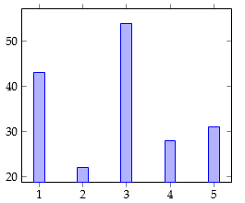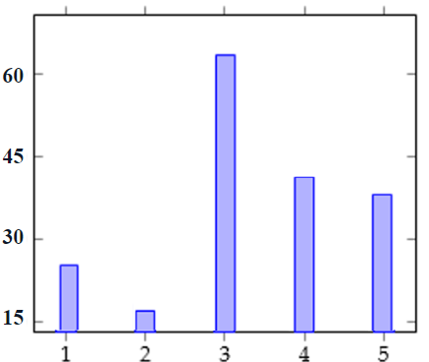
Figure 7b. On a scale from 1 to 5, with 1 being "Not likely at all" and 5 being "Very likely," how likely are you to recommend the use of a menstrual cup for others?

Figure 7a. On a scale from 1 to 5, with 1 being "Not likely at all" and 5 being "Very likely," how likely are you to try a menstrual cup in the future?

