Article

Knowledge, Awareness, and Practices of Menstrual Cup Usage Among Malaysia’s Undergraduate Students

Yoo Kee Law¹,Chng Saun Fong^{*1} and Kim Ling Chin^{*1,2}

1Institute for Advanced Studies (IAS), Universiti Malaya, Kuala Lumpur, 50603, Malaysia
2Department of Medical Microbiology, Faculty of Medicine, Universiti Malaya, Kuala Lumpur, 50603, Malaysia

*Corresponding author: kimling@um.edu.my; fongcs92@um.edu.my
Received:
Accepted

Abstract: This study explores undergraduate students' knowledge, awareness, and practices toward menstrual cups, highliting key factors influecing their adoption and continued use. Despite growing awareness, sustained usage remains low due to significant barriers, including concerns about comfort, safety and insufficient information. Utilizing a survey approach, this study examines the motivations and challenges associated with menstrual cup adoption, as well as the role of different information sources.. The study underscores the importance of menstrual health education, considering variables like environmental impact awareness and economic factors. Understanding university students' perspectives on menstrual cups is crucial for designing effective education programs. The discussion section critically examines safety concerns and the impact of awareness campaigns. It emphasizes the necessity of targeted educational initiatives to address knowledge gaps and promote positive discussions around menstrual cups. The study concludes by discussing the implications of encouraging sustainable menstrual hygiene practices and empowering the younger generation to make informed choices for their well-being and the environment.

Keywords: Menstrual Cups; female hygiene; university students; awareness and perception; environmental benefits

Introduction
Menstrual hygiene management is a critical issue that affects women worldwide, with disposable sanitary pads being the predominant method for many years. However, research indicates that an average woman generates approximately 125-150 kg of menstrual waste in her lifetime (Kaur et al., 2018), raising significant environmental concerns. Menstrual cups, introduced as a sustainable alternative, are silicone, latex, or thermoplastic vessels inserted into the vagina to collect menstrual fluid (Manley et al., 2021). Despite their invention in 1867, concurrent with pads and tampons, menstrual cups have gained significantly less market penetration. Studies demonstrate this disparity, with research in India showing only 0.3% of women preferring menstrual cups compared to 96.9% using sanitary pads (Singh et al., 2022). Similarly, UK data revealed a stark contrast between low-awareness individuals (95% preferring single-use products) and high-awareness individuals (42% preference) (Peberdy et al., 2019).
When examining the evidence, menstrual cups demonstrate substantial advantages over traditional menstrual products. Studies by Beatriz et al. (2023) and Van Eijk et al. (2019) demonstrated reduced rates of candidiasis among users. From an economic perspective, users in high-income countries can save approximately US$205 (RM 956.33) over the product's lifetime, replacing around 1,300 single-use products (Van Eijk et al., 2021). The environmental impact is equally significant, as disposable products contain chemicals that threaten aquatic ecosystems (Naz et al., 2022). Despite these benefits, the low adoption rate stems from various factors, including initial difficulty in usage, fear, and embarrassment (Singh et al., 2022). Moreover, limited awareness of environmental and health impacts, coupled with corporate promotion of single-use products for recurring profit, contributes to low adoption rates (Borowski, 2011). Recent research by Sahin et al. (2021) identified lack of knowledge and negative perceptions as major barriers among university students.
Malaysian undergraduate students represent a strategic focus for menstrual cup research for several key reasons. As young adults in an academic environment, they are often more open to adopting new practices and discussing menstrual health options with peers. With Malaysia generating 2.4 billion pieces of sanitary waste annually (Stella, 2022), understanding this demographic's awareness and attitudes toward sustainable menstrual products is crucial. University students also tend to be more environmentally conscious and could potentially influence their social circles and families regarding sustainable menstrual practices. Their perspectives and experiences can provide valuable insights for developing targeted awareness programs in the Malaysian context.

Literature Review
Single-use plastics have recently become a target for action. Still, it seems that menstrual products are going under the radar, with disposables often not recognized publicly as a source of single-use plastic. Although the presence of microplastics in the ocean was highlighted in the 1970s by scientists who warned that their concentration was likely to increase and cause problems (Carpenter and Smith, 1972), renewed interest has sparked more studies into its effects. Much of the environmental impact from popular menstrual products comes from their disposable nature (Spinks, 2015).
Historically, women felt that menstruation was something to be ashamed of, a feeling that is still prevalent in society and popular culture today (Rosewarne, 2012; Del Saz-Rubio and Pennock-Speck, 2009; Bell, 2021). Research indicates that while awareness of menstruation is associated with better management practices, it paradoxically correlates with increased feelings of embarrassment, particularly during menarche (Seyed, 2020). In Asian contexts,, cultural taboos and stigma often prevent open discussion and education about menstruation (Joshi, 2022; Metusela et al.,2017). Where many women to stick with familiar, traditionally accepted products rather than exploring newer alternatives like menstrual cups (Lim et al.,2020). This adherence to conventional products is perpetuated through intergenerational knowledge transmission, where established practices are passed down, limiting exposure to innovative solutions (Mpondo et al., 2018; Rahman et al.,2023). Within the Malaysian context, existing literature focuses predominantly on general menstrual hygiene practices, with limited attention to specific product adoption patterns. While Abdullah et al. (2024) examined Islamic menstrual education in Malaysian primary schools, and Lim et al. (2020) investigated sexual and reproductive health integration, research specifically addressing menstrual cup adoption among Malaysian university students remains notably scarce. Rahman et al. (2023) has expanded the discourse to include menstrual education for special needs teenagers and parental support systems, yet the specific dynamics of menstrual product choices among mainstream university students remain underexplored.
These cultural dynamics hold particular significance in Malaysia's multi-ethnic society, where diverse cultural beliefs and practices intersect with menstrual management decisions (Karupiah & Fernandez, 2022; Abdullah et al., 2024). In Malaysian Muslim communities, religious teachings from the Qur'an and Hadith influence not only religious practices but also shape product preferences, particularly regarding internal menstrual products (Delong, 2022). Research by Peberdy et al. (2019) and Pednekar et al. (2022) demonstrates that religious and cultural acceptability often supersede environmental or economic considerations in women's menstrual product choices. This complex interplay of religious and cultural factors creates substantial barriers to the adoption of alternative menstrual products, even when their benefits are acknowledged.
Market forces significantly influence menstrual product adoption patterns. The prevalence of disposable products over reusable alternatives may be attributed to their higher commodity potential, as they require regular repurchase, whereas a menstrual cup can remain functional for up to a decade (Davidson, 2012). Despite the early development of reusable menstrual cups, predating commercial tampons by over 50 years, their initial market penetration remained limited. Shure (2016) attributes this limited adoption to two key factors: aggressive marketing of disposable alternatives and women's increasing preference for products that minimized intimate body contact
While recent scholarship has examined menstrual cup adoption across various contexts, significant knowledge gaps persist regarding the Malaysian experience, particularly among young adults. Existing research has primarily centered on Western perspectives or broader developing nation contexts, with limited investigation into how Malaysia's unique social dynamics influence menstrual product choices. Furthermore, while social media has catalyzed renewed interest in reusable products (Randor, 2017), the translation of this digital discourse into practical adoption among Malaysian youth remains understudied. This study addresses these research gaps by examining menstrual cup awareness and adoption within the Malaysian university context, analyzing the intersection of environmental consciousness, practical considerations, and societal influences that shape menstrual product choices in this demographic.

Methodology

1. Data Collection
The survey was conducted among undergraduate students at Universiti Malaya, a public research university located in Kuala Lumpur, Malaysia. The university has a diverse student population, with over 21,000 undergraduate students enrolled across various faculties and programs. A randomized sampling method was used to recruit participants. The inclusion criteria for the study were: (1) being an undergraduate student at the Universiti Malaya, (2) being aged 18 years or above, and (3) providing informed consent to participate in the survey. Students who did not meet these criteria were excluded from the study. Male participants were deliberately included in this study to understand their awareness and attitudes towards menstrual cups, as they often play important roles as partners, family members, and future healthcare providers in supporting menstrual health decisions. This inclusion aligns with recent research by Daud et al. (2024), who found that addressing gender disparities in menstruation knowledge among university students is crucial for promoting better menstrual health outcomes and reducing stigma. Their study demonstrated that male students' understanding of menstrual health significantly influences broader societal attitudes and support systems. In this study, male participants have involved in awareness part only. The questionnaire was distributed through online platforms, including Google Forms, and shared via various social media channels and email lists. The data collection period lasted for 12 weeks in 2023. Participation was voluntary, and informed consent was obtained from all participants.

2. Questionnaire Design
The questionnaire was developed through a process to ensure reliability and validity. Initial items were generated based on extensive literature review and expert consultation. The instrument underwent content validation by a panel of three experts in women's health and survey methodology. A pilot study was conducted with 30 students (25 female, 5 male) to assess the clarity and comprehensibility of questions. Cronbach's alpha was calculated to determine internal consistency, with values ranging from 0.78 to 0.85 across different sections, indicating good reliability. The questionnaire comprises two main sections. The first section captures demographic information including age, gender, year of study, and faculty. The second section assesses knowledge and awareness of menstrual cups, with distinct question paths for female and male respondents. For female participants, questions cover current menstrual product usage, awareness of menstrual cups, factors influencing potential adoption, safety concerns, and environmental impact considerations. Male participants' questions focus on their awareness of menstrual cups, their understanding of environmental impacts of menstrual products, and their willingness to discuss or recommend sustainable menstrual products to female acquaintances.

3. Data Analysis
The information gathered from this survey was analyzed using the Statistical Package for the Social Sciences (SPSS) Version 23. Descriptive statistical analyses were performed to summarize and interpret the survey responses. Frequencies and percentages were calculated for demographic characteristics (age, gender, year of study, and faculty distribution) and for responses regarding awareness levels, usage patterns, and attitudes toward menstrual cups. The analysis focused on understanding participant profiles, assessing awareness and usage patterns, and examining attitudes and perceptions toward menstrual cups. Results were presented using both tabular and graphical formats, with frequency tables displaying demographic data, sources of information, and participant concerns, while pie charts and bar graphs were used to visualize yes/no responses and Likert scale measurements regarding attitudes and willingness to use or recommend menstrual cups. These insights help identify common obstacles, possible incentives, and areas where further guidance or assurance might be necessary.

Results

1. Demography of Participants
Table 1 presents the demographic data of the sample population according to age, gender, and faculty distribution. A majority of the respondents are aged 18-22 and predominantly female. This distribution is consistent with the general demographic profile of undergraduate students in Malaysia. According to the Statista (2024), the majority of undergraduate students in public universities are female in 2022 (58.95%) and within the age range of 18-22 years old. It is also observed that most respondents are from the Faculty of Science (N = 44, P = 24.7%) and Faculty of Business and Economics (N = 37, P = 45.5%). The higher representation of students from these faculties in the study sample can be attributed to the larger student population in these faculties compared to others. Although the sample may not be perfectly representative of the entire undergraduate population, the consistency with the general demographic profile suggests that the potential for bias is minimal. Furthermore, the use of randomized sampling in this study is justified due to the exploratory nature of the research and the limited resources available (Etikan et al., 201?).
A total of 178 respondents was obtained from data collection. In this cohort, a majority of the respondents fell between ages 18 to 22 (N = 142, P = 79.8%) which aligns with the typical age range of undergraduate students in Malaysia. Among the respondents, 146 (P = 82%) were female, 29 (P = 16.3%) were male and the remaining did not disclose their gender (N=3, P=1.7%). The higher proportion of female respondents is advantageous for this study, as menstrual cups are primarily used by women. This gender distribution allows for a more focused analysis of the awareness and perceptions of menstrual cups among the target users (van Eijk et al., 2019). Additionally, it was observed that 79 respondents (P = 44.4%) were from Year 1, 59 respondents (P = 33.1%) from Year 2, 25 individuals (P = 14%) from Year 3 and, 15 individuals (P = 8.4%) from Year 4. This distribution suggests that the study captured the perspectives of students across different stages of their undergraduate education. The inclusion of students from various years of study provides a more comprehensive understanding of the awareness and perceptions of menstrual cups among undergraduate students (Chopik et al., 2018). The three largest groups of respondents by faculty were from the Faculty of Science (N = 44, P = 24.7%), the Faculty of Business and Economics (N = 37, P = 20.8%), and the Faculty of Arts and Social Sciences (N = 23, P = 12.9%). These faculties collectively represented 58% of all participants. The diversity of faculties included in the study helps to capture a broader range of perspectives and experiences related to menstrual cup awareness and use. This is important as previous studies have shown that menstrual hygiene practices and knowledge can vary across different fields of study (Upashe et al., 2015).

Table 1. Tabulation of demographic data of respondents.
Demographic Data | N | P (%)
Age
18-22 | 142 | 79.8
22-25 | 31 | 17.4
25-30 | 5 | 2.8
Gender
Female | 146 | 82.0
Male | 29 | 16.3
Prefer not to say | 3 | 1.7
Faculty
Faculty of Science | 44 | 24.7
Faculty of Business and Economics | 37 | 20.8
Faculty of Arts and Social Sciences | 23 | 12.9
Faculty of Engineering | 13 | 7.3
Faculty of language and Linguistics | 12 | 6.7
Faculty of Law | 11 | 6.2
Faculty of Computer Science and Information Technology | 10 | 5.6
Others  (Faculty of Education, Faculty of Creative Arts, Academy of Islamic Studies, Faculty of Medicine, Faculty of Pharmacy, Faculty of Built Environment, Faculty of Sport Science and Recreation, Faculty of Dentistry, Academy of Malay Studies, prefer not to say  Faculty) | 28 | 15.8

2. Awareness Towards Menstrual Cup Among Participants
The study assessed participants' knowledge and sources of information about menstrual cups through several key questions. These questions explored prior awareness, initial sources of information, and understanding of menstrual cup characteristics and usage. According to Figure 1, most of the respondents (N= 161, P = 88.8%) have heard of menstrual cups before and majority of them first learnt of menstrual cups.

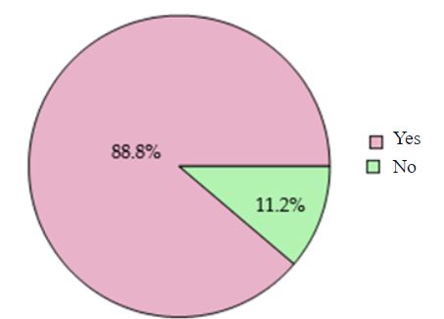

Figure 1. Question: Have you heard of menstrual cups before?

According to Table 2, most respondents were first introduced to menstrual cups through internet or social media (N=152, P=85.4%), highlighting the significant role of digital platforms in disseminating information. Educational workshops or classes were the second most common source (N=40, P=22.5%), indicating that structured learning environments also play a crucial role in awareness. Friends or family were the source for 17.4% of respondents, suggesting that personal networks contribute to spreading awareness. Only a small percentage (N=10, P=5.6%) learned about menstrual cups from healthcare providers or gynaecologists, underscoring a potential gap in direct medical advice on this topic. Minimal influence was observed from newspapers (N=1, P=0.6%) and forums (N=1, P=0.6%). Additionally, a small fraction of respondents (N=3, P = 1.8%) indicated they had not heard of menstrual cups at all, pointing to the need for broader outreach and education. This data emphasizes the importance of leveraging various information channels, particularly digital media, to enhance awareness and education about menstrual cups.

Table 2. Question: Where did you first learn about menstrual cups?
Method | N | P (%)
Friends or Family | 31 | 17.4
Internet or Social Media | 152 | 85.4
Educational Workshop or Classes | 40 | 22.5
Healthcare provider or Gynecologist | 10 | 5.6
Newspaper | 1 | 0.6
Forum | 1 | 0.6
I haven’t heard of menstrual cups | 3 | 1.8

Based on Table 3, most respondents believe that menstrual cups are reusable (N=141, P = 79.2%), made of medical-grade silicone, rubber, or latex (N=115, P = 64.8%), eco-friendly (N=114, P = 64.6%) and are cost-effective (N=95, P = 53.4%). A minority think that, and they can be worn up to 12 hours (N=57, P=32%), while some of the respondents also seem to believe that menstrual cups are uncomfortable (N=47, P = 26.4%). Only a small minority knew nothing about menstrual cups (N=4, P=2.2%) and one believed that menstrual cups are comfortable (N=1, P=0.6%).

Table 3. Question: What do you know about menstrual cups? (Multiple Choice)

Statement | N | P = N × 100%  178
They are reusable menstrual products. | 141 | 79.2
They are made of medical-grade silicone, rubber, or latex. | 114 | 64.0
They can be worn for up to 12 hours. | 57 | 32.0
They are eco-friendly and reduce waste. | 115 | 64.6
They are cost-effective | 95 | 53.4
They are uncomfortable to use. | 47 | 26.4
They are comfortable to use. | 1 | 0.6
I don’t know | 4 | 2.4

According to Figure 2, most of the respondents (N=83, P=46.9%) do not know how to properly insert a menstrual cup but are interested in finding out how while a minority of the respondents (N=13, P= 7.3%) are confident with inserting menstrual cups.
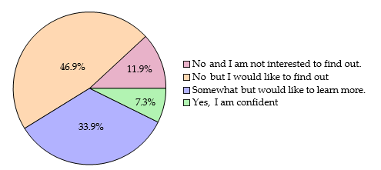
Figure 2. Question: Do you know how to properly insert a menstrual cup?

As we can see from Figure 3, majority of the respondents (N=110, P=61.8%) have considered of trying a menstrual cup, while other respondents (N=68, P=38.2%) have not considered. This indicates that while a significant majority is open to the idea of using menstrual cups, approximately two-fifths (38.2%) of respondents have not yet considered them, highlighting the potential for increased education and awareness to shift perceptions and encourage more individuals to explore this menstrual product.
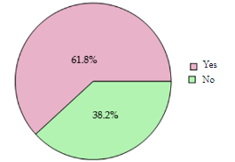
Figure 3. Question: Have you ever considered trying a menstrual cup?
3. Menstrual Cup Usage Among Female Participants
This section examines the experiences of respondents who have used menstrual cups, focusing on usage duration, confidence levels in proper usage, perceived cost-effectiveness, and likelihood of recommending the product to others.

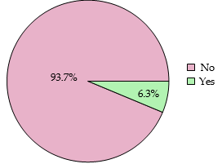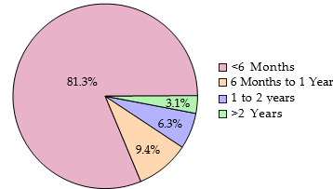

(Left) Figure 4a. Question: Are you still using menstrual cups? (79 responses)

(Right) Figure 4b. Question: What is the duration you have used the menstrual cups? (32 responses)

According to Figure 4a, a significant majority of respondents who tried menstrual cups (N=74, P = 93.7%) no longer use them, with only (N=5, P=6.3%) continuing usage. Figure 4b reveals that most users (N= 26, P=81.3%) used menstrual cups for less than 6 months, while fewer participants reported longer durations: 9.4% for 6 months to 1 year, 6.3% for 1-2 years, and 3.1% for more than 2 years. This pattern of short-term usage suggests potential barriers to sustained use, indicating a need for better education and support systems to encourage long-term adoption.
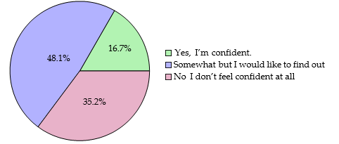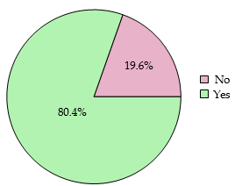

(Left) Figure 5a. Question: Do you feel confident in your knowledge of how to use a menstrual cup safely? (54 responses)

(Right) Figure 5b. Question: Do you think using menstrual cup is cost-effective for you? (56 responses)

According to Figure 5a, most of the respondents are somewhat confident in their knowledge of menstrual cup usage but would still like to learn more (N=26, P = 48.1%). Additionally, there are respondent do not feel confident at all (N=19, P=35.2%), while some are fully confident in their knowledge (N=9, P=16.7%). According to Figure 5b, it shows that majority of the respondents (N=45, P=80.4%) believe using a menstrual cup is cost-effective for them, while some do not share this view (N=11, P=19.6%). This indicates a strong perception among the majority that menstrual cups offer financial benefits.

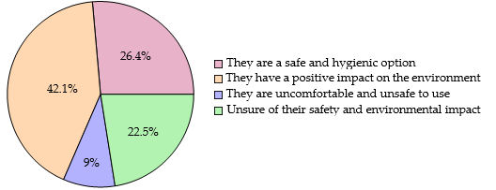
Figure 6. Question: What are your perceptions regarding the safety and environmental impact of menstrual cups?

Based on the Figure 6, many of the respondents believe that menstrual cups have a positive impact on the environment (N=75 P = 42.1%). However, a minority of the respondents believe menstrual cups are uncomfortable or unsafe to use (N=16, P = 9%), most of the respondents’ concerns are related to the issues that might occur when using menstrual cups such as pain for inexperienced users and health issues such as intensified cramps or tearing of the hymen.’

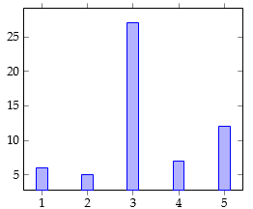

Figure 7. On a scale of 1 to 5, how much would you recommend someone else to try out menstrual cup? (57 responses)

According to Figure 7, majority of the experienced respondents are neutral about recommending menstrual cups to others (N=27, P = 47.4%). A significant portion of respondents (N=12, P= 21.1%) rated their recommendation at the highest level (5 out of 5), indicating strong support for menstrual cups among these individuals. Meanwhile, a smaller but notable percentage of respondents (N=7, P=12.3%) rated their likelihood of recommending a menstrual cup as a 4 out of 5, showing a positive inclination but with some reservations. Conversely, a combined 19.3% (N=6, P=10.5% for 1 and N=5, P=8.8% for 2) of respondents rated their recommendation at the lower end of the scale, reflecting skepticism or dissatisfaction with menstrual cups. The survey received mostly positive feedback from the experienced respondents where they stated their reviews of using menstrual cup.

4. Perceptions and Attitudes Towards Menstrual Cup
The study investigated participants' attitudes through three key aspects: motivations for using menstrual cups, reasons for non-adoption, and general concerns about menstrual cups, which depicted in Table 4.

Table 4. Factors Influencing Menstrual Cup Adoption:
Motivations, Barriers, and Concerns Among Undergraduate Students

 | Reason | N | P (%)
Motivation  (N=56) | Reduce leakage | 2 | 3.6
Motivation  (N=56) | Cost-effective | 17 | 30.4
Motivation  (N=56) | More comfortable | 12 | 21.4
Motivation  (N=56) | Curiosity | 5 | 8.9
Motivation  (N=56) | Environmental Factors | 18 | 32.1
Motivation  (N=56) | Safer option | 2 | 3.6
Barries to Adoption  (N=64) | Comfortable With Sanitary Pads/Tampons | 11 | 17.2
Barries to Adoption  (N=64) | Fear/Discomfort | 38 | 59.8
Barries to Adoption  (N=64) | Lack of Knowledge | 6 | 9.4
Barries to Adoption  (N=64) | Unsure of Safety | 4 | 6.3
Barries to Adoption  (N=64) | Peer Influence | 1 | 1.6
Barries to Adoption  (N=64) | Inconvenience | 1 | 1.6
Barries to Adoption  (N=64) | Cost/supply concerns | 3 | 4.7
Concerns  (N=178) | None | 70 | 39.3
Concerns  (N=178) | Hygiene/Safety Concerns | 23 | 12.9
Concerns  (N=178) | Discomfort | 43 | 24.2
Concerns  (N=178) | Lack of Knowledge | 38 | 21.3
Concerns  (N=178) | Lack of Awareness | 3 | 1.7
 | Cost | 1 | 0.6

Based on Chart 1, most respondents highlight "environmental friendliness" as their main reason for using menstrual cups (N=18, P=32.1%). This finding aligns with previous studies that have identified environmental concerns as a significant motivator for menstrual cup use (Hait & Powers, 2019). The second most common motive is cost-effectiveness (N=17, P=30.4%), consistent with the long-term financial benefits associated with using reusable menstrual cups compared to disposable menstrual products (Babagoli et al., 2022). Comfort was also a significant factor, cited by about quarter of users (N=12, P=21.4%). Less common motivations included curiosity (N=5, P=8.9%), reduction in leakage (N=2, P=3.6%), and safety considerations (N=2, P=3.6%). This distribution suggests that environmental and economic benefits are the most compelling reasons for menstrual cup adoption among the study participants.
Chart 2 present the barriers to menstrual cup adoption among non-users. Fear and discomfort emerged as the predominant reason (N=38, P=59.8%), significantly outweighing other factors. The second most common reason was comfort with current menstrual products (N=11, P=17.2%), followed by lack of knowledge (N=6, P=9.4%. Safety concerns (N=4, P=6.3%) and cost/supply issues (N=3, P=4.7%) were fewer common barriers, while peer influence and inconvenience were minimal factors (N=1, P=1.6% each). These findings suggest that addressing fears and discomfort through education and support could be crucial in increasing menstrual cup adoption.

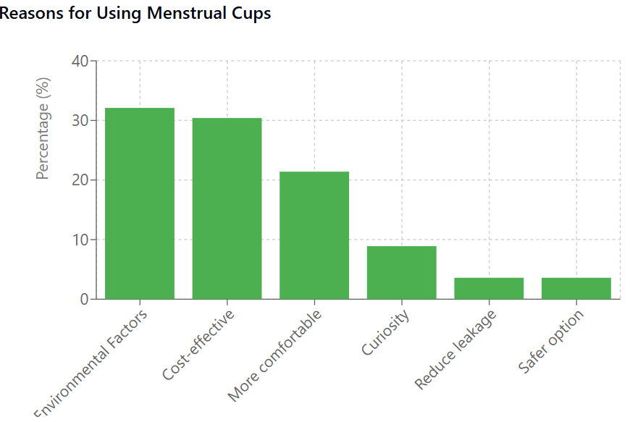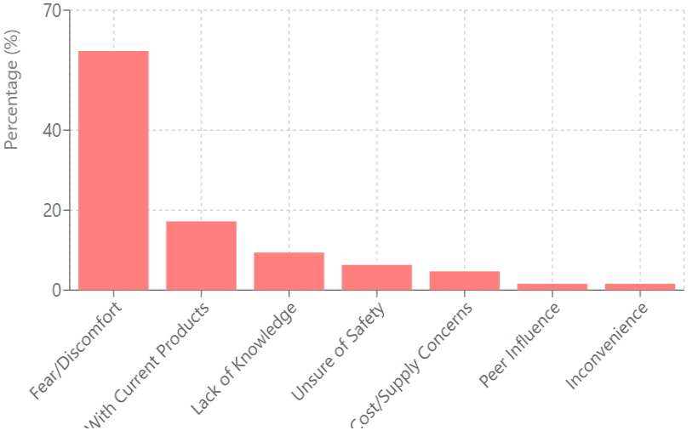
(Left) Chart 1. Reasons for Using Menstrual Cups
(Right) Chart 2. Reasons for Not Considering Menstrual Cups

Based on Chart 3, out of 178 responses, 39.37% reported no concerns about menstrual cups, indicating a high level of comfort. Conversely, 24.2% expressed worry about potential discomfort, and 21.3% were concerned about not knowing how to use menstrual cups. Health and safety concerns were voiced by 12.9% of participants, suggesting a subgroup prioritizing these aspects. A small fraction, 1.7%, indicated feeling uneasy due to a lack of information, and only 1 person (P = 0.6%) expressed concerns about the cost of the product. These insights underscore a varied landscape of considerations among respondents.

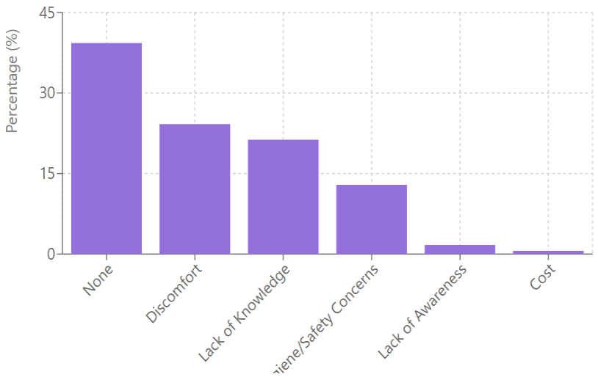

Chart 3. Concerns about the menstrual cups

According to Figure 7a, 24.2% of respondents indicated they were unwilling to try menstrual cups, while 30.3% showed potential interest in future use. This hesitation was primarily attributed to concerns about usage and comfort (van Eijk et al., 2019). Figure 7b shows that among those who have used menstrual cups, 13.5% would hardly recommend them, citing personal experiences with insertion difficulties or discomfort (Beksinska et al., 2015). However, 42.7% of respondents expressed positive inclination toward recommending menstrual cups to others, suggesting satisfaction with benefits such as cost-effectiveness and environmental sustainability (Hait & Powers, 2019; van Eijk et al., 2019).

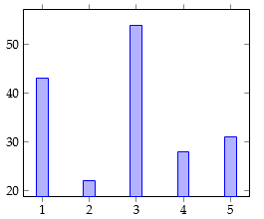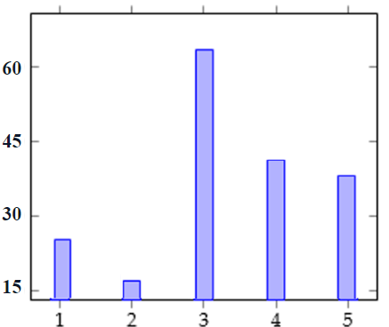
Figure 7b. On a scale from 1 to 5, with 1 being "Not likely at all" and 5 being "Very likely," how likely are you to recommend the use of a menstrual cup for others?

Figure 7a. On a scale from 1 to 5, with 1 being "Not likely at all" and 5 being "Very likely," how likely are you to try a menstrual cup in the future?

Discussion
This study examined menstrual cup awareness and adoption patterns among Malaysian undergraduate students. The demographic profile of respondents, predominantly female (82%) and aged 18-22 years (79.8%), aligns with the general demographic profile of Malaysian public universities where females constitute 58.95% of the student body (Statista, 2024). The primary sources of information about menstrual cups in our study were social media and internet platforms (85.4%), followed by educational workshops (22.5%), with healthcare providers contributing minimally (5.6%). This aligns with findings from South Kerala by Devan et al. (2022), where 93.4% of participants were aware of menstrual cups, with primary sources of information were social media (76.6%). This also prove that digital media acting as an effective resource for providing information about menstrual cups among university students (Destiana and Salman, 2015). These patterns suggest regional consistencies in reliance on digital and peer-based sources over traditional healthcare providers for menstrual cup information.
Our findings reveal high awareness levels, with 88.8% of respondents having heard of menstrual cups. This awareness rate aligns with previous studies across different geographical contexts, including findings from Peberdy et al. (2019) in the United Kingdom (86%) and Jamkhandi and Tile (2024) in India (93.5%). However, our study shows a significant gap between awareness and sustained usage. Among those who tried menstrual cups, 93.7% discontinued use, with most (81.3%) stopping within six months. This discontinuation rate is notably higher than reported in other regions; for instance, Hennegan et al. (2024) found only 29% of participants discontinued cup use, with primary reasons being discomfort (69%) and inconvenience (22%); and Singh et al. (2022) noted that 68.9% of their participants stated that they would continue the menstrual cup usage.
Environmental sustainability (32.1%) and cost-effectiveness (30.4%) emerged as the main motivators for menstrual cup interest, matching trends found in global studies. These percentages align closely with findings from Ramsay et al. (2023), who reported product comfortability, environmental concerns, and cost savings as top primary motivators in their multi-country analysis. However, our study found higher rates of concern about physical discomfort, with 59.8% citing fear and discomfort as barriers, compared to 31% in Jamkhandi and Tile (2024)’s findings in India study; while our findings is compatible cited in Devan et al., (2022)’s study with 56.2% of fear of insertion. Knowledge levels about basic aspects of menstrual cups were substantial, with 79.2% understanding their reusability and 64.6% aware of their eco-friendly nature. However, only 7.3% reported confidence in proper insertion techniques, while 46.9% expressed interest in learning more. This confidence level is lower than reported in comparable studies; for instance, Ganz et al. (2022) found 23% confidence levels among medical students.
Regarding cost-effectiveness perceptions, 80.4% of users in our study found menstrual cups economically beneficial, comparable to findings by two-thirds of the participants in Beksinska et al’s (2015) study reported good and excellent satisfaction in cost saving using a menstrual cup compared to tampons or sanitary pads. However, our study found that initial cost remains a barrier for 4.7% of respondents, a lower percentage than the 3.3% reported in Singh et al. (2022)’s study. The recommendation patterns among experienced users in our study present an interesting contrast with global data. While 21.1% gave the highest recommendation rating, the largest group (47.4%) remained neutral. This differs from findings by Anjana et al. (2024), where 90% of users were ready to recommend menstrual cups to others. The higher neutrality in our findings might be related to our observed high early discontinuation rates. Safety and environmental impact perceptions showed that 42.1% of respondents believe menstrual cups have a positive environmental impact, while 26.4% consider them uncomfortable. These findings align with a trend identified by Peberdy et al. (2019), where environmental benefits were recognized but comfort concerns persisted among new users.
A unique finding in our study was that while 80.4% of users found menstrual cups cost-effective, this recognition did not translate into sustained usage, suggesting that factors beyond economic benefits significantly influence continued use. This contrasts with findings from Singh et al. (2022), where cost-effectiveness strongly correlated with continued use. These results contribute to the growing body of global literature on menstrual cup adoption while highlighting some distinct patterns in the Malaysian university context. The high awareness levels coupled with low sustained usage rates suggest unique challenges that warrant further investigation.

Conclusion, Implications, and Future Directions
This study investigated the knowledge, awareness, and practices of undergraduate students towards menstrual cups using a survey approach involving 178 participants from the Universiti Malaya. The findings revealed that 82% of the female respondents (119 out of 146) expressed an interest in using menstrual cups, citing reasons such as preventing leaks, saving money, protecting the environment, and enhancing ease and comfort during menstruation. However, 18% of the female respondents (27 out of 146) were hesitant to use menstrual cups due to fear, lack of awareness, or preference for traditional menstrual products like pads. The study found that 42.1% of the respondents agreed that menstrual cups are sustainable, while a minority reported discomfort and insecurity as reasons for avoiding menstrual cups. Additionally, 30.3% of the respondents had a neutral level of willingness to try menstrual cups, and 36.6% had little to no willingness, primarily due to concerns about insertion, discomfort, and leakage.
Several practical implications emerge from these findings. While awareness of menstrual cups is high among Malaysian undergraduate students (88.8%), the significant early discontinuation rate (81.3% within six months) suggests a critical need for better support systems during the initial usage period. Educational institutions could address this by providing practical workshops and ongoing support services, particularly given that only 7.3% of respondents reported confidence in insertion methods. The dominance of social media and internet platforms (85.4%) as information sources suggests universities should leverage these channels while strengthening healthcare providers' involvement, which currently stands at just 5.6%. The economic aspects also require attention - while 80.4% of users found menstrual cups cost-effective, the initial cost remains a barrier for some students. Universities might consider implementing programs to address this upfront cost barrier, potentially through subsidies or installment payment options. Given that environmental sustainability (32.1%) and cost-effectiveness (30.4%) emerged as primary motivators, educational campaigns should emphasize these benefits while addressing the predominant concerns about fear and discomfort (59.8%).
This study, however, has several limitations that should be considered, particularly regarding sample diversity. The focus on a single university (Universiti Malaya) limits the generalizability of findings, as perspectives might differ across various Malaysian institutions of higher learning. The sample size of 178 participants, while providing valuable insights, represents only a fraction of the undergraduate population. Additionally, using a single survey form for both male and female participants created information asymmetry that could have been avoided with gender-specific questionnaires, particularly given the differing levels of relevance and experience with menstrual products between these groups. Future research should address these limitations by including a larger, more diverse sample size through extended survey periods. Survey design should be refined to be more inclusive and precise, particularly in questions about menstruation. For example, using direct questions like "Do you experience periods?" would be more appropriate than gender-based assumptions. Future studies should also consider using separate survey forms for different gender groups to improve data quality and reduce cleaning requirements.
The significance of this research lies in its contribution to understanding the factors influencing menstrual cup adoption among Malaysian undergraduate students. By identifying both motivations and barriers, this study provides valuable insights for developing targeted interventions to promote sustainable menstrual health practices. The findings underscore the importance of addressing practical concerns, providing adequate support systems, and increasing awareness about the benefits of menstrual products especially menstrual cups while acknowledging and addressing the barriers to their adoption.

Acknowledgement:
This research was supported by the Universiti Malaya ArtScience Fellowship Grant (UMG004-2024IAS). We extend our gratitude to Cherry Menstrual Cup for hosting the awareness campaign that facilitated this study. Special thanks to the undergraduates from the course GBH0045 for their assistance with data collection, as well as to all respondents for their valuable participation.

Conflicts of Interest: There is no conflict in this study.

References
Abdullah @ Abdul Aziz, N. F., Tumiran, M. A., Opir, H. & Md Soh, N. S. (2024). Islamic menstrual education in Malaysian primary school: A review of prospects and challenges. Journal of Islamic, Social, Economics and Development (JISED), 9 (65), 438 - 456.
Anjana, V. M., Jissa, V. T., & Mini, G. K. (2024). Knowledge, use and acceptability of menstrual cup: an explorative study among women health professionals in Kerala, India. International Journal of Community Medicine and Public Health, 11(4), 1593–1602. https://doi.org/10.18203/2394-6040.ijcmph20240896
Babagoli, M., Benshaul-Tolonen, A., Zulaika, G., Nyothach, E., Oduor, C., Obor, D., ... & Phillips‐Howard, P. A. (2020). The Cost-Benefit and Cost-Effectiveness of Providing Menstrual Cups and Sanitary Pads to Schoolgirls in Rural Kenya. Columbia Center for Development Economics and Policy, Working Paper, 87.
Beatriz Cassolatti Gracioli, Alice, M., Sena, J., Júlia Abbade Tronco, De, M., Cosi, F., Andréa Rocha Tristão, Duarte, C., Silva, & Ribeiro, B. (2023). The use of menstrual cups is associated with the maintenance of healthy vaginal microbiota: A prospective longitudinal study. Placenta and Reproductive Medicine, 2.
Beksinska, M. E., Smit, J., Greener, R., Todd, C. S., Lee, M. L. T., Maphumulo, V., & Hoffmann, V. (2015). Acceptability and performance of the menstrual cup in South Africa: A randomized crossover trial comparing the menstrual cup to tampons or sanitary pads. Journal of Women's Health, 24(2), 151-158. https://doi.org/10.1089/jwh.2014.5021
Bell, J. (2021, April Date). What advertising teaches us about periods. https://helloclue.com/articles/culture/what-advertising-teaches-us-about-periods
Borowski, A. M. (2011). Are American Women Turning to Reusable And Greener Menstrual Products Due To Health And Environmental Pollution Concerns? Rochester Institute of Technology.
Carpenter, E. J., & Smith, K. L., Jr. (1972). Plastics on the sargasso sea surface. Science, 175 (4027), 1240–1241.
Chopik, W. J., Bremner, R. H., Johnson, D. J., & Giasson, H. L. (2018). Age differences in age perceptions and developmental transitions. Frontiers in psychology, 9, 67.
Davidson, A. (2012). Narratives of menstrual product consumption: Convenience, culture, or commoditization? Bulletin of Science, Technology amp; Society, 32(1), 56–70. https://doi.org/10.1177/0270467612444579
Del Saz-Rubio, M. M., & Pennock-Speck, B. (2009). Constructing female identities through feminine hygiene tv commercials [Complaining in Interaction]. Journal of Pragmatics, 41 (12), 2535–2556. https://doi.org/https://doi.org/10.1016/j.pragma.2009.04.005
DeLong-Bas, N. J. (2022). The Qur'an: Ritual, Practice, Embodiment, and Culture. In Routledge Handbook of Islamic Ritual and Practice (pp. 13-37). Routledge.
Destiana, I., & Salman, A. (2015). The acceptance, usage and impact of social media among university students. e-BANGI, 10(1), 58.
Devan, G. M. S., Mohanan, G., Ajitha, G. K., Kavitha, H., Majeed, I., & Nair, A. N. K. (2022). Knowledge, attitude and practices regarding menstrual cup among females in an urban setting of South Kerala. Journal of Family & Reproductive Health, 16(4), 243.
Etikan, I., Musa, S. A., & Alkassim, R. S. (2016). Comparison of convenience sampling and purposive sampling. American journal of theoretical and applied statistics, 5(1), 1-4.
Ganz, C., Lever, E., Bredenkamp, J., Mponda, L., Ramaru, T., Mazonde, W., Chuene, S., & Mbodi, L. (2022). The understanding and perception of the menstrual cup among medical students. The Journal of Obstetrics and Gynecology of India, 72 (5), 439–445. https://doi.org/10.1007/s13224-022-01661-8
Hait, A., & Powers, S. E. (2019). The value of reusable feminine hygiene products evaluated by comparative environmental life cycle assessment. Resources, Conservation and Recycling, 150, 104422. https://doi.org/10.1016/j.resconrec.2019.104422
Hennegan, J., Orozco, A., Head, A., Marino, J. L., Jayasinghe, Y., & Lim, M. S. (2024). Menstrual cup acceptability and functionality in real‐world use: A cross‐sectional survey of young people in Australia. Australian and New Zealand Journal of Obstetrics and Gynaecology.
Jamkhandi, S. S., & Tile, R. (2024). Awareness, Acceptability, and Feasibility of the Menstrual Cup: A Descriptive Study. Journal of South Asian Federation of Obstetrics and Gynaecology, 16(4), 346-349.
Joshi, S. (2022). Chhaupadi practice in Nepal: a literature review. World Medical & Health Policy, 14(1), 121-137.
Karupiah, P., & Fernandez, J. L. (Eds.). (2022). A Kaleidoscope of Malaysian Indian Women’s Lived Experiences: Gender‐Ethnic Intersectionality and Cultural Socialisation. Springer Nature.
Kaur, R., Kaur, K., & Kaur, R. (2018). Menstrual Hygiene, Management, and Waste Disposal: Practices and Challenges Faced by Girls/Women of Developing Countries. Journal of Environmental and Public Health, 2018(1730964), 1–9.
Lim, S. C., Yap, Y. C., Barmania, S., Govender, V., Danhoundo, G., & Remme, M. (2020). Priority-setting to integrate sexual and reproductive health into universal health coverage: the case of Malaysia. Sexual and reproductive health matters, 28(2), 1842153.
Madziyire, M. G., Magure, T. M., & Madziwa, C. F. (2018). Menstrual cups as a menstrual management method for low socioeconomic status women and girls in Zimbabwe: A pilot study. Women's Reproductive Health, 5(1), 59-65. https://doi.org/10.1080/23293691.2018.1429371
Manley, H., Hunt, J. A., Santos, L., & Breedon, P. (2021). Comparison between menstrual cups: first step to categorization and improved safety. Women's Health, 17, 17455065211058553.
Metusela, C., Ussher, J., Perz, J., Hawkey, A., Morrow, M., Narchal, R., ... & Monteiro, M. (2017). “In my culture, we don’t know anything about that”: sexual and reproductive health of migrant and refugee women. International journal of behavioral medicine, 24, 836-845.
Mpondo, F., Ruiter, R. A., Schaafsma, D., Van den Borne, B., & Reddy, P. S. (2018). Understanding the role played by parents, culture and the school curriculum in socializing young women on sexual health issues in rural South African communities. SAHARA-J: Journal of Social Aspects of HIV/AIDS, 15(1), 42-49.
Naz, S., Chatha, A. M. M., Bhat, R., Javad, S., Abdul, S., Sattar, F. S., ... & Nawaz, A. A Systematic Review of the Literature on the Toxicity Caused by Diapers and Pads.
Peberdy, E., Jones, A., & Green, D. (2019). A study into public awareness of the environmental impact of menstrual products and product choice. Sustainability, 11(2), 473.
Pednekar, S., Some, S., Rivankar, K. et al. Enabling factors for sustainable menstrual hygiene management practices: a rapid review. Discov Sustain 3, 28 (2022). https://doi.org/10.1007/s43621-022-00097-4
Rahman, P. A., Dahlan, A., Azman, N., & Selamat, S. (2023). Navigating Puberty with Special Needs Teenagers: Empowering Parents Through a Sexuality Education Workshop. e-BANGI Journal, 20(4).
Ramsay, C., Hennegan, J., Douglass, C. H., Eddy, S., Head, A., & Lim, M. S. (2023). Reusable period products: use and perceptions among young people in Victoria, Australia. BMC Women's Health, 23(1), 102.
Randor, A. (2017, November, Date). “we’re having a menstrual liberation”: How periods got woke. https://www.theguardian.com/society/2017/nov/11/periods-menstruation-liberation- women-activists-abigail-radnor
Rosewarne, L. (2012, June). Periods in pop culture. Lexington Books.
Seyed Hosseini, A. S. (2020). Unpreparedness, impurity and paradoxical feeling: menstruation narratives of Iranian women. International Journal of Adolescent Medicine and Health, 32(6), 20180008.
Shure, N. (2016, month date). Why has it taken the menstrual cup so long to go mainstream? https://psmag.com/news/why-has-it-taken-the-menstrual-cup-so-long-to-go-mainstream
Singh, R., Agarwal, M., Sinha, S., Chaudhary, N., Sinha, H. H., & Anant, M. (2022). Study of adaptability and efficacy of menstrual cups in managing menstrual health and hygiene: A descriptive longitudinal study. Cureus. https://doi.org/10.7759/cureus.29690
Spinks, R. (2015, April Date). Disposable tampons aren’t sustainable, but do women want to talk about it?https://www.theguardian.com/sustainable-business/2015/apr/27/disposable-tampons-arent-sustainable-but-do-women-want-to-talk-about-it
Stella, P. M. (2022). Knowledge regarding menstrual cup among nursing students. Hypothesis, 7(10).
Upashe, S. P., Tekelab, T., & Mekonnen, J. (2015). Assessment of knowledge and practice of menstrual hygiene among high school girls in Western Ethiopia. BMC women's health, 15, 1-8.
Van Eijk, A. M., Jayasinghe, N., Zulaika, G., Mason, L., Sivakami, M., Unger, H. W., & Phillips-Howard, P. A. (2021). Exploring menstrual products: A systematic review and meta-analysis of reusable menstrual pads for public health internationally (B. Ravindran, Ed.). PLOS ONE, 16(9), e0257610.https://doi.org/10.1371/journal.pone.0257610
Van Eijk, A. M., Zulaika, G., Lenchner, M., Mason, L., Sivakami, M., Nyothach, E., Unger, H., Laserson, K., & Phillips-Howard, P. A. (2019). Menstrual cup use, leakage, acceptability, safety, and availability: A systematic review and meta-analysis. The lancet public health, 4(8), e376–e393.

