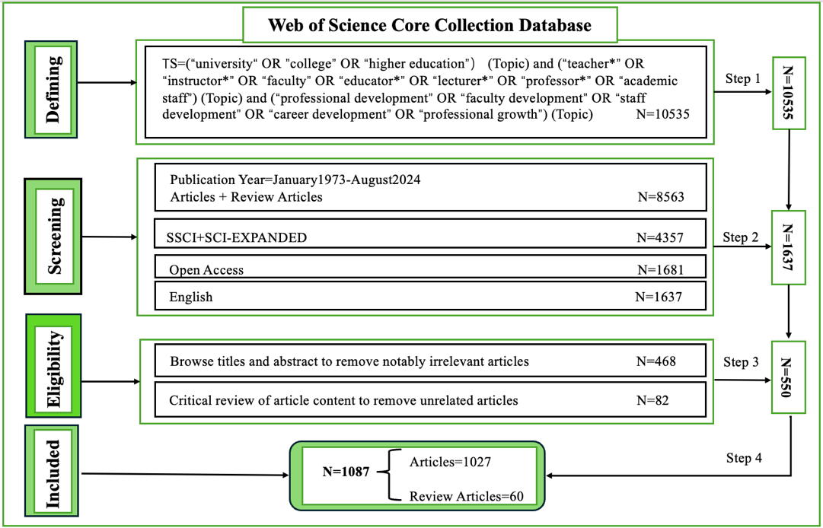
Figure 1. Sample Identification Flowchart

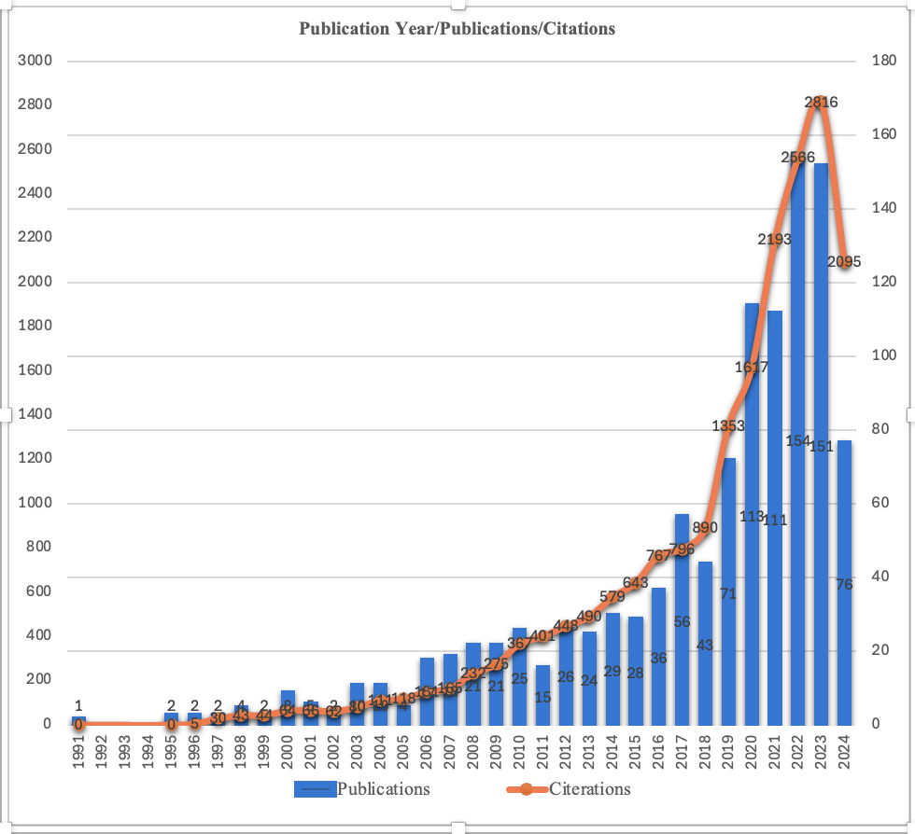
Figure 2. Publications and Citations Trends Over Time

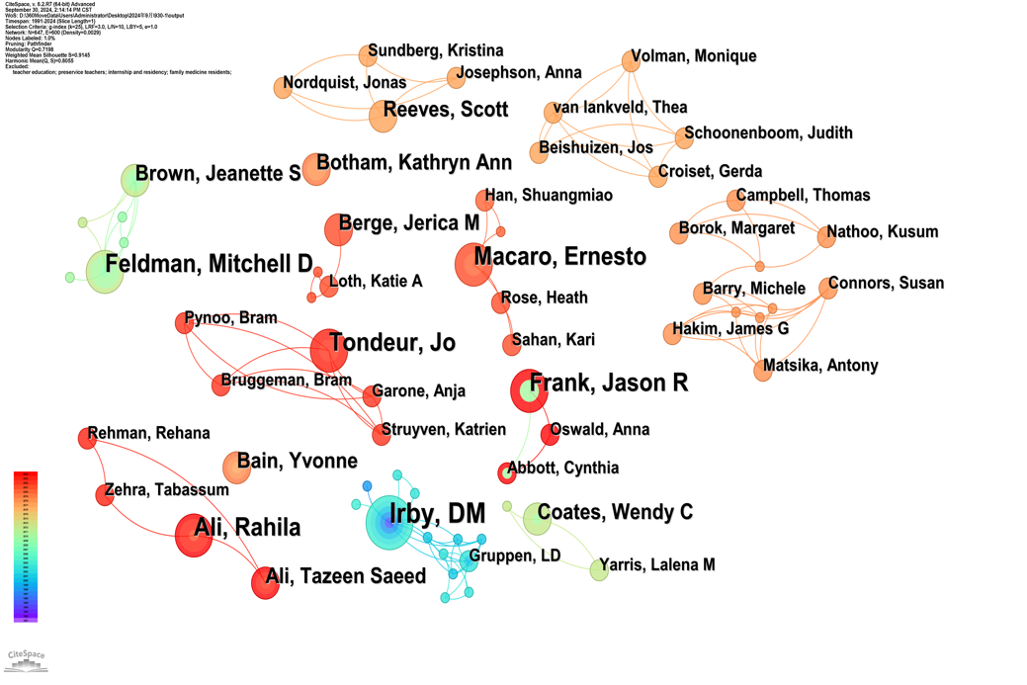
Figure 3. Network of Co-Authorship

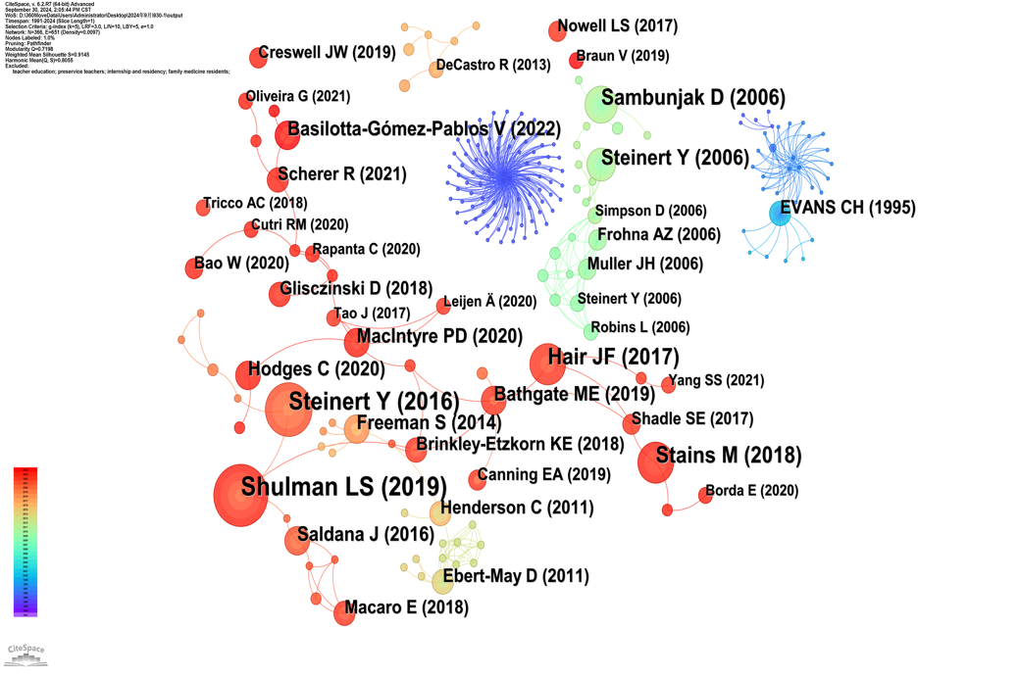
Figure 4. Document Co-Citation Network

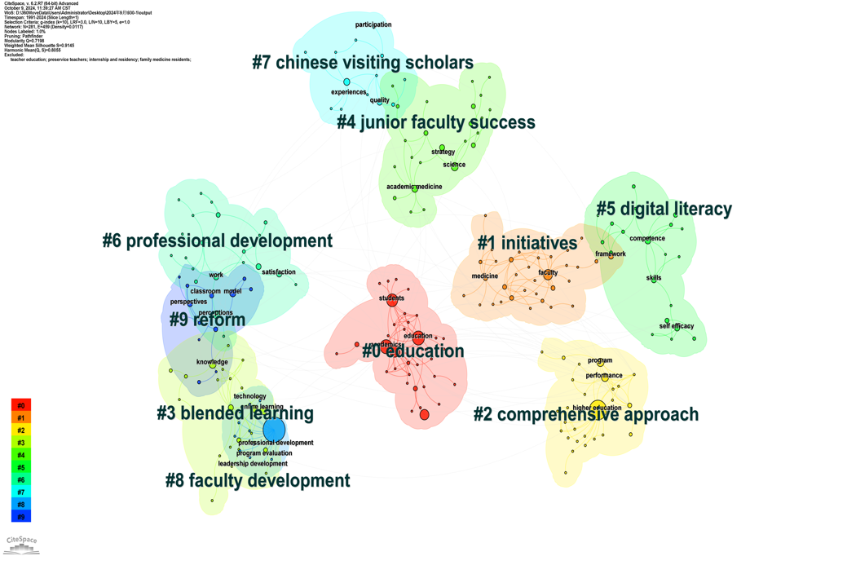
Figure 5. Cluster Map of Keywords((The colored regions represent the initial appearance of keywords, with blue fields indicating earlier occurrences than the subsequent green, yellow, and red fields.)

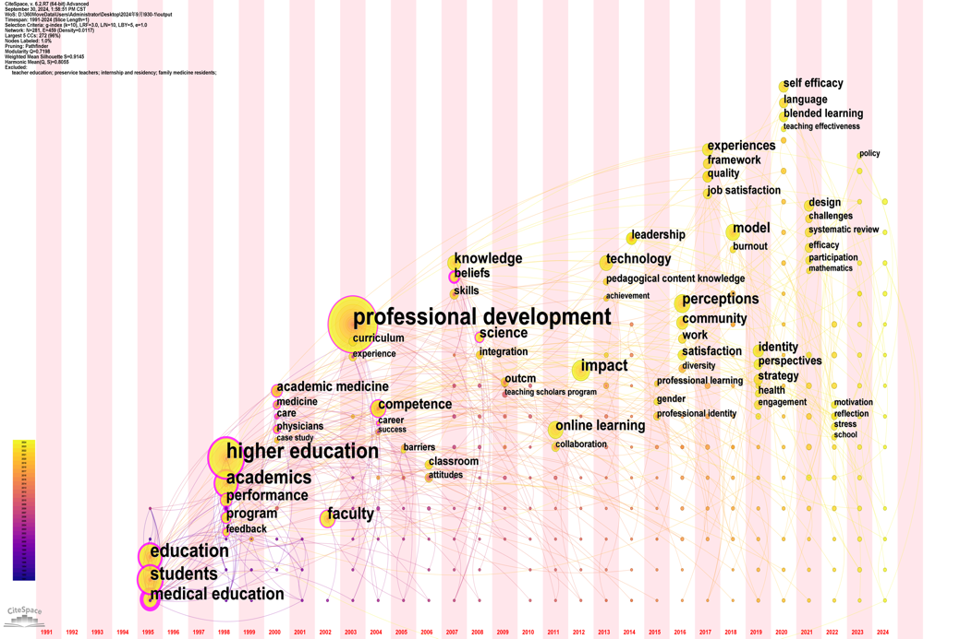
Figure 6. Network Keyword Timeline(The vertical axis displays keyword clusters by size, while the horizontal axis represents time. Node size reflects keyword frequency, and connecting lines indicate collaborations between keywords. Color gradients—from oldest to newest—illustrate the evolution of research trends over time)

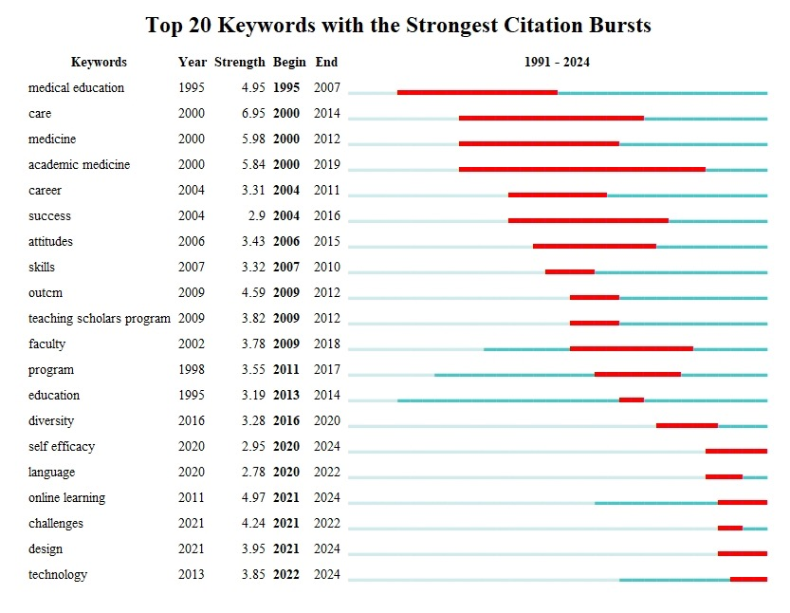
Figure 7. Top 20 Keywords with the Strongest Citation Bursts

