Type of the Paper (Article)

INTERACTION-WITH-INTERFERENCE (I∩I): UNCONCEALING THE ILLUSION OF MEDIA SPECTACLE IN QUANTUM-LIKE SOCIETY

Zhao Jie^{1*}, Sanghamitra Dalal², Mohd Syuhaidi Bin Abu Bakar³, Wan Aida Wan Yahaya⁴

¹Tianjin Academy of Fine Arts, Tianjin, China
^{1, 2, 3, 4} Faculty of Film, Theatre and Animation, Universiti Teknologi MARA, Malaysia

*Corresponding author: zhaojie@tjarts.edu.cn

Abstract: In the digital age, media spectacle relies on images and illusions to shape perception and judgement, yet interactive interference in communication remains underexplored. UNESCO’s promotion of art-based quantum literacy has reshaped Scientific Aesthetics. The metaphor of a Quantum Society, rooted in superposition, entanglement, uncertainty, and emergence, offers a critical lens on social structures and behaviours but has rarely been integrated with media-spectacle studies, leaving gaps on how interactive media and interference shape social dynamics and aesthetic experience. This research advances Interaction-with-Interference (I∩I) to examine how interference modulates information flow, exposes the illusion of spectacle in a quantum-like society, and characterises interactive spectacle, including user participation, immersion, and quantum-inspired design, while foregrounding the creative potential of interference aesthetics in interactive animation. Methods combined theoretical analysis of spectacle’s evolution with an empirical programme: a one-minute PDTM (Preference and Dwell-Time Measurement) comparing dynamic for A/B Choice, quantum-inspired elements (uncertainty, randomness, superposition) to static controls; a questionnaire probing quantum concepts as artistic inspirations; and qualitative interviews on media interaction and interference. Results show increased interaction time in the dynamic environment, with 67.1% preferring it; the survey identified Uncertainty and Superposition as top inspirations; interviews highlighted addiction, filter bubbles, and misinformation, alongside creative affordances of interference aesthetics. We conclude that I∩I offers a novel interdisciplinary perspective in which interaction and interference are inherently integrated, reframing interference as vital to creativity and guiding interactive design that harmonises technological advances with humanistic values.

Keywords: Media Spectacle, Digital Illusion, I∩I, Quantum Aesthetics, Interactive Animation, IYQ.

Abstract: Dalam era digital, tontonan media bergantung pada imej dan ilusi untuk membentuk persepsi dan pertimbangan, namun gangguan interaktif dalam komunikasi masih kurang diterokai. Promosi literasi kuantum berasaskan seni oleh UNESCO telah membentuk semula Estetika Saintifik. Metafora Masyarakat Kuantum, yang berakar umbi dalam superposisi, keterikatan, ketidakpastian, dan kemunculan, menawarkan lensa kritikal terhadap struktur dan tingkah laku sosial tetapi jarang disepadukan dengan kajian tontonan media, meninggalkan jurang tentang bagaimana media interaktif dan gangguan membentuk dinamik sosial dan pengalaman estetik. Penyelidikan ini memajukan Interaksi-dengan-Gangguan (I∩I) untuk mengkaji bagaimana gangguan memodulasi aliran maklumat, mendedahkan ilusi tontonan dalam masyarakat seperti kuantum, dan mencirikan tontonan interaktif, termasuk penyertaan pengguna, rendaman, dan reka bentuk yang diilhamkan oleh kuantum, sambil mengetengahkan potensi kreatif estetika gangguan dalam animasi interaktif. Kaedah menggabungkan analisis teori evolusi tontonan dengan program empirikal: PDTM satu minit (Pengukuran Keutamaan dan Masa Diam) yang membandingkan dinamik untuk Pilihan A/B, elemen yang diilhamkan oleh kuantum (ketidakpastian, kerawakan, superposisi) dengan kawalan statik; soal selidik yang menyelidiki konsep kuantum sebagai inspirasi artistik; dan temu bual kualitatif mengenai interaksi dan gangguan media. Keputusan menunjukkan peningkatan masa interaksi dalam persekitaran dinamik, dengan 67.1% lebih menyukainya; tinjauan mengenal pasti Ketidakpastian dan Superposisi sebagai inspirasi utama; temu bual mengetengahkan ketagihan, gelembung penapis dan maklumat salah, di samping affordance kreatif estetika gangguan. Kami menyimpulkan bahawa I∩I menawarkan perspektif interdisipliner baharu di mana interaksi dan gangguan secara semula jadi disepadukan, membingkai semula gangguan sebagai penting untuk kreativiti dan membimbing reka bentuk interaktif yang mengharmonikan kemajuan teknologi dengan nilai-nilai humanistik.

Kata kunci: Tontonan media; Ilusi digital; I∩I; Estetika kuantum; Animasi interaktif, IYQ.

Introduction
The introduction outlines the nature, purpose, and contribution of the research, alongside references to prior work. Media spectacle, evolving from its Latin roots (spectaculum, 'a show'), has become a defining feature of the digital age, centred on images and illusions that manipulate human perception (Han, 2017, p. 27; Zhao et al., 2024, p. 135). Guy Debord's (1970, p. 16) 'Social Spectacle' framed images as agents of social control, drawing on Marxist commodity fetishism (Marx & Engels, 1887, p. 48), while Douglas Kellner extended this to 'Media Spectacle' by highlighting high-tech media's role in producing and deploying spectacle within specific historical contexts (2003, p. 29). Today, digital tools have birthed 'Interactive Spectacle,' which grants users an 'illusion of agency' through real-time engagement, yet the interaction with interference in this paradigm requires further investigation.(O’Neill, 2009, p. 182; Zhao et al., 2025a, p. 56, 2025b, p. 139). In the International Year of Quantum Science and Technology (IYQ 2025), UNESCO emphasised that quantum mechanics can reshape artistic expression and perception within Scientific Aesthetics.
This research addresses three critical gaps: first, the lack of a framework to systematically analyse interaction-interference dynamics, herein dubbed I∩I; second, the limited application of Quantum-like Society principles (superposition, entanglement) to media spectacle research (Schweitzer, 2018, p. 41; Wendt, 2015, p. 4); third, the under recognition of interference's creative potential in interactive art (Eustáquio & Carvalhais, 2017, pp. 143, 148). Its core contribution lies in integrating philosophical, psychological, and quantum perspectives to unpack media spectacle's illusions and redefine interference as a dialectically unified dualistic force, both disruptive and generative.

Literature Review
The literature review clusters around three interconnected themes.
First, spectacle evolution: Debord's Social Spectacle posits images replace tangible reality, with Heidegger's 'Being-ready-to-hand' (2007, p. 113) critiquing overreliance on semiotic interpretations of this phenomenon; Kellner's Media Spectacle narrows focus to media's active role in spectacle production; and contemporary Interactive Spectacle, defined by digital and multimedia features, shifts users from passive observers to 'agentic' participants (Baecker, 1969, p. 2; Nusselder, 2009, p. 4).
Second, In Interaction-with-Interference (I∩I), Perceptual Interference (Sensory & Imaginative) draws on James (1890, p. 409), Taine (1871, p. 98,111.267), Rovelli et al. (2021, p. 128), Whitehead (1968, p. 95), Weeks (2019, p. 23), Eriksen & Schultz (1978, p. 8), Lloyd-Jones & Vernon (2003, p. 577), Bellemare-Pepin et al. (2022, p. 1), Blom (2010, p. 6), Conrad (1966, p. 7), Fish(1960, p. 4), and Mishara (2010, p. 11); Mnemonic Interference (Memory-Based) relies on Plato (1924, p. 266), Bartlett (1932, p. 264), Hume (1739, p. 14), Bergstrom (1893, p. 356), Kahana (2012, p. 122), and Beaty et al. (2017, p. 14); Social Interference (Collective & Cultural) involves Marcus Aurelius (2006, p. 143) Lippmann (1922, p. 87), Noelle-Neumann (1984, p. 144), Nusselder (2009, p. 77), Feuerbach (1854, p. xii), and Bacon (2000, p. 40, 1902, p. 79). Detailed Core Perspectives of Interaction-with-Interference (I∩I) as shown in Table 1.
Third, Quantum Society: Auguste Comte's (1853, p. 4) 'Social Physics' laid groundwork for applying physical principles to social dynamics, with Alfred North Whitehead (1978, p. 309) later proposing 'quantum-like energy flows' in natural processes. Modern Quantum Society research uses principles like complementarity (Bohr, 1939, pp. 270, 271) and 'undivided wholeness' (Bohm et al., 2006, pp. 86, 271) to bridge micro-scale (consciousness) and macro-scale (societal) dynamics, offering a lens to unpack digital media's complexity (Dunk, 2020, pp. 2, 9; Rovelli et al., 2021, p. 129).

Table1. Categories of Interaction with Interference (I∩I)
Category | Concept | Scholar(s) | Core Perspective
Perceptual Interference  (Sensory & Imaginative) | Attention Displacement | William James | Selective attention suppresses competing sensations from consciousness.
Perceptual Interference  (Sensory & Imaginative) | In–Out Corrected | Taine; Rovelli | Perception as internal hallucination corrected by external sensation..
Perceptual Interference  (Sensory & Imaginative) | Emotional Disturbance | Whitehead | Emotions interfere with rational and perceptual clarity.
Perceptual Interference  (Sensory & Imaginative) | Imaginative Distortion | Weeks | Mental motion lets imagination distort perception, forming idols.
Perceptual Interference  (Sensory & Imaginative) | Iconic/ Visual Persistence | Eriksen & Schultz; Lloyd-Jones & Vernon | Residual imagery affects new perception—temporal interference.
Perceptual Interference  (Sensory & Imaginative) | Pareidolia / Visual Bias | Bellemare-Pepin; Blom | The mind imposes familiar patterns onto ambiguous stimuli.
Perceptual Interference  (Sensory & Imaginative) | Apophany Insight | Conrad; Fish; Mishara | Hallucinations may reflect distorted—but meaningful—internal revelations.
Mnemonic Interference  (Memory-Based) | Retroactive Interference | Plato | Later memory imprints overwrite earlier ones—wax tablet metaphor.
Mnemonic Interference  (Memory-Based) | Remembering Interruption | Bartlett | Memory is reconstructed, not replayed; interruption is inherent.
Mnemonic Interference  (Memory-Based) | Associative Interference | Hume; Bergstrom; Kahana | Interacting ideas modulate and distort each other.
Mnemonic Interference  (Memory-Based) | Semantic Interference | Beaty et al. | Language meaning disrupts cognitive fluency or task performance.
Social Interference  (Collective & Cultural) | Internal Interpretation | Marcus Aurelius | Disturbance arises from internal opinions, not external events.
Social Interference  (Collective & Cultural) | Stereotype Interference | Lippmann; Noelle-Neumann | Prejudiced mental constructs hinder recognition of shared humanity.
Social Interference  (Collective & Cultural) | Media Disruption | Nusselder | Digital media fragments sign–referent relationships, blurring reality.
Social Interference  (Collective & Cultural) | Sacred Illusion | Feuerbach | Illusions, when collectively revered, transform into sacred truths.
Social Interference  (Collective & Cultural) | Cognitive Idols | Francis Bacon | Mental biases (Tribe, Cave, Marketplace, Theatre) distort clear reasoning.
Source: Compiled from core literature (1924–2024)

The pyramid categories in Figure 1 organize interference into a hierarchical structure, from individual sensory experiences (Perceptual) to collective cultural phenomena (Social), providing a systematic tool to analyze interaction-interference dynamics in digital media. Key patterns include the pervasiveness of internal interference (e.g., Aurelius' 'internal opinions') and the role of technology in amplifying social interference (e.g., Nusselder's 'media disruption').

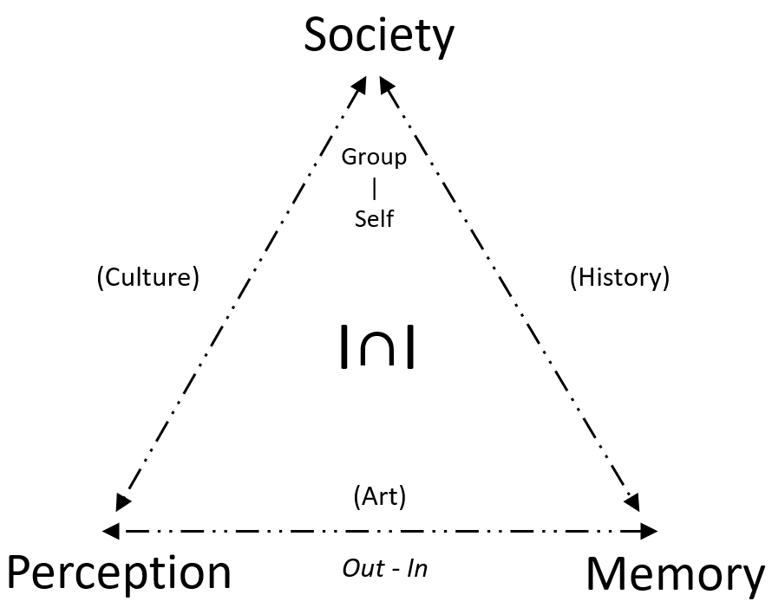
Figure 1. Pyramid of I∩I
Source: Drawing from Categories of Interaction with Interference (I∩I)

Methodology
1. Theoretical Framework Construction
The study integrates three strands of literature: spectacle evolution in media studies, Interaction-with-Interference (I∩I) with philosophical and psychological roots, and Quantum-like Society grounded in uncertainty, superposition, entanglement, and emergence. To operationalise I∩I, a pyramid category system (Table 1) classifies interference into Perceptual, Mnemonic, and Social types derived from 22 core studies across philosophy, psychology, and media studies. This taxonomy guides coding, measurement, and interpretation in the empirical sections.

2. Three empirical methods were used to collect and analyse data:
PDTM for A/B Choice: 307 valid participants engaged with two interactive environments: Situation A (dynamic, quantum-inspired elements: uncertainty, randomness, superposition, entanglement) and Situation B (static control). A game engine recorded behavioural data (interaction time, preference), which was analysed via Power BI and Jamovi. The 'LagTimer' variable quantified the time difference between duration in two situations, while 'TimerA' measured interactive timeline in Situation A.
Survey: A multiple-choice item asked which quantum concept most inspired artistic creation among Uncertainty, Superposition, Interference, Entanglement, and Emergence, etc. Statistical analysis used chi-squared testing (χ² = 48.213, p < 0.001) to validate significance.
Interviews: 15 interviewees (4 Continents / 7 Countries) with expertise in media, art, and technology were recruited. Pre-Screening of semi-structured interviews by Tongyi Efficiency (AI platform) and manually verified before QDA. Grounded Theory coding in QualCoder produced the thematic coding which identified three key findings: media addiction/filter bubbles, misinformation dilemma, and interference aesthetics.

3. Ethical Consideration
This study obtained institutional ethics approval from Universiti Teknologi MARA, collected N=307 valid responses via on-site, public venue, and limited international online channels between April 2023 and July 2025. Informed consent was obtained from all participants in empirical studies, adhering to research ethics guidelines. The questionnaire used a two-part: Part 1 (Unity3D WebGL game-like interaction, ≈1 minute) captured behavioural A/B indicators, and Part 2 (Microsoft Forms) collected demographic and rating data.

The Findings
This section presents a concise description of the study's results, using tables and figures to illustrate quantitative and qualitative data, and dividing findings into three subsections for clarity.

1. PDTM for A/B Choice Results
Participants were randomly routed to one of three game-like levels, with each level containing both the A/B situation for comparison. The PDTM (Preference and Dwell-Time Measurement) for A/B Choice revealed a significant difference in user engagement between dynamic and static environments. Situation A (quantum-inspired dynamic elements) showed a mean interaction time of 40.16 s (Median = 38), compared to 19.64 s for Situation B (static non-interaction). Regression analysis showed a positive correlation between TimerA (engagement duration in Situation A) and LagTimer (Time in Situation A minus Time in Situation B), indicating that dynamic elements prolonged user attention. 'A1B-1test' records the avatar’s final situation at 60 s (A = 1, B = −1). Additionally, 67.1% (206/307) of participants preferred Situation A 66.93% (TimerA/1 minute), confirming strong aesthetic appeal of quantum-inspired design.

Table 2. Coefficients - TimerA
 |  |  | 95% Confidence Interval
Predictor | Estimate | SE | Lower | Upper | t | p
Interceptᵃ | 23.50384 | 0.510227 | 22.49980 | 24.50787 | 46.0655 | 6.9761e-139
LagTimer | 0.50395 | 0.011611 | 0.48110 | 0.52680 | 43.4036 | 4.4508e-132
Level:
2 – 3 | 4.04375 | 0.656408 | 2.75205 | 5.33544 | 6.1604 | 2.3049e-9
1 – 3 | -1.53387 | 0.701279 | -2.91387 | -0.15388 | -2.1872 | 0.029489
Source: ᵃ Represents reference level in A/B Choice data (2024)

Table 2 reports a jamovi linear model of engagement time as a function of lag and level: TimerA = β₀ + β₁·LagTimer + β₂·I (Level = 2) + β₃·I (Level = 1) + ε, with Level 3 as the reference. Model fit was strong (R² = .915, adjusted R² = .914, N = 307). LagTimer showed a large positive association (β = .50395, SE = .01161, t = 43.40, 95% CI [0.4811, 0.5268], p < .001; standardized β ≈ .87), meaning that each additional second of lag predicted about 0.50 s longer engagement. Relative to Level 3, Level 2 exhibited +4.04 s longer engagement (p < .001), whereas Level 1 was −1.53 s shorter (p = .030), holding lag constant. Diagnostic plots indicated mild heteroscedasticity, so HC3-robust standard errors were reported and conclusions were unchanged.

Figure 2 illustrates the clustering of data points around the trend line, emphasizing the positive correlation between dynamic elements and engagement. The visualization also highlights that over two-thirds of participants favoured the quantum-inspired environment, aligning with the study's hypothesis that uncertainty and randomness are associated with higher perceived interactivity.

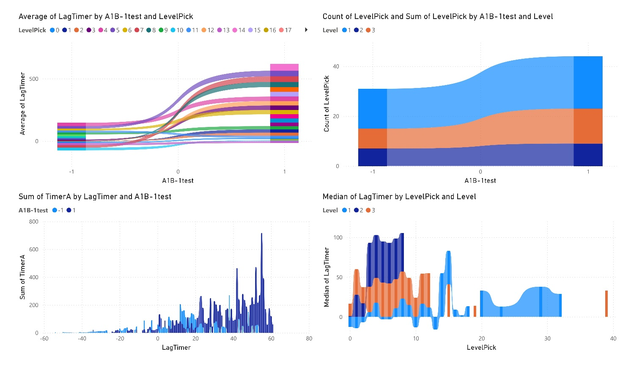
Figure 2. A/B Choice PDTM Data Visualization
Source: A/B Choice data (2025)

2. Survey Results
The survey (n=307) identified clear preferences for quantum concepts as artistic inspiration. Popularity Rate of Uncertainty was the most popular (58.63%), followed by Superposition (51.79%), Entanglement (47.56%), Emergence (29.64%), Interference (28.34%). This hierarchy reflects a strong artistic draw to unpredictability (Uncertainty) and multiple coexisting realities (Superposition)—themes that resonate with digital media's capacity to blur fiction and reality.

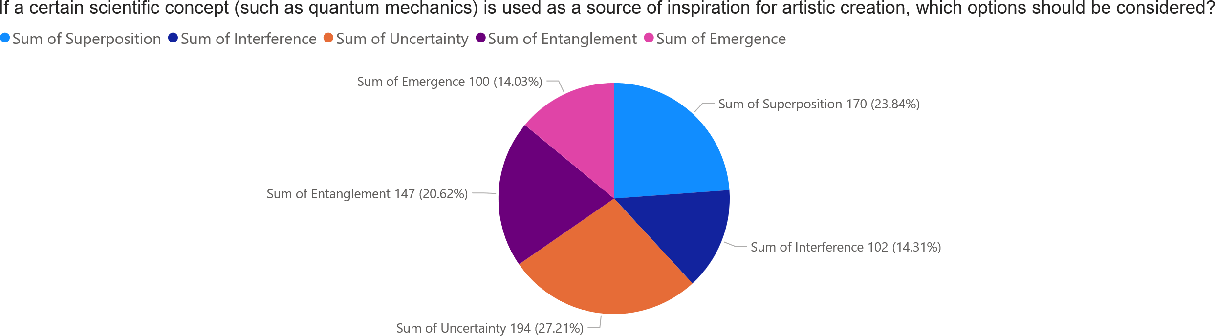
Figure 3. Popularity of Quantum Concepts as Artistic Inspiration
Source: Survey data (2025)

Figure 3 quantifies the survey results, with Uncertainty and Superposition collectively accounting for over half of all responses. This finding supports the integration of quantum principles into interactive art, as these concepts align with artists' desire to explore complexity and novelty.

3. Interview Findings
Thematic coding of the interview data identified three key insights, which are summarized in Table 3. These insights were derived from in-depth discussions with 15 interviewees, whose core professional backgrounds are as follows: Mark (Experimental Animation Director/Researcher), Peter (Generative Art Expert), Niki (New Media Artist/Director), David (3D Animation Artist/Educator), Chuah (Digital Artist/Architect), Ifeo (XR Developer/3D Artist), Kaoru (Interactive Art Creator), Tian (Digital Media Artist), Tsai (Serious Games Researcher), Miao (Multimedia Artist), Yash (Quantum Gamedev Researcher), Razeef (Animation & Media Researcher), Ma (Digital Interaction Artist), Sun (Tech Art Researcher), and Yang (Artificial Intelligence Researcher).

Table 3. Interview Themes and Keywords
Topic | Interviewee | Keywords/Core Idea
Media Addiction and Filter Bubbles | Niki | 'dopamine hits', 'attention as currency' (fuelling screen addiction)
Media Addiction and Filter Bubbles | David | 'resistance and addiction-like behaviour', 'secretive engagement' (regarding game addiction)
Media Addiction and Filter Bubbles | Razeef | 'wake to sleep' usage, mobile phone as multifunctional tool, embedded in routines
Media Addiction and Filter Bubbles | Chuah | 'filter bubbles', 'unaware of data influence' on digital reality
Media Addiction and Filter Bubbles | Yang | 'information cocoon' effect, 'filter bubbles' leading to isolation
Media Addiction and Filter Bubbles | Tian | 'cognitive adaptation', 'thinking Inertia' (formation under mutual influence)
Media Addiction and Filter Bubbles | Miao | 'digital chatting degrades writing'
The Digital Dilemma of Misinformation | Yang | 'Bias determined at thought arises', 'survivor cognitive bias'
The Digital Dilemma of Misinformation | Yash | 'Cultural misrepresentation' from decontextualized information, 'misinformation'
The Digital Dilemma of Misinformation | Chuah | 'power controls bias', 'AI bias shapes techno belief ', 'digital reality dilemma'
The Digital Dilemma of Misinformation | Sun | 'malicious data AI bias'
The Digital Dilemma of Misinformation | Ifeo | 'overwhelmed by information', desire to disengage from internet
Interference Aesthetic in Interactive Art | Yang | 'order in randomness', 'more random more creativity'
Interference Aesthetic in Interactive Art | Kaoru | 'randomness enhances artistic unpredictability'
Interference Aesthetic in Interactive Art | Ifeo | 'synaesthesia' adding 'multi-sensory dimension' (via virtual reality)
Interference Aesthetic in Interactive Art | Tsai | ' AIGC impacts aesthetics', 'images shape beliefs and practices'
Interference Aesthetic in Interactive Art | Ma | 'art’s charm lies in randomness, uncertainty'
Interference Aesthetic in Interactive Art | Mark | 'apophenia', 'pareidolia' (cognitive biases)
Interference Aesthetic in Interactive Art | Peter | 'complex behaviour rules' (e.g., point attractors, chaotic patterns)
Interference Aesthetic in Interactive Art | Niki | 'randomness and uncertainty are significant components of play design' (philosophical importance in creating engagement)
Source: Interview data (2024)

Discussion
This section interprets the findings from the perspective of prior studies and the study's working hypotheses, exploring their broader implications and highlighting future research directions.
First, the PDTM for A/B Choice results align with Eustáquio & Carvalhais (2017, pp. 139, 148), who argue that interference can be an 'asset improving systems.' The average timeline of engagement with quantum-inspired dynamic elements (40.16s vs. 19.64s) suggests that uncertainty and randomness, often framed as 'disruptive', actually is associated with higher attention. This supports the I∩I framework's core proposition: interference is dualistic, with both detrimental (e.g., addiction) and generative (e.g., aesthetic appeal) roles.
Second, the survey's emphasis on Uncertainty (58.63%) and Superposition (51.79%) as artistic inspiration resonates with David Bohm's (2006, pp. 86, 271) concept of 'undivided wholeness' in quantum theory. Artists' preference for these concepts reflects a desire to capture digital media's complexity, where users experience multiple 'realities' (e.g., social media personas) simultaneously, blurring the line between fiction and reality (Nusselder, 2009, p. 77). This also aligns with Alexander Wendt's (2015, p. 4) claim that 'all intentional phenomena are quantum mechanical,' as digital interactions exhibit quantum-like properties (superposition of identities, entanglement of user behaviours).
Third, interview findings on media addiction and misinformation extend Lippmann's (1922, p. 87) concept of 'stereotypes' as interference. Algorithmic filter bubbles (Chuah's quote) and AI bias (Sun's quote) are modern manifestations of Bacon's (2000, p. 40) 'Idols', biases that distort clear reasoning. However, the interviews also highlight interference's creative potential: Yang's 'order in randomness' and Ifeo's 'synesthesia' suggest how interactive art can harness interference to foster innovation, echoing Beyls' (1991, p. 311)argument that 'without chaos there cannot be creativity'.
Limitations of the study include the geographic homogeneity of participants in survey (focused on digital media users in Asia), the small-scale qualitative interviews, and the one-minute duration constraint of the PDTM for A/B Choice, this short timeframe fails to capture long-term interaction effects, such as whether users’ preference for quantum-inspired dynamic elements persists beyond brief engagement, or if prolonged exposure to these elements is linked to sensory adaptation that diminishes their appeal. Future research could address these gaps by expanding to cross-cultural samples, scaling up qualitative interviews, extending the A/B Choice timeline to explore long-term user behaviour, and integrating AI-driven media to further explore I∩I in emerging digital paradigms.

Conclusion
This research in the context of IYQ 2025, concludes by summarizing the study's core contributions, practical implications, and limitations. The introduction of the Interaction-with-Interference (I∩I) framework fills three critical gaps: it provides a systematic tool to analyse interaction-interference dynamics, integrates Quantum-like Society principles into media spectacle research, and redefines interference as a dualistic force, both disruptive and generative.
Theoretical contributions include the I∩I pyramid categories (Table 1), which organize interference into actionable types (Perceptual, Mnemonic, Social) for future media research, and the link between quantum principles (superposition, uncertainty) and interactive spectacle, validating the Quantum Society metaphor as a useful lens for digital age analysis. Empirical contributions include the finding that quantum-inspired design enhances user engagement (67.1% preference) and that Uncertainty/Superposition are top artistic inspirations, providing practical guidance for interactive animation and media design.
Practically, I∩I offers a tool to address contemporary digital challenges: for example, using interference aesthetics to design media that balances engagement with critical thinking (e.g., highlighting filter bubbles through interactive art). Limitations include sample homogeneity and small-scale interviews, but these also point to future directions—cross-cultural studies and AI-driven media applications.
Ultimately, this research emphasizes that interference is not a barrier to digital experience but a vital component of it. By embracing I∩I, scholars and designers can create media that harmonizes technological advancement with humanistic values, fostering a more critically engaged and creative digital society.

Acknowledgement: Heartfelt appreciation to the editors of e-bangi, and the iCOMS 2025 symposium, for their valuable feedback and lively discussions. Gratitude to UiTM supervisors: Dr. Sanghamitra Dalal, Prof. Dr. Mohd Syuhaidi Bin Abu Bakar, and Prof. Ts. Dr. Wan Aida Wan for their academic support. Acknowledgments to interviewees: Prof. Dr. Peter Beyls, Prof. Mark Chavez, Niki Smit, David McBride Swartzsinger, Ts. Dr. Mohamad Razeef Shah, Chong Yan Chuah, Yash Agarwal, Kaoru Tanaka, Ifeoluwa Osunkoya, Tian Xiaolei, Miao Jing, Rhett Tsai, and colleagues Dr. Yang, Dr. Ma, Dr. Sun for their insights. Special thanks to my family for their unwavering support, granting me time for scientific research. Their backing remains a strong foundation both spiritually and materially. Sincere gratitude is expressed to all mentioned individuals for their contributions to the successful completion of this project.
Informed Consent Statement: Informed consent was obtained from all subjects involved in the study.
Conflicts of Interest: The authors declare no conflict of interest.

References
Aurelius, M. (2006). The meditations of Marcus Aurelius: Spiritual teachings and reflections. London : Sacred Wisdom. http://archive.org/details/meditationsofmar0000marc_x5q7
Bacon, F. (2000). The new organon (L. Jardine & M. Silverthorne, Eds.). Cambridge University Press.
Bacon, F. (with Cornell University Library). (1902). Novum Organum. New York : P.F. Collier. http://archive.org/details/cu31924029009920
Baecker, R. M. (1969). Interactive Computer-mediated Animation [Massachusetts Inst Of Tech Cambridge Project Mac]. http://publications.csail.mit.edu/lcs/pubs/pdf/MIT-LCS-TR-061.pdf
Bartlett, F. C. (1932). Remembering: A Study in Experimental and Social Psychology. Cambridge University Press. https://pure.mpg.de/rest/items/item_2273030_5/component/file_2309291/content
Beaty, R. E., Christensen, A. P., Benedek, M., Silvia, P. J., & Schacter, D. L. (2017). Creative constraints: Brain activity and network dynamics underlying semantic interference during idea production. NeuroImage, 148, 189–196. https://doi.org/10.1016/j.neuroimage.2017.01.012
Bellemare-Pepin, A., Harel, Y., O’Byrne, J., Mageau, G., Dietrich, A., & Jerbi, K. (2022). Processing visual ambiguity in fractal patterns: Pareidolia as a sign of creativity. iScience, 25(10), 105103. https://doi.org/10.1016/j.isci.2022.105103
Bergstrom, J. A. (1893). Experiments upon Physiological Memory by Means of the Interference of Associations. The American Journal of Psychology, 5(3), 356. https://doi.org/10.2307/1410999
Beyls, P. (1991). Discovery through Interaction: A Cognitive Approach to Computer Media in the Visual Arts. Leonardo, 24(3), 311. https://doi.org/10.2307/1575573
Blom, J. D. (2010). A Dictionary of Hallucinations. Springer New York. https://doi.org/10.1007/978-1-4419-1223-7
Bohm, D., Hiley, B. J., Hiley, B. J., & Bohm, D. (2006). The Undivided Universe: An Ontological Interpretation of Quantum Theory (1st ed). Taylor and Francis.
Bohr, N. (1939). Natural Philosophy and Human Cultures*. Nature, 143(3616), 268–272. https://doi.org/10.1038/143268a0
Comte, A. (1853). The positive philosophy of Auguste Comte. Vol. 2 (H. Martineau, Trans.; This edition first published 1853 This digitally printed version 2009, Vol. 2). Cambridge Univ. Press.
Conrad, K. (1966). Die beginnende Schizophrenie: Versuch einer Gestaltanalyse des Wahns. Thieme.
Debord, G. (1970). The Society of the Spectacle (F. Perlman, Trans.). Black & Red. https://library.brown.edu/pdfs/1124975246668078.pdf
Dunk, R. A. (2020). Diffracting the “Quantum” and the “Social”: Meeting the Universe Halfway in Social Science. Cultural Studies ↔ Critical Methodologies, 20(3), 225–234. https://doi.org/10.1177/1532708619880212
Eriksen, C., & Schultz, D. (1978). Temporal Factors in Visual Information Processing: A Tutorial Review. In J. Requin (Ed.), Proceedings of the Seventh International Symposium on Atention and Performance (Vol. 1, p. 730). Hillsdale, N.J. : Erlbaum Associates ; New York : Distributed by Halsted Press Division, Wiley. http://archive.org/details/attentionperform0000atte
Eustáquio, L., & Carvalhais, M. (2017). Interaction Under Interference. Proceedings of the Fifth Conference on Computation, Communication, Aesthetics and X, 137–149. https://2017.xcoax.org/pdf/xCoAx2017-Eustaquio.pdf
Feuerbach, L. (with Saint Mary’s College of California). (1854). The essence of Christianity (G. Eliot, Trans.). London : John Chapman. http://archive.org/details/a581696600feneuoft
Fish, F. (1960). Die Beginnende Schizophrenie. By K. Conrad Georg Thieme, Stuttgart, 1958. Journal of Mental Science, 106(445), 1595–1598. https://doi.org/10.1192/bjp.106.445.1595
Han, B.-C. (2017). In the swarm: Digital prospects. MIT Press.
Heidegger, M. (2007). Being and time (J. Macquarrie & E. Robinson, Trans.). Blackwell publ.
Hume, D. (with Internet Archive). (1739). A treatise of human nature. New York, N.Y. : Barnes & Noble. http://archive.org/details/treatiseofhumann0000hume_l3g0
James, W. (with Robarts - University of Toronto). (1890). The principles of psychology. New York : Holt. http://archive.org/details/theprinciplesofp01jameuoft
Kahana, M. J. (2012). Foundations of human memory. Oxford University Press.
Kellner, D. (2003). Media Spectacle. In Routledge. Routledge. https://doi.org/10.4324/9780203166383
Lippmann, W. (with Internet Archive). (1922). Public opinion. New York, Harcourt, Brace and Company. http://archive.org/details/publicopinion00lipp
Lloyd-Jones, T. J., & Vernon, D. (2003). Semantic Interference From Visual Object Recognition on Visual Imagery. Journal of Experimental Psychology: Learning Memory and Cognition, 29(4), 563–580. https://doi.org/10.1037/0278-7393.29.4.563
Marx, K., & Engels, F. (1887). Capital: A critique of political economy. Volume 1,The process of production capital Volume 1,The process of production capital (S. Moore & E. B. Aveling, Trans.). Progress Publishers. https://www.marxists.org/archive/marx/works/download/pdf/Capital-Volume-I.pdf
Mishara, A. L. (2010). Klaus Conrad (1905–1961): Delusional Mood, Psychosis, and Beginning Schizophrenia. Schizophrenia Bulletin, 36(1), 9–13. https://doi.org/10.1093/schbul/sbp144
Noelle-Neumann, E. (1984). The spiral of silence: Public opinion, our social skin. University of Chicago Press.
Nusselder, A. (2009). Interface fantasy: A Lacanian cyborg ontology. MIT Press.
O’Neill, S. (2009). The Interactive Spectacle and the Digital Situationist. In P. Turner, S. Turner, & E. Davenport (Eds.), Exploration of Space, Technology, and Spatiality (pp. 155–167). IGI Global. https://doi.org/10.4018/978-1-60566-020-2.ch012
Plato. (1924). Theaetetus (B. Jowett, Trans.). In B. Jowett (Ed.), The Dialogues Of Plato Vol-iv (3rd ed., Vol. 4). Oxford University Press. http://archive.org/details/in.ernet.dli.2015.156509
Rovelli, C., Segre, E., & Carnell, S. (2021). Helgoland: Making sense of the quantum revolution (First U.S. hardcover). Riverhead Books.
Schweitzer, F. (2018). Sociophysics. Physics Today, 71(2), 40–46. https://doi.org/10.1063/PT.3.3845
Taine, H. (with Toronto, R.-U. of). (1871). On intelligence. London : Reeve. http://archive.org/details/onintelligence00tainuoft
Weeks, S. V. (2019). Francis Bacon’s doctrine of idols: A diagnosis of ‘universal madness.’ The British Journal for the History of Science, 52(1), 1–39. https://doi.org/10.1017/S0007087418000961
Wendt, A. (2015). Quantum Mind and Social Science: Unifying Physical and Social Ontology (1st ed.). Cambridge University Press. https://doi.org/10.1017/CBO9781316005163
Whitehead, A. N. (1968). Modes of thought (10. print). Free Pr.
Whitehead, A. N., Griffin, D. R., & Sherburne, D. W. (1978). Process and reality: An essay in cosmology (Corrected ed). Free Press.
Zhao, J., Dalal, S., Bakar, M. S. A., & Yahaya, W. A. W. (2024). The Artistic Creation of Cultural Sustainability and Interactive Creativity through Three-Dimensional Animation. Journal of Creative Arts, 1(1), 130–144. https://doi.org/10.24191/jca.v1i1.1475
Zhao, J., Dalal, S., Bakar, M. S. A., & Yahaya, W. A. W. (2025a). Intelligent Spectacle and Interactive Interference for Cultural Sustainability via Research-Creation. International Journal of Art and Design, 9(2, SI-2), Article 2, SI-2. https://doi.org/10.24191/ijad.v9i2
Zhao, J., Dalal, S., Bakar, M. S. B. A., & Yahaya, W. A. W. (2025b). Interaction & Interference: Meditation on Interactive Animation and Media Spectacle in Digital Being. In R. K. Hamdan (Ed.), Tech Fusion in Business and Society: Harnessing Big Data, IoT, and Sustainability in Business: Volume 2 (pp. 135–145). Springer Nature Switzerland. https://doi.org/10.1007/978-3-031-84636-6_12

