Part-of-Speech Tagging for Malay Social Media Text

Siti Noor Allia Binti Noor Ariffin
sitinoorallia@gmail.com
Faculty of Information Science and Technology
Universiti Kebangsaan Malaysia
43600 Bangi, Selangor

Sabrina Tiun
sabrinatiun@ukm.edu.my
Faculty of Information Science and Technology
Universiti Kebangsaan Malaysia
43600 Bangi, Selangor

ABSTRACT

Processing the meaning of words in social media text like tweets is one of the challenges in Natural Language Processing (NLP). Malay tweets are no exception since it demonstrates distinct linguistic phenomena like the use of dialects from each state in Malaysia, borrowing foreign language terms in the context of Malay language, using mixed language, abbreviations, and spelling errors or mistakes in sentence structure. Tagging the word class of tweets is an arduous task because tweets is characterized by its distinctive style, linguistic sounds, and errors. Currently, existing works on Malay Part-of-Speech (POS) are based only on standard Malay and formal text, and thus, unfit to implement in tagging tweet text. Thus, it is a firm belief that POS model tweets tagging for non-standardize Malay language need to be developed. The purpose of this study is to design and implement the non-standardize Malay POS model for tweets and assessment is made based on the percentage of word tagging accuracy of test data of unnormalized and normalized tweet text. The study purposed a solution by adapting a probabilistic POS tagging named QTAG. As a result, the Malay adapted QTAG achieved the best average accuracy for normalized test dataset which is above 90% and 88.8% POS tagging accuracy for the unnormalized test dataset.

Keywords: part-of-Speech; informal Malay text; Malay POS tagger; Malay tweet; QTAG.

INTRODUCTION

Part-of-Speech (POS) is a category divide word based on their use and functions in a sentence. For instance, the English language has eight major POS – nouns, pronouns, adjectives, verbs, adverbs, prepositions, conjunctions and interjections, and, Malay language has 18 major POS listed by Dewan Bahasa Dan Pustaka (DBP) – a government organization in authority for managing the practice of the Malay language and literature in Malaysia (Ahmad, D. H. 1986). Gimpel et al., (2011) and Antony, Mohan, and Soman (2010) stated that POS tagging plays a significant role in the linguistic pipeline, a basic form of syntactic analysis, which has numerous applications in NLP such as Sentiment Analysis (Altawaier & Tiun, 2016; Nielsen, 2011) and Named Entities Recognition (Alshaikhdeeb & Ahmad, 2016). In addition, Chowdhury (2003) point out NLP is an area of research and application that deal with the ability of a computer program to understand and processing human language, in large amounts of natural language data. Among the challenges in NLP is to process the meaning of words in social media texts such as tweets, since, the tweets are written more freely without maintaining a formal grammar and correct spelling; and abbreviated words are often used as well (Java, Song, Finin & Tseng, 2007). Figure 1 shows a sample of tweet which demonstrates an NLP challenge.
Aq pelik viral tambang bas merah 4 genih. Yg viral tu pulak budak2 yg tgh bercuti kat malaysia. Geng, aq dlm bas skg ni. Harga masih 3 genih. Bas mini tu je 4 genih setakat ni. xkn nk aq selfi dlm bas ni pulak bru caye
FIGURE 1. Example tweet that poses challenges in Malay POS tagging.
POS tagger was originally developed by Toutanova and Manning (2000) for English POS tagger and give results of 96.86% accuracy on the Penn Treebank (PTB). Later on, the tagger has been improved for its speed, performance and usability; as well as support for other languages (Toutanova, Klein, Manning & Singer, 2003), resulting in 97.24% accuracy on the PTB WSJ and an error reduction of 4.4% from previous results.
In this paper, we construct a Malay POS tagger that is designed especially for Twitter data – the popular microblogging service (Gimple et al., 2011). In contrast to latest Malay POS tagger studies (Anbananthen et al., (2017); Chekima and Alfred (2017); Xian et al., (2016)), we produce a Malay POS tagger exclusively for informal Malay language, where, dialect (regional variation), grammatical and typographical error, and abbreviations words are commonly used in a social media text (tweets). Our contributions are as follows:

- We developed a POS tagset for Twitter,
- We manually tagged 500 tweets,
- We used QTAG (Tufis & Mason, 1998; Mason & Tufis, 1997) features for Twitter POS tagging and conducted experiments to evaluate them, and
- We provide our annotated corpus and trained POS tagger to the NLP research field and educational society.

This Malay POS tagger created using QTAG (Tufis & Mason, 1998; Mason & Tufis, 1997) models, is a supervised machine learning POS tagging approach, where, it requires a large amount of annotated training corpus data to tag accurately. Elworthy (1995) discussed that the size of the POS tagger set affects the performance of the tagging. The appropriate training corpus means it has a total fraction of between 100,000 and more than one million words in the same corpus. While some tagging has been programmed to learn language models from raw text (without annotations), however, the taggers still require verification after the output is released and bootstrapping procedures will be carried out to ensure that the tagging reaches the minimum level of error rate. The larger the tagger set, the greater the size of the required training corpus (Berger, Della Pietra & Della Pietra, 1996). POS tagging of informal Malay social media text needs to be developed as there is a high demand in the industries such as NLP related research fields and educations, especially when informal Malay social media texts are concerned.
The informal Malay language is a slang word that is formed from the modification of the word in the Malay Standard or is derived from other languages. It is often used especially in urban communities, which may be difficult to understand among the previous generation (Yusof, 2018); for example, the words usha (perhati)/observe; skodeng (intai)/peek; cun (lawa)/pretty; poyo, slenge (buruk)/bad and so on. The new pronouns are also designed by using existing prefix combinations with words that refer to people, for instance kitorang (kita/us + orang/people, replacing the word kami/we); korang (kau/you + orang/people, to refer to many people and to replace the word kalian/all of you); diaorang or dorang (dia/them + orang/people, substitute for the word mereka/they). Communicating via social media has encouraged the switch coding of Malay Standard and Malay dialect; for example, the Javanese dialect as mentioned in Harun and Yusof (2015).
Bukhari, Anuar, Khazin, and Abdul (2015) said the change of one language to another within the same utterance or in the same oral/written text are called as code-mixing, whereas, Muysken (2000) expresses lexical items and grammatical features of two languages that in the same sentence as a code-mixing. Moreover, Li (1998) explains that any admixture of linguistic elements of two or more language systems in the same utterance at various levels - phonological, lexical, grammatical and orthographical, indicate as a code-mixing. Bukhari et al., (2015) also stated, in a multilingual society such as in Malaysia, code-mixing is regarded as a common phenomenon which generates mixed language. Besides, Yang et al. (2016) also acknowledged a mix of different cultures often creates a mixture of languages in a sentence particularly from informal sources. Examples of loan terms used are: Bestlah tempat ni (This is a good place); Kau ni terrorlah (You're awesome). Table 1 displays some short-form of words which are commonly used by Malaysian teenagers.
TABLE 1. List of abbreviation often used by Malaysian teenagers.
No. of Abb. | Types of Abbreviation | Normal Phrase | Example | Meaning
1 | Replace tidak with the letter x | Tidak boleh | X boleh | Cannot
2 | After reduplication | Hari-hari | Hari2 | Everyday
3 | Eradicate vowel letters | Bangun | Bgn | Get up
4 | Eradicate the letter r | Terserang | Terseang | Attacked
5 | Eradicate affix | Kekasih | Kasih | Sweetheart
6 | Eradicate initial letter | Itu | Tu | That
7 | Eradicate last letter | Tidur | Tidu | Sleep
8 | Combine words | Macam mana | Camne | How
Source: Omar, Hamsani, Abdullah, Abidin and Alam (2017).

POS TAGGING OF SOCIAL MEDIA TEXT IN OTHER LANGUAGES

The study of novel POS tagging for Malay social media text has been done before by Anbananthen et al., (2017) and Xian et al., (2016). However, none of them had focused on developing tag set and corpus, especially for informal Malay languages where, dialect, grammatical and typographical error, and abbreviations words are concerned. Meanwhile, tons of works on POS tagging of social media text for other languages have been conducted. The following are several novel related works on this POS tagging along with results (the percentage of accuracy).
Owoputi et al., (2013) employed on improving English POS tagging accuracy for online conversational text - Twitter and Internet Relay Chat (IRC), by evaluating the use of large-scale unsupervised word clustering and new lexical features, using a first-order maximum entropy Markov model (MEMM) tagger and resulting in 93% tagging accuracy, whereas, Derczynski, Ritter, Clark, and Bontcheva, (2013) present a detailed error analysis of existing taggers, identifying and evaluating techniques to improve the performance of English POS tagging. They reached 88.7% POS tagging accuracy and managed reducing 26.8% token error and 12.2% sentence error.
Nooralahzadeh, Brun, and Roux (2014) constructed a French POS Tagging for social media data such as Twitter, Facebook and forums by employing a linear-chain CRF model, enriched with abundant morphological, orthographic, lexical and large-scale word clustering features. They successfully obtained high POS tagging accuracy by 91.9%. Meanwhile, Albogamy and Ramsay (2015) constructed an evaluation and a detailed error analysis of Arabic POS taggers when applied to Arabic tweets, since, the performances of Arabic taggers predictably excellent on Modern Standard Arabic (MSA) text with 96-97% tagging accuracy, although the percentages decline to 46-65% accuracy on Arabic tweets. They obtained 79% tagging accuracy by made some improvements based on observed errors.
Afterwards, Gui, Zhang, Huang, Peng, and Huang (2017) who proposing incorporate large scale unlabeled in-domain data, out-of-domain labeled data, and in-domain labeled data for Twitter POS tagging task, used Target Preserved Adversarial Neural Network (TPANN), to learn domain-invariant representations through in-domain and out of domain data and construct a cross domain POS tagger through the learned representations. Gui et. al., (2017) then obtained similar tagging accuracy result as Owoputi et.al., (2013). Abdulkareem and Tiun, (2017) then propose in designing and implement models of speech tagging for Arabic tweets through investigating loads models of machine learning (ML) like K-Nearest Neighbour (k-NN), Naive Bayes and Decision Tree (DT). They then produced an automatic Feature-Rich POS Tagging and Tweets analysis using ML Classifier and resulting in 87.97% POS tagging accuracy, whereas, van der Goot, Plank and Nissim (2017) study the impact of normalization on POS tagging in a realistic setup by comparing normalizing of only unknown words with fully automatic normalization model. The impact of leveraging large amount of unlabeled data then being evaluates using word embeddings and self-training approach, which resulting in higher percentage on word embedding with 90% tagging accuracy.
Among all the POS tagging word mentioned, the highest POS tagging average with a score of 93% tagging accuracy is the study on English POS tagging (achieved by Owuputi et al. (2013)), in which, they mostly used the standard English POS Tag set - Penn Treebank (PTB). In addition, the reviewed studies reported the most effective approach for POS tagging for social media text is the supervised machine learning (ML) approach, whereas, the most studied language for social media work are English, French and Arabic.

POS TAGGING OF MALAY SOCIAL MEDIA TEXT

As mentioned in the previous section, the POS tagging for Malay social media text studies has been done recently by Anbananthen et al., (2017) and Xian et al., (2016). Nevertheless, none of them had studies on developing Malay tag set and corpus, solely for informal Malay languages on Twitter domain, where, dialect, grammatical and typographical error, and abbreviations words are concerned. The following are several novel related works upon Malay POS tagging for social media, along with results (the percentage of accuracy):
Chekima and Alfred (2017) has recently working on sentiment analysis of Malay social media text, where, they proposed a framework to tackle common challenges posed by informal Malay social media text. The features discussed on the managing of Bahasa Rojak (mix-code language), Bahasa SMS, Emoticon and Valance shifter, which resulting in designing RojakLex lexicon consist of 4 different lexicons combined together – MySentiDic (a Malay lexicon), English Lexicon (translated version of MySentiDic), Emoticon lexicon (combination of 9 different renowned used online emoticons) and Neologism lexicon (consist of neologism words commonly used in Malay social media text). The proposed framework successfully achieved 79.28% accuracy.
Meanwhile, Anbananthen et al., (2017) presented a comparison of stochastic and Rule-Based POS tagging to deal with ambiguous and unknown words on Malay online text. As a result, for ambiguous words tagging, there is no significant difference recorded between the average accuracy of rule-based (93.4%) and stochastic (92.1%) approaches, whereas, for unknown words tagging, the average accuracy obtained by rule-based is higher with 89.9% compared to stochastic tagger (85.6%). For the overall average accuracy, rule-based achieved higher POS tagging accuracy by 92.9% than 91.4% accuracy of stochastic tagger, whereas, Xian et al., (2016) developed a benchmarking Mi-POS of Malay POS tagger using a probabilistic approach with context information. They compared their probabilistic Malay POS (Mi-POS) against the rule-based approach (RPOS) and HMM’s approaches, which resulting in Mi-POS has outperforms other Malay POS tagger with an accuracy of 95.16% obtained by tagging new words from the same training corpus and 81.12% for words from different corpora types.
Accordingly, based on previous studies, the direction on the study of Malay POS tagging on social media text can be viewed in two directions; (i) the need to develop a tagged corpus with suitable POS tag set, and (ii) the technique that is suitable for informal Malay language to perform automatic POS tagging, using the probabilistic tagging – QTAG (Tufis & Mason, 1998; Mason & Tufis, 1997). The grounds on choosing QTAG will be justify later in the next following sections. In this study, the focus will be on developing a suitable POS tag set and Malay tweets corpus annotated with POS labels.

MALAY POS TAGS

Novel works for Malay POS tagging can found in Alfred, Mujat and Obit (2013), Bakar, Omar, Nasrudin and Murah (2013), Mohamed, Omar, and Aziz (2015) and Halid and Omar (2017). Arbak (2005), Hassan et al., (2006) and Hock (2009) mentioned that the criteria used for Malay POS tagging are roughly similar to Greek and English, since, English POS tag set (roughly) similar to Malay POS tag sets – registered by DBP, they both have the POS tag set for main POS such as nouns, pronouns, adjectives, verbs, adverbs and prepositions.
Nevertheless, the English POS tag set is inappropriate to be adapted to Malay language, especially POS tag set for informal Malay language. For instance, in the Penn Treebank (PTB) POS tag set, there are several POS tags that are inappropriate for Malay language like VBZ (verb, third person singular present) – miss + es = misses, VBP (verb, non-third person singular present) – run + s = runs, VBD (verb, past tense) – play + ed = played, VBN (verb, past participle) - sing–sang–sung, and VBG (verb, gerund or present participle) – go + ing = going, because the basis for such a POS tag is that the verbs are associated with the subject and the time in which the action happened, whereas, in the Malay language the verb is not clearly associated with the execution, whether plural or singular and the time in which the act was performed, such as, rindu/miss, membuat/do, menyanyi/sing, pergi/go, and etc..
The PTB POS tag set is clearly incomplete because of the absence of POS tag for the collective nouns that exist in the Malay language. Therefore, it is one of the goals of this study to find out the suitable POS tag set that especially cater for the informal Malay social media text, before further development is constructed – normalizing, tokening and annotating. Malay POS tag set depends on the various uses or tendencies of the scholars as found in various dictionaries, textbooks or and linguistic computing researchers. Knowles and Zuraida (2006) defined that the POS tag set of Dewan Bahasa Dan Pustaka (DBP) is considered acceptable since DBP is a Malaysian government agency responsible for any issues concerning the Malay language in Malaysia. The POS tag set in DBP is similar to the POS tag set used in another Malay dictionary as well; such as in Arbak (2005), Gimpel et al. (2011) and Hawkins (2008).
TABLE 2 shows a comparison of primary DBP POS classes with the Malay POS tag set used in Hawkins (2008). However, since the coverage is larger than DBP’s POS tag set, where Hawkins (2008) have 21 tag set compared to 18 DBP’s tag set (see TABLE 2), thus in this study, Hawkins (2008)’s POS tag set is used instead.
TABLE 2. Comparison of DBP POS tag set against Hawkins (2008) POS tag set
DBP POS Tag Set | Hawkins (2008) POS Tag Set | Explanations
N | KN | Kata Nama/Noun
K | KK | Kata Kerja/Verb
S | ADJ | Adjektif/Adjective
I | KSN | Kata Sendi Nama/Preposition
- | KB | Kata Bantu/Auxiliary verb
- | KG | Kata Ganti/Pronoun
H | KH | Kata Hubung/Conjunction
A | ADV | Adverba/Adverb
- | SR | Kata Seru/Interjection
B | KT | Kata Tanya/Question
- | KBIL | Kata Bilangan/Cardinal
- | KPM | Kata Pemeri/Narrator
 | KKT | Kata Keterangan/Statement
- | KP | Kata Penguat/Command
- | KPB | Kata Pembenar/Justified word
W | - | Wacana/Discourse
- | IMB | Imbuhan/Affix
- | AWL | Awalan/Prefix
- | AKH | Akhiran/Suffix
- | KEP | Kependekan/Short form
# | - | Nombor/Number
$ | - | Simbol Wang/Money symbol
% | - | Simbol Huruf/Alphabet symbol
D | - | Dektif/Deictic
G | - | Kata Ganti Nama/Pronoun
L | - | Senarai/List
P | - | Penentu/Indicator
X | KNF | Kata Nafi/Deny
Z | - | Perkataan Asing/Foreign word
- | UNG | Frasa/Phrase
Source: Mohamed et al., (2015) – In his paper, he compared DBP pos tag set with Hock (2009).
Klitik (@KG) which is a term used as an abbreviation of the noun is important in the Malay language because it determines the function of the noun like -ku, -kau, -mu and -nya. Another particles (#E) that exist other than klitik are -lah and –kah. The word phrase expression (UNG) is for a Malay POS tag speech phrases such as kud, dok and ea. Since social media text contains a lot of klitik and particles, accordingly, words connected with klitik and particles, need to be considered in this study. FIGURE 2 shows an example of Malay corpus annotated with POS that contains the Klitik, and/or particles term.

… haish_{SR} memalam_{KNG} dok_{KK} sorang2_{KNG} kat_{KSN} rmh_{KN} ni_{KN} lahh_{#E} nk_{KK} dngaq_{KK} baby_{KN} nangis_{KK} pon_{KPB} satgi_{KKT} aq_{KGNP} yg_{KH} nangis_{KK} kott_{UNG}
… aku_{KGDP} habaq_{KK} banyak_{ADJ} kali_{KKT} dah_{ADJ} tiap_{KN} kali_{KKT} nak_{KK} keluaq_{KK} benda_{KGNT} sama_{ADJ} dok_{UNG}
FIGURE 2. Example of Malay POS corpus

QTAG POS TAGGER

QTAG POS tagging is a based on probabilistic approach. Its basic algorithm is fairly straight-forward which is at first, the tagger looks up into the dictionary for all possible tags that the current token may have, together with their respective lexical probabilities (i.e. the probability distribution of the possible tags for the word form). This is then combined with the contextual probability for each tag to occur in a sequence preceded by the two previous tags. The tag with the highest combined score is selected. Two further processing steps also consider the scores of the tag as the second and first element of the triplet as the following two tokens are evaluated (Tufis & Mason, 1998; Mason & Tufis, 1997).
The QTAG model developed by Tufis and Mason (1998) worked by combining two sources of information which are a dictionary of words with their possible tags and the corresponding frequencies and a matrix of tag sequences, also with associated frequencies. These resources can easily be generated from a pre-tagged corpus (Tufis & Mason, 1998; Mason & Tufis, 1997). Tufis and Mason (1998) stated that the tagging works on a window of three tokens, which is filled up with two dummy words at the beginning and the end of the text. Tokens are read and added to the window which is shifted by one position to the left each time. The token that 'falls' out of the window is assigned a final tag. The following is the tagging steps of Tufis and Mason (1998):
- read the next token
- look it up in the dictionary
- if not found, guess possible tags
- for each possible tag
- calculate P_{w} = P (tag|token) the probability of the token to have the specified tag
- calculate P_{c} = P (tag|t₁, t₂) the probability of the tag to follow the tags t₁ and t₂
- calculate P_{w,c} = P_{w} * P_{c}, the joint probability of the individual tag assignment together with the contextual probability
- repeat the computation for the other two tags in the window but using different values for the contextual probability: the probabilities of the tag being surrounded and followed by the two other tags respectively.

The POS QTAG tagging algorithm can be simplified as in FIGURE 3 below and FIGURE 4 displays illustration of how this algorithm works.

Algorithm: QTAG POS Tagging
- Input: word (w)  - Output: tokenized and annotated word  - Start  - Calculate the probability of the token,  P_{w} = P (tag|token)  - Calculate the probability of the tag,  P_{c} = P (tag| t₁, t₂)  - Calculate the joint probability,  P_{w,c} = P_{w} * P_{c} | (1)  (2)  (3)
FIGURE 3. Simplified POS QTAG algorithm (Tufis & Mason, 1998)
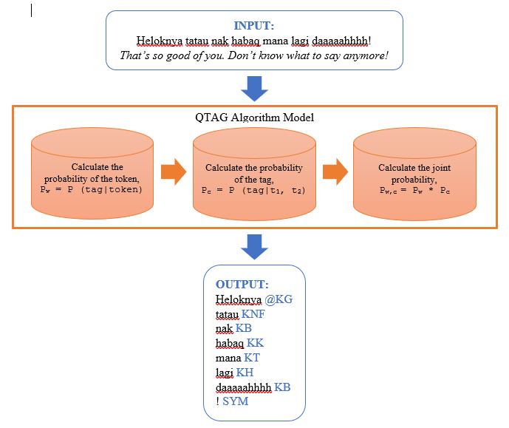
FIGURE 4. POS QTAG algorithm function illustration.
Since QTAG POS tagging is a simple and easy approach to adapt to into other languages, it has been adapted for other languages such as Romanian (Tufis & Mason, 1998), German (Cox, 2010) and Norgweigen (Nøklestad & Søfteland, 2007). Due to its simplicity with minimal number of required resources (corpus with annotated POS tags and a set of POS tags), QTAG has been a favoured approach to build minorities language POS tagging as well, such as for Vietnam language (Nguyen, Vu, & Le-Hong, 2003) and the subgroup of Germanic language named Plautdietsch (Cox, 2010). The successful as well as the encouraging results (in the range of 80% to 90% accuracy) obtained from these studies using QTAG give a good justification for this study to use QTAG as the approach to build Malay POS tagging for Malay social media text. In addition, the same range of result is expected to be obtained from this study as well.

METHOD

The POS tagging for (informal) Malay social media text (Twitter) generally is a simple architecture consist of only two submodules; (i) pre-processing sub-modules and, (ii) Malay QTAG tagger, where the input is a raw tweet extract from twitter.com and gives an output of tokenized and annotated corpus. Figure 5 display the architecture of Malay POS tagger.

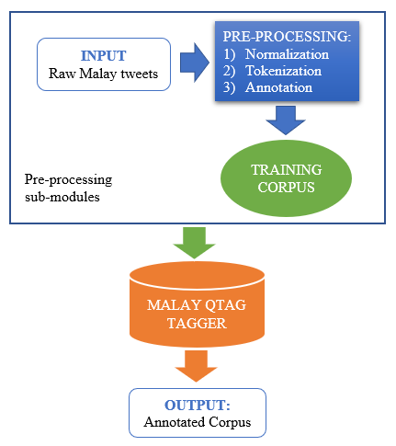
FIGURE 5. Malay QTAG POS tagger architecture.
The development of Malay POS tagger for social media text (Twitter) requires two main phases: (i) creating the social media text corpus annotated with POS, and (ii) developing the Malay QTAG by adapting the English QTAG developed by Tufis and Mason (1998). As follows, in the next subsection, explanation on the how building Malay POS corpus will be given, which will be followed with the description on how the Malay QTAG is built.

MALAY POS CORPUS

The constructing of the Malay QTAG tagger requires a set of training corpus – a manually tokenized and annotated corpus, where, the texts (tweets) of the corpus are taken (collected) from Malay Twitter accounts, which only informal Malay tweets – tweets consist of dialect (regional variation), grammatical and typographical error, and abbreviations words, are accepted as training corpus. Statistically, in average, the training corpus contains 70% of informal Malay texts and the rest are standard Malay texts. Hence, the following are steps taken to produce a set of training corpus.
Firstly, the texts (tweets) of the corpus are collected manually from twitter.com, where only Malay written tweets are accepted. The collected tweets called as raw Malay tweets/corpus, then undergone the pre-processing phase – normalized, tokenizing and annotating. The function of the normalization process is to eliminate any punctuations or symbols in the corpus, before it can proceed to the next pre-processing step – tokenization. Next, the tokenization process function is to break the corpus sentences into tokens based on the root word, the spacing between sentences and new lines. The tokenized cops then will resume to the last step of pre-processing phase – annotating. Lastly, in annotating step, the tokenized corpus will be manually tagged with (informal) Malay POS tag set that have been designed before. Thus, a completed annotated corpus called as the training corpus, then ready to be used as the training data in order to build the Malay QTAG.
Figure 6 display an illustration of pre-processing phase process and Table 3 display the summary of statistical information of Malay POS tagged (annotated) corpus.

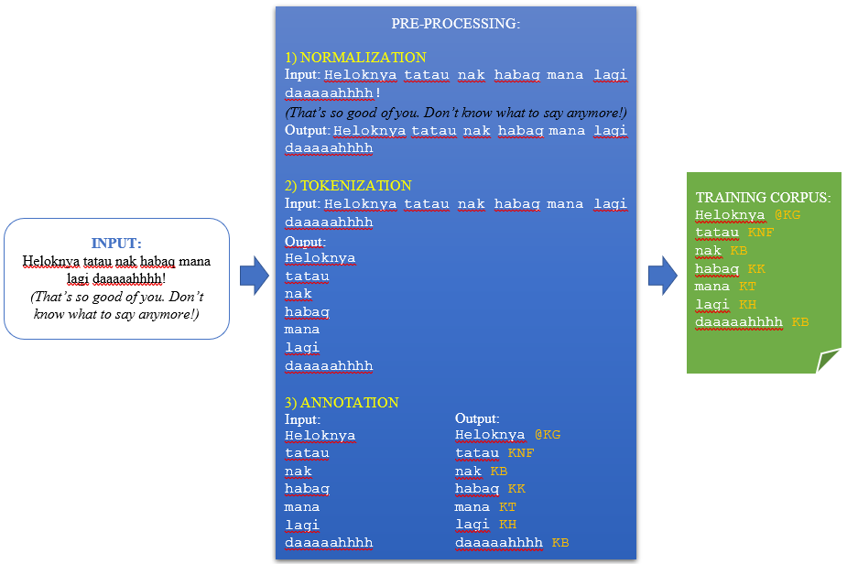
FIGURE 6. Pre-processing sub-modules process.
TABLE 3. Summary of statistical information of Malay POS tagged corpus
Items | Value
No. of Tweets | 300
No. of Words | 5513
No. of Lexical Item | 2527
No. of Errors | 680
Tag Sets | 38

MALAY QTAG

The Malay QTAG POS tagger is designed by adapting the probabilistic QTAG POS tagger, created by Tufis and Mason (1998) for English POS tagging. We choose QTAG because its algorithm is made straightforward, which easier to study POS of any minority languages, whereas as earlier works on QTAG POS tagging of various languages can be found in Cox (2010) – English, Sornlertlamvanich, Charoenporn and Isahara (1997) – Thailand, and Tran, Le, Ha & Le (2009) – Vietnamese, none of them have studied or developed a QTAG POS tagger exclusively for Malay language.
The designing of Malay QTAG POS tagger started by creating a resource file (.dat file). The resource file is built from the training corpus done in pre-processing sub-modules, which we named it as (MAZI_pretagged.txt) and the Malay POS tag set, which we called as (MalayTagset.txt). Afterwards, the following command was executed to produce the resource file (MalayTagset.dat).

java -cp qtag.jar qtag.LexiconCreator MalayTagset.dat < MAZI_pretagged.txt

The program that contains the tagger (QTAG.jar) and the generator (qtag.LexiconCreator)to create resource file (.dat) can be downloaded from ‘Tagging with QTAG’ (2007). Next, as the resource file is ready to use, the following command was executed to test the Malay QTAG tagger by inserting a new raw Malay tweet as input.txt.

java -jar qtag.jar MalayTagset.dat < input.txt > output.txt

The evaluation of new raw Malay tweets (test corpus) is done by manually checking and correcting repeatedly all the tokens and its associated POS labels to ensure the suitability of the POS per word. The combined corpus is once again used as a training corpus and this process is repeated to ensure all data (words) is completely annotated. The following Figure 7 displays an illustration of how the Malay QTAG POS tagger is run.
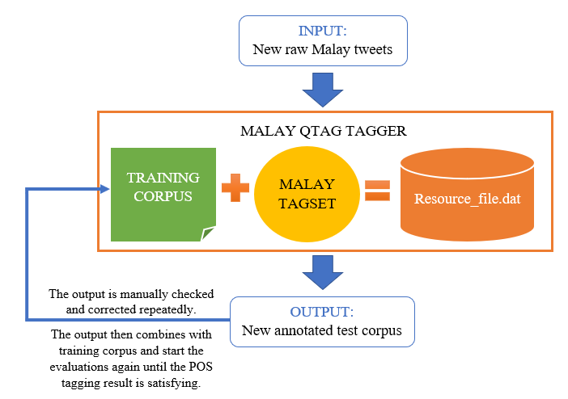
FIGURE 7. Illustration of Malay QTAG POS tagger.

RESULT

This section explained on the Malay QTAG POS tagging evaluation phase. The evaluation phase setup to evaluate the suitability of Malay POS tag set and the developed training corpus with the raw Malay tweets taken from twitter.com. This phase requires two types of data sets (corpus): (i) the unnormalized (raw) test dataset – extract directly from Twitter without make any changing to the texts, and (ii) the normalized test dataset – the same corpus as (i), but had to undergone normalization process (the same process explained in the previous section) (See Figure 6).
The following figures (Figure 8 and 9), shows how the new Malay tweets, known as test dataset, are evaluating using the Malay QTAG POS tagger, under the first type of evaluation phase which the unnormalized (raw) test data set.
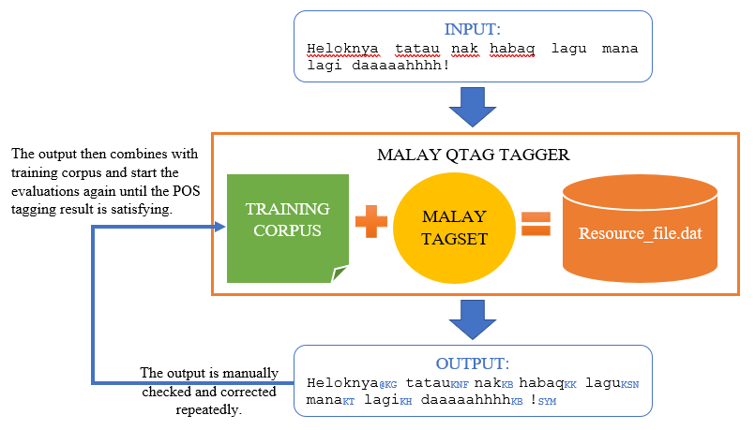
FIGURE 8. Illustrate the first example of unnormalized evaluation phase of Malay QTAG POS tagger.
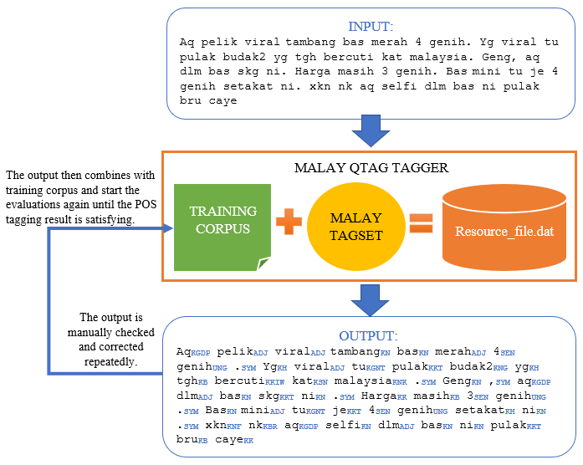
FIGURE 9. Illustrate the second example of unnormalized evaluation phase of Malay QTAG POS tagger.
Next, the following figures (Figure 10 and 11), shows how the new Malay tweets (test dataset), which had undergone the normalization process first, are evaluating using the Malay QTAG POS tagger, under the second type of evaluation phase which the normalized test data set.

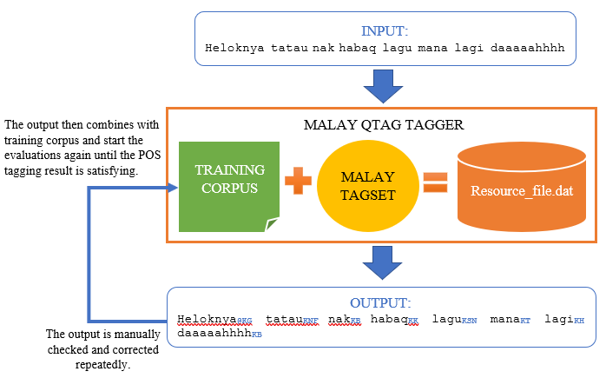
FIGURE 10. Illustrate the first example of normalized evaluation phase of Malay QTAG POS tagger.
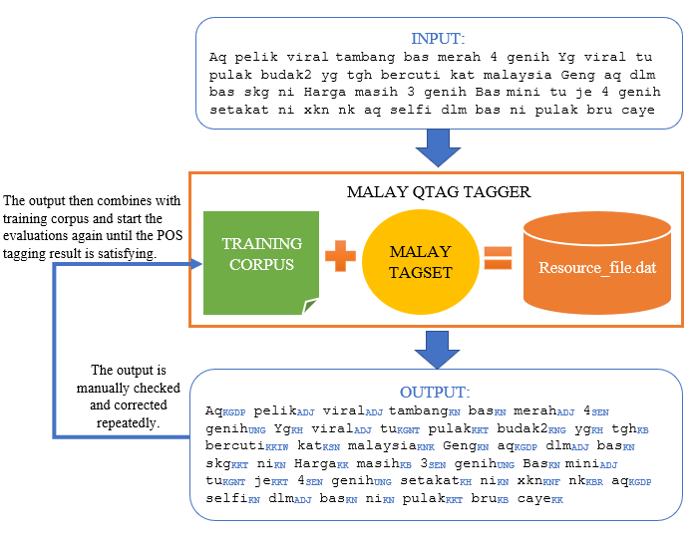
FIGURE 11. Illustrate the second example of normalized evaluation phase of Malay QTAG POS tagger.

To reiterate, the approach to evaluate the Malay POS tagging performance was based on the approach used in Tufis and Mason (1998). The proposed evaluation was carried out by splitting the test data into a small set of test data and the accuracy obtained from all the small dataset. The performance was then assessed by calculating the average of all the obtained accuracies from the small test data set. In this study, evaluation was carried out 15 times, in which, both of the test dataset (unnormalized and normalized test data sets) were chunked into 15 small data sets. The result of first set of test dataset (unnormalized test dataset) can be seen in Table 4. The results of the evaluation of the second set of test corpus (normalized test dataset) can be seen in Table 5. The overall evaluation of both test data set is shown in Table 6.

TABLE 4. Results of unnormalized test datasets
Unnormalized Datasets | No. of Tokens | No. of Errors | Accuracy
CWS_1 | 11 | 3 | 72.7 %
CWS_2 | 141 | 5 | 96.4 %
CWS_3 | 305 | 18 | 94.1 %
CWS_4 | 134 | 18 | 86.6 %
CWS_5 | 287 | 33 | 88.5 %
CWS_6 | 29 | 6 | 79.3 %
CWS_7 | 130 | 5 | 96.2 %
CWS_8 | 123 | 5 | 96.0 %
CWS_9 | 155 | 5 | 88.4 %
CWS_10 | 53 | 11 | 79.2 %
CWS_11 | 140 | 21 | 85.0 %
CWS_12 | 90 | 15 | 83.3 %
CWS_13 | 177 | 46 | 74.0 %
CWS_14 | 163 | 20 | 87.7 %
CWS_15 | 174 | 25 | 85.6 %

TABLE 5. Results of normalized test dataset
Normalized Datasets | No. of Tokens | No. of Errors | Accuracy
COS_1 | 11 | 0 | 100.0 %
COS_2 | 124 | 5 | 96.0 %
COS_3 | 301 | 5 | 98.7 %
COS_4 | 133 | 4 | 97.0 %
COS_5 | 289 | 11 | 96.2 %
COS_6 | 29 | 1 | 96.6 %
COS_7 | 127 | 3 | 97.6 %
COS_8 | 124 | 3 | 97.6 %
COS_9 | 157 | 4 | 97.5 %
COS_10 | 56 | 2 | 96.4 %
COS_11 | 138 | 15 | 89.1 %
COS_12 | 88 | 13 | 85.2 %
COS_13 | 176 | 36 | 80.1 %
COS_14 | 164 | 2 | 98.8 %
COS_15 | 172 | 18 | 89.5 %

In Table 4, the highest obtained accuracy which is 96.4% is with the second test file (CWS_2) that contains 141 tokens with only five numbers of wrongly labeled POS tags. The same test file that has been normalized (COS_2) before being tagged with POS, obtained almost the same accuracy (96.0% - Table 5). However, this situation does not apply to all the small dataset files. A contrasting result is obtained with test file CWS_1 in the unnormalized dataset (Table 4), with the lowest accuracy of only 72.7%, whereas for the same file, that underwent the normalized process (COS_1) achieved the highest accuracy. In fact, the best accuracy of all with 100%, hence, no indication of error. In this manner, the application of average accuracy of the overall data sets is much more practical in terms of evaluating the whole aspect of the test dataset (number of words and various styles of writings). The overall evaluation of accuracy on all the test files was conducted and presented in Table 6.

TABLE 6. Overall evaluation result on both test datasets
Test Datasets | No. of Tokens | No. of Errors | Accuracy
Unnormalized Datasets | 2112 | 236 | 88.8 %
Normalized Datasets | 2089 | 122 | 94.6 %

Based on the overall evaluation on these test datasets; both the unnormalized datasets and normalized datasets, a high average accuracy rate of more than 85% (88.8% for unnormalized datasets and 94.6% for normalized datasets) were obtained. In Table 6, the number of tokens in unnormalized datasets is higher than the normalized datasets since some tokens are symbols and punctuations. As described earlier, these tokens are removed during the normalization process. With the number of errors being reduced from 236 to 122 (almost 50% of error reduction), this implies that the removal of symbols and punctuation plays an important role in improving the accuracy of the POS tagging on Malay social media texts.

DISCUSSION

Based on the findings, a few points are worthy to be discussed; (i) the impact of the simple normalization process before the POS tagging, (ii) the capability of probabilistic approach, the QTAG (Tufis & Mason 1998; Mason & Tufis, 1997) when adapted for Malay language (specifically on Malay social media text), and (iii) how the adaptation of QTAG on Malay language compared to the current state-of-art of POS tagging Malay, in general.
Therefore, the difference in the result which the normalized test dataset obtained higher accuracy than unnormalized test dataset could be due to the filtering punctuation and symbols from the text. It is also presumed that the punctuations and symbols contribute to the change of meaning, of a sentence or a word, in the context of Malay social text writing. Thus, due to the change of meaning, incorrect POS was labelled.
The findings on whether the adoption of Malay language on QTAG POS tagging is a success or not; the best result of the evaluation, which is at 94.6% (see Table 6) for average accuracy, is considered as a good result. The result is comparable to other adapted QTAG languages. For example, the Romanian QTAG achieved the best results of 98% for formal Romanian text, and the Germanic language (Cox, 2010) obtained the best result of 90% and above for normalized text. The previous works on QTAG (Cox, 2010; Tufis & Mason, 1998; Mason & Tufis, 1997) are based on formal text. It is a well-known and accepted fact that the use of incorrect lexicon, structural errors, spelling mistakes and acronym in social media such as tweets posed a greater challenge in POS tagging.
The next consideration is the performance of Malay QTAG, which is built for automatic POS tagging on social media text, compared with the performance of another language. Based on previous studies, most work used supervised machine learning, and the annotated corpus was semi-manually built (this study built the corpus in a similar way). Although the corpus was built in a similar manner, the range of informal text of POS tagging performances is from 74.28% (Albogamy & Ramsay, 2015) to 97.6% (Al-Sabbagh & Girju, 2012). Therefore, the Malay QTAG has been considered as performing quite well since its best result of accuracy is 94.6%.
Another contribution of the present study, is the capability of the Malay QTAG tagger compared to the other automatic Malay POS tagging, though the datasets are different since current works on Malay POS tagging is on formal Malay text, whereas this study is focused on informal text on social media. Thus, constructing a tagger exclusively for (informal) Malay POS tagging is seen more challenging than the formal Malay language text. However, despite the challenges, this study manages to obtain a high result of 94.6% POS tagging accuracy, compared to the novel work in formal Malay POS tagging by Halid and Omar (2017) with only 93.06%. The range of formal text of Malay POS tagging performances with various kinds of approaches are between 80% (Alfred et al., 2013) and 99.23% (Mohamed et al., 2015) of accuracy. In this study’s, the best result is 94.6%, hence, the Malay QTAG is considered as performing well since the result is within the range of other automatic Malay POS tagging. The size of the annotated POS corpus influences the performances of supervised POS tagging, and this is particularly true for QTAG POS tagging approach as well (Cox, 2010). In this study, (see Table 3), the total of words is only around 5000, But QTAG can still perform with the best accuracy of 94.6%. Mason and Tufis’s work (1997) used a much larger scale of corpus with 23, 000 words extracted from books. Therefore, the reported accuracy is higher, which is at 98%. Accordingly, one of the definite future directions of this study is to work with a much larger corpus, for the optimum performance of Malay QTAG to be achieved.
The best performance of Malay POS tagging is 99.23% of Mohamed et al. (2015) and the result was obtained using SVM technique. This implies that the performance of Malay POS tagging can be improved by applying a more suitable supervised machine learning approach. Therefore, another future work that should be carried out is to investigate how the automatic Malay POS tagging is performed on social media text based on other well-known supervised approaches, particularly SVM.

CONCLUSION

This study concluded that Malay QTAG POS tagger for social media text has been successfully developed with a training corpus set containing over 5000 words and, with an average Malay POS tagging accuracy of over 90%. The performance of this (informal) Malay QTAG POS tagger can be improved with a much higher tagging accuracy by increasing the size of training corpus – corpora used to train the Malay QTAG tagger, from 5000 words to 20, 000 or 30, 000 words in a corpus. Another improvement that can be made are by designing more detailed Malay POS tag set which is much more appropriate to be used with informal Malay tweets. For instance, in this study all the slang words such as kud, la and ea, are being classified by UNG (idiom phrase POS tag) POS tag, rather than its very own POS tag set, where these changes can be made by editing the developed training corpus manually through searching the correspondent word and trained the corpus back with Malay QTAG tagger with command stated in the previous section.
Although this study has over 5000 words in the training corpus and achieved above 90% POS tagging accuracy, another improvement should be made by adding more Malay dialect words such as Johor, Kelantan, Terengganu and etc., into the training corpus. The more dialect words being input in the training corpus, the higher the POS tagging accuracy of informal Malay language can be obtained. After studies on these have been conducted, the future direction is the application of various types of supervised machine learning techniques. This would enable researchers to identify the best technique for the analysis of Malay POS tagging. Applying various kinds of supervised machine learning techniques and see which techniques can give the best impact on the Malay POS tagging. Since, POS tagging is one of the NLP application tools, one of the future directions of this study is to investigate the impact of this Malay POS tagging in one of NLP application which is Sentiment Analysis on social media text for informal Malay language.

Acknowledgment

We thank Dr Oliver Mason for providing us the program code as well as the consultation regards to program. This project is funded by MoHE under research code: FRGS/1/2016/ICT02/UKM/02/14.

REFERENCES

Abdulkareem, M., & Tiun, S. (2017). COMPARATIVE ANALYSIS OF ML POS ON ARABIC TWEETS. Journal of Theoretical & Applied Information Technology, 95(2).
Ahmad, D. H. (1986). The role of the Dewan Bahasa dan Pustaka in the advancement of indigenous academic publishing in Malaysia. Academic Publishing in ASEAN, 150-156.
Albogamy, F., & Ramsay, A. (2015). POS tagging for Arabic tweets. In Proceedings of the International Conference Recent Advances in Natural Language Processing (pp. 1-8).
Alfred, R., Mujat, A., & Obit, J. H. (2013, March). A ruled-based part of speech (RPOS) tagger for Malay text articles. In Asian Conference on Intelligent Information and Database Systems (pp. 50-59). Springer, Berlin, Heidelberg.
Al-Sabbagh, R., & Girju, R. (2012). A supervised POS tagger for written Arabic social networking corpora. In KONVENS (pp. 39-52).
Alshaikhdeeb, B., & Ahmad, K. (2016). Biomedical Named Entity Recognition: A Review. International Journal on Advanced Science, Engineering and Information Technology, 6(6), 889-895.
Altawaier, M. M., & Tiun, S. (2016). Comparison of machine learning approaches on arabic twitter sentiment analysis. International Journal on Advanced Science, Engineering and Information Technology, 6(6), 1067-1073.
Anbananthen, K. S. M., Krishnan, J. K., Sayeed, M. S., & Muniapan, P. (2017). Comparison of Stochastic and Rule-Based POS Tagging on Malay Online Text.
Antony, P. J., Mohan, S. P., & Soman, K. P. (2010, March). SVM based part of speech tagger for Malayalam. In Recent Trends in Information, Telecommunication and Computing (ITC), 2010 International Conference on (pp. 339-341). IEEE.
Arbak, O. (2005). Kamus komprehensif Bahasa Melayu. Shah Alam: Oxford Fajar.
Bakar, J. A., Omar, K., Nasrudin, M. F., & Murah, M. Z. (2013, November). Morphology analysis in Malay POS prediction. In Proceeding of the International Conference on Artificial Intelligence in Computer Science and ICT (AICS 2013) (Vol. 25, p. 26).
Bakar, J. A., Omar, K., Nasrudin, M. F., & Murah, M. Z. (2013). Part-of-speech for old Malay manuscript corpus: A Review. In Soft Computing Applications and Intelligent Systems (pp. 53-66). Springer, Berlin, Heidelberg.
Berger, A., L., Della Pietra, SA., Della Pietra, V., J. (1996): A Maximum Entropy Approach to Natural Language Processing in Computational Linguistics, vol. 22, no. 1 (pp. 39-72), March 1996.
Bukhari, N. I. B. A., Anuar, A. F., Khazin, K. M., & Abdul, T. M. F. B. T. (2015). English-Malay code-mixing innovation in Facebook among Malaysian University students. Researchers World, 6(4), 1-10.
Chekima, K., & Alfred, R. (2017, November). Sentiment Analysis of Malay Social Media Text. In International Conference on Computational Science and Technology (pp. 205-219). Springer, Singapore.
Chowdhury, G. G. (2003). Natural language processing. Annual review of information science and technology, 37(1), 51-89.
Cox, C. (2010). Probabilistic tagging of minority language data: a case study using Qtag. Corpus linguistic applications: current studies, new directions. Amsterdam: Rodopi, 213-231.
Derczynski, L., Ritter, A., Clark, S., & Bontcheva, K. (2013). Twitter part-of-speech tagging for all: Overcoming sparse and noisy data. In Proceedings of the International Conference Recent Advances in Natural Language Processing RANLP 2013 (pp. 198-206).
Elworthy, D. (1995). Tagset design and inflected languages. arXiv preprint cmp-lg/9504002.
Gimpel, K., Schneider, N., O'Connor, B., Das, D., Mills, D., Eisenstein, J., ... & Smith, N. A. (2011, June). Part-of-speech tagging for twitter: Annotation, features, and experiments. In Proceedings of the 49th Annual Meeting of the Association for Computational Linguistics: Human Language Technologies: short papers-Volume 2 (pp. 42-47). Association for Computational Linguistics.
Gui, T., Zhang, Q., Huang, H., Peng, M., & Huang, X. (2017). Part-of-speech tagging for twitter with adversarial neural networks. In Proceedings of the 2017 Conference on Empirical Methods in Natural Language Processing (pp. 2411-2420).
Halid, N. A., & Omar, N. (2017). Malay Part of Speech Tagging Using Ruled-Based Approach. Asia-Pacific Journal of Information Technology and Multimedia, 6(2).
Harun, K., & Yusof, M. (2015). Komunikasi bahasa melayu-jawa dalam media sosial. Jurnal Komunikasi, Malaysian Journal of Communication, 31(2).
Hawkins, J. M. (2008). Kamus dwibahasa Bahasa Inggeris–Bahasa Malaysia. Selangor: Oxford Fajar.
Hock, O. Y. (2009). Kamus Dwibahasa. Petaling Jaya: Pearson Longman.
Java, A., Song, X., Finin, T., & Tseng, B. (2007, August). Why we twitter: understanding microblogging usage and communities. In Proceedings of the 9th WebKDD and 1st SNA-KDD 2007 workshop on Web mining and social network analysis (pp. 56-65). ACM.
Knowles, G. O., & Mohd, Z. (2006). Word class in Malay: a corpus-based approach. Dewan Bahasa dan Pustaka.
Li, D. (1998) The Plight of the Purist. In Pennington, M. (ed.) Language in Hong Kong at
Century’s End, pp. 161-190. Hong Kong: Hong Kong University Press.
Mason, O., & Tufis, D. (1997, October). Probabilistic tagging in a multi-lingual environment: Making an English tagger understand Romanian. In Third European TELRI Seminar, Montecatini, Italy.
Mohamed, H., Omar, N., & Aziz, M. J. A. (2015). Malay Part of Speech Tagger: A Comparative Study on Tagging Tools. Asia-Pacific Journal of Information Technology and Multimedia, 4(1).
Muysken, P. (2000). Bilingual speech: A typology of code-miixing. United Kingdom:
Cambridge University Press.
Nguyen, T. M. H., Vu, X. L., & Le-Hong, P. (2003). A case study of the probabilistic tagger QTAG for Tagging Vietnamese Texts. In Proceedings of the 1st National Conference ICT RDA.
Nielsen, F. Å. (2011). A new ANEW: Evaluation of a word list for sentiment analysis in microblogs. arXiv preprint arXiv:1103.2903.
Nøklestad, A., & Søfteland, Å. (2007). Tagging a Norwegian Speech Corpus. Proceedings of the 16th Nordic Conference of Computational Linguistics NODALIDA-2007, 25-26 May, Estonia, Tartu.
Nooralahzadeh, F., Brun, C., & Roux, C. (2014). Part of speech tagging for french social media data. In Proceedings of COLING 2014, the 25th International Conference on Computational Linguistics: Technical Papers (pp. 1764-1772).
Omar, N., Hamsani, A. F., Abdullah, N. A. S., Abidin, S. Z. Z., & Alam, S. (2017). Construction of Malay Abbreviation Corpus Based on Social Media Data. Journal of Engineering and Applied Sciences, 12(3), 468-474.
Owoputi, O., O'Connor, B., Dyer, C., Gimpel, K., Schneider, N., & Smith, N. A. (2013). Improved part-of-speech tagging for online conversational text with word clusters. In Proceedings of the 2013 conference of the North American chapter of the association for computational linguistics: human language technologies (pp. 380-390).
Sornlertlamvanich, V., Charoenporn, T., & Isahara, H. (1997). ORCHID: Thai part-of-speech tagged corpus. National Electronics and Computer Technology Center Technical Report, 5-19.
Tagging with QTAG. (2007). Retrieved from https://www1.essex.ac.uk/linguistics/research/resgroups/clgroup/Resources/Nugues/QTAG/
Toutanova, K., & Manning, C. D. (2000, October). Enriching the knowledge sources used in a maximum entropy part-of-speech tagger. In Proceedings of the 2000 Joint SIGDAT conference on Empirical methods in natural language processing and very large corpora: held in conjunction with the 38th Annual Meeting of the Association for Computational Linguistics-Volume 13 (pp. 63-70). Association for Computational Linguistics.
Toutanova, K., Klein, D., Manning, C. D., & Singer, Y. (2003, May). Feature-rich part-of-speech tagging with a cyclic dependency network. In Proceedings of the 2003 Conference of the North American Chapter of the Association for Computational Linguistics on Human Language Technology-Volume 1 (pp. 173-180). Association for Computational Linguistics.
Tran, O. T., Le, C. A., Ha, T. Q., & Le, Q. H. (2009, December). An experimental study on Vietnamese POS tagging. In Asian Language Processing, 2009. IALP'09. International Conference on (pp. 23-27). IEEE.
Tufis, D., & Mason, O. (1998, May). Tagging romanian texts: a case study for qtag, a language independent probabilistic tagger. In Proceedings of the First International Conference on Language Resources and Evaluation (LREC) (Vol. 1, pp. 589-596).
van der Goot, R., Plank, B., & Nissim, M. (2017). To normalize, or not to normalize: The impact of normalization on part-of-speech tagging. arXiv preprint arXiv:1707.05116.
Xian, B. C. M., Lubani, M., Ping, L. K., Bouzekri, K., Mahmud, R., & Lukose, D. (2016). Benchmarking mi-pos: Malay part-of-speech tagger. International Journal of Knowledge Engineering, 2(3), 115-121.
Yang, L. C., Selvaretnam, B., Hoong, P. K., Tan, I. K., Howg, E. K., & Kar, L. H. (2016). Exploration of road traffic tweets for congestion monitoring. Journal of Telecommunication, Electronic and Computer Engineering (JTEC), 8(2), 141-145.
Yusof, M. (2018). Trend Ganti Nama Diri Bahasa Melayu dalam Konteks Media Sosial. Jurnal Komunikasi, Malaysian Journal of Communication, 34(2).

About the authors

Siti Noor Allia Binti Noor Ariffin: An undergraduate degree student at the Faculty of Information Science and Technology (FTSM) in Universiti Kebangsaan Malaysia (UKM). Currently, she is under the supervision of Dr. Sabrina Tiun for an industrial training in research track program.

Dr. Sabrina Tiun: A senior lecturer at the Faculty of Information Science and Technology (FTSM) in Universiti Kebangsaan Malaysia (UKM). Range of research interests are form Natural Language Processing to Speech Processing and Information Retrieval. Member of the Knowledge Computing research group, under the Centre of Artificial Intelligence.

