“Is Selangor in deep water?”: A corpus-driven account of air/water in the Malaysian Hansard Corpus (MHC)
Norsimah Mat Awal, Azhar Jaludin, Anis Nadiah Che Abdul Rahman & Imran Ho Abdullah
Center for Literacy and Social Transformation
Faculty of Social Sciences and Humanities
UNIVERSITI KEBANGSAAN MALAYSIA
norsimah@ukm.edu.my
Abstract
‘Air” or its English equivalent ‘water’ is very important our everyday life so much so that when the tap runs dry, it even made it as one of the topics debated by politicians. This paper looks at the issues that surround air/water in Malaysian Parliamentary debates by specifically focusing its relation to the state of Selangor. The air/water related issues were examined based on the collocates of air and Selangor in the Malaysian Hansard Corpus (MHC) from Parliament 1 (P1) to Parliament 13 (P13). The findings show that air consistently present as one of the collocates of ‘Selangor’ in P4 to P13. The recurring issues during those periods are the never-ending water-related problems and the steps taken by the government to overcome the problems as illustrated from phrases such as kegawatan air/water crisis, masalah krisis air/water crisis problem, penjimatan air /saving water or penstrukturan air di Selangor/structuring the water supply in Selangor. This corpus-driven account has managed to show the trend of the parliamentary debates in relation to ‘air’/water and ‘Selangor’.
Keywords: air/water, Selangor, Malaysian Hansard Corpus, parliamentary debates, water crisis

1.0 Introduction
Language is a powerful tool of communication as it can perform various purposes such as conveying thoughts and ideas, sharing information, expressing one’s feelings, build relationship and influence others and as a great tool to get people to act and think in a certain way (Supardi, 2016). Language, too, takes place in a social context and the social context determines the language or linguistic choice used by the communicators. Such social context includes legal, political, parliamentary, formal and informal contexts (Amberg & Vause, 2010). Hence, this paper looks at issues that are brought up in parliamentary debates. Specifically, it looks at the lexicals ‘Selangor’ and ‘air’/water and their collocates in the Malaysian Hansard Corpus (henceforth MHC).

2.0 Malaysian Parliament
Parliament is the highest legislative authority that formulates laws in accordance to the nation as a whole and also serves as a forum for people’s representative to debate and discuss the issues regarding the national interests. (Ngeow, Kuang & David, 2011). Parliament is also responsible to carry the will of the people in the government and their expectations that democracy policy is enacted properly by being truly responsive to the needs of the nation’s society. Hence, the members of parliamentary have distinct responsibilities to solve the conflicting interests and expectations of different groups of communities. That is why the parliament is the most dynamic and complex institutions of democratic society that allows for traditional setting for open dialogue – often times are conflicting – among the elected members of parliament (Ilie, 2015).
In Malaysia, the Parliament of Malaysia is the highest legislative body of the country and it is the place where laws are being enacted. Dewan Rakyat or the House of the Representatives is one of the three components in the Parliament of Malaysia, the premier legislative body in Malaysia after the Dewan Negara (Senate) and His Majesty The King. The House of Representatives has 222 members that are elected from the General Election of Malaysia that is held in every five years. Each Member of Parliament (MP) represents a Parliamentary Constituency (The Offficial Portal of Parliament of Malaysia, 2018). The role of the House of Representative stands as the body to pass, emend and repeal the laws of the country. The parliamentary debates of House of Representative and Senates are all recorded in an official record called Hansard.
His Majesty The King, The Yang Di Pertuan Agong, serves as the head of state and is the only one in the parliamentary institution who has the power to summon, discontinue or dissolve for a session in a parliament. Meanwhile, the Senate consist of 70 members made up two categories which are federal and state appointments. Members of Senate or the senators are elected based on their distinguished public services, those with prominent distinction in their respective professional fields, the ability to represent the racial minorities or the capability of representing Orang Asli’s interests.
The political party with the highest number of members being elected can form a federal government and has the authority to rule the country. Thus, Members of Parliament have a larger role and prominent responsibilities to play in the parliamentary institution as they are entrusted by the nation to uphold the country (Ng, 2017). Ilie (2015) notes that the Members of Parliamentary should have a mission to speak and act on behalf of the citizens that they are representing.
2.1 The Role of Parliamentary
According to Ilie (2015), as the representative body of democracy, parliaments are designed and formed to democratically discuss political deliberations, problem-solving and decision making. Hence, parliament is expected to help solve pressing problems and issues of the society.
Ngeow, Kuang and David (2011) concur because parliament is a place where high government officials meet with the politicians to discuss or debate about any particular issues the may hold the important key towards the country’s development in specific sectors. Discussions made during the parliamentary session will have an impact on the future of a country because it determines the various policies to be implemented and enacted. Indirectly, the fate of the people also lies in the hands of the result of parliamentary discussions. Ong (1976) notes that the parliamentary have the important role of bridging the elite and the mass and hence, they are often held to be “rubber stamps” or minimal legislatures”. He further states that the role of parliamentary in developing countries seems to have bypassed that role of the political and social scientist in a quest to search for political stability and order.
In Malaysia, parliamentary plays a role to demonstrate democracy policy the country is adopting. According to the official portal of the Parliament of Malaysia, the elected representative reflects the people’ aspiration and thus the whole institution can be seen to represent the democratic structure of the government. The Parliament of Malaysia has the legislative authority for the federation to enact laws and enforce the laws nationwide. Besides that, the institution also has the authority to passes federal laws and make amendments to the current and existing federal laws. Besides law-related element, the Parliament of Malaysia also has the role to examine the government’s policies, approves the current government’s expenditure and new taxes. Hence, the members of this institution are the law-makers that govern the rules and regulations of Malaysia.
Furthermore, the institution also functions as a forum for the Members of Parliament to discuss issues regarding the public interest. Ng (2017) iterates that the Members of Parliamentary have a primary role they should carry out well. Instead of doing on-the-ground work for their political play, they should be active in the parliamentary debates and discussions to solve the people’s problems, address specific needs, redress grievances of their local constituency.
3.0 Language and Parliamentary
In parliament, language is fully utilised by the politicians to get their ideologies or agendas across. Ilie (2015) states that Members of Parliaments use language to acquire political power, to challenge political power, to compete for political power or to defend and consolidate political power. In other words, language is used as a tool to balance out their political struggle in the parliamentary. Ngeow, Kuang and David (2011) notes that most Members of Parliamentary are good speakers with excellent oral skills. This means they are eloquent at using language to their advantage by “presenting their arguments and thoughts well”. Thus, they are skilled at delivering persuasive speech or talks in an attempt to influence others into believing what they want the people to believe.
Kovarikova (2006, as cited by Ngeow, Kuang & David, n.d.) also pointed out that Members of Parliament may use the formal and informal form of language, insert colloquial slangs or words, make jokes, employ mix markers of authority and familiarity as well as other well-thought strategies to appeal to their intended audience.
Hence, past studies suggest that language is fully utilised by the Members of Parliamentary in the parliamentary debate or discussion sessions to fulfil a certain agenda or commitment.
3.1 Parliamentary Discourse
The importance of parliamentary sitting on a country’s direction and the condition has made it one of the most significant areas of study within the political discourse analysis (Ngeow, Kuang & David, 2011). When discussing parliamentary discourse, there are many areas of study being developed to comprehend the nature of the institution. Some areas of study that has been widely researched include politeness strategies used by the members to achieve their political agenda or commitments.
According to Brown & Levinson (1987), the way a conflicting discourse is created by the members of the parliament can be analysed using the politeness concept. They stress that in politeness theory, a ‘face’ influence the strategies used by the people when facing conflicts. The ‘face’ refers to the public self-image that every member of society wants to have for himself or herself. This theory analyses how the speakers behave towards the hearer when in conflict.
Besides that, a linguistic pattern is also widely researched under the umbrella of parliamentary discourse. Ilie (2015) states that analysing recurring linguistic patterns and rhetorical strategies of the Members of Parliament can reveal their ideological commitments, hidden agendas and argumentation tactics. Ngeow, Kuang and David (2011) conducted a content analysis study that revealed how frequent the Members of Parliament attack the opposition party. Their study shows that “I” or “we” are more supreme and well behaved than “they” which means the struggle of having power is being enacted through comparison between the different parties. Besides that, their study also shows that Members of the Parliament from both the ruling coalition and the opposition are equally aggressive and defensive in their speeches.
David, Govindasamy and Nambiar (2009) found out that in Malaysian parliamentary debates, it is expected the there is an in-group and out-group between opposing parties due to different ideologies and practices. It is similar to any parliaments from the rest of the world, where the we-them dichotomy is the norm in the debate sessions of Malaysian Parliament and there exist power struggles on both the ruling government and the opposition.
The we-them dichotomy has the consequence that leads to greater diversity, exclusivity and differentiation especially in term of the ideologies held by the Members of Parliament which in return, influence the issues being presented in the parliamentary (Ngeow, Kuang & David, 2011).
3.2 Issues Raised in The Parliamentary
There is a potential that when the Members of Parliament speak, they prolong conflicts by engaging in debates about controversial issues to gain publicity (Baron, Byrne & Branscome, 2006). The act of prolonging debates over controversial issues can gain the positive ‘face’ of the Members of Parliament and them appear to care about the nation’s interest.
According to a news report by Bernama on July 17, 2018, in the Malaysian parliamentary, there are no restrictions for the Members of Parliamentary to raise any issues. For example, with the new government in power, scandalous issues such as 1MDB and the RM 2.6 billion ‘donation’ can now be discussed in the parliamentary.
Generally, the issues raised in the parliamentary involve the nation’s interest or particularly the constituency of the Members of Parliamentary (Muhamad Fuzi Omar, 2008). A research on the issues raised by the opposition parties in the Malaysian Parliamentary session shows that there are 19 categories of different issues being raised which includes “education, health, security, housing, supply of electricity and water, tourism, price of petrol, transport, new identity card, insurance, citizenship status, national service, taxes and prices of goods and toll rate” (Muhamad Fuzi Omar, 2008).
In term of the educational issue, the prominent aspect raised in the parliamentary are the state of Chinese education and schools as well as the state of affairs of the public universities in Malaysia (Muhamad Fuzi Omar, 2008). In his study, the political party DAP (Democratic Action Party) often raises issues concerning Chinese education in order to gain continuous support from the Chinese community.
Members of Parliament from the oppositions also often raise issues about students studying abroad causing an increase in brain drain as well as issue about the increasing interference by the politicians in universities due to the University and University Colleges Act (UUCA). The UUCA is claimed to be enacted for the political interests of the government instead of an academic consideration. Hence, these issues are often raised by the Members of Parliament from the oppositions to highlight the weakness of the ruling party in an attempt to achieve political power and the support of the people.
Another opposition party, PAS (Parti Islam Se Malaysia), which has ruled Kelantan for 27 years has always shown keen interest towards the Islamic state of Kelantan. They frequently raise issues regarding the economic development of Kelantan which is said to be neglected by the federal government. For example, they often question the role of Public Service Department (PSD) or the Federal Development Committee in Kelantan on the postponement and cancellation of loans for several projects in the state in attempt to put pressure on the government to support their political agenda of having more improved Islamic facilities such as religious schools (Muhamad Fuzi Omar, 2008).
It is obvious that there are many issues raised by Members of Parliament from both government-linked political parties and the opposition and this paper will present a corpus-driven account of the issue(s) raised during parliamentary debates utilizing the MHC as our data.

4.0 Methodology
The current research adopts a corpus-driven approach utilizing both quantitative and qualitative methods. According to McEnery (2013) corpus – driven approach is “an inductive process where corpora are investigated from the bottom up and patterns found therein are used to explain linguistic regularities and exceptions of the language variety/genre exemplified by those corpora”

4.1 The Corpus
The corpora used in the present study is the Malaysian Hansard Corpus (MHC). MHC was primarily developed in 2016 from the reports of Malaysian Parliamentary Debates in the House of Representative (Dewan Rakyat). To date, the corpus has 3,511 files of reports from 13 parliamentary proceedings (Parliament 1 – 13). The first meeting of the Parliamentary Debate was conducted in 1959 while the final collection of the corpus was taken from the Parliamentary Debates in 2018. This diachronic corpus of parliamentary discourse contains over 157 million words.

4.1.1 The Malaysian Hansard Corpus
The Malaysian Hansard Corpus (MHC) is corpus of parliamentary discourse developed by UKM researchers in 2016-2018. Initially, there are two subcorpora in the MHC which include the Senate (Dewan Negara) and House of Representatives (Dewan Rakyat). However, the study has utilised the Dewan Rakyat Corpus as it is ready for analysis. The corpus was constructed based on the reports taken from the Malaysian Hansard or the official record for Malaysian parliamentary debates. The reports are verbatim account of the debates and has several reporting formats. The files are open data and retrieved from the Malaysian Hansard Portal were in Portable Document Format (PDF) and were later converted into plain text files with several processes of cleaning up. The clean up process include machine convertion and human correction on the errors made by the converter. The data for this corpus was collected from the reports of the Parliamentary Debates from the first Parliament (P1) in 1959 until the most recently dissolved Parliament Thirteen (P13) in 2018.
4.1.2 The composition of the MHC
The existing MHC is divided into smaller subcorpora which are sorted according to the Parliaments (Parlimen), Sessions (Penggal) and Meetings (Mesyuarat). Each meeting has a number of reports because it is conventionally held for several days. Each day of meeting is reported in one file. Therefore, a Meeting in a Session could comprise of at least 2 (Parliament 1 , Session 1, Meeting 2) reporting files up and could be up to 95 files (Parliament 8, Session 1, Meeting 2) in which, one report denotes one sitting day.
To date, there are 3,511 Hansard reports of the House of Representative collectively with the total of over 157 million words (token).
TABLE 1: The Divisions of House of Representative according to Parliaments and Sessions: Last Measured in April 2018 (Imran et al, 2018)
Parliament  Session | 1 | 2 | 3 | 4 | 5 | 6 | 7 | 8 | 9 | 10 | 11 | 12 | 13 | Total
1  2  3  4  5  6  Total | 12  46  44  38  40  182 | 50  60  56  31  44  241 | 43  50  45  138 | 63  72  61  71  267 | 108  59  64  231 | 109  66  60  21  256 | 103  65  64  24  255 | 109  96  4  67  276 | 70  84  86  72  46  385 | 4  77  77  61  67  286 | 68  77  91  85  321 | 80  70  83  63  70  20  366 | 54  57  93  53  57  334 | 3,511

Based on Table 1, the total number number of 3,511 reports are compiled from Parliament 1 to Parliament 13. Parliament 1 has the least number of reports with 182 reports while Parliament 9 has the most number of reports (385). Customarily, each Parliament has 5 sessions except for Parliament 13 whic has 6 sessions. The number of reports denotes the number of days of the parliamentary sittings.

The size
Figure 1 shows the token (running words) in text according to the parliamentary sessions.
FIGURE 1: Division of Basic Statistical Information according to Parliaments (Generated using WordSmith 5.0) (Imran et al, 2018)

Based on figures illustrated in Fig. 1, there is an upward trend in the number of token over the years. Parliament 3 has the least number of word token while Parliament 12 has the most number of word token. The increasing number of word token may indicate that the number of debates have also increased in the parliament.

4. 2 The Corpus Tools
The corpus tool utilized to process and analyze the target corpus for the current research is WordSmith Tools (WST), version 5 (https://lexically.net/wordsmith/version5/ index.html). WST is an organic integrated suite of programs for examining the manner in which words behave in a text. It was developed by Mike Scott from the University of Liverpool. There are three main tools within WST, namely: Concord, KeyWord and Wordlist and 12 utilities. The three core tools all have their own facilities for analysing texts and obtaining statistical support (Scott 2008). A brief discussion on each of the main tools are as follows.

a. Concord
Scott (2008) states that “you get a much better idea of the use of a word by seeing lots of examples of it, and it’s by seeing or hearing new words in context lots of times that you come to grasp the meaning of most words in your native language”. The primary purpose of a concordance is to see many lexical items in context (Key Word in Context, KWIC format). It allows a researcher to analyse a word, part of a word or lexical chunk in its linguistic context, and thereby notice recurring lexical features or idiosyncratic usages of a lexical item or chunk (Guillén Nieto et al. 2008).

b. Keywords
Scott (2008) states that “key-words provide a useful way to characterise a text or a genre”. The purpose of the KeyWords function is to compare two word lists: a reference corpus and a study corpus. The comparison results in a list of keywords where the frequencies are significantly different between the reference corpus and the study corpus. For example, if the word the has a frequency of 6% in the reference corpus, and 5% in the study corpus it will not be key, even though it may be the most frequently occurring word (Scott 2008). The KeyWord tool is useful for observing lexical similarities or differences between two texts and lastly, noticing the writer’s stylistic preferences (Guillén Nieto et al. 2008).

c. Wordlist
Scott (2008) describes the purpose of the WordList tool is to (1) analyse the vocabulary used, (2) identify common word clusters, (3) compare the frequency of a word in different text files or across genres, (4) compare the frequencies of cognate words or translation equivalents between different languages and, (5) lastly to get a concordance of one or more words in a list. The current research, however, uses only two out of the three WST main tools, namely Concord and Wordlist tools.

4.3. The Procedure
The following 4 steps were followed in order to meet the objectives of the research:

Step 1: Producing the frequency count of the term ‘Selangor’ in each parliamentary sitting i.e. from the first parliament through to the thirteenth parliament. The frequency count for ‘Selangor’ in each parliament was determined using WST, the count was then normalized to count per million and then plotted on a line graph. The plot indicates the trend of occurrence of the term ‘Selangor’ spanning from the first parliament to the thirteenth parliament. The normalization of the frequency count was carried out, in order to accurately compare corpora (or sub-corpora) of different sizes. The procedure for calculating the normalized or relative frequency per 1,000,000 words as used in this research is as follows (Evison, 2010):

The raw frequency count of the particular item was initially determined, and multiplied by 1,000,000. The result was then divided by the total number of words in the specified section (each parliament).

Step 2: Generating the collocates of ‘Selangor’ in each Parliamentary sitting. According to McEnery (2013), collocation is “a co-occurrence relationship between words or phrases. Words are said to collocate with one another if one is more likely to occur in the presence of the other than elsewhere ‘. Even though there are a number of statistical tests that can be used to measure collocational strength, for example the MI (mutual information), z, t, log-likelihood, log-log, and MI3 scores (Xiao and Mcenery 2006). The current research opted to use MI (mutual information) as a measure of collocation strength. A higher MI score means a stronger association and thus a more coherent relationship between words (Salazar 2014). MI score works well with content words rather than function words. MI score of 3 or higher indicates that the two lexical items frequently co-occur (Xiao and Mcenery 2006). However, this current research sets the minimum MI score to 6, and items must have a minimum co-occurrence frequency of 10 (within a 4–4 window span) to be considered as a collocate of a given node word. These settings allow for greater statistical significant differences of the collocations.

Step 3: Identifying the most consistent collocate/s of ‘Selangor’. This step was done manually. The MI value and the normalized co-occurrence frequencies of the identified collocate/s were recorded and then plotted on a line graph.

Step 4: Identifying the context of use by concordance analysis (Keyword in context) of the collocate identified in step 3. Wordsmith tools is use here to determine the context of use of the collocate in relation to the ‘Selangor’.

5.0 Findings and Discussion
The research findings will be presented in three categories:
- The frequency of ‘Selangor’ in the MHC.
- The collocates of ‘Selangor’ in each parliamentary session in the MHC.
- The most consistent collocates of ‘Selangor’ throughout the 13 Parlimentary sessions – ‘air’/water.

5.1 ‘Selangor’ in Malaysian Hansard Corpus (MHC)

This study focuses on the profile or trend of one of the states, namely ‘Selangor’. As the most developed state in Malaysia (The Sultan of Selangor Opening Address in the 3rd Session of the 13th State Assembly, Sinar Online 31 March, 2015) ‘Selangor’ or issues pertaining or related to Selangor would often be brought up in Malaysian Parliamentary debates. Utilizing WordSmith tools, ‘Selangor’ was set as the node to determine its frequency in 13 parliamentary sessions to plot the trend of its occurances in those parliamentary debates. Figure 2 indicates the trend of ‘Selangor’ in MHC.

FIGURE 2: The Trend of “Selangor” in MHC

Figure 2 shows that ‘Selangor’, indeed, is widely mentioned in Parliament 1 to Parliament 13 particularly in P3, P7, P11 and 12. Hence, our next aim is to look at the issues that surround ‘Selangor’. In order to get an insight on the issues discussed or debated pertaining to ‘Selangor’, the collocates of ‘Selangor’ from P1 to P13 were generated. The collocates of ‘Selangor’ was generated for all 13 parliamentary periods. The aim is to look at the pattern of the top 15 collocates of the node ‘Selangor’ with Mutual Information (MI) score and frequency set as > 6 and > 10 respectively (see Appendix 1). The list is grouped according to the Parliament and sorted according to MI score. It can be seen that most of the top collocates with ‘Selangor’ are nouns, specifically proper noun such as names of states Perak, Pahang, Kedah or names of persons such as Chen, Lee, Daud or Ibrahim. Another trend observed from the list is the consistent presence of the lexical ‘air’/water as one of the collocates of ‘Selangor’ from P4 to P13, although ‘air’/water did not occupy the upper rank of the collocates list. Hence, we will next look at the context of occurrence of ‘air’/water in MHC.
5.2 ‘air’/water as a consistent collocate of Selangor
As one of the consistent collocates for ‘Selangor’, a detailed information on ‘air’/water needs to be examined. Figure 3 shows the trend of the collocate ‘air’/water with the node “Selangor” based on its MI score for each Parliament. The two dotted lines signify the parameters of the MI score for the study. The study sets the collocate results of MI score at 6.0 and above.
Figure 3: The MI Score of ‘air’/water as a collocate for ‘Selangor’ from P1-P13

Figure 3 shows that ‘air’/water is one of the consistant collocates of the node ‘Selangor’ from P4 to P 13. This, however, does not mean that ‘air’/water did not appear in P1, P2 or P3 (1959-1973), on the contrary, ‘air’/water did appear but not as a collocate of ‘Selangor’. Additionally, ‘air’/water was spelled as ‘ayer’ during those periods until the formation of the Majlis Bahasa Indonesia – Malaysia (MBIM) – Indonesia-Malaysia Language Council in 1972 which also launched the standardization of the romanised spelling system of the Malay language in Malaysia and Indonesia (Awang Sariyan, 2002). ‘air’/water was also referred to by its English equivalent ‘water’ during those three parliamentary periods.
In terms of frequency, ‘air’/water also shows an interesting trend as demonstrated in Figure 4.
Figure 4: The Trend of ‘air’/water as a collocate of ‘Selangor’

The above figure shows the trend of ‘air’/water as the collocate of ‘Selangor’. The figures are generated from the frequencies of the collocate ‘air’/water with the node ‘Selangor’. To compare between the parliaments, each of the frequencies were normalized. ‘air’/water started to show an upward trend in P7 but went down in P8. However, from P8 ‘air’/water seems to regain momentum as it continuously to be one of the issues frequently brought up in parliamentary debates and reached its peak in P11. ‘air’/water, however took a nose dive in P12 and has since continued to be one of the frequently discussed topics. In light of this interesting trend, it is felt that the issues that surround ‘air’/water should be closely examined by looking at the contextual usage. We will next look at the concordances of ‘air’/water and its contextual usage.
5.3 The case of ‘air’/water
The concordances examined in this section are taken from 7, P8, 11 and P12. The contextual usage of the concordances will also be given to give additional details and information.
- ‘air’/water in Parliament 7
There are two recurring themes brought up in P7, namely on ‘bekalan air’/water supply and ‘masalah air’/water problem.
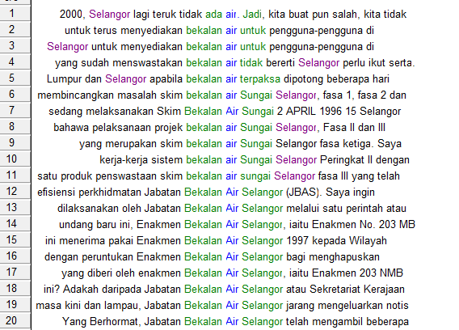

Tuan Yang di-Pertua, untuk makluman Ahli- ahli Yang Berhormat, sebelum pembentukan Wilayah Persekutuan Kuala Lumpur, keseluruhan pembekalan air di negeri Selangor dieselenggarakan oleh Jabatan Bekalan Air Selangor di bawah kuasa yang diberi oleh enakmen Bekalan Air Selangor, iaitu Enakmen 203 NMB Bab. 203.
Your Excellency and members of the House of Representative, before the formation of Federal Territory of Kuala Lumpur, the entire water supply in Selangor was supervised by the Selangor Water Supply Department.
The issue of water supply was frequently mentioned as evidenced in the above concordances from the phrase ‘bekalan air’ or water supply in relation to the Department of Water Supply, the Enactment of Water Supply, the system and projects on water supply.
In addition, problems relating to air/water were also frequently brought up during the parliamentary debates as signaled by phrases such ‘kegawatan air/water crisis’, ‘kekurangan air/ shortage of water’ and ‘masalah air/ water problem’. Members of Parliament were also informed of the steps taken by the goventment to overcome the problem as in the phrase ‘kempen menjimatkan air/ campaign to save water’ in the concordances below:
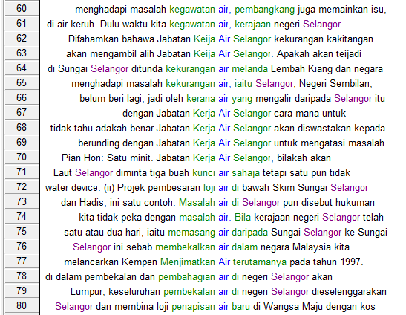

“Dulu waktu kita kegawatan air, kerajaan negeri Selangor menghadapi masalah kegawatan air, pembangkang juga memainkan isu, macam-macam isu dia main, seolah-olah perancangan kita tidak baik dan kerajaan kita tidak peka dengan masalah air”.
“previously when we were facing critical water crisis, the Selangor state government was facing critical water crisis, the opposition played up the issue, various issues, as if our plans are not good and the government is not aware or sensitive of the water problem.

- air/water in Parliament 8
In P8 the topic of air/water was not brought up as often as in P7. However, similar themes appear i.e. shortage of water and suggestions and efforts taken to solve the water crisis. Problems caused by shortage of water was not mentioned as much compared to suggestions and efforts taken to solve the crisis.
The focus is clearly on efforts taken to solve the problem as evident from the concordances of water such as ‘penjimatan air /saving water’, ‘kawasan tadahan air/water catchment area’, ‘bekalan air/water supply’ and ‘penyaluran air/chanelling water’.
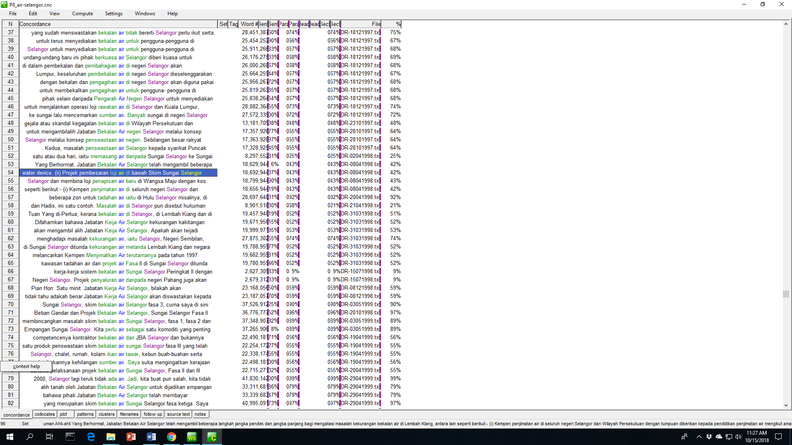

Untuk makluman Ahli Yang Berhormat, beberapa projek baru juga akan dilaksanakan di negeri Selangor seperti pembinaan dua buah empangan dan empat buah loji penapis air. Kementerian mencadangkan supaya projek-projek ini dibiayai melalui pinjaman Kerajaan Pusat kepada Kerajaan Negeri Selangor. Projek penyaluran air daripada negeri Pahang juga akan dilaksanakan secara penswastaan.
For your information Ahli Yang Berhormat, a few new projects will be carried out in Selangor, for example, constructing two dams and four water refinery centers…..Project on chanelling water from the state of Pahang will also be carried out and will be privatised.

- ‘air’/water in Parliament 11
In P11, the same issues on ‘air’/water were brought up during the debates, that of ‘bekalan air/water supply’ and ‘masalah air/ water problems’. The debates on water supply touched upon various issues such as ‘penstrukturan semula bekalan air/re-structuring the water supply’, ‘perkhidmatan bekalan air/the services of water supply’, ‘peningkatan permintaan bekalan air/the increase in demand of water supply’ and ‘melibatkan catuan bekalan air/involved rationing of water supply’. It seems that the debates center on overcoming the problems related to water supply.

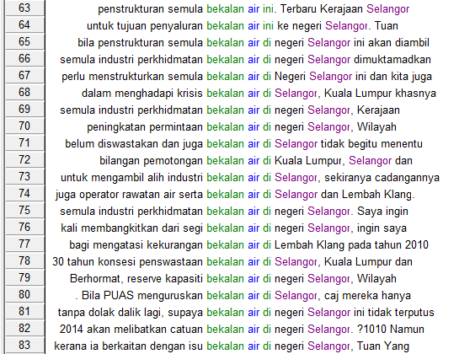

Cadangan membina empangan untuk projek perpindahan air mentah dari Pahang ke Selangor bagi mengatasi kekurangan bekalan air di Lembah Klang pada tahun 2010 dan sebagainya menjadi bahan bualan dan perhatian segenap lapisan masyarakat.
The proposal to build a dam for the project on transferring raw water from Pahang to Selangor to overcome the shortage of water supply in the Klang Valley in the year 2010 has been the talk of everyone from all walks of life.
In P11, the debates also center on water crisis as evident in concordances examples below. The main issues seem to be on shortage of water and the question of ownership of Konsortium Air Selangor. This can be seen from phrases such as ‘masalah kekurangan air/ the problem of water shortage’, ‘menghadapi krisis kekurangan air/are facing water shortage crisis’, ‘pemilik konsesi air Selangor/owner of water conssession in Selangor’ or ‘milik siapa Konsortium Air Selangor/ who owns the Selangor Water Consortium’. The Members of Parliament are being told of steps taken to mitigate the water crisis problem but questions or issues are still brought in the debates such as the continuing water crisis and ownership of Selangor Water Consortium.
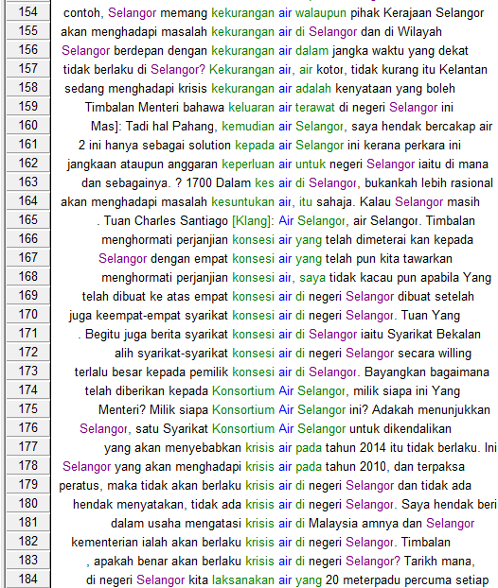

Ini bermakna Kerajaan Pusat sendiri tidak ada satu kajian yang menyeluruh, apakah benar akan berlaku krisis air di negeri Selangor? Tarikh mana, bila? Kalau benar berlaku tahun 2014, maknanya pembinaan Langat 2 ini tidak akan memenuhi dan menyelesaikan masalah krisis air kalau benar berlaku tahun 2014.
This means the Federal Government does not have a comprehensive study, is there really a water crisis in Selangor. Where is the date? When? If it will happen in 2014, it means the construction of Langat 2 will not alleviate and solve the problem on water crisis if it were to happen in 2014.

- ‘air’/water in Parliament 12
In P12 the debates are on steps to be taken to solve the water issue. Several steps are mentioned but mainly the focus seems to be on restructuring the water supply and services in Selangor. Phrases such as ‘penstrukturan air di Selangor/structuring the water supply in Selangor’, ‘infrastuktur air di Selangor/the infrastructure of water supply in Selangor’, penstrukturan pengurusan air di negeri Selangor/structuring the water management in Selangor’ or ‘industri perkhidmatan air Negeri Selangor/the water service industry in the state of Selangor’ point to the steps undertaken by the state of Selangor..
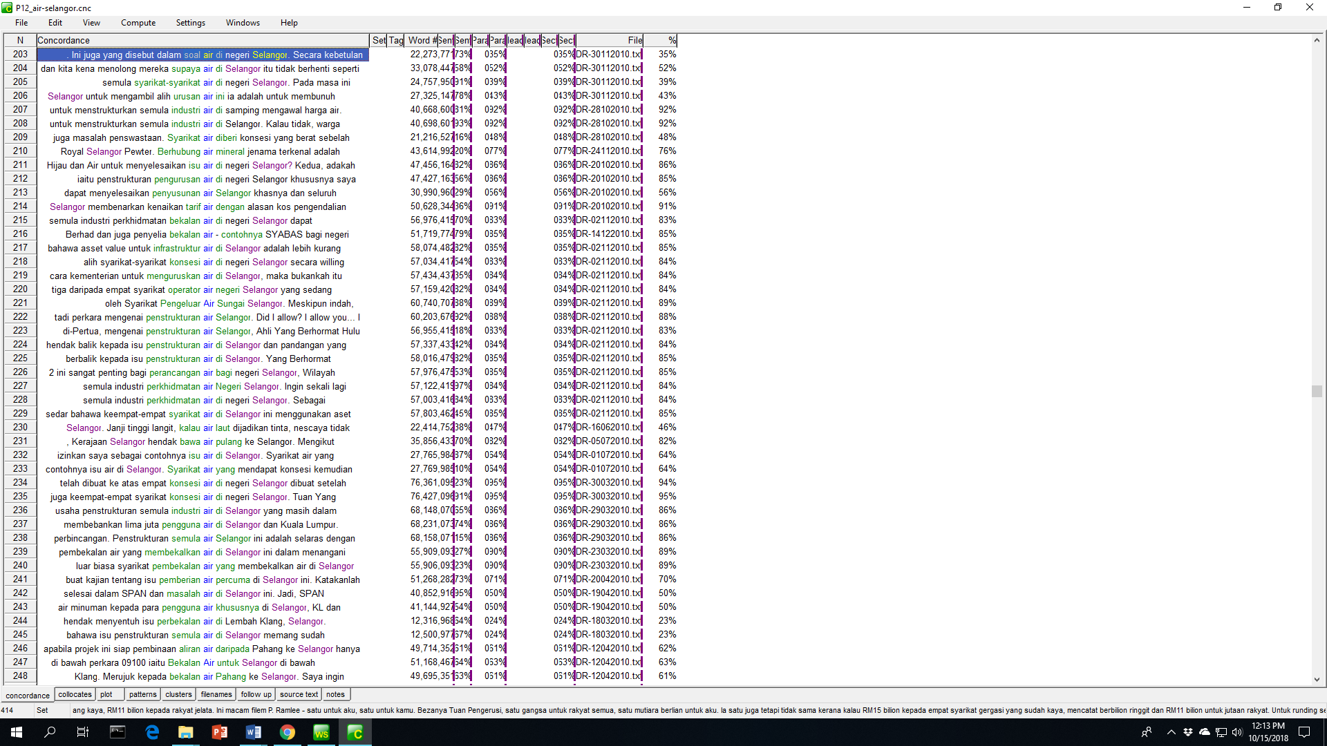

Kedua, pada masa kini pengurusan air di Selangor adalah di bawah SYABAS dan semua perbelanjaan SYABAS terkandung dan dikawal oleh concession agreement (perjanjian konsesi), khususnya semua peruntukkan ini mesti diluluskan oleh Suruhanjaya Perkhidmatan Air Negara

Second, currently the water management in Selangor is within the purview of SYABAS and all expenditure of SYABAS is included and controlled by the concession agreement, specifically all these provisions must be approved by the National Water Service Commision.

Conclusion

This study initially planned to examine the states in Malaysia that are frequently mentioned or debated upon during the parliamentary debates. However, it is felt that it is better to just focus on one state and our search has brought us to ‘Selangor’. Through statistical analysis we have been able to determine the issue closely related to Selangor, which is ‘air’/water. The issue of ‘air’/water haus been shown to have a long history that started to be on of the main issues debated in P7 to P13. In reality, Selangor did experience a major water crisis in 1998 (P9) and steps and efforts have been taken to avoid another major water crisis as has been shown from the parliamentary debates.
However, the debates on the water crisis have also shown that the debates prolong the conflict (between government and opposition) by engaging in debates that could stir controversy and indirectly gain publicity for those who raised it. (Baron, Byrne & Branscome, 2006). This can be observed when issue was raised on the ownership of the Selangor Water Consortium.
Finally, this study has able to show the trend of a topic by observing how it is discussed through the years. In addition, the issues that surround a particular topic have also been observed through this corpus-driven approach.

*This study was supported by Universiti Kebangsaan Malaysia research grant KRA-2018-005.
REFERENCES
Amberg, J. S., & Vause, D. J. 2010. American English: History, Structure, and Usage. Cambridge: Cambridge University Press. Retrieved March 13, 2017, from http://assets.cambridge.org/97805218/52579/excerpt/9780521852579_excerpt.pdf

Awang Sariyan. 2002. Ceritera tentang KejayaanPerancangan Bahasa Melayu di Malaysia.
http://pts.com.my/berita/perancangan-bahasa-melayu-di-malaysia/

Brown, P., & Levinson, S. C. (1987). Politeness: Some Universals in Language Usage. Cambridge University Press. Retrieved October 13, 2018, from https://pure.mpg.de/rest/items/item_64421/component/file_2225570/content.
Baron, R. A., Byrne, D. R., & Branscombe, N. R. 2006. Mastering Social Psychology (1st ed.). Pearson.
David, M. K., Govindasamy, S., & Nambiar, M. (2009). Levels of Politeness in Malaysian Parliamentary Discourse. Language in India, 9(9). Retrieved October 13, 2018, from http://www.languageinindia.com/sep2009/politenessmalaysiaparliament.pdf
Ilie, C. 2015. Parliamentary Discourse. In The International Encyclopedia of Language and Social Interaction (1st ed.). John Wiley & Sons. doi:10.1002/9781118611463/wbielsi201
Imran Ho Abdullah, Anis Nadiah Che Abdul Rahman & Azhar Jaludin. (2018). Malaysia Hansard Corpus: The Parliamentary Documents in Malay/ Malaysian Setting. Unpublished
Members of Parliament free to raise any issue in Dewan Rakyat - Dr M. 2018, July 17. New Straits Times. Retrieved October 13, 2018, from https://www.nst.com.my/news/nation/2018/07/391652/members-parliament-free-raise-any-issue-dewan-rakyat-dr-m
Muhamad Fuzi Omar. 2008. Parliamentary Behaviour of the Members ofOpposition Political Parties in Malaysia. Intellectual Discourse, 16(1), 21-48. Retrieved October 13, 2018, from http://journals.iium.edu.my/intdiscourse/index.php/islam/article/view/29/24
Ngeow, Y. M., Kuang, C. H., & David, M. K. 2011. Discourse, Politeness and Ethnic Sensitivities in Malaysian Parliament. International Research Journal, 1(2), 1-24. Retrieved October 13, 2018, from http://citeseerx.ist.psu.edu/viewdoc/download?doi=10.1.1.303.4225&rep=rep1&type=pdf
Ngeow, Y. M., Kuang, C. H., & David, M. K. n.d. Politeness and Ethnic Sensitivities In The Malaysian Parliament. Retrieved October 13, 2018, from http://repository.um.edu.my/19074/1/REVISED%2B04052009%2BPOLITENESS%20AND%20ETHNIC%20SENSITIVITIES%20%2BMALAYSIAN%20PARLIAMENT.pdf
Ong, M. 1976. The Member of Parliament and His Constituency: The Malaysian Case. Legislative Studies Quarterly, 1(3). doi:10.2307/439505
Primary role of Members of Parliament - Ng Seng Yi. 2017, July 24. Malay Mail. Retrieved October 13, 2018, from https://www.malaymail.com/s/1427967/primary-role-of-members-of-parliament-ng-seng-yi
Supardi. 2016. Language Power in Courtroom: The Use of Persuasive Features in Opening Statement. Indonesian Journal of Applied Linguistics, 6(1). doi:dx.doi.org/10.17509/ijal.v6i1.2663
Thornborrow, J. 2012. Language and the media. In Language, Society and Power: An Introduction (pp. 55-74). Routledge.
Xiao, R. and McEnery, T. (2006). Collocation, Semantic Prosody, and Near Synonymy: A Cross-Linguistic Perspective. Applied Linguistics, Volume 27, Issue 1, 1 March 2006, Pages 103–129
Salazar, D. (2014). Lexical Bundles in Native and Non-Native Scientific Writing. Amsterdam: John Benjamins
The Official Portal of Parliament Malaysia. Hansard. 2018. Retrieved from http://www.parlimen.gov.my/hansard-dewan-rakyat.html?uweb=dr

Appendix 1
Top 10 and 11 Collocate List for “Selangor” in MHC

No | Word | Relation | ƒ | No | Word | Relation | ƒ
 | P1 |  |  |  | P4
1 | SELANGOR | 12.62954521 | 996 | 1 | NEGERI | 6.009408951 | 481
2 | PERAK | 8.827691078 | 87 | 2 | WING | 10.84006596 | 167
3 | COMMERCE | 8.784480095 | 73 | 3 | SUM | 10.02421474 | 165
4 | STATE | 6.346147537 | 58 | 4 | CHEN | 9.20233345 | 165
5 | LABOUR | 7.171729565 | 44 | 5 | MICHAEL | 10.76914406 | 164
6 | SEMBILAN | 9.354406357 | 37 | 6 | RAJA | 7.314871311 | 133
7 | PAHANG | 8.403063774 | 32 | 7 | ISHAK | 8.568361282 | 131
8 | TRENGGANU | 6.694219112 | 29 | 8 | NASRON | 8.872180939 | 97
9 | JOHORE | 7.566857338 | 28 | 9 | PERAK | 7.625770569 | 96
10 | SULTAN | 8.256325722 | 26 | 10 | WILAYAH | 6.68702507 | 67
 |  |  |  | 11 | AIR | 3 | 6
 | P2 |  |  |  | P5
1 | STATE | 6.686161995 | 153 | 1 | NEGERI | 6.194514751 | 443
2 | PERAK | 8.321522713 | 148 | 2 | PERSEKUTUAN | 6.991550446 | 124
3 | SEMBILAN | 9.549764633 | 95 | 3 | WILAYAH | 6.927373886 | 114
4 | AFFAIRS | 7.499453068 | 93 | 4 | UMNO | 8.559337616 | 72
5 | PAHANG | 8.3122015 | 62 | 5 | PERAK | 7.542766571 | 63
6 | NEGRI | 8.785064697 | 51 | 6 | SEMBILAN | 8.576512337 | 36
7 | LABOUR | 6.12132597 | 40 | 7 | PINANG | 6.566469193 | 36
8 | KEDAH | 6.987283707 | 39 | 8 | JOHOR | 6.2122159 | 35
9 | MELAKA | 6.463280678 | 38 | 9 | BARAT | 7.597874641 | 33
10 | TRENGGANU | 6.207083225 | 36 | 10 | LAUT | 6.418653011 | 29
 |  |  |  | 11 | AIR | 3.5966 | 12
 | P3 |  |  |  | P6
1 | WING | 10.68507195 | 89 | 1 | NEGERI | 6.029141903 | 285
2 | SUM | 9.404016495 | 89 | 2 | WILAYAH | 6.817350388 | 78
3 | MICHAEL | 10.66073322 | 88 | 3 | PERAK | 8.337896347 | 73
4 | CHEN | 8.033283234 | 86 | 4 | PERSEKUTUAN | 6.423883438 | 73
5 | RAJA | 6.802962303 | 84 | 5 | SAI | 9.716993332 | 52
6 | ISHAK | 8.073349953 | 75 | 6 | KIM | 9.310194969 | 52
7 | STATE | 6.45844841 | 75 | 7 | LEE | 7.38002634 | 52
8 | CHIK | 7.553602695 | 72 | 8 | JOHOR | 7.707167625 | 43
9 | PERAK | 6.523229122 | 53 | 9 | PULAU | 6.037938595 | 37
10 | SEMBILAN | 7.93559742 | 40 | 10 | PAHANG | 8.67684269 | 36
 |  |  |  | 11 | AIR | 4.37 | 8

Cont.
No | Word | Relation | ƒ | No | Word | Relation | ƒ
 | P7 |  |  |  | P10
1 | SELANGOR | 12.3943224 | 1794 | 1 | NEGERI | 7.270579815 | 187
2 | NEGERI | 6.173442841 | 394 | 2 | SUKAN | 7.790607929 | 257
3 | PERAK | 9.097774506 | 98 | 3 | BELIA | 7.799220085 | 255
4 | DARUL | 10.60398579 | 92 | 4 | AIR | 6.928060532 | 36
5 | EHSAN | 12.30126095 | 84 | 5 | PERSEKUTUAN | 7.430027962 | 91
6 | WILAYAH | 6.886706352 | 74 | 6 | WILAYAH | 8.556547165 | 93
7 | PERSEKUTUAN | 6.376464844 | 74 | 7 | PERAK | 9.345826149 | 81
8 | PULAU | 6.591117859 | 68 | 8 | LUMPUR | 6.76533556 | 56
9 | SUBRAMANIAM | 8.061209679 | 63 | 9 | JOHOR | 7.15233326 | 59
10 | PINANG | 7.310675621 | 55 | 10 | SUNGAI | 6.495744705 | 46
11 | AIR | 5.450642586 | 9
 | P8 |  |  |  | P11
1 | NEGERI | 20.97286797 | 675 | 1 | NEGERI | 7.017210484 | 212
2 | DAN | 18.05793953 | 537 | 2 | TARIHEP | 11.90260887 | 321
3 | YANG | 20.12871361 | 376 | 3 | DAUD | 11.84880543 | 321
4 | PALANIVEL | 11.78103352 | 363 | 4 | HULU | 9.220503807 | 320
5 | PERAK | 18.40701485 | 171 | 5 | AIR | 6.392780781 | 59
6 | WILAYAH | 8.206079483 | 137 | 6 | SUNGAI | 6.705155373 | 61
7 | PERSEKUTUAN | 6.936355591 | 133 | 7 | LUMPUR | 7.3737607 | 93
8 | PULAU | 18.60754776 | 131 | 8 | PAHANG | 9.129398346 | 67
9 | BESAR | 14.27156162 | 120 | 9 | PERSEKUTUAN | 6.488616467 | 77
10 | JOHOR | 15.75632763 | 118 | 10 | JOHOR | 7.094004631 | 85
11 | AIR | 13.89605236 | 12
 | P9 |  |  |  | P12
1 | NEGERI | 7.173819542 | 765 | 1 | AHMAD | 8.911207199 | 363
2 | ADNAN | 12.36036396 | 175 | 2 | DZULKEFLY | 10.82863045 | 363
3 | JAMALUDDIN | 8.540949821 | 174 | 3 | NEGERI | 6.520933151 | 276
4 | ABDOL | 10.65914059 | 164 | 4 | PANCHANATHAN | 10.82731819 | 191
5 | MULOK | 10.64920807 | 164 | 5 | PINANG | 7.293728828 | 128
6 | PERSEKUTUAN | 7.434614182 | 119 | 6 | MIC | 7.677032948 | 188
7 | WILAYAH | 8.614062309 | 114 | 7 | KEDAH | 6.179595947 | 110
8 | PERAK | 9.564443588 | 100 | 8 | SIKIT | 6.282687187 | 72
9 | AIR | 6.619233131 | 97 | 9 | PAKATAN | 6.078561783 | 89
10 | SUNGAI | 6.898245811 | 86 | 10 | PERAK | 6.421103954 | 84
 |  |  |  | 11 | AIR | 5.987871647 | 73

Cont.
No | Word | Relation | ƒ
 | P13
1 | IRMOHIZAM | 10.9547348 | 724
2 | SEKINCHAN | 9.797624588 | 14
3 | MAKAM | 9.337225914 | 11
4 | PKNS | 9.167301178 | 11
5 | IJOK | 9.070439339 | 16
6 | IBRAHIM | 8.979006767 | 738
7 | SPLASH | 8.703296661 | 28
8 | KUALA | 8.523644447 | 3032
9 | PENYALURAN | 8.242791176 | 17
10 | EXCO | 7.870017529 | 37
11 | AIR | 6.902613163 | 74

