A Malaysian politician’s communication strategies during the COVID-19 Pandemic

ABSTRACT

The world in general was not prepared for the coronavirus disease 2019 (COVID-19) pandemic in December 2019. Global lockdowns were inevitable and individual country preparedness was questionable as the pandemic continued to spread fast causing massive deaths. Government officials were forced to impose drastic measures in order to curb the spread. The Ministry of Health relied on political leaders and government agencies to help disseminate as much health information and the government policies efficiently and effectively. As these representatives or leaders belong to different ethnicities, they are more likely to understand the life circumstances, needs, strengths, and capabilities of multicultural and vulnerable communities, and would be the best people to convey government policies and pandemic-related information. Thus, effective communication and leadership are central to the management of pandemics and to give the public assurance in order to alleviate their fears and anxiety in having to adapt to the rapidly changing societal and economic landscape. For effective crisis communication, timely translation of core communications into various languages to address language barriers are necessary. The focus of the current study is the Tamil community and how a Malaysian Indian politician, Saravanan responds, engages, and communicates with his followers. Seventeen Facebook posts in Tamil on Saravanan’s page were extracted and analysed qualitatively. The communication strategies recommended by Hyland-Wood et al. (2021) for the development and delivery of public health crisis communication were used in the analysis of the posts. The strategies utilized by Saravanan showed his resolve and effectiveness in managing crisis.

Keywords: communication strategies, Facebook posts, pandemic, political leader, Tamil

INTRODUCTION
The World Health Organization (WHO) has announced the cause for the unknown pneumonia cases found in Wuhan City, China since December 2019 (Unuabonah, & Oyebode, 2021) and named it as coronavirus disease 2019 (COVID-19) on 12 January 2020. Two months later, the COVID-19’s rapid spread to many countries compelled WHO to classify this disease as a pandemic. The world in general was not well-prepared for the pandemic, and individual country preparedness was questionable. This classification urged many countries to declare Movement Control Order (MCO) as a preventive measure. Malaysia’s first case of COVID-19 was detected on 25 January 2020, and the carriers were 3 Chinese nationals who came from Singapore, who had close contact with an infected person (Elengoe, 2020). The first MCO during the pandemic was declared in Malaysia on 18 March 2020, which resulted in a total lockdown where people were required to self-quarantine and isolate themselves.
Due to the restricted movement and uncertainty of the future, people relied on the media for information and announcements by the government regarding COVID-19. Social media is an effective platform which provides and disseminates information, and the public could access it easily and quickly (Islam et al., 2021). Thus, social media platforms are the preferred media for many, compared to conventional media such as radio and television. Convenience in accessing and the availability of various information relating to COVID-19, has increased the use of social media globally. There are many advantages of using social media such as Facebook, WhatsApp, Messenger, and Instagram, as news and information gets circulated instantly and reaches a wide range of recipients across the globe. However, there is the danger of predatory sources circulating fake news and messages that are made viral just as fast (Igwebuike & Chimuanya, 2020). In the current crisis situation, such misinformation can only increase anxiety, fear, and depression among the recipients. More importantly it curtails the government’s efforts to diagnose, mitigate, and treat those who are tested positive for Covid-19 and the public. As such, the government, health authorities and Civil society have taken to social media to disseminate accurate information, and updates on the crisis (Prieto-Ramos, Pei, & Cheng, 2020). This initiative has gained the trust of the public and garnered a strong following, as the public believed in the credibility of information from a reliable source, i.e. the government.
Government agencies including the Ministry of Health (MOH) and National Security Council (Majlis Keselamatan Negara) used social media to disseminate important information regarding COVID-19 and continue to update the facts, and the number of casualties on a daily basis. Malaysia successfully reduced the spread of COVID-19 in the first phase of MCO between 18 March 2020 and 1 April 2020. The Health director-general, Tan Sri Dr Noor Hisham Abdullah, said that the implementation of the first phase of the MCO was an initial attempt at controlling and flattening the curve of COVID-19 (Rafidah Mat Ruzki & Noor Atiqah Sulaiman, 2020). It was thus, important to ensure the speed and level of governmental intervention, and how the target communities responded to the information provided by government (Hyland-Wood et al., 2021).
Various communication mediums are utilized to inform the public on the disease risks, policy updates, and emergency hotlines. For example, Malaysians were able to receive information and updates on COVID-19 through the Official Portal of the Ministry of Health Malaysia (or in Malay, KKM), the special Facebook pages called the Crisis Preparedness and Response Center (CPRC), and via the Telegram channel of CPRC, KKM (Mat Dawi et al., 2021). As face-to-face interactions were limited during the lockdowns, Facebook emerged as one of the most influential online modes of communication to connect with diverse groups of people (Harris, 2020). Facebook posts were used to positively influence Malaysians to fight the crisis (Azizan et al., 2020), and Government officials also leveraged on social media to interact with and inform the public on the risks of the pandemic and the precautionary measures the public should take. As government officials are more likely to understand the life circumstances, needs, strengths, and capabilities of multicultural and vulnerable communities (Everett et al., 2020), this study highlights the role of government officials in strategically influencing the public through crisis communication. Effective communication and leadership are central to the management of pandemics and the rapidly changing societal and economic landscape (Hyland-Wood et al., 2021). In a multicultural society, the conveyance of government policies and pandemic-related information to all ethnic communities is essential.

Subsequently, for effective crisis communication in multiracial environments, Stayner (2020) recommends timely translation of core communications into various languages to address language barriers. The focus of the current study is on a minority community, the Tamil community where Tamil language is predominantly used. Therefore, the scope of this study is the use of Tamil language by a Malaysian Indian politician, Datuk M Saravanan, a Member of Parliament for the Tapah constituency, and the present Minister of Human Resource. Since the changeover of the ruling government on March 2020, Saravanan serves as the only Indian representative in the ruling political party. Prior to the ministerial position, he was also the elected Vice-President of the Malaysian Indian Congress, a long-standing political party for the Indian minority. As the sole Indian politician in the Malaysian cabinet, it is the expectation of the government and the community that he takes on the role as a spokesperson and representative of the Indian community. Thus, the aim of the study is to investigate how Saravanan engaged with the Indian community through his Facebook posts, using Tamil language as a medium to spread awareness among the Indian community especially during the pandemic. It became crucial to reach out to the public and this crisis communication is expected to enhance public trust through civic engagement and transparent communication. However, the risk of losing one’s credibility is equally possible. Therefore, the following questions are addressed:
(i) which communication strategies were realized in the Facebook posts of Saravanan during the pandemic?
ii) how did Saravanan engage and disseminate information to the Indian community?
Both questions are essential to gauge how a leader performs not only in terms of the expectation to communicate information to the public, but also the ways in which he engages with and responds to the needs of the public.

METHODOLOGY
This study examines the communication strategies found in Facebook posts by Saravanan during the first Covid-19 lockdown period. A multi-level sampling procedure was employed for data collection. The Facebook search feature was used to find the official page of Saravanan. Initially, the search was done by typing ‘YB Saravanan’, the result showed two pages and one public group with his profile picture. All these Facebook accounts revealed very few followers. The Facebook account named ‘Datuk M. Saravanan’ had 1000 followers, and the public group named ‘YB Datuk Seri M Saravanan’ had 3000 followers, while the page ‘The Saravanan Frontline’ had 5,400 followers. It was the search for ‘Datuk Seri M Saravanan’ that revealed 59,619 followers (as of 7 May 2021). The description on the timeline of this page showed Datuk Seri M Saravanan, Menteri Sumber Manusia, Ahli Parlimen Tapah, Perak, merangkap Timbalan Presiden MIC Kebangsaan (Minister of Human Resource, Member of Parliament for Tapah, Perak-cum-Deputy President of the Malaysian Indian Congress). The page entitled ‘Datuk Seri M Saravanan’ was chosen as the research source as it has a huge following and serves as the official page for policy and public health message conveyance.
All posts available on Saravanan’s page were checked from 2018. It was found that between 5 November 2018 until 25 March 2020, there were no posts uploaded on the page. It was only after his appointment as the Minister of Human Resources from 25 March 2020, Saravanan started posting on his Facebook. Hashtags in social media posts help in curating, tagging, and searching contents (Zappavigna, 2018). However, as hashtags were rare, and the Tamil posts were all picture quotes, the posts were identified manually. Seventeen picture quotes in Tamil posted on Saravanan’s FB page were extracted and analysed qualitatively based on Hyland-Wood et al.’s (2021) Recommendations for Effective Communication Strategies. As the Facebook pages and groups are accessible to the public, no informed consent was required for this research (Franz et al., 2019). For data analysis, the posts were labelled as Post 1 (P1) to Post 17 (P17), while Hyland’s recommended strategies were labelled as Strategy 1 (S1) to Strategy 10 (S10).

DATA ANALYSIS AND FINDINGS
This study employs the communication strategy recommended by Hyland-Wood et al. (2021) for the development and delivery of public health crisis communication. Effective communication is interactive and requires ongoing engagement with communities. It also involves the conveyance of messages about the pandemic, nature of risks, and the government arrangements for the management of the pandemic. On the other hand, communities also can become actively involved in eliciting information from trustworthy sources, and in sharing and enhancing relevant messages in turn to others.
To gain public trust, leaders are expected to provide transparent information on the pandemic, control of the disease, and recovery. The 10 recommendations for effective communication and conveyance of public health crisis communications reflect the importance of transparency and civic engagement in establishing trust as shown in Table 1.

Table 1: Communication Strategies
Label | Communication strategy | Description
S1 | Engage in clear communication | Provide specific information on what to do and what to avoid; cognitive processing effort can be minimised if clear instructions are given. Inconsistent messages should be avoided. Keeping regular communication to enhance trust
S2 | Strive for maximum credibility | Leveraging trusted, authoritative intermediaries such as medical and public-health experts to communicate key messages via government health websites.
S3 | Communicate with empathy | Listen to the community’s needs and concerns and express genuine empathy and concern.  Should not fear expressing empathy or showing emotion; should praise frontlines and encourage positive behaviours
S4 | Communicate with openness, frankness, and honesty | Explaining the rationale behind decisions made, thus providing the public with access to accurate information, both positive and negative, helping people to build proper expectations. Even incomplete information must be communicated early.
S5 | Recognise that uncertainty is inevitable | Provide certainty where possible, help people prepare for the immediate and longer-term future both pragmatically and mentally, update as new evidence emerges, acknowledge uncertainties.
S6 | Account for levels of health literacy and numeracy | Leaders must consider variations in health literacy and numeracy across audiences.  Community then applies the information within their daily lives to make more informed decisions, capacity to understand risks.
S7 | Empower people to act | Communication needs to be accompanied by appropriate measures to facilitate behaviour change and action. Consider barriers. Message framing by giving assurance. Frames should promote agency and appeal to citizens’ capacity to act versus citizens as passive recipients of instructions. Harnessing power of togetherness / empower people.
S8 | Appeal to social norms | In-group sentiments, fostering solidarity and aligning messages with the social norm to take responsibility and avoid becoming a disease vector.  Creating a sense of responsibility towards others by appealing to shared norms without alienating those who may not identify with such norms. The need for meaningful engagement with communities to develop targeted ‘social norming’ strategies. Engage with diverse communities to balance public health messaging.
S9 | Consider diverse community needs | Information is made on a timely manner and accessible in various ways and applying risk management. Translated versions are made available. Prevention strategies must be sensitive to spiritual, religious practices, and cultural norms.
S10 | Be proactive in combating misinformation | Transparently providing factual and current information prevents subsequent susceptibility to emerging misinformation and conspiracy theories.  Reminding people to think carefully about the accuracy of online information and consider the credibility of the source before sharing information on social media
(Source: Hyland-Wood et al., 2021).

COMMUNICATION STRATEGIES IN THE FACEBOOK POSTS

Saravanan has used eight out of ten communication strategies outlined by Hyland-Wood et al. (2021). When analysing the posts, it was found that the strategies recommended by Hyland-Wood et al., overlapped in terms of the stipulated descriptions. In multicultural Malaysia, social and cultural norms exist in tandem, and as such the Appeal to social norms (S8) and Considering diverse community needs (S9) i.e., being sensitive to the spiritual, religious, and cultural norms were found in the same post. Likewise, Communicate with openness, frankness, and honesty (S4), and Recognise that uncertainty is inevitable (S5) occurred together. This explains the number of co-occurrences of the strategies within a single post, as shown in Table 2.

Table 2: Communication Strategy found in Saravanan’s FB Posts
Communication  Strategy  FB Post | S1 | S2 | S3 | S4 | S5 | S6 | S7 | S8 | S9 | S10 | Total
P1 |  |  |  |  |  |  |  |  |  |  | 4
P2 |  |  |  |  |  |  |  |  |  |  | 4
P3 |  |  |  |  |  |  |  |  |  |  | 4
P4 |  |  |  |  |  |  |  |  |  |  | 5
P5 |  |  |  |  |  |  |  |  |  |  | 7
P6 |  |  |  |  |  |  |  |  |  |  | 5
P7 |  |  |  |  |  |  |  |  |  |  | 5
P8 |  |  |  |  |  |  |  |  |  |  | 2
P9 |  |  |  |  |  |  |  |  |  |  | 3
P10 |  |  |  |  |  |  |  |  |  |  | 3
P11 |  |  |  |  |  |  |  |  |  |  | 4
P12 |  |  |  |  |  |  |  |  |  |  | 6
P13 |  |  |  |  |  |  |  |  |  |  | 6
P14 |  |  |  |  |  |  |  |  |  |  | 3
P15 |  |  |  |  |  |  |  |  |  |  | 6
P16 |  |  |  |  |  |  |  |  |  |  | 5
P17 |  |  |  |  |  |  |  |  |  |  | 2
TOTAL | 12 | 0 | 9 | 12 | 5 | 10 | 10 | 12 | 4 | 0

Based on the analysis, it was found that there are three recommended communication strategies that were most frequently used, which are (i) Engage in clear communication, (ii) Communicate with openness, frankness, and honesty, and (iii) Appeal to social norms. These strategies were found in 12 out of 17 posts. The second most used strategies were Account for levels of health literacy and numeracy, and Empower people to act, which were evident in 10 posts. The other strategies that follow these main strategies are Communicate with empathy (9) and Recognise that uncertainty is inevitable (5). The least preferred strategy is to Consider diverse community needs (4). Two strategies were not found in Saravanan’s FB posts, namely Strive for maximum credibility (S2), and Be proactive in combating misinformation (S10). It is clear that based on the messages and policies of the Ministry of Health and the Government, Saravanan has creatively constructed messages in Tamil for his followers. For each strategy, excerpts from the original posts are drawn and explicated.

ENGAGE IN CLEAR COMMUNICATION
During a pandemic, it is important to dispense accurate information to overcome anxiety (Sultan & Rapi, 2020) and educate the public on what to do and what to avoid. Clear communication aims to inform the public on the purpose of a specific action that has been taken or needs to be taken, in a timely manner. All 12 posts categorized under this strategy were delivered as per the Ministry of Health’s information or guidelines. The posts are simple, clear and precise. Three posts identified under this strategy clearly instructs the public on what to do to reduce the disease transmission as shown below.
PI : உங்களின் குடும்பத்தினரின் பாதுகாப்பை உறுதிசெய்ய வீட்டிலேயே இருங்கள் (uṅkaḷiṉ kudumpattiṉariṉ pātukāppai uṟuticeyya vīṭṭilēyē iruṅkaḷ) - stay home for your family’s safety
P11 : வாசல் கடக்காதே (vācal kadakkātē) - do not step out of the entrance
P12 : உள்ளே அடங்கும் காலம் (uḷḷē adaṅkum kalam) - time to stay home
P4 : கைகுலுக்கல் நிறுத்துங்கள் (kai kulukkal niṟuttuṅkaḷ) - stop handshakes

The first three posts (P1, P11 and P12) revolve around the stay-at-home or movement control order. However, they all differ in terms of the function that each linguistic expression plays. P1 appeals to the public to stay home to be safe, while P11 is a directive to refrain from leaving one’s home. P12 acts as an observation that it is stay-at-home period. In the fourth post, P4, the public are advised to change some social practices, particularly handshakes கைகுலுக்கல் நிறுத்துங்கள் (kai kulukkal niṟuttuṅkaḷ - stop handshakes) to prevent disease transmission. The implied meaning here is obviously related to the handshake, indicating the high risk of the virus being transmitted via human contact. It is thus the intention of the post to warn the reader and the public to always observe personal hygiene.

COMMUNICATE WITH OPENNESS, FRANKNESS, AND HONESTY
The public is more likely to obey decisions that are openly communicated, which involves rational explanations on why particular actions must be followed and the consequences, if otherwise. By conveying both negative and positive information accurately, leaders can help the public to build reasonable expectations and avoid overpromising (Petersen, 2020).
Twelve posts from Saravanan’s FB account were classified under this category, as his posts communicated the reality to the public without ‘sugar-coating’ the information. The unprecedented lockdown caused chaos among the public, and Saravanan took the initiative to explain the reasons, transmission risks, the benefits of lockdown, as well as the lack of health solutions for the disease. All the posts had only one message, a plea to the public to stay-at-home. His first post (P1), on 31 March 2020, 13 days after the MCO order was aimed at warning the public that the disease can spread to anyone regardless of their social status, thus implying the importance of staying home. In P2, which was also the beginning of the second phase of MCO, he directed the people to stay home, as this reduces the risk of spreading the disease exponentially.
As much as communicating the reality during a crisis, it is equally important not to scare the public (Sandman & Lanard, 2020). Likewise, in P5, Saravanan attempts to explain the seriousness of the transmission risks while advising the public to cooperate to contain the disease by staying home.
P5 | 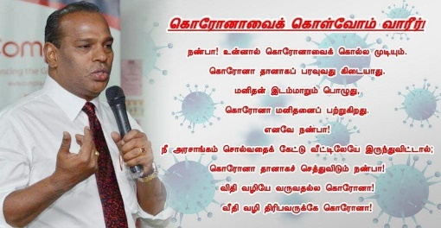  10 April 2020 | Transliteration: | korōṉāvai koḷvōm vārīr!  naṇbā! uṉṉāl korōṉāvaik kolla mudiyum.  korōṉā tāṉākap paravuvatu kidaiyātu.  maṉitaṉ idam māṟumpoḻutu,  korōṉā maṉitaṉaip paṟṟukiṟatu.  eṉavē naṇbā!  nī aracāṅkam colvataik kēṭṭu vīṭṭilēyē iruntu viṭṭāl;  korōṉā tāṉākac cettuviṭum naṇbā!  viti vaḻiyē varuvatalla korōṉā!  vīti vaḻiyē tiribavarukkē korōṉā!
P5 |  | Translation: | Let's contain the corona!  Friend! You can kill the corona.  Corona does not spread by itself. When man moves around,  the Corona strikes him.  So friend!  If you listen to the government and stay at home,  Corona dies naturally friend!  Corona does not come by fate! Corona is for those who wander in the streets!
Again, it is a plea to contain the disease by limiting the number of contacts between persons in order to mitigate the transmission of the COVID-19 in the community, and to give time for health care systems to respond (Guest et al., 2020). The caption, கொரோனா தானாகப் பரவுவது கிடையாது (korōṉā tāṉākap paravuvatu kidaiyātu) - Corona does not spread by itself, and விதி வழியே வருவதல்ல கொரோனா! (viti vaḻiyē varuvatalla korōṉā!) - Corona does not come by fate, indicate the rapid spread of the disease mainly through human contact. The post also states why it is necessary to limit outdoor activities so that the disease does not ‘get him’ (the people) as shown in கொரோனா மனிதனைப் பற்றுகிறது (korōṉā maṉitaṉaip paṟṟukiṟatu)- Corona strikes him, and வீதி வழியே திரிபவருக்கே கொரோனா! (vīti vaḻiyē tiribavarukkē korōṉā!) Corona is for those who wander the streets. The post is written as a friendly plea to the public, using a particular term of endearment நண்பா (naṇbā ) - friend, which appears twice in the post. The government’s stay-at-home order and movement restriction except to purchase essential items, such as food and medical needs, is reiterated. Placing the burden of responsibility on the public, the post pleads for people to listen to the government, while stressing that by doing so the virus would automatically die. Thus, it is not just about disseminating correct information to the public but changing people’s transmission-related behaviours in response to the disease that is pertinent (Guest et al., 2020).

APPEAL TO SOCIAL NORMS
This novel virus outbreak has caused the public to experience unprecedented laws, regulations and lifestyle changes. These required changes are contrary to existing social norms, where the multicultural ethnic communities in Malaysia are known for their social tolerance and camaraderie shared with each other. The physical closeness shared with in-group members are contrary to the current expectations that physical distancing is to be observed to keep the disease at bay. Another instance is the new norm of wearing masks and using hand sanitisers when leaving home. As such, people are influenced by two processes, informational influence, and normative influence (in Neville et al., 2021) when people use the attitudes of actions of those in their social groups as cues to correct behaviour. Informational influence occurs when people conform to injunctive norms because it is the right thing to do under the law, while normative influence occurs when people do not want to stand out negatively for not adhering to the law and so observe descriptive norms.
It is the influence of the social groups within the community that shapes the behaviour of the people, and thus, leaders are expected to play a role in promoting desirable social norms, using descriptive norms and/or injunctive norms to provoke desirable behavioural changes (Schultz et al., 2007). This is because the innate nature of humans motivates them to look after their in-group, who shares similar identity, beliefs, or common practices (Cammett & Lieberman, 2020). Therefore, aligning messages with the social norm will promote the public to take responsibility for people close to them and avoid becoming a disease vector (Everett et al., 2020). Twelve posts were classified under this category as they convey the need for people to conform to the new norm and observe the standard operating procedures during and post-lockdown.
In P7, the phrase சமூக விலகல் அல்ல, சுமூக விலகல் (camūka vilakal alla, cumūka vilakal) - not social distancing, but smooth distancing, indicates Saravanan’s attempt at redefining the public’s perception on social distancing. எல்லோரும் விலகியிருப்போம் (ellōrum vilakiyiruppōm) - let’s retain distance, conveys that everyone is subjected to risks, thus everyone needs to be cautious and maintain distance. The concept of social distancing, which is approximated at one metre apart is now a frame of reference, understood as the physical distance expected between two persons.
During the start of the pandemic, people looked to others within and external to their social groups for guidance on ways to cope and respond. In P13, Saravanan refers to countries which have successfully contained the disease by observing the stay-at-home order. By referring other countries, he informs that the entire world is subjected to the pandemic and that lockdowns are a global phenomenon.
P13 | 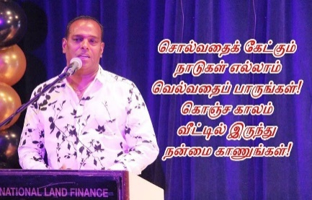  27 April 2020 | Transliteration: | colvataik kēṭkum  nādukaḷ ellām  velvataip pāruṅkaḷ!  koñca kālam  vīṭṭil iruntu  naṉmai kāṇuṅkaḷ!
P13 |  | Translation: | See how the countries are successful by complying with instructions!  Stay home for a while to reap the benefit

However, exactly which countries Saravanan was referring to is unknown. He obviously expects the readers to do their own research or through their own reading to understand how countries have controlled their numbers by complying with government regulations. He adds that it was through the stay-at-home policy that has proven to be beneficial to these countries. As such, he is advocating that Indians follow the same to help the country control the numbers.

ACCOUNT FOR LEVELS OF HEALTH LITERACY AND NUMERACY

The pandemic took many countries by surprise especially those with no experience at dealing with such a phenomenal crisis. On the one hand the preparedness of countries dealing with the disease and communicating information with accuracy, consistency and urgency were of concern. On the other hand, the health literacy and numeracy skills of the common man would dictate the reach of critical health information or impede access to information if one has limited literacy skills (Rudd & Baur, 2020). It is thus pertinent for leaders to consider the levels of health literacy and numeracy to utilise strategies that would broaden the reach of health information.

At the other end of the spectrum, the enormous amount of information could also overwhelm the public on health information. In addition, the social media also provides a good platform for misinformation or inadequate information to be disseminated and circulated as rapidly as authentic ones causing confusion and panic. The public who receive such misinformation on social media may actually believe it to be true with no way of verifying the source of the news. In some countries, misinformation on some effective remedies to cure the COVID-19 infection was disseminated through WhatsApp and other social media platforms which are not scientifically proven, i.e. herbal products, cooked food and spices like turmeric and saffron (Wajahat Hussain, 2020), and which was also circulated in Malaysia.

Thus, the account for levels of health literacy and numeracy is an important strategy that applies the audiences’ daily practice to help them to understand and act accordingly. In mediating the health information, Saravanan explained the nature of the disease, and prevention measures highlighted by the WHO and by the Malaysian Security Council. While explaining the nature of COVID-19, Saravanan only emphasized that it is contagious, but failed to mention how it spreads. He used the word தொற்று நோய் (toṟṟu nōy) meaning infectious disease in P3 and P6, thus emphasizing the contagious and infectious nature of the disease. In P3 he states இது தொற்று நோய் என்பதை அறிந்திடுவீர்! (itu toṟṟu nōy eṉpatai aṟintiṭuvīr!), that it is contagious. In P6, Saravanan mentions இந்தத் தொற்று நோய்க்கு மருந்தில்லை (intat toṟṟu nōykku maruntillai), that there is no medicine for this disease, and informs the public on the reality of the pandemic situation at its early phase. These updates are seen as important as Saravanan is sharing whatever available information on the disease to the community.
Next, he advices the public to follow precautionary measures in several posts by providing simple daily practices, which include stay-at-home order (P5, P9, P11, P12, P13, P15, P16), maintaining social distancing (P3, P6), regular hand washing (P4) and avoiding physical contact (P4). In these posts, Saravanan used a range of verbs, such as இரு (iru) - stay (P5, P13 15, P16), அடங்கு (adaṅku) - be calm (P9, P12) and வாசல் கடக்காதே (vācal kadakkātē) - do not step out of the entrance (P11). Despite using varied verbs, there was no diversification in his communication manner. Saravanan did not provide any quantitative estimate of risks, not even a simple percentage as recommended by Hyland-Wood et al. (2020) in conveying the health information.

EMPOWER PEOPLE TO ACT
As this unprecedented pandemic situation has caused various lifestyle changes, leaders use this strategy to potentially aid people to calm down by giving them assurance and provide appropriate measures, thus facilitating positive behavioural changes and actions. Leaders are also expected to consider the emotional and physical barriers to ensure the public is able to practice the recommended measures.
As Lakoff (2010) claims, message framing is a critical aspect in empowering people. Hyland-Wood et al., (2021) highlights that, despite messages like ‘calm down’ or ‘we are getting on top of the crisis’ perceived to be positive, the impact of the crisis is capable of triggering anxiety. Hyland-Wood et al. (2021) recommends phrases such as ‘we are on the road to recovery’ as a preferable way of message framing to instil calmness and optimism. However, such a way of message framing was not present in the seventeen posts, as experts nationwide were still struggling to contain the rise of positive cases.
Meanwhile, this strategy includes eliciting collective responses from the public. Among the ten classified posts, P7, P10 and P14 explains the common benefit of the stay-at-home order or social distancing. Saravanan requests the public to practice social distancing for everyone’s wellbeing as shown in P7.

P7 : எல்லோர் நலனுக்காகவும் எல்லோரும் விலகியிருப்போம் (ellōr nalaṉukkākavum ellōrum vilakiyiruppōm) – for everyone’s sake let us keep our distance
In order to do this, Saravanan cites a religious example in the opening of his post. In the first line of P7, நந்தி விழகியது நந்தனுக்கு நல்லது (nanti vilakiyatu nantaṉukku nallatu) - It is good for Nandan that Nandi gave way, refers to a narrative in the Hindu religion. Nanda is a Hindu saintly figure and Nandi is the guardian deity of Kailash, the home of Lord Shiva. In temples, Nandi is placed in a strategic position and guards the entrance to Shiva’s chamber, thus blocking a direct view of the main deity. With the Lord’s blessings and consent, Nandi moved aside to pave the way for Nandan to worship Lord Shiva directly. Thus, Saravanan supposes that if Nandi himself could make exceptions and move aside from what is the norm, there is no reason for the public to keep to status quo and do the same for the benefit of all. He adds that he does not consider it as social distancing, which is forced upon the public, but should be voluntary as if it is smooth distancing where everyone initiates the practice voluntarily.
Similarly, in the first line of P10, Saravanan starts with அவன் அருளாலே அவன் தாள் வணங்கி (avaṉ aruḷālē avaṉ tāḷ vaṇaṅki) meaning with His blessings, he bowed and paid obeisance.

P10 | 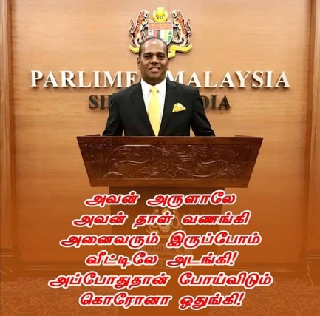  22 April 2020 | Transliteration: | avaṉ aruḷālē  avaṉ tāḷ vaṇaṅki  aṉaivarum iruppōm  vīṭṭilē adaṅki  appōtutāṉ pōyviṭum  korōṉā otuṅki
P10 |  | Translation: | By his grace,  we bowed to the feet  will all be subdued at home  Only then we can prevent Corona.
This line is adopted from one of the devotional scriptures called ‘Sivapuraanam’. These lines can only be interpreted by those who have fair knowledge of the ‘Sivapuraanam’ and the Hindu religion. These lines require higher cognitive processing effort which is contrary to the Clear communication strategy (S1). Saravanan’s deliberate use of these initial lines in his posts is aimed at establishing a commonality and in-group sentiments between a particular community and himself. However, the extent to which these lines in P7 and P10 were inferred correctly by the followers could not be ascertained. Saravanan is known to be a staunch Hindu devotee, and he has publicly affirmed his religious beliefs in past press interviews (D'Cruz, 2021). Thus, he attempts to convey that being a minister, and one who holds the same values as the Hindu community, does not exempt him from being subjected to the risks of the pandemic nor adapting to the new norm. Social solidarity is important to implement pandemic-related regulations and minimizing public health risks by enhancing collective consciousness in the community during an ongoing crisis (Mishra & Rath, 2020; Sultan & Rapi, 2020).

COMMUNICATE WITH EMPATHY
When leaders communicate with empathy, the expression of compassion enhances the leader’s credibility (Reynolds & Quinn, 2008). Leaders can elicit cooperation by communicating respect and trust towards the public (Leask & Hooker, 2020). Citizens are more likely to reciprocate to orders if politicians are able to display their concern for the public’s well-being (Pfattheicher et al., 2020). In P2, Saravanan attempted to make the public understand that the citizens are the beneficiaries of the MCO. Moreover, the use of நண்பா (naṇbā) – friend, in P2 and P5 indicates his attempt to appear friendly, welcoming, and that he is not exempted from the government stipulated regulations.

Saravanan proceeds to encourage all to stay-at-home for the safety of each member of the family, and for the sake of the brethren of the nation. Hyland-Wood et al. (2021) states short narratives could be used by leaders to recognise the hardships experienced by people to show empathy. Likewise, it is observed that in P17, Saravanan acknowledges that the new MCO rules may seem restrictive, but it was aimed at protecting the public’s wellbeing.

P17 | 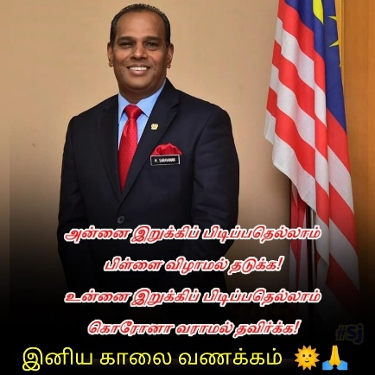  11 May 2020 | Transliteration: | aṉṉai iṟukkip pidippatellām  piḷḷai viḻāmal tadukka!  uṉṉai iṟukkip pidippatellām  korōṉā varāmal tadukka!
P17 |  | Translation: | Mothers holds tight  to prevent the child from falling,  MCO holding you tight  to prevent you from the corona.

By comparing the regulations imposed by the government (உன்னை இறுக்கிப் பிடிப்பதெல்லாம் கொரோனா வராமல் தடுக்க! - uṉṉai iṟukkip pidippatellām korōṉā varāmal tadukka - holding you tight to prevent you from the corona), to the embrace of a mother who protects her child (அன்னை இறுக்கிப் பிடிப்பதெல்லாம் பிள்ளை விழாமல் தடுக்க! - aṉṉai iṟukkip pidippatellām piḷḷai viḻāmal tadukka! - Mothers holds tight to prevent the child from falling), Saravanan assures the public that the restrictions imposed on them is necessary to protect them from the disease. By referring the Government as a caring parent, Saravanan advocates the need to impose such strict laws for the safety of the public.

RECOGNISE THAT UNCERTAINTY IS INEVITABLE
In a crisis, communicating uncertainties is inevitable, and leaders need to play an important role in providing words of comfort and assurance to alleviate some of the anxiety and stress that the public is undergoing. Thus, words play an important role. During the first phase of the MCO, most Malaysians were positive in combating the pandemic, while others were uncertain (Azlan et al., 2020). In such circumstances, it is indeed important for leaders to acknowledge and communicate uncertainties present to help the public prepare themselves mentally and pragmatically (Hyland-Wood et al., 2021). Five posts are categorized under this strategy, i.e.: P1, P9, P12, P13 and P15. In P1, during the initial phase of lockdown, Saravanan informs the public that even the world’s top-notch scientific experts, who launched rockets and satellites, were clueless in handling the pandemic.
Saravanan uses a rhythmic pattern in P9 to describe the lockdown conditions and how the public should behave.
P9 | 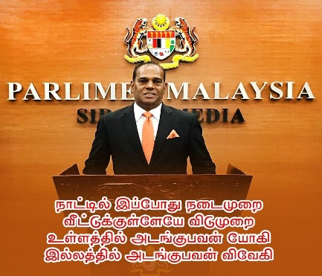  21 April 2020 | Transliteration: | nāṭṭil ippōtu nadaimuṟai  vīṭṭukkuḷḷēyē vidumuṟai  uḷḷattil adaṅkubavaṉ yōki  illattil adaṅkubavaṉ vivēki
P9 |  | Translation: | The country’s current policy  Holidaying at home,  The one who is calm at heart is a yogi  The one who is stays at home is a wise man
In the first line he states நாட்டில் இப்போது நடைமுறை (nāṭṭil ippōtu nadaimuṟai) - the government’s current policy and highlights that வீட்டுக்குள்ளேயே விடுமுறை (vīṭṭukkuḷḷēyē vidumuṟai) - the people are having a holiday at home, referring to the lockdown and the public having to self-quarantine. In the third line, Saravanan uses symbolic reference to a யோகி (yōki) ‘yogi’ to describe the characteristic that is desirable of the public. The implied meaning is that the yogi practices some form of withdrawal from society, something which is strongly recommended to mitigate the spread of the disease. Furthermore, a yogi practices a simple life, seeks knowledge despite many obstacles, and would offer to help for the betterment of the community. Saravanan continues that this could be achieved by simply staying at home. In other words, he likens those who stay at home as having the wisdom (விவேகி – vivēki) and are instrumental in ensuring the success of the government’s policy.
Meanwhile, in P12 Saravanan compares the change of times காலம் (kālam), அன்று துள்ளித் திரிந்த காலம் (aṉṟu tuḷḷit tirinta kālam) - those were joyful days, and இன்று உள்ளே அடங்கும் காலம் (iṉṟu uḷḷē adaṅkum kālam) - today it’s our lockdown days.
P12 | 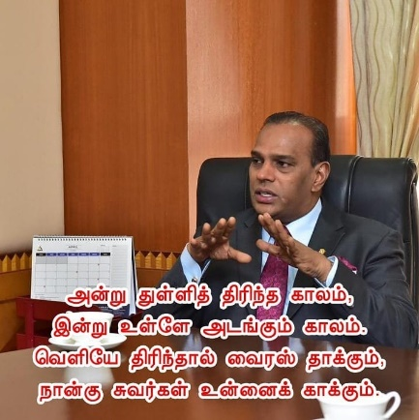  24 April 2020 | Transliteration: | aṉṟu tuḷḷit tirinta kālam  iṉṟu uḷḷē adaṅkum kālam  veḷiyē tirintāl vairas tākkum  nāṉku cuvarkaḷ uṉṉaik kākkum.
P12 |  | Translation: | Those were joyful days  Today it’s our lockdown days  Virus will attack if you go out;  The four walls will protect you.
He describes pre-Covid as a joyful time in the past and compares the current times as a time to self-quarantine. The unspecified length of time for self-quarantine indicates Saravanan’s attempt at making the public aware of the uncertainties surrounding the disease. He affirms that the only certainty is that should anyone wander out of the home, the virus would strike. Thus, he reminds the public to remain within the four walls (நான்கு சுவர்கள் - nāṉku cuvarkaḷ - four walls), in order to be safe.

In P15, Saravanan updates the public on the developments taking place during these challenging times.
P15 | 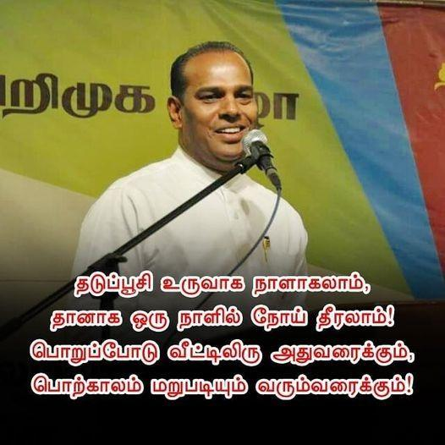  29 April 2020 | Transliteration: | taduppūci uruvāka nāḷākalām,  tāṉāka oru nāḷil nōy tīralām!  poṟūppōdu vīṭṭiliru atuvaraikkum,  poṟkālam maṟupadiyum varumvaraikkum!
P15 |  | Translation: | Vaccine may take days to be developed,  The disease can heal by itself one day!  until then, stay home responsibly  for the golden age to come again!

Although he is unsure of the details, he is aware that vaccines are being tested and developed in various countries to curb the disease. He is uncertain whether such a vaccine would be discovered over time, or if the disease would heal by itself (தானாக ஒரு நாளில் நோய் தீரலாம்! - tāṉāka oru nāḷil nōy tīralām!). All Saravanan wanted the public to do was to stay at home responsibly in order to enjoy the good times again, i.e. pre-Covid days.

CONSIDER DIVERSE COMMUNITY NEEDS
During a crisis, a leader is expected to address vulnerable communities and their needs through communication. Likewise, addressing cultural differences, language barriers or the varied needs of specific communities to facilitate shifts due to this new norm is imperative. For instance, in Malaysia, offering ‘salam’ or handshakes are a part of the Malay community’s cultural practice and it has also become a common practice among non-Malays to greet the same way when meeting each other. However, due to the pandemic, the government discourages such practices, even during festivities or family gatherings, even among friends and family members.
Meanwhile, in P4 and P5, Saravanan highlights cultural practices to introduce preventive measures. In P4, he discourages shaking hands as the disease could spread through physical contact.
P4 : கைகுலுக்கல் நிறுத்துங்கள் (kai kulukkal niṟuttuṅkaḷ) - stop handshakes
As more and more Indians have assimilated shaking-hands as part of their socializing routine, despite it not being an inherent cultural practice, such practices are discouraged now. By highlighting age-old practices of the Indians, Saravanan draws on the rationality of such practices upheld by our forefathers then. By looking back at the cultural norms, Saravanan backs up his point by mentioning the risks of having physical contacts, thus the message may appear less intimidating to the public.
P5 on the other hand, alerts and challenges people who are resigned to putting their trust and belief on fate and destiny (விதி வழியே - viti valiyē), or even God sent.
P5 : விதி வழியே வருவதல்ல கொரோனா! (viti vaḻiyē varuvatalla korōṉā!) - Corona does not come by fate
When a portion of the population holds this notion that whatever man is experiencing is decided by fate or that one is destined to suffer, then whatever happens is decided by God. Such acceptance also means that this group would not adhere to imposed restrictions nor contribute towards ending the pandemic. Nevertheless, while conveying such a sensitive message, he attempted to portray himself as a more amicable and concerned politician, by using the word நண்பா (naṇbā )- friend, and also explained the transmission risks in detail.
On the other hand, from the seventeen posts collected, the remaining two strategies: Strive for maximum credibility (S2), and Be proactive in combating misinformation (S10) were not present. These strategies are recommended to be used to further facilitate the public via online communication.

STRATEGIES USED TO ENGAGE WITH THE COMMUNITY

The manner in which a leader engages with the community can have a long-lasting impact on the uptake of information. The role of a leader is essential especially in times of crisis. Aside from the authority and power that a leader exudes, he/she is expected to encourage and motivate the community in times of crisis. In addition to the pandemic, the political scenario in the country is also not favourable, and as such Saravanan faces a lot of challenges in terms of gaining public trust and support, what more the need for the public to check Facebook posts. His posts are, therefore only followed by a few people. Despite this, Saravanan tries his best to keep his followers updated with the political and health information from time-to-time.

The first strategy is seen in P4 which is clear and precise, but what makes it interesting is the initial rhythmic effect used in the post to make the information less commanding.
P4 | 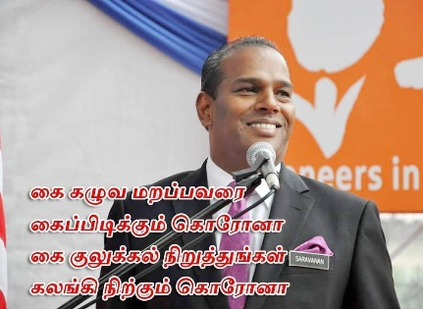  8 April 2020 | Transliteration: | kai kaḻuva maṟappavarai  kaip pidikkum korōṉā  kai kulukkal niṟuttuṅkaḷ  kalaṅki niṟkum korōṉā
P4 |  | Translation: | For those who forget to wash their hands  The Corona would hold your hands  Stop handshakes  The Corona will stop tearfully

The word கை (kai) refers to the hand, and it is used repeatedly in the three lines as follows, கை கழுவ (kai kaḻuva) hand-washing, கைப்பிடிக்கும் (kaip pidikkum) hand-holding, and கை குலுக்கல் (kai kulukkal) hand-shake. The rhythmic repetition of the word makes it easy for the reader to sum up the message as referring to the hand. This repetition makes the message concise and easily understood.

Within this same post, another strategy that was used by Saravanan is personification. When describing the disease, Saravanan personified coronavirus as being able to கைப்பிடிக்கும் (kaip pidikkum) ‘hold your hands’ if one fails to wash his/her hands. He continues to suggest that should the public avoid handshakes, it is likely for the disease to கலங்கி நிற்கும் (kalaṅki niṟkum) ‘stop tearfully’ and would not be able to spread as rapidly.
The third strategy is the use of exclamation marks which adds emphasis to the imperative clause that act as directives or commands. In P11, the first and third clauses, நடமாட்டம் நிறுத்து! (nadamāṭṭam niṟuttu!) - stop moving around! and வாசல் கடக்காதே! (vācal kadakkātē!) - do not step out of the entrance! are clearly directives.
P11 | 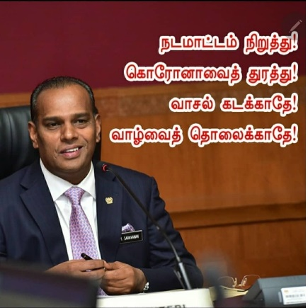  23 April 2020 | Transliteration: | nadamāṭṭam niṟuttu!  korōṉāvait turattu!  vācal kadakkātē!  vāḻvait tolaikkātē!
P11 |  | Translation: | Stop moving around!  Chase Corona away!  Do not step out of the entrance!  Do not lose your life!
The second clause கொரோனாவைத் துரத்து! (korōṉāvait turattu!) - chase Corona away! is an emphasis on the effect of adhering to the first directive. The last clause, வாழ்வைத் தொலைக்காதே! (vāḻvait tolaikkātē!) - do not lose your life! is a caution, should one choose to ignore the directives.

Saravanan also drew on religious knowledge in the opening of his post, as in P7.
P7 | 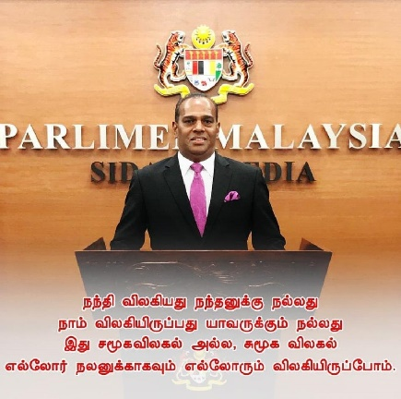  18 April 2020 | Transliteration: | nanti vilakiyatu nantaṉukku nallatu  nām vilakiyiruppatu yāvarukkum nallatu  itu camūkavilakal alla, cumūka vilakal  ellōr nalaṉukkākavum ellōrum vilakiyiruppōm
P7 |  | Translation: | It is good for Nandan that Nandi gave way  It is good for all if we stay apart  This is not social distancing, but smooth distancing  We would stay apart for the wellbeing of all.

In the first line, நந்தி விழகியது நந்தனுக்கு நல்லது (nanti vilakiyatu nantaṉukku nallatu) - it is good for Nandan that Nandi gave way, refers to a narrative in the Hindu religion. Obviously, Saravanan assumes his readers to have a high level of literacy and would be able to understand the post. By using this strategy, he also affirms his religious beliefs and tries to enhance his in-group association with his Hindu followers.

Studies on political discourse has shown that using inclusive pronouns is a common strategy used by politicians (Wai & Ha Yap, 2018). Saravanan is no exception, in that he used the second person singular ‘you’ நீ (nī) in P5 to refer to the community as a whole, while the second person plural உங்கள் (uṅkaḷ - your) in P1, is a polite form of address. By using the plural form, Saravanan indicates why the community has to stay together and the fact that everyone is in a similar situation should help reduce anxiety and stress (Alkhawaldeh, 2021; Azizan et al., 2020; Haslam et al., 2018). From the seventh (P7) post onwards, Saravanan used the inclusive nouns நாம் (nām – we) and நம் (nam – our). The use of inclusivity portrays Saravanan as a leader who believes in people power and when people are empowered, they would collectively act, and this could just be the answer to end the pandemic sooner. Terms of address are also found to be used by Saravanan as shown in P14.
P14 | 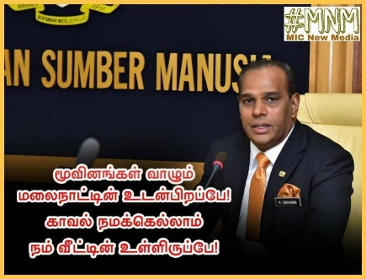  29 April 2020 | Transliteration: | mūviṉaṅkaḷ vāḻum  malaināṭṭiṉ udaṉpiṟappē!  kāval namakkellām  nam vīṭṭiṉ ulliruppē!
P14 |  | Translation: | Siblings of multiethnic Malaysia!  Staying home is our protection!

Saravanan addresses the public as Malaysian உடன்பிறப்பே (udaṉpiṟappē) - siblings. This address term is seen here as a strategy that appeals to the public’s soft side to listen to his plea, and the address term suggests the inclusivity of all Malaysians whom Saravanan considers as his own siblings. This address term is regularly used by politicians in India to address their followers and the public, and it is thus not an exaggeration to assume that Saravanan was inspired by his counterparts in India.

In sum, Saravanan’s posts in Tamil were clearly aimed at the Indian minority who were proficient in the language. More importantly, Saravanan has used several strategies to engage with the community in simple and interesting ways. From the seventeen posts, Saravanan used poetic effect, personification, punctuation marks, inclusive nouns, and address terms.

CONCLUSION
Leaders play a vital role in ensuring the community they represent are well-informed and are up-to-date with issues pertaining to government policies and decisions. In the current state of the pandemic that continues to threaten lives and has created over-anxiety, fear and stress among the public, leaders have to also ensure the emotional health of the community. The current study has highlighted the role of a leader who uses social media to engage, communicate, and respond to his followers and the public. Saravanan engaged with the Indian community through his Facebook posts, using Tamil language as a medium to spread awareness. It is obvious that he was acting as the spokesperson for the Ministry of Health and the Government, and this crisis communication is expected to enhance public trust through civic engagement and transparent communication.

Clear communication is essential as the public needs to understand health-related terms such as pandemic, variants, social distancing, alcohol-based hand rub, sanitizers, front-liners, and vaccine. In this instance, leaders have to highlight these terms to familiarize the public with health-related issues as these will affect the implementation of policies and Standard Operating Procedures. By constantly updating the public, leaders exhibit their resolve and political will in handling a crisis. Further, words of assurance are important to motivate the public, and our featured leader, Saravanan displayed empathy when he used Tamil language, and appealed to the cultural and religious practices of the minority Indian community. However, being in the Human Resource Ministry, the challenges of low-income groups, disabled people, front-liners and students of the Indian community, should have been particularly highlighted. In fact, there was an absence of praise for the domestic group of people or the front-liners who put their lives at stake by serving the public, as recommended by Hyland-Wood et al. (2021).
Interestingly, Saravanan also used the inclusive first person plural noun ‘we’, நாம் (nām) and நம் (nam) - our, as well as the address terms நண்பா (naṇbā) - friend and உடன்பிறப்பே (udaṉpiṟappē) - siblings, to endear the public towards him. These terms of address exhibited compassion and also showed him to be transparent, as he did not pretend to be certain of how the pandemic would pan out. Instead, Saravanan admitted that nothing was certain, and if inventors and researchers around the globe were helpless in dealing with the pandemic, what more a leader like him. Saravanan displayed both a condescending and authoritative nature in his use of the imperative form, but this is exactly how the Ministry of Health spells it out in the Malay and English languages. However, in some of his posts the tone is friendly and casual, in an obvious attempt to cajole and plead with the public to act responsibly. Saravanan’s mastery of poetic language acted as a persuasive device in delivering the essence of his message. In this way, he was acknowledging the literacy level of the reader or public. In order to understand the message behind his posts, the public was deemed knowledgeable in literature as well as the religion to be able to make inferences of the health message.
While there are many strategies instantiated in Saravanan’s posts, crisis communication has to be interactive, and this was lacking somewhat in the Facebook posts. Although there were enquiries made by the public, there were no attempts at responding to the questions. Thus, the response strategies that would test the leader’s resolve and effectiveness in crisis communication (Kusumaningrum & Aryani 2020), was not evident. One of the reasons could be due to the regularly changing standard operating procedures and information updates on the pandemic. It is commendable that the leader has used social media to reach out to a wider range of public quickly, as it is pertinent to reach out to those without access to social media or any form of communication. In the case of vulnerable communities that have limited health literacy, the public must also be educated, and information made accessible to all.
This study has not explored the extralinguistic features of the political leader such as the body language, facial expressions, tone and pitch of voice, eye movements, and hand gestures as this would warrant a study on its own. Future research could also include, examining a larger text corpus of contextually Indian political leaders’ usage of dysphemistic and metaphoric language.

REFERENCES
Alkhawaldeh, A. A. (2021). Persuasive Strategies of Jordanian Government in fighting Covid-19. GEMA Online®️ Journal of Language Studies, 21(1), 274-291 http://doi.org/10.17576/gema-2021-2101-16
Azizan, M., Ismail, H. H., & Qaiwer, S. N. (2020). Power and solidarity in positive Facebook postings amidst Covid-19 in Malaysia. Journal of Nusantara Studies (JONUS), 5(2), 329-364
Azlan, A. A., Hamzah, M. R., Sern, T. J., Ayub, S. H., & Mohamad, E. (2020). Public knowledge, attitudes and practices towards COVID-19: A cross-sectional study in Malaysia. Plos one, 15(5), 1-15 https://doi.org/10.1371/journal.pone.0233668
Cammett, M., & Lieberman, E. (2020). Building solidarity: challenges, options, and implications for COVID-19 responses. COVID-19 Rapid Response Impact Initiative, White Paper 4. Edmond J. Safra Center for Ethics, 30.

D'Cruz, F. (2021, January 29). Poser over 'privileged Thaipusam devotee'. Free Malaysia Today (FMT)https://www.freemalaysiatoday.com/category/highlight/2021/01/29/poser-over-privileged-thaipusam-devotee/.
Elengoe, A. (2020). COVID-19 outbreak in Malaysia. Osong Public Health and Research Perspectives, 11(3), 93.
Everett, J.A.C., Colombatto, C., Chituc, V., Brady, W.J., & Crockett, M. (2020). The effectiveness of moral messages on public health behavioral intentions during the COVID-19 pandemic. https://doi.org/10.31234/osf.io/9yqs8
Franz, D., Marsh, H. E., Chen, J. I., & Teo, A. R. (2019). Using Facebook for qualitative research: a brief primer. Journal of medical Internet research, 21(8), e13544.

Guest, J. L., del Rio, C., & Sanchez, T. (2020). The three steps needed to end the COVID-19 pandemic: Bold Public Health Leadership, Rapid Innovations, and Courageous Political Will. JMIR Public Health Surveillance, 6(2). https://doi.org/10.2196/19043
Harris, J. (2020, March 22). Facebook is still far too powerful. It’s also how millions are coping with the crisis. The Guardian. Retrieved from https://www.theguardian.com/commentisfree/2020/mar/22/facebook-powerful-crisis-coronavirus-communities-online
Hyland-Wood, B., Gardner, J., Leask, J., & Ecker, U. K. (2021). Toward effective government communication strategies in the era of COVID-19. Humanities and Social Sciences Communications, 8(1), 1-11.

Igwebuike, E. E., & Chimuanya, L. (2020). Legitimating falsehood in social media: A discourse analysis of political fake news. Discourse & Communication, 15(1) 42-58
Islam, M. M., Islam, M. M., Ahmed, F., & Rumana, A. S. (2021). Creative social media use for Covid-19 prevention in Bangladesh: A structural equation modeling approach. Social Network Analysis and Mining, 11(1), 1-14.

Lakoff, G. (2010). Moral politics: How liberals and conservatives think. USA: University of Chicago Press.

Leask J., & Hooker, C. (2020) How risk communication could have reduced controversy about school closures in Australia during the COVID-19 pandemic. Public Health Res Practice 30(2), 1-5 . https://doi.org/10.17061/phrp3022007
Mat Dawi, N., Namazi, H., Hwang, H. J., Ismail, S., Maresova, P., Krejcar, O. (2021). Attitude Toward Protective Behavior Engagement During COVID-19 Pandemic in Malaysia: The Role of E-government and Social Media. Frontiers in public health, 9, 113. 1-8

Neville, F. G., Templeton, A., Smith, J. R., & Louis, W. R. (2021). Social norms, social & identities and the COVID‐19 pandemic: Theory and recommendations. Social and Personality Psychology Compass, 15(5), 1-12. https://doi.org/10.1111/spc3.12596
Pfattheicher, S., Nockur, L., Böhm, R., Sassenrath, C., & Petersen, M. B. (2020). The emotional path to action: Empathy promotes physical distancing and wearing of face masks during the COVID-19 pandemic. Psychological Science, 31(11), 1363-1373.

Prieto-Ramos, F., Pei, J., & Cheng, L. (2020). Institutional and news media denominations of COVID-19 and its causative virus: Between naming policies and naming politics. Discourse & Communication, 14(6), 635-652.
Rafidah Mat Ruzki & Noor Atiqah Sulaiman, (2020, April 1). COVID-19: PKP fasa satu ada kejayaan. Berita Harian Online retrived from https://www.bharian.com.my/berita/nasional/2020/04/671806/covid-19-pkp-fasa-satu-ada-kejayaan
Reynolds, B., & Quinn, S. C. (2008) Effective communication during an influenza pandemic: the value of using a crisis and emergency risk communication framework. Health Promot Practice, 9(4_suppl):13S–17S. https://doi.org/10.1177/1524839908325267

Rudd, R., & Baur, C. (2020). Health literacy and early insights during a pandemic. Journal of Communication in Healthcare: Strategies, Media and Engagement in Global Health. 13(1), 13 – 16.
Schultz, P.W., Nolan, J.M., Cialdini, R.B., Goldstein, N.J., Griskevicius, V. (2007) The
constructive, destructive, and reconstructive power of social norms. Psychol
Sci,18(5), 429–434
Stayner, T. (2020, March 26) As in-language communication about COVID-19 is harnessed to reach multicultural groups, advocates warn minority communities must not be forgotten. SBS News. https://www.sbs.com.au/news/australia-s-minority-communities-urgently-need-covid-19-resources

Sultan, S., & Rapi, M. (2020). Positive Discourse Analysis of the Indonesian Government Spokesperson’s Discursive Strategies during the Covid-19 Pandemic. GEMA Online Journal of Language Studies, 20(4), 251-272.

Unuabonah, F. O., & Oyebode, O. O. (2021). ‘Nigeria is fighting Covid-419’: A multimodal critical discourse analysis of political protest in Nigerian coronavirus-related internet memes. Discourse & Communication, 15(2), 200-219.

Wai, B. L. M., & Ha Yap, F. (2018). Inclusivity and exclusivity in the use of Cantonese ngo5dei6 (‘we’) in evasive replies in Hong Kong political discourse. Discourse & Society, 29(6), 691-715.
Wajahat Hussain (2020) Role of Social Media in COVID-19 Pandemic. The International Journal of Frontier Sciences, 4(2), 59-60 doi: https://doi.org/10.37978/tijfs.v4i2.144
Zappavigna, M. (2018). Searchable talk: Hashtags and social media meta discourse. London, Bloomsbury Publishing.

