Genre Analysis of Risk Management Reports by an Islamic Financial Institution in Malaysia

Roslina Abdul Aziz
leenaziz@uitm.edu.my
Akademi Pengajian Bahasa,
Universiti Teknologi MARA Cawangan Pahang

Nadhratunnaim Abas
nadhra@uitm.edu.my
Akademi Pengajian Bahasa,
Universiti Teknologi MARA Cawangan Pahang

Khairul Firhan Yusob
khairulfirhan@uitm.edu.my
Akademi Pengajian Bahasa,
Universiti Teknologi MARA Cawangan Pahang

Norhidayah Md Yusof
norhidayahmy@uitm.edu.my
Akademi Pengajian Bahasa,
Universiti Teknologi MARA Cawangan Pahang

ABSTRACT

Risk management report (RMR) has become an important section for a bank's annual reports, and it has been used to inform the stakeholders and public of the stability of a bank. Nevertheless, most studies on risk management have yet to place much emphasis on the language use nor move-step structure that was employed in the report since more attention was given to the risks faced by the institutions and how they were solved. This preliminary study aims to explore the move-step structure of risk management reporting in the RMR. To achieve this aim, genre analysis was utilised as a method to investigate how language was used in specific contexts to achieve their communicative purposes. Five RMR of an Islamic bank operating in Malaysia were obtained from its official website and analysed for their communicative content as demonstrated by the move-step constructs. The findings revealed that the RMR adhered to five moves. The findings provide an insight into how a financial institution’s reputation is constructed through the appropriations of the textual conventions in the reports.

Key Words: Genre analysis; Islamic financial institution; move analysis; risk management report

INTRODUCTION

Risk management is a key activity for financial institutions and its practice is reflected in Risk Management Report (RMR). RMR is an audited section that has been mandated in annual reports. However, it was only introduced in the early 2000s (Gao et al., 2019). When it was first implemented, the U.S gave directives to all public listed companies to disclose significant risk factors in their annual reports. China followed the practice by setting up China Securities Regulatory Commission (CSRC). The commission was held responsible in assuring public listed companies discuss risk factors that they encounter (Gao et al., 2019). Since then, RMR has been used as a channel to inform the public of the stability of a bank. To date, risk management reporting has been evolving and it is also used to anticipate the future of a banking institution (Härle et al., 2016).
Risk management reporting between Islamic and conventional banks has been found to be slightly different since the former uses shariah principles as guidelines. Hence, this leads to high total risks faced by Islamic banks (Hussain & Al-Ajmi, 2012), while both types of banks are exposed to different types of risks (Baej, 2013). These differences are unique elements to be studied in the reporting of risk management considering that Malaysia operates in dual banking systems; Islamic and conventional.
To date, most studies on risk management have yet to place much emphasis on the language use nor moves in the report, but more focus was on the risks faced by the institutions and the ways they were solved. Louhichi and Zreik (2015) perceived a positive correlation between risk reporting and firm reputation as it supports the legitimacy theory that necessitates risk information to depict good reputation. Hence, it is crucial to linguistically examine this link by highlighting the move-step pattern of RMR, as this would provide an insight into how a financial institution’s reputation is constructed through the appropriations of the textual conventions in the reports. According to Hussain et al. (2020), well-reputed company images can be constructed based on interdiscursive appropriations of positive language features with reduced negativity.
The need to conduct such a study is also heightened by the lack of studies involving financial institutions in countries where English is an L2 (Mobasher et al., 2013), and the scarcity of studies on RMR which combine both genre and corpus analysis. The present study aims to uncover the major moves in risk management reporting by utilising both genre analysis and corpus-based methodology, besides providing researchers, ESP instructors and financial professionals with the valuable data and knowledge of the reporting practice that could help financial institutions to project the desired company image, hence gaining the trust of stakeholders and future investors. In summary, the study aims to explore move-step patterns in the RMR produced by an Islamic financial institution in Malaysia.

LITERATURE REVIEW

GENRE ANALYSIS

Genre is understood as a category of texts that belong to similar types. Some common genres that we often come across are lectures, journal articles, short stories and any other types of texts which can be both written and spoken. In linguistics, genre has been critically conceptualized in Swales’ (1990) English for Specific and Academic Purposes. Since its introduction, genre analysis has provided a strong framework for research in specialized discourse studies and contributed to developing second language (L2) pedagogy. Hyland (2007) considers genre as a communicative strategy which is used to accomplish social actions that belong to specific discourse communities.
Genre analysis provides insights on the nature of different genres. Bhatia (2002) finds genre analysis as a means of exploring highly conventionalised texts which belong to similar contexts. He believes that genre analysis can be used in investigating how members of the same discourse communities interpret and utilise a genre to achieve certain communicative goals. While genre analysis is most often investigated based on its linguistic features, most studies have concentrated on the rhetorical moves found in different genres and further developed their own framework for move analysis. For instance, they have examined corporate discourse such as annual report narratives (Rutherford, 2005) and sections of annual reports involving Management Forewords (Mobasher & Ali, 2015) and Letters to the Shareholders (Falco, 2018). Other studies have involved Arabic patent abstracts and a product information brochure (see Alzarieni, 2019 & Goh, 2019).

SWALES’S (1990) MOVE ANALYSIS – CREATE A RESEARCH SPACE (CARS) FRAMEWORK

Creating A Research Space (CARS) is a framework which can highlight the significance of a research article for better comprehension. It is founded on three moves which are:

Move 1: Establishing a Territory (putting your research into a wider context)
Move 2: Establishing a Niche (What's missing in the previous research and body of knowledge?)
Move 3: Occupying the Niche (How will you fill the gap?)

A number of studies which opted for CARS as their framework of analysis have concerned the introductions (see Farnia et al., 2017; Kafes, 2018). Besides introductions, abstracts have also been examined using CARS (Sanchez, 2018).

RISK REPORTING

Robayany et al. (2019) views ‘risk’ as coherent with uncertainties and probabilities pertaining to profits and losses. Studies on risks have often been associated with ‘risk management’ and ‘risk disclosure’. Financial risks, according to Elamer et al. (2019) can be exemplified by credit risk, market risk, capital management and adequacy risks. Mandatory and voluntary risk disclosures act as the mitigation strategies to counter for possible risk occurrences. Mandatory risk disclosure applies to the disclosure that fulfills the minimum requirement. Meanwhile, voluntary risk disclosure covers other risk information concerning the narrative sections which is not mandated in annual reports. Furthermore, two elements related to shariah compliance are religiosity and ownership structure (Rosli et al., 2017). Regardless, Ramli et al. (2019) found that the market firms listed in Bursa Malaysia were prone to disclose the mandatory risk instead of voluntary risk information.
Studies on risk disclosure in the banking sector seem to correspond with the extent of the usefulness and integrity of the information shared by the institutions for their users, mainly the stakeholders. The risk information must be relevant to serve its users’ needs for decision-making purposes at an appropriate timely basis. Besides, it has to be comprehensive in terms of the inclusion of the kinds of information that are deemed as useful to its users. Regardless, it may not necessarily include all kinds of information or else the disclosure will be immaterial or useless for the decision-making purpose. Finally, the risk information also needs to be consistently comparable to allow risk profiling among different banks of different localities and at different times.
The quality of risk reporting has been examined in terms of the comprehensibility of the reports such as in Polizzi and Scannella (2020) who found that the risk disclosure practices of Italian banks needed to be improved. Besides, the quality of risk reporting has also been analysed by comparing the reports to examine the extent of the disclosure. Based on the annual reports of 48 manufacturing companies over a six-year period (2010–2015) in Bangladesh, Dey et al. (2018) discovered that they lacked standardisation as certain risks seemed to be disclosed more than the others. In contrast, Ahmad et al. (2015) found that the risk disclosure among Malaysian public listed firms indicates good compliance with risk management and internal control disclosure monitored effectively. Moreover, Lajili et al. (2020) who observed the increased information disclosure in the Canadian and German risk reporting concluded that it tends to be weighted on firm authorities more than its performance. Hence, this further indicates deficiencies in the quality of the reporting.
Studies that examined banks’ risk disclosures had compared the reports between those produced by the Islamic banks and the conventional banks. The results tended to vary, hence, could not conclusively determine whether or not one type of financing was better than the other. Some discovered that conventional banks reported more profits although Islamic banks could be more liquefied (Alam et al., 2018; Qian & Velayutham, 2017). In another comparison involving five Islamic and 19 conventional banks in Pakistan, Khan et al. (2017) highlighted the prevalence of the former in terms of profitability, efficiency, risk and liquidity management. However, a number of studies agreed that Islamic banks were prone to more risks due to their adherence to the shariah law (see Hemrit, 2019; Alam et al., 2018; Khan et al., 2017). The Malaysian Islamic banks show better risk disclosures than the foreign Islamic banks (Kabir et al., 2019; Chong et al., 2019). Kabir et al. (2019) found that the reports by the Malaysian Islamic banks were better than Bangladesh as the risk information in the latter indicated good governance. Unfortunately, they were also described with ‘window dressing’, a term that denotes general, standardised and not updated annual reports with the absence of actual instances of risks as well as the mitigation strategies. Nevertheless, other studies demonstrated that the Islamic banks had insufficient risk information in their disclosures. Grassa et al. (2020) reported that the level of risk disclosure of some but not all Islamic banks was lower, with Malaysia placed second after Turkey. Meanwhile, based on the analysis of the annual reports of five Malaysian Islamic banks, Rhanoui and Belkhoutout (2019) concluded that each bank had not properly disclosed certain risk information.

METHODOLOGY

DATA

The corpus data for the study, which is a compilation of RMR, were extracted from the Annual Reports of an Islamic bank in Malaysia from 2015 to 2019. These reports were obtained from the bank’s official website. Table 1 below summarises the composition of the Annual Report corpus and the RMR sub-corpus analysed in this study:

TABLE 1: Word tokens of Annual Reports corpus and RMR sub-corpus

 | Word Tokens
Year | Annual Report Corpus | Risk Management Report Sub-corpus
2015 | 33164 | 1158
2016 | 28641 | 1191
2017 | 33300 | 1578
2018 | 31137 | 877
2019 | 30977 | 1253
Total | 157219 | 6057

APPROACH TO GENRE ANALYSIS

The study adopted Bhatia’s (1993) approach of genre analysis with its main focus on identifying ‘moves’ used by authors to achieve the communicative functions in the text. Bhatia’s (1993) seven steps to analysing unfamiliar genres was used as the guiding principles in analysing the data in the present study. According to Bhatia (1993) it is necessary to consider some or all of the seven steps as summarised below:

- Placing the Given Genre-Text in a Situational Context:

Step 1 is to place the unfamiliar genre within the situational context, which could be established by relying on researchers’ prior knowledge on a genre and the internal clues available in the text collection of the genre (Bhatia, 1993). Hence, the researchers relied on their own experience, library research and input from a specialist informant to derive the situational context for the text gathered and analysed. The situational context allows researchers to have a better understanding of the communicative conventions of a genre. The genre investigated in this study belongs to the banking community, which may comprise the gatekeepers, shareholders, investors, employees, and the customers of the bank.

- Surveying Existing Literature:
Bhatia (1993) states that the review of existing literature should include literature on other linguistic examinations conducted of the genre or similar genres, research tools, methods, theories of linguistic/discourse/genre analysis which might be relevant to the situation to be analyzed. Documents/texts relevant to the speech community involved which may include practitioner advice, guide books, manuals etc. and any discussion on the social structure, interactions, history, beliefs, goals etc., of the professional or academic community in question which uses the genre in question should also be reviewed.

For this study, the literature reviewed on genre analysis included studies by Bhatia (1993) on product and self-promotion in business settings, introductions in student academic writings, legal discourse in professional settings, Mobasher and Ali (2015) on management forewords, Falco (2018) on letters to the shareholders, Alzarieni (2019) on Arabic patent abstracts, Goh (2019) on product information brochure and Rutherford (2005) on corporate annual reports. Relying on the literature available, this study aimed at analysing the genre-text of RMR by a prominent Islamic bank in Malaysia. The existing as well as the lack of literature in related research context supported the genre analysis conducted in this study.

- Refining the Situational / Contextual Analysis:
Once the researcher has established the text in a situational framework, the next step is to refine the analysis further by defining the (i) speaker/writer of the text, the audience, their relationship and their goals; (ii) historical, socio-cultural, philosophic and/or occupational placement of the community in which the discourse takes place; (iii) network of surrounding texts and linguistic traditions that form the background to this particular genre-text; (iv) topic/subject/extra-textual reality which the text is trying to represent, change or use and the relationship of the text to that reality (Bhatia, 1993, p. 64-65).

This study identified the writer as the bank, the audience was the gatekeepers (including but not limited to Bank Negara Malaysia (BNM), Securities Commission of Malaysia, Shariah Compliance Board, etc.), shareholders, existing and potential investors, employees and customers to whom the bank is accountable for reporting its financial standing, key achievements and strategies for future growth.

- Selecting Corpus:
In selecting the right kind and size of corpus, a researcher needs to clearly define the genre so that it is distinguishable from other genres that are similar or closely related to it. The definition can be based on the communicative purposes, situational context(s), and some distinctive textual characteristics of the genre-text (Bhatia, 1993). The genre of this study belongs to the written communication produced by the bank to disclose mandatory and voluntary information to its shareholders and customers. The study focused on the RMR section that is intended to report the possible risks that the bank may face and the measures taken by the bank in managing them. The selection of the texts was influenced by; convenient collection of data to be used in the analysis, representativeness of the data to the topic of the study and appropriateness for corpus compilation to be used in the study.

- Studying the Institutional Context
In understanding the influence of the organisational context on the construction of a genre, a study of the institutional context from which the genre originates has to be conducted. This entails studying the linguistic, social, cultural, academic and professional rules and conventions that influence the use of language. In this study the genre investigated is regulated by two main regulating bodies (i.e. BNM & Securities Commission of Malaysia) and the writing conventions and the structural layout of the genre adhere to strict industry requirements (i.e. Companies Act 1965 & Bursa Malaysia Securities Berhad).

- Levels of Linguistic Analysis
The next step is to conduct a series of linguistic analysis, which may focus on one or more of the following three levels of linguistic realisation:

Level 1: Analysis of lexico-grammatical features involves analysing specific language features that are predominantly used in the specific genre. Nevertheless, Bhatia (1993) cautions that even though the analysis may help to confirm or disapprove of intuitive statements, they provide very little information about how texts are textualised.

Level 2: Analysis of text-patterning or textualization. The analysis focuses on the tactical aspects of the conventional language specialist writers utilised when operating in a specific genre. It goes beyond the linguistic description and provides the answer to why specialist writers write the way they do. The analysis thereby goes beyond the linguistic analysis.

Level 3: Structural interpretation of the text-genre, highlights the cognitive aspects of language organization, which would reveal the preferred ways specialist writers communicate their intention in a particular genre.

The linguistics analyses were not administered as they were beyond the scope and objectives of the study.

- Specialist Information in Genre Analysis.
In establishing validity to the move analysis conducted, findings have to be checked and validated by a specialist informant, who is generally a practising member of the disciplinary culture from which the specific genre originates. The specialist informant not only confirms and validates the findings, but also “adds psychological reality” to the analysis (Bhatia, 1993). This study gained assistance from the bank’s internal auditor who has aided in checking and validating the move schemes in this study.

The move schemes analysis involves the following process;

  - Analysing the core components of RMR
  - Analysing the move schemes following Singh et al. (2012)
  - Sending move scheme to specialist information for validation

FINDINGS

MOVE-STEP STRUCTURE OF RMR OF BANK

A thorough analysis of the corpus data found that the RMR of the bank comprises five moves and the number of steps for each move varies. A summary of move-step structure of RMR is shown in the Table 2 below:

TABLE 2. Summary of move-step pattern of RMR by the bank

Move | Step | 2015 | 2016 | 2017 | 2018 | 2019
M1: Overview | S1. Outlining scope of risks/ | ✓ | ✓ | ✓ | ✓ | ✓
(OVW) | scope of risk management
M2: Risk | S1. Stating importance of risks | ✓ | ✓ | ✓ | X | ✓
Management | S2. Outlining the structure | ✓ | ✓ | ✓ | ✓ | ✓
Framework | S3. Outlining Risk governance | ✓ | ✓ | ✓ | ✓ | ✓
(RMF) | S4. Outlining Risk appetite | ✓ | ✓ | ✓ | ✓ | ✓
 | S5. Outlining Risk Management Process | ✓ | ✓ | ✓ | ✓ | ✓
 | S6. Outlining Risk Culture | ✓ | ✓ | ✓ | ✓ | ✓
M3 Shariah | S1. Clarifying definitions of term(s) | ✓ | ✓ | ✓ | ✓ | ✓
Compliance Risk | S2. Establishing compliance | ✓ | ✓ | ✓ | ✓ | ✓
(SCR)/Shariah | S3. Stating responsibility | ✓ | ✓ | ✓ | ✓ | ✓
Non-Compliance Risk | S4. Establishing compliance | X | ✓ | ✓ | ✓ | ✓
(SNCR) | S5. Describing the procedures involved | ✓ | ✓ | ✓ | X | X
M4: Information | S1. Clarifying Definition of term(s) | X | X | ✓ | ✓ | ✓
Technology Risk | S2. Mitigating risk | X | X | ✓ | ✓ | ✓
(ITR) | S3. Stating responsibility | X | X | ✓ | ✓ | ✓
 | S4. Describing the procedures involved | X | X | ✓ | X | ✓
M5: Compliance Culture (CR) | S1: Stating bank’s commitment in cultivating compliance culture | X | X | X | ✓ | ✓
 | S2: Reporting the measures taken | X | X | X | ✓ | ✓
 | S3: Highlighting the strength of the measures taken | X | X | X | ✓ | ✓
 | S4: Highlighting the effectiveness of 3 lines of defence approach | X | X | X | ✓ | ✓
 | S5: Highlighting the importance of managing compliance risk | X | X | X | ✓ | ✓
 | S6: Listing the bank’s achievements and key compliance activities | X | X | X | ✓ | ✓

Table 2 exhibits the results of the analysis of five RMR published by the bank from 2015-2019. Overall, there are five moves and different numbers of steps for each move.
As shown Table 2, Move 2 (Risk Management Framework) and Move 5 (Compliance Culture) consist of more steps than any other moves. The analysis also shows that Move 1 has the least number of occurrences since it functions as an introduction of the reports. Even though each move has a different number of steps, it is evident that most of the steps occur consistently throughout the data.
The following subsections detail out all moves by providing a description of the moves and the steps that take place in RMR. To further clarify, examples from RMR are presented in Appendix A. Words that are used to signal the moves and steps are highlighted in bold.

MOVE 1: OVERVIEW

This move appears at the beginning of RMR. In fact, the move has been typically used as the opening of different genres (e.g. Barabas, 2018). Its main communicative function is to overview the scope of risks and risk management practice of the bank. This move only comprises one step which is outlining the scope of risks. Since the move introduces readers to the risks that the bank has to deal with, it becomes an obligatory move. As can be seen in Table 2, the move is available throughout the corpus.

Step 1: Outlining scope of risks

The first step that appears in RMR involves outlining the scope of risks by informing readers the significance of practising risk management. This is done to assure stakeholders of the ability of the bank in managing risks. Typically, the bank would begin by briefly narrating the global situation before narrowing it to the local situation which directly involves the bank. Example 1.1 illustrates how risk management practice is introduced in the report. As can be seen, the reports first stated the challenges in the global situation and later the focus was shifted to the local scenario before moving on to the important role of risk management practice.

MOVE 2: RISK MANAGEMENT FRAMEWORK (RMF)

This move appears as the second move in RMR. A risk management framework (RMF) is a systematic process for determining potential threats to the bank and establishing a strategy for removing or mitigating their effects (Sookye & Mohamudally-Boolaky, 2019). Therefore, the main communicative function of the move is outlining the RMF by introducing the elements or strategies used by the bank in mitigating risk which comprise Risk Governance, Risk Appetite, Risk Management Process and Risk Culture. All of these strategies are treated as individual steps. Since all RMR must introduce the framework used in the risk management practice, this move becomes obligatory and appears across the corpus data. The move consists of six steps, namely stating importance of risks, outlining the structure, outlining risk governance, outlining risk appetite, outlining risk management process and outlining risk culture. All of these steps are further elaborated below:

Step 1: Stating importance of risks

Possessing risks is perceived positively and banks that do not take risks are viewed as making more losses than profits (Temile et al., 2019). Therefore, Step 1 is written to emphasise the inevitable occurrence of risks in a running financial institution. This step states reasons for a bank to have good risk management. As can be seen from Table 2, this step appears only in the first three years of corpus data. It was found that throughout the years, the same wordings were used to indicate the step (see Example 1.1). The example depicts the significance of risks and how good risk management practice helps in dealing with the risk.

Step 2: Outlining the structure

Step 2 is typically used to introduce the elements of RMF, namely Risk Governance, Risk Appetite, Risk Management Culture and Risk Culture. Due to the function of the step, it appears throughout the five years. It is also worth noting that window dressing (Kabir et al., 2019) is evident here in which similar wordings are used for each report. The example of the step can be seen in Example 2.1. As can be seen in the example, the bank highlights how RMF is guiding the risk management using the elements.

Step 3: Outlining Risk Governance

Risk Governance is the most important aspect in RMF since it highlights the bank’s structure in managing and implementing the framework. Risk governance also aims to implement effective corporate governance principles to risk evaluation and management in ensuring that risk-taking practices are consistent with an institution's ability to sustain losses and long-term viability (BNM, 2013). Hence, in this step, the bank establishes compliance by stating its responsibility in following guidelines provided by Bank Negara Malaysia (BNM). The step also introduces the risk committee that is responsible for the implementation of the framework as can be seen in Example 2.3a.
The step also informs readers the measures taken in ensuring risk governance. In doing this, the bank uses the 3-Lines of Defence Approach to explicate where risks arise in the company and how they are managed. Example 2.3b shows how this step is written in the risk management section.

Step 4: Outlining Risk Appetite

The role of risk appetite (RA) is to help organisations make better decisions, as nearly all of the decisions that an organisation has to make involve an element of risk (Epetimehin, 2013). Step 4 of the RMR communicates the importance of risk appetite (RA) of the bank and the maximum level of risk the bank is prepared to tolerate in support of its stated strategy. In this step the bank states the scope of its RA, highlighting the commitment of the bank in the RA elements it adopts. Adjectives like critical and robust were used to stress the bank’s commitment (see Example 2.4a). It also highlights the bank’s commitment to the stakeholders, giving assurance that the RA elements adopted, the bank’s preparedness as well as commitment can result in optimum risk returns. Strong verbs like ensure and enhance were used to deliver the bank’s confidence (see Example 2.4b). From 2015 to 2017 the step ended with the bank’s statement of compliance to relevant laws and the shariah rules and principles, with specific emphasis to its zero-tolerance to shariah non-compliance (SNC) (see Example 2.4c), which aims to ensure the stakeholders of the bank’s compliance to Islamic Financial Services Act 2013 (IFSA 2013). As an Islamic bank, it is obligated to abide by the statutory duties as stipulated by IFSA 2013 and this is stressed in this step.

Step 5: Outlining Risk Management Process

Risks are inherent in any enterprise and hence, they need to be properly dealt with and managed through a RMF to further strategise on their mitigation. Realising this, the bank’s initiative is announced in Step 5 as it attempts to standardise the process involved in managing the risks encountered. Nevertheless, while the 2015-2017 reports were prefaced by the efficacy of this initiative, this part was absent in the 2018-2019 reports as shown in Examples 2.5a and 2.5b. The 2018-2019 reports excluded the part in Example 2.5a but began the section with Example 2.5b which represents the second part of step 5.
With the absence of the first part, the efficacy of the initiative in the later reports was conveyed by the premodified manner of risk management specified as structured, systematic and consistent. While the reference to the institution remains the same in the 2015-2018 reports (Bank), the 2019 report tends to represent it in a wider scope through the term Group. This can imply the transformation of the institution from a reference with a more restricted function (Bank as a financial institution) to a Group of financial bodies.

Step 6: Outlining Risk Culture

The risk culture of an organisation ensures the effectiveness of its RMF. Wood (2018) attributed weak risk culture to a great deal of financial losses such as in the 2008 global financial crisis and scandals. The Institute of International Finance (IIF) (as cited in Wood, 2018) defined risk culture as “the norms and traditions of behavior of individuals and groups within an organization that determine the way in which they identify, understand, discuss, and act on the risks the organization confronts and the risks it takes”. This definition highlights the essence of risk culture in influencing the risk management behaviours. Hence, the analysis uncovers the bank’s initiative in incorporating risk culture as Step 6 covers the reference to risk culture which has been presented in two different versions as shown in Examples 2.6a and 2.6b. The later versions tend to condense the reference to risk culture while maintaining the integrity of the concept. The 2015-2017 reports continued with the definition of culture as presented in Example 2.6c. This definition has not been included in the later years, perhaps, due to the inclination to condense the reports. The inclusion of the tagline is also presented in two different versions within which they embrace the notion of culture as each member’s responsibility (see Examples 2.6d and 2.6e).

MOVE 3: SHARIAH COMPLIANCE RISK (SCR)/SHARIAH NON-COMPLIANCE RISK (SNCR)

The third move is Shariah Compliance Risk (SCR) or in 2019 referred to Shariah Non-Compliance Risk (SNCR), which appeared from 2015 until 2019. According to Islamic Financial Services Board (IFSB), SNCR can be defined as the potential risk due to the Islamic bank’s unsuccessful attempt in complying with the shariah rules and principles that are decided by the shariah board or any relevant entity in the jurisdiction in which the Islamic bank operates (Oz et al., 2016). Thus, it can be seen that this move communicates the bank’s commitment to SCR/SNCR through the five steps discussed below:

Step 1: Clarifying definitions of term(s)

This step is used to clarify the definitions of the terms SCR and and SNCR as can be seen in bold in Example 3.1a and Example 3.1b respectively. It informs the readers what SCR/SNCR means, hence provides an understanding of what the bank’s SCR/SNCR entails. According to Bhatti (2019), SNCR can be regarded as a form of operational risk whose function is to ensure a bank’s operation adheres with the shariah procedures.

Step 2: Establishing the compliance

Step 2 is where the bank established its compliance by highlighting its adherence to Shariah-compliance Risk Management Guideline (see Example 3.2). This is one of the key aspects emphasised by the bank in giving assurance to its stakeholders that the bank’s operation is always monitored and in line with the shariah-compliance guideline. Alvi (2005) stresses that it is essential for a bank to refer to and be guided by a proper regulation and supervision in order to gain the continuous confidence of its clients. Hence, the presence of this step in the bank’s RMR from 2015 to 2019 has been observed.

Step 3: Stating responsibility

Step 3 draws and assures the stakeholders of the bank’s responsibilities in managing SCR in terms of developing strategies, designing and implementing the SCR management. The statements of responsibilities appeared in the bank's Annual Report 2015 and 2016 (see Example 3.3a). Nevertheless, from 2017 to 2019, the bank simplified this step by only stating the unit responsible for managing SCR as seen in Example 3.3b. Hanefah et al., (2020) highlighted that practising shariah compliance in a bank’s operation can enhance its clients’ confidence in terms of the effectiveness and efficiency of operations, the reliability of financial reporting and the level of compliance with applicable laws and regulations and accounting and auditing standards.

Step 4: Establishing the compliance

Step 4 communicates the bank’s transformation in managing its SCR by adopting the Operational Risk Management (ORM) tools, which were introduced in 2016 and have been used since. ORM tools help the bank manage its SCR as the tools are tailor-made to suit the regulatory requirements on shariah governance as stated in Example 3.4a. Although the bank omitted the term ORM in 2019 (see Example 3.4b), the establishment of ORM could still be identified in Step 4 of that year. Having tools which are tailored to the bank’s needs helps to manage its SCR more effectively. Abdullah et.al. (2011) highlights that specific adaptation of operational risk measurement and risk management practices based on the nature of Islamic banks are needed in achieving greater SCR.

Step 5: Describing the procedures involved

Step 5 communicates the procedures involved in the management of the shariah compliance risk. It highlights the shariah risk awareness initiatives undertaken by the bank in ensuring its staff are well-versed in shariah compliance risk specifically and the shariah principle in Islamic banking generally as mentioned in Example 3.5. The step is a manifestation of the bank’s readiness in managing the shariah compliance risk, and is seen as a way to gain the stakeholders’ trust. Hanefah et al. (2020) believes that the management of Islamic financial institutions must be equipped with ample knowledge regarding shariah compliance in terms of the internal aspect control and the understanding of its principle.

MOVE 4: INFORMATION TECHNOLOGY RISK (ITR)

BNM (2020) defines Information Technology Risk (ITR) as the risks which are surfaced from the use of technology or the internet. These risks occur as a result of deficiencies or breaches in IT applications, software, platforms, or infrastructure, which could lead to financial impairment, disturbances in financial services or operations, or reputational damage to the bank. Thus, in acknowledging the risk, ITR is introduced as Move 4 in RMR. Its main communicative function is to explicate the risk involving information technology. However, ITR was only introduced in 2017. This shows the transformation of the bank in managing its risks is in line with the transition of time. This move comprises four steps which are discussed further below:

Step 1: Overview IT Risk

The first step begins with a brief introduction of ITR. As the name suggests, this step is used to give an overview of ITR by describing the reason for the bank to be technology dependent. It is crucial to establish the step since it allows readers to understand the new risk the bank has to manage. As can be seen in Example 4.1, it further clarifies that dependency on technology inevitably exposes the bank to ITR.

Step 2: Mitigating risk

BNM (2020) highlights that mitigating ITR is one of the strategic plans that any financial institution must be equipped with. Therefore, Step 2 is used to inform the stakeholders what the bank has planned to mitigate ITR. Some of the plans that the bank has to offer are enhancing its controls and processes as well as invest in the latest IT infrastructure as can be seen in Example 4.2. This shows the bank’s effort in convincing the stakeholders by stating their effort to mitigate the risk.

Step 3: Stating responsibility

Since mitigating ITR has been made mandatory to the bank, it has set up a department dedicated to fulfill the task. The responsibility of the department includes, among others, establishing, maintaining and enforcing IT risk policies and guidelines. Hence, Step 3 is used to inform stakeholders of the department accountable to supervise ITR and the tasks that they are assigned to. Example 4.3 illustrates how the bank states the responsibility of the department.

Step 4: Describing the procedures involved

In convincing stakeholders of how the bank mitigates ITR, it becomes crucial for it to inform the procedures that take place. Hence, Step 4 is used to highlight the four mechanisms that the bank applies in managing ITR, which include designing, executing and monitoring processes (see Example 4.4). However, unlike other steps which appear consistently throughout the corpus, this step was excluded in 2018 possibly due to the effort to condense the report.

MOVE 5: COMPLIANCE CULTURE

Move 5 on compliance culture was introduced in 2018 as a part of the bank’s RMR. Prior to 2018 compliance culture was treated separate from the bank’s RMR, hence was placed under a different heading. The move is inclusive of 6 steps, all of which communicate the bank’s concerted efforts in ensuring its full commitment in cultivating compliance culture.

Step 1: Stating bank’s commitment in cultivating compliance culture

BNM in 2016 issued a Compliance Policy which emphasises that compliance in banks begins from the top with “the board and senior management lead by example”, who at the same time are responsible to usher in a strong compliance culture involving all officers and each staff member in all business lines and functions within the bank (BNM, 2016). Adherence to this policy is clearly communicated by Step 1 in which the bank communicates its continuous effort and commitment in cultivating compliance culture, highlighting the involvement of top management (strong tone from the top) and every facet of the bank (blood and vein of every employee) in this effort (refer to Example 5.1).

Step 2: Reporting the measures taken

Step 2 communicates the measures taken by the Board and Senior Management of the bank to embed and integrate the principles of zero-tolerance to non-compliance. The first measure was to integrate the principle of ‘Zero-Tolerance’ throughout the financial year, followed by reinforcing compliance resources and the final was approving all proposed budget for compliance systems and projects (see Example 5.2). This step is a reassurance of the bank’s commitment to cultivating compliance culture, illustrating a strong presence of the Board and Senior Management in ensuring zero-tolerance to non-compliance is achieved.

Step 3: Highlighting the strength of the bank’s policy and framework

Step 3 communicates the strengths of the bank's policy and framework, which have given it the right platform, mechanism and tools to manage its compliant risks. This is seen as an effort to secure stakeholders’ trust and confidence. In the same step the bank once again reiterates the total involvement of the staff in mitigating its compliance risks by employing robust identification and mitigation process (see Example 5.3) in its concerted effort to develop an overall compliance environment.

Step 4: Highlighting the effectiveness of 3 lines of defence approach

Step 4 states as a matter-of-factly the effectiveness of 3-lines of defence approach adopted by the bank (see Example 5.4). Further explanation on the approach was not available in this step as it has been dealt with under the RMF (M2S2) of the RMR.

Step 5: Highlighting the measure taken to ensure staff commitment

Step 5 communicates the measures taken by the bank to ensure that staff of all levels are committed to the bank’s compliance risks by setting compliance to risk as the staff’s Key Performance Indicator (see Example 5.5). This is to ensure that the mitigation of risk is implemented by every staff across the board.

Step 6: Listing the bank’s achievements and key compliance activities

The last step (Step 6) concludes Move 5 by listing the bank's achievements and key compliance activities for the financial year concerned, which provides further proof of the bank’s well integration of compliance culture and commitment in its practices.

CONCLUSION

The analysis of the rhetorical moves and steps in RMR of the bank identifies five moves with varying numbers of steps for each move. The findings reveal that some moves occur annually while others have only appeared more recently. In addition, since RMR is an audited section of an annual report, all moves are obliged to be disclosed annually. However, these reports have shown instances of “window dressing” (Kabir et al., 2019) through generalised, standardised and lack of updated information. They present the absence of actual instances of risks and generalised mitigation strategies. Moreover, the RMR of 2015-2017 comprise almost similar moves while RMR from 2018 and 2019 are shorter in length but contain additional moves. Nonetheless, it can be concluded that RMR is strengthened by the generalised mitigation strategies that function as the bank’s countermeasures against any risks to communicate its resilience and thus, are used to convince the stakeholders.

ACKNOWLEDGEMENT

This study was funded by Ministry of Higher Education (Malaysia) and Universiti Teknologi MARA (UiTM) under Research Acculturation of Early Career Researchers RACER/1/2019/SSI01/UITM//1

REFERENCES

Abdullah, M., Shahimi, S., & Ismail, A.G. (2011) Operational risk in Islamic banks: examination of issues. Qualitative Research in Financial Markets, 3(2),131-151.
Ahmad, R., Abdullah, N., Jamel, N., & Omar, N. (2015). Board characteristics and risk management and internal control disclosure level: evidence from Malaysia. Procedia Economics And Finance, 31, 601-610. doi: 10.1016/s2212-5671(15)01147-8
Alam, N., Hamid, B. A., & Tan, D. T. (2018). Does competition make banks riskier in dual banking system?. Borsa Istanbul Review, 19, 34-43.
Alvi, I., A. (2005). Guidelines for financial controls, operational controls and shariah compliance. Islamic Finance News, 2(16).
Alzarieni, M. M., Zainudin, I. S., Awal, N. M., & Sulaiman, M. Z. (2019). Rhetorical structure of the Arabic patent abstracts. GEMA Online® Journal of Language Studies, 19(4), 148-168.
Baej, Y. M. A. H. (2013). A comparison of key dimensions in conventional and Islamic banking: An international perspective with implications for the bank transformation process in Libya. Unpublished Doctoral dissertation, Griffith University, Queensland, Australia.
Bank Negara Malaysia. (2011). Shariah Governance Framework for Islamic Financial Institutions, [Online], available at: http://www.bnm.gov.my/guidelines/05_shariah/ 02_Shariah_Governance_Framework_20101026.pdf.
Bank Negara Malaysia. (2013). Risk Governance, [Online], available at: https://www.bnm.gov.my/documents/20124/938039/gl_013_5.pdf/d00c604b-412b-6a32-990e-f6368249a598?t=1592212357829
Bank Negara Malaysia. (2016). Compliance Policy. [Online], available at: https://www.bnm.gov.my/documents/20124/938039/pd_compliance_Oct2015+%28Reissuance_May2016%29.pdf/6da52ca8-734a-d2fb-e214-093430ea8fb6?t=1592219195301
Bank Negara Malaysia. (2020). Risk Management in Technology (RMiT). [Online], available at: https://www.bnm.gov.my/documents/20124/963937/Risk+Management+in+Technology+%28RMiT%29.pdf/810b088e-6f4f-aa35-b603-1208ace33619?t=1592866162078
Barabas, C. D. (2018). Rhetorical moves and the functional constituent of process in higher education institutions’ promotional materials. The Asian ESP Journal, 14(1), 364-390.
Bhatia V.K. (1993). Analyzing genre: Language use in professional settings. London: Longman.
Bhatia, V. (2002). Applied genre analysis: Analytical advances and pedagogical procedures. In A. Johns (Ed.), Genre in the classroom: Multiple perspectives (pp. 279–283). Mahwah, NJ: Lawrence Erlbaum Associates.
Bhatti, M., (2019). Managing Shariah Non-Compliance Risk via Islamic dispute resolution. Journal of Risk and Financial Management, 13(1), 1-9.
British standard publication on Risk Management Code of Practice (2008) BSI 31100 risk management: Code of practice (BS 3110:2011) BSI.
Chong, V. S., Lam, J. M., & Tan, S. H. (2019). The relationship of risk management and bank profitability performance between domestic and foreign Islamic banks in Malaysia. Humanities & Social Sciences Reviews, 7(6), 411-415.
Dey, R. K., Hossain, S. Z., & Rezaee, Z. (2018). Financial risk disclosure and financial attributes among publicly traded manufacturing companies: Evidence from Bangladesh. Journal of Risk and Financial Management, 11(3), 50. doi:10.3390/jrfm11030050.
Epetimehin, F. M. (2013). Impact of risk appetite on the value of a firm, European Scientific Journal, 9(22), 331-344.
Elamer, A. A., Ntim, C. G., Abdou, H. A., Zalata, A. M., & Elmagrhi, M. (2019). The impact of multi-layer governance on bank risk disclosure in emerging markets: The case of Middle East and North Africa. Accounting Forum 43(2), 246-281.
Falco, G. (2018). Discourse strategies in governance genres: How corporations manage economic and financial crisis. Critical Approaches to Discourse Analysis Across Disciplines, 10(1), 115-134.
Farnia, M., & Barati, S. (2017). Writing introduction sections of research articles in Applied Linguistics: Cross-linguistic study of native and non-native writers. Indonesian Journal of Applied Linguistics, 7(2), 248-256
Gao, X., Wang, X., & Tian, F. (2019). Do significant risk warnings in annual reports increase corporate bond credit spreads? Evidence from China. China Journal of Accounting Research, 12(2), 191-208.
Goh, C. F., Chan, M. Y., Ali, A. M., & Rashid, S. M. (2019). The complementary and alternative medicine (CAM) product information brochure: How is generic structure used to persuade potential users?. GEMA Online® Journal of Language Studies, 19(4), 219-242.
Grassa, R., Moumen, N., & Hussainey, K. (2020). Do ownership structures affect risk disclosure in Islamic banks? International evidence. Journal of Financial Reporting and Accounting. Vol. ahead-of-print No. ahead-of-print. https://doi.org/10.1108/JFRA-02-2020-0036
Hakim , A. L. (2017). Application of three lines of defense in Islamic financial institution. International Journal of Management and Applied Research, 4(1), 44-57. https://doi.org/10.18646/2056.41.17-005
Hanefah, M., Kamaruddin, M., Salleh, S., Shafii, Z. and Zakaria, N., (2020). Internal control, risk and Sharīʿah non-compliant income in Islamic financial institutions. ISRA International Journal of Islamic Finance, 12(3), 401-417.
Härle, P., Havas, A., Kremer, A., Rona, D., & Samandari, H. (2016). The future of bank risk management (McKinsey Working Papers on Risk). New York: McKinsey & Company.
Hemrit, W. (2019). Difference between the determinants of operational risk reporting in Islamic and conventional banks: Evidence from Saudi Arabia. Journal of Operational Risk, Forthcoming, 15(1), 1-38.
Hidayah, Nunung Nurul (2016) Critical reflection on the three lines of defence and the role of Shariah Governance in Islamic Financial Institutions. Islamic Finance Review, 33-41.
Hussain, H. A., & Al‐Ajmi, J. (2012). Risk management practices of conventional and Islamic banks in Bahrain. The Journal of Risk Finance. 13(3), 215-239.
Hussain, S. S., Ali, A. M., Kasim, Z. M.,Jalaluddin, I. (2020). A review on the rhetorical structure and linguistic features of corporate annual reports. International Journal of Academic Research in Business and Social Sciences. 10(9), 236-256.
Hyland, K. (2007). Genre pedagogy: language, literacy and L2 writing instruction. Journal of Second Language Writing, 16 (3), 148-164.
Islamic Financial Services Act 2013. [Online], available at: https://www.bnm.gov.my/-/islamic-financial-services-act-2013
Kabir, M.R., Sobhani, F.A., Omar, N., & Mohamad, N. (2019). Corporate governance and risk disclosures: A comparative analysis between Bangladeshi and Malaysian Islamic banks. International Journal of Financial Research, 10, 110-125.
Kafes, H. (2018) A genre analysis of English and Turkish research article introductions. Novitas-ROYAL Research on Youth and Language, 12(1), 66-79.
Khan, I., Khan, M. and Tahir, M. (2017). Performance comparison of Islamic and conventional banks: empirical evidence from Pakistan. International Journal of Islamic and Middle Eastern Finance and Management, 10(3), 419-433.
Lajili, K., Dobler, M., Zéghal, D., & Bryan, M. (2020). Risk reporting in financial crises: A tale of two countries. International Journal Of Accounting & Information Management, ahead-of-print(ahead-of-print). doi: 10.1108/ijaim-03-2020-0034.
Louhichi, W., & Zreik, O. (2015) Corporate risk reporting: A study of the impact of risk disclosure on firms reputation. Economics Bulletin, Economics Bulletin, 35(4), 2395-2408.
Luburic, R., Perovic, M., & Sekulovic, R. (2015). Quality management in terms of strengthening the “three lines of defence” in risk management process approach. International Journal for Quality Research, 9(2) 243–250.
Sookye, L., & Mohamudally-Boolaky, A. (2019). Effectiveness of financial risk management framework: An analysis of the Mauritian banking sector. Journal of Financial Risk Management, 8(02), 106-124. doi: 10.4236/jfrm.2019.82008.
Mobasher, A., Ali, A. M., Abdullah, F. S., & Yuit, C. M. (2013). Review of studies on corporate annual reports during 1990-2012. International Journal of Applied Linguistics and English Literature, 2(2), 133-141.
Mobasher, A., & Ali, A. M. (2015). Exploring the macrostructure of management forewords of corporate annual reports. International Journal of Applied Linguistics and English Literature, 4(1), 14-25.
Oz, E., Khokher, Z. R., Ali, M. M., & Rosman, R. (2016) Shariah non-compliance risk in the banking sector: Impact on capital adequacy framework of Islamic banks: IFSB Working Paper Series. Islamic Financial Services Board. Bank Negara Malaysia.
Polizzi, S., & Scannella, E. (2020). An empirical investigation into market risk disclosure: Is there room to improve for Italian banks?. Journal of Financial Regulation and Compliance, 28(3), 465-483.
Qian, D. J., & Velayutham, S. (2017). Conventional Banking and Islamic Banking: Do the Different Philosophies Lead to Different Financial Outcomes. Journal of Wealth Management & Financial Planning, 4, 3-14.
Ramli, N., Ismail, R., F., Ab Samad, N., H., & Zainon, S. (2019). An empirical study on capital structure decisions in determining risk information disclosure in Bursa Malaysia ACE market. International Journal of Innovation, Creativity and Change, 7(5), 303-336.
Rhanoui, S., & Belkhoutout, K. (2019). Risks faced by Islamic banks: A study on the compliance between theory and practice. International Journal of Financial Research, 10(2), 137-146.
Robayany, A. T., & Augustine, Y. (2019). The impact of voluntary risk management disclosure, The composition of the board of independent commissioners toward firm value on Indonesian property, real estate and building construction companies. Journal of Economics and Sustainable Development, 10(8), 143-155.
Rosli, N., Mohammed, N., & Sanusi, Z. (2017). The determinants of voluntary risk disclosures: The case of shariah compliant companies in Malaysia. SHS Web Of Conferences, 36(2), 1-14. doi: 10.1051/shsconf/20173600002.
Rutherford, B. (2005). Genre analysis of corporate annual report narratives: A corpus linguistics-based approach. Journal of Business Communication, 42(4), 349-378. doi: 10.1177/0021943605279244
Sanchez, J., A. (2018) Applicability and variation of Swales’ CARS model to applied linguistics article abstracts. ELIA: Applied English Linguistics Studies, 18, 213-240.doi:10.12795/elia.2018.i18.09
Singh, M. K. S., Shamsudin, S., & Zaid, Y. H. (2012). Revisiting genre analysis: Applying Vijay Bhatia's approach. Procedia-Social and Behavioral Sciences, 66, 370-379.
Siti Norshila Jamil & Jasri Jamal (2013). Importance of Islamic Financial Services Act 2013 in takaful industry after the repelled Takaful Act 1984. Diponegoro Law Review, 1(1), 17-27.
Swales, J. (1990). Genre analysis: English in academic and research settings. Cambridge: Cambridge University Press.
Temile, S., Enakirerhi, L., Enaibre Felix, I., & Jatmiko, D. (2019). Risk management and internal control system of Nigeria's banking sector. Humanities & Social Sciences Reviews, 7(4), 943-949.
The Institute of Internal Auditors (IIA) (2013), The Three Lines of Defense in Effective Risk Management and Control, USA: Institute of Internal Auditors [Online], available at: https://na.theiia.org/standards-guidance/Public%20Documents/PP%20The%20Three%20Lines%20of%20Defense%20in%20Effective%20Risk%20Managem.
Wood, A., & Lewis, A. (2018). Risk culture development and its impact: The case of the Caribbean Development Bank. International Journal of Business and Economic Development (IJBED), 6(1), 18-37.

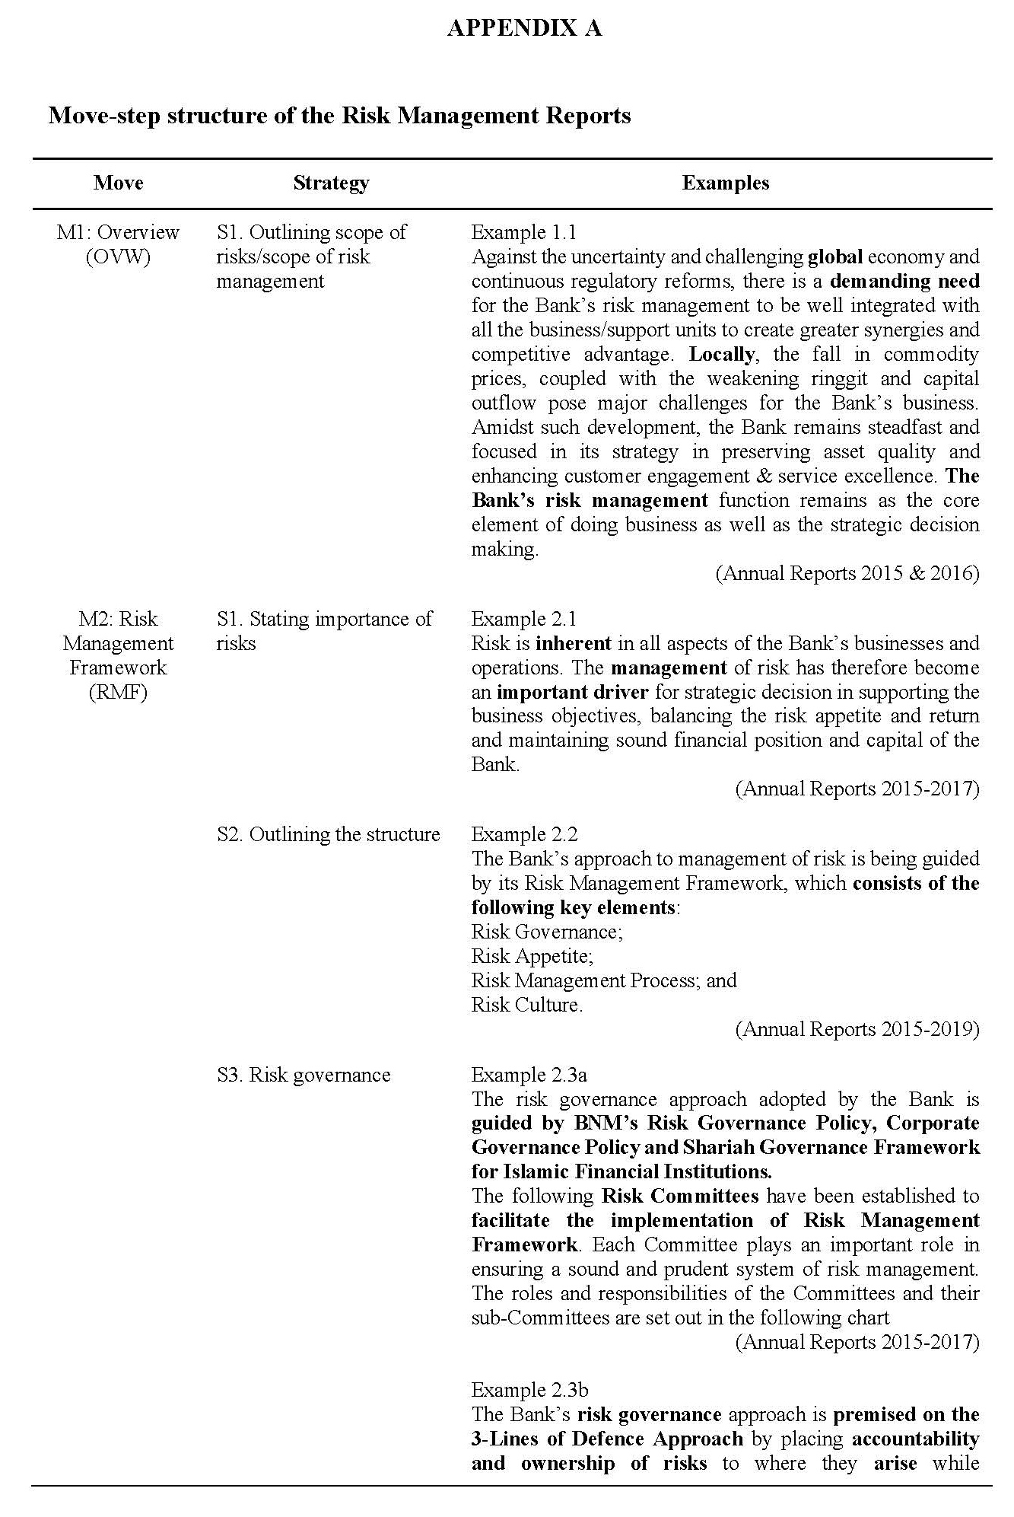
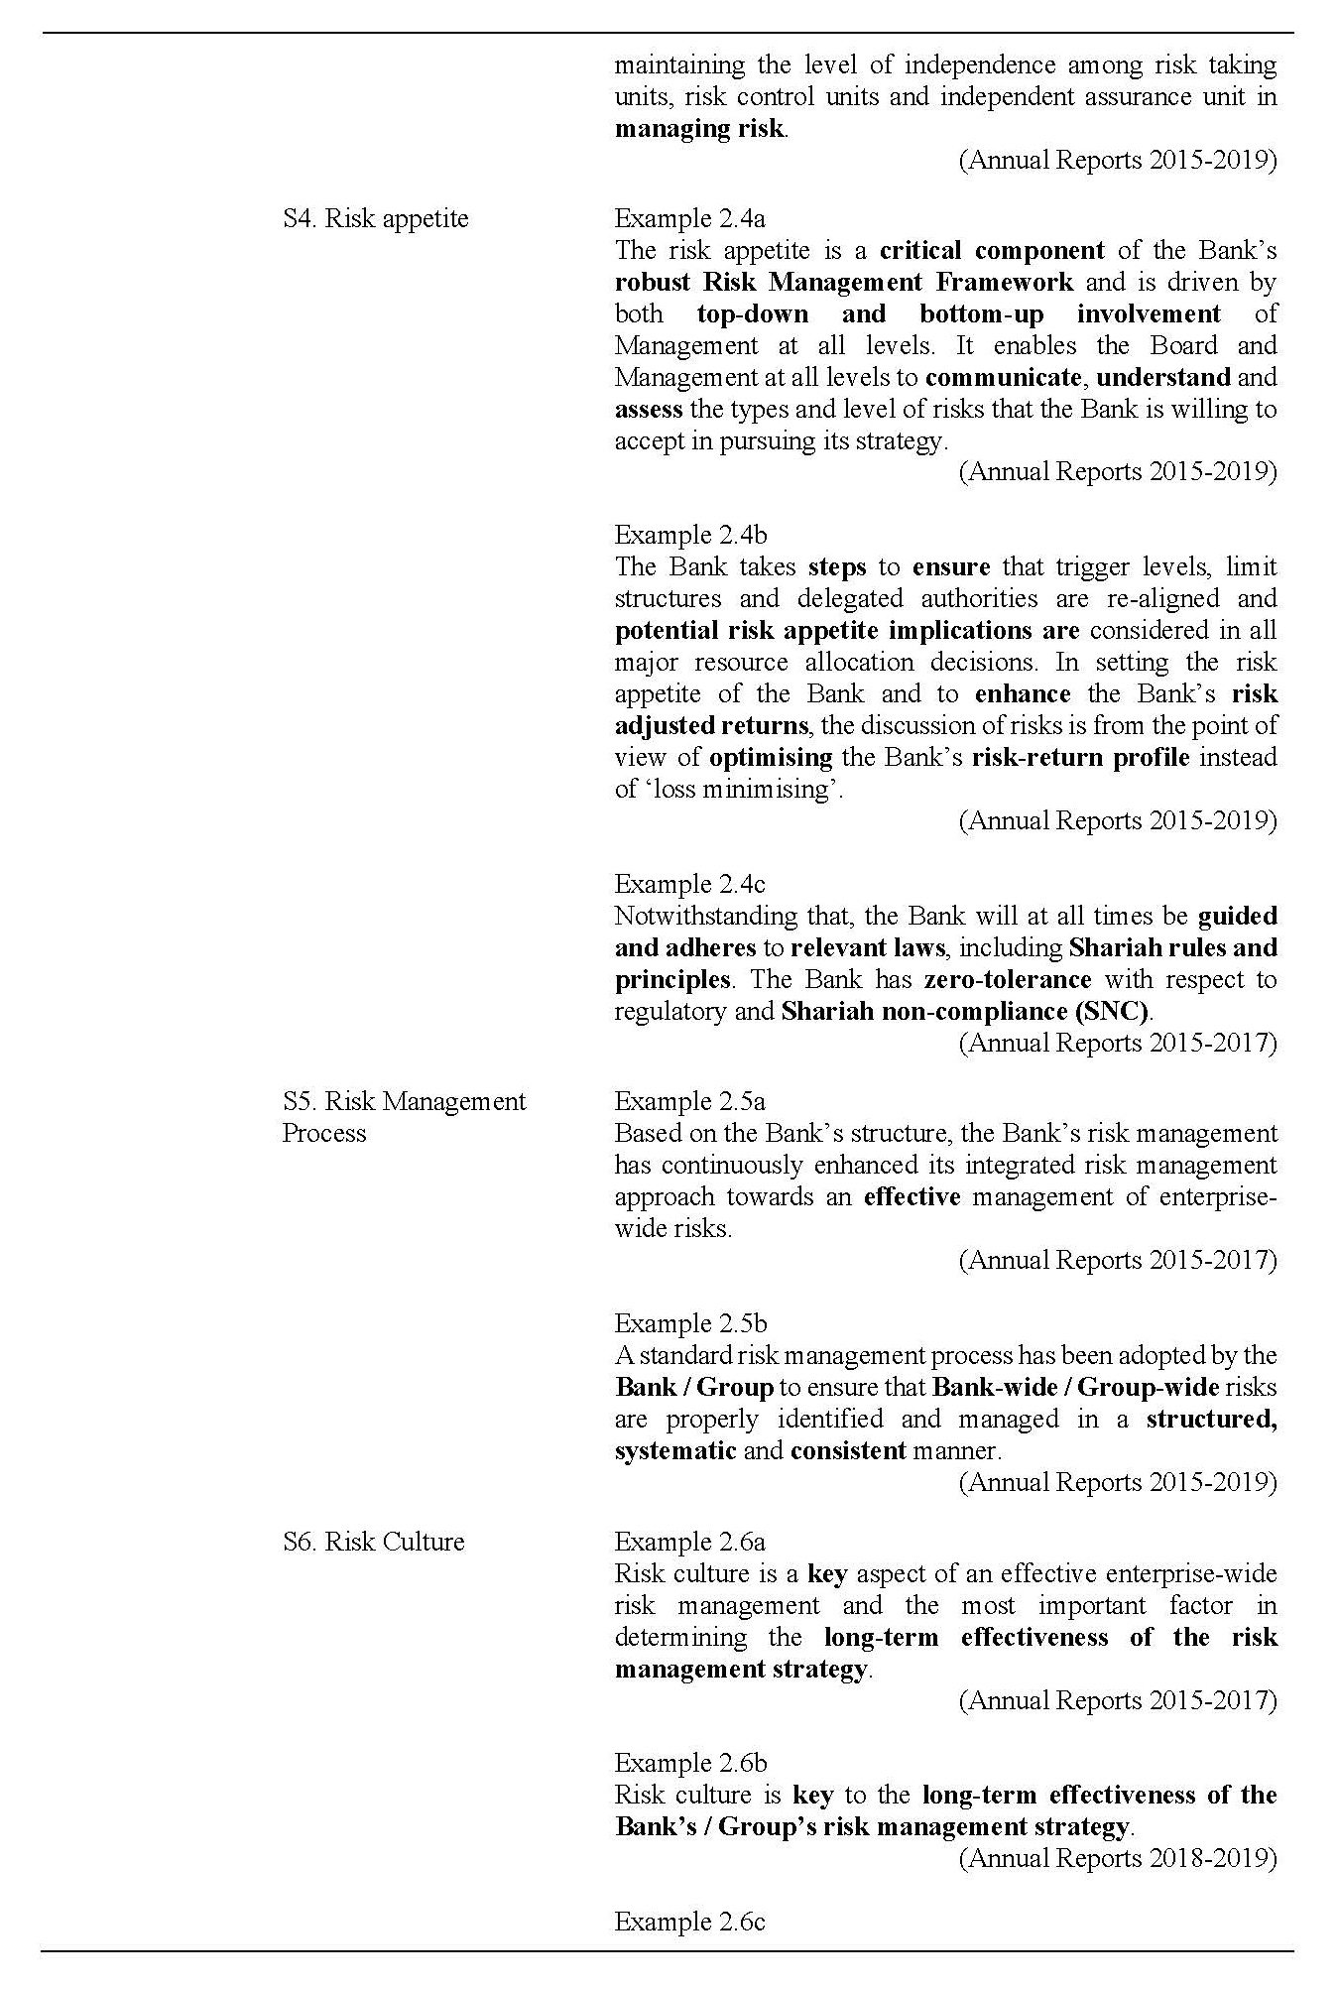
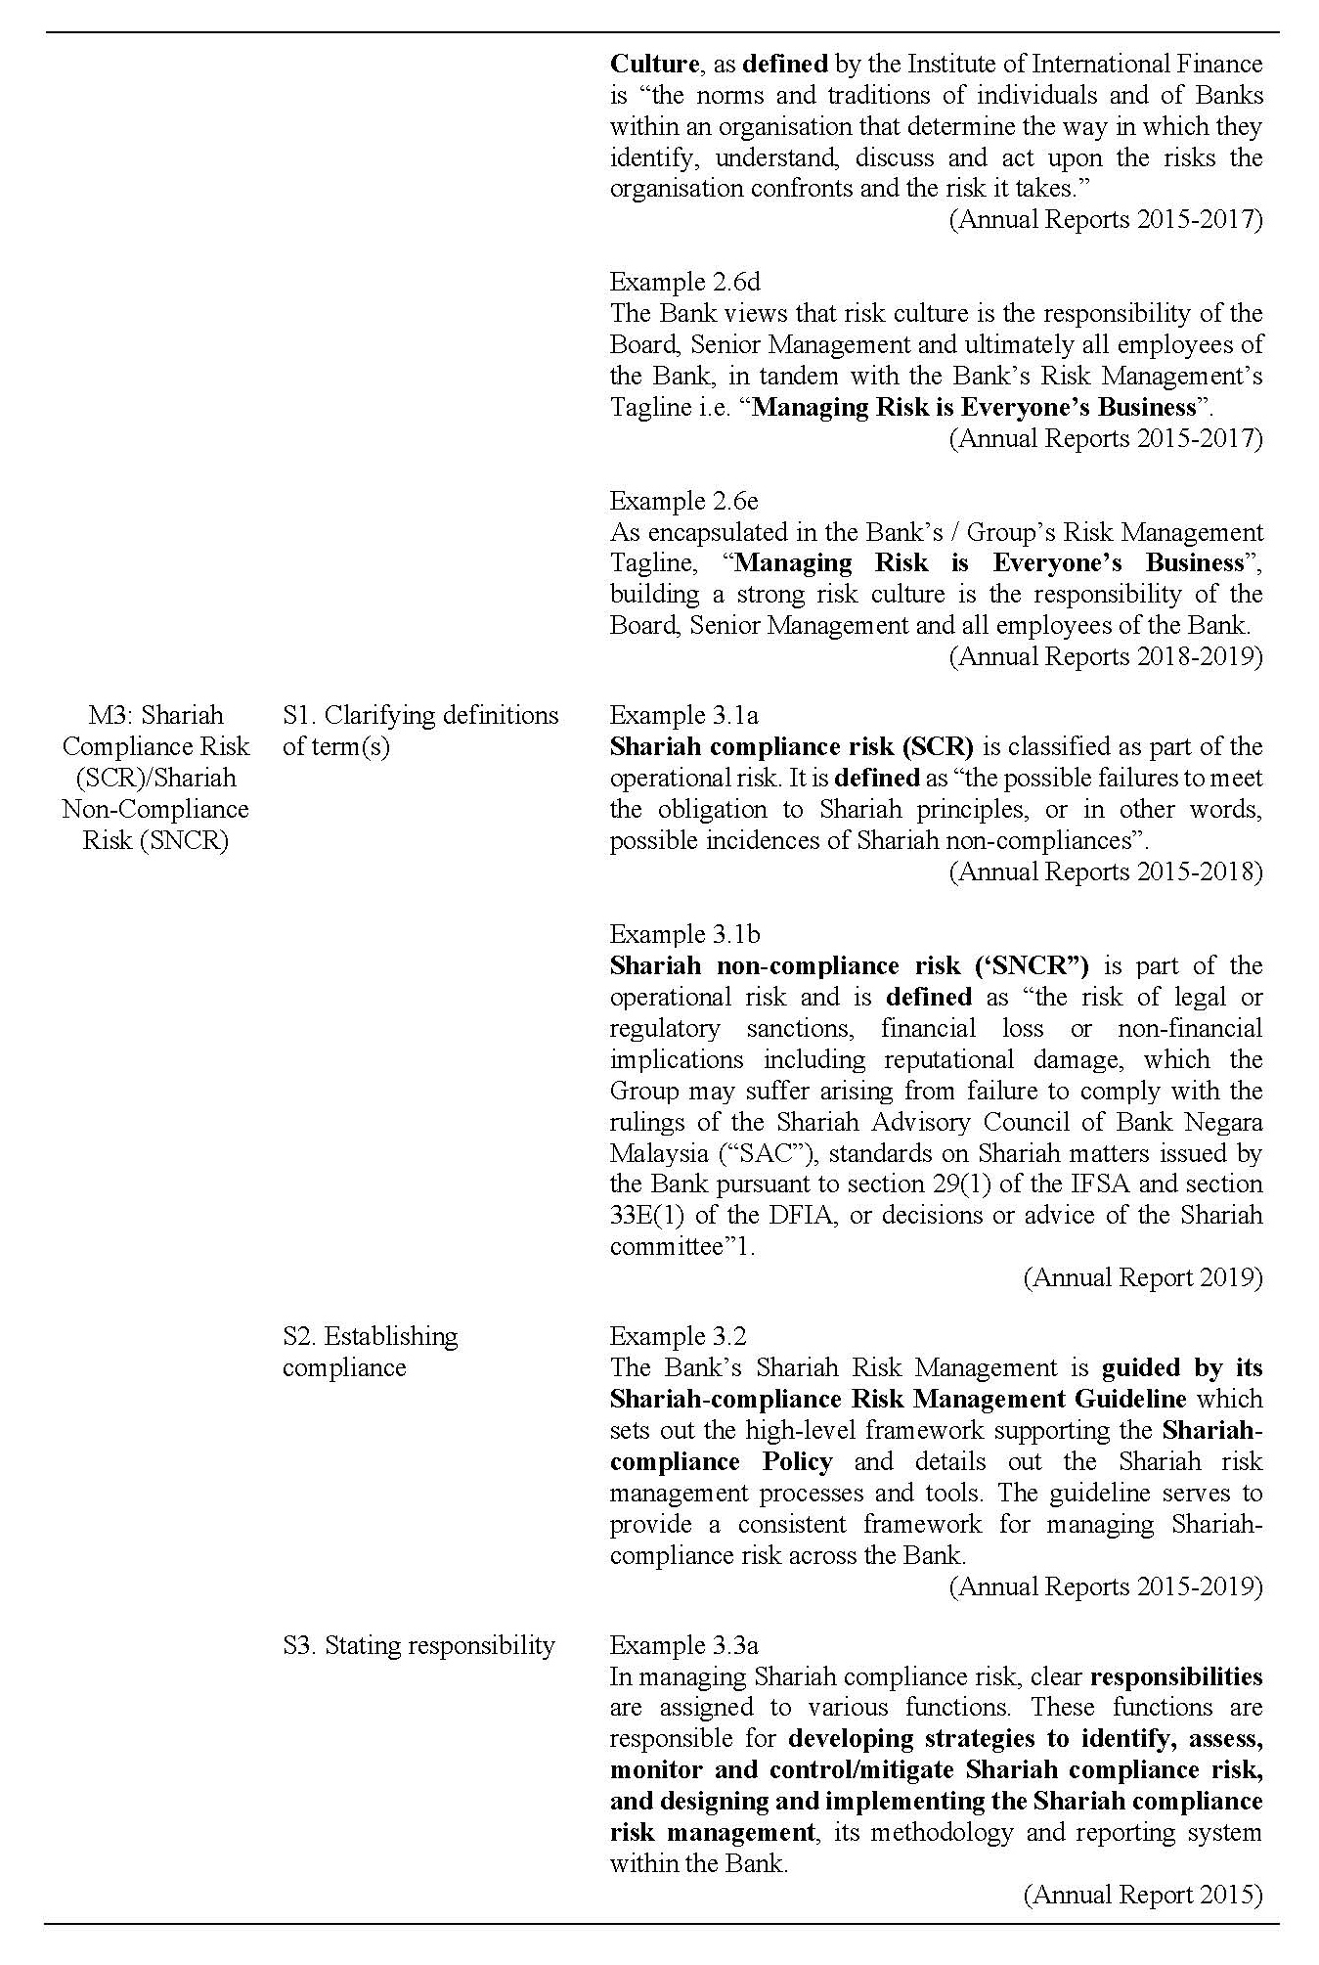
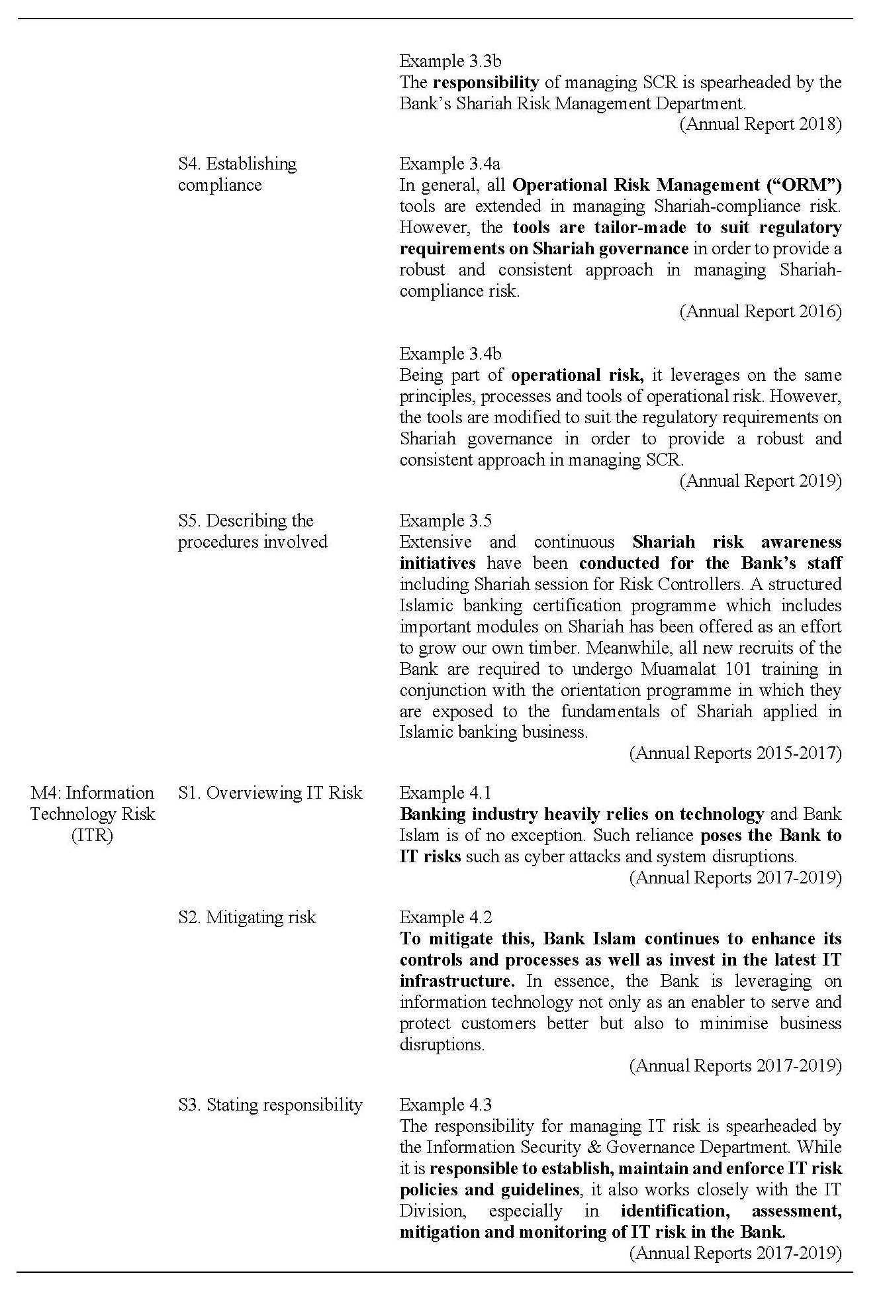
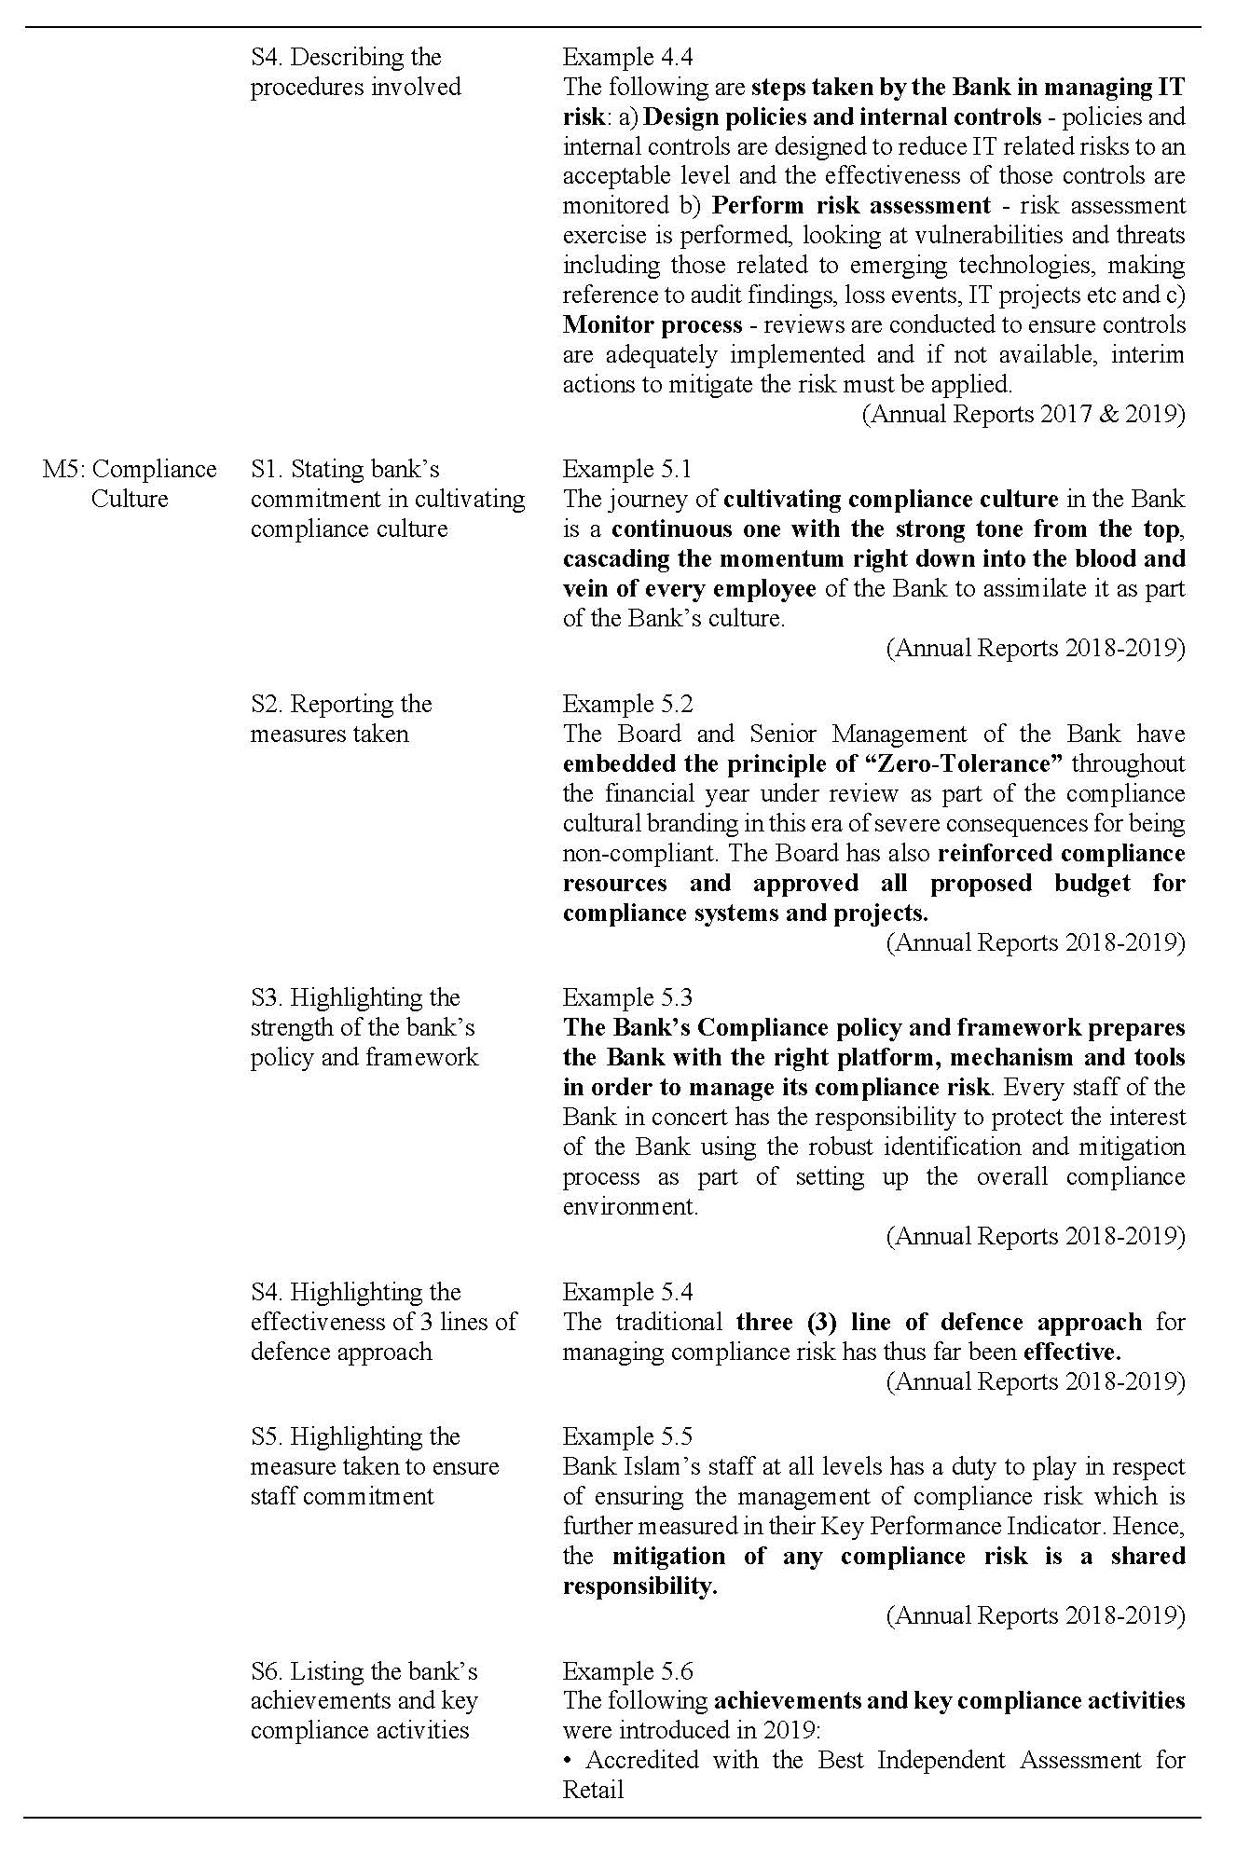
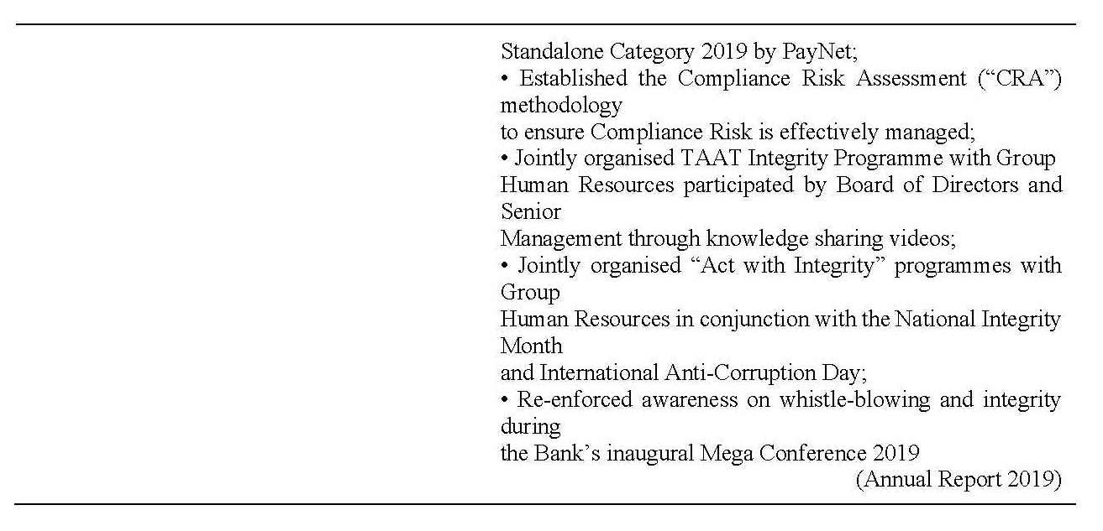

About the authors

Roslina Abdul Aziz is Senior Lecturer at the Akademi Pengajian Bahasa, Universiti Teknologi MARA Cawangan Pahang. She graduated with a master’s degree in Language Studies from Universiti Kebangsaan Malaysia and her doctorate in Corpus Linguistics from Universiti Malaya. Her research interests include Corpus Linguistics, ESP and Language Teaching and Learning.

Nadhratunnaim Abas is Senior lecturer at the Akademi Pengajian Bahasa, Universiti Teknologi MARA Cawangan Pahang. She obtained her master’s degree in Language Studies from International Islamic University Malaysia and her doctorate in Discourse Analysis from Universiti Malaya. Her research interests include Sociolinguistics, Rhetoric and Discourse Analysis.

Khairul Firhan is Lecturer at the Akademi Pengajian Bahasa, Universiti Teknologi MARA Cawangan Pahang. He obtained his master’s degree in Applied Linguistics from Universiti Putra Malaysia. He is pursuing his doctorate in English Language at Universiti Putra Malaysia. His research interests include Genre Studies, ESP and Language Teaching and Learning.

Norhidayah Md Yusof is Lecturer at the Akademi Pengajian Bahasa, Universiti Teknologi MARA Cawangan Pahang. She obtained her master’s degree in English Language Studies from Universiti Kebangsaan Malaysia. Her research interests include Applied Linguistics, Politeness, Language Teaching and Learning mainly on Teacher Talk.

The Annual Reports were extracted from a larger Corpus of Bank Annual Report (CorBAR), which comprises Annual Reports of international and local conventional and Islamic banking institutions operating in Malaysia.
Introduced by the Institute of Internal Auditors in 2013 (in Hakim, 2017), the approach was developed after the 2008/2009 worldwide economic meltdown to enhance communication on risk management and control by clarifying essential roles and duties of the senior management, governing bodies/boards/audit committee and internal auditor (IIA, 2013). It has since been applied successfully by many European institutions for years (Luburic et al., 2015) and has been adopted by financial institutions in this region, including Malaysia (Hidayah, 2016).
The British standard publication on Risk Management Code of Practice published in 2008 (revised 2011) defines risk appetite as “the amount and type of risk that an organization is prepared to seek, accept or tolerate”.
The IFSA 2013 outlines thorough statutory duties for the Board of Directors, Shariah Committee and the management of Islamic financial institutions to ensure that the industry achieves shariah compliant status (Siti Norshila & Jasri, 2013).
Both SCR and SNCR carry the same meaning as mentioned in the BNM’s Shariah Governance Framework (2011, p. 5), the terms SCR and SNCR are used interchangeably in the Bank’s documents.

