Postcolonial Aesthetics and the Representation of Malaysian Identities in the Picture Book App Upin & Ipin Storybook: The Rain and The Sea Part 1

ABSTRACT

Digital picture book app formats contain semiotic technologies that can produce transformative aesthetic and cultural engagement between producers and users. This transformative exchange takes place within the contact zone in picture book apps (that are also known as postcolonial texts/transcultural texts/intercultural texts). Since the richness in the multimedial and interactive quality (aesthetic quality) of picture book apps opens the way for transformative exchange, this paper explicates a model that employs the Semiotic Technology approach to investigate Postcolonial Aesthetics in the Semiotic Technology of the picture book app. Through a qualitative approach that has employed purposeful sampling to gather six picture book apps for a primary investigation, the digital picture book app version of the Malaysian animated series Upin and Ipin: Storybook: The Rain and The Sea Part 1 was selected as case study for this paper. Selection criteria consisted of three aspects; narration being in English and contained semiotic technology (interactively; that contained deeper semiotic affordances), the contents reflect characters, symbols and narratives that portray Malaysian culture, including aspects of popularity. The discussion especially reveals a postcolonial aesthetic that extensively operates based on the ideologies of the dominant class or culture through the representations of ethnic nationalism. Thus, this directs at a value that is not regarded as the effect of the stimuli on the senses. This article contributes to the ongoing debates about the aesthetic dimension of postcolonial literature with reference to specifically aesthetic valuation of the 21st century’s software applications in the form of picture book apps for children.

Keywords: picture book apps; semiotic technology; Malaysian identity; postcolonial aesthetics.

INTRODUCTION
Young readers shape themselves as global subjects and are shaped by the representations of people, places, and concepts they read and see in picture books. Moreover, “technological advancements of the 21st century have elevated the art of storytelling and allowed for stories to be created and disseminated through multiple modes of meaning” (Perry, 2020, p.20) especially in digitized formats as in the picture book apps. The meaning-making affordances in picture books are best investigated via semiotic theory, as suggested by Nodelman (1988). However, since picture book apps appear as technologically mediated resources, Poulsen, Kvale and van Leewuen (2018) including Zhao and Unsworth (2017) have suggested intensified multimodal social semiotic analytical tool such as the Semiotic Technology approach to reveal complex relationships within softwares like the app for social meaning-making. Thus, the best analytical perspective to investigate the semiotic, social, and technological dimensions of a picture book app as a technologically mediated resource for social meaning-making is the Semiotic Technology approach.
Due to rapid advances in technology, Mottus and Lamas (2015, p. 1) note that new ways for interaction are emerging, and thus aesthetic values of these interactions are enhanced through new forms e.g., “touch screens, speech recognition and gesture censors.” As such technology becomes more ubiquitous and interactive devices become highly intelligible, and aesthetic aspects adjoin, like “elegance of movement and enjoyable feel of touch” (Mottus & Lamas, 2015, p. 1). This is because users of technology “perceive aesthetics differently when they are actually interacting with a technology instead of just watching or holding it passively” (Mottus & Lamas, 2015, p. 1). It is further reported that most studies were found to mention mobile phones and touch devices as products with aesthetic values mainly due to interactivity elements.
Ashcroft (2015, p. 415) notes that “postcolonial” aesthetic,” “lies in the materiality of the language, for this is the space of contact between cultures.” However, this study contends that besides language, any form or mode with affective or “non-cognitive” quality like visuals, music, dance etc. can lead to postcolonial aesthetics. For example, the digital picture book in the app form which is made up of multimedial and interactive digitized elements such as touch designs, multimedia tools and personalized content creations (the resonance of this digitized postcolonial text) is perceived as containing aesthetic values reveal to us a more contemporary aesthetics.
Due to its interactive, fun and wide-screen physical materiality as a device, the Asianparent Insights (2014) had reported that the iPad is found to be the most popular device across Southeast Asia with 40% of children in SEA having access to the iPad. In addition, latest statistics by Application Category Distribution stated that in July 2017, the Book category apps have been listed as one of the top ten applications. Having such preference reported, it is of opinion that with such powerful material resonance as one of its aesthetic values, children’s picture book apps crucially must have adequate and equal representation of racial and ethnic groups, and to give voice to the stories and experiences of diverse groups of people. This study investigates the different roles postcolonial aesthetics play through semiotic technology (digital picture book app) for a more meaningful production of Asian identities in the story of Upin & Ipin Storybook: The Rain and The Sea Part 1.

PATH TO POSTCOLONIAL AESTHETICS IN DIGITAL PICTURE BOOK APPS FOR CHILDREN

According to Nankani (2015), Campbell Naidoo and Sarah Park had reported that diversity gap exists in children’s digital picture book apps. In addition, survey on Ethnic Representations in Children’s Books conducted by the Centre for Literacy in Primary Education (CLPE) in UK in (2019) shows that there is still a gap in representation of diverse ethnicities in children’s digital picture book apps. As noted by CLPE, it is vital to ensure that there are accurate and positive representations of people from diverse ethnic and geographical backgrounds so that children are able to ‘mirror’ themselves in the books that they read. Although there are publications of works featuring diverse cultures and people are on the increase, for the most parts, many publications both print and digital are still Western centric.
Children’s literature is a subject of concern particularly due the prominence of Western culture and contexts in its contents. This scenario is also present in prominent fictions for young adults (Rasagam, 2016). The majority of interactive book apps for children in the Apple Store as observed during the data collection for this study were found to be centred on Caucasian characters and contexts suggesting a lack of diversity in ethnic and cultural representation in the genre of children’s digital edutainment resources.
The availability of children’s books as mirrors are important because being able to see reflections of their own culture, they learn how much they are valued/undervalued in the society they are a part of. This is especially important for children of minority groups. Whereas it is crucial for children of the dominant groups to be able to “look through windows” and walk through the wider sliding glass doors “of books to come to know people whose cultures are different from their own” (Bishop, 1990, p. 15) to overcome glorifying homogeneity or ethnocentrism. Besides, books that play roles as windows and sliding glass doors, “help to socialize children,” and “nurture imagination” (Bishop, 1990, p.15-16) This is worrying as cultural contents that are alien to children belonging to a multiracial community in a country such as Malaysia, convey values and beliefs by borrowing views and thoughts from cultural realms other than from their own national community (Vengadasamy, 2011).

POSTCOLONIAL AESTHETICS

‘Aesthetic’ is generally defined as “a set of principles concerned with the nature and appreciation of beauty” by the online Oxford dictionary (as cited in Mottus & Lamas, 2015, p.1). However, more than the dictionary definition, it is important that this study responsibly highlights an awareness of the journey of aesthetics in the literary sense in terms of Aristotelian aesthetics, to New Criticism and then to Postcolonial aesthetics. Moving on, the denotation roots from the Aristotelian aesthetics related to the “beauty…” that “consists in a correspondence of artistic creations” (Marshall, 1953, p. 228). Artistic creations according to Marshall (1953, p. 228-229) are contained by “productive knowledge” and they encompass creations of “things from houses to poems” through “human creativity.” This category of knowledge concerns the ways to make things appear beautiful (appealing) when artistic creations or “artistic productions correspond to reality” (Marshall, 1953, p.228). Ferrari (1999) believes that the artistic creations/artistic productions stated in Aristotle’s Poetics refer to what is termed as “literature” nowadays while postcolonial critics like Boehmer (2010) raise the overlapping between the field of poetics and aesthetics and also the “sharing of a common genealogy” (Shusterman, 1986). Poetics/Aesthetics are anyhow related to the emphasis on the historical, social, biographical, or psychological contexts, or the moral or philosophical implications (including the textual-linguistic) of an artistic production (Francis, 2008).
However, the New Criticism approach detaches the work from its author right from its point of creation. In other words, as stated by Francis (2008, p. 29), the “central tenet of New Criticism: when it comes to reading, a critic needs only the text itself, not anything outside the text.” This objective and formal approach is perceived by aesthetic theories (in literary sense) as interpreting meanings from text-object (especially poems) itself along with its “formal components” instead of interpreting meanings perceived from the readers’ view. Thus, the aestheticism of literature from the New Criticism point of view, became invisible and been isolated away from the aesthetic theory (Francis, 2008).
In the postcolonial context, the notion of aesthetic appears to be “devoid of any instrumentality or interests or political ends.” Hence, the theory of aesthetic has been cautiously avoided in the postcolonial literature context. The notions of ‘aesthetics’ and ‘postcolonial literature’ are perceived by many postcolonial scholars as paradoxical or “contradictory in terms” (Moslund, 2015, p. n.a). This view is because ‘aesthetic’ concerns “matter of taste or harmony or transcendental experiences of beauty” while ‘postcolonial writing’ is “a form of literature that never loses sight of ideology/political approaches. Nevertheless, Boehmer (2010, as cited in Moslund, 2015, p. n.a) had suggested that a postcolonial aesthetic can be of affordance with a notion that generates “a fundamental critique of the values we live by, for example by raising questions of the final unknowability of other human beings.” This means, Boehmer suggests “an aesthetic reading of literature” that does not lack interest “to ideology” but “highly critical of ideology” (Moslund, 2015, p. n.a). In other words, an aesthetic that grounds manifestations of “objects and things of the world, brings these near and the artwork” (postcolonial text), “accordingly invites a philosophical exploration of how we relate to reality at several levels and modes of experience and existence.” This is in interest of this study as its main objective is to investigate ways Asian representations are made/created to foreground the roles of postcolonial aesthetics (‘beauty’ that underlies postcolonial texts) through an interactive semiotic technology.
Boehmer’s pioneering suggestion of a possible theory of “postcolonial aesthetic;” also taken up by scholars like Ashcroft (2015), John Su (2011), Lokuge (2010), Huggan (2007), and Bahri (2003), has interestingly led to the way for an exclusive inquiry of the aesthetic dimension in postcolonial texts. However, in this article, the most recent view of developing a specifically postcolonial aesthetic by Ashcroft (2015) will be discussed to address its objectives. In particular, the concept of postcolonial aesthetics in analyzing the picture book app in this study is developed through a critique of Ashcroft’s concept.
From Ashcroft’s angle, postcolonial aesthetics is understood as an area embedded or joins along the meaning process in a postcolonial text (also known as “transcultural text” or “intercultural text), that triggers feelings/emotions, and this “affective space” (pg. 410-411) enables a kind of (cultural) shared metamorphic exchange between text producers and consumers. Such a metamorphic exchange takes place when postcolonial texts as “diverse” (Young, 2013, as cited in Noske, 2013, p.614) or “hybrid and multiplicitous” (Ashcroft, 2015, p. 614) category, are produced and consumed through a variety of cultural contexts where levels of various worlds meet. During that instant, contact between “producer and consumer” in the “affective” “contact zone” (within the postcolonial text) is mutually transformed (“transformative exchange”). Such “a mutually transformative affective space” is what postcolonial aesthetics all about according to Ashcroft (2015, p. 411).
The aesthetic transformation that takes place in the affective space of the contact zone gives “a value” “to a property” (Ashcroft, 2015, pg. 413). And these values are related to emotional responses that are driven by senses (aesthetic response) as effects of the stimuli. Once the transformation has taken place in this space, the type of role played by the aesthetic(s) in the contact zone is determined by its status as either an ideology or stimulus, as universal or cultural-specific or as elitist vs quotidian.
“Aesthetic response as an effect of stimuli on the senses” is strongly claimed by Ashcroft (2015, p. 413) as opening up “a vast area of intercultural exchange.” However, the definition or status of aesthetic roles depends on the type of value triggered by the engagement with an object. “Values for” are non-judgmental and transcultural or “ideologically determined inherent value- values of a dominant class or culture.” And these values “vary according to the nature and context of the aesthetic engagement.”
It is important to understand that salient features in a postcolonial text (materiality in a text) determine the kind of engagement with the text. This affective response to the materiality of the text is described to be aesthetically engaged one. With reference to this physical construction in texts, the digitally mediated resources found in the selected picture book app are the materialities of text. One category of affective response is aesthetic engagement that operates as a “stimulus” instead of an “ideology” (Ashcroft, 2015, p. 413). Aesthetic engagement with the materiality of the text determines the transculturation or cross-cultural communication in the affective space that is embedded in the meaning process.
This study aims to investigate the roles played by “affective spaces” created by children’s picture book app creator(s) and consumed by users. It will focus on investigating the roles played by postcolonial aesthetics foregrounded by the digitally mediated resources found in the selected picture book app is the main aim of this study.
Nevertheless, Ashcroft’s (2015) emphasis on the centrality of language in his discussion of postcolonial aesthetic to explain mutual cultural transformation is not entirely agreed upon in this paper. Through his discussion in Towards a Postcolonial Aesthetics on the idea of richness (resonance) in the language of the postcolonial text (including postcolonial arts), it is realized that postcolonial aesthetics also lies in materiality of visuals, music, as well as “sensory stimuli such as touch...” (pg. 419). His limited discussions about the postcolonial aesthetic values that lie in the other forms of 21st century digital textual materiality will be extended in this article.
In addition, in the final section of his article, Ashcroft (2015, p. 419) had suggested that “to cover a range of textual formations…we can call the “material resonance.” He further exemplifies using combination of language, music and voice in songs about apprehending or knowing of the otherness of the other.” In other words, through materiality of text, apprehension beyond meaning is possible. Moreover, the idea of “affect the meaning” (by the stimuli or communication media: iPad – touch screen) by this physical or material construction of a postcolonial text (“different media affect the meaning they carried”) is said to allow “experiencing, responding to, of “understanding” the world apart from structures of meaning” besides the type of interpretation secured in language/linguistically. Material resonance is professed by Ashcroft (2015, p. 420) as placed at the “heart of the aesthetic encounter.”
In the twenty first century, newer forms of postcolonial texts (including animated e-books, enhanced e-books, and book applications (or apps) such as the picture book apps have become increasingly pervasive through materialities of communication like communication media in the form of digital devices to cater for the current generation of children who are digital natives.
The most interesting and sought-after digital book format is the app format, that is based on these two characteristics: multimediality and interactivity (Zhao & Unsworth, 2017). In other words, it is interesting to observe that the digital book format is the type of postcolonial text or the contact zone in which calls for a semiotically critical analysis on the digitized materialities in this text (embedded in the meaning process) to understand the type of aesthetic role involved in its affective space. Anyhow, it is strongly recommended by Nodelman (1988), that the (multimodal social) semiotic theory is the best adopted to understand meaning-making potentials in picture books. This is because texts and images that form the base of this printed picture book format are semiotic agents that can impact readers through words, and visuals. Similarly, Van Leeuwen had responded to the semiotic surfaces in software technologies like the digital book application by outspreading the social semiotic theory to a more holistic approach for critical multimodality that he refers to as “Semiotic Technology in 2013 – technology for meaning-making” (Zhao & Djonov, 2017, p.10).
As picture book apps use technologically mediated resources as materialities in the text, the Semiotic Technology perspective is selected as the analytical tool to assist in foregrounding the role played by the postcolonial aesthetic in this picture book app. This approach “investigates how social and semiotic assumptions and norms are inscribed in software and other kinds of technology and realized in social practices that use the technology” (Poulsen, Kvale & van Leewuen, 2018, p. 594).
In addition, in the context of mobile apps, the most defining interactive feature is to touch the screen. Furthermore, it is asserted that the salient feature of a book app is interactivity (Sargeant, 2015). A touch screen device such as the iPad together with the interactive features (touch designs within the content of the story in the app) in the case of this study, are the stimuli that cause the effect on the senses (aesthetic response) of users, and this will lead to the process of aesthetic transformation which gives value to the Asian contents in the picture book apps. Then, the engagement will determine the type of aesthetic role or status in the representation of Asian identities in the picture book app.
The type of interactive touch design involved as one important variable in this study, intra-text design, consists of a hotspot or button that does not signify or “symbolize” the outcome. Intra-text interactive hotspots “typically designed using visual narrative elements like the characters, the background of a page, and various inanimate objects” (Zhao & Unsworth, 2017, p.95) enable semiotic acts or meaning-making affordances when users of the story app perform physical acts such as tapping, swiping, or clicking. In the case of the intra-text interactive hotspot in this study, when the user taps or clicks on the main characters of this story; Upin and Ipin, sounds of excitement and their facial expressions change to smiles and mouths open to show joy. The image of these characters does not represent the purpose of tapping or the clicking, instead connotes several sociocultural related meanings. This type of interactive hotspot is the primary affective element that contributes to the resonance of this story app as it enables some kind of sense through its stimuli (iPad) that triggers an aesthetic sense or quality which causes mutual engagement between producer and user of this app in the space of this app. The engagement would involve a simultaneous aesthetic and cultural engagement especially when producer and users belong to diverse cultural backgrounds. Types of Interactive Touch Designs are as seen in Table 1.

TABLE 1. Types of Interactive Touch Design
Activity Hotspot/Button Outcome
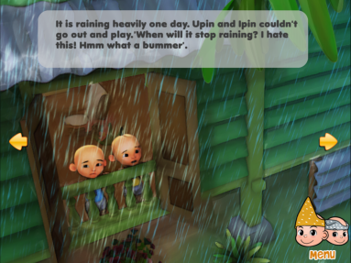
(touch gestures: tapping/
clicking)
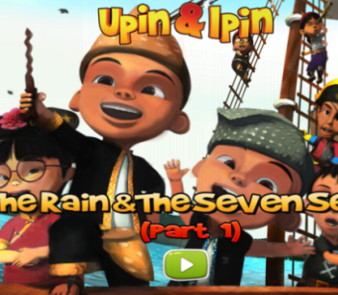
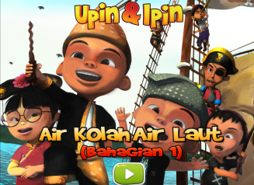
- Extra-text
interactivity

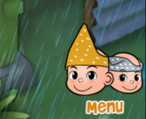
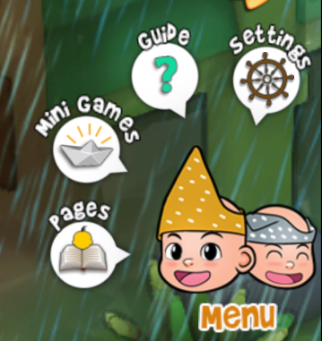
Settings
Guide
Mini Games
Pages navigation
- Intra-text
interactivity

Besides that, since multimodality encompasses all latest technologies including interactivity as claimed by van Leewuen (2018), the multimodal dimension is relevant to the first objective of this study. This dimension is extended to semiotic technology; technologically mediated resources like the texts, images, audio, audio recording, animation, interactive games, and other types of digital interactive media are described Poulsen and Kvale (2018). As the first objective of this study is to investigate meaning making through selected digitally mediated resources like words, images and most importantly extra-text and intra-text interactivity touch designs, this dimension was found to be relevant.
The social dimension on the other hand, can be used to analyze the meaning-making process involved in apps as semiotic technology at one level, the “social as a strand of meaning” (Poulsen & Kvale, 2018, p.704). Meaning making in this context is analyzed in terms of three strands of metafunctional meaning: ideational, interpersonal, and textual metafunctions. Each of these strands are described below. The other three levels of this dimension are more suited to the purposes and roles played through social networking activities unlike from those involved in software applications like the picture book app. Thus, these three levels are irrelevant to the approach practiced in this study.
Ideational metafunction refers to “objects, people and places within an image” and it refers to the power of semiotic systems to represent objects and their relations in a world “outside the representational system or in the semiotic systems of a culture” (Kress & Van Leeuwen, 1996, p.40). Hence, in the case of this study, representation of identities among Asian communities in these picture book apps via semiotic technologies can be successfully investigated using objects or people and their connectedness within or outside their realm, through ways offered by semiotic systems.
The interpersonal metafunction is about the actions among all the participants involved in the production and viewing of an image as informed by Kress and Van Leeuwen (1996) (that is the interactive as well as the represented participants: the app producers, the viewers/users and the participants depicted within the image). However, the aim of this study is to investigate meaning making by the interactive semiotic technology contents in the picture book apps together with merely its users.
Since textual metafunction acts as the compositional factor of an image or the layout of a semiotic system that represents meanings as a whole, this study has integrated ways picture book apps as semiotic technology had been used to represent Asian communities.
Thus, this material resonance in the digital picture book app that is made up of an assemblance of materialities of text namely visuals, written texts, sound/music, including sensory aspect like the touch designs (these are also conventionally described as semiotic or meaning-making signs) enables the tangible effects that affect meaning when aesthetically engaged in this contact zone. In other words, through the digitally semiotic materialities in the picture book app for children, this paper intends to investigate the type of role played by the postcolonial aesthetic in the representation of Malaysian identities. This objective is achieved with the conceptual framework that has been described above.

METHODOLOGY
This section will discuss in detail, the methodology for the described conceptual framework of postcolonial aesthetic valuation (pages 7-10) used in this study including the research questions and method of data collection.
In this article, we examine ways postcolonial aesthetics plays its role(s) in representation of Malaysian social contexts like identity markers. This role(s) is/are foregrounded by the interactivity element like the touch-designs in the context of digital picture book apps for children. Specifically, we intend to answer the following research questions:

- How are the Malaysian social contexts represented through interactivity features in the popular children’s picture book app in the i -Books (iOS) for the iPad?

- How can postcolonial aesthetics of interactivity play a role for a more meaningful production of Malaysian Identities in the popular children’s picture book apps in the i -Books (iOS) for the iPad?

DATA COLLECTION METHOD

Through a non-random/purposeful sampling method, Asian communities from four Asian geographical divisions were identified from the book apps listings for children according to age categories in the App Store including listings of 70 picture book apps in the website’s listings according to age categories of Common Sense Media (at https://www.commonsensemedia.org/lists/best-book-apps-for-kids). Common Sense Media is a software evaluation site for children’s book apps recommended by Rosalind Charlesworth, a Professor Emerita profound in the fields of child development and early childhood education. In addition, developers not updating the apps’ versions and vague regional (geographical) nor ethnic or race affiliation was criteria too for a purposeful method of sampling. Thereafter, a total of five picture book apps for children in the corpus were identified. However, as this study is at a preliminary stage, this article discusses 1 picture book app as case study, and only elements of animated visuals and text especially interactivity is discussed (i.e.: hotspot buttons in the form of intra-text interactivity that contains deeper semiotic processes compared with extra-text interactivity).

DISCUSSION

UPIN AND IPIN STORYBOOK: THE RAIN AND THE SEA: PART 1
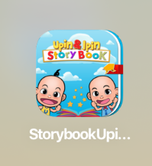

FIGURE 1. Profile Cover of the Picture book App

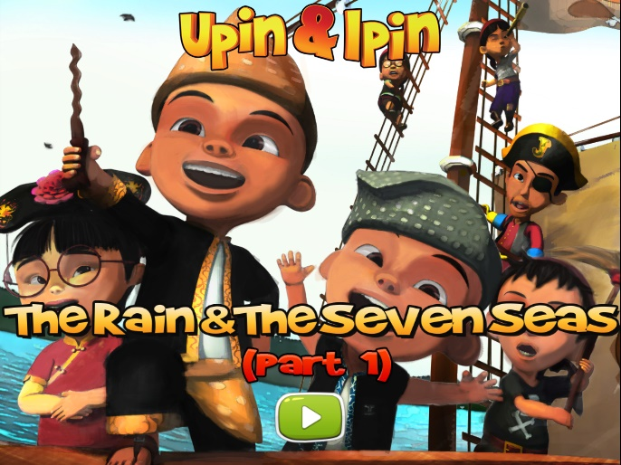

FIGURE 2. Page 2 of the Picture book App

BACKGROUND AND SYNOPSIS OF STORY AND PICTURE BOOK APP

This picture book app is developed by Les’ Copaque Games Development Incorporation for children aged four and above. It was first published as an app in 2016, and made available as an iOS app. This app was made available as free in the Top List under Kids Category in the iBooks for iPad. This story app is for users aged 4 and above. The following will present a discussion on identification of salient identity markers found within the Asian/Malaysian community represented in Upin & Ipin Storybook: The Rain and The Sea: Part 1 according to identity markers including geographical aspect. On the overall, this study finds Asian identity markers such as geography, cultural architecture, race (skin color and physical appearance), ethnicity and language represented in this picture book app.
The plot in Upin and Ipin Storybook: The Rain and The Sea: Part 1 begins with Upin and Ipin, the main characters, who were bored with being indoors as it was a rainy day and had come up with their own imaginary sea adventure. The story narrated appears to be set at first in a Malaysian kampung house with few other prominent characters in Upin and Ipin’s life like their Opah (grandmother) and their elder teenage sister, Kak Ros. Users are subsequently brought to a flashback of several parts from 15th century Malaya through extra-text interactivity. These time and geographical settings in the first half of the story are perceived to be set during 21st century in Malaysia while the sea adventure directs at the 14th-15th century Malaccan Maritime of the Southeast Asian Sea. It is also believed that the second half of the story is based during the 15th century Malaya because Upin and Ipin appear as Malay warriors: protagonists Laksamana Hang Upin and Laksamana Hang Ipin (believed to refer to Malayan historical admirals, Hang Tuah and Hang Jebat).
The discussion that follows is based upon Asian/Malaysian identity markers reflected through cultural and digitally interactive visual language including texts. These modes are presented in animated form. Animation is claimed to have its ambivalences by Dahlan Abdul Ghani (2015). “Thus, it contributes towards the role in educating young children but there is significant potential to capitalize on their ability to enhance development and learning especially related to social or cultural issues” (Luckin et al 2003, cited in Dahlan bin Abdul Ghani, 2015, p.245). The narrative used in Upin Ipin animation represents the overall within the Malaysian multicultural context. Hence it is agreed with Dahlan Abdul Ghani (2015) that “Upin and Ipin signifies the art of animation that influences the children’s cognitive and thinking faculty which responds to the cultural scenario in the country” (p. 245) The picture book app representing the digitized story of Upin and Ipin has great influence on children’s mind, because digitally interactive “animation has strong cultural resonances” (p.245) for many children through provision of material resonance.

ANALYSIS & FINDINGS

ROLES OF POSTCOLONIAL AESTHETICS IN REPRESENTATION OF MALAYSIAN IDENTITIES FOUND IN
UPIN AND IPIN STORYBOOK: THE RAIN AND THE SEA: PART 1

For the purpose of establishing a comprehensive analysis, this study conducted a micro-level analysis about identities of Malaysian communities in the animated visuals and texts of this picture book app using geographical division, cultural architecture, ethnicity, race, and language. More importantly, thereafter, the ways Malaysian communities were represented through technologically mediated resources in this picture book app and how this foregrounds the role (s) played by postcolonial aesthetics has been discussed as follows.

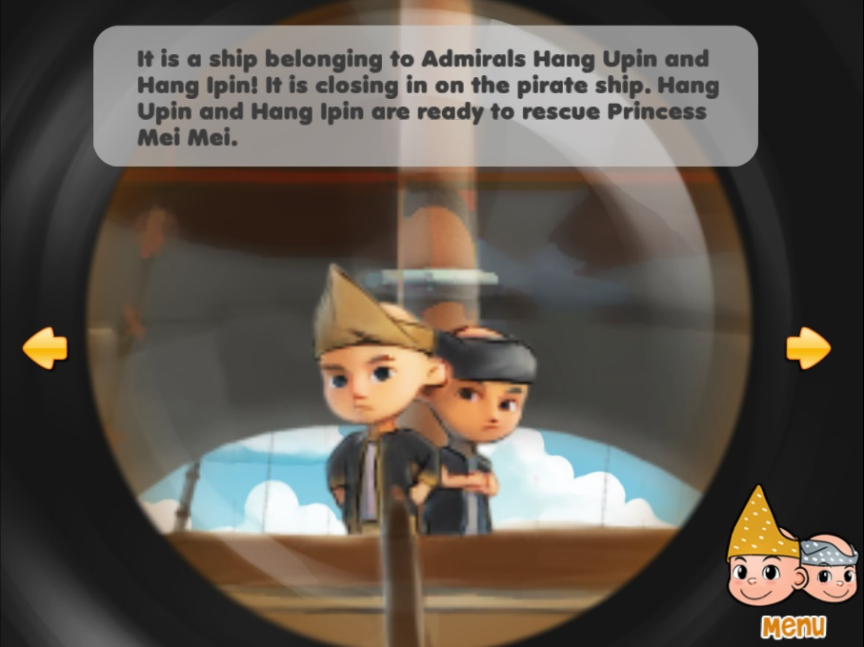

FIGURE 3. Page 16 of the Story App: Upin and Ipin Represented as Admirals Hang Tuah and Hang Jebat

In their sea adventure, animated visuals of Upin and Ipin as materialities of the text have been represented in traditional Malay male costume referred to as “baju Melayu” (consisting of a loose tunic which is worn over a pair of trousers and accompanied with a sarong called a sampin, wrapped around the hips along with a tengkolok as (headwear). This cultural clothing also marks their Asian identity as Malays of 15th century Malaya located in Southeast Asia. This too foreshadows the geographical aspect of the story. Furthermore, visual representation of the Malaccan admirals (roles played by Upin and Ipin) is another “performance” which “stimulates the sense of being a member of a select group” (McLeod, 2000, p.69). The multiplicity of the heroic legend, Hang Tuah, “has had an everlasting appeal, told and retold in many forms, from theatre productions to children’s comic books to box office movies” including becoming the “subject of many academic studies.” “Hang Tuah – the great native warrior — served as a unifying nationalistic figure in the colonized nation on the brink of independence” (van der Putten & Barnard 2007, as cited in Rusaslina Idrus, 2016, p.4-5). Even in the 21st century, Hang Tuah’s name is “ever present in the landscape of the country:” from street signboards to stadiums and museums including subway stations as well as state-sponsored awards for children. With representation of Hang Tuah, “the legendary hero of Malaysia” (Rusaslina Idrus, 2016, p.5), this paper opines that it “helps concoct the unique” (aesthetic) “sense of the shared history and common origins” of the Malaysian people (McLeod, 2000, p. 69). The postcolonial aesthetic lies in the materiality of the animated visuals of Upin and Ipin as Malaysian legendary heroic figures as this is the space that has enabled “affective” engagement between producers of these visuals and users of this picture book app. This affective engagement is mutually developed between producer of the app and users as the kind of cultural realm involved in this contact zone is not what the “western philosophy would wish it to be” (“inherent value”) (Ashcroft, 2015, p.413). Hence, in the space of contact in such a zone containing representation of diversified Malaysian identities, the multiplicity (transformation) of the legendary hero beginning from prehistoric Malaya up till today is the point where mutual aesthetic transformation occurs together with a cultural transformation.
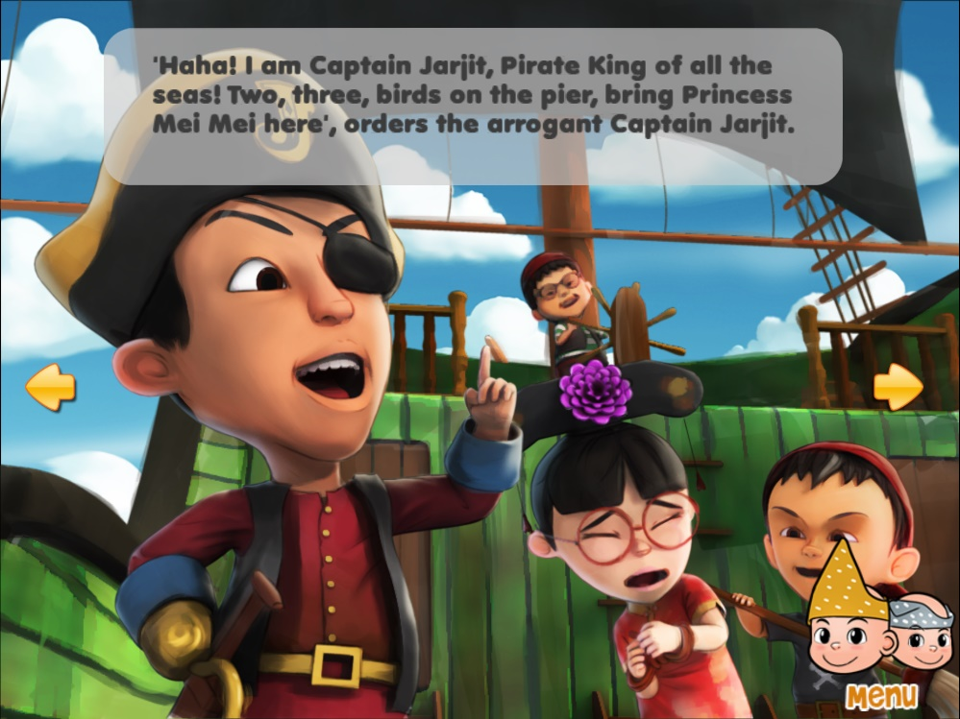

FIGURE 4. Page 13 of the Story App: Presence of three Major Ethnics in Malaysia and Representation of prehistoric and colonial characters

Other than this Malay ethnic group, two prevalent and large Asian populations (Asian identity marker: ethnicity) have been presented in this picture book app; the Chinese and Punjabis. Besides Jarjit, of the Punjabi Sikh community, and who is represented as dressed in the attire of a British sea-captain with a hook for his right hand, Mei Mei who is Chinese, is represented with more salient cultural and physical attributes of a Chinese princess, dressed in a traditional Chinese Cheongsam along with a traditional royal Chinese princess headwear. These three ethnic groups; “Malay, Chinese and Indian, predominantly define Malaysia” (Kaboudarahangi, Osman Mohd Tahir & Mustafa Kamal M.S, 2013, p.198) and they are strongly articulated in the story of this app as linked to a political, economical and cultural historic form in a pre-colonial period. The multiethnic representation in this picture book app shows not only Malaysian identities but also Asian identity markers as present in this picture book app.
As a matter of fact, the ASEAN Intellectual Property Portal was reported as acknowledging “Upin & Ipin animated series to bring in millions of new viewers on their YouTube Channel and Disney Channel Asia who are subscribers from Southeast Asian region” (Nor Ashikin Seman, Noor Nirwandy Mat Noordin & Fariza Hanis Abdul Razak, 2018, p.189) and this has paved the way for “Les Copaque’s (producer of this picture book app) international presence” (p.189) It can be inferred here that this animated series of cartoons has effectively depicted the icon of Malaysian culture as ‘Truly Asia.’ This series is accepted in “Asia neighboring countries such as Indonesia, Brunei, Singapore, and Philippines” due to its “satire of moral and Islamic values” (p. 242). It is clear that the representation of these various identity markers through materiality of the animated visuals (technology) communicated through the materiality of the iPad (modern technology) in this picture book app is an example of Ashcroft’s (2015, p. 417) “hybridization of forms, adapted materials and a transcultural aesthetic sensibility…” as consequence of globalization or modernity by technology. Hence, through materiality of communication (iPad) and materiality of text (animated visuals), producers of this picture book app have established a contact zone that enables them to engage with users globally in which a more widespread aesthetic transformation together with cultural transformation occurs.
Animated visual representation of these three major Malaysian ethnic groups and their identity markers in this digital postcolonial text ideally indicates potential for an aesthetic engagement between its users and producers (app creator, illustrator, and story writer) due to a value associated with sense of belonging to a particular nation, i.e.: Malaysia. In other words, this is referred to a sense of national belonging that is mutual especially due to presence of continuity between Malaysia’s prehistoric past in the Malaccan kingdom’s 14th-15th century and the present modern Malaysia’s 21st century. These three major ethnics have been predominant ever since the prehistoric past through trade and commerce including migration due to Malacca’s status as “attractive commercial, cosmopolitan city” (Muhammad Haji Salleh, 2008, p.3). This national triad comradeship has been enshrined as the common past of a ‘collective’ Malaccan people (involved in economic activities in cosmopolitan city of Malacca) not only in historical narratives like the Sulalat al-salatin, but also continues till today. This recurring transformative process in the relationship between the Malaysian community foregrounded in the materiality of text in this picture book app by is another affective space in the contact zone that allows mutual transformative exchange.

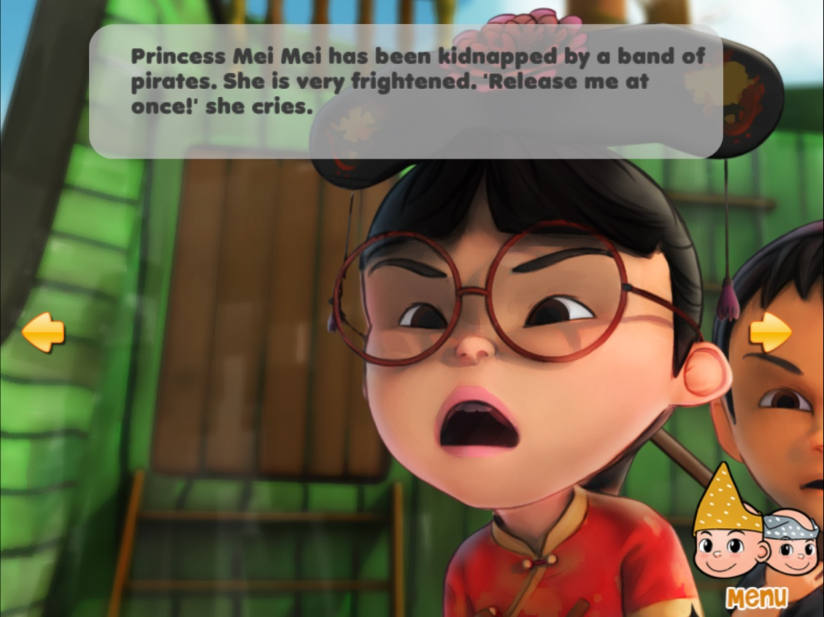

FIGURE 5. Page 14 of the Story App: Representation of Mei Mei as Princess Hang Li Po

As a matter fact, Muhammad Haji Salleh (2008, p.4) mentions of a Malaccan sultanate that “does not confine itself to political relationships, but also devotes considerable attention to significant marital alliances between Melaka and the royal families of these two great countries - between Melaka princes and Indian and Chinese royal maidens.” It is believed that princess Mei Mei in this picture book app is a representation of the legendary Chinese princess Hang Li Po, who was said to have married Sultan Mansur Syah, the sixth Malaccan sultan. Producers of this picture book app had presented an abduction of the princess by the British captain played by the character in this story, Jarjit. The princess was bound to be saved by Hang Upin and Hang Ipin. It is interesting to note that this scene contained an aesthetic quality that stimulated a sense of resistance towards the imperial or colonial power. This sense of resistance thereafter causes an aesthetic response (effect of the stimuli – the rescue of the abducted princess by fighting against the British captain and his ship men) presented through the animated visual that leads to an aesthetic engagement between producer and user of this picture book app in its space. Resistance of the imperial power represented through Jarjit the British captain by rescuing the princess is opined to cause an aesthetic transformation together with a cultural transformation due to representation of the Malaysian national heroic figures (Malay admirals) as saviors.
On the overall, through animated visuals, a transcultural aesthetic is evident in this case as the representation of these prominent races in the transcultural space of the contact zone evokes an aesthetic transformation. The aesthetic transformation is evoked as producer of the app had represented these main three ethnic groups within a scene (it is believed that this connotes the wholesome of Malaysian community), but they are made to appear ‘different’ from each other through identity markers; ethnic cultural attires including the attire representing the imperial power. A physical appearance that significantly marks an aesthetic transformation at this point is representation of the imperial culture i.e., Jarjit dressed as a British captain of the ship, through transformation of the features of the imperial culture. In other words, producers of this story app have implied the rise of nationalism from colonialism. This is done through reminiscence of the “struggles forefathers had to go through, to achieve the country’s independence. History plays an important role to nurture nationalism spirit among the people, teaching them to love the country by learning from the country’s past events” (Nor Ashikin Seman, Noor Nirwandy Mat Noordin & Fariza Hanis Abdul Razak, 2018, p.188). The three main Malaysian ethnic groups have been brought together in this story app to make appropriate Malaysian unity through the concept of a unified diversity. In other words, a Malaysian “diversity that encompasses acceptance and respect” (Dahlan Abdul Ghani, 2015, p.242) despite their differences and impacted by the divide-and-rule tactics of the British in Malaya is the engagement point where the aesthetic transformation takes place mutually together with a cultural transformation.
Besides animated visual representations that show Malaysian identity markers, the language aspect as well plays its role as symbol of Malaysia’s national language to indicate a postcolonial transformation. Bahasa Malaysia, in its role as identity marker for the Malaysian community type in the story of this app can also be seen in kinship terms used such as Opah (it means grandmother in a Malay dialect that belongs to the Perak state of Malaysia according to the fourth edition of Kamus Dewan, 2017) and Kak Ros. Kak (+ name of the eldest sister, Ros) is the short form for Kakak which means eldest sister Ros in Bahasa Malaysia according to Kalthum Ibrahim and et al (5). These kinship names or terms in Bahasa Malaysia also indicate that though story in this app is narrated in the English language, cultural authenticity, and poetic resonance of the kinship terms in Malay language is kept in original form within the English language. Though this is simple language form, it acts as the model that stimulates a sense of cultural authenticity within the language of the imperial. The postcolonial aesthetic lies in the materiality of the kinship terms in Bahasa Malaysia because that is the space of contact between cultures, i.e., the Malaysian culture and the imperial culture. In other words, a culture-specific aesthetic engagement is evident in the transformative space of this picture book app.
In addition, “dressing, tradition festivals, food, first language, and also their language styles even when communicating in the national language that is Bahasa Melayu,” are some of the identity markers that diversify them. Though there are cultural similarities that Malaysians share, “there are several linguistic features which are distinctive that make them unique in their very own way” (Dahlan bin Abdul Ghani, 2015, p. 242).

FIGURE 6. Page 13 of the Story App: The “Pantun Dua-Kerat” in Jarjit’s dialogue

An example of a Malaysian character in this picture book app who demonstrates the Malaysian diversity via language as a model is Jarjit. For example, “the use of Pantun” (oral poetic form) or “idioms whose origin traces back to the Malay society who has been using it for decades.” Jarjit, who is Upin and Ipin’s classmate, “is known for using ‘Pantun’ rather excessively especially when he mentions “Dua Tiga Kucing Berlari” or “Two Three Cats Start to Run,” in his dialogues” (Dahlan Abdul Ghani, 2015, p.253). In the case of this story app, he uses Two Three Birds on the Pier. This style of pantun or poems are mostly structured in even-numbered lines and are known as pantun dua-kerat. Indirectly, by showing Jarjit who belongs to the ethnic group other than the Malay ethnic, Dahlan Abdul Ghani (2015, p. 253) suggests, other ethnics who are not from the dominant group in Malaysia, “are also supportive on preserving this cultural identity through language or aesthetic art forms such as the pantun.” This is the uniqueness of Malaysian culture that the producers of this picture book app cultivate in the interactive animated narrative for the users “to perceive, promote and preserve in terms of the cultural elements of this country” (p.253). Hence, the postcolonial aesthetics lies in the materiality of language; in this case the ‘pantun’ form because it is the space in the contact zone where an aesthetic transformation takes place simultaneously with a cultural transformation (due to the usage of pantun by Jarjit).
Thus, so far, in this picture book app that acts as the contact zone for the producers of the app and the users, it is found that the qualitative effect of the stimuli stems from the interactive digitized visuals (materialities of the text) that can be seen and heard. This is foregrounded in its animated visuals and texts. This form of stimuli has an effect (aesthetic response/engagement) on the users’ sense of mutually belonging to a group of community or nation with a common past and collective identity as present Malaysians (with national symbols like historical narrative and heroic legend of the narrative). Hence, when this sense of belonging occurs, an aesthetic engagement happens, and simultaneously aesthetic transformation is processed. In the same line, as the cultural context in the story of this picture book app involves three predominant races in Malaysia, a transcultural moment takes place along with the aesthetic transformation, i.e., an “aesthetic transformation that goes hand in hand with a cultural transformation,” (Ashcroft, 2015, p. 414) and the primary model for it is the animated visuals in the case of this picture book app. This process is referred to as a postcolonial aesthetic and this gives the value for this postcolonial text/transcultural text/intercultural text. The value for the picture book app is regarded as effect of stimuli on the senses instead of determined ideologically by a set of inherent values.
Though on some basis, there is a sense of homogeneity present in the mutually transformative affective space of this picture book app, it is deemed important to politically sense that two main characters of Upin and Ipin belonging to the dominant ethnic group in Malaysia, have been selected over the other two minority ethnics as images that function as symbols of interactive hotspot/button. This could lead to an investigation on the reality of the relationship between the imagined community of the nation that are also diversified. This reality is reflected in the representation of few other Malay cultural identity markers.

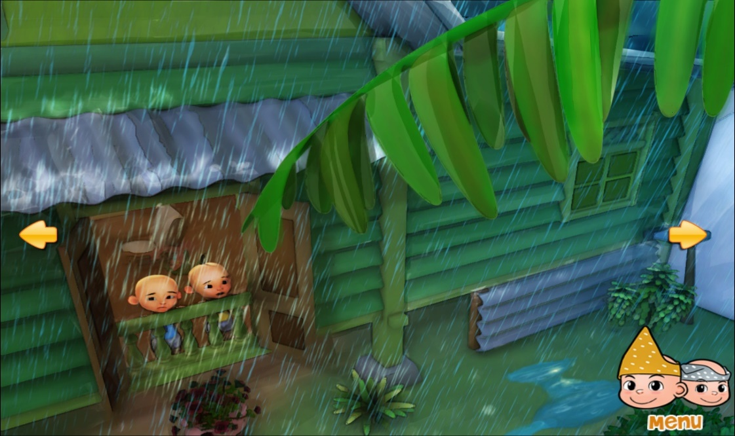

FIGURE 7. Page 3 of the Story App: A Traditional Malay kampung house

For example, in the first page of this picture book app (as in Figure 7), there seems to be a traditional Malay kampung house illustrated. This traditional Malay “ cultural icon” too is said to “make up the identity” of Malays according to Malaysian cartoonist Datuk Mohammad Nor Khalid, famously known as Lat, when he launched a book on traditional Malay houses (entitled Rumah) ( Farah Fazanna Zulzaha, 2014, https://www.thestar.com.my/news/community/2014/03/25/the-kampung-house-revisited-book-by-cultural-icon-pays-tribute-to-the-traditional-malay-dwelling). As a matter of fact, Dahlan bin Abdul Ghani (2015, p. 246) states that “most of the Upin and Ipin episodes focus on a Malay rural area, mainly the setting is a wooden house in Kampung Durian Runtuh. that envisages the environment of Malay culture background such as wooden house.” The traditional kampung house Upin and Ipin live in with their Kakak and Opah is a typical of the Malay traditional house with a roof very steep and “always have wide overhangs for shading and protection from heavy tropical downpours” (p. 246). The dominant Malay culture setting is evident in the site of a kampung, their village in which few other races live too.
Though a harmonious environment is created using the visuals related to locations and backgrounds in this series, and an “aesthetic Malaysian culture value” (Dahlan Bin Abdul Ghani, 2015, p.247) is quite evident, however, a character placement of the other races within a Malay aesthetics culture in a Malay village is also foreshadowed. The centralizing of the Malay dominated culture and setting, in this cultural context is imagined as being the pivotal point of a spiral whereby the other races along with their cultures and values merely follow from that pivotal point. This stimulates a sense of nationalism that is dominated by the cultures of the dominant class. This brings in an aesthetic response which enables a simultaneous transformation between the aesthetic values of the other races living in the village context and culture of the Malay-dominated context in the affective space of this zone.
On a micro-level, the general findings on the representation of identity markers of the characters in this picture book app had provided a foresight to the meaning affordances by the animated visuals in the text (multimedia aspect). Let us now move further to the Interactivity features that are shown in the digital interactive modes in this picture book app. Some other role (s) of postcolonial aesthetics is foregrounded in these digital interactive modes.
Interactivity is said to be often the defining feature of a book app; hence it is important to note that this study intends to exemplify the proposed analytical approach described from pages 7-10, with reference to merely one particular dimension of Semiotic Technology Approach; interactivity.
Though this picture book app incorporates both types of interactivity (touch designs): extra-text and intra-text, only intra-text interactivity will be analyzed as it does not represent symbols merely as a foreseeable technology function (like the start button icon that can be easily predicted to start the narration of the story by leading users to the first page) but it is also a semiotic resource for meaning making in the context of picture book apps.

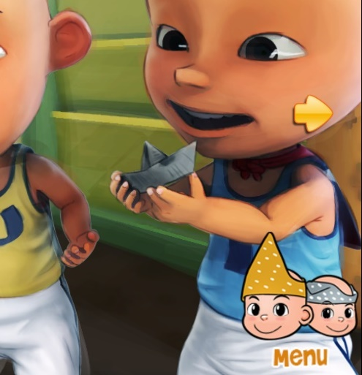

Extra-text Interactive Hotspot

Intra-text Interactive Hotspot

FIGURE 8. Types of Interactive Touch-Designs: Extra-text Interactive Hotspot and Intra-text Interactive Hotspot (described in Table 1 – page 7 as well)

When a user of the app interacts with an intra-text interactive design through the physical act of gesturing, they also perform an act of meaning-making in the context of the narrative (Kress & van Leewuen, 1996). The touch design for instance, involves intra-text interactivity that activates interpersonal meaning, that is, tapping/clicking on hotspots with Upin and Ipin’s faces and both these protagonists’ facial expressions change. Besides, they produce voices that sound excited too when tapped/clicked and this appears to be an interaction or immediately creates a relation with the users. Intra-text touch interactives are “often created using visual narrative elements”, most often the character(s) (like faces of the main characters in this app: Upin and Ipin), “the background of a page and various inanimate objects” (Zhao & Unsworth, 2017, p.95).


Upin and Ipin used as symbols in this intra-text hotspot. When tapped, they interact with users.

FIGURE 9. Main characters of this story, Upin and Ipin have been used as symbols in the Intra-text Interactive Hotspot

In this app, Upin and Ipin have been used as hotspot symbols. The kind of relation interactive users and the intra-text interactive design in this app share is as represented participants. The relation between represented participants of this app is direct and immediate as there is voice production when tapped, from the main characters used as symbols of the hot spot. Besides the relation through the interactive design, the Image Act (producer using the participant to do something to the viewer) from one of the characters (wearing a tengkolok - Malay male head wear) seems to look directly at the viewer.
When this is the case, vector is formed through the eyelines of the participant and thus connects with the user. Though connection is formed on an imaginary basis, contact is established. This contact is deemed to address the user as you. Images that address viewers/users directly in such a way are called as demands. This is because, such images appear as though they demand for an imaginary relation with the viewer and what kind of relation depends on facial expressions and nonverbal cues of the participant (Gaze). The facial expression of the characters (symbols) including the sound of excitement produced when tapped/clicked attracts users to “interact” or engage with the characters. This is because they have been designed to interact with wide-eyes and a wide smile. Hence, the kind of demand from users involved is perceived to be of the type that involves demands for admiration and identification with Upin’s and Ipin’s native background and their ancestral land: Malaysia. Furthermore, this is also because, only characters belonging to the dominant population of Malaysia have been selected to be placed as the symbol of the hot spot by the app producer instead of using a symbol consisting of available Malaysian characters with multiracial background.
The meaning-making act by the user of the app when tapping/clicking this intra-text interactive design will involve noticing or understanding that the salient characters of the plot are those that are natives of Malaysia as there is high probability in maintaining focus on roots and homeland. The participants seem to revolve around elements that define their ancestral identity as Malays as well as the dominant group in this country. This is perceived as establishing their dominant identity as distinguishable from the other races.
A sense of being less important or less homogenized is potentially to be the effect or affective response/the value given to the content of the story in this picture book app. This is because, the theme of ethnic nationalism (“Malay nationalism”) (Tan Chee Beng, 2015, https://www.cambridge.org/core/books/malaysian-chinese/malaysia-ethnicity-nationalism-and-nation-building/3CA3865DE8E8DD7C263A4E1D95176338) is foregrounded by the meaning-making affordance by these touch-designs that act as the materialities of this text. This is the case with the response or value given towards the story in this app because of the settings of this story including centralization and repetition of the main characters (icons) of the story: Upin and Ipin (who are of the dominant ethnic) and their images have been utilized as hotspots over the other characters from the minority groups.
Furthermore, representation of Hang Tuah (and Hang Jebat) through one of the main characters, is “an important symbol of Malay cultural survival and identity” (Maier 1999; Muhammad Haji Salleh 2011, as cited in Rusaslina Idrus, 2016, p.6). He is the epic hero of the Malay world and in fact is claimed by Rusaslina Idrus (2016, p.1) to be “legendary hero of Malaysia, like Beowulf is to the Anglo-Saxons, and Achilles to the Greeks.” This folk hero continues to be relevant in modern times, “often evoked in discussions about Malay rights and nationalism” claims Rusaslina Idrus (2016, p.2). As expressed by National Literary Laureate Muhammad Haji Salleh (2008, p.1) in his introduction to a translation of Hikayat Hang Tuah: “Hang Tuah has been present in the minds of the Malays for at least the last six centuries … as their symbol of self-sacrifice, achievement, patriotism and, not least, as the foremost symbol of their survival…Renewed passion for him and what he means surges to the surface when Malays feel threatened in one way or another militarily or even economically.”
Hence, it is perceived that through the meaning-making process of digitized materiality of text that contains the image of the main characters (who are of the dominant ethnic group in Malaysia) as symbols of the hotspots, a “nationalism of domination” (Balibar; Wallerstein &Verso, 1991, as cited in McLeod, 2000, p.103) is likely the sensed theme amongst users of this picture book app. Hence, the “value of a dominant class or culture” (Ashcroft, 2015, p. 413) is the kind of engagement reached in the contact zone.


FIGURE 10. Page 1 of the Story App: Language Selection for Narration purpose

Another set of hotspots or buttons present are for narration purpose; that is in Bahasa Malaysia (the only language selection provided by the app producer despite Malaysia being a multilingual country) and English. The Malaysian flag is symbol for narration of the story in the Malay language whilst the British flag is symbol for narration in the English language. Bahasa Malaysia is another identity marker for the Malaysian community represented in the story of this book app as it is the national language. However, Bahasa Malaysia is also the mother tongue of the Malays. Besides the language factor, a sense of centralizing on Malaysian dominant class or culture is achieved in the affective space of this postcolonial text due to the textual meaning in the compositional arrangement of the hotspots containing the flags; the hotspot containing Malaysian flag is placed on the left whereas the hotspot containing the British flag is placed on the right.
When visuals utilize the horizontal axis by positioning elements on the left, Kress and van Leewuen (1996, p. 187) claim that “they are presented as Given” while those on the right are ‘New.” The Given means “it is presented as something the viewer already knows, as a familiar and agreed-upon point of departure for message.” Whereas, New is “presented as something not yet agreed upon by viewer and so viewer must pay special attention.” In other words, the hotspot with the Malaysian flag as symbol is commonsensical and self-evident. The flag is an already-known Given symbol of the nation that especially Malaysian users of the app will be familiar with. On the other hand, the British flag is positioned as “information at issue” or “contestable.” It is quite evident that the connotation underlying this compositional positioning also indicates that a state-nationalism is also a part of Malaysia’s nationalism practice besides ethnic nationalism.
However, it is also important to note that despite being a multiracial country and so it is multilingual with especially languages of the predominant ethnics like Chinese and Tamil languages, only Bahasa Malaysia is available as the language for narration purpose of the story in this picture book app. This reflects the strategy of a nationhood that is privileging a certain ethnicity through establishment of national languages. In other words, as highlighted by Maiitri Aung-Thwin (2018, p.82), “national leaders in Burma, Vietnam, and Malaysia promote indigenous languages of the majority ethno- linguistic groups as the “national” language, antagonizing minority groups who already are insecure about their political futures.” Due to “political autonomy with cultural (or linguistic) autonomy being reinforced,” the tension arising from such policies are complicated: “these measures tended to alienate minority speakers and devalue their experiences.”
Hence, users of this picture book app who belong to the minority groups would most likely experience a sense of lacking recognition of the diversity in them as individuals that are part of the imagined community of the nation. In conclusion, the postcolonial aesthetic value given to the story of this book app once again will be related to ideology of the dominant group.

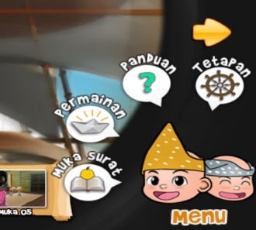

FIGURE 11. Interactive Extra-Text Hotspots

Besides these flags as hotspot symbols, a ship wheel, a reader holding a book, a question mark and a paper ship for respective functions have been used too. These are few other hotspots in this picture book app. These hotspots have been designed using inanimate objects as symbols. However, the symbols are insignificant to the objectives of this study.
A stimulus and Malaysian culture-specific aesthetic was foregrounded in the digitized materiality of text in this picture book app through its animated visuals and language texts (to a small extent). However, to a larger extent, a Malay culture-dominant ideology was inferred as the role or status of the postcolonial aesthetic of this picture book app. This was investigated through the interactive intra-text hotspot utilized in its pages.
In other words, in the frontal transformative space of this picture book app, a feeling of being a member of a select group or a mutual sense of collectivity or belonging to a community would be the emotive foundation. However, this aesthetic as a stimuli / cultural aspect operates to a large extent as ideology related to values of the Malay- dominant culture in Malaysia as the analysis critically moves further into the meaning-making affordances of the digitally interactive materiality of this text. Primarily the postcolonial aesthetics in this picture book app (contact zone) lies in the animated visuals, interactive intra-text hotspot and thereafter the language (texts) aspects are the models that represented the theme of “ethnic, cultural, and language nationalism” (Noor Ashikin Seman, Noor Nirwandy Mat Noordin & Fariza Hanis Abdul Razak, 2018, p.198-200) that seem to enable a transformation of aesthetics together with a cultural transformation. As these nationalism types centralized on the dominant culture of this country, the role played by the postcolonial aesthetic in this digital picture book app is one that has the ideological status.

CONCLUSION

This study has employed the Semiotic Technology approach through the lens of postcolonial aesthetics to interpret meaning making in a digital picture book app for children. The model encompasses the Touch Designs, Interactive Multimedia Supporting Tools and Personalized Content Creations (assimilation of multimodal dimension, the social dimension and the media dimension from the Semiotic Technology approach and interactivity features) and the transculturation process in the mutually transformative affective space of a contact zone (the contact zone being the postcolonial text). This model presents elements as guide for not only production of meanings by digitized semiotic modes but also for the aesthetic description of the affective meanings produced by these modes for narratives in interactive digital media.
This approach suggested focuses on the touch designs that are interactive; as interactivity is the most salient feature of a digital app (Sargeant, 2015). The hotspots containing images of the main characters of this story, Upin and Ipin, as symbol is found to indicate a mutually transformative affective space in this picture book app. However, the type of role played by the aesthetic in the contact zone is largely ideological. This fixation according to racial background is perceived as eliciting “an ideologically determined inherent value” (Ashcroft, 2015, p. 413). It is perceived that using a more ethnically diverse range of characters as hotspot symbol (as in a few other story book apps produced by Les’ Copaque Games Development Incorporation itself) would create a “socially cohesive society amongst diverse ethnicities in a nation such as Malaysia” (Pillai, Menon & Vengadasamy, 2016, p.28).
This study examines the role of semiotic technology in highlighting postcolonial aesthetics and the representation of Malaysian identities in the digital picture book app. It enables educators, app developers and illustrators, researchers, and apps users (parents and teachers) to explore the quality of diverse representations in digital narratives for young readers. The meaning making potential and aesthetic values in these narratives should be further researched as messages delivered through them can impact users especially children who are trying to understand and determine their identities in this millennium.

REFERENCE

A. Samad A. (Ed). (2019). Sulalatus Salatin: Sejarah Melayu. Kuala Lumpur: Dewan Bahasa dan Pustaka.
Asianparent Insights. (2014). “Mobile Device Usage Among Young Kids: A Southeast Asia Study.” Retrieved July 18, 2017 from https://www.scribd.com/document/295675742/Asian-Parent-s-insights-on-mobile-device-usage
Ashcroft, B. (2015) Towards a Postcolonial Aesthetics. Journal of Postcolonial Writing. 51 (4), 410-421.
Bishop, R, S. (1990). Windows and Mirrors: Children’s Books and Parallel Cultures. 14th Annual Reading Conference 1990: Celebrating Literacy, California, 5 March, California ERIC_ED337744 ark:/13960/t5t75d097 (1990).
Boehmer, E. (2010). A Postcolonial Aesthetic: Repeating upon the Present. In Wilson, J., Sandru, C., & Welsh, S.L, (Ed.). Rerouting the Postcolonial: New Directions for the New Millenniumm (170-181). New York: Routledge.
Centre for Literacy in Primary Education. (2019). The Centre for Literacy in Primary Education. Retrieved 19th September 2019 from https://clpe.org.uk/RR
Common Sense Media. Best Book Apps for Kids. Retrieved January 2017-July 2017 from https://www.commonsensemedia.org/lists/best-book-apps-for-kids
Dahlan A, G. (2015) Upin and Ipin: Promoting Malaysian Culture Values through Animation. Historia y Comunicación Social. 20(1), 241-258.
Dewan Bahasa dan Pustaka. (2017). “Opah” and “Kakak.” Kamus Dewan Bahasa dan Pustaka. Kuala Lumpur: Dewan Bahasa dan Pustaka.
Farah Fazanna, Z. (2014). The Kampung House Revisited.” TheStar. Retrieved 28th March 2014 from https://www.thestar.com.my/News/Community/2014/03/28/The-kampung-house-revisited/
Ferrari, G, R, F. (1999) Aristotle’s Literary Aesthetics. Phronesis. 44 (3), 181-198.
Francis, J. (2008) Aesthetic Confusion: The Legacy of New Criticism. Language Arts Journal of Michigan. 24(1), 28-33.
Kalthum, I. (2016) Kata Panggilan Kekeluargaan oleh Mahasiswa dari Pantai Timur Universiti Kebangsaan Malaysia; Satu Kajian Sosiolinguistik. Jurnal Linguistik. 20(1), 1-9.
Kaboudarahangi, M., Osman, M. T., & Mustafa, K, M.S. (2013) Malaysia’s Three Major Ethnic Group Preferences in Creating a Malaysian Garden Identity. Australian Geographer. 44(2), 197-213.
Kress, G., & Leewuen, T, V. (1996). Reading Images: The Grammar of Visual Design. London: Routledge.
Maiitri Aung-Thwin. (2018). Nationalism and Post-colonial Identity in Southeast Asia: Defining Communities. In Owen, N.G. (E.d). Routledge Handbook of Southeast Asian History (pp. 75-85). Routledge.
Marshall, J, S. (1953) Art and Aesthetic in Aristotle. Journal of Aesthetics and Art Criticism. 12 (2), 228-231.
McLeod, J. (2000). Beginning Postcolonialism. United Kingdom: Manchester University Press.
Moslund, S, P. (2015). Literature’s Sensuous Geographies: Postcolonial Matters of Place. New York: The John Hopkins University Press.
Mottus, M., & Lamas, D. (2015). Aesthetics of Interaction Design: A Literature Review. MIDI '15: Proceedings of the Multimedia, Interaction, Design and Innovation, 1-10 June, Poland 978-1-4503-3601-7.
Muhammad Haji Salleh. (2008). The Epic of Hang Tuah: An Introduction. In Malaysian National Institute of Translation (Ed.). Hikayat Hang Tuah (pp. 1-18). Malaysia: Malaysian National Institute of Translation.
Nankani, S. (2015). Mind the (Diversity) Gap in Kid’s Digital Media: Literary Safari. Retrieved 23 May 2018 from https://joanganzcooneycenter.org/2015/01/27/mind-the-diversity-gap-in-kids-digital-media/
Nodelman, P. (1988). Words About Pictures: The Narrative Art of Children’s Picture Books. The University of Georgia Press.
Nor Ashikin, S, Noor Nirwandy, M, N., & Fariza Hanis, A, R. (2018) A Qualitative Content Analysis: The Type of Animation and Elements of Nationalism Used in Animation Series of Upin & Ipin in Episodes: Magic Pimpimpong, Masih Ada Sayang & Kompang Dipalu. Journal of Media and Information Warfare. 11(2), 187-215.
Noske, C. (2013) A Postcolonial Aesthetic? An interview with Robert Young. Journal of Postcolonial Writing. 50(5), 609-621.
Perry, M, S. (2020). Multimodal Engagement through a Transmedia Storytelling Project for Undergraduate Students. GEMA Online Journal of Language Studies. 20(3), 19-40.
Pillai, Menon, S., & Vengadasamy, R. (2016). The Marginalization of Malaysian Texts in the English Language Curriculum and its Impact on Social Cohesion in Malaysian Classrooms. Kajian Malaysia. 34(2), 25-58.
Poulsen, S.V., Kvale, G., & Leewuen., T, V (2018). Review of Special issue: Social Media as Semiotic Technology. Social Semiotics. 28(5), 593-600.
Poulsen, S.V, & Kvale, G. (2018) Studying Social Media as Semiotic Technology: A Social Semiotic Multimodal Framework. Social Semiotics. 28(5), 700-719.
Rasagam, M., & Pillai. S. (2016) Interpolating South Asian Transnational Heritage: Allegory in South Asian Diasporic Metropolitan in Young Adult Fiction. International Journal of Asia Pacific Studies. 12(1), 44–60.
Rusaslina Idrus. (2016) Multicultural Hang Tuah: Cybermyth and Popular History Making in Malaysia. Indonesia and the Malay World. 1-21.
Sargeant, B. (2015) Interactive Storytelling: How Picture Book Conventions Inform Multimedia Book App Narratives. Australian Journal of Intelligent Information Processing Systems. 13(3), 29-35.
Shusterman, R. (1986) Deconstruction and Analysis. British Journal of Aesthetics. 26(4), 311-327.
Tan, C, B. (2015). Malaysia: Ethicity, Nationalism, and Nation Building. Retrieved July 8, 2021 from https://www.cambridge.org/core/books/malaysian-chinese/malaysia-ethnicity-nationalism-and-nation-building/3CA3865DE8E8DD7C263A4E1D95176338
Lynch, Julie S., van den Broek, Paul, Kremer, Kathleen E., Kendeou, Panayiota, White, Mary Jane & Lorch, Elizabeth P. (2008) The Development of Narrative Comprehension and Its Relation to Other Early Reading Skills. Reading Psychology. 29 (4) ,327-365.
Vengadasamy, R. (2011) Metaphors as Ideological Constructs for Identity in Malaysian Short Stories. 3L: The Southeast Asian Journal of English Language Studies. 17 (Special Issue), 99-107.
Zhao, S., & Djonov, E. (2017, November 22). Chapter 1 Social Semiotics: A Theory and a Theorist in Retrospect and Prospect. 19, 1-17.
Zhao, S., & Unsworth, L. (2017) Touch Design and Narrative Interpretation: A Social Semiotic Approach to Picture Book Apps. In Kucirkova, N., & Falloon, G, (Ed.). Apps, Technology and Younger Learners: International Evidence for Teaching (pp. 89-102). United Kingdom: Routledge.

