Voice Onset Time of Mankiyali: An Acoustic Analysis

ABSTRACT
Mankiyali is Indo-Aryan language spoken in a hilly area of northern Pakistan. It is an endangered language which has around 500 speakers. It has dire need from linguistic point of view to investigate its different features. Therefore, the present study aims to investigate the Voice Onset Time (VOT) values of its stop consonants acoustically. The objectives of the present study are to investigate the VOTs of Mankiyali and to explore the duration of sound release in terms of negative, positive and zero VOTs which help in identifying the laryngeal categories of the language. For doing this, the data was collected from male speakers through Zoom H6 in a comfortable environment. Five tokens were recorded from five different native speakers that collectively produced twenty-five tokens for a single phoneme. Each phoneme was analysed with the help of PRAAT software. Mankiyali has three laryngeal categories; voiceless unaspirated (VLUA) stops, voiceless aspirated (VLA) stops, and voiced unaspirated (VDUA) stops. The results showed that VOTs of stops were significantly different in terms of place of articulation and phonation. In term of place of phonation, VLUA bilabial stop /p/, VLUA alveolar stop /t/, and VLUA velar stop /k/ showed shorter voicing lag than their VLA counterparts /pʰ, tʰ, kʰ/. In terms of negative and positive VOT values, differences found that all VLUA and VLA stops had +VOTs and all VDUA have –VOTs. In terms of place of articulation, bilabial /p/ has longer voicing lag than alveolar /t/, but has shorter voicing lag than velar /k/. Additionally, in terms of articulation, the results related to voicing lag of VDUA /b, d, ց/ showed closeness to one another.
Keywords: VOT, Indo-Aryan, place of articulation, aspiration, acoustic analysis.

INTRODUCTION
Language groups/lists are categorized upon the shared linguistic properties such as morphology, grammar and so on. There are many languages that have not received attention of researchers to investigate their structures and properties, such as Indo-Iranian and Indo-Aryan (IA) languages. Indo-Iranian and IA languages are among those languages which have not been investigated deeply (Anjum, Khan, & Gulzar, 2016; Yutaka, 2018). Zarifian and Fotuhi (2020) argue that IA languages come under Indo-European family. These languages are mainly spoken in Pakistan, India, Bangladesh, Nepal, Maldives Islands and Sri Lanka.
Krauss (1992) divides spoken languages into three categories: moribund, endangered and safe. He expresses that moribund is no more learnt by younger generation. The endangered languages are learnt by younger generation, but it changes to moribund with the passage of time when the number of speakers reduces. The last category is safe, the languages which have more than 100,000 speakers. The categorization for languages proposed by Krauss (1992) clearly indicates that Mankiyali language comes under endangered category which has less than 500 hundred speakers. The present situation of Mankiyali language is seriously endangered (Hussian, 2020; Kochetov, Petersen, & Arsenault, 2020; Ullah, Hussain, & Anjum, 2020) that it needs immediate documentation of its orthography (alphabet), phonology, morphology and syntax which are dominant aspects of a language.
Mankiyali is an Indo-Aryan (IA) language, but it comes under the Dardic group of languages. According to Hussain (2021), Dardic group of languages are mainly spoken in the mountainous regions of northern Pakistan which stretches into northern Afghanistan on the West and Kashmir on the East. Khowar is considered the main language of Chitral which is Dardic. Along with this, Palula, Kalasha, Damiei, and Indus Kohistani also belong to Dardic which are spoken in Chitral. Bateri, Gowro, Chilisso, Kalam Kohistan, Torwali Kohistan, and Ushojo are spoken in hilly areas (Anjum, Kiani, & Khan, 2018).
As can be noticed, figure 1.1 shows that Mankiyali belongs to Dardic branch of IA language family. Arsenault (2017) divulges that the Dardic languages’ existence in Hindu Kush part of Pakistan covers district Gilgit, Chitral, Baltistan, Azad Kashmir, Hunza, Swat and Dir. Beside Dardic languages, Pashto language spoken in Swat and Dir, belongs to Iranian family which is also frequently practiced in Swat and Dir. Even Pashto is considered the mother tongue of these speakers. According to Grierson (1919; as cited in Arsenault, 2017), Dardic languages are formed into three different language groups: A) Kafir group. B) Khowar, Chitrali or Arniya. C) Dard group, proper. The Dard group entails three languages e.g., Shina, Kashmiri and Kohistani.
Languages are divided into different families based on their phonological and grammatical categories. Mankiyali language comes under the family of Indo-Aryan language. The family tree diagram has been given in figure 1.1 which illustrates the relationship of Mankiyali with other sister languages and all those ancestor languages to which it has been connected. Eberthard, Gary and Charles (2019) have divided languages according to their respective properties and regions. Mankiyali has got its relationship with many languages that is clearly shown below in figure 1.1.
Indo-European

Indo-Aryan Iranian Nuristani

Intermediate division Outer languages

Eastern Western Eastern, Northwestern, Southern, Western Hindi

Dardic

Chitral, Kashmiri, Kohistan, Kunar, Pashai, Shina

Bateri, Chiliso, Degano, Gowro, Kalami, Kohistani-Indus, Mankiyali,Tirahi, Torwali,
Figure 1: Family Relation of Mankiyali
Mankiyali speakers live in Danna village which is the part of union council Bandi Shungli. This village is known by the nearest city which is called Mansehra. The nearest villages to Danna are Dogahi, Butti, Bajana, Galli, Ramkot and Chamrasi. Village Danna is approachable from two sides. One is village Shoshni, where someone can take the walking track to reach Danna. Second is from Shungli Bandi Road (Anjum et al., 2016; Kochetov, & Arsenault, 2019).
Though many scholars (Anjum et al., 2016; Anjum et al., 2018; Anjum, Saleem, Qadeer, Khalid, & Shehzad, 2020; Torwali, 2021) have investigated Mankiyali language, and have identified it as an endangered language, yet there exists a dire need of further thorough investigation from a linguistic perspective. So, a study is required to investigate the VOT values acoustically and identify its various features. Therefore, the present study focuses on the VOTs of Mankiyali.
Literature Review
Speech sounds have bundles of constituent and distinctive features (Cathcart, 2020; Cho, Whalen, & Docherty, 2019). This idea was supported by scholars (Cangemi & Baumann, 2020; Cheng, 2021) who classified the speech sounds of English into four different categories on the basis of their place of articulation, manner of articulation, nasal-oral and voicing. According to Liljegren and Khan (2017), humans produce sounds according to their needs. These sounds are identified through phonetics which has mainly three branches, articulatory, auditory, and acoustic. Phonetic research is done to investigate the properties of sounds such as acoustic and articulatory.

Chodroff and Wilson (2020) depict that physical properties of sounds are analysed through acoustic phonetics which exhibit all the properties of sound i.e., bearing duration, amplitude and other features. Basically, it classifies the human speech. Previous studies in the field of acoustic phonetics (Bosen, Monzingo, & AuBuchon, 2020; Horo, Sarmah, & Anderson, 2020) have identified the importance of VOT in terms of temporal measurement and vowel duration in articulation and perception of speech.
Plosive sounds are the properties of almost all languages in the world, but these vary according to their acoustics and articulatory properties (Hussain, & Mielke, 2020). The prominent property of voiceless stop is that closure phase is followed by a burst and then transmits to next sound, whereas in voiced stop, voicing remains in the closure phase and bursts (Stevens, 1998). The most common consonant sounds /p, t, k/ in all human languages are articulated with egressive pulmonic airstream (Siregar, 2022). Patil, More and Sasikumar (2019) claim that Hindi has voiced aspirated plosives /b bʰ p pʰ/. Along with this, there are some languages belonging to Indo-Aryan family which have not only stops that are differentiated from each other by their VOTs, and phonation as well. These two categories of voiced stops are classified through voice quality (Samudravijaya, 2021).

VOT is one of the main features of temporal features of phonemes which is mostly overlooked in human speech recognition, perception and accent detection (Hauser, 2021). The acoustic properties of particular phonetic phonemes are influenced by variability of various sources such as speaker, speaking rate, phonetic context and syllable position (Feehan, 2020).
Voicing clearly distinguishes the consonants into two categories and identifies that some are voiced and some are voiceless. It also distinguishes aspirated from unaspirated. VOT is one the main features of phonemes which also differs them form one another, and it is mostly measured on word initial sounds. The measurement of time interval between the release of stops and first pulse of vibration is noted. The differences in VOT values also serve separating the manner of articulations of various languages (Reetz & Jongman, 2020).

VOT is from the release of consonant to the onset (Lisker & Abramson, 1964). VOT is the interval of the time between the release and the onset of voicing phase for the voiced stop that comes next (Lalain, Ghio, Giusti, Robert, Fredouille, & Woisard, 2020; Winn, 2020). Different languages may have various VOT values, and these differences are identified by a number of other properties of a language (Khan, Stokes, Khan & Seyffert, 2020), such as speech rate (Subramaniam & Ramamurthy, 2020), the following vowel (Heeren, 2020), age and gender of speaker (Winn, 2020). There are more factors that affect the duration of VOT such as physiological differences, pathological conditions and various performances (Zhou, Li, & Guo, 2020). Sometimes, VOT cannot be clearly measured in pathological voices. This occurs due to facing difficulty in determination of the burst location (Cohn, Segedin, & Zellou, 2022). The identification of the burst boundary is difficult when speaker fails in achieving full closure during articulation of stop consonants (Lopez-Backstrom, & Koffi, 2020). Women have longer VOTs than men (Ditewig, Smorenburg, Quené, & Heeren, 2021). However, Giovannone and Theodore (2021) introduced that there is no such gender-based differences in the measurement of VOTs, although difference depends on the communicator.

The measurements of VOT are performed before and after the release sounds. As mentioned, measuring the VOT performance before the release of sound is identified with negative numbers i.e., known as voicing lead. In contrast, measuring the VOT performance after the release of sound is recognized with positive numbers i.e., termed as voicing lag (Yun, Choi, & Shattuck-Hufnagel, 2020; Winn, 2020). When the release and voicing have exactly the same time, VOT is zero.
Cross-linguistic studies of languages classified three categories of stop consonants based on their VOTs. Voicing lead, its range limits from 125 to 75 ms and the median value of it is 100 ms. Short voicing lag, its range limits from 0 to 25 ms and the median value of it is +10 ms. The third one is long voicing lag, its range limits from 60 to 100 ms and the median value is +75 ms (Narayan, 2020). The VOTs in English consonants remain somewhere from 0 to75 ms (Winn, 2020) and Levi (2021) describes that labial stops have short VOTs (0-50 ms), alveolar stops have (10-65 ms), and velar stops have (20-80 ms). However, Chodroff, Golden, and Wilson, (2019) have opposite notion that alveolar stops have longer VOTs than velar stops. Ahmadi, Karshenas, Babaali, and Alinejad (2020) opine that expected range of VOTs in English would be 20-25 ms for bilabial, nearly 35 ms for alveolar stops and around 40 ms for velar. Hussain (2018) clarified that VOTs of affricates have longer values than VOTs of stops. The main reason of longer values is additional intervals of aspiration or frication with the production of affricates. Chodroff and Wilson (2020) express that different languages have different VOTs in terms of voiced and voiceless stop consonants. Earle, Landi, and Myers (2018) have the view that bilingual speakers have significantly different VOTs than those speakers who are monolingual.
The family of Indo-Iranian languages is divided into three families: Iranian, Nuristani, and Indo-Aryan (Hussain & Mielke, 2020). Dardic languages belong to Indo-Aryan language family. Hindi is one of the Indo-Iranian languages which is frequently studied. It has voiced aspirated stops. Hindi is an Indo-Iranian language which is mostly studied, probably because it possesses voiced aspirated stops which have been extensively reported in the cross-linguistic surveys and various textbooks dealing with general phonetics and phonology (Zarifian & Fotuhi, 2020).
Many studies have been conducted on Iranian languages which revealed that they have two laryngeal categories such as voiceless unaspirated stop /p/ and voiced unaspirated stop /b/, which found in Balochi (Jahani & Korn, 2009), Dari (Baker, 2016), Kurdish (McCarus, 2009). Khotanese and Tumshgese have three laryngeal categories: voiceless unaspirated, voiced unaspirated and voiceless aspirated (Emmerick, 2009). Keiffer (2009) introduced that Parachi has four laryngeal contrasts: voiceless aspirates and unaspirates, voiced aspirates and unaspirates, which are very distinct features of it.

Hussain (2018) conducted research on ten languages, which included two Iranian, seven Indo-Aryan and Burushaski. The last one is isolated language. The results clearly indicated that there was clear distinction in aspirated and unaspirated voiceless stops. Shorter VOTs were noted for aspirated voiceless stops than unaspirated voiceless stops. Indo-Aryan languages have clear distinctive features of laryngeal contrasts both in plosives and affricates.
The view from the existing literature exhibits that zero VOTs are identified where the burst of vocal track starts exactly the same time as onset occurs. Positive VOTs take place when the vocal fold starts vibration after the burst, and negative VOTs happen when the vocal fold begins vibration before the burst. It is also clear that every language has various number of sounds and has various VOTs. There are many studies (Hussain, Proctor, Harvey, & Demuth, 2020; Hussain, 2021; Kochetov, Petersen, & Arsenault, 2020) conducted VOT analysis of various languages that clearly showed their VOT values. However, Mankiyali is an undocumented Indo-Aryan language and there is no acoustic analysis of its VOT values presented. Therefore, the current study intends to investigate the VOTs of Mankiyali acoustically using Praat (Boersma & Weenink, 2017).

The objectives of the present study are to investigate the VOTs of Mankiyali and to explore the duration of sound release in terms of negative, positive and zero VOTs. The obtained VOT values clearly distinguish the laryngeal categories of Mankiyali stops. These values also differentiate length of phonemes based on negative and positive VOTs. Positive VOT further shows the aspiration in stops. Based on the above objectives, the study has following research questions.
Question 1. What are the acoustic properties of VOTs of Mankiyali stop?
Question 2. Do these phonemes have positive or negative VOTs?
Question 3. Which phonemes have longer VOTs in terms of place of articulation?
Question 4. Do aspirates and unaspirates have same duration?

Methodology
The present study acoustically analysed the words initial stop; voiceless unaspirates /p, t, k/, voiceless aspirates /pʰ, tʰ, kʰ/ and voiced unaspirates /b, d, ց/ in combination with /ɪ/ in table 1. This data was collected to analyse the VOTs of various stops followed by same vowel.
Table: 1 Stimuli for VOTs, Stop Followed by High Close Vowel
Nonsensical words | Consonants
pim | p
pʰim | pʰ
bim | b
tim | t
tʰim | tʰ
dim | d
kim | k
kʰim | kʰ
ցim | ց

Data Collection
Five male Mankiyali speakers (ageing 30 to 40 years, average 36.8) were recruited from Danna village. They grew up in this village. All of them had their childhood and adulthood in the mentioned place. They didn’t have permanent city exposure, but rarely visited city i.e., shopping, appointment with doctors etc. They had no language disorder in perception and production. All the speakers were practicing Mankiyali at homes and outside their residences in various situations i.e., mosque, funeral, Eid celebration, wedding ceremonies etc, but it is not practiced at schools.
The present is limited to a single feature (VOT) of Mankiyali stop consonants. For obtaining this feature, the data was collected only from male speakers due to ethical and societal restrictions because women are not allowed to set in the environment having recording and discussion with others than their family members.
These nonsensical words for the current study were presented in Table 1. It had stop consonants followed by high close vowel /i/. These monosyllabic words were arranged in CVC forms. The total number of words is 09 and all of them having stop at the initial. Hussian et al. (2017) have the view that the qualities of vowels effect the measurements of VOT. Therefore, the nonsensical words were selected to get the correct results of every stop. The same vowel in all words reduce the distraction that brings correct results. All the sounds in these nonsensical words are existing phonemes of Mankiyali, but the selection of the above data set was done for obtaining desired results.
The lists of these words were presented to native speakers of the language in English script. The participants were asked to utter the words in a normal voice and comfortable rate. All the words were uttered by the participants in isolation and carrier sentences and each word was repeated 8 times (09 x 8 x 5 = 360). The total number of these entries were 360. From the eight repetitions of phonemes in words, only five tokens were measured of each speaker for a single phoneme that created 25 (5 x 5 = 25) responses and total number of responses for the present study was 225 (09 x 5 x 5 = 225). In all these repetitions, the focus remained on the VOTs of target phonemes that were discussed below and the values were provided in Table 2.
Recording
Recordings were done in a single village (Danna). All experimental protocols were made with high concentration. For this purpose, a high-quality portable device Zoom H6 recorder was used to record the utterances of the participants. The device was checked many times before starting the recordings and made changes in setting e.g., 44.1 kHZ and 16-bit. After recordings, the files were saved in uncompressed WAV forms and transferred to a laptop. The recordings were converted into mono for better results, using Praat software (Boersma, 2014).
Acoustic Analysis of Data
The data were edited, saved into individual files, and analysed acoustically with the help of Praat software. Five tokens of each speaker were measured and VOT values were recorded in milliseconds. The VOTs’ boundaries were marked carefully for all stop consonants. There are three laryngeal categories in Mankiyali stops (voiceless unaspirated, voiceless aspirated and voiced unaspirated stops). The values, range and number of VOT values of tokens were presented below in various tables.
VOTs of the phonemes were measured in milliseconds which were obtained by analysing the time interval from the beginning of the release to onset of the following vowels. The clear distinctions and measurements were shown in the following given Figures.
Table 2 Voice Onset Time of All Five Speakers in Milliseconds (stop + high close vowel + stop)
Sounds | p | pʰ | b | t | tʰ | d | k | kʰ | ց
Values S1 | 16.6 | 72.2 | -97 | 9.8 | 45.8 | -96 | 38 | 68.8 | -78
Values  S 2 | 14.6 | 59.8 | -101.2 | 11.4 | 56.4 | -109 | 27.6 | 75.4 | -95
Values S 3 | 14.6 | 49.6 | -119.8 | 13.2 | 41.4 | -129 | 31.4 | 77.6 | -114
Values S 4 | 9.4 | 45.2 | -119 | 9 | 34.4 | -95.4 | 35 | 84.8 | -86
Values S 5 | 13.4 | 64.6 | -119 | 9 | 56.2 | -107 | 25.5 | 74.8 | -107
Range | 9.4: 16.6 | 45.2: 72.2 | -97: -119 | 9: 13.2 | 34.4: 56.4 | -95.4: -129 | 25: 38 | 68.8: 84.8 | -78: -114
No of Tokens | 5 | 5 | 5 | 5 | 5 | 5 | 5 | 5 | 5

The above table 2 contains the results of stimuli presented in table 1. Five responses were measured carefully via Praat. Every value was noticed and presented in Table 2. The phonemes /p, pʰ, b, t, tʰ, d, k, kʰ, ց/ were arranged in the first row of the table and the values, ranges and number of tokens were presented respectively under them. The above words were uttered by all five speakers.
The values of voiceless unaspirated VLUA /p/ (bilabial) were recorded 16.6 and by speaker 1 (S1), 14.6 by speaker 2 (S2), 14.6 by speaker 2 (S3), 9.4 by speaker (S4), and 13.4 by speaker (S5). These values were taken from the sum of 5 tokens and the range lasted from 13 ms to 19 ms for S1, 11 ms to 16 for S2, 11 ms to 18 ms for S3, 9 ms to 10 ms for S4, and 10 ms to 17 ms for S5. The values of voiceless aspirated VLA /pʰ/ (bilabial) was recorded 72.2 from the utterances of S1, 59.8 by S2, 49.6 ms by S3, 45.2 ms by S4, and 64.6 ms by S5. Each value was the average of the sum of 5 tokens. The range lasted from 69 ms to 79 ms fro S1, 46 ms to 70 ms for S2, 42 ms to 65 ms for S3, 34 ms to 54 ms for S4, and 55 ms to 74 ms for S5. The values of voiced unaspirated VDUA /b/ (bilabial) were recorded -97 from the utterances of S1, -101.2 ms for S2, -119.8 ms for S3, -119 ms for S4, and -119 ms for S5. The values of this phoneme were averages from the sum of 5 tokens. The ranges lasted from -82 ms to -115 ms for S1, -75 ms to -119 ms for S2, -114 ms to -131 ms for S3, -113 ms to -127 ms for S4, and -111 ms to -127 ms for S5.
The values of voiceless unaspirated VLUA /t/ (alveolar) was recorded 9.8 ms uttered by S1, 11.4 ms by S2, 13.2 ms by S3, 9 ms by S4, and 9 ms by S5. These values were averaged from the sum of 5 tokens. The ranges of these speakers lasted from 9 ms to 13 ms for S1, 10 ms to 13 ms for S2, 11 ms to 13 ms for S3, 8 ms to 10 ms for S4, and 7 ms to 12 ms for S5. The value of voiceless aspirated VLA /tʰ/ (alveolar) was recorded 45.8 from the utterances of S1, 56.4 ms for S2, 41.4 ms for S3, 34.4 ms for S4, and 56.2 ms for S5. These values are the averages taken from the sum of 5 tokens for each phoneme. The ranges lasted from 43 ms to 49 ms for S1, 49 ms to 61 ms for S2, 33 ms to 48 ms for S3, 31 ms to 41 ms for S4, and 34.4 ms to 56.4 ms for S5. The values of voiced unaspirated VDUA /d/ (alveolar) was recorded -96 produced by S1, -109 ms by S2, -129 ms by S3, -95.4 ms by S4, and -107 ms by S5. These values were taken in average from the sum of 5 tokens. The ranges lasted from -81 to -111 ms uttered by S1, -87 ms to -135 by S2, -97ms to -155 ms by S3, -78 ms to -107 ms by S4, and -82 ms to -126 ms by S5.
The values of voiceless unaspirated VLUA /k/ was recorded 38 ms uttered by S1, 27.6 ms by S2, 31.4 ms by S3, 35 ms by S4, and 25.5 ms by S5. The averages of these values produced by them were the sum of 5 tokens. The ranges of them lasted from 31 ms to 42 ms for S1, 22 ms to 34 ms for S2, 26 ms to 36 ms for S3, 24 ms to 43 ms for S4, and 20 ms to 39 ms for S5. The values of voiceless aspirated VLA /kʰ/ were recorded 68.8 ms from S1, 74.4 ms S2, 77.6 ms S3, 84.8 ms S4, and 74.8 ms uttered by S5. These values were taken from the sum of 5 tokens produced by each speaker. The ranges of VOT for /kʰ/ lasted from 60 ms to 77 ms produced by S1, 67 ms to 81 ms by S2, 67 ms to 90 by S3, 81 ms to 90 ms by S4, and 62 ms to 87 ms by S5. The values of voiced unaspirated VDUA /ց/ was recorded -78 ms uttered by S1, -95 ms by S2, -114 ms by S3, -86 ms by S4, and -107 by S5. These values were taken in averages which were the sum of 5 tokens. The ranges of these uttered values lasted from -68 ms to -95 ms for S1, -71 me to 134 ms for S2, -83 ms to 129 ms for S3, -75 ms to -107 ms for S4, and -88 ms to -121 ms for S5.
The waveforms of speaker 1 were presented in figure 1 and 2. Figure 1 contains all VLUA and VDUA sounds /p, b, t, d, k, ց/ while Figure 2 contains only VLA sounds /pʰ, tʰ, kʰ/. These were given for the acoustic representations and physical properties of phonemes.
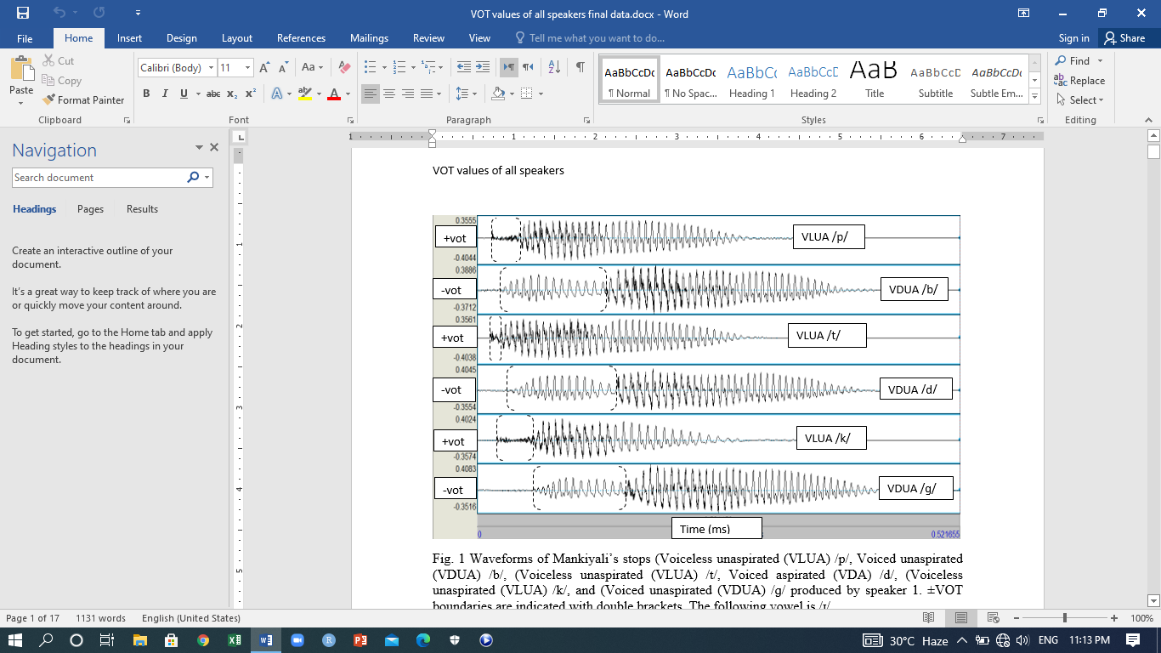
Figure 1 Waveforms of Mankiyali’s stops (VLUA) /p/, (VDUA) /b/, (VLUA) /t/, (VDA) /d/, (VLUA) /k/, and (VDUA) /ց/ produced by speaker 1. ±VOT boundaries are indicated with double doted brackets. The following vowel is /i/.
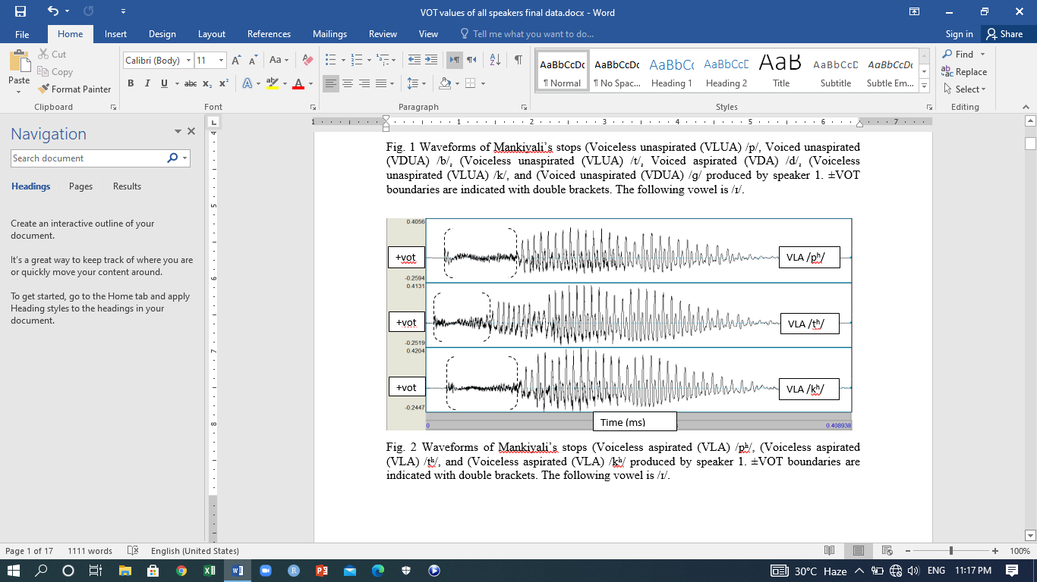
Figure 2 Waveforms of Mankiyali’s stops (VLA) /pʰ/, (VLA) /tʰ/, and (VLA) /kʰ/ produced by speaker 1. ±VOT boundaries are indicated with double brackets. The following vowel is /i/.
The above figures 1 and 2 represent the waveforms of S1 only for representing the acoustics analysis and spectrograms of all phonemes. The same process was done for all phonemes produced by all speakers, but only the above figures 1 and 2 were given.
Results and Discussion
A single data set of stimuli for the present study having stops followed by high close vowel was taken. The data set was presented in Table 1. The main interest and reason behind the same vowel in all words was to have quality results of VOT values of consonantal phonemes.
The utterances of all five speakers were analysed acoustically that collectively made 25 tokens for each phoneme. The collected values of all speakers are given below in table 3. The waveforms of each speaker were taken in the same process, but the spectrograms of S1 were only given in the above figures. The total number of figures are two; in these figures, the figure 1 shows (VLUA) /p/, (VDUA) /b/, (VLUA) /t/, (VDUA) /d/, (VLUA) /k/, and (VDUA) /ց/ produced by speaker 1. The figures 2 exhibits the waveforms of (VLA) /pʰ/, (VLA) /tʰ/, and (VLA) /kʰ/ produced by S2. Similarly, the spectrograms of all were taken respectively and values were taken, but representations were gives of S1 only.
Table 3 Grand averaged values of VOTs of all 5 Speakers in ms (stop + high close vowel + stop)
Sounds | p | pʰ | b | t | tʰ | d | k | kʰ | ց
Values | 13.7 | 58.2 | -111 | 10.5 | 46.8 | -108 | 31.6 | 76.2 | -96.4
Range | 9.4: 16.6 | 45.2: 72.2 | -97: -119 | 9: 13.2 | 34.4: 56.4 | -95.4: -129 | 25: 38 | 68.8: 84.8 | -78: -114
No of Tokens | 25 | 25 | 25 | 25 | 25 | 25 | 25 | 25 | 25

At first, 5 tokens were measured of each speaker. Then, the average of 5 tokens was taken for each speaker. At the last, the average off all 5 speakers was taken then, and noticed the ranges and number of tokens respectively.
The value of VLUA /p/ was recorded 13.7 ms and this value had been taken from the sum of 25 tokens and the ranges lasted from 9.4 ms to 16.6 ms. The value of VLA /pʰ/ was recorded 58.2 ms of which average is the sum of 25 tokens and the range lasted from 45.2 ms to 72.2 ms. The duration between the VOT values of VLUA /p/ and VLA /pʰ/ is significantly different. The value of VLA /pʰ/ is almost four times longer than VLUA /p/. The value of VDUA /b/ was measured -111 of which average was taken from the sum of 25 tokens and the range lasted from -97 ms to -119. The values of VLUA /p/ and VLA /pʰ/ are positives, but the value of VDUA /b/ is negative.
The value of VLUA /t/ was recorded 10.5 and this averaged value is the sum of 25 tokens and the range lasted from 9 ms to 13.2 ms. The value of VLA /tʰ/ was recorded 46.8 and this was averaged from the sum of 25 tokens and the range lasted from 34.4 ms to 56.4 ms. Significance difference between the VOT values of VLUA /t/ and VLA /tʰ/ was found. The value of VLUA /t/ is shorter than the value of VLA /tʰ/, because it has got three times greater value. The averaged value of VDUA /d/ was recorded -108 ms which is the sum of 25 tokens and the range lasted from -95.4 ms to -129 ms. In these phonemes, the VLUA /t/ and VLA /tʰ/ had positive and VDUA /d/ had negative values.
The averaged value of VLUA /k/ was recorded 31.6 ms which is the sum of 25 tokens and the range lasted from 25 ms to 38 ms. The value of VLA /kʰ/ was recorded 76.2 ms of which average is the sum of 25 tokens and the range lasted from 68.8 ms to 84.8 ms. Like above, the same significance difference was noted between the durations of VOTs of VLUA /k/ and VLA /kʰ/. Both of them are voiceless, but the difference was noted in VOTs, the VLA /kʰ/ got two times greater VOTs than the VLUA /k/. The averaged value of /ց/ was recorded -96.4 ms which is the sum of 25 tokens and the range lasted from -78 ms to -114 ms.
The responses of each speaker were analysed and were placed in various tables. The averaged values were taken of them and were presented the whole data in values in table 2. The given in table 2 were obtained from the utterances of speaker 1, 2, 3, 4, 5 respectively. The results presented in all these tables 2 and 3 revealed significant differences in the VOTs of stops. There were significant differences based on positive and negative VOTs, place of articulation, and aspiration. All VLUA /p, t, k/ and VLA /pʰ, tʰ, kʰ/ stops have +VOTs and VDUA /b, d, ց/ have –VOTs. VLUA bilabial stop /p/, VLUA alveolar stop /t/, and VLUA velar stop /k/ have shorter voicing lag than the VLA counterparts /pʰ, tʰ, kʰ/. The reasons behind the shorter voicing lag of VLUA stops and long voicing of VLA were clearly noticed. The longer VOT values were noticed due to aspiration. It made the measurements different from VLUA stops.
Bilabial /p/ has longer voicing lag (13.7 ms) than alveolar /t/ (10.5 ms), but has shorter voicing lag than velar /k/ (31.6 ms). These three are VLUA phonemes /p, t, k/, but their durations were significantly different. The VOT values of /k/ were almost two times longer of the VOT values of /p/, and were three times longer than /t/. Additionally, the results related to voicing lag of VDUA /b, d, ց/ showed closeness to one another.
The data given in table 3 were the obtained averaged values of all 5 tokens of each speaker which were 25 total in number. The results showed that VOTs of stops varied in terms of place of articulation and aspiration. The VOTs of VLA /pʰ/ and /tʰ/ were 4 to 5 times longer than their VLUA counterparts /p/ and /t/; and VLA /kʰ/ was 2 to 3 times longer than its VLUA counterpart /k/. In VLUA stops, /k/ was nearly 2 times longer than /p/, and 3 times longer than /t/. The VOTs of VDUA /b, d, ց/ found close to one another. No significant difference was found in terms of place in the VOTs of VDUA /b, d, ց/.
The above values were taken from the utterances of all five speakers, each phoneme had twenty-five repetitions. The averages were taken then and analysed through R software. R software was used for box plot and statical analysis that gave results in the figure below.
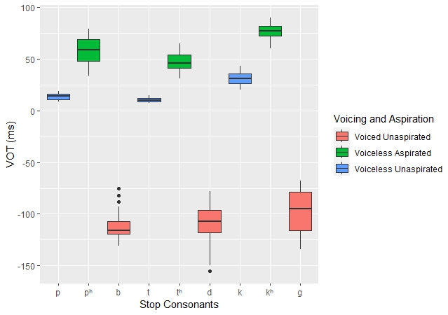
Figure 1. Boxplot of VOTs (ms) of the Stop Consonants of Mankiyali
Figure 1 shows the VOTs of all the stop consonants of Mankiyali. These results showed the different phonemes which were coloured for clear understanding and simplicity. All the VDA were coloured with red, VLA with green, and VLUA with blue. These results were taken using R software and data for these results are in Table 2. It was reported earlier that these phonemes have significant differences which were clearly shown here. The significance differences were noted in places of articulations and voicing. All the VLA and VLUA consonants had positive VOTs and VDU consonants had negative VOTs. The positive and negative VOTs were clearly marked with the middle horizontal line where positive values are above and negative values are below of it. It was also observed that VLUA stops had smaller voicing lag than their counterparts VLA stops. Among the VLA, the velar /k/ had got larger voicing lag then the rest two e.g., bilabial /p/ and alveolar /t/. These differences were further noticed in more statistical analysis which were given below in Table 4.
Table 4. Results of the separate phoneme
Sounds | Mean | Standard Deviation | Range
p | 13.7 | 3.17 | 10
pʰ | 58.3 | 12.4 | 45
b | -111 | 14.3 | 56
t | 10.5 | 10.1 | 8
tʰ | 46.8 | 10.1 | 34
d | -108 | 20.2 | 77
k | 31.6 | 7.29 | 23
kʰ | 76.2 | 8.49 | 30
ց | -96.4 | 20.3 | 66

The results provided in Table 4 were obtained using R. The data were analysed and these results obtained which show the mean, standard deviation, and range all stop consonants.
Conclusion
The present study investigated a single feature (VOT) of Mankiyali acoustically. The physical properties of stop phonemes were analysed where the focus remained on phonemes, durations, -VOTs, and +VOTs. The major findings of the study showed that Mankiyali has three laryngeal categories; voiceless unaspirated (VLUA), voiceless aspirated (VLA), and voiced unaspirated (VDUA) stops. Significant differences were found there in stops in terms of –VOTs, +VOTs, place of articulation, duration and phonation. –VOTs had always longer voicing lag, and +VOTs varied based on place of articulation. Negative and positive VOT values showed differences that all VLUA and VLA stops had +VOTs and all VDUA have –VOTs. In terms of place of articulation, bilabial VLUA /p/ has longer voicing lag than alveolar VLUA /t/, but has shorter voicing lag than velar VLUA /k/. Furthermore, the results related to voicing lag of VDUA /b, d, ց/ showed closeness to one another. VLUA bilabial stop /p/, VLUA alveolar stop /t/, and VLUA velar stop /k/ showed shorter voicing lag than their VLA counterparts /pʰ, tʰ, kʰ/. The VLA stops got two and three times longer voicing lag than the VLUA stops. Phonation enlarged the duration and it constantly changed with the place of articulation. The current study was limited to a single language (Mankiyali) in which it focussed on the VOT values of stop consonants. This study is based on the phonological aspects of the language and will create more spheres for further researchers to do the acoustic analysis of nasal and glottal phonemes.
This research will open the door for researchers to investigate other areas of the language that will lead to documentation of the language. It also brings a positive change in the mind of native speakers to conduct research on it.

References
Ahmadi, T., Karshenas, H., Babaali, B., & Alinejad, B. (2020). Allophone-based acoustic modeling for Persian phoneme recognition. Signal and Data Processing, 17(3), 37-54.
Anjum, U., Khan, Q., & Gulzar, A. (2016). Translation, cultural adaptation and cross language validation of domains of language use patterns. Journal of Asian Civilizations, 39(2), 1-25.
Anjum, U., Kiani, Z. H., & Khan, Q. (2018). Gender variation of language use in family: A study of an endangered language spoken in North Pakistan. Kashmir Journal of Language Research, 21(1), 123-132.
Anjum, U., Saleem, T., Qadeer, A., Khalid, M., & Shehzad, W. (2020). Tarawara community a marginalized linguistic community: An ethnohistorical perspective. Journal of Asian Civilizations, 43(2).
Arsenault, P. (2017). Retroflexion in South Asia: Typological, genetic, and areal patterns. Journal of South Asian Languages and Linguistics, 4(1), 1-53.
Boersma, P. (2014). 17 Acoustic analysis. Research methods in linguistics, 375.
Bosen, A. K., Monzingo, E., & AuBuchon, A. M. (2020). Acoustic-phonetic mismatches impair serial recall of degraded words. Auditory perception & cognition, 3(1-2), 55- 75.
Cangemi, F., & Baumann, S. (2020). Integrating phonetics and phonology in the study of linguistic prominence. Journal of Phonetics, 81, 100993.
Cheng, A. (2021). Maintenance of phonetic and phonological distance in the English and Korean back vowel contours of heritage bilinguals. Journal of Phonetics, 89, 101109.
Cho, T., Whalen, D. H., & Docherty, G. (2019). Voice onset time and beyond: Exploring laryngeal contrast in 19 languages. Journal of Phonetics, 72, 52-65.
Chodroff, E., & Wilson, C. (2020). Acoustic–phonetic and auditory mechanisms of adaptation in the perception of sibilant fricatives. Attention, Perception, & Psychophysics, 82(4), 2027-2048.
Chodroff, E., Golden, A., & Wilson, C. (2019). Covariation of stop voice onset time across languages: Evidence for a universal constraint on phonetic realization. The Journal of the Acoustical Society of America, 145(1), EL109-EL115.
Cohn, M., Segedin, B. F., & Zellou, G. (2022). Acoustic-phonetic properties of Siri-and human-directed speech. Journal of Phonetics, 90, 101123.
Ditewig, S., Smorenburg, L., Quené, H., & Heeren, W. (2021). An acoustic-phonetic study of retraction of/s/in Moroccan Dutch and endogenous Dutch. Nederlandse Taalkunde, 26(3), 315-338.
Earle, F. S., Landi, N., & Myers, E. B. (2018). Adults with specific language impairment fail to consolidate speech sounds during sleep. Neuroscience letters, 666, 58-63.
Feehan, C. (2020). Articulatory and acoustic phonetics of voice actors. The Journal of the Acoustical Society of America, 148(4), 2581-2581.
Giovannone, N., & Theodore, R. M. (2021). Individual Differences in the Use of Acoustic- Phonetic Versus Lexical Cues for Speech Perception. Frontiers in Communication, 6, 120.
Hauser, I. (2021). Contrast implementation affects phonetic variability: A case study of Hindi and English stops. Laboratory Phonology, 12(1).
Heeren, W. F. (2020). The effect of word class on speaker-dependent information in the Standard Dutch vowel/aː. The Journal of the Acoustical Society of America, 148(4), 2028-2039.
Horo, L., Sarmah, P., & Anderson, G. D. (2020). Acoustic phonetic study of the Sora vowel system. The Journal of the Acoustical Society of America, 147(4), 3000-3011.
Hussain, Q. (2021). Fundamental frequency and phonation differences in the production of stop laryngeal contrasts of endangered Shina. Languages, 6(3), 139.
Hussain, Q. (2021). Phonetic correlates of laryngeal and place contrasts of Burushaski. Speech Communication, 126, 71-89.
Hussain, Q., & Mielke, J. (2020). An acoustic and articulatory study of laryngeal and place contrasts of Kalasha (Indo-Aryan, Dardic). The Journal of the Acoustical Society of America, 147(4), 2873-2890.
Hussain, Q., Proctor, M., Harvey, M., & Demuth, K. (2020). Punjabi (Lyallpuri variety). Journal of the International Phonetic Association, 50(2), 282-297.
Khan, B., Stokes, M., Khan, S., & Seyffert, S. (2020). Acoustic-phonetic analysis of speech following a lobectomy or esophagectomy. The Journal of the Acoustical Society of America, 148(4), 2584-2584.
Kochetov, A., Petersen, J. H., & Arsenault, P. (2020). Acoustics of Kalasha laterals. The Journal of the Acoustical Society of America, 147(4), 3012-3027.
Krauss, M. (1992). The world’s languages in crisis. Language, 68(1), 4-10.
Lalain, M., Ghio, A., Giusti, L., Robert, D., Fredouille, C., & Woisard, V. (2020). Design and development of a speech intelligibility test based on pseudowords in French: Why and how? Journal of Speech, Language, and Hearing Research, 63(7), 2070-2083.
Levi, S. V. (2021). Course structure and projects for undergraduate CSD Acoustic Phonetics courses. The Journal of the Acoustical Society of America, 149(4), A131-A131.
Liljegren, H. (2019). Gender typology and gender (in) stability in Hindu Kush Indo-Aryan languages. Grammatical gender and linguistic complexity, 1, 279-328.
Liljegren, H., & Khan, A. A. (2017). Khowar. Journal of the International Phonetic Association, 47(2), 219-229.
Lopez-Backstrom, M., & Koffi, E. (2020). A Sociophonetic Account of the Similarities Between Northern Minnesota English and Winnipeg Canadian English. Linguistic Portfolios, 9(1), 9.
Narayan, C. R. (2020). An acoustic perspective on 45 years of infant speech perception. II. Vowels and suprasegmentals. Language and Linguistics Compass, 14(5), e12369.
Patil, A., More, P., & Sasikumar, M. (2019). Incorporating finer acoustic phonetic features in lexicon for Hindi language speech recognition. Journal of Information and Optimization Sciences, 40(8), 1731-1739.
Reetz, H., & Jongman, A. (2020). Phonetics: Transcription, production, acoustics, and perception. John Wiley & Sons.
Samudravijaya, K. (2021). Indian language speech label (ILSL): a de facto national standard. In Advances in Speech and Music Technology (pp. 449-460). Springer, Singapore.
Schertz, J., & Khan, S. (2020). Acoustic cues in production and perception of the four-way stop laryngeal contrast in Hindi and Urdu. Journal of Phonetics, 81, 100979.
Siregar, I. (2022). Cyber Library Auditorium Acoustic Evaluation in Acoustic Phonetic Perspective. Budapest International Research and Critics Institute (BIRCI-Journal): Humanities and Social Sciences, 5(1), 5276-5284.
Subramaniam, N., & Ramamurthy, K. (2020). Effect of mode of delivery and background noise on speech characteristics of talkers in a classroom environment. Building Acoustics, 27(2), 113-135.
Torwali, Z. (2021). The Dards, Dardistan and its linguistic diversity. Pashto, 50(62).
Winn, M. B. (2020). Accommodation of gender-related phonetic differences by listeners with cochlear implants and in a variety of vocoder simulations. The Journal of the Acoustical Society of America, 147(1), 174-190.
Yun, S., Choi, J. Y., & Shattuck-Hufnagel, S. (2020). A landmark-cue-based approach to analyzing the acoustic realizations of American English intervocalic flaps. The Journal of the Acoustical Society of America, 147(6), EL471-EL477.
Yutaka, Y. (2018). The family tree model and “dead dialects”: Eastern middle Iranian languages. Senri Ethnological Studies, 98, 123-152.
Zarifian, T., & Fotuhi, M. (2020). Phonological development in Persian-speaking children: A cross-sectional study. International Journal of Speech-Language Pathology, 22(6), 614-625.
Zhou, Q., Li, Y., & Guo, L. (2020). An acoustic study of English word stress of Amdo English learners. Theory and Practice in Language Studies, 10(1), 117-122.

