Which Hollow is Witches’ Hollow? An Empirical Approach to Translating Proper Names
[For anonymity reasons
the author’s name,
contact information, and affiliation
have been moved to the biodata file.]
Abstract
Proper names—especially the telling ones—can play a vital role in portraying characters and settings in works of fiction. Their capacity to carry both literal and connotational meanings makes them excellent devices for both designing readers’ emotions and cueing them. Nevertheless, there is no consensus on their treatment of choice in translation, which informed a more detailed and in-depth approach aiming to empirically identify the differences resulting from various approaches to translating proper names. The paper explores the differences between two types of translation—domestication vs. foreignization—of a toponym from Lovecraftian horror fiction. The data were collected from native speakers of Polish (N_{pl}=514) and English (N_{en}=81) by means of the Binary Dimensions Matrix—a custom-made inventory devised to capture differences in connotational meaning. The analyses found significant connotational divergence between the foreignized and domesticated translations on 12 out of 41 dimensions and confirmed the occurrence of the divergence on 9 out of 9 hypothesized horror-related dimensions. The comparison of the results with the data from the English-speaking group revealed that although the significant differences yielded by foreignization (as compared to domestication) were fewer in number, they were also greater in strength. The results show that—at least for horror fiction and English–Polish translation—foreignization is not only more ‘horrific’ than domestication but also than the original name to the original audience, suggesting that ‘translation loss’ is a two-fold phenomenon that is to be considered on qualitative and quantitative levels alike.
Keywords: proper names; translation; reception; horror fiction; foreignization and domestication
If the translator simply transposes a name from a source text without facing the problems of adapting either phonology or orthography (…) is the resulting name in translation still the same name?
(Tymoczko, 2014, p. 226)
Introduction
It seems that there is a common belief among translation studies scholars that many people, including inexperienced translators, share the notion that proper names should not be translated (Tymoczko, 2014, p. 223; Parianou, 2007; Nord, 2003). Praxis, however, shows that nomina propria enjoy a wide variety of translative pampering during their transcultural tournee (e.g., Atikah Zabir & Haslina Haroon, 2018; Mazi-Leskovar, 2017; Nord, 2003), which should come as no surprise for the following two reasons. First, they are loaded with information (Rachut, 2017; Tymoczko, 2014, p. 223), whose availability in the target text is contingent on a translation’s skopos (Vermeer, 2000, pp. 221–223) and the resulting translative treatments such names undergo. Second, depending on the information they carry, proper names play a number of textual roles which ultimately force the hand of the translator.
Although the transference of semiotic loads in translation—especially when telling/meaningful names are considered—depends on the adopted strategy, it ultimately boils down to translators’ individual decisions and techniques used. Based on the review by Fernandes (2006), the following modes of transfer for proper names can be distinguished: deletion (absence from translation), substitution (lack of formal or semantic relevance), recreation (re-invention of an invented source text item), addition (inserting extra information for the sake of comprehensibility or appeal), conventionality (conventional counterpart), phonological replacement (re-creation of the sound image of the original by substituting it with a name that is graphically and phonetically similar), transcription (adapting the name to target writing system and grammar), copy (retaining the name in its original form), and rendition (translating the words comprising the name). In the case of deletion, substitution, recreation, and addition there is no transfer of meaning whatsoever. Phonological replacement seems to partially fall into that category as well and partially into the next; as there is hardly any ‘objective’ semiotic link other than that which is supplied by sound symbolism (Kohlheim, 2018). Furthermore, sound symbolism is also one of two factors that transcription and copy are contingent on (cf. Parianou, 2007; Fernandes, 2006); the other being the cultural distance (Galewska, 2019) between the target languaculture (TLC) and the source languaculture (SLC). Although it may be tentatively assumed that sound symbolism works universally on the most fundamental level (just like the bouba/kiki effect), the combination and quality of sounds coded in the graphic layer may trigger varying associations/connotations, as they introduce to the TLC a foreign SLC element (cf. Tymoczko, 2014, p. 224). The understanding of meaningful proper names translated this way, however, would still rely mostly on the shortness of the cultural distance allowing the readers to grasp the culture-specific aspects of such names (Galewska, 2019; Mazi-Leskovar, 2017)—with the translator being a notable example of such a reader (cf. Rachut, 2017). At the same time, rendition would work on the same cline, but in the opposite direction, dressing the foreignness in domestic robes. As the two approaches mirror Venuti’s (1995) foreignization and domestication, it stands to reason that should a general disposition towards either of them exist, it would have serious ramifications for translation. But what would they be? In terms of designing readers’ emotions, which of the two techniques works better? Or do both recreate the SLC’s connotations equally well?
Apart from the skopos, the choice of particular techniques for meaningful proper names depends on their textual functions (cf. Fernández Costales, 2014; Lungu-Badea, 2013, p. 446). Proper names identify single unique objects, they are not, however, single-purpose (Nord, 2003, pp. 183–184). By the means of their graphic and phonetic forms or semantic load they can shed light on their extensions’ qualities, reveal their socio-cultural or ethnic affiliations (Lungu-Badea, 2013, p. 444), or strike some affective chords (Parianou, 2007). Although proper names can also invoke history, geography, or social values (Tymoczko, 2014, p. 245), their true potential becomes evident when they are construed as micronarratives (Filar, 2015)—particularly potent devices for story- and worldbuilding in fiction, devices capable of delivering a tremendous narrative payload with just a few words. Proper names can also be seen as carriers for the ‘objective correlative’ or—as Eliot (1920, p. 92) would describe it—a formula for a particular emotion, be it an event, object, or a situation. Or an image. Or connotations. Given that an important part in establishing a fictional space rests with designing readers’ emotions and setting the mood (Fernández Costales, 2014), proper names should prove particularly suitable for creating atmosphere in horror/gothic/weird fiction. Unsurprisingly, they are (Kohlheim, 2018; Joshi, 2013, pp. 1272–1273). Which is why their utility and importance for the world depicted begs a question about the best way to approach their translation.
Although Newmark generally advised against it, he noticed that since literary proper names may carry connotations, they could be translated—rendered, not copied or reproduced—but only in special cases and provided that the connotation is of paramount importance (Newmark, 1986, p. 71). Lungu-Badea (2013, p. 453), on the other hand, postulates that the author–original reader relation should be similar to the translator–target reader relation, which seems to speak strongly in favor of rendition. Even the translative practice fails to uncover a clear-cut general preference. Nord (2003, p. 194) found reproduction to be most commonly used while Mazi-Leskovar (2017, p. 149) showed that it was the foreignization that prevailed (at least in the case of toponyms). Amenta (2020, pp. 18–19) suggested that the preference may be culture-bound, as Italian publishers strongly favor domestication in general; the notion is also at least partially consistent with Fernández Costales (2014) who reports different preferences for Spanish (foreignization) and Mexican (domestication) translations, and in line with conclusions by Ellefsen and Bernal-Merino (2018), and Mangiron (2018, p. 292). The great variance in translative practice suggests that it is the matter of the translation’s skopos, TLC, and textual functions rather than of a universal treatment of choice.
Because a certain level of SLC competence is essential to being a translator, most translators are not formally trained in the TLC and draw on their native competence (assuming that translations are rendered mostly by members of the TLC). It stands to reason, therefore, that with regard to designing readers’ emotions, translators’ work is largely intuitive (cf. Suojanen, Koskinen, & Tuominen, 2015, p. 116)—that is to say, grounded in their individual experience with their native LC. This probably also holds true for the majority of analytical translation case-studies, as most often they are based on intuitions from researchers (i.e., individuals who do not need the translation) and not on the insights from the translations’ target readers, a notion that gave rise to Reception Studies and the concept of User-Centered Translation by Suojanen and colleagues (2015). However, as follows from their review (ibidem, pp. 111–122), proper names have yet to elbow their way into mainstream in the field. The need for more empirical quantitative research is also emphasized by Mangiron (2018, p. 285) as it would prove beneficial not only for the industry but also to academia and translator training. Although Mangiron’s statement pertained to game localization, it also holds true for literary texts as the two increasingly often become mutual paratexts or result from intersemiotic translation.
How can one know how to best tackle the translation of meaningful proper names? Does a translator’s choice to copy or render a meaningful proper name influence the name’s connotations and, if so, how? Do domestication and foreignization recreate the SLC’s connotations equally well? Based on the above-mentioned considerations, it seems logical to adopt a new approach to answer these questions. Because participants’ judgements and self-reported preferences seem to be not very reliable, as they may be grounded in varying—from person to person—criteria for assessment, thus not saying anything in particular about the translative procedure’s effect, or be subject to social desirability bias (cf. Fernández Costales, 2016, pp. 191–192), it would be prudent to delve directly into the differences generated by various translative approaches instead of relying on participants’ opinions. Although questionnaires are rarely used in Translation Studies (ibidem, p. 190), they seem well-suited for use with large samples. This is why, to tackle the problem of translating proper names from a different perspective, a new questionnaire measure and an empirical procedure were devised, wherein the domestication approach was operationalized as translation by rendition while foreignization—as translation by copying (cf. Fernandes, 2006). It was also decided that the research should focus on a horror/weird fiction toponym due to the genre’s heavy reliance on evoking emotions and the fact that toponyms seem to be under-researched (Kohlheim, 2018).
Hypotheses
Based on the questions above, it is hypothesized that:
H_{1.1}: Translations by copying and rendering have different connotations for a weird fiction toponym in the TLC.
H_{1.2}: Compared to rendering, copying is more potent at evoking the feeling of horror—stronger connotations of the (ac)cursed, the alien, anxiety, chaos, danger, darkness, death, the evil, and impurity.
H₂: Compared to the SLC’s reception, in the TLC’s reception, translation by copying is related to fewer instances of connotational divergence than translation by rendering.
Method
Instruments
Being a part of a larger research project on translation of meaningful proper names in fiction, this study makes use of the Polish and English versions of the Binary Dimensions Matrix (BDsM), a custom-made inventory designed especially for the purpose of the project. Inspired by the semantic differential (Osgood et al., 1967) technique—a quantitative measure of attitudes and associations towards a single stimulus or sign, or subjective meaning thereof—the BDsM consists of 41 pairs of binary oppositions, such as dry—wet, good—evil, darkness—light, etc. The words in each pair mark the extremes of a continuum, whereon the participants are asked to mark down their associations with the sign—here, a meaningful literary toponym. Once the name is presented, the instruction encourages the participants to picture the place, ponder what it is like and how it makes them feel. Then they are asked to assess the place with regard to each pair of oppositions or—in other words—to locate the place on the continuum between them. The answers are given on a 7-point labelled scale ranging from “1—only the first (←left) word of the pair” through “4—both words equally” to “7—only the second (right→) word of the pair”. For the full list of items, see the complete questionnaire in appendix A or the visualization of the results in Figure 1.
Unlike the original semantic differential procedure, here the categories were stipulated in advance (i.e., not proposed by the participants but pre-determined by the experimenter). Limiting the array of possible categories was necessary to ensure comparability of the results in particular dimensions. Although the categories are not necessarily universal and may carry different symbolic readings across cultures, they were informed by the original psychological studies (Osgood et al., 1967), as well as linguistic and anthropological thought, and may be considered as reflecting at least some of the most fundamental categories of human cognition.
Moreover, contrary to the original technique, the words comprising the oppositions are not limited to adjectives—some are nouns. The primary function of adjectives is to describe qualities of objects, while nouns are more capable of bringing abstract ideas to mind. Take the dichotomies: dark–light (adjectives) versus darkness–light (nouns)—the former would seem to highlight the fact that a place is ‘painted’ in light or dark colors, while the latter would seem to refer to whether the place is permeated or essentially imbued with darkness or light. Another example is one of Osgood’s dichotomies, active—passive. Being an inanimate object, a place cannot be active. It can, however, be associated with stagnancy or action. Furthermore, because Polish nouns and adjectives have a grammatical gender—which has been shown to carry considerable connotational load (Phillips & Boroditsky, 2003)—it was decided that to prevent it from contaminating the participants’ associations, all the adjectives in the Polish version were given in the neuter.
Traditionally, when the technique of semantic differential is used in ethnolinguistic research, the favorable qualities are grouped on the left side of the questionnaire, while their pejorative oppositions—on the right side. The semantic ontology created this way may impose the notions of goodness and badness on other items—especially ones that do not fall into either category by nature or depend on the context, like feminine—masculine or small—great, respectively. To remedy that, the order of words within pairs—where applicable—reflected the location of numbers on the mental number line (MNL; Qiangqiang Wang et al., 2018). The MNL effect states that if numbers that grow in magnitude are mentally ordered in a line, they will grow from left to right in left-to-right writing systems and in the opposite direction in right-to-left writing systems. Since both Polish and English are written left-to-right, the small numbers/amounts in the questionnaire are associated with the left hand side (e.g., small—great, not great—small). Even in the case of life—death, which technically is hardly gradable, it remains intuitive as humans—in our experience—tend to move from being alive to being dead, much less in the opposite direction. Additionally, changing the order of words within pairs so that the terms that are conceptually familiar are not positioned on the same side of the questionnaire can prevent the participants from providing superficial, random responses (Tucholska et al., (in print)).
To mitigate the influence an item may have on another item that it directly precedes, it was decided that the list of all the binary oppositions should be presented to each participant in a random order. For instance, the calmness–rage opposition may semantically prime the participants and bias their next association towards negative emotions. The necessity to counteract such consistent bias against one item by randomizing the order of all items in each questionnaire was the primary reason to turn towards digital humanities and crowdsourcing, which has been recognized as a valid approach in Reception Studies (Suojanen et al., 2015, p. 108). The remaining ones being the outbreak of the covid-19 pandemic and the study’s design assuming the participation of English speakers (based in countries other than the experimenter’s). The questionnaire was created in Google Forms on a secure account dedicated exclusively to the study.
Despite being originally designed and developed in Polish, the BDsM was intended to have a parallel version in English from the outset, and the works on its translation/adaptation started immediately after the completion of its initial version. Although the BDsM is not intended as a psychometric test, the process was partially based on the procedure of adapting psychological measures and included the steps of translation, review, and adjudication as outlined by (Harkness et al., 2010). Its translation into English was commissioned to three professional Polish-English translators whose first and dominant language was English. All items rendered by the translators identically were automatically accepted. In the few cases of one translator differing from the other two, the item in question was adjudicated by another translator and settled with a discussion. To verify the quality of the adaptation and refine it, three separate back-translations were also commissioned with the resulting doubts being settled with the help of both another translator’s adjudication and a majority vote by a panel of 7 competent judges.
For the purpose of randomly assigning experimental conditions to Polish-speaking participants, Fergusson’s (2016) random redirect tool was used.

Material
It was decided that the proper name for the study should be Witches’ Hollow—a toponym from a short story that was first published in a collection of weird fiction tales, The Watchers Out of Time, by August Derleth. The eponymous Witches’ Hollow was chosen for the following reasons.
First, the proper name is not ‘artificial’, it has not been fabricated for the purpose of the study, but comes from an actual literary work and its translation(s). Using an authentic, real-life linguistic material adds to the study’s ecological validity.
Second, it is a meaningful name. Apart from referring to a place, its constituents do carry their own meanings both literal and connotational.
Third, referring to a place set in Lovecraftian universe, the toponym comes from a work that, in a way, epitomizes weird and horror fiction genres. At the same time, the story is Lovecraftian only in the sense that it takes place in the cult world of Cthulhu Mythos, inspired by Lovecraft’s works and notes he left, and stylized as Lovecraftian, but not authored by Lovecraft (Joshi & Schultz, 2001). Having been written solely by Derleth, the story is not canonical par excellence and it does not seem to enjoy as much zest for pop-cultural retellings (e.g., in role-playing games, film, or other fiction) that could affect—if not superimpose new readings on—the way its landscapes are experienced.
Fourth, the story offers practically no description of Witches’ Hollow. It does provide scant information on the area in general, and some generic facts about parts of the valley, but no palpable details that could be attributed to the Witches’ Hollow itself. In other words, it is not so much that the description gives the place the vibe, but rather the place lends its vibe to the story’s mood; or at least it is one of the cues that hint the atmosphere.
Fifth, there are at least three renditions of Witches’ Hollow used in Polish: Wiedźmi Jar (IPA: /vjɛd͡ʑmʲi jar/) in a published translation by Robert P. Lipski, Wiedźmia Kotlina (IPA: /vjɛd͡ʑmjɑ kotljina/) in the Polish Wikipedia entry on Lovecraft Country, and Dolina Wiedźm (IPA: /dolinɑ vjɛd͡ʑm/) an improvised translation sometimes used in casual speech. The abundance of Polish renditions offers a unique opportunity to contrast the original form of the name not against the quirks of one unique rendition, but against a number of separate Polish renditions capturing the ‘Polishness’ of these translations in general rather than a translator’s use of artistic license. It seems logical to expect that aggregating Polish renditions would contribute to cancelling out their idiosyncrasies and amplifying what the three renditions have in common (i.e., the general effect of domestication).
Study structure and procedure
This study consisted—in fact—of three separate sub-studies. The first employed an early version of the Binary Dimensions Matrix consisting of 31 items (BDsM-31-pl) and aimed to verify the H_{1.1} and H_{1.2}. The second one was conducted as a follow-up to the first one—its goal was to gather additional data by the means of additional ten items (BDsM-10-pl) that were added to the original inventory in the meantime. Both of these procedures involved self-identified native speakers of Polish (NSPL) and were conducted with the use of the Polish version of the questionnaire. The third study, involving self-identified native speakers of English (NSEN), employed the English adaptation of the 41-item version of the Binary Dimensions Matrix (BDsM-41-en) and aimed to verify the H₂.
In the case of both studies on Polish-speaking samples, upon clicking the link in the invitation, the prospective participants were randomly assigned to one of four groups and redirected to the appropriate survey version—each being one of the possible translations of Witches’ Hollow into Polish: (1) Witches’ Hollow (copying), (2) Wiedźmi Jar, (3) Wiedźmia Kotlina, and (4) Dolina Wiedźm (three renditions). The invitation for the NSEN linked directly to the English version of the questionnaire, as there was only one group (one English proper name) in the study.
At the beginning of each questionnaire, a clear description of the study was added, informing the participants about the (1) purpose of the study (it did not involve any form of deception or misinformation), (2) estimated completion time, (3) fact that the data is collected for the purpose of pooled analyses, (4) fact that the participation is anonymous and no data is recorded by the experimenter prior to submitting a completed survey and that because no data allowing identification is collected, a submitted questionnaire is impossible to be linked with the submitting person and, as a result, to be removed from the data pool. The participants were also provided with the experimenter’s identity, affiliation, and contact information and were informed that once they start the survey, they are under no obligation to complete or submit it and can withdraw from the study any time prior to submitting the results. Before starting the survey, consent was obtained from the participants.
Subsequently, the persons who agreed to take part in the study were asked to provide the following basic pieces of demographic information about themselves: age (in full years), gender (not obligatory), proficiency in English and—in the case of the NSEN—the name of the country wherein they had spent the most time and that best described their linguistic/cultural background. The levels of English proficiency had been predefined and the participants chose from a 7-item list covering the native option, as well as the six CEFR levels ranging from A1 to C2 together with the names of the most popular certificates and the Polish national education system’s equivalents.
Once that part was complete, the participants were provided with the toponym they were assigned, an instruction, and the list of binary oppositions to mark down their associations with the given place. Irrespective of the assigned group, at the end of the first sub-study (BDsM-31-PL), each participant was presented with four instances of the same excerpt from the story—each differing only in the toponym’s translation—and was asked to indicate how appealing each of them was on a scale from “1—the worst” to “5—the best”.
In the case of the follow-up study (BDsM-10-pl), once the participants completed the 10-item inventory, they were asked whether they had taken part in the previous part of the study. A positive reply would end the survey, while the negative one would display a request to provide a few more insights. No participant declared having taken part in the previous sub-study and all agreed to continue. The request was intended as a means of increasing the sample size of the previous stage of the study. The individuals who agreed to continue were randomly assigned a set of additional 4 out of 31 items from the BDsM-31-pl part. In this case, however, the randomization failed and all the participants were given the same set of items cold—hot, fragrance—stench, shallow—deep, and silence—noise. Since no grounds for exclusion of the data was found, the results were included in the analyses.
Recruitment and data collection
In the case of all three sub-studies, the invitations to participate were extended to either the NSPL or NSEN interested in horror, gothic, or weird fiction literature. The invitations were distributed among them via mailing lists and social media groups. The dissemination of the invitations among other fans of the genres by word of mouth was also encouraged.
The BDsM-31-pl sub-study was launched online in April 2021 and the data were collected over the course of the next seven months. The invitations for the follow-up study (BDsM-10-pl) were issued in May 2022, and the form remained open until November 2022. The survey for English-speaking audiences (BDsM-41-en) was made available in June 2022, and the data were collected through November 2022.
Participants
The 212 participants of the first BDsM-31-pl sub-study were randomly assigned to one of four groups, each numbering 52–54 persons, and the 302 participants of the follow-up study (BDsM-10-pl) were randomly assigned to one of four groups with 73–77 persons each. Because the latter was a follow-up to the BDsM-31-pl (both can be seen as two parts of the same inquiry) and their results are not compared against each other, the entire Polish-speaking sample is presented in one demographic profile. Out of 514 individuals, 235 (45.7%) were women, 277 (53.9%) were men, and 2 (0.4%) chose not to provide this information. The participants’s age spanned between 18 and 63 years (M = 28.57; SD = 8.175). In terms of English proficiency of the Polish-speaking group, 12 (2.3%) participants declared they were at A1 level, 13 (2.5%) A2, 76 (14.8%) B1, 215 (41.8%) B2, 149 (29.0%) C1, and 49 (9.5%) C2.
In the case of the third study, 100 individuals consented to participate and completed the BDsM-41-en questionnaire. However, the results from one of the participants were removed from the pool due to low data quality, and another 18 individuals were excluded from the analyses because even though they came from an English-speaking country, they assessed their English fluency at a C1 or C2 levels (meaning that English might have been their second language). Ultimately, the data pool came from 81 individuals—39 (48.1%) women, 41 (50.6%) men, and 1 (1.2%) person who chose not to supply this information. Their age ranged between 18 and 71 (M = 37.02, SD = 13.650). With regard to the country best describing the participants’ LC background, 54 (66.7%) indicated the United States, 15 (18.5%) the United Kingdom, 8 (9.9%) Canada, and 4 (4.9%) New Zealand.
Analyses
The statistical analyses were conducted by the means of the IBM SPSS Statistics 29 software. Because the data were not normally distributed and the groups varied in sizes, Mann-Whitney U tests were performed. The effects’ sizes (Eta-squared) were calculated form the Z-values provided by the inferential tests with the help of the MS Excel package, which was also used to visualize the final results.
Prior to the analyses, the raw numerical values for each pair—ranging from 1 to 7—were transformed so that the neutral label’s value was zero and the scale ranged from −3 to +3 (left to right). Although the Mann-Whitney test does not compare means, median would be hardly useful in visualizing the data, and for that reason for each of the binary dimensions the mean was also calculated and then transformed into percentages of the extreme values of the scales (i.e., x̄/3×100%; meaning that −3 would translate to −100% and +3 to +100%). The values were then visualized as bars in Figure 1; each reflecting the group’s average perception of a given toponym with regard to the particular connotational category.
The first analysis aimed to verify the H_{1.1} and H_{1.2} and compared the BDsM results from two groups of the NSPL. Each member of the first group, NSPL Witches’ Hollow, was presented with the toponym in its original form (copying technique), and each member of the other group, NSPL aggregated renditions, was presented with one of three Polish renditions of Witches’ Hollow. The second analysis aimed to verify the H₂ and compared the NSEN’s perception of Witches’ Hollow with the NSPL’s perception of Witches’ Hollow and with the aggregated Polish renditions (the two above-mentioned groups).
Results
Tables 1–3 present the detailed analyses for dimensions that reached the assumed significance level (α = 5%) or were nearly significant. Although the results for the remainder—non-significant—dimensions are not included, the complete connotational profile for all three conditions is visualized in Figure 1. Customarily, eta-squared values 0.14 and above indicate large effects, below 0.14 but equal or above 0.06—medium, while below 0.06 but above 0.01—small (Cohen, 1988, pp. 283–288).
The comparison of connotations for two types of translation in the NSPL found that out of 41 binary oppositions of the inventory, 12 showed statistically significant divergence in connoted meaning, while 2 more results reached near-significant levels (see Table 1). In terms of calm(ness)—anxiety, the original version connoted greater anxiety than its Polish renditions. Witches’ Hollow was also darker and more alien, evil, (ac)cursed, death-related, impure, and dangerous than the same place imagined on the basis of the Polish renditions of the toponym. The dimension of order—chaos was found to be significant, although by a whisker as it reached significance only for the directional H_{1.2} (for the purpose of verifying the H_{1.1} it was not significant). Additionally, the translation by copying was also related to greater levels of cold, stench, and misfortune. Furthermore, Wiedźmi Jar, Wiedźmia Kotlina, and Dolina Wiedźm together proved to be more inaccessible than Witches’ Hollow. With the exception of medium effect for safety—danger, the remainder of the above-mentioned effects were small. The results lend support to the H_{1.1} and H_{1.2} (significance levels for the latter hypothesis are one-tailed, as it postulated the direction of the relationship). Additionally, an almost-significant difference was found for the pleasant—unpleasant dimension, in which case the toponym in its original form seemed to have stronger negative connotations.
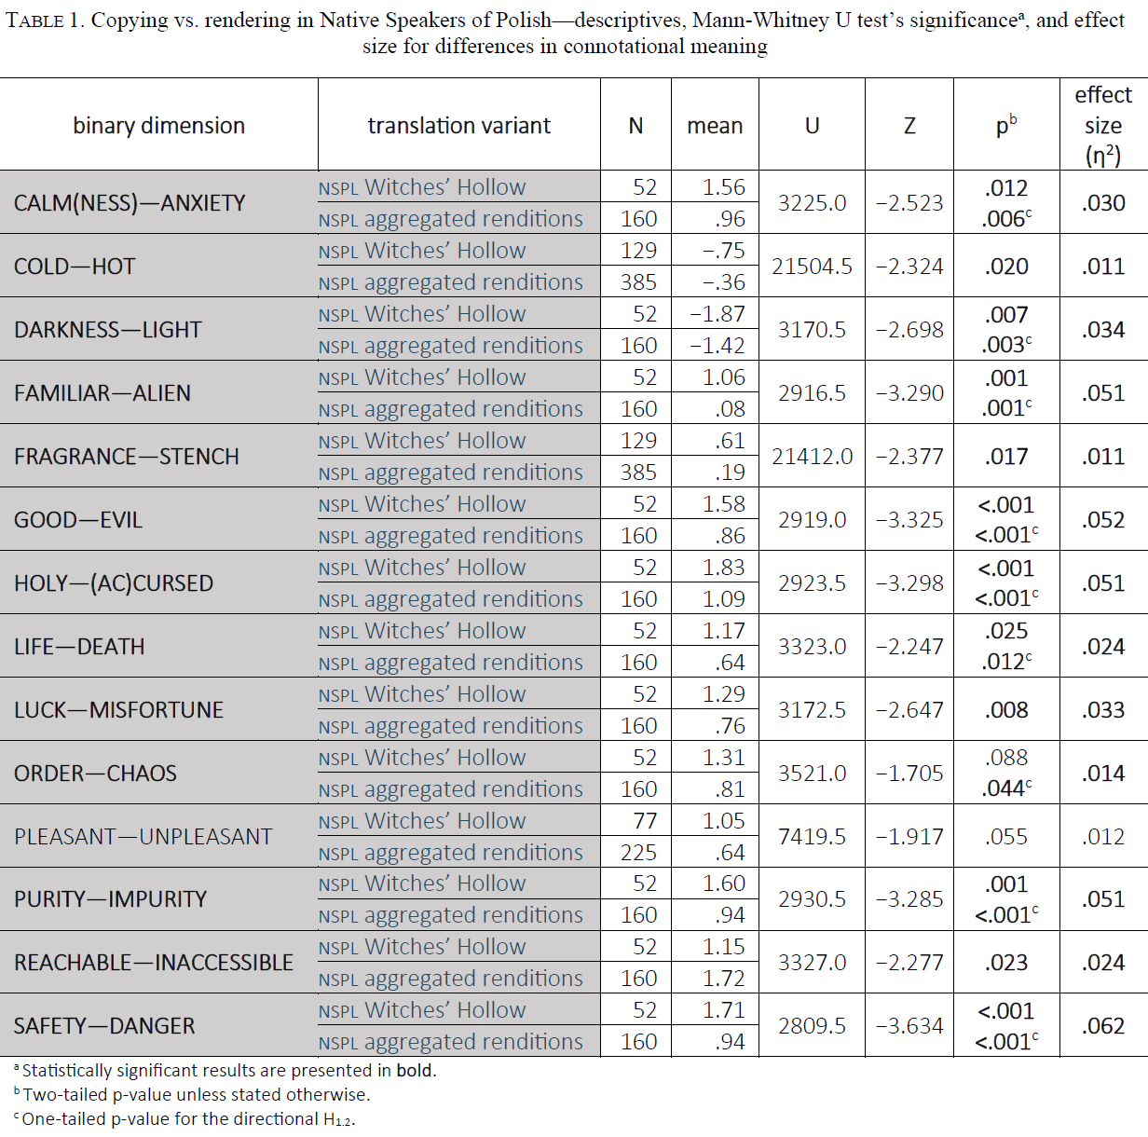
Significant and near-significant results of the comparison of the Witches’ Hollow’s connotations for the NSPL and NSEN are shown in Table 2. Out of 41 of the BDsM’s items, 12 showed significant differences, and another five—near-significant. Compared to the NSEN, the NSPL found Witches’ Hollow to be less interesting, less spiritual, and more related to anxiety, evil, the (ac)cursed, the secret, north, chaos, impurity, the inaccessible, danger, and depth. Despite not having reached the assumed significance levels, other differences might also include Polish-speakers associating the place to a lesser extent with the exotic, and to a greater degree with sadness, death, misfortune, and small size. The effect size was large for calmness—anxiety, medium for good—evil, north—south, and purity—impurity, and small for the remaining dimensions.
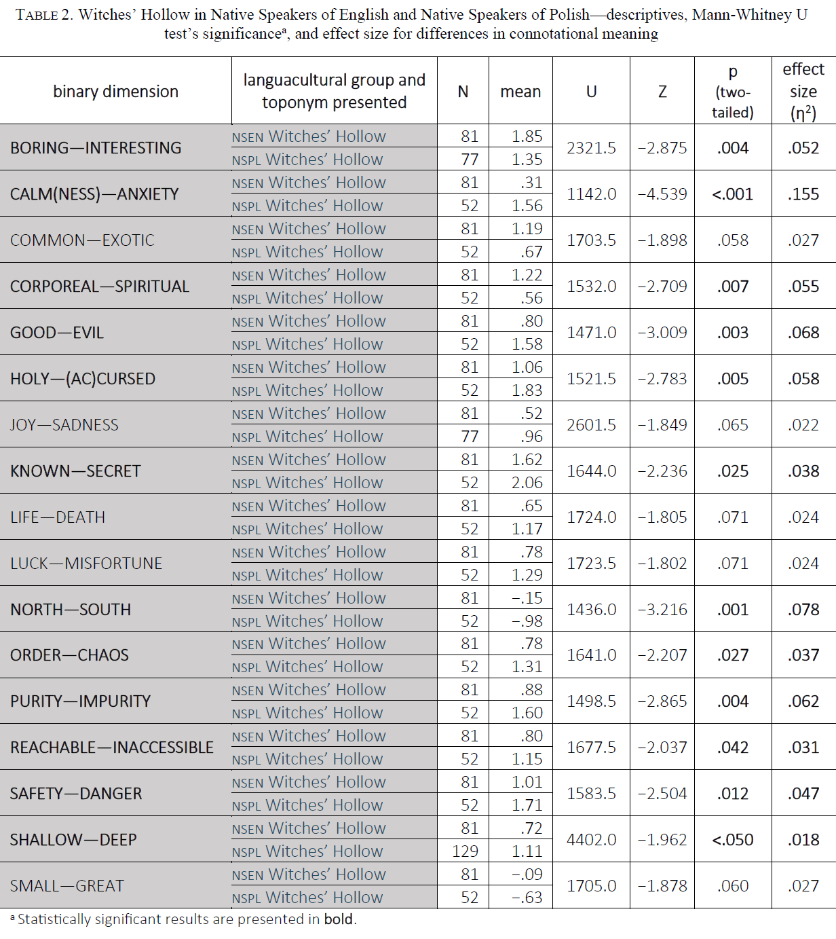
The analyses of connotations of Witches’ Hollow in the NSEN and of the toponym’s renditions in the NSPL yielded 13 significant results and one almost-significant (Table 3). Compared to the NSEN, the Polish group, on average, associated Wiedźmi Jar, Wiedźmia Kotlina, and Dolina Wiedźm to a lesser extent with such qualities as the interesting, cold, the spiritual, darkness, and the alien; at the same time, they also associated the rendered toponyms to a greater degree with anxiety, rage (contrary to the NSEN who linked Witches’ Hollow with calm(ness)), the ancient, wetness, secrecy, north, inaccessibility, and depth. The common—exotic dimension, although nearly-significant, might suggest that Polish renditions seemed less exotic to the NSPL than the original toponym to the NSEN. One effect, for reachable—inaccessible, was medium, and the rest were small.
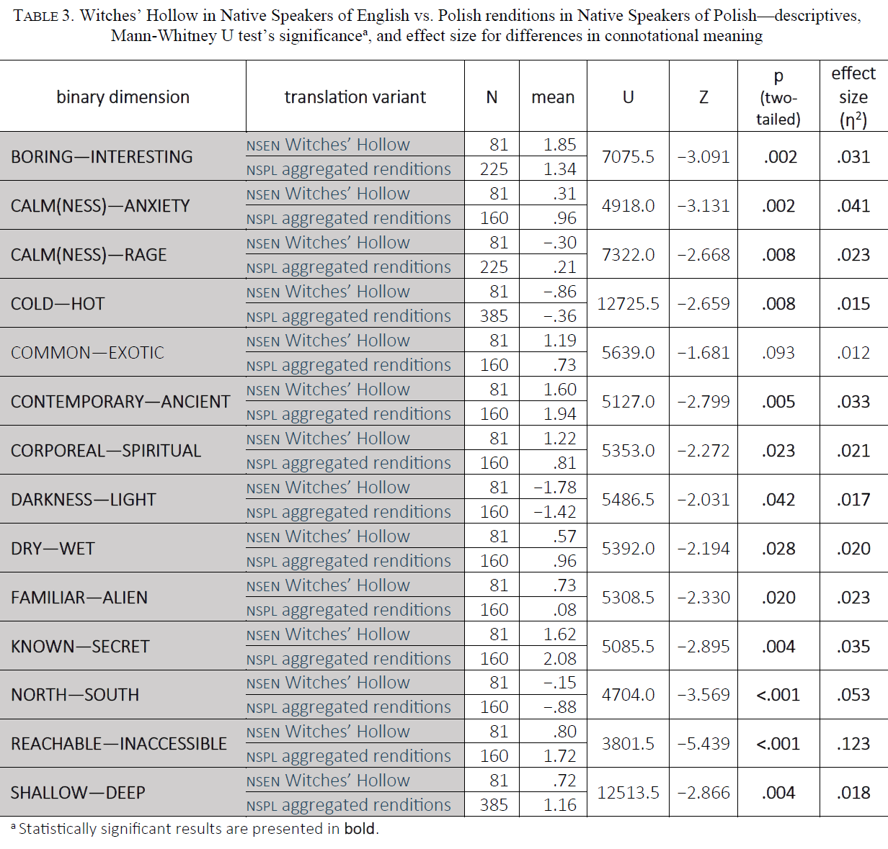
Given that there were 12 significant connotational differences between the NSPL and NSEN with regard to the name Witches’ Hollow and 13 significant differences between the NSEN and the Polish renditions it would seem that the H₂ was also confirmed, if only by a skin of a witch’s teeth. However, having considered the effects’ sizes—1 large, 3 medium, and 8 small in the former case vs. 1 medium and 12 small in the latter case—it need be noted that even though technically confirmed (fewer instances of divergence), with the overall strength of the divergence pointing in the opposite direction, the matter may be more complex.
With regard to translation assessment, the mean rating of the excerpt with Witches’ Hollow was 3.00, while the mean for the aggregated renditions was slightly higher and amounted to 3.27.
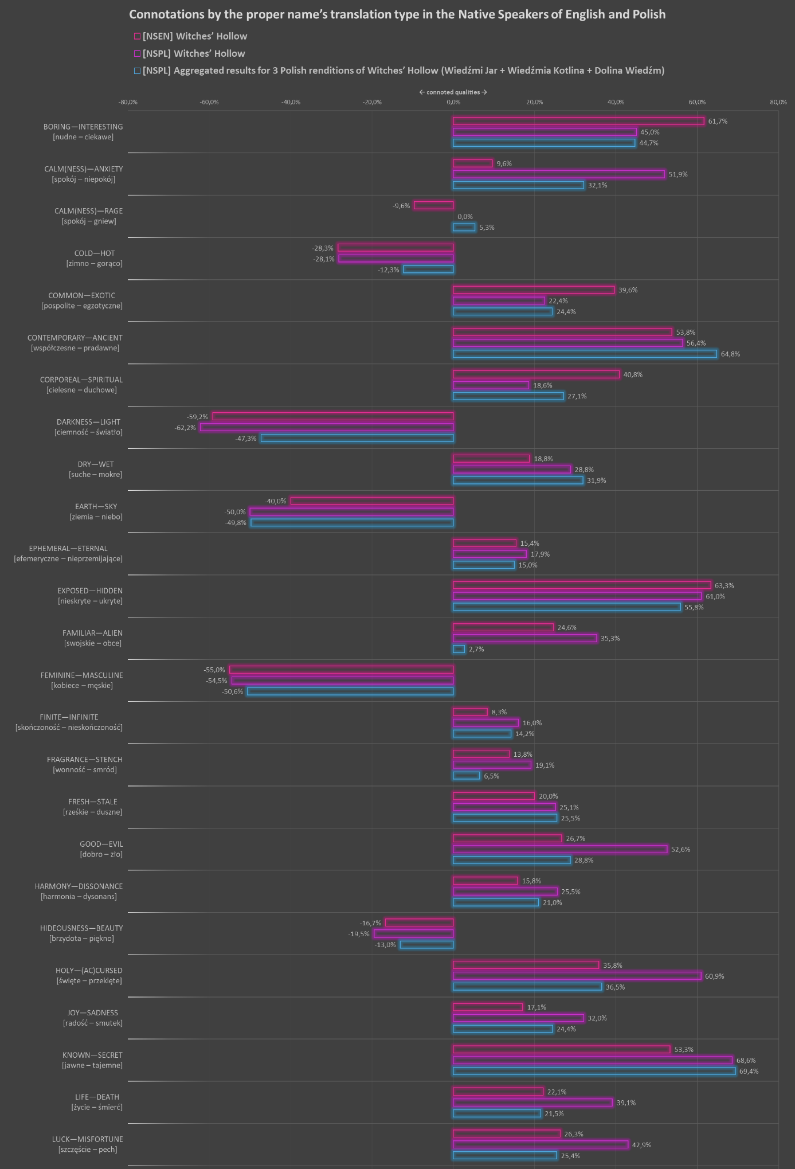
Figure 1. Connotations by the participant’s native language and by the proper name’s translation type.

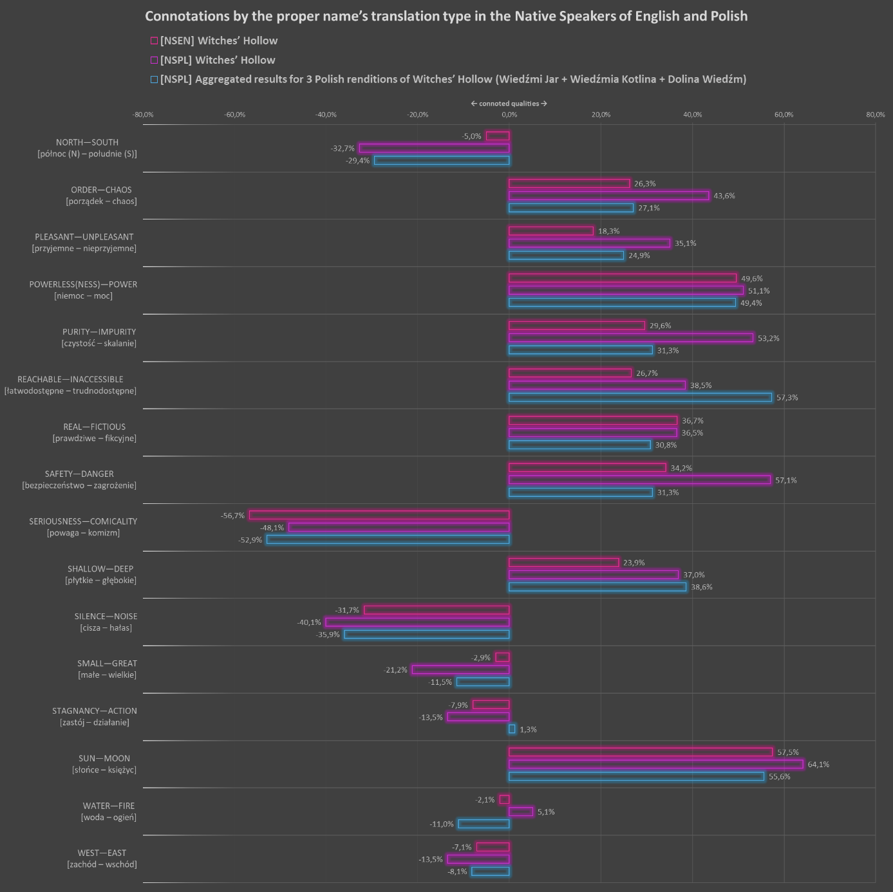
Figure 1—continued. Connotations by the participant’s native language and by the proper name’s translation type.

Discussion
In behavioral sciences, the majority of the effect sizes obtained are traditionally classified as small (but not negligible). This is to be expected when comparing connotations of linguistic items whose literal meanings are considered to be as close to equivalent as possible, as it is the numerous details, feelings, and associations that differentiate between them. Despite that, the measures of effect sizes were calculated because they provide more practical insights into the data obtained. The value of eta-squared is the proportion of the total variance in the results that can be explained by—in this case—the toponym variant. Although the values for several items cannot be summed up, they can still indicate which dimensions are subject to the greatest changes. Additionally, the values can serve to establish a benchmark for similar studies in the future.
The H_{1.1} was confirmed on the account of 12 significant connotational differences discovered. Given that 30% of the questionnaire’s items indicated significant differences, this seems like a very good result, especially since not all the items must necessarily be relevant to this particular toponym and that not all the items are expected to always yield differences. Take west—east. The copied toponym implies the place is located in an English-speaking country, so probably the so-called Western world (relatively to Poland), but it may also be just a conventional exotic name in a fantastic world. There is also no reason to expect that any of the Polish renditions would suggest any particular location of the place along the west—east axis; the meanings (and connotations) of dolina, kotlina, and jar in members of the Polish LC are contingent on their (prototypical) experience with Polish lay of the land, which gives no preference to any of them based the location on the west—east axis. This is consistent with the fact that in both Polish groups the mode was located in the middle of the scale (no preference). The fact that the results are slightly leaning towards west most probably stems from the combination of the name’s exoticism and genre’s convention—the inability to pinpoint the location would shroud it in a veil of mystery, adding to the atmosphere of obscurity. Perhaps that is also one of the reasons for the perceived inaccessibility of the place.
In order of the decreasing effect size, copying proved superior in connoting danger, evil, impurity, the (ac)cursed, the alien, darkness, misfortune, anxiety, death, chaos, and coldness. In bold are the qualities that lend support to the H_{1.2} as they were hypothesized to be stronger when foreignized. It would seem that the technique proved very efficient in evoking all the desired associations, with danger being the greatest (medium size) connotational difference, as it is the sense of danger that fuels the thrill. Evil, impurity, and unholiness that are the next to follow, seem to form a semantic complex whose in-depth analysis—informed by religious studies—would require a separate paper. The next two dimensions, alienness and darkness, are also related to the unknown; the notion is supported by consistently high results in the categories of the hidden and secret. Although the hypothesis did not mention misfortune, it is also consistent with the overall notion of malevolent higher power present in Witches’ Hollow. Anxiety, a connate to danger, shows a far weaker effect, which is hardly surprising when the comparison with the NSEN is taken into account. Apparently, the Polish renditions are not associated with anxiety as much as the copy, but they are still significantly more anxiety-laden than Witches’ Hollow for the NSEN. It seems that even Polish renditions sound exotic, if not peculiar, which is consistent with the fact that the renditions also proved significantly more inaccessible. In the case of the next two dimensions life—death and order—chaos, the renditions are on a par with how the NSEN experience the toponym, but the connotations are weaker than for the copied name. Being a known danger, death is not as terrifying as the unknown, perhaps that is why the unspecified danger ranks higher. Had the direction of the associations not been hypothesized the order—chaos dimension would not have qualified as a significant difference. It seemed, however, only logical that a Lovecraftian toponym be brimming with chaos. At the same time, it should be noted that Witches’ Hollow is not a name that implies anything unearthly large, immeasurably ancient, or even balefully sentient as the Old Ones, so—perhaps—that is why its relationship with chaos is only crawling, as it is nowhere near the numinotic experience that places such as Lovecraftian R’lyeh would instantly evoke.
Although technically the H₂ has been confirmed—which would suggest that foreignization ensures less connotational divergence than domestication—the number of differences found may not be the only measure of fidelity. On average, the effect sizes in Table 3 are smaller than the ones in Table 2 (also in terms of the number of medium effects: one in Table 2 vs. none in Table 3), which may indicate that domesticating causes the translation loss to manifest at smaller strength but across greater number of categories, while foreignizing is more limited in scope but greater in intensity. This would also indicate that translation loss (Hervey & Higgins, 2002, p. 20) may be seen as a two-dimensional phenomenon wherein translators may decide to ‘minimize difference’ by increasing its scope and decreasing intensity (domestication) or decreasing the number of qualitative differences at the cost of making them stronger (foreignization). This interpretation is consistent with the fact that included in Table 3 are the aggregated results for three separate renditions whose individual quirks mutually cancel out and accentuate the effects they have in common. Still, a more detailed analysis of the individual renditions would be required to further explore the matter.
The fact that the translation assessment question revealed a slight preference for the Polish renditions is far more difficult to interpret on its own because the participants’ assessment criteria are unknown—it might be due to the renditions having more appeal because of their creativity, the fact that declined names sound more natural in an inflectional language, a bias, or something else entirely. Combined with the more detailed data, however, the finding may suggest that it is precisely the jarring aspect of the name that founds its evocative potential. Counter-intuitive as it may be, it supports the notion that connotational measures such as the BDsM can yield more reliable data, explicitly showing the implications of given techniques or strategies and revealing whole complexes of meaning for interpretation.
Limitations and further research
Based on their self-assessment, the Polish participants can be regarded as possessing a good command of English (80.3% were at least B2), which presumably contributed to unlocking the meanings of words comprising the copied toponym. It remains unclear, however, how the two approaches would work for a group located in a greater cultural distance from the SLC (e.g., as in Atikah Zabir & Haslina Haroon, 2018).
It should also be noted that since the participants were recruited by purposive and snowball sampling methods, it is not possible to know whether the same approach to translation would have similar effects in other genres and for other—less weird, so to say—audiences. The extent to which the effectiveness of the translative techniques is contingent on the genre’s convention and readers’ familiarity with it also requires further investigation.
Conclusions
Despite being taken somewhat out of the original context of Tymoczko’s work, the question opening this paper remains fundamental to the work of a translator—particularly so, when telling names are in question. And while the answer to it—at least with regard to the scope of this inquiry—would be negative, it is also true that even rendered meaningful weird fiction toponyms are not the same name as the name from the source text, as both the SLC and TLC may construe and experience them differently.
What the study has demonstrated was that there is no single most appropriate choice, as all depends on a number of factors, chiefly the skopos, the textual function of the proprium, and the distance between the SLC and TLC. Consequently, the most appropriate approach is the one that takes these factors into account. It also shows that—at least in the case of weird fiction—unlike a name, the experience of the weird or the horror cannot be copied into to TLC, as in both cases there may be unique qualities to the experience that can only be shared by members of the same languaculture, thus partially confirming the conclusions of Atikah Zabir and Haslina Haroon (2018) and adding to the understanding of the notion of translation loss as described by (Hervey & Higgins, 2002). Incorporating the scope-intensity trade-off into the concept may contribute to more effective use of domestication and foreignization, especially with regard to designing readers’ emotions.
In terms of a new approach to Reception and Translation Studies, although participants’ general statements and judgements may offer valuable insights, their usefulness is strongly conditioned by the fact that the assessment criteria are not known to researchers and vary from participant to participant (i.e., each participant may understand and operationalize the question differently). As a result, the BDsM shows much promise as a user-friendly, comparable measure that can deliver quantifiable, easily interpretable data.
Acknowledgements
The author would like to extend their gratitude to Dr. Aeddan Shaw for his time and invaluable assistance and to the following Facebook communities for their support and engagement in the study: Zew Cthulhu RPG, Horror Weird Fiction, Grozownia, and H.P. Lovecraft Historical Society.
References
Agar, M. (2008). A Linguistics for Ethnography. Why Not Second Languaculture Learning and Translation? Journal of Intercultural Communication, 8(1), 1–12. https://doi.org/10.36923/jicc.v8i1.449
Amenta, A. (2020). O tłumaczeniu literatury fantasy na podstawie włoskiego przekładu cyklu wiedźmińskiego Andrzeja Sapkowskiego. Przekładaniec, 40, 7–21. https://doi.org/10.4467/16891864PC.20.001.13164
Atikah Zabir, & Haslina Haroon. (2018). Procedures in the Translation of Proper Names in Harry Potter and the Goblet of Fire into Malay. GEMA Online® Journal of Language Studies, 18(2), 108–123. https://doi.org/10.17576/gema-2018-1802-08
Cohen, J. (1988). Statistical Power Analysis for the Behavioral Sciences (2 ed.). Routledge. https://doi.org/10.4324/9780203771587
Eliot, T. S. (1920). The Sacred Wood: Essays on Poetry and Criticism. Methuen & Co. Ltd.
Ellefsen, U., & Bernal-Merino, M. Á. (2018). Harnessing the roar of the crowd: A quantitative study of language preferences in video games of French players of the northern hemisphere. The Journal of Internationalization and Localization, 5(1), 21–48. https://doi.org/10.1075/jial.00009.ell
Fergusson, A. (2016). Designing online experiments using Google forms+ random redirect tool. https://teaching.statistics-is-awesome.org/designing-online-experiments-using-google-forms-random-redirect-tool
Fernandes, L. (2006). Translation of Names in Children’s Fantasy Literature: Bringing the Young Reader into Play. New Voices in Translation Studies, 2(1), 44–57. https://doi.org/10.14456/nvts.2006.5
Fernández Costales, A. (2014). Video game localisation: Adapting superheroes to different cultures. Quaderns: Revista de Traducció, 21, 225–239.
Fernández Costales, A. (2016). Analyzing Players’ Perceptions on the Translation of Video Games: Assessing the Tension between the Local and the Global Concerning Language Use. In A. Esser, M. Á. Bernal-Merino, & I. R. Smith (Eds.), Media across borders: Localizing tv, film and video games (pp. 183–201). Routledge, Taylor & Francis Group.
Filar, D. (2015). Język jako wielka narracja: Teoria narracyjności w semantyce. Bulletin de La Société Polonaise de Linguistique, LXXI, 9–26.
Galewska, K. (2019). Tłumaczenie chińskich nazw własnych w ujęciu kognitywnym. Onomastica, 63, 263–278. https://doi.org/10.17651/ONOMAST.63.14
Garland, R. (1990). A Comparison of Three Forms of the Semantic Differential. Marketing Bulletin, 1, 19–24.
Harkness, J. A., Villar, A., & Edwards, B. (2010). Translation, adaptation, and design. In Survey methods in multinational, multiregional, and multicultural contexts. (pp. 117–140). John Wiley & Sons, Inc. https://doi.org/10.1002/9780470609927.ch7
Hervey, S. G. J., & Higgins, I. (2002). Thinking French translation: A course in translation method : French to English (Second edition). Routledge.
Joshi, S. T. (2013). I am providence: The life and times of H.P. Lovecraft. Hippocampus Press.
Joshi, S. T., & Schultz, D. E. (2001). An H.P. Lovecraft encyclopedia. Greenwood Press.
Kohlheim, V. (2018). Proper names in literature: A “reevaluation of all values.” Onoma, 53, 81–92. https://doi.org/10.34158/ONOMA.53/2018/6
Lungu-Badea, G. (2013). Translation of Literary Proper Names. In O. Felecan (Ed.), Onomastics in contemporary public space (pp. 443–457). Cambridge Scholars Publ.
Mangiron, C. (2018). Reception studies in game localisation: Taking stock. In E. Di Giovanni & Y. Gambier (Eds.), Reception studies and audiovisual translation (pp. 277–296). John Benjamins Publishing Company.
Mazi-Leskovar, D. (2017). Names in Literary Translation: A Case Study of English Versions of the Slovenian Tale Martin Krpan. Acta Neophilologica, 50(1–2), 137–152. https://doi.org/10.4312/an.50.1-2.137-152
Newmark, P. (1986). Approaches to translation. Pergamon Press.
Nida, E. (2000). Principles of Correspondence. In L. Venuti (Ed.), The Translation studies reader (pp. 126–140). Routledge.
Nord, C. (2003). Proper Names in Translations for Children: Alice in Wonderland as a Case in Point. Meta, 48(1–2), 182–196. https://doi.org/10.7202/006966ar
Osgood, C. E., Suci, G. J., & Tannenbaum, P. H. (1967). The measurement of meaning. University of Illinois Press.
Parianou, A. (2007). Translating Proper Names: A Functionalist Approach. NAMES: A Journal of Onomastics, 55(4), 407–416.
Phillips, W., & Boroditsky, L. (2003). Can Quirks of Grammar Affect the Way You Think? Grammatical Gender and Object Concepts. Proceedings of the Annual Meeting of the Cognitive Science Society, Volume 25, 928–933.
Qiangqiang Wang, Mowei Liu, Wendian Shi, & Jingmei Kang. (2018). Mechanism of the SNARC Effect in Numerical Magnitude, Time Sequence, and Spatial Sequence Tasks: Involvement of LTM and WM. Frontiers in Psychology, 9, 1558. https://doi.org/10.3389/fpsyg.2018.01558
Rachut, K. (2017). The specificity of literary proper names: Harry potter in translation into polish and russian. Annales Neophilologiarum, 11, 127–142. https://doi.org/10.18276/an.2017.11-10
Suojanen, T., Koskinen, K., & Tuominen, T. (2015). User-centered translation (First published). Routledge.
Tucholska, K., Gulla, B., Wysocka-Pleczyk, M., Piotrowski, P., Florek, S., Sekulak, M., & Głomb, K. ((in print)). Time experiencing in men serving the term of imprisonment—A semantic differential study. KronoScope. https://doi.org/10.57903/UJ/PBVUPE
Tymoczko, M. (2014). Translation in a postcolonial context: Early Irish literature in English translation. Routledge.
Venuti, L. (1995). The translator’s invisibility: A history of translation. Routledge.
Vermeer, H. J. (2000). Skopos and Comission in Translational Action. In L. Venuti (Ed.), The Translation studies reader (pp. 221–232). Routledge.

[Research grant info moved to biodata file for anonymity.]
Originally coined by Paul Friedrich as ‘linguaculture,’ the term was borrowed and modified by an American ethnographer, Michael Agar (2008) to emphasize that learning—and making sense of—a second language is as much about vocabulary and syntax, as it is about culture—a map to finding the meanings buried in the linguistic code. The term ‘languaculture’ is used throughout this paper as a reminder that meanings, symbols, and dispositions to experience linguistic phenomena in a particular way are acquired via enculturation rather than studying dictionaries as “language is part of a culture” (Vermeer, 2000, p. 222). What is meant by ‘cultural distance’ is the (lack of) languacultural familiarity and intelligibility, much like in Nida (2000, p. 130; not in the Hofstedean sense).

