Appendix 1: Officially Recommended Alphabets:

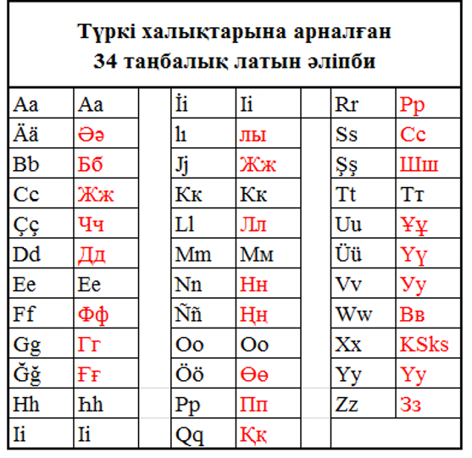
FIGURE 1. "Common Turkish Alphabet", 1994.

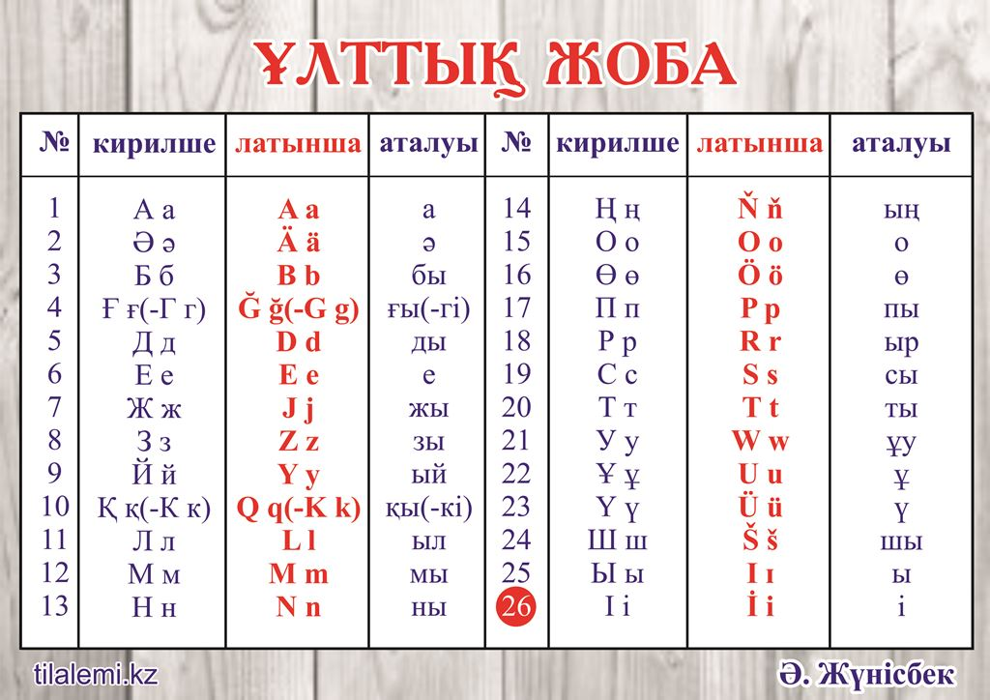

FIGURE 2. "National project", 2017.

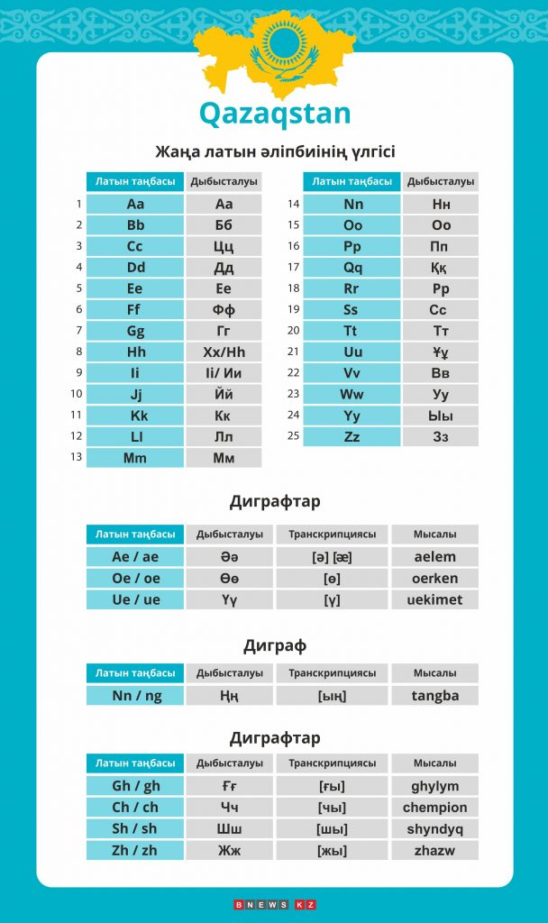

FIGURE 3. "Digraph Alphabet", September 11, 2017.
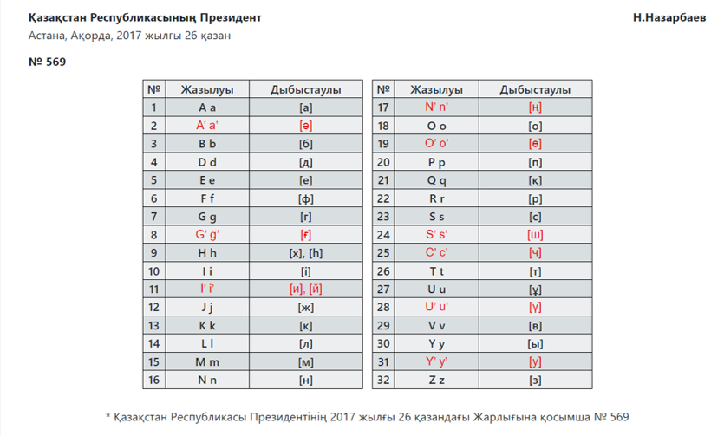

FIGURE 4. "Apostrophe Alphabet", October 26, 2017.

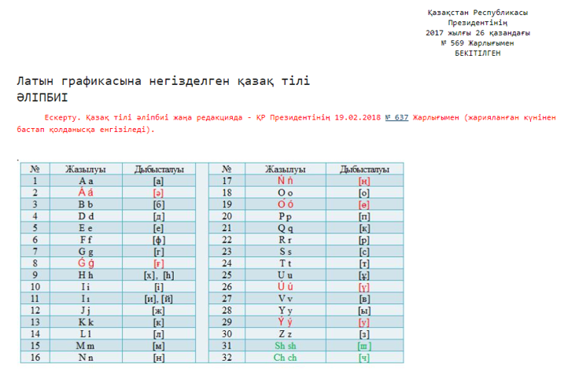

FIGURE 5. "Acute Alphabet", February 20, 2018.
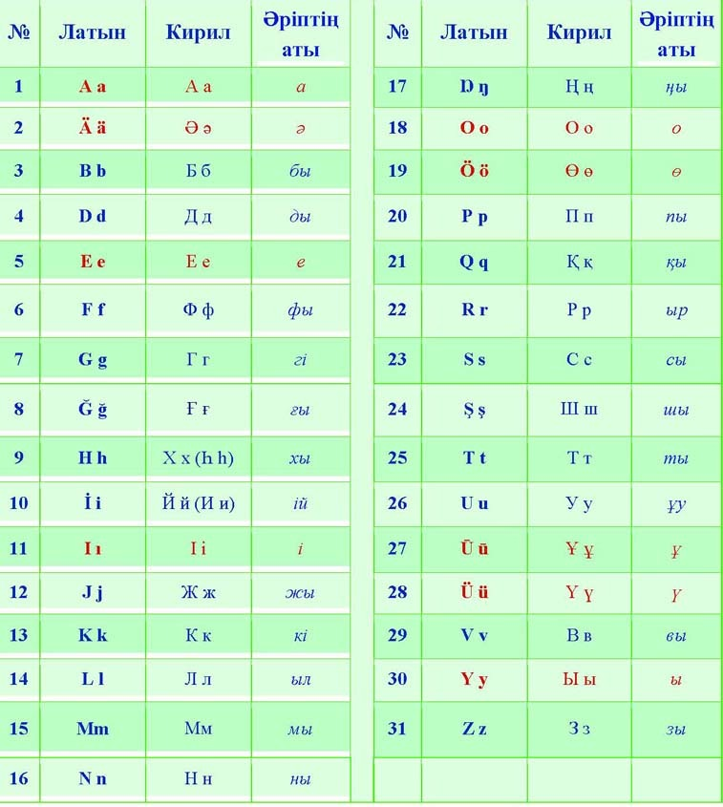

FIGURE 6. "Advanced Alphabet", January 28, 2019.

