Two Faces of Collaboration: A Critical Perspective on Effects of Collaboration in Learners' Corpus Consultation

ABSTRACT

Collaborative learning has been increasingly incorporated into learners' corpus consultation as a type of pedagogic mediation. However, studies found that the collaborative learning has negative aspects as it may cause conflicts and power inequality among members. Given the two sides of collaboration, this study provides a critical investigation on functions of collaboration in learners' corpus consultation. Through two collaborative corpus analysis sessions, three students of different L2 proficiency levels assisted each other’s understanding of corpus data to complete group activities. The students’ verbal and nonverbal behaviors during corpus analysis became the main source of investigation, complemented by the results of pre-/post-interviews and the researcher's direct observations. The findings of this study suggest that collaboration creates significant power inequality among the participants by gradually marginalizing the less capable student in the group from the learning process and increasing the psychological burden for the most capable student. In addition, collaborative work during corpus consultation could impede critical learning opportunities for individual students to pursue personal queries during collaboration. Despite some limitations, the findings of this study provide a realistic picture of collaboration in learners’ corpus consultation and bring pedagogical implications to corpus-based instruction.

Keywords: Learners' corpus consultation, two-sides of collaboration, pedagogic mediation, critical perspective

INTRODUCTION

Learners' corpus consultation has brought many advantages in L2 learning such as enhanced linguistic awareness and learning autonomy (e.g., Boulton, 2009; Yoon, 2008), but the advantages come with serious difficulties for the students (e.g., Pérez-Paredes, Sánchez-Tornel, Alcaraz Calero & Jiménez, 2011). As Conrad (2005) indicated, students experienced difficulties in analyzing corpora because they needed "a number of technological and research skills: to use the computer, to handle what may at first appear to be an overwhelming amount of data, to make observations, to generalize from observations, and to assess the limitations of the generalization they derive" (Conrad, 2005, p. 402). Without appropriate guidance, students had to exert great time and energy in the data analysis process and were at high risk of analyzing the corpora incorrectly. Thus, researchers have noted that learners' corpus consultation should include a proper type of pedagogic mediation to make corpus data pedagogically appropriate (e.g., Widdowson, 2000).
Among several types of pedagogic mediation such as providing pre-selected and pre-edited data (e.g., Tribble & Jones, 1990), using computer-guided instruction (e.g., Curado Fuentes, 2003), and taking a guided inductive approach (e.g., Flowerdew, 2012), collaborative corpus consultation has received a lot of attention with the increasing popularity of collaborative learning in L2 pedagogy (e.g., Flowerdew, 2008; Gavioli & Aston, 2001; O'Sullivan, 2007). In examining the pedagogic value of corpus data that provoked a pragmatic reaction between students, Gavioli and Aston (2001) suggested that use of the corpus encouraged spoken interaction between students because they discussed their findings with each other. As students often reached different conclusions from the same concordances, the research pointed out that students could arrive at interpretations that were more comprehensive, or more generalizable, by comparing their analyses through collaborative group work. With the example of a group examining concordances of food and its Italian equivalent cibo, the authors showed that a group of students jointly hypothesized a difference in the meanings of the two words after discussion of their findings, which might have been impossible if the students had analyzed the data individually.
Similarly, O’Sullivan (2007) suggested that the learners' corpus consultation enhanced the language learning process, which was cooperatively constructed in a group. Advocating process-based as opposed to product-based learning, the author noted that corpus consultation agreed with the theoretical assumptions of process-oriented teaching and constructivist principles in L2 learning in that the corpus data offered the resources for students to co-construct their knowledge as a community.
Drawing on Vygotskian sociocultural theories, Flowerdew (2008) adopted peer response activities to use the corpus data for creating a contextual writing environment. The study showed that group activities in consideration of participants’ different language proficiencies and analytic abilities enabled co-construction of the learning process of corpus consultation in that group members assisted each other’s development. In the scaffolding-type of activity, the author intentionally designed groups including students of different levels of proficiency. During the activity, the weaker students were able to build knowledge as well as independence in learning as more proficient students shared their interpretations and understanding on the corpus data. The author reported success of group discussion activities in the learners' corpus consultation as a form of pedagogic mediation, which improved awareness on differences in registers. The study demonstrated the benefits of group works in corpus consultation to encourage the weaker students' productive dialogue.
However, collaborative group work in corpus-based instruction has not always generated positive results. The study of Vannestål and Lindquist (2007) used a group activity in a corpus-based instruction. In the investigation on the change in learners’ attitudes toward grammar learning by introducing corpus consultation, the authors made students to work in pairs to deduce grammar rules from corpus consultation. Then, each pair of students in a group of four (i.e., two pairs in one group) took turns explaining the grammatical rules to each other. However, it was interesting to find that the students felt significant degree of difficulties especially in formulating their queries and interpreting the corpus data and a student even questioned the benefits of corpus consultation in grammar learning. In conclusion, the authors acknowledged the need for a large amount of introduction and support in learners' corpus analysis, hinting that the peer collaboration might not have been useful to assist the learners' corpus consultation.
Given the findings of the prior studies, it seems noteworthy that the benefits of collaboration may have a flip side to examine, especially from a psychological and motivational perspective. In particular, it is apparent that the benefits of collaboration in learners' corpus consultation have been celebrated in terms of how generalizable or successful the results of collaboration were (e.g., Flowerdew, 2008; Gavioli & Aston, 2001; O’Sullivan, 2007), not regarding the effectiveness of the collaboration in alleviating the learners' difficulties in corpus consultation. Thus, the mixed results on the efficacy of collaboration in learners' corpus consultation necessitated a qualitative investigation on the collaborative process of corpus consultation with focused attention on how collaboration actually functions in the process of learners' corpus consultation.

TWO SIDES OF COLLABORATION IN LANGUAGE LEARNING

Collaborative learning involves the "mutual engagement of participants in a coordinated effort to solve the problem together" (Roschelle & Teasley, 1995, p. 70). Johnson and Johnson (1999) found that collaboration enabled students to develop communication skills as well as social relationships and group cohesion. In addition, students were able to engage in deeper level learning, develop critical thinking skills, and retain instructed information in the long term through collaborative learning (e.g., Garrison, Anderson & Archer, 2001). Also, the collaboration facilitated learner's co-construction of knowledge and development of overall competence of language (e.g., Keen, 1992). When engaging in a web search task, in particular, peer collaboration encouraged students to express their ideas, guided the search process, and regulated search results (Lazonder, 2005).
Despite the benefits of collaborative learning, successful collaboration cannot be guaranteed at all times. Collaboration includes negotiation and competition, the process of which creates conflicts and power inequality among the participants (e.g., Chan & Chen, 2010). In particular, inequality among group members seems to be a natural consequence of competition between members of different levels of ability in collaborative learning. For instance, in examination of two non-native English speaking students' (NNS) experiences in mixed groups of native English speaking students (NS) and NNS in English university courses, Leki (2001) found that NNS were kept aware of their lack of power and control in collaborative group work due to their limited linguistic ability. Similarly, Cheng (2013) reported that the co-writing process of a mixed group of NS and NNS created a noticeable power inequality between participants, majorly caused by the lack of linguistic ability of NNS. The findings of the studies suggested a strong possibility that the less capable members within a group of NNS may be as vulnerable as the NNS in the mixed group of NS and NNS. In this sense, collaborative learning may create an environment that discourages and demotivates the less capable members to make contributions to group work.
In fact, studies on affective and motivational aspects of collaboration have reported pitfalls of collaboration in the learning process (e.g., Järvenoja & Järvelä, 2009). The process of collaboration may include conflicts due to students' different characteristics, goals, and demands, which cause negative emotions and discouragements (e.g., Järvelä, Lehtinen, & Salonen, 2000). In particular, Järvenoja and Järvelä (2009) noted that the process of co-construction of knowledge may entail strong motivational challenges, discouraging the learners to participate in collaboration. In this sense, collaboration in learning may demotivate some learners to contribute to the group task, causing psychological distress in relationships between members and disturbing the learning process itself.
Based on the findings of previous research on bright and dark sides of collaboration, the present study provides a critical observation on functions of collaboration in the process of learners' corpus consultation. This study analyzes three sources of data, including verbal and nonverbal communications during group work, findings from pre- and post-interviews, and the instructor's observation notes, to examine the process of learners' collaboration from multiple perspectives. Through two tasks of collaborative corpus consultation by three students at different L2 proficiency levels, this study identifies critical functions of collaboration, concerning the instructional, motivational, and psychological aspects of learning. The description of the collaborative corpus consultation provides a realistic picture of collaboration in learners' corpus analysis, which would deepen our knowledge on the collaborative process in corpus analysis.

METHODOLOGY

PARTICIPANTS

Three female students were recruited through an online community website of a four-year university in Seoul, Korea. They volunteered to participate in this experiment with interests in learning English. They varied in terms of age, major, linguistic proficiency level based on TOEIC (Test of English for International Communication) score, and experience studying abroad (Table 1). In terms of linguistic proficiency level, this study utilized categories from A to E based on the TOEIC score by ETS^{i}. S1 was level B (TOEIC score higher than 730 and lower than 860), and S2 and S3 were level A (860 or higher). It is expected that the students' different linguistic proficiency levels would allow natural flow of knowledge between group members during the corpus consultation.

TABLE 1. Description of participants

Students | S1 | S2 | S3
Age | 30 | 23 | 21
Major | International Relations | Business Administration | Japanese
TOEIC score | 775 | 885 | 910
Linguistic proficiency level | B | A | A
Self-reported computer skills | medium | medium | medium
Experience abroad | None | None | Six months in Canada as an exchange student
Experience in corpus linguistics | None | None | None

Among the three participants, S1 had the lowest linguistic proficiency level based on her TOEIC score. During the pre-interview, she noted that despite her major (International Relations), which required a good command of English, her English was not good enough to understand English lectures. Thus, she felt strong need to study English and keep applying for TOEIC tests to improve her score. In addition, S1 was the oldest member as she had entered this university after graduation from a different college. S2 majored in Business Administration and had strong interests in improving her English because her major required high English proficiency. During the introductory session of this study, she seemed to be thrilled as she thought the corpus consultation as an innovative way of learning English. S3 was the youngest student, but had the highest TOEIC score. She had spent six months in Canada, while the other two had no experience studying abroad. S3 majored in Japanese, but she seemed to have high English proficiency. During the corpus consultation, she read and comprehended concordance lines the fastest and most accurate among the members.

DATA COLLECTION PROCEDURE

The introductory class started with a written survey asking the participants' personal information. The survey also asked students to write sets of synonymous expressions whose usage and semantic differences seemed to be indiscernible to them such as affect/effect/influence and hope/wish. The sets of synonymous expressions were used in designing two tasks of corpus consultation in this study. After the survey, the students took one-hour lecture about the basic concepts of corpus linguistics and how to use the Lextutor, a web-based system for exploring online corpora. After the lecture, the students were given hands-on activities to use the Lextutor and analyze search results. At the end of the class, students were interviewed to share their opinions and expectations on using corpus consultation in learning English.
On the next day, students worked as a group to complete a task by collaborative corpus analysis. The students were given one computer to share, which was to encourage verbal and nonverbal communication among members. Before the start of corpus analysis, each student was given a worksheet to fill in, which asked the students to discern semantic and functional differences of two sets of synonymous expressions (affect/effect/influence and travel/journey/trip). Through group discussion on concordance lines of search terms on Lextutor, students created hypotheses on differences among the expressions as students had done in the study by Gavioli and Aston (2001).
The third day’s session required students to analyze corpus data as a part of an essay writing activity (i.e., translation as a standardized task of writing in this study). The reason for inclusion of the writing activity in the experiment was that during the pre-interview, the students expected to use corpus data as an L2 writing reference. A task of the third day's session consisted of two parts: the first was to consult corpus data to discern semantic and functional differences of three sets of synonymous expressions (even as/even though/during, worth/worthy, hope/wish): and the second was to translate a short Korean passage into English by using appropriate words among the given synonymous expressions. For successful completion of the task, it is key to identify differences among the synonymous expressions and choose appropriate ones for translation. The answers that students provided in the worksheet could vary since each student was given individual worksheet, but the process of corpus analysis was collaborative as they were encouraged to discuss their ideas on the search results.
At the end of the third day session, group and individual interviews were conducted to investigate the students' change of attitudes toward the corpus consultation. During the interview, the students gave their honest responses to the corpus consultation activities and the roles of collaboration as pedagogic mediation. Also, the researcher asked the students about the different types of difficulties they experienced during the corpus analysis and the role of group work to cope with the difficulties.

DATA ANALYSIS

The major source of the analysis was verbal and nonverbal communication between the three students during the corpus consultation. The original dialogues during the corpus consultation activities were in students' native language (Korean). The use of native language as a medium of communication was crucial in this study, because it allows students' active and effective communication for collaboration. In addition, studies found encouraging roles of students' L1 in L2 learning (e.g., Kim & Yoon, 2014), which supported the use of L1 in the experiment of this study. The students' dialogues were transcribed and romanized according to the Yale system, representing actual sounds of Korean morphophonemic forms. In excerpts, English translation was given along with the romanized versions within parentheses (e.g., Hall, 2004). The transcripts of the two collaborative corpus consultation sessions were analyzed to discover themes indicating distinctive functions of collaboration.
In the first stage of data analysis, the transcripts were manually coded to reveal prominent categories relevant with critical roles of collaboration in the corpus analysis process. In the next stage, common categories that occurred frequently in clusters were identified to create themes. For the sake of research reliability, two experienced researchers of TESOL reviewed the transcripts independently and sought consensus on data interpretation. The investigation revealed double-sidedness of collaboration in corpus consultation and identified three major themes of negative effects of collaboration, which were labeled as follows: gradual marginalization of the less capable student from the collaboration; increasing psychological burden of the most capable student in the group; and loss of critical learning opportunities during collaboration. The data was complemented by pre-/post-interviews and the researcher's observations on the collaborative process of corpus consultation.

FINDINGS AND DISCUSSION

DOUBLE-SIDEDNESS OF COLLABORATION

The investigation on the roles of collaboration in learners' corpus consultation suggested that collaboration had two-sided effects in the learning process: It provided a guided process of hypotheses building in corpus analysis, while it also created psychological isolation among the participants. Depending on the perspective of the researcher, the collaboration can be interpreted as either facilitative or debilitative in learners' corpus consultation. In terms of a facilitative role, the collaboration enabled students to draw more comprehensive conclusion through a co-constructive process of data analysis. Many times, the more capable students in the group (S2 and S3) gave negative reactions to the less capable one (S1), preventing her from making wrong generalizations, as illustrated in excerpt 1.

EXCERPT 1.^{ii}

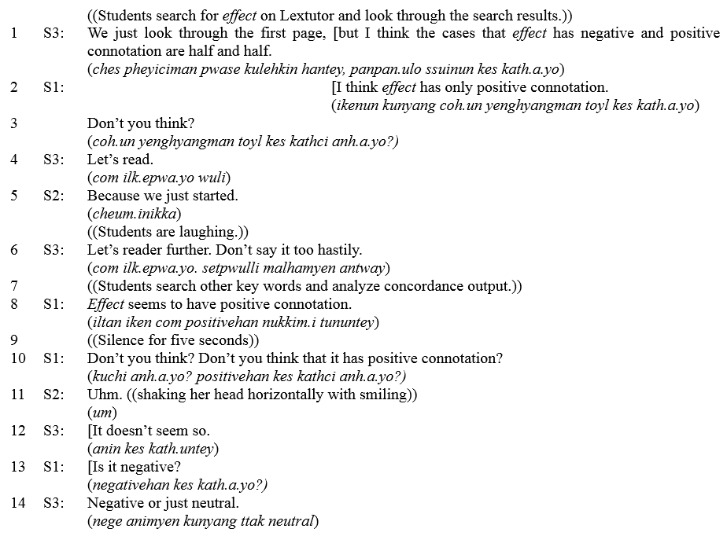

The excerpt 1 captured a moment when S1's interpretation of the corpus data was guided by the other two students. As S3 started making a hypothesis about the semantic connotation of effect, (line 1), S1 noted that effect had a positive connotation (line 2), which was different from S3's opinion. In response to S1's attempt to gain consensus (line 3), S2 and S3 cautioned against S1' premature assumption (line 4, 5, 6), which played a crucial role to guide S1's corpus analysis in the right direction. When S1 proposed the same idea after subsequent analysis (line 8), there was a long silence (line 9), an indication of the other students' indirect rejection to S1's idea. As S1 persistently asked for agreement with her opinion (line 10), the other two students rejected it more explicitly (line 11, 12), leading to the more comprehensive interpretation that effect did not have a positive connotation and but it was neutral (line 14). The excerpt showed a clear example that collaboration provided a guidance through corpus consultation process, guarding against the wrong data interpretation.
At the post-interview, all participants noted that the group work was helpful in corpus analysis, acknowledging the benefits of collaboration as pedagogic mediation. It is interesting that the benefits of collaboration were experienced not only by S1 who seemed to be the primary beneficiary of the collaboration, but also by S3 who was the major contributor to the group work.

When I analyzed the corpus data by myself during the group work, I was stuck on several expressions, feeling trapped by my limited knowledge. Even though I tried to look for various usages of the search terms in the concordance, I only looked at the examples that I wanted to examine. ... However, through collaboration, we were able to find different things from the same search results... The collaboration enabled me to better deal with corpus data. (S3)

S3 acknowledged that when she tried to analyze the corpus data alone, she was unable to reach a generalizable conclusion. With the help of discussion with the others, she was able to expand her view in analyzing corpus data. In highly complex and analytic tasks such as corpus analysis, the most capable students as well as the weaker ones benefited from the negotiative dialogue through the collaborative learning process.
At the same time, however, the negotiative dialogue through collaboration may have gradually marginalized the less capable student, as it constantly discouraged her from contributing to the group work. In excerpt 1, S1 made three attempts at creating a hypothesis on the semantic orientation of effect (lines 2, 8, 10), all of which were immediately rejected by the other members. As repeated experiences of rejection have been shown to elicit high levels of negative emotions and distress, which may affect the process of group work as a whole (e.g., Buckley, Winkel, & Leary, 2004), further examination is required on the effects of collaboration in the overall process of learners' corpus consultation from a critical perspective.

A CRITICAL EXAMINATION ON COLLABORATIVE CORPUS CONSULTATION

GRADUAL MARGINALIZATION OF THE LESS CAPABLE STUDENTS

Along with the repeated rejections of S1's ideas, this study found that collaborative corpus consultation gradually marginalized S1 (the less capable student in the group) and discouraged her from contributing to the group work, the psychological effects of which were captured by examination on students' behaviors and gestures. In the first collaborative corpus analysis session (on the second day of the experiment), S1 arrived first, allowing her a chance to choose a place to sit, and she sat in the middle chair as described in Figure 1 (left).

FIGURE 1. Students' positions in collaborative corpus consultation sessions 1 and 2

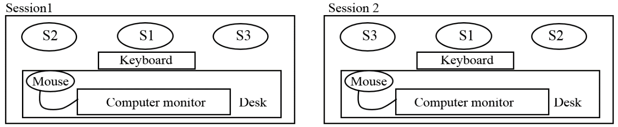

The middle position seemed to be ideal for collaborative corpus consultation because it was adjacent to the computer screen while it gave the person ready access to input devices such as the mouse and keyboard. Hence, as the first treatment session started, S1 seemed to have a great deal of ownership in the search process as she could search for any query she might have. At the beginning, S1 started the query by typing on the keyboard and scrolling down concordance lines. However, as the consultation proceeded, S3 stretched her arm across S1 to use the mouse, which was a critical violation of S1's personal space (Figure 2 top two). In addition, S3 gained control over the keyboard, which was on the sliding shelf attached to the computer desk (Figure 2 bottom two). From then on, it seemed to be challenging for S1 to regain control over the input devices, which was a huge loss of her autonomy in the corpus analysis process.

FIGURE 2. S3 (on the right-hand side of the pictures) gaining control of the computer mouse (top two) and the keyboard (bottom two) during the first collaborative corpus consultation

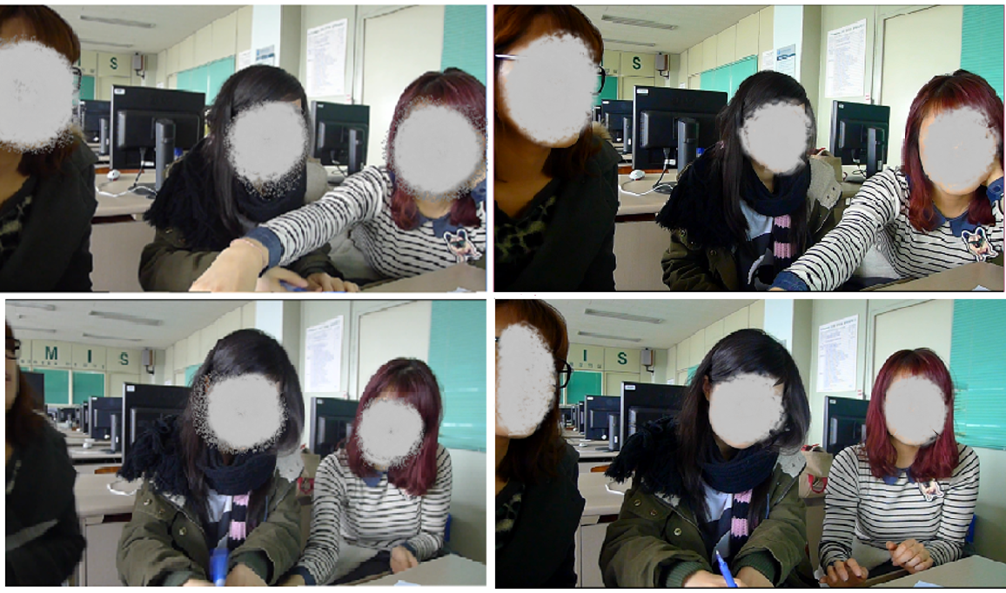
Note. The students' faces were erased to protect their anonymity.

In the second corpus consultation session (on the third day of the experiment), S1 came to the class first and sat in the same position as the previous day. However, interestingly enough, S3 who arrived after S1 chose to sit on the right hand side of S1, which gave S3 better access to mouse control as well as the keyboard (Figure 1 right). With exclusive control over the computer mouse, S3 asked S1 to type specific terms on the keyboard by saying, "Let's look at the word hope," and asking, "Would you type the word wish?" This indicates the transformation of the role of S1 from an enthusiastic doer to a humble listener over the course of two collaborative corpus consultation sessions.
Handing over the control of corpus analysis to S3, S1 seemed to develop reluctance in the learning process which was demonstrated in S1's arm folding during the last part of the second session (Figure 3).

FIGURE 3. S1's arm folding during the second collaborative corpus consultation



The gesture may carry varied meaning, but mostly it suggests a negative attitude toward the situation (e.g., Kumar, 2012). Considering the fact that S1 did not show such a gesture during the first session, S1's arm folding in the second session seemed to suggest that her reluctance and passiveness developed throughout the two collaborative group work sessions. In addition, as shown in Figure 3, S2 was keeping her hands down throughout the second session, hinting at a lack of willingness to gain access to input devices (keyboards and mouse). It seemed that S1’s left hand position gave S2 some disadvantages, which was a stark contrast with S3 in the first session who constantly attempted to lead the data search process by obtaining control of the mouse and the keyboard (see Figure 2). Due to the close centered angle of the camera to S1, Figure 3 did not show S3's hands, but it was evident that S3 was taking control over the computer as S1 was folding her arms and S2 was putting down her hands below the table. Compared to the initial stage of the collaboration, S3 gained dominant control over the search process after the two group corpus analysis sessions, while the other members became reluctant in contributing to the group work, and S1 in particular seemed to be gradually marginalized from the learning process.

INCREASING PSYCHOLOGICAL BURDEN OF THE MOST CAPABLE STUDENT

The gradual transfer of the control of the corpus analysis process from S1 to S3 not only marginalized S1 from the learning process, but increased the level of authority and responsibility of the S3. In particular, it was noteworthy that S3 gained authority in collaborative group work based on tacit agreement from S1 and S2, which was captured in excerpt 2. During the third day session, when students discussed semantic and functional difference between hope and wish (line 1 and 2), S2 wanted to change the sorting of concordance lines (line 4). In response, S3 immediately changed the sorting (line 5) and S1 acknowledged that she asked S3 in the same polite way when she wanted to search terms in corpus (line 6). This appears to indicate high degree of politeness between members, but more significantly, it shows the students' mutual acknowledgement of strong power of S3 in the collaboration process.

EXCERPT 2.

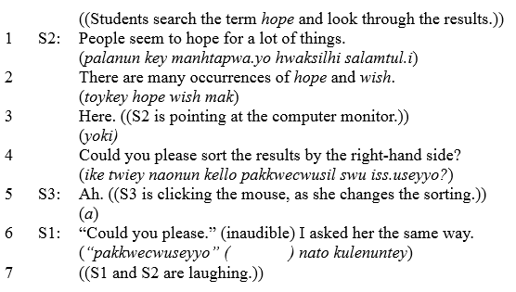

As for S3, the assumed ownership of the search process increased the level of responsibility, which in turn brought strong psychological distress in the collaborative process of group work. When asked about difficulties in the group corpus consultation during the post-interview, S3 noted a strong degree of difficulty in performing the corpus search, reflecting her intense psychological burden in the group corpus consultation.

Searching and sorting out the corpus data were very challenging. It was even more difficult than understanding the meaning of authentic expressions in the corpus data. Performing search techniques was one of the most difficult things in this group activity. (S3)
I have no opinion on the difficulty of searching corpus data because I had almost no chance to search terms in either corpus analysis session due to denied access to the keyboard and the mouse. (S2)
Searching corpus data itself was not that challenging. For me, dealing with unfamiliar vocabulary in the many results of concordance output was more difficult. (S1)

During the post-interview, S3 acknowledged that performing search techniques in corpus consultation was more difficult than understanding and analyzing corpus data. This was in stark contrast with S1 and S2 who seemed to find searching corpus data less difficult. In particular, S2 said she had no opinion on the matter as she had no chance to use the input devices of the computer, indicating the strong authority of S3 in the group corpus consultation. Similarly, S1 noted a weaker degree of difficulty in searching corpus data than S3 by highlighting the difficulty in understanding unfamiliar vocabulary in corpus data.
In consideration of the students' similar level of computer skills (as reported in Table 1), S3's strong degree of difficulty in searching and analyzing corpus data was less likely due to her limited computer skills, but was attributable to her increasing responsibility and the resulting psychological burden in the collaborative corpus consultation process. In brief, as S1 and S2 gradually handed over control of the corpus analysis process to S3, S3 seemed to feel an enhanced level of responsibility and pressure in collaborative corpus consultation, increasing her experienced degree of difficulty in searching and analyzing corpus data.
In addition, the psychological pressure of S3 seemed to be intensified by her task-focused leadership style. Excerpt 1 showed that S3 was more concerned with achieving the common goal of identifying the semantic connotation of effect rather than respecting the different ideas of the other group members. In lines 4 and 6, S3 asked S1 to continue corpus consultation without appreciation of S1's efforts to contribute to the group discussion. Further, in an attempt to find the best answer to the group task, S3 presented her opinion with explicit rejection of S1's idea in lines 12 and 14. Studies of leadership (e.g., Klein, Knight, Ziegert, Lim, & Saltz, 2011) have suggested that a leader with task-focused leadership provides a strong setting for team activities to achieve a collective goal efficiently while person-focused leadership values team members' individual perspectives and close relationships. Thus, a task-focused leader like S3 has to bear the heavy responsibility to guide and restrict members' ideas toward a common goal, which can cause psychological distress throughout the group work.

LOSS OF CRITICAL LEARNING OPPORTUNITIES

As the participants were focused on a common goal in the group activity, the collaborative corpus consultation may have hindered the students' learning opportunities to pursue personal queries. In particular, when the students had difficulty in dealing with unfamiliar vocabulary, they seemed to ignore them in an attempt to engage in the group agenda rather than to ask questions or to consult a dictionary. Even when the students sought assistance from the group, they could end up with a wrong conclusion despite genuine intention to improve each other's learning.
In excerpt 3, when S1 asked for help to understand the definition of nuclei (line 1), S3 gave her an incorrect answer that it was a typo (line 2). Guided by S3's response, S1 came to think that it was a misspelling of nuclear, which was met by positive approval by S3. S1 and S3 as well as S2, who was a bystander of the conversation, came to think that nuclei was a typo, a misspelling of nuclear. If the students had engaged in individual analysis, held responsible for their own understanding of the corpus data, they would have looked up the word in a dictionary and found that nuclei was the plural form of nucleus.

EXCERPT 3.

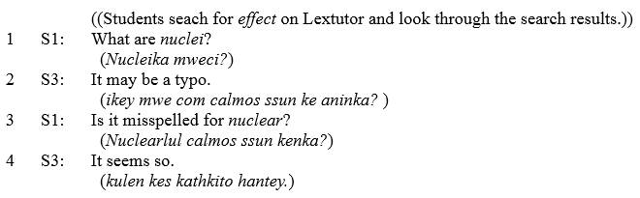

In particular, the examination of the post-interview revealed that the less capable student in the group (S1) seemed to be more vulnerable than the more capable ones (S2 and S3) to losing out on personal learning opportunities in group work. During the post-interview, S1 noted a more severe degree of difficulty in dealing with unfamiliar vocabulary and analyzing concordance output than S2 and S3. In the scale from 1 (the easiest) to 6 (the most difficult), S1 chose 5 while S2 and S3 chose 2 and 3 respectively when asked about the degree of difficulty in dealing with unfamiliar vocabulary in corpus consultation. In addition, S1 pointed out the need for the use of a dictionary in corpus analysis, suggesting that she missed several opportunities to learn unfamiliar vocabulary during the collaborative working process.

I wish I had a chance to study the search terms alone before the group corpus analysis. ...And to be honest, as corpus analysis is difficult to do alone, I think the definition of vocabulary in corpus data needs to be provided along with corpus data… The corpus analysis should be complemented by the use of a dictionary. (S1)

S1's need for individual corpus analysis prior to the group activity was an indication that she felt frustration in the process of the collaborative activity. She could have asked for help from others or used a dictionary but usually decided not to, losing a chance to pursue further learning of vocabulary in the group work. Her reticence to seek help during the collaborative group work could be attributed to several reasons, and in this study the face saving aspect of Korean culture is considered one of the primary reasons. Face saving is "maintaining one's public dignity and the avoidance of threats to public image" (Monkhouse, Barnes & Pham 2012, p. 8). It is one of the common Confucian values for avoiding humiliation in front of the public (e.g., Lim, 2003; Monkhouse, Barnes & Pham, 2012). Unlike Western culture, which values the power of questioning in the learning process, students in Confucian culture, like the Koreans in this study, may consider the behavior of posing questions as the recognition of personal ignorance, causing public humiliation.
In addition, more capable students (S2 and S3) seemed to acknowledge the difficulty in dealing with unfamiliar vocabulary as they noted the need for a dictionary in corpus analysis during the post-interview as indicated below.

At first, I thought I could use the corpus data alone, but (after two collaborative corpus sessions) I feel the need to use a dictionary... During the group work, I sometimes looked up words in the dictionary. (S2)
If the corpus data were provided with definitions of vocabulary, it would be much easier for basic level students to analyze corpus data. (S3)

S2's frustration in dealing with unfamiliar terms seemed to be strong as she changed her attitude toward corpus use after the two collaborative corpus analysis sessions. In the pre-interview on the first day, S2 seemed to be fascinated by corpus data, choosing it as the primary source of English learning, followed by use of dictionaries and websites such as Google. However, in the post-interview after two collaborative corpus analysis sessions, she acknowledged the difficulty of dealing with unfamiliar vocabulary and chose the dictionary as her most preferred source for language learning, followed by corpus data and websites. Considering the need for consulting a dictionary in corpus analysis noted by S1 and S2, the collaborative nature of the activity in this study seemed to deepen the degree of students' difficulty in analyzing corpus data.
Similar with S1 and S2, S3 noted the need for the use of a dictionary in corpus analysis in the post-interview, but she kept psychological distance from basic level students such as S1 and S2 in her interview, hinting that she did not experience much difficulty in dealing with unfamiliar vocabulary that the basic level students suffered from. The psychological distance between S3 and the other two students seemed to be constructed through the collaborative process of learning in which S3 acquired strong authority in the group work.

CONCLUSION

This study provided a critical examination on the functions of collaboration in learners' corpus consultation. The investigation of this study revealed the double-sidedness of collaboration in learners' corpus consultation. The collaboration provided guidance on the hypothesis-creating process through negotiative dialogue, but at the same time the less capable member was gradually marginalized in group work, increasing the psychological burden and responsibility of the most capable member. Also, collaborative corpus consultation may impede significant personal learning opportunities majorly due to the learners' limited knowledge in L2 and the decreased access to dictionaries compared to individual corpus analysis.
The double-sidedness of collaboration in this study seemed to call for caution against researchers' prejudicial bias toward the positive effects of collaboration in language learning. Depending on the perspectives of researchers, the interpretation of an instance of collaboration can be extremely different. At the same time, instructors using collaborative learning in their classrooms should keep in mind the double-sidedness of collaboration and make efforts to minimize the negative effects. In particular, collaboration may lower the less capable students' self-esteem and confidence in learning as they may experience a constant feeling of failure through the disregard and rejection of their suggestions. Sometimes, such experience can cause humiliation in front of their group members, which may not only discourage learning of a language, but also deteriorate their self-image. In this sense, instructors need to provide students with sufficient opportunities to build a sense of community as a group before the start of group work. As Kreijns, Kirschner, and Jochems (2003) noted, in order to facilitate successful collaboration in the learning process, students need to trust each other and feel a sense of belonging with a strong willingness to participate in and a commitment to the group work. In administering collaborative learning activities such as group corpus consultation, instructors should provide students with adequate opportunities to build rapport and a sense of community among participants. After development of student relationships, the weaker members of the group will be recognized as a part of the community, not merely as someone who is always asking for help.
Also, instructors should consider the needs of less capable students in the collaborative activities. As the less capable students in this study experienced a strong degree of difficulty in dealing with unfamiliar vocabulary and analyzing concordance output, instructors need to provide students with enough time to consult corpus data and familiarize themselves with search terms before the group work. In addition, instructors can use pre-selected and pre-edited corpus data (e.g., Tribble & Jones, 1990) which is tailored to the linguistic and analytic level of students. In this way, collaborative corpus analysis could be manageable for basic level students.
Furthermore, instructors should keep in mind the psychological burden that the most capable student may likely feel when given strong control over group work. Thus, instructors need to constantly adjust and appropriately distribute the burden of group work based on close observation of the collaborative process so that more capable students will not be overwhelmed by psychological pressure, while less capable students can have increased chances to contribute to the group work.
Finally, instructors should make efforts to reduce the loss of critical learning opportunities during collaborative group work. Before the start of collaborative corpus consultation, the instructor may provide short instruction on a list of key expressions relevant with the subsequent corpus consultation. Also, as participants of this study suggested, the instructor may allow students to study targeted expressions individually before collaborative corpus consultation. In addition, it is important for the instructor to encourage students to ask questions and exchange feedback during collaborative group work.
However, the findings of this study come with some limitations. Most of all, the period of the experiment was too short. A long-term study with a similar experimental design would provide a much clearer picture of the role of collaboration in learners' corpus consultation. In addition, this study did not have a control group that engaged in corpus consultation individually, to compare with the collaborative group. A comparative examination between individual and collaborative corpus analysis processes would allow for better understanding on the role of collaboration in learners' corpus analysis. Finally, with the focus on the process of corpus consultation, this study did not examine the results of students' corpus analysis and writing. It is hoped that future studies investigate the results of group corpus analysis to provide robust evidence regarding the value as well as the pitfalls of collaborative corpus consultation.
Despite its limitations, this study holds value as it examined the process of learners' corpus consultation from a critical perspective on the roles of collaboration. In particular, this study shed light on the negative aspects of collaboration in corpus consultation, which invited attention on psychological and motivational changes of students through collaborative learning. Based on the findings of this study, future studies are required to take into serious consideration the power inequality between group members of different abilities and provide practical suggestions to balance the inequality to reap the best benefits of collaborative corpus consultation. In addition, it is desired that future studies will examine various types of instructional strategies in collaborative corpus consultation to facilitate more effective corpus-based L2 instruction.

ENDNOTES

i ETS grades TOEIC scores of 860 or higher as level A, 730 or higher as level B, 470 or higher as level C, 220 or higher as level D, and scores less than 220 as level E.
ii The transcription conventions used in excerpts of this study include a bracket [ to indicate simultaneous talk, and double parentheses (( )) to provide contextual information such as explanation on the situation and the participants' gestures. The English translation appears first with romanized Korean in italics below in each turn.

REFERENCES

Boulton, A. (2009). Data-driven learning: Reasonable fears and rational reassurance. Indian Journal of Applied Linguistics, 35(1), 81-106.
Buckley, K. E., Winkel, R. E., & Leary, M. R. (2004). Reactions to acceptance and rejection: Effects of level and sequence of relational evaluation. Journal of Experimental Social Psychology, 40, 14–28.
Chan, L. H., & Chen, C. H. (2010). Conflict from teamwork in project‐based collaborative learning. Performance Improvement, 49(2), 23-28.
Cheng, R. (2013). A non-native student's experience on collaborating with native peers in academic literacy development: A sociopolitical perspective. Journal of English for Academic Purposes, 12(1), 12-22.
Conrad, S. (2005). Corpus linguistics and L2 teaching. In E. Hinkel (Ed.), Handbook of research in second language teaching and learning (pp. 393-409). Mahwah, NJ: Lawrence Erlbaum Associates.
Curado Fuentes, A. (2003). The use of corpora and IT in a comparative evaluation approach to oral business English. ReCALL, 15(2), 189-201.
Flowerdew, L. (2008). Corpus linguistics for academic literacies mediated through discussion activities. In D. Belcher & A. Hirvela (Eds.), The oral-literate connection: Perspectives on L2 speaking, writing and other media interactions (pp. 268-287). Ann Arbor, MI: University of Michigan Press.
Flowerdew, L. (2012). Exploiting a corpus of business letters from a phraseological, functional perspective. ReCALL, 24(2), 152-168.
Garrison, D. R., Anderson, T., & Archer, W. (2001). Critical thinking, cognitive presence, and computer conferencing in distance education. American Journal of Distance Education, 15(1), 7-23.
Gavioli, L. & Aston, G. (2001). Enriching reality: Language corpora in language pedagogy. ELT Journal, 55(3), 238-246.
Gupta, S., Walker, M. A., & Romano, D. M. (2007). How rude are you?: Evaluating politeness and affect in interaction. In A. Paiva, R. Prada, & R. W. Picard (Eds.), Affective computing and intelligent interaction (pp. 203-217). Berlin Heidelberg: Springer.
Hall, J. K. (2004). Practicing speaking in Spanish: Lessons from a high school foreign language classroom. In D. Boxer & A. D. Cohen (Eds.), Studying speaking to inform second language learning (pp. 68-87). Clevedon, UK: Multilingual Matters.
Järvenoja, H., & Järvelä, S. (2009). Emotion control in collaborative learning situations: Do students regulate emotions evoked by social challenges. British Journal of Educational Psychology, 79(3), 463-481.
Järvelä, S., Lehtinen, E., & Salonen, P. (2000). Socio-emotional orientation as a mediating variable in the teaching-learning interaction: Implications for instructional design. Scandinavian Journal of Educational Research, 44(5), 293-306.
Johnson, D. W., & Johnson, R. T. (1999). Making cooperative learning work. Theory into practice, 38(2), 67-73.
Keen, K. (1992). Competence: what is it and how can it be developed? In J. Lowyck, P. de Potter, & J. Elen (Eds.), Instructional design: Implementation issues (pp. 111–122). Brussels, Belgium: IBM Education Center.
Kim, Y., & Yoon, H. (2014). The use of L1 as a writing strategy in L2 writing tasks. GEMA® Online Journal of Language Studies, 14(3), 33-50.
Klein, K. J., Knight, A. P., Ziegert, J. C., Lim, B. C., & Saltz, J. L. (2011). When team members’ values differ: The moderating role of team leadership. Organizational Behavior and Human Decision Processes, 114(1), 25-36.
Kreijns, K., Kirschner, P. A., & Jochems, W. (2003). Identifying the pitfalls for social interaction in computer-supported collaborative learning environments: A review of the research. Computers in Human Behavior, 19(3), 335-353.
Kumar, V. (2012). Body language. New York: Sterling Publishers.
Lazonder, A. W. (2005). Do two heads search better than one? Effects of student collaboration on web search behaviour and search outcomes. British Journal of Educational Technology, 36(3), 465-475.
Leki, I. (2001). "A narrow thinking system": Nonnative‐English‐speaking students in group projects across the curriculum. TESOL Quarterly, 35(1), 39-67.
Lim, V. K. G. (2003). Money matters: An empirical investigation of money, face and Confucian work ethic. Personality and Individual Differences, 35(4), 953-970.
Monkhouse, L. L., Barnes, B. R., & Pham, T. S. H. (2012). Measuring Confucian values among East Asian consumers: A four country study. Asia Pacific Business Review, 19(3), 320-336.
Pérez-Paredes, P., Sánchez-Tornel, M., Alcaraz Calero, M. J., & Jiménez, A. P. (2011). Tracking learners' actual uses of corpora: guided vs. non-guided corpus consultation. Computer Assisted Language Learning, 21(1), 55-75.
Roschelle, J., & Teasley, S. D. (1995). The construction of shared knowledge in collaborative problem solving. In C. O'Malley (Ed.), Computer supported collaborative learning (pp. 69-97). Springer Berlin Heidelberg.
Tribble, C., & Jones, G. (1997). Concordances in the classroom. Athelstan.
Vännestal, M. & Lindquist, H. (2007). Learning English grammar with a corpus: Experimenting with concordancing in a university grammar course. ReCALL,19(3), 329- 350.
Widdowson, H. G. (2000). On the limitations of linguistics applied. Applied Linguistics, 21(1), 3-25.
Yoon, H. (2008). More than a linguistic reference: The influence of corpus technology on L2 academic writing. Language Learning and Technology, 12(2), 31-48.

