

Addressing urban security challenges in Nigeria through neighbourhood renewal: A reflection of Mokola World Bank slum upgrading pilot project

Tabiti S. Tabiti ¹, Jinadu A. Mohammed², Daramola Japheth³

¹ Department of Urban and Regional Planning, Federal Polytechnic Bida, Nigeria
² Department of Urban and Regional Planning, Federal University of Technology Minna, Nigeria
³ Department of Surveying and Geo Informatics, Federal Polytechnic Bida, Nigeria

Correspondence: Daramola Japheth (email: widespreadint@gmail.com)

Abstract

Urban insecurity is among the challenges militating against sustainable urban governance. In the first place it distorts the peace of urban areas making them unsafe. On the other hand it hinders the effective performance of urban functions. Urban security challenges manifest in different forms such as, street violence, theft and robbery, accidents of different types kidnapping, killings etc. Efforts to address urban security challenges in Nigeria have been concentrated in legislative, law enforcement and the use of community vigilante groups. The study examines the potentiality of urban renewal scheme in reducing urban insecurity in Nigeria cities. The place of physical planning strategy through effective neighbourhood renewal as practiced in Mokola, Nigeria is presented as an effective complementary approach for addressing urban insecurity. A total of 298 houses in eight streets in the study area were selected for sampling. The results show that there was a significant improvement in access to health facilities, provides job opportunity within the neighbourhood and ultimately reduced crime and enhanced community security. The paper recommends the need for gradual rehabilitation of urban slum neighbourhoods by the state government in collaboration with World Bank and other development financiers. The local governments should be made autonomy in Nigeria so as to make them more responsible to the people. Other recommendations suggested in the paper include creating enabling environment that will promote economic empowerment and public enlighten on personal and community sanitation. It is certain that if these recommendations are adopted the challenge of urban insecurity will reduce significantly in Nigerian cities.

Keywords: challenge, neighbourhood, renewal, security, sustainable, urban

Introduction

Urban areas all over the world stand as commercial hubs and major contributors to national economies. Urban areas also play key roles as nodes in global markets thereby deepening globalization and increasing international competition for investment. This makes urban areas the targets of wide range of public interventions (OECD, 2014). Cebu Daily News (2013) citing a report from the UN-HABITAT (2011) on the economic role of cities as the haven of population shows that a turning point was reached in the first time in history of the world in 2008, when more than half the world human population (3.3 billion people) live in urban areas. Literarily this implies that the urban areas are hosting half of the world production (secondary economy). Obviously urban areas play an important role in economic development in every nation of the world by encouraging economies of scale as well as agglomeration and localization of industries. Urban areas also provide efficient infrastructure and services through transportation, communications, power, human interactions, water and sanitation services (Musa, 2011).
UN-Habitat (2009) reported that unequal distribution of scarce resources and power in urban areas accounted for cases of crime and violence that characterized most urban settlements in the world. It is evident from Africa and Latin American that, where the level of income inequality is high, usually, there are records of high level of homicide. Similarly, lack of attention to the social relations in urban areas by the government in terms of lack of political influence, insecure and uncertain distribution of resources are objects of discrimination further compounded the urban security challenges (Cross, 2002). According to Cross (2002) nobody wants to live next to a slum dweller, because slum dwellers are dirty, they play loud music, they have many children, they fight all the time, they tease women and spit everywhere. Most efforts directed towards addressing urban insecurity the world over has failed particularly the use of state force. This calls for the need to look inward for a more people friendly strategy such as improving the general lives of urban slum nieghbourhoods. It is on this backdrop this study aimed at examining the place of urban Renewal in addressing urban security challenges. Among the objectives explored in the study include; identification the security challenges experienced in urban areas in Nigeria, their causes and efforts directed to solving them. Other include examining the security challenges in Mokola before the World Bank slum upgrading intervention, determining the state of urban security in Mokola after the World Bank Intervention and identifying the role urban renewal could play in addressing urban security challenges in Nigerian cities.

Literature review

The role of urban areas cannot be over emphasized in nation building as they offer good jobs and other opportunities (such as places of training and investment). Cities also attract talents and skilled labour that allow for the possibility of further specialization in knowledge, skills, and management capabilities (Musa, 2011). Nigerian cities since two decades ago have witnessed an unprecedented growth both in the spatial dimension and population concentration. This according to Agbola (2004) is an offshoot of rapid urbanization resulting from rural–urban migration and massive increase in urban natural birth. Consequently, such growth has brought about the burgeoning of squatter, slum and informal settlements characterized by high density neighbourhoods, poor housing and high risk of environmental and health hazard with epic security challenges. Bitencourt (2003) observed that high crime rate in Brazilian urban cities has been a shocking component of daily life defying the efforts of state authority. This Bitencourt (2003) attributed to high population of Brazilian cities.
Nwadialor (2014) observed that the problem of insecurity which used to be one of the lowest in the hierarchy of social problems facing this country seems to have assumed alarming proportions since the end of the Nigerian civil war which ended in 1970. It has been widely observed that crime is spatially related in the urban area. It is common to describe some parts in the urban area as hot spot for crime or high-risk zones. From this context, it is obvious that some areas possess characteristics that encourage or entrench crime (Fabiyi, 2013).
Onokerhoraye (1988) in the study of urban slums in Nigeria, attributed urban insecurity to deviance from the general moral ethics, the rejection of the work ethic and other social values resulting from political marginalization in terms of deprivation from socio–political sphere. Describing the state of urban insecurity in urban slum areas, Onokerhoraye (1988) confirmed that slum dwellers are excluded from many of the attributes of urban life that are critical to all citizenship but that remain a monopoly of a privileged minority in urban area and this deprivation promotes a negative reaction in form of agitation expressed in violence and sorts of crime. Brooke (2007) explained that non integration or the exclusion of slum dwellers in political programmes political voice, security; safety and rule of law are other areas of deprivation suffered by slum residents which engendered insecurity in urban areas. He explained that the politicians come around to steal the support of the slum residents during election, recruit the youth as political thugs and party agents. This consequently exposes slum dwellers to insecurity and life of aggression. Ayuba and Wanda (2009) submitted that the low level of awareness on the part of the slum dwellers, absence of advocacy contributed to high rate of juvenile delinquency, crime and criminal tendencies which are frequently experienced in slum settlements which are threats to urban security.
Knox and McCarthy (2005) observed that criminal and socially undesirable activities are identifiable with certain age groups which comprises of youths and middle age men and women. It is evident that about 10–15% of slum residents can be found in this groups and the activities peculiar to the groups include drug dealing, smuggling, theft, extortion and prostitution (Knox & McCarthy, 2005). Sociological attributes traceable to slums settlements according to Olotuah and Adesiji (2005) is that slum settlements develop into uncivilized communities filled with dangerous and unhealthy behaviours. These behaviours threaten the pattern of lives of the long-lasted families and the society as whole. They include lack of respect for neighbours privacy, violation and abuse of other people’s rights. The spread of dangerous social diseases such as organized robbery, drugs addiction, alcohol addiction, mutual violence and adultery with relatives are common cases in slum communities.
In the view of Montiel (2012), mostly crime, violence and immorality are leading ways of life in slum settlements. Violence, quarrels, fights and abuses are daily life styles of slum dwellers. The daily life of the dwellers starts and ends with the quarrel and it happens because of drinking liquor. On this note slum dwellers (whom are already deprived of adequate shelter) are not able to realize their full capabilities, and therefore are not able to benefit from, contribute to and have an influence on development. As a result, to fit into their environment they mostly engage in anti-social vices such as crime, drug addiction and alcoholism which lead to high rate of mental illness and suicide (Montiel, 2012). Another strong factor that occasioned urban security challenges as observed by Nwadialor (2014) is the issue of lop-sided development. This according to the author is a situation where deliberate concentrations of Nigeria’s capital resources are invested in few cities in the name of Federal and State capitals. This consequently led migration of large population of rural communities to cities of Lagos, Port-Harcourt, Kano, Enugu, Ibadan, Kaduna, Calabar and others. This without doubt has equally compounded the security challenges experience in Nigerian cities today. From the ongoing it is evident that the challenge of urban security is an issue that requires an in house solution through effective renewal of urban degenerated neighbourhoods.
Musa (2011) identified certain issues like religion, ethnicity, stressful public policy, student unrest, cultism and extra-judicial activities as the major causes of urban security challenges in Nigeria. The authors also highlighted the various types of security cases prominent in urban areas in Nigeria. These include loss of lives and properties due to crime related cases, ethnic violence, juvenile crises, theft and robbery. Another dimension of insecurity in Nigerian cities are; psychological stress, social disorder, regimentation, disinvestment and low socio-economic status. Others security challenges confronting urban areas in Nigeria include, flooding, building collapse, outbreak of diseases and environmental degradation. No doubt, series of efforts have being put up by various levels of government to address the issue of insecurity in Nigerian cities. Prominent among the efforts include, deployment of security agents, emergence of community vigilante groups and litigations. Other measures include the use of vigorous campaigns and public enlightenment through radio and television programmes. These efforts could only reduce the social aspect of insecurity in urban areas, except a physical planning dimension is integrated in efforts to fight insecurity in urban areas; all attempts and resources investment toward arresting urban insecurity will not yield much result. It is on this backdrop that this paper attempts to examine the imperativeness of neighbourhood renewal in addressing urban security challenges in Nigeria by taking clue from the World Bank slum upgrading pilot project in Mokola area of Ibadan, Oyo state.

Methods and study area

The study examines the potentiality of urban renewal scheme in reducing urban insecurity in Nigeria cities. In this study, Mokola slum upgrading pilot project carried out by the World Bank in 2001 was selected as case study. Among the variables examined in the study include; prominent security cases in the study area, the prominent health case in the study area before and after the project is another variable examined in the study. The essence of this study is to ascertain the effectiveness of neighbourhood renewal project in addressing urban insecurity. The geographical scope of the study is restricted to Mokola Neighbourhood in Ibadan North Local Government of Oyo State, Nigeria. Hence all the survey carried out in the study centred on the community alone.
Basically, secondary source of data was explored in obtaining useful information needed for the study. It involved the extraction of data directly from available resources which focused on generating information on the state of security in the study area before and after the upgrading project. Other issues examined in the survey include types of security cases prominent in the community before and after the project, this is to establish the level of improvement in security position of the community. The incidence of health cases that could pose a threat to lives in the community was also examined in the survey as part of urban security challenges. The essence of this is to determine how the upgrading project has contributed to safety in the community. The major variables examined include; types of health cases recorded in the community before and after the project and the number of health cases recorded before and after the project. An interview was held with a health provider in the community to ascertain the difference in the level of community health after the upgrading project.
Other relevant data were obtained from related journals, articles and internet search where information on urban security were obtained. The nature and dimensions of urban security challenges were accessed through internet search and relevant textbooks and publications.
Sample size and sampling procedure

In generating data for the study, street identification and housing count were carried out in the study area. Through the exercise, 16 streets were identified in Mokola with a population of 985 houses.

Determination of sample size

In other to achieve proper representation and adequate coverage, a set of sample size was drawn from the population of houses in study area using a statistical sample size formula as stated by Woolf et al. (1986).

SS = Z/2 . x²
e

Where, SS means sample size
Z = area under the normal distribution curve corresponding to the desire level of
confidence
 = significant level (0.05)
 = standard deviation
x = population of houses in each street in the study area
e = sample error

Going by the formula SS is calculated as follows:
 = 17793
16
 = 17793
16
 = 33.35

The next stage is to determine the sample error using the formula;
e = 
 N

Where  stands for standard deviation and
N represents total number of streets
e = 33.35
16
e = 33.35 = 8.338
4

Going back to the formula
SS = (Z/2 x) ²
e
SS = (1.96 x 33.35) ²
8.338
SS = (65.336) ²
8.338
SS = (7.839)2
SS = 61.45
SS = 62

Following the calculation, the expected percentage sample size is 62%. However 50% of the streets, representing 8 streets among the streets in the study area were selected for sampling (Table 1 for the list of selected streets which were selected randomly). So the total number of buildings to be sampled in study area is 298.

Table 1. Sample size in Mokola

List of streets sampled | No. of buildings | 62%
Alafia | 36 | 22
Balogun | 12 | 7
Okunmade | 78 | 48
Darligton | 64 | 40
Adelaja | 84 | 52
Gbadebo | 73 | 45
Easylife | 63 | 39
Agotapa | 68 | 42
Source: Adapted from Tabiti (2012)

Mokola is a neighbourhood located in the central business district of Ibadan Metropolis. It is a major commercial centre of Ibadan North Local Government area of Oyo state in western part of Nigeria. It lies between Latitudes 7⁰ 23’and 7⁰ 26’ North of Equator and between Longitudes 3⁰ 20’ and 3⁰ 51’ East of Greenwich Meridian Figure 1 shows the location of Mokola in Ibadan North local Government of Oyo State. The community is bounded in the North by Mokola hill which host’s the famous Premier Hotel and Ibadan University College Teaching Hospital bounded the community at the North Eastern part. Elizabeth road serves as the major route that linked the community to Dugbe market and the eastern boundary. Sango bounds the community at the western part and Oyo road formed the boundary at the southern part. Mokola has a landmass of 44 hectares with a terrain of 50 to 200 metres above sea level (Onibunoje, 1998). The community slope gently from the popular Mokola hill eastward to Elizabeth road. Mokola has a population of 25,000 (Olalere, 2004) which makes the community to be among the densely populated areas in Ibadan metropolis. It was among the three communities selected for urban renewal programme under the community improvement programme, Figure 2 shows Mokola project area.

Source: Ministry of Lands and Housing, Oyo State, 2008.

Figure 1. Map of Ibadan showing Mokol a project area

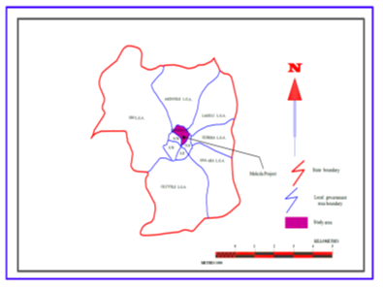
Source: Modified from Oyo State Urban Regional Board Record, 2008.

Figure 2. Mokola project area

Results and discussion

Incidences of security cases, environmental health cases and numbers of commercial outfits were the security indicators adopted in the study to examine the potentiality of slum upgrading in addressing urban security challenges. On this backdrop, the number of security cases and their prominence in the community before and after the project were examined. Similarly, the number of health facilities and prominent types of environmental diseases experienced in the community before and after the upgrading project were also examined to ascertain the level of improvement in the state of security of lives and properties in the community.

Community security

Among the security cases considered in this study include; street violence, theft/robbery, ethnic conflict, juvenile crises, drug peddling and alcoholism. A survey was conducted to appraise the types of security challenges in Mokola per month before and after the project. Table 2 shows the types of security cases experienced in Mokola before and after the project.

Table 2. Types of security cases in Mokola before and after the project

Security cases in Mokola | Numbers of security cases before the project |  | Numbers of security cases after the project
Security cases in Mokola | Number of respondents | % | Number of respondents | %
Street violence | 45 | 15 | 16 | 5.4
Theft/ robbery | 93 | 31.1 | 58 | 19.5
Ethnic conflict | 10 | 3.5 | 4 | 1.4
Juvenile crises | 3 | 1.0 | 2 | 0.6
Drug peddling | 10 | 3.2 | 3 | 0.9
Alcoholism | 8 | 2.6 | 14 | 4.7
Street violence and robbery | 106 | 35.8 | 5 | 1.7
Ethnic conflict and theft and robbery | 4 | 1.4 | 0 | 0
Drug peddling and juvenile crises | 14 | 4.7 | 3 | 1.0
Alcoholism and robbery | 6 | 2.1 | 5 | 1.7
All | 5 | 1.7 | 5 | 1.7
None | 0 | 0 | 183 | 61.4
Source: Adapted from Tabiti (2012)

Table 2 shows that 15% of the residents identified street violence among the prominent security cases experienced every month before the project while 31.1% of the residents claimed that theft and robbery cases were prominent security cases. Similarly, 3.5% and 1.0% of the residents claimed that ethnic conflict and juvenile crises were prominent security cases experienced in the community before the project while 3.2% and 2.6% identified drug peddling and alcoholism as prominent security challenges in the community. On the other hand, 35.8% of the residents declared that street violence and theft and robbery were prominent security challenges experienced in the community before the project. Relative to this claim, 1.7% of the residents acknowledged that all the security cases highlighted in the study were experienced in Mokola before the project. However, after the project, it was discovered that cases like street violence reduced significantly as only 5.4% of the residents identified classified it among security challenges experienced in the community after the project. Theft and robbery, ethnic conflicts and Juvenile crises also reduced significantly to 19.5%, 1.4% and 0.6% respectively (Table 2).
Conversely, Figure 3 shows that there were evidences of reduction in security cases in the study area compared to what it used to be before the project.

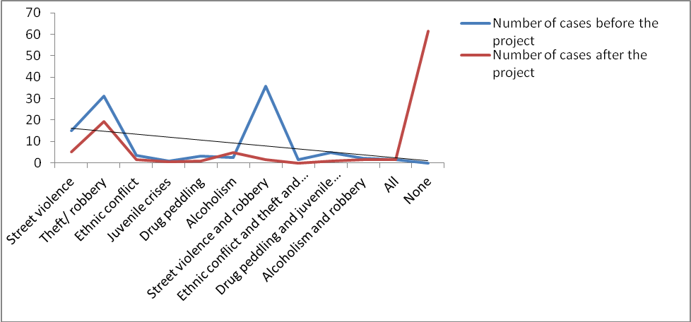
Source: Adapted from Tabiti (2012)

Figure 3. The trend of incidence of security cases in Mokola before and after the slum upgrading project.

A line of trend was plotted to establish the trend of security cases in the study area and it is evident from Figure 1 that all the security cases fall under the trend line which is an indication that there was significant improvement in level of security in the community after the project which can be attributed to decent environment brought about by the project.

Health condition in Mokola

Access to health facilities is fundamental to the wellbeing of the residents and security of lives in the study area. On this backdrop, the study took inventory of the types and numbers of health facilities available in Mokola before and after the project. Table 3 shows the types and numbers of health services in Mokola.

Table 3. Types and numbers of health facilities in Mokola before and after the project

Types and number of health facilities in Mokola | Before the project | After the project
Private hospital | 2 | 2
Public hospital | 0 | 0
Community Comprehensive health centre | 0 | 0
Private clinic | 0 | 1
Public clinic | 0 | 0
Source: Adapted from Tabiti, 2012.

Before the project, there were only two private hospitals in Mokola before the project, which are still in existence as at the time of the survey. The first one is called Group Medical, located along Elizabeth road and Alafia Hospital which is sited outside Mokola community about 100m along Mokola–Dugbe road. However after the project one private clinic maternity home was added to the two existing private hospitals, thereby improving the residents’ access to health facility (Table 4). This signifies that there was improvement in access to health in Mokola after the project.

Incidence of environmental health diseases in Mokola before and after project

Incidence of environmental health cases in Mokola before and after the project was examined in the study to determine the level of residents’ safety healthy and good sanitary environment. This was done by considering incidence of some environmental health related diseases in the study area. Table 4 shows the record of cases of environmental diseases experienced in Mokola before and after the project.

Table 4. Incidence of environmental health diseases in Mokola before and after project

Health cases | Health cases recorded in Alafia hospital in 1996 before the project |  | Health cases recorded in Alafia hospital in 2009 after the project |  | Percentage reduction of health cases
Health cases | Number of cases | % | Number of cases | %
Diarrhea | 11 | 5.7 | 5 | 5.7 | 54.5%
Dysentery | 10 | 5.2 | 3 | 3.5 | 70%
Cholera | 6 | 3.1 | 0 | 0 | 100%
Typhoid | 28 | 14.5 | 17 | 19.5 | 39.3%
Malaria | 52 | 27 | 43 | 49.4 | 17.3%
Skin disease | 18 | 9.3 | 0 | 0 | 100%
Influenza | 24 | 12.4 | 9 | 10.4 | 62.5%
Measles | 44 | 22.8 | 10 | 11.5 | 77.3%
Source: Adapted from Tabiti, 2012.

Table 4 shows the record of heath cases in Mokola as obtained from the Head of Laboratory Unit of Alafia Hospital. The table shows that in 1996, 11 cases of diarrhea, 10 cases dysentery and 6 cases of cholera were recorded. Other health cases recorded in the hospital the same year include 28 cases of typhoid, 52 cases of malaria, 24 cases of influenza and 44 cases of measles. However a record of health cases in 2009 (13 years after the project) (Table 4) shows that, no case of Cholera was reported in the study area after the project, while cases of diarrhea and dysentery reduced to 5 and 3 respectively. Other health cases like malaria with 43 cases, typhoid with 17 cases and measles with 10 cases were still on the high side even though they had reduced compared to the situation in 1996. A contrast of the incidence of enteric diseases before and after the project as presented in Table 4 shows that cases of diarrhea reduced from 11 cases before the project to 5 cases after the project which signifies 56% reduction. Similarly, dysentery recorded a reduction from 10 numbers of cases before the project to 3 cases after the project amounting to 70% reduction. Cases of cholera also witnessed remarkable reductions from 6 cases to 0 representing 100% reduction after the project. Typhoid recorded a reduction of 39%, malaria also reduced by 17%. Skin diseases similarly recorded a reduction of 100%, influenza and measles reduced by 62% and 77% respectively (Table 4). This shows that there was a significant improvement in security of life in terms of the health of the residents as occasioned by the slum upgrading project.

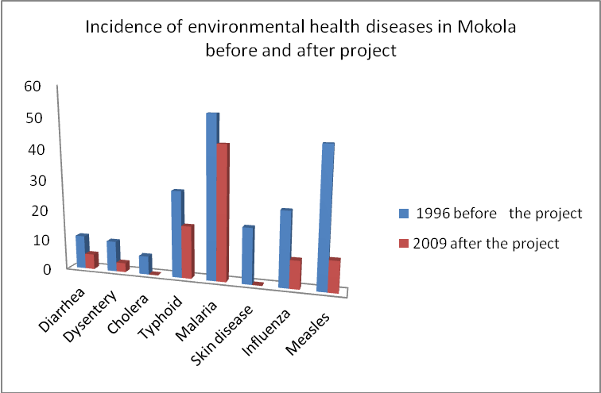
Source: Adapted from Tabiti, 2012.

Figure 4. Incidence of environmental health diseases in Mokola before and after project

Employment

Employment opportunity created as a result of the upgrading project was examined. This may not have direct connection to safety of lives and properties, however availability of enabling environment for business and other employment opportunities could help in reducing the propensity for violence and crime. It is on this backdrop that the study considered numbers of commercial outfits available in the study area before and after the project. This was done by investigating the numbers of shops in each street selected for sampling. Table 5 shows that there were no shops in Alafia and Balogun I before the project but after the project 11 commercial outfits and 5 commercial outfits were in operation. Okunmade has an increase of 13 numbers of commercial outfits after the project, likewise Darlington has 8 commercial outfits, Adelaja has an increase of 30 numbers of commercial outfits and an increase of 2 numbers of commercial outfits was identified in Gbadebo. Easy life and Agotapa witness an increase of 13 and 66 numbers of commercial outfits respectively.

Table 5. Number of commercial outlets in the study area before and after the slum upgrading project

Number of commercial outfits in Mokola before and after the project
Streets | Before the project | After the project | Remarks
Alafia | Not existing before the project | 11 | 11 shops came up
Balogun I | Not existing before the project | 5 | 5 shops came up
Okunmade | 12 | 25 | 13 number increase
Darlington | 7 | 15 | 8 number increase
Adelaja | 6 | 36 | 30 number increase
Gbadebo | 14 | 12 | 2 number increase
Easy life | 5 | 18 | 13 number increase
Agotapa | 2 | 68 | 66 number increase
Source: Adapted from Tabiti, 2012.

It is apparent from Table 5 that the project created opportunity for employment through road rehabilitation as witnessed in the study which on the other hand provided enabling environment for improvement in socio economic activities in the community, thereby engaging some people who would have been involved in theft or robbery or other social in the community.
The commercial outfits found in the study area include; mini markets, saloon, printing shops etc. which provided employment opportunities for the resident after the upgrade. This ordinarily provides job opportunity within the neighborhood and ultimately reduced crime and enhanced community security. Figure 5a and 5b shows the condition of roads before and after the project and how the opening up of the roads has encouraged commercial activities in the community.

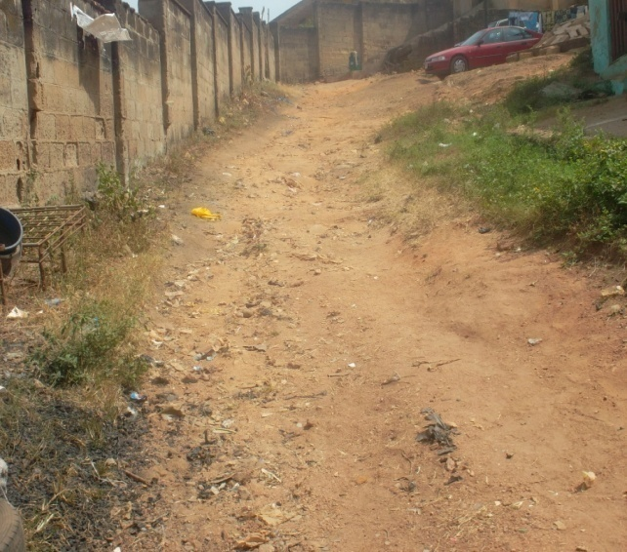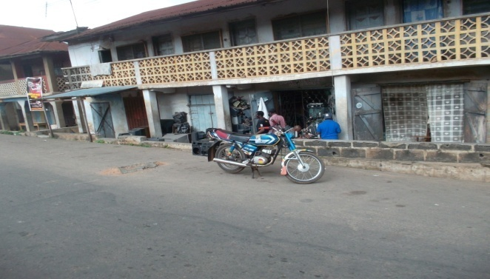
Source: Tabiti, 2012. Source: Tabiti, 2012.

Figure 5a. Road condition before the project Figure 5b. Road Condition after the upgrading project.

Conclusion

Efforts in addressing urban security challenges should not be left in the hand of the law enforcement agents and the community vigilante arrangement. Efforts to curbing crime and other security problems in Nigerian cities should include the renewal of urban neighbourhoods by the government. This strategy has proved very effective in reducing security challenges experienced in Mokola before. It is therefore apparent that if the urban neighbourhoods are rehabilitated, urban security challenges will be effectively managed and Nigerian cities will be safer to live. In order achieve this, the Federal and the state governments should as a matter of necessity embark on massive rehabilitation of urban slums through community and public neighbourhood renewal scheme. This should be in collaboration with international financials like the World Bank, United Nations Development Project.
In addition to this, there is a need to create economic empowerment opportunity in urban communities through economic policies that encourage the development of small scale businesses, easy access to micro finance and cooperative society. Where this is available, people will be committed to one economic activity or the other thereby improving their economic statues and standard of living. This on the other hand will reduce the unwholesome activities that pose threat to security of life and properties in urban centres. The Nigerian constitutional reform should as a matter of fact support and emphasize the agitation for local government autonomy and economic empowerment. This will enable the local government councils the only tier of government that is closer to the people to be responsible to the people. The essence of this is to ensure that local government councils carry out such statutory responsibilities such as opening up of neighbourhood roads, managing solid waste and maintenance of law and order in urban areas within their jurisdictions. This will complement the effort of law enforcement agents in curbing urban insecurity. Adequate awareness should be done among neighbourhoods residents on personal hygiene and environmental sanitation. This will reduce the incidence of health risk and disasters that pose threat to security of life and properties in urban communities.

References

Agbola, T (2004). A study of urban violence and insecurity in Abuja. Journal of the Nigerian Institute of Town Planners, xxvii(1), 2004.
Ayuba, U.G., & Wanda, Z.M, (2009). Principle of urbanization studies in urban and regional planning practice. Maiduguri, Umah Publishers.
Bitencour, L. (2003). Brazil growing urban insecurity: Is it a threat to Brazilian Democracy. Retrieved from http://www zotero.org.
Cross, N. (2002). Why sustainable development is a goal worth working towards and what it means in practice. The International Development Magazine, 18(2).
Cebu Daily News (2013). The role of cities. Retrieved from http://newsinfo.inquire.net.
Fabiyi, O. (2013). Gate neighbourhood and privatization of urban security in Ibadan metropolis. Institute Francais de recherché en Afrique (IFRA) Nigeria.
Knox, P.L., & Mccarthy, L. (2005). Urbanisation. (2nd ed.) United State of America. Pearson Prentice Hall Upper Saddle River N J.
Nwadialor, M. (2014). Nigeria and security challenges. Retrieved from Nigerian Vanguard News Paper.
Montiel, P.J. (2012). “Increasing resilience to shocks to ensure sustainable growth”. Paper presented to High- Level Conference on Pacific Islands Countries co-hosted by the IMF and the Government of Samoa. Apia, Samoa, March 23. Retrieved from www.imf.org/external/np/seminars/eng/2012.
Musa, K. A. (2011). Urban violence and insecurity in Nigerian cities. Continental Journal of Environmental Design and Management, 2, 62-69.
Oganisation for Economic Cooperation and Development (OECD) (2004). Regional Policy/ urban development. Retrieved from oecd.org/gov on June 20th 2014.
Olalere, I. (2004). Housing Conditions in the community improvement programme project areas; focus on world bank assisted urban renewal programme in Ibadan. (Masters dissertation) Retrieved from Centre for Urban and Regional Planning. Faculty of the Social Science, University of Ibadan.
Olotuah, A.O., & Adesiji, O.S. (2005). Housing Poverty, slum formation and deviant behavior. Retrieved from www.yok.ac/inst/chp/has/antum/papers/olotuah.
Onibunoje, P. (1998) Geography of West Africa MacMillian Nigera Publishers Ltd. Ilupeju, Lagos
Onokerhoraye, A.G. (1988). The Study of slum settlement case study of slums and Environmental problem. In. Sada & Odetoyinbo (Eds.). Environmental issues and Management in Nigeria (pp. 47- 85). NISER, Ibadan.
UN-Habitat. (2009). Eviction and demolition in port harcourt report of fact-finding mission to port-harcourt city. Retrieved from www.unhabitat.org.
Woolf, E ,Tanna, S. and Singh, K. (1986). Quantitative analysis. London, Pitman Publishing Ltd.

