The impact of world crude oil price on the liberalisation of Malaysia’s paddy industry

Siti ‘Aisyah Baharudin

School of Social Sciences, Universiti Sains Malaysia

Correspondence: Siti ‘Aisyah Baharudin (email: sab16@usm.my)

Abstract

Malaysia has adopted an open economy policy to boost its economic growth and per capita income. As a small and open economy, the country is susceptible to external shocks such as the 2008 financial crisis. Moreover, the increase in the international food price and the shortage of food in early 2008 imposed a new challenge to the national paddy sector. Besides, the increase in average world crude oil prices from USD 69.08 per barrel in 2007 to USD 101.56 per barrel in 2009 saw accompanied escalation in world food commodity prices, resulting in increases in input costs and hence the cost for food production. This paper examines the impact of the world crude oil price on the liberalisation of Malaysia’s paddy industry using system dynamics analysis. The two types of inputs impacted by crude oil price are fuel and fertiliser price. The results showed that 120 litre per hectare of diesel and petrol is the rate of fuel used in paddy production. The fertiliser consumption is 388.53 kilogram per hectare. The removal of fuel subsidies accompanied by the increase in the world crude oil prices significantly impacts farmers’ income and productivity levels as it triggers higher production expenses. The simulation results of the policy suggest that the subsidy rationalisation programme will free up more funds for product development such as precision farming technology as well as increased farm practices by farmers.

Keywords: crude oil price, farmers’ income, machinery cost, paddy industry, productivity, system dynamics

Introduction

Farmers’ income and paddy productivity play a vital role in the paddy and rice industry, as both determine the performance of the industry and the welfare of farmers. The national average productivity in 2016 was 4.1 tonnes per hectare, which was lower than Malaysia’s most productive plots that typically gave more than 7 tonnes per hectare (FAO, 2018). There are 296,000 paddy farmers in Malaysia of whom 40% are full-time farmers who rely on paddy activity as their primary source of income (Man & Sadiya, 2009). Since 2005, the total income from paddy production has increased by 39.8%. Meanwhile, the total income of paddy farmers equals MYR 1,990. MYR 1,340 of it is the average monthly income from paddy production, and the balance of MYR 550 is obtained from other income-generating activities. Although the total income of paddy farmers is higher than the national poverty level of MYR 750 per month, paddy farmers still have high poverty levels compared to farmers in other agricultural sectors (Rabu & Shah, 2013). A recent study conducted by Idris and Siwar (2017) showed that 40% of the farmer population is within the lowest level of income with an average salary of MYR 1,440 per month.
Effective use of inputs increases paddy productivity, and optimum production costs increase farmers’ income. These two factors reflect the essential role of the efficient utilisation of fuel and fertiliser in paddy production. In agriculture, fuel and fertiliser are referred to as energy. Fuel is used to run machinery and transportation, while fertiliser is for improving soil fertility. Agriculture scholars distinguish two kinds of energy as direct and indirect energy. Direct energy is used in the form of fuel, electricity and human labour. Meanwhile, indirect energy is required mainly in the production and application of mineral and chemicals fertilisers to improve crop yields (Bundschuh & Guangnan, 2014).

Fuel allocation

Although farmers in Malaysia are not entitled to fuel subsidies compared to what the fishermen are granted, they enjoy the benefits of RON95 petrol and diesel subsidies allocated to all Malaysian citizens. Malaysia introduced the diesel subsidies in October 1999 and RON95 subsidy in June 2005. The total government expenditure for providing fuel subsidy has increased from MYR 28 million in 1993 to MYR 7,337 million in 2010 as shown in Figure 1. In 2009, Malaysia’s fossil fuel subsidies per capita were the world’s third highest by spending USD 199.6 per person behind Brunei at USD 804.1 and Russia at USD 274.3.

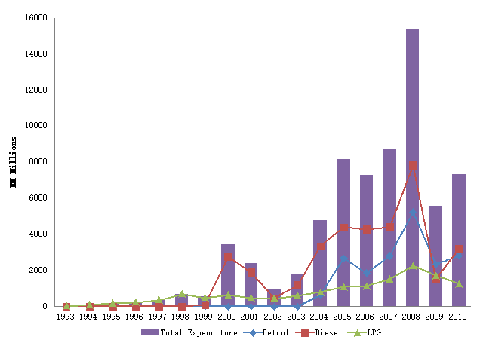

Source: ECM, 2011

Figure 1. Total expenditure (MYR) in fuel subsidy (1993-2010)

In 2012, Malaysia’s fuel price took the eighth lowest place in the world with a fuel subsidy of MYR 23.7 billion. In 2013, the government subsidised RON95 petrol by MYR 0.83 per litre and diesel by MYR1.00 per litre, which cost MYR 24.8 billion. In September of the same year, the government implemented a fuel subsidy rationalisation policy to reduce bulk subsidies in stages and fuel price fixation through market forces. Recently, the government incurred a subsidy of MYR 0.33 per litre for RON95 petrol and diesel based on crude oil prices at MYR 3.97 per litre (Bernama, 2018).

Fertiliser allocation

Farmers in Malaysia receive fertiliser subsidy in the form of a compound, urea and additional fertiliser NPK (Nitrogen, Phosphorous and Potassium). The recommended time for each fertiliser is explained in Table 1. Paddy Statistics of Malaysia showed that 28% of farmers had applied organic fertiliser. While, besides the subsidised fertilisers, 14% of farmers had used additionally purchased fertilisers at the rate of 173 kilograms per hectare for an average of 67 days after seeding (DAS).

Table 1. The average fertiliser rates (kilogram/hectare) of paddy in Malaysia

Fertiliser | 1st application |  | 2nd application |  | Total
Fertiliser | Average day  (DAS) | Average rate  (kilogram/hectare) | Average day  (DAS) | Average rate  (kilogram/hectare) | Average rate  (kilogram/hectare)
Compound | 19 | 232 | 50 | 118
Urea | 35 | 98.8 | 60 | 77.3
NPK | 57 | 137.1 | 65 | 75.4
Total |  | 467.9 |  | 270.7 | 738.6
Source: MoA, 2013

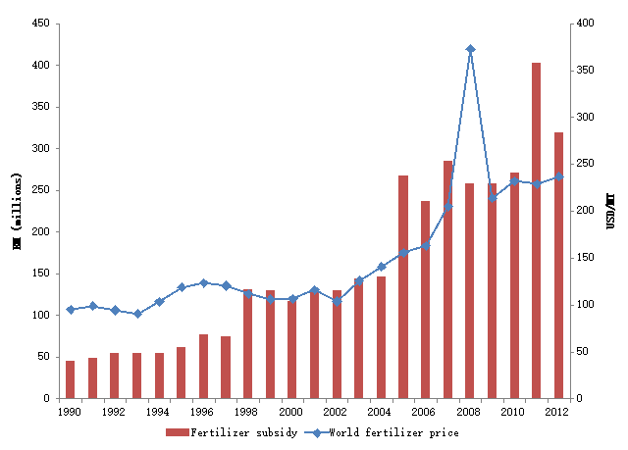
Source: FAO, 2018 and MoA, 2013

Figure 2. Domestic fertiliser subsidy (MYR) and World fertiliser (USD/MT) (1980-2012)

The government played a role in providing fertiliser subsidies so that farmers were not adversely affected by an uncertain increase in world oil prices. Total expenses for fertiliser subsidy given by the government showed volatile trends from 1980 to 2012. Fertiliser subsidy expenditure in 1980 was MYR 150 million and dropped to MYR 132 million in 1984. However, the fertiliser subsidy expenditure began to increase in 1985 from MYR 139 million to MYR 146 million in 2000. In 2008, the fertiliser subsidy expenditure decreased to MYR 137 million due to the global economic crisis, which had adversely affected the economic growth of Malaysia. Currently, the government continues to subsidise fertiliser in the form of a kilogram per type of fertiliser to farmers.

World crude oil price

Like prices of other commodities, crude oil prices experience wide price swings during supply shortage or oversupply. The crude oil price cycle may extend over several years responding to changes in demand as well as Organisation of the Petroleum Exporting Countries (OPEC) and non-OPEC supply. OPEC was established in 1960 with five founding members; Iran, Iraq, Kuwait, Saudi Arabia and Venezuela. One of the most critical factors determining the price level was petroleum inventories in the United States of America (USA) and other consuming countries.
Figure 3 shows that there is a long-run relationship between crude oil prices and fertiliser prices. World fertiliser prices had increased in tandem with rising crude oil prices. Sanyal and Kaplan (2015) suggested that the increase in crude oil prices will increase fertiliser prices as well as farming cost. Abdul Rahim and Zariyawati (2011) founded that there is a relationship between crude oil prices and long-term rice prices through the increased production costs. Farmers’ production costs are directly influenced by the price variation, agriculture equipment (machinery) and input usage. On average, paddy production cost takes up about 85% of the paddy price. The share of fuel cost is 12.5% of the total paddy production cost, but the fertiliser cost is about 40% (currently subsidised by the government) will be affected by the fuel increase indirectly (MADA, 2013).
Production costs have a negative relationship with government subsidies. For example, increase in crude oil at USD 60 per barrel in 2003, the government required to subsidise about MYR 8.27 of the petrol retail price to maintain the then-price level (Saari et al., 2008). Meanwhile, the allocation for fertilisers in paddy production is the highest at 76% (MYR 949 per hectare) of the total subsidy (MYR 1,249 per hectare). The direct costs incurred by farmers were 73%, while the government accommodated 37% for owner category and 20% for tenant category from total production costs (MADA, 2013).

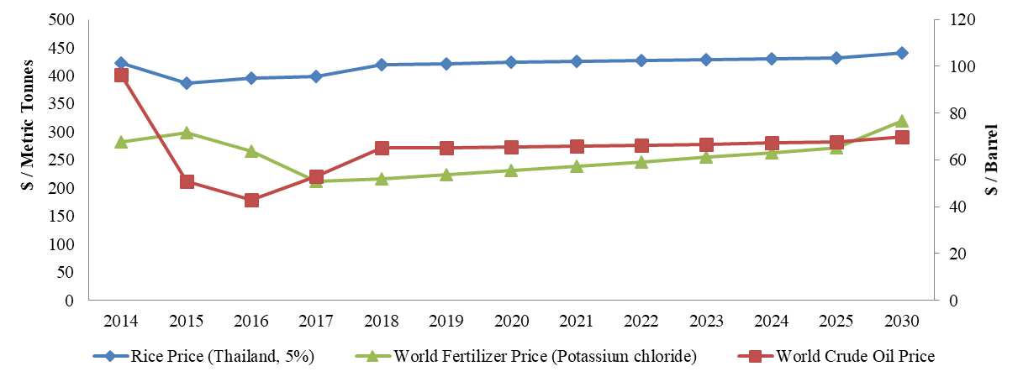
Source: Gusev, 2018

Figure 3. World crude oil price, fertiliser price and rice price (2017-2030)

Based on the aforementioned discussion, we found that fuel prices are directly impacted by the world crude oil prices, and fertiliser prices are indirectly impacted by the world crude oil prices. Although the 2008 global food crisis had no direct impact on Malaysia, the government should take the initiative to overcome the shortcomings of the country's rice sector as rising production costs, inadequate use of inputs, competition for resources and climate change (Mat & Othman, 2014). This brings the question of what are the impacts of the removal of fuel subsidy with the increase in world crude oil price on both paddy productivity and farmers' income?

Methods

System dynamics (SD) is a decision-making process that involves the dynamics phenomena resulted from the interaction of the physical structures and decision-making structures. The physical structure is formed by the accumulation and flow network of people, goods, energy and materials. The decision-making structure is formed through the accumulation and information flow network used by actors in the system that describes the rules of their decision-making processes. Input-output analysis, social accounting matrix and econometrics are among the methods included in SD. This method is capable of identifying the problem, formulating and assessing policy, as well as participating complementarily or inclusively (Forrester, 1992).
This study utilised both primary and secondary data. Secondary data include published materials and reports in Malaysia from 1990 until 2016. The reports include Malaysia Economics Statistics, Paddy Statistics, Statistics of MADA and Malaysia Plan. Primary data were collected through the distribution of purposely-structured questionnaires and in-depth interviews with machine suppliers and farmers. The purpose of the interview with machine suppliers is to acquire the machinery data. The interview with the farmers was aimed to obtain fertiliser consumption data. The variables used include fuel and fertiliser consumption per hectare and cost (MYR per hectare). The survey was carried out in selected granary area Muda Agriculture Development Authority (MADA) in Kedah for the paddy production season in 2018.
The research hypothesis suggested that the production cost will increase as a result of an increase in the world crude oil and fertiliser prices. The increase in production cost will reduce the use of allocated inputs and paddy productivity. Lower productivity and inefficient use of input will decrease farmers’ income. Besides, if global crude oil price continues to rise without fuel and diesel subsidies provided by the government, farmers will not be able to improve their productivity due to the increase in input material expenses. Government decisions are treated as exogenous policy and government is not permitted to engage in any deficit spending except as an explicit policy.

Productivity model

From the production side, paddy production is a function of productivity. The production sector in the model represents paddy as an output produced by the farm. Determining the output is the core of the production section in every industry, and the characteristics of the production function are critical in determining the behaviour of the model. The calculation of production is explained in equation (1).

Paddy production=(Paddy area * Actual productivity) * (1-Paddy loss) (1)

Actual productivity per hectare is defined by the average of paddy production (tonnes) and paddy area (hectare). Actual productivity is a function of four effects, which consist of land fertility, allocated input, farm practices and technology on paddy production. Paddy loss during harvesting activity occurs consistently in paddy production. Paddy losses are due to the poor condition of machines, poorly trained combine operators, crop conditions – lodging, too easy-shattering varieties and poor field conditions due to late water removal and field with no hard-pan. Paddy loss is estimated to be at 285.4 kilograms per hectare or 7.2% of productivity (Jafni et al., 2010).
Meanwhile, allocated input refers to fertiliser usage in paddy production. The resources of fertiliser are based on subsidy and allocation by the farmers. The rate of fertiliser usage by the farmers is at 0.38 tonnes per hectare (Ramli et al., 2012). Farmers also used additional fertilisers purchased at the rate of 0.17 tonnes per hectare. The rate shows that the maximum allocated input by the farmers is 33% compared to allocated input from subsidy at 70% of the optimum input required (MoA, 2013). Allocation for input by the farmers is based on desired input in the paddy field. Allocation for input will affect the land fertility. If land fertility is equal to one, paddy productivity can be achieved. However, if land fertility is less than 1, productivity will be reduced.

Income model

Generally, there were three sources of income for farmers – from revenue of paddy production and non-paddy production. Figure 4 shows farmers’ income behaviour in Malaysia. Farmers’ income is a function of paddy production, expenditure (production cost) and paddy price. However, due to the fixed paddy price by the government, income consists of output and cost (Amin, 1989). Farmers’ income is one of the objectives of government policy. Guaranteed Minimum Price (GMP) and paddy price subsidy are also included in the sub model of farmers’ income. The GMP represents paddy farmers prices and maintains the price level above the world standard price. Effective price refers to if domestic paddy price below than GMP, the farmers will receive GMP. Government support price and input are policy tools to achieve SSL targets. Currently, farmers receive a paddy price subsidy of MYR 248.10 per every tonne of paddy sold as the GMP is at MYR 750 per tonne (MADA, 2013). Hence, income consists of revenue from paddy sold, paddy price subsidy and income from non-paddy production as in equation (2).

Income = Revenue from paddy price subsidy + Revenue from paddy sold + Income from paddy production (2)

Figure 4. Stock and flow diagram (Farm cash)

Each farmer strives to keep their money in balance. Money balance represents farmers’ cash to meet their expenditure as in equation (3). The ratio of actual to desired cash measures the farmers’ cash availability. If cash availability drops, payments are reduced to bring total expenditure in line with revenues, and vice versa. To get the effect of cash available on expenditure, we have to model the desired expenditure and cash availability.

Farmers cash = Income - Expenditure (3)
Availability concept (cash availability) is equal to the farmers’ cash/desired cash. If the availability is more than 1, then the farmers are believed to own the desired cash level. The farmers can deliver their stock based on demand required. However, if the availability is less than 1, the farmers are believed not to have the desired cash level. The percentage of income from paddy activity is 60% of total income (Hashim, 1998).
Results and discussion

Two analyses have been utilised to study the impact of the world crude oil prices on the paddy sector towards liberalisation. The first analysis attempted to calculate the cost of fuel and fertiliser used based on machinery and transportation costs. While the second analysis is a simulation of system dynamics to study the impact of the removal of fuel subsidy with the change in world crude oil prices.

Fuel and fertiliser cost

Mechanisation in paddy cultivation has been widely used in the MADA area to accelerate the paddy production activity. Among the machines rented by farmers are Kubota, tractor and combine harvester as shown in Table 2. The cost of paddy mechanisation increases due to equipment maintenance cost and fuel price factors.

Table 2. The rate of machinery used per season in paddy production (2018)

Stages | Activity | Inputs | Model | Duration time (hour/hectare) | The weight of machine (kilogram) | Life-long (year)
Land preparation | Cut stable | Tractor 4W | New Holland | 1.4 | 450 | 8
Land preparation | Plowing | Tractor 2W | New Holland | 1.4 | 2380 | 10
Land preparation | Levelling | Power tiller | Dongfen | 1.4 | 488 | 8
Planting | Direct seeding | Blower | Maruyama | 1.4 | 20 | 5
Crop Management | Cleaning of field boundaries | Bush cutter | Tanaka | 2.8 | 4.1 | 5
Crop Management | Pesticides spray | Sprayer | Maruyama | 0.7 | 10 | 5
Crop Management | Weed | Bust Cutter | Tanaka | 2.8 | 4.1 | 5
Harvesting | Harvest | Combine harvester | New Holland | 1.4 | 12000 | 10
Source: Interview with machine supplier, MADA

Crop management activities show a longer usage time of 6.3 hours per hectare followed by land preparation activity of 4.2 hours per hectare. However, the amount of time used varies according to the type of paddy land. Most of the machines are purchased second-hand from suppliers. The company renovates machines depending on their usages and soil types. For instance, ploughing tractor tyres are replaced with track because of the severe soil condition. Each machine is upgraded with equipment on demand. The process is done by the company.

Table 3. Machinery wages rate and fuel cost (MYR/hectare) in MADA (2018)

Types | Kubota | Tractor (3W) | Tractor (4W) | Combine harvester | Truck
Wages rates (MYR/hectare) | 150 | 200 | 260 | 320 | MYR45 /  kilogram
Fuel Cost (MYR/hectare) | 20 | 35 | 45 | 50 | MYR20/Trip
Price (MYR) | 45,000 |  |  | 75,000
Maintenance (MYR/season) | 2,000 | 5,000 | 5,000 | 10,000
Source: Interview with machine supplier, MADA

The portion of cost per hectare for combined harvester rental price in the MADA area is about MYR 320 per hectare including; (i) management charges (MYR 14), (ii) machine supplier (broker) charges (MY R58), (iii) diesel cost (MYR 50-60), iv) driver salary (MYR 58) and (v) machine supplier profit (MYR 100-130). Most of the machines are in good condition for three to four seasons’ use. The machine is underutilised due to concerns about possible damages. Maintenance service is done once for every season. Broken machines are repaired at MYR 360. Tractors are rented from MADA and wages for the worker are paid daily. The endurance of this tractor depends on the engine. A truck is used to deliver paddy that has been harvested from the paddy field to the rice mill.
Table 4 shows the fuel consumption rate and costs involved in paddy production. The rate of fuel in the includes diesel and petrol used by paddy machinery. Land preparation activities show the highest utilisation rate of 45 L per hectare with a production cost of MYR 98.10 per hectare. The high utilisation rate is due to the use of the tractor for ploughing and land levelling. Meanwhile, based on Table 5, the paddy cultivation process consists of a total of 3-4 cycles of fertilisation of N, P₂O₅, K₂O manure and (organic). The amount of fertiliser used in the MADA area is 388.53 kg/hectare with the highest N content totalling to 137.04 kg/hectare, followed K₂O (111.6 kg/hectare), P₂O₅ (82.33 kg/hectare), and manure (57.56 /hectare). The rate of manure is still low among farmers. This is influenced by the supply of subsidised fertiliser.

Table 4. Rate (L/hectare) and cost (MYR/hectare) of fuel per season in paddy production (2018)

Stages | Activity | Inputs | Fuel | Rate (L /hectare) | Cost (MYR/hectare)
Land preparation | 1st Tillage | Tractor 4W | Diesel | 15 | 32.70
Land preparation | 2nd Tillage | Tractor 2W | Diesel | 15 | 32.70
Land preparation | Leveling | Power Tiller | Diesel | 15 | 32.70
Land preparation | Total |  |  | 45 | 98.10
Planting | Direct seeding | Blower 20kg | Petrol | 6 | 13.2
Crop management | Fertiliser | Sprayer 20L | Petrol | 8 | 17.60
Crop management | Pesticides | Sprinkle 20L | Petrol | 8 | 17.60
Crop management | Weeding | Bust Cutter | Petrol | 16 | 35.20
Crop management | Total |  |  | 32 | 70.40
Harvesting | Harvest | Combine harvester | Diesel | 30 | 69.76
Transportation |  |  | Petrol | 7 | 15.40
Total |  |  |  | 120 | 266.86
Notes: Price of diesel = MYR 2.18 per L. Price of petrol = MYR 2.2 per L

Table 5. Rate of fertiliser used (Kilogram/hectare) per season in paddy production (2018)

Activity | Elements | Composition (Rate/re) | Rate (kg) | Rate (kg/hectare)
1st Fertilising | Nitrogen (N) | 17.5 | 16.28 | 46.85
1st Fertilising | Phosphorus (P₂O₅) | 15.5 | 14.42 | 41.5
1st Fertilising | Potassium (K₂O) | 10 | 9.3 | 26.76
 | Total |  |  | 115.11
2nd Fertilising | Nitrogen (N) | 17.5 | 12.21 | 35.14
2nd Fertilising | Phosphorus (P₂O₅) | 15.5 | 10.81 | 31.11
2nd Fertilising | Potassium (K₂O) | 10 | 6.98 | 20.09
2nd Fertilising | Manure | - | - | 14.39
2nd Fertilising | Total |  |  | 100.73
3rd Fertilising | Nitrogen (N) | 17 | 12.75 | 36.69
3rd Fertilising | Phosphorus (P₂O₅) | 3 | 2.25 | 6.47
3rd Fertilising | Potassium (K₂O) | 20 | 15 | 43.17
3rd Fertilising | Manure |  | - | 28.78
3rd Fertilising | Total |  |  | 115.11
4th Fertilising | Nitrogen (N) | 17 | 6.38 | 18.36
4th Fertilising | Phosphorus (P₂O₅) | 3 | 1.13 | 3.25
4th Fertilising | Potassium (K₂O) | 20 | 7.5 | 21.58
4th Fertilising | Manure |  | - | 14.39
4th Fertilising | Total |  |  | 57.58
Total |  |  |  | 388.53
Source: Interview with the farmer, MADA
Simulation of system dynamics

As a result in fuel and fertilisers section, changes in the world oil prices will directly impact the cost of fuel used by machines. In addition, it will indirectly impact the fertiliser costs because a significant share of the fertilisers used is imported chemical fertilisers. Furthermore, the data will be used for the simulation of system dynamic models. The model validity is usually carried qualitatively and informally. System dynamics become confident in the models when they see the replication of historical records on model simulations. The starting point of the model is 1990, which provides two decades of simulated historical experience. Comparison of simulated and actual behaviour establishes the model’s ability to capture trends and turning points in essential quantities.The behaviour of the model between 1990 and 2016 is compared to the actual performance of the paddy industry. The model captures major trends and turning points in important economic events with an error tolerance generally under 15%. The simulated behaviour of the economy is then presented to 2030. Actual data are based on a dataset collected by the Department of Statistics. Meanwhile, simulation data is illustrated by the equation for important variables involved in paddy production.

Paddy production
(Million tonnes)
Domestic Fuel Price
(RM/liter)

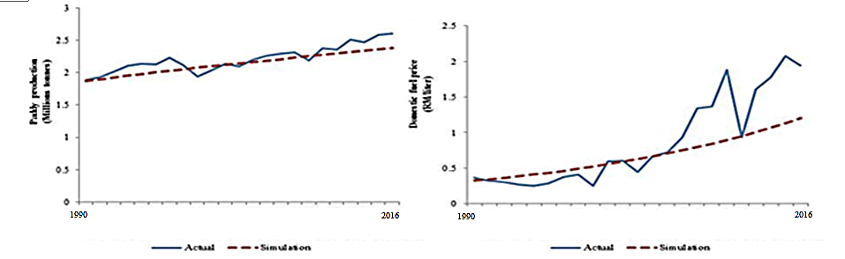

Figure 5. Simulation vs actual behaviour for selected variables (1990-2012)

Table 7. Error analysis of the paddy productivity model

Variable | (RMSPE)  (%) | R² | Theil Inequality Statistics
Variable | (RMSPE)  (%) | R² | Mean (U^{m}) | Deviation (U^{s}) | Covariation (U^{c})
Paddy productivity | 4.71 | 0.78 | 0.40 | 0.03 | 0.57

Errors of unequal variation can be corrected by incorporating a theory of the missing cyclic behaviour in the model. The mean square error (MSE), root-mean-square-per cent error (RMSPE) and Theil inequality statistics are used to quantify the magnitude and nature of the errors. RMSPE measures the average per cent difference between simulated and actual values. Because the per cent error is squared, a single large error counts more heavily than two smaller errors with the same magnitude (Sterman, 2004). For this model, a value of less than 10% represents a lower error between the simulated and historical data. The RMSPE for paddy productivity is of a smaller value (4.71%) showing that the model variables are in the right direction.
Model validation involves examining the ‘robustness’ of the model under extreme policies, shocks and extreme values of parameters. The model should be robust in extreme conditions, which means the behaviour of the model should exhibit realistic results even under extreme values for the input. The model is simulated without any change known as ‘business as usual’ (BAU) to predict behaviour based on historical data. Meanwhile, a scenario is defined as the changing of structure, whether through parameter, value or both to check sensitivity and predict the outcome.
Based on the baseline scenario, we initially test the model under an extreme condition. In this case, the extreme condition refers to a scenario (S1) simulating removal of fuel subsidy with a change in world crude oil prices. The fuel subsidy is set at 0 in 2018 and remains constant until 2030. Based on historical behaviour, world crude oil prices increase over time. At the same time, the liberalisation of the paddy sector needs to consider the rising crude oil price factor for the industry to be competitive in the world market. The world bank estimates that oil price will continue to increase to reach USD 70 per barrel in 2030 compared to USD 52.8 per barrel in 2017. Meanwhile, Canada Energy Board estimates an increase of 32.5% in crude oil price from 2017 to 2030 (Gusev, 2018). Using these statistics, this simulation for world crude oil price is expected to increase by 50% in 2018 until 2030.

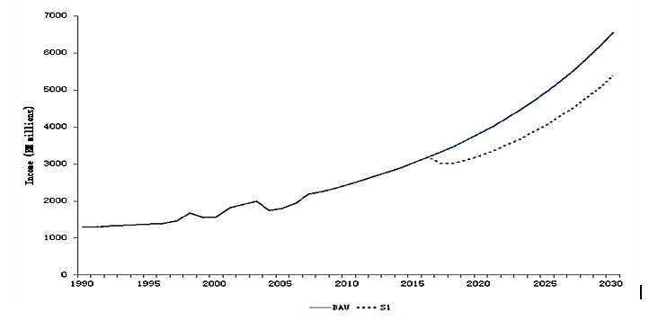
Income (RM millions)
Figure 6. Simulation behaviour for farmers’ income

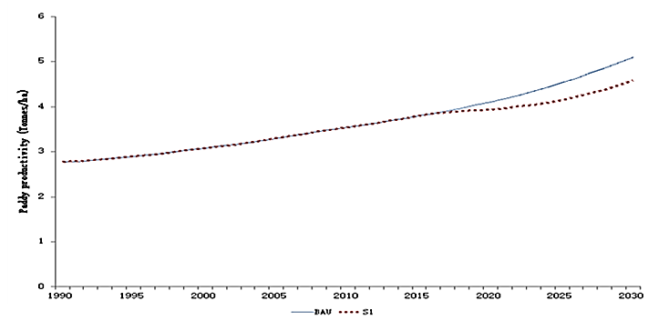
Paddy productivity (Tonnes/ha)
Figure 7. Simulation behaviour for paddy productivity
Removal of fuel subsidies with the increase of world crude oil prices will affect productivity level and farmers’ income, as shown in Figures 6 and 7. The simulation results of S1 shows a declining trend in the farmers’ income by 18% over time because of the reduced farm cash by 10.1%. The machinery expenditure increased by 2.5% in 2030, as it is the multiplication of fuel price and average unit of fuel consumption. When the machinery cost goes up, the paddy production cost will also rise. It is noted that the increment is small in magnitude at 1.3%, as we assume the other production costs are kept constant. The only variation comes from the increase in machinery cost. Fuel prices also indirectly affect the price of fertiliser. With a 1% increase in world crude oil price, the fertiliser price will increase by 3.4% (Siti 'Aisyah Baharudin et al., 2016).
The indirect effect is higher than the direct impact on paddy productivity. Therefore, rising fuel prices will increase the price of fertiliser and ultimately affect farmers' expenses by 45%. Less fertiliser usage will cause a drop in productivity by 10.2% because there is a direct relationship between these two variables. Interestingly, Saari et al. (2008) argued that the primary product is one of the affected sectors due to a 90% petroleum price increase and given that there is no government intervention in fuel price.

Policy implication

The model is satisfactory for validation purposes when the models operate reasonably under extreme conditions. However, these criteria are indefinite and lead to quick conclusions. Therefore, in constructing a model for policy analysis using the system dynamics methodology, the model has to reflect the way decisions are made in the system (Forrester, 1992). To improve the simulation behaviour in the future, researchers need to design a better strategy and formulate superior policy implementation. The goal will be realised through the implementation of the right strategy to achieve a higher productivity level. The strategy is a plan of actions to achieve a particular purpose and often implemented through programs. The program is realised by executing activities according to the conditions and time.
Policy scenarios are set by the model structure (including the current policy, government actions and exemplary actions from other countries) and parameters. Policy analysis is run under two policy scenarios. The model is simulated with the removal of fuel subsidies, and world crude oil price is expected to increase by 50% known as Base Run (S1) which began in 2018. Policy scenario 1 (PS1) examines the implications of BAU with the implementation of improved farm practices. On the other hand, the second scenario (PS2) examines the impact of precision farming technology.

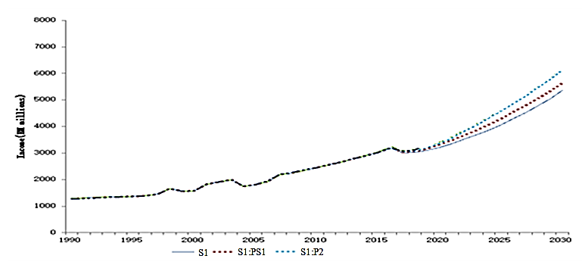
Income (RM millions)

Figure 8. Policy simulation for farmers’ income

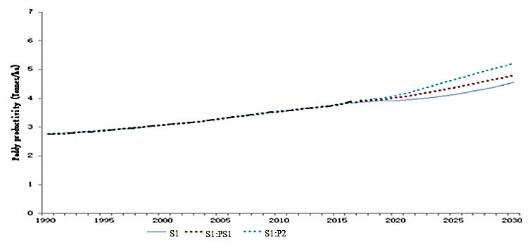
Paddy productivity (Tonnes/ha)

Figure 9. Policy simulation for paddy productivity

Improvement in farm practices is known as scoring specific production practices. Based on the survey conducted in the MADA area, it is evident that the farmers need to improve or change the current practices to minimise over usage of chemical input, extensive use of chemical pesticide control and attitude towards other farmers in terms of sharing water sources and information about paddy planting. Good farm practices refer to the optimum level of input usage and farmers’ attitude in generating paddy yield. The checklist of paddy planting or ‘Rice Check’ acts as a guide to the management of paddy planting to abide by the targeted production goal. The primary purpose is to ensure smooth growth of the paddy plant, which is geared towards high paddy productivity.
Best proposed practices include i) use of organic fertiliser and pesticides, ii) proper timing for land preparation activity until the paddy is transferred to millers, and iii) adequate frequency of chemicals input. Current practice is set as 30%, while the maximum best practice is set at 100% based on the previous study. Improvement in farm practices seems like an excellent way as it does not inflict any additional cost but only requires a change in the attitude among the farmers themselves. It can be implemented through a proclamation by institutes such as PPK, MADA and other agencies. These agencies could help promote a better understanding of good farm practice and amicable communication among farmers. The simulation PS1 shows that paddy productivity increases by 16.2 %.
Based on the survey in the MADA area, we found that the agricultural machinery suppliers have modified most of the machines used by paddy farmers. Most of the farmers use large second-hand machines. Unfortunately, such machines cause inefficient consumption of energy, fuel and time. Therefore, this study suggests expanding the use of precision farming among the farmers. Precision farming refers to the management of paddy plantation related to spatial and temporal information introduced by the Malaysian Agricultural Research and Development Institute (MARDI) to manage paddy fields using modern technology. Another benefit of the technique is the low cost it incurs to develop a digital field plot map using rapid field plot digitising based on images collected from commercial remote sensing satellite or aerial images. Developed countries such as South Korea and Japan have demonstrated how technological advancements have helped in increasing their agricultural productivity and cater to the needs of their population. This simulation result of PS2 indicates an increment in productivity by 40% within the 12 years of implementation from 2018.

Conclusion

The impact of higher world crude oil prices can be traced through direct and indirect impacts. The direct impact is the increased fuel cost and machinery rental that influence farmers’ income. Due to the change in fuel price, production cost also increases as the share of fuel is only about 5%, and we assume that other production costs are kept constant. On the other hand, the indirect impact is the increased fertiliser cost and decreased fertiliser consumption that influences paddy productivity. The circumstance leads to a reduction in farmers’ cash flow. Given the increase in the petroleum price, this exerts pressure on profit margins. For the farmers, their welfare declines since they have to pay higher production costs to produce paddy. Therefore, besides making decisions on paddy price subsidy and fertiliser subsidy, the government also has to pay special attention to its effect from the increase in world crude oil prices to machinery rental. A comprehensive study must be carried out to ensure the government policymakers have sufficient information before making decisions.

Acknowledgement

This research was fully funded by Short-Term Grant, Universiti Sains Malaysia (USM) (304/PSOSIAL/6315147).

References

Abdul Rahim, A.S., & Zariyawati, M.A., (2011). Causal effects of world crude oil prices on the prices of rice and soybean oil: An ardl approach. Pertanika Journal Social Science and Humanities, 19(1), 123-130.
Amin Mahir Abdullah. (1989). Subsidi dan kesannya ke atas petani padi. Jurnal Ekonomi Malaysia, 19, 17-30.
Bernama. (2018). MOF: Harga RON95, diesel ditetapkan pada RM2.20, RM2.18 seliter, Bernama, 1-3. June 7.
Bundschuh, J., & Guangnan Chen, E. (2014). Sustainable energy solutions in agriculture. (1st ed.). CRC Press, London.
ECM. (2011). National energy balance, Putrajaya, Suruhanjaya Tenaga (Energy Commission of Malaysia).
FAO. (2018). Agricultural outlook 2018-2027, Rome, OECD-FAO.
Forrester, J.W., (1992). Policies, decisions and information sources for modeling. European Journal of Operational Research, 59(1), 42-63.
Gusev, M. (2018). Crude oil price forecast: 2018, 2019 and long term to 2030. Retrieved from http://comstat.comesa.int/infographics/.
Hashim, S.M., (1998). Income inequality and poverty in Malaysia. (1st ed.) Rowman & Littlefield, London.
Idris, N.D.M., & Siwar, C. (2017). From poverty reduction to poverty relief: Impact of non-farm income in Integrated Agriculture Development Area (IADA) Samarahan, Sarawak, Malaysia. Geografia Malaysian Journal of Society and Space, 11(2), 32-41.
Jafni, J.M., C.H., Abu Hassan, D., & Mohd Shahrul Shah, M. (2010). Strengthening food security through sustainable rice production. Serdang, In Proceeding of national rice conference 2010, 434-437.
MADA. (2013). Statistics of MADA 2013. Kedah: Lembaga Kemajuan Pertanian Muda Retrieved from http://www.mada.gov.my/en
Man, N., & Sadiya, S.I. (2009). Off-farm employment participation among paddy farmers. In the MUDA Agricultural Development Authority and Kemasin Semerak Granary areas of Malaysia. Asia-Pacific Development Journal, 16(2), 3-18.
Mat, B., & Othman, Z. (2014). Regional cooperation in addressing food security issues in Southeast Asia: Malaysian perspectives. Geografia Malaysian Journal of Society and Space, 10(6), 37-47.
MoA. (2013). Agrofood statistics 2013, Putrajaya, Ministry of Agriculture and Agro-based Industries.
Rabu, M.R., & Shah, M.D.M. (2013). Food and livelihood security of the Malaysian paddy farmers. Economic and Technology Management Review, 8(1), 59-69.
Ramli, N.N., Mad Nasir Shamsudin, Zainalabidin Mohamed, & Radam, A. (2012). The impact of fertilizer subsidy on Malaysia paddy/rice industry using a system dynamics approach. International Journal of Social Science and Humanity, 2(3), 2013-2015.
Saari, Y., Alias Radam, & Abdullah., A.M. (2008). The impacts of increase in the domestic petroleum prices on cost production in the agricultural and agro-based sectors. International Journal of Business and Society, 9(1), 37-39.
Sanyal, P.L.A.M., & Kaplan, P. (2015). Impact of energy price variability on global fertilizer price: application of alternative volatility models. Sustainable Agriculture Research, 4(4), 132-144.
Siti 'Aisyah Baharudin, Fatimah Mohamed Arshad, Muhammad Tasrif, & Ibragimov, A. (2016). Impact of fuel prices on paddy farmer’s expenditure allocation in Malaysia. British Journal of Applied Research, 1(1), 5-9.
Sterman, J.D. (2004). Business dynamics: Systems thinking and modeling for a complex World. (1st ed.). New York, Irwin/McGraw-Hill.

