

Managing crime for urban wellbeing and sustainable housing delivery: Through the lens of residents and housing developers in Malaysia

William Wee-Lim Hew¹, Siok Hwa Lau¹, Gerald Guan-Gan Goh¹, Boon-Yee Low¹

¹Faculty of Business, Multimedia University, Malaysia

Correspondence: William Wee-Lim Hew (email: wlhew@mmu.edu.my)

Received: 10 April 2019; Accepted: 22 October 2019; Published: 25 November 2019

Abstract

Social sustainability is a form of development that promotes a harmonious society that is conducive to residential integration and improvement of the population's quality of life. The rapid urbanization of today’s society has increased the costs of living and created much social problems and crime. Crime has turned new residential projects into urban ghettoes, driving property prices down, encouraging urban flight. The desertion of traditional housing estates and the poor sales performance of new residential projects has put a dampener into the national property market. Thus, this study was conducted in two stages at the southern region of Malaysia. First, semi-structured interviews were conducted with 24 residents in crime-prone localities using snowball sampling. Second, discussions were held with 11 housing developers. This paper discusses the impacts of crime on residents, the housing market, and how the issue may be resolved from the perspectives of these two groups of respondents. The interviews revealed the destabilizing nature of crime on the sustainability of urban housing and the gradual failing of traditional open neighbourhoods in favour of safer, gated and guarded neighbourhoods; it also revealed the difficult operational positions faced by property developers in the past in particular the high costs incurred and the large overhang units. This paper contributes by recommending how developers may incorporate crime-prevention measures through innovative spatial management practices such as in eco-housing to increase attractiveness of their projects while minimizing costs.

Keywords: crime; housing innovation; social sustainability; spatial management

Introduction

Towards the end of the 20th century, there was a great shift in global economy; many of the world’s nations, which were formerly self-contained and closed economies have begun to embrace globalization and open their doors to foreign investments. This have facilitated the rapid transition of many of the world’s nations from rural to urban economies. Asia for instance has grew by leaps and bounds with the emergence of countries like South Korea, India, and China into the global economic landscape. This process of transformation is referred to as urbanization. It speaks of the transformation of a society’s rural economy and lifestyle to one that is predominantly urban (Ray, 2016) resulting in a society which is clustered, with a size so large that it has never been regarded possible previously (Davis, 1965). Most if not all high-income countries in the world today owed their success to urbanization. It has been reported that nearly all countries that achieved middle-income nation have at least a 50 percent urban population, and for high income nations, the urbanization rate would have reached about 70 to 80 percent (Spence, Annez, & Buckley, 2009).
However, urbanization also raises various problems, as it involves rapid change in a nation’s social structure, disparities are common (Spence et al., 2009). Urbanization encourages migration of rural folk into cities, and they are usually disadvantaged at salaries, employment opportunities, and access to urban housing in comparison to their urban counterparts. These rural migrants often end up working in dangerous, filthy, and low-paying jobs; turning them into resentful urban poor (Tacoli, McGranahan, & Satterthwaite, 2015). Until now, sociologists have never failed to link urban poverty with crime. Criminal activities are usually prevalent in areas where there are high concentrations of low-income (Bobo, 2009; Ludwig, Duncan, & Hirschfield, 2001; Sampson & Laub, 1994; Sampson, Raudenbush, & Earls, 1997; Soh, 2012). Worse, crime often have a multiplier effect; impunity has led to the self-reinforcing nature of crime and encourage it to continually thrive in these neighbourhoods (Ludwig et al., 2001; Sampson et al., 1997; Schrag & Scotchmer, 1997).

Literature review

Neighbourhood crime and housing: The case of Malaysia

Malaysia is a newly industrialized nation in Southeast Asia with an urban population that has risen dramatically from 20 percent in the 1950s to 72 percent in 2010. It was estimated that rate would reach 82 percent in 2030 (United Nations Department of Economic and Social Affairs, 2008). In Malaysia, crime has continued to be prevalent and threatening residential order and safety. The Performance Management and Delivery Unit, PEMANDU (2014) reported that since the commencement of a Government Transformation Programme initiated early of the decade, crime index fell by 15, 11 and 7.6 percent respectively in the subsequent years (p.108). Nonetheless, these figures may be understated; the Crime Suppression and Prevention Department considers the possibility of ‘dark figures’ where many cases remained unreported and claimed that the actual crime rate to be significantly higher. A survey via crowd sourcing conducted in 2014 by Khan (2015) suggests that about 25 percent of criminal cases remained unreported as residents regard most residential crimes to be petty cases and fear reprisal from the perpetrators should they report the incidences. During the same year an international survey on 240 expatriates living in Malaysia also supported the fact that crime is still rampant with a majority (69 percent) have fallen victim to crime at least once in the past two years and 92 percent of them who have been to Singapore felt that it was safer to live there (Davison, 2014). The survey revealed that snatch theft was the main form of crime, followed by break-ins, physical assault and vehicular theft. Later from 2015 to 2016, the national crime rate was reported to have been reduced by 0.8 percent. However, further scrutiny revealed that the decrease was mainly contributed by lower incidences of organized crime e.g. murder rather than petty, neighbourhood crimes which remained high (Othman & Chuah, 2016). During the first quarter of 2016, crime rates spiked by 4.6 percent, and 58 percent of it was attributed to property crimes, with increases in snatch thefts and burglaries as criminals learnt the art of lock-picking and outsmarting the security systems (Shahrudin, 2016).
In more recent years, the public has begun to doubt the accuracy of these projected crime statistics. Despite various assurances that the crime rates are within control, residents were feeling increasingly unsafe (Ismail, 2017). For instance, in 2018, Malaysia has been found wanting for exceptionally high crime rates. Numbeo (2018) reported that Malaysia ranks first among 23 Southeast Asian countries with the highest Crime Index of 66.95, and ranks second among a list of 90 Asian countries.
In Malaysia, the dwellers of affordable housing estates often come from the lower-income group and by such, their tight finances have often compelled them to attempt maximizing income derived from these homes, even if it meant renting to immigrants and foreign workers. News reports are abounded on how affordable homes have been leased to foreign workers, and they have been blamed for creating social problems and turned these areas undesirable (Looi, 2017). For instance, there were complaints how these immigrants have become a nuisance by roaming the neighbourhood in their undergarments, drinking alcohol, quarrelling and fighting among themselves (Looi, 2017). Criminal incidents such as robbery, car break-ins, and burglary have been rampant particularly in low-cost social housing areas, and residents in these areas have been increasingly living in fear (Marzuki, 2016). Even in regular neighbourhoods, residents are constantly worried for their safety against burglary and snatch theft. This have resulted in urban flight; with many hoping to move into gated communities with constant surveillance and security patrols (Tan, 2016; Zainon et al., 2017).

Neighbourhood crime, social and economic sustainability

Generally, there are three kinds of neighbourhoods. The first is open neighbourhoods, or residential enclaves that are freely accessible to the general public the major streets. Then there are guarded neighbourhoods where these residential enclaves that were formerly open are now barricaded and controlled with boom gates. Finally, there are gated communities, or residential enclaves where the neighbourhood is barricaded by physical barriers such as a fence or a wall (Tan, 2016). As gated neighbourhoods often employ security to patrol and control access, the terms guarded and gated may sometimes be used interchangeably. Traditionally, most residential enclaves were open neighbourhoods. A major distinction between an open neighbourhoods from a gated community is that the former has a diverse mix of residents; people with different levels of income and class often lived together without much distinction in social class or income. This traditional model of housing has allowed residents to freely socialize with people of other neighbourhoods and develop close friendships (Roitman, 2013).
Nonetheless in time, the housing landscape has become more fragmented; urbanization has socially divided urban residents where more affluent dwellers preferring to distance themselves from the lower-income residents as the lower-income group is increasingly being stigmatized for rising social problems and crime. As many were formerly from disadvantaged families, their newly-attained social upgrade has motivated them to provide a better, safer environment for their children to grow up in (Roitman, 2017). Thus, the attractiveness of traditional open neighbourhoods have been declining in favour of more protected alternatives i.e. guarded or gated communities. Urban planners and housing developers are generally aware of the seriousness of addressing the issue of safety in both social and private housing, nonetheless many new projects were built for the sake of building; the design and spatial planning of social housing in particular are usually minimalist without much considerations of safety and sense of place. To promote sustainability, housing development must consider the preservation of the environment and maintenance of quality at these human settlements (Tan, 2011) to prevent them morphing into modern ‘ghettoes’ devoid of public order and rampant in crime and gang activities (Goodchild & Cole, 2001; Murdie, 1994; Walks & Bourne, 2006). Crime has been found to increase street crime, turn residents antisocial, promote mental illness, and residential turnover. These finally result in ultimate depopulation of the area and closure of local institutions and business establishments (Atkinson, 2000). Residents will then opt for gated communities with protected surroundings (Ellen & O’Regan, 2010; Roitman, 2017).
Research have also shown that neighbourhood crime and presence of security were among the main determinants to one’s decision to purchase a home (Tan, 2013). Housing ownership is an important contributor to economy and societal wellbeing; it promotes familial stability which in turn encourage families to raise children and increase consumption of household goods and services (Bourguignon, Browning, Chiappori, & Lechene, 1993). Homeowners also make interest payments on bank mortgages, a source of commercial banks’ income, and the originator of lending funds for new entrepreneurs (DeYoung & Rice, 2004).
The absence of crime attracts homebuyers, increases the value of the neighbourhood, provides the owners with financial gains, and improve their wellbeing in general. Furthermore, owning a home have been found to increase a person’s perception of their neighbourhood, encourage them to stay in the neighbourhood longer, invest into maintenance of the area, and increase their socialization with the local community. Through their close dealings with neighbours, they were able to supervise their children better and this have resulted in improved children behaviour and better academic performance (Tan, 2008). Given the role of safety in promoting economic and social wellbeing, they must be studied.

Method and study area

This study uses a qualitative method for analysis. This study was conducted in two stages. First, interview is conducted with residents in crime prone locations. Second, discussions were held with developers in the same regions. Data from the interviews are then collated and mapped to one another to reveal patterns in responses. The following sub-sections detail the two stages involved:

Stage 1: Interview with residents in crime-prone locations

In the first stage, semi-structured interviews were conducted with residents residing in crime-prone locations in the southern region of Peninsular Malaysia between November and December 2017. The locations were identified based on crime data provided by local police headquarters, under the condition that these locations shall not be explicitly named in order to avoid drawing unwanted attention to these neighbourhoods and to protect the residents from provoking ire and reprisals from criminals. The residents who had experienced crime in their neighbourhood were identified using snowball sampling, where a resident who had experienced victimization identifies another victim in their neighbourhood. A total of 24 were chosen for the interview.
In the selection of interviewees, care was employed to ensure a balanced representation between different age groups, and between Bumiputra and non-Bumiputra responses. The majority of the interviewees were young adults aged 20 to 30 (41.67 percent), 31 to 40 (37.5), followed by mid-life adults aged 41 to 50 (16.67 percent), and seniors aged 61 and above (4.17 percent). The majority of interviewees aged from 20 to 40 is a good representation of the residential composition as these are the ages whereby adults have the highest mobility; at these ages, they get married, seek employment, and pursue homeownership (Tan, 2008; Leh et al., 2016). Females constitute approximately two-thirds (62.5 percent) while males made up one-third of the interviewees (37.5 percent). They have generally moved into the neighbourhood for less than 10 years (75 percent), followed by those who have resided between 11 to 20 years (20.83 percent), and one who have been rooted for more than 20 years (4.17 percent). In terms of ethnicity, they were Malays (37.5 percent), Chinese (54.17 percent), and Indian (8.33 percent). The majority are staying at open neighbourhoods (66.67 percent) while the remainder stayed at guarded, gated communities (33.33 percent). The following Table 1 summarizes the characteristics of the respondents in this Study.

Table 1. Demographic characteristics of the 24 resident interviewees

Age | Frequency | Percentage | Gender |  | Ethnicity |  |  | Tenure (years)
 |  |  | Male | Female | Malay | Chinese | Indian | <10 | 11-20 | >20
20 | 1 | 4.17 | - | 1 | - | 1 | - | 1 | - | -
21 - 30 | 9 | 37.50 | 3 | 6 | 2 | 6 | 1 | 7 | 2 | 1
31 - 40 | 9 | 37.50 | 4 | 5 | 5 | 4 | - | 7 | 2 | -
41 - 50 | 4 | 16.67 | 1 | 3 | 1 | 2 | 1 | 3 | - | -
> 61 | 1 | 4.16 | 1 | - | 1 | - | - | - | 1 | -
Total | 24 | 100 | 9 | 15 | 9 | 13 | 2 | 18 | 5 | 1
Percentage |  |  | 37.50 | 62.50 | 37.50 | 54.17 | 8.33 | 75 | 20.83 | 4.17

Stage 2: Discussions with property developers

In the second stage, discussions were held with executives and managers from 11 housing developers between May and June 2018 in the same southern region, covering the states of Malacca, Johor, and Negeri Sembilan. The developers identified were having significant projects in the areas in and around the criminal hotspots identified by the police. Contrary to a semi-structured interviews with residents, the form of interview conducted with developers is unstructured as this method builds rapport with the interviewees; as experts often need the freedom to express their views. It also removes their answering constraints which allowed them to reveal more information (Moore & Miles, 1991). Three questions were posed to the developers: First, they were asked to comment on the current conditions of the housing market and the implications to their performance of their business. During the discussion, developers were also triggered to relate their performance with the growing concerns for safety among Malaysian residents. Each interview lasted between 30 to 45 minutes. Table 2 summarizes the demographics of the interviewees representing the developers.

Table 2. Demographic characteristics of the 11 developer interviewees

Location | Frequency | Percentage | Area of Expertise
 |  |  | Sales/  Marketing | Finance/  Accounting | Managerial  (General) | Contract/ Leasing | Investment
N. Sembilan | 1 | 9.09 | 1
Melaka | 3 | 27.27 | 1 | 1 | 1
Johor | 7 | 63.64 | 3 | 1 | 1 | 1 | 1
Total | 11 | 100 | 5 | 2 | 2 | 1 | 1

Results and discussion

Table 3 summarizes the opinions and issues raised by the residents. This summary shows that in brief, residents in crime-prone locations are generally worried about the escalating crime in Malaysia and how it devalues their properties. Many have even considered leaving the neighbourhood should crime worsen. Security problems cited are mostly on the neighbourhood environment and community support and to improve safety. Residents have ranked neighbourhood general security rather than for individual homes to be most important.

Table 3. Findings from interview with residents

Factor | Findings | Percentage | Remark
The nature of residents' victimization | Burglary  Robbery  Snatch theft  Vehicular-jacking | 83.33%  25.00%  4.17%  12.5% | Burglary happens mainly at open neighbourhoods
Perception on the severity of crime in Malaysia | Not serious  Serious, under control  Serious | 4.17%  12.5%  83.33% | Crime are perceived to be more serious in urban areas than rural areas
Impact on property values and attractiveness | Will not affect property values  Reduce property values | 8.33%  91.67% | Property values perceived to drop at higher crime areas
Tendency to leave the neighbourhood | Will not leave  May consider leaving | 4.17%  95.83% | Urban flight tendencies were more common in mobile respondents
Safety and security loopholes | Poor housing environment  Lack community support | 70.83%  37.5% | The environment refers to the layout and ambience
Residents' recommendations  to improve safety  and security | Home security features  Neighbourhood security  Residents’ involvement  Vigilance and self-driven | 29.17%  45.83%  50.00%  33.33% | External(neighbourhood) safety must be considered before internal (home) safety can take place
Source: Findings of the study

Nature of criminal victimization in housing estates

The nature of crime in residential areas were mainly violation of property rights. Burglary remained the most common crime in the neighbourhoods with 83.33 percent of interviewees citing at least one incidence of victimization by burglary. One interviewee remarked an astounding 25 cases of break-ins in her neighbourhood within a month’s period alone. Most of the burglary cases involved theft of cash, jewellery, computers and electronic devices and occur during festive seasons when families were away on vacation or returned to their hometowns. Other cases include smashing of vehicle windows and theft of motor accessories and valuables placed within; this is common because the most regular form of urban dwelling is terraced or linked-housing, lack adequate space for parking motorized vehicles. Therefore, vehicles are often parked on the streets in full exposure to dangers of theft and damage. In recent years, burglars have also become ingenious and emboldened; residents have exemplified burglars’ convincing pretence of moving into an abandoned house only to later loot everything within; breaking in guised by the pitter-patter of rain falling while the victim’s neighbours are obviously around; climbing over a locked gate in daytime; pretending to be a representative of the owners sent to collect their belongings; and entering the victim’s car while she was nearby, engine with a baby in the passenger seat.
The next common crime is robbery (25 percent); followed by snatch theft (4.17 percent); vehicular-jacking and break-ins (12.5 percent). Robbers often attempted to trick homeowners into believing that they are government officials or representatives of utilities companies. As this became widespread, residents have become sceptical of all unknown visitors including canvassers and even genuine officials. Residents felt that the fear is justified given that criminals have become emboldened and uncompassionate; as it was not uncommon for robbers using harming homeowners with weapons, one even reported a robber clobbering an elderly resident before snatching his belongings. While the majority of these cases were in open neighbourhoods, enclosed communities were not spared as gated and guarded communities made up a significant minority, and surprisingly several even made the list of criminal activity hotspots.
In general, 83.33 percent of residents interviewed perceived that crime is escalating and serious; 12.5 percent believed that it is serious but under control and 4.17 percent believed that it is not serious. It appeared that residents that considered crime to be serious mostly reside in urban areas within 10 to 15 kilometres from the urban centres, whereas residents who believed that crime is under control and not serious reside mainly in the suburbs. The difference in opinions is mainly because in urban areas, the disparity of income is large. The interviewees have cited instances whereby rural folks who took their chances of employment in urban centres had difficulty making ends meet; thus the high the cost of living have forced them, who are mainly from the lower income group to commit crimes. Conversely, the costs of living in neighbourhoods located in the suburbs are lower, hence the lower crime rates. It also appeared that communities at suburbs are more closely-knitted hence the residents are more likely to engage in community safety initiatives and willing to watch out for one another out against potential break-ins and robberies.

Impacts of crime on property prices, residents’ flight intentions and perpetuity of estate

Residents have expressed concerns that rising crime in their areas have multiplier effects on the liveability, and perpetuity of the neighbourhood. A high 91.67 percent of residents interviewed believed that criminal activities would drive property prices down while the remainder 8.33 percent believed that the situation would remain unchanged. For those who believed that property prices may fall, they were also concerned that this may have a multiplier effect on further degradation of the neighbourhood. As property prices fall, the neighbourhood would become less attractive to investors and respectable homeowners but instead become attractive to criminals and social outcasts for their low rents. 83.33 percent were troubled by the possibility that criminal activities would intensify which in turn would create more problems such as the abandonment of homes. This would reduce the living element of community life in the area, such as businesses like eateries and retail shops. As houses and business premises get abandoned, these places may eventually harbour drug addicts and social outcasts. This is the beginning of the transformation of the neighbourhood into a ‘black spot’ area as more illegal activities are carried out within the perimeter. Due to the safety issues and the possible crime activities in the area, the property values would drop and rents would reduce, so there would be an influx of illegal immigrants and foreign workers into the neighbourhood. For those who believed that the property prices would remain unchanged, they were confident that as people moved out, other residents will move in and the thus the crime conditions would remain fairly unaffected.
A majority of respondents (95.83 percent) will consider moving out should the crime levels escalate while only one resident (4.17 percent) will not consider moving. From the interviews, work and family commitments seemed to affect residents’ flight tendencies. Residents who are younger and have resided for shorter periods were seemingly more willing to move should crime escalate. On the contrary, residents who are older and have resided for longer periods were generally more reluctant to move; they would give more considerations when the situation calls for it. This may be because younger residents are more mobile and are constantly seeking for better employment opportunities. Thus, they would not have much commitments to a place and reside for shorter periods. On the other hand, older residents who have resided for extended periods usually have commitments to the place such as fixed employment, and having their parents or dependencies nearby, or schooling arrangements for their children. Nonetheless, each person has a threshold; despite the deep attachments and emotions linked with the place, if the criminal activities surpass their levels of acceptance, the need for self-preservation would be prioritized and they would move. For those reluctant to move, there were concerns that these older residents may become easy target for robbers and snatch thieves should the neighbourbood gets deserted. In addition, as businesses and other conveniences move out, they would need to travel far distances to procure their daily necessities and health services.

Security problems concerning the housing environment and community

In regard to security loopholes, it appears that residents were more concerned over the poor residential environment which is conducive to crime than the inaction of community support such as neighbourhood watch groups. 70.83 percent cited poor housing environment as a major security loophole in their neighbourhoods while 37.5 percent considered the lack of community support as a major concern. In regard to the housing environment, the most commonly discussed issue was the ambient factors such as the ‘sense of safety’ in the neighbourhood, street lighting at night, presence of unknown people or cars in the vicinity, and cleanliness, as cleanliness is a sign that the place is being maintained and cared for by the local council. In terms of layout, residents were also concerned over the presence of open roads and multiple entry and exit points to the neighbourhood which allowed robbers and snatch thieves to escape. For community support, residents felt that the authorities have not put in enough effort to combat crime, and the community itself does not have much initiatives to safeguard the neighbourhood. At present, it appears that safety and security is very much at the hands of the house owners rather than the authorities; and that the focus of safety measures was more towards individual homes rather than the neighbourhood as a whole. One resident exemplified the ineffectiveness of individual home security: in case of burglary or break-ins, residents may install alarms; however, many do not pay any attention to the sounds of house or vehicle alarms, believing them to have been triggered by accident, or they were just not concerned since it was not their property. In case of snatch thefts and vehicular-jacking, auto gates may be installed so that the owners need not alight their vehicles to manually open the gates and leave the car and belongings therein vulnerable; nonetheless a robber may sneak into a house compound using a motorbike when the gate is closing and the owner is not aware. Without safety measures implemented at the neighbourhood level, house security systems would be ineffective.
To deal with crime and improve security, it has been suggested that safety and security should be improved by improving residents’ involvement in maintaining security through neighbourhood watch committees and community policing (50 percent); having security features at the neighbourhood level (45.83 percent), being self-aware and vigilant of one’s own surroundings as well as willing to take initiatives when identifying suspicious activities in the neighbourhood (33.33 percent) and interestingly, home security features such as closed-circuit television (CCTV) cameras and alarm systems were believed to be the least effective measures (29.17 percent). The residents of crime-prone housing estates generally believed that home security systems are effective, but only to a certain extent. Many have called for more active resident involvement in community safety initiatives, monitoring by authorities, as well as innovative spatial management practices.

Crime prevention through innovative spatial management in housing delivery

In the interviews with developers, they were asked to comment on their performance and also give opinions how residents’ need for safety into housing development to improve the performance of the housing market. From the investigation, it was evident that many housing developers were experiencing difficulties in managing costs, in particular costs of rising prices of building materials such as cement, bricks, steel bars and premium paid for land acquisition. Developers were required by law to devote 30 percent of their projects for the development of affordable homes, and this would only be achieved at the expense of regular-priced units. The implementation of the Goods and Services Tax, a value-added tax earlier in 2015 have also made the situation worse. Another concern was the shortage of suitable land for housing, leading to the development of projects in the outskirts of the city, where there are often insufficient amenities, far from schools, sources of employment, and lack presence of law enforcement authorities; making them places conducive for crime.
While developers were aware that neighbourhood safety has been major concern for homebuyers and noted an increase in demand for gated neighbourhoods and guarded communities, many were not optimistic as such projects would be an added burden due to increased complications, development and management costs. At present, gated neighbourhoods are mainly offered at premium housing locations, catered for the top 20 percent of Malaysian society (Figure 1) and not for the middle-income group which is the main contributor to the national economy.

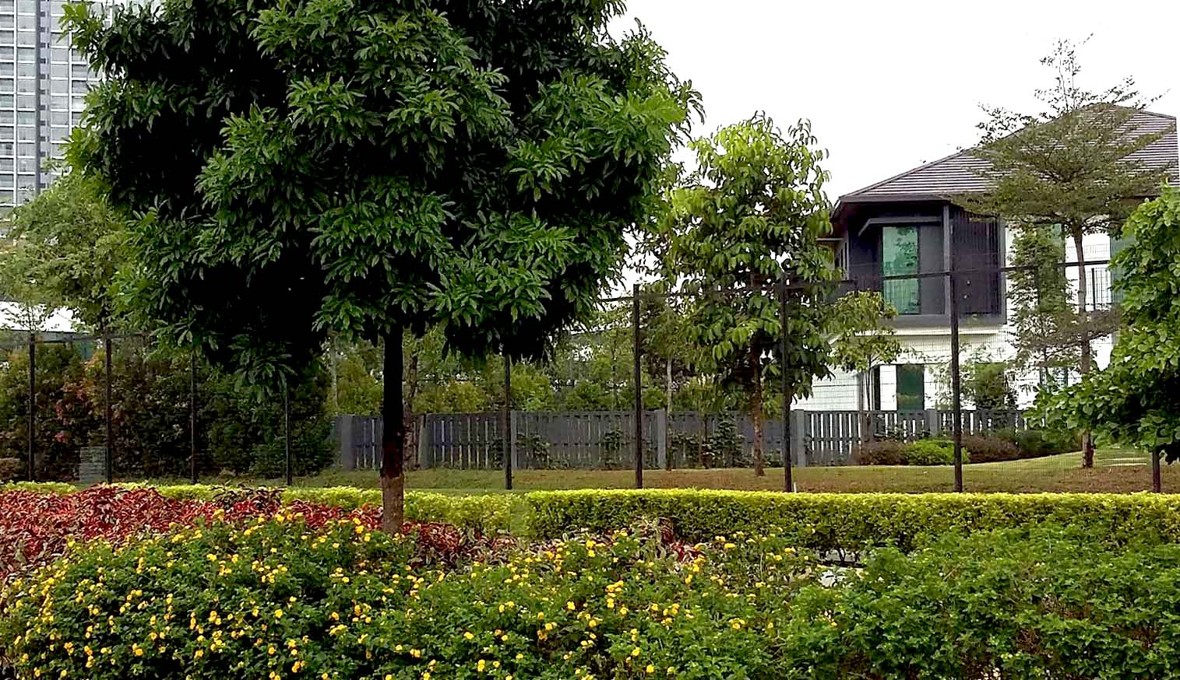
Source: Observation by the authors

Figure 1. Gated housing for premium neighbourhoods

CPTED practices for sustainable housing delivery

CPTED is an acronym for Crime Prevention through Environmental Design. Its principles of held that “the proper design and effective use of the built environment can lead to a reduction in the fear and incidence of crime, and an improvement in the quality of life” (Crowe, 2000, p.46). While CPTED is not a new approach to crime prevention, its principles have yet to gain considerable attention in Malaysia. While developers need to reduce costs, it does not necessarily mean that development of safe neighbourhoods would have to come at the expense of safety. The need for cost reduction have overshadowed all potential improvements to the housing delivery system. Ignoring safety concerns makes these properties illiquid, worsening the already stagnating property market.
Discussions and observations made at these developers’ projects revealed that successful projects often employ include some safety features into their spatial management practices and they do not necessarily require expensive security services and technology. CPTED strategies will improve the attractiveness of residential projects in crime-prone locations and at the same time, cuts development costs. Cost-efficient CPTED practices are noted primarily in the project designs of eco-housing developers. While taking an environmentally-friendly approach towards development, eco-housing appeared to enhance many of the CPTED principles namely access, surveillance, activity support, and maintenance.
Today, home owners desire fences and barriers not only for their homes, but for the entire housing estate (Tahir & Abdul Malek, 2018). Nonetheless, traditional gated neighbourhoods and guarded communities require high maintenance and labour, and were often enclosed within unsightly fences which looked like ‘prison walls’. Eco-housing were often conceptualized to incorporate natural landscapes as part of its design. These successful projects which were built with hills and dense forests serve as cost-efficient natural barriers that protect homes from intruders, reducing the need for unsightly fences for security.
One of the most common misconceptions about eco-housing is that these homes are often premium projects unaffordable to the general populace. Observations of an award-winning eco-housing project in the state of Malacca revealed that the houses were designed in smaller manageable sizes, which allowed them to be sold at cheaper prices. Today, homebuyers no longer consider the price to built-up ratio as the main consideration for purchase as Malaysian households are becoming smaller (Department of Statistics Malaysia, 2017) as families bore fewer children, getting more mobile and all this have called for more manageable, and smaller homes. The price of an eco-house in the surveyed project has a minimum built-up area of 1,600 square feet which costs 400,000 MYR (approximately 95,000 USD). This size is close to the size of a lower-end single-storey terraced/link house which usually has a built-up of 1,540 square feet (22 by 70 feet). These eco-houses were also built as clusters of four without hideous back lanes; the lack of which increases the security of these homes. The increased proximity of the houses also allowed neighbours to keep watch of one another (Figure 2). Doing away with back lanes is in line with CPTED principles of increasing visibility and surveillance, and making maintenance easier. Well maintained properties goes to suggest that the residents are currently staying in the property.

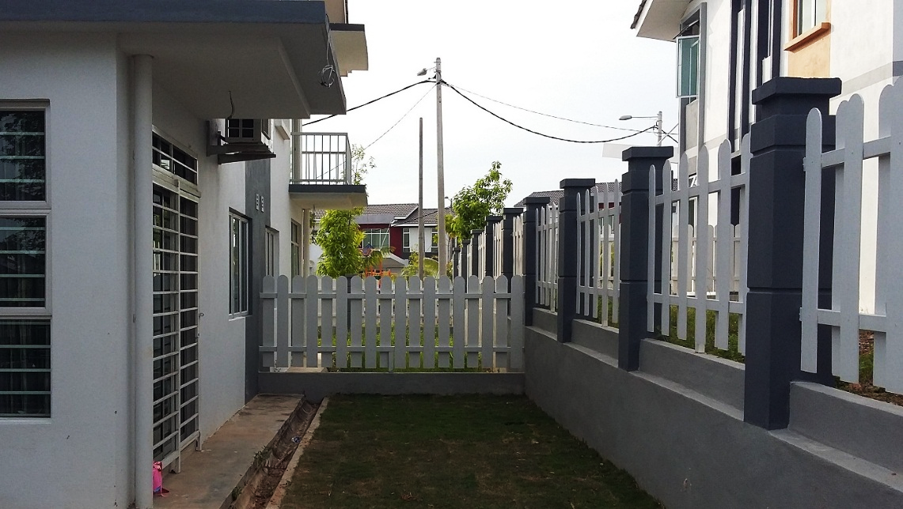
Source: Observation by the authors

Figure 2. Space conservation by cluster housing

Perceptions of safety often influence the sales performance of houses. As shown in Figure 3, houses that are unsold are often located near main motorways [1] e.g. lots P11-28, P11-31, P12-7, or the house is located deep within the recesses of the property, away from the view of others [2] e.g. lots P10-29, P11-8, P8-12, P8-9, P9-12, P12-10, P12-11 and P12-12. Contrarily, houses that received the best response are often those in full view of one another; when every group of 8-12 houses are designed to face a common space like a park or a green patch where residents may congregate. The housing orientation improves surveillance while the green patches encourages residential activity in line with CPTED principles of providing activity support. This encourages residents to keep an eye out for one another and discourages robbers from attempting to break into any of these homes [3]. Success is also determined by layouts that were designed in such a way that minimizes entry and exit points to the neighbourhood, creating “choke points” that can be monitored [4]. This slows vehicles down and enables closer scrutiny of all visitors entering the community.
Additionally, for the entire neighbourhood, there would be only one or two entry exit points, controlled by reasonably narrow entrance, which serves as a further deterrent to criminals. Moreover, the roads exiting the housing area should pass public spaces where people congregate such as parks, eateries, markets, police stations. These will discourage criminals from attempting to enter the area. Moreover, the houses must also be visible from one another, meaning they should all face a common space like a field where every house is in perfect view of all other houses. This encourages residents to keep an eye out for one another and discourages robbers from attempting any of these homes. In CPTED terms, this relates to restricting access to unwanted visitors, and improving surveillance against unwanted activities.

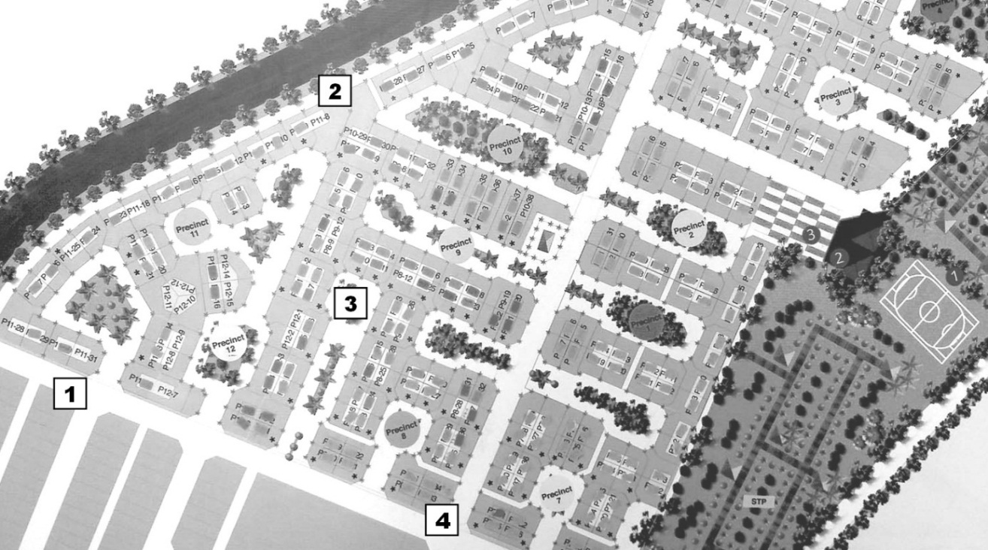
Source: Observation by the authors

Figure 3. Effective crime-control spatial planning for eco-housing

Landscapes also play a role in enhancing safety; within residential green patches, trees were placed in a manner so as not to directly obstruct the view of other homes. Small-leaf and wispier varieties such as Black olive (Bucidamolineti) and Brazilian ironwood (Caesalpineaferrea) have been used; these varieties are less dense and enables light penetration and minimize obstruction to vision yet able to still give a soft touch. The placement of park benches and pedestrian pathways encourages residents to walk the area, and such activities may serve as a deterrent to criminals (See Figure 4).

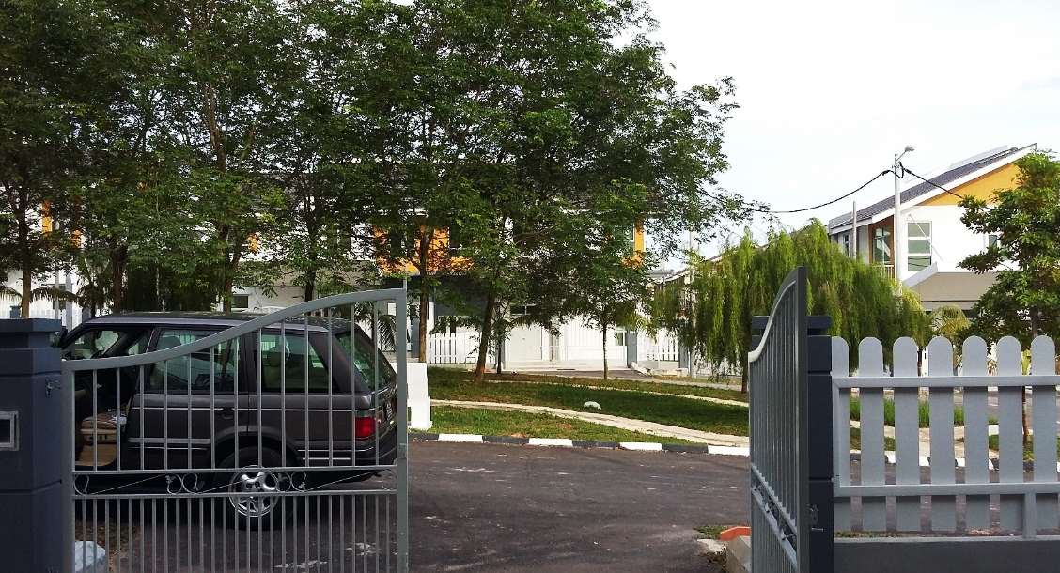
Source: Observation by the authors

Figure 4. Careful landscaping for crime prevention

CPTED practices were noted primarily in eco-housing projects in the states of Johor (around Nusajaya and Iskandar), the garden cities of Cyberjaya and Putrajaya whereas in many of the other southern states like Melaka and Negeri Sembilan, such development principles have only begun to gain attraction. For these states, cost-saving initiatives may be done through environmental design which encourages surveillance and promote residential activity. The hills landscapes, and road layouts should also be manipulated to serve as natural barriers that restrict access to criminals.

Conclusion

In brief, criminal activities are destabilising crime-prone neighbourhoods and this has adverse impacts on urban wellbeing and runs counter to aspirations of social and economic sustainability. In a country where residents are usually resilient, crime has shown to turn residents restless; many anticipate more social ills, and have considered leaving the neighbourhood, in spite of fear losing the value of their property investments. Should the problems persist, urban flight may lead to large tracts of residential estates being abandoned. Given the importance of promoting safety in residential estates, one would expect developers to take initiatives in create more gated neighbourhoods and guarded communities. Nonetheless owing to the slumping housing market and battling with operational costs, many continued offering traditional open neighbourhood projects which are deemed easier to manage. Nonetheless, the sales of traditional housing concepts remained poor.
Successful developers appeared to be those who incorporate innovative environmental design which discourage crime into their development projects. Based on the interview with residents, it was suggested that projects should be conducive for community life, where the streets should be well lighted, presentable and clean as having a living community is the best method to deter crime. Based on the interview with developers and observations, it was also suggested that housing developers may incorporate practices which help developers mitigate costs and deter crime, and this may be achieved through eco-housing practices which is synonymous with CPTED principles. For instance, designing homes in smaller communities, with appropriate street layouts, facing directions, using manageable and smaller clustered homes. As crime may become an undoing of the urbanization process, combating crime is of utmost importance. This promotes the wellbeing of the society as well as ensure that the housing market continues to contribute to the amelioration of the national economy.

Acknowledgement

The authors would like to thank the Ministry of Higher Education Malaysia for their generous funding through the Fundamental Research Grant Scheme (FRGS), Project ID: FRGS/1/2016/ SS10/MMU/03/1.

References

Othman, A.F., & Chuah, B.K. (2016). National crime index down by 0.8 per cent. New Straits Times. Retrieved from https://www.nst.com.my/news/2016/10/181567/national-crime-index-down-08-cent
Atkinson, R. (2000). The hidden costs of gentrification: Displacement in central London. Journal of Housing and the Built Environment, 15, 307-326.
Bobo, L.D. (2009). Crime, urban poverty and social science. Du Bois Review: Social Science Research on Race, 6(2), 273-278. https://doi.org/10.1017/S1742058X0999021X
Bourguignon, F., Browning, M., Chiappori, P.-A., & Lechene, V. (1993). Intra household allocation of consumption: A model and some evidence from French data. Annales d'Economie et de Statistique, 137-156.
Crowe, T. (2000). Crime Prevention Through Environmental Design: Applications of Architectural Design and Space Management Concepts (2nd Edition). Oxford: Butterworth-Heinemann.
Davis, K. (1965). The urbanization of the human population. Scientific American, 213(3), 40-53.
Davison, A. (2014). Results from the expat survey on crime in Malaysia. Retrieved from https://www.expatgo.com/my/2014/06/03/results-from-the-expat-survey-on-crime-in-malaysia/
Department of Statistics Malaysia. (2017). Vital Statistics Malaysia, 2017. Putrajaya, Malaysia: Chief Statistician's Office of the Department of Statistics Malaysia. Retrieved from https://www.dosm.gov.my/v1/index.php?r=column/pdfPrev&id=NXRCRDh0RENGeU13bC9EdzJ1cUFtZz09
DeYoung, R., & Rice, T. (2004). How do banks make money? The fallacies of fee income. Economic Perspectives-Federal Reserve Bank of Chicago, 28(4), 34.
Ellen, I.G., & O'Regan, K. (2010). Crime and urban flight revisited: The effect of the 1990s drop in crime on cities. Journal of Urban Economics, 68, 247-259.
Goodchild, B., & Cole, I. (2001). Social balance and mixed neighbourhoods in Britain since 1979: A review of discourse and practice in social housing. Environment and Planning D: Society and Space, 19, 103-121.
Ismail, L. (2017). Crime index may have dropped, but Malaysians still feel unsafe. New Straits Times. Retrieved from https://www.nst.com.my/news/nation/2017/07/260918/crime-index-may-have-dropped-malaysians-still-feel-unsafe
Khan, A. (2015). Throwing light on crime statistics. The Star Online. Retrieved from https://www.thestar.com.my/news/nation/2015/04/19/throwing-light-on-crime-statistics-it-is-not-just-about-the-numbers-but-what-we-do-about-them-that-m/
Leh, O.L.H., Mansor, N.A. & Musthafa, S.M. (2016). The housing preference of young people in Malaysian urban areas: A case study Subang Jaya, Selangor, Geografia-Malaysian Journal of Society and Space, 12(7), 60-74.
Looi, S.C. (2017). Penang goes ahead with foreign worker dorms. Free Malaysia Today News. Retrieved from https://www.freemalaysiatoday.com/category/nation/2017/01/07/penang-goes-ahead-with-foreign-worker-dorms/
Ludwig, J., Duncan, G.J., & Hirschfield, P. (2001). Urban poverty and juvenile crime: Evidence from a randomized housing-mobility experiment. The Quarterly Journal of Economics, 116(2), 655-679.
Marzuki, F.N. (2016). Public housing projects becoming crime haunts. The Star Online. Retrieved from https://www.thestar.com.my/news/nation/2016/06/10/public-housing-projects-becoming-crime-haunts
Moore, C.J., & Miles, J.C. (1991). Knowledge elicitation using more than one expert to cover the same domain. Artificial Intelligence Review, 5(4) 255-271.
Murdie, R.A. (1994). 'Blacks in near‐ghettos?’ Black visible minority population in metropolitan Toronto housing authority public housing units. Housing Studies, 9(4), 435-457. https://doi.org/10.1080/02673039408720799
Numbeo. (2018). Crime Index 2018 Mid-Year.
PEMANDU. (2014). GTP Annual Report 2013.
Ray, B. (2016). Quality of life in selected slums of Kolkata: a step forward in the era of pseudo-urbanization. Local Environment, The International Journal of Justice and Sustainability. doi: 10.1080/13549839.2016.1205571
Roitman, S. (2013). Close but divided: How walls, fences and barriers exacerbate social differences and foster urban social group segregation. Housing, Theory and Society, 30(2), 156-176. doi: 10.1080/14036096.2012.728150
Roitman, S. (2017). plintering (sub) urbanism and social differences: Gated communities as the driver for suburban change in Chacras de Coria (Mendoza, Argentina). Revista INVI, 32(90), 159-182.
Sampson, R.J., & Laub, J.H. (1994). Urban poverty and the family context of delinquency: A new look at structure and process in a classic study. Child Development, 65(2), 523-540.
Sampson, R.J., Raudenbush, S.W., & Earls, F. (1997). Neighbourhoods and violent crime: A multilevel study of collective efficacy. Science, New Series, 277(5328).
Schrag, J., & Scotchmer, S. (1997). The self-reinforcing nature of crime. International review of Law and Economics, 17(3), 325-335.
Shahrudin, H.S. (2016). Malaysia's crime index sees 4.6 per cent increase. New Straits Times. Retrieved from https://www.nst.com.my/news/2016/05/144196/malaysias-crime-index-sees-46-cent-increase
Soh, M.B.C. (2012). Crime and urbanization: Revisited Malaysian case. Procedia - Social and Behavioral Sciences, 42, 291-299.
Spence, M., Annez, P.C., & Buckley, R.M. (Eds). (2009). Urbanization and Growth. Washington, D.C.: The World Bank. Retrieved from https://siteresources.worldbank.org/ EXTPREMNET/Resources/489960-1338997241035/Growth_Commission_Vol1_ Urbanization_Growth.pdf
Tacoli, C., McGranahan, G., & Satterthwaite, D. (2015). Urbanization, Rural–Urban Migration and Urban Poverty. London: IIED.
Tan, T.H. (2008). Determinants of homeownership in Malaysia. Habitat International, 32, 318-335.
Tan, T.H. (2011). Sustainability and housing provision in Malaysia. Journal of Strategic Innovation and Sustainability, 7(1), 62-71.
Tan, T.H. (2013). Homeownership schemes in Malaysia for first homebuyers. International Conference on Innovation and Sustainability, 3-4 April 2013, Bandar Sunway, Petaling Jaya, Malaysia.
Tan, T.H. (2016). Residential satisfaction in gated communities: Case study of Desa Park City, Kuala Lumpur, Malaysia. Property Management, 34(2), 84-99.
United Nations Department of Economic and Social Affairs. (2008). World urbanization prospects the 2007 revision. United Nations Department of Economic and Social Affairs/Population Division.
Walks, R.A., & Bourne, L.S. (2006). Ghettos in Canada's cities? Racial segregation, ethnic enclaves and poverty concentration in Canadian urban areas. The Canadian Geographer/Le Géographe canadien, 50(3), 273-297.
Zainon, N., Mohd-Rahim, F.A., Sulaiman, S., Abd-Karim, S.B., & Hamzah, A. (2017). Factors affecting the demand of affordable housing among the middle-income groups in Klang Valley Malaysia. Journal of Design and Built Environment, [S.I.], 1-10.
Tahir, Z. & Abdul Malek, J. (2018). Prioritizing the physical security elements of gated community housing using the Analytical Hierarchy Process. Planning Malaysia: Journal of the Malaysian Institute of Planners, 16(3), 13-23.

