BASIN AREA AND SEDIMENT YIELD RELATIONSHIPS UPSTREAM SHIRORO RESERVOIR, NIGERIA.
LIST OF FIGURES AND PLATES
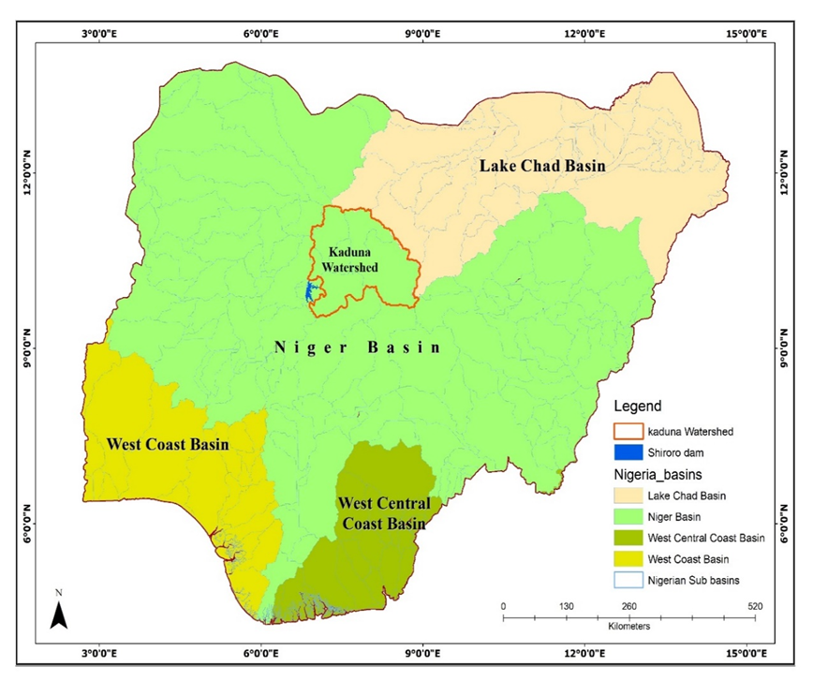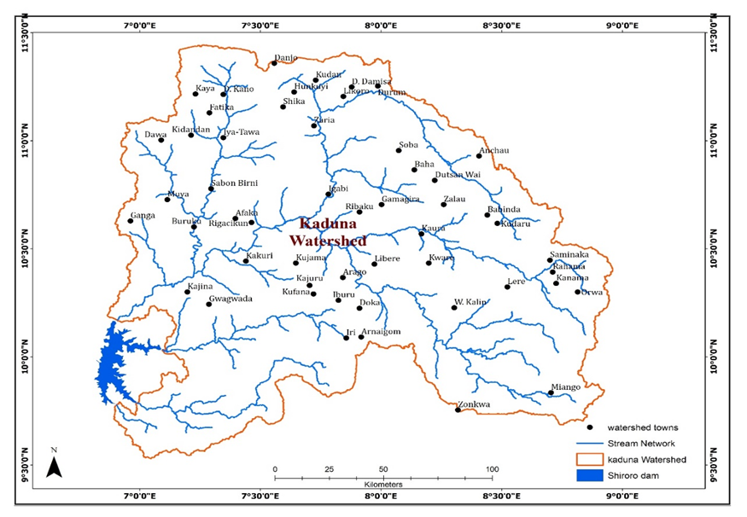
Fig 1.1: Map of Nigeria Showing Kaduna Watershed
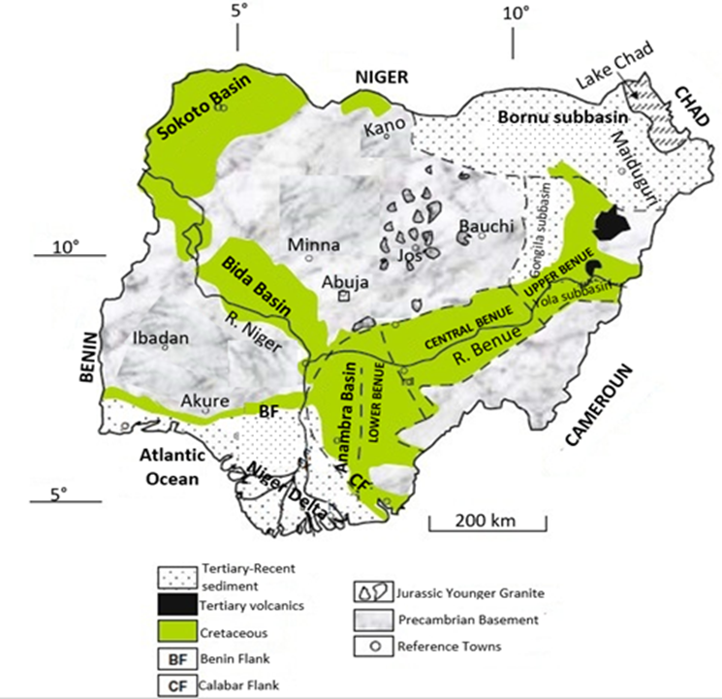
Figure 1.2 Geological Map of Nigeria. Source: Igwe and Adepehin (2013)
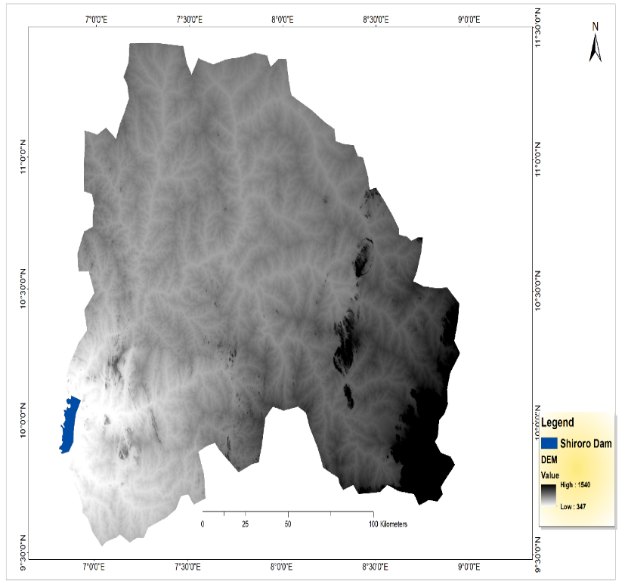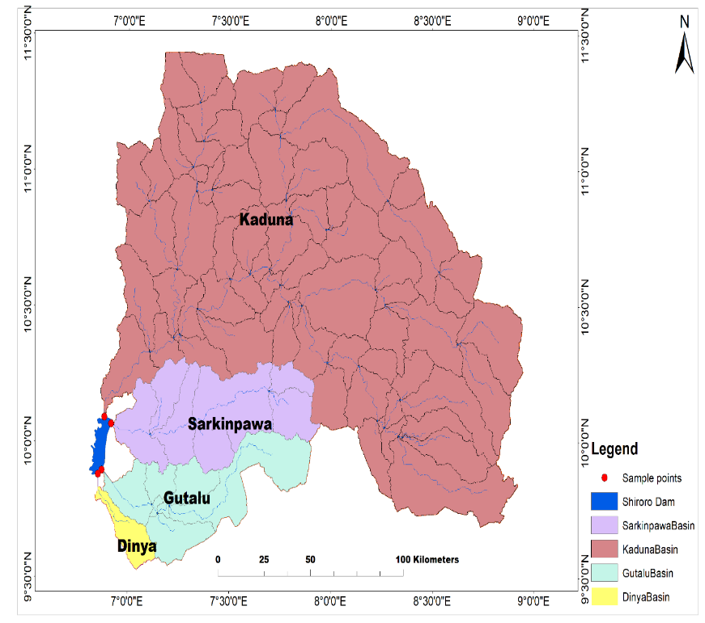Fig 3.1: A: Kaduna Watershed DEM B: Sub-watersheds Delineation and Stream network. 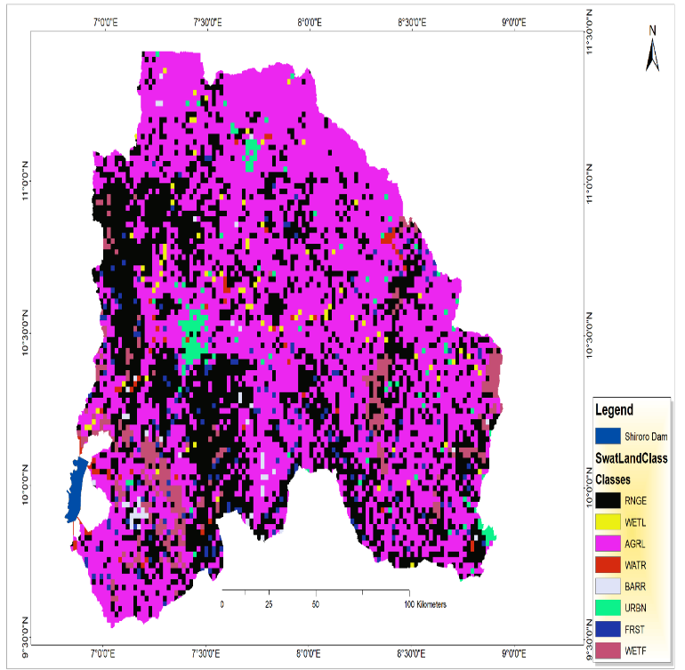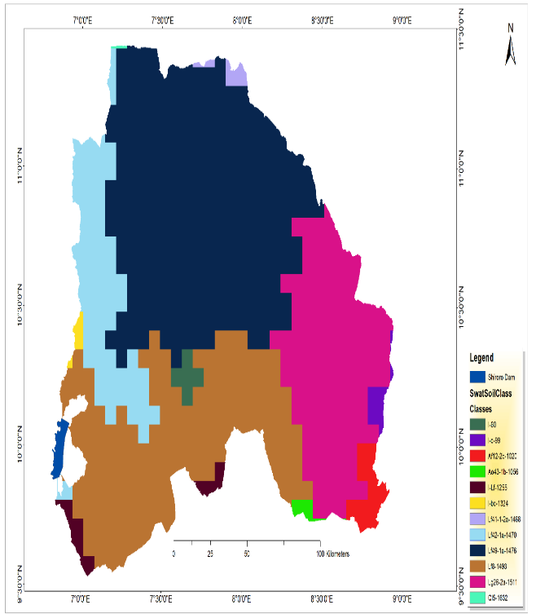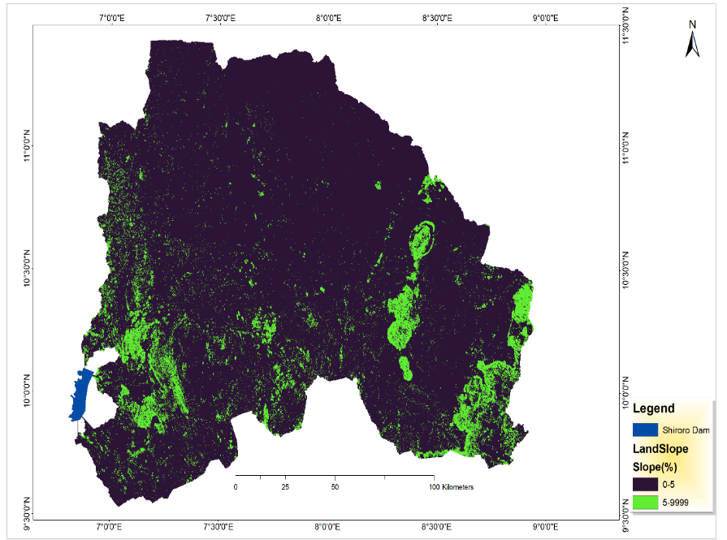
A
B
A
B
C
Figure 3.2: Kaduna Watershed, A: Land-use and Land Cover, B: soil and C: Slope Classification

Fig 3.3: Monthly Average of Suspended Sediment Concentrations in the Four Sub-Watersheds.

Figure 3.4: Percentage Sub-Watershed Land Area and Percentage Sub-Watershed Reaches SSC

Figure 3.5 Regression Analysis of Rainfall and Sub-watersheds Suspended Sediment Concentration

Figure 3.6 Turbidity Variation of the Four Sub-Watershed Reaches

Figure 3.7 Relationship between SSC and Turbidity
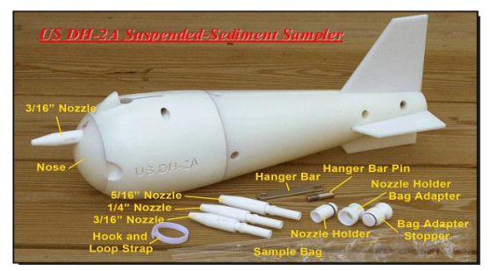
B
A
C
D
Plate 2.1: A: US-DH-2A sampler B: US-DH-2A sampler assemblage C: Water Samples Collections at sampling points and D: Laboratory analysis of SSC and Turbidity.

BASIN AREA AND SEDIMENT YIELD RELATIONSHIPS UPSTREAM SHIRORO RESERVOIR, NIGERIA.
LIST OF TABLES

Table 2.1 Geographic location of sample points in each sub-watershed
S/n | Sample points | Sub-watershed | Latitude | Longitude
1. | Reach Kaduna | Kaduna | 10.100509 | 6.883008
2. | Reach Sarkinpawa | Sarkinpawa | 10.062851 | 6.93419
3. | Reach Gutalu | Gutalu | 9.902773 | 6.883824
4. | Reach Dinya | Dinya | 9.893015 | 6.853076

Table 3.1 Land use Land Cover Classification of the Study Area Watershed
Land use Land Cover Types | SWAT Code | Area [ha] | Area[acres] | % Wat.Area
Range-Grasses | RNGE | 1066467.2 | 2635293.775 | 32.73
Agricultural Land-Generic | AGRL | 1848911.895 | 4568753.739 | 56.7
Barren | BARR | 12070.7517 | 29827.431 | 0.61
Residential | URBN | 46746.2108 | 115512.2242 | 1.78
Wetlands-Mixed | WETL | 22091.7579 | 54589.8384 | 1.01
Forest-Mixed | FRST | 71832.8666 | 177502.605 | 2.44
Wetlands-Forested | WETF | 125877.9664 | 311050.7488 | 3.93
Water | WATR | 18464.2243 | 45626.0215 | 0.81

Table 3.2 Kaduna Watershed Soil Classification
Soil Class | SWAT Code | Area [ha] | Area[acres] | %Wat.Area
SANDY_LOAM | Lf42-1a-1470 | 321040.1472 | 793306.2557 | 9.99
SANDY_LOAM | Lf49-1a-1476 | 1345603.031 | 3325052.369 | 41.89
SANDY_LOAM | Lf41-1-2a-1468 | 2984.3024 | 7374.3605 | 0.09
SANDY_CLAY_LOAM | Lg26-2a-1511 | 607316.4238 | 1500709.249 | 18.91
SANDY_CLAY_LOAM | Lf8-1493 | 808879.9539 | 1998782.81 | 25.18
LOAM | I-60 | 25565.4848 | 63173.5913 | 0.8
LOAM | I-c-99 | 18572.6467 | 45893.9387 | 0.58
SANDY_CLAY_LOAM | Af12-2b-1020 | 46821.4064 | 115698.0363 | 1.46
LOAM | I-bc-1324 | 8479.9465 | 20954.3717 | 0.26
LOAMY_SAND | Ao43-1b-1056 | 390.2588 | 964.349 | 0.01
SANDY_CLAY_LOAM | I-Lf-1255 | 26809.2722 | 66247.0522 | 0.83
Table 3.3 Study Area Watershed Slope Classification
 | Slope 0-5 | Slope  5-9999 | Elevation 369-500 | Elevation 501-999 | Elevation 1000 & Above
Area(ha) | 3044929 | 7524171
Area(ha) | 167534.1 | 413985.2
%Watershed Area | 94.78 | 5.22 | 7.27 | 89.35 | 3.41

Table: 3.4 Spatial-Temporal Variation of Suspended Sediment Concentration of Kaduna Watershed
Month | Sarkinpawa | Kaduna | Dinya | Gutalu
March | 17.5 | 14.5 | 53.5 | 13.5
April | 15.5 | 13.5 | 64 | 11.5
May | 42 | 76 | 58 | 52
June | 116 | 136 | 178 | 125
July | 283 | 268 | 368 | 386
August | 1374.5 | 1366 | 1452.5 | 1196
September | 590 | 515 | 350 | 370
October | 405 | 500 | 255 | 340
Total | 3844 | 3889 | 3781.5 | 3444

Table 3.5 Rainfall and Sediment Concentration Pattern of the Study Area
Months | PPT Shiroro | PPT Kaduna | SP | KD | DY | GUT
Mar | 0 | 0.055 | 17.5 | 14.5 | 53.5 | 13.5
Apr | 21.6 | 32.503 | 15.5 | 13.5 | 64 | 11.5
May | 152.8 | 165.905 | 42 | 76 | 58 | 52
Jun | 226.85 | 275.95 | 116 | 136 | 178 | 125
Jul | 352.5 | 182.436 | 283 | 268 | 368 | 386
Aug | 443.0 | 290.228 | 1375 | 1366 | 1455 | 1196
Sep | 289.07 | 241.53 | 590 | 515 | 350 | 370
Oct | 77.9 | 77.9 | 405 | 500 | 255 | 290

Table 3.6 Spatial-Temporal Variation of Kaduna Watershed Reaches Turbidity
Month | SP(Turb) | KD(Turb) | DY(Turb) | GUT(Turb)
March | 19.5 | 20 | 22.5 | 10.5
April | 18 | 19 | 29 | 10
May | 18 | 25.5 | 35 | 14.5
June | 92.5 | 92.5 | 95 | 120
July | 137.5 | 117.5 | 129 | 125
August | 150 | 132.5 | 130 | 132.5
September | 92.5 | 95 | 90 | 115
October | 50 | 39 | 46.5 | 42.5
Total | 578 | 541 | 577 | 570

