

Water salinity variability mapping for flooded paddy plots at Kuala Kedah, Malaysia

Samera Samsuddin Sah^{1,2}, Khairul Nizam Abdul Maulud^{1,3}, Othman A. Karim¹, Suraya Sharil¹

¹Department of Civil Engineering, Faculty of Engineering and Built Environment,
Universiti Kebangsaan Malaysia
²Faculty of Chemical Engineering Technology, Universiti Malaysia Perlis.
³Earth Observation Centre, Institute of Climate Change, Universiti Kebangsaan Malaysia

Correspondence: Khairul Nizam Abdul Maulud (email: knam@ukm.edu.my)

Received: 14 October 2020; Accepted: 17 December 2020; Published: 30 November 2021

Abstract

Salinity is an essential parameter in rice cultivation activity. It has a significant impact on paddy growth and also the yield of paddy. However, the level of salinity concentration in paddy plots depends on the surrounding conditions. The distance of the paddy area from the coastline, the temperature and intensity of rainfall should be considered in studies involving water quality. Additionally, the tide of events is also included in this study because of the position of the study area near the coastline. Therefore, this study was conducted to assess the level of salinity in two different rice cultivation seasons and describe the level of salinity concentration using a salinity variability map using the Inverse Distance Weighted (IDW) interpolation method. The data collection activities involved water sampling at 44 water inlets for each paddy plot in 30 hectares of the study area by referring to the Day After Sowing (DAS) as the paddy’s growth stage. These water samples were collected on 10 DAS, 40 DAS, and 60 DAS and subsequently tested using a portable conductivity meter namely EC500 Exstick II pH/Conductivity/Temperature Meter. Parallelly, georeference data which is latitude, longitude and elevation were gathered using Garmin GPSMAP 64s. Then, these data were analyzed using the IDW interpolation method in ArcGIS software and comes with salinity variability maps. The produced maps give an overview of the salinity concentration distribution by color scale range. Based on these salinity variability maps, the highest salinity concentration was recorded on 10 DAS and 60 DAS during Season 1 2019 and Season 2 2019, respectively for both tidal events. This result shows that the salinity concentration trend for both seasons is different due to the amount of rainfall received and the position of the paddy plot compared to the mean temperature factor.

Keywords: GIS, interpolation, oryza sativa, rice, saline water, seawater encroachment

Introduction

Water quality is an indicator that represents the current state of the water resources for particular purposes (Kamarudin et al., 2019; Wahab et al., 2019; Wan Mohtar, Abdul Maulud, Muhammad, Sharil, & Yaseen, 2019). One of the water quality parameters that is often taken seriously in the agricultural industry is salinity (Ahmed & Haider, 2014; Khanom, 2016). Salinity is a measure of the dissolved salts in the water. Salinity is usually highest during periods of low flows and increases as water levels decrease (Hoang, Williams, Khanna, Dale, & Mundree, 2014; Mccaffrey, 1997; Samsuddin Sah, Abdul Maulud, Sharil, A. Karim, & Abdul Nahar, 2020). Sources of salinity include urban and rural run-off containing salt, fertilizers and organic matter. However, areas in the tidal limit of rivers that flow into the sea will experience fluctuations in salinity between high and low tide (Ahmed & Haider, 2014). Tide level uncertainty is related to sea level change and global climate change (Abdul Maulud, Hasan, & Karim, 2015; Hamzah, Abd Hamid, Mohamad, Mohd Shah, & Awang, 2018; Walsh & Miskewitz, 2013). This problem is gaining attention due to the possible impact on food security in many countries (Khong, Young, Loch, & Thennakoon, 2018; Walsh & Miskewitz, 2013).
Consequently, salinity that is beyond the normal range will cause stress or even death to the plant. In addition, nutrient intake by plants is also affected and in turn causes plant growth to be stunted and the salt accumulation in the leaves affect the lifespan of the leaves (Ahmed & Haider, 2014; Munns, James, & Läuchli, 2006; Osakabe, Osakabe, Shinozaki, & Tran, 2014; Pattanagul & Thitisaksakul, 2008; Rad, Aref, & Rezaei, 2012; Samsuddin Sah et al., 2020; Xiong, 2007). If this situation persists, the yield of rice grains is declining mainly due to the development of low rice spikelet due to salt pressure (Radanielson, Gaydon, Li, Angeles, & Roth, 2018; Reddy, Kim, Yoon, Kim, & Kwon, 2017; Zhang et al., 2015).
According to Takehisa et al. (2004) almost 30% of the world’s paddy cultivation area is affected by salinity and 50% of paddy production reduced because of saline water (Ma et al., 2018). As the second largest of world rice exporter, Vietnam faced the problem of the sea level rise which had a significant impact on rice production (Dam, Amjath-Babu, Bellingrath-Kimura, & Zander, 2019). This phenomenon causes seawater penetration to occur more frequently and loss of the paddy growing land (Dam et al., 2019; Smajgl et al., 2015).
Rice or the scientific name Oryza sativa is the staple food for most countries in Asia, the region consumes more than 80% of the world’s rice including Malaysia. In 2005, the paddy industry remained the third most important sub-agricultural sector in Malaysia after the oil palm and rubber industry. According to Bohluli et al. (2014), more than 450 thousand hectares of the total agricultural land in Malaysia are used for rice cultivation. However, the number of the paddy area keep decreasing and become more challenging to meet the local demand year by year.
Currently, Malaysia strives to meet the demand for local rice by ensuring that every farmer is able to produce rice optimally (Che Omar, Shaharudin, & Tumin, 2019). Farmers, especially those who are in the Kedah coastal areas, often experience the problem of sea water entry into the paddy cultivation area. Kuala Kedah is a part of Kedah which located nearby the coastal line in the west coast of Peninsular Malaysia. Most of the farmers in this area complained about the decrement of paddy yield starting 2016 until 2019. This is due to sea water's existence in the paddy plot caused by sea water intrusion especially during high tide phenomenon and heavy rain events. A previous study by Ercan, Fauzi, & Kavvas, (2013); Reddy et al., (2017); Samsuddin Sah et al., (2020) found that the salinity concentration of more than 1100 ppm will directly stunt the paddy growth and in turn lead to a reduction in rice yields at affected areas. This also supported by Fogliatto, Serra, Patrucco, Milan and Vidotto, (2019); Khanom, (2016) where the growth reduction due to root damage, ion toxicity, lessened nutrient and water uptake, and inhibition of photosynthesis will lead to the decrement of yields
Hence, this study was conducted to assess the level of salinity in two different seasons and describe the level of salinity concentration using salinity variability map using Inverse Distance Weighted (IDW) interpolation methods that are available in ArcGIS software for both the season. Consequently, proper planning and improvement can be seriously considered by local agencies responsible for maintaining agricultural activities as well as local livelihoods.

Method and study area

Kuala Kedah is located at the west coast of peninsular Malaysia and faces Malacca Strait. The study area involved almost 30 hectares of rice cultivation area along the low laying zone at Kuala Kedah, the coast of Kedah, which is found at the west coast of Peninsular Malaysia. These 30 hectares of paddy cultivation area is located between 6°06'41.5"N to 6°07'33.0"N and 100°16'44.7"E to 100°17'14.5"E as illustrates in Figure 1.

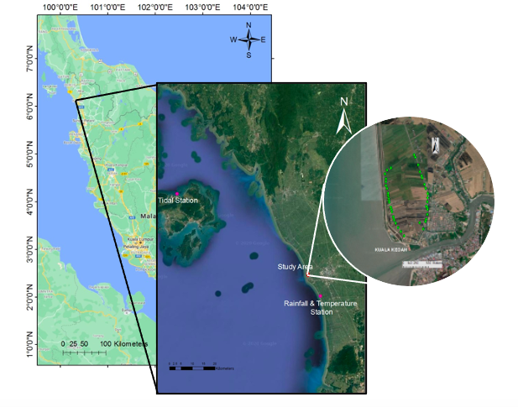
Figure 1. Location of the study area, meteorology and tidal station with observed 44 sampling point.
This study area involved 44 water inlets and was observed during low and high tide events for two different cultivation seasons in the Year 2019. The paddy cultivation for the first season is from May to August 2019, while the second session started from October 2019 to January 2020. Figure 2 illustrates the flow process in this study which consists of five (5) main elements.
Firstly, the water samples were collected at the identified 44 water inlets using a 100 ml water container by submerging the bottle 5 cm for the tillering and flowering stage as recommended by Talpur et al. (2013). In this study, the water sampling activities were planned by considering the growth stage of paddy known as tillering, flowering, and maturing stage as shown in Figure 3 by using the term “Day After Sowing” (DAS) as reference. Therefore, 10 DAS, 40 DAS, and 60 DAS were selected to represent these three growth stages and the observation has been conducted for two seasons in the Year 2019 by considering the tidal events as stated in Table 1. These three periods were selected based on the existence of water in the paddy plot. After 60 DAS, the paddy plot will be drained out to put pressure on the paddy plants to flower and subsequently produce the rice seeds. Then, the water samples were analyzed using a portable conductivity meter namely EC500 Exstick II pH/Conductivity/Temperature Meter.

Table 1. Water sampling schedule for Season 1 and Season 2 2019.

Time | Season 1 2019 | Season 2 2019
10 DAS | 27th May 2019 | 16th Oct 2019
40 DAS | 28th June 2019 | 20th Nov 2019
60 DAS | 18th July 2019 | 7th Dec 2019

The rainfall and temperature data during this study were retrieved from the Department of Meteorology Malaysia (DMM). The nearest DMM rain gauge station namely Station Kuala Kangkong was located at 06° 02’ N, 100° 20’ E with 20 m height from Mean Sea Level (MSL). This station was recorded average annual temperature and rainfall is 28.3°C /year and 194 mm/year, respectively while the average annual temperature and annual rainfall of 2019 in Malaysia reported by Jabatan Meteorologi Malaysia (2019) is 27.63°C and 2850 mm. In addition, the tide pattern from Langkawi Tidal Station located at 6° 26’ N, 99° 46’ was observed for both seasons.
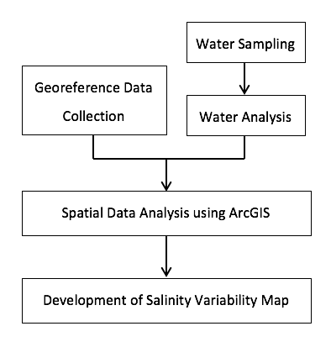
Figure 2. Study flow process.
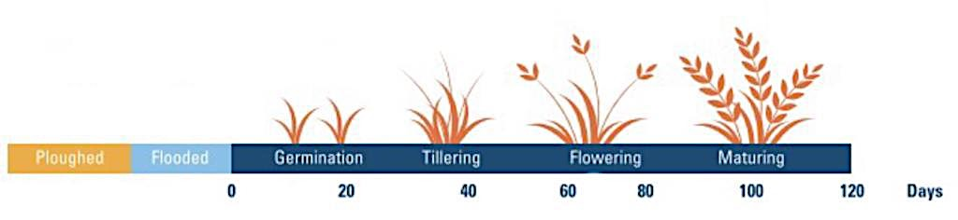
Source: Che Omar et al. (2019)

Figure 3. General process in the rice cultivation cycle.

The georeference location of each sampling point was recorded using Garmin GPSMAP 64s. Each point consists of coordinate data (latitude, longitude, and elevation) and consequently, converted into the projected coordinate system for mapping purposes. The projected coordinate system normally is known as a coordinate system designed for on a flat and two- dimensional surface (Kennedy & Kopp, 2004).
The spatial analyst was used to transfigure the geospatial data in the form of raster and vector data in this study. The data of salinity concentrations as well as their respective georeference locations, were imported into ArcGIS software. ArcGIS platform was created and developed to visualize and present the data spatially. Specifically, ArcGIS 10.7.1 was used to produce the spatial maps of salinity variability. These maps were generated by using the Inverse Distance Weighted (IDW) interpolation method in ArcGIS spatial analyst tool to represent the current water quality status in the paddy plots. This method is one of the most applied and deterministic interpolation techniques because fast and easy to compute, and straightforward to interpret the unknown points by calculated with a weighted average of the values available at the known points (Abdullahi et al., 2017; Bhunia, Shit, & Maiti, 2018).
The IDW is widely used and well known in computing the unknown value using the nearby weighted values as equations below.
$Z\left(x\right)= \frac{\sum_{i=1}^{n}{W_{i}Z_{i}}}{\sum_{i=0}^{n}{W_{i}}}$ (1)

$W_{i}= \frac{1}{d_{i}^{k}}$ (2)

where Z(x) is the estimated value at an unknown point, and Zi is the observed value at the point i. While, Wi is the weight value at point i, and di is the distance between point i and the unknown point; moreover, k is the power variable (Wu, Mossa, Mao, & Almulla, 2019).
Sapna et al. (2018) and Gunarathna et al. (2016) stated that the best interpolation method to estimate the water quality parameter especially electric conductivity (EC) and pH is the IDW method. This statement aligned with findings by Yang et al. (2020) was indicated that this interpolation method is an effective tool to estimate surface water quality. Although IDW is a fast method (Achilleos, 2008), best method in interpolation (Mirzaei & Sakizadeh, 2016) and accurate in the present the actual data, it is sensitive to existing outliers in the dataset and does not issue any error indications (Wu, Hung, & Patton, 2013). The main uncertainty issue as raised by Achilleos (2008) is inequality surface elevation of sampling points due to the long distance between the points. However, this issue can be easily neglected in this study. This is because the surface elevation at flooded paddy fields is normally a flat area.
Furthermore, the IDW interpolation approach is more applicable and better than another method such as Kriging and Spline (Yang, Xie, Liu, Ji, & Wang, 2015) in estimating the water quality value, especially in rice cultivation area (Pirmoradian, Rezaei, Davatgar, Tajdari, & Abolpour, 2010). In addition, according to Tanjung, Syahreza and Rusdi (2020), this approach is described as the best method to interpolate the water electrical conductivity (EC), which is also represents the salt concentration in water.
Therefore, in this study, the IDW interpolation method was preferred to interpolate the spatial distribution of salinity and finally, twelve salinity variability maps were produced for both tidal events during these two seasons. All these maps were colored by designated unique value for each raster data. However, there are some limitations in this study that have been identified which is this study does not involve any analysis of paddy yield either according to the paddy plot or the entire area. Then, the study period only involved only one cycle of wet and dry seasons.

Results and discussion

Environment condition: Rainfall, mean temperature, tidal

According to Figure 4, the highest average monthly rainfall and mean temperature was recorded on May 2019, while the lowest average monthly rainfall and mean temperature were detected on January 2020 and December 2019, respectively. However, during the Season 1-2019, this area received more rainfall compared to the Season-2 2019. In this case, the observation was conducted in two different seasons which is wet season occurs from May 2019 until August 2019, while dry season occurs from Oct 2019 until Jan 2020.

Figure 4. Mean temperature and average monthly rainfall.

Subsequently, a tidal events pattern was observed during Season 1 2019 and Season 2 2019. This data was extracted from Tide Table 2019 by National Hydrographic Centre, Malaysia. Figure 5a shows the pattern with maximum height recorded on 19th May 2019 and 04th July 2019 at 1235hrs and 1319hrs, respectively with 3.11 m height while the minimum height recorded on 05th and 19th May 2019 at 0619hrs and 0643hrs with 0.24 m height.
However, during Season 2 2019, the maximum and minimum height was spotted on 29th Oct 2019 at 0036hrs with 3.18 m height and the minimum height was spotted on 28th October 2020 at 1821hrs with 0.04 m height as shown in Figure 5b.

- Season 1 2019

- Season 2 2019

Source: National Hydrographic Centre (2019)

Figure 5. Tidal pattern for year 2019.

Salinity Variability Maps for Season 1 and Season 2 2019

Salinity variability maps were produced using ArcGIS 10.7.1 by using the interpolation spatial analyst tool. The salinity concentration was classified in five main ranges based on the article by Prince (2019) as illustrates in Table 2.

Table 2. General salinity concentration range for water.

Group | Concentration (mg/L) | Status
1 | 0 - 456 | Very Low
2 | 457 - 700 | Low
3 | 701 - 1100 | Moderate
4 | 1100 - 1500 | High
5 | > 1500 | Very High
Source: Prince (2019)

Figure 6 and Figure 7 show the distribution of salinity concentration during low and high tide events for Season 1 2019, respectively. This clearly indicates that the salinity concentration decreases from the early stage to the later stage of paddy growth. The 10 DAS maps show more than 70% of the study area faced very high salinity concentration with a value of more than 1100 ppm, which is represented by brown and pink color range. This situation illustrates that the existence of saltwater in paddy fields is due to tidal events and also the driving factor which is heavy rain due to the highest tide height and the amount of rainfall recorded in May 2019 which fell during the 10 DAS period as reported by (Lian, Xu, & Ma, 2013; Shaha, Cho, & Kim, 2013). They found that these two factors played a significant role in the flood phenomenon, especially in the estuary and coastal areas.

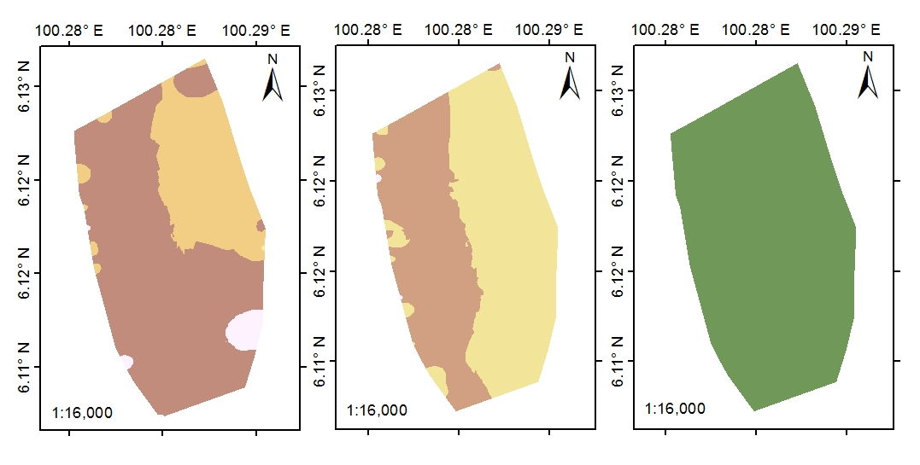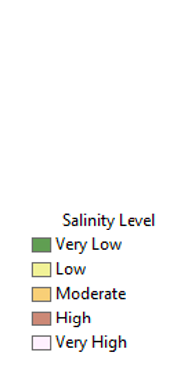
(a) (b) (c)
Figure 6. Water salinity variability maps during low tide events on (a) 10 DAS, (b) 40 DAS, and (c) 60 DAS for Season 1-2019.
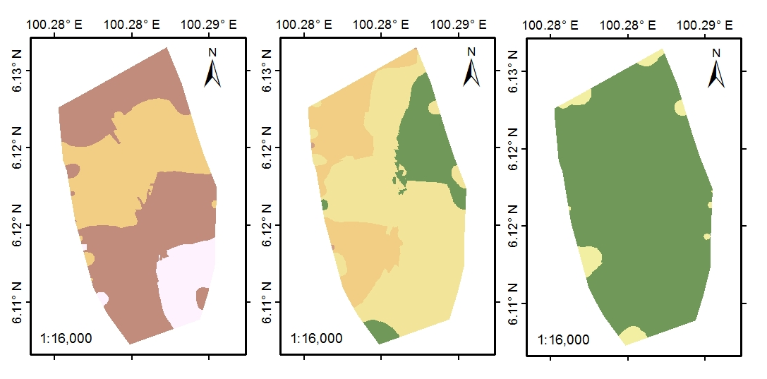
(a) (b) (c)
Figure 7. Water salinity variability maps during high tide events on (a) 10 DAS, (b) 40 DAS, and (c) 60 DAS for Season 1-2019.

However, during Season 2 2019, the trend changed as salinity concentrations increased throughout the rice cultivation cycle. According to Figure 8 and Figure 9, the highest salinity concentrations were spotted on 60 DAS for both tidal events which is contradicting with the high tide events occurred on 10 DAS period (October 2019). This situation occurred due to the lower rainfall intensity on 60 DAS that produces higher salinity concentration in this area. The salinity concentration in water significantly affected by the dry season as claimed by Abdullah, Rak and Wei, (2018) and Yan et al. (2015).

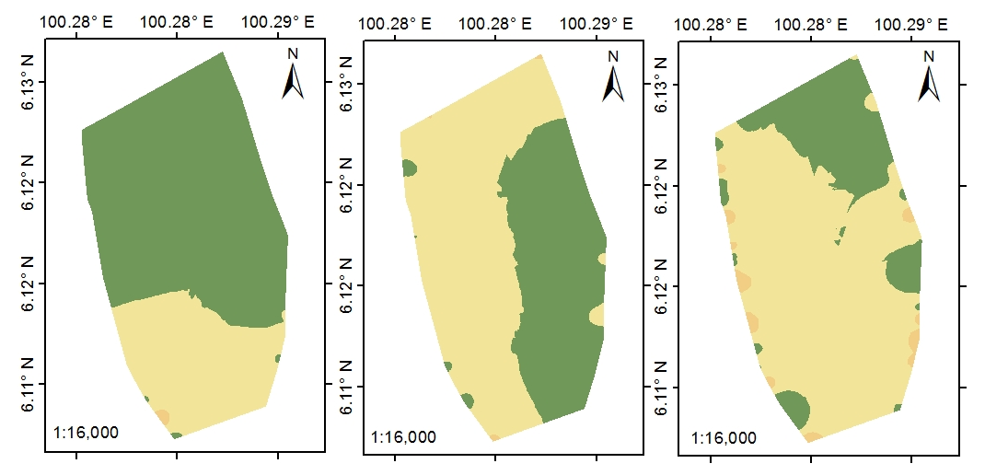
(a) (b) (c)
Figure 8. Water salinity variability maps during low tide events on (a) 10 DAS, (b) 40 DAS, and (c) 60 DAS for Season 2 2019.

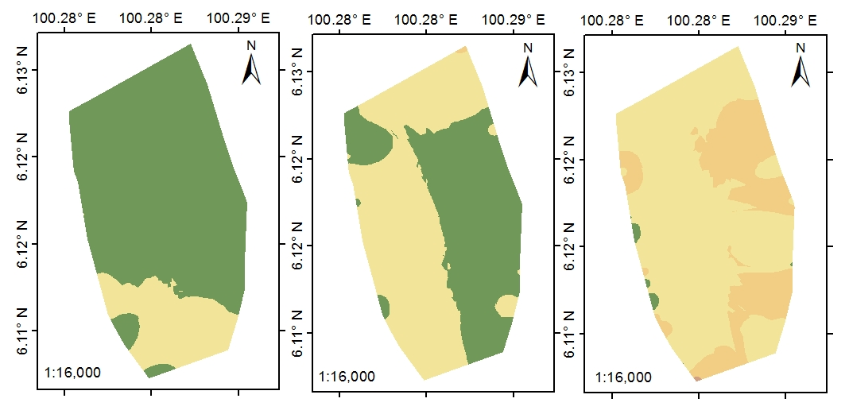
(a) (b) (c)
Figure 9. Water salinity variability maps during high tide events on (a) 10 DAS, (b) 40 DAS, and (c) 60 DAS for Season 2 2019.

Generally, during the 10 DAS period for both seasons and tidal events, the highest salinity concentrations are spotted in the downstream area of the Kedah River estuary. There are tidal gates that are commonly used to prevent seawater from entering the body of water nearby and also used to drain the highlands if it receives heavy rainfall (Walsh & Miskewitz, 2013). However, when heavy rains and high tides occur, the possibility for seawater to enter the river is very high due to rising sea levels. That is caused by the concentration of salinity is higher in this area (Fatema, Omar, & Isa, 2016). In addition, during this period, the river is used directly for the purpose of irrigating rice plants in the area.
Nevertheless, during the 40 DAS and 60 DAS, salinity concentrations were seen concentrated on the left side of the diagram for both seasonal and tidal events. This area is located closest to the coastal line and indicates that seawater penetration occurs while the area receives high rainfall. This result aligned with the report by Geng & Boufadel (2017) were found that ﻿rainfall intensity significantly affected pore water salinity near the beach surface. The movement of salinity particles to the supratidal zone occurs more rapidly when receiving more rainfall at one time (Yu et al., 2020).
In general, the supratidal zone known as spray zone was defined as a zone near the coastal but higher than the level of high tide. It is sometimes splashed but not inundated or submerged by seawater (Darmawan, Saputra, Wiadnya, & Gusmida, 2018). This zone is only flooded by seawater during spring tides or possibly large storm waves splash over the coastal zone. Therefore, salinity concentrations should be monitored and controlled to avoid yield loss as reported by Radanielson et al. (2018) and Reddy et al. (2017), with concentrations over 1100 ppm, yield shortages can reach 1 ton for each a hectare area.
Overall, salinity concentration trends for both seasons are different. Based on boxplots in Figure 10, clearly expresses the salinity concentration are decreasing throughout the growth stages for Season 1 2019. On the other hand, Figure 11 shows the trend for Season 2 2019 is seen as the contrary of the previous season. The concentration of salinity indicates an increase from the early stage to the later. As reported by Fatema et al. (2016), the water quality parameters, including salinity were significantly different between spring and neap tide events. This findings also aligned with studies by Uncles and Stephens (2011) and Purnaini, Sudarmadji and Purwono (2018).

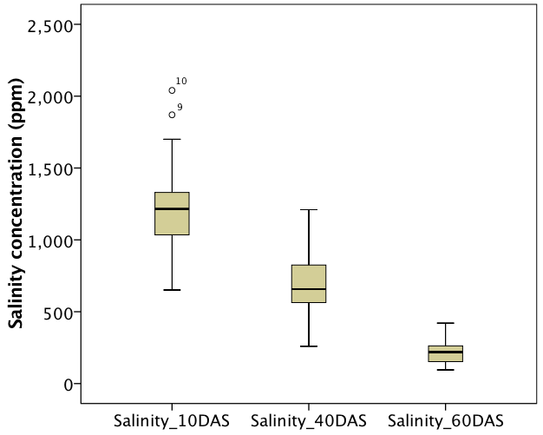  (a) (b) | 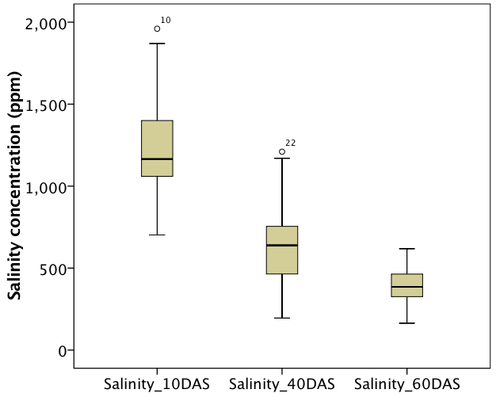
Figure 10. Boxplots of salinity concentration data during (a) low tide and (b) high tide events on Season 1-2019, respectively.

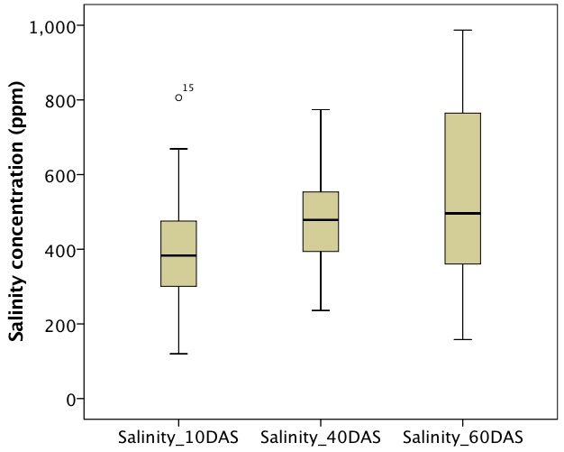  (a) (b) | 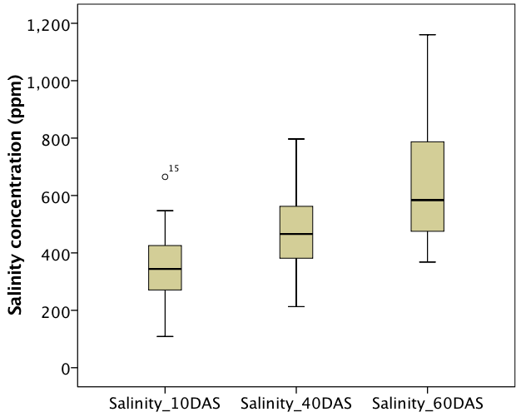
Figure 11. Boxplots of salinity concentration data during (a) low tide and (b) high tide events on Season 2-2019, respectively.

Based on findings by Liu et al. (2020), salinity concentrations can be directly diluted by rainfall. This means that the salinity concentration will be reduced if it receives high rainfall. Additionally, these researchers also found that salinity was less sensitive to temperature compared to rainfall. However, in this study, the higher rainfall gives a higher value of salinity concentration especially during Season 1 2019 which contrary with the findings reported by Liu et al. (2020). This is due to the location of the study area which is located approximately 200m from the shoreline and the seawater easily penetrated into the paddy plots during heavy rainfall and also the high tide events, as discussed in earlier paragraphs (Geng & Boufadel, 2017).

Conclusion

Salinity variability maps have been developed using the Spatial Analyst Tool in ArcGIS for these paddy plots. The highest salinity concentration was recorded on 10 DAS during Season 1 2019 for both tidal events. During this period, paddy plots have received water directly from irrigation canals with high concentrations of salinity due to seawater penetration. Conversely, during Season 2 2019, the highest reading of salinity concentration was spotted on 60 DAS. This is because in Season 1 2019, this area received a high amount of rainfall compared to Season 2 2019, which results in the movement of salty particles from the sea occurs faster. Overall, the salinity concentration trends for both seasons using are different. In conclusion, salinity concentrations were remarkably affected by the amount of received rainfall, especially in the supratidal zone area. Conversely, mean temperature not relatively affect the salinity level in the samples water observed due to the geography factors of the study area.

Acknowledgement

The authors would like to thank the Muda Agriculture Development Authority (MADA) for giving the permission for entering the study area and the Department of Irrigation and Drainage (DID), Malaysia providing relevant data, and also Universiti Kebangsaan Malaysia (UKM) for the financial support under research grant DIP-2018-030.

References

Abdul Maulud, K. N., Hasan, Z., & Karim, O. A. (2015). An accuracy of chart datum in the tidal observation period: Case study for Teluk Ewa, Pulau Langkawi. Jurnal Kejuruteraan, 27, 103–109.
Abdullah, H. H., Rak, A. E., & Wei, L. S. (2018). The impacts of monsoon and dry seasons on physical water quality changes and farmed Asian seabass Lates calcarifer (Bloch, 1790) mortality at Sri Tujuh lagoon, Tumpat, Kelantan, Malaysia. AACL Bioflux, 11(1), 167–183.
Abdullahi, M. G., Kamarudin, M. K. A., Umar, R., Endut, A., Khalit, S. I., & Juahir, H. (2017). Night sky brightness assessment in Nigeria using environmetric and GIS technique. International Journal on Advanced Science, Engineering and Information Technology, 7(1), 28–34. https://doi.org/10.18517/ijaseit.7.1.970
Achilleos, G. (2008). Errors within the inverse distance weighted (IDW) interpolation procedure. Geocarto International, 23(6), 429–449. https://doi.org/10.1080/10106040801966704
Ahmed, M. F., & Haider, M. Z. (2014). Impact of salinity on rice production in the south-west region of Bangladesh. Environmental Science, 9(4), 135–141. https://doi.org/10.4135/9781446247501.n1321
Bhunia, G. S., Shit, P. K., & Maiti, R. (2018). Comparison of GIS-based interpolation methods for spatial distribution of soil organic carbon (SOC). Journal of the Saudi Society of Agricultural Sciences, 17(2), 114–126. https://doi.org/10.1016/j.jssas.2016.02.001
Bohluli, M., Sung, C. T. B., Hanif, A. H. M., & Rahman, Z. A. (2014). Silt pit efficiency in conserving soil water as simulated by HYDRUS 2D model. Pertanika Journal of Tropical Agricultural Science, 37(3), 321–330.
Che Omar, S., Shaharudin, A., & Tumin, S. A. (2019). The status of the paddy and rice industry in Malaysia. Kuala Lumpur: Khazanah Research Institute.
Dam, T. H. T., Amjath-Babu, T. S., Bellingrath-Kimura, S., & Zander, P. (2019). The impact of salinity on paddy production and possible varietal portfolio transition: a Vietnamese case study. Paddy and Water Environment, 17(4), 771–782. https://doi.org/10.1007/s10333-019-00756-9
Darmawan, A., Saputra, D. K., Wiadnya, D. G. R., & Gusmida, A. M. (2018). Prediction of supratidal zones as turtle nesting sites using remote sensing and geographic information system, a case study in Pacitan, Southern Java Sea. IOP Conference Series: Earth and Environmental Science, 137(1). https://doi.org/10.1088/1755-1315/137/1/012091
Department of Primary Industries and Regional Development. (2019). Water salinity and plant irrigation. Retrieved from https://www.agric.wa.gov.au/print/node/2977.
Ercan, A., Fauzi, M., & Kavvas, M. L. (2013). The impact of climate change on sea level rise at Peninsular Malaysia and Sabah-Sarawak. Hydrological Processes, 27(3)(January), 367–377. https://doi.org/10.1002/hyp.9232
Fatema, K., Omar, W., & Isa, M. (2016). Effects of tidal events on the water quality in the Merbok Estuary, Kedah, Malaysia. Journal of Environmental Science and Natural Resources, 8(2), 15–19. https://doi.org/10.3329/jesnr.v8i2.26858
Fogliatto, S., Serra, F., Patrucco, L., Milan, M., & Vidotto, F. (2019). Effect of different water salinity levels on the germination of imazamox-resistant and sensitive weedy rice and cultivated rice. Agronomy, 9(10). https://doi.org/10.3390/agronomy9100658
Geng, X., & Boufadel, M. C. (2017). The influence of evaporation and rainfall on supratidal groundwater dynamics and salinity structure in a sandy beach. Water Resources Research, 53, 6218–6238. https://doi.org/10.1002/ 2016WR020344
Gunarathna, M. H. J. P., Nirmanee, K. G. S., & Kumari, M. K. N. (2016). Are geostatistical interpolation methods better than deterministic interpolation methods in mapping salinity of groundwater? International Journal of Research and Innovations in Earth Sciences, 3(3), 59–64.
Hamzah, A. F., Abd Hamid, M. R., Mohamad, M. F., Mohd Shah, A., & Awang, N. A. (2018). Impact of sea level rise due to climate change: Case study of Klang and Kuala Langat Districts. International Journal of Engineering and Technology, 10(1), 59–64. https://doi.org/10.7763/ijet.2018.v10.1035
Hoang, T. M. L., Williams, B., Khanna, H., Dale, J., & Mundree, S. G. (2014). Physiological basis of salt stress tolerance in rice expressing the antiapoptotic gene SfIAP. Functional Plant Biology, 41(11), 1168–1177. https://doi.org/10.1071/FP13308
Jabatan Meteorologi Malaysia. (2019). Annual Report 2019. Kuala Lumpur: Jabatan Meteorologi Malaysia.
Kamarudin, M. K. A., Nalado, A. M., Toriman, M. E., Juahir, H., Umar, R., Ismail, A., … Harith, H. (2019). Evolution of river geomorphology to water quality impact using remote sensing and GIS technique. Desalination and Water Treatment, 149, 258–273. https://doi.org/10.5004/dwt.2019.23838
Kennedy, M., & Kopp, S. (2004). Understanding Map Projections GIS by ESRI. North, 110. Retrieved from https://gis.icao.int/icaoetod/map_projections[1].pdf
Khanom, T. (2016). Effect of salinity on food security in the context of interior coast of Bangladesh. Ocean and Coastal Management. https://doi.org/10.1016/j.ocecoaman.2016.06.013
Khong, T. D., Young, M. D., Loch, A., & Thennakoon, J. (2018). Mekong River Delta farm-household willingness to pay for salinity intrusion risk reduction. Agricultural Water Management, 200, 80–89. https://doi.org/10.1016/j.agwat.2017.12.010
Lian, J. J., Xu, K., & Ma, C. (2013). Joint impact of rainfall and tidal level on flood risk in a coastal city with a complex river network: A case study of Fuzhou City, China. Hydrology and Earth System Sciences, 17(2), 679–689. https://doi.org/10.5194/hess-17-679-2013
Liu, F., Zhang, H., Ming, J., Zheng, J., Tian, D., & Chen, D. (2020). Importance of precipitation on the upper ocean salinity response to Typhoon Kalmaegi (2014). Water, 12(614). https://doi.org/doi:10.3390/w12020614
Ma, N. L., Che Lah, W. A., Kadir, N. A., Mustaqim, M., Rahmat, Z., Ahmad, A., … Ismail, M. R. (2018). Susceptibility and tolerance of rice crop to salt threat: Physiological and metabolic inspections. PLoS ONE, 13(2), 1–17. https://doi.org/10.1371/journal.pone.0192732
Mccaffrey, S. (1997). Water quality parameters & indicator. Retrieved from https://sswm.info/sites/default/files/reference_attachments/MCCAFFREY%20ny%20Water%20Quality%20Parameters%20&%20Indicators.pdf.
Mirzaei, R., & Sakizadeh, M. (2016). Comparison of interpolation methods for the estimation of groundwater contamination in Andimeshk-Shush Plain, Southwest of Iran. Environmental Science and Pollution Research, 23(3), 2758–2769. https://doi.org/10.1007/s11356-015-5507-2
Munns, R., James, R. A., & Läuchli, A. (2006). Approaches to increasing the salt tolerance of wheat and other cereals. Journal of Experimental Botany. https://doi.org/10.1093/jxb/erj100
National Hydrographic Centre. (2019). Tide Tables Malaysia 2019. Royal Malaysian Navy, Port
Klang.
Osakabe, Y., Osakabe, K., Shinozaki, K., & Tran, L. S. P. (2014). Response of plants to water stress. Frontiers in Plant Science, 5(MAR), 1–8. https://doi.org/10.3389/fpls.2014.00086
Pattanagul, W., & Thitisaksakul, M. (2008). Effect of salinity stress on growth and carbohydrate metabolism in three rice (Oryza). Indian Journal of Experimental Biology, 46(October), 736–742.
Pirmoradian, N., Rezaei, M., Davatgar, N., Tajdari, K., & Abolpour, B. (2010). Comparing of interpolation methods in rice cultivation vulnerability mapping due to groundwater quality in Guilan, north of Iran. ICEEA 2010 - 2010 International Conference on Environmental Engineering and Applications, Proceedings, (Iceea), 147–150. https://doi.org/10.1109/ICEEA.2010.5596110
Purnaini, R., Sudarmadji, & Purwono, S. (2018). Tidal influence on water quality of Kapuas Kecil River downstream. E3S Web of Conferences, 31, 04006. https://doi.org/10.1051/e3sconf/20183104006
Rad, H. E., Aref, F., & Rezaei, M. (2012). Response of rice to different salinity levels during different growth stages. Research Journal of Applied Sciences, Engineering and Technology, 4(17), 3040–3047.
Radanielson, A. M., Gaydon, D. S., Li, T., Angeles, O., & Roth, C. H. (2018). Modeling salinity e ff ect on rice growth and grain yield with ORYZA v3 and APSIM-Oryza. 100(March), 44–55. https://doi.org/10.1016/j.eja.2018.01.015
Reddy, I. N. B. L., Kim, B. K., Yoon, I. S., Kim, K. H., & Kwon, T. R. (2017). Salt tolerance in rice: Focus on mechanisms and approaches. Rice Science, 24(3), 123–144. https://doi.org/10.1016/j.rsci.2016.09.004
Samsuddin Sah, S., Abdul Maulud, K. N., Sharil, S., A. Karim, O., & Abdul Nahar, N. F. (in press). Impact of saltwater intrusion on paddy growth in Kuala Kedah, Malaysia. Journal of Sustainability Science and Management. (accepted, 3 September 2020)
Sapna, K., Thangavelu, A., Mithran, S., & Shanthi, K. (2018). Spatial analysis of river water quality using Inverse Distance Weighted interpolation in Noyyal Watershed in Coimbatore, Tamilnadu, India. Research Journal of Life Sciences, Bioinformatics,Pharmaceuticals and Chemical Science, 4(1), 150–161. https://doi.org/10.26479/2018.0401.13
Shaha, D. C., Cho, Y. K., & Kim, T. W. (2013). Effects of river discharge and tide driven sea level variation on saltwater intrusion in sumjin river estuary: An application of finite-volume coastal ocean model. Journal of Coastal Research, 29(2), 460–470. https://doi.org/10.2112/JCOASTRES-D-12-00135.1
Smajgl, A., Toan, T. Q., Nhan, D. K., Ward, J., Trung, N. H., Tri, L. Q., … Vu, P. T. (2015). Responding to rising sea levels in the Mekong Delta. Nature Climate Change, 5, 167–174. https://doi.org/10.1038/nclimate2469
Takehisa, H., Shimodate, T., Fukuta, Y., Ueda, T., Yano, M., Yamaya, T., … Sato, T. (2004). Identification of quantitative trait loci for plant growth of rice in paddy field flooded with salt water. Field Crops Research, 89(1), 85–95. https://doi.org/10.1016/j.fcr.2004.01.026
Talpur, M. A., Ji, C., Junejo, S. A., Tagar, A. A., & Ram, B. K. (2013). Effect of different water depths on growth and yield of rice crop. African Journal of Agricultural Research, 8(37), 4654–4659. https://doi.org/10.5897/ajar12.1693
Tanjung, M., Syahreza, S., & Rusdi, M. (2020). Comparison of interpolation methods based on Geographic Information System (GIS) in the spatial distribution of seawater intrusion. Jurnal Natural, 20(2), 24–30. https://doi.org/10.24815/jn.v20i2.16440
Uncles, R. J., & Stephens, J. A. (2011). The Effects of wind , runoff and tides on salinity in a strongly tidal sub-estuary. Estuaries and Coasts, (34), 758–774. https://doi.org/10.1007/s12237-010-9365-3
Wahab, N. A., Amri Kamarudin, M. K., Toriman, M. E., Juahir, H., Md Saad, M. H., Ata, F. M., … Harith, H. (2019). Sedimentation and water quality deterioration problems at Terengganu River basin, Terengganu, Malaysia. Desalination and Water Treatment, 149, 228–241. https://doi.org/10.5004/dwt.2019.23836
Walsh, S., & Miskewitz, R. (2013). Impact of sea level rise on tide gate function. Journal of Environmental Science and Health - Part A Toxic/Hazardous Substances and Environmental Engineering, 48(4), 453–463. https://doi.org/10.1080/10934529.2013.729924
Wan Mohtar, W. H. M., Abdul Maulud, K. N., Muhammad, N. S., Sharil, S., & Yaseen, Z. M. (2019). Spatial and temporal risk quotient based river assessment for water resources management. Environmental Pollution, 248, 133–144. https://doi.org/10.1016/j.envpol.2019.02.011
Wu, C. Y., Mossa, J., Mao, L., & Almulla, M. (2019). Comparison of different spatial interpolation methods for historical hydrographic data of the lowermost Mississippi River. Annals of GIS, 25(2), 133–151. https://doi.org/10.1080/19475683.2019.1588781
Wu, Y. H., Hung, M. C., & Patton, J. (2013). Assessment and visualization of spatial interpolation of soil pH values in farmland. Precision Agriculture, 14(6), 565–585. https://doi.org/10.1007/s11119-013-9316-7
Xiong, L. (2007). Abscisic acid in plant response and adaptation to drought and salt stress. In Advances in Molecular Breeding Toward Drought and Salt Tolerant Crops. https://doi.org/10.1007/978-1-4020-5578-2_9
Yan, S. F., Yu, S. E., Wu, Y. B., Pan, D. F., She, D. L., & Ji, J. (2015). Seasonal variations in groundwater level and salinity in coastal plain of Eastern China influenced by climate. Journal of Chemistry, 2015, 1-8. https://doi.org/10.1155/2015/905190
Yang, W., Zhao, Y., Wang, D., Wu, H., Lin, A., & He, L. (2020). Using principal components analysis and IDW interpolation to determine spatial and temporal changes of surface water quality of Xin’Anjiang river in Huangshan, China. International Journal of Environmental Research and Public Health, 17(8), 1–14. https://doi.org/10.3390/ijerph17082942
Yang, X., Xie, X., Liu, D. L., Ji, F., & Wang, L. (2015). Spatial interpolation of daily rainfall data for local climate impact assessment over Greater Sydney Region. Advances in Meteorology, 2015, 1-12. https://doi.org/10.1155/2015/563629
Yu, X., Zhan, C., Wu, M., Niu, X., Zhang, X., Wang, Q., & Cui, B. (2020). An improved method for mapping tidal waterways based on remotely sensed waterlines: A case study in the Yellow River Delta, China. Marine Georesources and Geotechnology, 38(8), 887–895. https://doi.org/10.1080/1064119X.2019.1640321
Zhang, J., Lin, Y., Zhu, L., Yu, S., Kundu, S. K., & Jin, Q. (2015). Effects of 1-methylcyclopropene on function of flag leaf and development of superior and inferior spikelets in rice cultivars differing in panicle types. Field Crops Research, 177(2015), 64-74. https://doi.org/10.1016/j.fcr.2015.03.003

