

Hipster foods and cafes: Framing cohesion and identity

Kartini Aboo Talib @ Khalid¹, Muhammad Helmy Abd. Gapar¹, Rahmah Ismail², Suzanna M. Isa²

¹Institute of Ethnic Studies, Universiti Kebangsaan Malaysia
²Faculty of Law, Universiti Kebangsaan Malaysia

Correspondence: Kartini Aboo Talib @ Khalid (k_khalid@ukm.edu.my)

Received: 03 December 2020; Accepted: 11 March 2021; Published: 29 May 2021

Abstract

Foods and cafés are experiencing a robust change and have become a trend for consumers. The literal meaning of hipster is anything that goes outside the mainstream culture. Foods and restaurants commonly serve as places to eat, and the serving menu is usually food consumed. On the contrary, hipster cafes and cuisine offer new lists and odd food serving beyond indigeneity foods. This article discusses the hipster foods and restaurants in Bangi, framing new cultural identities to attract consumers. However, the trend attracts youngsters beyond ethnic boundaries but shows a clear-cut class difference. This research is exploratory, and the method applies participant observation and interviews. Thematic analysis is developed based on unstructured interviews with twenty-five respondents to understand the implications of cultural capital and framing towards the state’s reconciliation processes to create a moment of unity amongst multi-ethnic communities. The findings conclude that identity lives in an active form, and foods and dining connect diversity in tranquillity.

Keywords: Cafes, cultural mainstream, foods, hipster, identity, integration platform

Introduction

The growth of hipster cafes offering odd menus from everyday foods is challenging consumers’ conventional products. The hipster has become a new trend in most big cities as a new way of healthy eating. Some people say that nonconventional products like household appliances replace a plate, a pickle jar to replace a drinking-glass, or a dustpan serving plate for a burger. Such food presentations have created a variation to the usual food serving. The everyday-defined food is now self-identifying that promotes food as part of a unique identity.
For hipsters, intersectionality is a cultural capital that challenges the meaning of typical food served for commoners. The unique café designed, serving, and menus challenge the prevalent consumerism and tearing down the metanarrative about the everyday defined food into their self-defining foods. For instance, new shell-out meals served rice and side dishes in a flower vase, pickle jar, and dustpan against the typical food serving. Moreover, hipster cafes and nutrition are a trend that competes with the indigenous’ everyday meals and menu. The question is, in a state that is struggling with nation-building, would the new trend of hipster café and foods add another obstacle to the struggle or emerge as a platform to mitigate cultural differences by becoming a tool outside the mainstream? This paper discusses hipster café and food as a hybrid product that creates a moment of unity and differences amongst Malaysians. The idea of hipsters may not please the traditionalist, but it fits well amongst youngsters with more adrenalin to try new things.
In this case, the mainstream reflects the indigenous identity stipulated in the Federal Constitution in line with article 160, article 152, and 153. According to Article 160 of Malaysia’s Federal Constitution, indigenous people refer to the Malays and Bumiputera of Sabah and Sarawak. Articles 152 and 153 each consist of descriptions about the Malay language as the national language. The Constitution equally safeguards the Malays’ particular position and indigenous of Sabah and Sarawak with other communities’ rights. The emergence of hipsters needs to be analysing further because the amalgamation concept may apply that hipster balances the majority and minority debates over identity. The Constitution promotes that the Malay identity, custom, and culture are the mainstream elements. However, hipster identity appears to be cutting across ethnic boundaries because of the consumerist culture.
Pountain and Robins (2000) argue that generational groups such as Baby Boomers, Generation X, and Y have their specific shared culture. The Baby Boomers were the generation born between 1946 and 1964, and they represented the largest generation. To Americans, these generations are becoming Medicare eligible, have a longer life expectancy, high rates of diabetes, and 40% are obese (Silva, 2016). Large pieces of literature on Generation Y or the millennial generation describe them as young consumers, gadget-savvy, sophisticated, obsess with virtual interaction and online consumption, and enjoy media entertainment. Their habits and values branding them of their global culture, facilitate comprehensive media tools such as MTV, Ninja Warrior, Nat Geo, Disney, and Marvel superhero (Coupland, 1991; Howe & Strauss, 2009; Paul, 2001; Ferguson, 2011).
Similar patterns observed in Generation Y and Z are enthusiastic about defining themselves, including provoking the conventional. Most of them perceive foods are self-defining. The viral black pearl ball made of brown sugar, black artificial food colouring, glutinous, and tapioca flours add into iced-tea cup becomes the town’s hit everywhere in urban areas. The black pearl iced-tea makes the franchise out of the demands, particularly the youth groups from the petrol station’s kiosk to the gallery of shopping malls. The black pearl iced-tea may have various names, received comments from certified medical doctors that the principal amount of sugar is bad for health. An incident exhibited a teenage girl of fourteen years old recently hospitalized due to a digestion problem. The girl consumes the black pearl iced-tea almost every day and later complaining about having chest pain. The MRI scan showed the pearls are undigested and occupying most of her thorax and abdomen. The high fructose syrup blended with glutinous and tapioca flours made the pearl gluey and hard to digest (Kashmira, 2019).

Literature review

This paper refers to the work of Roland Barthes (1977), Bourdieu (1986), Bordieu and Randal Johnson (1993), De Graf (2000), and Shamsul (2015). The concept coined by Roland Barthes is on signs and the connotative meaning shared by the encoder and decoder of the subculture groups. The encoder and decoder are decoding through symbols, language, style of dressing, and appearance. Thus, this semiology is invaluable to subcultural groups. Pierre Bourdieu’s concept of cultural capital helps understand the processes that construct people’s choices, judgments and differentiate them from others. The aesthetic cultivated in an individual or society as a whole craft through their education, social upbringing, and class results in cultural hierarchy and preferences.
While Shamsul’s concept of reconciliation is away from cultural identity, it is useful to understand foods and cafés as the integration platform. Foods attract people to get together despite their multi-ethnic differences, and cafes are the third right place’ other than home and workplace for people to sit and dine (Oldenberg, 1997). Olmedo (2014) argues that mamakization is a reconciliation process that shows the acceptance of multi-ethnic society to sit and eat together at the mamak restaurant enjoying their meals despite their ethnic differences. The moment of unity is remarkable at the mamak restaurant, especially during soccer or badminton games, with full support and cheers to the national team.
The hipster phenomenon is quite contemporary, and it relates most to cultural preference and self-promotion of sub-cultural groups such as hippies, beats, punks, and Ah Beng. These subcultural groups exhibit their uniqueness through languages, clothing, hairstyles, and music preference as their identity. They may undergo meticulous ways to create their identity, such as tattoo, to signify themselves, which others understand as an encoder to the decoder. The groups conventionally share the symbol, language, and style that express a particular meaning. The logo, communication, and style are inconceivable for the outsiders and may be perceived as a bad sign. This semiology or the science of manifestation is constructed to be invaluable by the followers. Thus, myth is a term coined by Roland Barthes to explain the notion of symbol, sign, and value that adds to a new aspect of reality.
Besides, Bourdieu’s cultural hierarchy and social orientation lead to a significant influence on the way individuals presenting themselves. Within the spectrum of cultural authority, communication, and preference, the overall range manifested from the social orientation of education and upbringing influences individuals. A specific social-class group supports a sure view of culture, taste, and lifestyle that differentiates them from highly sophisticated cultural values with the non-class groups. Bourdieu derives his argument from the Marxist theory that revolves around resources’ notion to define social classes. The prospering economy, then the better the social problem for the people to improve their social wellbeing. A different economic background results in different social classes, cultural values, and tastes. Thus, an individual from a particular social class with a specific aesthetic taste and ritual makes each society different.
Furthermore, each individual from different layers of society has a different perspective, standpoint, and principle from which they come from and upbringing. Kavitha et al. (2011) argue that intrinsic factors such as health, sensory appeal, price, and extrinsic factors such as mood, convenience, and familiarity influence an individual’s choice or food preference. These factors prove to Generation Y, people born between 1977 and 1994 (Herbig et al., 1993; Paul, 2001; Piggford et al., 2008) are adventurous in trying new food. They are also perceptive consumers that populate more than 25% of Malaysia’s population and dominate the consumers’ market with their lifestyles and eating habits.
The term hipster emerged in the 1940s, referring to the white Americans who adopted the black jazz musicians’ lifestyle, and these people were called hipsters due to their unique dressing and acting. Nevertheless, at the end of the 1950s, this group of people became famous for their contribution as authors, poets, and artists called the beat generation (Rasmussen et al., 2012). The term resurfaced in the late 1990s, known as Williamsburg’s bohemians, referring to New York’s Williamsburg neighborhood that promoted the hipster life and style. The hipsters claim to have been accepting worldwide, and it is not just limited to fashion, but a hipster also influenced gadgets, food, and café.
Hipster, as an identity, also represents a different social class. Though the common prejudice for anything outside the mainstream is antisocial and anti-establishment, hipsters’ café and menu seem to break the common prejudice where those who are well educated promote this trend. They are exposed to a different culture and dwelling with various people in a diverse community. Kavitha et al. (2011) argue that Malaysians generally are aware of health knowledge and healthy eating, but most Malaysians are not practicing those healthy lifestyles. Factors such as self-indulgence, convenience, and food characteristic, including taste, appearance, and texture, could influence an individual’s food preference (Matthew, 2015). Although price sensitivity is a concern amongst most people, the sensory appeal towards the healthy choice of foods makes the hipster community, especially Generation Y, 86.8%, support that the food they consume must be valued for money (Moss, 2014). An option to embrace hipsters’ lifestyle is a cultural way of communicating preferences by the new generation.

a. Framing the identity

In a policy setting, framing is the element that applies to agenda-setting competing issues to get into a political intention (Weaver, 2007; Vreese, 2005). While in communication studies, framing refers to the way journalists present topics and problems due to time and resources constraint; they become selective (Osama et al., 2020; Azahar & Adibah, 2018). Audiences may interpret the framing issue based on their social frames constructed through their orientation, norms, values, belief system, and peers (Nurhamizah & Asbah, 2019). Framing food for identity is another aspect to explore. The element essential for framing food for hipster identity is the highlight of food presentation, menu, label, style, and decoration that encourage specific interpretation—for this study, constructing the hipster identity with unique food presentation, menu and reserving a kiosk for a local brand to reach customers. At the same time, dining and eating is a new attractive marketing concept and strategy.
Framing concept in media studies is profound for advertising new restaurants and menus away from the mainstream. The hipster café and foods in the Bangi areas framed their identity to compete in the food business and attract new patronage. Such framing allows an independent character to submerge common foods into identity. As a result, the framing concept leads to a new effort of constructing an integration platform by feeding masses with festive and delicious images of hipster foods for customers to dine in regardless of class and ethnicity. Such a framing strategy encourages people to try a new taste and accept social differences by allowing a diversity of clients to share space to eat and sit together without animosity. Although profit could motivate hipster’s café and restaurant owners to set no boundary, the idea of welcoming clients of various demography is genuinely bountiful.

b. Cafes as integration platforms

Tun Mahathir comments that Malaysians struggle with identity and nation-building after sixty years of independence, and he admits that unity is still an unaccomplished goal (Loone, 2019). Shamsul (2014) argues that Malaysia is a state without a nation due to its vernacular identity. Hence, each ethnic group’s national intent expresses in various perceptions and goals. For instance, the DAP’s version of national purpose for most Chinese is the 1Malaysia that promotes equality and equity for the Chinese to the Malays. In contrast, the 1Malaysia notion amongst Malays retains the host’s identity with active accommodation activities to integrate the settlers, namely the Chinese and Indians, with the host. However, the narrative of peace that Malaysians are enjoying is social cohesion, which depicts an agree to disagree situation underpinning social deficits.
In 2015, the National Unity Consultative Council Report (2015) outlined the findings from eighteen separate town hall dialogues in thirteen states and three federal territories with 5,675 participants. The result highlights the social deficits, namely ethnicity, religion, language, education, politics and governance, spatial of urban and rural, intergenerational gaps, socio-economic class, gender, and media. These ten social deficits emerge depending on who, why, what, and how individuals or groups advocate the issues. If the problem is ill-managed, it transforms into something controversial and politicized within ethnic prejudice, racism, and hatred.
The social deficits are managed using the bargaining, negotiation, and mediation approach of mitigating ethnic conflict. This reconciliation approach is a powerful platform to create innovative ways of integration. For example, creating a mediation unit to mediate ethnic grievances will be an initiative to manage ethnic differences. The grassroots and non-state actors holding community charity and displaying foods and cultural festivals are examples of integration platforms carried by everyday people. Citizens continue to celebrate religious holidays and support the national sports team in any games event to reflect society’s resilience to stay together. These constant efforts empower diversity, inculcate self-belonging, and nurture acceptance towards differences with respect and tolerance.
For foods and the third good place, the integration platform mutually reinforces if the acceptance level amongst inter-ethnic groups is high. For instance, the mamak restaurant appears to be the most attending place by all ethnic groups who enjoy eating Indian foods whether or not the foods are serving on banana leaves. Mamakization is a process of accepting mamak foods besides spicy, delicious Indian cuisines, the Wi-Fi services, big-screen television for soccer, and the 24/7 services, making the neighbourhood less worried about their teenagers hang out at the mamak restaurant from dusk until dawn. Mamak restaurants seem to provide another space for teenagers to hang out. At any gathering in a public area of boys and girls or couples, the likelihood of conducting any mischievous behaviour is unlikely. However, mamak restaurants with 24/7 services have little time to look after their hygiene (Muhamad Faiz, 2015). Most mamak restaurants have several violations regarding hygiene issues, and surprisingly, such labels of ‘rats and dirty’ do not drive people away from going to mamak restaurants. People accept dirty restaurants, not just mamak, and those mamak restaurants with certified hygiene inspection will thrive. The idea of foods tailor to clients’ requests and 24/7 services, including Wi-Fi, create mamak’s loyal patronage from near and far.
Other than mamak restaurants, the hipster is also associated with anything beyond the local. In Bangi, a few local restaurants with Korean hit desserts serve MyKori, Kakigori, and Taiyaki, are crowded with youngsters. The ice cream is a hybrid version of local ABC (Ais Batu Campur) into a mixing of a fruit-based ice cube, nata de coco, and fruit of choice (cantaloupe, honeydew, watermelon, and pineapple). The mountain of ice-flakes adding in the fruit of choice simmer with flavoured syrup. These restaurants provide space and a place to hang out with a light menu of ice creams and gelato for people to enjoy talking and get together, indulging in cooling sweet ice in enjoying the companies.

Method and study area

This research utilizes participant observation techniques to observe hipster cafes and foods around Bangi areas. Researchers dressed like the hipster ate at the hipster café and mingled with the community to get their perspective on the restaurant, menu, and meals. The Bangi is an urban and modern city populated by middle-class and upper-class neighbourhoods with an approximate annual household income of RM200,000 to RM400,000 [USD49,562.24–USD150,000] and above. The hipster food and cafes offer menus outside the ordinary meal, and they are fast-growing in this area. The trend is becoming popular amongst locals that are now enjoying the seasonal staple foods combining with coffee or green tea, high fibre, desserts made of stevia, and vegan food [gluten-free] serve in unique utensils and appliances.
A few indicators used while conducting the participant observation are the menus, the appearance of cafés, especially the internal and external decoration, the kiosk that builds in with the lounge or restaurants, the clients with fancy dress and cars, the service and serving, the business operating hours including peak hours, and locations. The same elements applied to all cafés and restaurants in Bangi, which fit into the term hipsters. For unstructured interviews, twenty-five respondents were youths aged in their twenties and early thirty. The recorded interviews were transcribed, and later themes were developed based on the similar and frequent context of statements identified in the interviews’ transcription (Taylor & Bogdan 1998, 154-158).
There are eleven hipster cafés presently in the Bangi area out of many available foodies outlets. This sample is a population study because these are the total number of hipster cafés located in sections 4, 7, 9, and 15 of Bangi. Most of them offer meals and drinks sumptuous with health remedies, including blend veggies or fruit drinks or a mix of vegan foods with little carb, high protein, or high fibre. The cooking style for these foods is influenced heavily by the Mediterranean style, such as grilling smears with olive oil, but local meals are included in the menu despite the signature food such as cake and pastry. Most hipster cafés are built-in with a small kiosk to sell books, clothes, shoes, and scarves. The restaurants’ location is located near residential housing areas, urbanized with excellent public transportation and highway. Most restaurants are modern build-in of shop-houses and kiosks inside the shopping mall.

Results and discussion

Hipster and cultural mainstream

Hipster is now entering the mainstream, and from the commercial point of view, this new trend is good for advertisement tools. Hipsters’ identity is conveying a new demand for fashion, gadgets, and taste. For instance, hipster clothing brands are often unknown to mainstream citizens, either too exclusively expensive, and hipsters hardly compromise with quality. However, for the gadget, the hipster’s community is likely to choose the Apple IT-brand, though it is a well-renowned brand, iPhones, iPods, and MacBook owned by a specific group be seen among hipster (Greif, 2010). Apple products are unique, and this software differs from Microsoft that controls most of the system. Thus, this brand attracts hipsters. The cultural taste of hipsters is unique, disliked by the mainstream; however, it motivates people to know and experience new things. Because cultural capital is essential to hipsters, their unique aesthetic preference stands as their identity.
Most hipster cafes patronages are youths, and the twenty-five respondents (11 males and 14 females; 5 Chinese, 2 Indian, and 18 Malays) in this exploratory interview are middle-class with fancy cars and speak the ‘Manglish’ - a mix used of Malay and English. Those patrons who come to hipster café may enjoy the menu, and they do not present themselves with a unique hipster’s identity for fashion. They may own iPhone and iPod as the hipster gadget, but the fashion styles vary amongst customers. Perhaps it is difficult to tell the brand of colourful scarves and attire when the tag is hidden. Moreover, the era of robust social media, namely Instagram and Twitter, influence youngsters to idolize famous artists and successful entrepreneurs (Gale, 2007).
The observation in hipster cafés or restaurants was conducted briefly. Most people prefer not to be disturbed and willing to respond to a simple question and replied in a brief answer. It was hard to approach a couple or a group of strangers while they were sitting and dining. The brief conversation accumulated from twenty-five respondents revealed a few themes essential to exhibit their frequent expression regarding hipster café and food towards identity representation. This finding does not generalize the idea of identity, but the exploration is worth taking.
The social class exists vertically and horizontally in most societies, yet market demands urge competition to highlight each label and identity in food industries and dining offers. Thus, restaurants as the ‘third good place’ collapse social classes to allow people to enjoy dining and new tastes. Table 1 exhibits the expressions from restaurant patronages. Some people save months of salary to enjoy hipster food, other travel from different places just to taste new foods, and many voluntarily viral and share this new food taste and presentation on social media for free as showcasing self-indulgence, self-achievement, or sharing for goodwill. The maps in Figure 1-3 shows the various sections of Bandar Baru Bangi with various food outlets, including hipster cafés and restaurants, which can be found in these areas.

Table 1. Exploratory expression from restaurant patronages.

Food and menu | Food&health | Pleasant &pleasure | Identity by Choice | Scheme of action
Variety of western and local cuisine | Less oily | Cozy café | Hipster café is savvy and vibrant | Travel from different districts/states to Bangi for hipster foods
Tasty ranges from spicy, savory to sweet and salty | Many grills and baked foods | Smell delicious | Enthusiastic to try a new thing out of ordinary
All course of food from breakfast to dinner in one place | Much salad | Clean bathroom and proper sanitation | Enthusiastic to try a new thing out of ordinary | Viral and share unique food presentation and a blend of both east and west cuisines
Contain protein and fiber | Healthy soup and juice drink | Good service | A new trend and food culture
Unique food preparation and presentation | Calories concerned | Soothing music and not too loud | Eat but still maintaining lean physic | Save money to eat and try new taste because life is short
Source: brief interviews with 25 respondents at a few hipster café/restaurants in Bandar Baru Bangi

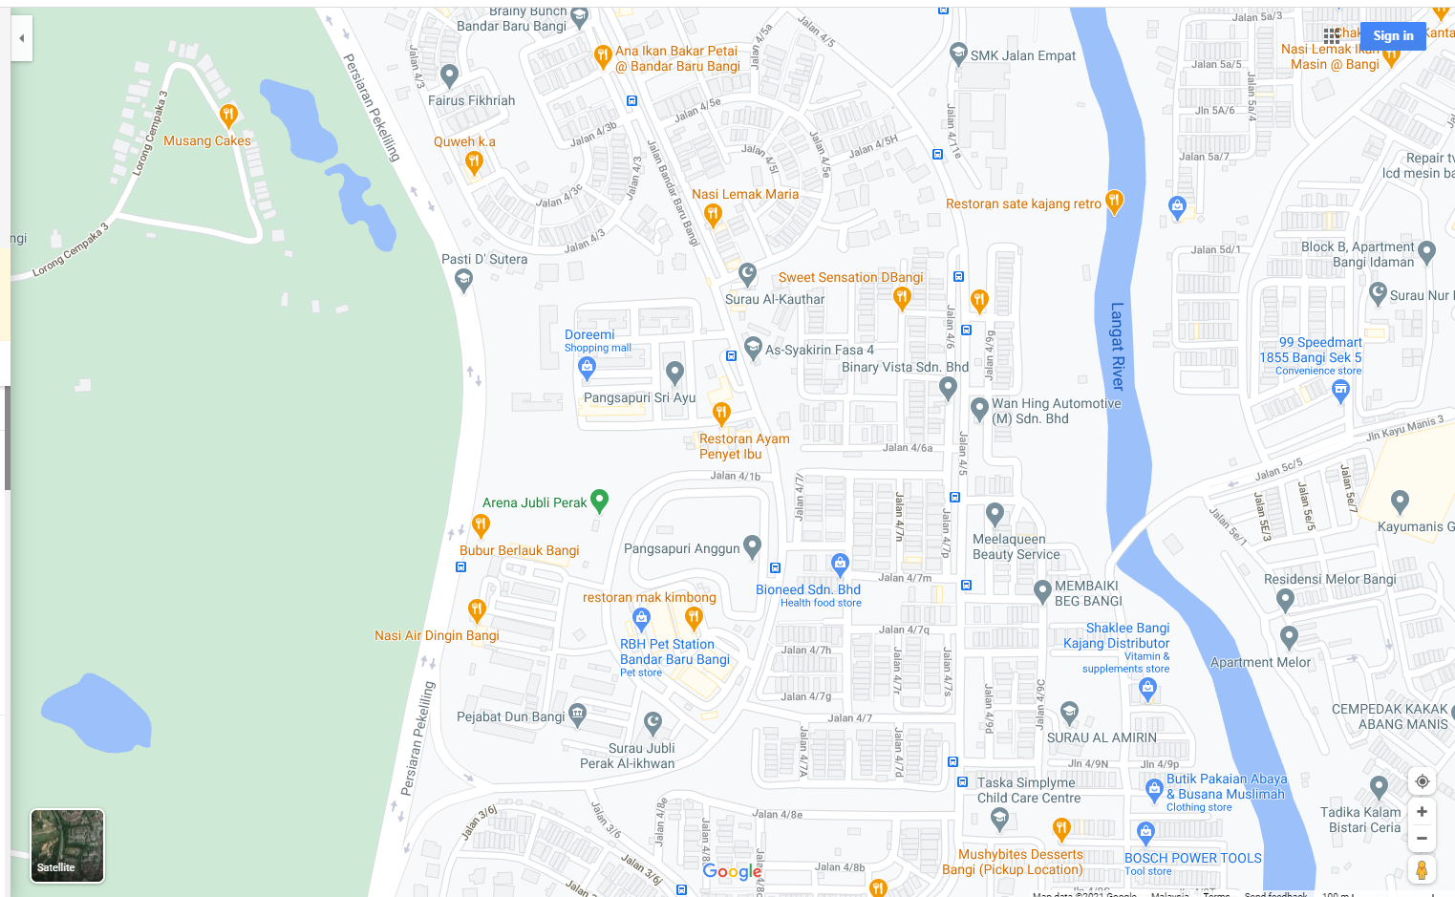
Source: Google. (n.d-a)

Figure 1. Section 4 and 7 of Bandar Baru Bangi (12 foodie outlets).

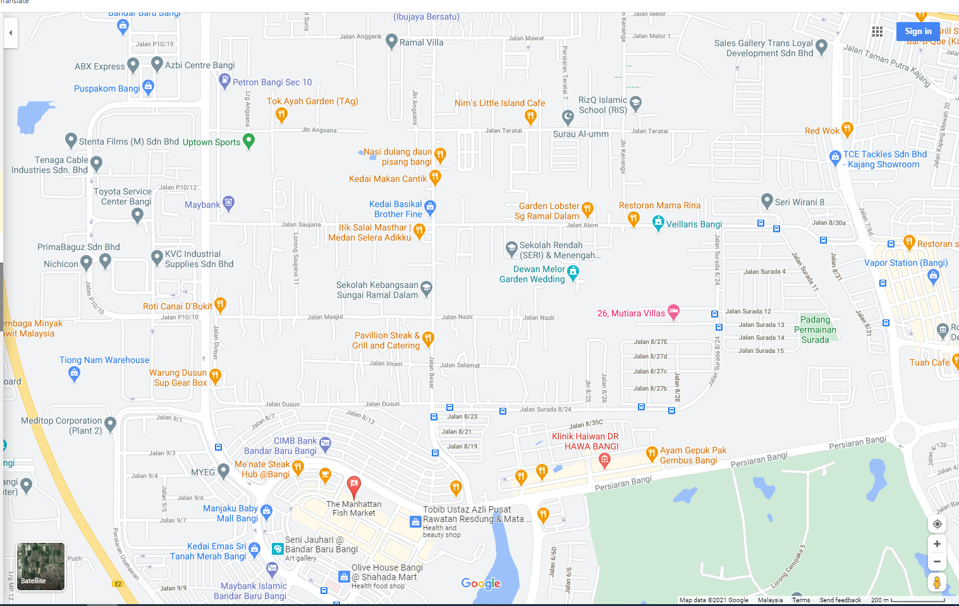
Source: Google. (n.d-b)

Figure 2. Section 9, Bandar Baru Bangi (14 foodie outlets).

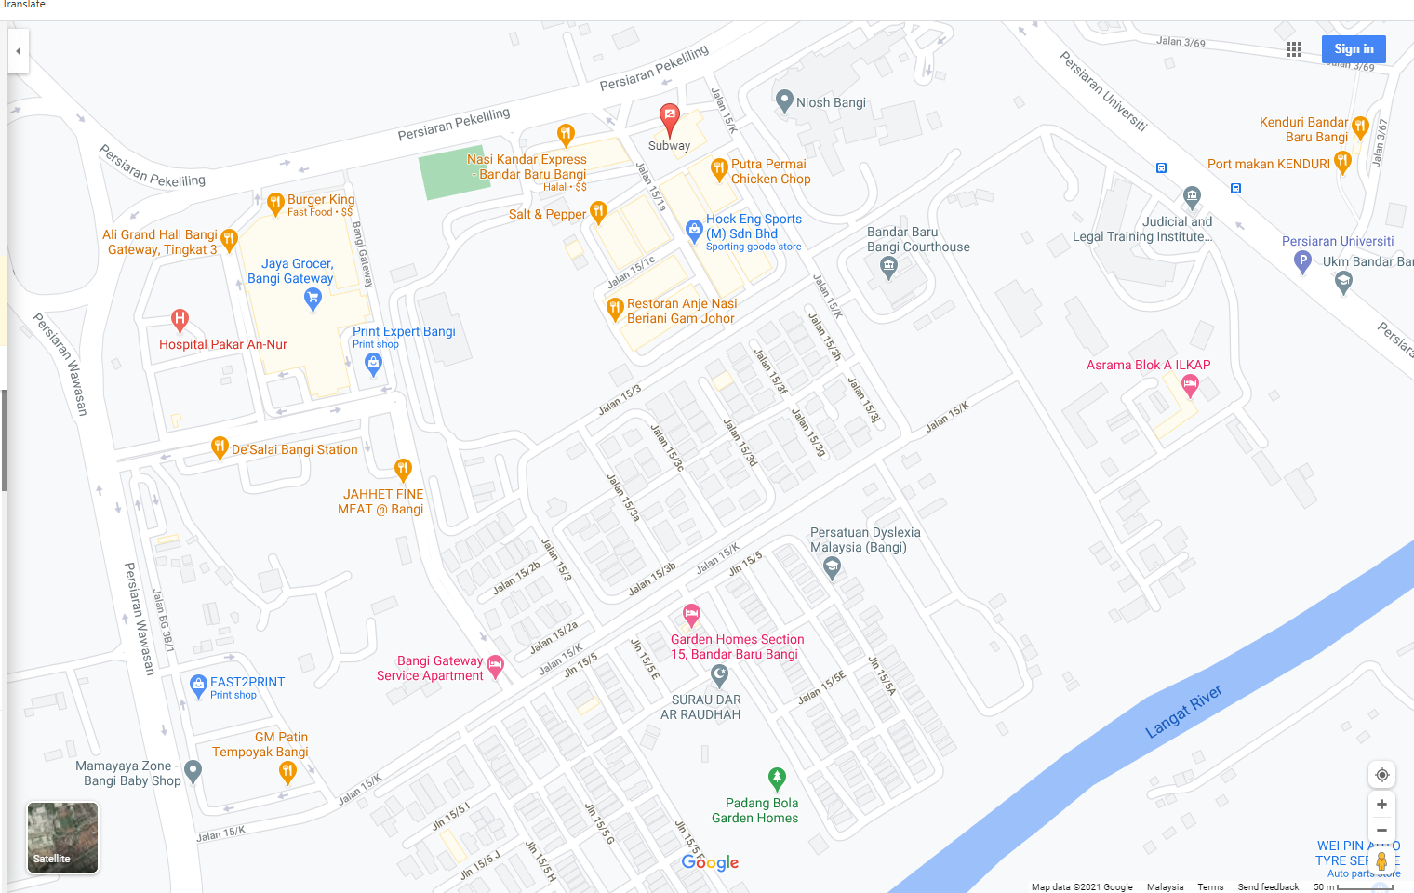
Source: Google (n.d-c)

Figure 3. Section 15, Bandar Baru Bangi (14 foodie outlets).
Nevertheless, the taste bud of hipsters is displaying in their selection of cafes and foods. Table 2 shows the menus of hipster cafes in Bangi, Selangor. The changing lifestyle from high carbohydrates to high protein or fibre diets are encouraging. The drinks list includes local ingredients of fresh fruits and herbs such as biji selasih, asam boi, mamak teh tarik to Thai tea, Japanese matcha, Italian Frappuccino, Sri Lanka Black Tea, and manuka honey-tea. A similar trend was found in the menu list, which combined both locals and abroad meals. For instance, nasi lemak and kuey teow are served together with vermicelli beef soup, grilled salmon, Vietnamese prawn rolls, Belgian waffles, Spaghetti, and fish chips. The names of countries abroad attached to the menu reflecting the internationalization of such lists to attract local consumers. Another interpretation may be that the internationalization menu represents class and fortune because those who travel abroad are the fortune class and elites.

Table 2. List of the menu for meals and drinks.

Menu | Local or Nusantara | West
Entree | Prawn Vietnamese summer roll  anchovy bun, salted egg calamari | mozzarella cheese stick, French fries
Breakfast | Nasi soto medan, nasi ayam penyet [Medan and Surabaya states are in Indonesia] | Bread toast, poached egg toast, garlic bread & mushroom soup, grilled beef sandwich, clubhouse egg sandwich
Lunch | Nasi lemak, creamy buttermilk chicken, the caravan fried rice, salted egg squid, salted egg chicken. | NZ lamb chop, chicken grill, Aussie tenderloins steak, grilled salmon steak, fish & chips.
Dessert | Fudgy brownies, mini Pavlova, crème Brule, Belgian waffle, banana split, vanilla ice cream.
Drinks | Sirap Biji Selasih, Limau Asam Boi, Honey Lemon, Mineral Water, Iced Water  Chocolate Avocado, passion fruit, banana caramel, Mango, Lemonade, Teh Tarik, iced Thai green tea, Lemon tea, honey lemon tea, honey tea, bird nest-longan, black tea | Cream and Lactose  Vanilla milkshake, chocolate milkshake, yogurt milkshake. Butterscotch milk, vanilla milk, caramel milk, hazelnut milk, The caravan coffee, espresso, Americano, cappuccino, latte, mocha, Caramelo & Choco Frappuccino, chocolate drinks  Juice and sparkling  Mojito, Passion Mojito, Strawberry Mojito, Lemon Passion Fruit, Raspberry, Strawberry, Apple Manuka honey, Carrot-milk, Strawberry mint, Orange Julius, Mango, Matcha green tea, Earl Grey Tea,
Source: Observation in a few hipster cafés and restaurants in Bangi Selangor Section 4 & 7, 9, and 15.

The exploration highlights that combining local and international meals creates a new fusion of food eaten at breakfast and lunch. The hipster’s term is ‘brunch,’ which means breakfast and lunch in one meal. Lunch and dinner are serving at any time at hipster’s café. The peak serving hours are in the afternoon and evening, and each hipster café has its own identity in terms of unique utensils, new food styles from the middle to significant portion with a high price for the serving. Each hipster restaurant carries a concept representing its restaurant, including decoration ranging from minimalist, antiques, classy, modern art, punk art, and gothic art. They are willing to sell product items such as clothes and shoes made by local artists with no brand name yet but as an alternative to buyers with hipster’s taste to consider.
The menu for hipster foods may look ordinary, but the serving of meals is extraordinary. Hipster restaurants are showcasing different tools for foods presentation such as dust bin for plate; big menthol bulb for glass-drink, black charcoal bun for a burger, nasi lemak serves in the form of pie or layered cake, ice-cream serves with anchovy, eggs, and chili paste, sushi in the form of a colourful doughnut. Most of these hipster restaurants presenting themselves as café with coffee served as the main menu. Although coffee is ordinary, the serving of coffee is unique away from conventional expectations. These café presented individual serving of coffee using menthol bulbs for ice latte, hot coffee in cup-vase designed, copper glass, and shoe-designed glass, or fruit juice serving inside the carving fruit, a basket-glass, and a shoe-like glass. The serving styles are different, and the unique variations attract young middle-class people to try new things.

Beyond nutritionist practice?

Annechen (2011) highlights the young people’s representation and practice about fast food and shows that youth food culture moves into healthy diets for good appearance and attractiveness. Young people are increasingly aware of calories and becoming sceptical of fast food. This attitude towards healthy living is an indication that the health trend is strong among youths. This study enhances the young people’s food practice because hipster cafes serve healthy food and diets, promoting gluten-free and minimizing carbohydrates, with creative food serving as a new culture of pride to hipster identity and community.
William (1999) discussed food fusion from ingredients to cooking methods from various cultures turned the food into a melting pot culture as Americans’ pride. In this hipster cafe observation, the food fusion of ingredients and serving of international and local driving the ‘glocal’ term to be part of hipsters’ identity. They find a sense of comfort in these hipsters’ cafes because the meals and drinks could only be consumed here rather than at home. Fleura et al. (2010) argue that cultural boundaries are apparent amongst travellers when traveling abroad. Travelers are likely to consume foods within their comfort mind and familiarity because travellers are more careful when eating new or peculiar foods. The negative experience during traveling elevates the cautious feeling about food consumption in a foreign land.
On the contrary, young people at hipster cafes are adventurous to try new foods outside their comfort home. Although they physically stood on the ground, the term ‘traveling’ views anything outside their home. They see home separates from their hipster taste bud and identity. House is about respecting the traditional, and home meals are local, sumptuous with fat and calories to be treated as ‘cheat days.’ The cultural capital embodied in food consumption as an identity could shape the present young generation less ethicised than before. The willingness to share the familiar taste and personality regardless of ethnicity may increase the likelihood of diverse Malaysians embracing a new form of integration other than maintaining each ethnic vernacular identity, which appears as a constant struggle for nation-building.

Conclusion

The hipster café and food can be the third good place’ for people to get together enjoying each other company. Still, it is also a platform for people of a particular class and identity to promote their uniqueness. Cultural capital and framing are fundamental for forming hipster identity and fashion, gadgets, music, and food taste. Such identity preference leads to questioning its capacity to create a moment of unity or disunity inter or intra ethnic. Being unique and different detach from the mainstream could be alarming if such identity led to obsession and exclusivism. Hipster allows class and exclusivity to thrive in a new urban community but may find it challenging to blend with the majority mainstream. Hipster identity could be a new form of hybrid community that disregards the indigenous mainstream nor supporting the dominant minority but thrive as a unique identity to be considered. A blend of colonial taste and local menus may endorse a modern lifestyle with new market innovation. Therefore, when supply and demand increase, hipster cafes’ prices may attract the other class of consumers to try the fresh taste of meals regardless of ethnicity, orientation, and income.

Acknowledgment

Authors thank grants PP-KITA-2020 and FRGS/1/2017/SSI10/UKM/02/4 for making this research possible.

References

Azahar Kasim, & Adibah Ismail. (2018). Framing strategic news from the perspectives of media organizations in Malaysia. Malaysian Journal of Communication, 34(1), 330-344.
Annechen Bahr Bugge. (2011). Lovin’ it? Food, Culture & Society, 14(1), 71-89. DOI: 10.2752/175174411X12810842291236
Barthes, R. (1977). The elements of semiology (translated by Annette Lavers and Colin Smith). New York: Hill and Wang.
Bourdieu, P. (1986). The forms of capital, in. J. Richardson (ed.) Handbook of theory and research for the sociology of education (pg.241-258). New York: Greenwood.
Bourdieu, P., & Randal, J. (1993). The field of cultural production. New York: Polity Press.
Coupland, D. (1991). Generation X: A tales of an accelerated culture (1st edition). USA: St. Martin’s Griffin
De Graaf, N. D., De Graaf, P. M., & Kraaykap, G. (2000). Parental cultural capital and educational attainment in Netherlands: A refinement of the cultural capital perspective. Sociology of Education, 73(2), 92-111. DOI: 10.2307/2673239
Ferguson, S. (2011). A global culture of cool? Generation Y and their perception of coolness. Young Consumers, 12(3), 265-275. https://doi.org/10.1108/17473611111163313
Fleura, B., Jacob, O., & Anders, B. (2010). Negotiating cultural boundaries: Food, travel and consumer identities. Consumption Markets & Culture, 13(2), 133-157, DOI: 10.1080/10253860903562148
Gale, D. (2007). Higher frequency, restaurants and institutions, 117(7), 83.
Google. (n.d-a). [Section 4 and 7 of Bandar Baru Bangi (12 foodie outlets)]. https://www.google.com/maps/contrib/113313508386317112112/reviews/ @2.9567723,101.7770382,17z/data=!4m3!8m2!3m1!1e1
Google. (n.d-b). [Section 9, Bandar Baru Bangi (14 foodie outlets)] https://www.google.com/maps/contrib/113313508386317112112/reviews/@ 2.9692727,101.75482,16z/data=!4m3!8m2!3m1!1e1
Google. (n.d-c). [Section 15, Bandar Baru Bangi (14 foodie outlets)]. https://www.google.com/maps/contrib/113313508386317112112/reviews/@ 2.9537118,101.771557,16z/data=!4m3!8m2!3m1!1e1
Greif, M. (2010). The Hipster in the Mirror. The New York Times. Retrieved November 19, 2020, from https://www.nytimes.com/2010/11/14/books/review/Greif-t.html
Herbig, P., Koehler, W., & Day, K. (1993). Marketing to the Baby Bust Generations. Journal of Consumer Marketing, 10(1), 4-9.
Howe, N., & William, S. (2009). Millennials rising: The next great generation. New York: Vintage Books
Kashmira Gander. Doctors discover over 100 undigested bubble tea balls inside teenage girls, June 12, 2019. Newsweek.com. https://www.newsweek.com/doctors-discover-over-100-undigested-bubble-tea-balls inside-teenage-girl-1443510
Kavitha, H., Souji, G., & Prabu, R. (2011). A study of factors influencing Generation Y’s food preferences with special reference to Kuala Lumpur, Malaysia. ZENITH International Journal of Business Economics & Management Research, 1(1), 1-14. http://zenithresearch.org.in/
Loone, Susan. (2019). Unity in Penang is very clear even with the change of government, says Tun M. Malaysiakini. https://www.malaysiakini.com/news/463226
Matthew, D. (2015). Building change culture with Generation Y. Rancontour: Business Innovation/Business Transformation. https://www.raconteur.net/business-innovation/ building-change-culture-with-generation-y
Moss, M., & Martins, N. (2014). Generational Sub-cultures: generation Y a Sub-culture? Mediterranean Journal of Social Sciences, 5(21), 147-160. DOI:10.5901/mjss.2014. v5n21p.147
Muhamad Faiz Baharin. (2015). MPS compound dirty ‘mamak’ restaurants. https://www.nst.com.my/news/2015/11/113764/mps-compounds-dirty-mamak-restaurant
MyKori. https://mykori.my/
National Unity Consultative Council Report on Pelan Perpaduan, Kesepaduan, Penyatupaduan. (2015). Department of Unity and National Integration, The Prime Minister Office (unpublished).
Nurhamizah Hashim, & Asbah Razali. (2019). Teknologi dan media sosial dalam komunikasi ibubapa dan anak-anak. Jurnal Komunikasi Malaysia, 35(4), 337-352.
Oldenberg, R. (1997). The Great Good Places. Cambridge, MA: Da Paco Press.
Olmedo, E. (2014). Mamakization food and social cohesion in Malaysia: A tentative framework. 34 (November), Ethnic Studies KITA Series. Bangi: KITA Press.
Osama Kanaker, Mohamed Oklah Abughazlih, & Mohd Faizal Kasmani. (2020). Media framing of minorities crisis: A study of Aljazeera and BBC News Coverage of the Rohingya, Malaysian Journal of Communication, 36(2), 1-16.
Paul, P. (2001). Getting inside Gen Y. American Demographics, 23(9), 42-49.
Piggford, T., Raciti, M., Harker, D., & Harker, M. (2008). Young adults’ food motives: An Australian social marketing perspective. Young Consumer, 9(1), 17-28.
Pountain, D., & Robins, D. (2000). Cool rules: Anatomy of an attitude. London: Reaktion Books Ltd.
Rasmussen, A. W., Caroline, B., Lasse, D. R., Laura, K., & Troels Bo, H. M. (2012). Investigation of the Hipster. Humanistic International Basic Studies, Roskilde University.
Shamsul, A. B. (2015). Politics of Language and Language of Politics: Theory and Practice of the Nation of Intent as articulated in Malaysia. UKM Ethnic Studies Paper Series. 35(June), Bangi: KITA Press.
Shamsul, A. B. (2014). Perpaduan, kesepaduan dan penyatupadauan: Satu kata akar tiga konsep keramat. https://www.academia.edu/5828754/Perpaduan_Kesepaduan_dan_ Penyatupaduan_Satu_Negara_Satu_Kata_Akar_Tiga_Konsep_Keramat?auto=download
Silva, E. (2016). Here come the Baby Boomers. Journal of the American College of Radiology, 13(3), 242. DOI: https://doi.org/10.1016/j.jacr.2015.12.002
Taylor, S. J., & Bogdan, R. C. (1998). Introduction to qualitative research methods: A guidebook and resources (3rd ed.). Hoboken, New Jersey, USA: John Wiley & Sons Inc.
Vresse, C. H. de. (2005). News framing: Theory and typology. Information Design Journal, 13(1), 51-62.
William, C. W. (1999). Soul food as cultural creation. Journal for the Study of Food and Society, 3(1), 37-47. DOI: 10.2752/152897999786690717
Weaver, D. H. (2007). Thoughts on Agenda Setting, Framing and Priming, Journal of Communication, 57, 142-147.

Endnote

Article 160 of the Federal Constitution of Malaysia defines that the Malays are the people who profess the religion of Islam, habitually speak Malay language and confer to Malay custom, Rosli Dahlan & Mohammad Afif Daud, Who is the Malay? 14 December 2015, TheStar.com. Retrieved September 20, 2019, from https://www.thestar.com.my/news/nation/2015/12/14/who-is-the-malay-the-confusion-between-the-constitutional-definition-and-the-understanding-of-the-wo Article 152 states that the Malay language is the national language but other languages shall be taught and learnt without forbidden, and this article shall not prejudice to let the federal and state to preserve and sustain other languages of any communities in the federal and state. Article 153 (1) states that it shall be the responsibility of the Yang di-Pertuan Agong to safeguard the special position of the Malays and natives of Sabah and Sarawak and the legitimate interest of the communities in accordance with the provisions of this article. Source: Federal Constitution (reprint 2010). Retrieved September 20, 2019, from http://www.agc.gov.my/agcportal/uploads/ files/Publications/FC/Federal%20Consti%20(BI%20text).pdf
Carton and Kleiner (2001) outline the forms of discrimination in restaurant industry towards employees and customers including race, physical impaired, gender, pregnant women, etc. See, Carton, Sharon & Brian H. Kleiner, (2001). Discrimination in the restaurant industry. Equal Opportunities International, 20(5/6/7): 128-132, https://www.emerald.com/insight/content/doi/ 10.1108/02610150110786877/full/pdf?title=discrimination-in-the-restaurant-industry
Mamak is a term used to describe an Indian Muslim in the Malaysian communities. They were immigrant in the 1930s brought in by the British and developed their own community dish and cuisine which easily acculturated with locals. Indian Muslims are well accepted amongst the natives particularly the Malay Muslims and those married to locals will have their identity status label as the Malay. A Malay as identity conforms to the Federal Constitution of Malaysia under Article 160 that entitles them too many opportunities reserved for the Malays accordingly.

