

Multi-site calibration of SWAT for the spatial distribution of sediment yield, Middle Awash Dam watershed, Ethiopia

Tesfu Abebe Tesema¹, Kuok-Choy Lam², Bogale GebreMariam³, Wasu Manawko Tefera⁴

¹Department of Water Resources and Irrigation Engineering, Jigjiga University, Ethiopia
²Geography Program, Centre for Research in Development, Social & Environment,
Faculty of Social Science & Humanities, Universiti Kebangsaan Malaysia, Malaysia
³Faculty of Hydraulic and Water Resources Engineering, Water Technology Institute,
Arba Minch University, Ethiopia
⁴Department of Hydraulic and Water Resource Engineering, Dilla University, Ethiopia

Correspondence: Tesfu Abebe Tesema (email: tesfuabebe@gmail.com)

Received: 18 December 2020; Accepted: 09 August 2021; Published: 30 November 2021

Abstract

Multi-site calibration of sediment yield has a significant effect on evaluating the spatial distribution of sediment yield of watershed and reservoirs sedimentation. Multi-site calibration was conducted at three gauging stations of the Proposed Middle Awash Dam watershed. The sequential Uncertainty fitting (SUFI-2) calibration uncertainty program (SWAT-CUP) has been used to calibrate and validate flow and sediment parameters using monthly flow and sediment rate observed data. P-factor and R-factor measured model calibration and uncertainty where the P-factor recorded 0.56-0.86/0.54-0.77 and R-factor 0.52-0.93/0.68-0.84 values respectively during the calibration and validation period for the three gauging stations. Model result showed the performance model was excellent during the calibration period with the coefficient of determination R2=0.78-0.82, Nash-Sutcliffe Efficiency ENS=0.77-0.79, Observation Standard Deviation Ratio RSR=0.44-0.48 and percent bias PBIAS=-13.3 to +14.3. Following the calibration process, the model estimated mean annual spatial distribution of sediment yield 7.23 ton/ha/yr at the outlet. Sediment yields spatial distribution showed that among the 19 sub-watersheds ranked based on their sediment yield contributions, eight sub-watersheds have a slope greater than 5%, which is relatively steeper and contributed average annual sediment yields of 16 ton/ha/yr. The temporal variability hydrograph showed 70.8 % of yearly sediment yield in the study area during the rainy season. The study results informed to development of watershed management strategies to minimize the sediment problems in the entire watershed.

Keywords: Hydrological modelling, Middle Awash Dam, sediment yield, spatial distribution, SWAT model

Introduction

The sediment yield from a watershed is an integrated result of all water erosion and transport processes occurring in the entire contributing area (Zhang et al., 2020). Surface soil erosion affects agricultural productivity and water infrastructures (Telles et al., 2013). Sediment inflows influence reservoirs service year (Brandt, 2000; ICOLD, 2012). Watershed sedimentation has been the results of poor land-use practices and a lack of suitable soil conservation measures. Sedimentation can cause a reduction in the storage capacity of reservoirs (Lee et al., 2010; Alemu, 2016). As the suspended sediment in the flowing water increases, the water quality in rivers and reservoirs has degraded.
In Awash River Basin, siltation of canals and reservoir sedimentation has considered a critical problem. The bathymetric survey conducted by Halcrow (1989) indicates Koka reservoir, which is part upstream of the proposed Middle Awash Dam, faces a sedimentation challenge with an average annual rate of 25 million m3/yr. A similar study by the Ministry of Water Resources (MoWR) shown the reservoir still lost its storage capacity with an average sedimentation rate of 12.08 million m3/yr (MoWR, 2002). The current capacity of the Melkassa reservoir has reduced to the level that it can no longer store water due to heavy siltation. Bishaw and Kedir (2015) reported that average annual sediment yields in the Awash River near Merti Bridge were 658,120 tons and increasing during the rainy season. This sedimentation becomes a fundamental problem for farms on the Metehara Sugar estate by reducing the canal system's capacity and height storage reservoirs (Zeleke, 2007). The estate costs a tremendous amount of money for maintenance (DHV, 1983).
Periodic evaluation is essential for sediment deposition pattern and assessment of sediment distribution of spatial and temporal variability. It has used to sustain the intended functions of reservoir construction like storage facilities for domestic and irrigation water supply, power generation and flood attenuation. Therefore, understanding watershed sediment processes is a criterion for effective watershed management.
SWAT has been used by researchers worldwide for estimation of sediment yield on a daily and monthly basis (Briak et al., 2016; Xu et al., 2009; Liu et al., 2015; Samad et al., 2016; Bossa et al., 2012; Le Roux, 2018). SWAT model applicability has been confirmed in Ethiopia in sediment yield estimation and spatial sediment distribution mapping (Tesema and Leta, 2020; Setegn et al., 2010; Welde, 2016). Researchers conducted SWAT model calibration, validation and uncertainty analysis to identify the most influencing hydrological parameters (Gyamfi et al., 2016; Singh et al., 2013; Manaswi and Thawait, 2014; Szezesniak and Piniewski, 2015). Calibration of the parameters can be conducted at multi-sites (Das et al. 2019; Piniewski and Okruszko, 2011; Chiang et al., 2014), single-site (Tesema and Leta, 2020). The authors have reported that multi-site calibration and validation efficiency were better than single sites focusing only on the outlet of data availability (Qi and Grunwald, 2005; Wang et al., 2012). In this study, we implemented an automated calibration procedure for further calibration, validation and uncertainty analysis of sediment parameters using SWAT-CUP (Abbaspour et al. 2007) sequential uncertainty fitting (SUFI-2) algorithm (Kumar et al., 2017). Using SWAT-CUP of sequential uncertainty fitting (SUFI-2) algorithm, research articles have been worked worldwide based on the calibration of sediment parameters (Hallouz et al., 2018; Mamo and Jain, 2013).
This study's primary objective was multi-site calibration of SWAT for Sediment's spatial distribution to the proposed Middle Awash Dam watershed. The objectives of this study are to estimate the sediment yield entry of sediment yield to the proposed Middle Awash Dam reservoir, and to assess the sediment yield distribution of the proposed Middle Awash Dam watershed. In this study, sediment parameters' multi-site calibration has been conducted after streamflow parameter calibration and validation. This technique's main advantage could be calibration from upstream to the downstream of the watershed, which increases the model calibration efficiency from upstream to downstream of the watershed hydrological parameters.

Material and methods

SWAT model description

SWAT (Arnold et al., 2012) has been using natural and human activity impacts on land surface to assess hydrological characteristics. In SWAT model, watersheds partitioned into sub-watersheds and stream networks using the digital elevation model (DEM). Sub-watersheds further sub-divided into the smallest simulation unit, Hydrological Response Units (HRUs). SWAT allows the users to choose slope classification. Four slope classes of 0-3%, 3-6%, 6-12%, and above 12% were defined. A 20% land use, 10% soil and 10% slope threshold are adequately assigned to create HRUs in the watershed to make the SWAT model more efficient in performing simulation (Neitsch et al., 2011). Sub-basins that contain a land use, soil or slope smaller than the threshold remain as the dominant land cover, soil or slope closest to it.
Hydrological variables such as runoff and sediment are simulated at each HRUs using multiple HRUs options assigned for this study and then accumulated into the sub-watershed level and routed through the stream channel to the main outlet of the watershed. The Routing phase of the SWAT hydrologic simulation consists of the transportation of hydrologic components in the stream networks. Manning’s equation calculates the rate and velocity of flows of the study watershed. For this study, the flow routed by the variable storage method. The erosion and sediment yield characteristics of each HRU calculated using the Modified Universal Soil Loss Equation (MUSLE). In this study, SWAT uses the curve number method to compute the surface runoff volume. The soil hydrologic group contribution in estimating surface runoff has used the U.S. Natural Resource Conservation Service. The SWAT model for this study used the Penman-Monteith method to estimate the potential evapotranspiration (Monteith, 1965). Since the study area has sufficient time-series data, the Penman-Monteith method has used in several ways.
The water flow through the soil material in the SWAT model has implemented by using the water balance equation (Mutenyo et al., 2013). The water balance of any watershed is dependent on the moisture and energy inputs provided by the watershed climate. Data sets required by the SWAT model in this study are precipitation, air temperature, solar radiation, wind speed and relative humidity (Neitcsh et al., 2005). For each sub-watershed, the model generates a set of weather data. The values for any sub-watershed developed independently, and there will be no spatial correlation of generated values between the different sub-watershed (Arnold et al., 2012).

SWAT-CUP

The SWAT-CUP, an interfaces program of ArcSWAT, was used to calibrate and validate the SWAT model's sensitive parameters. SWAT-CUP designed to evaluate the performance of the calibration of the SWAT model. Thus, the advantage of the application is its ability to give a wide choice of functions and great interfaces for parameterization, calibration and validation of the model. The SWAT-CUP model's execution involves using output files generated by the SWAT model in ArcSWAT (Abbaspour, 2014). One of the calibration techniques in SWAT-CUP, Sequential Uncertainty Fitting (SUFI-2), has implemented in this study. The uncertainty analysis of SUFI-2 has quantified by the coefficient of linear correlation (R²), the coefficient of Nash-Sutcliffe efficiency (NSE), the coefficient of Percent bias (PBIAS) and Root mean square error observation standard deviation ratio (RSR) between the observed data and simulated results.

Description of the study area

The proposed Middle Awash Dam watershed part of the Awash River basin is the location of 8°57.6’N, 40°9.6’E. A multipurpose dam will be used for nearby communities and Debu-Amibara irrigation sites (WWDSE, 2016). The geographical extent of the dam watershed, which ranges from 7°52’ and 9°25’ North, and 38°12’ and 40°36’ East and covers a total drainage area of 20,371km2 (Figure 1).

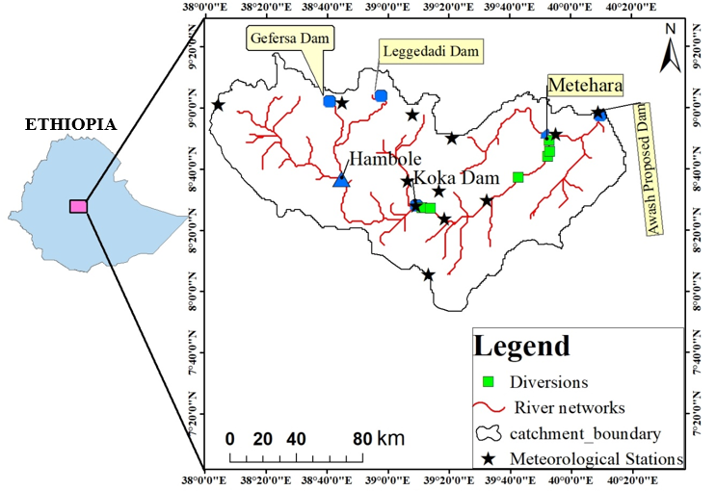

Figure 1. Location map of the proposed Middle Awash Dam watershed (MADWS) with Meteorological Stations

Data soures and compilation

We downloaded DEM of 30 m resolution (Figure 2) from the United States Geological Survey (USGS), SRTM (Shuttle Radar Topography Mission) for watershed delineation and stream network definition using SWAT (Waranyu and Anongrit, 2016). We used Ethiopia's 2008 LU/LC map ready by the Ministry of Agriculture (MoA) efforts with a 30m resolution was used to extract the LU/LC map of the study area (Figure 2). Ethiopia's soil shapefile map was obtained from MoA and clipped for the study area soil map with equal LULC and DEM projection (Figure 2). The watershed response rainfall events to runoff depend on the soil's chemical and physical properties (Buda & DeWalle, 2009). We used a Harmonized world soil database (Nachtergaele et al., 2010) to insert major soil types' basic physicochemical properties into the SWAT user soil database (FAO, 2002).
Daily weather data were obtained from National Meteorological Agency of Ethiopia from 1990-2014 (Table 1) for the study watershed. This study used streamflow from the Ministry of Water, Irrigation and Electricity of Ethiopia from the hydrology and water quality department in the daily time series (1990–2010). The water abstraction and reservoir data were obtained from Awash River basin Master Plan (Halcrow, 1989). Streamflow data used to calibrate streamflow parameters at Hambole, Metehara and Awash. Hambole gauging station is located at the nearest upstream of Koka Dam Reservoir on Awash River's channel. Metehara and Awash gauging stations are situated middle and lower part of the watershed. All selected stations have good streamflow records with 9% missing data in the study baseline, especially from 1990 to 2007; the unrecorded data were filled by linear regression for the wet season (Elshorbagy et al., 2000) and recession curve method for the dry season (Gyau-Boakye and Schultz, 1994).

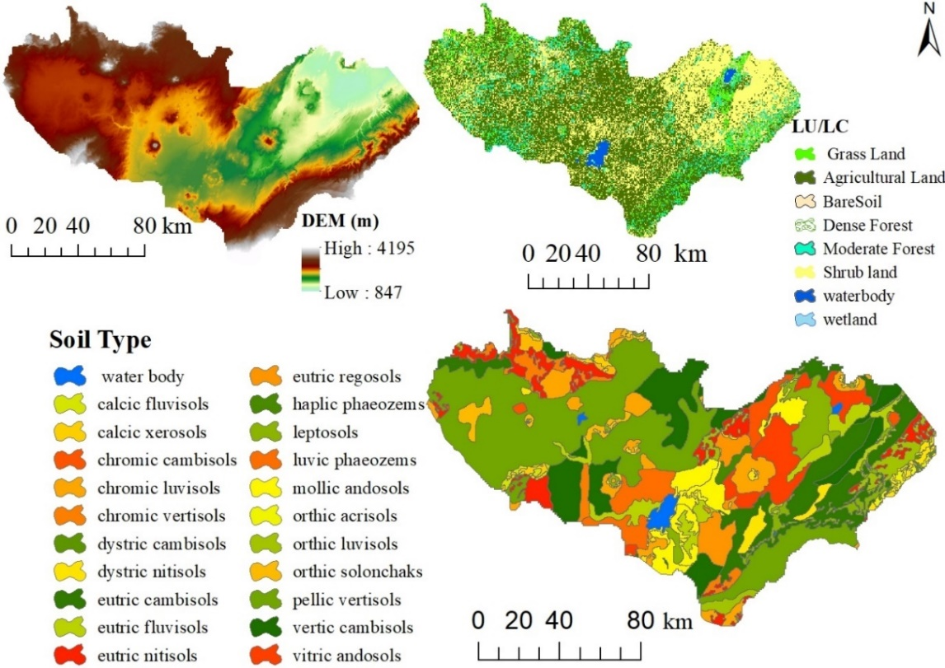

Figure 2. Proposed Middle Awash Dam watershed DEM (top left), LU/LC (top right) and Soil type bottom.

Table 1. Selected meteorological stations at Proposed Middle Awash Dam Watershed (1990 – 2014).

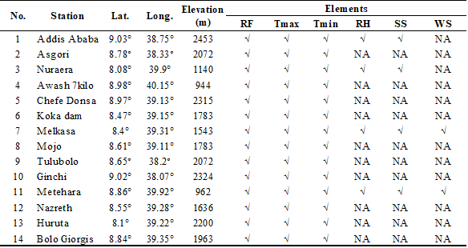
Note: Lat. = Latitude, Long. = Longitude, RF = Rainfall, Tmax = Maximum Temperature, Tmin = Minimum Temperature, RH= Relative Humidity, SS= Sunshine, WS= Wind Speed, √ = data available and NA= data not available (incomplete)
Sediment concentration was one of the inputs for sediment load calibration by SWAT. For this study, the sediment concentration data at the dam site (Awash gauging station) was not available. However, the Metehara gauging station located around 25km upstream of the dam site has sufficient sediment concentration data and gauges about 90% of Middle Awash Dam watershed area coverage. The remaining 10% (ungauged area) also has relatively similar soil, land use, and topography characteristics. Thus, we assumed it could be possible to use the equation of sediment yield rating curve (Clarke, 1994) developed at Metehara gauging station for computing the daily sediment load (ton/day) at the dam site by using the daily flow data measured at Awash gauging station. For sediment yield analysis at Hambole, the sediment rating curve for the Hambole gauging station adopted from the research conducted by Golla et al. (2006). After the rating curve has developed, discharges changed to sediment load (Morris and Fan, 1998).
Hydrologists preferably use a double mass curve to assess records' consistency at multiple locations, fill gaps and adjust inconsistent in records. We used the normal ratio method in this study to fill in the missing data of precipitation of each station is available, and the magnitude differs from that of each considered precipitation stations by more than 10%.
The SWAT model set-up has been created based on the proposed Middle Awash Dam watershed geospatial data such as DEM, LU/LC and soil maps (Abbaspour et al., 2015). In the current study, the watershed up to its outlet was subdivided into 70 sub-basins and further subdivided into 1319 HRUs. We took the threshold area of 15,000ha to create stream networks for simulation purposes properly. We were manually added the watershed outlet to generate streamflow lines and watershed boundaries. Moreover, based on SWAT manual document, reservoirs and water diversions (Berhe et al., 2017) has been considered in the SWAT model setup. Using the above information, the model automatically delineates a watershed area of 20,371km² (Figure 3).
Proceed to SWAT model sensitivity analysis, calibration, and validation using SWAT-CUP uncertainty analysis tool SUFI-2 (Abbaspour, 2014). The model was calibrated by changing the parameters systematically (Li et al., 2017). The calibration was conducted from 1/1/1992-12/31/1999 with the warm up period one-year 1991 and validation from 1/1/ 2000– 12/31/2006 using the observed streamflow and sediment yield at Hambole, Metehara and Awash gauging stations. Global sensitivity analysis uses t-test and p-values to determine each parameter's sensitivity (Abbaspour, 2014).

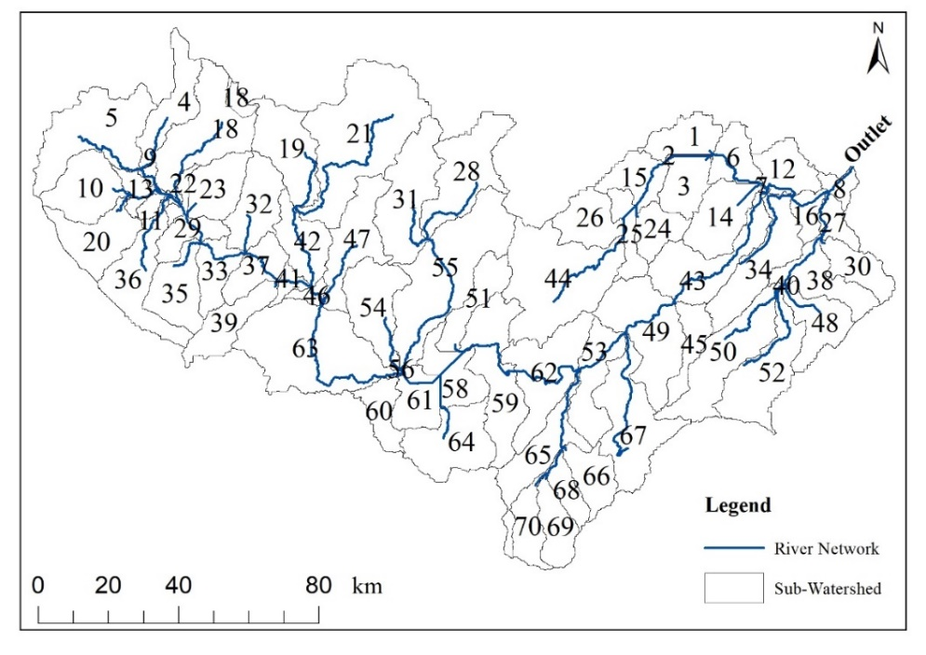
Figure 3. Sub-watershed and stream network of study watershed.

Model performance evaluation and uncertainty analysis

The SWAT performance evaluated using statistical measures to determine the quality and reliability of predictions compared to observed values. In this study the statistical indicators such as coefficient of determination (R²), Nash-Sutcliffe modeling efficiency (ENS) (Nash & Sutcliffe, 1970), Root mean square error observation standard deviation ratio (RSR) and percent bias (PBIAS) have been used to check the accuracy of streamflow and sediment yield calibration and validations.
The guidelines by Moriasi et al. (2007) and Santhi et al. (2001) proposed the acceptable range of parameters assumed for Ens>0.5 and R²>0.6 during the calibration of streamflow and sediment yields. PBIAS measures the tendency of simulated result is smaller or larger than the observed values (Gupta et al., 1999); 0 is the optimum value, the positive value indicates underestimation and negative value indicates an overestimation of the model output. RSR is error-index statistics (Singh et al., 2004). According to Singh et al. (2004) published guideline the lower RSR is the perfect model simulations; zero is the optimum value for RSR, which shows the positive the perfect model output.

…(1)
…(2)
…(3)
…(4)
Where Y_{obs} and Y_{sim} are the obserbed and simulated values respectively, is the mean of n observed values; and is the mean of n simulated values.

Results and discussions

Sensitivity analysis was executed to identify parameters implemented in SWAT-CUP during the calibration and validation process (Figure 1). In table 3, 19 flow and 12 sediment yield parameters separated as default parameters. Four parameters, CN2, GW_DELAY, ALPHA_BF and CANMX showed high sensitivity (Table 3). These informed CN2 associations with precipitation to generate runoff in the watershed (Van Liew et al., 2005). Groundwater and base flow were the most important variables in the study watershed (Xue et al., 2014). Subsequently, the parameters SPCON, Ch_COV2 and USLE_K approved high priority for calibration of sediment load (Table 3); they were associated with channel sediment, channel cover and erodibility.

Table 3. Default parameters of streamflow and sediment load at proposed Middle Awash Dam Watershed.

During calibration, relatively mismatching of hydrograph reports indicated between simulated and observed flow parameters. Therefore, by adjusting the sensitive flow parameters, model output data agreed with the observed flow data (Figures 4-5, Tables 4-5). Calibration and validation of flow and sediment carried out at sub-watersheds 42, 45 and 3 (Hambole, Metehara and Awash gauging station, respectively) (Figures 4-5). Table 4 shows the most sensitive streamflow parameters based on the associated low p_value (p < 0.05) and the corresponding high t_stat values. At the three calibration sites, such as Awash, Metehar and Hambole gauging stations, the runoff curve number was the first sensitive flow parameter and SPCON in sediment parameters (Table 4).

Table 4. Summary of calibrated parameters of flow and sediment.

Table 5 provides the model performance report at Awash gauging station with acceptable range (Table 2). Similarly, Metehara and Hambole gauging stations also fall in the ranges of model performance criteria following Santhi et al. (2001) and Moriasi et al. (2007) (Tables 5). The SWAT-CUP SUFI-2 shown in table 5 presents uncertainty measures P and R for calibration and validation at Awash gauging station. The 95PPU bracketed this station, about 77% of observed data of the calibration and 73% of the validation data. Likewise, around 86% of observed data of the calibration and 77% of observed data verification predicted in SUFI-2 for sediment yield. The uncertainty measure of SUFI-2 shows 85% of Metehara gauging station's observed data and 56% of observed data of Hambole gauging station was bracketed by the 95PPU for calibration with a better strength of estimation (R – factor < 1). Similarly, the validation period was in the acceptable range of model uncertainty (Table 5). This informed SWAT model has a low/adequate level of the doubt for estimating the flow of the study watershed.
The sediment yield parameter has confirmed a good agreement between observed and simulated sediment yield after calibration for the sediment yield parameter. In table 5, the statistical model ability and results of uncertainty measurements for simulated and observed sediment yield at Hambole, Metehara and Awash gauging stations reported. At the Metehara gauging station, the model shows slightly overestimated sediment yields of the watershed observed values, especially during low flow events and slightly underestimates during high flow events (Figure 4). The overestimated sediment yields have been happened due to the water diversion structures found in the study area (Azazh, 2008; Berhe et al., 2013). A similar attribute has also reflected at Awash gauging station.
Generally, after calibration and validation have carried out successfully, the average annual sediment yield of the watershed at the outlet was estimated by the model as 12.8 million ton/year from 1992-2014 study period (Figure 5).

Table 5. Summary of calibrated and validated performance criteria ‘s for monthly flow and sediment yield simulations and model uncertainty measurements.

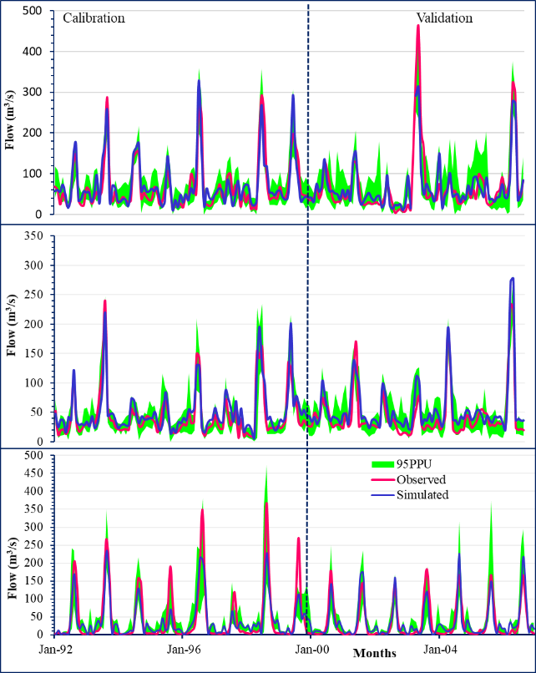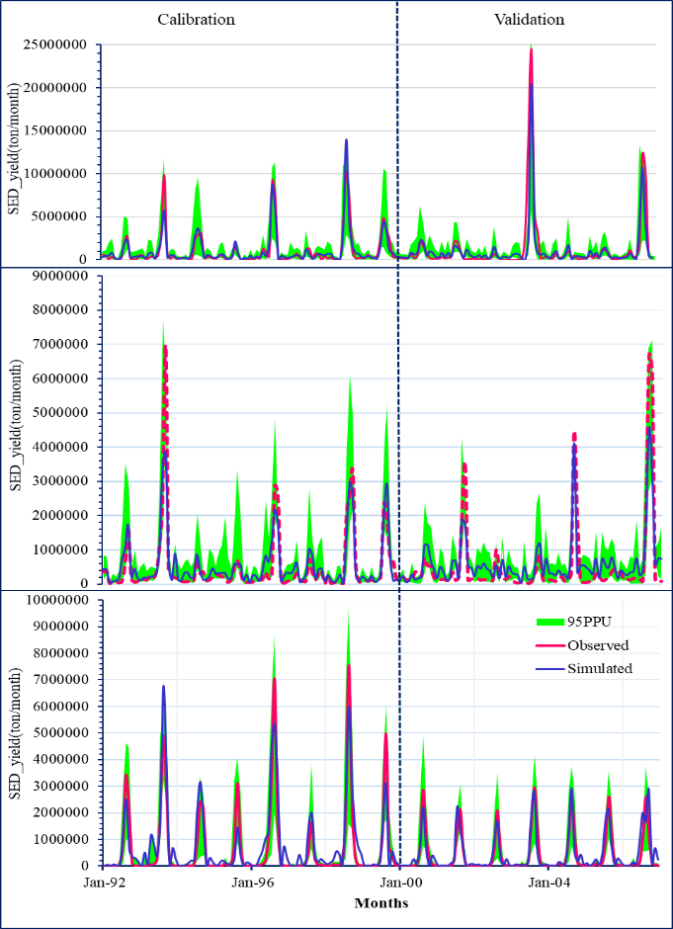
Figure 5. Monthly calibrated and validated sediment yield results at Awash (top), Metehra (middle) and Hombole (bottom) gauging station.

Figure 4. Monthly calibrated and validated flow results at Awash (top), Metehra (middle) and Hombole (bottom) gauging station.

Spatial and temporal variability of sediment yield

- Spatial variability

Following the successful calibration and validation of the flow and sediment yield, SWAT was run for 22 years (1992-2014) to get average annual sediment yield with sub-watershed level. In figure 6, the sediment outflow from each sub-watershed displayed. Accordingly, the variability of sediment yield for the entire sub-watershed has identified, and the predicted value ranges from 0.2 to 30.4 tons/ha/year with an average of 7.23 tons/ha/year (Figure 6). The sediment source map generated by using the average annual sediment yield from each sub-watershed based on erosion potential or sediment yield (ton/ha/year) (Figure 6). After simulation and calibration have performed, two sub-watersheds identified as very high sediment sources, seven sub-basins categorized as high sediment sources, nine sub-watersheds as moderately sediment sources, 17 sub-watersheds with low erosion and the remaining 34 sub-watersheds were shallow erosion-prone areas (Figure 6). These are an indicator of sustainable watershed management to control sedimentation (Anton et al., 2016), increasing the life span of reservoirs (Ezugwu, 2013).
For sediment yield rate, 11% (covering 12.7% of the total watershed area) of the sub-watershed is a critical source area and contributing 15-30.4 ton/ha/yr relatively higher; 13% of the sub-watersheds (covering 17.95% of the total watershed area) contribute relatively moderate (10-15tons /ha/yr), and the sub-watersheds covering 69.3% of the total area are contributing 0-10 ton/ha/year (Figure 6). Ranking of sub-watersheds based on their sediment yield rate (ton/ha/year) shows 19 sub-watersheds, which have a contribution of greater than 10 tons/ha/year, were identified (Figure 6).
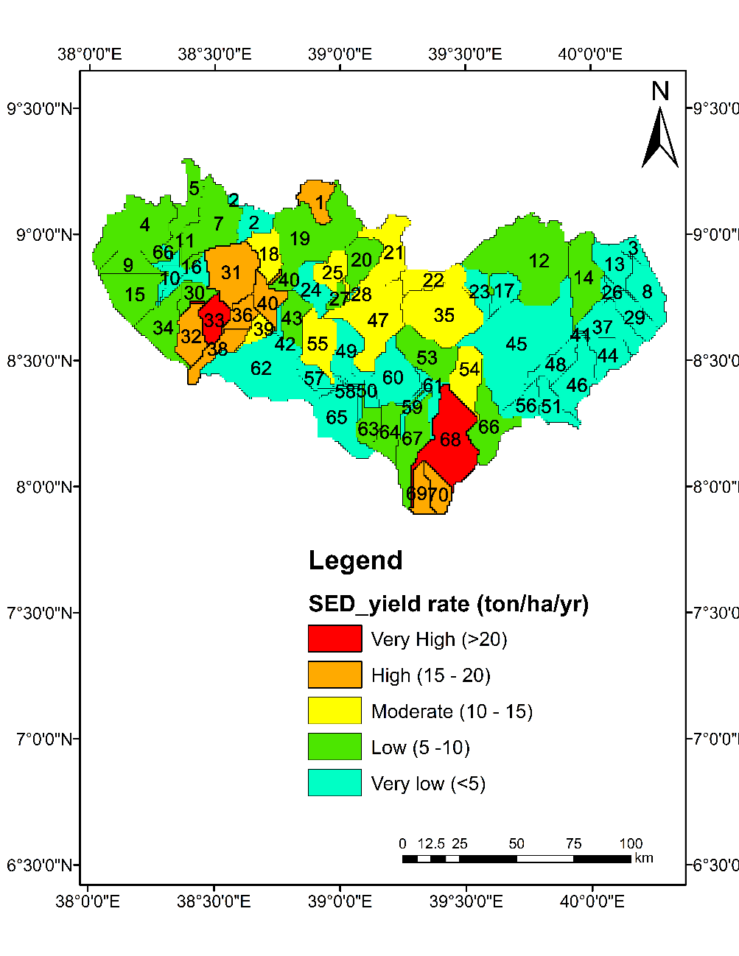

Figure 6. Variability of sediment yield in the proposed Middle Awash Dam watershed
As shown in table 7, sub-watersheds dominantly covered with agricultural land, grassland, shrublands and sparsely populated forest lands are the primary sources of sediment yield. Moreover, these sub-watersheds dominantly covered with Vertisols and Chromic Luvisols soil types (Figure 2). These indicated that these types of soil are the source of sedimentation. According to Virmani et al. (1994), Vertisols, Cambisols, and Luvisols can be affected by critical erosion problems. Among the 19 sub-watersheds ranked based on their sediment yield contributions, eight sub-watersheds have a slope greater than 5%, which is relatively steeper (Table 7).

Table 7. First 19 selected prioritized sub-watersheds based on sediment contribution.

When a seasonal and robust rainfall is associated with high intensity and high volume, such soils may be subjected to initiation to erosion. The most upstream sub-watersheds contribute most of the annual sediment yield. This upstream watershed sediment source is due to the frequent and intensive precipitation and runoff generated than the lower sub-watersheds (Figure 7).

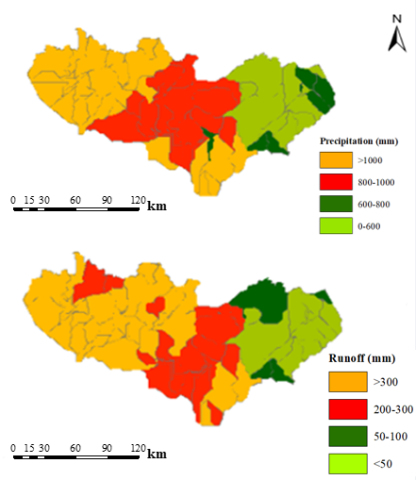

Figure 7. Spatial distribution of precipitation with the corresponding generated runoff.

b. Temporal variability

As the average monthly sediment yield graph estimated by the model (Figure 8), the sediment yield in each year increased during the months of high precipitation events. About 70.8% of the total annual sediment yield has occurred during July, August and September. The above temporal variability of sediment indicates surface runoff which is higher during July, August and September. In this study watershed, during these months' runoff was higher due to relatively higher precipitation occurrence. Likewise, in a monthly case, the watershed's annual sediment yields positively correlated with runoff and precipitation. For example, the maximum surface runoff occurred in 1996 and 2007, leading to maximum sediment yield with a mean annual rainfall of the year, which is relatively maximum. On the other hand, in 2002, relatively minimum precipitation was predicted and generated a relatively minimum runoff magnitude (114.27mm). This developed a proportionally minimum annual sediment yield of 6.4 tons/ha/year (Figure 8).

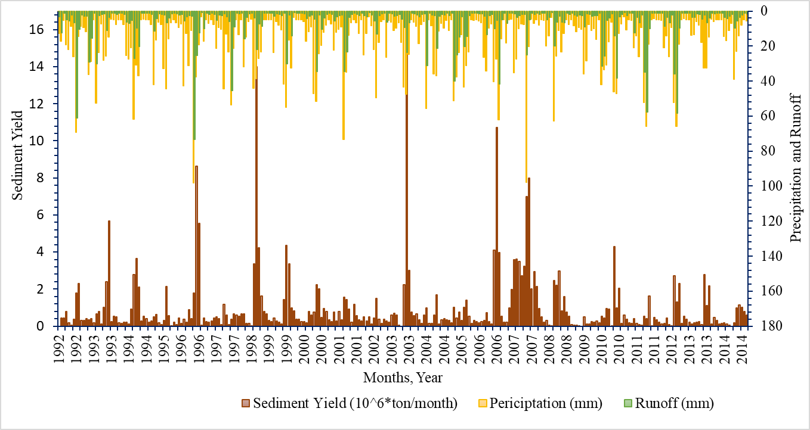
Figure 8. Monthly sediment yields potential variability and relation with Precipitation and runoff.
Conclusions

In this study, sediment yield characterization and identification of critical source areas attempted for the proposed Middle Awash Dam watershed. The entire watershed was subdivided into 70 sub-watersheds spatially linked by stream networks that take part in sediment source contribution. Multi-site calibration technique was applied. During calibration of flow, curve number was the first sensitive parameter. Similarly, the linear re-entrainment parameter for channel sediment routing was the most sensitive sediment parameter. The performance of the SWAT model was a perfect prediction ability. The watershed's average annual sediment yields informed that the watershed needs considerable management, about 30.65% of the total watershed area identified as a critical sediment source area. The majority of the required source area is relatively steeper in slope and dominantly covered with agricultural land, grassland and bushlands. The most upstream sub-watersheds are somewhat the source of sediment due to high runoff generated from high seasonal rainfall from July to September. In general, the model's performance has a strong predictive capability for the modelling of the hydrological process of the proposed Middle Awash Dam watershed for multi-site sediment yield calibration.

References

Abbaspour, K. C. (2014). User Manual for SWAT-CUP, SWAT Calibration and Uncertainty Analysis Programs. Swiss Federal Institute of Aquatic Science and Technology. Duebendorf, Switzerland, pp101.
Abbaspour, K. C., Rouholahnejad, E., Vaghefi, S., Srinivasan, R. & Klöve, B. (2015). Modelling hydrology and water quality of the European Continent at a subbasin scale: calibration of a high-resolution large-scale SWAT model. J. Hydrol., 524, 733–752.
Abbaspour, K. C., Vejdani, M., Haghighat, S., & Yang, J. (2007). SWAT-CUP calibration and uncertainty programs for SWAT. In: MODSIM 2007 international congress on modelling and simulation, modelling and simulation society of Australia and New Zealand, pp 1596–1602
Alemu, M. M. (2016). Integrated watershed management and sedimentation. Journal of Environmental Protection, 7(4), 490–494.
Anton, J. S., Franca, M. J., Juez, C., & De Cesare, G. (2016). Reservoir
sedimentation. J. Hydraul. Res., 54(6), 595–614.
Arnold, J. G., Haney, E. B., Kiniry, J. R., Neitsch, S. L., Srinivasan, R., Neitsch, S. L., & Williams, J. R. (2012). Soil and Water Assessment Tool (SWAT) theoretical documentation version 2012. Texas Water Resources Institute Technical Report No.439, pp650. College Station, Texas.
Azazh, B. (2008). Water Allocation Study of Upper Awash Valley for Existing and Future
Demands (From Koka Reservoir to Metehara Area). Addis Ababa University (M.Sc.
Thesis).
Berhe, F., Melesse, A., Hailu, D., Sileshi, Y. (2013). Catena MODSIM-based water allocation modeling of Awash River basin, Ethiopia. Catena, 109(2013), 118–128. doi: https://doi.org/10.1016/j.catena.2013.04.007
Bishaw, D., & Kedir, Y. (2015). Determining Sediment Load of Awash River entering into Metehara Sugarcane Irrigation Scheme, Ethiopia. Journal of Environment and Earth Science, 13, 224-3216.
Bossa, A.Y., Diekkrüger, B., Igué, A. M., & Gaiser, T. (2012). Analyzing the effects of different soil databases on modeling of hydrological processes and sediment yield in Benin (West Africa). Geoderma, 173–174, 61–74.
Brandt, A. (2000). A review of reservoir desiltation. International Journal of Sediment Research, 15(3), 321–342.
Briak, H., Moussadek, R., Aboumaria, K., & Mrabet, R. (2016). Assessing sediment yield in Kalaya gauged 16 watershed (northern Morocco) using GIS and SWAT model. Int. Soil Water Conserv. Res., 4, 177-185.
Buda, A. R., & DeWalle, D. R. (2009). Dynamics of stream nitrate sources and flow pathways during stormflows on urban, forest and agricultural watersheds in central Pennsylvania, USA. Hydrological Processes, 23, 3292–3305.
Chiang, L.C., Yuan, Y.P., Mehaffey, M., Jackson, M., Chaubey, I. (2014). Assessing SWAT’s performance in the kaskaskia river watershed as influenced by the number of calibration stations used. Hydrol. Process., 28, 676–687.
Clarke, R. T. (1994). Statistical modeling in Hydrology. John Wiley and Sons, pp 412.
Das, B., Jain, S., & Singh, S. (2019). Evaluation of multisite performance of SWAT model in the Gomti River Basin, India. Appl Water Sci, 9, 134. https://doi.org/10.1007/s13201-019-1013-x
DHV Consulting Engineers. (1983). Re-appraisal and design of irrigation system of the Metehara sugar estate and extension lands. Draft final report (main report), Ethiopian Sugar Corporation. Addis Ababa, Ethiopia.
Elshorbagy, A. A., Panu, U. S., & Simonovic, S. P. (2000). Group-based estimation of missing hydrological data: I. Approach and general methodology. Hydrological Sciences Journal, 45(6), 849-866. DOI: 10.1080/02626660009492388
Ezugwu, C. N. (2013). Sediment deposition in Nigeria reservoirs: impacts and control measures. Innov. Syst. Des. Eng., 4(15), 54–62.
FAO. (2002). Major Soils of the World. Land and Water Digital Media Series Food and Agricultural Organization of the United Nations, CD-ROM, Rome.
Golla, S., EL-Sersawy, H., Ahmed, A. A., & Vanacker, V. (2006). Modelling Water and Sediment Fluxes in Steep River Channels: Case of Awash Basin. International Conference of UNESCO Flanders FIT FRIEND/Nile Project - 'Towards a better cooperation', Date: 2005/11/12 - 2005/11/14, Location: Sharm El-Sheikh, Egypt.
Gupta, H.V., Sorooshian, S., & Yapo, P.O. (1999). Status of automatic calibration for hydrologic models: comparison with multilevel expert calibration. J Hydrol Eng., 4(2):135–143
Gyamfi, C., Ndambuki, J. M., & Salim, R. W. (2016). Application of SWAT model to the Olifants Basin: calibration, validation and uncertainty analysis. J Water Resour Prot., 8, 397–410.
Gyau-Boakye, P. & Schultz, G. A. (1994). Filling gaps in runoff time series in West Africa, Hydrological Sciences Journal, 39(6), 621-636.
Halcrow, W. (1989). Master Plan for the Development of Surface Water Resources in the Awash River Basin. Final Report, vol. 2, Ethiopian Valleys Development Authority, Addis Ababa.
Hallouz, F., Meddi, M., Mahé, G., Alirahmani, S., & Keddar, A. (2018). Modeling of discharge and sediment transport through the SWAT model in the basin of Harraza (northwest of Algeria). Water Science, 32, 79–88. https://doi.org/10.1016/j.wsj.2017.12.004
ICOLD. (2012). Sedimentation and sustainable use of reservoirs and river systems. International Committee on Large Dams, Bulletin 147
Kumar, N., Singh, S.K., Srivastava, P.K., & Narsimlu, B. (2017). SWAT model calibration and uncertainty analysis for streamflow prediction of the tons river basin, India, using sequential uncertainty fitting (SUFI-2) algorithm. Model Earth Syst Environ 3, 1–13
Le Roux. (2018). Sediment yield potential in South Africa’s only large river network without a dam: Implications for water resource management. Land Degradation and Development, 29(3), 765-775. https://doi.org/10.1002/ldr.2753
Lee, M., Park, G., Park, M., Park, J., Lee, J., & Kim, S. (2010). Evaluation of non-point source pollution reduction by applying Best Management Practices using a SWAT model and Quick Bird high-resolution satellite imagery, Journal of Environmental Science, 22, 819–833,
Li, Q. N., Zhang, J., & Gong, H.-L. (2017). Comparative study of multi-site uncertainty evaluation methods based on SWAT model. Yellow River, 39(1), 24–29.
Liu, Y., Yang, W., Yu, Z., Lung, I., & Gharabaghi, B. (2015). Estimating Sediment Yield from Upland and Channel Erosion at A Watershed Scale Using SWAT. Water Resource Management 29, 1399–1412.
Mamo, K. H. M., & Jain, M. K. (2013). Runoff and sediment modeling using SWAT in Gumera catchment, Ethiopia Open J. Mod. Hydrol., 3, 196-205.
Manaswi, C. M., & Thawait, A. K. (2014). Application of soil and water assessment tool for runoff modeling of Karam River basin in Madhya Pradesh. Int. J. Sci. Eng. Technol., 3(5), 529-532.
Monteith, J. L. (1965). Evaporation and the environment in the state and movement of water in living organisms, XIXth Symposium. Society for Experimental Biology, Swansea, Cambridge University Press. 205-234.
Moriasi D. N., Arnold J. G, Liew M. W., Bingner R. L., Haremel R. D., & Veith, T. L. (2007). Model Evaluation Guidelines for Systematic Quantification of Accuracy in Watershed Simulations. Journal of American Society of Agricultural and Biological Engineers, 50, 885-900.
Morris, G. L. & Fan, J. (1998). Reservoir Sedimentation Handbook, McGraw-Hill Book Co., New York.
MoWR (Ministry of Water Resources) (2002). Ethiopian Water Sector Stratagy, MoWR, Addis Ababa, Ethiopia.
Mutenyo, I., Nejadhashemi, A. P., Woznicki, S. A., & Giri, S. (2013). Evaluation of SWAT performance on a mountainous watershed in tropical Africa. Hydrol. Curr. Res., 6 No.Special Issue 3, S14:001 ref.38. DOI: 10.4172/2157-7587.S14-001
Nachtergaele, F., Velthuizen, H. Van, Verelst, L., Batjes, N. H., Dijkshoorn, K., & Engelen, V. W. P. (2010). The harmonized world soil database. Proceedings of the 19th World Congress of Soil Science, Soil Solutions for a Changing World, Brisbane, Australia (2010), pp. 34-37 1-6 August 2010. https://doi.org/3123
Nash, J. E., & Sutcliffe, J. V. (1970). River flow forecasting through conceptual models: Part 1. A discussion of principles. J. Hydrology, 10(3), 282-290.
Neitsch, S. L., Arnold, J. G., Kiniry, J. R., & Williams, K. W. K. (2005). Soil and Water Assessment Tool (SWAT) Theoretical Documentation, Version 2005. Texas: Grassland Soil and Water Research Laboratory, Black land Research Center, Texas Agricultural Experiment Station, Texas Water Resources Institute, College Station. Texas.
Neitsch, S. L., Arnold, J. R., Kiniry, J. R., & Williams, J. R. (2011). Soil and Water Assessment Tool (SWAT) Theoretical Documentation Version2009. Texas Water Resources Institute Technical Report No.406, Texas A&M University System, College Station, Texas.
Piniewski, M., & Okruszko, T. (2011). Multi‐site calibration and validation of the hydrological component of SWAT in a large lowland catchment. In Świątek D, Okruszko T (eds), Modelling of Hydrological Processes in the Narew Catchment, Springer-Verlag: Berlin Heidelberg; 15–41.
Qi, C., & Grunwald, S. (2005). GIS-based hydrologic modeling in the Sandusky watershed using SWAT. Trans ASABE, 48(1), 169–180
Samad, N., Chaudhry, M. H., Ashraf, M., Saleem, M., Hamid, Q., & Babar, U. (2016). Sediment yield assessment and identification of check dam sites for Rawal dam catchment. Arabian Journal of Geosciences, 9, 466.
Santhi, C., Arnold, J. G., Williams, J. R., Dugas, W. A., Srinivasan, R., & Hauck, L. M. (2001). Validation of the SWAT model on a large river basin with point and nonpoint sources. Journal of the American Water Resources Association, 37, 1169-1188.
Setegn, S. G., Bijan, D.i, Ragahavan, S., & Assefa, M. M. (2010). Modeling of Sediment Yield from Anjeni-Gauged Watershed, Ethiopia Using SWAT Model. Journal of the American Water Resources Association (JAWRA), 46(3), 514-526. doi:10.1111/j.1752-1688.2010.00431.x
Singh, V, Bankar, N, Salunkhe, S.S., Bera, A.K., & Sharma, J. R. (2013). Hydrological stream flow modelling on Tungabhadra catchment: parameterization and uncertainty analysis using SWAT CUP. Curr Sci, 104(9), 1187–1199.
Szezesniak, M. & Piniewski, M. (2015). Improvement of hydrological simulations by applying daily precipitation interpolation schemes in meso-scale catchment. Water, 7(2015), 747-779
Telles, T. S., Dechen, S. C. F., de Souza, L. G. A., & Guimarães, M. F. (2013). Valuation and assessment of soil erosion costs. Scientia Agricola, 70(3), 209–216.
Tesema, T. A., & Leta, O. T. (2020). Sediment Yield Estimation and Effect of Management Options on Sediment Yield of Kesem Dam Watershed, Awash Basin, Ethiopia, Scientific African, 10.1016/j.sciaf.2020.e00425, (e00425).
Van Liew, M. W., Arnold, J. G., & Bosch, D. D. (2005). Problems and potential of auto-calibrating a hydrologic model. Transactions of the ASAE. 48(3), 1025-1040. doi: 10.13031/ 2013.18514
Virmani, S. M., Katyal, J. C., Eswaran, H., & Abrol, I., eds. (1994). Stressed Agroecosystems and Sustainable Agriculture. New Delhi: Oxfoszezerd and IBH.
Wang, S., Zhang, Z., Sun, G., Strauss, P., Guo, J., Tang, Y., & Yao, A. (2012). Multi-site calibration, validation, and sensitivity analysis of the MIKE SHE Model for a large watershed in northern China. Hydrology and Earth System Sciences 16, 4621– 4632. DOI: 10.5194/hess-16-4621-2012
Waranyu Buakhao, & Anongrit Kangrang. (2016). DEM Resolution Impact on the Estimation of the Physical Characteristics of Watersheds by Using SWAT. Advances in Civil Engineering, https://doi.org/10.1155/2016/8180158
Welde, K. (2016). Identification and prioritization of sub watersheds for land and water management in Tekeze dam watershed, Northern Ethiopia. International Soil and Water Conservation Research, 4(1), 30-38.
WWDSE (Water Works Design and Supervision Enterprise). (2016). Middle Awash integrated Dam project, Draft Final Report. Addis Ababa, Ethiopia.
Xu, Z.X., Pang, J.P., Liu, C.M, & Li, J.Y. (2009). Assessment of runoff and sediment yield in the Miyun Reservoir catchment by using SWAT model. Hydrol Process 23:3619–3630
Xue, C, Chen B., & Wu, H. (2014). Parameter uncertainty analysis of surface flow and sediment yield in the Huolin Basin, China. Journal of Hydrologic Engineering, ASCE 19: 1224–1236.
Zeleke Agide. (2007). Modelling and optimization strategies of the main and field irrigation system in Metahara sugar estate, Ethiopia. MSc Thesis (WSE-HE-LWD-07-07).
Zhang, X. C., Zheng F. L., Chen, J., & Garbrecht, J. D. (2020). Characterizing detachment and transport processes of interrill soil erosion. Geoderma, 376. https://doi.org/10.1016/ j.geoderma.2020.114549

