

The preservation of provincial identity in baroque influenced artistic architectural structure at Kampung Cina, Terengganu

Nurkhazilah Idris¹, Tengku Intan Suzila T.S.², Liza Marziana Mohammad¹

¹ Faculty of Art & Design, Universiti Teknologi Mara, Kampus Alor Gajah, Melaka
²Academy of Language Studies, Universiti Teknologi Mara, Cawangan Pahang, Pahang

Correspondence: Tengku Intan Suzila T.S. (email: intansuzila@uitm.edu.my)

Received: 04 March 2021; Accepted: 07 May 2021; Published: 29 May 2021

Abstract

The states in the east of peninsular Malaysia are rich with unique cultural heritage. Congruently, Terengganu has a hidden treasure that has qualified it to be gazetted as one of the Malaysian heritage sites. The western Baroque artistic architectural is proposed as an analytical discussion in this article pertaining to the classical appreciation that are impressively portrayed on buildings at Kampung Cina, Kuala Terengganu. This study pursues to unfold the spectrum of the classical artistic western Baroque architectural elements’ influences, unfolding how stylization approach is incorporated, and to describe how provincial identity is preserved on buildings on the selected commercial buildings in Kampung Cina. The present study adopted qualitative approach with convenience sampling of the Kampung Cina, Terengganu buildings. Through visual evidence method, findings are revealed based on the simplistic visual impressionistic content comparison analysis. The findings suggest some strong evidence of geographical impact in relation to European Baroque inspirations that exist on these buildings. Yet, the complexity of the relationship with the local characteristics have commemorated this European flare. The intricacy of the relationship between provincial identity and colonialization is moderated by environmental characteristics which serve as an integral component in guiding the relationship between provincial identity to the state of great sophistication with the element of colonialization. Thus, the present study serves as a knowledge gateway to how colonial idealistic manifestation has impacted the local scene and how it has been mellowed by harmonization of strength and perseverance of provincial identity.

Keywords: Architecture, baroque element, commercial buildings, Kampung Cina, Kuala Terengganu, provincial identity

Introduction

There are varieties of building types that have been constructed in Malaysian towns since its colonialization periods until independence. Among these buildings are shop lots that became the pinnacle in its highest developmental activities. These commercial buildings are the birth of combination of intellectuality, creativity, and physical abilities of craftsmanship of the given time (Raja Nafida, 2007). The artistic architectural uniqueness attracts foreign visitors as it safeguards historical evidence and encompasses harmonious cultural treasure.
The Kampung Cina, Kuala Terengganu is distinguished as one of the Malaysian China Towns or Chinese Villages. It has been certified as part of the preservation record of Malaysian architectural history and the remembrance of its colonialization period (Abdul Halim, 2014; Teh, 2019). Aside from that, in 2004, the Malaysia government has declared the structure of these buildings as an architectural historical artefact collection thus gazette as one of the Malaysian heritage sites (Noor Aimran & Abdul Razak, 2017; Teh, 2019). It also portrays the soft touches of the art deco of post-modernism around the era of 1920s where ‘the history dates to the 18th century’ (A treasure trove of heritage sites, The Star, 2020). Therefore, it brings pride to the nation as an identity setting and a symbol of social integration that has been flourishing in many transcending years.
The observable spectrum of art deco post-modernism is part of the impact of British colonialization on Tanah Melayu. These beautiful British colonial classical motifs are apparent on buildings in Kampung Cina until today. Formalistically, post-war buildings physical features in Kampung Cina implement arts of wood carvings, bricks-based medium for concrete structure and the application of wooden flooring for the second floor which is exclusively for home living. In addition, it is also adorned by plaster media and ceramic based decorative elements. This architectural aesthetics has become the village pinnacle of Kampung Cina and that it has been certified as a national heritage site on the July 7, 2007 (Noor Aimran & Abdul Razak, 2017; Teh, 2019).
Daeng Haliza et al. (2014) reviewed several local researchers’ findings and called for ethics to be followed in Malaysian building restoration projects. Communities’ awareness, involvement and knowledge in the importance of heritage care is rather low despite the interest of the surveyed 27 respondents from Penang where 79.4% of them has never been involved in any restoration projects as it only involved responsible parties (Solihah et al., 2015). Similar studies are deemed necessary for the Kampung Cina, Kuala Terengganu.
The questions that guide the present study are how were the classical western Baroque artistic architectural elements adopted in Kampung Cina commercial buildings? and was stylization approach adopted in the classical western Baroque artistic architectural buildings in Kampung Cina, Terengganu? How was provincial identity preserved on buildings in Kampung Cina? The objectives of this study are to identify how the classical western Baroque artistic architectural elements were adopted in Kampung Cina and to unfold stylization approach incorporated in Kampung Cina buildings along with to describe how provincial identity is preserved on buildings in Kampung Cina.

Literature review

An analytical visual exploration of architectural buildings at Kampung Cina, Kuala Terengganu has advocated some aesthetic heritage splendour. The description of artistic elements Baroque European architectural style and its transfer onto local buildings in Malaysia artistic bring ethnic harmony to its dwellers’ environment. The fundamental of this harmony lies within the sensitivity towards provincial features.

Kampung Cina, Kuala Terengganu Revisited

Uncovering the regional history of Chinese migration to Terengganu, has insinuated a sea faring commercialization trade movement from the east and west. Its location where it is right in the path of the maritime silk route for the Chinese from mainland China to trade to the Middle East countries (Azarudin et al., 2018). Generally, the Terengganu state, or specifically the Kuala Terengganu town became an important offshore port in the 1720s (Teh, 2019). The Chinese dynasty authors have penned the glory of Kuala Terengganu as the main Southeast Asia twelve century commercial port and though exact date is unknown, Chinese trader had settled in Terengganu around the 16th century (Teh, 2019). It became the main route to sandalwood, laka and high-quality ivory trade with silver or gold (Noor Aimran & Abdul Razak, 2017). Pepper and gold exports were also available (Teh, 2019).
The east-west commercialization empire has posed a significant role on Terengganu as the centre of east Tanah Melayu trade. Consequently, a Chinese village emerged at the estuary of Kuala Terengganu River named Kampung Cina or China Town which had a row of shop lots of 1000 houses (Teh, 2019). It was a squatter area for Chinese traders since the beginning of early 15th century (Mohd Shahrul et al., 2015). As river water flows down-estuary on the right, Kuala Terengganu became the prime choice for wangkang (Chinese junk) to port as it was on the right-hand side of the estuary. Thus, Kuala Terengganu locality simplified wangkang docking (Nurkhazilah et al., 2014).
The Chinese traders learned and adopted the Malay Terengganu dialect to simplify communication among local dwellers who are also their customers. This is evidential in the memoir of legendary explorer Abdullah Munsyi where the Chinese in Kuala Terengganu is said to have high communication competency in Malay language (Nurkhazilah et al., 2014). Surveyed 86 Terengganu respondents have suggested that both the existence of China Town and the Chinese fluency in Malay language are evidence to be great commercial partnership between China and Terengganu government (Azarudin et al., 2018).
This success in trading and social assimilation through language have created a Chinese settlement in Kuala Terengganu until they successfully formed their architectural identity such as shop lots. The architectural structure of these Chinese shop lots in Kampung Cina, Kuala Terengganu adopted the use of high wooden stilts to avoid treats of water tide and flood. This resembled the architecture of dwellings in China mainland (Nurkhazilah et al., 2014). Nonetheless, design alterations are visible upon British colonialization. Syed Ahmad Jamal (2007) observed, “Colonial and European influences are also evident in their woodcraft. In comparison, later 19th-century Chinese migrants favoured more purely Sinic forms and motifs.” Elements of ethnic harmony are also visible.

Artistic elements and ethnic harmony

Harmonious ethnic relation is an essential element in Malaysia (Osman, 2015). As a multiracial country, any racial tension may create a not only socio-political hazards, but socio-economic peace may also be at risk. Malay Muslims, Indian and Chinese lived together side-by-side, once. In this Kampung Cina, Syed Abek a Muslim scholar live nearby and assisted Arab and middle eastern merchants (Teh, 2019) to do businesses with the Chinese. This created a positive social and economic integration.
Indian and Chinese traders who then assimilate in local Malay culture have economically and socially flourished together. Racial harmony in Malaysia can be achieved if one accurately comprehends the connotation of perceptions that precast a specific civilization socio-cultural and historical background (Arfah, 2017). The coherence between race in Malaysia is beyond verbal agreement but visibility evidential in buildings, food, and festive celebrations. Based on a study involving the community at Kampung Pulau Duyong, Kuala Terengganu has ranked symbolic value component the highest and economic value the lowest citing that the existence of modern-day physical development which are without the assimilation of local flare may create a trench between races and thus threaten the sustainability of local social community (Nur ‘Adilah et. al., 2020). Any inharmonious interferences shall damage the maintenance of life, intelligence and wealth (Mohammad Nidzam, 2017).
The pillar to a harmonious ethnic relation is said to achieve if it is based on shariah framework, nonetheless, good values play a significant function too that good values is the foundation for collision in building a corresponding fiqh ta’ayush (Mohammad Nidzam, 2017). The arrival of Islam to Tanah Melayu, has influenced Malay architecture led by Islamic values. Thus, when Islamic resurgence raised with features which include “to restore God’s rule and inaugurate a true Islamic social order, western-inspired civil codes must be replaced by Islamic law that although the westernization of society is condemned, modernization as such is not where science and technology are accepted, but they are to be subordinated to Islamic belief and values in order to guard against the Westernization and secularization of Muslim society (Mashitah & Anita, 2017: 397).” Mohamad Tajuddin (2017) too called for the value of inclusivity in Islamic designs. So, as these Chinese are living in proximity of Malays Muslims, they too abide to minimal representation of fauna as a symbol of harmonious ethnic relation. This is visible in the present study.

Baroque architectural style and transfer

The classical western Baroque artistic architectural features are founded on grandeur palace like decorative beauty as optical on churches in the 17th century yet in arts historical context, the term Baroque illustrate the western art period of 1600-1750 era to early 1900s (Zanlungo & Tarabra, 2012). This classical western Baroque artistic architectural is unique for its application fresco medium on walls and ceilings which enforces mythological element based on Christianity perspective (Muliyadi, 2013).
There are several terms that describe Baroque style. Conceptually, the Baroque classical style may also be defined as a western art era (Muhamad Nadzir, 2014). Literally, Baroque is defined as somethings that is complex, complicated, or incongruent, and yet generally reflects emotional ascend with exaggerated composition, post Renaissance yet confined (Muliyadi, 2013). It is the portrayal of European proud empire. While Wahiza (2011) describe Baroque as, “an Italian word that is ‘barocco’ which possibly can explain the concept behind the term ‘Baroque,’ ‘Barocco’ is a complex and complicated term. To this, Muliyadi (2013) further added that it is not from the Portugal word (barocco) which means a shape of a pearl. It is rather dark colours, dramatic phenomena elements with a spat of ideological light on subjects which produces shadowy effects that is also deemed as the main feature of the classical western Baroque artistic architectural (Muliyadi, 2013). To simplify these collective terms, Muliyadi (2013) further define the meaning of Baroque may tilt towards an inclination towards complicated decorations or intricate configuration (designs) and expressive with embellished masterpieces.
The incorporation of 1920s era artistic post-modernism art deco exquisiteness can be appreciated at every dwellings and commercial buildings which have stood for more than 200 years (Muhamad Nadzir, 2014). These buildings uniqueness majestically evoked the reminiscence of classical Baroque background on its artistic decorations. The Baroque era movement has been flaunted through artistic wood panel carvings on several artefact pieces such as the door panels, windows panels, and sill, including the walls of the buildings (Muhamad Nadzir, 2014). These features are boastfully reflected on the wood cravings of each door, windows even the building walls in shop lots in Kampung Cina, Terengganu. These grandeurs are then transferred to many colonized countries. It may have brought a sense of belonging to the colonizers in those foreign lands yet may suggest the sense of modernization and socio-economic status to the inhabited domains.

. 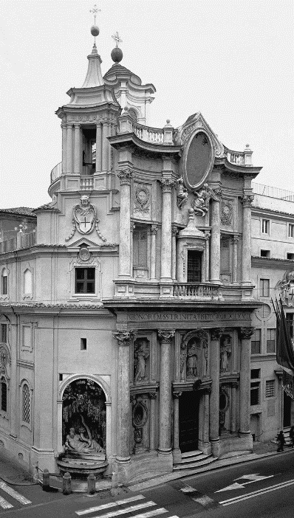
Source: https://decombo.com/barok-tarzi-mimari-ornekleri/

Figure 1. Baroque architectural of S. Carlo alle Quattro Fontane, Rome (1667) by Façade Borromini.

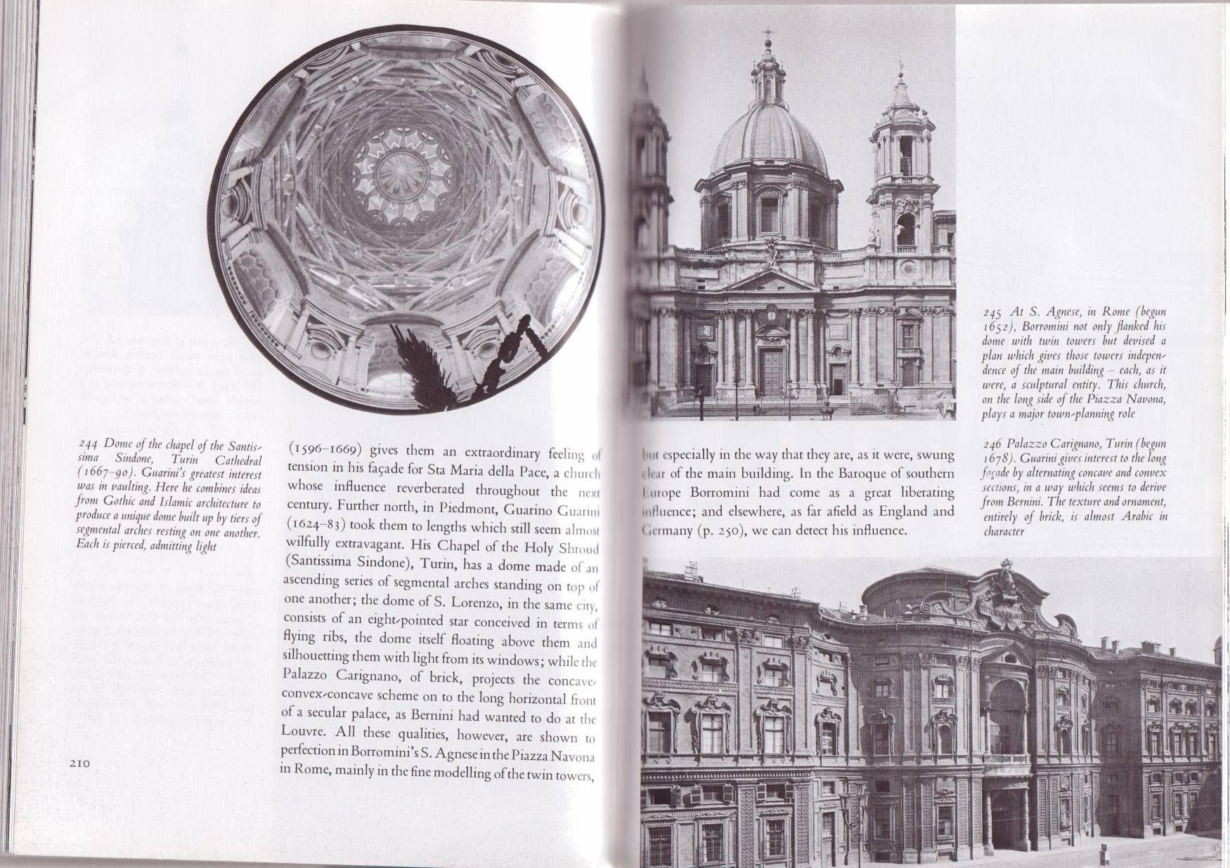

Source: Wahiza (2011)

Figure 2. Baroque architectural of the Palazzo Carignano, Turin (1678)

Definition of terms

Stylization

Stylization is an act to abide to an explicit customary style. In this study, stylization refers to an imitating process or being consistent to European palace-style design elements. It represents patterns or style conventionally specific to a Baroque stylistic pattern. This conforming to an idealistic value must be persistence and may suggest added values suitable to local flare.
Gagné (2020) suggested that style is “a dynamic resource for the creation and articulation of the self in interactional contexts.” In this study, European Baroque style is depicted in the buildings. Dyussenova and Samoilov (2020) notified that stylization do not always conceived as originally planned yet it must serve the purpose it was intended for. Tengku Anis Qarihah, et al., (2017) put stylistic character as level 4 in their 8-tier taxonomy chart of classical Malay architecture based on 50 studied Malay palaces. Their taxonomy of classical Malay architecture is a top-down taxonomy from the domain of classical architecture; kingdom of Malay World/nusantara; phylum – region 1 to 8; class of stylistic character, order of form, ration and proportion; level 6- family consisting building components, genus of building elements and lastly species which are the semantic names. Although the buildings sampled here are mostly of Chinese shop that functions as shop houses, they may suggest socio economic status of the owner and cannot be detached from the Malays original country residents and their neighbouring dwellers.

Provincial Features

Being one of the eastern states of peninsular Malaysia, Terengganu has rich provincial style. Arts and local provincial culture intertwined with lifestyle that projects artefacts in form of handicrafts, agricultural tools, furniture, jewelleries, ornaments even toys that reflects genuine regional style (Mohd Rohaizat et al., 2014). It is not absent of pronounced wood cravings. Mohd Rohaizat, et al., (2014) also noted five classification of wood carving in one of the six components of Terengganu perahu. This is paralleled with the emergence of wangkang (Chinese boat) manufacturing in the estuary of Kuala Terengganu.
In the 1900s, wood easily found in Terengganu as this is evidential in one of the oldest mosques in Terengganu that was originally built using wood in the period of Sultan Zainal Abidin II rulings before its expansion was finished by Sultan Zainal Abidin III in 1319 H or in the 1901 where motifs on wood was complete using a Malay wood craving technique called “sobekan” (Noor Hafiza et al., 2014). Hamdzun (2013) defined 18 flower motifs, 8 fauna, 9 cosmos, 1 geometrical 1 calligraphic types of Malay wood cravings.
In Terengganu, based on survey 57 respondents, the weight was always concerning local culture as wealthier enclosure of the cultural intelligences in a well-adjusted means to mould an all-inclusive comprehension of art, music, and literature and distinguish diverse social perceptions (Radha & Nurul Amalina, 2017). Culture is so important to the Terengganu people that provincial civilisation was realized to be the most generic (68%) even in teaching materials of English as foreign language (Cortazzi & Jin, 1999). This shows that the provincial elements are much more given respect and attention among the Terengganu people.
Tawfeeq et al. (2019) also put forth the significance of architecture and its achievement is to correlate to its deliverables to achieve demands the of users and guaranteeing all spaces comply with ones’ requirements and accomplish ones’ interest based on his 325 responses in Terengganu. For the Terengganu people, culture references are vital, thus, the aesthetic sense with local culture had the highest references (22 times) (Radha & Nurul Amalina, 2017). This involves celebrated personalities His Royal Highness (HRH) Al-Wathiqu Billah Sultan Mizan Zainal Abidin, Awang, Cik Lee, Ndak Raj (budak Raj), Pak Pandir as familiar titles; Kemaman, Redang Island as names references to locale; depictions and tags of local food such as keropok lekor, satar, nasi dagang, stuffed squid; and pictures and names of Terengganu’s Sultanate family and Royal Regalia (Radha & Nurul Amalina 2017) are among Terengganu pride. Local culture also prominently includes the dialect of Terengganu which is coda nasal (ŋ) which is also prominent among non-Malay descendants. These provincial features are not only significant in building social integration among races in Terengganu, they also mould Terengganu culture uniqueness derived from a strong sense of belonging despite being descendants of traders from China or India as seen in names such as Awang Teng, Cik Lee and Ndak Raj. Tawfeeq et al. (2019) further added that the notion of dwellings is beyond the existence persons walled or roomed, but rather being, sentiments, communication, evolution, and reciprocated encouragement. The focus is therefore towards space planning to ensure ultimate “rest and a sense of civilization” (Tawfeeq et al., 2019) within one’s environment.

Method

In Malaysian context, based on empirical document analysis there are five main constructs to determine the sustainability of heritage town which are economic prosperity, social, environmental and governmental and community harmony, and cultural heritage (Mohamad Khairul, 2020). Thus, the present study adapts the research framework of visual culture observation (Muliyadi & Mustaqim 2013). ‘Visual culture’ field of study enables detachment from theoretical studies thus enabling ‘visual studies’ which is more self-reflexive where the production of visual communication contributes to construct the visual culture in society (Muliyadi & Mustaqim, 2013:103).
Kampung Cina, Kuala Terengganu was visited, some buildings were photographed, and these pictures were compared to online sources for better quality pictures. These conveniently selected commercial building in Kampung Cina with visual evidential of the Baroque influences were analysed. Simplistic visual comparison analysis was carried out based on the available evidence of Baroque elements as in figures below. Coding of these elemental features were constructed where these evidential features were drawn out and listed based on features of Baroque described by Muliyadi (2013). This is a deductive analysis and predetermined codes are presented in Table 1. Then, content visual impressionistic comparison to the exhibited façade on the samples observed on commercial buildings in Kampung Cina, Terengganu were constituted.

Codes | Elements | Descriptions
Grandeur | European palace like decorations | Wealthy decorative refinements  Intricate Stone pillars / column  Elaborated archways
Exuberance | Sculptural | Exaggerated motion in decorations
Table 1. Coding to commercial buildings against Baroque features.

Findings and analysis

The Table 2 below summarize and guides the presentation of the findings and analysis. From the analysis, Figure 4 seems to barely fit in the two predetermined coding. On another note, symmetrical mirror image motifs placement is also a significant representation on motifs in almost all the samples. This is very common in many arrangements of artistic motifs. These are further discussed below.

Compliance | Non- compliance | Codes | Elements | Descriptions
Figure 3,5,6,7,8 | Figure  4 | Grandeur | European palace like decorations | Wealthy decorative refinements  Intricate Stone pillars / column  Elaborated archways
Figure 5,6,7,8 | Figure  3, 4 | Exuberance | Sculptural | Exaggerated motion in decorations
Table 2. Findings against Baroque features.

In Figure 3, the representation of coding 1 which is grandeur is observable. The archways are presented with depth and double ceramic carvings. Columns or stone pillars in the first two shop lots in Figure 3 suggest superiority over the shop lots evidential in Figure 4. However, wealthy decorative refinements on the pillars are minimally visible in Figure 3 without the elements of exaggerated motion in decorations despite the having arch ways (see Figure 3). The second coding – exuberance is therefore a non-compliance.

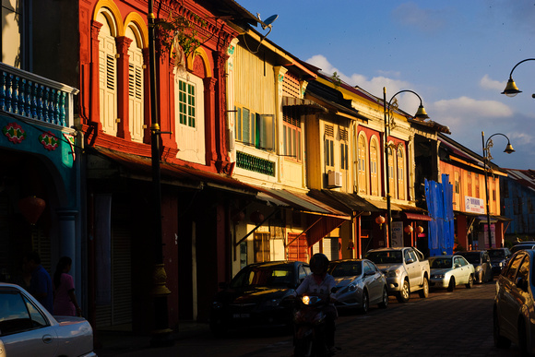

Source: http://zain.zanfolio.com/ktchinatown/e537c9764

Figure 3. Shophouses cum dwellings in Kampung Cina.

Figure 4 refers to a shop house that is about 3 shop lots away from those of Figure 3. Despite being in a similar row, the shop houses in Figure 4 shows minimal decorations thus minor accordance to the coding to insinuate Baroque influences. The archways are flat with very simple decorations. The sense of palace-like façade is not visible. This is a stylization or copy that has failed. Yet, the attempt gesture is acknowledged as it was significant to ensure status and such grandness was made. Social economic status influences might have played a role here.

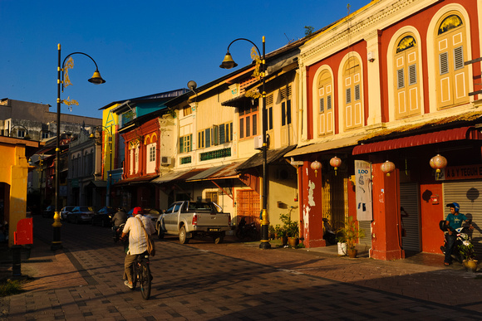

Source: http://zain.zanfolio.com/ktchinatown/e537c9764

Figure 4. Shop houses panorama in Kampung Cina.

The insertion of Baroque art design is visible in Figure 5. The incorporation of column structures gives an illusion of the old European classical palaces style. The upper portion the commercial building walls are softened with the beauty of arabesque motifs which symbolize the old Malay Archipelago traditions. These arabesques also sculptured in a manner to promote exuberance. Thus, both coding 1 and 2 are complied.
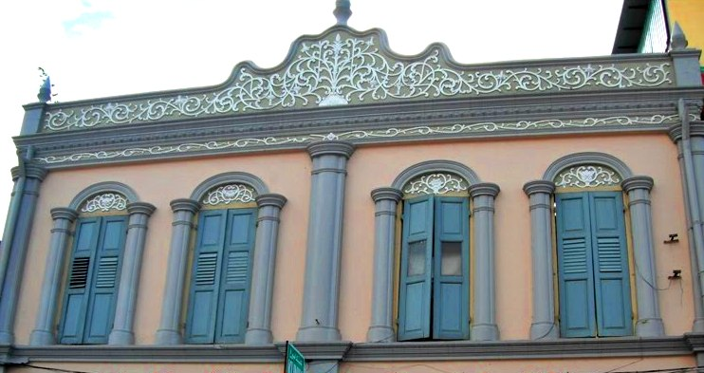
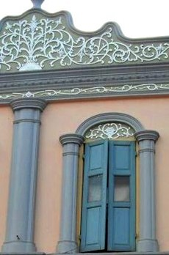

Arabesque motif

Stylization element on columns from Baroque style

Source: Left: http://architecture.blogspot.com/2011/03/kampung-cina-in-kuala-terengganu.html. Right: Nurkhazilah Idris
Figure 5. Stylization of stone pillars

Source: Left: http://architecture.blogspot.com/2011/03/kampung-cina-in-kuala terengganu.html.
Right: Nurkhazilah Idris et al. (2014)

Figure 5. Stylization of stone pillars.

Figure 6 shows the similar Baroque classical style yet stylization of columns in Figure 6 is much prominent than those in Figure 5. In Figure 6, the stone pillars are squared unlike the cylinder columns in Figure 5. As opposed to the squared columns seen in Figure 2 which are very much elaborated with several smaller intrigued motifs, those in Figure 6 are occupied with merely two simples rectangular. These stone pillars / column still confirm the coding of grandeur.
Another prominent finding that supports the concept of stylization in Kampung Cina, Terengganu commercial buildings are the Malay arabesque decoration. The motif of Malay most iconic and cunning animal that is the mousedeer (Hamdzun, 2013) is prominent. The mousedeer is known for its witty tricks’ personification in Malay folklores like “The mousedeer and the crocodile.” In this story, the mousedeer tricks the crocodile to line up for it to cross over the river, thus the mousedeer seen in Figure 6 appears to leaping. Baroque feature of exuberance transpires thus confirming the stylization application.
The arabesque floral motifs are strong Malay element which is also seen in many fine paintings and gold thread royalty songket cloth. These motifs also can be distinguished by its four to eight patels which abide to a vector arrangement. Bunga tabur (scattered floral decorative) or tapak manggis (mangosteen bud) are among two common Malay floral decorative.
Despite that, the Chinese beliefs that the lotus flower which also have symbolizes purity and divine birth has eight patels flowers as seen in Figure 6. That represents the wheel of life with eight laws of life (www.bbc.co.uk, 2014). It is said 'without the lotus there is no Hinduism or Buddhism’ when looking at the meaning of lotus flowers in Indian culture (www.bbc.co.uk, 1993). Therefore, the integration of floral motif here could represent both traditional cultures.
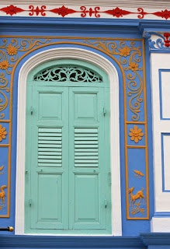
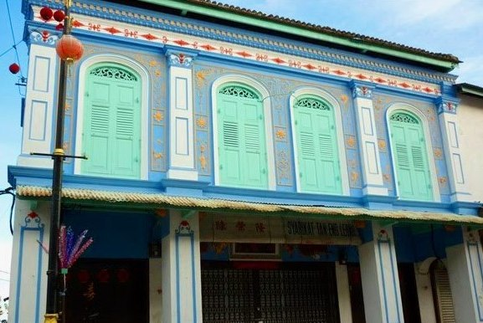

Malay arabesque motif (flora)
Animal Motif (fauna)

Source: http://2.bp.blogspot.com/_fQqla9QmQ4/TM08Veh2JOI/AAAAAAAACjU/Exncvlgbl7s/s1600/33511_ 142791585750643_1359979963755_300759_851229_n.jpg; http://zain.zenfolio/ktchinatown/e537c9760

Figure 6. Embedded local motifs.

Harmoniously, Chinese ritual pot is placed at three main pillars that divides the rooms in the building in Figure 7. To honour the sensitivity of local Malays, these ritual pots are only placed on three out of seven pillars. This would minimize the portrayal of foreign religious impact. Stylization concept is thus transpired here too.
Assimilation of vibrant colours which is a Chinese element in Barogue classical building’s structure is observed in Figure 7. Yellow, orange, teal and red are used. However, the pastel Baroque colours are retained as the background in blue and off-white ivory colour. These colours are acceptable to the local Malays too. In Figure 8, colours opted are golden brown as background, hinted with yellow and marron.

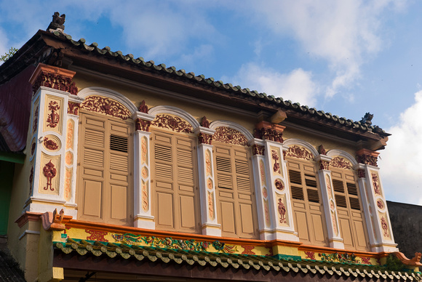
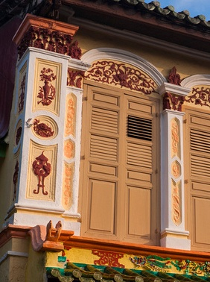
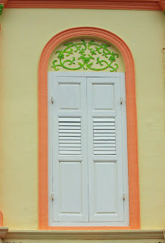

Motif from Chinese praying pots

Source: http://zainabdullah.wordpre.co,/2013/02/07/chinatown_of_kuala_terengganu/one of the shop houses with Neoclassical architectural style mixed with-Chinese-influence motifs

Figure 7. Embedded chinese motifs.

Figure 8 exhibits pillar heads with Baroque era artistic decorative which are incorporated with local elements. This again correspond with the stylification approach. The local featured here includes aesthetic Malay traditional arabesque wooden carving from local Terengganu Malays who are well-known for their ability to produce fine wood carvings (Fahrijah Faisal & Mastor Surat, 2014).

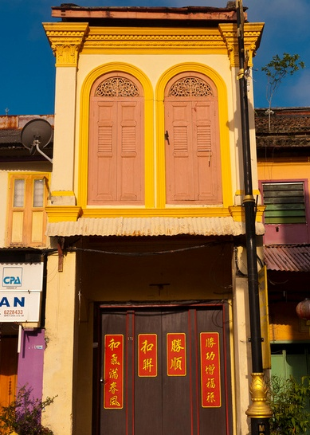
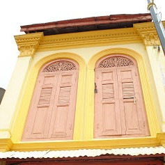
Wooden window panels
Pillar head structure Baroque era

Wood carvings ood carvings

Source: Left: http://architecture.blogspot.com/2011/03/kampung-cina-in-kuala-terengganu.html.
Right: Nurkhazilah Idris et al., (2014)

Figure 8. Baroque sculptured pillars and Malay wood cravings.

Discussion

Observation findings on conveniently selected samples suggest that buildings in Kampung Cina have incorporated the classical western Baroque artistic architectural through insertion of European palace-style decoration especially in terms of building construction structure using stone columns and motifs medium to imply cultural congruence.
In describing the classical western Baroque artistic architectural elements adopted in Kampung Cina commercial buildings, coding in content analysis was performed. Grandeur and exuberance are the two best adjectives to classify the classical western Baroque artistic architectural elements adopted in Kampung Cina commercial buildings. Wealthy decorative refinements include motifs of arabesque, flora vines and additional elements of wood carvings. The intricate stone pillars / column even has depiction of luxurious Chinese pots. Elaborated archways European palace like decorations may appear with double ceramic cravings while exaggerated motion in sculptural decorations is seen in magnificence arabesque 20-feet scale. If such classification failed to conform that the copy is acknowledged as mediocre attempt thus might negatively be reflecting on the owners’ socio-economic status. This is in accordance to Wahiza (2011).
The stylization approach was adopted in the classical western Baroque artistic architectural buildings in Kampung Cina, Terengganu. In Kampung Cina, European Baroque stylization is transferred to the architectural of commercial buildings. Stylization approach exposed in these findings show congruous integration of local and foreign artistic decorative adopted in Kampung Cina, Terengganu. The stylization configuration is adopted in the observed samples correlates to the Gange (2020) and partially parallel to Dyussenova and Samoilov (2020).
Provincial identity in Kampung Cina is preserved on buildings by adopting stylization approach. The stylization approach transmission is ingeniously not assimilating all components of the classical western Baroque artistic architectural features. The copy was only an illusion and the local culture aesthetics was harmoniously instilled. The local culture aesthetics was evidential in formal elements through traditional Chinese colours and motifs embedded with Malay element in Malay Archipelago.
Although served as a trading port to the Chinese, these Chinese respected the local Malay touches while embracing the classical western Baroque artistic architectural grandeur and exuberance facets to imply status. Kampung Cina decorative arts embraced Chinese characteristic with care for local sentiments. This suggests a second-tier stylization. While including Malay features, depiction of Chinese characters is not forgotten. Chinese pots and some dragon-like movement ornaments (Figure 7) are assimilated alongside Malay arabesque. This is to ensure social harmony which appropriate to Tawfeeq, et al., (2019) study.
Representation of fauna in Malay architecture is no longer prominent upon the arrival of Islam to Tanah Melayu. Westernization and secularization of Muslim society are to be secondary to Islamic belief and values (Mashitah & Anita, 2017). Thus, Chinese living in proximity of Malays too tolerate to marginal depiction of fauna as a symbol of good values (Mohammad Nidzam, 2017) between races. This is seen in only one sang kancil illustration.

Conclusion

This research among others was carried out as a mean of heritage documentation of the classical western Baroque artistic architectural influences on buildings Kampung Cina, Kuala Terengganu. Unique artistic architectural buildings in Kampung Cina which gathered history and national heritage that is eroded due to modernization includes the European arabesque, stylization that maintain provincial flare and harmonized with local traditions. Thus, it is significant to retain and preserve any potentially recollection of national history as depicted by the buildings in Kampung Cina which currently is also serving as a tourist attraction to Malaysia and specifically Terengganu. Mohamad Tajuddin Rasdi (2010) claimed, “Architectural work in that period has its own spirit of times or soul in accordance with times and has spirit of place or local soul”. It is hoped that this study could act as a bridge to knowledge which connects the readers to the manifestation of western architectural ideology in Malaysia. This western manifestation has coherently managed to immigrate and merged with local cultural traditions.

References

Abdul Halim A. (2014). Kisi-kisi warisan Terengganu. In Abdul Halim Ali, Mazda, M., & Ahmad Nizam O. (Eds.). Kisi-kisi warisan Terengganu. Budiman. Perak. https://anyflip.com/wkan/tkam.
Arfah Ab. Majid. (2017). Burgeoning of Islamic cultures and lifestyles in Malaysia: conservatism revisited. In Mashitah Sulaiman, & Anita Ismail (Eds.), Proceeding of Tamadun, Etnik & Turath Islami (I-STET) (pp. 275-282). Bandar Baru Nilai, Pusat Pengajian Teras, Universiti Sains Islam Malaysia.
Azarudin, A., Azman C.M., & Wahairi M., (2018). Kesepaduan budaya Melayu dalam kehidupan komuniti Cina Muslim di negeri Terengganu. Jurnal Kemanusiaan, 16(1). https://jurnalkemanusiaan.utm.my/index.php/kemanusiaan/article/view/239.
British Broadcast Company. (1993). Language of flower, the lotus flower in India. https://www.bbc.co.uk/sounds/play/p033k0jt.

British Broadcast Company. (2014). Tibetan prayer wheel. http://www.bbc.co.uk/ahistoryoftheworld/objects/YkfROsEyS5OpzHbjlGuQDw.
British broadcast company. (2019). Schools and religion. http://www.bbc.co.u/schools/buddism/introduction_questions.shtml.
Cortazzi, M., & Jin, L. (1999). Cultural mirrors, materials and methods in the EFL classroom. In Hinkel, E. (Ed.), Culture in Second Language Teaching and Learning (pp. 196-219). USA, Cambridge University Press.
Daeng Haliza Daeng Jamal, Zuliskandar Ramli, & Mastor Surat (2014). Penyesuaigunaan semula bangunan bersejarah di Malaysia: Isu dan cabarannya. In Zuliskandar Ramli, Mohd Samsudin, Nik Hassan Shuhaimi Nik Abd. Rahman, Ros Mahwati Ahmad Zakaria, & Mohd Rohaizat Abdul Wahab (Eds.), Prosiding Seminar Antarabangsa Ke-3 Arkeologi, Sejarah dan Budaya di Alam Melayu (pp. 443). Bangi, Institut Alam dan Tamadun Melayu (ATMA), Universiti Kebangsaan Malaysia.
Dyussenova D.G., & Samoilov K.I. (2020). The creation of a stylistic image of the crematorium building. Наука и образование сегодня, 4(5). https://publikacija.ru/images/PDF/2020/ 51/Science-and-education-today-4-51-.pdf#page=77.
Fahrijah Faisal, & Mastor Surat. (2014). Perwatakan seni bina warisan Banjar di Kalimantan Selatan-Indonesia. In Zuliskandar Ramli, Mohd Samsudin, Nik Hassan Shuhaimi Nik Abd. Rahman, Ros Mahwati Ahmad Zakaria, & Mohd Rohaizat Abdul Wahab (Eds.), Prosiding Seminar Antarabangsa Ke-3 Arkeologi, Sejarah dan Budaya di Alam Melayu (pp. 443). Bangi, Institut Alam dan Tamadun Melayu (ATMA), Universiti Kebangsaan Malaysia.
Gagné, I. (2020). Style and stylization. The International Encyclopaedia of Linguistic Anthropology, 76-79. https://doi.org/10.1002/9781118786093.iela0372.
Hamdzun Haron. (2013). Akal rekaan pandai seni warisan Melayu. Bangi, Institut Alam dan Tamadun Melayu.

http://des-world-of-architecture.blogspot.com/2011/03/kampung-cina-in-kuala-terengganu.html.
http://www.taylorstimes.com/issue04/achievements-recognition-knowing-kampung-china-through-arts.php.
Mashitah Sulaiman, & Anita Ismail. (2017). Western and Muslim scholars’ discourse on the concept and characteristics of Islamic resurgence in the Muslim world. In Mashitah Sulaiman, & Anita Ismail (Eds.), Proceeding of Tamadun, Etnik & Turath Islami (I-STET) (pp. 388-401). Bandar Baru Nilai, Pusat Pengajian Teras, Universiti Sains Islam Malaysia.
Mohamad Khairul Anuar Ghazali, Yazid Saleh, & Hanifah Mahat. (2020). Pembinaan kerangka konstruk kelestarian bandar warisan di Malaysia. Geografia-Malaysian Journal of Society and Space, 17(1), 211-226. https://doi.org/10.17576/geo-2021-1701-16
Mohamad Tajuddin Rasdi, & Nangkula Utaberta. (2010). The design of mosques as community development centres from the perspective of the Sunna and Wright’s organic architecture. Journal of Islamic Architecture 1(1), 1-7. doi: https://Doi.Org/10.18860/Jia.V1i1.1710.
Mohamad Tajuddin Rasdi. (2017). Contextualism in mosque architecture: Bridging the social and political divide. Journal of Islamic Architecture, 4(4), 181-187. doi: https://Doi.Org/10.18860/Jia.V4i4.4469.
Mohammad Nidzam Abdul Kadir. (2017). Antara hukum dan nilai mulia dalam hubungan etnik. In Mashitah Sulaiman, & Anita Ismail. (Eds.), Proceeding of Tamadun, Etnik & Turath Islami (I-STET) (pp. 210-2015). Bandar Baru Nilai, Pusat Pengajian Teras, Universiti Sains Islam Malaysia.
Mohd Rohaizat Abdul Wahab, Nik Hassan Shuhaimi Nik Abdul Rahman, Zuliskandar Ramli, Ros Mahwati Ahmad Zakaria, Ahmad Helmi Mohd Mukhtar, Hasnira Hassan, Norlelawaty Haron, Salina Abdul Manan, & Mohd Shafiq Mohd Ali. (2014). Bentuk-bentuk bangau pada perahu tradisional di Pantai Timur menyingkap sisipan elemen tradisional Melayu di Kampung Cina. In Zuliskandar Ramli, Mohd Samsudin, Nik Hassan Shuhaimi Nik Abd. Rahman, Ros Mahwati Ahmad Zakaria, & Mohd Rohaizat Abdul Wahab (Eds.). Prosiding Seminar Antarabangsa Ke-3 Arkeologi, Sejarah dan Budaya di Alam Melayu. Bangi, Institut Alam dan Tamadun Melayu (ATMA), Universiti Kebangsaan Malaysia.

Mohd Shahrul Imran, Lim Abdullah, & Reevany Bustami. (2015). Evolution and identity of the Kelantan Peranakan Chinese: Issues and challenges. International Journal of Multicultural and Multireligious Understanding, 2(1), 1-17.
DOI: http://dx.doi.org/10.18415/ijmmu.v2i1.8.
Muhamad Nadzir, I., Tuan Ederos, T.J., Muhammad Hasbi, A.R., Mazdi, M., & Mohd Abdul Nasir, A.L. (2014). Pelancongan warisan: Menyingkap potensi Kampung Cina, Kuala Terengganu. In Abdul Halim Ali, Mazda, M., & Ahmad Nizam O. (Eds.). Kisi-kisi warisan Terengganu. Budiman, Perak. https://anyflip.com/wkan/tkam
Muliyadi Mahamood, & Mustaqim, Karna. (2013). I draw therefore I am: Drawing as visual (communication) studies. ITB Journal of Visual Art and Design, 4, 103-118. 10.5614/itbj.vad.2013.4.2.2.
Muliyadi Mahamood. (2013) Seni abad ke-17: Seni Baroque. http://psv3.blogspot.com/ 2013/09/seni-abad-ke-17-seni-baroque-prof.html
Noor Aimran, S., & Abdul Razak, J. (2017). Kuala Terengganu “Waterfront Heritage City” – “Heritage” disrespecting heritage. Proceedings of 14th International Congress of Asian Planning Schools Association https://www.academia.edu/35447285/ Kuala_Terengganu_Waterfront_Heritage_City_Heritage_Disrespecting_Heritage
Noor Hafiza Ismail, Hamdzun Haron, Zuliskandar Ramli, Salina Abdul Manan, & Azni Hanim Hamzah. (2014). Motif ukiran kayu pada mimbar masjid Terengganu. In Zuliskandar Ramli, Mohd Samsudin, Nik Hassan Shuhaimi Nik Abd. Rahman, Ros Mahwati Ahmad Zakaria, & Mohd Rohaizat Abdul Wahab (Eds.). Prosiding Seminar Antarabangsa Ke-3 Arkeologi, Sejarah dan Budaya di Alam Melayu (pp. 189-200). Bangi, Institut Alam dan Tamadun Melayu (ATMA), Universiti Kebangsaan Malaysia.
Nur ‘Adilah Hassan, Nor Zalina Harun, & Noordeyana Tambi. (2020) Nilai simbolik sebagai penunjuk kelestarian modal sosial petempatan tradisional di Kuala Terengganu, Malaysia. Geografia-Malaysian Journal of Society and Space, 16(3), 201-218. https://doi.org/10.17576/geo-2020-1603-15.
Nurkhazilah Idris, Liza Marziana Haji Mohammad Noh, Shaliza Dasuki, Fazlina Mohd Radzi, Nurhasliza Abdullah, & Nurhikmah Mat Yusof. (2014). Menyingkap sisipan elemen tradisional Melayu di Kampung Cina. In Zuliskandar Ramli, Mohd Samsudin, Nik Hassan Shuhaimi Nik Abd. Rahman, Ros Mahwati Ahmad Zakaria, & Mohd Rohaizat Abdul Wahab (Eds.) Prosiding Seminar Antarabangsa Ke-3 Arkeologi, Sejarah dan Budaya di Alam Melayu. Bangi, Institut Alam dan Tamadun Melayu (ATMA), Universiti Kebangsaan Malaysia.
Osman Bakar et al., (2015). Modul pengajian Tamadun Islam dan Tamadun Asia. Kuala Lumpur, Penerbit Universiti Malaya.
Radha M.K.N., & Nurul Amalina, A. (2017). Integrating local knowledge into language learning: A study on the Your Language My Culture (YLMC) Project. Arab World English Journal, 8(4), 167-182. https://papers.ssrn.com/sol3/papers.cfm? abstract_id=3094531.
Raja Nafida, R. S. (2007). Kajian tipologi rumah kedai awal era Belanda di Bandar Melaka: Sumbangan kepada bidang pemuliharaan di Malaysia (Tesis Doktor Falsafah, Universiti Sains Malaysia). http://eprints.usm.my/31142/1/RAJA_NAFIDA_BINTI_ RAJA_SHAHMINAN.pdf
Solihah Mustafa, Mazdi Marzuki, Ruzanna Syamimi Ramli, Jabil Mapjabil, Mohammad Kadir Zainal Abidin, & Mohamad Pirdaus Yusoh. (2015). Pengurusan bandar warisan UNESCO dan penglibatan komuniti tempatan: Kajian kes di George Town, Pulau Pinang. Geografia-Malaysian Journal of Society and Space, 11(12), 87-99.
Syed Ahmad Jamal. (2007). Crafts and the visual arts. Kuala Lumpur, Editions Dedier Millet.
Tawfeeq A., Mohd Hisham O., Marzuki I., Hisham L., & Salem A. (2019). Space planning factors of Terengganu traditional house. Journal of Scientific Research and Engineering Development, 2(2), 568-576.

Teh Leam Seng. (2019). Cultural melting pot in Kampung Cina. The New Straits Time. http://www.nst.com.my/lifestyle/pulse/2019/02/459719/cultural-melting-pot-kampung-cina.
Tengku Anis Qarihah, Puteri Shireen, Norwina, & Noor Hanita. (2017). Classifying the early modern stylistic tendencies of classical Malay palaces in a taxonomy of hybrid architectural language. https://www.researchgate.net/profile/Shireen-Jahn-Kassim/publication/329962814_INHERIT77_Classifying_the_Early_Modern_Stylistic_Tendencies_of_Classical_Malay_Palaces_in_a_Taxonomy_of_Hybrid_Architectural_Language/links/5ebf5711458515626cac9a9f/INHERIT77-Classifying-the-Early-Modern-Stylistic-Tendencies-of-Classical-Malay-Palaces-in-a-Taxonomy-of-Hybrid-Architectural-Language.pdf.
The Star. (2020). A treasure trove of heritage sites. https://www.thestar.com.my/metro/metro-news/2020/12/16/a-treasure-trove-of-heritage-sites.
Wahiza Abdul Rahman. (2011). Sejarah seni lukis & seni reka: Satu pengenalan. Selangor. PTS Enterprise.
Zanlungo, C., & Tarabra, D. (2012). The story of Baroque architecture. Munich, Prestel.

