

Sustainability of urban recreational waterfront development in Colombo urban area, Sri Lanka

D.U. Rathnaweera, K.G.P.K. Weerakoon

Department of Estate Management and Valuation, University of Sri Jayewardenepura, Sri Lanka

Correspondence: K.G.P.K. Weerakoon (kgpk@sjp.ac.lk)

Received: 30 April 2021; Accepted: 23 October 2021; Published: 30 November 2021

Abstract

Cities in the twenty-first century recognized water's worth as a symbolic and spatial interpretive element. For city people who live in congested urban environments, waterfront areas provide excellent outdoor recreation and leisure opportunities. It revitalizes and arranges urban environments while avoiding the creation of spatial boundaries. It increases the value of urban environments and can help individuals visualize a specific image in their heads. The development of waterfront areas allows for the proper integration of human activities and agglomerations in an increasingly vulnerable and deteriorating environment. Consequently, the sustainability of waterfront development is vital for urban planning. Colombo urban area of Sri Lanka focusing on recreational waterfront development projects in recent years. Now is the time to pay attention to assessing the sustainability of these projects. This research evaluated this gap, with the aim of evaluating the sustainability of urban recreational waterfront development initiatives in the Colombo Urban Area. Primary and secondary data sources are used in a qualitative research approach. Observations and interviews are used to gather primary data. Using a judgmental sampling technique, structured interviews were conducted with professionals involved in Sri Lankan urban recreational waterfront development projects. Content analysis was used as a method of qualitative data analysis. The study outcome discovered that six environmental factors, three economic factors, and seven social factors contribute to the long-term sustainability of urban recreational waterfront development projects in Sri Lanka. The paper concludes with recommendations on sustainable measures in Colombo waterfront development and a well-designed waterfront that respects community aspirations.

Keywords: Economic factors, environmental factors, recreational waterfront development, social factors, sustainability, water retention

Introduction

Development of part of the town near waterbodies river or the sea is an urban waterfront development. Consequently, the urban waterfront is more than a stretch of land, with a network of places and functions linking water and the ground (Riham, 2017; Pramesti, 2017; Niemann & Werner, 2016; Roux, 2015). It plays a significant role in refreshing leisure in an urban area that gives people many values such as flood management, ecological and environmental balance, and control of urban heat (Aerts, & Botzen, 2011). Therefore, urban waterfront development has become so inescapable and identical to contemporary urban development due to urbanization (Davidson, 2020). In the 1950s, cities accommodated 30% of the world's population. In 2014, it was 54 percent (percent), and by 2020, it would be 56.2 percent (%). (Katharina, 2020)
As per the population predictions, it is projected to increase to 8.5 billion in 2030 and 9.7 billion in 2050. Rapid urbanization has led to extensive land-use change and increased demand for production factors such as capital, labor, natural resources like land, water, air, or landscape, and consumption factors of infrastructure, housing, working areas, recreation, etc. This process pressures urban land resources, exclusively agricultural lands, water bodies, wetlands, and lowlands in urban areas with associated issues, high urban resource depletion, depressed living standards, the spread of epidemics, and environmental degradation flooding over encroachment of water logging areas. Indeed, urban waterfront development aims to develop cities in the light of these vicissitudes while performing as a boundary demarcation to avoid unauthorized constructions or encroachments across the great attraction of the urban areas (Peng et al.,2015; Ragheb, 2017; Uswah & Wang, 2021)). On the other hand, sustainable development is "development that meets the needs of the present without compromising the ability of future generations to meet their own needs" (WCED, 1987). It refers to the shared space of social, economic, and environmental interfaces of a particular development context at a given time. The study of sustainability outcomes in urban waterfront development projects is essential for sustainable urban planning and design literature research. Recent empirical studies have been shown the sustainability outcomes of the particular urban waterfront development project as per the type and context of waterfront development (Peng et al.,2015; Ragheb, (2017)). The types of urban waterfront development differ as per the significant trends of transforming the waterfronts into vibrant commercial, cultural, environmental, historic, residential, and recreational zones. In Sri Lanka, several urban recreational waterfront projects were conducted during the past decades, and none of those projects underwent an evaluation process in terms of sustainability traits. This understanding is useful to inform the urban planning theory and practice to ascertain the potentials, complexities, and challenges associated with the present-day urban recreational waterfront development projects in achieving sustainable outcomes.

Literature review

Conceptualizing sustainability of recreational waterfront development.

Industrialization forced a drastic increment of working population towards inner cities and elite groups moving out from the core areas to suburban in the 19th century. However, industrial cities have become congested, polluted, and overcrowded with physical improvements of houses, factories, office buildings, shops, and ultimately raised slum (Hamer, 2000; Avni & Teschner, 2019). Society shapes slums and ghettos as improper living standards, vastly encroaching the water logging areas in cities. Consequently, it had become a filthy area and adversely affected the city image. In these circumstances, planning was essential for the state sector to deal with urban space disorders and epidemics. Initially, the waterfront development strategy was carried out as "slum clearance policies" in Europe and American cities. Later Dong, (2004) and Yasin et al. (2017) cited that the definition of waterfront development has varied in terms of understandings. Thus, it considerably changed concerning the characteristics of cities.
For instance, in Malaysian urban, waterfront development is vastly allied with river-based development concepts and the location between riverside and river development. In addition, "Sydney, London, Amsterdam, Hong Kong, Tokyo, Toronto, Osaka, Kobe, and Dublin" have provided evidence for a successful waterfront development process in which continuation under the city ‘inherent characteristics (Yassin et al., 2010; Mohomed, 2017; Chang et.al., 2017). Afterward, Yassin et al. (2012) again defined the waterfront development as "a development directly fronting on the water for any purposes. The water components can include river delta, coastal plains, wetlands, beached, and beached dunes, lagoon, and other water features". The major types of waterfront development refer as the conversion of waterfronts into the needs and aspirations of the city and attracting public and private investment that entails the transformation of the waterfronts into residential districts (Battery Park City and Rotterdam's Kop Van Zuid), tourist terminus (Baltimore's Inner Harbor, Sydney's Darling Harbor and Barcelona's Port Valley), commercial district (New York's Battery Park City and London's Canary Wharf) and recreational development (Waterfront Park, Boston, Massachusetts, Boat Quay, Singapore), etc. Accordingly, recreational development is wide-ranging, well acceptance segment in waterfront development. It always reflects the activities related to leisure and entertainment such as restaurants, pubs, aquariums, museums, leisure retailing, festival markets, historic ships, hotels, walkways, and many other related facilities (Dong, 2004). In Sri Lanka, during the past decades, several urban recreational waterfront projects have been conducted. Many recreational waterfront developments concentrated on the Colombo Urban Area, often developed and designed with recreational-based concepts such as parks, walkways, and other water-related recreational activities (Oshani & Wijethissa, 2015). The assessment of the level of development is come up diverse fields. Here, waterfront development is evaluated with sustainability dimensions in the field of urban planning. Thus, the successful elements of urban waterfront development are discussed in different cases in the literature. Figure 01 Torre (1989) has been recommended ten key components for planning and designing the successful waterfront development. Later Yassin, et al. (2012) and Rahana & Nizar (2020) further deliberated about these successful elements of waterfront development from their studies.

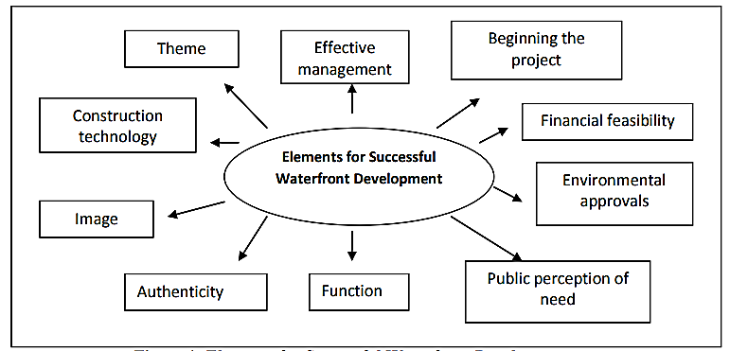

Source: (Torre, 1989)

Figure 1. Elements for successful waterfront development.

The concept of sustainable development is broadly known and emanated with the World Commission on Environment and Development (WCED) report, also known as the Brundtland Commission Report in 1987. An oft-cited definition of sustainable development is defined in this report as: "development that meets the needs of the present without compromising the ability of future generations to meet their own needs" (WCED, 1987). Thus, the Brundtland report continuously argued dynamic and complex problems of environmental deprivation together with issues of human development and poverty, which sought to overcome both challengers concurrently and in a mutually reinforcing way (Robinson, 2004). Accordingly, Brundtland Report has been taken several efforts to operationalize sustainable development, and the most general and conjoint term is the triangular concept with the three pillars of "economic, social and environmental" (WCED, 1987; Rydin et al., 2003; Moffatt, 1995; Reid, 1995). Therefore, the economic impression mainly followed the "desires," environmental features considered to the "limits" of the production and consumption, and finally, social measures supposed to ensure the "equity" among societies (WCED, 1987). This idea is considered a normative view, which exists and is operationalized based on the criteria of economic, social, and environmental sustainability interfaces. In market economic conditions, this trajectory was criticized (Grosskurth & Rotmans, 2005; Omar and Saheed, 2019) and challenged as to how and at what level the particular development project generate the returns on each of these components are conceded and produced an economically feasible, socially admissible, and environmentally friendly project outcomes (Berke & Canroy, 2000; Veeman & Politylo , 2003; Dempsey et al., 2011; Söderholm, 2020). Therefore, communicative planning has been realized as the basis of reaching a more sustainable society at all levels in which acknowledged as structures are not fixed and immutable, and they may be slow to change with time and context (Dempsey et al., 2011; Lima, 2021).
Urban waterfront development inevitably contains the principles of sustainability: economic, environmental, and social. These three perspectives should be incorporated at all levels. Bruttomesso (2006) recommended ten principles for obtaining sustainability of urban waterfront development projects. Besides Giovinazzi & Moretti (2010) and Rahana & Nizar (2020) reviewed these principles of their empirical studies, and those are namely, (1). Secure the quality of water and the environment; (2). Waterfronts are part of the existing urban fabric; (3). The historic identity gives character; (4) Mixed-use is a priority; (5) Public access is a prerequisite; (6) Planning in public-private partnerships speeds the process; (7) Public participation is an element of sustainability; (8) Waterfronts are long term projects; (9) Revitalization is an ongoing process; (10) Waterfronts profit from international networking (Bruttomesso, 2006; and Hussain, (2014). Although, sustainability outcomes of waterfront development projects vary from city to city with their inherent character and design interventions of the projects (Yassin, Bond, & McDonagh, 2012).

Method and study area

Data collection and analysis

The qualitative research approach is adopted with primary and secondary data sources. Primary data is collected using interviews and observations. Observations and interviews are highly behooved of the research objectives and mainly selected participatory observation method and semi-structured interviews to get a prior understanding of the context. The population of this study is considered as the professionals who are engaging with the recreational waterfront development projects in Sri Lanka. Amongst nine professionals were selected using the Judgmental sampling method as per criteria of position, responsibility, and level of engagement of the project. The study also relied on secondary data collected through documentary reviews since it is a possible option to identify background information of the projects. Thus, this study tries to incorporate content analysis to analyze the data collected through semi-structured interviews from key professionals in waterfront recreational development projects in Sri Lanka.

Selection of case study

There are several urban recreational waterfront development projects in Sri Lanka. Most of the projects are concentrated around the City of Colombo because it consists of many ecological resources such as 45 wetlands and river-based areas. Due to the scarcity of these open spaces and recreational areas, the government had to initiate more urban parks and recreational development aligned with rivers and wetlands. Many urban parks and recreational spaces are situated in suburban areas, and two study areas were selected for the study due to the time limitation. It is mainly based on proximity factors and other factors. (Table 1) Accordingly, Bellanwila Weras Ganga Project and Diyatha Uyana Park in Battaramulla are selected for empirical assessment of this study.

Table 1. Selection criterion.

Criterion | Diyatha Uyana Park  (Case 01) | Bellanwila Weras Ganga Park  (Case 02)
Type of Waterfront Development | Recreational Waterfront Development | Recreational Waterfront Development
Purpose of Development | Retention of water | Retention of water
Name of the Waterbody | Diyawanna Oya | Weras Ganga
Developer/ Constructor | Sri Lanka Army, Sri Lanka Navy, and the Civil Security Department under the guidance of the UDA and SLLDC. | Department under the guidance of the UDA and SLLDC. .
Extent | 88 Hactares | 15 Hactares
Proximity to the city center (CBD) from the development. | 8.4km | 12km
Geographical Location | 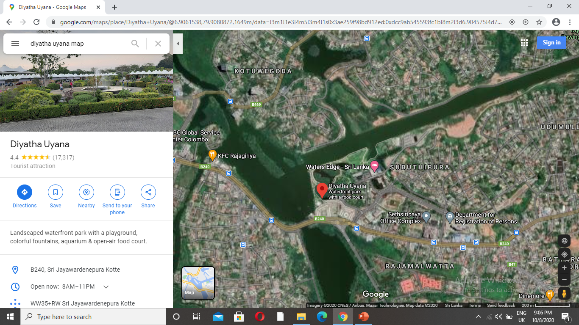  Source: (Google Map,2020) | 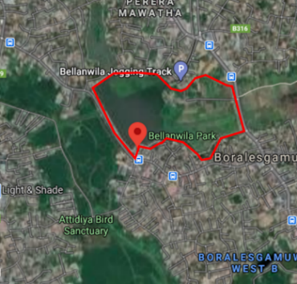  Source: (Google Map,2020)
Past Condition | 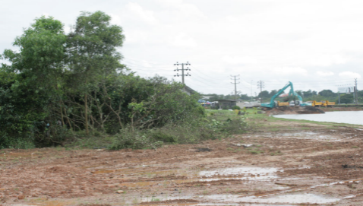  Source: (Diyatha Uyana,2019) | 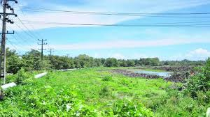  Source: (S.G.M. Films, 2015)
Present Condition | 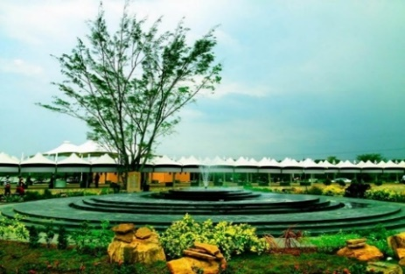  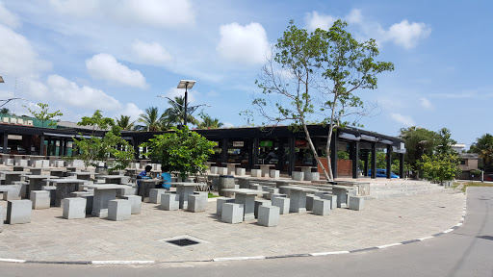

Results and discussion

Interviews were appropriately well responded to allow a response rate of 100 percent (%) (N=9) to be acquired. Respondents in this study were mainly practitioners from the government sector, which included Urban Development Authority (UDA), Sri Lanka Land Development Corporation (SLLDC), Central Environment Authority (CEA), and Boralesgamuwa Urban Council (UC). The semi-structured interviews have provided a clear view of waterfront development projects in Sri Lanka and presented sustainability criteria allied with the selected study areas.

Sustainability assessment of urban recreational waterfront development on environmental criteria

From an environmental point of view, the study areas of Diyatha Uyana Park (Case 01) and Bellanwila Weras Ganga Park (Case 02) were assigned six criteria: assessment of ecological impacts, conservation of natural resources, improvement of landscaping, avoid polluting materials use, eco -friendly construction materials and Flood mitigation.
As presented in table 03, all the respondents agreed that both projects had taken approval of EIA and IAA from relevant agencies to assess the ecological impacts, which provided the intention of protecting and improving the environmental quality of riverfront area in the future. The 78 percent (%) of respondents equally suggested the 'conservation of natural resources' criteria in both cases. Diyatha Uyana Park (case 01) consists of a separate area for special fauna and flora species and preserves the marshy areas via developing ponds. While Weras Ganga Park provides facilities for plant nurseries, cultivating riverine fruit, herbal vegetables, and other useful trees such as bamboos in the stream banks, cultivating high-value rice varieties in paddy lands adjacent to the footpaths. However, as per the rankings of each criterion, conservation of natural resources takes second and third positions in case 01 and case 02, respectively. The third criteria (C3) of 'promote and encouragement of green setting' has been accepted by all respondents in case 01 with first rank and 88 percent (%) in case 02 with the second rank (Refer table 03). Diyatha park provides a green landscape with chairs in strategic locations, and Weras Ganga Park also has stone tiles with planned patches of green.
According to the practitioners view the fourth criteria quoted as 'avoid polluting materials use.' The main reasons to suggest that both developments provide trash bins in strategic locations and restrict the use of polythene, plastic, and other polluting materials in park premises. Hence, this fourth criterion (C4) is accepted 66 percent (%) in both cases while acquiring the third and fourth positions under the ranking of case study 01 and 02, respectively. Eco-friendly construction materials were the fifth environmental criteria (C5) of the study. It was confirmed as 11 percent (%) (case 01) and 22 percent (%) (case 02) of low rate. The construction materials of park infrastructure mainly comprehended the cement, and it emits 5 percent (%) of greenhouse gases which adversely threaten the climate and endanger human life. Therefore, it ranked as the final criteria in both cases. The sixth criteria (C6) was suggested as 'flood mitigation and indicated 66 percent (%) and 78 percent (%) of respondents' rate in case study 01 and 02, respectively (Refer table 03). Water retention basins are used to control the flooding issues around parks. Therefore, it has been implemented across renovations of the existing river basins and new constructions of the new retention basins. This sixth criterion was performed as the third position in both cases of the study.

Table 2. Assessment of the environmental criteria in recreational waterfront development projects.

No | Criteria | Respondents (N= 9)
No | Criteria | Case 01 |  | Ranking | Case 02 |  | Ranking
No | Criteria | Frequency | % | Ranking | Frequency | % | Ranking
C1 | Assessment of ecological impacts | 9 | 100 | 1 | 9 | 100 | 1
C2 | Conservation of natural resources | 7 | 78 | 2 | 7 | 78 | 3
C3 | Promote and encourage the green settings | 9 | 100 | 1 | 8 | 88 | 2
C4 | Avoid polluting materials use | 6 | 66 | 3 | 6 | 66 | 4
C5 | Eco -friendly construction materials | 1 | 11 | 4 | 2 | 22 | 5
C6 | Flood mitigation | 6 | 66 | 3 | 7 | 78 | 3

Sustainability assessment of urban recreational waterfront development on economic criteria

Regarding the sustainability assessment in Sri Lankan urban recreational waterfront development projects, interviewees suggested three main economic criteria allied to the context of Diyatha Uyana Park and Weras Ganga Park. The first criteria (C1) of 'create employment or urban labor' indicated 66 percent (%) and 56 percent (%) of rate respectively in case 01 and case 02, which perform the second position of rankings in both cases as well (refer table 04). Thus, the second criteria (C2) were suggested as 'business activity which represented 78 percent (%) and 56 percent (%) respectively in case study 01 and 02. There were established 248 food stalls in Diyatha Uyana Park, and small businessmen in Viharamaha Devi Park were permitted to do business in these stalls. The main business activities are flower and flower-related products, vegetables and fruits, fertilizer and seeds, plastic, pottery, ceramic clay, cement, coir pottery, aquaculture-related activities and clothes, slippers, and another ornament that creates employment opportunities for many insiders and outsiders of the area. Bellanwila Weras Ganga waterfront project also provides business activities and more employment opportunities from constructing food stalls and small boutiques. Although, most communities tend to commence their agricultural and horticultural activities by supporting new canals that this project originated. Therefore, it is a unique experience for urban dwellers in Bellanwila and the surrounding area. Thus, there were many other employment opportunities in both study areas related to cleaning services, security, parking lots, etc.
Conversely, Bellanwila Park provides livelihood opportunities to low-income community across street vending along the roadside in which of those small stalls are offered free of charge. The last economic criteria suggested adequate parking facilities (C3), which is rated as 88 percent (%) and 100 percent (%) of case study 01 and case study 02, respectively (Refer table 04). Thus, it indicated as the first rank in both cases. The recreational areas are highly crowded, and high vehicle accumulation leads to air and noise pollution, congestion, and daily work delays. The cost of these issues positively affected the economy. As mentioned by the expertise, both of these study projects have enough parking spaces with good facilities to avoid unnecessary congestion near Diyatha Uyana Park and Bellanwila Weras Ganga Park. In this point of view, practitioners suggested parking facilities as an economic criterion of this study.

Table 3. Assessment of the economic criteria in recreational waterfront development projects.

No | Criteria | Respondents (N= 9)
No | Criteria | Case 01 |  | Rank | Case 02 |  | Rank
No | Criteria | Frequency | % | Rank | Frequency | % | Rank
C1 | Create employment/increase urban labor | 6 | 66 | 3 | 5 | 56 | 2
C2 | Business activity | 7 | 78 | 2 | 5 | 56 | 2
C3 | Adequate parking facilities | 8 | 88 | 1 | 9 | 100 | 1

Sustainability assessment of urban recreational waterfront development on social criteria

From the social point of view, seven criteria were identified for the study areas of Diyatha Uyana Park and Bellanwila Weras Ganga Park. The first criteria (C1) of 'providing a separate area for fitness facilities' has been accepted by 56 percent (%) in case 01 with fifth ranking and 78 percent (%) in case 02 with second-ranking (Refer table 05). There are several fitness facilities in Diyatha Uyana Park, such as walking, jogging, cycling, etc. Thus, there is located a neat walkway for cycling and jogging facilities along Bellanwila Lake. Therefore, these separate fitness areas upgrade the social interaction among park users and avoid conflict between park users and the surrounding local community. According to the practitioners' view, the second social criteria (C2) is 'Provide water-related and water-based activities. The recreational waterfront developments are created along with the water bodies, and many people come there to get rid of their busy lifestyles. For that purpose, water-based activities provide a remarkable experience and bring vast cognitive, emotional, psychological, social, and spiritual benefits for people of all ages and abilities. In Diyatha Uyana park, visitors can walk along the riverside and get experiences from riding the riverboats. It indicated 78 percent (%) of respondents' rate with the third rank in Diyatha Uyana Park. Although there is no possibility to boat rides yet in the Weras Ganga Park, boats are only used for cleaning activities of the lake. Therefore no one rated it in the model (Refer table 05). The third criteria (C3) of 'Provide a separate area for foods and beverages' indicated 66 percent (%) in both cases, which perform the fourth and third rankings in case study 01 and 02, respectively. Diyatha Uyana Park and Bellanwila Park provide a separate area for cafeterias with various food items that suit local and foreign visitors' choices. Hence, this fourth criterion (C4) is accepted 78 percent (%) and 88 percent (%) in case 01 and case 02 while acquiring the third and first positions under the ranking of case study 01 and 02, respectively. Diyatha Uyana Park has a musical water fountain that attracts the whole project and is ideal for families to spend their time in a quality environment. Earlier, there were blowing 3D artworks, which gained new unique experiences, and now these amazing 3D artworks are ruined destructively. Weras Ganga Park has cool outdoor enjoyable places with live wall structures that provide a calm environment for users. Provision of public accessibility was the fifth social criteria (C5) of the study. It was confirmed as 88 percent (%) (case 01) and 77 percent (%) (case 02) of high rate.
All social groups of any income level can enter both of these parks and enjoy the amenities free of charge. For instance, students come for studies, Youngers gather for celebrations, old - ages come for chatting, etc. within this calm and relaxing environment. The sixth (C6) criteria suggested a "combination of modern and cultural aspects," which indicated 66 percent (%) and 56 percent (%) in case 01 and case 02, respectively. Diyatha Uyana Park is shined by the parliamentary complex, which the Diyawanna Oya connects, and it creates another brightness for the Water's Edge Hotel Premises. Thus, the walking track of Bellanwila Park connected Bellanwila Raja Maha Viharaya and Pillawa Temple. Therefore, people can worship both temples very easily, which integrates modern and cultural values into development. The final criteria (C7) introduced as 'removal of unauthorized constructions, which indicated 100 percent (%) and 88 percent (%) in case study 01 and case study 02, respectively (Refer table 05). Thus, it was indicated as the first rank in both cases due to surrounding lands being free from the unauthorized settlements as a direct consequence of the projects.

Table 4. Assessment of the social criteria in recreational waterfront development projects.

No | Criteria | Respondents (N= 9)
No | Criteria | Case 01 |  | Ranking | Case 02 |  | Ranking
No | Criteria | Frequency | % | Ranking | Frequency | % | Ranking
C1 | Provide a separate area for fitness facilities. | 5 | 56 | 5 | 7 | 78 | 2
C2 | Provide water related and water-based activities. | 7 | 78 | 3 | 0 | 0 | 5
C3 | Provide separate area for foods and beverages | 6 | 66 | 4 | 6 | 66 | 3
C4 | Encourage the beautification. | 7 | 78 | 3 | 8 | 88 | 1
C5 | Provision of public accessibility. | 8 | 88 | 2 | 7 | 78 | 2
C6 | Combination of modern and cultural aspects. | 6 | 66 | 4 | 5 | 56 | 4
C7 | Removal of unauthorized constructions. | 9 | 100 | 1 | 8 | 88 | 1

Conclusion

Waterfront development is a worldwide phenomenon, and there are also several reviews and learning processes. Therefore, this paper inquiries into the sustainability outcomes of urban recreational waterfront development projects in Sri Lanka. The two leading recreational waterfront development projects are selected viz., Diyatha Uyana Park and Bellanwila Weras Ganga Park. Such two urban recreational waterfront development projects analyzed found to have been possessing six environmental sustainability attributes. Those are the assessment of ecological impacts conservation of natural resources, improvement of landscaping, avoid polluting materials use, eco-friendly construction materials, and Flood mitigation. Three economic sustainability attributes to creating employment or increasing urban labor, business activity, and adequate parking facilities. Providing separate areas for fitness facilities, water-related and water-based activities, separate spaces for foods and beverages, encouraging beautification, providing public accessibility, combining modern and cultural aspects, and removing unauthorized constructions are also seven social sustainability attributes. Hitherto, some inadequacies have shown in social, economic, and environmental attributes yet to affect the project outcomes. These open up further research - how planning practice for urban recreational waterfront development can be set to achieve an integrated and collaborative approach, high return on investment, and waterlogging protection that would be suited to the respective local context.

Acknowledgment

The authors like to thank the Centre for Real Estate Studies (CRES), Department of Estate Management and Valuation, University of Sri Jayewardenepura.

References

Affairs, D. O. (2019). World Population Prospects 2019, Highlights. New York: United Nations.
Avni, N., & Teschner, N. (2019). Urban Waterfronts: Contemporary Streams of Planning Conflicts. Journal of Planning Literature, 34, 408 - 420.
Berke, P. R., & Canroy, M. M. (2000). Are we planning for sustainable development? An evaluation of 30 comprehensive plans. Journal of the American Planning Association, 66(1), 21-33.
Bruttomesso, R. (2006). Waterfront development: A strategic choice for cities on water. Hong Kong: the Waterfront Development Forum: China Maritime.
Chang Geun Song , Tae Geom Ku , Young Do Kim and Yong Sung Park (2017) Floodplain Stability Indices for Sustainable Waterfront Development by Spatial Identification of Erosion and Deposition, Sustainability 2017, 9, 735; doi:10.3390/su9050735
Davidson, M. (2020). Waterfront Development. International Encyclopedia of Human Geography (pp. 245-251). Elsevier.
Dempsey, N., Bramley, G., Power, S., & Brown, C. (2011). The social dimension of sustainable development: Defining urban social sustainability. Sustainable development, 19(5), 289-300.
Dong , L. (2004). Waterfront Development: A Case Study of Dalian, China. Canada.
Giovinazzi, O., & Moretti , M. (2010). Port Cities and Urban Waterfront: Transformations and Opportunities. TeMA - Journal of Land Use, Mobility and Environment 2, 3, 57-64. doi:10.6092/1970-9870/123
Grosskurth, J., & Rotmans, J. (2005). The scene model: getting a grip on sustainable development in policy making. Environment, Development, and Sustainability, 7(1), 135-151.
Hamer, D. (2000). Learning from the Past: Historic Districts and the New Urbanism in the United States.
Katharina Buchholz (2020) How has the world's urban population changed from 1950 to today? https://www.weforum.org/agenda/2020/11/global-continent-urban-population-urbanisation-percent/
Lanka, G. o. (2016). Metro Colombo Wetland Management Strategy. Colombo: Signes.
Lima, V. (2021). Collaborative Governance for Sustainable Development. In Peace, Justice and Strong Institutions (pp. 1-11). doi:DOI: 10.1007/978-3-319-71066-2_2-1
Moffatt, I. (1995). Sustainable Development: Principles, Analysis and Policies. Carnforth:. Parthenon Publishing Group.
Mohomed Ismail, I. (2017). Place attachment to waterfront revitalisation development: case study of Lumut and Kuching, Malaysia/Mohd Ismail Isa (Doctoral dissertation, University of Malaya).
Niemann, B., & Werner, T. (2016). Strategies for the sustainable urban waterfront. WIT Transactions on Ecology and The Environment, 204, 431 - 439.
Omar N.A., Saheed. E.H. (2019). An Integrated Strategy for Waterfront Redevelopment Case Study: Alexandria, Egypt. Journal of Engineering Research, 3(2), 93-109.
Oshani, P., & Wijethissa, K. (2015). Motives and Issues: Diyatha Uyana Urban Park Visitors in Sri Lanka. International Journal of Scientific and Research Publications, 5(8), 1-7.
Peng, X., Shi, D., Guo, H., Jiang , D., Wang, S., Li, Y., & Ding, W. (2015). Effect of urbanisation on the water retention function in the Three Gorges Reservoir Area, China. Catena, 133, 241-249.
Pramesti, R.E. (2017). Sustainable urban waterfront redevelopment: challenge and key issues. Media matrasain, 14, 41-54.
Hussen R.M. (2014). Sustainable Urban Waterfronts Using Sustainability Assessment Rating System. World Academy of Science, Engineering and Technology International Journal of Architectural and Environmental Engineering, 11.
Ragheb, R. A. (2017). Sustainable Waterfront Development—A Case Study of Bahary in Alexandria, Egypt. Journal of Civil Engineering and Architectur, (11), 380-394 .
Rahana, H., & Nizar, S. A. (2020). Waterfront Development - A Tool to Restore the Neighbourhood. International Journal of Science and Research (IJSR), 9(4). doi:10.21275/SR20415201611
Reid, D. (1995). Sustainable Development: An Introductory Guide. London.
Riham A. Ragheb (2017) Sustainable Waterfront Development—A Case Study of Bahary in Alexandria, Egypt, Journal of Civil Engineering and Architecture, 11(2017), 380-394
doi: 10.17265/1934-7359/2017.04.007
Robinson, J. (2004). Squaring the circle: on the very idea of sustainable development. Ecological Economics, 48(4), 369-384.
Roux, R. l. (2015). An exploration of the role of waterfront development in urban regeneration: Mossel Bay as case study. 1-192.
Rydin, Y., Holman, N., Hands , V., & Sommer, F. (2003). Incorporating sustainable development concerns into an urban regeneration project: how politics can defeat procedures. Journal of Environmental Planning and Management, 545-561.
Scholz, M. (2007). Ecological effects of water retention in the River Rhine valley: a review assisting future retention basin classification. International Journal of Environmental Studies, 64(02), 171-187.
Shah, S., & Kumar, A. K. (2017). Social Sustainability of Urban Waterfront- The Case of Carter Road Waterfront in Mumbai, India. Procedia Environmental Sciences, (37), 195-204.
Söderholm, P. (2020). The green economy transition: the challenges of technological change for sustainability. Sustainable Earth, 3(1), 1-11.
Torre, L. A. (1989). Waterfront development. New York: Van Nostrand Reinhold.
Uswah, R., & Wang, L. (2021). Waterfront Public Space Planning on Krueng Aceh River in Banda Aceh-Indonesia. Current Urban Studies, 9, 218-226.
United Nations. (2020,). Retrieved February 8, 2020, from http://www.un.org
United, N. (2014, July 10). United Nations, Dept of Economic and Social Affairs. Retrieved November 21, 2020, fromhttps://www.un.org/en/development/desa/publications/2014-revision-world-urbanization-prospects.html
WCED. (1987). Our common future. Oxford University Press.
Yassin, A. B., Bond, S., & McDonagh, J. (2012). Principles For Sustainable Riverfront Development For Malaysia. Journal of Techno-Social, 4(1), 21-36.
Yassin, A., Eves, C & McDonagh, J. (2010). An evolution of waterfront development in Malaysia. In Proceedings of the 16th annual conference of the Pacific Rim Real Estate Society, Wellington, New Zealand, 24-27 January 2010.

