

Riverine People of Borneo: everyday political ecology of ‘lanting’ community in Sintang, West Kalimantan

Mira S. Lubis, Dalhar Susanto, Triatno Y. Harjoko

Department of Architecture, Faculty of Engineering, Universitas Indonesia
Kampus UI Depok, Jawa Barat, Indonesia

Correspondence: Mira S. Lubis (email: miralubis@gmail.com)

Received: 06 May 2021; Accepted: 11 November 2021; Published: 30 November 2021

Abstract

In the cities of Global South, riverbank settlements is often generalized, even stigmatized as slums. It also happened in the cities of Borneo, the largest island in Maritime Southeast Asia, which historically are deeply rooted in riverine culture. This study figures out the everyday political ecology of the inhabitants of the Kapuas River settlements in the form of ‘lanting’ or raft houses, in the midst of rapid urban development and environmental changes, which reflects their efforts in defending their existence as part of the urban society. Spatial ethnographic approach supported with observation and in-depth interviews were used to reveal the everyday political ecology of the lanting’s inhabitants in Sintang, the city chosen for this study. Converting the events into tactic-strategy approach, this study reveals the important meanings behind the daily activities of the lanting inhabitants which reflects the significant influence of people’s thoughts and actions in the production and reproduction of their living space. The results of this study confirm that the dwelling practice of the lanting community is not merely something caused by economic limitations. More than that, it is deeply integrated with urban economic activities and makes significant contributions to urban-rural socio-economic linkages based on dendritic river networks.

Keywords: Political ecology, everyday life, riverine people, ‘lanting’ (raft houses), Sintang City, West Kalimantan/Borneo

Introduction

Lanting (floating house), together with stilt house are water-related traditional settlements in Borneo/Kalimantan, island which is famous for its large rivers and strongly characterized by a river-cultured society (Christie 1995, Phillips 2006). They proliferate randomly in Kalimantan’s major rivers, integrated with a network of rivers and tributaries that are almost entirely navigable. Sintang, one of the district cities in West Kalimantan, is located at the confluence of two major rivers, Kapuas and Melawi (See figure 1). Growing and developing from the riverbank to far inland, yet Sintang City has a river culture to this day. One of them is in the form of floating houses, or “lanting” in the local language. It is a legacy of the city’s historical past, at a time when the river played an important role as the lifeblood of the community, as the main transportation system, and as political economic linkages within the Kalimantan region (See figure 2) (Fienieg & Sagita 2007, Heidhues 2003, Listiana 2012). Lanting is a water-based way of living that can be found all around the world, from places such as Musi River in South Sumatra, Lake Tempe in Central Sulawesi, Lake Tonle Sap in Cambodia, Chao Phraya River in Thailand, Lake Titicaca in Peru, and so on. Various types of floating settlements reflect close relationship between people and the waterscape and strongly simbolize the concept of human-nature interactions (Keskinen, 2006; Travers, 2012).

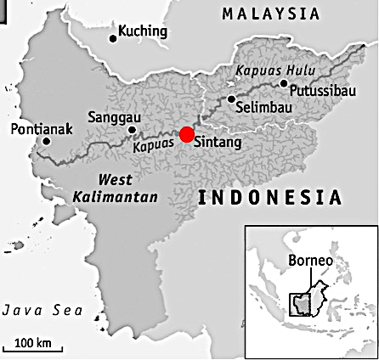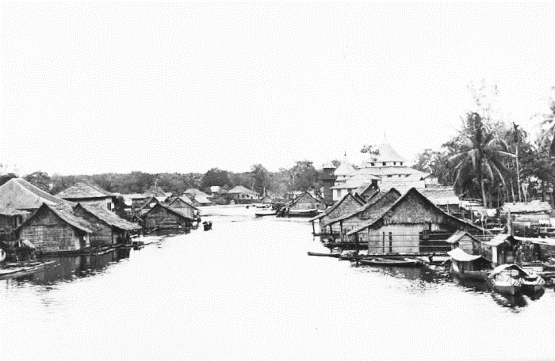
2

1

Figure 1 (left). Kapuas River and its dendritic tributaries in West Kalimantan; Figure 2 (right). Floating houses or lanting in one of Kalimantan rivers during old days. (Reproduced from: Collectie Stichting Nationaal Museum van Wereldculturen)

Although lanting in Sintang is considered more of a remnant of its past glory, it continues to exist today and integrates with modern ‘land-oriented’ urban life (See figure-3). Nowadays, it actually is not easy to live in lanting. The decline of the environmental conditions in Borneo due to global climate change as well as massive human exploitation of natural resources have a direct impact on the physical degradation of floating settlements, considering that they are very vulnerable to changes in river conditions. In most cases, they are now stigmatized as slums, which have consequences to the evictions and relocations of the inhabitants, as happened to hundreds of floating houses in Banjarmasin, South Kalimantan, for example (Jones 2017, Rahman et al 2019). This study tries to expand knowledge about informal urbanism in cities in the Global South, which has been biasedly studied through a formal urbanism perspective adopted from Western urban theory (Hesam & Peimani 2019).

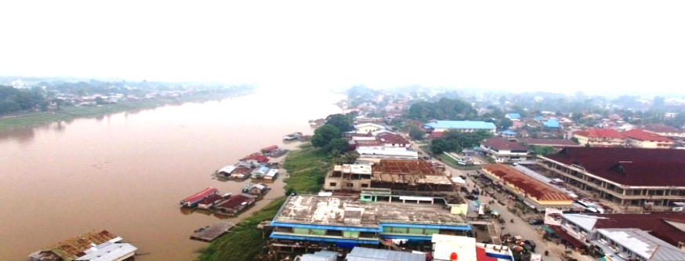
Figure 3. The aerial view of present day Sintang city. (Photo: Lubis, 2018)

Literature review

Studies on human-nature relationships are generally applying the concept of adaptation, whether it is seen from the physical or behavioral perspective, in order to explain how human deals with chances and challenges on its environment. However, to explain phenomena on a smaller space-time scale, this concept tends to be less suitable, since the adaptation is generally a process of change over a long period of time, so it is more appropriate for studies with a historical scenario approach (Perramond, 2007). As for research on contemporary time-scales, what the researcher observes may not be a process of adaptation but rather a series of everyday tactics and strategies that a person uses to deal with environmental constraints on a temporary or short-term basis.
Political ecology is the study of the relationships between political, economic and social factors with environmental issues and changes (Blaikie & Brookfield, 1987; Swyngedouw et al, 2002). On political ecology perspective, the concept of tactic and strategy is able to support the importance of scalar dimensions in political ecology research, in which short-term observations play an important role in building knowledge about a phenomenon of nature-society interactions based on everyday practices. The ‘tactic-strategy’ approach is expected to bridging the empirical studies with studies that use theoretically driven discourse-based analysis (Perramond, 2007).
In The Practice of Everyday Life, de Certeau (1984) explained various aspects of daily human life experiences in the context of modern society and consumer society using the concept of tactics and strategies. He defines "tactics" as small practices that are governed more by the concept of time than by the context or space in which they occur. Meanwhile, "strategy" is more systematic, and has broader and more focused control over the space where an activity takes place. De Certeau associates "strategy" with institutions and power structures that are "producers", while individuals are "consumers" who act in accordance with, or against, the environment dictated by strategy using "tactics". He emphasized that the "city" is the result of the strategy of governments, companies, and other institutional bodies that produce products such as master plans and maps that depict the city as a unified whole. (de Certeau, 1984).
In addition, Lefebvre (1991) has also emphasized that in the production of certain types of places and spaces, tactics and strategies are key forms of physicality. In other words, an event observed in the field may be a single action that occurs in person. If the event occurs more than once, or is a recurring tactic, then this may explain a context of habit or behavior. So, although 'tactic' is a single event, what matters is how the accumulation of tactics in everyday life becomes something more tangible and can be explained (Lefebvre, 1991). Lefebvre also dialectically defines everyday life as “the intersection of illusion and truth, power and helplessness; the intersection of the sector man controls and the sector he does not control.” (Lefebvre, 1947:40).
Except de Certeau and Lefebvre, Chase, Crawford and Kaliski (1999) also introduced the concept of ‘everyday urbanism’, which is considered as an approach to urbanism that finds its meanings in everyday life (Crawford et al, 1999). In contrast with ‘New Urbanism’ movement that has been criticized for asserting universal principles of design instead of attending to local conditions (Sharifi, 2015), everyday urbanism really cares of the specific daily life activities of urban people. It is used as the consideration on the decision plan and city planning. This is an empirical approach that views the importance of situations and experiences that occur in everyday life, which urban planners tend to override. In contrast to the perspective of urban design practice, everyday urbanism is not interested in the perfect engineering of an area or city spaces. Instead, it focuses on intense experiences for architects or urban planners in working with communities to understand how the space is used on a daily basis, in order to reconnect human and social meaning with architectural design and urban planning (Chase et al, 1999).

Method and study area

This study seeks to obtain an overview of the everyday lives of the lanting community in Sintang, in the midst of rapid urban development and the river’s environmental changes. Sintang is a district capital located in the interior of West Kalimantan, with a population of 68,126 people (2015). Currently there are approximately 130 lanting houses, most of which function as latrines and washing areas, while the rest are residential houses (10), inns (15), and other places of business (12).
The research was conducted during 2018-2019. The spatial ethnographic approach (which is part of an ethnographic study that seeks to reveal daily life that occurs in a space and place), which is supported by observations and in-depth interviews were used to reveal the everyday political ecology of the lanting’s inhabitants (Little, 2007; Low, 2017). The participants in this study, totaling 25 people, are mainly the lanting dwellers, which are located in two main areas: the Sungai Durian (West Sintang) and the Pasar Inpres (East Sintang), as seen in Figure 4. The selection of samples followed a purposive sampling strategy and snowball sampling, to produce an illustrative sample (Flowerdew & Martin, 1997).
In political ecology research, the case study approach is often criticized for its lack of generalizability, although it does yield in-depth information about a locality (Yin 1993, Berg 2009). While this may be true, the value of this research lies not in the development of a theory or model of urbanism that can be widely applied, but in the recognition of the importance of understanding the complexities of the interaction of local socio-political processes with changes in the environment, which affect spatial processes and form the basis for the development of urbanism in Kalimantan. This research attempts to articulate the local context within the framework of urban theory and broader spatial policy.

Results and discussion

The phenomenon of the lanting settlement in Sintang urban area is not merely a problem related to urban poverty and inequality, but has a long historical, social and cultural background, which is probably as long as the Sintang’s history itself. Our other parallel research which examined the diachronic view of lanting over time has shown the existence of lanting settlement in approximately the last 200 years of the Sintang’s history, from the kingdom era until today (Lubis, 2019). Although the practice of lanting was started by the indigenous people, it was the Chinese migrants who popularized the lanting culture in Sintang, both in the kingdom era (around the 18th century) and the Dutch colonial era (1855-1942). After that, lanting experienced dark times during the 3 years of repressive Japanese occupation (1942-1945), but continued to survive and even returned to its heyday in the 1960s, before collapsing again during Suharto era (1966-1998), which was caused by river environmental damage due to massive timber logging. Nevertheless, lanting has never really disappeared and continue to survive in the midst of the transformation of river-oriented to land-oriented settlements. The following description is about the everyday life of the lanting settlements in recent years.

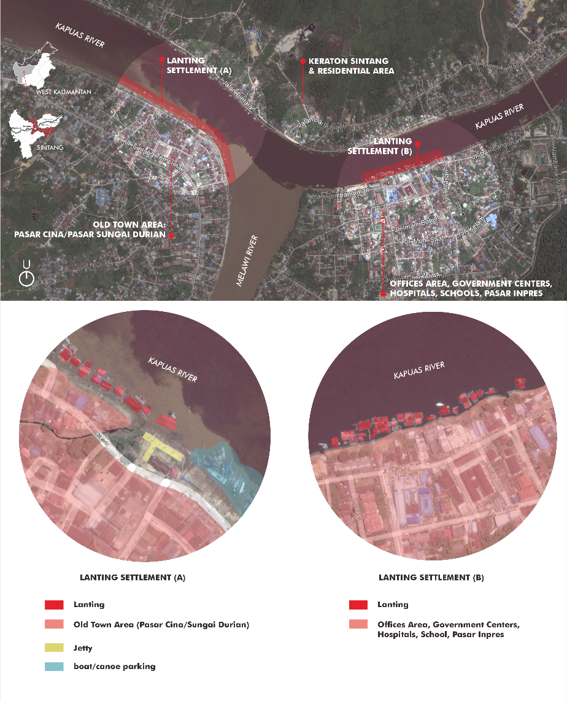
Figure 4. Two main locations of lanting settlements in Sintang, Sungai Durian area and Pasar Inpres area.
Based on their origin, today’s lanting dwellers in Sintang are divided into two groups: those who live in lanting for generations (minority), and those who came from villages around Sintang (the majority). The first group are those who continue the family business inherited by their parents, or simply continue the tradition of living in the lanting. The types of businesses run are generally related to river activities. The second category includes migrants and visitors from the villages along the Kapuas and Melawi rivers and their tributaries. They come to Sintang to access various urban facilities and services that are not provided in rural areas, such as hospital, high school, university, government offices, banks, or central market. Most of them are also workers who are dissatisfied with job opportunities in their villages and hope for better jobs in the city. These migrants and visitors stay in the lanting (inn/lodging or boarding houses) for varying lengths of time, ranging from daily, weekly, monthly, to yearly, depending on their respective activities (Lubis et al, 2019).
Despite the image of lanting as a settlement for the poor or as a slum, most of the lanting inhabitants experience many benefits and easiness. The lower cost of living than that on the land is the main reason. It also provides easier mobility to and from their villages through river transportation. The location of lanting along the riverbank which directly attached to the urban center gives direct access to important public facilities and services, without having to pay additional costs for transportation. These facts show that the value that lies in one's dwelling place is not only a matter of physical condition, because the house and its environment, which physically meet high material standards, do not necessarily have high value if the owner or the occupant are not guaranteed long-term economic sustainability (Turner 1968, Coelho 2018). John F. C. Turner, a prominent British architect who has written extensively on community dwelling wrote, even if the house is only a shack, it will be of great value if it can free the owner from the high cost of living, give them the opportunity to earn extra income, invest his savings, and take advantage of his spare time (Turner 1968).
Furthermore, this study has succeeded in identifying various tactical efforts of the lanting community in relation to everyday politics, space and place, and the environment, which are classified into several main issues: (a) securing territorial location, (b) utilizing lanting as a production/commercial space, (c) construction and maintenance efforts, and (d) coping with environmental changes.

Securing territorial location

In relation to the Sintang urban structure where the Kapuas and Melawi rivers are part of it, the commercial functions of the lanting houses requires them to choose the most strategic location that is integrated with the urban economic centers. As a result, there are spots that are densely populated with lanting, and some are not. Riverbank areas attached to strategic urban functions such as central markets, shops, hospitals, banks, and bus terminals, are the favorite spots for commercial lanting, as seen in Figure 5.
Sometimes conflicts arise between lanting owners in competing to acquire the location. To resolve conflicts, they make a simple consensus or mutual agreement: 'siapa cepat dia dapat’ or ‘first come, first serve’ (author’s interview, 2019). Securing the water space for territory can be seen as everyday politics and tactics. Unlike landed houses, lanting is not static. River currents and winds easily cause the lanting to shift, even if it is moored in a riverbank. In this case, dwelling practice is basically the quotidian practice of continuous marking and claiming the space (Rose, 2012).

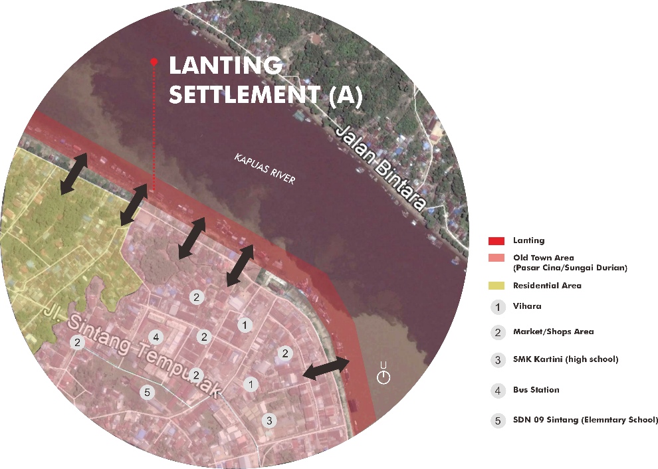
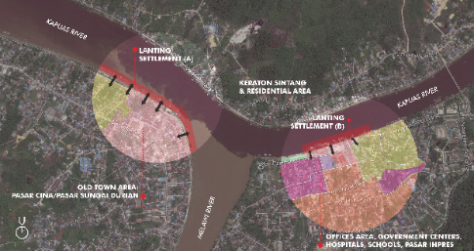

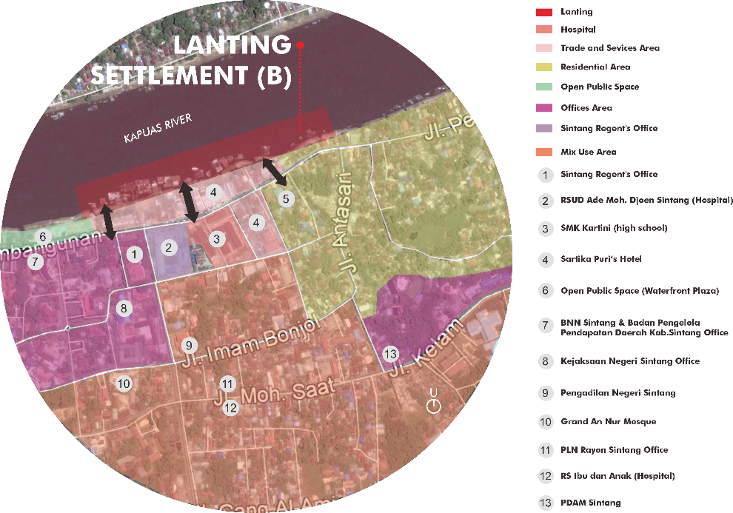
Figure 5. Lanting settlements are concentrated in two areas, that closely attached to urban commercial centers.

Often treated unkindly for being a poor community through the practice of evictions require the lanting owners to establish and maintain good relations with government officials. One of the successes of this effort was the recognition of lanting settlements as integral part of the zoning system for neighborhoods and community units on land. The head of the neighborhood unit or ‘Ketua Rukun Tetangga’ is a very important government representative for the lanting dwellers. It has an impact on the difference of access to services from one lanting neighborhood to another, depend on how good the relationship they build with their respective heads of neighborhoods. In one neighborhood, for example, all of the lanting dwellers already have the identity cards, family registers, and business permits, while those in other neighborhoods do not. So, although the lanting dwellers are well aware for their illegal status, more or less they feel secure by having all the identity documents and business permits. By establishing and maintaining good relations with the authorities in daily life, they can also get preliminary informations regarding the government’s plans that have the potential to displace or relocate them, such as construction projects for bridge or promenade (author’s interviews, 2019).
Lanting community's claim to urban space (which is not regulated in formal spatial planning) is, by using Lefebvre's term, the embodiment of 'differential space', in which market and state forces regulating spatial production can be counterbalanced (Lefebvre, 1991). Through the lanting, they struggle to deal with the endless changing of urban life, by claiming it as a representation of their existence in the city.

Utilizing lanting as a production/commercial space

For most of lanting owners, lanting is a source of livelihood, or a production space. Lanting's platform can be operated as jetty for boats (speedboats, houseboats, or motorboats) that stop at Sintang, using charter system. Many lanting owners offer their places as jetties, due to the limited capacity of the government’s port in serving boat traffic that stops or transits in the city. Generally, jetties do not stand alone but integrated with other commercial functions such as food stalls or inn. Some lanting houses function as rest area for transit passengers, which includes coffeeshop, toilet, and fuel kiosk; while the others function as inn/lodging and boarding houses for migrant workers and students. Usually floating inns are the biggest among other houses or in the form of two-storey floating building, since they contain plenty of rooms.
On certain occations, the lanting also functions as a pop-up market that accommodates trading activities between traders and buyers from Sintang with traders and buyers from rural areas that came through the river networks. Several lanting houses and open platforms are lined up and connected with wooden paths. During peak hours, this market is overcrowded by docked boats coming from the river’s upstream and tributaries, usually selling fish and agricultural products. As an exchange, before returning home, they load their boats with grocery items, clothing, and other household goods, to be sold in the countryside. The pop-up market provides convenience for both residents and visitors, for its practicality. Fresh fish can be bought directly from the fishing boats docked in lanting. Visitors can also shop directly at this floating market, although there are items that must be purchased from landed market (e.g. building materials, parabolic antennas, water tanks, etc).
Various commercial functions of lanting (as seen in Figure 6) reflect the economic and social interactions between urban and rural communities, based on river networks. Utilizing lanting as a production and commercial space has added the value to this settlement (Dhananka 2016). It can be seen as a tactical effort to elevate the role of the lanting, by giving the opportunity for the lanting community to participate in the urban economic activities. It is also a form of control and power of the lanting community in maintaining its existence, as well as an effort to remove the negative image against the lanting settlement (Fox, 2013).

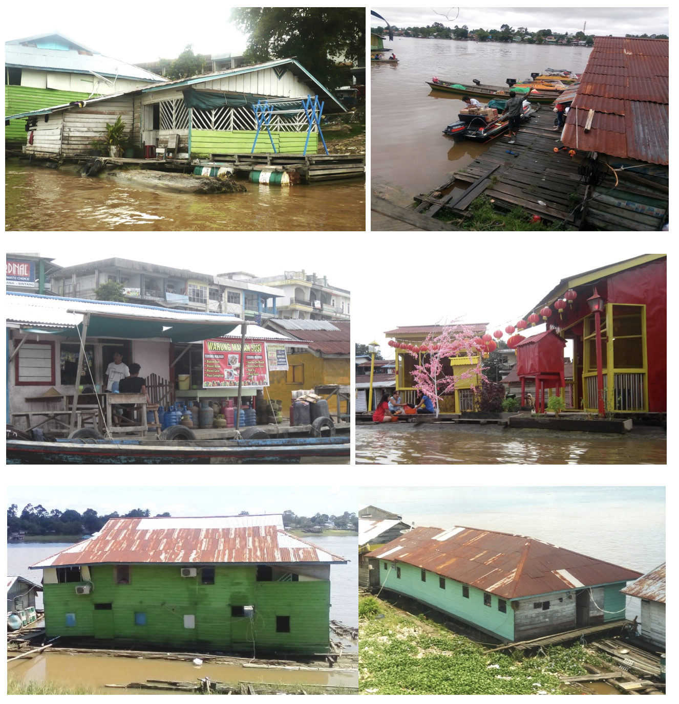
b
d
f
a
c
e
Figure 6. Commercial/non-residential functions of lanting in present day, such as food kiosk (6a), jetty (6b), mini market (6c), Chinese temple (6d), and cheap hotels/boarding houses (6e-f). (Photos: Lubis, 2018)

Lanting’s construction and maintenance

According to lanting owners, it is difficult to build the lanting directly in Sintang, due to the increasing scarcity of the ‘tengkawang’ (a type of wood used as floating structure) as a result of massive deforestation in Sintang District area. On the other side, importing these raw timber materials from other place is forbidden since the district governments enforced strict administrative procedures in timber distribution to prevent illegal logging practices. As a precautionary measure, the lanting is usually constructed at the river’s upstreams in neighboring district which still have larger forest areas providing the tengkawang wood, to then pulled by tug boat to Sintang or other destinations (author’s interview, 2018).
Every part of the lanting building also need to be well maintained with a higher frequency than that of landed houses, given the relatively humid conditions above the water, which causes the wooden parts to rot quickly. Each damaged part of the building has to be repaired immediately. Other maintenance efforts include: checking the mooring ropes so that the lanting does not drift away, keeping the distance between lantings so they don't get too close and colliding, keeping the lanting position against tides, cleaning stuck trash, securing items from falling during heavy currents, et cetera. Each lanting owner usually makes different efforts in maintaining his lanting on a regular basis, depending on their financial capacities.

Coping with environmental changes

Today, the lanting community are facing a serious threat of environmental degradation, which has a direct impact on their living space. Massive deforestation in the river's upstream (due to land clearing for oil palm plantation or illegal logging), illegal practices of gold mining in the river, and the use of toxic chemicals in fishing practices, have caused serious environmental problems, such as the water pollution, scarcity of fish, excessive fluctuation of water levels, as well as extreme drought and flood (Cleary and Eaton, 1992; Koninck et al, 2011). These situations require the lanting community to make serious efforts in order to survive.

- Excessive fluctuation of water levels

As a consequence of living on the water, the lanting community is required to have knowledge and alertness in responding to various hydrological conditions that are increasingly difficult to predict. Through this knowledge, the survival of the lanting is at stake. For example, when the water rises or recedes in no time (in the past and under normal conditions, the fluctuation of water levels lasted slowly and over a long period, over weeks), lanting dwellers have to pull or stretch the mooring ropes to keep the lanting position so that it stays on the water and does not tilt and run aground on the riverbanks. When the wind is too strong, the mooring rope must also be monitored so that it does not break, which can cause the lanting to drift away.
Some lanting residents described how difficult it is to predict the current river conditions which are increasingly uncertain, as a result of environmental destruction. Most of them said they were always worried about the changing river conditions. The lanting house is never left empty, because somebody always has to monitor the lanting in a safe position. In some lanting, holes were seen in the floor to inspect the sub-structure, as well as to clean up rubbish stuck under the lanting. When it rains heavily, it is certain that children will not be able to go to school on that day, because the riverbanks are slippery and too dangerous to pass (author’s interviews, 2019).
One of the inns and boarding house owners described how he and other house members had to be on guard every night to check the safety of the lanting. Everything has to be done manually (see Figure 7). On the other lanting house which is owned by a rubber seller, a control device has already been installed. The mooring rope is no longer tied to a tree or anchored to a riverbank, but is attached to a wooden stake equipped with a mechanical reel to adjust the lanting position with water levels (See Figure 8).

- River pollution and water scarcity

River pollution has an obvious impact on river ecosystems. Almost all lanting's owners participated in this study mentioned about the poor quality of the water and lack of fish for their daily consumption. One of the participants, Pak Husni (42 years old, the lanting owner), complained: “Today, living on the water does not always guarantee easy access to water. If the water is polluted or during a prolonged drought, we have to go 'up there' (ashore) to buy water from vendors. When the river is polluted, fish no longer exist. Sometimes I feel sad and ashamed. In the past, people up there bought fish from us. But now, everytime we want to eat fish, we, the river people, have to buy fish from the market on land."

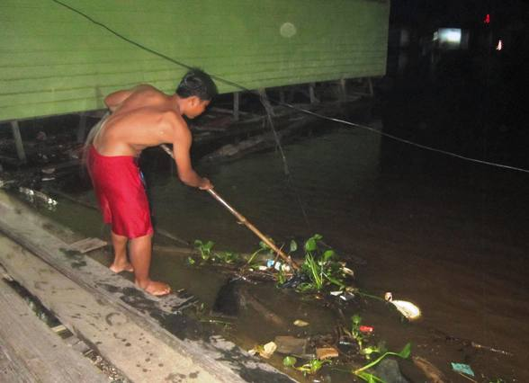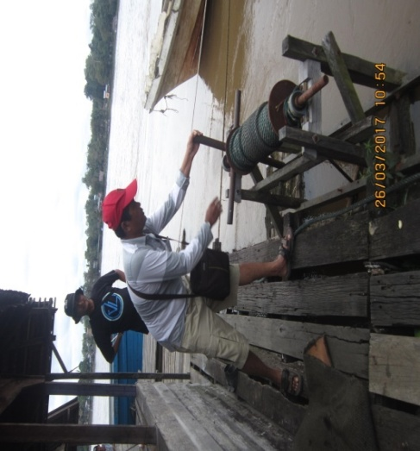
Figure 7 (left). Cleaning stuck trash during night-shift; Figure 8 (right). Mechanical reel to adjust lanting position with fluctuating water level (Photos: Albertus Imas, 2018)

According to the lanting community, river pollution has worsened since the rise of large-scale oil palm plantations owned by companies, as well as illegal gold mining practices. Since then, people have been afraid to consume river water for drinking or cooking, as was done in the past. Even at certain times, the water is too dirty to use for bathing, that causes skin irritation. Buying water from vendors or collecting rainwater (as seen in Figure 9) is the only tactical effort they can do in response to river pollution, considering that these lanting do not have access to public clean water services. The government's appeal to the lanting community to move to the land does not provide an effective solution since moving to land requires a lot of money.
A local hydrology expert who often studies the behavior of the Kapuas River confirmed the information obtained from the lanting dwellers. The phenomenon of changes in the hydrological behavior of the Kapuas River occurs due to changes in the land cover of the Kapuas watershed, due to the massive clearing of oil palm plantations, without taking into account the environmental carrying capacity. This causes less infiltrated rainwater and increased runoff, which causes rivers to overflow during heavy rains. In addition, he explained that the West Kalimantan region is also affected by global climate change which cause extreme rain and extreme drought (Author’s interview, 2019).
The everyday tactics carried out by the lanting community to anticipate environmental obstacles are basically part of a dynamic and continuous process of social-ecological interaction (Cabello et al, 2015), which involves many parties. There are actors who are responsible for causing environmental damage through deforestation, land clearing, illegal logging and mining, and so on; There are also policymakers (government) who, in this case, are negligent in implementing law enforcement to ensure environmental sustainability and provide protection for the people. On the other hand, there are people who are victims, especially the lanting community who are directly affected. Those daily efforts made by the lanting community are representations of everyday politics of urban citizens in managing themselves to survive, under the pressure of market and impartiality of the authorities, or, to use Lefebvre’s terms, a series of daily actions in dealing with the problem of alienation under the pressure of capitalism (Beveridge and Koch, 2018).

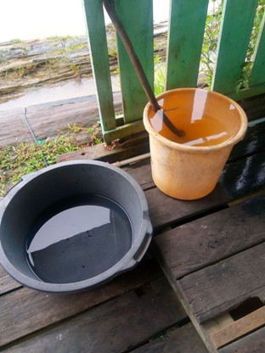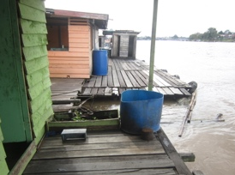
Figure 9. Left: Clean water bought from vendors; Right: Collecting rainwater. (Photos: Lubis, 2019)

To summarize, Table 1 shows the tactic-strategy relations, where the everyday tactics carried out by the lanting community are reactions and responses to strategies carried out by parties with power and influence, the government and large companies, which have the potential to threaten the continuity of the lanting settlement, in the context of their impacted environmental setting, which in this case, the river.

Table 1. The everyday political ecology of the lanting community.
Strategies  (performed by government, corporations, other parties) | Tactics  (performed by the lanting community) | Description
Urban policies and planning, which tend to ignore and marginalize the lanting settlement and its inhabitants | Securing the space and territory | - Claiming and marking spots on the riverbank as territories.  - Building mutual agreements among the lanting dwellers to avoid territorial conflicts.
 | Maintaining good relationship with the government apparatus | - Access to legal identities (ID card, family registers, etc).  - Access to preliminary informations regarding government’s plans and projects that might threaten the lanting settlement.
 | Adding values by utilizing lanting as production and commercial space | - Jetties  - Loading docks  - Rest Area  - Shops / kiosks  - Inn/lodge  - boarding house  - Pop-up market
Government’s restrictions on timber harvesting and distribution | Lanting’s construction and maintenance | - Constructing lanting at few places where timbers are allowed to harvest, to then moved to Sintang.  - Checking and maintaining the building conditions on a regular basis to avoid heavy repairs.
Large scale palm oil plantations and gold mining practices, that caused massive deforestation and environmental problems. | Coping with river’s environmental degradation (pollution, flooding, drought, and erratic tidal patterns). | Developing knowledge and practices on daily basis, to cope with the unpredictable changes of the river’s environment:  - Adjusment of lanting position to fluctuating water heights and changing water currents to avoid running aground or drifting away.  - Night-shift work and organizing schedule among the lanting dwellers to keep the house supervised for 24 hour.  - Keeping the safe distance between lantings to avoid colliding.  - Cleaning stuck trash.  - Securing household items from falling during heavy currents.  - Evacuating the elderly/babies to families on land during bad weathers.  - Collecting rainwater during the drought or heavy pollution.
Source: Authors, 2018-2019
Conclusion

I argued at the beginning of this article that cities in the Global South have not properly accommodated riverbank settlements into urban policy and planning, because of the approach and conceptualization of planning that tends to be ahistorical and generalizes the riverbank settlements as squatter or slum. Lanting, a form of riverbank settlements in Kalimantan, is a river-based community way of life that has existed for centuries to the present day, despite the fact that today it faces serious challenges in dealing with land-oriented modernization and coping with rapid environmental changes and degradation.
While this study does not offer an instant solution on how to improve the quality of lanting settlement and its community, it provides a more comprehensive perspective in understanding the dynamics of daily life of the lanting community as a form of struggle to become part of modern urban life. The perspective of everyday political ecology, enables us to understand the complex reciprocal relationship between social, political and economic processes and environmental changes on the daily basis. The accumulation of tactics plays an important role in building knowledge about a complex phenomenon of social and nature relationships, or in this case, the relationship between lanting inhabitants, the urban and rural social and economic processes, and the river ecology.
The existence of lanting settlements is a manifestation of its inhabitants as active and creative subjects. With all their capacities and limitations, they try to respond to various situations, both the dynamics of modernization, global economics, government policies, environmental changes, et cetera, by producing everyday tactics to maintain their existence, and to improve their lives. It can also be said that it is their struggle to claim the ‘right to the city’ (Lefebvre 1968). Amidst the instability and failures of urban planning, the act of dwelling is managed and sustained across multiple timescales and temporal possibilities (Sangtani 2020). If local planners and policymakers were to take this study seriously, they might rethink carefully about the planning and design of the riverfront area in the cities of Global South, especially in Kalimantan, which, not only prioritizes mere aesthetics and hydrological functions, but also accommodates the lives of the inhabitants of the riverbank settlements, without having to deprive them of their home.

Acknowledgement

This research is supported by Directorate of Research and Community Service University of Indonesia. I would like to express my sincere gratitude to my research supervisors, for their patient guidance, enthusiastic encouragement, and useful critiques of this part of my Ph.D. research work. I would also like to thank colleagues from West Kalimantan, for their advice and assistance during the process of data collecting, and also extended to colleagues and staff in the department, for their supports.

References

Berg, B. L. (2009), Qualitative Research Methods for the Social Sciences, Boston, Allyn & Bacon.
Beveridge, R., & Koch, P. (2018). Urban everyday politics: politicising practices and the transformation of the here and now. Environment and Planning D: Society and Space, (doi:10.1177/0263775818805487).
Blaikie, P. M., & Brookfield, H. (1987). Land Degradation and Society. London, Methuen.
De Certeau, M. (1984). The Practice of Everyday Life. Berkeley, University of California Press.
Cabello, V., Willaarts, B. Aguilar, M., & del Moral, L. (2015). River basins as social-ecological systems. Ecology and Society, 20(3), 20 (2015).
Chase, J., Crawford, M. & Kaliski, J. (1999). Everyday Urbanism. NY, Monacal Press.
Christie, J. W. (1995). State formation in early maritime Southeast Asia. Bijdragen tot de Taal-Land-en Volkenkunde 151/2, Leiden, 235-288.
Cleary, M., & Eaton, P. (1992). Borneo Change and Development. Singapore, Oxford University Press.
Coelho, K. (2018). The Canal and The City: An Urban–Ecological Lens on Chennai’s Growth. India International Centre Quarterly, 43(3/4), 287–300.
Dhananka, S. R. (2016). The Production of Space and Governmentality in the Urban Poor’s Claim over Land and Housing. South Asia Multidisciplinary Academic Journal, 14(2016).
Fienieg, A., & Sagita, N. (2007). The history of Sintang: a collection of books, manuscripts, archives and articles. Amsterdam, Royal Tropical Institute.
Flowerdew, R. & Martin, D. (1997). Methods in Human Geography: A Guide for Students doing a Research Project. Harlow, Pearson Education Ltd.
Fox, S. (2013) The Political Economy of Slums: Theory and Evidence from Sub-Saharan Africa. Working paper. London: Development Studies Institute, LSEPS.
Heidhues, M. S. (2003). Golddiggers, Farmers, and Traders in the "Chinese Districts" of West Kalimantan, Indonesia. Cornell University Press.
Hesam, K., & Peimani, N. (2019) Towards an Informal Turn in the Built Environment Education: Informality and Urban Design Pedagogy. Sustainability, 11, 4163.
Jones, P. (2017). Formalizing the Informal: Understanding the Position of Informal Settlements and Slums in Sustainable Urbanization Policies and Strategies in Bandung, Indonesia. Sustainability, 9, 1436.
Keskinen, M. (2006). The Lake with Floating Villages: Socioeconomic Analysis of the Tonle Sap Lake. Water Resources Development, 22(3), (2006).
Koninck, R. D., Bernard, S., & Bissonnette, J. (2011). Kalimantan transformed: agricultural expansion on the Southeast Asian frontier. Singapore, NUS Press.
Lefebvre, H. (1947). The Critique of Everyday Life. London, Verso.
Lefebvre, H. (1968). Le Droit à la Ville. English Editions, Paris, Anthropos.
Lefebvre, H. (1991). The Production of Space, Oxford, UK, Blackwell.
Little, P. E. (2007). Political ecology as ethnography: a theoretical and methodological guide. Horiz.antropol. vol.3 no.se Porto Alegre.
Listiana, D. (2012). Tanah Sintang Masa Kolonial: telaah sederhana tentang perubahan status pemerintahan dan wilayah kekuasaan. Pontianak, STAIN Pontianak Press.
Low, S. (2017). Spatializing Culture: The ethnography of space and place. Routledge, New York.
Lubis, M. S. (2019). The Political Ecology of Riverine Settlements, case study of Sintang, West Kalimantan. (Doctoral dissertation). Dept. of Architecture, Universitas Indonesia.
Lubis, M. S., Harjoko, T. Y. & Susanto, D. (2019). “Lanting’ as a way of life: A legacy of riverine culture and architecture in the present urban life of Sintang City, West Kalimantan”. IOP Conf. Ser.: Mater. Sci. Eng. 523 012060.
Perramond, E. P. (2007). Tactics and Strategies in Political Ecology Research. Area Vol.39 (4).
Phillips, D. A. (2006). Southeast Asia. NY, Infobase Publishing.
Rahman, S., Mentayani, I., Rusmilyasari, & Mahreda, E. (2019). Konsep Penataan Permukiman Kumuh Tepian Sungai di Kelurahan Sungai Bilu Kota Banjarmasin. EnviroScienteae. 15. 397. 10.20527
Rose, M. (2012). Dwelling as marking and claiming. Environment and Planning D: Society and Space 2012, volume 30, pages 757 – 771.
Sangtani, C. (2020). Between Dwelling and Displacement: A Study of Time Amidst the Uncertainty of Planning. Etnofoor, 32(1), 23–41.
Sharifi, A. (2015). From Garden City to Eco-urbanism: The quest for sustainable neighborhood development. Sustainable Cities and Society. 20: 1–16.
Swyngedouw, E., Kaika, M. & Castro, E. (2002). Urban Water: A Political-ecology Perspective. Built Environment (1978) 28 (2).
Travers, A. (2012). Floating Communities on Tonle Sap Lake, Cambodia: Spatial patterns and Adaptation Capacity. (Research Report). School of Geography, Planning and Environmental Management, University of Queensland. (2012).
Turner, J. C. 1968. Housing Priorities, Settlement Patterns, and Urban Development in Modernizing Countries. AIP Journal November 1968 p.354 – 363.
Yin, R. K. (1993) Applications of Case Study Research, Applied Social Research Methods Series, Volume 34, Sage Publications, Newbury Park.

