

Spatio-temporal variability of droughts over the Mullaitivu District in Sri Lanka from 1980 to 2020

Piratheeparajah Nagamuthu¹, Mou Leong Tan¹, Ngai Weng Chan¹, Fei Zhang^{2,3}

¹GeoInformatic Unit, Geography Section, School of Humanities, Universiti Sains Malaysia, 11800 USM, Pulau Pinang, Malaysia
²Key Laboratory of Wisdom City and Environment Modeling of Higher Education Institute, College of Resources and Environmental Science, Xinjiang University, Urumqi 830046, China.
³Key Laboratory of Oasis Ecology, Xinjiang University, Urumqi 830046, China.

Correspondence: Mou Leong Tan (email: mouleong@usm.my)

Received: 07 May 2021; Accepted: 27 November 2021; Published: 28 February 2022

Abstract

This research aims to evaluate the spatio-temporal changes of annual and seasonal droughts of the Mullaitivu District in Sri Lanka from 1980 to 2020 using the Standardized Precipitation Index (SPI). Four homogeneity tests were performed to identify the inhomogeneity of the monthly rainfall data obtained from twelve stations. Good quality observed data were chosen to measure SPI for determining the frequency, severity, and intensity of the drought events. This was followed by Mann Kendall's (M-K) test to analyze the drought occurrences trend. Further, the relationship between the drought events and Indian Ocean Dipole (IOD) was explored to understand how large-scale atmospheric circulation influences the local droughts. The findings show that dry periods occurred in 1982, 1998, and 2018, while 1989, 1992, 1994, 2001, 2003, 2007, and 2011 experienced severe dry phases. In addition, June, July, and August were identified as the dry months in the study area. Spatially drought over the Mullaitivu District spread from west to east, where the drought vulnerability originated in the west in March and moved eastward. A strong positive correlation (r = 0.83) between the drought events and IOD showed that IOD has considerably influenced the drought formation over the Mullaitivu District.

Keywords: Drought, Mullaitivu District, spatial pattern, Sri Lanka, Standardized Precipitation Index, temporal variations

Introduction

Climate change is an emerging issue worldwide, leading to unexpected weather extremes, creating much vulnerability in all sectors. The occurring frequency of climatic hazards has increased recently (U.N. Water, 2019). Asian countries, especially South Asian countries, have high threats due to severe occurrences of climatic hazards. South Asian countries confront difficulties in managing climatic dangers because of their sudden circumstances. Drought is the dominant climatic hazard impacting agricultural activities in South Asian countries (Mamavav et al., 2011).
The sea surface temperature (SST) of the Indian ocean influences determining the weather pattern of its surrounding countries like India, Sri Lanka, Bangladesh, Myanmar, and Pakistan (Mamavav et al., 2011). Anomalies of the Indian ocean's sea surface temperature are referred to as Indian Ocean Dipole (IOD). This is similar to El Nino Southern Oscillation (ENSO), which influences countries' air and sea temperature conditions (Shelton & Lin, 2019). Recent findings revealed that the IOD is the leading cause of the extreme dry spell conditions in Sri Lanka (Chandrasekara et al., 2017). Anomalies of the atmospheric temperature and the increases in surface temperature induce dry situations in Northwestern, Northern, Eastern, Southeastern, and North Central provinces of Sri Lanka (Peries, 2006).
Suppaiah (1996) explained that the low amount of rainfall generally occurs during the summer season and causes drought in the dry zone of Sri Lanka. Drought is known as extreme climatic events due to the low rain than the average for several months or years (Dai, 2011). Climate change can lead to more severe droughts, substantially impacting water availability (Aksoy et al., 2018). Sri Lanka's government faces obstacles mitigating the impact of droughts, particularly in dry zones (Manesha et al., 2015). Interruption of water supply is a common problem during dry periods, which leads to regional and national water crises in various communities in Sri Lanka.
Agricultural activities, particularly paddy cultivation, face severe threats due to drought. The prolonged absence of rainfall impacts the reservoir water levels (De Silva & Kawasaki, 2018), and rain-fed paddy cultivation of dry zone areas of the country face losses due to water scarcity or drought problems in summer seasons (De Silva & Hornberger, 2019). The absence of rainfall for a long time, higher evaporation rate, and high temperature are the leading causes of the drought problem in the dry zone areas of Sri Lanka (Abeysingha & Rajapaksha, 2020).
The Sri Lankan government pays considerable attention to mitigating the drought impact in the Northern, Northcentral, Eastern, and Northwestern provinces (De Silva & Kawasaki, 2018). Every year, more than seventeen million worth of paddy cultivation is affected by the drought. The farmers suffer much in recovering their losses due to the deficiency of water, leading to the shortage of rice (De Costa, 2010). Unexpected drought due to climate change is becoming a crucial issue in the dry zones of Sri Lanka, impacting the supply and demand of water and creating community conflicts on water sharing in Anuradhapura, Polonnaruwa, Puttalam, and Mannar (Gunawardena, 2015).
The Mullaitivu district of Sri Lanka has been significant in providing a substantial share in rice production for the last twenty years, from 1986 to 2006, before the fierce internal war (Northern Provincial Council, 2017). This district also produced subsidiary crops on a large scale before the war (Central Bank of Sri Lanka, 2018). However, Mullaitivu is categorized as Sri Lanka’s highest poverty index district. After the war, heavy crop damages were recorded due to weather extremes, especially drought (Rajendram et al., 2017). This continued every year after the end of the war. It challenges the farmers to rectify the damages and recover from damages.

Method and study area

Study area

Mullaitivu district is a coastal district located in the northern province of Sri Lanka (Figure 1). The average annual rainfall of the Mullaitivu District is 1275 mm/year, with a bimodal rainfall pattern, where 75% of the rain is received during the early phase of the northeast monsoon period from November to February. The remaining periods are parched and warm. On the other hand, a warmer temperature occurs during the southwest monsoon season from June to August. The monthly average temperature ranges between 23 °C and 39 °C.

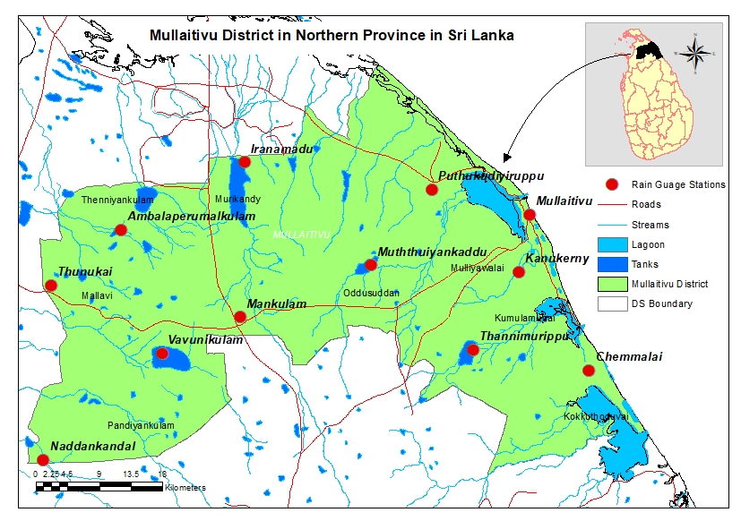
Figure 1. The location of Mullaitivu District of Sri Lanka

Data and methodology

Observed data

The monthly observed rainfall data for 1980 to 2020 of twelve rainfall measuring stations of the Mullaitivu district were collected (Figure 1). Many rainfall stations of the district were established during the 1960s, but some of them did not function continuously. The Department of Meteorology, Provincial Irrigation Department of Northern Province of Sri Lanka, and the Economic Development Department were essential sources for the rainfall data for this study.
The rainfall is measured using an automated rain gauge in one station and a manual in 15 stations. There are three times measured in a day, such as 8.30 a.m., 1.00 p.m. and 6.30 p.m in the day. The rainfall data for all stations of the Mullaitivu district were unavailable for 2008 and 2009 due to the severe internal war. Hence, the moving average method is used to fill the missing data for 2008 and 2009.

Homogeneity analysis

The homogeneity analysis of long-term time-series data is essential to remove inhomogeneous data (Kang & Yosof, 2012). Monthly rainfall data were checked in this study before calculating the Standardized Precipitation Index (SPI). Four homogeneity tests: Standard Normal Homogeneity Test, Pettit test, Buishand Test, and Von Neumann test methods were used. The Standard Normal Homogeneity Test, Pettit test, and Buishand Test were used to identify the break years. The Pettit and Buishand Test can evaluate the break years in the middle part of the time series. In contrast, the Standard Normal Homogeneity Test evaluates the breaking months and years in the initial or ending part of the time series (Tan et al., 2019). The stations can be divided into three categories: (1) Useful - there is none or rejection of the null hypothesis at the significance level of 95% so that data could be further analyzed; (2) Doubtful - two tests reject the null hypothesis at 95%, where the data has to critically examined before use, and (3) Suspect – three or all tests rejected the null hypothesis at 95% significance level.

Standardized Precipitation Index (SPI)

The SPI is a well-known index to study drought in any location based on the long-term rainfall data, e.g. 30 years (Fung et al., 2020). Many studies have utilized SPI to examine drought (Hong et al., 2007) because it is a relatively simple index using only rainfall data as input (Cancelliere et al., 2007). Positive SPI values indicate wet precipitation conditions, whereas negative values of SPI indicate dry conditions (Fung et al., 2020).

This study analyzed SPI for one-month (SPI-1), three-month (SPI-3), and twelve-month (SPI-12) time scales. Drought can be categorized based on Table 1. After the SPI calculation, the values were used to map the drought's spatial pattern using the Kriging technique available in the ArcMap 10.4 version. Kriging is an interpolation method based on geostatistical techniques, including autocorrelation of the statistical relationship of measured points. An ordinary kriging method with ‘spherical semi-variogram model with advanced default parameter’ was applied.

Table 1. SPI Values and the severity of drought (Source: WMO, 2008)

Values | Severity
≥ 2.00+ | Extremely Wet
1.50 to 1.99 | Severely Wet
1.00 to 1.49 | Wet
-0.99 to 0.99 | Near Normal
-1.00 to -1.49 | Dry
-1.50 to -1.99 | Severely Dry
≤ -2.0 | Extremely Dry

A drought event is identified based on the continuous negative SPI-1 values for three consecutive months (Lin et al., 2020; Naz et al., 2020). The drought frequency, severity, and intensity were calculated based on the identified drought events. Drought duration is the sum of the monthly duration for the continuous negative values for each station. Drought severity was calculated based on the sum of the SPI-1 negative values in the drought duration. Drought severity was divided by the drought duration (Naz et al., 2020).

Mann-Kendall (M-K) analysis

Mann-Kendall test helps to analyze the trend of SPI for each station from 1980 to 2020. It is widely used to identify a monotonic increase or decrease of the movement of hydro-climatic variables (Ahmad et al., 2015; Naz et al., 2020). The Mann-Kendall test's null hypothesis (H0) means no trend, while the alternative hypothesis (Ha) indicates a trend in the evaluated series. As per the M-K significance (alpha), 0.05 was selected to differentiate significant changes. Some advantages of this test are that the missing values, irregular spacing, and data length would not affect the results (Mondal et al., 2012).

Indian Ocean Dipole (IOD)

IOD is defined as the anomaly conditions of the ocean-atmospheric system of the Indian Ocean Surface. The peak of the IOD resulted in warmer weather conditions in the adjoining regions of the Indian ocean (Oliveira et al., 2018). It is slightly different from El Nino Southern Oscillation (ENSO), and only 35% of the events are linked with ENSO (Cai et al., 2005).
There are two major categories of IOD based on the tropical Indian ocean surface temperature, known as IOD West (50° E to 70° E and 10° S to 10° N) and IOD East (90° E to 110° E and 10° S to 10°N). A positive IOD value shows a colder sea surface in the eastern part of the Indian Ocean and a warm condition in the western part of the tropical Indian ocean (Zubair et al., 2003). Meanwhile, a negative IOD value is a hotter condition in the eastern Indian ocean and a colder situation in the western Indian ocean. An IOD value above +0.4 degree is considered positive, while less than -4.0 is negative. Monthly and annual IOD indexes were collected from the National Oceanic Atmospheric Agency (NOAA) and the International Research Institute for Climate Society of Columbia University (IRD). This study considered the IOD index for the Eastern part of the Indian Ocean to correlate with the SPI Values. The SPI was associated with IOD using the Spearman Correlation approach to identify the long-term relationship between these two phenomena.

Results

Data homogeneity analysis

Figure 2 shows the P values of the von Neumann method, Pettit method, and Buishand method for each station. Only Muththaiyankaddu and Semmalai were considered “doubtful,” while the remaining centers were classified as “useful” stations. All methods show the same breaking year in some stations, for example, Mullaitivu, Puthukkudiyiruppu, and Mankulam. These breaking years are most probably due to natural climate variability. Accordingly, observed rainfall data from all stations are identified as homogenous and considered to determine the spatio-temporal drought patterns over the Mullaitivu district of Sri Lanka.

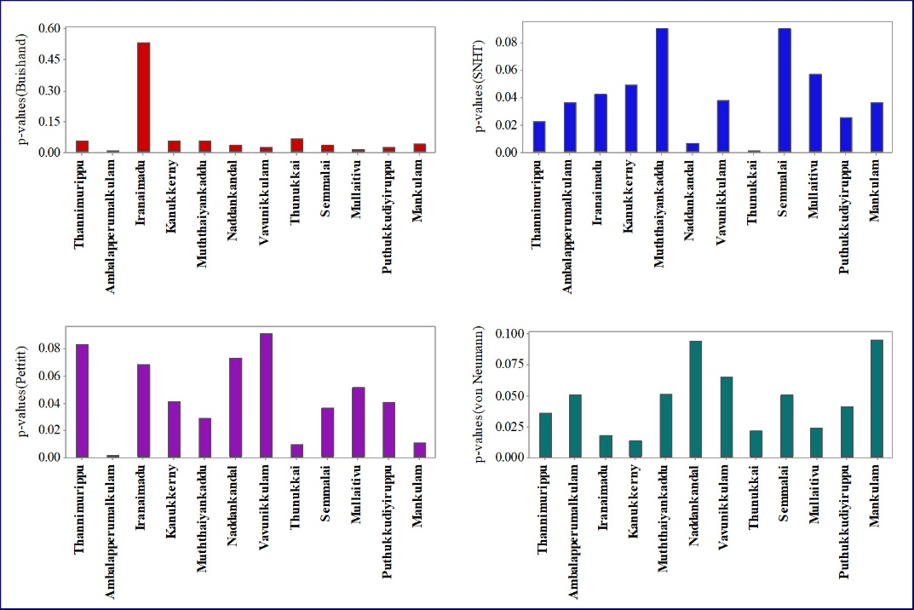
Figure 2. The p-value variations of homogeneity analysis of monthly rainfall data of every
Mullaitivu District station

Temporal variations of drought

Three severe droughts were found in 4/1982 to 3/1983 according to the SPI-12 analysis (Hereafter, the format will be month’s number and year), 5/1998- 3/1999, and 8/2018. The drought period of 1998-1999 severely affected more than half of the Mullaitivu District's eastern part. Meanwhile, the severe drought in 2018 lasted for more than eleven months and affected the western part of the Mullaitivu district. Moderate or mild droughts were identified in 5/1977-6/1978, 3/1989-1/1990, 5/1994-3/1995, 2/2001-12/2001, 4/2007-4/2008, and 5/2011-3/2012. During these periods, the district faced hardships in managing domestic and drinking water usage.
SPI-3 analysis revealed several severe drought occurrences in the Mullaitivu district for the last forty years from 1980 to 2020. Previous studies used SPI-3 for seasonal analysis in Sri Lanka, based on the paddy cultivation period (Abeysingha & Rajapaksha, 2020). In general, the southwest monsoon season is vulnerable to drought because droughts were mainly detected in this period, e.g., 1982, 1988, 1991, 1993, 1998, 2001, 2013, 2015, and 2018 (Figure 3). Seven severe droughts were identified during the first inter-monsoon season from SPI-3 in 1983, 1999, 2004, and 2012. There are seven severe droughts during the northeast monsoon season and the second inter-monsoon season, especially in 1981, 1982, 1988, 1990, 1998, 2003, and 2011 received less than 50% of its average total rainfall. The percentage of drought based on SPI-3 during the southwest monsoon season from 1980 to 2020 was 26.19%, showing that drought occurred once every 3.75 years, or, in other words, there will be a severe drought in the southwest monsoon season every four years.
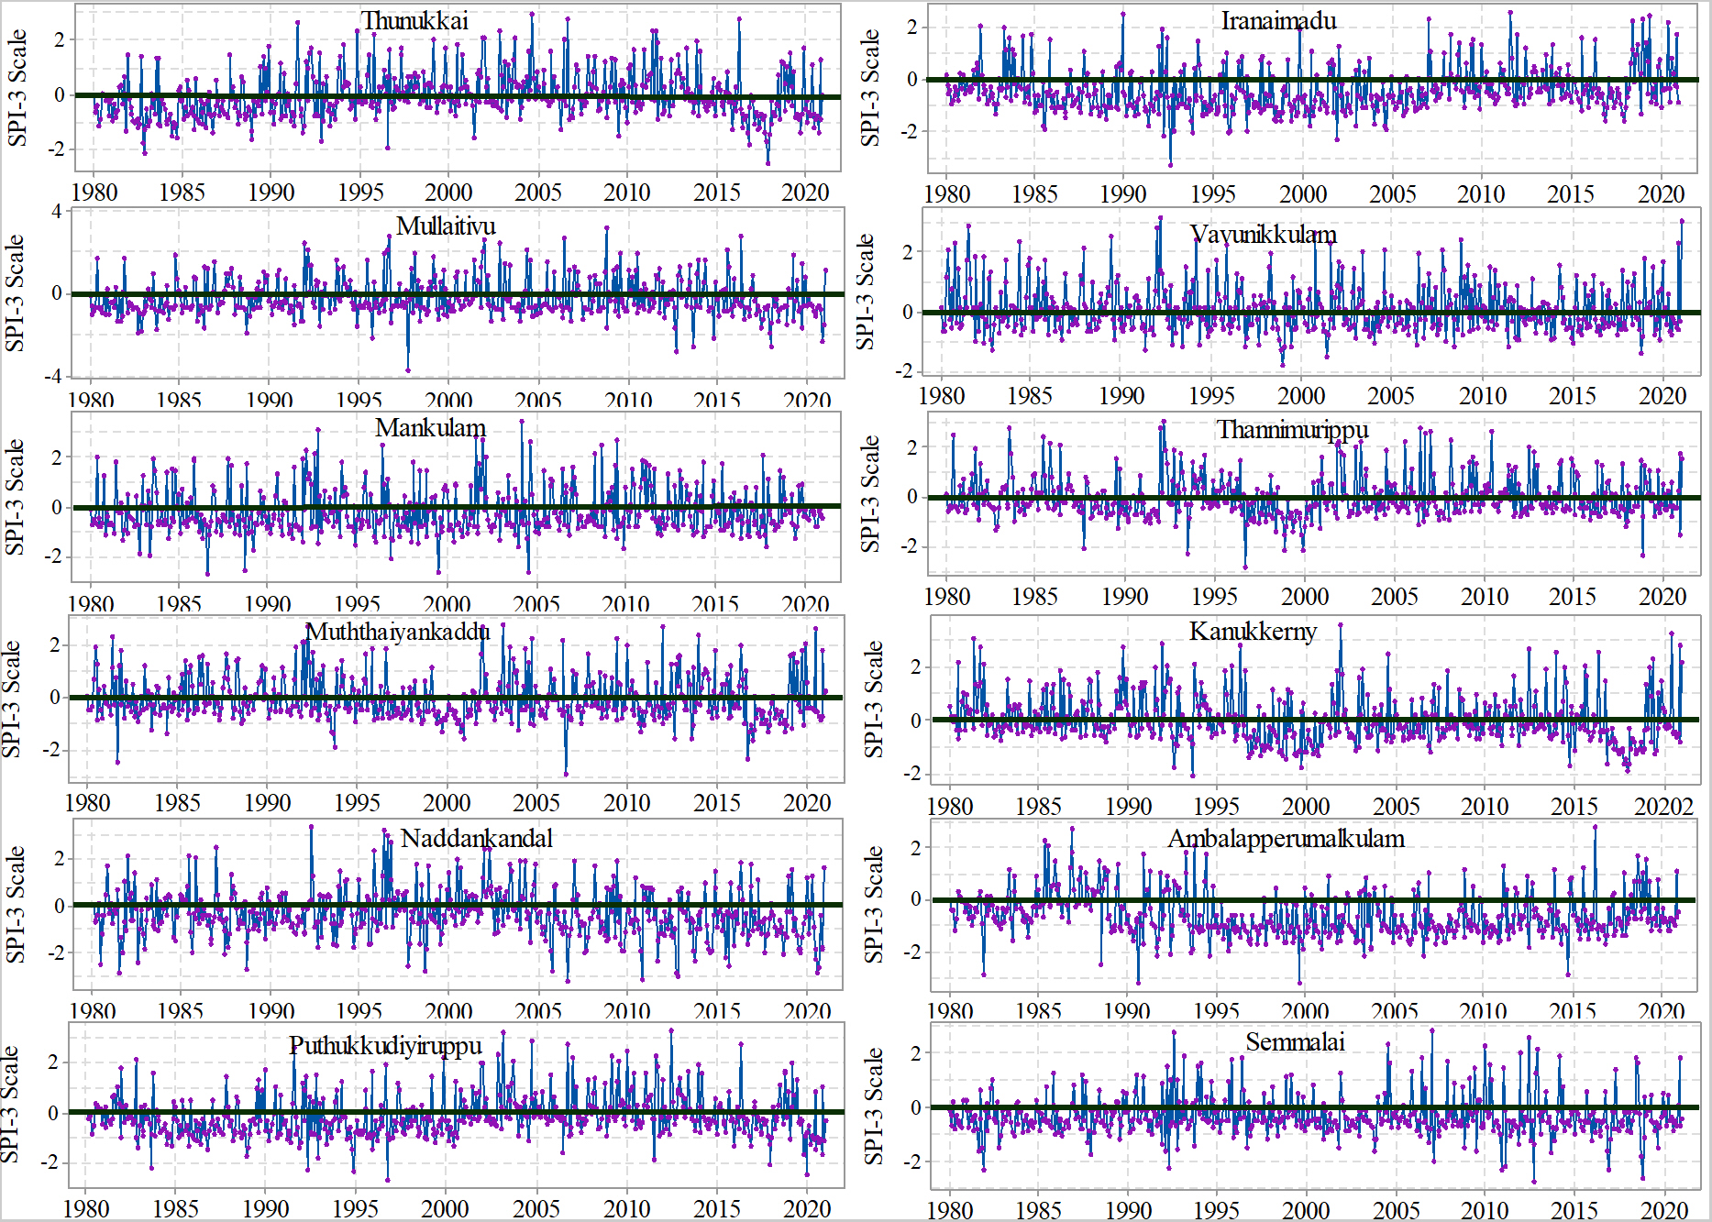
Figure 3. Temporal variations of SPI-3 in various stations of the Mullaitivu District

The SPI-1 analysis shows many exciting facts. Many variations have been identified spatially and temporally in the Mullaitivu District. As per the SPI-1 analysis, every station has a minimum of seven extreme drought months with variations between the stations (Table 2). According to the SPI-1analysis, the maximum number of extreme or severe droughts was identified in Naddankandal (18) and Ambalapperumal (10), while the lowest number of droughts was identified in Kanukkerny (6) and Thannimurippu (6). The SPI values of all these drought events are more significant than -1.5. In 1982, 1983, 1988, 1998, and 2018, more than 90% of the study area locations experienced drought or dry conditions during these identified months. However, the extreme drought based on SPI-1 varies in every station, and the received average rainfall for these months is less than 50mm/month.

Table 2. Years and months of extreme and severe drought occurrences in the Mullaitivu district based on SPI-1.

Station | Extreme/Severe drought - year and months based on SPI-1
Thunukkai | 1982/11, 1988/9, 1996/7, 2001/5, 2016/10, 2017/10, 2017/11,
Puthukkudiyiruppu | 1983/7, 1992/3, 1994/10, 1996/8, 2006/5, 2011/5, 2017/9, 2019/11
Ambalapperumal | 1981/9, 1988/7, 1990/8, 1991/8, 1993/7, 1994/8,1999/8, 2003/3, 2006/8, 2017/9
Iranaimadu | 1982/11, 1989/6, 1993/6, 1998/7, 2002/8, 2009/7, 2017/7
Mullaitivu | 1983/7, 1991/6, 1996/5, 1998/8, 2013/8, 2014/6, 2020/6
Mankulam | 1983/8, 1983/9, 1987/3, 1989/2,1994/8, 1997/4, 2004/10, 2009/6
Muththaiyankaddu | 1982/9, 1989/7, 1991/8, 1994/9, 1997/8, 2007/6, 2011/6, 2017/6
Naddankandal | 1980/4, 1981/3, 1981/4, 1982/6, 1998/9, 2003/4, 2003/6, 2003/7, 2004/8, 2006/4, 2006/9, 2010/4, 2011/9, 2016/3, 2016/4, 2017/5, 2020/7, 2020/8
Vavunikkulam | 1983/7, 1988/7, 1991/10, 1994/3, 1998/4, 1998/8, 2004/3, 2017/8
Thannimurippu | 1994/6, 1997/3, 1998/5, 1999/2,1999/12, 2018/6
Kanukkerny | 1983/5, 1988/6, 1991/4, 1993/9, 1994/5, 2017/11
Semmalai | 1982/10, 1988/8, 1992/7, 2007/4, 2011/4, 2011/5, 2016/6, 2018/6

Spatial variations of drought

Many variations on drought occurrences and the severity of droughts have been identified. The western part of the Mullaitivu experienced severe droughts during the early phase of the southwest monsoon season. Almost all areas in Mullaitivu District experienced drought in the later stage (Figure 4). As per Figure 5, drought spreads from west to east of the study region in March. During July and August, almost 90% of the study area was affected by drought. During the southwest monsoon season (June, July, August), droughts occurred in virtually every station of the study area. Drought conditions decreased during September and onward, and December is the wettest month of the study area since the SPI-1 values for each station are positive in some stations.

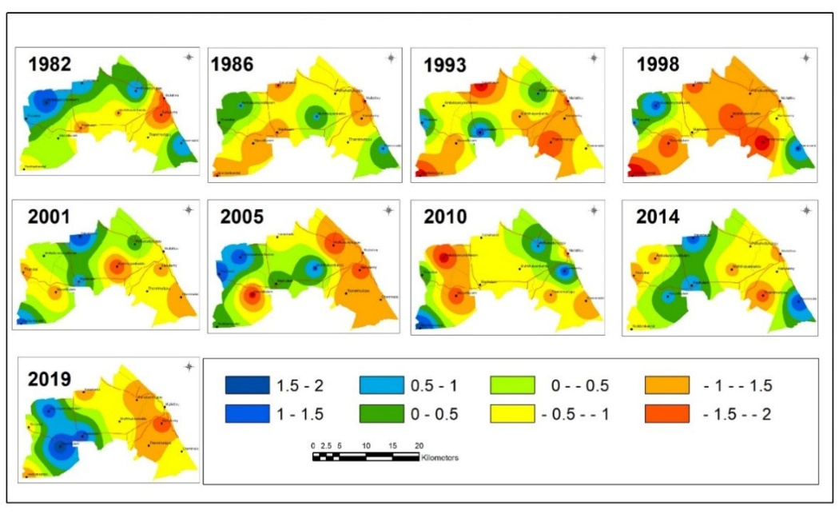
Figure 4. Spatial Patterns of SPI-3 during the southwest monsoon season in the Mullaitivu District.
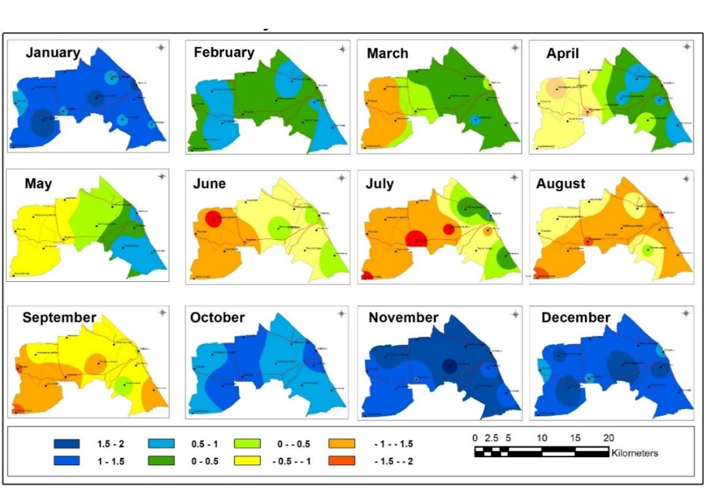
Figure 5. Spatial pattern of SPI-1 for each month over the Mullaitivu district, Sri Lanka.

Drought duration, severity, and intensity analysis

The SPI-1 representing meteorological drought was used to analyze drought duration, intensity, and severity. Figure 6 illustrates the trend of SPI-1 of every station and the drought trend of the Mullaitivu District. Naddankandal station provided the maximum drought duration in 1982, which was 09 months. Simultaneously, the drought duration of other stations was at least 05 months in 1982. In 1998, drought duration in most stations exceeded 04 months, with the highest drought duration in the Amabalapperumal station, which was 07 months continuously. In 2018, Semmalai and the Ambalapperumal stations had a prolonged drought than other stations, nearly 07 months. However, the M-K test indicated no significant change in drought duration in the past 40 years (Table 3). Figure 6 shows that the Thunukkai and Iranaimdu stations had the highest drought duration, while the Muththaiyankaddu station had the lowest.

Table 3. Mann - Kendall test values

Station | Z -Value | P-Value
Thannimurippu | 0.121 | 0.904
Ambalapperumalkulam | 0.944 | 0.345
Naddankandal | 0.097 | 0.923
Iranaimadu | 0.303 | 0.762
Kanukkerny | 0.145 | 0.885
Mankulam | 0.605 | 0.545
Muththaiyankaddu | 0.630 | 0.529
Thunukkai | 0.097 | 0.923
Mullaitivu | 0.968 | 0.333
Semmalai | 0.073 | 0.942
Vavunikkulam | 0.714 | 0.475
Puthukkudiyiruppu | 1.645 | 0.100
Thannimurippu | 0.121 | 0.904
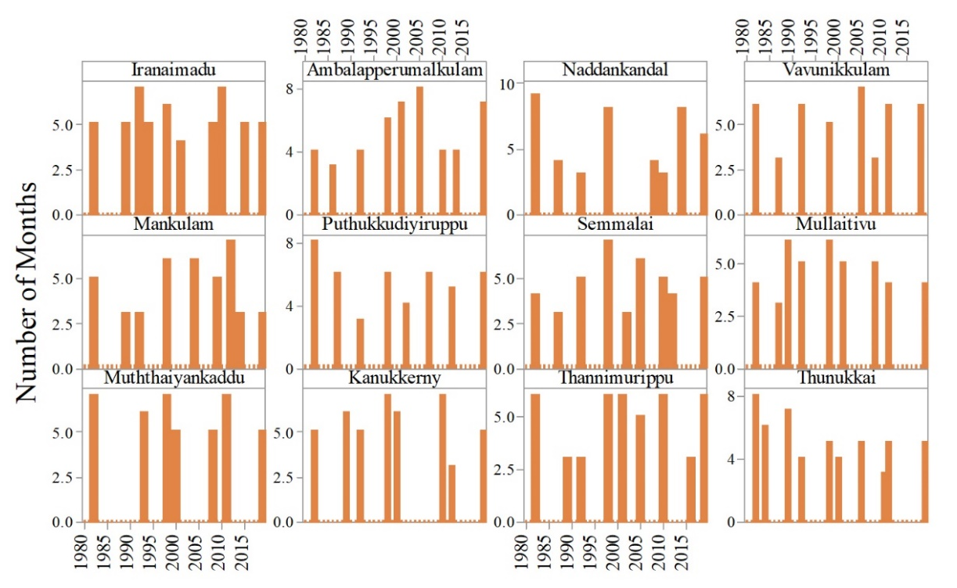
Figure 6. Drought duration for each station in the Mullaitivu District from 1980 to 2020
Figure 7 illustrates the maximum drought severity in the Ambalapperumal, Muththaiyankaddu, Semmalai, and Naddankandal stations, with a total SPI-1 above -12.5. However, drought severity varies from station to station and year to year. The maximum number of drought severity was identified in Iranaimdu, Ambalapperumal, and Thunukkai, and the lowest number of drought severity was recognized in the Kanukkerny and Muththaiyankaddu.
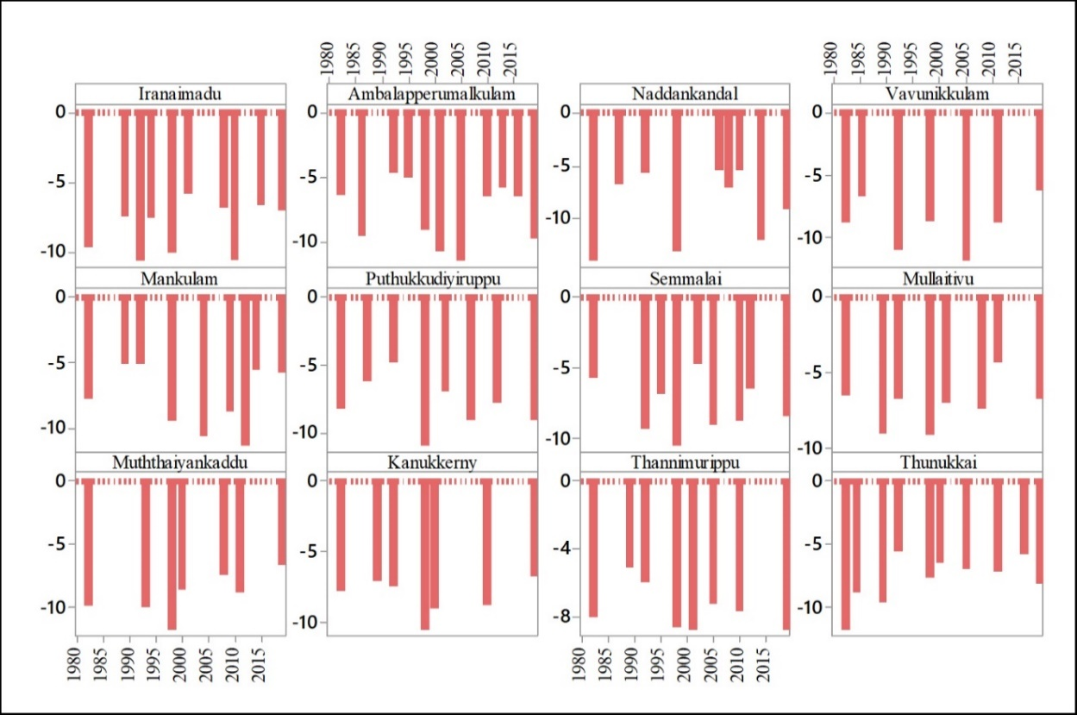
Figure 7. Drought severity of each station in the Mullaitivu District from 1980 to 2020
According to SPI, some variations have been identified in the severity and frequency of drought in every SPI scale, and some variations noted in the drought probability recurrence. According to the SPI-1 values, a higher drought intensity was identified in the Ambalapperumal, Thunukkai, and Thannimurippu stations, with an intensity above -2.00. The peak of the drought was also identified in these stations (Table 4). Extended drought duration with an intensity lower than -2.00 made extreme drought continuation for several months. The study area's drought intensity for the last 40 years shows many fluctuation patterns (Figure 8).

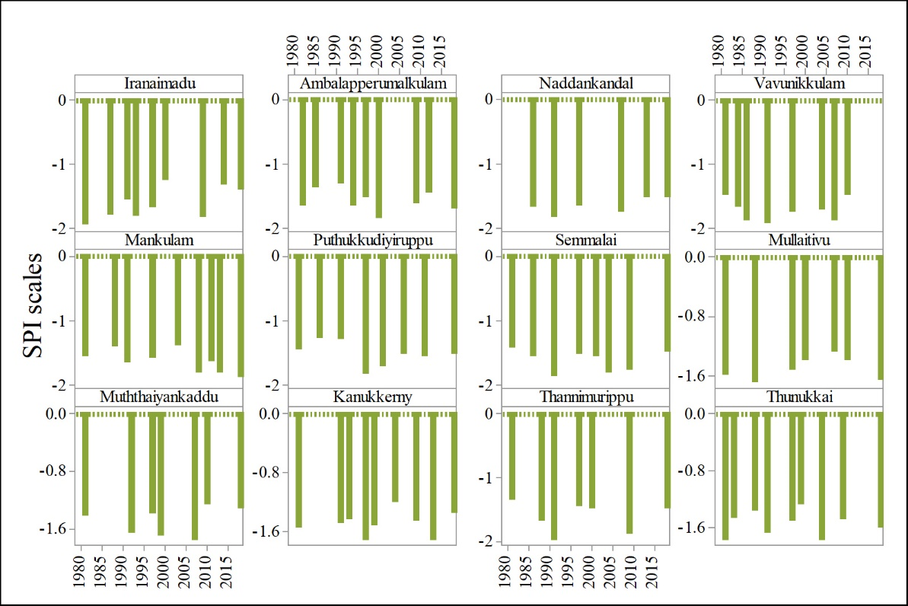
Figure 8. Drought intensity for each station in Mullaitivu District from 1980 to 2020

Table 4. Magnitudes, frequencies, and the probability of recurrences of drought in the
Mullaitivu District of Sri Lanka

SPI | Category | SPI-1 |  | SPI-3 (Seasons) |  | SPI-12 (Years)
SPI | Category | Number | Occurrences | Number | Occurrences | Number | Occurrences
-0.99 to 0.99 | Neutral | Nil | Nil | Nil | Nil | Nil | Nil
-1.0 to -1.49 | Moderate | 87 | Every 04 months | 19 | Every 08 season | 07 | One in 05 years
-1.50 to -1.99 | Severe | 51 | One in 09 months | 13 | One in 12 seasons | 06 | One in 06 years
-2.00 < | Extreme | 36 | One in 13 months | 09 | One in 17 seasons | 03 | One in 13 years

Correlation between IOD and drought in Mullaitivu district

Several studies have indicated that the variations of sea surface air temperature in the Indian ocean-atmospheric system influence the prevailing weather conditions of Sri Lanka (Abeysinghe & Rajapakshe, 2020; Jayawardene et al., 2015). The correlation analysis was made in this study to evaluate the relationship between drought occurrences of the Mullaitivu District and sea surface temperature changes in the Indian ocean surface. For that purpose, SPI-1, SPI-3, and SPI-12 values correlated with monthly, 03-month, and 12-Month IOD values, respectively.
According to Figure 9, IOD was highly correlated with SPI-1 (0.83), followed by SPI-3 (0.77) and SPI-12 (0.69). This shows that there is a significantly positive connection between IOD and droughts in the Mullaitivu district. The finding is consistent with previous studies (Suppaiah, 1996; Chandrasekara et al., 2017; Jayawardene et al., 2015; Zubair, 2002), which showed positive correlations between the rainfall variability and the IOD in Sri Lanka.
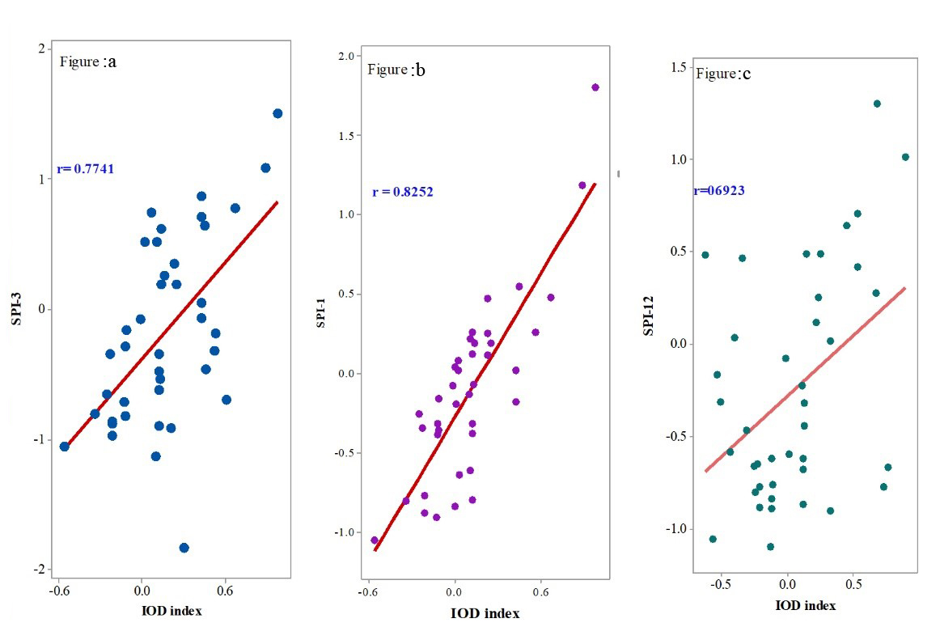
Figure 9. Correlation between SPI-1 and IOD of the Mullaitivu District from 1980 to 2020

Discussion

According to Balasundarampillai (2010), the district has microclimatic variations, and the natural setting of the area determines variations in natural hazard occurrences spatially and temporally. For example, drought originated in the first inter-monsoon season and extended to the southwest monsoon season in some years. Withanachchi et al. (2014) explained that lack of rainfall was the cause for this incidence. Some previous studies also indicate that these two seasons have over seven months of driest months of a year in the Northern, North Central, and Northwestern parts of Sri Lanka (Hettiarachchi, 2015; Fernando, 1997; Jayawardene et al., 2005). The southwest monsoon season was recorded as the dry spell—particularly July, August, and September, as the driest months in the study area, resulting in a high average temperature of 35 ºC (Fernando, 1997).
The high average temperature will impact water bodies and soil evaporation and induce dryness in the study area. Most drought durations were recorded in July, August, and September. Many stations indicated high drought severity if the drought intensity level is more than -1.00. De Silva and Kawasaki (2018) explained increasing drought occurrences due to the decreases in long-term rainfall patterns. Interestingly, the dry condition extended from the southwest monsoon season to the middle phase of the second inter-monsoon season, impacting agriculture. Some findings revealed that rainfall is due to the monsoon process fluctuating and decreasing in the southwest monsoon season. Drought severity and frequencies also increase in the Northwestern part of Sri Lanka (Alahacoon & Edirisinghe, 2021b; Ranagalage et al., 2020).
Studies on climate change have disclosed a significant temperature increase in many parts of Sri Lanka. Future climate change studies have also predicted an increase in temperature (Alahacoon & Edirisinghe, 2021a). As temperature increase is the vital source for drought occurrences, the future pattern of drought occurrences will also be in dense frequencies in the study area (Withanachchi et al., 2014).
Rainfall is the leading cause of drought and flood hazards in the study area. Generally, very little rainfall is recorded in June, July, August, and September, and in some months, no rainfall is recorded in the study area in some years. Figure 10 illustrates the monthly pattern of rainfall for the Mullaitivu district. No rainfall in June may lead to a water shortage because July is the hottest month in the study area. There are no significant changes in the annual total rainfall for the Northern region of Sri Lanka (Jayawardene et al., 2005). Still, there is a decreasing pattern in the monthly rainfall in the Mullaitivu district. This is the main reason for the frequent drought occurrences in the study area. Deforestation is not the main reason for the rainfall fluctuation and the increasing frequency of drought occurrences in the study area. The percentage of forest cover has been increased in the study area for the last two decades (Ranagalage et al., 2020).

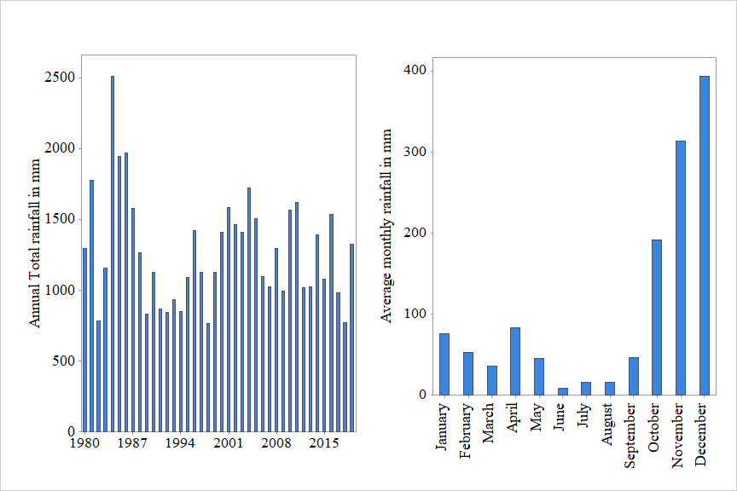
Figure 10. Annual total rainfall and average monthly rainfall pattern of the Mullaitivu District from 1980 to 2020.
Coastal stations have fewer drought conditions as compared to the stations located far from the ocean. Generally, drought conditions originate in Western land areas such as Thunukkai, Naddankandal, or Ambalapperumal and extend eastward. There are many reasons for these conditions, such as geographical location (distance from the sea), soil, and land use pattern. Besides, groundwater is in poor condition in this area. Changes in the SST will impact Mullaitivu because its eastern boundary is a colossal sea surface (Bay of Bengal). Previous studies on IOD in other parts of Sri Lanka also revealed a positive relationship between IOD and rainfall in Sri Lanka (Abeysingha & Rajapakshe, 2020; Adhikari et al., 2010; Zubair et al., 2003; Zubair, 2002).
The study area has seven (7) primary medium tanks and twenty-eight (28) small irrigation reservoirs providing water for domestic and irrigation purposes (De Silva & Hornberger, 2019). These reservoirs function as the drought mitigation sources for the area during the first inter and southwest monsoon. If the reservoir’s water holding capacity increases, it can be used during the high temperature and no/less rainfall period to mitigate or prevent the impact of drought in the district. Figure 11 illustrates the reservoirs detail of the Mullaitivu District. The drought originated in the western part of the study area. Correct identification of the origin of the drought in the west part allows easy mitigation of the impact of drought on the east aspect in advance. A drought-adapted agricultural system must be introduced to avoid crop damage or crop losses in the Mullaitivu district.

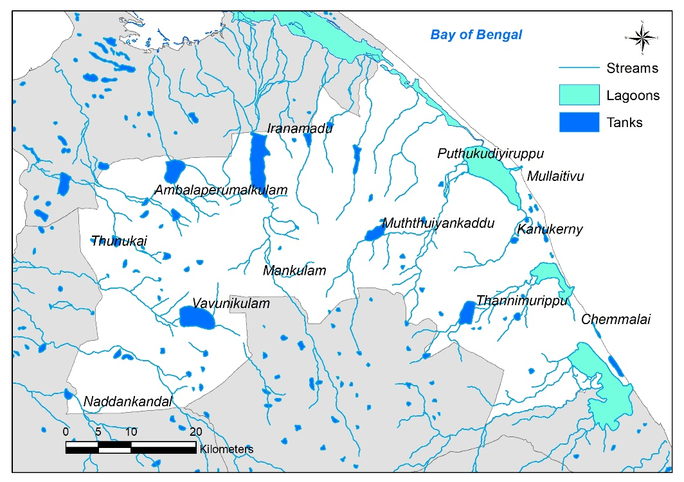
Figure 11. The reservoirs of Mullaitivu District of Sri Lanka

Further studies should analyze the drought impacts on the socio-economic activities, particularly on the agriculture activities of the study area. In that case, the drought severity and drought intensity can be identified, especially the dry zone area, influenced by the northeast monsoon wind. This study could help the water and agriculture-related administrators take preventive actions to mitigate the drought impact in the Mullaitivu district of Sri Lanka.

Conclusion

This research evaluates the spatio-temporal droughts during the past 40 years in the Mullaitivu district, Sri Lanka. The observed monthly rainfall data are homogeneous, which can be further used for analysis. The findings revealed extreme droughts in this region, i.e., in 1982, 1998, and 2018, and severe drought events in 1989, 1992, 1994, 2001, 2003, 2007, and 2011. The worse drought months in the study area are June, July, and August. A rhythmic pattern of drought is noted, spreading from west to east, and the drought vulnerability originated in the west in March and moved eastward. Spatially drought extends from west to east. The onset of drought is in March and further spreads every month up to September. In October, drought in all areas decreases. All sites in the study region face wet spells in November, December, and January. A strong positive correlation (r = 0.83) exists between drought and IOD, indicating that IOD has a considerable impact on the area's drought occurrence.
This study will be a prime and a scientific source for policymakers, development planners, and administrators to make decisions during development work and district emergencies. The information would help forecast drought hazards, generate awareness of the impact to be instigated by drought, plan future activities connected to such risks, and diminish them in the study area. Further, this study will help to formulate a meaningful and sustainable development plan for the Mullaitivu district.

Acknowledgment

This research was funded by the Ministry of Higher Education Malaysia (MOHE) under the Fundamental Research Grant Scheme (FRGS), Project Code: FRGS/1/2018/SS07/USM/02/2 and 203.PHUMANITI.6711695.

References

Abeysingha, S., & Rajapaksha, N. (2020). SPI- Based spatiotemporal drought over Sri Lanka. Advances in meteorology, 1-10.
Adhikari, S., Vahiya, Z., Chandimala, J., Nawarathna, B., Liyanaarachchi, S., & Bandara, R. (2010). Rainfall prediction based on the relationship between Southern Oscillation (ENSO). Journal of National science foundation Sri Lanka, 38(4), 249-255.
Ahmad, I., Tang, D., Wang, T., Wang, M., & Wagan, B. (2015). Precipitation trends over time using Mann-Kendall and Spearman's rho tests in swat River Basin, Pakistan. Advances in Meteorology, 1-15.
Aksoy, H., Onoz, B., Cetin, M., Yuce, I., Eris, E., Selek, B., Aksu, H., Burgan, I., Eswit, M., Orta, S., & Cavus, y. (2018). SPI-based drought severity – duration – Frequency analysis, 13th international congress on advances in civil engineering. Izmir, Turkey.

Alahacoon, N., & Edirisinghe, M. (2021a). Satellite-Based Meteorological and Agricultural Drought Monitoring for Agricultural Sustainability in Sri Lanka. Sustainability, 13, 3427.

Alahacoon, N., & Edirisinghe, M. (2021b). Spatial Variability of Rainfall Trends in Sri Lanka from 1989 to 2019 as an Indication of Climate Change. ISPRS Int. J. Geo-Inf. 10, 84.
Balachandran, S. (1992). Perception of Drought Months in Sri Lanka. International Geographical Union working groups on the Tropical Climatology and Human Settlements and the International Hydrological Program (pp 59-65). University of Peradeniya Sri Lanka.
Cai, W., Hendon, H., & Meyers, G. (2005). Indian Ocean dipole-like variability in the C.S.I.R.O. Mark 3 coupled climate model. Journal of climate, 18, 1449-1468.
Cancelliere, A., Di Maura. G, Bonaccorso, B. & Rossi, G. (2007). Drought Forecasting Using the Standardized Precipitation Index. Water Resource Management, 21, 801-819
Central Bank of Sri Lanka. (2018). Annual Report. Central Bank of Sri Lanka. 35-41
Chandrasekara, S., Prasanna, V., & Hankwon, H. (2017). Monitoring water resources over the Kotmale reservoir in Sri Lanka using ENSO phases. Advances in meteorology, 1-10.
Dai, A. (2011). Drought under global warming: a review. Wiley Interdisciplinary Reviews: Climate Change, 2011, 2:45–65

De Costa, W. A. J. M. (2010). Adaptation of agricultural crop production to climate change: A policy framework for Sri Lanka. Journal of the National Science Foundation of Sri Lanka, 38(2), 79–89.

De Silva M., T., & Hornberger, G. M. (2019). Assessing water management alternatives in a multipurpose reservoir cascade system in Sri Lanka. Journal of Hydrology: Regional Studies, 25(4), 100-124
De Silva, M. M. G. T., & Kawasaki, A. (2018). Socio-economic vulnerability to disaster risk: A Case study of flood and drought impact in a rural Sri Lankan community. Ecological Economics, 152, 131–140.

Fung, K. F., Huang, Y. F., & Koo, C. H. (2020). Assessing drought conditions through temporal pattern, spatial characteristic, and operational accuracy indicated by SPI and SPIE: case analysis for Peninsular Malaysia. Natural Hazards, 103(2). 62-74
Eriyagama, N., & Smakhtin, V. (2009). Observed and projected climatic changes, their impacts and adaptation options for Sri Lanka: A review. National Conference on Water, Food Security and Climate Change, October 2015, 99–117.
Fernando, T. K. (1997). Recent variations of rainfall and air temperature in Sri Lanka. Proceedings of the 53rdAnnual Session of Sri Lanka Association for the Advancement of Science, Section E1, 318-329

Gunawardena, N. (2015). Hydrometric analysis of the Northcentral provinces of Sri Lanka. Journal of Water, 5(1), 35–46.
Hettiarachchi, S. (2015). The trend of rainfall and rainy days in the North-central province of Sri Lanka. Journal of Humanities and Social Science, 3(1), 35–47.
Hong W., Mark D.Svoboda, Michael J.Hayes, Donald A. Wilhite & Fujiang Wen. (2007). Appropriate application of the Standardized Precipitation Index in arid location and dry season. International Journal of Climatology, 27, 65-79
Jayawardene, H.K.W.I., D.R. Jayewardene, D.R., & Sonnadara, D.U.J. (2015). Interannual variability of precipitation in Sri Lanka. Journal of the National Science Foundation of Sri Lanka, 43(1), 75-82
Jayawardene, H.K.W.I., Sonnadara, D.U.J., & Jayewardene, D. (2005). Trends of rainfall in Sri Lanka over the last century. Sri Lankan Journal of Physics, 6, 7–17.
Kang, H., & Yusof, F. (2012). Homogeneity tests on daily rainfall series. International Journal of Contemporary Mathematical Sciences, 7 (1), 9 – 22.
Lareef, Z., Suryachandra, A., Rao & Toshio Yamagata. (2003). Modulation of Sri Lankan Maha rainfall by the Indian Ocean Dipole. Geophysical Research Letters, 30(2), 1063.
Lin, H., wang, J., li, F., Xie, Y., Jiang, C & Sun, L. (2020). Drought trends and the extreme drought frequency and characteristics under climate change based on SPI. and H.I. in the upper and middle reaches of the Huai river basin, China. Water, 2020, 1-19.
Malmgren, B. A., Hulugalla, R., Hayashi, Y., & Mikami, T. (2003). Precipitation trends in Sri Lanka since the 1870s and relationships to El Niño-southern oscillation. International Journal of Climatology, 23(10), 1235–1252.
Mamavav, K.Sivakumar, & Stectaski, R. (2011). Climate Change in South Asia. Springer
Manesha, S., Premalal, S., & Vimukthini, S. (2015). Develop drought monitoring in Sri Lanka using the standard precipitation index (SPI.). Sri Lanka Journal of Meteorology, 1, 64-70.
Mondal, A., Kundu, S., & Mukho Padhyay, A. (2012). Rainfall trend analysis by Mann-Kendall test – A Case study of the northeastern part of Cuttack district, Orissa. International Journal of Geology, 2(1), 70-78.
Naz, F., Hussain Dars, G., Ansari, K., Jamro, S., & Krakauer, Y. (2020). Drought trends in Balochistan. Water, 12(470), 1-16.

Northern Provincial Council. (2017). Development strategies for Northern Province of Sri Lanka. Northern Provincial Council, Jaffna, Sri Lanka.
Oliveira, J., Debodas terassi, P., Degois, G., Silva junior, C., Cavalcante Blanco, C., Sobral, B., & Cruz Gasparini, K. (2018). Drought severity is based on the SPI Index and its relation to the ENSO and PDO climatic variability modes in the North and Northwest of Rio de Janeiro-Brazil. Atmospheric Research, 212(2018), 91-105.
Peries, G.H. (2006) Sri Lanka: Challenges for the New Millennium. Kandy, Sri Lanka. Kandy Books
Rajendram, K. (2019). An Assessment of drought in Mannar District, Sri Lanka. International Journal of Humanities and Applied Social Science, 11, 1–13.
Rajendram, M., Gunewardena, E., & Dayawansa, N. (2017). Impacts of climate change on irrigation water demand of paddy: A case study from Hakawatana Oya irrigation scheme in Sri Lanka. Tropical Agricultural Research, 28(4), 375–388

Ranagalage, M., Gunarathna, M. H. J. P., Surasinghe, T. D., Dissanayake, D., Simwanda, M., Murayama, Y., & Morimoto, T. (2020). Multi-decadal forest-cover dynamics in the tropical realm: Past trends and policy insights for forest conservation in dry zone of Sri Lanka. 1–24.

Shelton, S., & Lin, Z. (2019). Streamflow Variability in Mahaweli River Basin of Sri Lanka during 1990–2014 and Its Possible Mechanisms. Water, 11(12), 2485.

Suppaiah, R. (1996). Spatial and Temporal Variations in the relationships between the Southern Oscillation Phenomenon and the Rainfall of Sri Lanka. International Journal of Climatology, 16, 1-17

Tan, M.L., Chua, V.P., Li, C. & Brindha, K. (2019). Spatiotemporal analysis of hydro-meteorological drought in the Johor River Basin, Malaysia. Theoretical and Applied Climatology, 135(3-4), 825-837.

U.N. Water. (2019). Policy Brief Climate Change and Water. London.1–8.
Withanachchi, S., S., Kopke, S., Withanachchi, R., C., Pathiranage, R., & Ploeger, A. (2014). Water resource management in dry zonal paddy cultivation in Mahaweli river basin, Sri Lanka: An analysis of spatial and temporal climate change impacts and traditional knowledge. Climate, 2(4), 329–354.
World Meteorological Organization (WMO). (2012). Standardized Precipitation Index user guide, No.1090.
Zubair L., Rao S.A. & Yamagata, T. (2003). Modulation of Sri Lankan Maha precipitation by the Indian Ocean dipole. Geophysical Research Letters, 30(2): 1063.
Zubair, L. (2002). El Niño-Southern oscillation influences rice production in Sri Lanka. International Journal of Climatology, 22(2), 249–260.

