

Fluid practices and functions linked with traditional cuisine Busri
in Sindh- Pakistan

Umbreen Kousar¹, Abdullah Khoso²

¹Programme Anthropology and Sociology, University Kebangsaan Malaysia (UKM)
²The Faculty of Arts and Social Sciences, the Universiti Malaya (UM), Malaysia

Correspondence: Abdullah Khoso (abdullahkhoso@hotmail.com)

Received: 06 July 2021; Accepted: 01 April 2022; Published: 31 May 2022

Abstract

Some foods play essential symbolic functions in certain practices in some communities. Busri – a Sindhi traditional cuisine in Sindh, Pakistan, has various unexplored functions in the social, cultural, and religious contexts in which it has been served. The article uses archival data collected from the Sindhi Adbi Board. The paper applies Robert Merton’s concept of manifest and latent functions to understand busri as a social and cultural phenomenon and further analyses whether busri has performed latent functions to perform any role to bring a change to Sindhi communities (as Merton had asserted). Busri has reportedly manifest social, cultural, religious, and health-related functions. However, the article argues that the scale of these functions is neither large nor mandatory. The article also argues that busri lacked latent functions to serve the Sindhi community’s unintended purposes. Therefore, once it remained a regular part of Sindhi communities’ social, cultural, religious, and health-related practices, it has been disappearing in the rural areas of Sindh, where it is considered a delicacy of the rich class.

Keywords: Busri, latent and manifest functions, Pakistan, Robert Merton, Sindhi cuisine, social and cultural practices

Introduction

Busri is a Sindhi (most people in Sindh province of Pakistan speak Sindhi and India) traditional cuisine. Sindh is the second largest populated province of Pakistan- home to 47 million people, where the majority is Sindhi speaking (Pakistan Bureau of Statistics 2018). Busri is also famous by other names, for instance, mitho lolo and busri ji mani (both phrases mean sweet bread). There is no exact record of when busri is being prepared and served in Sindh and has become part of Sindhi traditional cuisine. However, history shows that in 1333 AD [in that time Soomra tribe ruled Sindh (Kalhoro, 2012)], foods offered between Multan and Delhi included busri (Panhwar, 2003). For Sindhis, once it was the best culinary luxury (Sindhiance 2018). Busri is taken on its own as a full breakfast meal, especially in the morning, and is also the main course dish. It is also used in social, cultural, religious, and health-related practices. With changing lifestyles and needs, rural communities in Sindh have gradually given up serving the busri in their spiritual, social, cultural, and health practices. For specific social and economic reasons, the serving of busri had been replaced with modern time sweets (foods) and other materials suited to peoples’ needs. The serving of customary culinary practices around busri may not live longer (may not be practised on social, cultural, and religious occasions) if the current social, cultural and religious practices change. Before the context-specific functions of busri disappear or die (as Kwon (2017) has feared), this article would like to record how and why busri have been prepared, served, and used and would like to preserve the dying practices connected with the use or serving of busri.

Literature review

Besides the above purpose, the article also wants to look at the latent and manifest functions of busri (concept associated with Robert Merton (1968)). Busri, like any other food, should not be without social, cultural, and other practices. Food’s importance is recognized as a prime source of expressing bonds, smooth social relationships, and conveying alarms. In many traditional societies, the rituals are nothing without distribution and food consumption (Fieldhouse 1995; Ratcliff, Baxter & Martin 2019). Food is a social substance with ethical and moral aspects (Rozin 1990); food has a social and cultural context (Rozin 1996). The rituals and ceremonies in communities are significant, which show substantial changes in social, cultural, and economic responsibilities and relationships. The display of changes in status and relationships is symbolically exhibited through consumption and exchange of food (Cohen 1968). The most useful framework for looking at things and practices is Robert Merton’s concept of manifest and latent functions within the structural functionalism theory.
In 1968, Merton introduced a distinction between the manifest and latent functions of social practice (Elwell 2009; Emeziem 2021). Merton had adopted the terms latent and manifest from Francis Bacon and distinguished the two primarily to differentiate between a person’s conscious motivation (reason) for doing a social activity and objective results (Merton 1968). Merton contended that manifest functions were intended, and consequences of such functions were known to individuals and social groups, aiming to adjust to the society or social groups. Latent functions also improved behaviors and practices in a community or group, but the group did not intend these consequences; instead, these work invisibly or unknowingly (Elwell 2009).
For Merton, a social practice, for instance, could have possibly intended purposes. But, the actual function of the ceremony had to be linked with real-life practices, which are latent or unintended. He suggested that researchers go beyond simple interpretations to apparent or manifest purposes of social behaviour, but they have to investigate deep into non-purposed or latent functions; in other words, they go beyond visible actions and determine the underlying consequences. The concept of latent functions provides an alternative interpretation of ceremonial practices and institutions that may not perform the avowed purposes. However, these still thrive among the communities, primarily because these perform latent (unintended) and unrecognized functions, which may cause their survival (Birnbaum 1989). Merton’s concept of latent function has widely been used in different contexts and settings, including psychological services (Kaswan 1981) in academic organizational structures (Birnbaum 1989), employment (Paul and Batinic 2010), differential responses in child welfare systems (Ji and Sullivan 2016) migration and remittance (Grabowska and Engbersen 2016)- a few to mention. However, studies on food's social, cultural, and economic functions are uncommon except a few (Fieldhouse 1968; Perry 2017; Rozin 1996). As stated above, busri had remained an important meal and source of cultural, social, and religious practices; however, neither in the English language nor the Sindhi languages, the literature describes and studies busri’s uses and functions in social, cultural, and religious contexts, in which it has been served. This article, thus, aims to examine whether busri could have latent functions to serve the communities’ hidden purposes.

Methods and material

The article is based on a detailed informal interview with an 80-year-old lady- Amaan Zulekhan. Before the detailed interview with her, one author had spent a couple of years with her family in her village, Khondi (in the south of Islamabad at a distance of 1235 kilometers), as a guest. Out of curiosity, the researcher had often inquired about the cultural practices associated with traditional food especially busri. After many years of gap, the researcher revisited her in the village and requested her to explain the contexts and purposes in which busri has been prepared and served. Amaan Zulekhan explained that she has lived as a traditional Sindhi woman. She has five sons, four daughters (one of them died while delivering a baby), and eight stepchildren from two other wives of her husband. Except for one, all of her children are married. She has many grandchildren. Also, she has sisters and brothers, their children and grandchildren, maternal and paternal cousins, their children and grandchildren, etc. She has arranged and attended hundreds of marriage ceremonies, has seen and taken care of many women delivering babies, got her sons circumcised, and attended many circumcision ceremonies in her village and relatives in adjacent villages. She has prepared, served, and eaten busri countless times in her life.
Amaan Zulekhan gave a detailed description of the occasions when the busri was prepared and served in her family, in her village, and among her relatives living in different villages across the rural areas of Sindh. Besides these most promising and first-hand empirical sources of learning through Amaan Zulekhan, the article drives a considerable length of secondary data from the archival sources in the Sindhi language. The researchers could not find the English literature on different social, cultural, health, and religious uses of busri; some web blogs offered little details on preparing busri. However, some documents, reports, and articles used (cited and referred) were collected and preserved by Sindhi Adbi [literary] Board. There is no specific article or essay on busri. However, in old manuscripts, especially biographies and personal observations found at Sindhi Adbi Board’s library, the authors have mentioned busri in one or a few sentences, including its contexts. In 1940, the first time, the Central Advisory Board for Sindhi Literature was made up in British India, named the Sindhi Adbi Board in 1951 (Ali, 2016).

Results

Ingredients and method of preparing busri

In 1333 AD (and still now), busri was made of two layers of wheat flour (means a dough for two rotis) and between the layers; honey, jaggery (also called gurr or gurr ji mithai or jaggery powder), butter sauce, and ghee butter (Panhwar, 2003). Amaan Zulekhan could not help prepare busri because of a severe arthritis condition at her current age. She cannot walk and stand for a long time. However, she informed me about the ingredients (see Figure 1) preparation method of busri. For a busri, dough -equal to two rotis- is prepared from the whole wheat flour, water, and a pinch of salt. The ready dough is halved into two equal parts, and both are separately rolled out with a rolling pin. One part is left empty, and on the other part, a thin layer of crushed jaggery (or jaggery powder) or sugar or rock sugar is sprinkled, and the empty part is placed on top of it. Once both layers of rotis are combined, the cook pressed corners to seal them together so that the jaggery filled inside may not come out while baking on tawa (black colour flat pan). In the meantime, tawa is heated, and before placing the roti on tawa, some butter or desi ghee is sprinkled on it. On medium-low heat, the busri is baked until it becomes golden brown on both sides; then it is placed on the serving plate, and a good quantity of butter or desi ghee is poured on the centre, and honey is poured on top of it. Butter melts and becomes delicious, golden, and sweet sauce (see Figure 2).
In the old days (around three decades ago), when villages were crowded or surrounded by trees and bushes, the villagers had enough availability of honey. However, growing agriculture and food needs have converted jungles and wilds into agricultural lands. Therefore, honey is rarely available in villages. Thus, primarily butter and white sugar, jaggery, or gurr ji mithai are used for baking busri if served in events. Amaan Zulekhan said that for most economically low-income families in her village who could not afford the luxury of butter and honey, serving of busri brought great joy once in a while. Some people add a pinch of black pepper and cardamom seeds to suit their taste buds, informed Amaan Zulekhan. Agro (2006) noted that besides busri in butter, honey, and jaggery, there is also busri prepared with palla (the Hilsa, scientific name Tenualosa ilisha) fish. However, it is not widespread across Sindh; it is only known and served among communities living on the banks of the river Indus downstream Kotri Barrage.

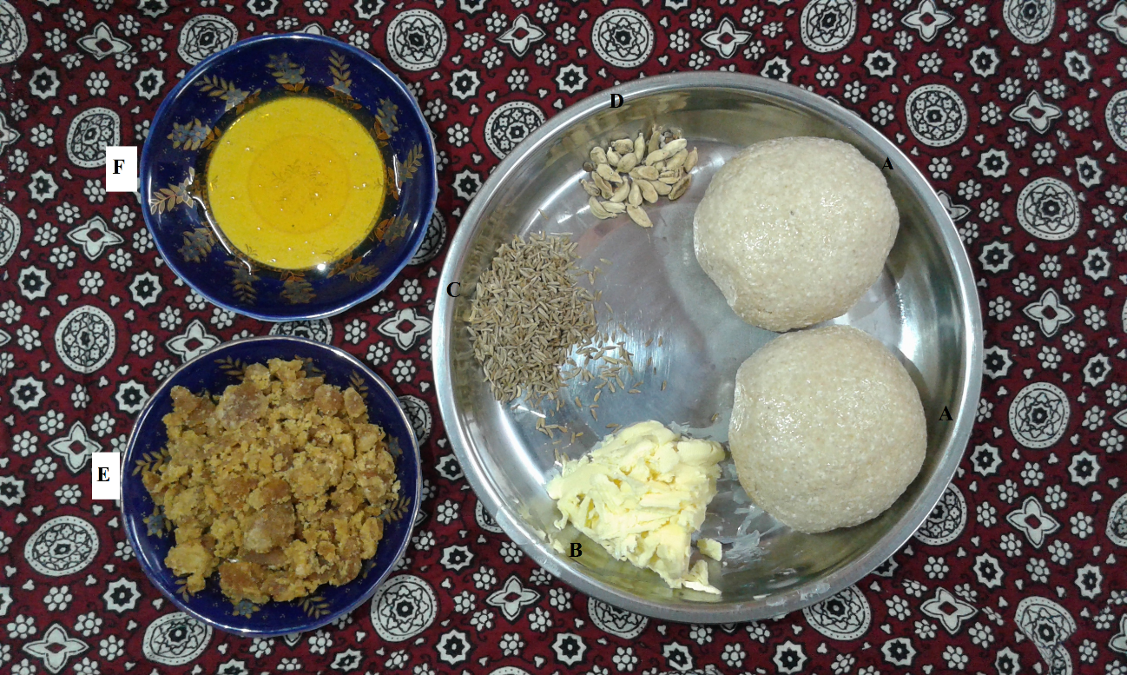

Source: Authors

Figure. 1. Basic ingredients of busri. (A) Two balls of dough were prepared from wheat flour. (B) Butter to be added once busri is baked on tawa. (C) Cumin and (D) cardamom could be added while preparing the dough. (E) Jaggery, added between the two layers made from two pieces of dough. (F) Honey poured once busri is placed on the plate.

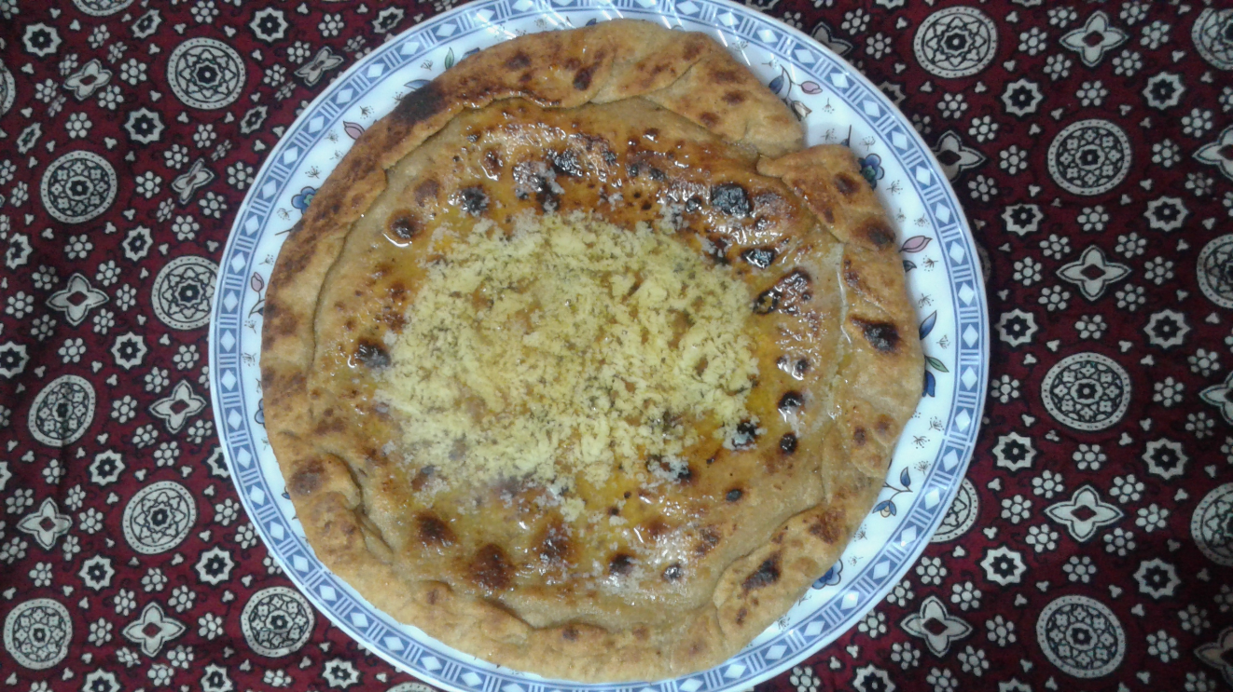

Source: Authors

Figure. 2. Busri was prepared by the first author at her home with the same ingredients mentioned in Fig. 1. On gold-brown hot roti, having jaggery inside its two layers, butter and honey are poured. Busri is the main course dish and is also taken as a dessert in different parts of Sindh.

Manifest functions of busri

Busri has remained an exclusive food in many ceremonies and practices among Sindhis and also has various manifest and latent functions:

a. A wintery and healthy cuisine

For Amman Zulekhan, busri is not a wintry cuisine, but it is served throughout the year on different times and occasions; there is no fixed time for eating busri, even one can eat it in the middle of the night. It is liked the most in the morning because fresh butter is prepared at home early in the morning, as shared by Amaan Zulekhan, and because it contains a lot of fat and sugar, the busri gets enough time to digest till lunch. Once busri was everyday food for all occasions; nowadays, it has become rare because homemade butter and pure honey have become very rare and expensive. So is the interest of people in the cuisine. Bulbul (1984) said that people often left home early in the morning for the fields and towns in the old days, and they often returned late because of a shortage of means of transportation. Therefore, they preferred to take heavy morning meals, and in it, they loved to eat busri with butter and jaggery to have enough energies to work in the field or visit towns.
Amaan Zulekhan said, “busri is more cherished in winter” (which lasts for around four months between November to February). It is because “it contains jaggery, which is also used as a medicine to treat flu and cough when consumed in its hot and melted form; it warms up the throat and body and thus provides relief.” In the old days, she informed that rural women, including her, hardly gave medicines to children when they caught cold and cough but cooked them juicy busri to treat a cough, cold, and flu. Jaggery has many nutritional and health benefits (Singh, Solomon & Kumar, 2013). Amaan Zulekhan also informed that no one thinks of giving busri to children when they catch a cold, cough, and flu for the last many years. She reasoned that people believe that butter in busri affects the throat and chest and causes more problems; thus, villagers run after the medicines or other treatments. She also informed the researchers had always noticed excellent results when she served her children with busri. Amaan Zulekhan added that she knew a relative who looked young in his eighty because he continuously ate busri and fresh butter in the morning; his teeth, ears, lungs, eyesight, and heart were quite good. She informed that busri with fresh butter was the primary and healthy energy source for sick and weak persons in the old days. Physically vulnerable people were always suggested to eat busri to bring back flesh on bones.
Kunbhar (2010) narrated that busri is also used to treat back pain. In that case, the busri should be given with the sap (glue) collected from ber (jujube) tree. Burdi (2016) notes that winter is always expected to bring seasonal diseases like cough, colds, and flu; therefore, the rural people use busri to protect themselves and their children from seasonal diseases. Bulbul (1984) has also shown that pregnant women ate busri in pre-natal and post-natal times in most rural communities. Black cumin seeds were added in the dough of busri, which was eaten in post-natal conditions because (Amaan Zulekhan also had the same views that) in rural areas, it is commonly believed that cumin increased the quantity of milk and its flow in women’s breasts. Bulbul (1984) noticed that in many rural areas, trained birth attendants suggested women not to take such foods; instead, they advised them to take multivitamins to get quick energy; therefore, busri’s use by women in such conditions has reduced.

b. Served in marriage ceremonies, circumcision and other rituals

Amaan Zulekhan shared that on the evening of the marriage, the bride’s family carries the henna (mehndi) to the groom’s house (if the groom belongs to the same village/town) where the sisters and aunts of the bride apply mehndi on groom’s hands and offer him the hot baked busri. In return, they demand money from him. In some communities, the bridegroom goes to the bride’s house to eat busri and return to his home. Later on, go back to the bride’s house for nikah (a religious ceremony where prayers are offered and the bride and groom’s consents are taken) and ruksati (bringing bride to grooms’ house). After nikah, the bridegroom is brought to the room where the bride waits on a decorated cot (sejh) in the bride's house. On this occasion, in some communities’ bridegroom’s side and others, bride’s side used to prepare busri and served to the bride and groom, so that sweetness and juiciness of busri transfer to the couple. If the bride’s side serves busri, the bridegroom had to give money to the sisters or close relative girls who prepared busri for the bridegroom. Sometimes, demand money is received, and sometimes, bridegrooms prove to be penny-pinching.
When serving busri, sisters-in-law make jokes with the bridegroom (Mirza, 1996; Soomro, 1996). Busri is also served among other people who participate in the nikah ceremony; since nikah ceremony usually took place in the early morning around 4 am, a few people were left to enjoy hot, tasty, juicy yummy busri. These days, nikah and such ceremonies occur in the daytime and marriage halls rather than at homes. In most marriages, the bride and groom belong to different villages/cities, and after nikkah, and groom goes back home rather than staying at the bride’s place. Thus, practices related to busri and other traditions are being served in a few communities in Sindh. The girl (bride) sits in the room's corner (in Sindhi, this practice is called wanwah), where male persons may not go. She is served busri so that her physical strength improves and given a special massage with ubtan to improve her skin health, as told by Amaan Zulekhan. However, the practice of wanwah has disappeared because families feel it unnecessary, especially when the families or to-be brides are educated and working (Mirza, 1996). For example, Razia (granddaughter of Amaan Zulekhan), a doctor by profession, did not sit in wanwaah because she could not get enough leaves from her employer. She married on 18 February 2018. The ubtan is now replaced by instant beauty creams, available under many famous brands, which change the complexion quicker than ubtan and are easy to apply.
Among Sindhis, daawan wadhan or a thread (or rope) cutting practice is also performed when a male child starts walking or has problems walking, said Amaan Zulekhan, busri is served here too. The child’s mother prepares the busri, and some people mash the busri into small pieces (make it kutti) and then cover it under a big flat pot. The child is then being asked to stand on the pot; around his both ankles, threads are tied; and then his maternal uncle would cut the thread with a knife, scissors, or any type of cutter available at that moment, along with repeating the following words a couple of times: Shall I cut the dawan (thread/shackle). The child’s mother replies; keep cutting dawan. The maternal uncle ate busri or kutti covered under the pot when the practice was performed. It was believed that after cutting dawan, the child could easily and quickly walk. Baloch (2005) has also noted that a thick rope, like a finger, was tied to a child’s legs; the rope was believed to be dawan, a barrier that had to be cut by the child’s maternal uncle. But, before cutting dawan, he had to eat busri and fresh butter; once the uncle finished eating busri, he had to run, and the child also had to run after him. In this running, the uncle is prohibited from looking behind. If he looked back, it could make the child coward, and if the uncle fell, the child could always be in trouble. If the uncle quickly ran away, it meant the child would walk correctly, but he would do well in his later life. In some tribes, once the uncle cut the rope or thread, he had to run away for a while and then had to come back to take the busri out of the pot and eat it. Busri had also been used to treat circumcised boys. After circumcision (termed as tuhar), often performed by barbers (called hajam in Sindhi), juicy busri is given to the boy. In some communities, parents do not allow the child to eat sides of the busri because it would bring bad luck for the boy. Amaan Zulekhan also informed that the (kutti) made from busri is also served on the occasion of shaving the newborn baby's head called jhand lahraaen. Still, the baby's parents do not eat that kutti because they believe that the child will turn dumb.
Amaan Zulekhan added that she often witnessed many peasant families in her village distributed busri among children when they received the final yield/production from the seasonal crops. They did it to please children who, in return, would be happy and result in barkat (permanence or constancy). She also informed that peasant families called the villagers and relatives to help them in the fields (for different activities) as wangaree (free helpers). These wangarees were served with busri in the morning.

c. Busri in feudal life

Busri is believed to be a luxury culinary more consumed by landlords and bureaucrats in Sindh. Such account of the use of busri has been offered by Rashidi (2000) in his book Those Days and Those Lions under the heading “the picture of landlords’ life” that in early 1900s bureaucrats very much liked busri and in one story of bureaucrats, Rashidi writes that a sick bureaucrat had a cough and palgham (mucus) and was suggested to take busri without jaggery but with sachi (original) misri (rock sugar) and cow’s fresh butter. It should also include two pieces of phota (cardamom). Solangi (2013) writes that before the independence of Pakistan in 1947, Hindus have had paid malhis (wrestlers) to play the Sindhi traditional game of malh. Malhis were given the best food, including fresh butter or desi ghee, but malhis could not take these directly; thus, they ate butter in busri.

d. Busri for prayers

Wafai (1986a) notes that in rural Sindh, busri is specially prepared and served to faqeer (beggars or poor). In return, the faqeers are requested to make dua (prayers) favoring the serving person so that their problems go away or their wishes get fulfilled. Amaan Zulekhan also shared that there is a practice of taking kutti (busri mashed into small pieces) to the graves of ancestors; and, while going to the graveyard, children are especially invited to join the procession because it is believed that Allah listens and fulfils children’s dua quickly, as they are innocent and pure-hearted. Inside the cemetery, the children were asked to make dua for the ancestors; then, they are served a hand full of kutti. She also said that many people in the village promise that if the peer(saint) fulfilled their specific needs or wishes, they would distribute different things that included serving busri; this practice is called baas basin Sukha. Once their desires are fulfilled, men and women, along with children, go to the shrine of the peer while singing sehra (traditional songs) on their way; at the shrine or by the grave of the peer, the kutti is distributed among the participants. Amaan Zulekhan added that she often saw her children bringing kutti from outside when she inquired her children; they told her they received it from a group of women who visited the nearby shrine and brought kutti along with them and distributed it among children around the shrine. Wafai (1986b) also notes that at the request of individuals, some faqeers sit in murakaba (mediation) for forty days or any number of days they liked to; these days, the faqeers are served busri in routine.

Fluid social practices

Amaan Zulekhan shared that for the last ten years, she had not seen or heard people in her village or relatives in other villages have served busri. She claimed that the new sweet products had replaced mainly busri in marriage and circumcision ceremonies and pregnancies, which are easily and readily available in the neighbourhood. She added that she did not exactly know why people had replaced it. But, she said that possibly people avoid preparing busri because the labour involved in its preparation and busri is not prepared/baked at restaurants. Thus, it is easily substituted with many other products, including sesame rewari and dates. The replacement of busri indicates that busri related practices, like any other practice, are not constant but fluid and changeable (Appadurai 2000). Amaan Zulekhan smiled and informed that a few weeks ago, her granddaughter was married, but neither her family (the bride's side) nor the groom’s family had prepared and served busri. She added that busri might be served in houses when people wish to eat it. Still, its purposes (referred to as the social, cultural, religious, and health-related contexts) used to be served might no longer exist in rural areas.

Bursi’s dysfunctions

However, it requires further investigation. Although busri is a very healthy food, full of nutrition, and provides energy for an entire day, it may have some adverse effects if eaten daily and in greater quantity. It could be one factor of obesity, overweight, and diabetes because sugar and butter are used in abundant quantities. It could contribute to weight gain and could also be a contributing factor in diabetes. Since busri is already a vanishing cuisine in rural areas of Sindh, as Amaan Zulekhan perceived, it is difficult to guess if busri could be one factor in overweight, obesity, and diabetic conditions in millions of people in Sindh. The National Diabetes Survey of Pakistan 2016-17, conducted with 10,800 people in Pakistan, shows that Sindh province has the highest 30.20 percent of diabetic patients (The News International, 2017). However, neither this survey nor any other report has directly or indirectly suggested that busri has contributed to any of the above health conditions. In earlier times, when people used to eat busri more often, they never feared or faced obesity. However, nowadays, living a sedentary life, especially in urban areas, has become hazardous eating full of fat and sugary meals.

Discussion

The article reveals that practices associated with Busri are on the verge of disappearance. Busri and the associated practices may remain there, but the contextual use of busri in specific practices may disappear. We have witnessed various manifest or intended usages of busri in social and cultural practices (Rozin, 1990; Rozin, 1996). In the past, busri has remained a tremendous social substance in traditional practices in rural Sindh. It has been used to express the bond between the bride and the groom’s families, used in symbolic context to support children’s growth and mental maturity, and other contexts that the community members clearly understood and knew. Busri has been used to display the importance of social relationships and status - as Cohen (1968), Ishak et al. (2017) and Huddart Kennedy, Baumann and Johnston (2019) have envisaged. Amaan Zulekhan and other families in rural Sindh cooked and served busri for conscious reasons and objective results. Now, busri remains part of the memories of old people and archives collection of the article at Sindhi Adbi Board, but it has neither in the past nor now has any latent functions. Therefore, survival is an essential factor in social practices (or itself as social practice) is no more. Merton (1968) believed that social practices (serving of busri in different social and cultural contexts) thrive primarily because these perform unintended and latent functions and adjust to the communities. Busri could not serve any unintended purposes/functions because it could not change the Sindhi community.

Conclusion

Based on the first-hand information from a Sindhi woman informant (Amaan Zulekhan) and archival material from the Sindhi Adbi Board, this article has analyzed traditional busri cuisine considering the concept of manifest and latent functions of Merton. It found that busri has various manifest or known contexts (functions) that includes various marriages practices (stages), circumcisions, pre-and-post natal conditions of women, preventing seasonal diseases among children, protecting children from bad omens, seeking prayers of beggars and bringing in barakah in the production/yields, and so on. Furthermore, the article finds out that busri may still be prepared and served in routine by many generations to come. However, the social, cultural, religious, and health-related practices (or the contexts in which it is served) may no longer survive.
Busri-related practises are on the edge of extinction. To put it another way, while busri and the behaviours may survive, the context in which abuse is utilised in specific practises may go away. Busri has been utilised in a range of social and cultural behaviours, both purposefully and accidentally. Busri has always played an important role in rural Sindh's traditional ceremonies. It has been used to express the link between the bride and groom's families, in a symbolic context to aid children's growth and mental maturity, and in several other contexts that the community was aware of. The context Busri has been used to emphasise the significance of social rank and connections. In rural Sindh, it is cooked and served for intentional causes and objective consequences. Busri is currently a part of people's memories and the Sindhi Adbi Board's archives collection of the article, but it has no previous or present latent functions.

References

Agro, G. R. (2006). Sindh men pakhen and janwaran jo shikar [Hunting of birds and animals in Sindh]. Jamshoro: Sindh Adbi Board.
Ali, Z. (2016). The rise and fall of the Sindhi Adbi Board. Retrieved from https://tribune.com.pk/story/1043423/no-longer-a-priority-the-rise-and-fall-of-the-sindhi-adabi-board/.
Appadurai, A. (1990). Disjuncture and Difference in the Global Cultural Economy. In Mike, F. (ed.) Theory, Culture, Society (pp. 295–310). London: Sage.
Baloch, N. B. (2005). Rasmoon Rawan aen Sawan [Traditions: right and wrong]. Jamshoro: Sindhi Adbi Board.
Birnbaum, R. (1989). The latent organizational functions of the academic senate: Why senates do not work but will not go away. The Journal of Higher Education, 60(4), 423-443.
Bulbul R. Z. S. (1984). Sindhi Tib: Tehqiqi makalo [Sindhi medicine: Research essay]. Jamshoro: Sindhi Adbi Board.
Burdi, A.B. (2010). Sar nisrya pandh, utar lago aa pireen [A plant has ripened, o beloved northern winds are blowing]. Retrieved from https://m.facebook.com/permalink.php?story_fbid= 1755456388036516&id=1640532072862282
Cohen, Y. A. (1968). Food Consumption Patterns. In Sills, D. L. (ed.) International Encyclopedia of the Social Sciences (5) (pp. 508–513) New York: The Free Press.
Elwell, F. W. (2009). Macrosociology: The study of sociocultural systems. Lewiston: Edwin Mellen Press.
Emeziem, C. (2021). A Tale of Two Rights? The Manifest Functions of Truth and Reconciliation Commissions and the Ambivalence Towards Economic, Social, and Cultural Rights. Seattle Journal for Social Justice. https://ssrn.com/abstract=3963100
Fieldhouse, P. (1995). Food and Nutrition: Customs and Culture. Boston: Springer.
Grabowska, I., & Engbersen, G. (2016). Social remittances and the impact of temporary migration on an EU sending country: The case of Poland. Central and Eastern European Migration Review, 5(2), 99-117.
Huddart Kennedy, E., Baumann, S., & Johnston, J. (2019). Eating for taste and eating for change: Ethical consumption as a high-status practice. Social Forces, 98(1), 381-402.
Ishak, S., Hussain, M. Y., Omar, A. R. C., Sum, S. M., Saad, S., Ramli, Z., & Manaf, A. A. (2017). Deciphering innovative behaviours of Malaysia’s small halal food enterprises: A tentative analysis. Geografia-Malaysian Journal of Society and Space, 11(2), 64-76.
Ji, D., & Sullivan, R. (2016). The Manifest and Latent Functions of Differential Response in Child Welfare. Research on Social Work Practice, 26(6): 641-652.
Kalhoro, Z. A. (2012). Hide not your wine from those who drink: Folktale and Tombs of the Bar Woman and Drunkards of Gadap, Karachi, Pakistan.” Journal of Asian Civilizations, 35(2), 103.
Kaswan, J. (1981). Manifest and latent functions of psychological services. American Psychologist, 36(3). 290-299.
Kunbhar N. (2010). Ber. [Jujube]. Retrieved from http://sindhiproverbs.blogspot.my/2011/12/ blog-post_9726.html
Kwon, D.Y. (2017). Why data creation is important for ethnic foods. Journal of Ethnic Food, 4(4), 211-212.
Merton R. (1968). Manifest and Latent Functions. In Robert, M. (ed.), On Theoretical Sociology (pp. 73-138). New York: The Free Press.
Mirza, G.J. (1996). Sartiyon: Mazharul Islam jon safar kahanyon. [Women: Mazharul Islam’s travel stories]. Jamshoro: Sindhi Adbi Board.
Pakistan Bureau of Statistics. (2018). Province Wise Provisional Results of Census – 2017. Retrieved from http://www.pbs.gov.pk/sites/default/files/PAKISTAN%20TEHSIL% 20WISE%20FOR%20WEB%20CENSUS_2017.pdf.
Panhwar, M. H. (2003). An Illustrated Historical Atlas of Soomra Kingdom of Sindh (1011-1351). Karachi: Soomra National Council.
Paul, K. I., & Batinic, B. (2010). The need for work: Jahoda's latent functions of employment in a representative sample of the German population. Journal of Organizational Behavior, 31(1), 45-64.
Perry, M.S. (2017). Feasting on Culture and Identity: Food Functions in a Multicultural and Transcultural Malaysia. 3L: Language, Linguistics, Literature, 23(4), 184-199.
Rashidi P. A. M. (2000). Uhy denh, uhy shehn [Those Days and Those Lions]. Jamshoro: Sindh Adbi Board.
Ratcliffe, E., Baxter, W. L., & Martin, N. (2019). Consumption rituals relating to food and drink: A review and research agenda. Appetite, 134, 86-93.
Rozin P. (1996). The socio-cultural context of eating and food choice.” In Meiselman, H.L., Greenhoff, K., & MacFie H.J. (eds.). Food choice, acceptance and consumption, (pp. 83–104). London: Blackie Academic and Professional.
Rozin, P. (1990). Social and moral aspects of food and eating. In Irvin, R. (ed.), The Legacy of Solomon Asch: Essays in cognition and social psychology (pp. 97-110). Hillsdale NJ: Lawrence Erlbaum Associates.
Sindhiance. (2018). Busree Bread - The Sweet Winter Delicacy of Sindh. Accessed April 1 2018. Retrieved from http://sindhiance.tumblr.com/post/79765251313/busree-bread-the-sweet-winter-delicacy-of-sindh
Singh J., Solomon S., & Kumar K. (2013). Manufacturing jaggery, a product of sugarcane, as health food. Agrotechnol, S11(7), 1-3.
Solangi, M. U. A. (2013). Dadu Zilo: Hik Abhyas [District Dadu: An Analysis]. Jamshoro: Sindh Adbi Board.
Soomro, N. (1996). Char Dost [four friends]. Gul Phul (children’s magazine). Jamshoro: Sindhi Adbi Board.
The News International. (2017). Sindh in the lead with 30.2 percent diabetes prevalence. Retrieved from https://www.thenews.com.pk/print/244030-Sindh-in-the-lead-with-302-per-cent-diabetes-prevalence.
Wafai, D. M. (1986a). Tazkera Mashaheer Sindh- Bhango tiyon [The account of peers of Sindh: Part three]. Jamshoro: Sindhi Adbi Board.
Wafai, D. M. (1986b). Tazkera Mashaheer Sindh- Bhangon biyon [The account of peers of Sindh: Part two]. Jamshoro: Sindhi Adbi Board.

