

Integration of the social dimension in urban wastelands reconversion projects: Case of the Guelma railway station, Algeria

Ghedjati Meryem ¹, Debache- Benzagouta Samira ²

¹Institute of Architecture and Urbanism, Saad Dahleb University, Blida. Algeria

²Faculty of Architecture and Urbanism, Salah Boubnider University, Constantine. Algeria

Correspondence: Ghedjati Meryem (bluemyriam@hotmail.fr)

Received: 07 June 2021; Accepted: 14 November 2021; Published: 30 November 2021

Abstract

The railway station of Guelma (city located in the Northeast of Algeria) is an imposing building, built by the French colonization, which is closed now after so many years of prosperity. The development of the city and the urban sprawl have meant that after having been located for a long time on the periphery, this station now occupies a central position, where the city is now made. However, the future of this station is so far unclear since it will no longer be operational, given that the new Guelma’s railway station will be located on the outskirts of the city. What would be the fate of this architectural good left to itself? By preserving the memory of the station by offering it a new permanent use, this architectural jewel with its fallow site is a real opportunity for urban regeneration for the city. Therefore, the purpose of this paper is to try to give new life to Guelma station, through a new global approach that would channel the useful and sustainable reuse of the site from its immediate environment and the current executive context. The questionnaire was used as an investigative tool intended for residents living near the station, in total, 40 respondents have been surveyed, to find out their opinions and expectations relating to the future of this lost part of the city. The data from the study were descriptively analyzed, using percentages. Results revealed that the inhabitants are aware of the importance of the reconquest of the station, which will constitute for them a real opportunity for urban and economic development for the region. A reconquest that wants to be sustainable by adopting a socio-spatial approach, which will integrate socio-economic and environmental aspects.

Keywords: industrial heritage, railway station, reconversion, sustainability, urban wasteland.

Introduction

Perceived positively by some and negatively by others, the industrial footprint has always been present in our environments (Bouaziz, 2012). It has shaped entire regions and made the sites it occupies real landmarks in the territories. By their presence in urban environments, these sites take on a touch of singularity, but above all a nostalgia from a bygone era for the most sensitive (De Roux, 2000). This industrial heritage can be defined as referring to all that is material and intangible that relates to industry (Garcia, 2005). The text of the Nizhny Tagil Charter for industrial heritage (2003), defined the components of industrial culture likely to illustrate this heritage which includes the buildings and machines, workshops, mills and factories, mines and processing and refining sites, warehouses and stores, production centers, transmission and use of energy, transport structures and infrastructure, and finally, places used for social activities related to industry.

Railway lines and stations were too often built around city/town fringes, or even away from built-up areas. Sometimes it became victims of the desertification of the countryside or conversely, caught up by urbanization, the fate of these stations differs from one place to another. They have either been adapted to accommodate new needs of the cities (Jin & Wang, 2004) or, in many cases, have simply been abandoned if they did not fit into the new urban structure of the post-industrial city (Lin, 2018). These pieces of cities mark urban rupture areas resulting in a "rust belt" (Zhang et al., 2020). Are they a land of opportunity or burden inherited from the past? Their status is often uncertain and remains a recurring subject of concern for public decision-makers (Deloitte, 2012).
The object of this paper are the railway wastelands located in urban areas. Stagnant out of sight, often in total indifference, these unexploited lands, in large areas, whose former railway vocation no longer corresponds to the evolution of the city, are deteriorating day by day. This state of affairs is exacerbated by the fact that Algerian policies, in terms of heritage and urban development, have not yet realized their importance and the role they can play in the process of regeneration of cities in a perspective of sustainable urban and social development. Even if, for the moment, they are only the object of one-off actions that are poorly or not at all planned and programmed (Djellata, 2006). The fate of these free zones (Groth & Corijn, 2005) could experience a surprising turnaround. The objective of this study is to show that the "reconquest" of these dormant plots is a solution to be exploited to limit the impacts of land consumption generated by urban sprawl.

Literature review

Definition of wasteland

Urban wastelands are large-scale areas cut off from their surroundings (Laprise et al., 2014). Built or not, private or public space previously used by human activities having had a strong impact (industrial, commercial, railway, military, etc.). Vacant, being abandoned or underused; which means that its use must be significantly less than the potential of the site: there may be marginal activities, a transitional or alternative occupation (Rey, 2003). About size, many studies retain a minimum threshold of 5000 m². They can be located at the outset on the periphery of urban centers and then engulfed by them (Merlin & Choay, 1988). A minimum period of abandonment of one year is generally retained so that a space left vacant can be considered as wasteland.

All the wastelands have in common the notions of abandonment, caesura, and decline. They indicate of the passage from the old to the present, from the past to the future through a present of crisis (Raffestin, 1997). In 1991, discourses about wastelands change, in terms of urban and cultural policy; Jean-Noël Blanc (1991) expresses the “cultural dimension” of wastelands, affirming that these are tourist, commercial and historical-cultural issues. These places represent the identity of the city, a mark of the local culture.

Le Lexique de géographie humaine et économique [The Lexicon of Human and Economic Geography] (1992) defines industrial wasteland (subject of our research) as follows : " Espace bâti ou non, terrain ou local, autrefois occupés par l’industrie et désormais en voie de dégradation par suite de leur désaffectation, c’est-à-dire de leur abandon total ou partiel par l’activité industrielle." [Built or unbuilt space, land or premises, formerly occupied by industry and now in the process of degradation as a result of their abandonment, i.e. their total or partial abandonment by industrial activity].

A definition of fallow land has emerged thanks to the rise of sustainable development in the world in the 2000s. The development of the city on itself is synonymous with sustainable development. France Dumesnilet and Claudie Oullet (2002) report in their article that it is essential in order to have a viable project, environmental, social and economic sustainability, to give priority to the decontamination of industrial wasteland in the urban fabric. Although industrial wastelands offer undeniably potentials for sustainable urban development, for a long time they were taboo subjects for the authorities, thorny issues, and without much interest in being resolved (Landel & Angotti, 2010).

Advantages of brownfield conversion operations

Despite its negative image, wasteland, through its recycling and reuse, can from an aesthetic point of view improve the image of a city; it also contributes to the densification and revitalization of the existing built fabric (Rey, 2007). It can be an opportunity to relaunch a dynamic urban planning policy, which is in line with sustainable development (CESER, 2015). Therefore, it appears as an unavoidable process in town planning. In this respect, Claude Chaline (1999) mentions as a priority to curb urban sprawl by promoting the return to the center, reusing all vacant spaces, preserving in addition the memory of the city. Moreover, if their transformation is done intelligently, these sites will have a knock-on effect, as this will lead to the regeneration of other surrounding tissues: buildings will be renovated; public transport will be more efficient. Consequently, the added value sought by the regeneration exceeds its own limits and can create a new neighborhood dynamic (Rey, 2013). This will also lead to economic development by creating jobs, both during the redevelopment process and in the long term. Thus, the reuse of existing urban infrastructure (roads, sewers, public services), reduces the need for new infrastructure by reducing mobility as well as infrastructure maintenance costs.

Converting wastelands: a risky exercise

These operations may be confronted with serious risks: one of the major problems of reconversion operations is the high cost of the actions to be carried out. Indeed, abandoned sites generally present strong constraints (pollution, obsolete buildings) and their rehabilitation requires a significant commitment of funds. There is also the risk of rejection by the populations if the needs and expectations of the population are not properly taken into account. Finally, the risk of short-term opportunistic development if the choice of "filling in" is made to the detriment of a long-term strategic vision, the conversion operation may not be successful.

The reconversion of wastelands is subject to multiple constraints

The requalification of a wasteland remains subject to a number of constraints. First, depending on the location and the configuration of the site, the needs and shortcomings in a locality vary, as do the opportunities offered, as well as the interests of the promoters. There are also the urban planning constraints; it would be best to integrate these constraints upstream of the operational implementation of the reconversion project. Particular attention should also be paid to the restrictions that may be imposed by a location within the perimeter of a historic monument or a protected area. Finally, numerous environmental constraints can weigh on conversion operations; they are linked in particular to depollution, which is often costly.
Although, increasing the number of wasteland regenerations is generally seen as a sustainable land take solution. These projects are not in themselves inherently sustainable (Eisen, 1999); their revitalization and their densification is a necessary but not sufficient condition to encompass the environmental, economic and social dimensions of sustainability (Andres, 2010; Rey, 2013). The result is therefore a bundle of constraints, which can only be analyzed on a case-by-case basis.

Study area

Guelma’s railway station, built by French colonization between 1870 and 1880, is an imposing building that was once pleasant and noisy. During the winter of 1956, the severe bad weather that had affected the region had washed away a railway section. The rehabilitation of the damaged network was postponed until the Greek Calends, and this was the beginning of the decline of the great station.
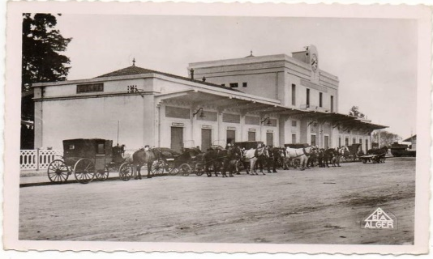
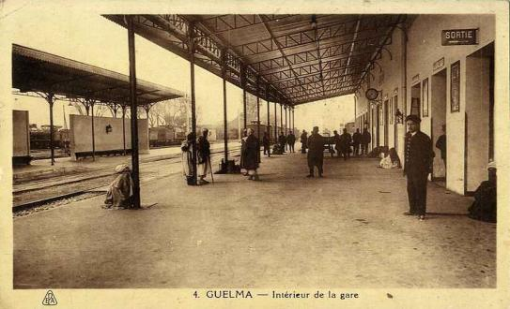

Source:.https://www.delcampe.net/fr/collections/cartes-postales/algerie/guelma/algerie-guelma-interieur-de-la-gare-de-chemin-de-fer-1274286955.html
Figure2. The station dock.

Source:.https://www.vitaminedz.com/fr/Algerie/algerie-guelma-la-gare-vue-exterieure-avec-139784-Photos-0-0-1.html

Figure 1. The station from the outside.

The development of the city and urban sprawl have meant that, after having been located for a long time on the outskirts, now this station occupies a central position, where the city is now being built. As can be seen from the maps (figure 3, 4, 5) that the station was built on the edge of the colonial city. Towards the end of colonization, the station suburb (now the Mebarki Said suburb) was built, where Algerians crammed into small houses that housed entire families; glued together, all of which did not extend beyond the ground floor.

The station

Source : http://alger-roi.fr/Alger/guelma/pages/0_plan_ville_
guelma_guide_vert.htm

Figure 3. Plan of Guelma city in 1869 showing the railway station outside the colonial city limits.

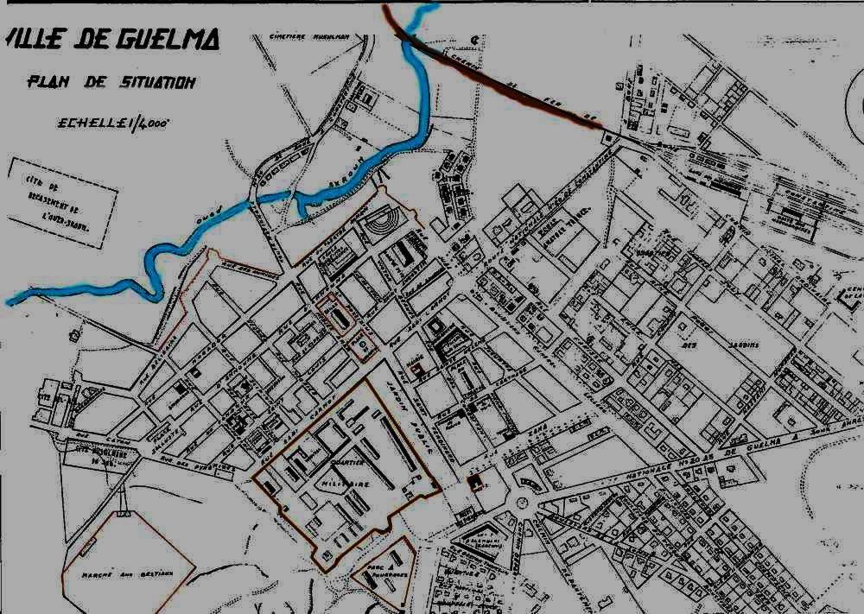
station suburb

Source : http://images.app.goo.gl/ytezyKCq5MkRsHK48

Figure 4. Location plan of the city of Guelma during the colonial era in 1952

After independence, this part of the city was reserved for industrial activities; several factories were built around the station (i.e. the ceramic factory, the sugar refinery, and the cycle and motorbike factory). Little by little, residential housing estates grew to meet the housing needs of a growing population in search of jobs in these factories. As a result, the city has undergone a major expansion that goes far beyond the physical limits of the railway station tracks.
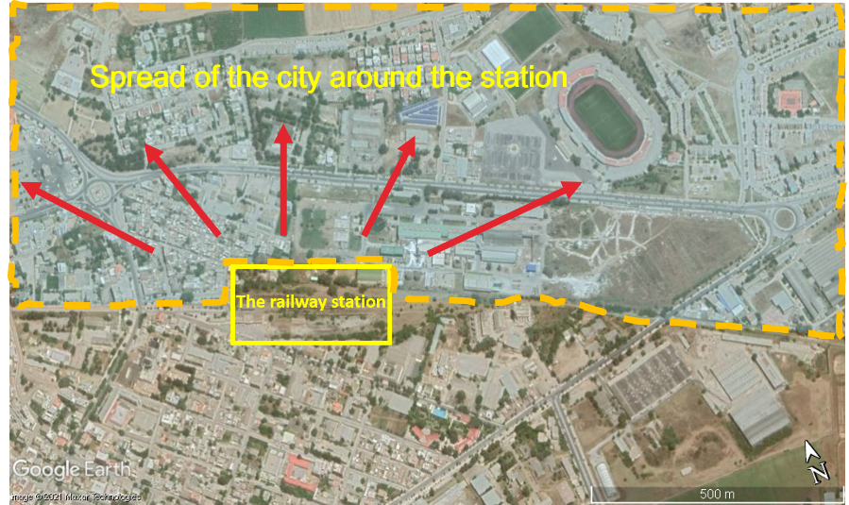

Source: Google earth 2020, edited by the author

Figure 5. Sprawl of the city outside its colonial limits.

At the end of the 90s, it was the irreversible condemnation of Guelma's main railway station, which definitively stopped the transport of goods and passengers for unknown reasons. It has been closed and the line of about forty kilometers has suffered the throes of destruction due to encroachment and vandalism. The future of this specific building is so far unclear because the new Guelma railway station will be located on the outskirts of the conurbation. However, as it has many advantages: it is well connected to the city center and to transport networks, which gives it good accessibility and visibility. And that makes it a land with high potential for upgrading or redevelopment. Nevertheless, this heritage left in abandonment is in danger: little by little, the awning sheets come loose; the rails are taken over by invasive vegetation, and there are tens of wagons stored in the open (figure 6, 7, 8, 9). Unfortunately, the ground floor is now used as premises for individuals who have carried out work by transforming the inside of the station without any respect to its authenticity.
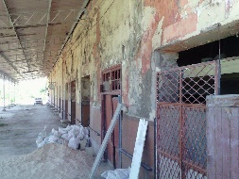
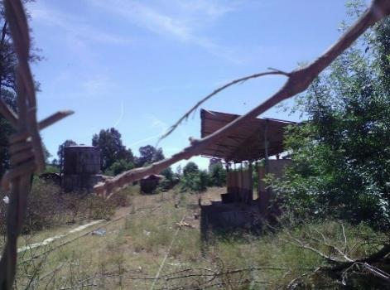

Figure 6. The rails ravaged by vegetation.

Figure 7. State of degradation of the quays.

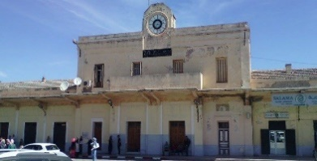
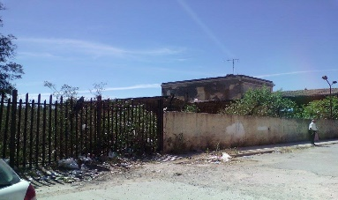

Figure 9. Pollution around the station.

Figure 8. Deterioration of the façade.

The neighboring annex buildings served as envelopes to house new public functions that have nothing to do with their original function (figure 10, 11, 12). The outside area of ​​the station has been used as a university bus stop for more than 10 years; CO² emissions from the exhausts of these buses have damaged the façade (figure 13). Unfortunately, the station also suffers from a bad reputation and pollution problems.

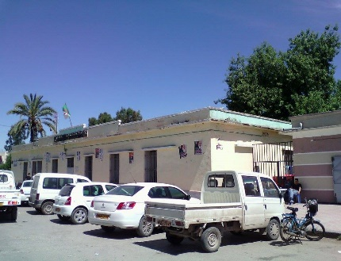
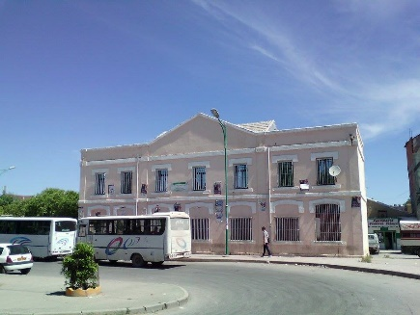

Figure 10. The hostel transformed into a chamber of commerce.

Figure 11. The annex transformed into the seat of the leadership of the former mujahedin.

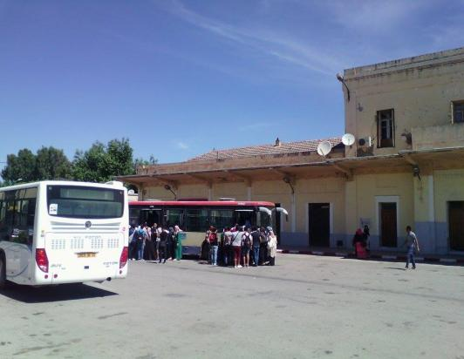
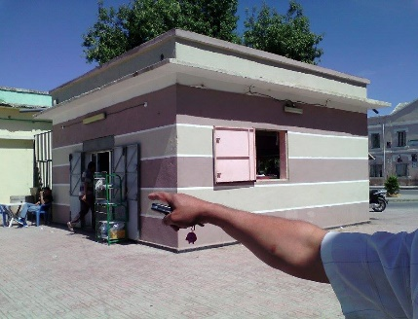

Figure 12. The small building converted into a coffee shop.

Figure 13. University transport bus station.

This inventory reveals a worrying situation. The degree of degradation underlines the extent of the indifference with which the station is confronted. However, its persistence in the landscape calls for the need for a reconquest, which aims to restore the urban balance and responds to environmental, socio-cultural and economic concerns linked to sustainable development. However, protect and win back to do what? The central problem of our research is that of knowing: how can this railway wasteland be reused sustainably (usefully), with a view to revitalize local or regional development, in order to satisfy the local population? What are the main criteria for a sustainable reconquest? What structuring logic should be taken into account to guide the choice of future use?
It is fortunate today to have a land of this magnitude in the heart of the city; this is why it is imperative to take charge of it by occupying it, by giving it a function; in short to inhabit it (Gravari-Barbas, 2005). However, it would be essential to ensure the success of such projects to have an increased knowledge of the initial situation, of the "génie du lieu" [genius of the place] (Magnaghi, 2003; Emelianoff, 2004). Moreover, to allow real collaboration between the public sector, the private sector and the population (Dumesnil & Ouellet, 2002). It would therefore be advisable to consider all these parameters and include them in a multidisciplinary approach according to the particularity of each site and the environmental policy in each country. For this reason, we started from the hypothesis that the reconversion of the station with an appropriate assignment, drawn from the real needs of the local population will make this architectural jewel a real opportunity for urban and social regeneration.

Method

Our approach was based on the construction of the research object in contact with the field. The opinions analyzed were collected through a survey by a questionnaire. Its vocation is to probe the attitudes and opinions, aspirations and expectations of its inhabitants.

Questionnaire

The purpose was to collect two types of information: quantitative information, which consist of the identification of participants; the number, age, etc. And qualitative information that represent the perception and representation of local residents of the old station, their feelings of belonging, etc. We had to collect a significant number of points of view on the research subject in order to validate, qualify or refute our hypothesis, decisions, projects ... we were looking for adhesions, feelings of belonging, expectations or proposals made by the people questioned. This therefore helps us to restore a general or collective idea, to judge their interest in the site, also to avoid taking conflicting directions, and finally to establish common ground: "consensus".

Sampling and counting

To create a sample specific to heritage studies in relation to society and using the means available to us, we were able to question 40 people. The basic rule in our choice is representativeness (Berthier, 2006). That is to say, choose the people who best correspond to express themselves on the subject, and who are, the local population. Then, the count was carried out in the form of tables, for closed questions and for open questions. The questions were split into three sections: The first concerns the identification of the people surveyed through their profiles (age, gender, socio-professional situation). The second section consists of determining the knowledge of the people questioned about heritage in general; to understand the meaning they give to the latter through the definition of the concept, the degree of knowledge of its importance and the causes of its marginalization. Finally, the third part, is the core target of the questionnaire; it includes a series of questions that ask respondents about the former Guelma train station, as shown in table 1.

Table 1. The main information sought

State of the site | Information for residents | Future of the site
Site perception  Links with the site  The expectations of residents  Perception of changes in the neighborhood since the closure of the site | The degree of information  The nature of the information  Information media. | Possible future uses  Disadvantages of a possible conversion of the site  Opinions of residents on the establishment of a new economic or industrial activity  Lacking factors in the conduct of the projects to be undertaken to reclaim the railway station.

Results and discussion

Profile

Out of 40 participants, 35 are men, and only 5 are women. In addition, as shown in figure 14, all the participants are adults, with a strong participation of 50-64 years old. Followed by 65 and over, which corresponds to an old population. So automatically, it is retirees who remember the station before it closed. With an almost majority still residents of Guelma (43.59% of those questioned specified that they still live in the suburb of the station).

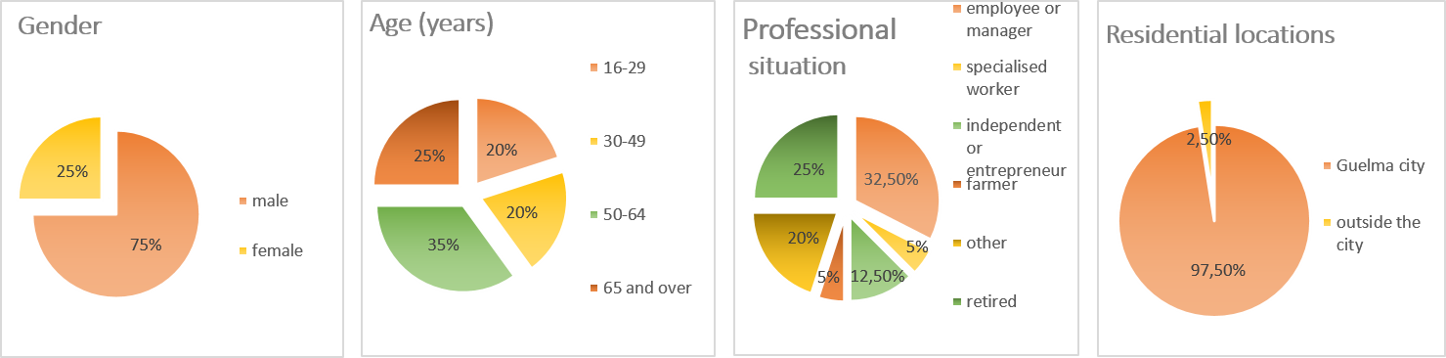
Figure 14. Profile of the participants

Information and knowledge about heritage

Regarding the definition of heritage (figure 15), the majority of people questioned testified to a good knowledge of this concept by answering that it represents a place of memory and heritage of our past. Most of them are aware of the importance of heritage as a representation of the past and of the fact that it is a vector of economic and social development, although it is in most cases a neglected place. On the state of conservation and exploitation of heritage in Guelma, the majority of respondents think that the state of conservation is bad, 27% consider that it could make better use, while no one finds that it is well preserved. It follows that the built heritage of the city is marginalized by its society because of the lack of awareness and learning in schools from an early age, lack of animation; a lack of knowledge of their history… However, these monuments and sites are, in most cases, also abandoned for reasons of insecurity.

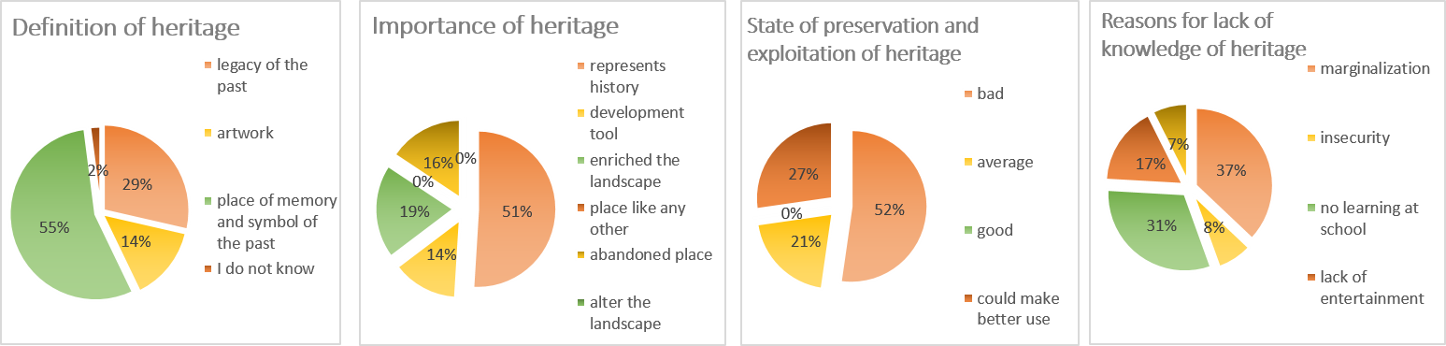

Figure 25. Identification of heritage by the respondents

Information and knowledge about the Guelma railway station

- Knowledge and perception of the site

It emerges from the results in figure 16, that residents have a rather positive perception of the Guelma train station, since they mostly feel linked to it (92.5% answered yes against 7.5% who did not feel linked to it). More than half show a feeling of regret; they regret both the closure of the site whose history has marked the locality, but also the loss of jobs that this closure has caused. For others, there is rather a feeling of relief, since for them it is the end of the nuisances formerly caused by the train in operation. For others, however, there is a kind of indifference, for them the site is just a wasteland like the others or a simple polluted site. This feeling of indifference may be due to the fact that former inhabitants of this suburb went to live and work elsewhere, and the new ones may not have a real vision of what the site was and what it brought to the locality. The loss of vitality and insalubrity are identified by the majority of participants as being the major change in the neighborhood. What they understand by loss of vitality is both the increase in unemployment, the massive departure of former residents, the closure of small businesses, and the weak socio-economic dynamics of the neighborhood, which has caused its marginalization. In short, people are aware of the social and economic damage caused by this closure.

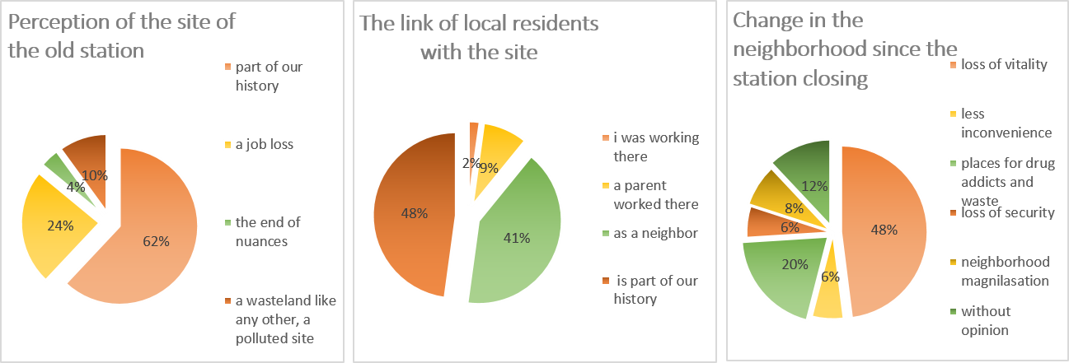

Figure 36. Perception and connection of respondents to the station

- State of preservation and current operation of the station

About the state of preservation and operation of the old Guelma station (figure 17), more than half of the respondents think that the state of preservation is bad, part of them judges that it could make better use, while no one finds it well preserved. Then, out of 40 participants, there are 32% who have expectations about the current or future state of the site, against 63% who have no expectations. However, 5% did not answer this question. We should specify that the majority of residents is interested by the future of the site since they believe that it should not be and its rehabilitation was mentioned as the primary motivation. As for them, its current abandoned operation does not promise anything either for them or for the neighborhood in general.

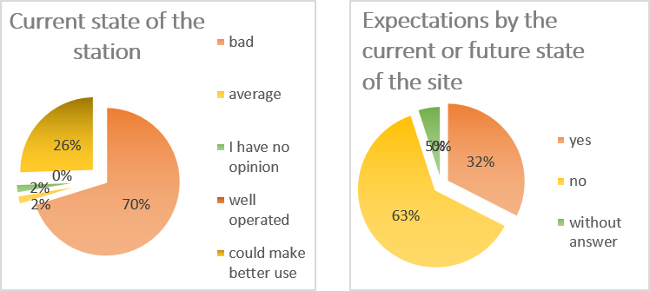

Figure 47. Opinions of respondents on the current state of the station

- Level of information for residents

As shown in figure 18, almost half of those questioned believe that they are not at all informed about what is going on at the station, 33% believe they are very poorly informed, no one considers him/herself very well informed. They would all like to know what is going on there, as there are many rumors circulating in the neighborhood without any certainty. In addition, the choice of information expected by residents relates to the future of the site at 91%. The fate of the site wins out because of the fear of the future, because they do not want in any case an implantation that would prove to be harmful. According to the same people, the desired support of information would be newspaper ads first, social networks as a second response, as well as meetings with managers. These choices can be explained by their accessibility and reliability. With other proposals, such as radio and television, associations and the body responsible of rail transport.

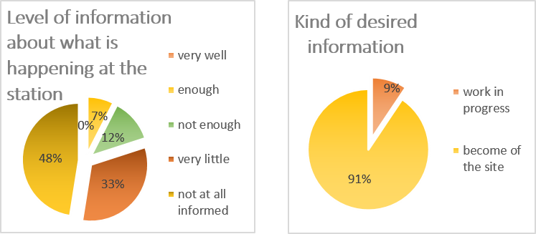

Figure 58. Degree of information of what is happening at the station

- The future of the site

Of the five proposed uses (figure 19), the conversion of the site into a commercial area is the major choice. Justified by the strategic location of the station, and that this choice of project will effectively enhance the neighborhood as well as the entire city and participate in social and economic development; by creating jobs while changing the negative image of the site. Next come 32% who believe that leisure space would be the most appropriate use, citing the terrible lack of recreational space in Guelma as the reason. Followed by of 13% for an industrial zone justified by functional continuity with the factories built in the 1970s not far from the station site. As well as the 9% who favor a residential area and find that, this choice would solve the problem of precarious housing in this suburb area. And the 6% who are for a green area justify their answer by the wish of a rupture with the long abandonment of the site and the need to have a green lung within a city, which is terribly lacking in green spaces. While specifying that 13% of the responses were in favour of mixed use, which they believe would be a very good alternative to revitalize the site.

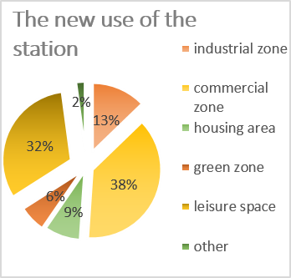

Figure 69. Proposals for the new use of the station

- Opinion about a new economic or industrial activity on the site

We can see through the figure 20, that more than half of the persons questioned consider that a new economic or industrial activity on the site of the old station would only bring benefits for the region of Guelma. By creating jobs, by ensuring security in the neighborhood by putting an end to the scourges widespread in this area, and thus the revitalization of the city. Some answers focus on light activities such as handicrafts, start-ups respectful of the environment, and cultural activities. While others (27%) think the opposite, justifying their answer by the fact that this type of activity should be installed outside urban areas given what they generate as pollution, they believe it would ensure a healthy environment for the residents. Some find that this would threaten the memory of the building, which risks falling into oblivion. And others for fear that the building will be phagocytized by the concrete trabendists by modifying completely the architectural aspect of the building without any knowledge. So here, we note an awareness of a large part of the population in terms of ecology, health, collective memory, etc.

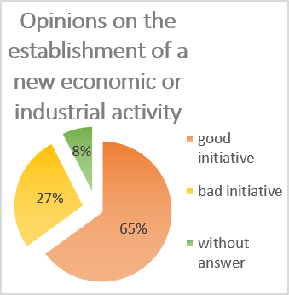

Figure 20. Opinion of respondents on the establishment of a new industrial or economic activity

- Missing factors in the conduct of projects for the conversion of the site

The opinion of those surveyed about political support, the willingness of decision-makers, regulatory achievements and actions to be taken was mainly focused on the idea of ​​theoretical willingness and the non-existence of actions on the real (figure 21). No project is planned to remedy this situation, confirms a person in charge in the transport department of the wilaya of Guelma (the wilaya is an administrative division that exists in Algeria). All the walis (the wali is the representation of the state at the level of a wilaya) who succeed in the wilaya of Guelma do not pay attention to this part of the city whose rehabilitation is considered as a luxury because this condition the involvement of several actors and a considerable financial budget. Without forgetting, the lack felt in the Algerian legislative system relating to industrial heritage. Notwithstanding these constraints, this solves a significant number of relative urban and societal ills observed in this area and will put an end to the marginalization of the site.

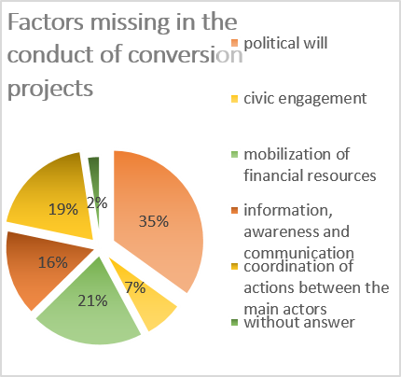

Figure 27. Factors lacking in the conduct of station conversion projects

In conclusion, the importance of a possible reconversion of the station would be the cohabitation of the residents with the new use of the site. They, therefore, must worry about the direction taken by the decision-makers if the latter presents major disadvantages for the revitalization of the neighborhood. However, it should be noted that the comments collected do not constitute elements of pressure and are not sufficient to guide the choice of the future use of the site. Though, they do have the merit of being known and perhaps some of them will fit perfectly into the choice of the future use of the station.

Additionally to these results, in order to select the most suitable transformation mode for Guelma’s station we had to go back to the several studies. In which were discussed the possibilities of three common strategies of reusing the abandoned railways: as a new transportation route, as a place for tourism and commerce and as a green corridor for the public (Zhang et al., 2020). Whilst converting into new rail transit systems will contribute to improve the public transport situation and increase land value. It is most appropriate for areas with a high demand for public transportation along the railway routes; which is not the case of Guelma city.

The business and tourism redevelopment mode are most applicable to nearby railways or destinations having significant cultural significance, in cities with strong tourism industries, or areas with a strong commercial environment. It will help redevelopment; increase both tourism income, and land value by maintaining the old tracks and stations. For example: the Osei Museum, in Paris, was transformed from a railway station that had been abandoned for many years. Also, the Puffing Billy Railway in Australia and the Jiji Town Railway Tour Line in Taiwan are famous for reuse as tourism routes. The city of Guelma is known for its archaeological sites inherited from the Roman era (the Roman theater in figure 22, the thermal baths in figure23 ... etc.), so this perspective could be applicable at Guelma station.

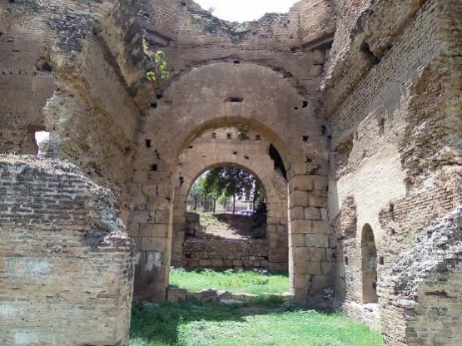
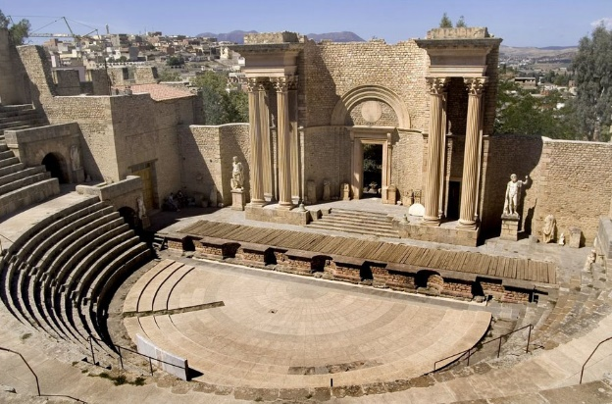

Source:https://www.leguidetouristique.com/ruinesbr/thermes-romains-de-calama-guelma

Figure 23. Roman thermal baths.

Source: http://cnra.dz/atlas/wp-content/uploads/2017/08/guelma03.jpg

Figure 22. Roman theater of Guelma.

Discussed from the perspective of ecological value and landscape design, as well as the promotion of the urban life quality for people, the most common ecological reuse strategy has been transforming abandoned railways into multipurpose trails for walking, cycling, horse riding, ice-skating, and other similar usage. This reconversion mode is most suitable to areas lacking public green space; Guelma suffers greatly from this problem. If this mode of reconversion will be adopted for Guelma station, the urban green space, parks and greenways created from abandoned railways will quickly not only improve the urban environment, but also increase surrounding land prices for housing which serves to promote economic development (Jo, 2002; Oppido & Ragozino 2014). In Germany, Australia, the United Kingdom, Spain, Belgium, and other countries, hundreds of greenways have been created from abandoned railways, forming greenway networks for cyclists and pedestrians all over the world (Rail to Trails, 2019).

Conclusion

Overcoming the many obstacles to reclaiming urban railway wastelands is undoubtedly a long-term task. However, the game is certainly worth the candle; as much for the land reservoir they constitute, the privileged geographical location they occupy, as for the potential unsuspected reconversion possibilities that they conceal. All of these results allow us to state that moving from objectives to action requires the implementation of a comprehensive approach for the wastelands to rise from their ashes. For this reason, we recommend consultation between the actors concerned for the definition of sustainable projects, which requires the establishment of processes promoting the emergence of innovative solutions and judicious arbitration between the various actors involved. This approach should be made up of interdependent elements maintaining a cause-and-effect relationship for a useful and lasting revaluation of wastelands once they are renovated. That is to say that the work determines the results and the results determine the uses and vice versa.

This interdependence has set the objective of our study to consider the socio-spatial approach as an approach that deploys a process of reconversion of this railway leg by integrating socio-economic and environmental aspects. Environmental, respecting the immediate environment of the site, the site itself, its specificities, while including ecological concerns. Social, by involving society, and finding a consensus between the different actors to preserve these vestiges for future generations. Finally, the economical aspect, by choosing a sustainable use that would meet the needs of the local population, and contribute to the economic development of the city by creating jobs.

References

Andres, L., & Bochet, B. (2010). Regenerating brownfields and promoting sustainable development in France and in Switzerland: what convergences? Revue d'Economie Regionale & Urbaine : 729–746.
Berthier, N. (2006). Les techniques d'enquête en sciences sociales - Méthode et exercices corrigés. (3eme Ed.). Cursus, Armand Colin.
Blanc, J-N. (1991). Les friches industrielles de l'économique à l'urbain / Industrial wastelands : from economic to urban aspects. Revue de géographie de Lyon, Mutations économiques et requalifications territoriales, 66(2), 103-107.
Bouaziz, S. (2012). Elaboration d’un consensus de réhabilitation du patrimoine industriel pérennisant son authenticité dans le contexte Algérien : cas des ateliers de maintenance SNTF, El Hamma Alger. Mémoire de magister, UMMTO.
Cabanne, C. (1992). Le Lexique de géographie humaine et économique. Paris, Dalloz.
CESER Centre-Val de Loire, (2015), Requalification des friches urbaines- quelles perspectives en région Centre-Val de Loire ? Conseil économique, social et environnemental régional de la région Centre-Val de Loire. DOI : FRICHES URBAINES en CVdL 150709
Chaline, C. (1999). La régénération urbaine. Paris, PUF, coll. Que sais-je?.
De Roux E. (2000). Patrimoine industriel. Paris, Editions SCALA.
Deloitte. (2012). Les reconversions de friches urbaines-Au service du dynamisme des territoires. DOI : www.deloitte.com/content/dam/Deloitte/fr/Documents/Associationsfondations/ Publications/Etude_Friches_urbaines2012.pdf.
Djellata, A. (2006). Planification urbaine et stratégie de reconquête des friches. (Cas de Boufarik). Mémoire de magister, EPAU.
Dumesnil, F., & Ouellet C. (2002). La réhabilitation des friches industrielles : un pas vers la ville viable?, VertigO, La revue électronique en sciences de l'environnement, 3(2). DOI : www.vertigo.uqam.ca/vol3no2/art7vol3n2/f_dumesnil_c_ouellet.html
Eisen, J. B. (1999). Brownfield policies for sustainable cities. Duke Environmental Law Policy Forum, 9, 187–229.
Emelianoff, C. (2004). Les villes européennes face au développement durable : une floraison d’initiatives sur fond de désengagement politique", Les Cahiers du PROSES, (8), 159-169.
Garcia, D-F. (2005). Atlas du patrimoine industriel de Champagne-Ardenne. Les racines de la modernité. Reims, Centre régional de documentation pédagogique de Champagne-Ardenne.
Gravari-Barbas, M. (2005). Habiter le patrimoine : Enjeux, approches, vécu. Rennes, Presses Universitaires de Rennes.
Groth, J., & Corijin, E. (2005). Reclaiming urbanity: indeterminate spaces, informal actors and urban agenda setting, Urban Studies, 42(3), 503-526.
Jin, F., & Wang, E. (2004). China railway network expansion and spatial accessibility in the 20th century. J Geogr, 59(2), 293–302.
Jo, S. (2002). The geography of ‘‘disused’’ railways: what is happening in Portugal? Finisterra Revista Portuguesa De Geografia, 74, 55–71.
Landel, O., & Angotti, P. (2010). Les friches, cœur du renouveau urbain, les communautés urbaines face aux friches : état des lieux et cadre pour agir. Communautés urbaines de France, caisse d’épargne.
Laprise, M., Lufkin, S., & Rey, E. (2014). Integration of sustainability issues into the regeneration of urban wasteland: From theoretical framework to operational monitoring tool. Conference: World Sustainable Buildings 2014 At: Barcelona. Volume: Session 12
Lin, W. (2018). Research on activation and utilization of urban abandoned railways. In: Sharing and quality—2018 China urban planning annual conference paper collection (02 Urban Renewals), 509–522.
Magnaghi, A. (2003). Le Projet local. Liège, Madraga.
Oppido, S., & Ragozino, S. (2014). Abandoned railways, renewed pathways: opportunities for accessing landscapes. Adv Eng Forum 11:424–432.
Raffestin, C. (1997). Une société de la friche ou une société en friche. Collage, 4, 12-15.
Rey, E. (2003). La reconquête de la ville passe par l’aménagement de ses friches. DOI : https://www.letemps.ch/economie/reconquete-ville-passe-lamenagement-friches
Rey, E. (2007). Des friches urbaines aux quartiers durables. Tracés, 5, 13.
Rey, E., Lufkin, S., Renaud, P., & Perret, L. (2013). The influence of centrality on the global energy consumption in Swiss neighborhoods. Energy and Buildings, 60, 75–82.
The International Committee for the Conservation of the Industrial Heritage (TICCIH). (2003). charte Nizhny Tagil pour le patrimoine industriel.
Zhang, C., Dai, S. & Xia, H. (2020). Reuse of Abandoned Railways Leads to Urban Regeneration : A Tale from a Rust Track to a Green Corridor in Zhangjiakou. Urban Rail Transit, 6, 104–115. https://doi.org/10.1007/s40864-020-00127-2.

