

A review on architectural and urban design approaches to reducing
the urban heat island effect

Chiu Hung Yu¹, Gabriel Hoh Teck Ling², Chih-Hong Huang¹, Pau Chung Leng²,
Nur Amiera Md Suhud², Wai Shin Ho²

¹ National Taipei University of Technology, Taipei, Taiwan
² University Teknologi Malaysia, Johor Bahru, Malaysia

Correspondence: Gabriel Hoh Teck Ling (email: gabriel.ling@utm.my)

Received: ; Accepted: ; Published:

Abstract

With the ongoing rapid urbanisation, humans enjoy the comfort of living with the use of advanced technology and infrastructure, without consideration towards the pollution produced daily, such as waste, heat, and exhaust gas emissions. Human-induced climate change has resulted in extreme weather and climate events, causing a consequential increase in the urban heat island effect. A large amount of radiant heat is focused in the city area, threatening the threshold of comfort in urban living, affecting our future generations to come. Therefore, this paper discusses how this phenomenon could be mitigated through a few design approaches. The existence of green roofs helps reduce the direct absorption of heat in buildings while water bodies help lower the surrounding temperature of a place. Additionally, using high reflectivity and spectral emissivity materials in buildings can also lower heat absorption into a building. Also, the design of urban wind corridors increases airflow into an area, hence cooling the surrounding temperature. When these steps are strategically incorporated into a design, the amount of heat could be significantly reduced, hence extenuating the urban heat island effect. However, more in-depth research is needed to ensure that it could successfully palliate the urban heat island effect in a city. It is hoped that this study could be a comprehensive guide to designers and engineers, or any individuals in the field of architecture and urban design in tackling the problem, hence achieving their target in eliminating the urban heat island effect in future works.

Keywords: Architectural design, climate change, review paper, urban heat island, urban planning

Introduction

The term ‘urban heat island’ has been a subject of interest for a long time. This study attempts to investigate the cause and effect of urban heat islands based on multiple references accumulated with its background and history elaborated in detail. The entry point of the discussion is to propose mitigation measures to reduce the urban heat island effect, as in architectural application and urban design, increasing green spaces in infrastructures, utilizing water bodies, application of suitable insulation materials, as well as analysing urban wind corridors. The discussion goes into the elaboration of each measure: firstly, by adding green paving, green roofs, and vegetation walls to increase green spaces. Then followed by designing blue zones or implementing water sprinkler systems to increase evaporative cooling. Next, by using high reflective insulation coatings and high heat resistant insulation materials to reflect radiant heat and lastly by using the urban wind corridor design to direct wind into higher temperature urban areas.
Through analysing relevant research and studies regarding the past and future impacts of the urban heat island effect, the study summarizes urban heat islands into four urban heat mitigation methods in relation to urban planning. This study believes that aside from an in-depth understanding of local culture and background environment, it is important to analyse the urgency of the urban environment and to appropriate design options that can be efficacious in reducing urban heat. It is highly recommended that scholars do follow-up research on the heat storage of buildings and artificial pavement, etc. in hopes of producing an urban design that can effectively cool down the urban heat island effect (see Yeo et al., 2021). Figure 1 shows the global average temperature ranging from the year 1880 to 2013. According to the Global Average Temperature Monitoring Report 2013, the global average temperature including the land and the ocean is 0.62°C higher than the previous average (National Oceanic and Atmospheric Administration, 2021). The BBC report even pointed out that when the global temperature gradually increases, it will bring catastrophic changes to the world, such as drought, heavy rain, holes in the ozone layer, bipolar ablation, and energy crisis.

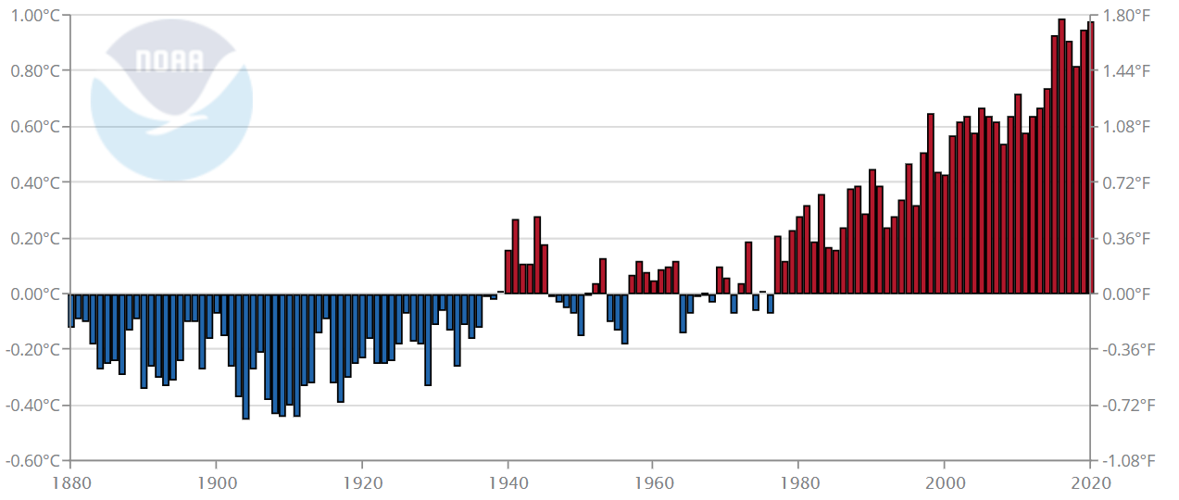
Source: National Oceanic and Atmospheric Administration, 2021

Figure 1. Global average temperature trend (1880-2013).

The development of various urban areas on a large scale has caused green urban spaces to decrease. Public buildings and roads accumulate a large amount of heat energy, air-conditioning equipment and vehicle waste heat emissions causes the temperature to rise continually, and natural wind cannot flow into the city centre due to high-rise buildings. This has caused urban heat islands to form due to higher temperatures in urban areas (Asimakopoulos et al., 2020). Facing the vicious circle of the urban environment, people should pay more attention to global environmental sustainability and ways to attenuate the impact of the ‘urban heat island’. For example, Taiwan is located in the subtropical region where air-conditioning is frequently used during the summer. The impact of energy consumption will continue to cause an increase in global average temperature over the next few decades, rising by about 0.06°C every 5-10 years, and 0.16°C every 10 years in the past 30 years (see Figure 1). It is estimated that at the end of the 21st century, the global average temperature will rise by 1.5 °C- 4.4 °C. The anthropogenic effect on earth has led to a counterattack from nature. Looking for ways to coexist with nature should be the primary goal for humans. As such, architects and urban planners should strive to reduce pollution by designing comfortable living spaces for their users.

Literature review

Background and causes of urban heat island

According to Stewart (2019), there have been relevant scholars studying the urban thermal environment since the early 1800s to the early 1900s, and it is divided into three major stages, namely the pioneering period (1800-1900), the research method innovation period (1920-1940), and the experimentalism period (1950-1980). The two major causes of the formation of urban heat islands are ‘solar radiation heat’ and ‘industrial waste heat’. Solar radiation heat is divided into the infrared, visible light, and ultraviolet light. The infrared and visible light content ratio is 97% of the total solar radiant heat, which accounts for most of the heat (such as Figure 2(a)). Figure 2(a) in general shows the solar radiation spectrum heat map of direct light at the top of the Earth’s atmosphere, blackbody spectrum and at sea level. As seen in Figure 2(a), the amount of spectral irradiance at sea level is small, which could be attributed to the presence of water vapour, carbon dioxide and ozone, which are largely present at sea. Oke and Cleugh believe that after absorbing radiant heat in the urban environment, the surface energy balance relationship between the rough surface and the atmosphere will be observed (Oke & Cleugh, 1987).

Q*+Q_{F}=Q_{H}+Q_{E}+ΔQ_{S}+ΔQ_{A}，

Q* = short-wave and long-wave radiation received by the urban surface;
Q_{F} = Man-made heat flux (vehicle waste heat, building refrigeration, industrial waste heat, human and animal metabolic heat);
Q_{H} = sensible heat flux (turbulent sensible heat flux),
Q_{E} = latent heat flux,
ΔQ_{S} = changes of stored heat amount from the ground surface, buildings and ground items,
ΔQ_{A} = net convection heat.

The equation is illustrated in Figure 2(b), showing a concept map of urban heat flux in equilibrium. With this logic in place, it is believed that the heat storage changes in urban settings are large compared to natural settings. This is due to the properties of materials used in buildings and the lack of vegetation in urban settings (Oke & Cleugh, 1987).

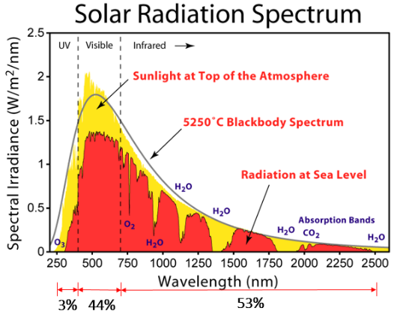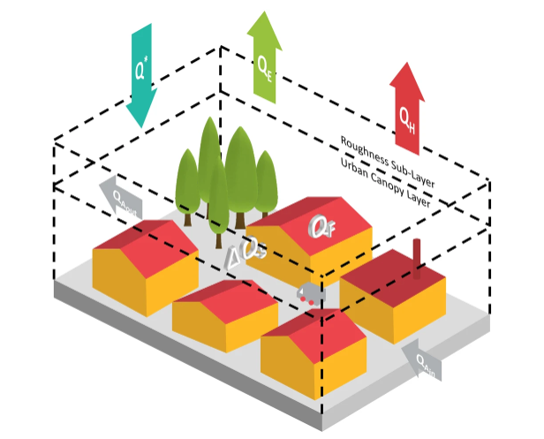
(a) (b)
Source: (Chrysoulakis et al., 2018, Wikimedia Commons, 2020)

Figure 2. (a) Solar radiation spectrum heat map (b) Urban heat flux equilibrium concept map

The second major cause of the formation of urban heat islands is ‘industrial waste heat’. According to Figure 3, the urban heat island effect is a result of urbanisation of human living after the industrial revolution resulted in (1) the increase in population which encouraged energy consumption and heat release in urban areas, (2) the change in surface covering material: the green area is reduced, the surface evapotranspiration capacity is reduced, and the increase in the use of strong thermal storage performance materials such as concrete, asphalt etc., (3) dense urban structure and urban canyons which causes thermal stagnation, (4) other greenhouse effects caused by fine-grained air pollution (Rizwan et al., 2008; Yamamoto, 2006).

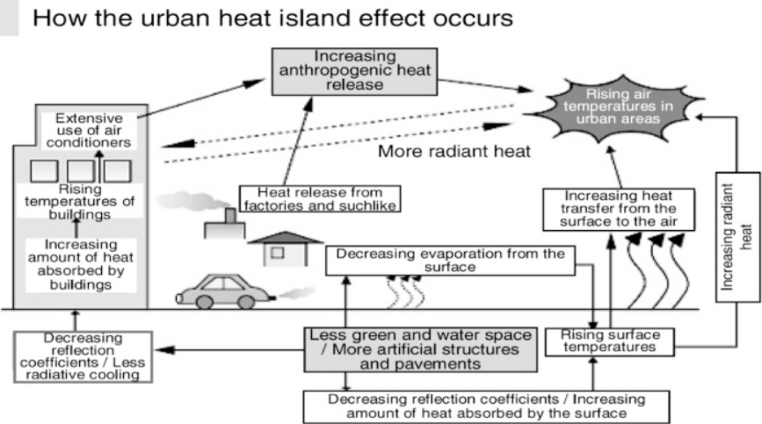
Source: Yamamoto (2006)

Figure 3. How the Urban Heat Island occurs

Impacts of Urban Heat Island

Yamamoto pointed out that the urban heat island effect usually occurs in the summer (Yamamoto, 2006). Due to high temperatures during the daytime, a large amount of heat energy will accumulate in the atmosphere which also affects nighttime. The high temperature at night leads to the increasing demand for air-conditioning systems, which results in higher energy consumption and waste heat emissions. Under the influence of radiant cooling systems in warm urban lands, the updraft of ozone-destroying pollutants causes the loss of the stratospheric ozone layer, which exacerbates the greenhouse gas effect.
In 2016, the WHO had attributed 12.6 million or 23 percent (%) of death globally to climate change and is predicted to increase over the years. Climate change affects the quality of water, air and nature significantly. As organisms live co-dependently, with each playing an important role in a large food chain, a slight change can rupture the whole system entirely. Additionally, the ageing population of the world will worsen the effect of climate change substantially. This is apparent as WHO had estimated approximately 38,000 heat-related death for the older population (aged 65 and older) as we approach 2050, with a large portion of the death happening in Asia as seen in Figure 4 (International Actuarial Association, 2017; World Health Organization, 2014). In the World Disaster Report 2004 and the research of Kosatsky, it was found that in the summer of 2003, there were 20,000 to 40,000 deaths in Europe in two weeks due to heat-related reasons (International Federation of Red Cross and Red Crescent Societies, 2004; Kosatsky, 2005). In addition, since the middle of the 1970s, diarrhoea, malaria and malnutrition have surged due to an increase in body temperature causing more than 150,000 deaths each year. It can be determined that the urban heat island which leads to climate change has negatively affected human health and earth’s ecology, increasing morbidity and mortality caused by extreme temperature differences and extreme weather conditions such as drought and storms, etc. (World Health Organization, 2002).

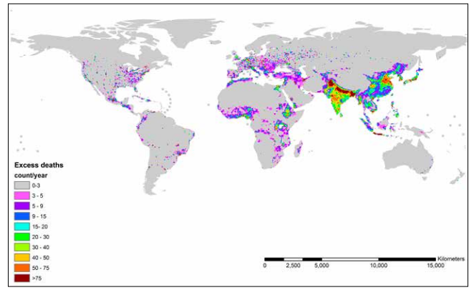
Source: (World Health Organization, 2014)

Figure 4. WHO estimated the amount of heat-related death for the older population by 2050.

The World Health Organization (WHO) believes that the morbidity and mortality caused by anthropogenic climate change will be extended to 2030. Some research had employed the Hadley Climate Model (GSM) to estimate that greenhouse gas emissions will double jeopardize human health till the year 2030 (Arnell et al., 2002). Meanwhile, Meehl and Tebaldi used the model to study the effects of heatwaves in Chicago in 1995 and Paris in 2003, indicating that by 2090, parts of Europe and the United States will be persecuted by heatwaves increasing by 25% and 31%, and also increasing from 8-13 days to 11-17 days (Meehl & Tebaldi, 2004).
The ozone air pollution will increase within the next 50 years, with an average increase of 3.7ppb in the case of high emission level "A2". Currently, the temperature and ozone pollution in the most polluted areas of east the of the United States continues to rise. According to Hogrefe et al., the downscaled climate model showed that in the mid-2050, ozone pollution is expected to contribute to a 4.5% increase in mortality compared to the 1990 average (Hogrefe et al., 2004). This has also been illustrated by Patz as seen in Figure 5 (Patz et al., 2005). Compared with the Community Multi-scale Air Quality (CMAQ), the average maximum ozone concentration of 8 hours daily during summer is at 2.7ppb in 2020, 4.2ppb in 2050, and 5ppb in 2080 (Hogrefe et al., 2004).

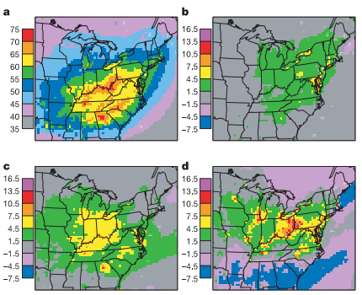
Source: Jonathan A. Patz et al. (2005)

Figure 5. Simulated ozone air pollution over the eastern United States by using a downscaled climate model linked to a regional air pollution model. (a) The average maximum ozone concentration of 8 hours daily in summer 1990. (b) Simulating 2020 with IPCCA2. (c) Simulating 2050 with IPCCA2. (d) Simulate 2080 with IPCCA2

Method and study area

Research framework

This research is based on urban heat islands and the content is divided into the following three parts. The first part discusses the background and causes of the urban heat island. The second part discusses the impact and hazards of urban heat islands in the past and the future. The third part is the summarised mitigation strategies collected from different case studies for analysis and discussion.
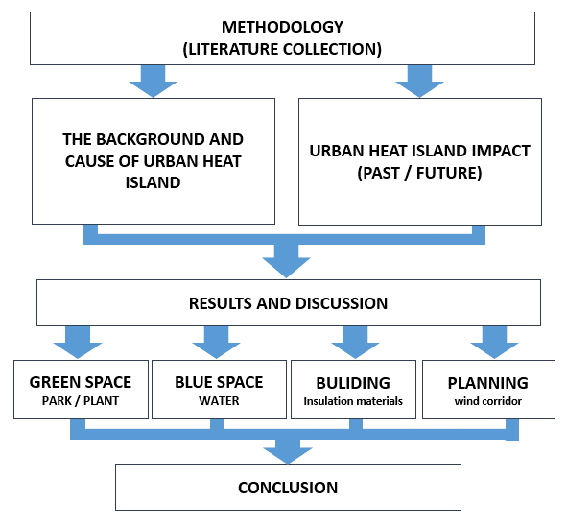
Source: Author

Figure 6. Research framework.

Based on such considerations, the algorithm uses a different colour image multiplied by the weighting coefficients of different ways to solve the visual distortion, and by embedding the watermark, wavelet coefficients of many ways, enhance the robustness of the watermark. ‘urban thermal environment’, ‘living environment’, ‘thermal comfort’, and ‘architectural and urban design’. References were collected over the past 20 years from 1980 to 2020 through Scopus Southeast Asia and had been referred to substantially. The background causes and effects of the urban heat island and research cases from various countries were analysed. This research delineates the improvement methods of human settlements through design options and analyses the solutions to urban heat islands in various countries.

Methodology

This research is carried out through a thorough study of related literature reviews. The keyword ‘urban heat island’, “urban thermal environment’, ‘living environment’, ‘thermal comfort’, and ‘architectural and urban design’. has been used extensively to collect related data, mainly from Scopus. By using the said keyword, a result of nearly 70 references, 10 papers, related books and other related research materials in Scopus Southeast Asia were obtained, from the year 1980 to 2020. However, only a total of 46 has been referred to substantially for this study.
The content analysis focuses on systematic and quantitative analyses to further clarify the results of the current research, while also exploring the context of the research. The findings were then classified under common themes, namely the demand for an increase of infrastructure in green spaces, presence of water body, insulation material and the design of urban wind corridor.

Results and discussions

Different design approaches and techniques will produce different results due to local background differences. Through this analysis, we can consider multiple mitigation measures to reduce the urban heat island effect by identifying their viability in the future. The design options can be summarized into the following four:

Increase the infrastructure of green space

Compared with the use of concrete and asphalt in the city, parks and green spaces have lower surface and air temperatures (Jauregui, 1990). Green spaces parks have a larger area of ​​plant cover to reduce direct heat radiation (Spronken-Smith & Oke, 1999). Greenery is also widely used on urban building facades or ‘green roofs’ which envelopes the surface of the building to reduce the buildings’ direct absorption of heat radiation (Oberndorfer et al., 2007). Besides mitigating the impact of urban heat, some researchers had also pointed out that green roofs provide biodiversity, design aesthetics, and rainwater management ecosystems which increases urban vitality and controls urban temperature by releasing stored water into the atmosphere (Dunnett & Kingsbury, 2008; Moody & Sailor, 2013; Oberndorfer et al., 2007)

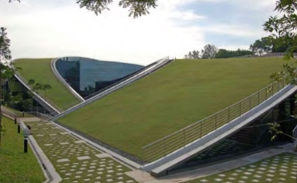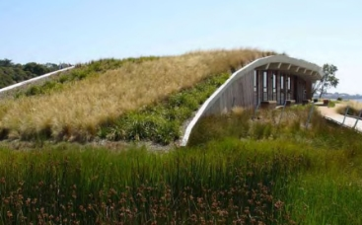
(a) (b)
Source: Dunnett and Kingsbury, 2008

Figure 7. (a) Green Roof of the Nanyang Technology University of Singapore; (b) Green Roof,

Water Body

Temperature, humidity and seasonal changes in the city have always been the most obvious way to express urban thermal comfort (Omonijo, 2017; Parsons, 2014). As such, utilizing water bodies can be an effective method to reduce urban temperature. The temperature of the water body is usually 2-6° C lower than the surrounding temperature (Manteghi et al., 2015). Water having strong heat absorption qualities and heat storage provides a valuable opportunity to absorb heat energy from the surroundings through evaporation and dissipation of water, transforming sensible heat to mild heat. Another cooling method is the use of sprinklers in urban paving to reduce air temperature (Chatzidimitriou et al., 2013). Urban blue spaces also known as water bodies are extremely important in city areas (Völker et al., 2013), whether it is active or passively designed. Passive designs are based on the principle of active evapotranspiration such as swimming pools and ponds, whereas active designs are evaporative wind towers, sprinklers, etc. Urban water bodies help cool down urban heat islands effectively (Santamouris et al., 2017).
However, it is important to note that while the presence of water can help reduce the urban heat island effect, it also poses some challenges of its own. While water bodies have a cooling effect, it also increases the surrounding humidity which leads to excessive evaporation, and this might negatively affect the thermal comfort of users (Hendel et al., 2016). Therefore, careful consideration should be regarded to ensure that the solution poses minimal problems in the future.

Insulation Material

Urban environments are mostly buildings and road pavements. Sidewalks and roofs usually account for more than 60% of urban surfaces (20% to 25% on roofs and about 40% on sidewalks) (Akbari & Rose, 2008).
The largest heat source of the urban heat island is solar radiation. Research on effective thermal insulation affecting surface temperature can be conducted, to mitigate the impact of solar radiation heat energy on the overall urban environment (Bretz & Akbari, 1997). Materials that have high reflectivity (SR) to solar radiation and high spectral emissivity € which prevents temperature increase and reduces the high temperature indoors, are considered to be one of the most effective technologies for the future (Synnefa et al., 2011).
If high reflectivity (SR) and high spectral emissivity € materials are used on building surfaces and road pavements such as insulation coatings with strong reflective capabilities, these materials may reduce the need for air conditioning. These materials reflect sunlight and prevent heat flux from entering indoor spaces (Berdahl & Bretz, 1997). Besides that, low thermal insulation materials such as aerogel insulation materials (Baetens et al., 2011), and the combination of phase change materials (PCM) can be used to reduce the impact of thermal stress on the roof, etc (Saffari et al., 2018). In addition, the application of dark reflective coatings on asphalt pavement (Kinouchi et al., 2004), and other colours of bitumen made by special coatings can increase reflectivity for thermal insulation (Synnefa et al., 2011).

Design of Urban Wind Corridor

The urban heat island effect is closely related to the height of the urban profile (Kalnay & Cai, 2003). City development must be subject to detailed planning and design. The average temperature during daytime in a commercial area is greater than the average temperature in residential areas and parks (Santamouris et al., 2007; A. Synnefa et al., 2008). ‘Urban Wind Corridor’ is an initiative to improve urban ventilation by encouraging wind flow through urban areas. The temperature, humidity, and air quality of the overall urban environment are affected by the layout of the urban landscape (Kress, 1979). Planning methods are often nested in different regional backgrounds and lead to different results. Many studies have further examined the relationship between wind speed field changes and building types through simulation software, computational fluid dynamics (CFD) models or GIS air duct analysis (Hsieh & Huang, 2016; Shi et al., 2006). The last initiative, which is the urban wind corridor may be effective, but it is limited by the expansion of the city (Gál & Sümeghy, 2007; Gál & Unger, 2009; Suder & Szymanowski, 2013, Huang et al., 2014).

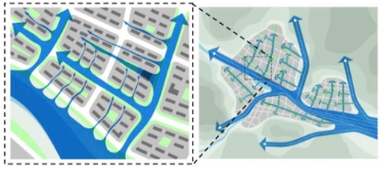
(a) (b)
Source: Ren et al., 2018

Figure 8. Wind Corridor

Conclusion

The urban heat island effect has been one of the major causes of the ever-rising problem of climate change. As predicted by research, the global average temperature will increase as much as 1.5 °C to 4.4 °C by the end of the 21st century. The phenomenon, mainly an effect of large urban scale developments happened as a large amount of heat from air-conditioning, vehicle waste and heat emission accumulated. From the sources and references throughout carrying out this research, the impact of the urban heat island was analysed. Therefore, after thorough analysis, the paper suggested methods to mitigate this problem through the adaptations of green areas, water bodies, better insulation materials and design of urban wind corridors. Increasing the number of green areas in a city will help alleviate the urban heat island effect as it can help reduce direct heat radiation into a building. Not to mention, the presence of green areas i.e., green roofs will promote biodiversity, aesthetics, rainwater management ecosystems hence increasing urban vitality through temperature control. In addition, the presence of a water body can help lower the surrounding temperature due to its strong heat absorption qualities. Moreover, the usage of high reflectivity (SR) and high spectral emissivity (e) materials in buildings will lower the amount of heat absorbed into the building, thus cutting the need for air conditioning. Lastly, the design of urban wind corridors increases airflow into an area, hence cooling the surrounding temperature. Proper planning and design should be done to incorporate these methods seamlessly in building or city design. With the advancement and innovation of science and technology, the issue of the urban heat island has gradually gained momentum among the scientific community. From the perspective of construction engineers and urban planners, there are various strategies to alleviate urban heat, as stated before. However, complications do exist within each mitigation method discussed in this article, such as green roofs affecting the selection of plants and ecosystem, water bodies increasing humidity and resulting in sweltering conditions, the high cost of thermal insulation materials and coating volatilisation, and the design of the air corridor that required large-scale would be part of the discussion with the issues in controlling the increasingly saturated urban development. Nonetheless, with careful design consideration during the construction phase, it could be minimized or eliminated. All in all, to tackle the issue of urban heat in the future, this study can be referenced for its comprehensive analysis and complete consideration of architectural and urban planning. We hope that scholars and experts in the field of architecture and urban design will be able to benefit from this study to achieve their target of reducing the urban heat island effect.

Acknowledgement

This research was financially supported by the “Research Center of Energy Conservation for New Generation of Residential, Commercial, and Industrial Sectors” from The Featured Areas Research Center Program within the framework of the Higher Education Sprout Project by the Ministry of Education (MOE) in Taiwan. Much appreciation and gratitude goes out to “Analysis of the Urban Heat Island Vertical Structure in a Subtropical Smart City with Deep Learning & IOT”,(108-2221-E-027-002-MY2) for supporting this study.

References

Akbari, H., & Rose, L. S. (2008). Urban Surfaces and Heat Island Mitigation Potentials. Journal of the Human-Environment System, 11(2), 85–101. https://doi.org/10.1618/jhes.11.85
Arnell, N. W., Cannell, M. G. R., Hulme, M., Kovats, R. S., Mitchell, J. F. B., Nicholls, R. J., Parry, M. L., Livermore, M. T. J., & White, A. (2002). The Consequences of CO2 Stabilisation for the Impacts of Climate Change. Climatic Change 2002 53:4, 53(4), 413–446. https://doi.org/10.1023/A:1015277014327
Asimakopoulos, D. N., Assimakopoulos, V. D., Chrisomallidou, N., Klitsikas, N., Mangold, D., Michel, P., Santamoutis, M., & Tsangrassoulis, A. (2020). ENERGY AND CLIMATE IN THE URBAN BUILT ENVIRONMENT. (M. Santamoutis (ed.); 1st ed.). ROUTLEDGE.
Baetens, R., Jelle, B. P., & Gustavsen, A. (2011). Aerogel insulation for building applications: A state-of-the-art review. Energy and Buildings, 43(4), 761–769. https://doi.org/10.1016/ J.ENBUILD.2010.12.012
Berdahl, P., & Bretz, S. E. (1997). Preliminary Survey of the Solar Reflectance of Cool Roofing Materials.
Bretz, S. E., & Akbari, H. (1997). Long-term performance of high-albedo roof coatings. Energy and Buildings, 25(2), 159–167. https://doi.org/10.1016/S0378-7788(96)01005-5
Chatzidimitriou, A., Liveris, P., Bruse, M., & Topli, L. (2013). PLEA2013 -29th Conference, Sustainable Architecture for a Renewable Future Urban Redevelopment and Microclimate Improvement: A Design Project in Thessaloniki, Greece. September.
Dunnett, N., & Kingsbury, N. (2008). Planting Green Roofs and Living Walls. In Portland OR Timber Press.
File:Solar Spectrum.png. (2020, September 27). Wikimedia Commons, the free media repository. Retrieved 15:19, September 15, 2021 from https://commons.wikimedia.org/w/index.php? title=File:Solar_Spectrum.png&oldid=473433513
Gál, T., & Sümeghy, Z. (2007). MAPPING THE ROUGHNESS PARAMETERS IN A LARGE URBAN AREA FOR URBAN CLIMATE APPLICATIONS. Acta Climatologica et Chorologica, 27–36.
Gál, T., & Unger, J. (2009). Detection of ventilation paths using high-resolution roughness parameter mapping in a large urban area. Building and Environment, 44(1), 198–206. https://doi.org/10.1016/J.BUILDENV.2008.02.008
Hendel, M., Gutierrez, P., Colombert, M., Diab, Y., & Royon, L. (2016). Measuring the effects of urban heat island mitigation techniques in the field: Application to the case of pavement-watering in Paris. Urban Climate, 16, 43–58. https://doi.org/10.1016/J.UCLIM. 2016.02.003
Hogrefe, C., Lynn, B., Civerolo, K., Ku, J. Y., Rosenthal, J., Rosenzweig, C., Goldberg, R., Gaffin, S., Knowlton, K., & Kinney, P. L. (2004). Simulating changes in regional air pollution over the eastern United States due to changes in global and regional climate and emissions. Journal of Geophysical Research D: Atmospheres, 109(22), 1–13. https://doi.org/10.1029/ 2004JD004690
Hsieh, C. M., & Huang, H. C. (2016). Mitigating urban heat islands: A method to identify potential wind corridor for cooling and ventilation. Computers, Environment and Urban Systems, 57, 130–143. https://doi.org/10.1016/J.COMPENVURBSYS.2016.02.005
Huang, H.-C., Lin, F.T., & Hsieh, C.-M. (2014), “A simple method for designation of urban ventilation path by using agent analyst in GIS — A study of Tainan, Taiwan”, Conference on sustainable business, energy and development in Asia, Hiroshima, Japan.
International Actuarial Association. (2017). Climate Change and Mortality. www.actuaries.org
International Federation of Red Cross and Red Crescent Societies. (2004). World Disaster Report 2004. https://doi.org/10.13140/RG.2.2.22682.16324
Jauregui, E. (1990). Influence of a large urban park on temperature and convective precipitation in a tropical city. Energy and Buildings, 15(3–4), 457–463. https://doi.org/10.1016/0378-7788(90)90021-A
Kalnay, E., & Cai, M. (2003). Impact of urbanization and land-use change on climate. Nature 2003 423:6939, 423(6939), 528–531. https://doi.org/10.1038/nature01675
Kinouchi, T., Yoshinaka, T., Fukae, N., & Kanda, M. (2004). DEVELOPMENT OF COOL PAVEMENT WITH DARK COLORED HIGH ALBEDO COATING. The Urban Environment, Vancouver, BC, 207–210.
Kosatsky, T. (2005). The 2003 European heat waves. Eurosurveillance, 10(7), 3–4. https://doi.org/10.2807/ESM.10.07.00552-EN
Kress, R., Germany (West)., & University of Dortmund. (1979). Regional air exchange processes and their importance for spatial planning . Bonn-] Bad Godesberg: Federal Minister for Regional Planning, Building and Urban Development.
Manteghi, G., Bin Limit, H., & Remaz, D. (2015). Water bodies an urban microclimate: A review. Modern Applied Science, 9(6), 1–12. https://doi.org/10.5539/MAS.V9N6P1
Meehl, G. A., & Tebaldi, C. (2004). More intense, more frequent, and longer lasting heat waves in the 21st century. Science, 305(5686), 994–997. https://doi.org/10.1126/science.1098704
Moody, S. S., & Sailor, D. J. (2013). Development and application of a building energy performance metric for green roof systems. Energy and Buildings, 60, 262–269. https://doi.org/10.1016/J.ENBUILD.2013.02.002
National Oceanic and Atmospheric Administration. (2021). Climate at a Glance | National Centers for Environmental Information (NCEI). https://www.ncdc.noaa.gov/cag/global/ time-series/globe/land_ocean/ytd/12/1880-2019
Oberndorfer, E., Lundholm, J., Bass, B., Coffman, R. R., Doshi, H., Dunnett, N., Gaffin, S., Köhler, M., Liu, K. K. Y., & Rowe, B. (2007). Green Roofs as Urban Ecosystems: Ecological Structures, Functions, and Services. Https://Doi.Org/10.1641/B571005, 57(10), 823–833. https://doi.org/10.1641/B571005
Oke, T. R., & Cleugh, H. A. (1987). Urban heat storage derived as energy balance residuals. Boundary-Layer Meteorology 1987 39:3, 39(3), 233–245. https://doi.org/10.1007/BF00116120
Omonijo, A. G. (2017). Assessing seasonal variations in urban thermal comfort and potential health risks using Physiologically Equivalent Temperature: A case of Ibadan, Nigeria. Urban Climate, 21, 87–105. https://doi.org/10.1016/J.UCLIM.2017.05.006
Parsons, K. (2014). Human thermal environments : the effects of hot, moderate, and cold environments on human health, comfort, and performance (3rd ed.). CRC Press.
Patz, J. A., Campbell-Lendrum, D., Holloway, T., & Foley, J. A. (2005). Impact of regional climate change on human health. Nature 2005 438:7066, 438(7066), 310–317. https://doi.org/10.1038/nature04188
Ren, C., Yang, R., Cheng, C., Xing, P., Fang, X., Zhang, S., Wang, H., Shi, Y., Zhang, X., Kwok, Y. T., & Ng, E. (2018). Creating breathing cities by adopting urban ventilation assessment and wind corridor plan – The implementation in Chinese cities. Journal of Wind Engineering and Industrial Aerodynamics, 182, 170–188. https://doi.org/10.1016/J.JWEIA.2018.09.023
Rizwan, A. M., Dennis, L. Y. C., & Liu Chunho. (2008). A review on the generation, determination and mitigation of Urban Heat Island. Journal of Environmental Sciences, 20(1), 120–128. https://doi.org/10.1016/S1001-0742(08)60019-4
Saffari, M., Piselli, C., de Gracia, A., Pisello, A. L., Cotana, F., & Cabeza, L. F. (2018). Thermal stress reduction in cool roof membranes using phase change materials (PCM). Energy and Buildings, 158, 1097–1105. https://doi.org/10.1016/J.ENBUILD.2017.10.068
Santamouris, M., Ding, L., Fiorito, F., Oldfield, P., Osmond, P., Paolini, R., Prasad, D., & Synnefa, A. (2017). Passive and active cooling for the outdoor built environment – Analysis and assessment of the cooling potential of mitigation technologies using performance data from 220 large scale projects. Solar Energy, 154, 14–33. https://doi.org/10.1016/J.SOLENER. 2016.12.006
Santamouris, M., Paraponiaris, K., & Mihalakakou, G. (2007). Estimating the ecological footprint of the heat island effect over Athens, Greece. Climatic Change 2007 80:3, 80(3), 265–276. https://doi.org/10.1007/S10584-006-9128-0
Shi, S., Ye, X., Dong, Z., & Zhou, H. (2006). Research on the integration of GIS-based digital valley system. First International Multi- Symposiums on Computer and Computational Sciences, IMSCCS’06, 1, 452–457. https://doi.org/10.1109/IMSCCS.2006.118
Spronken-Smith, R. A., & Oke, T. R. (1999). Scale Modelling of Nocturnal Cooling in Urban Parks. Boundary-Layer Meteorology 1999 93:2, 93(2), 287–312. https://doi.org/10.1023/ A:1002001408973
Suder, A., & Szymanowski, M. (2013). Determination of Ventilation Channels In Urban Area: A Case Study of Wrocław (Poland). Pure and Applied Geophysics 2013 171:6, 171(6), 965–975. https://doi.org/10.1007/S00024-013-0659-9
Synnefa, A., Dandou, A., Santamouris, M., Tombrou, M., & Soulakellis, N. (2008). On the use of cool materials as a heat island mitigation strategy. Journal of Applied Meteorology and Climatology, 47(11), 2846–2856. https://doi.org/10.1175/2008JAMC1830.1
Synnefa, A., Karlessi, T., Gaitani, N., Santamouris, M., Assimakopoulos, D. N., & Papakatsikas, C. (2011). Experimental testing of cool colored thin layer asphalt and estimation of its potential to improve the urban microclimate. Building and Environment, 46(1), 38–44. https://doi.org/10.1016/J.BUILDENV.2010.06.014
Völker, S., Baumeister, H., Classen, T., Hornberg, C., & Kistemann, T. (2013). Evidence for the temperature-mitigating capacity of urban blue space - A health geographic perspective. Erdkunde, 67(4), 355–371. https://doi.org/10.3112/ERDKUNDE.2013.04.05
World Health Organization. (2002). Reducing Risks, Promoting Healthy Life, The World Health Report. In World Health Organisation.
World Health Organization. (2014). Quantitative risk assessment of the effects of climate change on selected causes of death, 2030s and 2050s. www.who.int
Yamamoto, Y. (2006). Measures to Mitigate Urban Heat Islands. Environmental and Energy Research Unit. Quaterly Review, 18, 65–83.
Yeo, L. B., Ling, G. H. T., Tan, M. L., & Leng, P. C. (2021). Interrelationships between Land Use Land Cover (LULC) and Human Thermal Comfort (HTC): A Comparative Analysis of Different Spatial Settings. Sustainability, 13(1), 382.

