

Calcareous nannofloras in Western Lobe Offshore, Niger Delta: Eutrophication and climate change implications

Bamidele Samuel Oretade, Che Aziz Ali

Department of Earth Sciences and Environment, Faculty of Science and Technology,
Universiti Kebangsaan Malaysia, Malaysia.

Correspondence: Bamidele Samuel Oretade (email: p95743@siswa.ukm.edu.my; samtad@mail.com)

Received: 23 July 2021; Accepted: 06 September 2021; Published: 30 November 2021

Abstract

In support of the on-going temporal palaeoenvironmental and palaeoclimatic reconstructions of the Neogene sediments, this study attempts describing the palaeo-proxies recovered from DEL-1 Well, western offshore Niger Delta. The use of standard smear slide method enabled the recovery of well-preserved calcareous nannofossils that depicts early to mid – Miocene (NN4 – NN5) sediments. The up-hole relationships between the relative abundance of Discoaster spp. and coccolith size of Reticulofenestra show step by step collapse of sea surface stability from early to middle Miocene. The lower horizons (8000-9460 ft.) exhibit relatively high Discoaster abundance and relatively large Reticulofenestra spp. size to suggest a deep thermocline and nutricline that characterize oligotrophic conditions in less warm-water induced climate. Conversely, upper horizons (5225-6550 ft.) exhibit significant changes with relatively low abundance of Discoaster spp. and relative small Reticulofenestra spp. size to suggest a shallow thermocline and nutricline that characterize eutrophic conditions in warm-water induced climate. The high abundance of Helicosphaera coccoliths (Helicosphaera carteri) within the mid - NN5, suggests mesotrophic conditions within a stressed environment (fluctuating salinity and terrigenous influx) with the occurrence of carbonate fluctuating event. The combined parameters indicate gradual eutrophication and collapse of sea surface stability in favour of nutrients and influx of fluvial mechanism (terrestrial input) in the ocean water as it progressed from early to middle Miocene. The palaeo-proxies assemblages depict hyposaline waters in a neritic environment, characterized with induced warm water climatic conditions.

Keywords: Calcareous nannofossils, Neogene sediments, Niger Delta, palaeoecology, thermocline, sea-surface stability.

Introduction
Modern studies have raised major challenges faced in reconstructing the palaeo-natural attributes of the past ecosystems, which have influence on the ocean water and palaeoclimatic conditions mostly in the low to middle latitude regions (Hendrizan, 2016). These challenges evolved around the systematic structure and dynamics of hydrographic conditions of surface water that resulted to the ecological and climatic changes inferred from these areas (Farida et al., 2012; Imai et al., 2015). Modern studies are gradually designed with the use of proxies to elucidate attributes of oceanic surface water, most often by characterizing the thermocline and nutricline dynamics within a specific water body astronomically driven by climate change (Pouresmaeil et al., 2012). Consequently, marine eco-climatic research is undertaken in order to understand the relationship between the geographic and bathymetric variability. However, this type of research allows credible insights into concern factors that influence the ecosystem distribution patterns in ancient and modern oceans while exploring the term biodiversity. These, as a result of ecological and biogeochemical/physiological sensitivity of marine proxies, which could enact the changes in their habitat typically in modern environments, as they are astronomically driven by climate change. In addition, the retrieved phylogenetic trees and diversity data reserve best imprints to evaluate the thin line between biodiversity and palaeoceanographic conditions (Chira & Malacu, 2008).
Coccolithophores remain the primary component of oceanic phytoplankton responsible for global carbon cycle within the earth system (Hendrizan, 2016), made up by phytoplanktonic communities consisting of diatoms, cyanobacteria, nannofossils and dinoflagellates (Erba, 2006). Moreover, the calcareous nannofossils are remains of golden-brown, single-celled algae that live only in the oceans (Pouresmaeil et al., 2012). Subsequently, these algae produce tiny calcite platelets (calcareous nannofossils) within their cells that are preserved within marine sediments/rocks as fossils (Erba, 2006; Pouresmaeil et al., 2012). The use of their calcareous skeletons and exported calcium carbonates into the deep oceans make them important in examining biogeochemical cycles. Of this benefit, good preservation level based on their small sizes have huge advantages over the mechanical damage to their remains, and their widespread distribution across almost all marine habitats within the oceans is noteworthy. In addition, a very large number of individual nannoliths are often preserved in a tiny amount of sediment that is required for productive statistical results on the palaeo-ecosystem.
The importance of the calcareous nannofossils aside age indicators, merited palaeoenvironmental indices for determining the nutrients, temperature and current patterns of oceanic waters. However, an intrinsic understanding of each nannofossils’ evolutionary history and ecological preferences to their species level is of importance. While exploring their stratigraphic value, based on their biodiversity and speciation are essential for marine ecology and biogeochemistry reconstructions for palaeo-oceans (Pouresmaeil et al., 2012). However, proper understanding of their biodiversity – that has a strong connectivity with palaeoclimate trends, depicts high diversity is recorded during warm periods and low diversity during cool periods. Biodiversity is referred to as the totality of the species and ecosystem level from a region, and the taxonomic richness of a given area (Gaston & Spicer, 2013). The global diversity of calcareous nannofossil is sturdily influenced by oligotrophic, low-latitude water masses, climate and oceanography (Chira & Malacu, 2008), while eutrophic condition has been reported for producing varying marine assemblage, with endemic elements and influences of boreal. Consequently, this gives a clue to the reconstructions of the palaeoenvironmental and palaeoclimatic conditions of local or regional areas. This study tends to use the biosignals and biodiversity inferred from the retrieved nannofloras to elucidate the palaeoenvironmental and palaeoclimatic conditions of the surface water during deposition of the studied sediments, perhaps utilising the proxies as climatic signals.

Location and geology of the study area

The DEL–1 Well is located in the western arm of the Charcot fracture zone, offshore region of the Niger Delta Nigeria, situated in the Gulf of Guinea along the equatorial West Africa continental margin at the southern tip of Nigeria (Figure 1). The derived sedimentary units are composed of sediments from wide-range catchment areas of the Niger–Benue River system, which resulted in the bulk sediments of Neogene deposits compositionally altered with volcanically derived sediments from the emplacement of Cameroon volcanic line (Ozumba, 2018). The Niger Delta covers an estimated area of 256,000 square kilometres (Adegoke et al., 2017), and it is stratigraphically subdivided into three diachronous sequences across the depositional belts (Ozumba, 2018) that started developing in the Eocene. The accumulation of sediments in each depositional belt occurred in response to the eustatic effect of the sea-level oscillations prevailing during the basin development. Of the major depositional belts in Niger Delta, the study area lies within the western detachment fold zone (DFZ) of the sub-divided offshore depobelt (Figure 1).

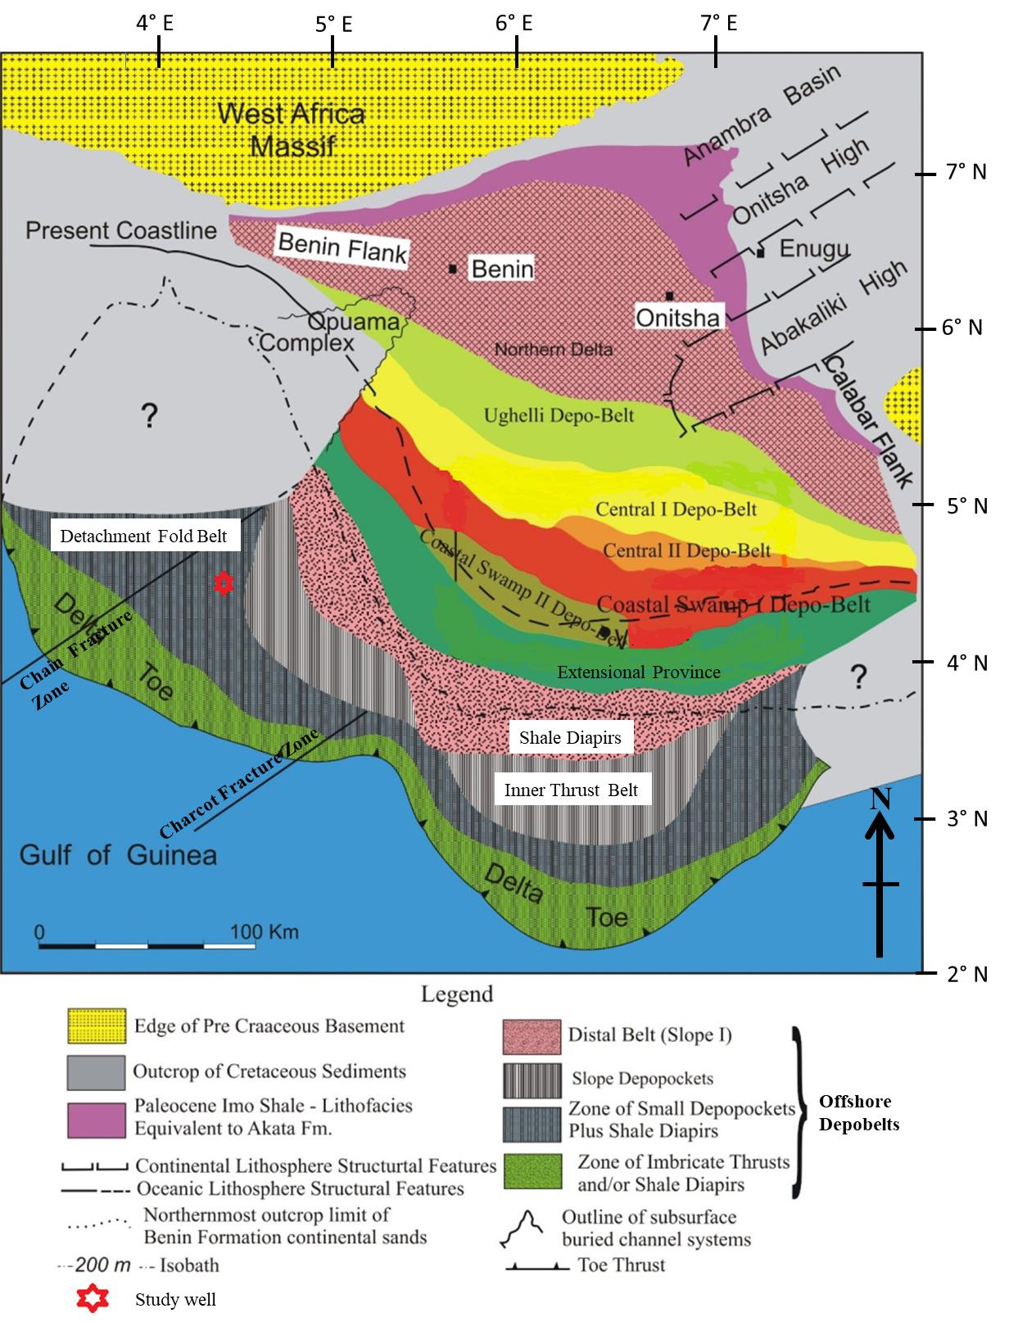
Figure 1. Regional map of the Niger Delta showing the distribution of main structural elements and Depobelts, highlighted is the study well (in red) (modified after Doust & Omatsola, 1990).
The Niger Delta stratigraphic sequences are composed of gross lithofacies grouped into formations. The Akata Formation – over-compacted-pressured pro-delta marine shale deposited in front of the advancing delta with lenses of sandstones, is the oldest and basal unit that is believed to be the main source rock. However, the Agbada Formation is composed of paralic sequences of alternating shale, sands and silts that are of clastic deltaic environment and lastly, is the upper unit called Benin Formation, characterized as a continental sands and silts (Ozumba, 2018). These lithostratigraphic units are systematically built as a result of imbricated super-imposed offlap depositional cycles across the delta. Overview of the evolution and general geology are reported by (Doust & Omatsola, 1990).

Material and methods

A total of 148 ditch cuttings were retrieved from Miocene succession within the depth interval 4600 – 9460 ft. of DEL–1 Well, offshore Nigeria. Ten grams of each sample were examined for their calcareous nannofossils contents following standard nannofloral laboratory procedure, while the slides were prepared using the standard smear slide method (Bown & Young, 1998) for each of the samples. The samples were gently crushed and thereafter dispersed in distilled water inside glass vials and stirred with a stirring rod after which they were decanted into another glass tubes. Using a disposable pipette, the decanted suspensions were pipetted onto 22 × 40 mm cover slips, then placed on a regulated hot plate and gently dried at a temperature of about 50˚C-60˚C. Then, the cover slips were mounted on the labelled glass slides using two drops of Norland optical adhesive mounting medium (Refractive index = 1.56) and cured them under the ultraviolet light for forty-five minutes.
A Sairan light microscope of ×1500 magnification was used under cross-polarized and phase-contrast methods to identify the calcareous nannofossils’ contents from the prepared slides, the catalogues and other published guides (Perch-Nielsen, 1985; Young, 1999) were used in the identification. Nannofossil zonation was carried out for the recouped calcareous nannofossils with the use of standard NN zonation of Martini (1971) and the biohorizons were delineated using Backman et al. (2012) and Raffi et al. (2016), correlated with Geological Time Scale (GTS, 2020) sensu Gradstein et al. (2020). The total nannofossil abundance counts were estimated following counting strategies of Flores et al. (1995), where a number of specimens were taken for the field of view. The palaeoecologic study was carefully examined due to low species abundance, while all nannofossil species were counted in 10 purviews in determining their biodiversity. The Shannon-Wiener index (H) is used to measure the species biodiversity and was calculated using the formula (Shannon & Weaver, 1949),
Diversity (H) = - $\sum_{i=1}^{s}{p_{i} In p_{i}}$ (1)

Note: p_{i} represents proportion of the individual taxa to the population and Richness (S) is the count of number of taxa per depth.

The species richness (S) and evenness (J) were calculated using statistical software PAST (Palaeontological Statistics; Version 3.05; Hammer et al., 2001) using the formula:

Evenness (J) = H/H_{max} = H/InS (2)

The species richness and nannofloral abundance were logged into the STRATABUG software's datasheet to obtain interpreted abundance and diversity trends to construe bioevents and geological relationships

Results and discussion

Nannofossils preservation

Modern researches have highlighted two major factors that strongly alter the preservation of calcareous nannofossils. These factors “dissolution and diagenesis” often affect their application in the reconstructions of palaeoenvironment and palaeoecology (Andruleit, 1997). This study uses visual skeletal inspection on both resistant and susceptible taxa for their intrinsic features to estimate the dissolution effect on the neritic sediments, perhaps construe the preservation level. Of the total count (n=1569) for the calcareous nannofossil retrieved in this study (presented in the supplementary data consisting of nannofossil zonation, nannofossil count, diversity trend and distribution), the visual skeletal inspection shows the nannofossils are not affected by etching (Figure 2), while their delicate structures (even for Pontosphaera spp. and Syracosphaera spp.) are well preserved. However, significant observations were taken on secondary calcite overgrowth on some nannofossil species, similarly minute species show their coccolith central structures tend to be lightly overgrown. Among the dissolution-resistant Neogene taxa listed by Gibbs et al. (2004), this study recorded relative abundance of Discoaster spp. and Calcidiscus spp. from the deeper water to shallower horizons. Both taxa are classed as the most dissolution-resistant since they are composed of thick calcite elements despite being small in coccoliths size, and they are expected to be dissolution vulnerable. Followed up are the less dissolution-resistant taxa, such as Sphenolithus spp, large and small Recticulofenestra spp. that are of crystal units. Furthermore, are the less dissolution-susceptible group that are classed by medium-sized taxa. They are made up of Helicosphaera spp., Thoracosphaera spp. and Scyphosphaera spp., while the only most dissolution-susceptible taxa recorded is Pontosphaera spp.
However, while examining the influence of dissolution on nannofossil relative abundance pattern, some authors (Chira & Malacu, 2008; Gibbs et al., 2004) use the ratio in percentage/count of these resistant taxa and visual inspection of preservation to estimate the absolute extent of dissolution in a succession. In this case, Calcidiscus spp. and Discoaster spp. express relative abundances of 78% and 22% respectively of the total resistant taxa with good preservation features that is present in their delicate structures (such grills in Calcidiscus leptoporus and ray tips in Discoaster druggii). Also, noticed are the easily separated delicate articulate placolith shields in them. Consequently, decrease in occurrences of Discoaster spp. and Sphenolithus spp. up-hole show very strong ecological signal that effectively place Calcidiscus spp. as terrigenous resistant taxa in an optimistic scenario. That is, high abundances of Discoaster and Sphenolithus species are interpreted to be prevalence in fair to moderate productivity intervals as seen in the early Miocene of this study, coupled with up-hole cyclic varying abundances of Discoaster spp. are interpreted to reflect possible productivity response to orbitally forced climatic signals (Gibbs et al., 2004, Imai et al., 2015).
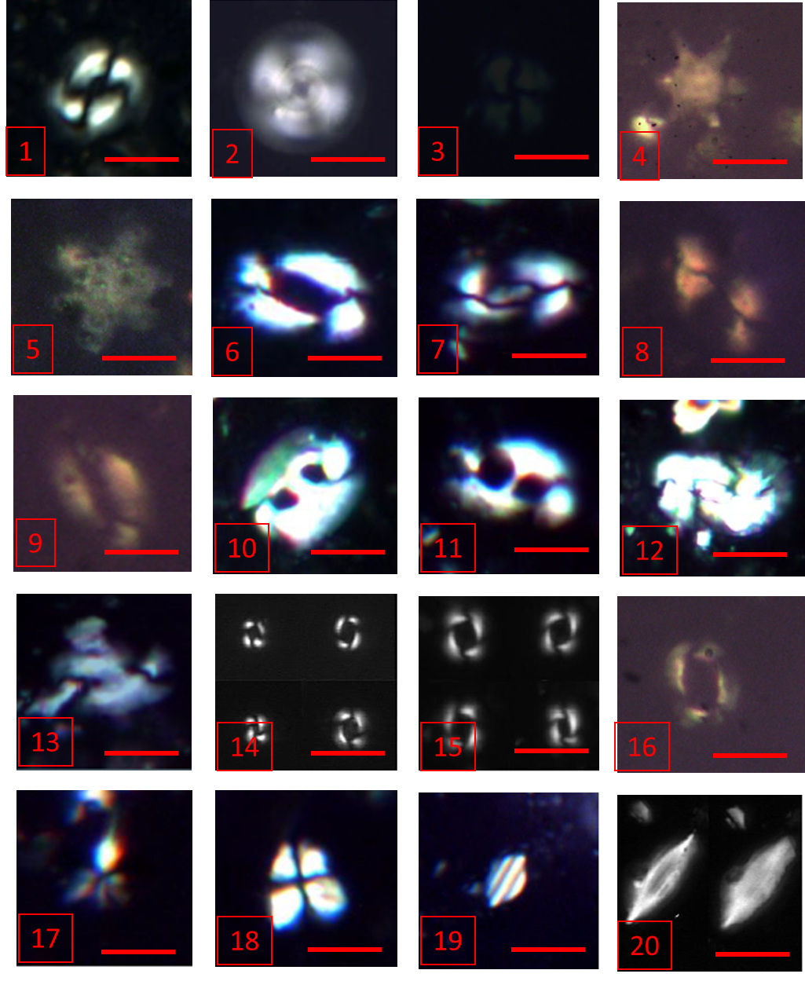
Figure 2. The illustrations are cross-polarized light (XP) micrographs of some studied calcareous nannofossil, the clarity of the photomicrographs help to determine the level of preservation. (1) Coccoliths pelagicus (Wallich 1877) Schiller 1930 (2) Calcidiscus macintyrei (Bukry and Bramlette 1969b) Loeblich and Tappan 1978 (3) Calcidiscus leptoporus (Murray and Blackman 1898) Loeblich and Tappan 1978 (4) Discoaster spp. (6 rays) (5) Discoaster druggii Bramlette and Wilcoxon 1967 (6) Helicosphaera ampliaperta Bramlette and Wilcoxon 1967(7) Helicosphaera euphratis Haq 1966 (8) Helicosphaera carteri (Wallich 1877) Kamptner 1954 (9) Helicosphaera scissura Miller 1981 (10) Helicosphaera oblique Bramlette and Wilcoxon 1967 (11) Helicosphaera mediterranea Muller 1981 (12) Helicosphaera intermedia Martini 1965 (13) Helicosphaera spp (14) Reticulofenestra minuta Roth 1970 (15) Reticulofenestra minuluta (Gartner 1967) Haq and Berggren 1978 (16) Reticulofenestra pseudoumbilica Gartner 1969 (17) Sphenolithus moriformis (Bronnimann and Stradner 1960) Bramlette and Wilcoxon 1967 (18) Sphenolithus moriformis (Bronnimann and Stradner 1960) Bramlette and Wilcoxon 1967 (19) Triquetrorhabulus challengeri Perch-Nielsen 1977 (20) Triquetrorhabulus milowii Bukry 1971. Note: Scale bar is 15µm.
This reasoning is supported with decrease in relative abundance of Discoaster spp. in the middle Miocene, and apparently coincident with the influx of terrestrial sediments (paralic sandstone composition) at the same horizons. Seemingly, this could have eventually led to almost barren or non-floral record at the top of studied succession. Thus, highlights influx of nutrient-rich sediments and perceived unstable water conditions that reveal variation in abundance patterns and assemblage character of dissolution-resistant or susceptible taxa. In summary, the early Miocene show relative enriched abundance of dissolution-resistant taxa, distorted patterns of less susceptible taxa and Shannon-Wiener diversity range of 1.3 to 2.2. While the middle Miocene is characterized with relative abundance of dissolution-resistant taxa, less distorted patterns of less susceptible taxa and Shannon-Wiener diversity range of 1.0 to 1.9. Although sparse occurrences of calcareous nannofossils were seen at the top horizon, and possibly shows presence of high dissolution effect. In addition, this shows there is apparent population alteration at the expense of dissolution effect. Therefore, it is reasonable to express the studied taxa are of less dissolution and good preservation of samples despite varying lithologically composited.

Nannoflora zonation

The studied succession contains low abundance and diversity of species of calcareous nannoplankton, with forty–seven (47) species from fifteen (15) genera were identified. These are mainly dominated by placoliths, helicoliths and nannoliths in this study. The Early to Middle Miocene zones (NN4 – NN5) could only be deduced in the succession. The bioevents at the basal horizons were characterized by first occurrence (FO) of Sphenolithus heteromorphus and first consistent occurrence (FCO) of Helicosphaera ampliaperta, which marks an index species for the Aquitanian – Burdigalian age (Chira, 2000). However, the absence of Sphenolithus belemnos – a marker species for NN3, suggests the studied interval is younger than NN3. The paracme ending (PE) of Sphenolithus heteromorphus and LO of Helicosphaera ampliaperta at depth 6775 ft., suggest assigning the upper limit to biohorizon NN4 to the upper section (see the supplementary data). While the LO of Sphenolithus heteromorphus at depth 5500 ft. suggests the upper limit of the biohorizon NN5 in this study. The FCO of Sphenolithus heteromorphus at depth 8250 ft. within the depth interval (6775 – 9025 ft.) suggests assigning this interval to the NN4 Zone. The upper horizon (5500 – 6775 ft.) is characterized with the FDO of Sphenolithus heteromorphus at 5500 ft. that marks the upper limit of the NN5 Zone (Chira, 2000). The upper interval is marked by moderate abundances and diversity of nannofossils with the association of Micrantholithus entaster Pontosphaera discopora, Reticulofenestra minuta, Reticulofenestra pseudoumbilica. For additional information and data presentation of nannofossil count, assemblage and population are in the supplementary data.
Nannoflora biodiversity and biosignals
In the present study, these nannofossils are regarded low-to-moderate diversity with Shannon-Wiener diversity range value of 0.9 to 2.2, and low to relatively moderate in abundance. Some ecological proxies were strictly examined such as Discoaster spp., Reticulofenestra spp. and Helicosphaera spp. Eight (8) Discoasters nannoliths were recouped to represent Discoasteraceae family. They are regarded as a warm water species that characterize lower photic zones in low latitudes. Moreover, they are perceived sensitive to temperature variations and nutrient availability. This depicts their susceptibility to prevailing surface water stability within the deep horizons of the studied well. Their species richness varies within less than 2 to 18 (Figure 3 and the supplementary data). The genus Sphenolithus is a nannolith known for its large distribution in warm water conditions at lower latitudes. The distribution pattern of the five (5) Sphenolithus nannoliths decreases up-hole (middle Miocene), while the species richness varies between 1.2 and 10.
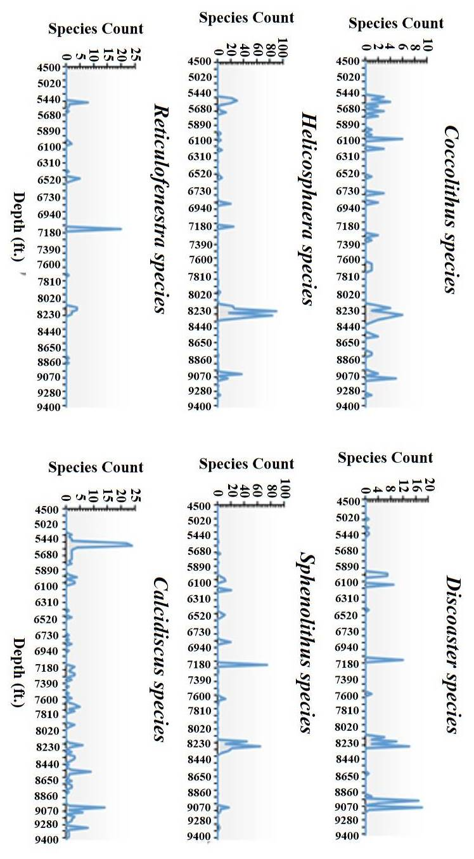
Figure 3. Comparison of selected ecological nannofossil records from DEL-1 Well. Incorporate taxa in their pattern and abundance to highlight their covariance.
The Reticulofenestra species recovered appear generally low in their occurrences and abundances, with five (5) distinguished species showing fluctuating frequencies along the stratigraphic column (Figure 3). The measured size variance (Figure 4) shows an up-hole increase of small size Reticulofenestra coccoliths, while a decrease in large size species within the same stratigraphic column. With a diameter of 6 to 10 μm in the lower part of the studied interval (8500-9450 ft.), an abrupt decrease in modal Reticulofenestra size of 5-8 μm was identified at 8140-8460 ft., and a further decrease in size (to 3-4 μm) up to depth 7150 ft. However, the Helicosphaera coccolith shows their presence across the horizons of the studied well to show their level of resistance. Their size measurements ranged from 6 to 8 μm, while the modal size recorded is 7 μm to enable the sub-zoning of the stratigraphic water-condition along the column. The dominant occurrences of Helicosphaera coccolith show varying frequencies of 30%, 20% and 26% at depth interval 5480 ft., 7150 ft. and 6820 ft. respectively. In the absence of Discoaster exilis in this study, Coccolithus pelagicus is considered cold water taxa in the Miocene sediments (Haq et al., 1977). C. pelagicus is regarded as a sub-polar water-mass species today, which evolved in the tropics in the early Cenozoic and move pole-wards in the mid-Cenozoic (Rahman & Roth, 1990). Despite being a long-ranging species, its importance as palaeoclimatic indicator shows it is a dissolution-resistant species. Notably, intervals with dominant carbonate dissolution will increase its apparent abundance, while it prefers cold nutrient-rich surface waters (7 ºC and 14 ºC). Moreover, it is often stated some calcareous nannoplanktons are rare to absent in todays’ tropical waters, such as C. pelagicus, some species of Helicosphaera and Sphenolithus are reported to avoid boreal waters (Chira et al., 2000; Martini, 1971). Therefore, implies possible changes (increase) in temperature and physiochemical condition of the water-masses.

Palaeoecological and palaeoclimatic significance

The examined calcareous nannofossils (Reticulofenestra coccoliths, Helicosphaera coccolith and Discoaster spp.) were resolved to their palaeontological and palaeoecological signals to reconstruct palaeoenvironmental conditions (Figure 4) and temperature control/changes. Discoaster species – a producing organism (primary producer) is assigned as photic zone species, restricted primarily to warm water bodies to characterize their abundance in the early Miocene to the support of warmer climatic conditions. Their presence has been reported to suggest warm oligotrophic waters in the Neogene sediments (Imai et al., 2015). The Reticulofenestra coccoliths are regarded as warm water species and brackish water species, used as a biosignal to define the level of eutrophism and nutrient changes in a water column across various oceans and lands (Imai et al., 2015). Coccolith sizes of Reticulofenestra are regarded as palaeoenvironmental indicators, while small size specimens both associate freely and characterize an upwelling region to suggest strong eutrophic conditions. Helicosphaera ampliaperta is a eutrophic and brackish water species. This taxon often prefers cooler water, but shows a gradual decrease up-hole to support the view of a gradual displacement of cooler water in the early Miocene of this study (Farida et al., 2012; Imai et al., 2015). Conversely, Helicosphaera carteri is accustomed to warm waters that are characterized with moderate-elevated nutrient levels. The taxa lives today in the tropical and subtropical waters, for example in the Atlantic Ocean at a temperature range 16 and 26 ºC. Their presence in a stressed or polluted environment characterized them as a resistant species that tolerates fluctuating salinity and terrigenous influx (Pouresmaeil et al., 2012).
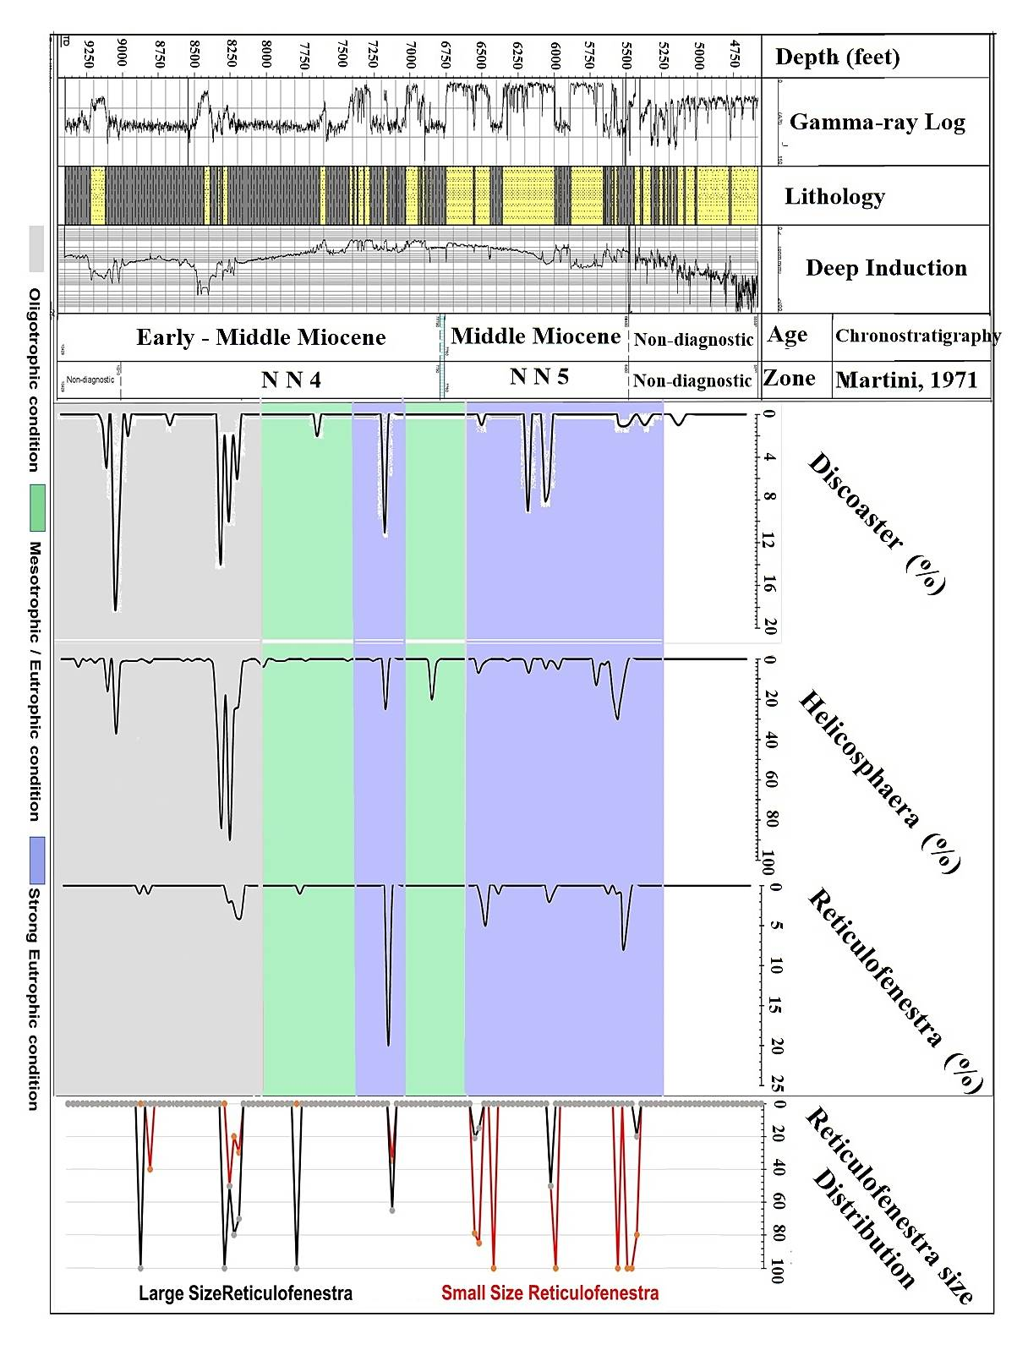
Figure 4. Percentage distribution plot for Discoaster spp., Helicosphaera coccoliths and Reticulofenestra coccoliths recovered from DEL-1 Well, using their relationship to interpret the surface water condition along the water column. The biosignals were plotted along the gamma ray signature with interpreted lithologic facies.

Based on the measured Reticulofenestra coccoliths, size ranged from 6 – 10 μm in the lower section of the well (8140-9450 ft.) with relative abundance of Discoaster spp. group (Figure 4) to suggest the development of deep fall in thermocline and nutricline as inclined factors characterizing an oligotrophic conditions prevailing at the sea surface (Hendrizan, 2016; Imai et al., 2015). An abrupt decrease in size (3-4 μm) was recorded around 7150ft. with slight dominance of resistant species of Helicosphaera carteri (Figure 3) to suggest a prevalence of mesotrophic condition that implies gradual collapse of the thermocline and nutricline dynamics within the water column (Hendrizan, 2016; Imai et al., 2015). Dominant small sizes of Reticulofenestra coccoliths (2-4 μm) were recorded in the upper section of the well (5489-6490 ft.) with relatively less abundance of Discoaster spp. group (Figure 3) to suggest a rise to or dominance of thermocline and nutricline to the sea surface, thus, show evidence of prevailing eutrophic conditions at the sea surface (Imai et al., 2015).
Therefore, where the high abundance of small size Reticulofenestra coccoliths are recorded, it shows an abrupt decrease in thermocline to imply an upwelling-induced eutrophication (strong eutrophic condition) of the surface water with possible increase in nutrient contents (Farida et al., 2012; Imai et al., 2015). This suggests an influx of nutrient content controlled by the collapse of sea surface stratification by constant fluxes of foreign materials. The interplay between the abundances of Helicosphaera ampliaperta and Helicosphaera carteri, thus show both species recorded relative abundances in the lower horizon, to suggest a replacement of marine faunas with brackish or fresh-water fauna. However, these could be as a result of a shift from a climate–induced cool water of the Oligocene / Miocene boundary events to warm water climatic condition (Imai et al., 2015). Helicosphaera carteri known as a eutrophic, eurythermal, hyposaline water and estuarine environment taxon (Hendrizan, 2016), and it’s often regarded as a ubiquitous species (Pouresmaeil et al., 2012). Its distribution reflects an appreciable level of nutrient contents within the section supported possibly by upwelling conditions and surface productivity that enhanced the increase of small Reticulofenestra coccoliths up-hole (Imai et al., 2015). Intervals with sparse occurrence of nannofloras but do record the presence of Coccolithus pelagicus and Helicosphaera carteri, thus, depicts stressed environment or event characterizing nannofloral provinces such in marginal oceans or neritic areas. Consequently, it could be reasoned that floral variation in the studied succession seems to be dissociated from preservation variability; rather it upheld the hypothesis of floral variability possibly associated with variations in the environmental conditions of surface waters induced by climate.
In this study, the biologic variability versus climate shows a strong correlation between the relative abundance of some ecological taxa (Reticulofenestra coccoliths, Helicosphaera coccoliths, Coccolithus pelagicus, Sphenolithus coccoliths and Discoaster spp.) and the abiotic records. The warming episode at early Miocene is supported by marked increase in abundance of Discoaster–Sphenoliths–Helicosphaera–Reticulofenestra assemblages coinciding with deposition of transgressive sediments along the Gulf of Guinea (Figure 3). However, the late early Miocene is interpreted to be of unstable water condition (mesotrophic), with a potential carbonate crash event that left behind a scarce association of Sphenolithus species, Coccolithus pelagicus and Helicosphaera species within the interval. Thus, suggest the first cooling event during the early Miocene and could possibly coincide with the initial regressive events of the succession. The dominance occurrence of Calcidiscus leptoporus, Helicosphaera carteri and absence of Discoaster species suggest the dominance of hyposaline and warm water in the middle Miocene, thus, characterized with influx of nutrient rich terrestrial sediments in eutrophic water condition. It is worth knowing the ecological and evolutionary signals of the studied taxa are construe to have stayed intact. However, it is presumed that the temperature of the water masses are induced climatologically and it’s important at datum appearance of each calcareous nannofossils, as most species are reportedly adaptable. This is often reflected from the relative abundance and biodiversity of some species of calcareous nannoplankton (coccolithophores), which individually are good climatic indicators even in the modern oceans.

Conclusions

The following conclusions are drawn from this study, the retrieved calcareous nannofossils are relatively well to moderate preserved, low-to-moderate diversity and low to moderate abundance from the studied section. The relative occurrence and fossil record characterized with the FDO of Helicosphaera ampliaperta and FDO of Sphenolithus heteromorphus enabled nannofloral zonation of NN4 to NN5 (early to mid-Miocene) within the studied section.
The attribution of the ecological taxa permits environmental delineation characterized as neritic and hyposaline. Paying attention to the biodiversity and distribution pattern of the taxa as well as lithologic changes, suggest the marine changes from oligotrophic to eutrophic conditions with varying productivity levels from the early to middle Miocene. Also, highlights the presence of stress events during sedimentation of the late early-Miocene. From all the identifiable palaeoecological species, their biosignals inferred one cooling episode and two warming episodes in an alternating induced-climatic event typical of a tropical climate; the early and middle Miocene are dominant of warm water conditions, while the late early Miocene is characterized with cool water condition.

Acknowledgement

My sincere appreciation goes to the Geologic Service Unit (SNEPCO) for the provision of ditch cutting samples used for this research. Also, I appreciated Prof. Dr. Che Aziz Ali for his constructive criticism on the research that led to this manuscript. I sincerely appreciate the role played by Dr. Adepehin in suggesting different articles to support my findings on the Niger Delta geology.

References

Adegoke, O. S., Oyebamiji, A. S., Edet, J. J., Osterloff, P. L., & Ulu, O. K. (2017). Cenozoic foraminifera and calcareous nannofossil biostratigraphy of the Niger Delta. Elsevier Incorporation. http://dx.doi.org/10.1016/B978-0-12-812161-0.00002-8
Andruleit, H. (1997). Coccolithophore fluxes in the Norwegian-Greenland Sea: Seasonality and assemblage alterations. Marine Micropaleontology, 31, 41-64.
Bown, P. R., & Young, J. R. (1998). Techniques. In Bown, P. R. (Ed.), Calcareous nannofossil biostratigraphy (pp. 16-28). London, Chapman and Hall/Kluwer Academic Publishers.
Chira, C. (2000). Miocene calcareous nannoplankton and molluscs from Transylvania (Cluj-Napoca). Carpatica, 13, 183-196.
Chira, C., Filipescu, S., & Codrea, V. (2000). Paleoclimatic evolution in the Miocene from the Transylvanian Depression reflected in the fossil record. In Hart, M.B. (Ed.), Climates: Past and Present (pp. 55-64). London, Geological Society London Special Publications.
Chira, C., & Malacu, A. (2008). Biodiversity and paleoecology of the Miocene calcareous nannoplankton from Sibiu area (Transylvania, Romania). Acta Palaeontologia Romaniae, 6, 17-28.
Doust, H., & Omatsola, E. (1990). Niger Delta. In Edwards, J.D., & Santogrossi, P.A. (Eds.), Divergent/passive margin basins (pp. 201-238). Tulsa, American Association of Petroleum Geologists Memoir.
Erba, E. (2006). The first 150 million years history of calcareous nannoplankton: biosphere–geosphere interactions. Palaeogeography, Palaeoclimatology, Palaeoecology, 232, 237–250.
Farida, M., Imai, R., & Sato, T. (2012). Miocene to Pliocene paleoceanography of the western equatorial Pacific Ocean based on calcareous nannofossils, ODP Hole 805B. Open Journal Geology, 2, 72–79.
Flores, J. A., & Sierro, F. J., & Raffi, I. (1995). Evolution of the calcareous nannofossil assemblage as a response to the paleoceanographic changes in the eastern equatorial Pacific Ocean from 4 to 2 Ma. Leg 138, sites 849 and 852. In Pisias, N. G., Mayer, L. A., Janecek, T. R., Palmer–Julson, A., & van Andel, T. H. (Eds.), Proceedings of the ocean drilling program scientific results, College station TX 138, 163–176.
Gaston, K. J., & Spicer, J. I. (2013). Biodiversity: An introduction. New Jersey, John Wiley & Sons.
Gibbs, S. J., Shackleton, N. J., & Young, J. R. (2004). Orbitally forced climate signals in mid Pliocene nannofossil assemblages. Marine Micropaleontology, 51(1-2), 39-56.
Gradstein, F. M., Ogg, J. G., Schmitz, M. D., & Ogg, G. M. (2020). A geologic time scale. Elsevier (pp. 3-20). https://doi.org/10.1016/B978-0-12-824360-2-00001-2
Hammer, O., Harper, D., & Ryan, P. (2001). PAST: Paleontological statistics software package for education and data analysis. Palaeontologia Eletronica, 4, 1-9.
Haq, B. U., Perch-Nielsen, K., & Lohmann, G. P. (1977). Contribution to the Paleocene calcareous nannofossil biogeography of the central and southwest Atlantic Ocean (Ceara Rise and Sao Paulo Plateau, DSDP leg 39). Initial Representation Deep Sea Drilling Program, 39, 34-49.
Hendrizan, M. (2016). Nutrient level change based on calcareous nannofossil assemblages during late Miocene in Banyumas Subbasin. Indonesian Journal on Geoscience, 3(3) 183-194. Doi: 10.17014/ijog.3.3.183-194
Imai, R., Farida, M., Sato, T., & Iryu, Y. (2015). Evidence for eutrophication in the Northwestern Pacific and Eastern Indian Oceans during the Miocene to Pleistocene based on the nannofossil accumulation rate, Discoaster abundance, and coccolith size distribution to Reticulofenestra. Marine Micropaleontology, 116, 15 - 27.
Martini, E. (1971). Standard Tertiary and Quaternary calcareous nannoplankton zonation. In Farinacci, A. (Ed.), Proceedings of the second planktonic conference. Edizioni Technoscienza, 2, 739-765.
Ozumba, B. M. (2018). Stratigraphic framework of the western central swamp of the Niger Delta, Nigeria. Scientific Environment, 1, 105-114.
Perch-Nielsen, K., (1985). Cenozoic calcareous nannofossils In Bolli, H. M., Saunders, J. B., & Perch-Nielsen, K. (Eds.), Plankton stratigraphy (pp. 427-554). Cambridge, Cambridge University Press.
Pouresmaeil, A., Hadavi, F., & Lak, R. (2012). Calcareous nannofossils in Holocene surface sediments of the Persian Gulf. Journal of the Persian Gulf, 3(8), 35-48.
Rahman, A., & Roth, P.H. (1990). Late Neogene paleoceanography and paleoclimatology of the Gulf of Aden region based on calcareous nannofossils. Paleoceanography, 5(1), 91-107.
Shannon, C. E., & Weaver, W. (1949). The mathematical theory of communication. Urbana, IL, The University of Illinois Press.
Young, J. R. (1999). Calcareous nannofossil biostratigraphy. London, Kluwer Academic Publishers.

