

Spatial distribution of crimes in urban areas: An insight from Sri Lanka

Hashini T. Wickremasinghe, P. C. Kaluthanthri

University of Sri Jayewardenepura, Sri Lanka

Correspondence: Hashini T. Wickremasinghe (email: hashini@sjp.ac.lk)

Received: 29 July 2021; Accepted: 20 November 2021; Published: 30 November 2021

Abstract

Similar to other Asian countries, it is forecasted that the urban population in Sri Lanka will continue to increase at an accelerating rate and the majority will be living in urban areas by 2022. Urban crime which is a major challenge that cities face is assumed to spread with the increasing population. They are clustered geographically generating a substantial economic struggle. The related theories argue that criminal opportunity is the root cause of crime and physical environmental design makes an influence on the criminal opportunity. Therefore, a need of identifying how the built environment and different land uses become an opportunity and make an impact on the spatial distribution of urban crimes is evident. This study aims to do a hotspot analysis within the Colombo Municipal Council Area, Sri Lanka to identify the spatial relationship of urban crimes with different land uses. The data on 627 crime incidents occurred in 2018 were obtained from crime records of police stations in Colombo North, South and Central police divisions and were analyzed using Kernel Density Estimation in Geographical Information Systems (GIS) software. As per study findings, seven wards were identified as crime hotspots. Further, findings reveal that robbery and drug arrest incidents are common around low-income residential housing areas while property theft records are common around hospitals, cinemas and concentrated commercial areas. Vehicle thefts are often recorded near lakes, offices and playgrounds whereas housebreakings are recorded near housing schemes. Finally, implications to mitigate these impacts were also presented.

Keywords: crime types, GIS, land use, spatial distribution, Sri Lanka, urban crime

Introduction

Urban areas encounter various challenges due to complexity and vicissitudes in physical, economic, social and cultural aspects (Martinez-Fernandez, Audirac, Fol & Cunningham-Sabot, 2012). Booming urbanization which can be identified as the main source of these challenges (Sypion-Dutkowska & Leitner, 2017) is evident in the entire Asian region mainly as a result of the shift of economic power to Asia from the Western Region (Rathnayake, 2009). This is similar in the Sri Lankan context. According to the Director General of the Department of Census and Statistics, Sri Lanka, the current urban population is 42%, which is defined based on UN-Habitat and it is forecasted to increase up to around 50% by 2022 (Sittampalam, 2019). In addition, numerous development projects are being carried out in urban areas to cater to the increasing requirements which lead to high engagement and concentration of people.
Urban crimes which spread with the increasing urbanization is a major challenge that most cities face. In the United Nations’ eleventh sustainable development goal also the importance of making cities and human settlements inclusive, safe, resilient and sustainable has been highlighted. Moreover, according to UN-Habitat in the global report on Human Settlements (2007), urban crime has been identified as one of the three major threats to the safety and security of urban areas. The rate of crime incidents is also rising in developing countries as a result of lifestyle transformation and poor conditions of environmental and socio-politics (Ratnayake, 2015). Types of crime differ from country to country based on the legal system. According to the Police Department of Sri Lanka, crimes are mainly categorized into two; grave crimes that cause considerable damage to both people and society in general, and petty crimes which are commonly known as minor offenses (Sri Lanka Police, 2018).
As per the crime statistics of Sri Lankan police, 34,578 grave crime cases had been recorded in 2019 island-wide (Sri Lanka Police, 2019). In addition, most grave crime activities were recorded in the Colombo area, 1983 cases in total out of which 30% were presented in the Colombo Central Division. Commonly recorded crimes are residential crime, property damage, drugs, vehicle crime, theft of goods, fight & battery, etc. However, although cities develop, adequate attention has not usually been received by services such as crime prevention and law enforcement (Suryavanshi, 2001). As the increase of these activities is hazardous to the country in every aspect, taking actions to prevent these must be given priority by the responsible authorities. Further, the identification of the spatial distribution of crime patterns becomes important information to review the spatial distribution of crime and assist responsible authorities to evaluate the possible actions plan to mitigate such crime. Yet, studies in this area are inconclusive.
According to Sypion-Dutkowska and Leitner (2017), most of the urban crime events occur in areas characterized by speciﬁc features of land use, facilities, or population and those crime events get influenced by these characteristics. Telep and Weisburd (2018), noted that the concentration of urban crime portraits evidence of the relationship of crime type, and spatial scales. Further, Telep and Weisburd (2018); Eck et al. (2017) noted crime concentrates at micro-places within cities have gained considerable research attention in the last 30 years. This is further confirmed by the studies of Weisburd et al. (2004) who noted almost all crimes of the city happened within the 47-53% segment of the street of the city. This is also evident in the city of Vancouver where empirical investigation of Andresen et al. (2017) noted eight types of crime concentrated only in a particular street segment or intersection of the city. Another study done in Jaipur of India by Mazeika and Kumar (2017) also confirmed a spatial concentration of crime and pattern of concentration where four hotspots found representing less than 1% of the total land in the study area accounted for about 23% of burglary incidents. Further, de Melo et al. (2015) also confirmed that robbery and theft have similar concertations of spatial pattern in Campeones in Brazil. This is confirmed that crime was highly concentrated with spatial patterns and occurred at the micro-level of place.
According to the previous studies done in Sri Lanka, in house breaking and theft, theft of property, cheating and robbery are the major types of crimes in Sri Lanka whereas many of the robberies, cheating and breaking of shops and theft cases are recorded in commercial centres (Ratnayake, 2015). In this context, it has been identified that urban crime challenges the safety and security of urban areas (Kinney, Brantingham, Wuschke, Kirk & Brantingham, 2008; Sypion-Dutkowska & Leitner, 2017). In addition, they are clustered geographically generating a substantial economic struggle on city governments, businesses, residents, etc.
Felson and Clarke (1998) in the opportunity theory argue that the root cause of crime is the opportunity (Alabi, Adeleke & Olajide, 2021). In addition, the general multilevel opportunity theory which draws from various theories that explain differences in criminal opportunity across various analysis level (Wilcox, Gialopsos, & Land, 2013). This theory specifies micro and macro influences along with their cooperative impacts. In addition, an increasing amount of research that found such influences exist can also be seen. However, as previous scholars emphasize, the general multilevel opportunity theory has not been fully utilized as a theory to analyze crime events (Tillyer, Tillyer & Kelsay, 2015).
In order to prevent it from spreading, it is essential to identify how the built environment and different land uses to make an impact on the spatial distribution of urban crimes. In addition to that, it will be useful to different parties in recognizing perilous areas, allocating police resources more efficiently, and predicting & eliminating crime. This is mainly due to the rational allocation of policemen and required resources including police patrols to crime hotspots help to effectively control the crime within the city. The study of Braga, Papachristos & Hureau (2014) proposes hotspot policing as a strategy to reduce crime in identified hotspots rather than relocating it to other close by areas (Weisburd & Majmundar, 2018). Scholars have noted that systematic review and identification of crime hotspots and policing those hotspots reduces the crime rate within the city. In this context, exploring the spatial pattern how the concentration of crimes takes place is practically and academically significant. Therefore, it is important to review the spatial distribution pattern of grave crime within the urban area. Thus, following the basis of the general multilevel opportunity theory (Wilcox et al., 2003), the current study seeks to identify which type of land uses to act as opportunities for crime incidents or hotspots of crimes in urban areas, focusing on the Colombo Municipal Council area, Sri Lanka.

Literature review

Urban Crimes
A crime is defined as “an illegal act that can be punished by law” (Merriam Webster Dictionary, 2019; Oxford University, 2007). Crime types are different from country to country. For example, in Malaysia crimes are mainly two types, such as grave crimes and property crimes (Soh, 2012) while in the United States of America, primary crimes are categorized into personal crimes, inchoate crimes, property crimes, financial crimes and statutory crimes (Justia, 1984). According to the criminal law of Sri Lanka, crimes are mainly categorized into two, such as grave crimes and petty crimes (Sri Lanka Police, 2018). Crimes like rape, riot, robbery are indictable called grave crimes while petty crimes that are non-incredible are called minor offenses (Karunaratne, 1995). Rathnayake (2015) identified robbery, housebreaking theft, cheating, grievous hurt, drug arresters, rape, repeater shotguns, mischief, hurt by knife, arson, threat, abduction, and extortions as the major types of crimes in the selected case study area in Sri Lanka (Rathnayake, 2015).

Land uses and crime patterns
Land use is one of the environmental factors that caused grow urban crimes (Suryavanshi, 2001). Land use is defined as the function of land or utilizes land for various purposes such as commercial, residential, industrial and agricultural (Nanzip, 2020). Ludin (2013) mentioned that “land use planning plays a crucial role in creating a balance between the needs of society, physical development and the ecosystem”. According to him, poor land-use planning leads to grow criminal activities in urban areas (Ludin, 2013). Therefore, land use can also be considered as a physical factor that influences crime patterns in urban areas. In addition, people move to urban areas as a result of the urbanization process (Soh, 2012) and urban land use tends to face rapid changes. Suryavanshi (2001) stated that “due to land-use change activities that take place in a city and these changes create opportunities for crime that are available” (Suryavanshi, 2001). Hence, a relationship between urban crimes and urban land use is evident.
Malik (2016) mentioned that “the main facts of crimes in urban areas are the less possibility of arrest and the less probability of recognition and families are less intact in urban areas”. Therefore, in an urban context, significant growth of robberies (Soh, 2012), street crimes (Twinam, 2017), vehicle thefts near shopping centers (Brantingham & Brantingham, 1993) drug crimes (Dutkowska & Leitner, 2017), etc. can be seen. Those crimes can be generated due to various socio, economic and environmental factors in an urban context. The land use is considered one of those environmental factors that influence urban crimes (Dutkowska & Leitner, 2017).
The literature relates to environmental criminology also reveals that a connection between opportunities for land use and crime exists. Those studies have further indicated that a strong relationship exists between urban form and crime patterns. Moreover, Suryavanshi (2001) also argues that a relationship is evident between land use, routine activities, urban form and criminal activities. According to a previous study, poor land-use planning creates an opportunity for the growth of crimes. Figure 1 shows that the weaknesses of land use in urban areas lead to the growth of crimes in an urban context. Most importantly, the link between land uses and the influence that this creates opportunities for the crime was emphasized constantly and repeatedly.

Source: Suryavanshi (2001)

Figure 1. Flow from land use and opportunity for crimes.

Some research had identified that crime incidents get influenced by selected land use features, for instance, liquor stores, restaurants (Twinam, 2017), road networks (Ratnayake, 2015), etc. Research done in Chicago also has found that street crimes like robberies were driven in selected commercial land use features like liquor stores, restaurants and bars in Chicago (Twinam, 2017). Hence, crimes tend to grow more around liquor stores, restaurants and bars. As Bates (1987) mentioned, the various types of crimes committed related to different land uses evident consist of public channels (street), residential (private residences), retail and trade (commercial), storage nodes (parking lots), urban recreation (bar/tavern), educational facilities (school/college), industrial (construction sites), rustic recreation, office buildings, rural industrial, medical facilities and other. In addition, studies have also found that the probability of juvenile crimes and child-sex offenses taking place is much higher near educational institutes. A researcher had found that motor vehicle thefts indicted the highest percentage in residential areas. Suryavanshi (2001) said that studies about the relationship between urban crime and land use were important to ensure the safety of living conditions in urban areas (Suryavanshi, 2001).
Certainly, research studies done on other interpersonal crime types suggest that situational factors, for instance, location, time of day, use of weapons, victim-offender relationship and number of offenders, can affect on how crimes can occur (e.g., Tillyer, Miller, & Tillyer, 2011). Therefore, these factors are also worth exploring in order to identify how they can act as opportunities for criminals to commit crimes in urban areas.

Theoretical background

As argued in the opportunity theory by Felson and Clarke (1998), the root cause of crime is considered an opportunity (Alabi, Adeleke & Olajide, 2021). Previous researchers had identified land use in urban areas create opportunity for crimes through routine activities and urban forms and poor land-use planning create opportunity for growth of crimes (e.g, Suryavanshi, 2001). When reviewing the literature, several other significant theories and models that explain the relationship and interaction between crimes events and land use were also found. Crime pattern theory (Brantingham & Brantingham, 1981) is one of those theories that argue crime events occur based on routine activities. According to this theory, crimes occur targeting nodes or specific land use such as homes, shopping centers, office places and regular bars (Umar, 2017). As the theory further explains, a crime opportunity generates attachment to a specific place. Hence, the crime pattern theory proves land use leads to growing crimes in urban areas. Routine activity theory is another theory that explains crime patterns. This theory explains routine actives of people impact on crime generation. Furthermore, it explains place is the key factor that influences crime (Umar, 2017). Both crime pattern theory and routine activity theory indicate how land use in certain place influence on crimes. These theories prove the relationship between land use and crime. In addition, Suryavanshi (2001) had found a theoretical model along with an approach that shows the relationship between land use, urban form, routine activities and crime.
The general multilevel opportunity theory is another important theory that is drawn from an existing series of opportunity theories that jointly account for dissimilarity in criminal opportunity across numerous analysis levels (Wilcox, Gialopsos, & Land, 2013). The environmental design-related theories focus more on how the physical environment makes an influence on criminal opportunity through surveillance, territoriality, use of space and image (e.g., Newman, 1972).
The general multilevel opportunity theory owns its origins in theoretical traditions of social disorganization and opportunity which provide descriptions for the differences in crime throughout numerous analysis units (Wilcox & Tillyer, 2018). The theories which recognize criminal opportunity as crucial for crime activity occurrence consist of environmental design, lifestyle-routine activities, offender search, social control and rational choice theories (Wilcox, Gialopsos, & Land, 2013).
Moreover, the offenders who are motivated have a higher likeliness to be influenced by criminal opportunities linked to a larger area, for instance a neighborhood in case of robbery. In brief, the general multilevel opportunity theory identifies that there are multiple criminal opportunity sources and also that criminal opportunity occurs around multiple social life levels (Wilcox et al., 2013). The theme commonly seen in opportunity theories is that criminals make deliberate judgments and decisions about crime, though this decision-making may be hindered by various factors. In addition, criminal opportunity influences the offenders’ decision-making process, and as a result, it determines the crime events distribution. Thus, criminal opportunity generates crime patterns throughout diverse levels of social life, including individuals, street blocks, addresses, cities, neighborhoods, etc. Therefore, identifying how land use acts as an opportunity for criminals and studying the relationship between land-use and crime patterns would generate new insights which will be useful for many parties.

Method and study area

Study area

The analysis of land use and crime in 2018 was done focusing on the Colombo Municipal Council area, Western Province, Sri Lanka as the case study area (refer to Figure 2). It covers an area of 37 square kilometres divided into six administrative districts and 47 wards (Colombo Municipal Council, 2019). As per the Colombo city profile, the total numbers of properties and inhabitants are 155,501 and 555,031 respectively.

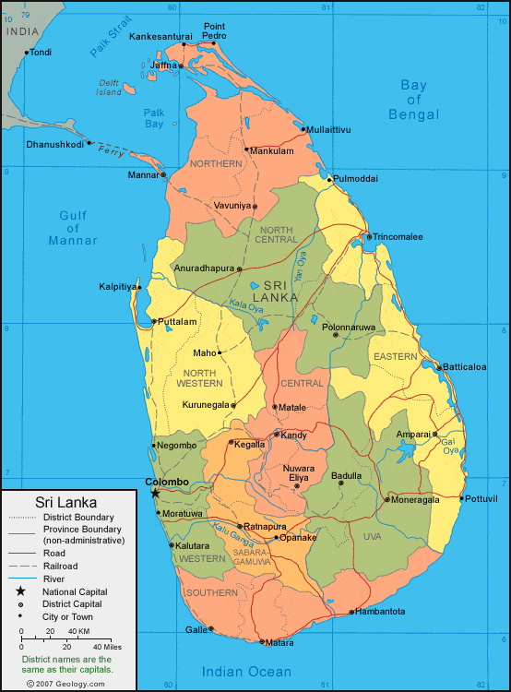
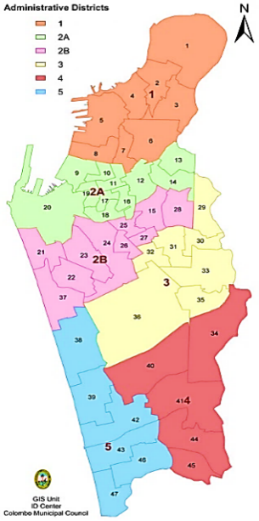

Source: Colombo Municipal Council Website (2018) and geology.com (2007)

Figure 2. Colombo Municipal Council Area.

Data collection method
The data on 627 crime incidents that occurred in 2018 and its attributes, for example the location and period of incidents were collected from the criminal records of police stations in Colombo North, South and Central police divisions. Details of the population on social and income status, ethnicity, family structures were gathered through the field survey and the information’s on Census and statistical department websites (2012 population data). The data on physical settings (e.g., area boundaries, base maps, etc.) and built environment features (e.g., location and individual property attributes) were gathered through Google Earth Pro, Open Street Map and Geographic Information Systems (GIS) software.

Data analysis method
Data analysis was done using Kernel Density Estimation in Geographical Information Systems (GIS) software in order to identify crime hotspots. Other secondary data gathered on number, day and time of incidents in each crime type were interpreted in descriptive and qualitative ways.

Results and discussion

Descriptive analysis of data
According to the Sri Lanka Police Grave Crime Abstract 2018, there are 26 major and minor types of crime in Sri Lanka. However, the number of crime incidents recorded was available in 17 types in the case study area. The number of incidents in five frequently recorded crime types and other crimes, day and time analysis of crime events is shown in Table 1.

Table 1. Profile of urban Crime Events in Colombo Municipal Council Area

 | Crime Incident | No of Incidents | Percentage
Crime Type | Robbery | 144 | 22.9%
Crime Type | Property Theft over LKR 25,000/- (USD 124)* | 133 | 21.2%
Crime Type | Drugs Arrest | 86 | 13.8%
Crime Type | Vehicle Theft | 81 | 12.9%
Crime Type | House Breaking | 52 | 8.3%
Crime Type | Other | 131 | 20.9%
Crime Type | Total | 627 | 100.00%
 | Day | No of Incidents | Percentage
Day Analysis of  Crime Events | Sunday | 96 | 15.3%
Day Analysis of  Crime Events | Monday | 102 | 16.3%
Day Analysis of  Crime Events | Tuesday | 87 | 13.9%
Day Analysis of  Crime Events | Wednesday | 106 | 16.9%
Day Analysis of  Crime Events | Thursday | 83 | 13.2%
Day Analysis of  Crime Events | Friday | 81 | 12.9%
Day Analysis of  Crime Events | Saturday | 72 | 11.5%
Day Analysis of  Crime Events | Total | 627 | 100.00%
 | Hour Intervals | No of Incidents | Percentage
Crime Event  Frequency  Based on Time  Intervals | 00.00h – 03.00h | 47 | 7.5%
Crime Event  Frequency  Based on Time  Intervals | 03.00h – 06.00h | 40 | 6.4%
Crime Event  Frequency  Based on Time  Intervals | 06.00h – 09.00h | 44 | 7.0%
Crime Event  Frequency  Based on Time  Intervals | 09.00h – 12.00h | 107 | 17.1%
Crime Event  Frequency  Based on Time  Intervals | 12.00h – 15.00h | 81 | 12.9%
Crime Event  Frequency  Based on Time  Intervals | 15.00h – 18.00h | 101 | 16.1%
Crime Event  Frequency  Based on Time  Intervals | 18.00h – 21.00h | 92 | 14.7%
Crime Event  Frequency  Based on Time  Intervals | 21.00h – 24.00h | 70 | 11.2%
Crime Event  Frequency  Based on Time  Intervals | Total | 627 | 100.00%
Note: *Conversion is done as per the exchange rate USD 01 = LKR 201 (November 2021)
Source: Authors (2021) using Police Department Data (2018)
Table 1 presents the percentages of five frequently recorded crime types and other crimes recorded in 2018. Accordingly, the five crimes which were frequently recorded accounting for high percentages are; robbery (23%), property theft over LKR. 25,000/- (USD 124) (21%), drugs arrest (14%), vehicle theft (13%), housebreaking (8%) and other crimes (21%). According to the analysis of the day and time of the crime event occurrences, as shown in table 1, most of the crime events were recorded on Wednesday (111), Monday (106) and Sunday (101). Data in table 1 further shows that although the median time of crime events is between 09.00h–12.00h, the majority of crimes have been recorded during the 12.00h to 24.00h. At the same time, a trend reveals that the overall direction of crime event occurrence tends to befall afternoon till midnight. This further proves the fact described in opportunity theory (Felson & Clarke, 1998) where it is argued that crime opportunities are focused on time and space as one of ten principles in the theory. Further, this finding is similar to many previous research (e.g. Rathnayake, 2015; Wijekoon & Yapa, 2014) where more than 50 percent of the crimes were recorded within 12.00h to 20.00h.

Identification of crime hotspots
The hotspot analysis focused on all 627 crime incidents (Figure 3) and the identified major five crime types separately (Figures 4, 5, 6, 7 and 8). Accordingly, maps were generated using Kernel Density Estimation, which is an effective point pattern analytical method (Yue, Zhu, Ye & Guo, 2017) in order to provide a visual display of clustering patterns of these crimes in the Colombo Municipal Council area. Figures 3, 4, 5, 6, 7 and 8 show the visual presentation of the identified crime hotspots.

  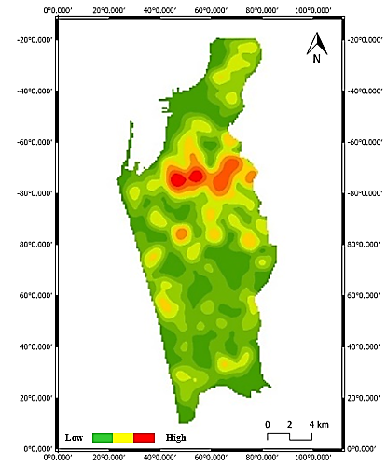  Keselwatte  Aluthkade West  New Bazaar  Maligawatte East  Grandpass South  Kochchikade South | 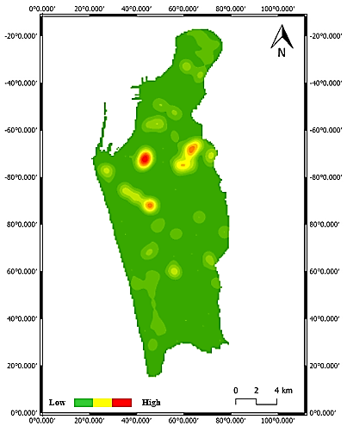  Aluthkade West  Grandpass South  Keselwatte
Figure 3. Heat map for all types of crimes | Figure 4. Heat map for robbery
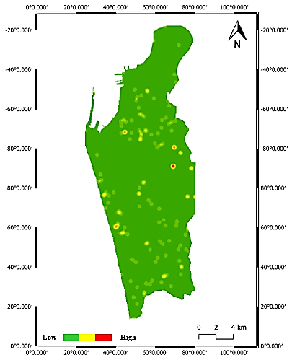    Narahenpita  New Bazaar | 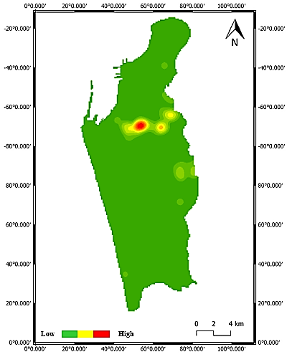  New Bazaar  Aluthkade East  Maligawatte East  Keselwatte
Figure 5. Heat map for property theft over LKR 25,000/- (USD 124) | Figure 6. Heat map for drugs arrest
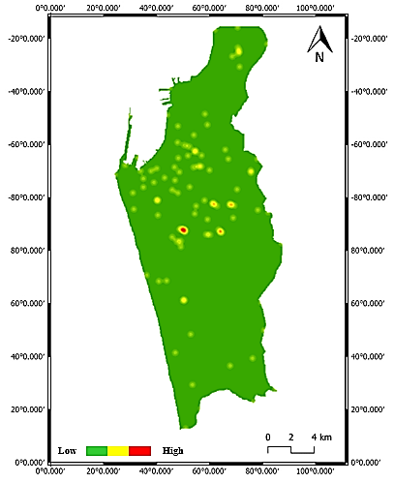  Hunupitiya  Dematagoda  Cinnamon Garden | 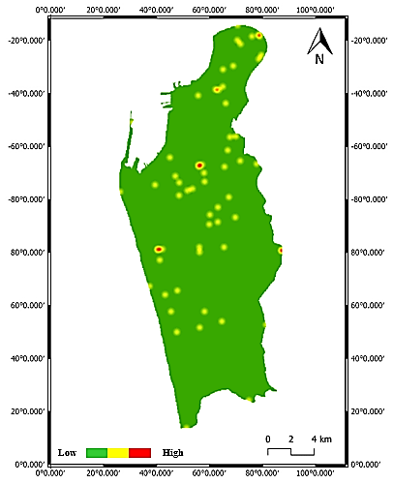  Kuppiyawatte East  Colpetty  Maligawatte East  Kochchikade South
Figure 7. Heat map for vehicle theft | Figure 8. Heat map for house breaking
The detailed review of hotspot analysis shown in figure 9 reveals that the wards 12 (New Bazaar), 14 (Grandpass South), 16 (Aluthkade East), 17 (Aluthkade West), 18 (Kehelwatte), 19 (Kochchikade South) and 28 (Maligawatte East) can be identified as highly concentrated areas of crime incidents in the Colombo Municipal Council area. Table 2 shows further details.

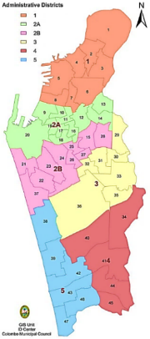
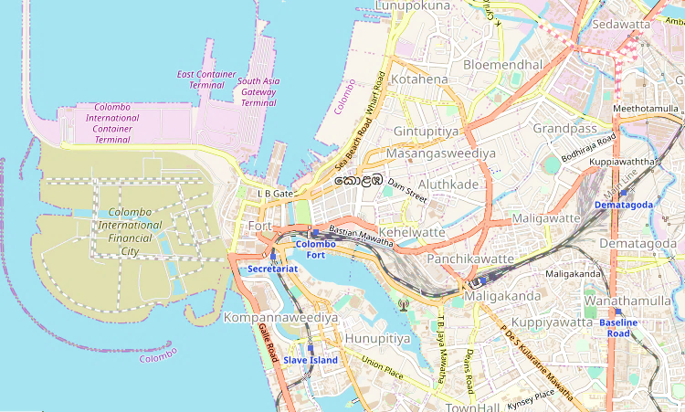
1
2
4
3
5
6
7
1- Kochchikade South | 2 - Aluthkade West | 3 - Aluthkade East | 4 – Keselwatta | 5 – New Bazaar | 6 – Grandpass South | 7 – Maligawatte East

Source: Created based on field data using an open street map (2021)

Figure 9. Identified crime hotspots.

Table 2. Highly concentrated areas of crimes.
Crime Type | Hotspots (Wards)
All | 12 (New Bazaar), 14 (Grandpass South), 16 (Aluthkade East), 17 (Aluthkade West), 18 (Keselwatte), 19 (Kochchikade South) and 28 (Maligawatte East)
Robbery | 17 (Aluthkade West), 18 (Kehelwatte) and 19 (Grandpass South)
Property Theft over LKR 25,000/- (USD 124*) | 12 (New Bazaar), 34 (Narahenpita) and 37 (Colpetty)
Drugs Arrest | 12 (New Bazaar), 16 (Aluthkade East), 18 (Kehelwatte), and 28 (Maligawatte East)
Vehicle Theft | 23 (Hunupitiya), 29 (Dematagoda) and 36 (Cinnamon Gardens)
House Breaking | 19 (Kochchikade South) 28 (Maligawatte East), 31 (Kuppiyawatte East), and 37 (Colpetty)
Note: *Conversion is done as per the exchange rate USD 01 = LKR 201 (November 2021)

Source: Compiled by Authors (2021)
Common features and land uses identified in crime hotspots

This study further explored the common features and key land-use types which are evident in the identified crime hotspots and those are summarized in table 3.

Table 3. Identified land uses and special features/ locations in hotspots.

Crime type | Special features/ locations of land use in identified hotspots
Robbery | Lower-income housing schemes, commercial purpose structures in poor condition, hospital, sports ground
Property theft over LKR 25,000/- | Hospital, cinema, concentrated commercial area
Drugs arrest | Schemes of slums, shanties, flats, housing & structures in poor condition
Vehicle theft | Lake, offices, playground
Housebreaking | Residential flats, residential and commercial mixed developments in conditions below average
Source: Compiled by Authors (2021)

The above analysis reveals that when considering all crime types, the common features of land use in high crime concentrated areas are slums, shanties and residential flats in poor condition. In addition, mixed uses in average conditions also attract crimes. All these uses fall into lower and lower-middle-income residential use and below-average conditions. This finding is congruent with the study of Ludin (2013) reveals that poor land use planning leads to growth criminal activities in urban areas. When focusing on property theft, most of the incidents have been recorded in new hospitals, cinema halls and concentrated commercial areas. This is similar to the finding of Twinam (2017) in their study, which was done focusing on Chicago. Twinam (2017) also has found that commercial land uses and features such as liquor stores, restaurants, bars where the concentration of public is high. Drug arrests and housebreakings have been found common around below-average housing schemes, flats, slums, etc. This is in parallel to the findings of the study done by Rathnayake (2015) where it was found that concentration of drug arrests are common around commercial Clusters and low-income households. Moreover, according to the study findings, vehicle theft is often recorded around lakes, offices and playgrounds.
Accordingly, incongruent with the opportunity theory by Felson and Clarke (1998) and the general multilevel opportunity theory (Wilcox, Gialopsos, & Land, 2013) land use, its features and physical environmental factors were identified as an opportunity that acts as a root cause of crime in urban areas. It was further emphasized that it is needed to be monitored to mitigate the probability of getting used to those opportunities by criminals.

Conclusion and recommendations

Urban crimes which spread with the increasing urbanization are a major challenge that most cities face. Theories and previous scholars argue that physical environmental features act as opportunities for crime incidents. Therefore, this study aimed at identifying the relationship between land use and spatial distribution of urban crime. This study has been mainly done using kernel density estimation in the Geographical Information Systems software (GIS). Through the data analysis, the study has found seven wards as urban crime hotspots. Those main areas are New Bazaar, Grandpass South, Aluthkade East, Aluthkade West, Keselwatte, Kochchikade South and Maligawatte East. The main crime types where the highest incidents are recorded are robbery, property theft over LKR. 25,000/- (USD 124), drugs arrest, vehicle theft, house breaking and other crimes. Moreover, most of the crime events were recorded on Wednesday (111), Monday (106) and Sunday (101) during the 12.00h to 24.00h. As most of the government institutions open up offices for general public affairs, Wednesdays become hectic and crowded. This might be one of the reasons for increased crimes on Wednesdays. Further, findings reveal that robbery and drug arrest incidents are common around low-income residential housing areas while property theft records are common around hospitals, cinemas and concentrated commercial areas. Vehicle thefts are often recorded near lakes, offices and playgrounds whereas housebreakings are recorded near housing schemes.
As per the above findings, it can be recommended that the necessary measures by the responsible authorities should be taken in order to eliminate the negative impact of urban crime and its burden on the economic and social harmony and to maintain the security in these land uses and location in identified crime concentrated areas in the Colombo Municipal Council area adopting proper technology. To be specific, as the high level of unemployment concentrates crimes (Sypion-Dutkowska & Leitner, 2017), an employment analysis should be done for residents in these below average conditioned residential and mixed-use built-up areas and a workplace should be placed to provide employment to the unemployed people living in these areas. In addition, it is recommended to place police posts and implement hotspot policing as suggested by Braga, Papachristos & Hureau (2014) in the identified areas in order to monitor and identify the criminal activities, generating points and causes especially during the stated days, especially on Wednesday and hours within the identified hotspot areas. Accordingly, immediate actions should be taken through proper strategies to eliminate crimes in urban areas or prevent them from repeating and spreading.

Acknowledgments

The authors would like to acknowledge the undergraduates of B. Sc. Estate Management and Valuation (Special) Degree Part IV (Academic Year 2014/2015), University of Sri Jayewardenepura, Sri Lanka for their contribution given in collecting secondary data. In addition, a special thank goes to the Inspector General of Police, Sri Lanka and Officers-In-Charge of all police stations in Colombo North, South and Central police divisions, Sri Lanka for their support given in data collection. Further, the assistance gained from the Centre for Real Estate Studies (CRES-EMV), Department of Estate Management and Valuation, University of Sri Jayewardenepura, Sri Lanka is also acknowledged.

References

Alabi, O. T., Adeleke, M. A., & Olajide, S. E. (2021). Measuring the influences of opportunity in residential neighbourhood crime. International Journal of Multidisciplinary Research and Development, 8(6),17-26.
Andresen, M. A., Curman, A. S., & Linning, S. J. (2017). The trajectories of crime at places: Understanding the patterns of disaggregated crime types. Journal of quantitative criminology, 33(3), 427-449.
Bates, S. (1987). Spatial and temporal analysis of crime. Chicago, IL: Illinois Criminal Justice Information Authority.
Braga, A. A., Papachristos, A. V. & Hureau, D. M. (2014) The effects of hot spots policing on crime: An updated systematic review and meta-analysis. Justice Quarterly, 31:4, 633-663.
Brantingham, P. J., & Brantingham, P. L. (1981). Introduction: The dimensions of crime. Environmental criminology, 1(1), 7-26.
Brantingham, P. J., & Brantingham, P. L. (1993). Nodes, paths and edges: Considerations on the complexity of crime and the physical environment. Journal of Environmental Criminology, 13(1), 3 – 28.
Colombo Municipal Council. (2019). Official Website. Retrieved from http://www.colombo.mc.gov.lk/colombo.php.
De Melo, S. N., Matias, L. F., & Andresen, M. A. (2015). Crime concentrations and similarities in spatial crime patterns in a Brazilian context. Applied Geography, 62, 314-324.
Dutkowska, N. S., & Leitner, M. (2017). Land use influencing the spatial distribution of urban crime: A case study of Szczecin, Poland. International Journal of Geo-Information, 23(1), 12-29.
Eck, J. E., Lee, Y., SooHyun, O. & Martinez, N. (2017). Compared to what? Estimating the relative concentration of crime at places using systematic and other reviews. Crime Science, 6(1), 1-17.
Felson, M. & Clarke, R. V. (1998). Opportunity makes the thief. Police research series, paper, 98(1-36), 10.
Justia. (1984). Types of Criminal Offenses. 1984. Retrieved from https://www.justia.com/criminal/offenses/.
Karunaratne, N. (1995). World factbook of criminal justice systems. Retrieved from https://www.bjs.gov/content/pub/pdf/wfbcjssl.pdf.
Kinney, J. B., Brantingham, P. L., Wuschke, K., Kirk, M. G., & Brantingham, P. J. (2008). Crime attractors, generators and detractors: land use and urban crime opportunities. Built Environment, 34(1), 62-74.
Ludin, A. N. M. (2013). Impact of urban land use on crime patterns through GIS application. Geospatial Analysis in Urban Planning, 2(1), 1-22.
Malik, A. A. (2016). Urbanization and crime: A relational analysis. IOSR Journal of Humanities and Social Science. 21(1), 68-74.
Martinez-Fernandez, C., Audirac, I., Fol, S., & Cunningham-Sabot, E. (2012). Shrinking cities: urban challenges of globalization. International Journal of Urban and Regional Research, 36(2), 213–225.
Mazeika, D. M., & Kumar, S. (2017). Do crime hot spots exist in developing countries? Evidence from India. Journal of quantitative criminology, 33(1), pp.45-61.
Merriam Webster Dictionary. (2019). Crime definition. 2019. Retrieved from https://www.merriam-webster.com/dictionary/crime.
Nanzip, B. N. (2020). Land use: Definition and different types of land use. Retrieved from https://www.jotscroll.com/forums/3/posts/204/land-use-definition-6-types-of-land-use.html.
Oxford University. (2007). Oxford English Mini Dictionary- Sri Lankan Edition. 7 ed. India: Oxford university Press.
Ratnayake, R. M. K. (2015). Distribution pattern of urban crimes in Sri Lanka; with special reference to Mirihana police division. International Journal of Multidisciplinary Research and Development. 2(8), 441-453.
Rathnayake, R. M. J. C. (2009). An analytical study of urban space and crime case study-Bambalapitiya (Master Dissertation). Retrieved from Digital Library, University Moratuwa, Sri Lanka.
Sittampalam, J. (2019). Underestimating urbanisation: tackling Sri Lanka's growing pains. Roar Media.
Soh, M. B. C. (2012). Crime and urbanization: Revisited Malaysian case. Procedia - Social and Behavioral Sciences. 42(1), 291-299.
Sri Lanka Police. (2018). Performance Report 2018, Colombo: Parliament of Sri Lanka. Retrieved from https://www.parliament.lk/uploads/documents/paperspresented/performance-report-srilanka-police-2018.pdf
Suryavanshi, V. M. (2001). Land use and opportunities for crime: Using GIS as an analysis tool (PhD dissertation). Retrieved from Blacksburg, Virginia: Faculty of the Virginia Polytechnic Institute and State University.
Sypion-Dutkowska, N. & Leitner, M. (2017). Land Use inﬂuencing the spatial distribution of urban crime: a case study of Szczecin, Poland. International Journal of Geo-Information, 6(1), 74-97.
Telep, C. W., & Weisburd, D. (2018). Crime concentrations at places. In The Oxford handbook of environmental criminology.
Tillyer, M. S., Tillyer, R., & Kelsay, J. (2015). The nature and influence of the victim-offender relationship in kidnapping incidents. Journal of Criminal Justice, 43(5), 377–385.
Tillyer, M. S., Miller, J. M. & Tillyer, R. (2011). The Environmental and Situational Correlates of Victim Injury in Nonfatal Violent Incidents. Criminal Justice and Behavior, 38(5), 433–452.
Twinam, T. (2017). Danger zone: Land use and the geography of neighborhood crime. Urban Economics. 1(1),104-119.
Umar, F. (2017). Understanding spatial patterns of urban crime in a developing country. (Doctoral thesis). Retrieved from University College London, UK.
UN Habitat. (2007). Enhancing urban safety and security global report on human settlements: reducing urban crime and violence: policy directions: Global report. Retrieved from http://mirror.unhabitat.org/pmss/listItemDetails.aspx?publicationID=2595.
Weisburd, D., & Majmundar, P. (2018). Hot spots of crime and place‐based prevention. Criminology & Public Policy, 17(1), 5-25.
Wilcox, P., Gialopsos, B. M. & Land, K. C. (2013). Multilevel criminal opportunity. In The Oxford handbook of criminological theory.
Wilcox, P. & Tillyer, M. S. (2018). Place and neighborhood contexts. In Connecting crime to place: New directions in theory and policy, ed. J.E. Eck and D. Weisburd. New Brunswick, NJ: Transaction.
Yue, H., Zhu, X., Ye, X., & Guo, W. (2017). The local colocation patterns of crime and land-use features in Wuhan, China. International Journal of Geo-Information, 6(1), 124-139.

