

The influence of El Niño Southern Oscillation on urban heat island formation at tropical city: Case of Kuching City, Sarawak

Ricky Anak Kemarau, Oliver Valentine Eboy

Geography Program,
Faculty Social Science and Humanities,
Universiti Malaysia Sabah.

Correspondence: Ricky Anak Kemarau (email: ricky.geo2005@gmail.com )

Received: 30 July 2021; Accepted: 16 August 2021; Published: 30 November 2021

Abstract

El-Niño Southern Oscillation (ENSO) is an opposing natural climate phenomenon in which the El Niño event causes droughts and the La Niña event causes floods. Literature studies stated there is still a lack of studies on the application of remote sensing in studying the effect of ENSO on Urban Heat Island (UHI) distribution patterns. The effect of UHI amplifies temperature, especially during El Niño. The objective of this study is to examine the influence of ENSO on UHI formation in tropical cities on a local scale. This study uses MODIS data and Landsat satellite data from 1988 to 2019. This study uses a combination of both data to investigate the influence of ENSO on UHI formation. The data must undergo pre-processing before the digital number is converted to Land Surface Temperature (LST). This study found that La Niña and El Niño events influenced the pattern of UHI variation. The strength of El Niño and La Niña differences influenced the value of LST and the total UHI area with a temperature of 30 °C. The result discovered that during the El Niño event, the maximum, minimum and mean temperature values ​​of LST were higher than during the La Niña event and the total of the area ​​hot spots that have temperatures above 30 ºC is higher during El Niño than during La Niña. The result of the study is very important to the community, local governments, and urban planners because remote sensing provides spatial information that represents the hot spot and cold spot.

Keywords: ENSO, UHI, remote sensing, spatial pattern.

Introduction

In 2016, the World Health Organization (WHO) reported the 2015/2016 El Niño event affected more than 60 million people in the world consuming in the region the Asia Pacific, Latin America, and Africa causing a persistent rise in temperature drought, and aridity. These adversely affect high-risk groups such as children and the elderly. In the same year, the WHO required immediate medical assistance and health problems of 51 million because of El Niño 2015/2016 (WHO, 2016). The level of LST is increasing in urban areas due to the impact of UHI (Islam et al., 2018; Kemarau and Eboy, 2020). For example, Iyengar's (2015) El Niño events in 2015/2016 caused over 2200 deaths in the major city of Karachi, Pakistan. Also, The Guardian newspaper (2016) reported that El Niño cost the lives of over 2000 people in major cities in India that year.
Studies on ENSO did not receive serious attention during 1982-83 when a severe El Niño occurred resulting in famine with 25 million deaths and which British scientists used to study the cause of monsoon rain failure in India (Koutavas and Joanides, 2012). Since then, the Tropical Ocean Global Atmosphere (TOGA) program has existed as part of the World Climate Research Program (WCRP), which focused on studying ENSO from the early 1980s to the mid-1990s. Kemarau and Eboy (2021), Kogan and Guo (2017) Moura et al., (2019) stated that there is a necessity for studies involving spatial information in diversifying and improving knowledge about the occurrence of ENSO.
This information space is important in providing accurate and correct information in channeling aid and construction of infrastructure in reducing the impact of ENSO incidents on the population on a local scale. Existing studies are only globally (Kogan and Guo, 2017) and regionally i.e., in Brazil (Moura et al., 2019) using MODIS. In local contexts and urban areas have not been studied by researchers. The objective of the study is to examine the effect of ENSO incidence on the temperature in urban areas. Is there an ENSO effect on temperature and urban heat island formation in the tropical urban area of ​​Kuching? If so, can remote sensing technology map the changes in UHI formation?

Literature review

Many studies of ENSO at the same time as ENSO lead to global precipitation (Ropelewski and Halpert 1989), temperature (Halpert and Ropelewski 1992) and models to predict El Niño events (Chen et al. 2002; Yang et al., 2018), observing systems to monitor and predict ENSO (Turkington et al., 2019; Hales et al. 2000). In 1997-1998, El Niño was the worst event of the 20th century (Hanley et al. 2000). This was a turning point in the study documenting ENSO. Globally, Kogan and Guo (2017) discovered El Niño events cause a temperature increase of 0.5 to 2.0 °C. In addition to Moura et al, (2019) reported a temperature increase of 7 to 8 °C in Brazil to depend on the location. The occurrence of ENSO has a great impact on extreme climates in Southeast Asia (Tangang et al., 2012). The results of studies have conducted the impact that ENSO occurs on temperature (Mou et al., 2021), which results in temperature changes of 0.3 to 0.5 °C in general. In Malaysia, Tawang and Tengku (2002) studied the impact of El Niño on temperature and the occurrence of El Niño caused a temperature increase of 0.1 to 1.9 °C in Kedah and 0.1 to 2.4 °C in Perlis at the time of El Niño 1997. Wong et al., (2018), Yatim et al., (2019), Suhaila and Yusop, (2018) discovered the El Niño influence the temperature in general. Besides that, Wai et al. (2005) discovered the increased the temperature on an annual scale from 0.09 to 0.34 ° C in 1971-2001. Meanwhile, Tangang et al. (2017) found a similar upward trend between 0.27 to 0.40 ° C between 1961 and 2002 in Peninsular Malaysia and North Borneo.
Mou et al. (2021) specified that there is still a lack of studies on the effects of ENSO events on extreme temperatures. Moreover, all the above studies use meteorological data. There only Moura et al, (2019) and Kogan and Guo (2017) conducted a study on the impact of ENSO on LST using remote sensing data. However, the study covers a large area that Moura et al, (2019) in Brazil and Kogan and Guo (2017) globally. Central literature found it still lacking study influence ENSO on land surface temperature and UHI formation. Moreover, Alexander (2016) showed that long-term high-temperature data are highly correlated. In addition, the use of different statistics and indices causes difficulties in the analysis of different studies. For example, Salleh et al. (2015) and Griffiths et al. (2005) found no significant temperature changes in Malaysia. Therefore, it is difficult to make a fair comparison with the current study.
For additional insights on the influence of ENSO on urban climate. In this study, the remote sensing technique is used in investigating the impact of ENSO on UHI formation because the following questions need to be answered which, can this technique be used to identify the impact of ENSO on LST in an urban area and UHI formation? If yes, where are the main impacts of ENSO in urban areas? And the final question: can remote sensing technology measure the impact of the degree of strength of ENSO on LST? This question raised was never answered in previous studies because, to the best of the researchers' knowledge, there has been no study on the use of remote sensing in studying the impact of ENSO on urban climate.

Method and data.

This study uses data from MODIS, Landsat satellites, and Malaysian Meteorological Department (MMD) temperature data. The selection of Landsat as data because providing thermal data from 1988 until the present. Landsat 5 TM, 7 ETM, and 8 OLI TIR will be used for this study. Data were collected from 1988 to 2019 with no cloud coverage. Landsat Data has 120 meters of access for Landsat 5TM satellites and Landsat 7 and 8 have 100 meters. Pre-process methods and conversion of digital values ​​for temperature use formulas (Kemarau and Eboy, 2021). Landsat data is downloaded at https://earthexplorer.usgs.gov/.
On another hand reason selection use data MODIS because it can provide data since 2000 by daily, monthly, and day and night. MODIS product provides an average LST value per month per pixel of ground surface and emissivity in pixels of 1,200 x 1,200 kilometers with a pixel size of 5,600 meters. This study uses 239 MODIS data that is since the MODIS sensor started operating from 2000 to 2019. A significant benefit of MODIS is the range of quality-checked data products produced by the MODIS team. These data products are processed and can be used directly for a variety of research purposes. Examples of such products that have been widely used in surface temperature studies include day and night surface temperatures and emissivity data from MOD11C3 (Feltz et al., 2018). Surface temperature values ​​in these products are taken by a general split-window algorithm (Feltz et al., 2018). The MOD11C3 product uses bands 31 and 32 (Feltz et al., 2018).
Zhou et al., (2019) strongly recommended applied combination data to achieve an objective study. The data used are limited to data without cloud cover. This is because the thermal wavelength is not able to penetrate the cloud cover. The data was collected from 1988 to 2019. However, MODIS data have been used since 2000 because MODIS services did not begin until 2000. Data from the Malaysian Meteorological Department (MMD) are needed to confirm the results of this study. The data are daily, monthly, and annual temperature data from MMD collected from 1988 to 2019. The daily data from temperature was collected by the MMD. The next data was applied to this study Oceanic Niño Index (ONI). ONI index shows the development and intensity of El Niño or La Niña events in the Pacific Ocean. ONI is a three-month sea surface temperature anomaly in the Niño region of 3.4 based on 5° North 5° South, 120° until 170° West. El Niño events are defined as three-month values at or above the anomaly of positive (+) 0.5 °C, the time when La Niña is defined as or below the climate anomaly negative (-) 0.5 °C (NOAA, 2020). The ENSO value level explains 5 Weak (with anomalies of 0.5 to 0.9 sea surface temperature), Moderate (1.0 to 1.4), Strong (1.5 to 1.9), and Very Strong (≥ 2.0) for El Niño events and vice versa for La Niño events.

The influence Of El Niño Southern Oscillation (ENSO) On Urban Heat Island Formation

MODIS
Landsat 4,5,6,7 and 8
ONI Index

Pre – Processing – Geometric Correction

Convert digital nombor to Kelvin = Data Value MODIS * 0.02
Convert digital number to radiance

Atmosphere Correction
Convert value º Kelvin to º C celsius = Kelvin value º – 273.15
Convert value radiance to surface reflectance and reflectance to LST

Subset Study area
LST Map from data remote sensing MODIS dan Landsat

Arrangement and classification of LST regarding ONI
Calibration and validation of data LST from RS and data from MMD

Final product – influence of ENSO to UHI formation

Figure 1. Flowchart method for achieving the objective of study.

Based on figure 1 the Landsat and MODIS satellite data must undergo geometric correction because much of MODIS satellite data is from 2000 to 2019 and Landsat satellite data is from 1988 to 2019. Then, the Landsat data must undergo atmospheric correction and conversion of digital number values to LST. For the MODIS satellites, it is necessary to follow the formula given by the MODIS team to obtain the LST value. After going through the second process, the ° K (Kelvin) value LST must be converted to °C. The conversion of digital number values for Landsat satellites 4 and 5 Thematic Mapper, 7 Enhanced Thematic Mapper, and 8 Operational Land Imager (OLI) Thermal Infrared Sensor (TIRS) is based on the formula used by Kemarau and Eboy (2020). The location of the study was Kuching, Sarawak, Malaysia (Figure 2). Temperatures in the study area are hot throughout the year with daily temperatures ranging from 23 °C in the morning to 32 °C during the day reported by Meteorological Department Kuching Branch. The climate in Kuching is influenced by the monsoon, Madden Julian Oscillation (MJO), ENSO, and Indian Ocean Dipole (IOD) (Tangang et al., 2012).
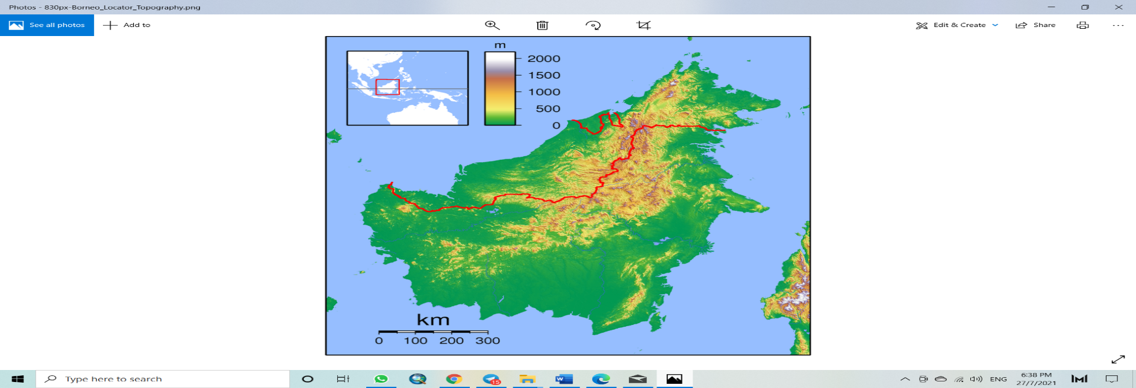 | 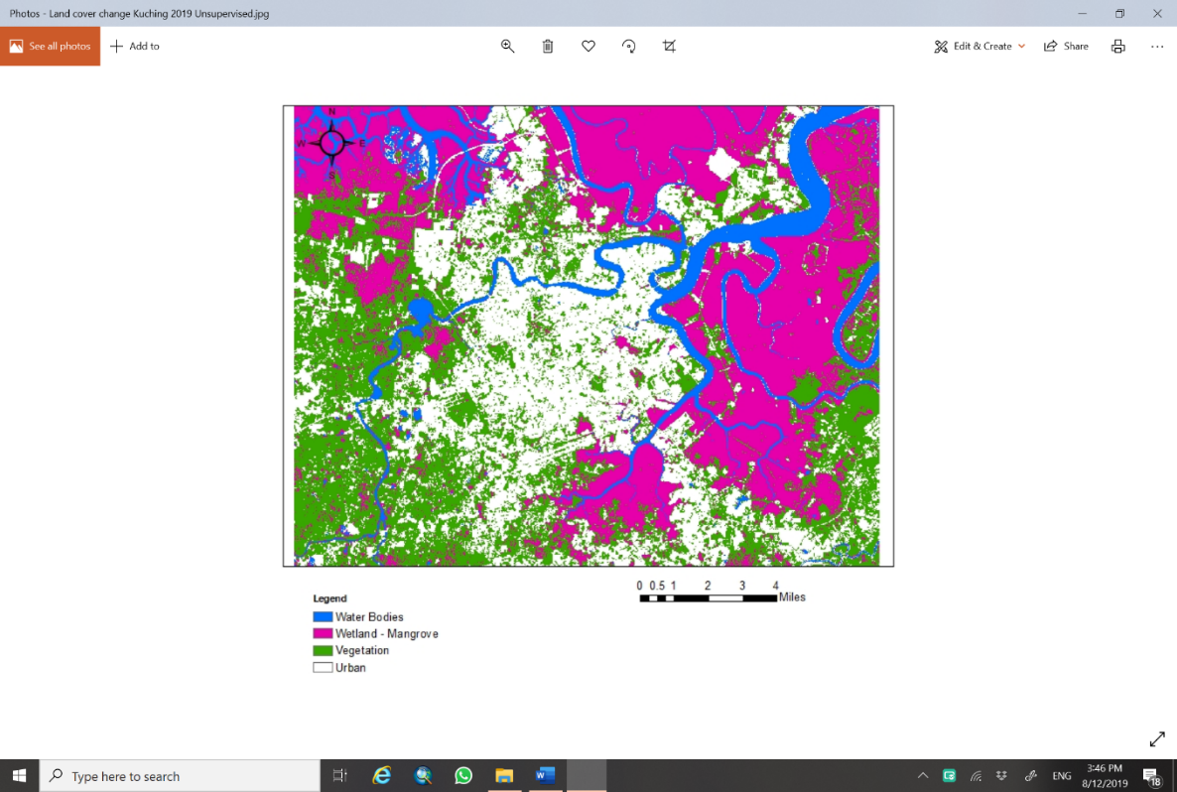
Source: Wikipedia
Figure 2. Location of study area.
This study using correlation to examine the accuracy of LST from MODIS and Landsat data with data temperature from the Malaysia Meteorology Department. The relationship between the temperature of the meteorological data and the LST of the MODIS satellite is positive which has a strong level of strength with the value of correlation coefficient is 0.90. On other hand, there is a perfectly positive strong correlation obtained between the daily temperature value of the Malaysian Meteorological Department data and the daily temperature of the Landsat Sensor satellite with a value of R=0.92. This correlation uses the pixel values ​​on the Landsat satellite that have the same coordinates as the current temperature gauge of the Malaysian Meteorological Department on the same day.

Results and discussion

This study found there is a positive relationship between ONI and monthly average temperature as display in figure 3. For example, May 1988 to May 1989 showed ONI values of -1 to -1.8, corresponding to 24.8 to 24 °C (Figure 3). Negative ONI values represent the La Niña events that occurred in early 1998, 2007, and 2010. While El Niño events in 1997 began from June 1997 to April 1998, ONI showed values of 0.8 to 2.4 in November 1997 and December 1997. This value increased the temperature from 26.4 to 27.9 °C.

Figure 3. Value Pattern of monthly mean and ONI from 1988 until 2019.

The second occurrence of El Niño can be observed from late 2015 to March 2016. El Niño can also be attributed to the different occurrences of 1991, 1997 to 1998, and 2015 to 2016 (Kogan and Guo et al., 2017; Tang et al., 2019). Based on figure 4 there was found a pattern of the different LST distribution for each of the La Niña and El-Niño events. During an El Niño event, the LST map displays an entire yellow color that fills the entire study area which is common with the LST map of La Niña events seeing blue areas and hot areas (red) concentrated in urban areas and man-made materials. Using Landsat data can display the different patterns of LST at every type of land cover. The pattern of areas hot spot same pattern with MODIS data which the hot spot areas higher during El Niño compared to during La Niña. The detailed explanation refers to figure 4 and figures 5. Examples during the El-Niño event were found that almost all zones (B, C, D, E, F, G, H, I and J) were found to have temperatures above 30 °C (Baum et al., 2009) which would cause discomfort to the population in Kuching City compared to during the La Niña event as in figure 3. For example, in figure 2 is during the El Niño event found hot spot areas of zones B, C, D, E, and F (Urban areas) and G, H, and I for the area industry which was found to have 8 hot spot zones compared to during La Niña which has 7 zones namely B, C, D, G, H, I and J.

Map LST during El Niño | Map LST during La Niña
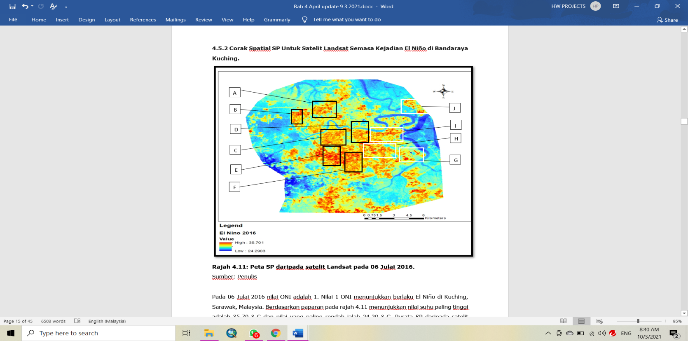 | 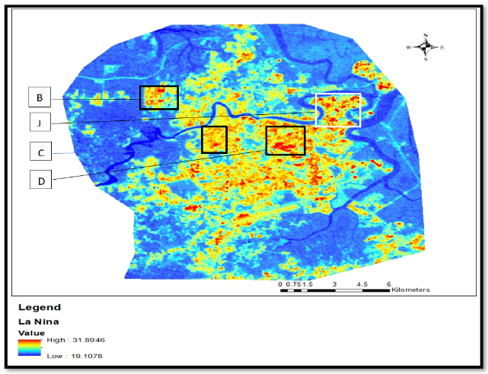
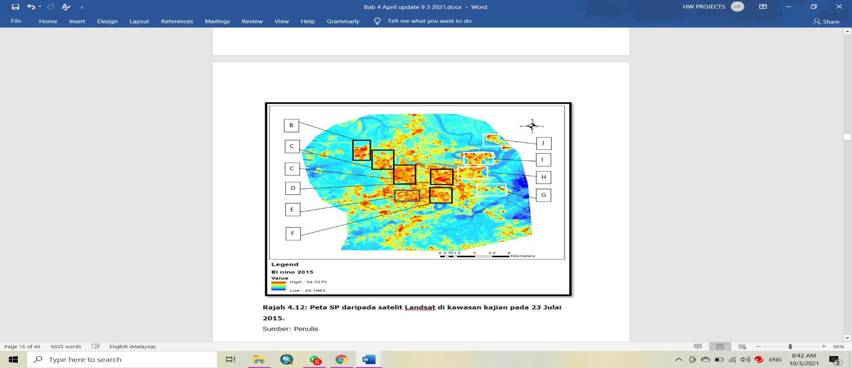 | 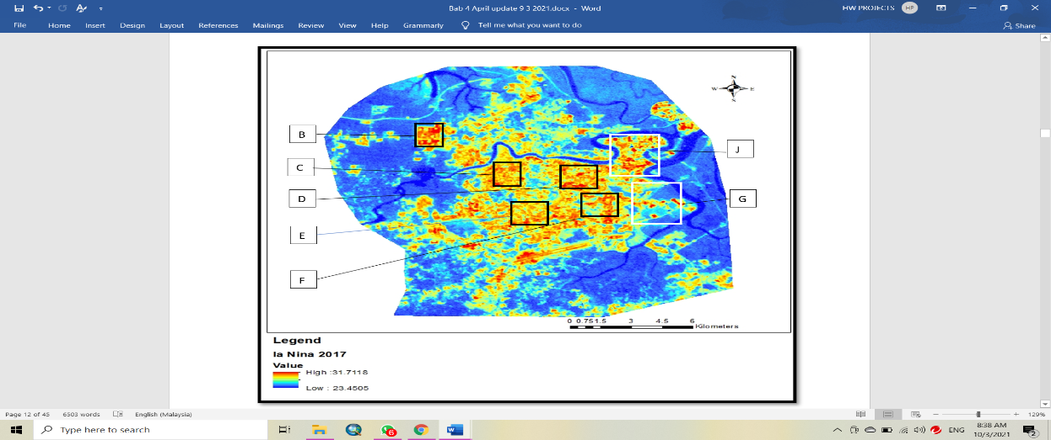
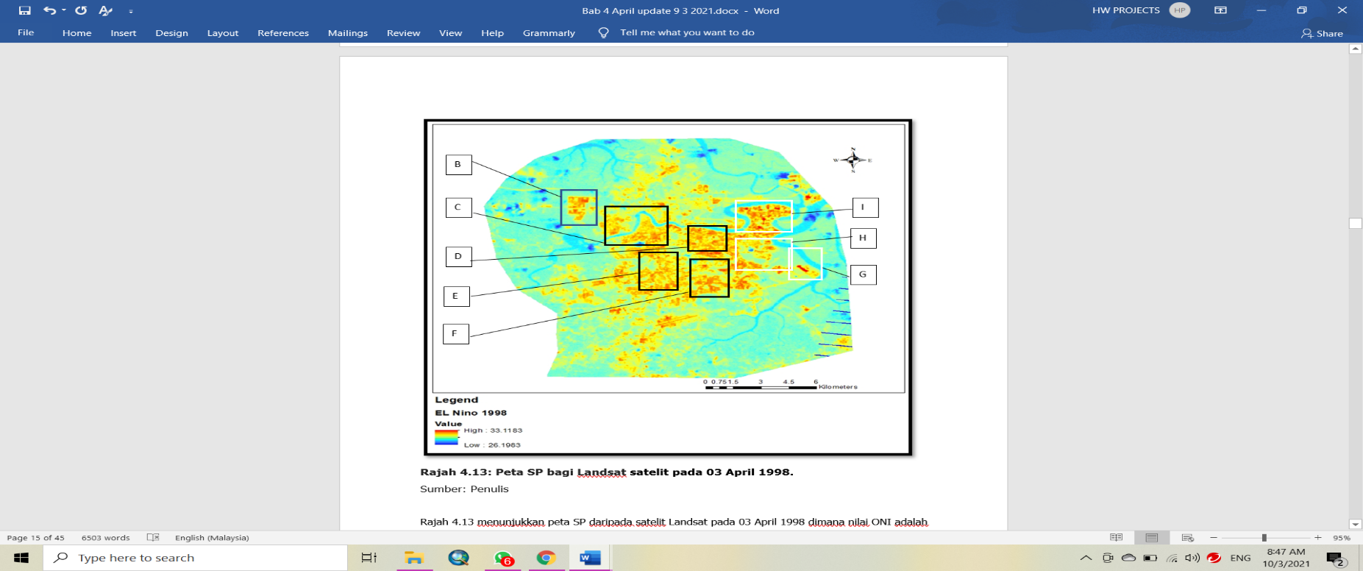 | 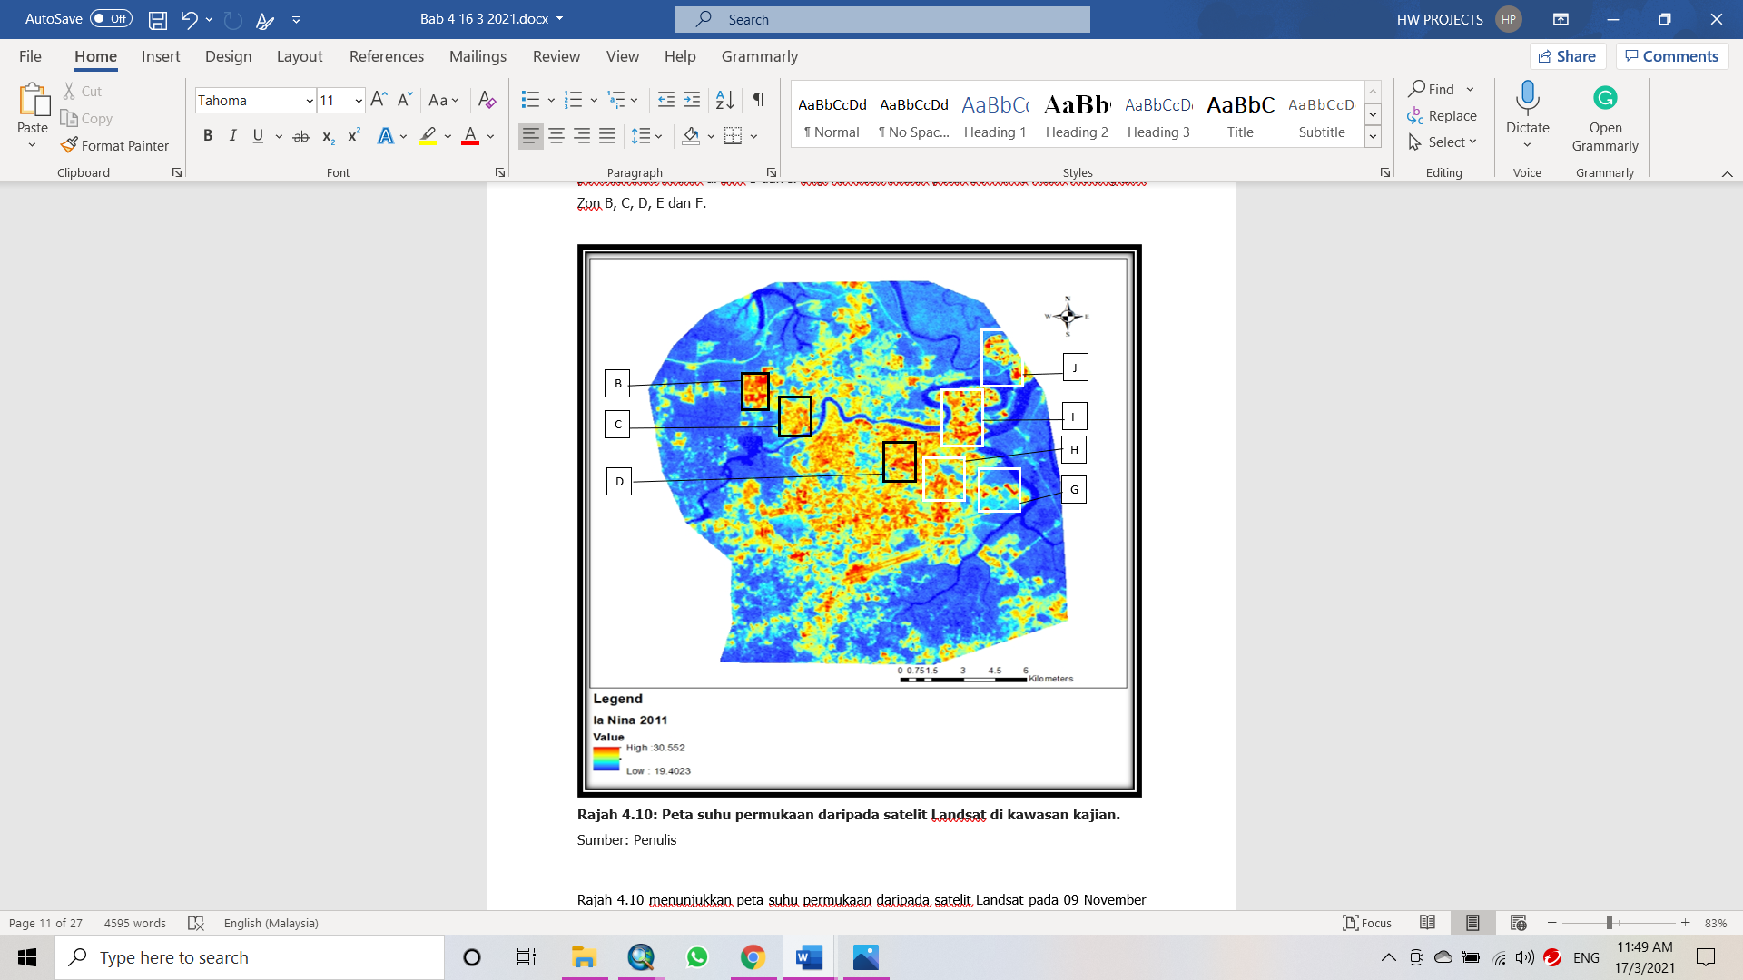
Figure 4: Map LST during La Niña and El-Niño.

The increase in hot spot area will be explained in depth using figures 4 and 5 which calculates the area of ​​hot spot area i.e., has temperatures exceed 30 °C during La Niña and El Niño events. The method utilized for the effect of ENSO on LST in the study area will be explained in detailed using table 1. The Landsat data provide information statistical value namely maximum, minimum, and mean LST for every selection data during La Niña and El Niño.
Table 1. Difference value statistic LST during La Niña dan El-Niño for Landsat.
Date Data | Value ONI | Value (°C) | Date data | Value ONI | Value (°C) | Difference(°C)
24 October 2017 | -1  (La Niña) | Maximum  (31.39) | 6 July 2016 | 1  (El-Niño) | Maximum  (35.90) | Maximum  (4.51)
24 October 2017 | -1  (La Niña) | Minimum (19.10) | 6 July 2016 | 1  (El-Niño) | Minimum  (24.29) | Minimum  (5.29)
24 October 2017 | -1  (La Niña) | Mean  (24.8) | 6 July 2016 | 1  (El-Niño) | Mean  (26.90) | Mean  (2.10)
21 August 2017 | -1  (La Niña) | Maximum  (31.71) | 28 July 2015 | 1.1  (El-Niño) | Maximum  (34.33) | Maximum  (2.62)
21 August 2017 | -1  (La Niña) | Minimum (23.45) | 28 July 2015 | 1.1  (El-Niño) | Minimum  (25.19) | Minimum  (2.74)
21 August 2017 | -1  (La Niña) | Mean  (24.2) | 28 July 2015 | 1.1  (El-Niño) | Mean  (26.72) | Mean  (2.52)
9 November 2011 | -1.1  (La Niña) | Maximum  (30.55) | 3 April 1998 | 1  (El-Niño) | Maksimum  (33.31) | Maximum  (2.76)
9 November 2011 | -1.1  (La Niña) | Minimum (19.42) | 3 April 1998 | 1  (El-Niño) | Minimum  (26.19) | Minimum  (6.77)
9 November 2011 | -1.1  (La Niña) | Mean  (24.91) | 3 April 1998 | 1  (El-Niño) | Mean  (27.81) | Mean  (2.9)
Source: Authors
Table 1 displayed the information values ​​for each of the El Niño and La Niña events. Selection only at data with non-cloud coverage data in the study area and ONI values 1 (El Niño) and (La Niña) -1 of different degrees of strength was strong. Table 1 shows the higher value of LST maximum, mean, and minimum during El-Niño compared to ​​during La Niña. For example, where the value ONI 1.1 in April 1998 represented El-Niño the value mean LST was 27.81 °C compared to during La Niña time in November 2011 where the value of mean LST was 24.91 °C. The second example during the data taken July 2015 whose ONI value is 1.1 (El Niño) and the value of mean LST that occurs 26.9 °C higher compared to the La Niña event whose ONI value is -1 where the LST mean value is 24.2 °C. The same data Landsat applies to maximum and minimum values LST where El-Niño is 35.90 °C and 24.29 °C respectively higher at the time of El Niño occurrence compared to the maximum value LST is 31.39 °C and the minimum value is 19.10 °C which is the ONI value -1 on 21 August 2017. Table 1 explains the temperature differences between the statistical values ​​of maximum, minimum, and means LST. For example, different values mean LST between ​​El Niño and La Niña event between 2.10 °C to 2.90 °C. The maximum value difference between 2.32 to 4.51 °C and the last for minimum value difference is between 2.74 °C to 6.77 °C.
ENSO events affect temperature and remote sensing technology can record and provide information on the hot spot and cold spot areas. Besides that, this study discovered the value maximum, minimum, and mean LST was higher during El Niño compared to La Niña Events. Chen et al., (2018) and Lin et al., (2018) showed that El Niño events can cause global temperature rise. The study area is affected by the global increase in El Niño events as explained by table 1 and figure 1. Maura et al., (2019) discovered an increase in temperature of 7 to 8 °C during the El Niño event in the Amazon, Brazil. Mou et al., (2021) also discovered the temperature increased between 0.3 °C to 0.5 °C because of El Niño events in Malaysia using meteorology data. The findings of Mou et al., (2021) are different from Tawang and Tengku's (2002), which discovered the temperature increased from 0.1 °C to 1.9 °C in Perlis and 0.1 °C to 2 °C in Kedah. In addition, Kogan and Guo (2017) stated there was an increase in temperature between 0.5 °C to 2.50 °C in the 2015/2016 El Niño event on a global scale. Figure 5 shows a distribution of surface temperatures that have surface temperatures above 30 °C (hot spot) with red color during the occurrence of La Niña and El Niño.
Based on figure 5, there discovered that the area of hot spot concentration during the El Niño incident was higher than during the La Niña incident. Figure 6 explained in-depth the difference in hot spot areas concentration during the la Niña and El Niño incidents.

Based on figure 6, it was found that the area of hot spot areas concentration during the El Niño incident was higher than during the La Niña incident. During 2015 and 2016, El Niño incidents were found to be hot spots with an area of 89.32 km² and 97.8 km² respectively compared to La Niña 2018 and October 2018 with a hot spot area of 61.23 km² and 59.73 km². The hot spot area was similar patterns the during the 1998 El Niño incident which had a hot spot area of 89.32 km² compared to La Niña 2011 with an area of 55.82 km². This demonstrates the influence of ENSO changing the area's hot spot concentration pattern. Increased temperatures during the El-Niño incident due to el-Niño capabilities increased temperatures globally (Chen et al., 2018; Lin et al., 2018; Yu et al., 2015). An indirect increase in global temperatures could lead to an increase in local temperatures, especially in the study area. The study results and findings were supported by Mou e al., (2021), Maura et al., (2019), Song et al., (2018), and Yu e al., (2015) which stated local climate influences could not influence the effect of warming by El-Niño when it was dominant at a maturity level. This explains why the statistical value and distribution of high surface temperatures around Kuching City during El Niño.

Map of the hot spot area (red color) which has value LST more than 30 °C during El-Niño | Map of the hot spot area (red color) which has value LST more than 30 °C during La-Niña
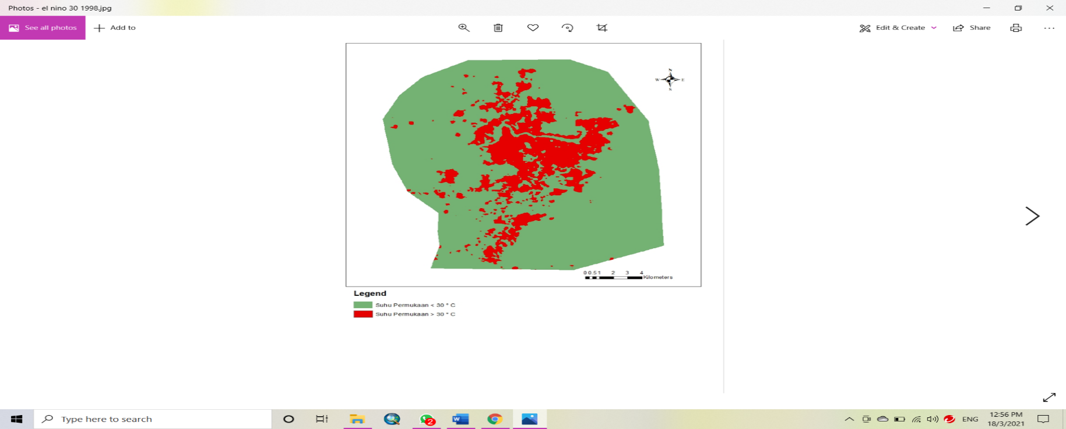  El Niño 1998 | 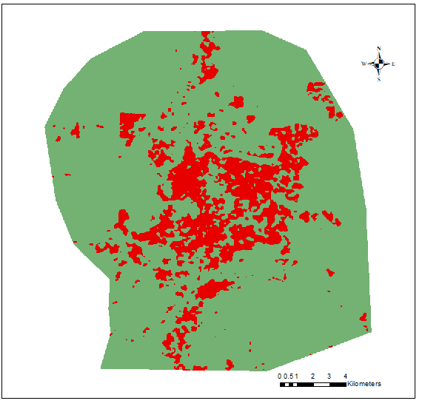  La Niña 2011
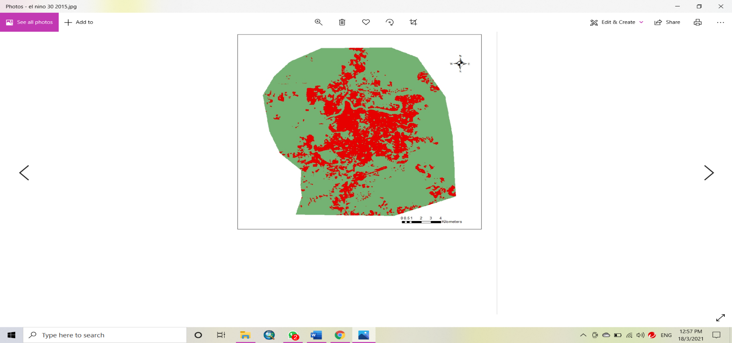  El Niño 2015 | 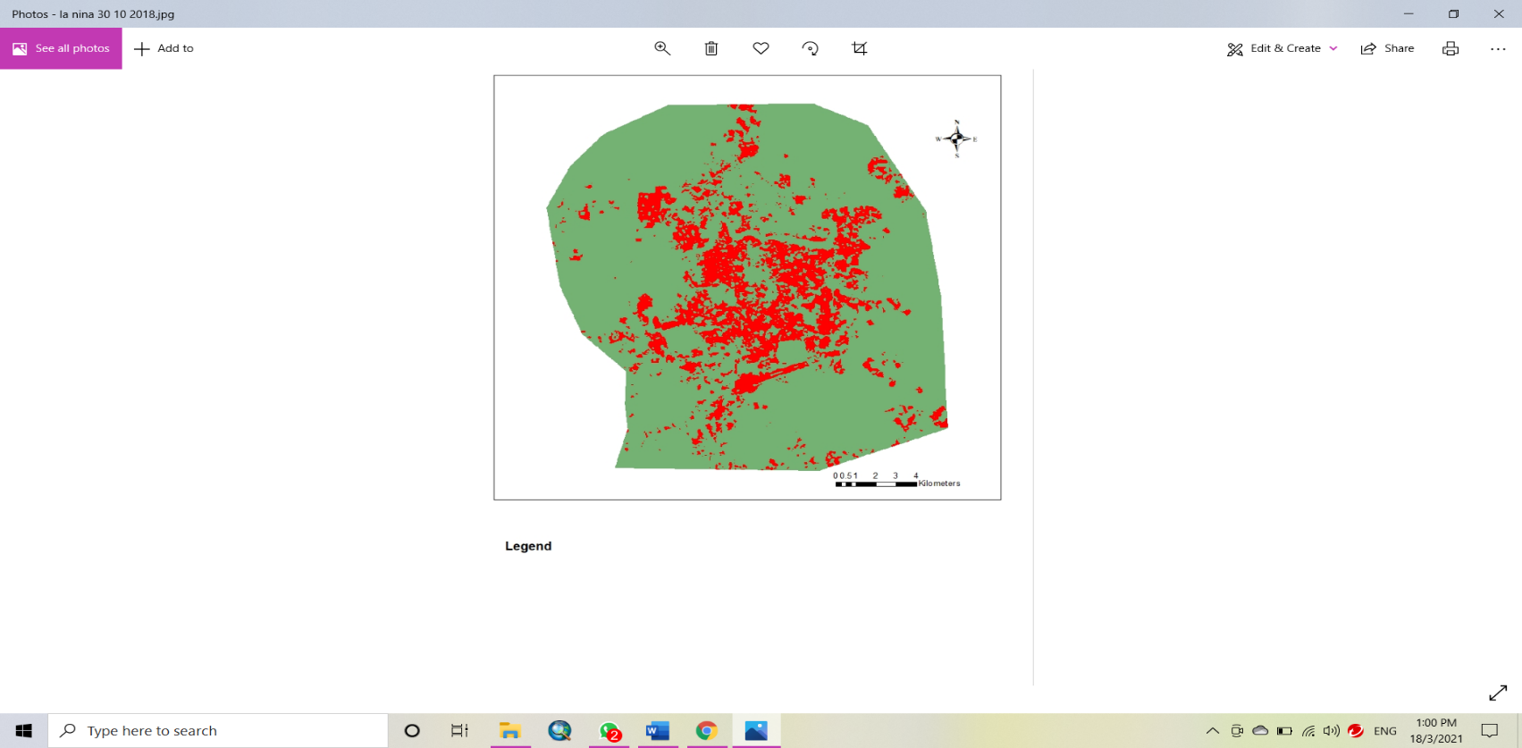  La Niña 2018
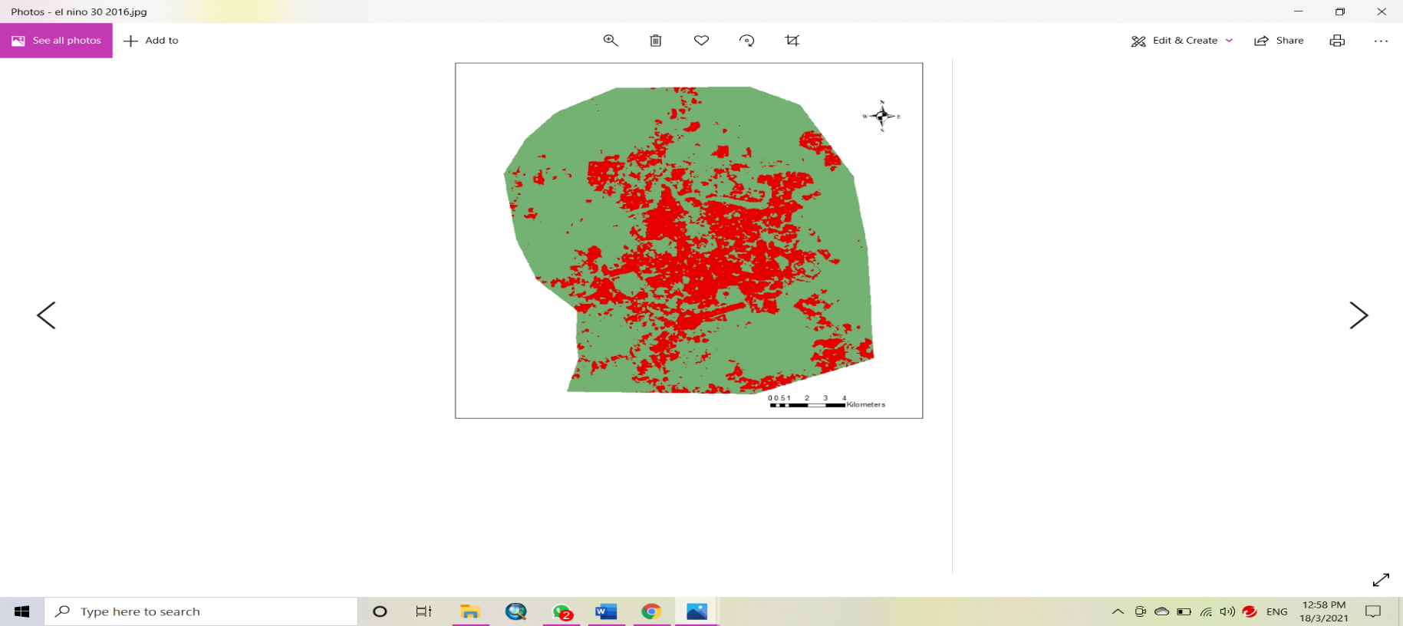  El Niño 2016 | 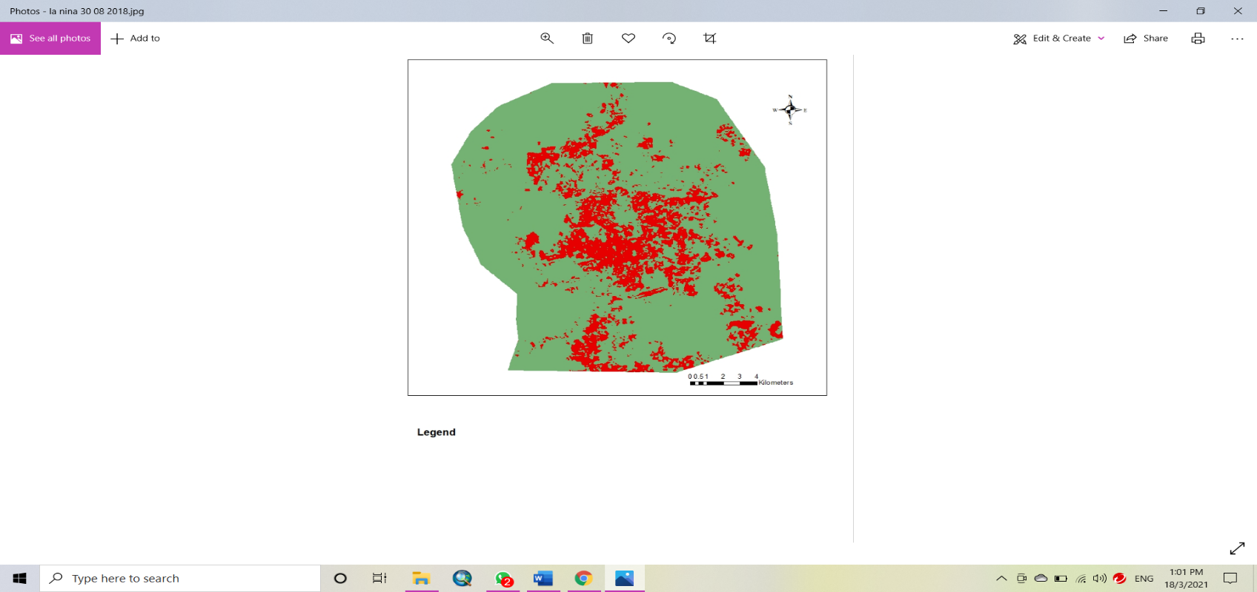  La Niña 2018
Figure 5: Spatial pattern of hot spot area that has a surface temperature of more than 30 °C (red color) during the occurrence of La Niña and El-Niño in Kuching City for Landsat satellites.

Figure 6. Graph Bar Area hot spot during the El Niño and La Niña incidents for Landsat satellites.

The average temperature during the occurrence of El Niño 1997 and 1998 was found to be 27.8 °C and 26.9 °C and average the during the occurrence of La Niña in November 2011 and September 2010 was found to be 24 ° C as display in table 1. There is a temperature difference of 2 to 3 °C between ONI occurrences. In contrast to the findings of Moura et al., (2019) have been conducted a study on Amazon where temperature differential occurs in 7.5 °C to 8 °C between two El-Niño and La Niña occurring. The high difference compared to the study area due to the factors in the terrain in which the study area in the lowlands compared to the Moura et al., (2019) study area was nearby in the Andes mountains. Kogan and Guo (2017) examined the effects of El Niño on the global plant and climate systems the world found the effects El Niño caused a temperature increase of 0.5 °C to 2.50 °C depending on the position of a place. The results of Kogan and Guo (2017) were almost identical to the findings. Landsat's use of satellites in examining the effects of ENSO on urban climates for selected data, namely those where ENSO's strength level is strong at -1 (La Niña) and 1 (El Niño) is observed to cause temperature increases between 2.10 °C and 2.80 °C. This explains the effect of the city's heat island in the increase in temperature during the La Niña incident from 1.30 °C to 1.50 °C after the minus the increase of LST value with value change (increase) in general from result literature for the whole of Malaysia without involving the influence of the city's heat island in the temperature increase pattern due to ENSO from Mou et al., (2021). The result of study similar to the result found by Tawang and Tengku (2002) reported El Niño events causing temperature increases of 0.1 °C to 1.9 °C in Kedah and 0.1°C to 2.4 °C in Perlis during the 1997 El Niño event. Based on figure 7, the distribution pattern of surface temperatures in Kuching City changed differently for each of the La Niña and El-Niño occurrences. During El-Niño it was found that the concentration area was more heated (pixel color red) than during the La Niña incident.

Map LST during El Niño | Map LST during La Niña
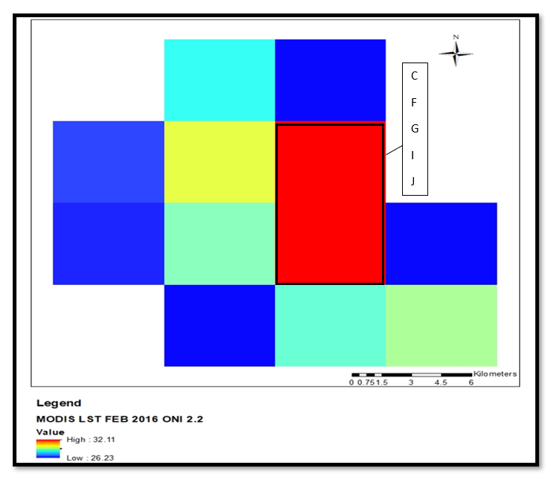 | 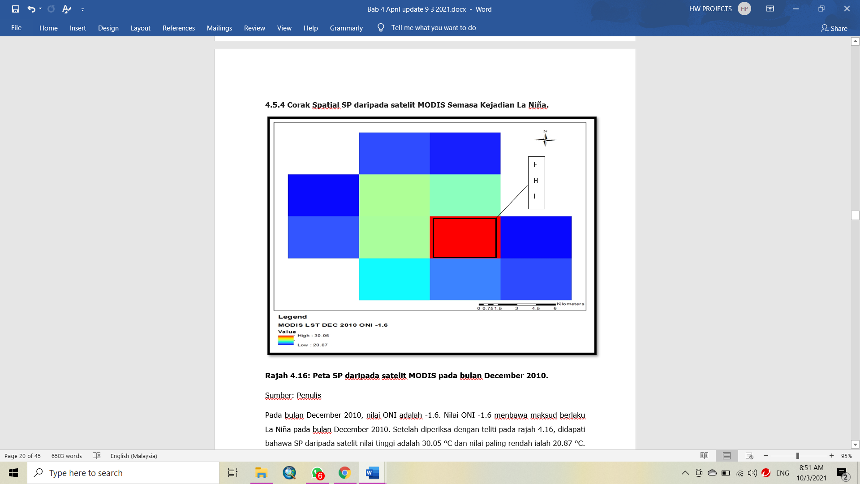
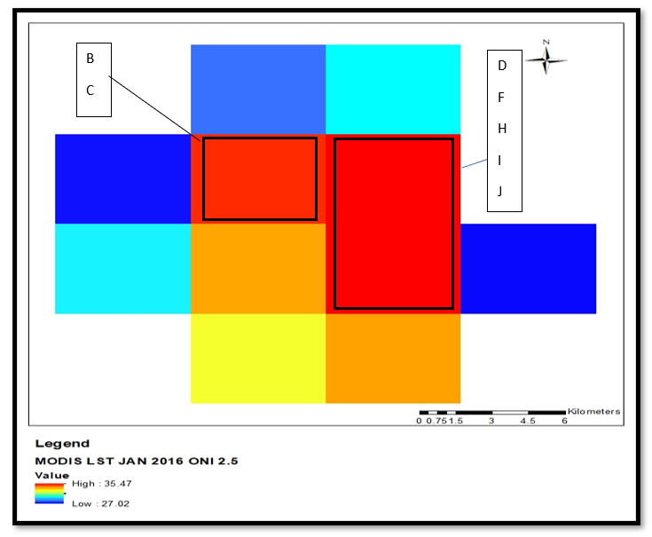 | 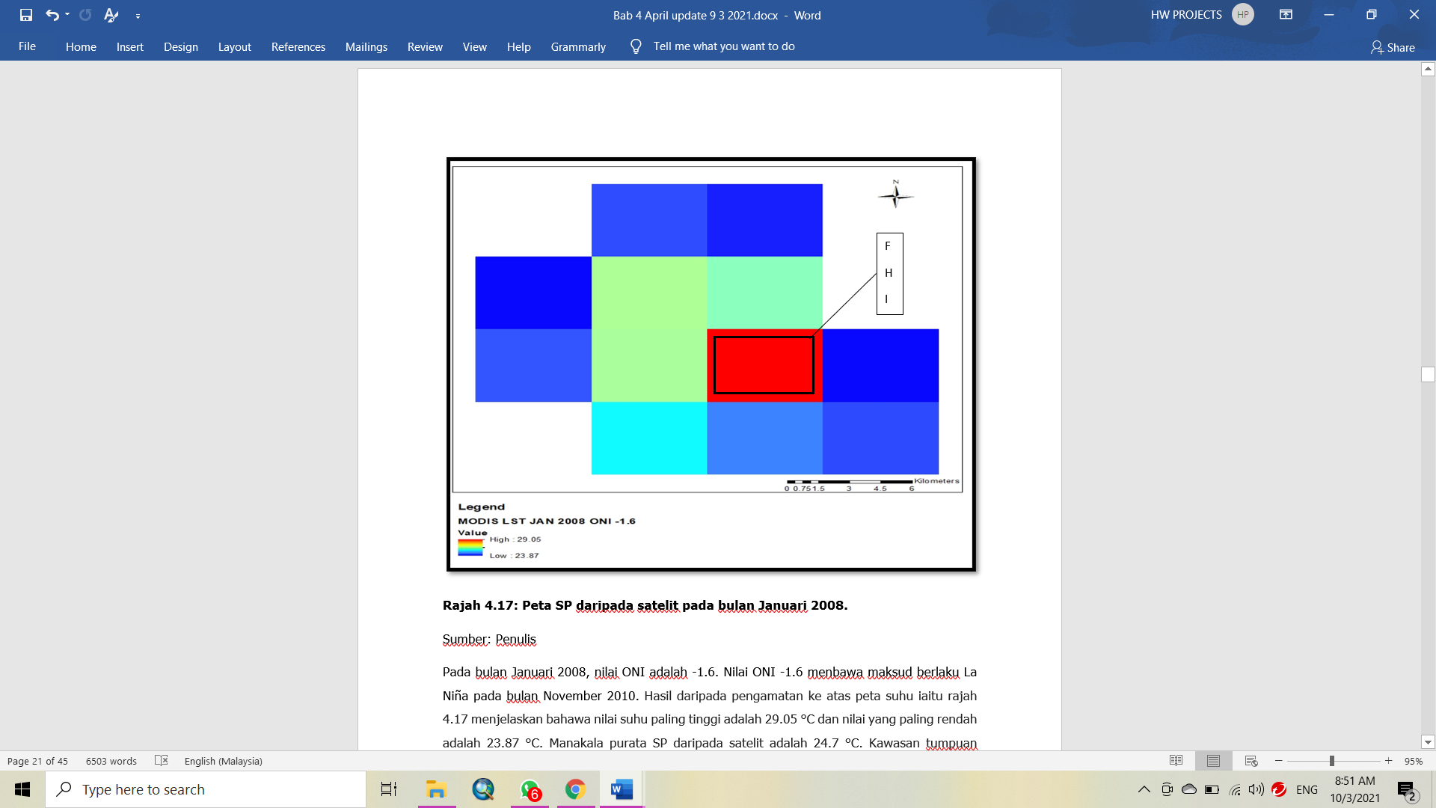

Figure 7. LST Map from MODIS during La Niña dan El-Niño.

For example, in La Niña in January 2010 it was found that land surface temperature values above 30 °C value was one pixel (red color pixel) compared to during the January 2016 El-Niño incident that had 3 pixels (red color). That explain the areas of hot spot during El Niño higher compare during La Niña. During El-Niño the area near the heat is more likely to occur in La Niña. For example, in La Niña January 2010 the different color of the surface temperature value of 30 °C is one pixel (zones H and I) during the January 2016 El-Niño event which has 3 pixels representing zones B, C, D, F, G, H, I and J. The detailed explanation will be discussed together with figure 6. Significant changes can be seen in table 2 where the differences in average, maximum, and minimum for each dates were shown.

Table 2: Difference value statistic during La Niña and El-Niño for MODIS.

Date data | Value ONI | Value (°C) | Date data | Value ONI | Value (°C) | Difference(°C)
December 2010 | -1.6  (La Niña) | Maximum  (30.05) | February 2016 | 2.2  (El-Niño) | Maximum (32.11) | Maximum (2.06)
December 2010 | -1.6  (La Niña) | Minimum (20.87) | February 2016 | 2.2  (El-Niño) | Minimum  (26.23) | Minimum  (5.36)
December 2010 | -1.6  (La Niña) | Mean  (24.5) | February 2016 | 2.2  (El-Niño) | Mean  (28.01) | Mean  (3.51)
November 2010 | -1.7  (La Niña) | Maximum  (30.71) | January 2016 | 2.6  (El-Niño) | Maximum  (35.31) | Maximum  (4.6)
November 2010 | -1.7  (La Niña) | Minimum (20.51) | January 2016 | 2.6  (El-Niño) | Minimum (27.02) | Minimum (6.65)
November 2010 | -1.7  (La Niña) | Mean  (24.3) | January 2016 | 2.6  (El-Niño) | Mean  (29.01) | Mean  (4.71)

Source: Authors

Table 2 shows the information values ​​for each difference of ONI values ​​for the selected data of each value 1 and -1. The values ​​of maximum, minimum, and mean LST show higher during El-Niño compare to La Niña. For example, during El Niño which value ONI 2.2 in February 2016 in El-Niño month the value means of LST 28.01 °C compare to time during current La Niña the value of ONI -1.6 in December 2010 where the value of mean LST is 24.51 ° C. In January 2016 where the value of ONI is 2.5 and the value means of LTS is 29.1 °C and the value of LST mean for November 2010 is 24.3 °C which is the value of ONI -1.7. During El Niño events the higher temperature values ​​are higher during La Liña. This same data also applies for the LST maximum values ​​of El-Niño is 32.11 °C and 35.31 °C in January and February 2016 respectively compare to during the La Niña event at 30.01 °C and 30.71 °C and December 2010. Table 2 also represented a difference that occurs between the events of El-Niño and La Niña. The value of the LST value varies between 3.51 to 4.71 °C for the value of the LST mean. For the maximum temperature, the difference between 2.06 to 4.6 °C and the minimum temperature between 5.36 to 6.65 °C.

Figure 8. Graph bar area hot spot during the El Niño and La Niña incidents for MODIS satellites.
With a reference to figure 8 was found to be an area of hot spot areas concentration during the El Niño incident higher than during the La Niña incident. The El Niño incident occurred during February 2016 which was valued at ONI 2.6 and El Niño which occurred in January 2016 which was valued at ONI 2.1 was found to be a hot spot at 95 km² and 62.72 km² respectively compared to during the La Niña 2008 and 2010 incidents. The results of the hot spot area difference during the El Niño and La Niña incidents were similar to the results of the findings of using the Landsat satellite which is the area of the hot spot concentration area of El Niño higher than La Niña. For the context of the Kuching City area, the effect of El Niño was an increase in temperature between 0.5 °C to 1.5 °C referring to data supplied at Kuching Meteorological Station. While the temperature decreases range from 0 °C to 1.2 °C during La Niña. The distribution of rainfall will decrease during the El Niño incident, and this can cause temperatures to rise while the distribution of rainfall will increase during la Niña incidents and this can cause lower temperatures (Kemarau and Eboy, 2021).

Conclusion

This study successfully achieved the set objectives and answered the research questions mentioned in the introduction. The first question is remote sensing technology study the effects of ENSO on LST? If yes, remote sensing technology can study the effect of ENSO on temperature and LST. Temperature and LST values ​​change based on the ONI index which measures the strength of an ENSO event. Temperature and LST increase if ONI values ​​increase. Referring to the second where are the effects of ENSO? Overall, the study area was affected. The areas that recorded the highest temperatures in town areas and industrial areas. Cold spot areas are air bodies and plants. And the last question is can remote sensing technology measure the effect of ENSO strength level on LST? Yes, remote sensing technology can measure the level of ENSO incident strength to LST. This study the occurrence of El Niño events each event that causes drought. The drought due to temperature and increased values of maximum, minimum, and mean temperature values ​​were recorded. An increase in the maximum, minimum, and mean temperature values ​​occurs if the ONI value increases. In addition, the result of this study demonstrates the influence of ENSO changing the area's hot spot concentration pattern. Increased area of hot spot during the El-Niño incident due to el-Niño capabilities increased temperatures at study areas. This study was conducted directly using remote sensing technology of results with the use of meteorological data of extreme trends and temperature changes across Malaysia similar to countries such as Indonesia (Supari et al., 2017) and Thailand (Limjirakan and Limsakul, 2012) on ENSO incidents causing overall temperature changes in 1997/1998 and 2015/2016. The findings of this study can provide knowledge and answers about what happens in the town area during the El Niño event. Knowledge regarding the effect of ENSO on temperature and LST for other parties such as natural disaster management agencies and the government need to take actions such as the construction of green and blue area infrastructure in the wake of the effects of UHI and El Niño. Researchers plan that in the future this study area should be developed in large urban areas such as Greater Johor and the Klang Valley which have a population of over two million. Based on this study, it is found that the effect of ENSO influence varies depending on the position of an area.

Acknowledgment

Thanks to the Malaysia Metereology Department for supplying the temperature data and NASA’s "Free Data" policy to MODIS and Landsat satellite data.

References

Alexander, L. V. (2016). Global observed long-term changes in temperature and precipitation extremes: A review of progress and limitations in IPCC assessments and beyond. Weather and Climate Extremes, 11, 4-16.
Baum, S., Horton, S., Low Choy, D., & Gleeson, B. (2009). Climate change, health impacts, and urban adaptability: a case study of Gold Coast City. Research Monograph, 11, 68.
Chen, R., Wen, Z., & Lu, R. (2018). Large-scale circulation anomalies and intra season oscillations associated with long-lived extreme heat events in South China. Journal of Climate, 31(1), 213-32.
Feltz, M., Borbas, E., Knuteson, R., Hulley, G., & Hook, S. (2018). The combined ASTER and MODIS emissivity overland (CAMEL) global broadband infrared emissivity product. Remote Sensing, 10(7), 1027.
Griffiths, G. M., Chambers, L. E., Haylock, M .R., Manton, M. J., Nicholls, N., Baek, H. J., Choi, Y., Della‐Marta, P. M., Gosai, A., Iga, N., & Lata, R. (2005). Change in mean temperature as a predictor of extreme temperature change in the Asia–Pacific region. International Journal of Climatology: A Journal of the Royal Meteorological Society, 25(10), 1301-1330.
Hales, S., Kovats, S., & Woodward, A. (2000). What El Niño can tell us about human health and global climate change. Global Change and Human Health, 1(1), 66-77.
Hanley, D.E., Bourassa, M.A., O'Brien, J.J., Smith, S.R., & Spade, E.R. (2003). A quantitative evaluation of ENSO indices. Journal of Climate, 16(8), 1249-58.
Islam, M. A, Chan, A., Ashfoldm M. J., Ooi, C. G, & Azari, M. (2018). Effects of El-Niño, Indian Ocean dipole, and Madden-Julian oscillation on surface air temperature and rainfall anomalies over Southeast Asia in 2015. Atmosphere, 9(9), 352.
Iyengar, Rishi (22 June 2015). "A Heat Wave in Pakistan Has Killed Around 140 People". Time. Retrieved 28 July 2018.
Kemarau, R.A., & Eboy, O.V. (2020). Urbanization and it impacts to land surface temperature on the small medium-size city for the year 1991, 2011 and 2018: Case study Kota Kinabalu. Journal of Borneo Social Transformation Studies, 6(1), 58-76.
Kemarau, R. A., & Eboy, O. V. (2021). The Impact of El Niño–Southern Oscillation (ENSO) on Temperature: A Case Study in Kuching, Sarawak. Malaysian Journal of Social Sciences and Humanities (MJSSH), 6(1), 289-97.
Kogan, F., & Guo, W. (2017). Strong 2015–2016 El Niño and implication to global ecosystems from space data. International Journal of Remote Sensing, 38(1), 161-78.
Koutavas, A., & Joanides, S.. (2012). El Niño–Southern oscillation extrema in the Holocene and last glacial maximum. Paleoceanography, 27(4).
Limjirakan, S., & Limsakul, A. (2012). Observed trends in surface air temperatures and their extremes in Thailand from 1970 to 2009. Journal of the Meteorological Society of Japan. Ser. II. 90(5), 647-62.
Lin, R., Zheng, F., & Dong, X. (2018). ENSO frequency asymmetry and the Pacific decadal oscillation in observations and 19 CMIP5 models. Adv. Atmos. Sci, 35(5), 495-506.
Moura, M. M., Dos Santos, A. R., Pezzopane, J. E. M., Alexandre, R. S., da Silva, S. F., Pimentel, S. M., de Andrade, M. S. S., Silva, F. G. R., Branco, E. R. F., Moreira, T. R. & da Silva, R. G. (2019). Relation of El Niño and La Niña phenomena to precipitation, evapotranspiration, and temperature in the Amazon basin. Science of The Total Environment, 651, 1639-1651.
Mou Leong, T., Juneng, L., Tangang, F. T., Chung, X. J., & Radin Firdaus, R. B. (2021) Changes in temperature extremes and their relationship with ENSO in Malaysia from 1985 to 2018. International Journal of Climatology. 2021.
NOAA., (2020). National Centers for Environmental Information, State of the Climate: Global Climate Report for Annual 2019. Available at https://www.ncdc.noaa.gov/sotc/ global/201913
Ropelewski, C. F., & Halpert, M. S. (1989). Precipitation patterns are associated with the high index phase of the Southern Oscillation. Journal of climate, 2(3), 268-84.
Salleh, N. H., Hasan, H., & Kassim, S. (2015). Trends in temperature extremes across Malaysia. Advances in Environmental Biology, 9, 174-181.
Song, K., & Son, S. W. (2018). Revisiting the ENSO–SSW relationship. Journal of Climate, 31(6), 2133-2143.
Suhaila, J., & Yusop, Z. (2018). Trend analysis and change point detection of annual and seasonal temperature series in Peninsular Malaysia. Meteorology and Atmospheric Physics, 130(5), 565-81.
Tangang, F., Juneng, L., & Aldrian, E.. (2017). Observed changes in extreme temperature and precipitation over Indonesia. International Journal of Climatology, 37(4), 1979-97.
Tangang, F.T., Juneng, L., Salimun, E., Sei, K., & Halimatun, M. (2012). Climate change and variability over Malaysia: gaps in science and research information. Sains Malaysiana, 41(11),1355-66.
Tawang, A., & Tengku Ahmad, T. B. A. (2002). Stabilization of Upland Agriculture under El Niño-induced Climatic Risks: Regional and Farm Level Risk Management and Coping Mechanisms in the Kedah-Perlis Region, Malaysia (No. 1438-2016-118912).
Tawang, Ariffin, Tengku Ahmad, Tengku Ariff, & Abdullah, Mohd Yusof., (2002). Stabilization of upland agriculture under El Niño-induced climatic risk: impact assessment and mitigation measures in Malaysia, Working Paper No. 61, Bogor, Indonesia: CGPRT Centre. http://ageconsearch.umn.edu/bitstream/32667/1/wp020061.pdf.
Turkington, T., Timbal, B., & Rahmat, R. (2019). The impact of global warming on sea surface temperature based El Niño–Southern Oscillation monitoring indices. International Journal of Climatology, 39(2), 1092-103.
The Guardian. (2016) https://www.theguardian.com/global-development/2016/may/30/el-Niño-is-over-but-it-leaves-nearly-100-million-people-short-of-food
Yang, S., Li, Z., Yu, J. Y., Hu, X., Dong, W., & He, S. (2018). El Niño–Southern Oscillation and its impact in the changing climate. National Science Review, 5(6), 840-57
Yatim, A.N, Latif, M.T., Ahamad, F., Khan, M.F., Nadzir, M.S., & Juneng, L. (2019). Observed Trends in Extreme Temperature over the Klang Valley, Malaysia. Advances in Atmospheric Sciences, 36(12), 1355-70.

Yu, J. Y., Paek, H., Saltzman, E. S., & Lee, T. (2015). The early 1990s change in ENSO–PSA–SAM relationships and its impact on Southern Hemisphere climate. Journal of Climate, 28(23), 9393-408.
Wai, N. M., Camerlengo, A., Khairi, A., & Wahab, A. (2005). A study of global warming in Malaysia.
World Health Organization., (2016). https://www.who.int/news-room/feature-stories/detail/el-ni%C3%B1o-affects-more-than-60-million-people
Wong, C. L., Yusop, Z., & Ismail, T. (2018). The trend of daily rainfall and temperature in Peninsular Malaysia based on gridded data set. International Journal of GEOMATE, 14(44), 65-72.
Zhou, D., Xiao, J., Bonafoni, S., Berger, C., Deilami, K., Zhou, Y., & Sobrino, J. A. (2019). Satellite remote sensing of surface urban heat islands: Progress, challenges, and perspectives. Remote Sensing, 11(1), 48.

